

Programme: Master of Business Administration International Business
Module: Human Capital Management
Module code: LCMB7023
Title: Assessment component 1: Individual report
Word count: 2709
Lecturer: Ejike Udeogu (Birmingham)
Student Name: Harshkumar Mangarola
Student ID: 2505073
Submission Date: 17th October 2025

Table of Contents:

Introduction 3
1: How are technological advancements reshaping labour markets, and what implications does this have for HRM and IHRM strategies? 3
Introduction 3
1.1 Definition of HRM 3
1.2 Importance of HRM 4
1.3 Definition of IHRM 4
1.4 Importance of IHRM 5
1.5 Challenges in IHRM 5
Conclusion 6
2: What are the key demographic and geopolitical factors influencing employment markets today, and how do they create challenges for HR professionals? 6
Introduction 6
2.1 Demographic Factors 6
2.2 Geopolitical Factors 7
2.3 Implications for HR Professionals 7
Conclusion 8
3: How can organisations address persistent skills gaps and talent shortages in critical sectors through strategic HRM? 8
Introduction 8
3.1 Identifying and Understanding Skills Gaps 9
3.2 Strategic Recruitment and Talent Acquisition 9
3.3 Employee Development and Retention 9
3.4 Creating a Talent Pipeline 10
Conclusion 10
4: In today's globalised workplace, it is essential that every employee is equipped to perform effectively in an international environment. Additionally, with rapidly evolving technologies, it is increasingly important for individuals to continuously adapt and innovate in order to take full advantage of emerging opportunities. Write a reflective report on your current capabilities in working within an international context, focusing on technology, communication, teamwork, leadership, and self-directed learning. What are your strengths and weaknesses in these areas? How do you intend to leverage your strengths and address your areas for improvement? Ensure that your arguments are supported by appropriate evidence drawn from your current learning activities this term or your recent working experience. 11
Introduction 11
4.1 Technology 11
4.2 Communication 12
4.3 Teamwork 13
4.4 Leadership 14
4.5 Self-Directed Learning 14
Conclusion 15
Overall Conclusion 16
References 16

Introduction
Human Resource Management (HRM) plays a vital role in shaping the success of organizations by managing their most valuable resource—people. Over the years, HRM has evolved from a purely administrative function to a more strategic role, where Human Resource Management is aligned with the long-term goals and objectives of an organization. This transformation is referred to as Strategic Human Resource Management (SHRM). SHRM focuses on integrating HR practices with business strategies to create a workforce capable of driving organizational success. This assessment will explore the key concepts, elements, and applications of SHRM, examining its importance in contemporary organizations.

1: How are technological advancements reshaping labour markets, and what implications does this have for HRM and IHRM strategies?

Introduction
Technological advancements such as automation and artificial intelligence are rapidly transforming labor markets. These changes present both opportunities and challenges for Human Resource Management (HRM) and International Human Resource Management (IHRM). As businesses adapt to these developments, HRM and IHRM strategies must evolve to manage global workforces, address skills gaps, and ensure organizational success in a digitally-driven world. HR professionals must become proactive in leading change, adapting policies, and supporting the workforce through these transitions. This report examines how technology reshapes labor markets and its implications for HRM and IHRM.

1.1 Definition of HRM
Human Resource Management (HRM) involves managing an organization’s employees to enhance their contributions to organizational goals. It includes recruitment, training, performance management, compensation, and employee relations. HRM ensures that the organization has the right people with the necessary skills at the right time (Armstrong & Taylor, 2020). HRM is crucial for fostering a productive workforce and aligning HR practices with business strategies, improving organizational performance and employee satisfaction (Boxall & Purcell, 2016). HRM today is more than just reactive management; it plays a proactive role in aligning workforce skills with business needs and supporting growth in a technology-driven world.

1.2 Importance of HRM
HRM is important for:
- Employee Motivation and Development: HRM fosters employee engagement and provides growth opportunities, which boost job satisfaction and productivity.
- Strategic Alignment: HRM aligns people management practices with organizational goals, such as market expansion or operational efficiency.
- Legal Compliance: HRM ensures compliance with labor laws, mitigating legal risks and upholding the organization’s reputation (Torrington et al., 2017).
HRM helps organizations respond to shifts in the labor market, economic changes, and technological advancements, ensuring long-term competitiveness.

1.3 Definition of IHRM
International Human Resource Management (IHRM) is the management of human resources in an international context, including recruitment, training, and managing employees across multiple countries. IHRM addresses challenges that multinational corporations (MNCs) face with diverse workforces in different cultural, legal, and economic environments (Brewster et al., 2005). IHRM is more complex than domestic HRM due to the need to navigate cultural differences, international labor laws, and diverse employee expectations.

1.4 Importance of IHRM
IHRM is crucial for MNCs because it helps them:
- Manage Cultural Diversity: IHRM fosters collaboration and minimizes conflicts by effectively managing cultural differences.
- Adapt HR Policies Across Borders: While some HR policies can be standardized, IHRM tailors others to fit local cultural and legal contexts.
- Expatriate Management: IHRM ensures the effective selection, training, and support of expatriates to perform well in foreign subsidiaries (Schuler et al., 1993).
IHRM ensures that employees are well-integrated into the global workforce and can perform effectively across diverse environments.

1.5 Challenges in IHRM
Key challenges in IHRM include:
- Cultural Adaptation: Ensuring expatriates and local employees understand cultural differences. Effective cross-cultural training is essential for success (Brewster et al., 2005).
- Legal Compliance: IHRM must navigate different labor laws, tax regulations, and employment practices in multiple countries.
- Talent Management: Developing global leaders and managing expatriate careers, including repatriation, are ongoing challenges (Tarique et al., 2015).
As technological advancements reshape labor markets, HRM and IHRM must evolve to address challenges like managing remote work, automation, and AI, while maintaining employee engagement and legal compliance.

Conclusion
Technological advancements are reshaping HRM and IHRM by demanding new strategies to manage workforces and adapt to global changes. HR professionals must align people management practices with business goals while addressing challenges like skills gaps, cultural diversity, and legal compliance. Moving forward, HRM and IHRM will need to continuously innovate and integrate technology to remain effective in a rapidly evolving global labor market.

2: What are the key demographic and geopolitical factors influencing employment markets today, and how do they create challenges for HR professionals?

Introduction
Demographic and geopolitical factors play a significant role in shaping employment markets today. These factors influence labor supply, skill sets, and employee expectations, creating new opportunities and challenges for HR professionals. Understanding these trends allows HR professionals to adapt their strategies to meet evolving workforce needs and global demands.

2.1 Demographic Factors
- Aging Populations: In many developed countries, aging populations are leading to a shrinking workforce. With longer life expectancies and lower birth rates, HR must focus on succession planning, retirement strategies, and engaging older employees to prevent labor shortages (ILO, 2020).
- Youthful Workforce: In regions like sub-Saharan Africa, younger populations are entering the workforce. HR must attract and retain talent from Millennials and Gen Z, who value flexibility, work-life balance, and career growth (Boxall & Purcell, 2016).
- Diversity and Inclusion: Global migration has increased workforce diversity, requiring HR to foster inclusive environments that support employees from various backgrounds. This includes managing diversity in recruitment and creating equal opportunities (CIPD, 2021).

2.2 Geopolitical Factors
- Globalization: As businesses expand globally, HR faces challenges managing employees across different legal systems and cultures. HR professionals must develop global HR strategies that balance corporate goals with local practices (Brewster et al., 2005).
- Political Instability: Political instability affects labor markets, causing disruptions and migration. HR must adapt by offering relocation support or managing workforce instability in these regions (Schuler et al., 2017).
- Trade and Labor Mobility: Shifts in trade agreements and tariffs affect labor mobility and skill availability. For example, Brexit altered migration patterns, impacting workforce dynamics. HR must adjust recruitment and compliance strategies accordingly (Tarique et al., 2015).

2.3 Implications for HR Professionals
These factors create several challenges for HR professionals:
- Talent Acquisition: HR must adapt recruitment strategies to address labor shortages and talent gaps caused by demographic shifts, especially in aging populations.
- Diversity Management: Managing a diverse workforce requires HR to develop strategies that promote collaboration across cultures. Cross-cultural training is critical to fostering an inclusive and harmonious work environment.
- Global Workforce Management: Managing employees across borders requires HR to tailor policies for local cultures while ensuring global consistency. Additionally, legal compliance across various jurisdictions remains a significant challenge (Torrington et al., 2017).

Conclusion
Demographic and geopolitical factors are reshaping employment markets, creating new complexities for HR professionals. To succeed, HR must implement adaptable strategies, focusing on workforce diversity, global talent management, and legal compliance in a rapidly changing world. The evolving workforce requires innovative HR practices that address the challenges posed by an aging population, youth employment, political instability, and globalization.

3: How can organisations address persistent skills gaps and talent shortages in critical sectors through strategic HRM?

Introduction
Skills gaps and talent shortages have become pressing challenges in critical sectors like technology, healthcare, and hospitality. As industries evolve and new technologies emerge, organizations face increasing difficulty in finding qualified talent to meet their specific needs. Strategic Human Resource Management (SHRM) offers a framework for addressing these challenges by ensuring that HR practices are aligned with business goals. Through strategic planning, targeted recruitment, and employee development, organizations can overcome talent shortages and build a skilled workforce to drive business success.

3.1 Identifying and Understanding Skills Gaps
To address skills gaps, organizations need to identify where they exist. Sectors like tech, healthcare, and hospitality often face specific challenges due to rapid technological advancements and changing market demands. In tech, the rise of AI, data analysis, and cybersecurity creates a need for specialized skills, while in healthcare, advancements in medical technologies require expertise in telemedicine and geriatrics (Armstrong & Taylor, 2020).
HR professionals can conduct skills audits and use AI-driven recruitment tools to identify the skills required for both current and future business needs, allowing them to prioritize training and development.

3.2 Strategic Recruitment and Talent Acquisition
After identifying skills gaps, HR must focus on strategic recruitment. In high-demand sectors like technology and healthcare, traditional recruitment strategies may not be sufficient. HR professionals need to tap into global talent pools and attract diverse candidates.
Partnerships with universities and technical institutes can help identify and develop potential talent early. Additionally, diversity and inclusion initiatives help broaden the talent pool, offering diverse perspectives and skills, which drive innovation (Boxall & Purcell, 2016). Employer branding also plays a key role in attracting talent by highlighting the organization’s values, work culture, and professional growth opportunities.

3.3 Employee Development and Retention
To bridge skills gaps, organizations must prioritize employee development. Sectors like tech and healthcare require continuous learning to keep up with evolving demands. HR professionals can offer training programs and certification courses to ensure employees remain up-to-date with the latest technologies (Torrington et al., 2017).
Employee retention is also crucial. Offering competitive compensation, career progression, and a supportive work culture helps retain talent. Providing flexible work arrangements and mental health support is particularly effective in high-demand sectors prone to burnout and high turnover.

3.4 Creating a Talent Pipeline
Building a talent pipeline is a long-term strategy to address talent shortages. Organizations can establish internship programs, apprenticeships, and job shadowing initiatives, which help develop talent from within and ensure a steady supply of qualified candidates for critical roles (Tarique et al., 2015).

Conclusion
To address persistent skills gaps and talent shortages, organizations must take a comprehensive approach that includes strategic recruitment, employee development, and building a talent pipeline. By aligning HR strategies with business objectives and adapting to changing industry needs, HR professionals can ensure their organizations remain competitive and equipped with the talent required for success.

4: In today's globalised workplace, it is essential that every employee is equipped to perform effectively in an international environment. Additionally, with rapidly evolving technologies, it is increasingly important for individuals to continuously adapt and innovate in order to take full advantage of emerging opportunities. Write a reflective report on your current capabilities in working within an international context, focusing on technology, communication, teamwork, leadership, and self-directed learning. What are your strengths and weaknesses in these areas? How do you intend to leverage your strengths and address your areas for improvement? Ensure that your arguments are supported by appropriate evidence drawn from your current learning activities this term or your recent working experience.

Introduction
In today’s globalized workplace, it is essential for employees to perform effectively within an international environment. As industries evolve and new technologies emerge, employees must continuously adapt and innovate to capitalize on new opportunities. This reflective report assesses my current capabilities in working internationally, focusing on technology, communication, teamwork, leadership, and self-directed learning. I will evaluate my strengths and weaknesses in these areas and describe how I intend to leverage my strengths and address areas for improvement.

4.1 Technology
The integration of technology into international workplaces has transformed how tasks are executed, especially with the growing reliance on digital tools, cloud computing, and virtual collaboration platforms. I am proficient in using tools such as Microsoft Teams, Zoom, and Slack, which are essential for virtual communication and project management in an international context. Furthermore, my academic coursework on digital transformation has equipped me with a basic understanding of emerging technologies like AI, cybersecurity, and machine learning (Armstrong & Taylor, 2020). These technological capabilities align closely with the growing global emphasis on digital HR transformation.
However, my understanding of advanced technologies like blockchain is limited. To address this, I intend to take online courses and attend workshops focused on emerging technologies. This will allow me to expand my technical knowledge and better contribute to the international teams I work with in future roles (Boxall & Purcell, 2016).

4.2 Communication
Effective communication in an international environment requires clarity, cultural sensitivity, and adaptability. I have developed strong communication skills through academic presentations, writing reports, and engaging in cross-cultural collaborations. These experiences have helped me understand the importance of active listening and adapting my communication style to fit diverse audiences (Torrington et al., 2017).
One of my strengths is the ability to tailor my message depending on the audience. For example, I make sure to adjust my tone and language when communicating with colleagues from different cultural backgrounds, recognizing that certain phrases or gestures may have different meanings in various cultures (CIPD, 2021). However, a weakness I have is that I sometimes over-communicate, especially when I believe clarity is needed. This can sometimes lead to information overload or confusion. To improve, I plan to practice delivering clearer and more concise messages, particularly when addressing multicultural teams (Armstrong & Taylor, 2020).

4.3 Teamwork
Working effectively in international teams requires collaboration across different cultural and geographical boundaries. I have worked in teams with individuals from various cultural backgrounds, which has enhanced my ability to foster collaboration and manage diverse work styles. I am adept at building relationships, facilitating group decision-making, and contributing to discussions in an inclusive manner (Brewster et al., 2005).
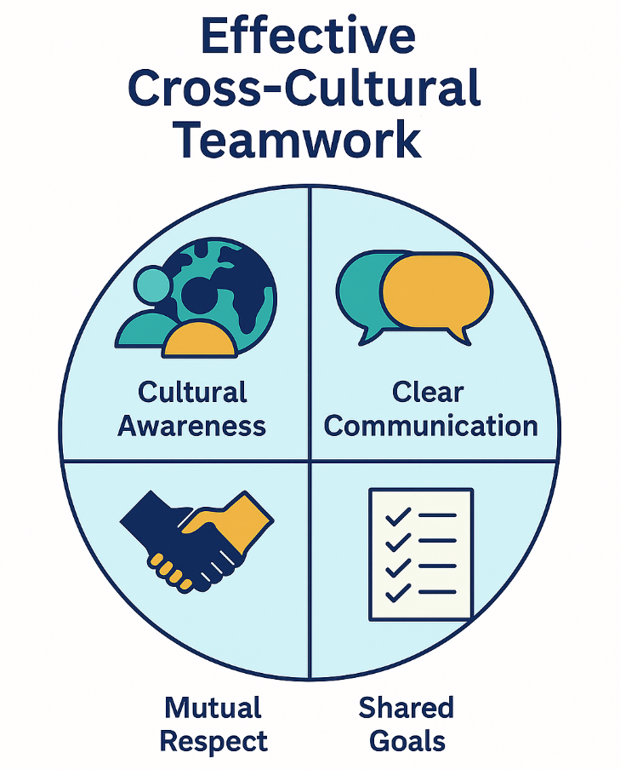
Figure 1 – Effective Cross-Cultural Teamwork
A strength I possess is my ability to empower others and encourage collective decision-making. This approach is especially important in an international context, where diverse perspectives can lead to innovative solutions. However, I sometimes struggle with balancing assertiveness with cooperation. At times, I avoid conflict, which can hinder the decision-making process. To address this, I will focus on developing my assertiveness and leadership skills to engage more effectively in group discussions and drive outcomes (Schuler et al., 1993).

4.4 Leadership
Leadership in an international context demands adaptability and a deep understanding of different cultural norms. I have had opportunities to lead group projects, where I demonstrated strengths in organizing tasks, motivating peers, and aligning everyone toward a common goal. I also value emotional intelligence (EQ) in leadership, understanding that managing diverse teams requires awareness of the emotional needs of team members (Boxall & Purcell, 2016).
A key strength is my ability to delegate tasks effectively and empower team members. However, I sometimes struggle with delegating responsibility fully, as I tend to feel a personal responsibility for the outcome of tasks. This can lead to micromanaging, which undermines team autonomy. To improve, I will work on building trust within my team, ensuring that I delegate more effectively and provide support where needed (Torrington et al., 2017).

4.5 Self-Directed Learning
In the fast-changing global landscape, the ability to learn independently is crucial. I regularly engage in self-directed learning, reading academic papers, attending webinars, and taking online courses on topics relevant to my field. This proactive approach allows me to stay up-to-date with the latest developments in my industry and field of study (Tarique et al., 2015).

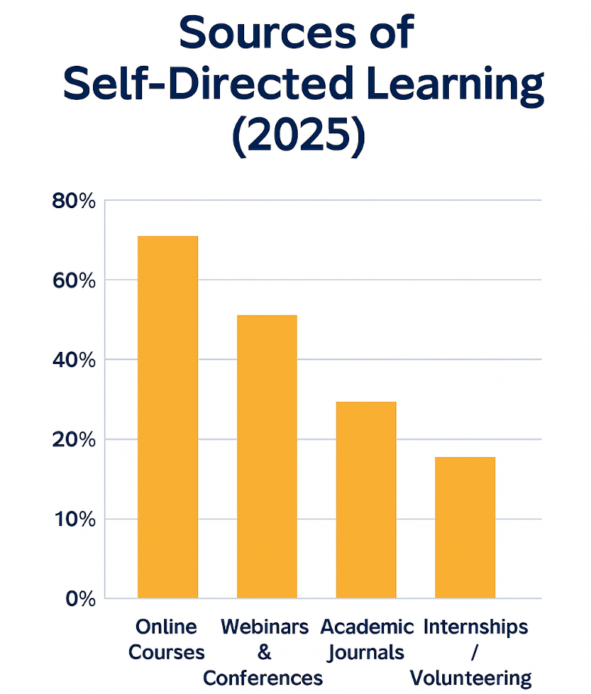
Figure 2 – Sources of Self-Directed Learning (2025)
One strength is my commitment to continuous learning. I regularly seek out new knowledge to stay informed about the latest trends in business, leadership, and technology. However, a weakness I have is my tendency to focus on theory rather than practical application. To address this, I plan to focus more on practical experiences through internships or volunteer work, allowing me to apply my knowledge in real-world settings (Armstrong & Taylor, 2020).

Conclusion
Reflecting on my capabilities in working within an international context, I recognize that my strengths lie in communication, teamwork, and self-directed learning. These strengths have helped me collaborate effectively across cultures and continuously adapt to new developments. However, areas for improvement include leadership and delegation skills. By focusing on enhancing these areas through targeted learning and feedback, I can better leverage my strengths to contribute to global organizations and take full advantage of international opportunities.

Overall Conclusion
In conclusion, this assessment demonstrates that technological, demographic, and geopolitical forces are reshaping global labor markets. Effective HRM and IHRM strategies, underpinned by continuous learning, innovation, and adaptability, are vital for sustaining competitiveness and building resilient workforces in an evolving international environment. As organizations navigate these changes, they must ensure that HR practices align with both local and global needs. The ability to manage cultural diversity, adopt emerging technologies, and foster talent development will be key to overcoming future challenges in HRM and IHRM.

References

Armstrong, M. & Taylor, S. (2023) Armstrong’s Handbook of Human Resource Management Practice. 16th ed. London: Kogan Page. Available at: https://www.koganpage.com/hr-learning-development/armstrong-s-handbook-of-human-resource-management-practice-9781398606630 (Accessed: 15 October 2025).

Boxall, P. & Purcell, J. (2016) Strategy and Human Resource Management. 4th ed. London: Palgrave Macmillan. Available at: https://books.google.com/books/about/Strategy_and_Human_Resource_Management.html?id=oCVHEAAAQBAJ (Accessed: 15 October 2025).

Brewster, C., Sparrow, P. & Vernon, G. (2005) International Human Resource Management. London: CIPD. Available at: https://books.google.com/books/about/International_Human_Resource_Management.html?id=s3WpPyiz3IIC (Accessed: 15 October 2025).

CIPD. (2021) Diversity and Inclusion at Work. Available at: https://www.cipd.co.uk (Accessed: 15 October 2025).

Schuler, R.S., Dowling, P.J. & De Cieri, H. (1993) ‘An integrative framework of strategic international human resource management’, International Journal of Human Resource Management, 4(4), pp. 717–736. Available at: https://doi.org/10.1177/014920639301900209 (Accessed: 15 October 2025).

Tarique, I., Briscoe, D.R. & Schuler, R.S. (2015) International Human Resource Management: Policies and Practices for Multinational Enterprises. 5th ed. New York: Routledge. Available at: https://www.routledge.com/International-Human-Resource-Management-Policies-and-Practices-for-Multinational-Enterprises/Tarique-Briscoe-Schuler/p/book/9781138489509 (Accessed: 15 October 2025).

Torrington, D., Hall, L., Taylor, S. & Atkinson, C. (2017) Human Resource Management. 10th ed. Harlow: Pearson Education.

