ERD
Costumer-Costumer Id, costumer name, costumer address, telephone number
Branch-branch id, branch name, address, staff id *, telephone number
Staff-staff id, branch id*, staff name, address, telephone number
Supplier-supplier id, supplier name, Address, branch Id*
Order-order id,costumer id*, date
Invoice- invoice number, costumer id*, order*
Accounting system- accounting records id by date, branch id*, invoice supplier*,, costumer id*, invoice number*, order Id*
The catering business “The Sandwich R Us” it’s made to have scalabilities in order to manage and open new stores. The account records give the possibility to the system to collect customer details, all invoices and graphics to calculate the quarterly and yearly profits.
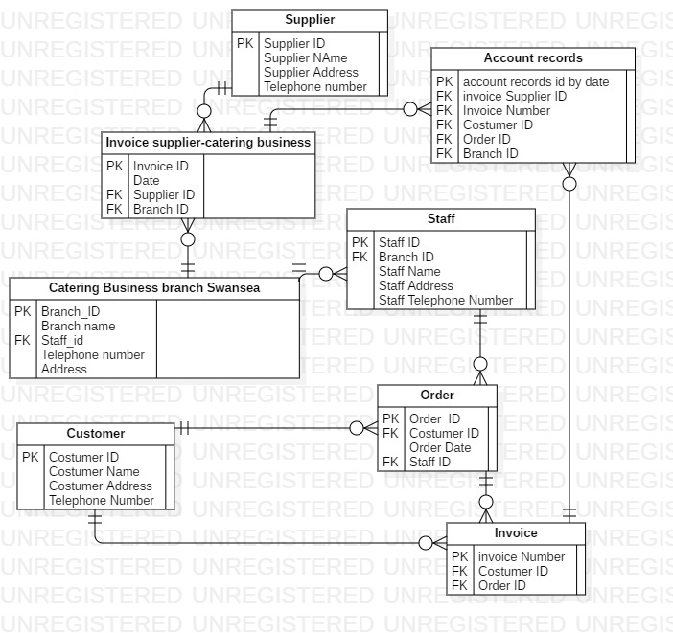

DATA FLOW DIAGRAM LEVEL 1 TO UNDERSTAND BOTH PROCESS BETWEEEN CUSTOMER AND ORDER AND BETWEEN CATERING BUSINESS AND THE SUPPLIES
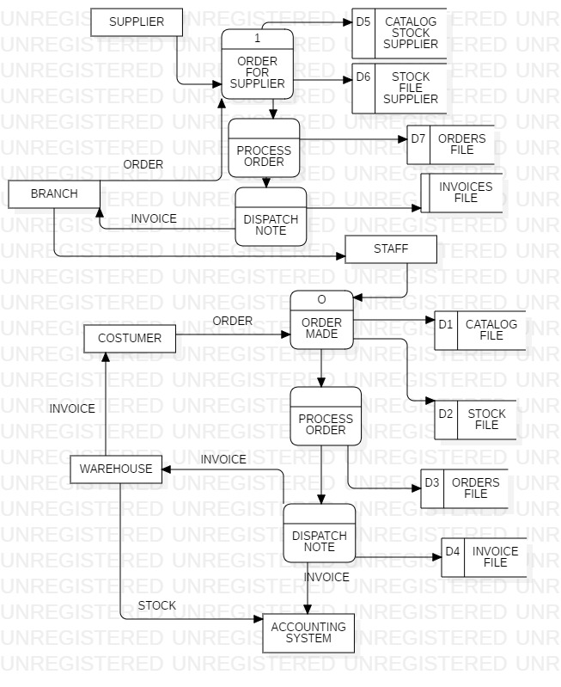

USE CASE DIAGRAM
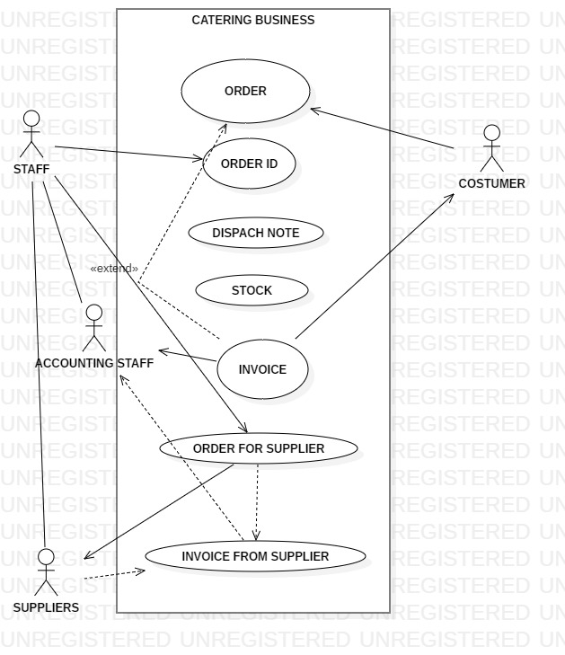

DFD-data flow diagram level 0



