University of Wales Trinity Saint David
Wales Institute of Science & Art



Energy in a Flywheel
Motor Vehicle Engineering Science ACHA4036
Ned Henderson
2506337
March 2026
Contents
1. Introduction 2
2. Experimental Procedure 3
3. Results 4
4. Analysis 5
5. Conclusion 7
6. Evaluation 8
7. Further Work 9
8. References 10

Introduction
The aim of this experiment is to prove the theory governing energy storage in a flywheel, and to determine the total moment of inertia of the flywheel assembly from experimental measurements. A flywheel is a rotating mechanical component used to store rotational kinetic energy, acting as a reservoir that resists changes in rotational speed. In motor vehicle applications, flywheels serve a critical function in smoothing the intermittent power pulses delivered by internal combustion engines, ensuring a more consistent output torque is transmitted to the drivetrain (Salem Press, 2023).
The principle being investigated is the conversion between potential energy (PE) and kinetic energy (KE). A falling mass converts its gravitational potential energy into rotational kinetic energy in the flywheel. By measuring the drop height, the return height, and the time of travel, the angular velocity and acceleration of the flywheel can be calculated, from which the total moment of inertia and stored kinetic energy can be determined.
Flywheels are used extensively in engineering beyond automotive applications. They are found in industrial machinery, grid-scale energy storage systems (Karrari, 2021), and historically in steam engines, where their ability to maintain rotational momentum under varying loads is essential. In modern hybrid and electric vehicles, flywheel energy storage systems (FESS) are being investigated as an alternative to electrochemical batteries for short-duration energy buffering (Olabi et al., 2021). Understanding the fundamental energy relationships in a flywheel is therefore of significant industrial relevance.

Experimental Procedure
The experiment was conducted with two experimenters using the TecQuipment Potential and Kinetic Energy Kit ES9 (TecQuipment Ltd, 2012), mounted on the Work Panel Board. The procedure was carried out following the instructions, starting with the Bearing Block and Flywheel assembly being fixed to the Work Panel, and the Flywheel Brake Thumbscrew unscrewed by at least one turn to allow free rotation of the shaft. The magnetic rule was positioned vertically below the pulley, and the drop height (h1) was set to 280 mm (0.28 m) by aligning the bottom of the mass with the cord extended (Figure 1). Each increase of mass was wound and released, and a stopwatch was used to record the total time (tt) for the mass to fall and return to its highest point. The return height (h2) was also recorded using the steel rule, with the eye kept level with the weight hanger guide. This process was repeated 3 times for each increase in mass.
Figure 1: Apparatus Setup
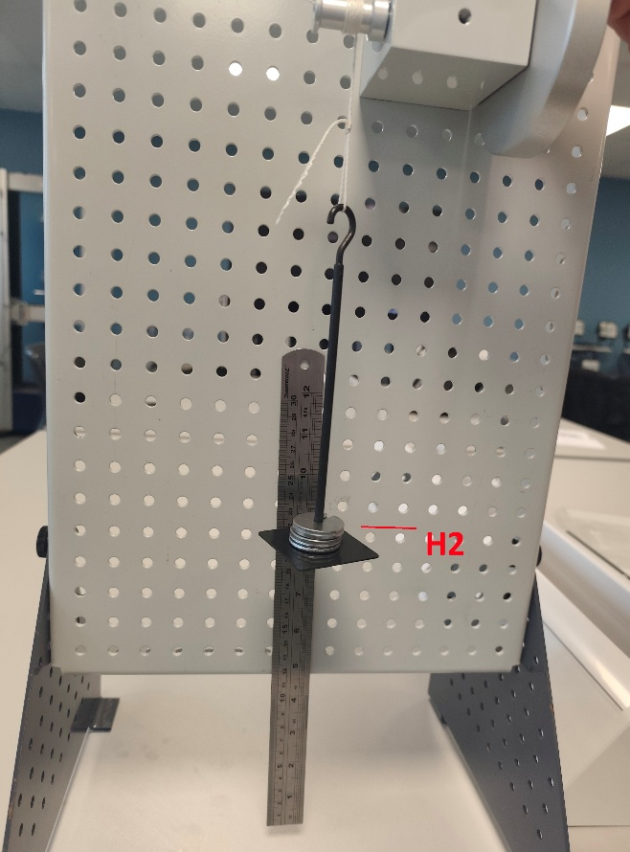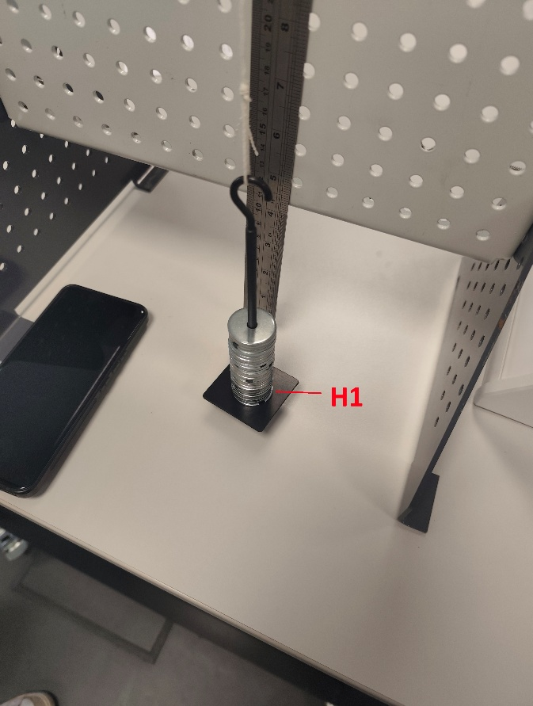
Showing Drop Height and Return height. (Source: Authors' own photograph, 2026)

3. Results
The raw data recorded during the laboratory session are presented in Table 1. These are direct measurements only, prior to any calculation.
Table 1: Raw Data from Experiment
MASS (KG) | TIME 1  (S) | TIME 2 (S) | TIME 3 (S) | HEIGHT 1 (MM) | HEIGHT 2 (MM) | HEIGHT 3 (MM)
0.1 | 3.94 | 4.01 | 4.0 | 250 | 250 | 250
0.2 | 3.33 | 3.4 | 3.4 | 255 | 255 | 255
0.3 | 2.84 | 2.55 | 2.56 | 252 | 251 | 253
0.4 | 2.13 | 2.20 | 2.08 | 245 | 242 | 245
0.5 | 1.9 | 2.14 | 2.0 | 230 | 225 | 231
The drop height of 0.28 m was kept constant throughout all runs.

4. Analysis
All calculations were performed in Microsoft Excel using the formulae from the ES9 Guidance Notes. All collected averages were entered into Microsoft Excel and calculated using the formulae from the ES9 Guidance Notes (TecQuipment, 2012). The nominal data used were: flywheel $I = 3.862 × 10⁻⁴ kg.m²$, shaft and pulley $I = 0.834 × 10⁻⁴ kg.m²$, pulley radius r = 0.0065 m (allowing for cord thickness), pulley circumference c = 0.0408 m, and drop height (h1) = 0.28 m.

Table 2: Formulae Calculations in Excel
Calculated Results (Source: Authors' own data)
The following formulae were applied in sequence.

The falling time (tf) was derived from the total travel time using the height ratio.
$$tf = tt × [h1 / (h1 + h2)]$$

Linear acceleration of the falling mass from kinematics:
$$a = 2h1 / tf²$$

Maximum linear velocity of the mass at the bottom of travel:
$$v = a × tf$$

Angular velocity of the flywheel, converted from linear velocity via pulley circumference:
$$ω = 2πv / c$$

Torque applied to the flywheel shaft:
$$Torque = (mg - ma) × r$$

Angular acceleration:
$$α = a / r$$

From the governing torque equation $τ = Iα$, plotting Torque on the y-axis against α on the x-axis produces a straight line whose gradient equals the total moment of inertia It. From the trendline equation on the Excel scatter chart (see Table 3):
$$It (experimental) = 0.0004 kg.m² (4.0 × 10⁻⁴ kg.m²)$$

The given value from parts data is:
$It = (3.862 + 0.834) × 10⁻⁴ = 4.696 × 10⁻⁴ kg.m²$.

Kinetic energy was then calculated using the experimentally determined moment of inertia:
$$KE = 0.5 × It × ω²$$

As mass increases from 0.1 kg to 0.5 kg, KE rises from 0.336 J to 1.221 J, reflecting the higher angular velocity achieved with greater driving torque. The adjusted PE loss increases from 0.016 J to 0.135 J over the same range, confirming that energy losses grow with rotational speed.

Table 3: Final Graph from Calculations

Graph: Torque vs Angular Acceleration with Linear Trendline (Source: Authors' own, 2026)
•

5. Conclusion
The experiment demonstrated the conversion of gravitational potential energy into rotational kinetic energy and allowed the total moment of inertia to be determined from the gradient of the torque–angular acceleration graph, which produced a broadly linear relationship as predicted by theory (τ = Itα).
The experimentally determined total moment of inertia was It = 4.0 × 10⁻⁴ kg.m², compared to the nominal value of 4.696 × 10⁻⁴ kg.m², a discrepancy of 14.8%. Koken (2017) suggests that in experimental moment of inertia determinations a deviation exceeding 10% is indicative of a procedural issue, and on that basis the result here falls outside what would be considered a clean outcome. Berendsen (2011) notes that errors in derived quantities propagate from every measured input, and in this experiment timing error affects (tf), acceleration, and angular velocity in sequence before reaching the gradient.
For four of the five mass values, energy losses follow the expected trend, return height h2 decreases as driving mass increases. However, the 0.1 kg result is anomalous: h2 = 0.250 m is lower than the 0.2 kg result of 0.255 m, despite the expected trend. This is most likely a measurement error on that specific run, possibly caused by difficulty judging the precise peak of the return travel.
Overall, the experiment confirms the energy principles and the linear torque and inertia relationship, but the results should be treated with caution given the anomaly and difference in results compared to the nominal values.

6. Evaluation
Several sources of error were identified during the experiment, along with the actions taken to minimise their effect. The biggest source of uncertainty was timing, as human reaction time in operating the stopwatch introduces error into every measurement. This effects the calculated values. To mitigate this, each mass was timed at least three times and the results averaged.
When reading h2 from the magnetic rule, the eye must be level with the weight hanger guide as specified in the ES9 Guidance Notes (TecQuipment Ltd, 2012), since any offset produces errors in results taken. Care was taken to position correctly for each reading. The effective pulley radius, which at r = 0.0065 m includes a nominal allowance for cord diameter taken from the kit specification. If the actual cord diameter differed from this value, an error in angular velocity would result, though this was not possible to verify without direct measurement.
Finally, the flywheel brake thumbscrew was confirmed to be fully unscrewed before each run. Had the brake been even partially engaged, travel time would have been artificially reduced and the resulting moment of inertia distorted.

7. Further Work
Given unlimited time and resources, several improvements could be made to increase the rigour of this experiment. One option would be replacing the stopwatch with infrared photogate sensors positioned at the top and bottom of the mass travel path, which would eliminate human reaction time error entirely and allow consistent, repeatable timing data to be logged directly to a computer (Pasco, accessed 2026). A high-speed camera could also have been used to capture the motion of the mass and flywheel in detail, allowing velocity and acceleration to be extracted frame by frame, though it is worth noting that the volume of data generated would be considerably larger and would require dedicated software to process effectively. Using a calibrated scale to verify the actual mass of each weight, rather than relying on nominal values, would reduce uncertainty in the driving force calculation at relatively little cost or complexity. Finally, repeating the experiment across multiple values of h1 rather than a single fixed drop height would verify that the results are consistent across a range and not specific to the 280 mm height used here, giving confidence in the conclusions.

8. References
Berendsen, H., 2011. A Student’s Guide to Data and Error Analysis.
Karrari, S., 2021. Integration of Flywheel Energy Storage Systems in Low Voltage Distribution Grids.
Koken, M., 2017. The Experimental Determination of the Moment of Inertia of a Model Airplane. Williams Honors Coll. Honors Res. Proj.
Olabi, A.G., Wilberforce, T., Abdelkareem, M.A., Ramadan, M., 2021. Critical Review of Flywheel Energy Storage System. Energies 14, 2159. https://doi.org/10.3390/en14082159
Pasco, S., accessed 2026. Photogates, Fences, and Timers [WWW Document]. PASCO Sci. URL https://www.pasco.com/products/guides/photogates (accessed 3.25.26).
Salem Press, 2023. Principles of Mechanics, 1st ed. ed. Salem Press, Hackensack, New Jersey.
TecQuipment Ltd, 2012. POTENTIAL AND KINETIC ENERGY KIT ES9.

