Learner – Mrs. Sian Louise White
Number – 86455928
Unit – 5CO02
Assessment ID – CIPD_5CO02_23_01
Total word count (Excluding reference criteria titles) Section 1 – 2590 words Section 2 –
1608 1498 words Total words 4198 4088

Section One
Evidence Based Practice Report
By Sian White
29th November 2023
(AC 1.1)
Evidence-based practice is, quite simply, taking an evidence-based approach to your work, using the right data and the right information in a structured way, to inform the decisions you make and the work that you do, because it leads to better outcomes. CIPD (2023)
One commonly used approach is group discussions. This approach can be particularly effective when seeking to identify gaps in skills across the business. One effective method involves conducting group discussions among employees. By involving employees in this process, you can tap into their knowledge, experiences, and insights. This approach allows for a more inclusive and comprehensive understanding of the skills gaps within your organisation.
To gather evidence through group discussions, you can ask employees to provide recommendations regarding the need for up-skilling. This can provide valuable insights into the areas employees perceive as lacking in their own skill set or the skills of their colleagues. By considering the recommendations put forward by employees, you can proactively develop and implement effective training and development programs.
One scenario where staff surveys can be particularly valuable is when there is a decline in well-being, highlighted due to an increase in sickness absence. This may indicate an underlying issue that requires further investigation. By conducting a staff survey, you can gain a deeper understanding of potential causes and identify potential solutions.
For example, if the survey results indicate that a recent change in the shift pattern has resulted in increased call volumes, leading to pressure from managers to agree to overtime, you can use the evidence gathered from the surveys to determine if this change was effective or if it needs to be reversed.
A traditional approach to decision making is personal experience, professional experience, and traditions. These approaches may lead to misguided and biased decisions as they are based on opinions. Whereas evidence-based practice emphasises the importance of utilising information from various sources to make more informed decisions. By conducting critical evaluations of the quality and relevance of the evidence used, you can ensure that the decisions are made from reliable sources. This evaluation process involves considering factors such as study design, sample size, data collection methods, and potential biases. By adhering to this approach, you can make evidence-based decisions that promote effective management practices and positive outcomes. CIPD (2023)
Rob Briner (2023) states by adhering to the principles, you can avoid fads and instead identify important business-relevant issues and implement only those practices which are most likely to help. By embracing these principles, you can make evidence-based decisions that drive positive outcomes for your employees and the overall success of your organisation and ensure your decision-making is grounded in reliable evidence from multiple sources. (Armstrong and Taylor 2023)

(AC 1.2)
An analysis tool that you could use to recognise and diagnose issues, opportunities, and challenges is SWOT analysis. It could help you identify your internal strengths and weaknesses, as well as external opportunities and threats. It could also nudge your organisation to look beyond the present to anticipate potential future scenarios.

You could use swot analysis if two departments were merging, by examining the strengths and weaknesses of each department, you could evaluate their compatibility to decide whether it would be a productive partnership. Additionally, conducting the internal analysis of the merger could help identify opportunities and threats, helping to ensure successful integration.

Conducting a SWOT analysis enables organisations to gain a comprehensive understanding of their current position, identify areas for improvement, and make informed decisions about future strategies, resources, capabilities, and potential risks, enabling you to adapt and grow in a rapidly changing business environment. CIPD (2023)

See below example of a swot analysis template

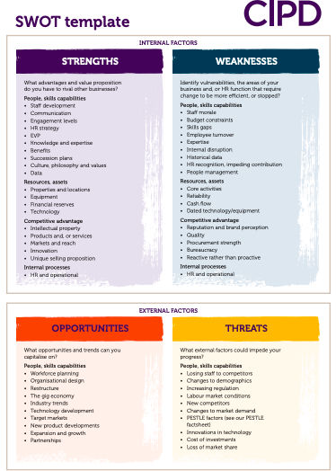

Source: CIPD (2023)

An appropriate analysis method that complements SWOT is PESTLE analysis, a strategic management tool that helps you understand and evaluate your external macro-environmental factors that can impact your operations. It can be used in many scenarios to guide professionals and senior managers in strategic decision-making. (CIPD 2023)

One example of when to use pestle analysis is when a new product or service is being developed. By conducting a thorough pestle analysis, you can gain insights into the external factors that may impact its success as it will evaluate the external environment in which your new product is going to exist. All the elements of the analysis are potentially impactful external factors which could affect the feasibility of an idea. By combining swot analysis with pestle analysis, you can gain a comprehensive understanding of both internal and external factors and influences. Indeed (2023)

See a below example of a pestle analysis template

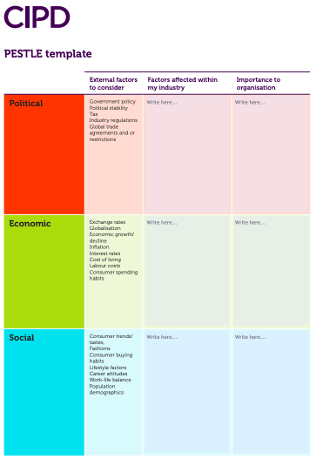

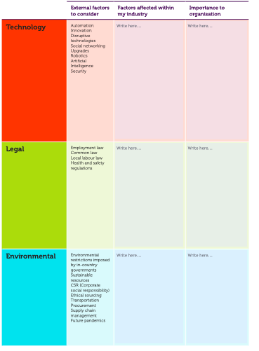

Source: CIPD (2023)

(AC 1.3)

Critical thinking is an important skill for professionals to have. It is the ability to think clearly and rationally. You need to be able to engage with the ideas and perspectives of others, even if you disagree with them, it is about reviewing all the evidence before forming a biased opinion and raising questions to identify any gaps or inconsistencies before jumping to any conclusions. Howlett, W (2019)
When applying critical thinking to your work checking source validity is a critical thinking principle that plays a crucial role in objective rationale debate. It involves assessing the credibility and reliability of the sources of information used in arguments or decision-making processes. As a people professional, you need to understand the importance of checking source validity to ensure accuracy and effectiveness one of the simplest methods is to conduct thorough research. This involves searching for reputable sources, such as CIPD factsheets, government policies, or industry publications, that provide reliable and evidence-based information. By examining these sources, you can determine the credibility and relevance of the information they provide.
Critical thinking does not mean disapproval or being negative, critical thinking is about weighing up evidence to make a judgment, solve a problem, or reach a decision with the aim to come to well-reasoned conclusions, solutions and to test them against relevant criteria and standards. (Armstrong and Taylor 2023)

(AC 1.4)

The "Six Thinking Hats"

This technique developed by Edward de Bono aims to enable creative thinking and problem-solving by encouraging individuals or groups to explore an issue from multiple perspectives. By adopting different thinking modes or "hats," individuals can step outside their usual patterns of thinking to approach the issue from various angles. Mindtools (2023)

To use the six thinking hats method, participants must focus on one hat at a time. Each hat represents a specific perspective and approach to thinking. By wearing the hat, individuals can direct their thinking towards that perspective. For instance, if the participant chooses to wear the white hat, they should focus on gathering facts and information. On the other hand, if the participant selects to wear the black hat, they should explore and identify potential problems (LinkedIn 2023)

See below example of Edward De Bonos six thinking hats

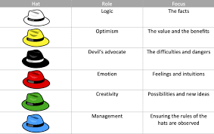

Source: LinkedIn 2023

Situational decision-making

This is a fundamental aspect of effective decision-making in the workplace. It involves making choices and considering specific situations or contexts, rather than adopting a "one-size-fits-all" approach. By considering the unique characteristics of each situation, decision-makers can tailor their choices to align with professional principles and values. One of the key aspects of situational decision-making is identifying different options and weighing the benefits and risks associated with each alternative. Decision-makers must consider the short-term and long-term implications of their decisions, as well as the impact on colleagues and the organisation as a whole. CIPD (2023)

The Eight Steps for Making Better Decisions in the Workplace
1. Define the Decision
Before deciding, it is important to clearly define the objective or problem at hand. Clearly articulating the issue at hand helps focus the mind and ensures that the necessary information is available.
2. Gather Information
Gathering relevant information is crucial for making informed decisions. Conduct research, consult with experts, and gather data from various sources. By gathering a comprehensive picture of the situation, you can identify potential solutions and evaluate their feasibility.
3. Brainstorm and Evaluate Alternatives
Once you have gathered information, the next step is to brainstorm and evaluate potential alternatives. Consider different possibilities, weigh the pros and cons of each option, and evaluate their feasibility. This stage allows for creativity and encourages an open mind.
4. Evaluate Risk and Impact
Every decision will carry risks and potential consequences. It is crucial to evaluate the risks and impacts associated with each alternative. Consider the potential negative consequences, both positive and negative, and weigh them against the desired outcomes.
5. Seek Guidance and Feedback
Seeking guidance and feedback from colleagues, experts, or even team members can be beneficial. They may offer valuable insights, different perspectives, or additional information that can assist you in the decision-making process.
6. Make a Decision
After carefully considering your alternatives, evaluating risks, and seeking guidance, it is time to decide. Select the alternative you believe will yield the best results and decide.
7. Implement and Monitor
Once you have made your decision, it is important to implement it and monitor its progress. Regularly assess the effectiveness of your decision, adjust as needed, and learn from any mistakes or successes.
8. Reflect and Learn

After deciding, take the time to reflect and learn from the experience. Analyse the outcome, identify what worked well and what could be improved, and apply these lessons to future decisions. Indeed (2023)

(AC 1.5)

In today's complex business world, ethical decision-making is essential. You may face ethical dilemmas daily, and it is crucial for you to have a clear framework for guiding moral decision-making. Three prominent ethical perspectives that offer valuable insights in this regard are consequentialism, deontology, and utilitarianism. By understanding these perspectives, employers can navigate ethical challenges more effectively and make informed decisions that align with the values and expectations of the broader community (Armstrong and Taylor 2023)

One example of how you can apply ethical decision making is individual performance.
The consequentialist perspective would consider consequences of individual performance, such as how it impacts team dynamics, productivity, and customer satisfaction. The focus is on achieving the greatest overall benefit or minimising harm. BBC (2014)

The utilitarian perspective would consider the happiness and well-being of the employees when setting individuals performance goals and expectations. By prioritising the success and satisfaction of individuals, you will create a positive work environment that promotes employee motivation and productivity. BBC (2014)

The deontology perspective would focus on the rightness and wrongness of actions, rather than the consequences of those actions. In the context of performance, the deontology approach emphasise the importance of adhering to moral principles and values, rather than solely focusing on achieving goals or outcomes. BBC (2014)

Understanding various ethical perspectives will guide you to moral decision-making. You will make more informed decisions that align with the values and expectations of the broader community. This holistic approach to ethical decision-making promotes a culture of good ethical practices in the workplace and fosters a harmonious and productive work environment. professionals and senior leaders should agree on the extent to which ethics are the core expectations of employees and any organisation’s representatives, and what consequences might arise if those ethics are not upheld. CIPD (2023)

CIPD (2015) Research report stated There will never be a ‘golden rule’ that fits all ethical decisions: it’s always going to require effort, imagination and judgement, and the outcome is often going to be inconclusive. If you use the eight lenses identified in this report, you will aid ethical decision making by thinking about work using philosophical ethics. None of lenses represent the ‘right’ or ‘wrong’ ways of making decisions in the workplace but offer different perspectives on work dilemmas.

The lenses are:

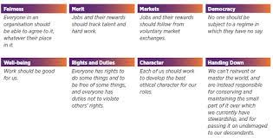
Source CIPD (2015)

(AC 3.1)

You can use various methods to measure performance, including financial measures and non-financial ones. These measures provide valuable insights into your organisation's success and help stakeholders make informed decisions.

Financial performance measures assess your financial health and viability. These measures focus on your ability to generate profit, manage costs, and allocate resources efficiently. One commonly used financial measure is return on investment (ROI). When it comes to return on investment (ROI), retention analytics can have a significant impact on the bottom line. By leveraging the power of data analytics, you can gain valuable insights into the full costing and employee churn, enabling informed decision-making and driving improvement in workforce management. People Management (2023)

Non-financial performance can be measured through key performance indicators (KPIs) or workforce data analytics. Through these measures you can highlight how employees are engaging in their work tasks. Use a collaborative approach to create key performance indicators (KPIs) that stretch employees and are aligned to the overarching business strategy. Involving your employees in the process can result in happier employees and immediately impact the bottom line. People Management (2023)

Both financial ratios and KPIs play a crucial role in measuring the performance of organisations. While financial ratios provide insights into an organisation's financial health, KPIs focus on strategic performance measures that drive the organisation's success. To measure both, you could use the Balance Scorecard, which is a powerful tool that helps you align your strategic objectives with key performance indicators. By incorporating financial, customer, internal business processes, and learning and growth metrics, allowing you to gain a comprehensive view of your performance and to make data-driven decisions. Mindtools (2023)

According to Kaplan and Norton, (2005) "What you measure is what you get." In other words, companies that focus solely on financial output risk restricting themselves to a narrow view of their performance. The BSC provides a balanced approach to performance management, ensuring you address all aspects of your business.

The Balanced Scorecard: Four Key Measures That Drive Performance

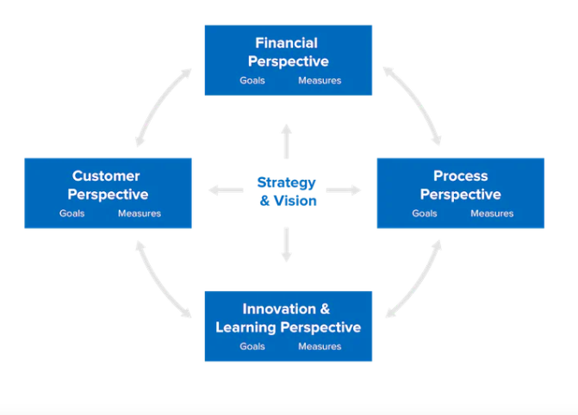

Source: Mindtools

(AC 3.2)

In today's competitive business landscape, organisations recognise the critical role that effective people practices play in driving success. One of the primary ways in which people practice add value is by fostering employee engagement. Engaged employees are more committed, motivated, and aligned with your goals contribute to a positive culture. By implementing practices such as employee recognition programs, open communication channels, diversity and inclusion initiatives, and work-life balance measures, you can create an environment where employees feel valued and motivated to contribute their best.
Moreover, people practice can add value through their impact on employee development. By investing in training and development programs, providing opportunities for career growth, and providing clear performance expectations, you can help employees develop their skills and achieve their potential. To be effective, it needs to align with strategic business objectives. Strategic talent management has several benefits: it builds a high-performance workplace; it fosters a learning climate; it adds value to the employer brand, and it improves diversity. CIPD (2023)
Employee surveys are a valuable tool for you to gather insights into employee perceptions, attitudes, and engagement levels. By conducting surveys, you can gain insights into the effectiveness of your people practices and identify areas for improvement. Employee surveys can cover a wide range of topics, including job satisfaction, work-life balance, leadership effectiveness, and diversity and inclusion.
Additionally, the utilisation of people analytics and Key Performance Indicators (KPIs) has gained prominence in evaluating the impact of people practices (CIPD, 2023). By measuring turnover rates, employee engagement scores, productivity levels, and customer satisfaction scores, you can make evidence-based decisions and identify trends for continuous improvement.
As the CIPD 2023 wisely states, "what gets measured gets attention," emphasising the importance of aligning metrics with people practices. By implementing effective people practices, you will not only enhance individual performance but also foster a positive work environment that can positively impact your overall.

Section two

Quantitative and qualitative analysis review

Data analysis is a crucial step in conducting research. It involves the process of examining the data collected and drawing meaningful conclusions from it. You can do this using quantitative and/or qualitative data.
Qualitative analysis is more concerned with understanding the underlying meanings and patterns within the data, what? why? how? while quantitative analysis involves testing theory and making generalisations based on numerical data. Both techniques have their own strengths and weaknesses and are used in various fields of research. By understanding the key concepts and procedures involved in qualitative data analysis and quantitative data analysis, you can make informed decisions on how to best analyse the data to extract valuable insights. CIPD (2022)

Below is an analysis of the recent gender, salary, and disability report.

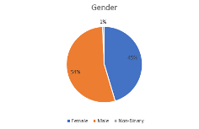

The total number of employs is 260, males constitute the largest group in the organisation comprising 54% whilst females make up 45% which indicates a slight gender imbalance. Non-binary individuals represent an exceedingly small portion at 1%. The presence of non-binary individuals suggests some diversity in gender identities within.

- To gain deeper insights, you might want to explore factors such as age, Job role, or departments.

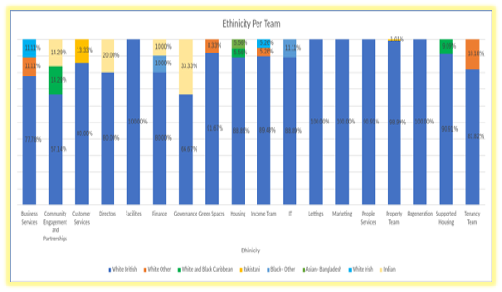

Count of Team | Disability status
Team | Disabled | Not disabled | Grand Total
Business Services | 0.00% | 3.46% | 3.46%
Community Engagement and Partnerships | 0.38% | 2.31% | 2.69%
Customer Services | 1.15% | 4.62% | 5.77%
Directors | 0.00% | 1.92% | 1.92%
Facilities | 0.00% | 0.77% | 0.77%
Finance | 0.77% | 3.08% | 3.85%
Governance | 0.00% | 1.15% | 1.15%
Green Spaces | 0.38% | 4.23% | 4.62%
Housing | 0.77% | 6.15% | 6.92%
Income Team | 0.38% | 6.92% | 7.31%
IT | 0.77% | 2.69% | 3.46%
Lettings | 0.38% | 3.46% | 3.85%
Marketing | 0.00% | 1.54% | 1.54%
People Services | 0.77% | 3.46% | 4.23%
Property Team | 1.92% | 36.15% | 38.08%
Regeneration | 0.00% | 1.92% | 1.92%
Supported Housing | 0.00% | 4.23% | 4.23%
Tenancy Team | 0.38% | 3.85% | 4.23%
Grand Total | 8.08% | 91.92% | 100.00%

Out of the 18 teams, seven teams do not have any employees with disabilities, while eleven teams employ individuals with varying disabilities the total % of disabled employees is 8.08%. Among the teams with employees with disabilities, the IT team employs the highest number of individuals with a disability, accounting for 22% of the total workforce. The Property team, on the other hand, employs the fewest disabled individuals, representing 5% of the employees.
Of the 18 teams, 4 teams are exclusively comprised of white British employees. These teams represent 22% of the total workforce. The remaining 14 teams consist of a diverse mix of ethnicities, reflecting the organisation's commitment to inclusivity.
CIPD (2022) Points to every employee needing to be aware of their part in creating inclusive work environments. Employers must do this by establishing clear guidelines for inclusionary behaviour, treating all coworkers with respect and decency, and giving staff members the authority to confront discriminatory actions.By implementing these recommendations, your organisation can build on its current commitment to diversity and inclusion, creating a workplace that is truly inclusive and supportive of all employees.

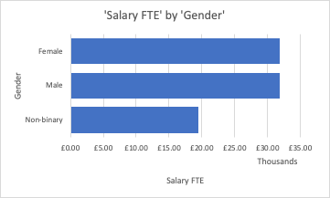

Average of Salary FTE
£31,757.46

The salary FTE by gender compared to the average salary FTE is of a similar amount however, the salary average for non-binary is significantly lower. This could highlight unequal pay between genders, specifically when comparing the earnings of men and women who perform the same job or have similar qualifications.

The gender pay gap is a complex issue that affects individuals of all genders. According to the CIPD (2023) its the result of economic, cultural, sociological, and educational issues. Some contend that they also represent the results of individual choice, but it is still true that women have fewer options than men do when it comes to choosing a career. For example, while choosing to pursue paid work may be a personal decision, the results of that decision are heavily impacted by factors outside of the person's control, like the cost and accessibility of childcare.

Conducting a thorough analysis of the gender pay gap will help to identify any disparities in compensation, implementing strategies to address unequal pay, including adjusting salary structures, promoting transparency in compensation practices, and providing equal opportunities for career enhancement will foster gender diversity.

Recognising and addressing the gender pay gap for non-binary individuals is crucial for achieving pay equity and ensuring equal opportunities for all. By implementing strategies that promote education, advocacy, and policy changes, we can create more inclusive workplaces for all individuals, regardless of their gender identity.

The comprehensive overview of gender distribution, along with disability and ethnicity data, paints a detailed picture of the organisation's workforce. Here are some further observations and recommendation.

Targeted initiatives such as mentorship programs, leadership development opportunities and policies promoting work life balance for all genders should be implemented, if your managers are not sufficiently trained the organisation runs the risk of discrimination, or even an employment tribunal which will come at a much higher cost to the business than the outlay of the training courses,

CIPD (2019) Points to regular reviews of HR practices being essential to ensure inclusive of all genders identities, including non-binary individuals. Non -binary representation can be enhanced by updating polices, providing gender-neutral facilities, and offering tailored diversity training. Disability inclusion can be promoted through awareness programs and active recruitment of individuals with disabilities, along with accessibility training. Celebrating ethnic diversity and implementing targeted recruitment strategies are crucial steps in further increasing representation across teams in alignments with organisational diversity goals.

By implementing these recommendations, your organisation can build on its current commitment to diversity and inclusion, creating a workplace that is truly inclusive and supportive of all employees

Gender Diversity
- Implement targeted initiatives to address the slight gender imbalance. This could include mentorship programs, leadership development opportunities, and policies that support work-life balance for all genders.
- Regularly review and update HR practices to ensure they are inclusive of all gender identities, including non-binary individuals.

Non-Binary Representation
- Ensure that policies and practices are inclusive of non-binary individuals. This includes updating HR forms, providing gender-neutral facilities, and offering diversity and inclusion training that specifically addresses the needs of non-binary employees.

Disability Inclusion
- Develop and implement awareness programs to educate employees about the benefits of disability inclusion and to remove potential biases.
- Actively recruit individuals with disabilities for the teams currently lacking representation. Implement accessibility training to ensure the workplace accommodates the needs of all employees.

Ethnic Diversity
- Continue to celebrate and promote the diversity of ethnicity across teams.
- Implement targeted recruitment strategies to further increase diversity in teams where representation is not reflected in the overall organisational diversity.

Intersectionality
- Consider how different aspects of diversity intersect and impact employees. Develop strategies that address the unique experiences of individuals who may belong to multiple underrepresented groups.

Employee Resource Groups (ERGs)
- Establish or enhance ERGs that focus on gender, disability, and ethnicity. These groups provide a supportive community, promote awareness, and offer insights to the organisation.

Metrics and Accountability
- Establish clear metrics and goals for diversity and inclusion. Regularly track and report progress. Hold leadership accountable for meeting these goals to demonstrate a commitment to fostering an inclusive workplace.

Communication
- Communicate regularly with employees about diversity and inclusion efforts. Highlight successes, share stories of diverse employees, and reinforce the organisation's commitment to creating an inclusive culture.

Training and Development
- Implement training programs for all employees, focusing on diversity, equity, and inclusion. Include modules on unconscious bias, cultural competence, and creating an inclusive work environment.

Continuous Feedback
- Create channels for employees to provide feedback on diversity and inclusion initiatives. Use this feedback to refine and improve strategies over time.

Leadership Development
- Ensure diversity is reflected in leadership roles. Provide training for leaders on fostering an inclusive culture, and actively support the development and advancement of diverse talent into leadership positions.

Table 2. | Feedback scores from a recent employee survey on hybrid working practices.
 |  | 3 | 4 | 5
The ratings shown represent statements on a scale of 1-5 where:
1 = fully agree, 2 = agree, 3 = not sure, 4 = disagree, 5 = strongly disagree
Feedback from 300 employees
I enjoy working for home on some days of the week |  | 19 | 94 | 18
Hybrid working practices support my work-life balance and well-being. |  | 11 | 34 | 8
I miss engaging with my colleagues in the workplace |  | 30 | 155 | 94
I feel fully supported when working at work |  | 18 | 138 | 102
I find working remotely a challenge |  | 101 | 53 | 73
I find it difficult to separate work from my personal life when working from home |  | 23 | 70 | 14
Hybrid working practices make me more productive |  | 5 | 82 | 65
Working from home does not affect cross functional communication and collaboration with my team |  | 5 | 78 | 101
Since hybrid working has been in place, I feel more connected to our company culture. |  | 3 | 39 | 72
Working from home allows me to meet my targets |  | 1 | 57 | 142
I can easily access resources at home |  | 6 | 35 | 112
Working from home removes conflict |  | 7 | 27 | 89
I feel less stressed when away from the workplace |  | 0 | 5 | 250
I get the same amount of recognition about my work when working from home |  | 2 | 71 | 88

Firstly it is noticeable, that there’s a mix of responses across the spectrum for each statement indicating a diverse range of experiences and opinions among the surveyed employees. One key theme in the feedback is the ambivalence towards remote and hybrid work. While a significant proportion of employees agree or strongly agree that they enjoy working form home on some days and that hybrid practices support their work life balance and well being. For example a portion of respondents indicate missing engaging with colleagues in the workplace, feeling less connected to company culture since the adoption of hybrid practices, and struggling with separating work form personal life while working remotely

Encourage the development of team relationships. Schedule social talks. This improves rapport and facilitates communication between individuals who might not interact frequently. It lessens emotions of loneliness as well. When face-to-face interactions occur, emphasise connections and relationships. CIPD (2023) Points to improving the ability to listen will help, when two people are not in the same room, it can be difficult to read each other's emotions and thoughts from body language or tone alone, especially during more intense conversations. Focus on the silences and probe for further information to help you understand.
To address the multifaceted challenges of remote work, the organisation could implement a comprehensive strategy focused on providing additional training and resources to help employees overcome work challenges, while also establishing clear communication channels for prompt support. Managers could prioritise work life balance by promoting healthy practices and offering flexible scheduling options. Furthermore you could foster employee engagement and team building through regular virtual activities and occasional in person meetings and activities. To ensure ongoing support conduct regular check ins and performance reviews and provide better provisions for managers to support their teams.
Implementing these recommendations can contribute to a more positive and effective hybrid working environment, addressing specific concerns highlighted in the survey and fostering a culture of collaboration, well-being, and productivity

Addressing Challenges of Remote Work
- Provide additional training and resources to help employees overcome challenges associated with remote work.
- Establish clear communication channels for remote employees to seek support and address issues promptly.

Enhancing Work-Life Balance
- Encourage managers to promote and model healthy work-life balance practices.
- Implement flexible scheduling options to accommodate individual preferences.

Colleague Engagement and Team Building
- Organise regular virtual team-building activities and events to foster a sense of camaraderie.
- Consider occasional in-person meetings or retreats to facilitate face-to-face interactions.

Support at the Workplace
- Conduct regular check-ins and performance reviews to ensure employees feel supported and valued.
- Provide additional resources or training for managers to better support their teams.

Communication and Collaboration
- Invest in collaborative tools and platforms to facilitate seamless communication among remote and in-office team members.
- Establish clear guidelines for effective virtual collaboration and ensure that all team members are familiar with these tools.

Promoting Productivity
- Offer resources and training on time management and productivity for remote work.
- Encourage employees to establish dedicated work spaces at home to enhance focus and concentration.

Company Culture and Connection
- Foster a strong sense of company culture through virtual events, town hall meetings, and regular updates on company achievements.
- Seek employee input on how to maintain and strengthen the company culture in a hybrid work environment.

Recognition and Feedback
- Establish a formal recognition program for remote work accomplishments.
- Encourage regular feedback sessions between employees and managers to acknowledge achievements and discuss areas for improvement.

Stress Management
- Provide resources and initiatives for stress management, including wellness programs and mental health support.
- Encourage breaks and time away from screens to prevent burnout.

Clear Communication on Expectations
- Clearly communicate expectations regarding work hours, availability, and deliverable for remote and in-office employees.
- Regularly revisit and adjust communication protocols based on feedback.

Conflict Resolution
- Implement effective conflict resolution strategies and training for both remote and in-office teams.
- Establish clear channels for addressing conflicts and ensure a supportive environment for open communication.

Monitoring and Adjusting Policies
- Regularly review and update hybrid work policies based on ongoing feedback and evolving needs.
Be flexible and willing to adjust policies as the organization learns more about

Reference List

Armstrong, M. and Taylor, S. (2023) Armstrong’s Handbook of Human Resource Management Practice 16th ed. London Kogan

Briner, R. How to Avoid Fads in HR Available at: https://www.personneltoday.com/hr/hr-fads-rob-briner/ (Accessed on 21st October 2023)

The CIPD 2023 Evidence-based HR: Make better decisions and step up your influence. Available at: https://www.cipd.org/uk/knowledge/guides/evidence-based-profession/#what-evidence -should-we-use. (Accessed 6th November 2023)

The CIPD 2023 Evidence based practice for effective decision making. Available at: https://www.cipd.org/uk/knowledge/factsheets/evidence-based-practice-factsheet/ (Accessed on 11th November 2023)

The CIPD 2023 Swot Analysis Available at: https://www.cipd.org/uk/knowledge/factsheets/swot-analysisp-factsheet. (Accessed 12th November 2023)

The CIPD 2023 The People Profession Map Available at: https://www.cipd.org/uk/the-people-profession/the-profession-map/explore-the-profession-map/core-knowledge/evidence-based-practice/#:~:text=Evidencebased%20practice%20is%2C%20quite,it%20leads%20to%20better%20outcomes.(Accessed 14th November 2023)

The CIPD 2023 Pestle Analysis Available At: https://www.cipd.org/uk/knowledge/factsheets/pestle-analysis-factsheet (Accessed 20th November 2023)

The CIPD (2023) Situational decision making Available at: https://www.cipd.org/uk/the-people-profession/the-profession-map/explore-the-profession-map/core-behaviours/situational-decision-making/ (Accessed November 9th, 2023)

The CIPD (2022) Ethical practice and the role of people professionals Available at: https://www.cipd.org/uk/knowledge/factsheets/ethics-role-hr-factsheet/ (Accessed 11th November 2023)

The CIPD Employee Engagement and motivation Available at: https://www.cipd.org/uk/knowledge/factsheets/engagement-factsheet/ (Accessed on 23rd November 2023

The CIPD 2018 Creating and capturing value at work: who benefits? Available at: https://www.cipd.org/globalassets/media/knowledge/knowledge-hub/reports/creating-and-capturing-value-at-work_2018-who-benefits-part-2_tcm18-37078.pdf (Accessed November 21st, 2023)

The CIPD (2022) People Analytics Available at: https://www.cipd.org/uk/knowledge/factsheets/analytics-factsheet/#:~:text=Quantitative%20data%20is%20quantifiable%20and,by%20someone%20and%20is%20subjective. (Accessed on 30th December 2023)

The CIPD 2023 Talent Management Available at: https://www.cipd.org/uk/knowledge/factsheets/talent-factsheet/ (Accessed on 28th November 2023)

The CIPD (2015) Ethical decision-making: Eight perspectives on workplace dilemmas Available at: https://www.cipd.org/globalassets/media/comms/the-people-profession/profession-map-pdfs/ethical-decision-making-2015-eight-perspectives-on-workplace-dilemmas_tcm29-9564.pdf (Accessed 10th November 2023)

Ethics Guide (2014) Introduction to Ethics Available at: https://www.bbc.co.uk/ethics/introduction/duty_1.shtml (Accessed 20th November 2023)

Ethics Guide (2014) Introduction to Ethics Available at: https://www.bbc.co.uk/ethics/introduction/consequentialism_1.shtml (Accessed 20th November 2023)

Howlett, W. and Coburn, T (2019) Critical Thinking. [Podcast}, CIPD. Available at: https://www.cipd.org/uk/knowledge/podcasts/critical-thinking/ (Accessed: 19th November 2023)

Indeed 2023 A guide to PESTLE and SWOT analysis (with example)
https://uk.indeed.com/career-advice/career-development/pestle-and-swot-analysis (Accessed 20th November 2023)

Mindtools 2023 Six thinking hats Available at: https://www.mindtools.com/ajlpp1e/six-thinking-hats (Accessed 10th November 2023)

Indeed (2023) 8 steps for an effective decision-making process (With tips) Available at: https://uk.indeed.com/career-advice/career-development/decision-making-process (Accessed 10th November 2023)

Kaplan, R.S. and Norton, D.P. (2005). The Balanced Scorecard: Measures That Drive Performance Available at https://hbr.org/2005/07/the-balanced-scorecard-measures-that-drive-performance (Accessed 20th November 2023)

LinkedIn (2023) The Six Thinking Hats Method: A Powerful Tool for Improved Decision Making Available at: https://www.linkedin.com/pulse/six-thinking-hats-method-powerful-tool-improved-decision-palleti (Accessed 10th November 2023)

No Author (2023) The Balance Scorecard Available at: https://www.oxfordreference.com/display/10.1093/oi/authority.20110803095442300 (Accessed on 27th October 2023)

PM People Management (2023) From insight to impact : three workforce analytics that drive unprecedented ROI https://www.peoplemanagement.co.uk/article/1840210/insight-impact-three-workforce-analytics-drive-unprecedented-roi (Accessed 26th October 2023)

CIPD (2023) Gender Pay Gap Reporting Available at: https://www.cipd.org/uk/knowledge/guides/gender-pay-gap-reporting-guide/ (Accessed on February 10th 2024)

CIPD (2022) Five actions you can take to foster inclusion Available at: https://www.cipd.org/uk/knowledge/guides/five-actions-fostering-inclusion/ Accessed on 10th February 2024

CIPD (2019) Diversity management that works Available at: https://www.cipd.org/uk/knowledge/reports/diversity-management-recommendations/?_gl=1*1gnleau*_ga*MzIwMTkwNTMyLjE3MDczOTE2NzU.*_ga_D9HN5GYHYY*MTcwNzc2NjAwNC40LjAuMTcwNzc2NjAwNC42MC4wLjA. (Accessed on 11th February 2024)

CIPD (2023) Getting the most from remote working Available at: https://www.cipd.org/uk/knowledge/guides/remote-working-top-tips/ (Accessed on 12th February 2024)

