Student : | Meliha Drenk
Student ID: | 1922136


Lecturer: | Koushik Modak
Digital Skills and Research Methods
(BMSW4003_LON)

Table of contents

Introduction………………………………………………………….2
Rationale…………………………………………………………….2
Research objectives…………………………………………….….2
Literature review…………………………………………………….3
Research methodology.……………………………………………4
Qualitative method………………………………………………….4
Quantitative method ...……………………………………………...4
Primary data…………………………………………………………5
Secondary data……………………………………………………...5
Data collection process…………………………………………….6
Population……………………………………………………………6
Sample……………………………………………………………….6
Sample size………………………………………………………….6
Ethics in data collection…………………………………………….7
Results, analysis and discussion………………………………….7
Conclusion and recommendation…………………………….….11
Reference list………………………………………………………12
Appendix 1…………………………………………………………15
Appendix 2…………………………………………………………17

INTRODUCTION

This report will be focused on Virtual Learning Environment (VLE) on the students from UWTSD London campus. I will discuss a few open ended, close ended, Yes/No and multiple choice questions.
I will present primary data research (online questionnaire via email due to the Covid-19 pandemic) in an Excel table about the impact of (VLE) on the students whose sample size is 13. Their answers will be demonstrated with Bar and Pie-charts and later on the results will be analysed. This will help us to better understand the effect from the VLE on the students and their education and will help us make improvements and adjustments.

RATIONALE

The purpose of this research is to give us new information how VLE affects the students and what impact it has on their study. This will show us what are negatives and positives from it and will help for his future progress and how to be improved.

RESEARCH OBJECTIVES

The purpose of this questionnaire is to show the impact of (VLE) on the students. Is it helpful for them, how often they use, are they satisfied and how can it be improved?

LITERATURE REVIEW

‘With the evolution of digital technologies classic learning methods started to change and technologies became an important part in a student’s education. In the past few years many universities started to use VLE (Moodle) as a teaching tool. VLE, ‘Moodle’, was presented in 2001.One of the main purposes is to help students to show progress and to make their studies easier – providing them the opportunity for a lot of learning resources.
It also allows different colleges and universities to communicate and exchange information. It gives the students a variety of options to work and study from home. (Laurillard, 2005). It gives the lecturers and students the ability to communicate and interact effectively - as if they were in the classroom. The challenges in front of the lecturers are to keep their students motivated and engaged to the learning process’ (Hettiarachchi, 2016). Due to the current circumstances it has become compulsory. (Barker and Gossman, 2013) observed that ‘’VLE supports teaching and learning’’.
‘’In theory, a well-maintained VLE should enable students of all learning styles to receive the best possible education, in a way that they may not in an exclusively lecture-based environment which tends to be focused on auditory learners only (i.e. those who learn best by listening ‘’(Williams and Fardon, 2005; Vigentini, 2009, quoted in Demian, 2015, pp.11-19).
‘’Technologies and media frequently provide the basis for conversation in social and personal relationships. Reports have indicated that anywhere from 10.5% to half of all conversations involve media content to some extent’’ (Alberts et al,2005, quoted in Maund, 2017, p.113).
With all advantages from the VLE, (Crook, Seabolt & Arends, (2000) and Muirhead, (2001) quoted in Barker and Gossman, (2013) pointed out that it does not give the students social interaction compared to the classroom. Based on different reports and researches, it is observed that students are not as satisfied as in the classroom. (Robertson and Klotz, 2002).

RESEARCH METHODOLOGY

There are two most frequent types of research methodology: qualitative and quantitative.

Qualitative research method: is most related with words, images, feelings, emotions - things that we can describe. (Caroll and Rothe, 2010) observed that ‘’Qualitative data are non-numerical. Qualitative research helps to analyse verbal discourse through interviews, written documents, or participatory field observations.’’
Quantitative research method: is when we use numbers or categories that we can labelled with numbers. ‘’Quantitative data collection methods are based on numbers and mathematical calculations. Findings of quantitative studies are usually easy to present, summarize, compare and generalize.’’ (Dudovskiy,2018).
In my report I’m using both methods because I managed a questionnaire.

PRIMARY DATA COLLECTION

Data can be described as raw facts and figures. When we process data by adding context to it becomes information. When we collect information we get knowledge which helps us to make better decisions. ‘’Data‟ themselves are simply collections of facts or symbols (e.g., numbers or words) with no intrinsic meaning. Data evolves into „information‟ only when data patterns and relationships are identified and contextualized. „Knowledge‟ requires yet another level of abstraction, and derives from information. Knowledge is what we hope to achieve through collecting data and doing research’’. (Caroll and Rothe, 2010).
We have two types of data collection: primary and secondary.
Primary data collection is when we are witness to something from first hand and we collect data by ourselves, we are involved in the process. ‘’Original data collected for a specific research goal’’ (Hox & Boeije, 2005, p.593). Main advantage of it is that we control the process and we can get exactly the information we want. The disadvantages are that it takes time and can be expensive. For primary data collection I conducted a survey for the purpose of which I prepared a questionnaire for my colleagues.
Secondary data collection is when data is collected by someone else and is not done by us. ‘’Originally collected for a different purpose and reused for another research question’’ (Hox & Boeije, 2005, p.593). It is information that is already available. For the secondary data collection, I used: books, e-books, journals and online articles. The advantages are better sources of use with many data sets. The disadvantages are that it can be difficult to find appropriate data and sometimes we may have to pay for access.
DATA COLLECTION PROCESS

Data collection process is a ‘process of collecting information for research purposes’. (Bhandari, 2020). After that we analyse this data and we transform it to information and knowledge. More knowledge gives us more opportunities and help us to make better decisions.

POPULATION, SAMPLE AND SAMPLE SIZE

Population is the biggest part of the research. It can be defined as ‘group of individuals or objects which are the goals of the researcher. Another word that can replace population is the term universe’. (Rafeedalie, 2019). In my research the population are the students from UWTSD London campus.
Sample is all the individuals that take part in our research. ‘’A sample is the people that we select from a target population’’ (McLeod, 2017). The sample in my survey are the colleagues that study Digital skills and research methods.
Sample size - can be defined as all the participants that are chosen for this questionnaire (McLeod, 2017). My sample size is 13 students from Level 4 Health and social care course Group 1. Part of my sample size (11 students) replied via email, the other 2 students through a social media.

ETHICS IN DATA COLLECTION

Ethics in data collection process can be defined as a ‘’social and moral principles that guide research’’. (Shalom, 2016). For this questionnaire I had the university’s permission. All my colleagues who were involved in my research gave their permission. I didn’t manipulate the results and their answers will not be shared with third parties.

RESULTS, ANALYSIS AND DISCUSSION

The results and analysis has been done based on the questionnaire shown in Appendix 1.

Qqd

Question 1: According to the questionnaire 85% of the students said that they are familiar using Moodle, however 15% find it difficult and unfamiliar. From the grafts it is visible that more students find it familiar and easy to use whereas a smaller part of them find it difficult and foreign because Moodle is a new service that is fitting in a practice.

Question 2: Over half of the students – 54% declared that they use Moodle twice a week, 23% said that they use it every week, also another 23% use it daily. None of the students selected never and from time to time options. These results have shown us that Moodle is used by all of the students very often.

Question 3: As it is illustrated on the graphs 100% from the participants in the questionnaire agreed that Moodle is useful for their studies. This implies that Moodle is a very useful and helpful digital environment for learning.

Question 4: Based on the results from this question 85% of the students are comfortable to spend a few hours daily on a computer while 15% of them said that they are not. This shows that the majority of the students don’t mind using computers a few hours a day as long as it benefits their education.

Question 5: From the results is clear that 46% of the students declare that they spend between 8-10h per week on VLE, another 23% said that they spend over 12h weekly, 16% spend between 6-8h, and lastly 15% spend between 10-12h per week. These graphs present, that the time that students spend on VLE, varies depending on the amount of tasks that they have.

Question 6: As it is visible from the graphs 69% from the participants responded that Moodle is an effective digital environment, 23% find it very effective and 8% said that it is less effective.
Based on the results Moodle is described as an effective learning tool because it helps students and has a positive impact on their learning. It is getting popular and students feel confident to use it.

****************************

Question 7: 38% from all the participants chose the neutral option. The same amount of students (31% per each option) strongly agree and agree that they are able to learn effectively and properly through Moodle. The results show us that all students learn productively because they have easy access to a lot of learning resources in a time that is convenient for them.

Question 8: 62% from all the participants are satisfied and 23% are extremely satisfied from using Moodle as a virtual learning tool. While 15% are unsatisfied.
Students’ satisfaction is the result of their ability to find needed information very quick. Their dissatisfaction is caused by technical issues that they have experienced and they found it difficult to use.

CONCLUSION AND RECOMMENDATION
Based on the survey I can conclude that VLE(Moodle) has a positive impact on the students. They found it useful and are very satisfied, because it gives them a lot of options for learning materials just with one click, learning from long distance and saves them time for travelling and transport costs. VLE(Moodle) gives them the ability to be flexible and improves their IT skills. It also inspires students to learn independently and increase their self-motivation. With all its benefits students still have some drawbacks like lack of interaction between them and lecturers, limited types of feedback and engagement, and technical issues.
I can summarise that not just due to the current circumstances, but in general, VLE and technologies are becoming very common and will be used a lot in the education system in the future.

Reference list

Barker, J. and Gossman, P. (2013) ‘The Learning Impact of a Virtual Learning Environment: Students’ views’, Teacher education, Vol. 5(2), pp.19-38. Available at: https://core.ac.uk/download/pdf/29422368.pdf (Accessed : 30th December 2020).

Bhandari, P. (2020) ‘A step-by-step guide to collect data’, Scribbr, 3rd July. Available at: https://www.scribbr.com/methodology/data-collection/ (Accessed: 28th December 2020).

Caroll, L. J.& Rothe, J. P. (2010) ‘Levels of Reconstruction as Complementarity in Mixed Methods Research: A Social Theory-Based Conceptual Framework for Integrating Qualitative and Quantitative Research’. International journal of Environmental research and Public Health, (7), 3478- 3488, Available at: https://www.mdpi.com/1660-4601/7/9/3478/htm, (Assessed:12th December 2020).

Demian, P. and Morrice, J. (2015)’The use of virtual learning environments and their impact on academic performance’, Engineering education,15th December. Available at: https://www.tandfonline.com/doi/full/10.11120/ened.2012.07010011 (Accessed:13 December 2020).

Dudovskiy, J. (2018) The Ultimate Guide to Writing a Dissertation in Business Studies: A Step-by-Step Assistance. Business research methodology. Available at: https://research-methodology.net/research-methods/quantitative-research/ (Accessed:14th December 2020).
Hettiarachchi, S. and Wichramsinghe, S. (2016), ‘Impact of virtual learning for improving quality of learning in higher education’, 2nd International Conference on Education and Distance Learning, Horizon College of Business and Technology, Malabe, Sri Lanka. Available at: https://www.researchgate.net/publication/304827139_Impact_of_virtual_learning_for_improving_quality_of_learning_in_higher_education (Accessed: 14th December 2020).

Hox, J. & Boeije, H. (2005) Data Collection, Primary vs Secondary, Encyclopedia of Social Measurement, (1), 593-599.

Laurillard, D. (2005) Department of education and skills ‘Harnessing technology - Transforming learning and children’s services’ (1296-2005DOC-EN), DfES 2005. Available at: https://telearn.archives-ouvertes.fr/hal-00190344/document (Accessed: 3rd January 2021).

Maund, A.; Shriek, M. and Tinkler, P. K (2017) Certificate in higher education: Skills for the workplace Student yearbook, London: Sage.

McLeod, S. A. (2017). Psychology research methods. Simply Psychology. Available at: https://www.simplypsychology.org/research-methods.html. (Accessed: 30th December 2020).

Rafeedalie, E. (2019) ‘Social science education’, Research: Population and Sample. Available at: https://tophat.com/marketplace/social-science/education/course-notes/oer-research-population-and-sample-dr-rafeedalie/1196/ (Accessed: 2nd January 2021).

Robertson, T. J. and Klotz, J. (2002) ‘How can instructors and administrators fill the missing link in online instruction’, Online Journal of Distance Learning Administration, 5(4). Available at: https://www.westga.edu/~distance/ojdla/winter54/roberson54.htm (Accessed: 4th January 2021).

Shalom (2016). Ethical considerations in making a Research. Available at: https://www.slideshare.net/janysshalom/ethical-considerations-in-making-a-research (Accessed: 24th December 2020).

Appendix 1
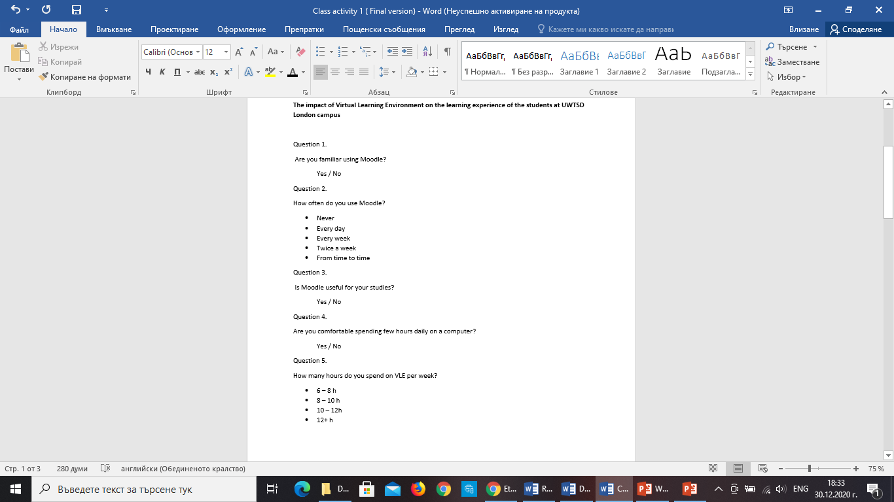
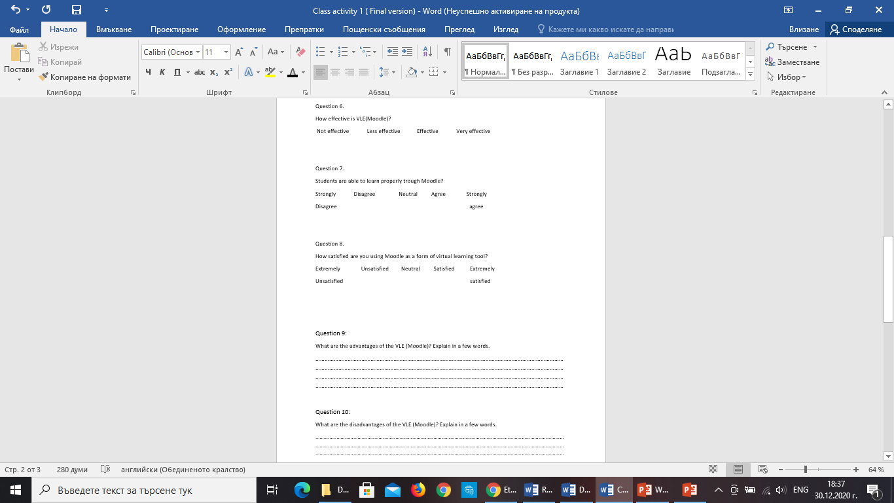
Appendix 2



