

Student name : Luiza Georgiana Lisac
Programme: BA Business Management
Module: Data Handling & Business Intelligence
Module code: LCBB5000
Assignment Title:Current Trends of Business
Intelligence

Executive summary
In this report an in-depth illustration of the concept of Business Intelligence and importance of this BI in the present times have been highlighted in an effective manner. It has been shown that BI helps the business firms in taking faster decisions, increased consumer experience, more flexibility and rapid data analysis. Business Intelligence comprises business analytics, data visualization, data mining, and effective practices support business firms in making more data driven related decisions. The five trends of BI have been highlighted such as “Natural language insight”, “Cloud BI and analytics platforms”, mobile analytics, digital literacy and Automation and augmented analytics.

Table of Contents
Introduction 3
Concept of Business intelligence 3
Importance of Business intelligence in the business firms 4
Five current Business Intelligence trends in association with the scenario 5
Impact of these five current business intelligence trends on companies 7
Conclusion 8
Reference List 9

Introduction
Technologies utilizing data analytics support business firms spot patterns and trends that ultimately support optimization of procedures and resources. According to the scenario, over the previous decade, “Business Intelligence” (BI) has been revolutionized along with data explosion, including that which became big, where several business firms have obtained access to the cloud. The rise of this “self-service analytics” democratized this data product chain including those advanced analytics was not only for these analysts. In this report, an in-depth analysis of the five “Business Intelligence trends” based on the scenario have been shown in an effective manner. Side by side, in this report, the concept of this “Business Intelligence” and impact of these BI trends have also been highlighted.

Concept of Business intelligence
“Business Intelligence (BI)” refers to the technological and procedural infrastructure that assembles, analyzes and stores the data generated through any business firm's activities. BI can be considered as the vast term that encompasses descriptive analytics, process analysis, data mining, and performance benchmarking. In the present times various trends can be seen in business intelligence, data warehousing and data mining. Business firms that leverage “business intelligence” have effective visibility, better control over the business procedure (Hamad et al. 2021). It can be stated that this helps these business firms in identifying and rectifying inefficiencies and errors in existing business procedures. In addition, it also supports them in predicting unforeseen challenges and acting accordingly. Business Intelligence helps the companies in reducing the bottlenecks issues, enhances the decision-making procedure, supports in analyzing the system, supporting in understanding the business and provides “real time analysis”.
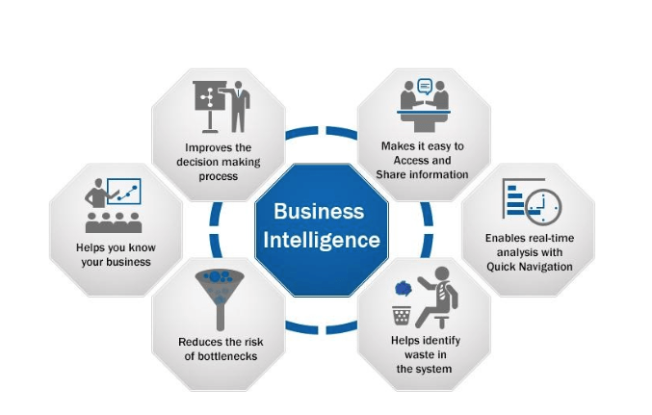
Figure 1: Advantages of Business Intelligence
(Source: Hamad et al. 2021)

Importance of Business intelligence in the business firms
The year of 2021 can be recognized as the major year for the industry of business intelligence, though the BI landscape is also evolving and the Business Intelligence’s future is currently played with some emerging trends that needs to be kept in mind. BI comprises data analytics including that business analytics though utilizes them just as a portion of the overall procedure. It is not unknown that, BI supports users in drawing conclusions from the data analysis (Ashrafi et al. 2019). In addition, data scientists delve deep into the specifics of information utilizing advanced statistics including those predictive analytics for discovering patterns including that forecasting the future patterns.
The business firms that get advantages from utilizing BI tend towards those that need their staff to create independent decisions rapidly. This creates a better fit for data-centric business firms, startups including those business firms searching to expand rapidly. In the present scenario, Delta Airlines, American Express, Coca Cola, Walmart, Uber, Starbucks, and Netflix these companies are using Business Intelligence (Yiu et al. 2021). In addition, BI systems help the business firm in improving consumer experience, providing employee satisfaction, enhancing organizational efficiency, rapid decision making and faster analysis.
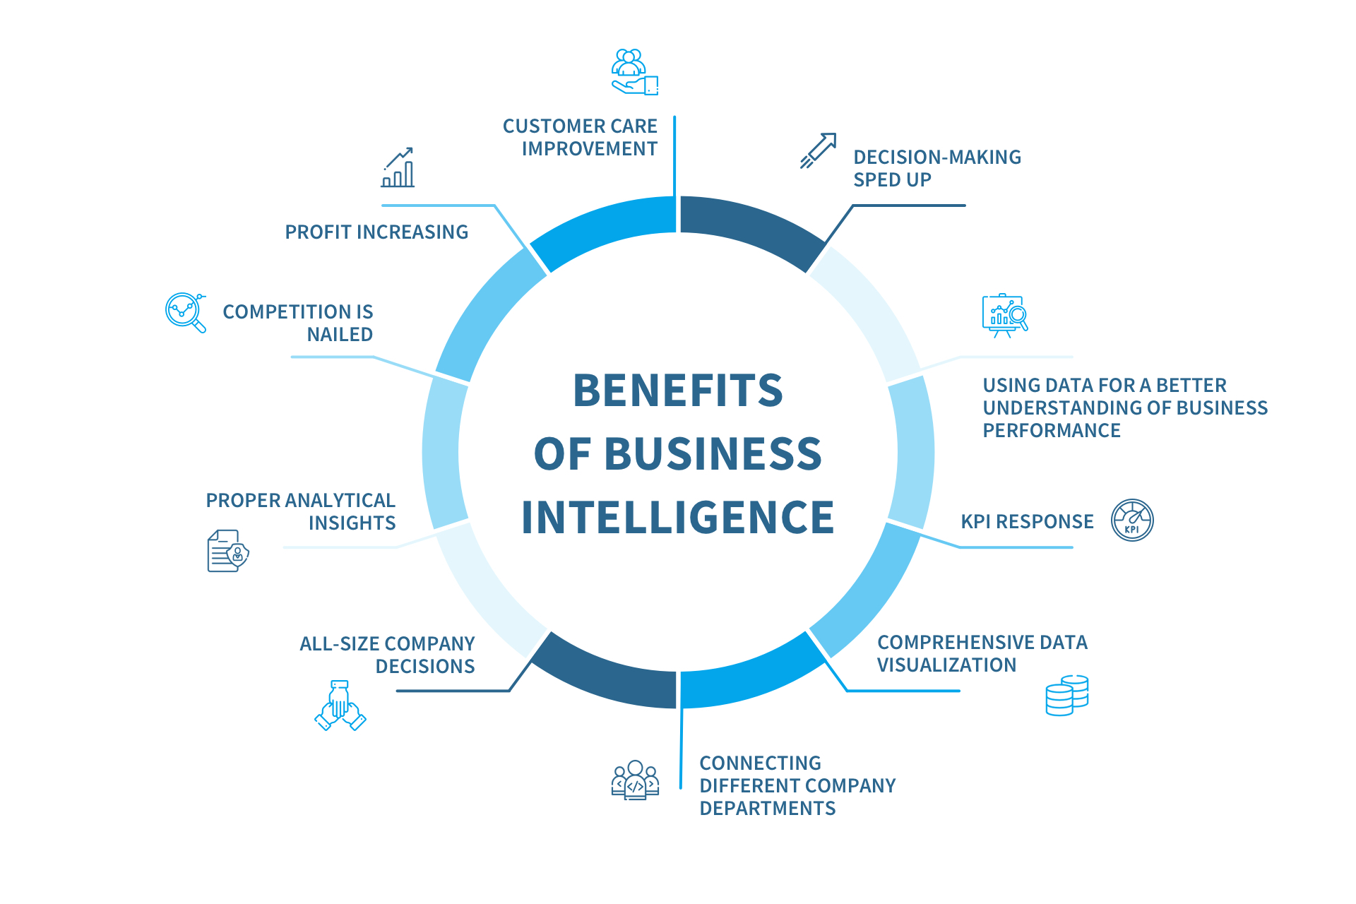
Figure 2: Role of Business Intelligence
(Source: Yiu et al. 2021)

Five current Business Intelligence trends in association with the scenario
Business firms are no longer getting surprised in case data visualizations enhance analyses though the companies are still analyzing the effective way to analyze the data story, mainly with the support of “modern BI dashboard software”. The year of 2022 is the year of data discovery and data security and this would also be the year of artificial intelligence and collaborative BI (López-Robles et al. 2019). “Artificial Intelligence operations” within data warehousing would become necessary, as “machine learning algorithms” trained on enhanced data would produce more appropriate actions including those proactive insights for making data operations more efficient along with that cost effective. The current trends within this data mining are the application exploration and data mining are extremely utilized for exploring applications in some other areas mainly as financial analysis, biomedicine, science, wireless security, and telecommunications (Ayyoubzadeh et al. 2020). There are various types of “Business Intelligence trends” in the present times and among these five trends that the business firms are following have been shown below.
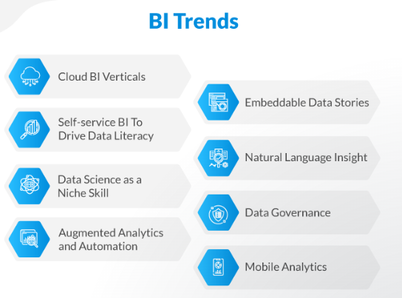
Figure 3: Trends in Business Intelligence
(Source: Ayyoubzadeh et al. 2020)
- Focusing on the provided scenarios, it can be stated that digital literacy can be recognized as the most effective trend with several business firms realizing the advantages of data democratization (RVSPK et al. 2020). In addition, artificial intelligence is day by day becoming more mainstream, with automation and NLP increasing in popularity.
- The COVID 19 pandemic situation has put the business firms as well as industries in major emergency mode as these firms scrambled to create a sense of the particular situation. “On-premise solutions” might not measure up towards the challenge of a vastly remote workforce including that business firms realigned their overall budget for making room for the migration towards “Cloud BI and analytics platforms”.
- Among several BI trends, mobile analytics can be recognized as the business-crucial element of the company’s pipeline. This trend comprises videos, audio, streaming data and text, images, that contain priceless information. It provides product managers effective insights into establishing mobile applications. Marketing teams in the company utilize mobile BI for attracting new leads, extending their user base including optimizing the consumer experience.
- “Natural language insight” is among the best BI trends presently and it is holding tremendous value in the future of BI. Utilizing “natural language processing technology” any individual might be able to sort by unstructured data for improving research efforts, patient care and also disease diagnosis (Olivetti et al. 2020). This trend of BI is less costly than employing the human workers, gives better consumer service-related response.
- Forecasting the business trends with these predictive analytics is not restricted for data scientists and this can happen through automation and augmented analytics. Automation can be recognized as the most recognized and famous trends of this BI, speeding up the delivery pipelines as these analytics arise with difficult data volumes. Machine learning based algorithms are faster, giving automated responses towards searches and prompting “event driven workflows'' (Prat, 2019). Most of the people perform the data analytics and data discovery with the common software skills. This trend provides more efficiency in the data analysis, simple accessibility towards data and discovering latest insights.

Impact of these five current business intelligence trends on companies
- Automation and augmented analytics
The most powerful and convenient benefit of this “automated business intelligence” is providing a better allowance to the company’s consumers to be clicked away from the advanced help of experts within the BI platform, which can be considered as the extension of support including the system of decision making (Crowell, 2022). In addition, with the help of this trend, no one needs a data scientist for making wise decisions.
- “Natural language insight”
NLP is necessary for business firms as it supports companies in gaining better insight into consumer satisfaction and brand performance.
- Mobile analytics
This BI trend is capable of bringing business intelligence including those analytics closer towards the user when done appropriately.
- “Cloud BI and analytics platforms”
This trend refers to business intelligence, including that “data analytic applications” hosted on some virtual networks (Chan, 2020). These applications provide a better analyzation of operating health, identification improvements and future trends, including that of making crucial business decisions.
- Digital literacy
Digital literacy in the business firms plays a crucial role in a business's capability to digitally transform and this also puts an effective impact on the employee experience.

Conclusion
In this report work, an in-depth concept of Business Intelligence has been highlighted and BI comprises business analytics, data visualization, data mining, data tools along with infrastructure and effective practices to support companies in making better decisions. Several business firms are using BI for getting faster data analysis, making wise decisions, enhanced consumer experience and flexibility. In this report, five BI trends have been illustrated such as “Natural language insight”, “Cloud BI and analytics platforms”, mobile analytics, digital literacy and Automation and augmented analytics.

Reference List
Ashrafi, A., Ravasan, A.Z., Trkman, P. and Afshari, S., 2019. The role of business analytics capabilities in bolstering firms’ agility and performance. International Journal of Information Management, 47, pp.1-15. https://www.sciencedirect.com/science/article/pii/S0268401218307734
Ayyoubzadeh, S.M., Ayyoubzadeh, S.M., Zahedi, H., Ahmadi, M. and Kalhori, S.R.N., 2020. Predicting COVID-19 incidence through analysis of google trends data in Iran: data mining and deep learning pilot study. JMIR public health and surveillance, 6(2), p.e18828. https://publichealth.jmir.org/2020/2/e18828/
Chan, J.O.P., 2020. Digital transformation in the era of big data and cloud computing. Int. J. Intell. Inf. Syst, 9(3), p.16. https://pdfs.semanticscholar.org/bdbd/d0c75a304a536277e815a4e5ca1b1f7eaa95.pdf
Crowell, B., 2022. Blockchain-based Metaverse Platforms: Augmented Analytics Tools, Interconnected Decision-Making Processes, and Computer Vision Algorithms. Linguistic and Philosophical Investigations, 21, pp.121-136. https://search.proquest.com/openview/1285dade91795228385a330e11a96614/1?pq-origsite=gscholar&cbl=136108
Hamad, F., Al-Aamr, R., Jabbar, S.A. and Fakhuri, H., 2021. Business intelligence in academic libraries in Jordan: Opportunities and challenges. IFLA journal, 47(1), pp.37-50. https://journals.sagepub.com/doi/abs/10.1177/0340035220931882
López-Robles, J.R., Otegi-Olaso, J.R., Gómez, I.P. and Cobo, M.J., 2019. 30 years of intelligence models in management and business: A bibliometric review. International journal of information management, 48, pp.22-38. https://www.sciencedirect.com/science/article/pii/S026840121730244X
Olivetti, E.A., Cole, J.M., Kim, E., Kononova, O., Ceder, G., Han, T.Y.J. and Hiszpanski, A.M., 2020. Data-driven materials research enabled by natural language processing and information extraction. Applied Physics Reviews, 7(4), p.041317. https://aip.scitation.org/doi/abs/10.1063/5.0021106
Prat, N., 2019. Augmented analytics. Business & Information Systems Engineering, 61(3), pp.375-380. https://link.springer.com/article/10.1007/s12599-019-00589-0
RVSPK, R., Priyanath, H.M.S. and Megama, R.G.N., 2020. Digital literacy, business uncertainty & economic performance: An empirical study of small businesses in Sri Lanka. Journal of Academic Research in Business and Social Sciences, 10(5), pp.50-76. https://www.researchgate.net/profile/H-M-S-Priyanath-2/publication/341216589_Digital_Literacy_Business_Uncertainty_Economic_Performance_An_Empirical_Study_of_Small_Businesses_in_Sri_Lanka/links/5eb43c2e299bf1287f74170e/Digital-Literacy-Business-Uncertainty-Economic-Performance-An-Empirical-Study-of-Small-Businesses-in-Sri-Lanka.pdf
Yiu, L.D., Yeung, A.C. and Cheng, T.E., 2021. The impact of business intelligence systems on profitability and risks of firms. International Journal of Production Research, 59(13), pp.3951-3974. https://www.tandfonline.com/doi/abs/10.1080/00207543.2020.1756506

