Cell Revision Worksheet

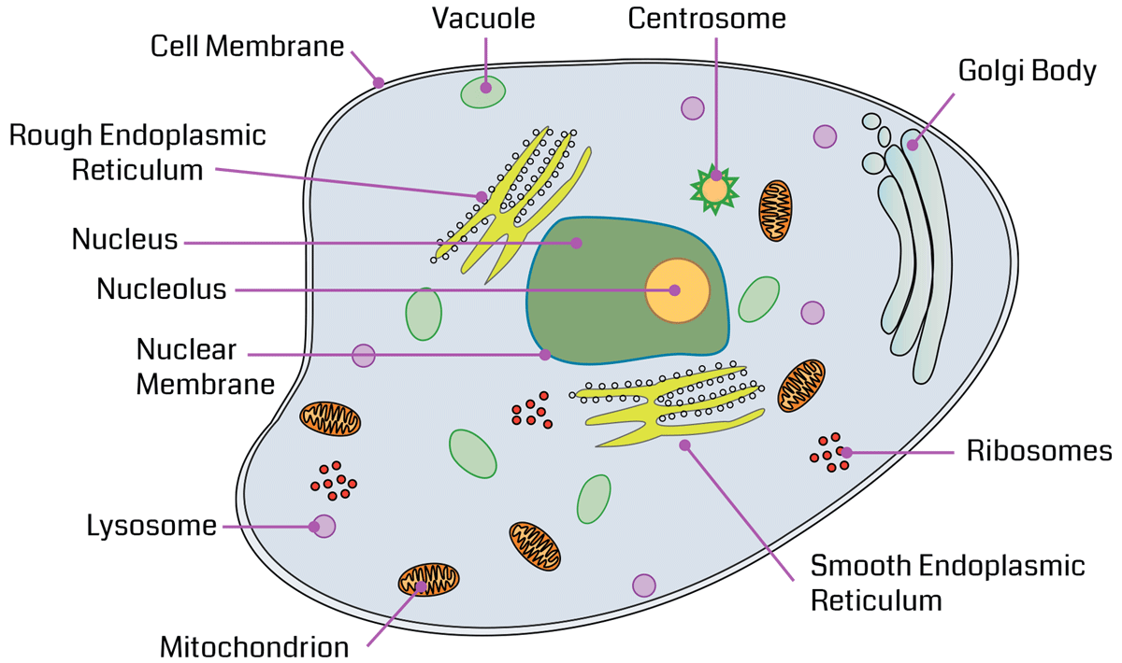

What is the main function of each of the organelles
Cell membrane
Cytoplasm
Nucleus
Nucleolus
Lysosome
Mitochondria
Smooth endoplasmic reticulum
Rough Endoplasmic reticulum
Golgi apparatus
Ribosome
Centrosome
Vacuole
What is Mitosis?
What is Apoptosis?
What is Autophagy?
What is Chemotaxis?

