

Upgrade to HV Switchgear Control & Indication
Independent Project Final Report…..ACCA6020
By
Christian Howells 2215654

BEng Electrical & Electronic Engineering | April 2024

DECLARATION

I, Christian Howells declare that I am the sole author of this Project; that all references cited have been consulted; that I have conducted all work of which this is a record, and that the finished work lies within the prescribed word limits.
This work has not previously been accepted as part of any other degree submission.

Date : ...............................................

FORM OF CONSENT

I Christian Howells hereby consent that my Project, submitted in candidature for the B.Eng. (Hons) Electrical & Electronics degree, if successful, may be made available for inter-library loan or photocopying (subject to the law of copyright), and that the title and abstract may be made available to outside organisations.

Date : ...............................................

Abstract

The abstract is short summary of the entire project. It should summarise the important points and should include:

a) The overall aims and objectives.
b) A summary of the methods used.
c) A summary of the major findings and/or deliverables.
d) A statement of conclusions and recommendations.
Keep it concise. The idea of the Abstract is that someone could read it and decide from it whether it would be worth their while to read the whole report. Although it’s the first thing that appears in the report, it is the last thing to be written.

Write Abstract at End

Contents
Table Of Figures 1
Introduction 3
Background/Overview 3
Overview of Solution 5
Research & Review of Literature 6
STC Control 6
PLC Control of Circuit Breakers 8
HMI (Human Machine Interface) 10
VCB (Vacuum Circuit Breakers) 11
Standards 12
Tatasteel High Voltage Rules EIS 5 12
HSG230 (keeping electrical switchgear safe) 13
BS6626: 2010 code of practice for maintenance of electrical switchgear & control gear above 1kv and up to 36kv 13
BS 7671: 2018 requirements for electrical installations 13
IEC 61131 Standard for plc’s 14
Research and Development Methodology 15
Flowchart - Sequence of Steps 16
Overview flow diagram of new control system 17
PLC selection 18
HMI selection 19
Current Transducer 20
Cable selection 21
Interfacing to existing installation 22
Location of new control panel 23
Management of Change (MOC) & Risk Assessment 24
Gantt Chart 29
Design & Implementation 31
Expectations of Operation 31
Information Collecting on Existing Installation 31
Create I/O List 33
PLC Requirements 35
I/O Configuration 39
Current Consumption 40
Control Panel Power supply 40
Materials/Hardware 40
Design layout of panel & wiring diagrams 42
Digital Output connection diagram 43
Digital Input Connection Diagram 44
Analogue Input connection diagram 45
T749 Control Relay connection diagram 46
T749 Distribution SAK block 47
1.5MVA 11KV/415V Updated schematic diagram (zoomed in) 48
Control Panel Build 49
PLC Programming 53
HMI Programming 55
Testing on T749 59
Video clips of Tests on T749 & T707 60
Evaluation 62
Conclusions & Recommendations 62
Reflection 63
References 64
Bibliography 67
Appendices 67

Table Of Figures
Figure 1. 11KV interconnected Mimic at Energy Control 4
Figure 2. Concast South Substation Transformers Mimic 4
Figure 3. Matrix Mark 2, Switchgear control & Indication 6
Figure 4. CompactLogix interchangeable i/o modules 8
Figure 5. Networking possibilities of HMI 10
Figure 6. Type MX51S Arrangement with busbar isolator 11
Figure 7. Typical GEC MX51S VCB 11
Figure 8. STC cable run ECC-Concast South 15
Figure 9. Flowchart of necessary tasks 16
Figure 10. Overview 17
Figure 11. STC cubicle - outgoing cabling to circuit breakers 22
Figure 12. STC cubicle - Space for new installation 23
Figure 13. Management of Change Initiation 25
Figure 14. Risk Assessment Team 25
Figure 15. Risk Analysis 26
Figure 16. Risk Matrix 26
Figure 17. Risk Value 4E 27
Figure 18. Risk Value 4B 27
Figure 19. Risk Value 3D 27
Figure 20. Risk Value 3C 28
Figure 21. MOC Task Creation & Assignment 28
Figure 22. MOC Completion Notification 28
Figure 23. Gantt Chart 29
Figure 24. Original Schematic Drawing 1.5MVA Transformers 31
Figure 25. Multicore cabling diagram 1.5MVA transformers 32
Figure 26. List of I/O 34
Figure 27. OB32 24V DC source output card 35
Figure 28. IQ32 24V DC sink/source input card 36
Figure 29. IF16V voltage analogue input card 37
Figure 30. I/O Count 38
Figure 31. I/O Configuration 39
Figure 32. Current Consumption 40
Figure 33. List of Hardware & costs 40
Figure 34. List of materials and costs 41
Figure 35. New control panel layout 42
Figure 36. DO4 Digital Output Connection Diagram 43
Figure 37. DI 1 Digital Output Connection Diagram 44
Figure 38. AI5 Analogue Input Connection Diagram (1/4) 45
Figure 39. T749 Control Relays 46
Figure 40. T749 Distribution SAK block 47
Figure 41. Updated VCB indication diagram 48
Figure 42. Framework construction within control panel 50
Figure 43. DIN rail & trunking mounted 50
Figure 44. Component mounting in Control panel 51
Figure 45. Wiring ready for control relays 51
Figure 46. SAK block panel 52
Figure 47.Re-locating PLC & Network Switch 52
Figure 48. PLC connected 53

Introduction
An upgrade to the remote switching and indication of High Voltage Vacuum Circuit Breakers (VCBs) in Concast South Substation at Tata Steel in Port Talbot has become essential. The original control system, STC (Standard Telephones & Cables Ltd) uses copper cores over long distances and an arrangement of control relays. The system was installed in the late 1970’s, and over time has become nonfunctional due to damage and deterioration to the cabling running between the Main control room (Energy Control Centre, ECC) and Concast South Substation.

Background/Overview
There are two main substations at Tata Steel Port Talbot; called Grange and Cefn Gwrgan. The electrical supplies are imported to site from National Grid at 66,000V. National Grid use Super-Grid and Grid transformers to step down to 66KV. The Super-Grid transformers are known as SGT1 & SGT2, are 275KV-66KV, 180MVA and feed into Grange. The Grid transformers are known as GT1 & GT2, are 132KV-66KV, 45MVA and feed into Cefn Gwrgan. Under normal scenarios, the Grid transformer are used as a standby.
Nineteen Supply Transformers (ST’s) step down the voltage from 66KV to 11KV, then the 11KV is distributed throughout site on an interconnected network to 42 substations. An on-site power plant can generate up to 90MW via 7 Turbo Alternators (T/A’s) and feed into the interconnected network. The generation of electricity on site is essential to ensure there is always a source of electricity if a power cut was to occur off site. This is safety critical due essential supplies being required in hot metal areas. A minimum of 47.5MW must be generated when all plants are running.
Distribution transformers step down the voltage levels further from 11KV to 3.3KV or 415V. One of the roles of the Energy Department is to continuously deliver 11KV, 3.3KV and 415V to the various works areas. The works area will then distribute throughout their area. There are approximately 70 substations containing these voltage levels in total.
Energy Control Engineers remotely monitor and control the 11KV interconnected network and distribution transformers from Energy Control; They should be able to remotely open, close and monitor 11KV circuit breakers. If instructed by ECC, mobile authorised electricians can carry out switching operations from remote control panels within the substations (locally to switchgear). In some substations, the switchgear controls date back to the 1950’s, newer systems of control have been utilised as time has gone on.
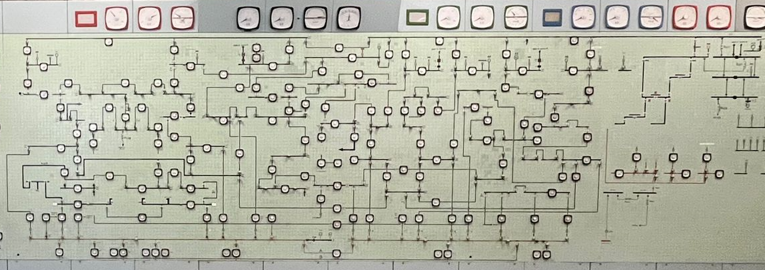
The Energy Controllers use a large wall sized mimic at ECC to open, close and monitor the circuit breakers which are controlled by the STC system. The mimic allows for the opening & closing of CB’s. Voltage & current readings. It will give a discrepancy tone & lamp when the switch is in a different position to the CB. It will give a TNH (trip not healthy) tone and lamp when the CB trip circuit is not healthy. It will give a fault trip tone & lamp if the CB opens via a circuit protection relay (Master Trip). Over the years, as the 11KV interconnected network has grown and developed, newer control systems have been installed which are not on the wall mimic. These newer systems include ABB micro Scada and Ifix.
Figure 1. 11KV interconnected Mimic at Energy Control
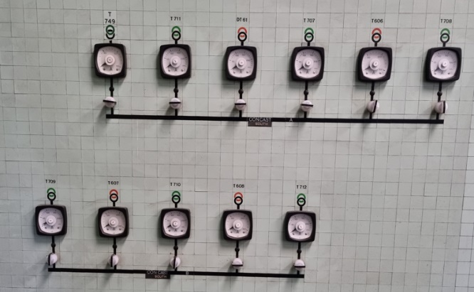
The above image (Figure 1) is of the mimic located at ECC. The controllers use this to monitor and operate the STC controlled circuit breakers on the 11KV network. The below image, Figure 2, is of the control switches for the 11KV circuit breakers on the primary side of distribution transformers located at Concast South substation, as well as ammeters for each transformer.
Figure 2. Concast South Substation Transformers Mimic

Overview of Solution
Repairing or replacing the damaged control cable would cost a substantial amount of money so this option was not viable. It was decided that a newer more modern approach to the control system would be the way forward. A PLC was to be used to operate and receive indications from the circuit breakers. A local HMI would be installed, allowing mobile authorised electricians to carry out safe switching from a remote location within the substation. This would then evolve to incorporate a SCADA system called ifix, allowing Energy Controllers to have full control over the 13 Energy Department owned VCB’s at the substation.
Tata steel UK High Voltage safety rules, EIS 5 rule number B.4.2.1 state:
“The switching of production equipment supplied from a single high voltage source may be carried out by a competent person using control equipment which is remote from the switching device, and which is provided for this purpose.” [1]
The aim of this project is to have remote operation of three 11KV circuit breakers (T749, T707 & T708) via a PLC & HMI. There may be references to other circuits throughout the report as preparation work for these circuits was carried out at the same time.
This chapter should start off by setting the context for the work:
- What is the project about? What are the initial aims and objectives for the project?
- Aim - what is the overall research question you're trying to answer?
- Objectives - what are the actions you're going to take to try to satisfy the aim?
- A brief description of what is coming up in the following chapters (this should be the final paragraph of the introduction).
Usually, you start with a very broad statement of the problem and refine that down to more specific items. Unless yours is a problem area with which all readers of your report will be familiar (very unlikely), you will want to describe the problem in some detail and give sufficient background information so that everyone can understand it.
You should then describe the objectives, aims or goals of your particular piece of work. Your overall aim was presumably to solve a particular problem or to answer a particular question. This could be broken down into a number of specific objectives that together work towards achieving the aim.
The introduction should end with a section that leads the reader in to the rest of the report. The important thing is to give your reader a clear picture of what your report is setting out to do.
******* Works network ********
******** Costs of repair work to cable ***********
Case Study Selector ABB

Research & Review of Literature

STC Control
Standard Telephones and Cables PLC was a company founded in London in 1883, then known as International Western Electric. It changed to STC in 1925. They were a manufacturer in the telephone, telegraph, radio, and telecommunications sector. In the 1950’s they installed the original STC supervisory switchgear control in the Steel Company of Wales (SCOW), this control system developed and in the 1960/70’s the STC Matrix Mark 1 was implemented. The late 1970’s saw the introduction of the STC Matrix Mark 2 system, Figure 3, which is what was present in Concast South Substation. [2]
The system uses:
- Control switches located on the mimic at ECC, one per circuit breaker.
- Control cards, located in STC cubicle at ECC, one per circuit breaker.
- One Guard relay (CK), located in STC cubicle at ECC, one per substation.
- Indication cards, located in STC cubicle at substation, one per circuit breaker.
- Control relays (Close, Trip & HTS (Healthy trip supervision)), located at substation, one set of three per circuit breaker.
- Outstation matrix, located at substation, with one ‘S’ relay per circuit breaker.
- A Close Guard (CG) and a Trip Guard (TG) relay, located at substation.
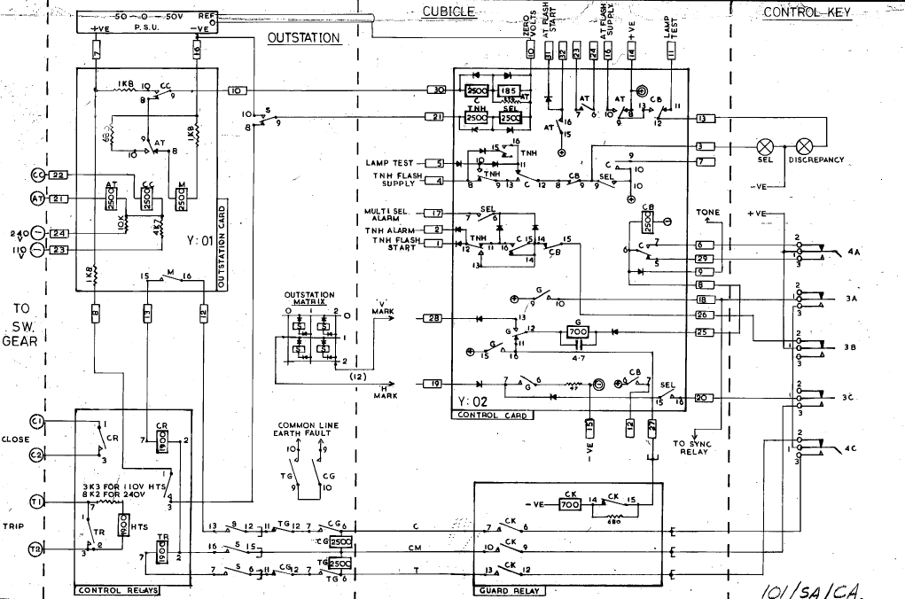
- 50 – 0 – 50 volt power supply, located at substation.
[3]
Figure 3. Matrix Mark 2, Switchgear control & Indication
Circuit Breaker Control & Indication
Referring to the previous Matrix Mark 2, switchgear control & indication diagram.
- When CB open and Control switch in the Open position: Only the ‘M’ relay on the indication card is energised.
- When Control switch moved from Open to Close: Contacts on 4A & 4C of the switch move. ‘CB’, ‘G’ and ‘SEL’ relays on control card energise. SELECT and Discrepancy lamps at ECC illuminate. Discrepancy tone sounds at ECC. Circuit specific ‘S’ relay on the outstation matrix is energised. ‘CK’ relay at ECC is energised. ‘CG’ relay at substation is energised. This act ‘Arms’ the circuit in readiness for the overthrow (closing of circuit breaker).
- When Control switch overthrown Open to Close: Contacts 3A, 3B & 3C of the switch move. +50v sent down ‘Close’ line and -50v sent down ‘CM’ line energising ‘CR’ which provides a close contact for the Circuit Breaker. Once closed ‘HTS’ relay energises at substation. ‘C’ and ‘TNH’ relays on control card energise.
- When Circuit Breaker closed: If ‘HTS’ (healthy trip supervision) relay was too de-energise, the TNH relay on control card would drop out; initiating a TNH flash lamp and alarm. A blown tripping fuse, or an open circuit tripping coil are causes for a TNH alarm.
- When circuit Breaker closed: If a protection relay operated causing the Circuit Breaker to trip, ‘AT’ relay on outstation card would energise. ‘AT’ on control card would energise. Fault trip lamp will illuminate and Discrepancy tone sounds (as control switch is now in incorrect position.
- When Control switch moved from Close to Open: Contacts 4A & 4C of the switch move. ‘CB’, ‘G’ and ‘SEL’ relays on control card energise. SELECT and Discrepancy lamps at ECC illuminate. Discrepancy tone sounds. Circuit specific ‘S’ relay on the outstation matrix is energised. ‘CK’ guard relay at ECC is energised. ‘TG’ relay at substation is energised. The circuit is now ready for the overthrowing of the switch.
- When Control switch overthrown Close to Open: Contacts 3A, 3B & 3C of the switch move. A +50v is sent down the ‘Trip’ line and -50v sent down the ‘CM’ line, energising ‘TR’, closing a contact which in turn opens the Circuit Breaker. Only the ‘M’ relay will be energised once this action has been completed.

***Find existing Control systems***

PLC Control of Circuit Breakers
The benefits of using a PLC to replace the STC system far outweigh the replacement/repair work required on the cabling between Concast South and ECC. By using a PLC, it will eliminate the need for copper cabling running over long distances, the need for control and outstation pcb cards, the use of an outstation matrix and close/trip/guard relays (that’s 10 relays per circuit & 3 common relays). The installation will then only require Close(CR), Trip(TR) and Health Trip Supervision(HTS) relays.
The introduction of the PLC began in the 1970’s, and they have become the go-to choice for manufacturing controls, due to the numerous advantages they provide. Programmable Logic Controllers offer cost effective solutions managing complex systems. They are highly flexible and easily adaptable to control a wide range of systems. They are equipped with advanced computational capabilities and enable sophisticated control strategies. Programming and fault finding are simplified due to help and assistance functions. PLCs are made with reliable components ensuring prolonged operation, often lasting years without encountering failures. [4]
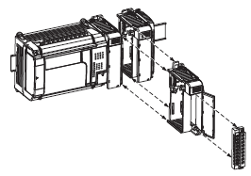
An existing CompactLogix PLC at Concast South Substation will be utilised as part of the upgrade. The 1769-L30 controller accommodates up to a maximum of 8 i/o modules, Figure 4. The controllers are designed for industrial environments and are suitable for use when installed correctly. They are intended for use in clean, dry environments. The modules are panel or DIN rail mounted and mechanically lock together to become a solid assembly, with an integrated communication bus connected which interconnect between modules. [5] [6]
The Digital input card already housed in the exiting installation was a 1769-IQ32, which has 32 inputs (8 points/group) and requires 24V dc sink/source. A digital input is an input that can be termed on/off, high/low or 1/0, additional DI cards will need to be added. A compatible Digital Output card is the 1769-OB32, with 32 outputs (16 points/group) and requires a 24V dc source. A quick look at Concast South suggests 26 DO are required (13 Circuits x Open/Close = 26). These outputs are either on/off, high/low, or 1/0. The Analogue input card in the existing installation is the 1769-IF16V, which requires a voltage input (0-10V, 0-5V, 1-5V or ±10V) and can take up to 16 single ended inputs. [6]
Figure 4. CompactLogix interchangeable i/o modules
The Allen Bradley CompactLogix 1769-L30ER bears a CE mark, signifying it has been designed and rigorously tested to meet the following directives:
EMC Directive – The product undergoes testing to comply with Council Directive 89/336/EC Electromagnetic Compatibility (EMC). It adheres to the standards below, either in whole or partially, as documented in the technical construction file.
- EN 50081-2 EMC – Generic Emission Standard Part 2, Industrial Environment
- EN 50082-2 EMC - Generic Immunity Standard Part 2, Industrial Environment. [5]
Low Voltage Directive – This product is tested to comply with Council Directive 73/23/EEC Low Voltage. This achieved by adhering to the safety requirements outlined in EN 61131-2 Programmable Controllers Part 2 – Equipment Requirements and Tests. [5]
The following examples from journals and case studies support the advantages of using PLCs for the control & indication of switchgear:
A case study called “Digital control systems for high voltage substations” says “Western began deploying PLC control systems in 1996 with a pilot project at the Fort Thompson 230KV yard. Theses initial designs replaced only the substation control wiring. After modifications to the original design, the PLC design became the standard and was deployed in 20 substations across Western’s service territory.” [7] which demonstrates that other companies are using PLCs to control HV switchgear in substations.
A journal paper called “Substation fault monitoring and controlling using PLC and HMI” showing the effectiveness of remote switching of Circuit Breakers by using a similar technique as at Concast South- “PLC on the other hand is like the brain of the system with the joint operation of PLC & HMI, it is possible to control and operate the power system remotely. The task like opening of CB, changing transformer taps & managing the load demand can be carried out efficiently.” [8]
A journal paper named “Automation in substation using Programmable Logic Controllers” found that “The manufacturers of PLCs have responded by developing new products that meet the unique requirements of the substation automation and SCADA applications. PLCs are very cost competitive with RTUs (remote terminal units), and have many benefits in substation automation applications. PLCs have an important place in substation automation and their use in substation applications will grow.” [9]
The following journal used PLC/HMI for power system protection laboratory experiments and found that the “PLC and HMI were efficiently integrated to build a dynamic educational power system protective relays platform, which could be used for wideband protective applications through development of the appropriate application-dependant firmware.” [10] This paper show the usefulness and ability to use a similar such system for training purpose, incorporating elements of circuit protection.
There are many applications of PLCs used within the Energy Department at Tata steel Port Talbot such as; Blast Furnace Gas (BFG) Flares, Demin water filtration plants, BFG water seals, Steam superheater, the washdown of media filters at main pumphouse, water treatment plants, and numerous pump controls.

HMI (Human Machine Interface)
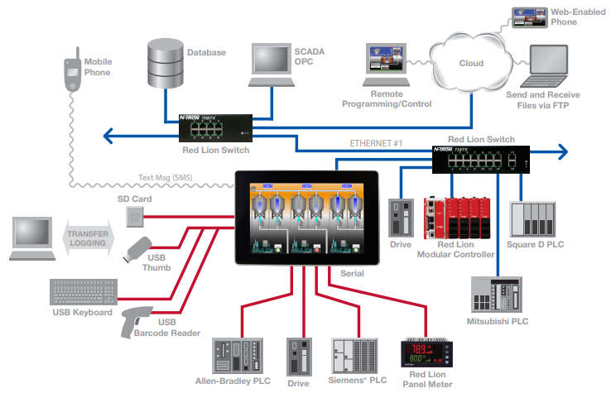
An HMI is a used interface or dashboard that connects a person to a machine, system, or a device. It allows users to interact with and control the machine or system through visual representations such as graphical displays, touchscreens, buttons, and indicators. HMIs are commonly used in industrial automation, manufacturing, process control and other fields where human interaction with machines is necessary. They play a crucial role in facilitating efficient operation, monitoring, and management of complex systems. [11]
[11]
Figure 5. Networking possibilities of HMI
The hardware and software allow human operators to intervene manually during emergencies, monitor status of controlled processes and make adjustments. Control engineers and operators can modify controller settings, algorithms and set points using the HMI. The HMI can be configured to display historical data and reports.
A study involving the interfacing of a PLC with a HMI for industrial applications was carried out by members of the New Horizon college of Engineering. A major benefit found in the study was that it “Will boost operator productivity and save costly plant downtime.” And “This modernisation of the electrical control system has been accomplished by constructing a control panel with PLC, HMI, and relays, among other components. This technique has facilitated the accessibility of electrical equipment and shortened the duration of the process.” Similar advantages will be achieved in the upgrade of the Concast south control and indication system. The authorised electricians carrying out the HV switching will have full current circuit breaker status available, minimise the potential for errors, speed up the switching procedure and provide a safe environment away from the HV equipment. [12]

VCB (Vacuum Circuit Breakers)
HV Circuit breakers are essential in transmission and distribution systems, they are tasked with swiftly opening and disconnecting faulty, or overloaded circuits from electrical supplies. Additionally, they are used for normal load switching operations (e.g., for maintenance work and testing). The different types of Circuit Breaker include the Vacuum, Oil filled, SF6 (Sulphur Hexafluoride) and air circuit breakers. Each type has its advantages. VCBs utilize a vacuum medium to extinguish the arc. The dielectric recovery properties of a vacuum during interruption are excellent, particularly during high frequency currents. When a fault is detected, the trip coil is energized, causing the contacts within the vacuum bottle to break. As the contacts open, an arc is generated. This is swiftly extinguished as the electrons and ions condense on the contact surfaces, leading to the restoration of dielectric strength. [13]
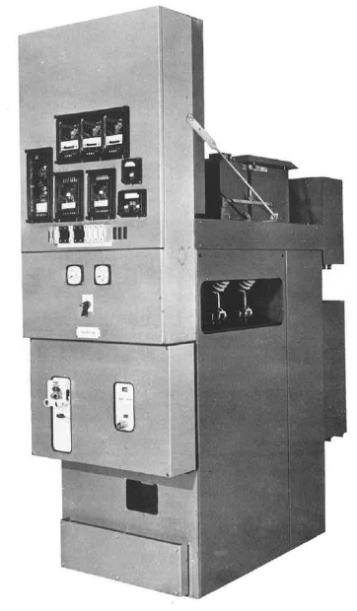
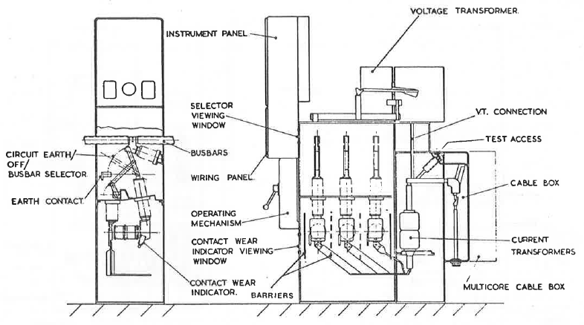
The VCB’s used in Concast South substation were made by GEC in the late 1970’s and type MX51S. They are designed for power system voltages up to 15KV. The switchgear units are of compact design with a simple layout, allowing for installation as a single unit, or as a bank of units extending from either side. The main compartment houses the vacuum interrupters (bottles), operating mechanism and busbar side isolator. The isolator is positioned to enable earthing of the outgoing/incoming circuit cable through the vacuum bottles. The busbars are mounted at the top of the main compartment and can be extended for additional units. The CT’s (current transformers) are located between the vacuum bottled and the cable box. Protection relays at Concast South are mounted in a separate panel on top of the main unit. The isolator and CB operating mechanism are interlocked so that isolators can only be operated when CB is open. [14]
Figure 6. Type MX51S Arrangement with busbar isolator
Figure 7. Typical GEC MX51S VCB

Standards
Standards can be defined as “an agreed, repeatable way of doing something”. These standards can take the form of international standards (ISO), National standards (BS), industrial standards or in-house standards. [15]
These documents typically consist of published information demonstrating how to perform a task consistently and correctly. Standards are usually voluntary and do not inherently impose legal responsibilities. However, legislation may reference these standards, thereby lending them legal authority and weight.

Tatasteel High Voltage Rules EIS 5
The High voltage safety rules, EIS 5 are mandatory on-site rules to be followed when working on high voltage systems, which is voltages above 1000V ac or 1500V dc. The rules are set down for safely isolating and for regulating work on all high voltage systems and equipment. The procedures are designed to ensure that:
- Systems and equipment are safe before any electrical work on them is started.
- Safety is maintained throughout the work.
- There is no risk of danger being introduced during the course of the work.
- Apparatus used in operations on high voltage systems is adequate for the duty. [1]

The voltage classifications for National Grid are:
- LV, Low Voltage – Up to 1000V
- MV, Medium Voltage – 1000V – 45KV
- HV, High Voltage – 45KV – 230KV
- EHV, Extra High Voltage – 230KV and above. [16]

Tatasteel Rule EIS 5 - B.4.2.1 states: “The switching of production equipment supplied from a single high voltage source may be carried out by a competent person using control equipment which is remote from the switching device, and which is provided for this purpose.” [1]
A company called Transmission capital have their own operational & safety switching rules, with a similar requirement around remote switching: 3.4.1- “Where Switching is being carried out on Live Equipment or where Equipment may be Charged. The Switching operation shall, where reasonably practicable be carried out remotely (i.e. from SCADA or via the LCC) rather than from a Local Position.” [17]

HSG230 (keeping electrical switchgear safe)
HSG230 is a guidance document issued by the HSE targeting the owners and operators of 3 phase electrical switchgear, with voltage ratings between 1KV - 33KV ac, in industrial and commercial organisations. It aims to assist managers, engineers and other relevant personnel understand their responsibilities and duties regarding the selection, use, operation, and maintenance of HV switchgear. It covers various Circuit Breakers (oil, air, vacuum, SF6), switches, switch fuses, isolators and HV contactors. It includes guidance on assessing risks associated with aging switchgear and offers guidance when considering refurbishing or replacing the asset.
HSG230-148 states “The provision of remote operating facilities should be considered in order to minimise the risks to personnel operating the equipment” when new, replacement or refurbishment of switchgear takes place. [18]

BS6626: 2010 code of practice for maintenance of electrical switchgear & control gear above 1kv and up to 36kv
This is a British Standard, published by BSI, gives detailed guidance and recommendations for electrical switchgear maintenance with a voltage rating between 1KV and 36KV ac/dc. It aims to ensure the switchgear remains in an acceptable condition. This standard is intended to guide both maintenance personnel and the administrative staff overseeing the activities. The typically inactive state of electrical switchgear doesn’t alert to potential faults, and hazards arising from neglect. The implementation of an organised maintenance plan becomes crucial to ensure ongoing safe and reliable operation of the electrical equipment, minimising failures, damages, and supply interruptions. This Standard builds upon the HSE guidance HSG230. [19]

BS 7671: 2018 requirements for electrical installations
BS7671 is the British Standard for the requirements for electrical installations. It is also known as the IET or 18th Edition Regulations. This standard provides the guidance and sets the requirements for the design, installation, maintenance and verification of new electrical installations, and the addition or alteration to existing installations in the UK. BS7671 ensures electrical installations are safe, efficient, and compliant with regulations to protect people, property, and the environment from electrical hazards. [20]

HASAWA????

IEC 61131 Standard for plc’s
The IEC 61131 is a set on international standards for programmable logic controllers (PLCs) and associated peripherals. These standards are made up of 8 parts, and define programming languages, communication protocols, and other aspects related to the development and use of PLCs. The languages specified by IEC 61131 include ladder logic, structured text, function block diagram, sequential function chart, and instruction list. These standards help to ensure the ability to connect, communicate and continuity amongst PLCs manufactured by varying companies. [21]
Year 3/Level 6 projects should include a comprehensive element of review and scholarly research. Your work is done in the context of an academic discipline, Computing. Show how your project fits into the framework of that discipline by reviewing books and papers describing the problem you are trying to solve and potential solutions to the problem.
- What other research has been done in your field?
- Who did this research?
- What were their results?
- How do these results relate to other researchers' work in the field?
- Split the literature review into sections, each looking at a different part of the research problem
- Write an introductory paragraph at the start of the chapter that briefly describes the sections
- Write a concluding paragraph at the end of the chapter that briefly sums up the most important points.
The Literature Review gives your reader sufficient background knowledge for them to be able to appreciate later why the approach you took was valid or best. Since they may not be familiar with either the problem or the possible solutions or both, you need to provide them with a basic grounding in the important and relevant material. This does not, however, mean that you should include a detailed tutorial.
You also need to demonstrate that you considered all the possible solutions to the problem and that you took all available material into account. This part of the review usually summarises quite succinctly approaches that have been taken by other people in similar situations. Some will have been successful and some not, and this should be indicated. It is perfectly all right to express justified disagreement with something you’ve read - “criticism” is often an excellent feature of a review.
The most important attribute that your review should possess is relevance.
It is strongly recommended that a first draft of this section is developed in the first term. You will also need to present your initial literature review at the Interim Viva. Ask your supervisor for advice.

Research and Development Methodology
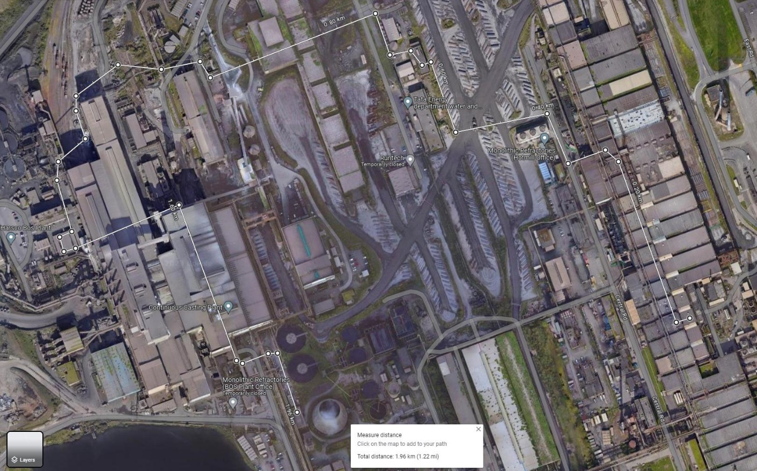
The STC 100 pair cable run between Energy Control (ECC) and Concast South Substation does not run in a straight line. It reaches its destination via two other substations; Abbey melting Shop Central (AMSC) and BOS North, with an approximate overall length of 1.2 miles, running in ground, in tunnels and in basements, Figure 8. There has been ongoing issues with the cable for many years, and 10-15 years ago a replacement length was run in between ECC and AMSC. The plan back then was to have the whole 1.2 miles renewed not just a partial renewal, but this did not materialise. A recent basement fire in the hot mill damaged a large section of the ‘newer’ ECC-AMSC length, leaving all HV switchgear control and indication at Concast South nonfunctional. The cost of running in a new length of 100 pair cable to replace the recently damaged section, installation of new traywork and cable jointing will be significant. Even with that repaired, there would still be the ongoing issues with the AMSC-Concast South section of cable. A record of all inground cable routes can be found in our onsite database called Cab-I-Net. The ECC-Concast South cable ID number is 147/40 and its run can be identified by using the drawings.
Energy Control
Cable length approx.. 1.96Km (1.22miles)
Concast South S/S
Abbey Melting Shop Central S/S
BOS North S/S
Figure 8. STC cable run ECC-Concast South
Finding an alternative method of controlling the HV switchgear was essential. Discussions with Engineers within the department led to the suggestion of using a PLC to control the circuit breakers and receive relevant feedback.

Flowchart - Sequence of Steps
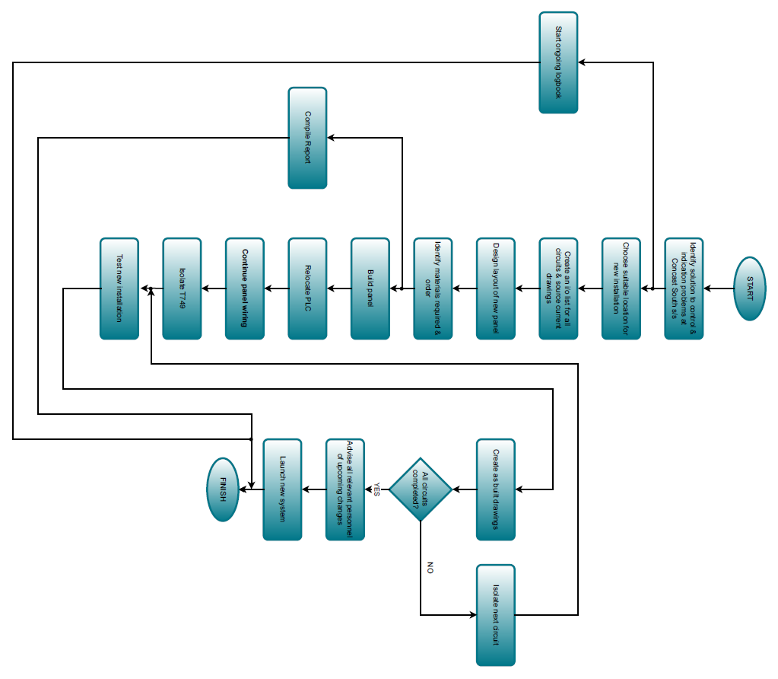
The following is the sequence of events (Figure 9) required to complete the task of upgrading the control system, incorporating a PLC and local HMI.
Figure 9. Flowchart of necessary tasks

Overview flow diagram of new control system
The following shows a pictorial image (Figure 10) of the main components to the new control system. Authorised electrical personnel will have access to the new HMI. They will be able to monitor circuit statuses, alarms, warning, and circuit amps. If instructed by ECC, they can open or close circuit breakers from the HMI. The HMI communicates with the PLC over Ethernet via a network switch. The PLC will send a Digital Output to the control relay when requested by the Authorised person. The PLC receives Digital Inputs and Analogue Inputs from the VCB.
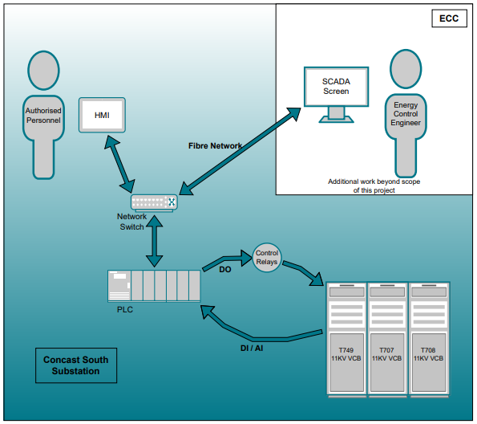
Once the local HMI controls has been executed, the project will progress into the development of remote control from ECC by using the SCADA system called Ifix.
Figure 10. Overview

PLC selection
A table used to compare different Allen Bradley PLCs. Allen Bradley has become the departmental standard. The highlighted option is the PLC chosen for the installation. This PLC was already located at Concast South, it only needed expanding, so costs were less.
 | 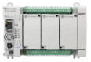 | 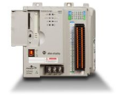 | 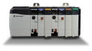
Model | Micro850  2080-L50E-48 | CompactLogix 1769-L30ER | ControlLogix 1756-L71
Power Supply | 24V DC | 24V DC | 24V DC
Expandable | Yes, up to 192 i/o | Yes, 8x i/o cards | Max total i/o 128,000
DIN Rail Mounting
EtherNet/IP
User Memory | 500KB | 1MB | 2MB
Current draw | 8.8mA @ 24V DC | 225mA @ 24V DC | 800mA @ 5.1V DC
Power dissipated (max) | 33W | 4.5W | 22.5W
Communication rate | 10/100Mbps | 10/100Mbps | 10/100Mbps
Programming languages | Relay ladder logic  Structured text  Function block diagram | Relay ladder logic  Structured text  Function block diagram  Sequential function chart | Relay ladder logic  Structured text  Function block diagram  Sequential function chart
Hardware  Costs | CPU (48 i/o) £963  DI £327  DO £248  AI £543 | CPU £1676.45  PSU £304  DI £282  DO £346  AI £772 | CPU £5077  PSU £820  Ethernet module £2376  DI £426  DO £604  Ai £1401
[22] [23] [24]

HMI selection
Different HMIs have been researched, with the Red Lion CR300007 being chosen. Red Lion is the departmental choice when HMIs are being installed. Familiarity with the use, display designing, and programming being a big factor in the decision. The 7” Red Lion HMIs are kept in our Main stores, so delivery was quick.
 | 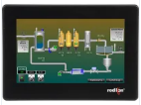 | 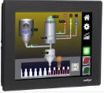 | 
Model | Red Lion CR300007 | Red Lion CR300010 | Allen Bradley PanelView 2711R-TNT
Supply voltage | 10-30V DC | 10-30V DC | 24V DC
Display size | 7” | 10.4” | 7”
Power Consumption | 12.5W @ 24V dc | 16W @ 24V dc | 11W
Ethernet ports | x2 | x2 | x1
Display type | TFT | TFT | LCD TFT
Pixels | 800 x 480 | 800 x 600 | 800 x 480
Memory | 512MB + SD card slot | 512MB + SD card slot | 256MB + micro SD slot
Mounting Type | Panel | Panel | Panel
Programming software | Crimson 3.1 | Crimson 3.1 | Connected components workbench 8.00 +
IP rating | IP66 | IP66 | IP65
Stock Number | RS 233-7973 | RS 233-7974 | RS 893-7789
Cost | £1389.30 | £2778.60 | £998.46
The ergonomics of a HMI is crucial for designing interfaces that are comfortable, efficient, and safe for users. It involves considering factors like screen placement, font size, button size and overall layout to minimize strain and maximize usability. [25]
[26] [27] [28]

Current Transducer
A current reading showing the current flowing into each of the transformers should be available. There are local ammeters present on the front of each VCB. A remote reading should also be available, a transducer is required to convert an input AC current, into a manageable output signal. The below options were considered, and the PR 4179 was selected. They are user friendly; setup is simple and easy to navigate. Also, a good price.
 | 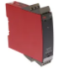 |  | 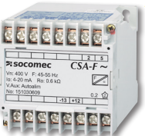
Model | PR Electronics 4179 | JM Concept ULCOS 600 | Socomec 192Y1104
Supply voltage | 21.6–253V AC or 19.2-300V DC | 90-230V AC or 22-240V DC | 230V AC
Max required power | <1.8W | 2.2W | 1.5W
Input type | AC Current or AC Volts | AC Current | AC Current
Current Input Range | 0-0.5A, 0-1A, 0-5A AC | 0-5A AC | 0-5A
Output type | mA or Volts | mA | mA
Output Range | 0-20mA, 4-20mA, 0-5V, 1-5V, 0-10V, 2-10V. | 0-20mA, 4-20mA, 0-10V | 4-20mA
DIN rail mounting
Input response time | <0.75 Sec | <200ms | <200ms
Output response time | 0 – 60 Sec | -- | --
IP Rating | IP20 | IP20 | IP20 / IP10
Stock Number | RS 168-2943 | RS 232-8246 | RS 221-0382
Cost | £195.80 | £204.19 | £350.95
[29] [30] [31]

Cable selection
There are different elements to think about when selecting a cable to use for control panel wiring.

 |  | DEF STAN
Harmonised |  | no | YES

*** Maybe Brief paragraph of selection of cable, trunking, bootlace crimps, connectors****

*******Panel wiring colour coding*******

Interfacing to existing installation
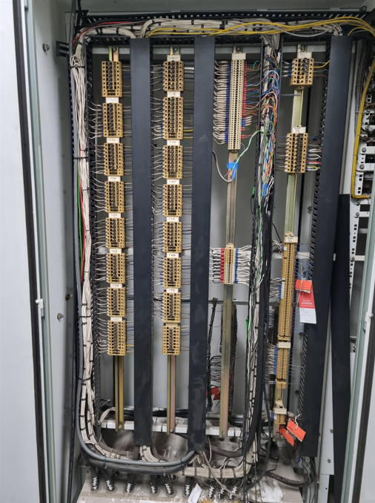
The new control system needs to couple up with existing control wiring, Figure 11. Control cables run between each 11KV VCB and the STC cubicle, utilising these will hopefully eliminate the need to run new cables (as long as there are sufficient number of spare cores on each). If running new cables is unavoidable, asbestos tests on fire stop would need to be conducted, as cables would have to break through the substation floor and into basement, where traywork and racking already. This will add cost and may impact on timescales, even more so if samples came back as positive for asbestos.
Figure 11. STC cubicle - outgoing cabling to circuit breakers

Location of new control panel
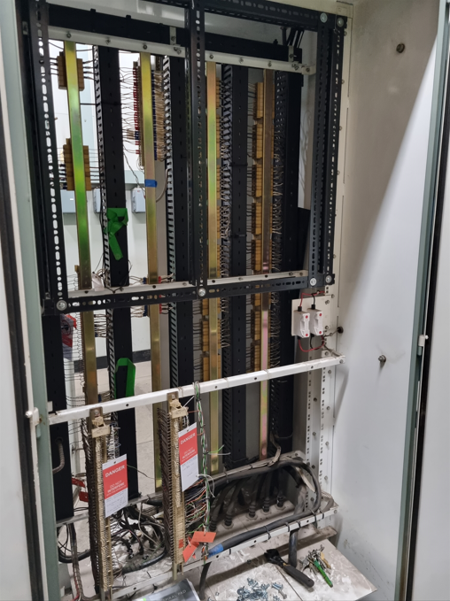
My initial idea was to fit a new Rittal standing enclosure in a gap opposite the existing STC cubicle. If I had gone with this option, I would have had to run traywork and cabling between this new panel and the existing STC cubicle, as this is where the control cabling from circuit breakers arrive. However, the STC cubicle consists of two double doored panels, with each being ‘double sided’. One side was barely used, with a substantial amount of space, enough to house the new control system, Figure 12.
Figure 12. STC cubicle - Space for new installation

Management of Change (MOC) & Risk Assessment
The Management of Change (MOC) process is crucial for ensuring that any changes made to an existing installation or procedure do not lead to unintended consequences. A change inherently carries risks, but effective managing of any changes, minimizes these risks. A well-executed MOC process involves planning, implementation, and oversight to prevent or minimize any negative impacts on employees, the public, the environment, assets or customer satisfaction. It provides a structured approach to identify, assess, and mitigate risks, evaluate any impacts (procedures, behaviours, training, documentation), defines safe working plans, involve relevant personnel, obtain necessary approvals, and update documentation (SWPs, drawings, COSHH, etc). By following the MOC process, risks can be reduced.
A change requires an MOC if:
- The change has no standard.
- The change is a deviation from the standard.
- The standard is adjusted.
- The change is a deliberate change from what our customer (internal or external) are used to receiving from us. [32]
There two main types of change, permanent and temporary.
I initiated an MOC for the upgrade to Concast South HV switchgear control system. The change is a deliberate alteration from what ECC and authorised electricians are used to, hence the need to complete an MOC. I was the person who highlighted/identified the need for a change, and to be able to initiate an MOC I had to have completed e-learning awareness. This gave me access to the MOC application, where:
- A title was given to MOC
- A description of what is being changed, why, and an overview of how the change will be implemented, Figure 13.
- The functional location of the work is provided (all assets on site have a Floc).
- My name was provided as the initiator.
- I designated an MOC manager, however this could be changed before authorisation.
- The MOC is automatically referred to my section manager, who won’t authorise until a CRAG (Change Review Authorisation Group) process has taken place. This is a group of engineers within the department who I had to present the change to. If they are in agreement, the change is authorised.

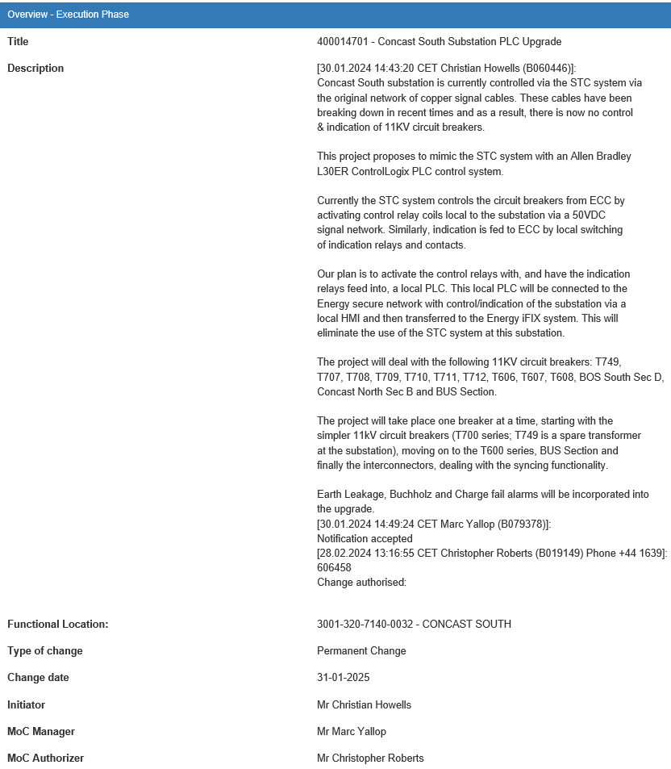
Figure 13. Management of Change Initiation
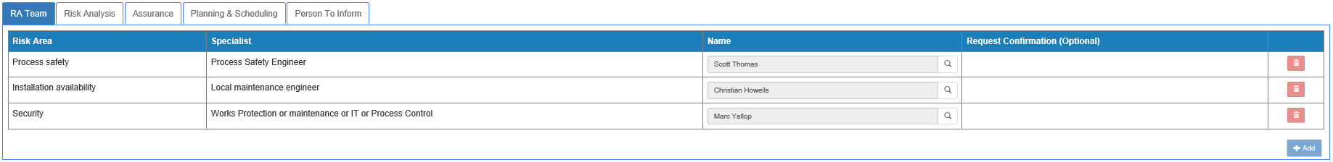
A Risk Assessment team (Figure 14) was set up to ensure that the change cannot detrimentally affect any existing risk control measures, or introduce new hazards for which there are no appropriate existing risk control measures. No change can be implemented unitl it has been authorised.
Figure 14. Risk Assessment Team
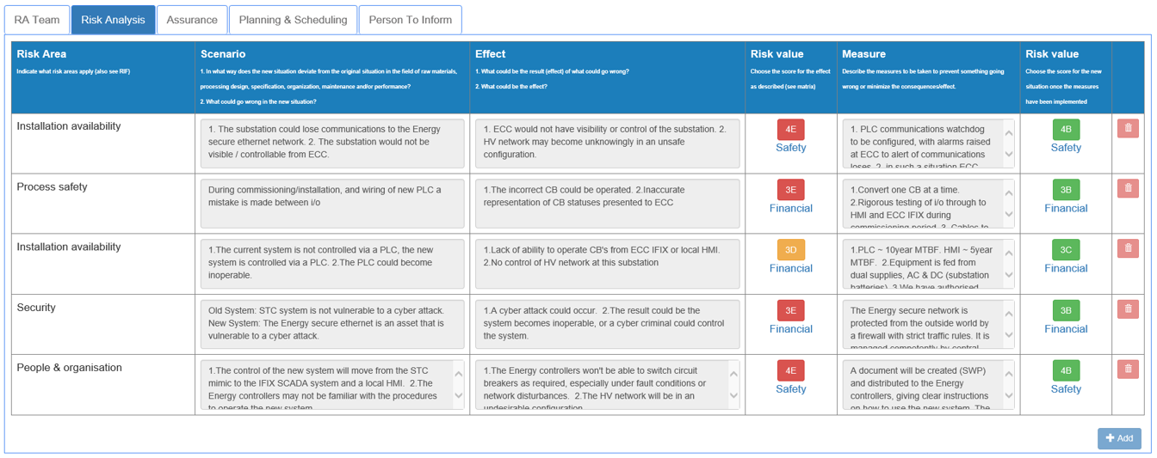
The following Risk Analysis (Figures 15 & 16) was carried out by the RA team. Risk Areas were recognised, and then scenarios built as to how the new control system deviates from the original STC, and what could go wrong. If something was to go astray, a risk value is obtained by using a risk matrix, Severity x Likelihood. If measures are put in place, the risk value should decrease.
Figure 15. Risk Analysis
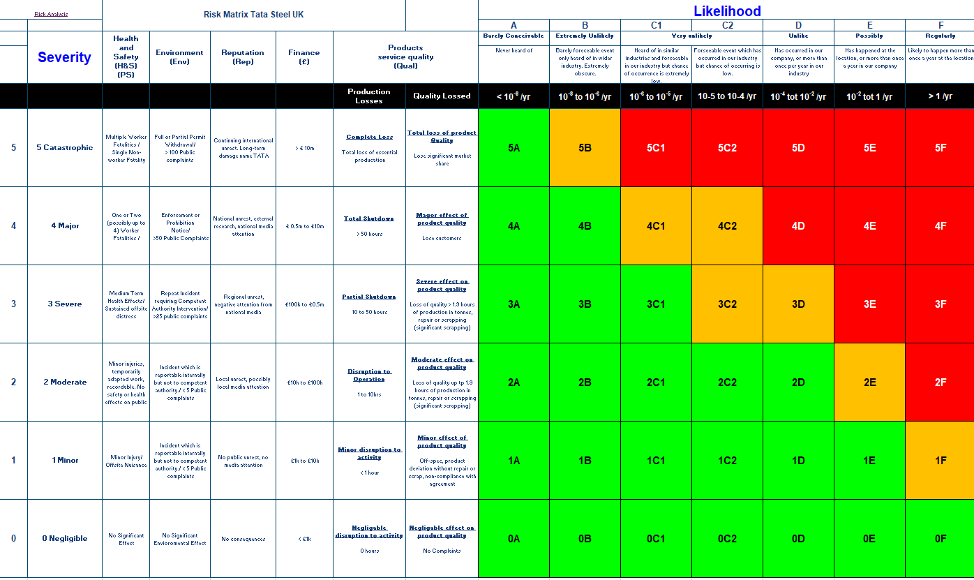
Figure 16. Risk Matrix

Examples of Risk Values before and after control measures have been put in place.
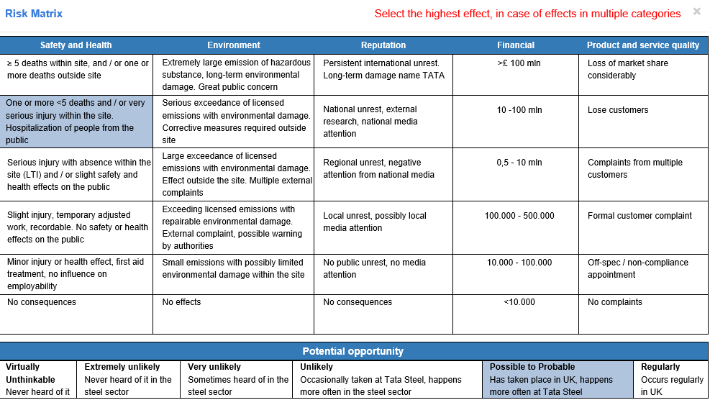
This image shows a Health & Safety Risk Value of 4E before any measures.
A severity of 4 - One or more <5 deaths and/or very serious injury within the site. Hospitalization of people from the public.
A likelihood of E – Possible to probably likelihood of occurring.
Figure 17. Risk Value 4E

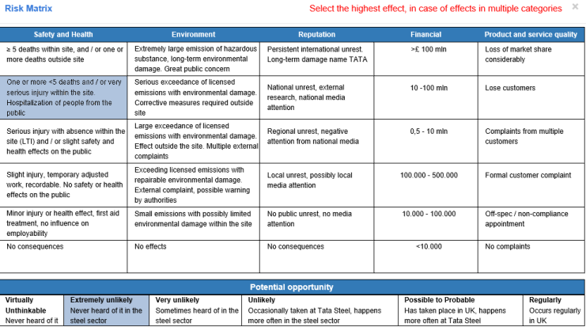
This image shows a Health & Safety Risk Value of 4B, after measures are taken.
A severity of 4 - One or more <5 deaths and/or very serious injury within the site. Hospitalization of people from the public.
A likelihood of B - Extremely unlikely of occurring.
Figure 18. Risk Value 4B

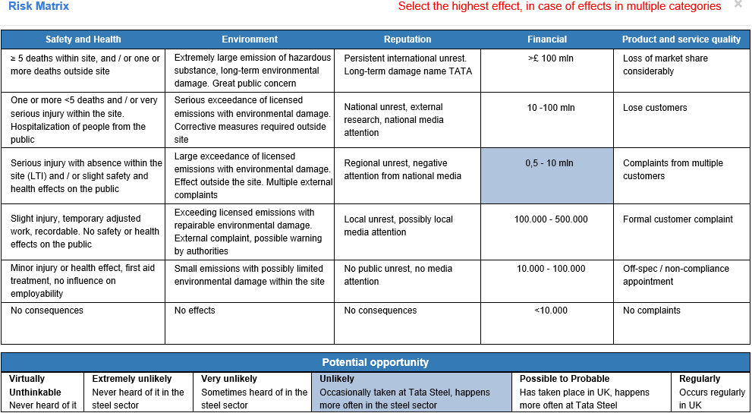
This image shows a financial Risk Value of 3D, before measures are taken.
A severity of 3 - £0.5m to £10m losses.
A likelihood of D - Unlikely of occurring.
Figure 19. Risk Value 3D

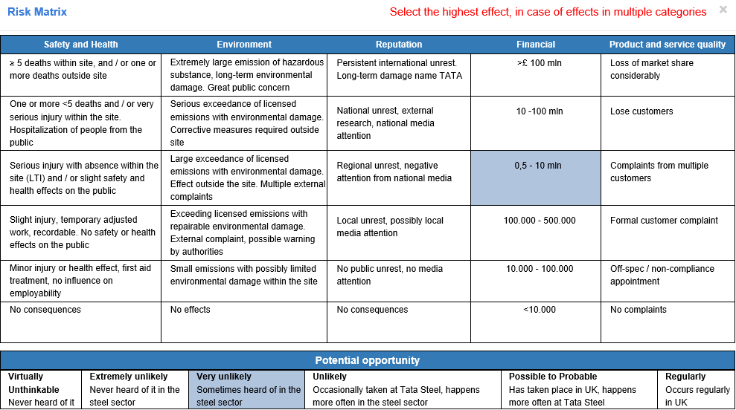
This image shows a financial Risk Value of 3C, after measures are taken.
A severity of 3 - £0.5m to £10m losses.
A likelihood of C - Very unlikely.
Figure 20. Risk Value 3C

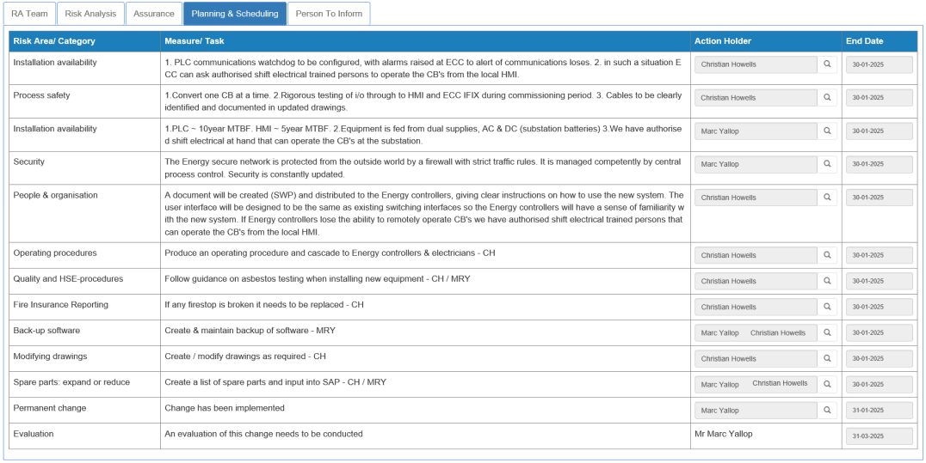
Tasks and measures were identified and assigned to myself & an engineer. These must be completed before the MOC can be closed out, Figure 21.
Figure 21. MOC Task Creation & Assignment

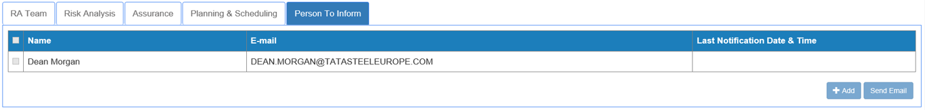
Upon completion of the MOC, the Manager of Energy Control will be sent a notification, this will be part of the handover, Figure 22.
Figure 22. MOC Completion Notification

Gantt Chart
A Gantt chart is a visual project management tool that illustrates a project schedule. It shows the start and finish dates of the various tasks within a project, and often displayed as horizontal bars along a timeline. Each bar represents a task or activity, with its length indicating its duration. Progress statuses and milestones can be associated to each of the tasks. Gantt charts provide a clear, visual representation of the projects schedule, helping to keep organised and on track.
The Gantt chart below, Figure 23, shows the tasks that need to be completed.
- Period 1 represents week commencing 5/6/2023
- Period 47 represents week 22/4/2024

The milestones I set myself are:
- Period 16 – Have control panel ready for final connections.
- Period 20 – Project proposal.
- Period 24 – Begin programming PLC.
- Period 28 – Begin programming HMI.
- Period 29 – Obtain SFT (permit) on T749, complete wiring, test & return to service.
- Period 33 – Interim Viva presentation.
- Period 33 – Obtain SFT on T708 (3rd circuit), complete wiring, test & return to service.
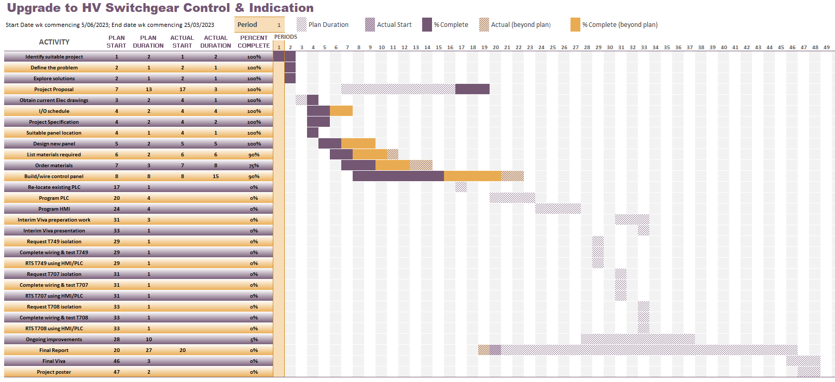
Figure 23. Gantt Chart

Research Methodology
Here you explain in detail the what, why and how of the procedures you used in order to generate the solution to the idea.
The rule is to describe your method in sufficient detail to allow the reader to replicate your study. What research methodology/methodologies did you use - experimental (hypothesis testing), investigative, action, survey, case-study etc? Do not include a review of all possible methods that could be used – the reader is interested in what method you chose and why.

For each of the layers of the research onion, decide which method you intend to use and explain:
  - Why you have chosen that method
  - What are the advantages of that method to your project
  - If there are any disadvantages to the method then how will you work around them?

Also indicated what evaluation criteria are to be used? What methods of testing and statistical analysis are to be used?

Design & Implementation

Expectations of Operation
- Design an overview page for T749, T707 & T708 11KV VCBs on HMI.
- Have an Individual page on HMI for each 11KV VCB.
- Open each 11KV VCB using HMI.
- Close each 11KV VCB using HMI.
- Open position feedback of each 11KV VCB on HMI.
- Closed position feedback of each 11KV VCB on HMI.
- Failed to Open 11KV VCB indication on HMI.
- Failed to Close 11KV VCB indication on HMI.
- In the event of an 11KV VCB fault trip, applicable Indication & Alarm on HMI.
- In the event of TNH (Trip Not Healthy) on 11KV VCB, relevant indication on HMI.
- 11KV circuit current reading on HMI.
- Transformer Buchholz Alarm on each circuit, indication & alarm on HMI.

Information Collecting on Existing Installation
Electrical drawings are kept on a database called Cab-I-Net. The system can be used to drill down to particular plant areas, and in some cases individual assets. The below drawing, Figure 24, is a schematic drawing of AC & DC circuits for 1.5MVA (11KV/415V) transformers at Concast South Substation.
- The Indications for ‘OC’, ‘CC’ and ‘AT’ are 110V DC.
- The VCB close and trip coils are 110V DC.
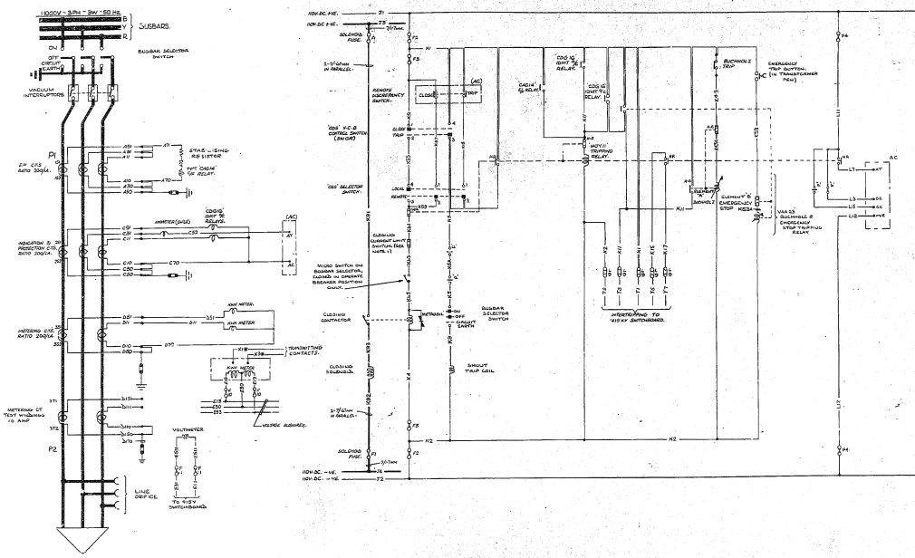
- The CT Ratio of indication CT is 200/1 (AY – AC used for current readings)
Figure 24. Original Schematic Drawing 1.5MVA Transformers
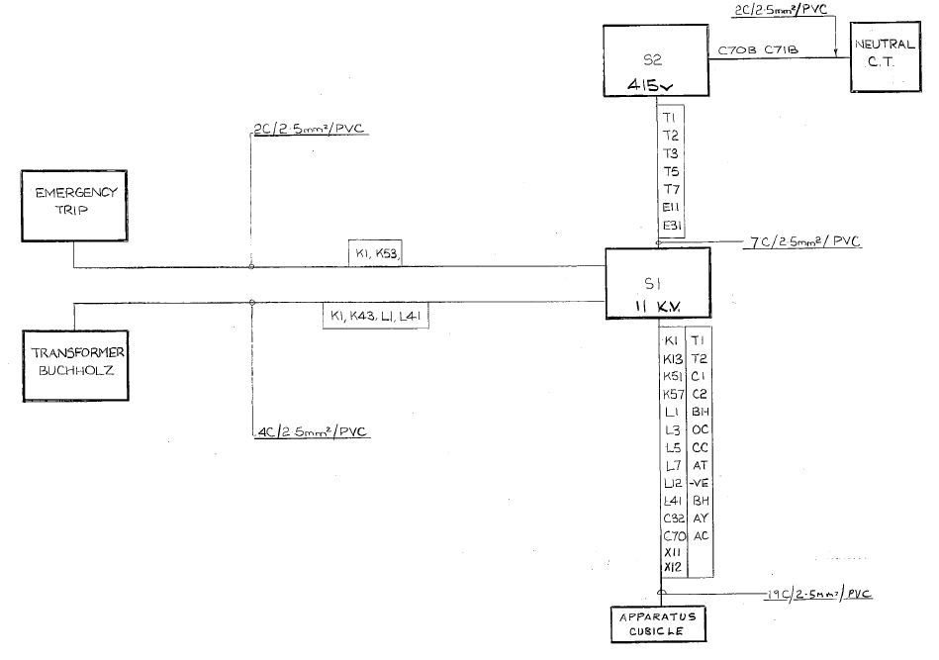
The local multicore cabling diagram of the 1.5MVA transformers is shown below, Figure 25. There is a 19 core 2.5mm² cable running between the 11KV VCB and STC apparatus cubicle, with 14 cores being used. Leaving 5 cores spare.
Figure 25. Multicore cabling diagram 1.5MVA transformers
The Matrix Mk2 switchgear control and indication drawing shows the Close (CR) and Trip (TR) control relays are 50V DC with voltage sourced from ECC batteries. The +50V DC HTS/TNH alarm leaving Concast South is sourced from the substations 50-0-50 power supply.

Create I/O List
An I/O schedule was created for all of the Energy Owned switchgear at Concast South. The scope of this project is to complete the upgrade to 3 transformer circuits, but the project will continue beyond these to include all 13 circuits. A list was made for each circuit one at a time. In addition, other alarms within the substation were included on the list. The ten 11KV VCBs for the 700 and 600 series transformers have the same I/O requirements.
The below information is the requirements per transformer (Interconnectors & BUS Section differ slightly, see spreadsheet on following page, Figure 26).
- Digital Outputs per transformer:
  - Close Command
  - Open Command
2x DO
- Digital Inputs per transformer :
  - Closed Indication
  - Open Indication
  - TNH
  - Fault Trip
  - Buchholz Alarm
5 x DI
- Analogue Input per transformer:
  - Circuit Amps
1x AI

The total number of I/O for the upgrade to all thirteen 11KV VCBs and additional substation alarms is:
- Digital Outputs =26
- Digital Inputs =71
- Analogue Inputs =16
(as can be seen in spreadsheet on following page, Figure 26)

Figure 26. List of I/O

PLC Requirements
The chosen PLC is the Allen Bradley 1769-L30ER. There was a PLC already installed at Concast South Substation, but needed expanding, relocating, and reprogramming. Allen Bradley is the departmental choice for new installations.
Compatible I/O modules for the 1769-L30ER are:
- Digital Output (DC) Selection, Specifications & Wiring
  - 1769-OB8 (8 output, 24V DC).
  - 1769-OB16 (16 output, 24V DC).
  - 1769-OB16P (16 output, 24V DC, protected output).
  - 1769-OB32 (32 output, 24V DC).
  - 1769-OB32T (32 output, 24V DC, terminated output module). [6]
The highlighted module was chosen. The self-termination of the output module wiring is preferred and cheaper than purchasing the additional wiring loom/plug. The previous I/O list (Figure 26) showed the total number of DO required was 26. Advise from the departmental PLC specialist was to add an extra 20% when calculating I/O required, therefore a Digital Output card of 32 is sufficient (see spreadsheet Figure 27).
Outputs | 32 (16 points/group)
Voltage Category | 24V DC source
Max current per point | 1A @ 30⁰C
Fixing | DIN rail or Panel mount
Wire size | 22….16AWG Stranded  22….14AWG Solid
Wire type | Cu-90⁰C

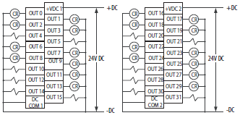

Figure 27. OB32 24V DC source output card
[6]
- Digital Input (DC) Selection, Specifications & Wiring
  - 1769-IQ16 (16 input, 24V DC).
  - 1769-IQ16F (16 input, 24V DC, high-speed).
  - 1769-IQ32 (32 input, 24VDC).
  - !769-IQ32T (32 input, 24V DC, terminated input module).
The highlighted input module was chosen. The existing installation already had an IQ32 card fitted, made sense to keep continuity, and cost effective. I did not choose the terminated input module, its cost effective not to, and this method is preferred. The previous I/O list (Figure 26) shows the total number of DI required was 71. Adding an extra 20% to ‘future proof’ the installation, takes the total to 85.2 (Figure 27) , therefore 3x 32 input cards will be needed.
Inputs | 32 (8 points/group)
Voltage Category | 24V DC sink/source
Max inrush current | 250mA
Fixing | DIN rail or Panel mount
Wire size | 22….16AWG Stranded  22….14AWG Solid
Wire type | Cu-90⁰C

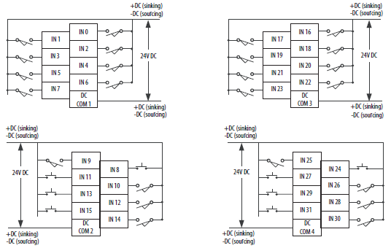

Figure 28. IQ32 24V DC sink/source input card

[6]
- Analogue Input (V DC) Selection, Specifications & Wiring
  - 1769-IF4 (4 voltage/current inputs.)
  - 1769-IF4I (5 isolated voltage/current inputs).
  - 1769-IF4X0F2 (4 combined input & output module).
  - 1769-IF8 (8 voltage/current inputs).
  - 1769-IF16C (16 currents inputs).
  - 1769-IF16V (16 voltage inputs).
The highlighted analogue voltage input module was chosen. The existing installation had an IF16V card installed but wasn’t being used. This model was kept as it was cost effective. Previous I/O list showed that 16 AI was required, with a 20% extra built into the design that takes it up to 19.2,(Figure 27), therefore two cards would be required.
Inputs | 16 single ended
Input Range | ±10V, 0-10V, 0-5V, 1-5V
Current draw | 70mA @ 24V
Rated working voltage | 30VAC/30VDC
Fixing | DIN rail or Panel mount
Wire size | 22….16AWG Stranded  22….14AWG Solid
Wire type | Cu-90⁰C

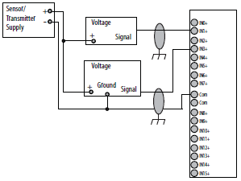

Figure 29. IF16V voltage analogue input card
[6]

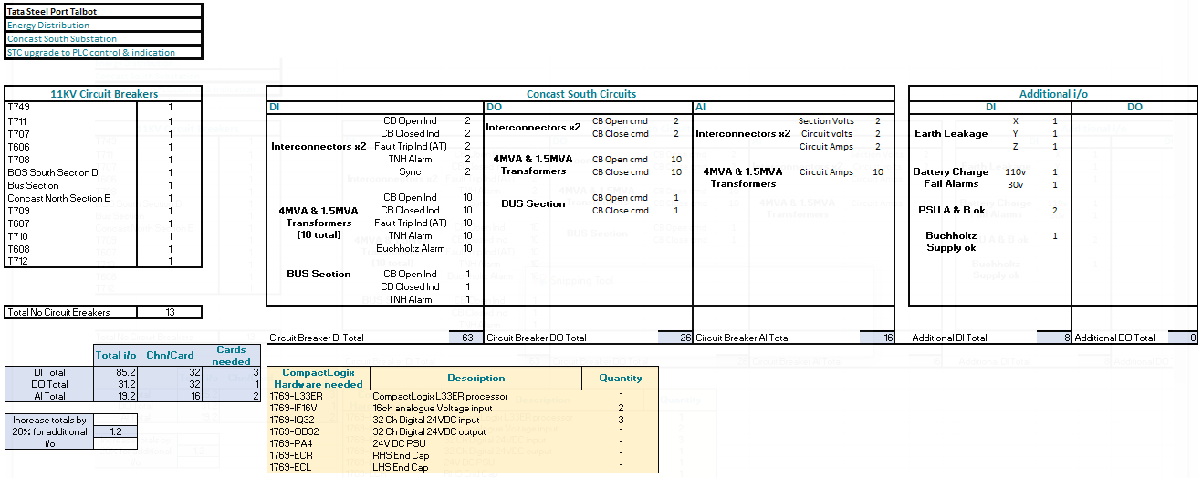

Figure 30. I/O Count

I/O Configuration
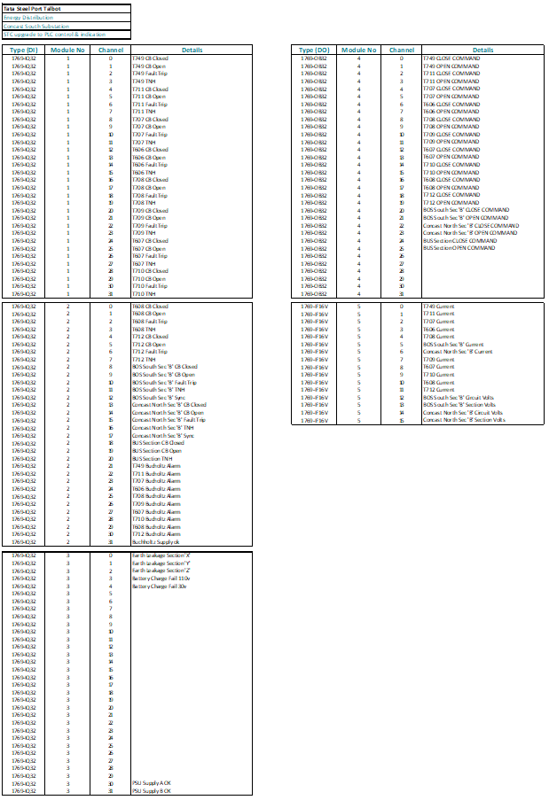
Each input and output was assigned a I/O module and a channel. Figure 31. See Appendix for larger images.
Figure 31. I/O Configuration

Current Consumption
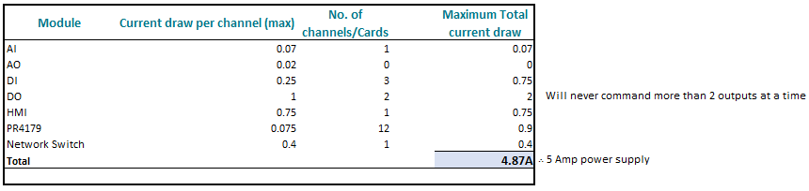
The maximum current that can be drawn from the Concast South control panel upgrade is 4.87A @ 24V DC. The equipment list and currents used are shown in the spreadsheet below (Figure 31).
Figure 32. Current Consumption

Control Panel Power supply
An Allen Bradley 1606-XLS 120E DIN rail mountable power supply was chosen to power up the control panel equipment. It has an output of 24V DC and up to 5A, Operating on input voltage ranges of 100-240V AC or 110-150V DC. Two 24V power supplies will be installed, this allows for one power supply to be fed from 230V AC substation auxiliary supplies, and the other from the 110V DC substation batteries. This offers redundancy, decreasing the possibility of a power failure to the control panel components. A power fail alarm will be incorporated into the new upgrade.

Materials/Hardware
The following spreadsheet (Figure 32) shows the hardware required for the upgrade. It states the quantity required, quantity already on site and the quantity needed to be ordered. Purchase Orders (PO’s) were created, and once passed by the HV section manager, Purchase Requests (PR’s) were sent to Routeco, RS components and Tata main stores (on-site).
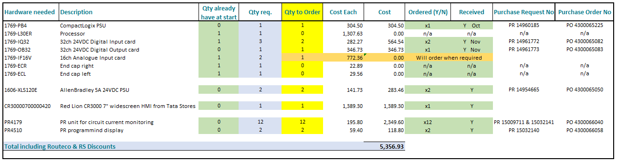
The total cost for the hardware is £5356.93 (See Appendix for full spreadsheet)
Figure 33. List of Hardware & costs

The following spreadsheet, Figure 33, shows materials needed to build the new Concast South HV switchgear control panel, their costs, quantities and total cost.
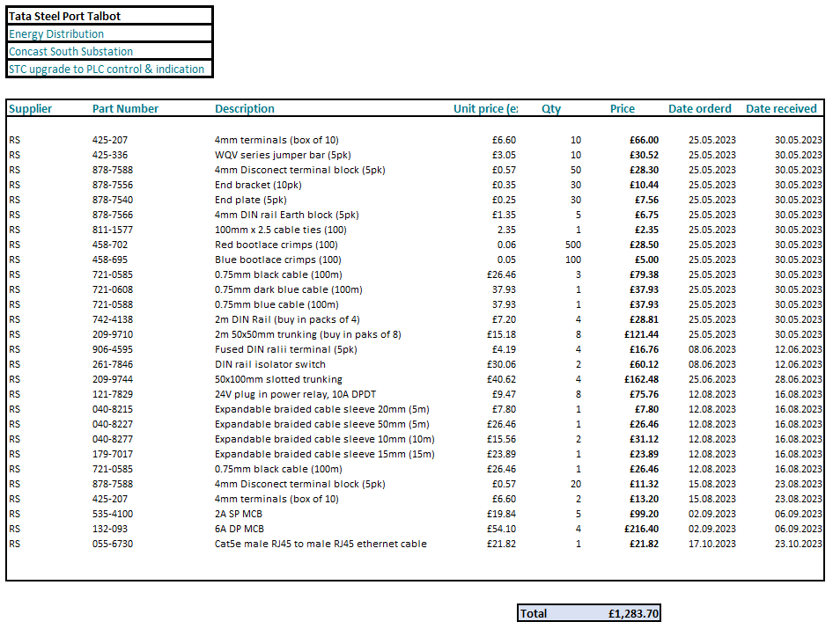
All these items were ordered from RS Components. The RS ‘punch out’ catalogue can be accessed through the onsite SAP system, when ordering, a PO is created, once approved by management a PR is sent to RS. Once an item has been received a Goods Receipt Note (GRN) has to be created on SAP, this then pays the company for the goods.
Figure 34. List of materials and costs

****Cable size – PLC info says acceptable cable range****

Design layout of panel & wiring diagrams
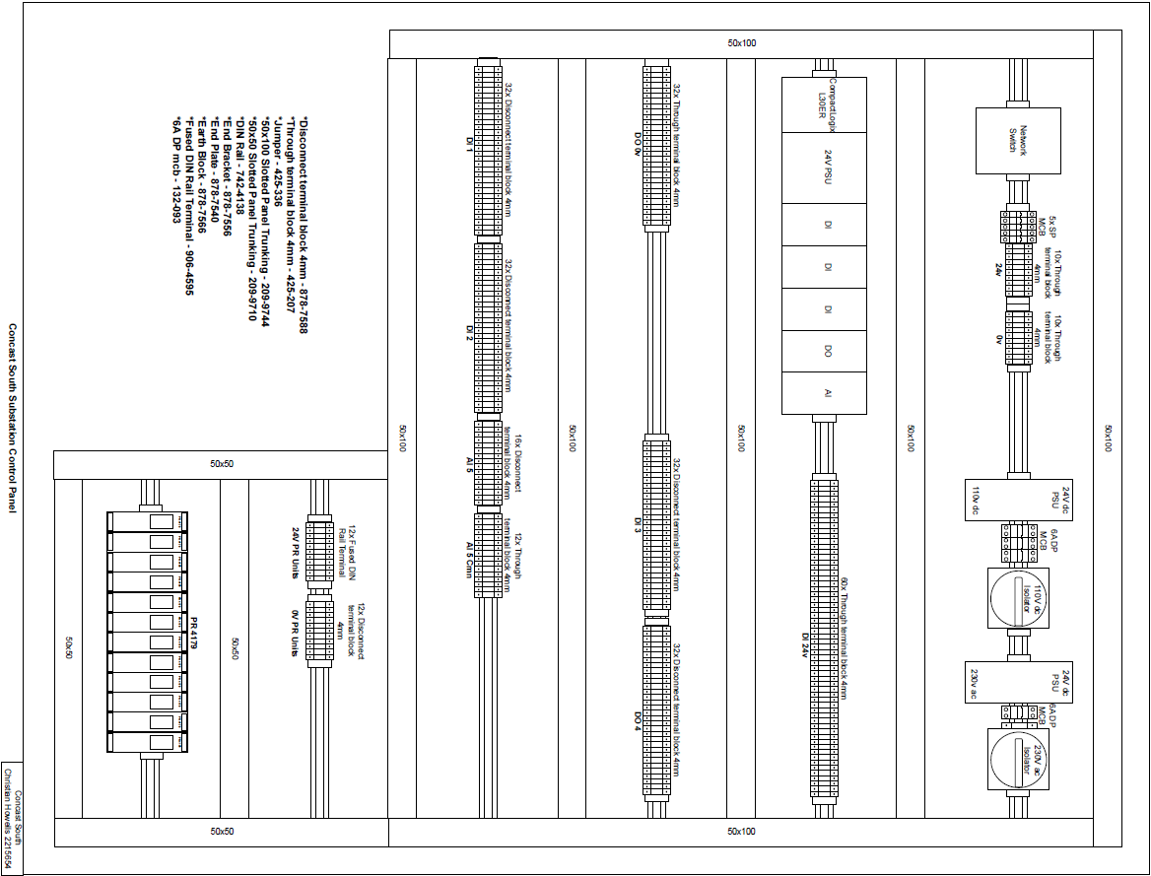
Using the existing drawings, the list of I/O and dimensions of all materials/hardware, I was able to create a layout for the new control panel, Figure 35. Initially drawn using pencil and paper, and later composed using the free online diagram software named ‘Draw.io’. The materials used are listed in bottom left corner. (See Appendix for larger drawings).
Figure 35. New control panel layout

Digital Output connection diagram
Figure 36 below is the connection diagram for the digital outputs for all Energy dept owned 11KV circuit breakers, consisting of:
- DO 4, Digital Output module.
- TB 4, Terminal Block.
- Open & Close 24V Octal Relays.
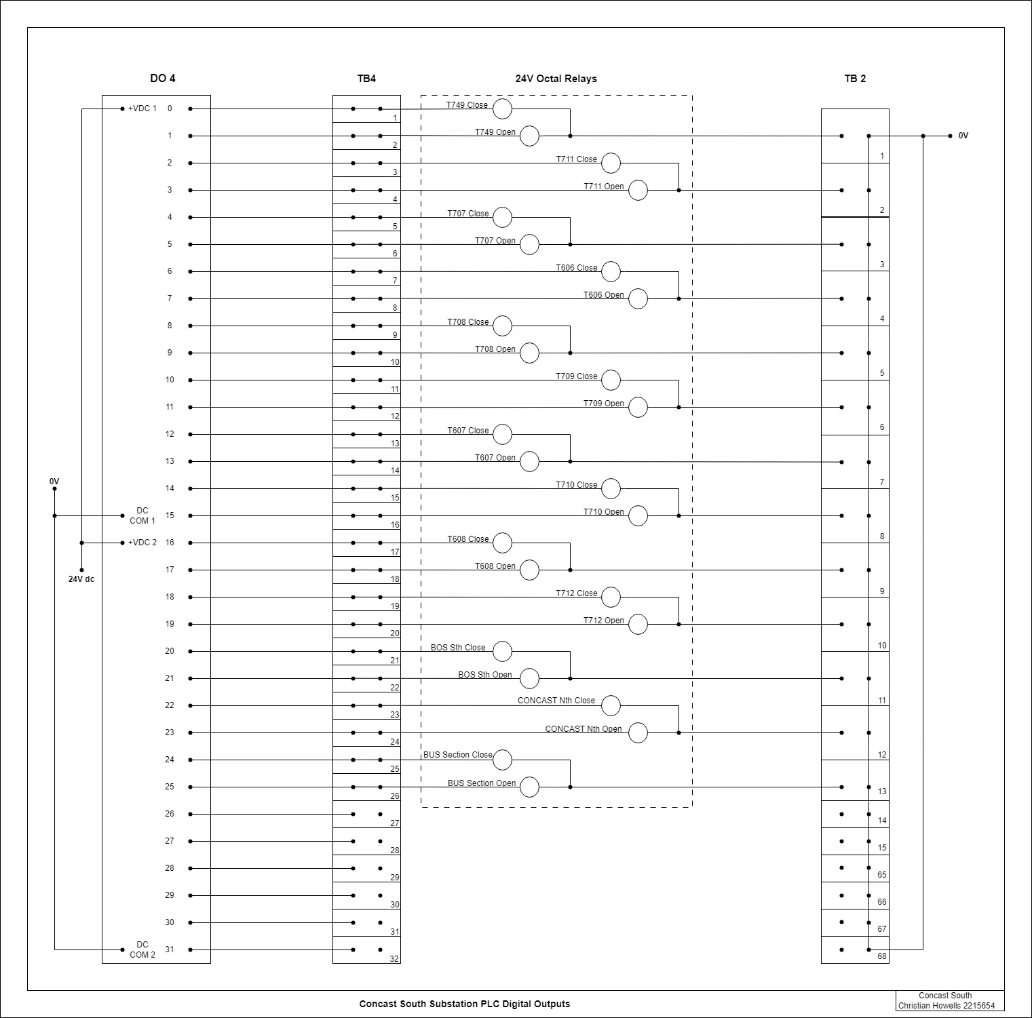
- TB 2, Common 0V Terminal Block.
Figure 36. DO4 Digital Output Connection Diagram

Digital Input Connection Diagram
Figure 37 shown below is the digital input connection diagram for 8 of the Energy owned 11KV circuit breakers within the substation, comprising of:
- DI 1, Digital Input module.
- TB 5, Terminal Block.
- Indication returning from circuit breaker, master trip relay and TNH relay.
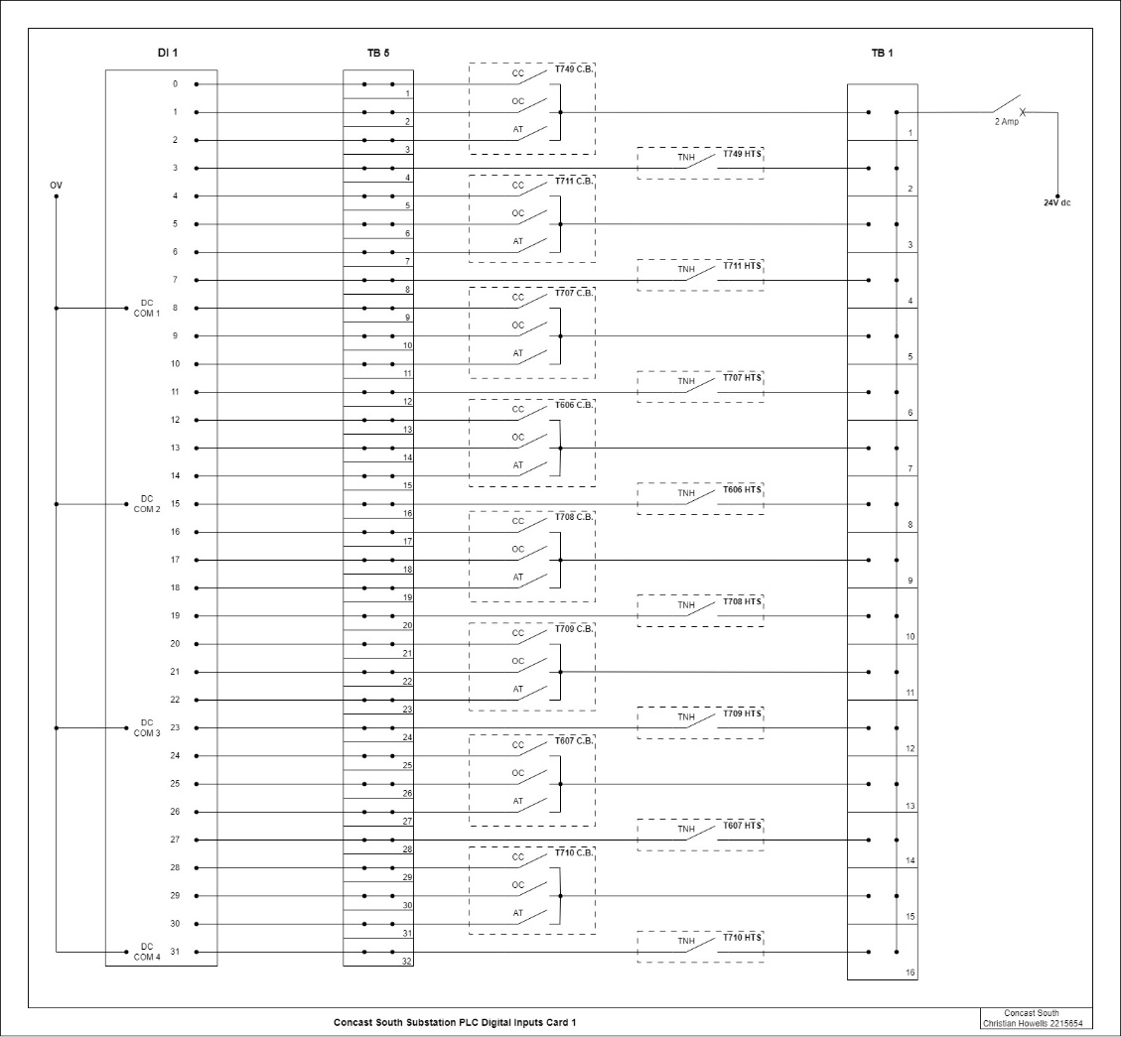
- TB 1, Common 24V terminal block used for Dis.
Figure 37. DI 1 Digital Output Connection Diagram

Analogue Input connection diagram
Figure 38 is drawing number 1 of 4 for the analogue input connections. It represents four of the Energy owned analogue inputs and used as a means of indicating the current flowing in each 11KV circuit.
- AI 5, Analogue Input module.
- TB 7, Terminal Block.
- PR4179, one per circuit receiving circuit current from CT. The input is 0-1A, output set up for 1-5V. Each PR unit requires a 24V power supply, which is fed from FB & LB.
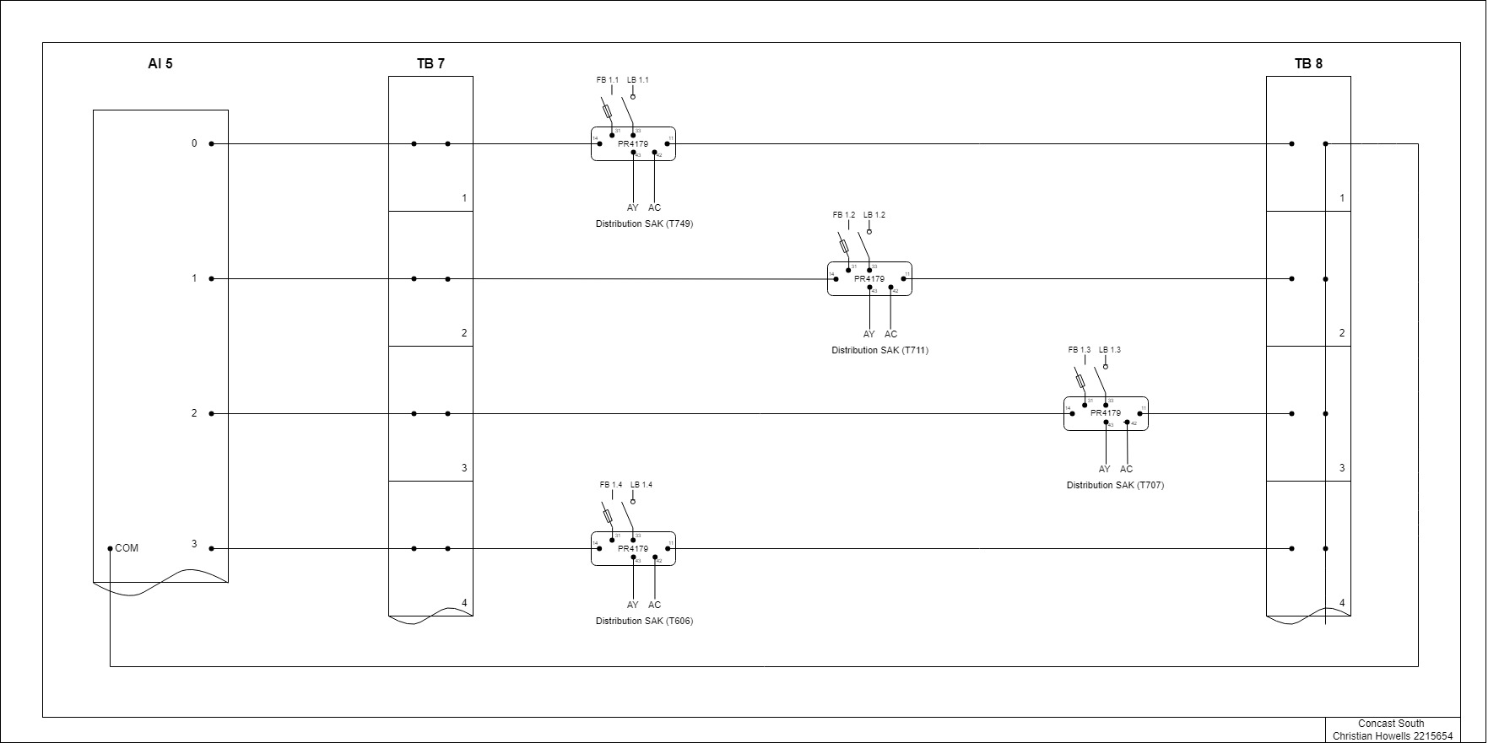
- TB 8, is a common point which connects back to AI 5.
Figure 38. AI5 Analogue Input Connection Diagram (1/4)

T749 Control Relay connection diagram
The control and TNH relays for T749 are shown in Figure 39. It is the same arrangement for all other 11KV circuit breakers.
- CR relay has a 24V DC coil, energized by a 24V DC pulse from DO4.0. (TB4.1). A common 0V originates from TB2.1. The pulse will stop when the closed indication is received in the PLC, or if it times out. Two contacts in the octal relay are used to send a 110V close signal to a closing contactor in the circuit breaker.
- TR relay has a 24V DC coil, energized by a 24V pulse from DO4.1 (TB4.2). It utilises the same 0V as the CR relay. The pulse will stop when the open indication is received in the PLC, or if it times out. Two contacts in the octal relay are used to send a 110V open signal to a trip coil in the circuit breaker.
- HTS relay, is the healthy trip supervision, it has a 48V DC coil. When the circuit breaker is closed a 3K3 resistor is used in series with the 1920Ω coil to drop the 110V down to 48V. If the trip circuit was to become unhealthy i.e., the trip coil goes open circuit or trip fuse blows, the HTS will de-energise, causing the contacts within the octal relay to open, which will in turn generate a TNH (trip not healthy) dropping the DI into DI1.3 out (TB5.4). TB1.2,the 24V DI rail is used for this input.
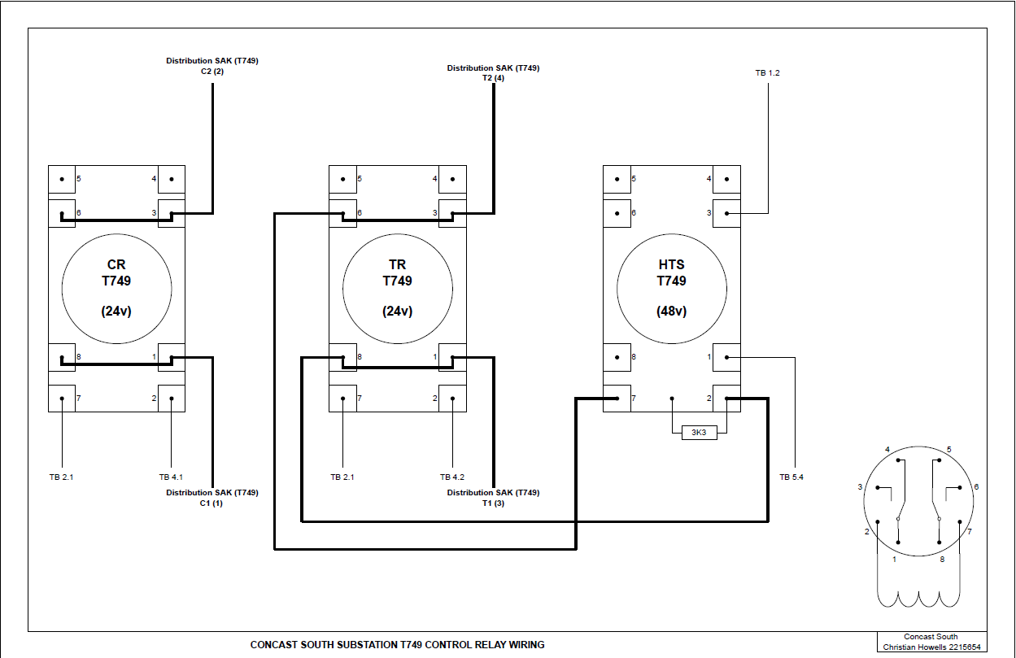
Figure 39. T749 Control Relays

T749 Distribution SAK block
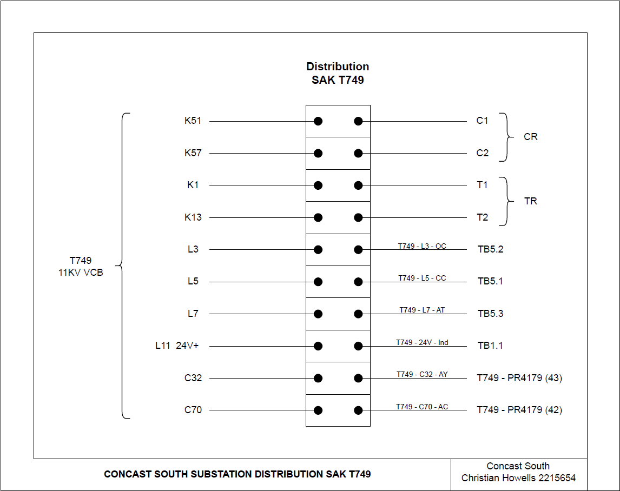
The Distribution SAK block is where the new installation meets the existing installation. The diagram below is for T749 (Figure 40). The close (K51/C1, K57/C2) and open (K1/T1, K13/T2) merge into the VCB control wiring. The circuit breaker position indications are connected to auxiliary contacts (L3 & L5) within the VCB. There is a contact on the master trip relay located on top of the main VCB unit; when operated sends 24V to the PLC card on L7/AT. A common 24V DC is set to the VCB for these indications. The secondary side of the indication CT enters the STC apparatus cubicle on C32 & C70, they are then connected into the PR4179 unit.
Figure 40. T749 Distribution SAK block

1.5MVA 11KV/415V Updated schematic diagram (zoomed in)
Figure 41 shows the changes made to the indications AT, OC, CC, and the accompanying source voltage, 24V DC. The original 110V DC used for these indications has been removed, see Figure 24 for original schematic.
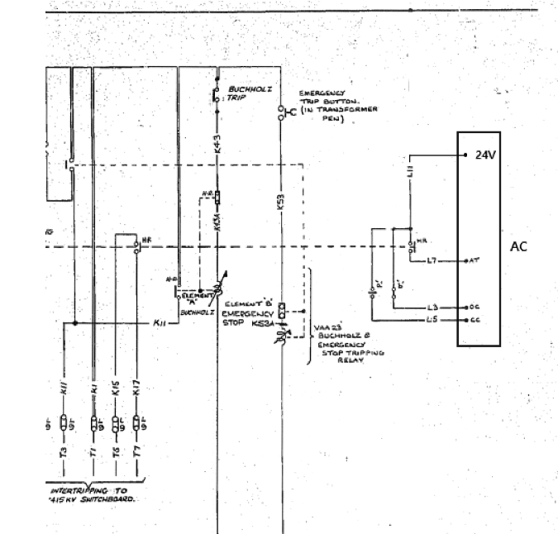
Figure 41. Updated VCB indication diagram

*****New 240v power to cubicle
Cable size calculation.*****

Control Panel Build

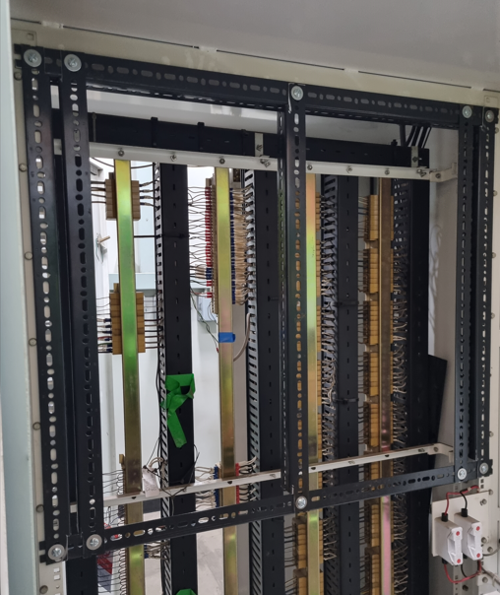
Figure 42. Framework construction within control panel

Once the control panel layout and a plan for wiring was completed, I was able to start building the panel. The components within the panel needed a fixing point, so the first action was to build a framework within, Figure 42. 90⁰ angle brackets were cut and bolted in place for this purpose.

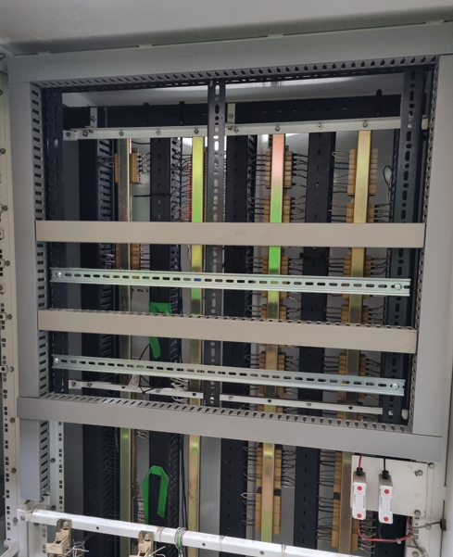

Figure 43, DIN rail and the slotted trunking have been mounted on the newly built framework.

Figure 43. DIN rail & trunking mounted
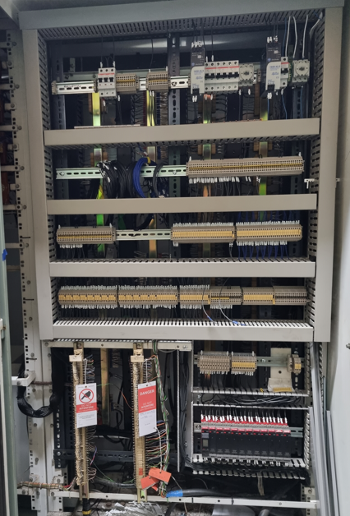
Additional DIN rail, slotted trunking, PR units, mcb’s, terminal rails, 2x 24V power supplies and 2x isolator switches have been mounted (Figure 44). Control panel wiring has begun. It was at this point that I realised 50x50mm trunking would be too small, larger slotted trunking 50x100mm was purchased and fitted in its place.
A list of clip-on ferrule IDs was compiled. I asked a colleague from a different team to print them out for me (I don’t have access to the equipment) once printed they were ready to be used on the corresponding core.
Figure 44. Component mounting in Control panel

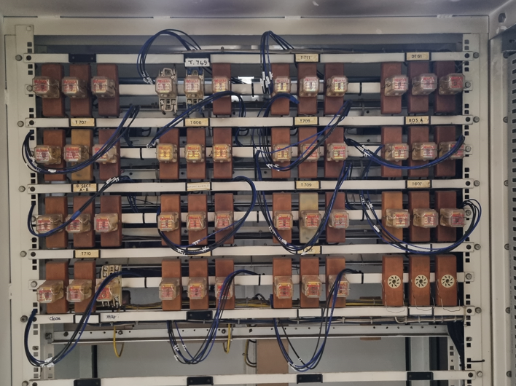
The existing control relay bases are being re-used. The CR and TR relay will become 24V rather than 48V. The HTS relay will remain 48V. Figure 45 shows the wiring run in ready for connection to the relay bases, for all thirteen Energy department circuits.

Figure 45. Wiring ready for control relays

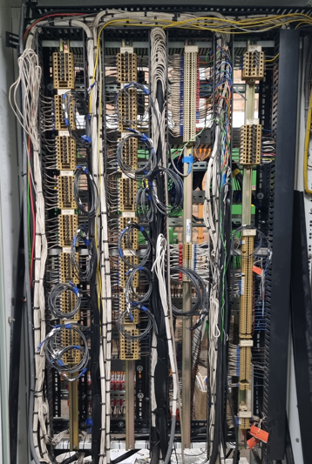

The Distribution and Interconnected SAK blocks for each 11KV VCB is shown in Figure 46. The Cabling for the Buchholz and Earth Leakage alarms also arrive in this panel. The wiring has been run in ready for connection. It looks untidy at the moment, but once the connections have been made and redundant cabling removed, all lids will be replaced.

Figure 46. SAK block panel

The 24V power supplies have been powered up. One from the existing 110V DC sourced from substation battery system and 240V AC from a local Fuse Board FB 194/3/1/1 B1. A day was chosen to relocate the PLC and Hirschmann Network Switch.
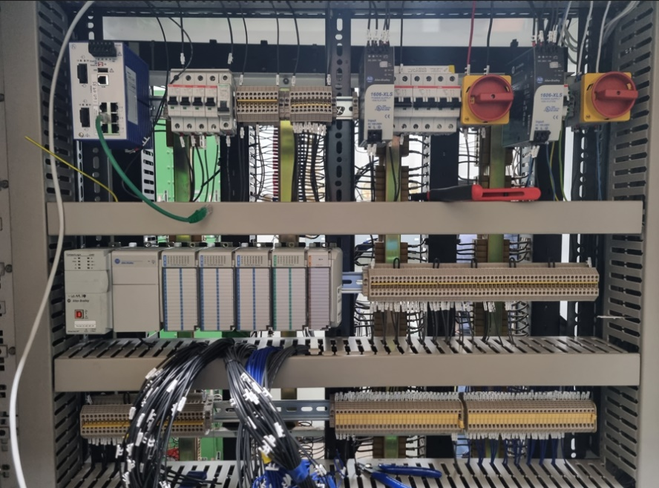

Figure 47.Re-locating PLC & Network Switch

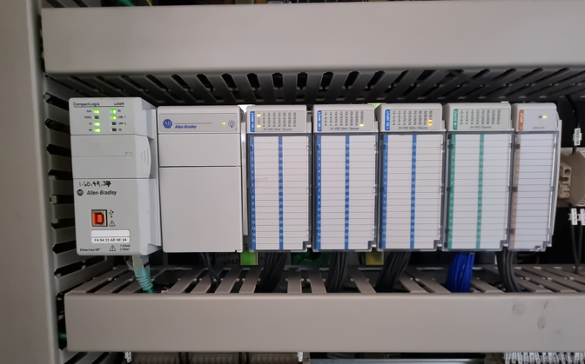
Figure 48 shows all input and outputs connected to their designated I/O channel. The existing Buchholz and Battery charger fail alarms were given alternative I/O addresses to correspond to the new I/O schedule list. This was done by the department PLC engineer.

Figure 48. PLC connected

****Testing PR unit in workshop with Sverker injection set.******

PLC Programming
Begin PLC programming
Re-locate PLC and wire in Buchholz alarms into new location

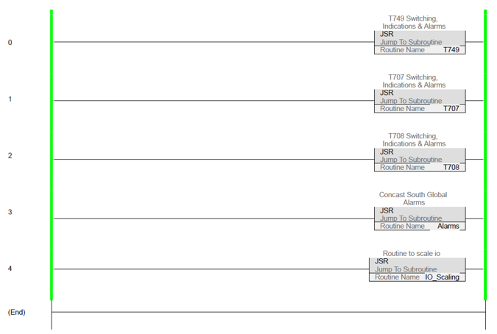

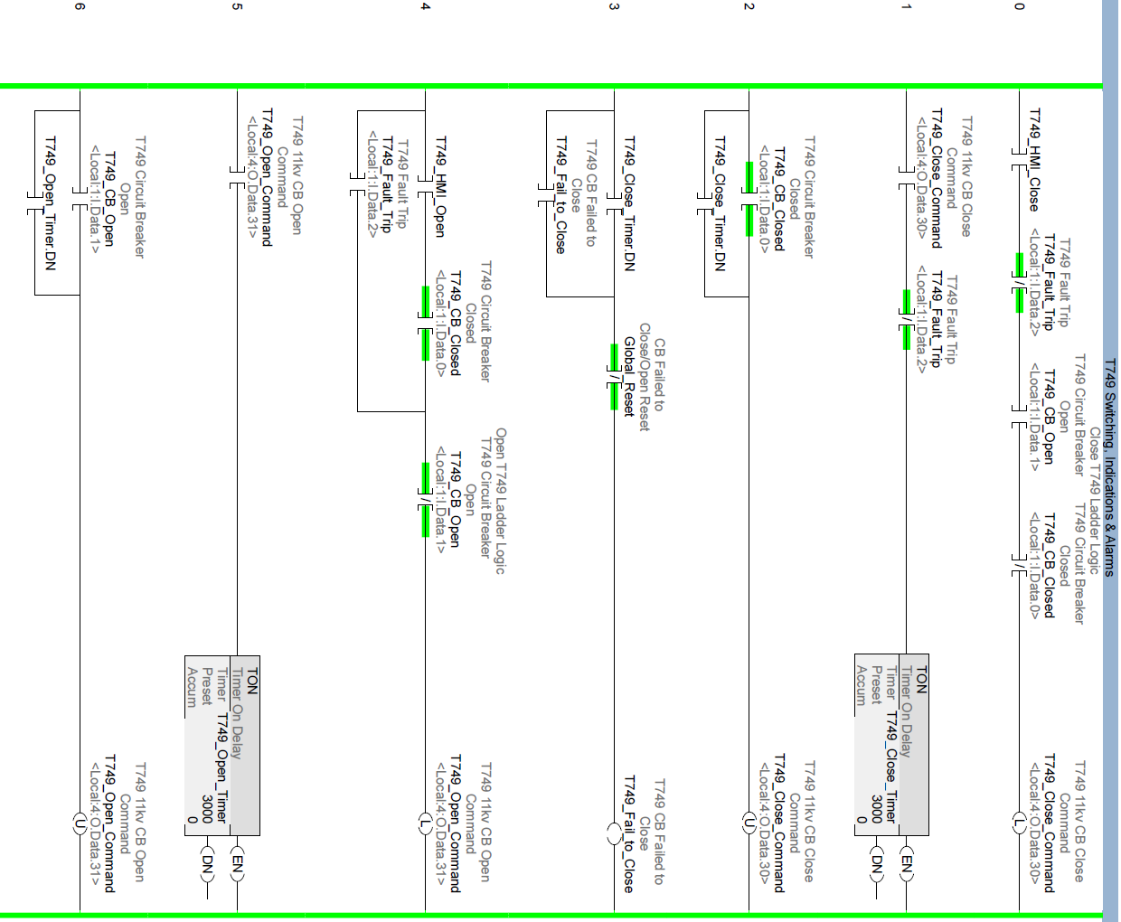
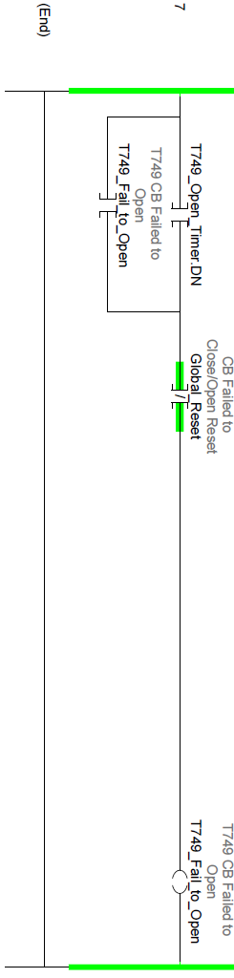

HMI Programming
Begin HMI programming
Import tag names from PLC L5K file
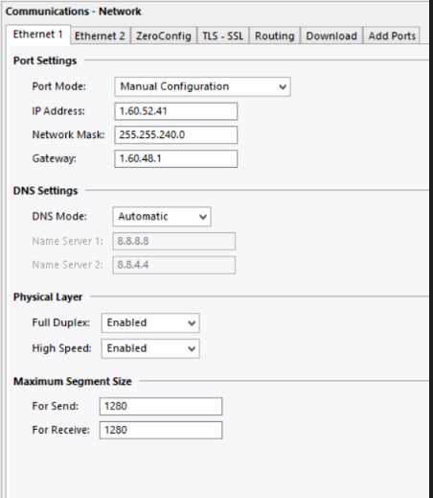
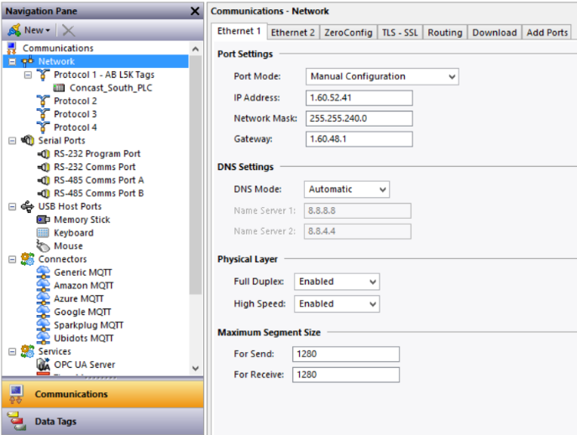

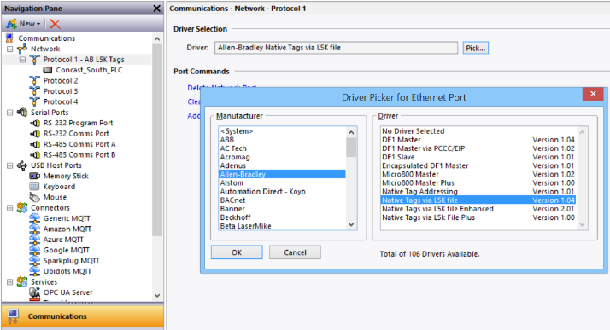
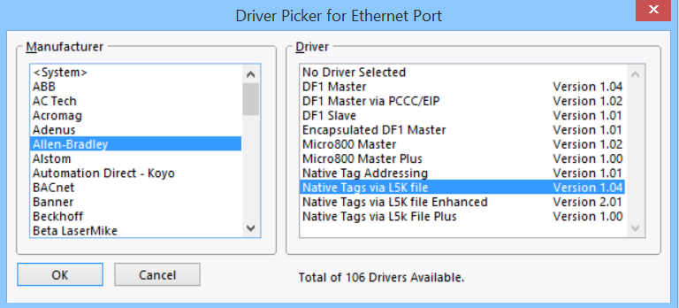

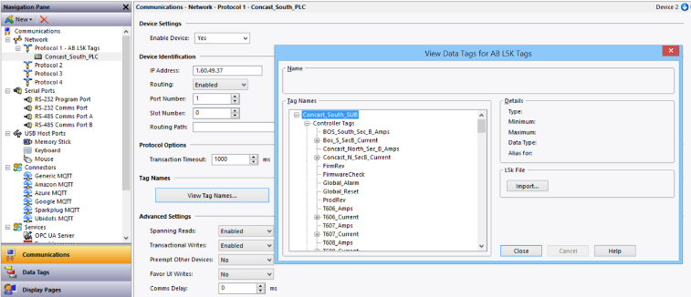

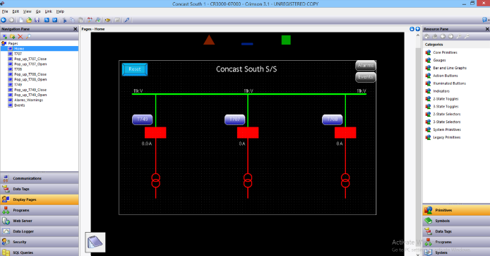

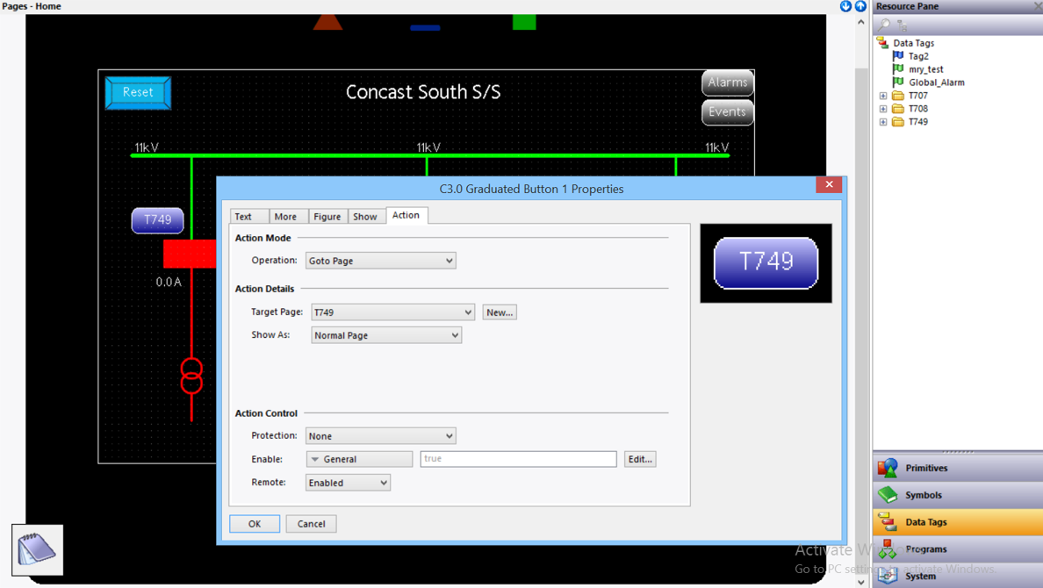

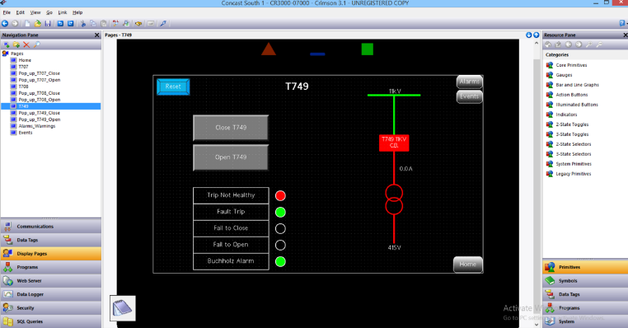

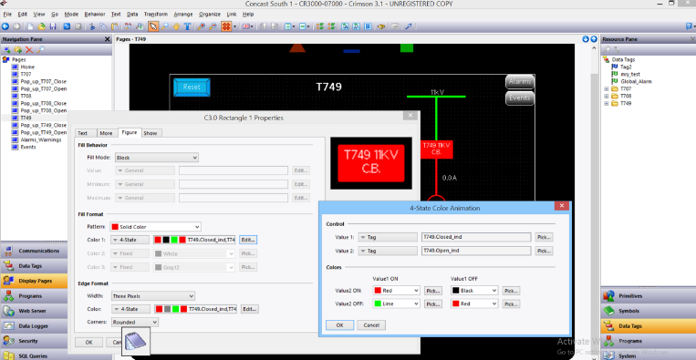

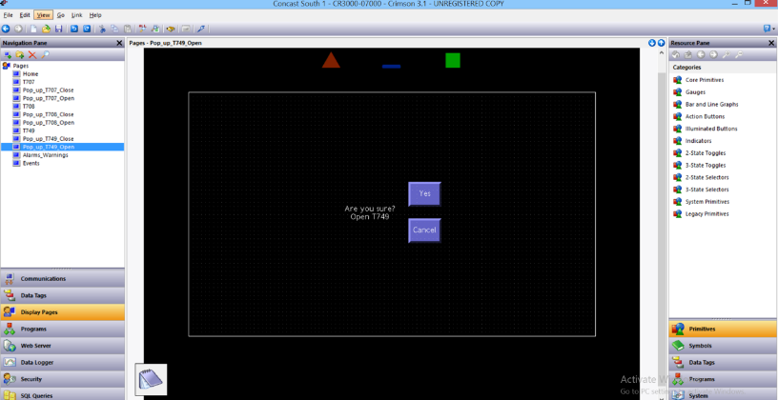

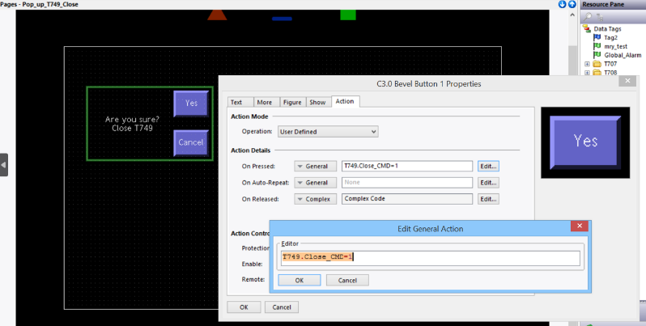

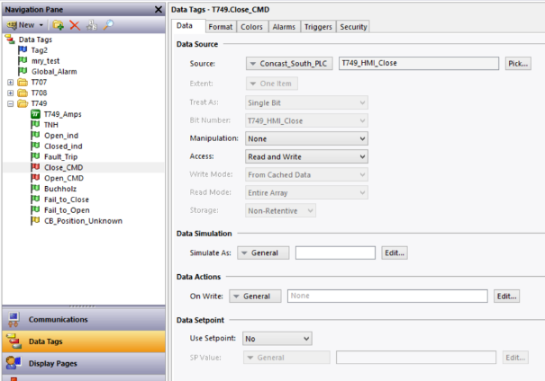

Testing on T749
Once all preparation work was completed, the circuit (T749) needed to be isolated so final connections and testing of the operations via HMI/PLC could be made.
Concast South has a ‘spare’ 700 series transformer, this allows maintenance and testing to be undertaken even when the Concast is running. It also offers redundancy in case of any faults. Knowing this, in our weekly planning meeting I requested an isolation with an SFT (Sanction for Test) permit issued on it for the following week.
****Insert copy of my SFT****
The list of work to be done on the day:
- Remove 110V DC +/- fuses on VCB main unit and disconnect wiring from rear of them. Also remove links on T749 Distribution SAK block.
- Locate L12 cores in control termination panel at rear of VCB, main unit and in STC apparatus cubicle, replace ferruling with L11 24V. Connect L11 24V together in VCB upper unit.
- In control termination panel and apparatus cubicle, identify spare core on control cable, this to be identified as L3 OC (VCB open indication, The STC control didn’t require an ‘OC’, so this is an addition). Connect onto relevant position at VCB, and in apparatus cubicle
- Terminate wiring on control relays in apparatus cubicle, removing old wiring.
- Terminate new wiring on Distribution SAK block in apparatus cubicle, removing old wiring.
- Terminate relevant wiring in new control panel.
- Replace links in Distribution SAK block and insert 24V octal relays into ‘CR’ and ‘TR’ relay bases.
- Using HMI, Close VCB.
  - Check indication updates on HMI (green closed indication).
  - Open the closed indication link on TB5.1, check for indication error on HMI (red).
  - Remove tripping fuse from VCB main unit, check for TNH indication on HMI.
- Using HMI, Open VCB.
  - Check indication updates on HMI (grey/black background open indication).
  - Open the open indication link on TB.2, check for indication error on HMI (red).
- Using HMI, Close VCB.
  - Use a SVERKER780 Current injection test set, to inject current into protection relay (connections A70 +A71 in VCB upper unit).
  - Check VCB position indication updates (open), Fault trip indication updates, Fault trip indication on alarm page and audible alarm on HMI.
  - Reset relays.
- Using SVERKER 780 Current injection test set, inject 1A on secondary side of 150/1 CT (connections C32 + C70 in VCB upper unit). Check reading on PR4179 + HMI, should be 150A.

****Tests – include issue with Current scaling block in PLC****

Video clips of Tests on T749 & T707
The following links are for Unlisted YouTube videos. They show the tests I conducted using the new HMI at Concast South Substation to control HV switchgear.

- T749 Close & Open VCB - https://youtu.be/8yvQvzPYpTw
- T749 Fault trip - https://youtu.be/mtzzmcC9I4c
- T749 Amps - https://youtube.com/shorts/kXy-Mp4dPIc
- T749 Indication Error - https://youtube.com/shorts/UPQII18Zm8E
- T749 11KV/415v walk around - https://youtube.com/shorts/DrkLTotWtwQ

- T707 Close VCB - https://youtu.be/B5plBkZ4MJM
- T707 Fault trip - https://youtu.be/8OZViyljFXI
- T707 Amps - https://youtu.be/YPE2GdYgab4

This is a major section which describes your deliverable. It may be a software artifact, a new framework, a systems design, etc. This may span more than one chapter and will have title(s) which reflect its content.
Design
If you’ve built something to solve a problem, you had to make some design decisions along the way. Why did you choose to do something one way rather than another? Why did you choose to include one thing but leave out something else? Which factors did you think were most important and which did you choose to ignore?
Don’t just list your decisions; place them in a context. It should be possible for the reader to understand how your design decisions contributed to meeting your objectives. Also important is that you show the method by which you accomplished your design - “process” is as important as “product” to an engineer.
- What processes did you use?
- How did they contribute to ensuring that what you did was complete/consistent/correct?

It should be possible for the reader to understand how your design decisions contributed to meeting your objectives. Also important is that you show the method by which you accomplished your design - “process” is as important as “product” to an engineer. What processes did you use? How did they contribute to ensuring that what you did was complete/consistent/correct? Don’t just write about what you did, or how you did it. Why you did it is most important.

The starting point for your design is, of course, your requirements. In some projects the requirements are specified in advance. The customer provides a document that (in more or less detail) specifies the behaviour of the item to be constructed. More commonly, the customer has a more vague “need” for something, and it is part of the project itself to refine that into a more detailed set of requirements. A project that doesn’t have a written set of requirements is not a very good one, though it would not be normal to describe the requirements in much detail in the body of the report. It is better to include the requirements specification document as an appendix to your report. If a detailed discussion of how you elicited, analysed and specified the requirements is necessary, (for “necessary”, read interesting and relevant), it could be a separate chapter before this one.

A project that doesn’t have a written set of requirements is not a very good one, though it would not be normal to describe the requirements in much detail in the body of the report. It is better to include the requirements specification document as an appendix to your report. If a detailed discussion of how you elicited, analysed and specified the requirements is necessary, (for “necessary”, read interesting and relevant), it could be a separate chapter before this one.
The “design” stage is often held to be the key stage of your project. It is certainly the part of project reports that is most closely looked at by external examiners! It is the one where you can show off your ability to apply your engineering and commercial knowledge and skills to best advantage. This is precisely what you will be doing in your working life if your chosen career is in any way related to your degree.
In terms of computing projects, this section will include details of algorthms, data structures, file systems, user interfaces etc.
Implementation
After you designed your solution to your problem, you implemented it. This section normally describes how you did that. What tools and techniques did you use? What difficulties did you encounter, and how did you overcome them?
Some students believe that this section is equivalent to writing the internal documentation of a program. It isn’t. This chapter of your report should only address issues that are interesting. Mundane details about how the program is structured should be left out. On the other hand, if you developed a new algorithm or applied an old technique in a new way, then that is of interest and should be included.
Do not include all or significant amounts of code in your report, only include code fragments to illustrate a technique that was used. Focus on why you have implemented the system, application, program, etc, in the way you have to achieve the results you have obtained.

If, in your project, you designed something but did not build it, there may still be scope for an equivalent to this chapter, in that you could discuss issues that would probably arise during future implementation and provide advice on how potential problems could best be prevented or solved.
Involving potential users of the system in the evaluation is always a good idea. If this can be done in a simulation of the real environment, then so much the better. Feedback from users which is structured is more useful than their verbal comments.
You do not want to give lots of boring, mundane detail here. So, for example, you would not normally describe in excruciating detail exactly what tests you conducted and their results, but you would describe in general terms what you did (your strategy) and what results you obtained.

Evaluation
Evaluation usually comes in one of two forms: either you compare what you did with your objectives, or you can compare what you did with what someone else did.
- What conclusions can be drawn from your data?
- Did your data back up the research in your literature review or disagree with it?
- Did you meet your objectives? If not, why not?
- Did you meet your aim? If not, why not?
- Overall, are the answers what you would expect? If not then why not?
- If you were to do it again, what would you do differently?
Different HMI screen size, anything that could be done differnetly

Conclusions & Recommendations

- This section should summarise everything you have done
- Does your project suggest any further avenues for research?
Addition that can be made (wireless etc), additional time, cost implications of adding
This chapter is where you tie up all the loose ends in the previous chapters. It is most important that it relates to what you have described previously, and that it does so in a relevant and concise fashion.
In your summing-up, you need to show how what you did contributed to meeting the objectives you set in the introduction. In doing so, it is appropriate to repeat (in summary form) key points from your review, design, implementation and evaluation as necessary.
Any further work that can, or should, be undertaken to expand upon your work is to be highlighted, fully explained and justified. The benefits gained from your work should be identified (these are not to include personal benefits). Also, any recommendations should be included here.
It is perfectly OK to have some loose ends left at the end of a project. Sometimes there will be aspects you simply did not have time to address. Other times there will be things that you were unable to do because of force of circumstances. Above all, there will have been pointers raised during the course of the project that you did not anticipate and were not within your scope to tackle. All these things can be discussed in this chapter and, where further work can be identified, a distinct sub-section, “Suggestions for further work”, should be included.

Reflection

The key question here is:
- What did you learn while doing the project? How did it change you as a person?
What things have been learnt, how did I develop, don’t dwell on negative things
You will need to reflect upon the work that you’ve done and there is a specific mark allocated to this in the marking scheme. Reflection is the process of looking back at something which has happened in order to show what you have learned from it. The purpose of reflective writing is to help you learn from a particular practical experience. It will help you to make connections between the documented theory and what you did in practice. Through reflection, you should be able to make sense of what you did and help yourself to do a superior job next time. Put simply - could you have done it better and, if so, how?

Think of the project in a broader context – not just the technical skills you might have gained but “soft” skills too. This is probably the biggest individual project you have ever done – think about skills such as time management, recovering from setbacks and so on.

References

[1] | Tatasteel Electrical Committee, High Voltage Safety Rules EIS 5, Tata Steel UK Ltd, 2011.
[2] | Science museum group, “standard telephones and cables PLC 1883-1991,” STC, [Online]. Available: https://collection.sciencemuseumgroup.org.uk/people/cp33741/standard-telephones-and-cables-plc. [Accessed 02 April 2024].
[3] | Tata steel, Schematic diagram Matrix system for switchgear control & Indication, 1979.
[4] | H. Jack, Automating Manufacturing Systems with PLCs, Boston: GNU free documentation , 2007.
[5] | “1769-L20, 1769-L30 CompactLogix™ Controllers,” Rockwell, April 2003. [Online]. Available: https://literature.rockwellautomation.com/idc/groups/literature/documents/in/1769-in047_-en-p.pdf. [Accessed 04 04 2024].
[6] | Rockwell Automation, “1769 Compact I/O Modules Specifications,” Rockwell Automation, Nov 2023. [Online]. Available: https://literature.rockwellautomation.com/idc/groups/literature/documents/td/1769-td006_-en-p.pdf. [Accessed 04 April 2024].
[7] | J. P. &. M. Dood, “Case study of Digital Control Systems for high-voltage substations,” Western Area Power Administration, South Carolina, 2006.
[8] | S. S. B. ,. P. K. A. T. T. P. Bhushan Keda Ahire, “Substation Fault Monitoring and Controlling using PLC and HMI,” Sandip Institute of Engineering and Management, Nashik, 2018.
[9] | M. S. C. Kundargi, “Automation in Substation using Programmable Logic Controllers,” International Research Journal of Engineering and Technology (IRJET), Karnataka, India, 2019.
[10] | R. S. A. R. A. A.-A. Jawad Radhi Mahmood, “PLC/HMI-Based Implementation of a Real-Time,” Creative commons attribution, Basel, 2020.
[11] | Red Lion, “HMI Solutions,” Red Lion, [Online]. Available: https://www.lcautomation.com/wb_documents/redlion/red%20lion%20graphite%20hmi%20brochure.pdf. [Accessed 09 April 2024].
[12] | P. R. M. J. L. D. V. S. V. K. S. S. S. Jayanth R, “Study of Interfacing PLC With HMI for Industrial Applications,” in 2023 Second International Conference on Electronics and Renewable Systems (ICEARS), Tuticorin, 2023.
[13] | a. G. G. B. Kondala Rao, “Development and Application of Vacuum Circuit Breaker Model in Electromagnetic Transient Simulation,” 2006. [Online]. Available: https://ieeexplore.ieee.org/stamp/stamp.jsp?tp=&arnumber=1632503. [Accessed 06 April 2024].
[14] | GEC Distribution Switchgear Limited, Vacuum Distribution Switchgear Type MXs Units, Manchester: GEC, 1979.
[15] | HSE, “HSE Glossary - Standards,” HSE, [Online]. Available: https://www.hse.gov.uk/work-equipment-machinery/glossary.htm. [Accessed 04 April 2024].
[16] | “Voltages And Their Classifications,” Network Power Connections, 2024. [Online]. Available: https://networkpowerconnections.co.uk/voltages-and-their-classifications/#:~:text=Extra%20high%20voltage%20or%20EHV,or%20LV%3A%20up%20to%201000V. [Accessed 06 April 2024].
[17] | D. White, “TCS Operational & Safety Switching,” 22 Nov 2019. [Online]. Available: https://www.transmissioncapital.com/pdf/safety_rules/SHEQ-TCSESR-SP-002-3.0_SR_Supporting_Procedure_2-Operational_&_Safety_Switching.pdf.
[18] | HSE, “Keeping electrical switchgear,” Health and safety executive, 2015. [Online]. Available: https://www.hse.gov.uk/pubns/priced/hsg230.pdf. [Accessed 04 April 2024].
[19] | British Standards Institution, “BS 6626:2010,” BSI, 31 Aug 2010. [Online]. Available: https://knowledge.bsigroup.com/products/maintenance-of-electrical-switchgear-and-controlgear-for-voltages-above-1-kv-and-up-to-and-including-36-kv-code-of-practice?version=standard&tab=preview. [Accessed 2024 April 04].
[20] | IET, Requirements for electrical installations, Stevenage: IET, 2018.
[21] | International Electrotechnical Commission, “International Standard IEC 61131-1,” IEC, 2003. [Online]. Available: https://webstore.iec.ch/preview/info_iec61131-1%7Bed2.0%7Den.pdf. [Accessed 09 April 2024].
[22] | Routeco, “2080-L50E-48QBB,” Allen Bradley, [Online]. Available: https://routeco.com/en-gb/shop/programmable-controllers/micro800/2080-l50e-48qbb. [Accessed 11 April 2024].
[23] | Routeco, “1769-L30ER,” Allen Bradley, [Online]. Available: https://routeco.com/en-gb/shop/programmable-controllers/compactlogix/1769-l30er. [Accessed 11 April 2024].
[24] | Routeco, “1756-L71,” [Online]. Available: https://routeco.com/en-gb/shop/programmable-controllers/controllogix/1756-l71. [Accessed 11 April 2024].
[25] | StudySmarter, “Human Machine System,” StudySmarter, 2024. [Online]. Available: https://www.studysmarter.co.uk/explanations/engineering/design-engineering/human-machine-system/#:~:text=Role%20of%20Ergonomics%20in%20the,productivity%2C%20accuracy%2C%20and%20safety.. [Accessed 11 April 2024].
[26] | RS Components, “Red Lion CR3000 Series TFT Touch Screen HMI - 7 in, TFT Display,” Red Lion, [Online]. Available: https://uk.rs-online.com/web/p/hmi-displays/2337973. [Accessed 11 April 2024].
[27] | RS Components, “Red Lion CR3000 Series TFT Touch Screen HMI - 10.4 in, TFT Display,” Red Lion, [Online]. Available: https://uk.rs-online.com/web/p/hmi-displays/2337974. [Accessed 11 April 2024].
[28] | RS Components, “Allen Bradley PanelView 800 Series PanelView 800 Touch Screen HMI - 7 in,” Allen Bradley, [Online]. Available: https://uk.rs-online.com/web/p/hmi-displays/8937789. [Accessed 11 April 2024].
[29] | RS Components, “PR Electronics 4 Series Signal Conditioner,” PR Electronics, [Online]. Available: https://uk.rs-online.com/web/p/signal-conditioners/1682943?gb=s. [Accessed 11 April 2024].
[30] | RS Components, “JM CONCEPT ULCOS 600 Series Current Signal Converter,” JM Comcept, [Online]. Available: https://uk.rs-online.com/web/p/signal-conditioners/2328246. [Accessed 11 April 2024].
[31] | RS Components, “Socomec 192Y Series Current Transformer,” Socomec, [Online]. Available: https://uk.rs-online.com/web/p/current-transformers/2210382. [Accessed 11 April 2024].
[32] | GSH - Manager of change standard, “Management of Change Standard,” TSUK, Port Talbot, 2024.
[33] | R. King, “Control panel wiring colour codes,” Rowse, 16 07 2019. [Online]. Available: https://www.rowse.co.uk/blog/post/control-panel-wire-colour-codes. [Accessed 13 Oct 2023].

A list of references (work directly quoted or paraphrased in your text) and its source. For more information on this, see Appendices 4 and 5.

Bibliography
A list of background reading undertaken, but not necessarily directly quoted in the text.

Appendices
Appendices to a report contain information that, while not important or interesting enough to be included in the body of the report, is nevertheless relevant. Common examples include program source code, program documentation, intermediate documents. Your report stands alone without these, but the reader may occasionally wish to refer to them.

The key word here is “occasionally”. If it is crucial to read something in order to understand some point being made in the report, then that “something” should be replicated in the body of the report.

- All data used in the development of the project.
- Annotated code for any programs developed.
- Examples of questionnaires
- A summary of questionnaire results.
- Test data used to evaluate the product.
- Tables too detailed for the main text
- Technical notes
- Copies of documents not generally available but referred to in the report

(Note: If you have a lot of program source code which is too big to upload to Moodle, provide it on a CD or DVD, or ask Gaynor to set up a OneDrive folder)

https://youtube.com/shorts/DrkLTotWtwQ
https://youtu.be/8yvQvzPYpTw
https://youtu.be/mtzzmcC9I4c
https://youtube.com/shorts/kXy-Mp4dPIc
https://youtube.com/shorts/UPQII18Zm8E



