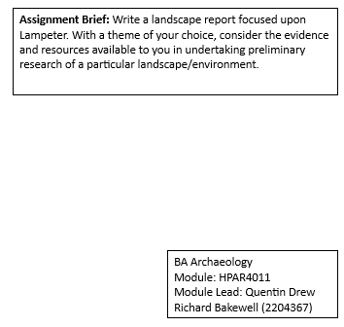
INTRODUCTION
This landscape report discusses Conti's Café at 5 Harford Square, Lampeter, Ceredigion and will present preliminary research findings from various accessible sources. The report will then explore relevant associated sites within the local area before delving into the Conti Café business in South Wales. Finally, it will examine the topic of Italian immigration to Wales before and after World War 2 before discussing the impact this has had on the Welsh Italian culture and community.

LOCATION
Lampeter is a South West Wales town and is a central location for roads leading to Cardigan Bay or the Cambrian Mountains. The town has roads that provide access to Llandeilo, Llandovery, Aberystwyth, Tregaron, Carmarthen, Newcastle Emlyn, Cardigan, and the coast. (Dyfed Archaeological Trust, 2021; Discover Ceredigion, 2024). Conti’s Café is ideally situated on the busy junction of Harford Square, where these roads converge within the town's retail area, and is close to the University (See Pics 1, 2, 3 and 4).
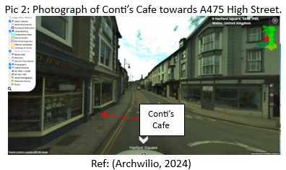
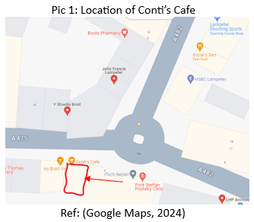

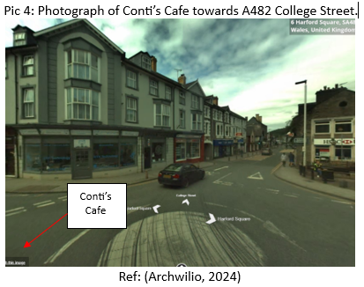
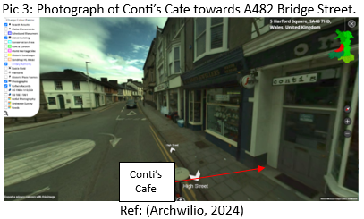

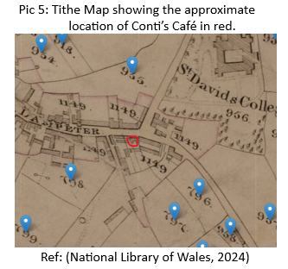
The premises are within the Lampeter conservation area, although not a listed building. Harford Square and the general outline of the building are shown on older maps, including a Tithe map (See Pic 5) from 1843 (Dyfed Archaeological Trust, 2021; National Library of Scotland, 2024).

CONTI’S CAFÉ LAMPETER
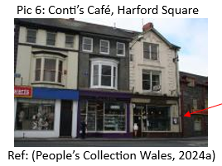
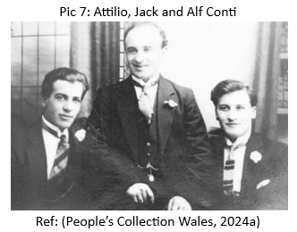
In 1933, Attilio Conti, an Italian immigrant, established Conti's café in Lampeter. The location of Harford Square was a good business decision, being within the town centre and at the junction of the three main roads. The university's location and other businesses would have provided a steady footfall of customers as it still does today. The terraced building is three stories tall and overlooks the square (See Pic 6). When it opened, Mr Conti and his brothers Alf and Jack (See Pic 7) owned 17 cafes across South and West Wales (Coflein, 2021; UWTSD, 2024; BBC, 2020). Lampeter was a natural choice for expanding their business, being well connected to Carmarthen, where they established a business circa 1925 (People’s Collection Wales, 2024).
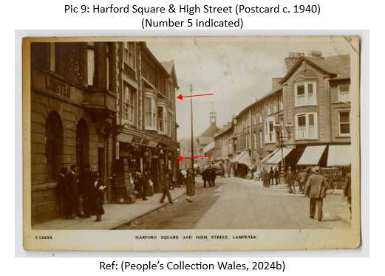
Preliminary research reveals no documentary evidence of the business and limited early photographs, including one labelled 1930, which is likely an error as other sources state the business was started in 1933 (See Pics 8, 9, 10 and 11). Numerous pictures of the Conti family and their cafes in South Wales are accessible online. However, the availability of images for the Lampeter café is limited. Some sources that do have pictures include the café's current website, People's Collection Wales, Coflein, and Facebook.
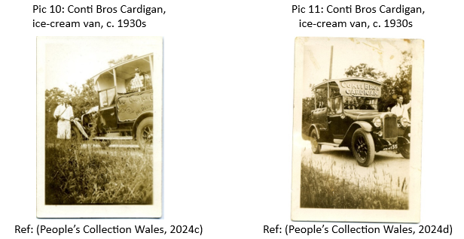
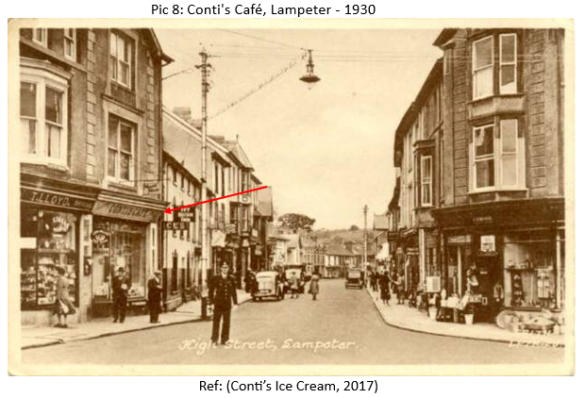

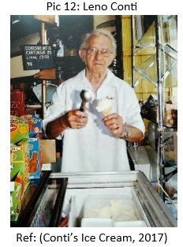
Within Lampeter, the Conti family is well known, especially Leno (See Pic 12), also known as Angelo Attilio Alfredo Conti, who, having left the RAF in 1948, returned to the town to help his father run the business up until his retirement. The Café has been a successful business within the Lampeter community and is still family-owned by the third generation. The Lampeter café was the last of the Conti’s, but it expanded to a second site in Llanerchaeron. Their well-known ice cream is available across multiple cafes and restaurants across Wales (Conti’s Ice Cream, 2017; National Trust, 2024).

Research of the social media site Facebook shows two pages, ‘The Lampeter Society’ and ‘Old Lampeter Photos’, with numerous results for the café and family. The overall impression is of great fondness and nostalgia for the café as an integral part of the community for 90 years. Below is a selection of the photographs submitted by members of these groups (See Pic 13).
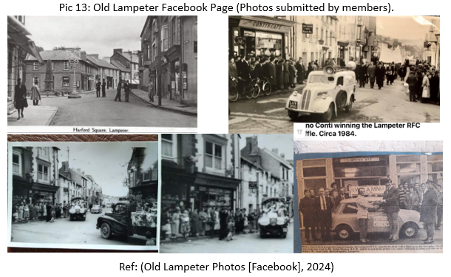

ITALIAN COMMUNITY WITHIN THE LAMPETER AREA
Further research was conducted into Italian connections to the Lampeter area for this period. The first result was ‘Our Lady of Mount Carmel Catholic Church’, Lampeter (See Pic 14), built in 1938 and within a short walking distance of Harford Square. As Irish, Italian, and Polish immigrants came to West Wales for work, a Catholic Church was needed in the area since the closest was 60 miles away (Imaging the Bible in Wales, 2024; Coflein, 2021; Catholic Church Lampeter, 2024).
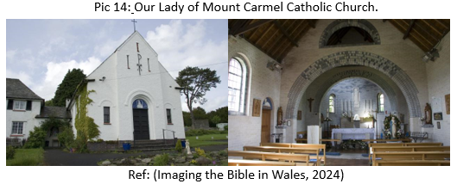

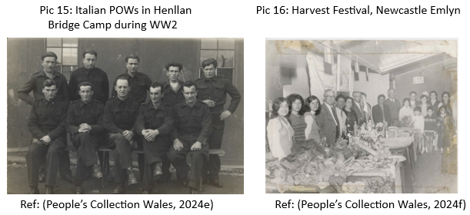
The second result is the Italian Prisoner of War Camp at Henllan Bridge, Llandysul (See Pic 15 and 16), which housed Italian prisoners from 1943 to 1946. Some prisoners developed strong relationships with the communities and, following the War, chose to remain in Wales. Pic 16 shows the descendants of a Henllan prisoner who stayed after the war (Coflein, 2024; People’s Collection of Wales, 2024). A letter addressed in reply to local schoolchildren from a former prisoner, Angelo Sartoretto, dated 2007, is shown in Appendix 1 (Ceredigion Archives, 2024).

THE CONTI FAMILY
The Conti family lived on a small farm in Bardi near Parma and struggled with poverty, which was prevalent in the country at the time (Hughes, 1991, pp. 16-19). In the early 1900s, a young Attilio walked from Northern Italy to South Wales. Due to the problematic rural life in Italy, many people migrated from different parts of the country to South Wales, and Attilio was one of those people (Hughes, 1991, pp. 20-24). The South Wales Valleys had booming iron and coal industries and were popular among immigrants from poorer countries (Hughes, 1991, pp. 25-35). He found work at a cafe owned by the Berni brothers in Merthyr Tydfil. Italian immigrants settled in South Wales Valleys and established cafes, ice cream parlours and restaurants that became a significant part of Welsh industrial life (Wales Online, 2022; National Library of Wales, 2024).

Attilio joined the Italian army during World War 1 to fight German troops in the Alps. Later, he returned to Wales with his siblings Giacomo and Alfredo, and they opened the first Conti's Cafe in Ystradgynlais in 1920 (See Pic 17). Coffee and ice cream were rare then, so they saw an opportunity to serve them in a café (UWTSD, 2024), which became famous for coffee, ice cream, and food, and more branches opened in Newport, Lampeter, and Builth (Wales Online, 2022). Sample research for other Conti establishments again shows many pictures and stories with nostalgia like Lampeter (See Pic 18).
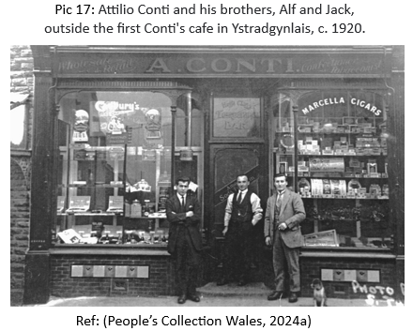

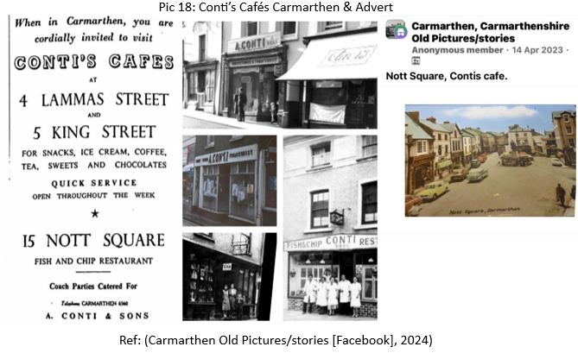

ITALIAN IMMIGRATION TO SOUTH WALES
It is estimated that about 4,000 Italians came to Britain between 1821 and 1851. By the time of the 1871 census, that figure had risen to 5,063 and by 1911, it was up to 20,389. By the end of the 19th century, approximately 1,000 Italians had come to Wales, most working as seamen out of ports like Cardiff and Newport or in related industries. Italian immigrants to Wales mostly came from the northern Apennine Mountains region, particularly the town of Bardi. Italian immigrants in Wales set up cafes and food shops in the 1890s, mainly in the Glamorgan and Gwent valleys, due to favourable conditions like cheap energy, affordable premises, and lack of competition. The cafes that began appearing were soon named "bracchi," inspired by one of the initial Italian families to establish a business in Wales.

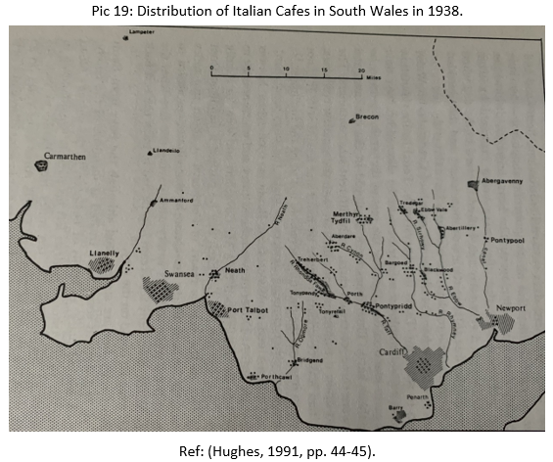
Over the following decades, this industry expanded across South and West Wales. Montis Cafe opened in Pembroke Dock, and Antoniazzis started the Penguin Cafe in Aberystwyth near the town's famous pier. And it wasn't just shops that they ran. Ice cream vendors could be found selling their products from carts they operated around valley towns' streets and homes (BBC, 2012). In 1939, there were over 330 Italian-owned businesses in Wales, roughly one for every 7,700 residents. Most of these (83%) were in Glamorgan and Monmouthshire, with every coal mining town having at least one or two. Cardiff, Swansea and Newport also had many, and some were in Aberystwyth, Llandudno and Rhyl (See Pic 19) (BBC, 2020; Hughes, 1991, pp. 44-45; Giudici, 2013, pp. 649-674).

IMPACT OF THE SECOND WORLD WAR
During World War 2 and Mussolini’s declaration of war, the British government arrested and interned non-citizen Italians, sending them to the Isle of Man or Canada. The Italian Cafe trade was adversely affected by this situation, resulting in the internment of hundreds of shopkeepers. Nevertheless, in many cases, the Italian women could continue running the shops until their husbands were released from internment. The Arandora Star, carrying Italian internees to Canada, was torpedoed by a German U-boat, killing 805 people, including 470 Italians. Among them, 53 were from Welsh towns and communities. After the war, Italian workers arrived to fill gaps in British industry. They worked in mining, tin plating, and agriculture while running popular cafes (Hughes, 1991, pp. 92-105; Chezzi, 2014, pp. 376-393; Giudici, 2013, pp. 649-674). Although South Wales experienced economic crisis and de-industrialization during the 1970s and 1980s, a few cafes have managed to endure until now. These cafes have either updated their old-fashioned appearance or expanded their operations to include selling coffee machines or producing ice cream on a large scale (Giudici, 2013, pp. 649-674). The Welsh-Italian community is estimated to have more than 40,000 individuals, including men, women, and children, and is Britain's most prominent Italian community (BBC, 2012).

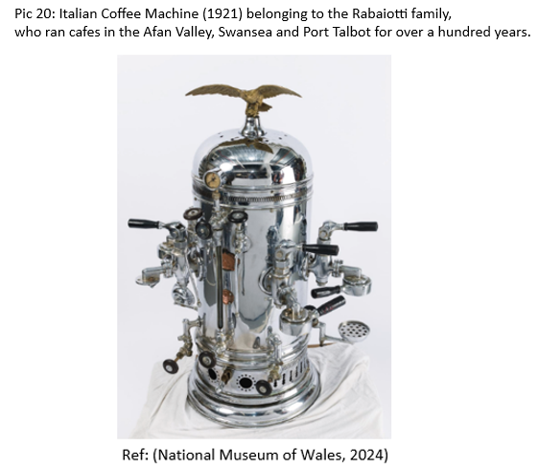
The Italian-Welsh culture is reflected in televised programmes, such as ‘Fifty Years of a Welsh Italian Family Cafe in the Valleys,’ ‘A Visit to This Valleys Cafe Is Like Stepping Back in Time,’ and ‘The Welsh Italians’ (YouTube, 2024), an exhibition in Cardiff from 2008-2010, the ‘Italian Memories in Wales project’ (Wales Online, 2009), and items being held by the National Museum of Wales, such as in Pic 20. Italian cafes are an integral part of the cultural identity of South Wales. As a result, they are perceived as a significant component of the region's culture.
CONCLUSION
This report has focused on Lampeter café. However, the name "Conti" carries a sentimental and fond connotation among generations of individuals in the communities and landscapes of South Wales, much like other Italian family names that were involved in this business. The impact and history of this Italian-Welsh family on the landscape of Lampeter and South Wales continue to live on in the memories of many people in the community.

REFERENCES
Archwilio (2024) Harford Square, Lampeter. Available at: https://archwilio.org.uk/her/chi3/arch.php?county=Ceredigion&lang=eng (Accessed: 2 February 2024).
BBC (2012) The Italians in Wales. Available at: https://www.bbc.co.uk/blogs/wales/entries/fdcff8e1-66dc-34e2-b279-a6e7280958cc (Accessed: 2 February 2024).

BBC (2020) Why cafe culture has rich Italian flavour in Wales. Available at: https://www.bbc.co.uk/news/uk-BBwales-51448889 (Accessed: 2 February 2024).
Carmarthen Old Pictures/stories (2024) Conti’s Café. [Facebook]. (Accessed: 2 February 2024).

Catholic Church Lampeter (2024) Our Lady of Mount Carmel. Available at: http://catholicchurchlampeter.org/our-parish/ (Accessed: 2 February 2024).
Ceredigion Archives (2024) Letter from Angelo Sartoretto: Ref ADX/870/7/3/1/7. (Accessed: 3 February 2024).
Chezzi, B. (2014) “Wales Breaks its Silence: from Memory to Memorial and beyond. The Italians in Wales during the Second World War,” Italian Studies, 69(3), pp. 376–393. Available at: https://doi.org/10.1179/0075163414Z.00000000078 (Accessed: 7 February 2024).

Coflein (2021) Conti’s Café, 5 Harford Square, Lampeter. Available at: https://coflein.gov.uk/en/site/407755?term=harford%20square (Accessed: 2 February 2024).
Coflein (2021) Henllan Bridge Prisoner of War Camp. Available at: https://coflein.gov.uk/en/site/419278/ (Accessed: 2 February 2024).
Conti’s Ice cream (2017) Our history/Ein Hanes. Available at: https://www.contisicecream.com/history-hanes (Accessed: 2 February 2024).
Discover Ceredigion (2024) Lampeter – market town and gateway to Ceredigion. Available at: https://www.discoverceredigion.wales/areas-of-ceredigion/cambrian-mountains/communities-of-the-cambrian-mountains/lampeter/ (Accessed: 4 February 2024).

Dyfed Archaeological Trust (2021) The Archaeology of the medieval towns of southwest Wales, Lampeter. Available at: https://www.dyfedarchaeology.org.uk/wp/wp-content/uploads/historic-towns-2020/EPRN_125663_LAMPETER.pdf (Accessed: 2 February 2024).
Giudici, M. (2013) “A bridge across ethnic lines? Italian cafes in popular culture and public history,” Welsh History Review, 26(4), pp. 649–674. Available at: https://www-ingentaconnect-com.ezproxy.uwtsd.ac.uk/content/uwp/whis/2013/00000026/00000004/art00005# (Accessed: 7 February 2024).
Google Maps (2024) 5 Harford Square, Lampeter. Available at: https://www.google.com/maps/search/5+harford+square,+lampeter+history/@52.1128822,-4.0787958,20z?hl=en&entry=ttu (Accessed: 4 February 2024).
Hughes, Colin (2003) Lime, lemon & sarsaparilla : the Italian community in South Wales 1881-1945. 1st edn. Bridgend: Seren.

Imaging the Bible in Wales (2024) Church of Our Lady of Mount Carmel, Lampeter, Ceredigion. Available at: http://imagingthebible.llgc.org.uk//site/131 (Accessed: 2 February 2024).
National Library of Scotland (2024) Lampeter. Available at: https://maps.nls.uk/geo/explore/print/#zoom=16.0&lat=52.11384&lon=-4.07851&layers=6&b=2 (Accessed: 2 February 2024).
National Library of Wales (2024) Transactions of the Honourable Society of Cymmrodorion 2004: Italian migration to South Wales in the Early Years of the Twentieth Century. pp. 189-204. Available at: https://journals.library.wales/view/1386666/1426735/#?xywh=-2653%2C-195%2C7736%2C3875 (Accessed: 2 February 2024).
National Museum of Wales (2024) Coffee Machine. Available at: https://museum.wales/collections/online/object/3f9a5f3d-110f-3492-b539-b50eb2899f19/Coffee-machine/ (Accessed: 2 February 2024).
National Trust (2024) Eating and shopping at LLanerhaeron. Available at: https://www.nationaltrust.org.uk/visit/wales/llanerchaeron/eating-and-shopping-at-llanerchaeron (Accessed: 2 February 2024).
Old Lampeter Photos (2024) Conti’s Café & Harford Square. [Facebook]. (Accessed: 2 February 2024).
People’s Collection Wales (2024) Conti’s Café, 5 King Street, Carmarthen. Available at: https://www.peoplescollection.wales/items/43767#?xywh=27%2C-17%2C499%2C401 (Accessed: 7 February 2024).

People’s Collection Wales (2024) WW2 Prisoners of War. Available at: https://www.peoplescollection.wales/collections/1780596#:~:text=At%20the%20end%20of%20the,near%20Newcastle%20Emlyn%20in%201942 (Accessed: 4 February 2024).
People’s Collection Wales (2024a) The Conti brothers – cafes in Wales. Available at: https://www.peoplescollection.wales/collections/377969 (Accessed: 2 February 2024).
People’s Collection Wales (2024b) Harford Square and High Street Lampeter. Available at: https://www.peoplescollection.wales/items/43246#?xywh=13%2C-70%2C982%2C789 (Accessed: 2 February 2024).
People’s Collection Wales (2024c) Conti. Available at: https://www.peoplescollection.wales/items/43766#?xywh=-292%2C-1%2C1326%2C1066 (Accessed: 2 February 2024).
People’s Collection Wales (2024d) Conti. Available at: https://www.peoplescollection.wales/items/43765#?xywh=-287%2C-105%2C1510%2C1214 (Accessed: 2 February 2024).

People’s Collection Wales (2024e) Italian POWs in Henllan Bridge Prisoner of War Camp WW2. Available at: https://www.peoplescollection.wales/items/1795686#?xywh=47%2C-75%2C982%2C789 (Accessed: 2 February 2024).

People’s Collection Wales (2024f) Harvest festival, Newcastle Emlyn Catholic Church, 1972. Available at: https://www.peoplescollection.wales/items/1795726#?xywh=-3%2C-1%2C967%2C778 (Accessed: 2 February 2024).
UWTSD (2024) Jo Conti. Available at: https://www.uwtsd.ac.uk/library/special-collections/200-biographies-celebrating-lampeters-bicentenary/arts-and-entertainment/jo-conti/ (Accessed: 2 February 2024).
WalesOnline (2009) Start of Italian immigrants’ display. Available at: https://www.walesonline.co.uk/news/wales-news/start-of-italian-immigrants-display-2115421 (Accessed: 5 February 2024).
WalesOnline (2022) The Italian who walked to Wales to open a cafe and his great-granddaughter who is continuing her family's legacy. Available at: https://www.walesonline.co.uk/whats-on/food-drink-news/contis-cafe-clydach-italian-swansea-25754762 (Accessed: 2 February 2024).

YouTube (2024) A visit to this Valleys cafe is like stepping back in time. Available at: https://youtu.be/Z4meo_Lv83M?si=V59HlSQCBRlhwjKu (Accessed: 2 February 2024).

YouTube (2024) Fifty years of a Welsh Italian family cafe in the Valleys. Available at: https://youtu.be/9gnnr8rX0GY?si=cDatsxkpdf4J6IIC (Accessed: 2 February 2024).

YouTube (2024) The Welsh Italians - Episode 1. Available at: https://youtu.be/VYP1SqzvAIs?si=zf3VQOYOxNXEPUns (Accessed: 2 February 2024).

YouTube (2024) The Welsh Italians - Episode 2. Available at: https://youtu.be/owXAZhG1TP8?si=hUvvAMgQOcye61Nu (Accessed: 2 February 2024).

APPENDIX

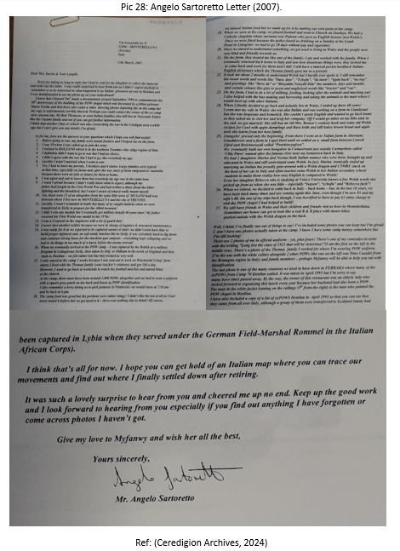
Appendix 1:

