Name: Gheorghe Alui-Gheorghe
Student number: 2018577
Module code and title: BMSW6106 | Developing emotional inteligence skills for the workplace
Lecture’s name: Amare Desta
Assignment title: Evaluation of Emotional Intelligence in Workplace Context

Table of Contents
Introduction 2
Case Background 2
Role of EI in The Workplace 4
EI Models for Clarke 5
Culture and EI 8
Harnessing EI at FAYE Inc 9
Conclusion 10
References 11
Appendix 12

Introduction
The following report analyses the use of EI at the workplace, focusing on the FAYE Inc. Organisation, which is facing several issues stemming from leadership by a new supervisor named Clarke. The report identifies Clarke’s communication with the employees, the cultural aspect of organisational communication, and the effects of Clarke’s leadership style on his subordinates. Clarke, a new employee hired from Texas, was surprised when he realised that his friendly ‘hi’s and timetable, erasing pretty much all flexibility from his days, made several employees uncomfortable – the women in particular and a visiting Chinese team in particular. Of course, FAYE Inc. values the principle of diversity among its employees, but the example with Clarke shows deficiencies in regard to the company’s emotional and cultural comprehension (Akila and Thangavel, 2017). EI is shown in Clarke’s case in leadership, where his ignorant activities in the organisation have had an impact on the morale of the employees, and there was a need for constructive leadership development. Emotional intelligence encompasses interpersonal and intrapersonal forms of regulation of one’s own and other people’s emotions that play an essential role in diverse and multicultural organisations such as FAYE Inc. This paper will, therefore, discuss two EI models that can be helpful in the enhancement of Clarke’s leadership skills and appropriate response to the issues reported to him by his subordinates. Also, it will explain how culture influences EI and why it is vital to integrate mindfulness into organisational settings to appreciate the cultural differences of employees.

Case Background
FAYE Inc. is a big industrial giant that has enthusiasm for employees globally across different regions of the country as well as from other countries. It has been a leader in the ways it continually challenged itself to do things for the company while embracing its employees and fostering good welfare for them. FAYE Inc. has been growing and developing by recruiting leaders from different backgrounds with different leadership styles to serve the organisation. In the current year, the company promoted Clarke, a Texas man, to the position of supervisor of employees in its division in the United Kingdom.
Through his work at a similar organisation in Texas prior to DirectBuy, Clarke learned how to lead by schedules, expectations and, more notably, by all-or-nothing verbal communication. However, as soon as Jorge started performing his tasks at FAYE Inc., some people complained about his greeting manner, especially females who did not like it when he called them ‘my love’. Specifically, Clarke, who was not aware of such feelings in the frame of UK culture, was shocked at this feedback as this informal greeting had a positive response when he was working in Texas. Some employees’ comments, like such stressed feelings of discomfort, pointed to the gap in knowledge of the cultural expectations of employees’ behaviour in the United Kingdom that Clarke had.
The increasing problem gradually affected the overall performance of the employees, and Clarke observed low morale among them. He also saw unpleasantness in the way he greeted his subordinates as having a knock-on effect on morale in the workplace, resulting in poor interaction among team members (Salovey and Mayer, 2017). Clarke admitted that the problem had not been solved in Texas when he was the team’s leader, but he faced the implications of his communication methods in a new state.
Hopper Besides the complaints of the female employees, Clarke encountered another ordeal when FAYE Inc.’s Chinese division came to the UK to watch the process of new systems deployment under Clarke's direction. Clarke, who disliked foxy talk and liked to work to the clock, still sought to communicate with the members of the visiting team in this manner – if you have an English name, would you please let me know so I can communicate with you with ease? This approach, however, did not sit well with the Chinese team, which operates within a family and friendship-based culture while people would prefer to be called by their Chinese names (Pool and Qualter, 2018). This can be understood by the elimination of Clarke’s suggestion of visiting the English names, which may have been understood to be the negative side of disrespecting their cultural honour, which may have had an adverse effect on the partnership between these two teams.
This is not a unique case as it pertains to a major problem and relationship between emotional intelligence (EI) in the workplace. Fearing offending any of the employees, Clarke overlooked the important cultural factors that define communication and processes within the working environment, which caused negative unanticipated results in his partnership with employees as well as the performance and motivation of his team (Barnes, 2022). There are two aspects here: the so-called ‘emotional quotient’ or ‘emotional intelligence’, meaning the capability to identify and deal with one’s own and other’s emotions, can have played a great part in helping Clarke cope with these issues more efficiently. There was not enough EI for the colleagues to be aware of the problem, let alone the cultural differences that made the employees feel disrespected, and Clarke could not find the words to fix the problems and bring harmony to the workplace.
FAYE Inc. currently has more than 5000 employees worldwide; it operates in the UK and has other operations in China. Standard engagement questionnaire checks at FAYE Inc. often yield very high satisfaction results; 85% of the workers indicate that they work in a positive environment (Akila and Thangavel, 2017).

Role of EI in The Workplace
Emotional intelligence, or EI, is a concept that has significant implications for leadership, managed relations, and organisational performance in the workplace. EI is the skill used in managing one’s emotions as well as those of others in different contexts. Because work in today’s organisations is frequently conducted by diverse teams, often with members in different geographical locations, who undertake multifaceted, high-risk activities, EI is viewed as a valuable commodity for managers and subordinates (Bradberry and Greaves, 2021). Increased EI has been associated with effective communication, better teamwork, conflict management, and higher levels of satisfaction and turnover.
Here in FAYE Inc., Clarke, the new supervisor, for example, has no awareness of EI, which leads to the uneasiness of the employees, hence affecting team morale. Lack of understanding of EI can be seen in how he apologised for using unprofessional language with the female employees and insisting that Chinese members adopt English names. EI is important in determining how a leader attends to cultural differences and how he or she addresses the different needs of the individuals who are part of his/her team (Kiruba and Priya, 2020). In this regard, Clarke, whose initial perception of his subordinate’s emotions was incorrect, was an indication of the negative impact of poor EI both on the interpersonal relationship at the workplace and on productivity.
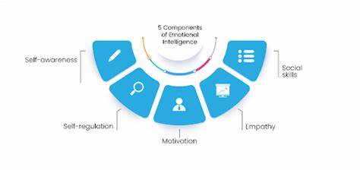
Figure: 5 components of EI needed at the workplace (Care, 2022)
Research evidence points to the reality of the importance of EI in the organisational environment. Research indicates that businesses with a higher population of employees with high EI report 20 % higher job satisfaction and 15% in productivity (Care, 2022). More so, organisations that invest in enhancing emotional intelligence when training leaders record a reduction of the turnover rate by 25% and an enhancement of the collaboration rate by 30% (Jamshed and Majeed, 2019). Such statistics point to the importance of EI in helping bring, set, or maintain a proper workplace culture that makes everyone feel and be appreciated. If leaders have EI, then they can handle the problems and complaints from the employees with courteous answers and, more importantly, give appropriate suggestions that will help them improve.
Besides the impact on enhancing interactions between people, EI contributes to the organisation by promoting efficient decision-making. In this respect, emotional intelligence would enable the leaders to act without getting overly stressed, and IL would make sound decisions in the storm. It translates to sound strategic decisions, effective conflict management, plus nurturing and encouragement of the workforce. Successfully, EI ensures diversity and inclusion play a critical role. EI is essential to diversity and inclusion.
When it comes down to digitising the objectives of dealing with an emotionally intelligent workforce, FAYE Inc. can easily achieve more effective leadership and better employee engagement. When incorporated into leadership development initiatives, the firm can train its leaders on how to regulate emotions in themselves to develop a healthy corporate culture.

EI Models for Clarke
EI models provide useful concepts for both enhancing emotional awareness and training people to comprehend/approach different emotional situations, which is exactly what Clarke and other leaders should do in today’s workplaces. Two theoretical models through which Clarke can enhance his leadership skills are EI – Daniel Goleman’s Emotional Intelligence Model and Mayer and Salovey’s Four-Branch Model (Cassey, 2024). It has presented Clarke with these models for improving his imposed self-awareness, self-regulation, social awareness and interpersonal relationship management, facets which are critical in his attempt to meet the needs of employees and create a working environment that is free from discrimination and harassment.
Goleman’s Emotional Intelligence Model identifies five key components of EI: skills of self-awareness, self-control, goal setting, relationship understanding and interpersonal relationships. All of these can be used right where Clarke has some issues. Recognition of feelings and how they are sensed from a personal level is the first component known as self-awareness. This awareness is very important for Clarke because his informal approach to addressing the Chinese team and suggesting how he wants to proceed with communicating with them was regarded as improper by his comrades (Goleman, David and Eurich, 2018). High self-awareness helps leaders to be less likely to impose their methods of expressing themselves without knowing how that is perceived in different cultures. The results prove that lessons per cent of courses displayed higher satisfaction levels of approximately 10% for those teams that are led by highly self-aware leaders.
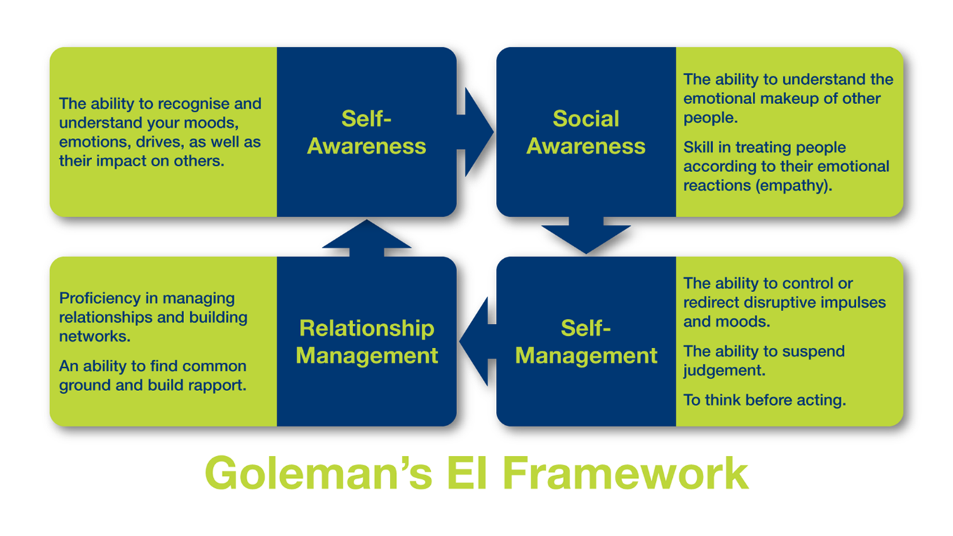
Figure: Goleman’s EI Framework (Barnes, 2022)
The self-regulation part of Goleman’s model assists leaders in handling or even paralysing behaviours across different circumstance types. For Clarke, it would be the ability to stop and think about how he was coming off to the employees since he understood that he might not be aware of how his behaviours were being interpreted by individuals in other cultures or having different personality types. There is a provision that shows that when a leader is self-regulated, there are improved chances of getting good results when compared to a leader who is not. Self-regulated leaders are able to avoid being prompted to make a certain decision and are more flexible, which will lead to an increased level of trust and engagement by employees of 15% and above (Chick, 2018).
Social awareness, of which the key aspect is empathy, is also one of the skills practitioners have to develop in order to succeed in their practice. Compassionate leaders can understand the moods of other people and know how to deal with them. In Clarke’s case, he lacked the level of empathy that could have made him see that his greetings were having adverse effects on some of the females and that his attempt to try and be familiar with the Chinese team by referring to them by the English names was incorrect. Substantial evidence on the impact of empathy in correlational and organisational development studies indicates that the reception of empathetic perception by employees increases by 25%, complaining levels in stress management, and so on (Emmerling, Shanwal and Mandal, 2018).
The Four-Branch Model by Mayer and Salovey also offers insights into improving EI by focusing on four skills: The four processes of emotions are perceiving, using affect in cognition, understanding affect, and regulating affect. The first branch, perceiving emotions, helps leaders to know how they and others feel and often by what words or gestures are spoken or unspoken. Clarke would benefit from identifying emotions more effectively as this would allow him to see when certain members of his team are uncomfortable or resistant to his methods and regular changes of tactics because of this (Ciarrochi and Mayer, 2023). The second branch, which is the use of emotions to help in thinking, would help Clarke to use his awareness of the body’s Emotional State to supplement the decision-making process in order to engage in proper communication that respects diversity.
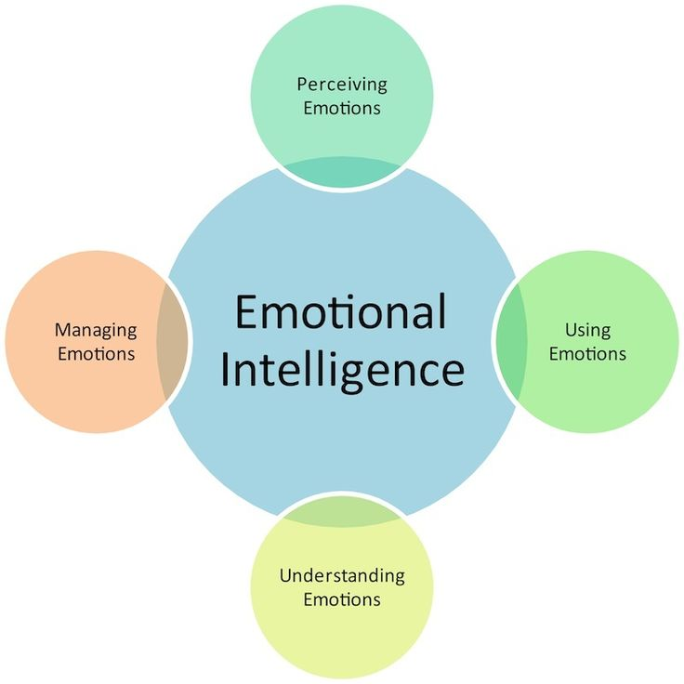
Figure: Mayer and Salvory’s Four-Branch Model (Cassey, 2024)
For example, the third branch of understanding emotion refers to the valuation of the reason why emotion is triggered and what impact it has on the one involved and others. If Clarke can understand how his behaviour affects the morale of the employees, he can then prevent conduct that may ruin the morale of the employees. Coaching, the fifth branch, is aimed at helping leaders by training them to control reactions, thus stabilising the organisational climate for the respondents. Executives who have good models of handling their emotions are connected with a 10% increase in productivity; as a result, stress can be minimised by analysing Clarke’s experience according to the elements that can be taken from the models created by Goleman Mayer and Salovey, it is possible to understand that, in order to become a better employee and a more sensitive person, he needs to develop the skills connected with empathy, self-regulation and cultural competencies (Craemer, 2020). These changes will help him create a more friendly atmosphere offorAYE Inc. that would improve the level of employee job satisfaction and performance. This is evidenced by statistics where leaders who undertake EI training present a more robust and motivated team growing by up to 30% of general effectiveness covering all organisations, making these models very practical (Clarke, 2019).

Culture and EI
Country culture highly determines how EI is practised and received in organisations. Culture defines how people perceive emotions, how they interact with their counterparts, and how they expect others to behave in the workplace, thus fashioning employee and leader perceptions of social interactions (Goleman, David and Eurich, 2018). Cultural differences are also important to Clarke's likes at FAYE Inc.; the failure to appreciate cultural diversity is what made Clarke offend several of his team members due to an unenlightened communication approach. Training cultural intelligence is the making of cultural awareness in the EI, which is crucial to leaders in diverse workplaces since it enables consideration, cooperation, and tolerance of differences.
Several countries have ring communication and emotional behaviour, which affects interpersonal relations and employees’ well-being. For example, employees from cultures that endorse formal communication will be offended when Clarke uses informal features such as “my love” to address his female employees (Cassey, 2024). Likewise, the Chinese team members who visited FAYE Inc. keep their native names, replacing the English aliases; this shows the global cultural factor of individualism in the working practice. These and other cross-cultural misunderstandings decrease morale as individuals may feel demotivated or insulted when cultures that differ from theirs are ignored. Various research studies have established that culture-wise, the executive branch enables about 25% of team engagement, and 15% lowers conflict rates (Jamshed and Majeed, 2019).
Reviews have suggested that EI in a multicultural environment/ workplace requires consideration of different emotional expectations and inclinations. For example, one might compare and contrast the American way of communicating with the Chinese way of communicating. Managers with higher cultural EI are in a position to manage these differences owing to the flexibility of their adjustment of the cultural communication expectations within their subordinates. The ability to adapt in this way helps to foster psychological safety as employees feel their individual selves are known and valued; this may even enhance team cohesiveness by as much as 20% (Ciarrochi and Mayer, 2023).
Also, studies show that culturally intelligent leaders positively impact their team members’ engagement and company performance by 30% (Bradberry and Greaves, 2021). Ways to bring a cultural perspective to EI Indeed, by incorporating cultural perspective in EI practices, leaders will be in a better position to work with diversity, enhancing the productivity of the teams. To Clarke and FAYE Inc., the enhancement of cultural EI will play a big role in improving organisational interactions and enhancing employees’ loyalty and performance.

Harnessing EI at FAYE Inc
For the company to reap the full benefits of EI at FAYE Inc., it needs to establish certain measures to develop an emotionally intelligent organisation. FAYE Inc. should aim to enhance EI among its human resources because when people follow the rules and are treated right, productivity and morale are boosted. EI can be used as a tool to improve the organisational culture within FAYE Inc., thus improving its way of handling diverse teams and employees and improving performance.
The use of workshops and other forms of training for leaders is one of the best ways for FAYE Inc. to implement the EI in the workplace. Research has found that the firms that include EI in their leadership programs see the employees’ engagement boosted by 20%, and the turnover goes down by 15% (Salovey and Mayer, 2017). As far as Clarke’s case, in which he found a lot of difficulties understanding the emotional and cultural requirements of workers, EI training would increase self-attunement and compassion and thus would help the leader to be more competent and effective in meeting these multicultural workforce needs. When leaders build these skills, the employees see themselves as valued and motivated to work efficiently, hence raising their levels of loyalty and happiness.
Moreover, FAYE Inc. can introduce measures relating to assertiveness and freedom of reporting complaints and ideas fearlessly at the company. Sustained feedback meetings, for instance, provide the avenue where experience is conveyed, and the leadership can respond with the improvements made to address such issues. Studies have shown that organisations that provide feedback to employees experience a 25% increase in the togetherness of employees while working as a team and a 30% increase in productivity (Goleman, David and Eurich, 2018). Such specific feedback opportunities that FAYE Inc. can develop are beneficial for enhancing trust between workers and the company as well as making the latter prove its focus on employees’ opinions.
The second method for FAYE Inc. to build EI is the adoption of organisational mindfulness, which includes offering meditation sessions, stress management sessions, and group activities. Research evidence indicates that mindfulness practices enhance MM and decrease worry and stress at the workplace; employees in mindfulness-based organisations complain 20% less and 15% of work absences as compared to organisational employees who are not allowed to do mindfulness practices (Care, 2022). By practising mindfulness, FAYE is able to guide its people towards better adjusting their emotions when it comes to decision-making, stress coping, and general interpersonal relationships in the workplace.

Conclusion
This report seeks to discuss why it is important to include emotional intelligence (EI) within the FAYE Inc. organisation’s organisational culture, which aims to enhance respect, productivity, and cultural diversity. This report discusses how EI can boost leadership performance, especially focusing on Clarke’s case of cultural issues and perceived bias that impacted team morale. With the help of conceptual approaches such as Goleman’s Model of EI and Mayer and Salovey’s Four Branch Model, it becomes possible to teach leaders of FAYE Inc. how to communicate with employees with more sensitivity and support, thus improving essential working relationships. Moreover, cultural aspects of EI were explained, with a focus on how cultural intelligence contributes to positive interaction at the workplace. The new professionally facilitated structured EI training, organisation of feedback and mindfulness practices will help to foster an environment for FAYE Inc, which promotes emotional intelligence and respect. Research indicates that such efforts enhance job satisfaction, increase retention rates, and increase organisational productivity, which will help Inc. create a more united, loyal, and productive workforce.

References
Akila, Dr.R. and Thangavel, Dr.N. (2017). Team Leader’s Emotional Intelligence Competencies and Team’s Emotional Intelligence Norms. Indian Journal of Applied Research, 3(3), pp.211–213. doi https://doi.org/10.15373/2249555x/mar2013/69.
Barnes, D. (2022). Leadership Series – Emotional Intelligence. [online] Newportwildman.com.au. Available at: https://newportwildman.com.au/resources/eap-blog/leadership-series-emotional-intelligence [Accessed 13 Nov. 2024].
Bradberry, T. and Greaves, J. (2021). Emotional intelligence 2.0. San Diego, California: Talentsmart.
Care (2022). Emotional Intelligence At Work. [online] United We Care | A Super App for Mental Wellness. Available at: https://www.unitedwecare.com/emotional-intelligence-at-work/ [Accessed 13 Nov. 2024].
Cassey, D. (2024). The Salovey Mayer Model Of Four Emotional Intelligence Abilities. [online] Photos All Recommendation. Available at: https://inforekomendasi.com/the-salovey-mayer-model-of-four-emotional-intelligence-abilities [Accessed 13 Nov. 2024].
Chick, G. (2018). Corporate Emotional Intelligence. Critical Publishing.
Ciarrochi, J. and Mayer, J.D. (2023). A Theory-Based, Practical Approach to Emotional Intelligence Training: Ten Ways to Increase Emotional Skills. pp.67–102. doi:https://doi.org/10.4324/9781315782935-11.
Clarke, N. (2019). Emotional intelligence and learning in teams. Journal of Workplace Learning, 22(3), pp.125–145. doi:https://doi.org/10.1108/13665621011028594.
Craemer, M. (2020). Emotional Intelligence in the Workplace. Sourcebooks, Inc.
Emmerling, R.J., Shanwal, V.K. and Mandal, M.K. (2018). Emotional intelligence: theoretical and cultural perspectives. New York: Nova Science Publishers.
Goleman, D., David, S. and Eurich, T. (2018). Self-Awareness (HBR Emotional Intelligence Series). Harvard Business Press.
Jamshed, S. and Majeed, N. (2019). Relationship between Team Culture and Team Performance through Lens of Knowledge Sharing and Team Emotional Intelligence. Journal of Knowledge Management, [online] 23(1), pp.90–109. doi:https://doi.org/10.1108/jkm-04-2018-0265.
Kiruba, R. and Priya, J.Y. (2020). EMOTIONAL INTELLIGENCE AT WORK PLACE-A REVIEW STUDY: Studies in Indian Place Names, 40(40), pp.456–464.
Pool, L.D. and Qualter, P. (2018). An Introduction to Emotional Intelligence. John Wiley & Sons.
Salovey, P. and Mayer, J.D. (2017). Emotional intelligence: key readings on the Mayer and Salovey model. Port Chester, N.Y.: Dude Pub

Appendix


