

Six Sigma Green Belt
(ACMA5005)

Project Report

David Adams 1908506

Table of Contents
Table of Contents 2
Table of Figures 4
1 Introduction 5
1.1 Company background 5
2 Define 6
2.1 Problem Statement 6
2.2 Process Mapping 7
2.3 Voice of the Customer / Critical to Quality 10
2.4 Project Scope 10
2.5 Project Charter 11
3 Measure 12
3.1 Identify Measurement Variation 12
Delay Duration 12
Delay Description 12
Delay Type 12
Berth Occupancy 12
Maintenance Costs 13
3.2 Determine Data Type 13
3.3 Develop Data Collection Plan 14
3.4 Perform Measurement System Analysis 14
3.5 Data Collection and Assess Process Capability 14
4 Analyse 15
4.1 Process Analysis Methods 15
4.2 Graphical Analysis Tools 18
Pareto Charts 18
5 Why Root Cause Analysis 20
Fishbone (Ishikawa) Diagram 20
6 Improve 21
6.1 Generate Improvement Alternatives 21
6.2 Improve FMEA Phase 21
6.3 Perform Cost/Benefit Analysis 21
Cost/Benefit Matrix 21
Eisenhower Matrix 22
6.4 Pilot Proposals 22
5.4.1 Future State Process Map 25
6.5 Implementation Plan 25
6.6 Validate Improvements 26
Asset Availability 26
Demurrage Costs 27
Maintenance Costs 28
7 Control 28
8 Conclusion 28
9 Bibliography 30
10 Appendices 31
10.1 Appendix 1: Failure Reduction Process RASCI (Responsible, Accountable, Support, Consulted, Informed) 31
10.2 Appendix 2: MPM4706 Digital Level Transmitter Datasheet (Microsensor Corp, 2022) 37

Table of Figures
Figure 1 - Sales by product FY19-20 (Tata Steel Europe, 2022) 5
Figure 2 - CAMF Process 7
Figure 3 - Failure Reduction Process 8
Figure 4 - Management & Control Reporting System 9
Figure 5 – KANO Model (Matzler, 1996) 10
Figure 6 – Pareto Analysis Chart: Delay Types 2019-2022 18
Figure 7 – Pareto Analysis Chart: Hydraulic Delays 2019-2022 19
Figure 8 - 5 Why Analysis Diagram of Low Oil Level Delays 20
Figure 9 – Low Oil Level Fishbone Diagram 20
Figure 10 – Revised FMEA 21
Figure 12 – Cost/Benefit Matrix for proposed improvements 21
Figure 11 – Eisenhower Matrix (Alrawashdeh, 2018) 22
Figure 13 – Current Level Indication Method 23
Figure 14 – Proposed Digital Level Sensor 23
Figure 15 – Proposed PLC Program including level sensors (1) 24
Figure 16 – Proposed PLC program including level sensors (2) 24
Figure 17 – Future-state Process Map 25
Figure 18 – Gantt Chart - Project Implementation Plan 26
Figure 19 – Asset Availability Oct 22 – Mar 23 26
Figure 20 – Hydraulic Delays Oct 22 – Mar 23 27

Introduction

Company background
“Tata Steel is one of Europe’s leading steel producers, with steelmaking in the Netherlands and the UK, and manufacturing plants across Europe. The company makes high-quality strip steel products for demanding markets such as construction, automotive, packaging and engineering.” (Tata Steel Europe, 2022)
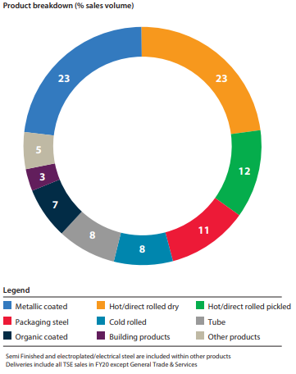
Figure 1 - Sales by product FY19-20 (Tata Steel Europe, 2022)
Port Talbot Steelworks is the UK’s primary steelmaking location. There are a variety of raw materials required for steel production at Port Talbot including iron ore, olivine, blast furnace coke, coal and coke breeze. These are transported via Cape and Panamax class dry cargo ship and are unloaded in the deep-water harbour by two ship unloader cranes. The rate of delivery and discharge of raw materials are planned and executed to an Annual Plan (AP). This plan is developed to ensure stock levels of raw materials can meet production volumes and ultimately customer demand of finished steel products.
Currently, the department is not meeting its KPI targets in regards to Asset Availability, Demurrage costs and Maintenance Costs. This is having a negative impact on the business and ultimately leading to the failure of AP.

Define

Problem Statement
Tata Steel Port Talbot (TSPT) Harbour department has a key performance indicator (KPI) of Discharge Rate (DR) and Asset Availability. These KPI targets are set in the Annual Plan (AP) every year and are calculated on the Berth Occupancy of the Deepwater Harbour and Furnace demand. These targets are shown in Table 1.
Table 1 - Harbour Target KPI's
Annual Plan Target | 2019 | 2020 | 2021 | 2022
Berth Occupancy | 73% | 73% | 73% | 73%
Discharge Rate (Tonnes per Hour) | 3600 | 3600 | 3600 | 3600
Asset Availability | 95% | 95% | 95% | 95%
Demurrage Costs (£M) | 0.6 | 0.7 | 0.8 | 1.0

Table 2 - Harbour Actual KPI's
Annual Plan Actual | 2019 | 2020 | 2021 | 2022
Berth Occupancy | 61% | 72% | 69% | 61%
Discharge Rate (Tonnes per Hour) | 3700 | 3500 | 3350 | 3200
Asset Availability | 98% | 95% | 90% | 88%
Demurrage Costs (£M) | 0.5 | 0.8 | 1.8 | 2.0

The actual values achieved for the year are shown in Table 2. It shows that there is a decline in asset availability to an unacceptable level (below target) over the last two years, it is also evident there is an undesired increase in demurrage costs over the same period.

Process Mapping
These are the current process maps for the Asset management process (Figure 2), Failure reduction process (Figure 3) and Management and control reporting systems (Figure 4).
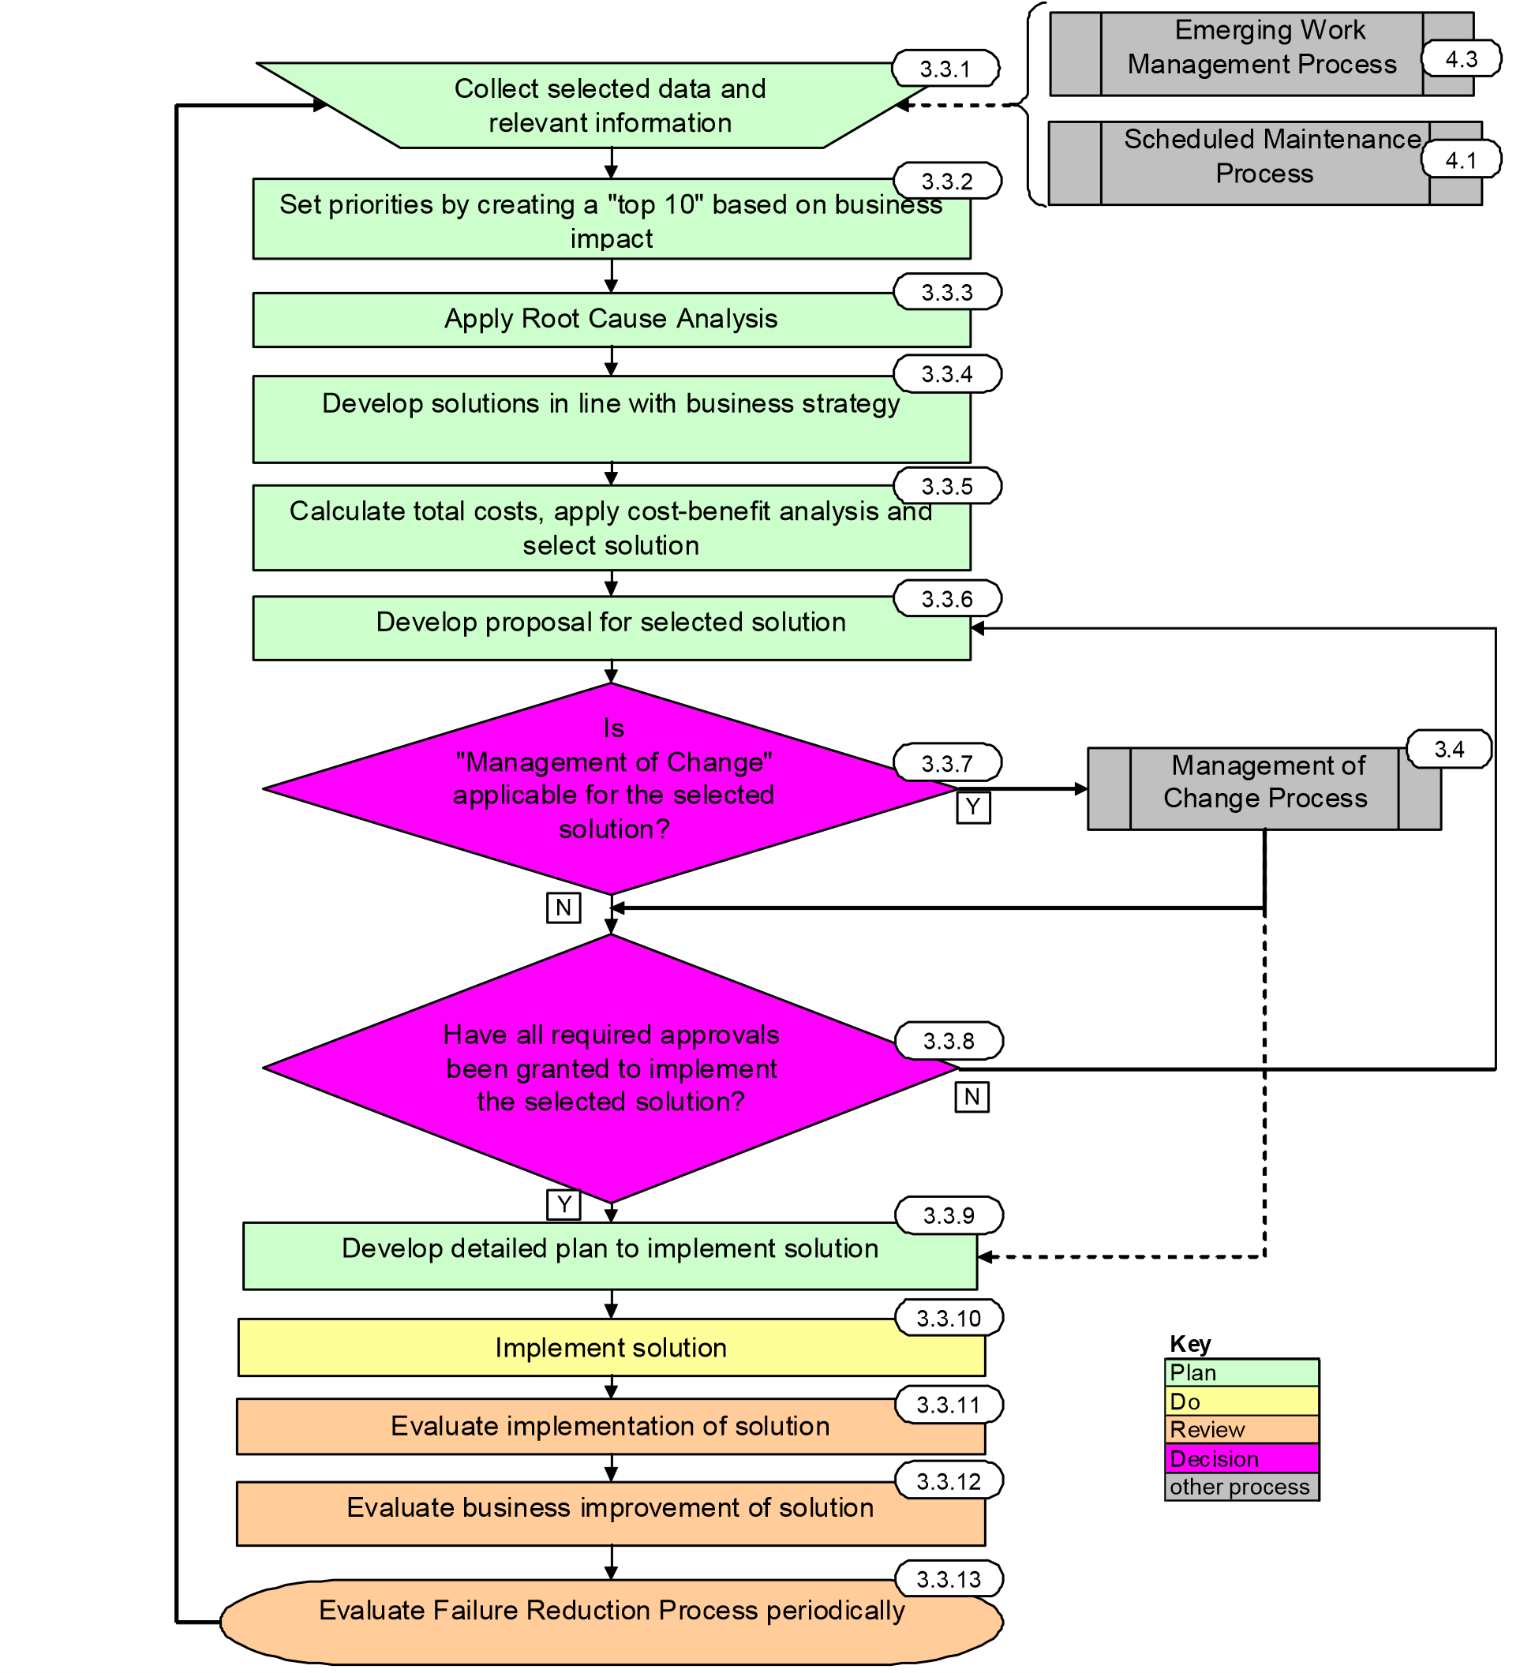
Figure 2 - CAMF Process

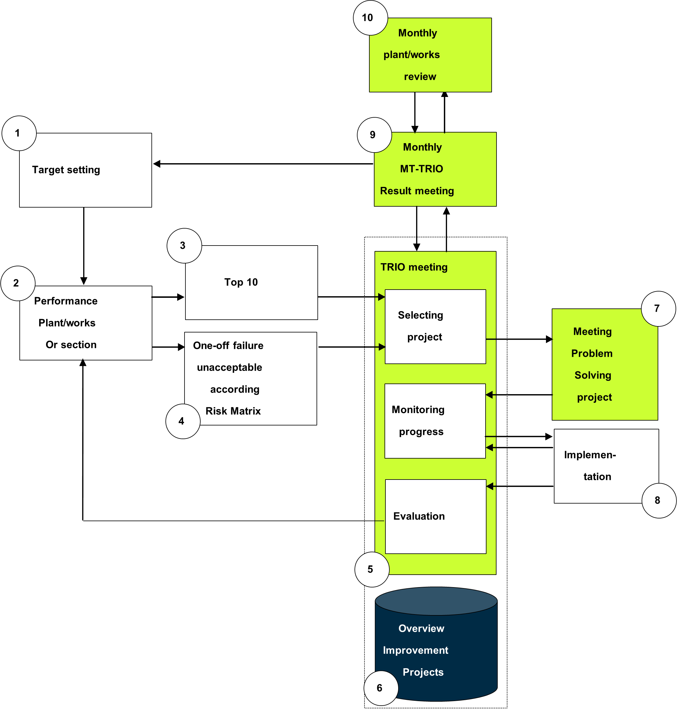
Figure 3 - Failure Reduction Process
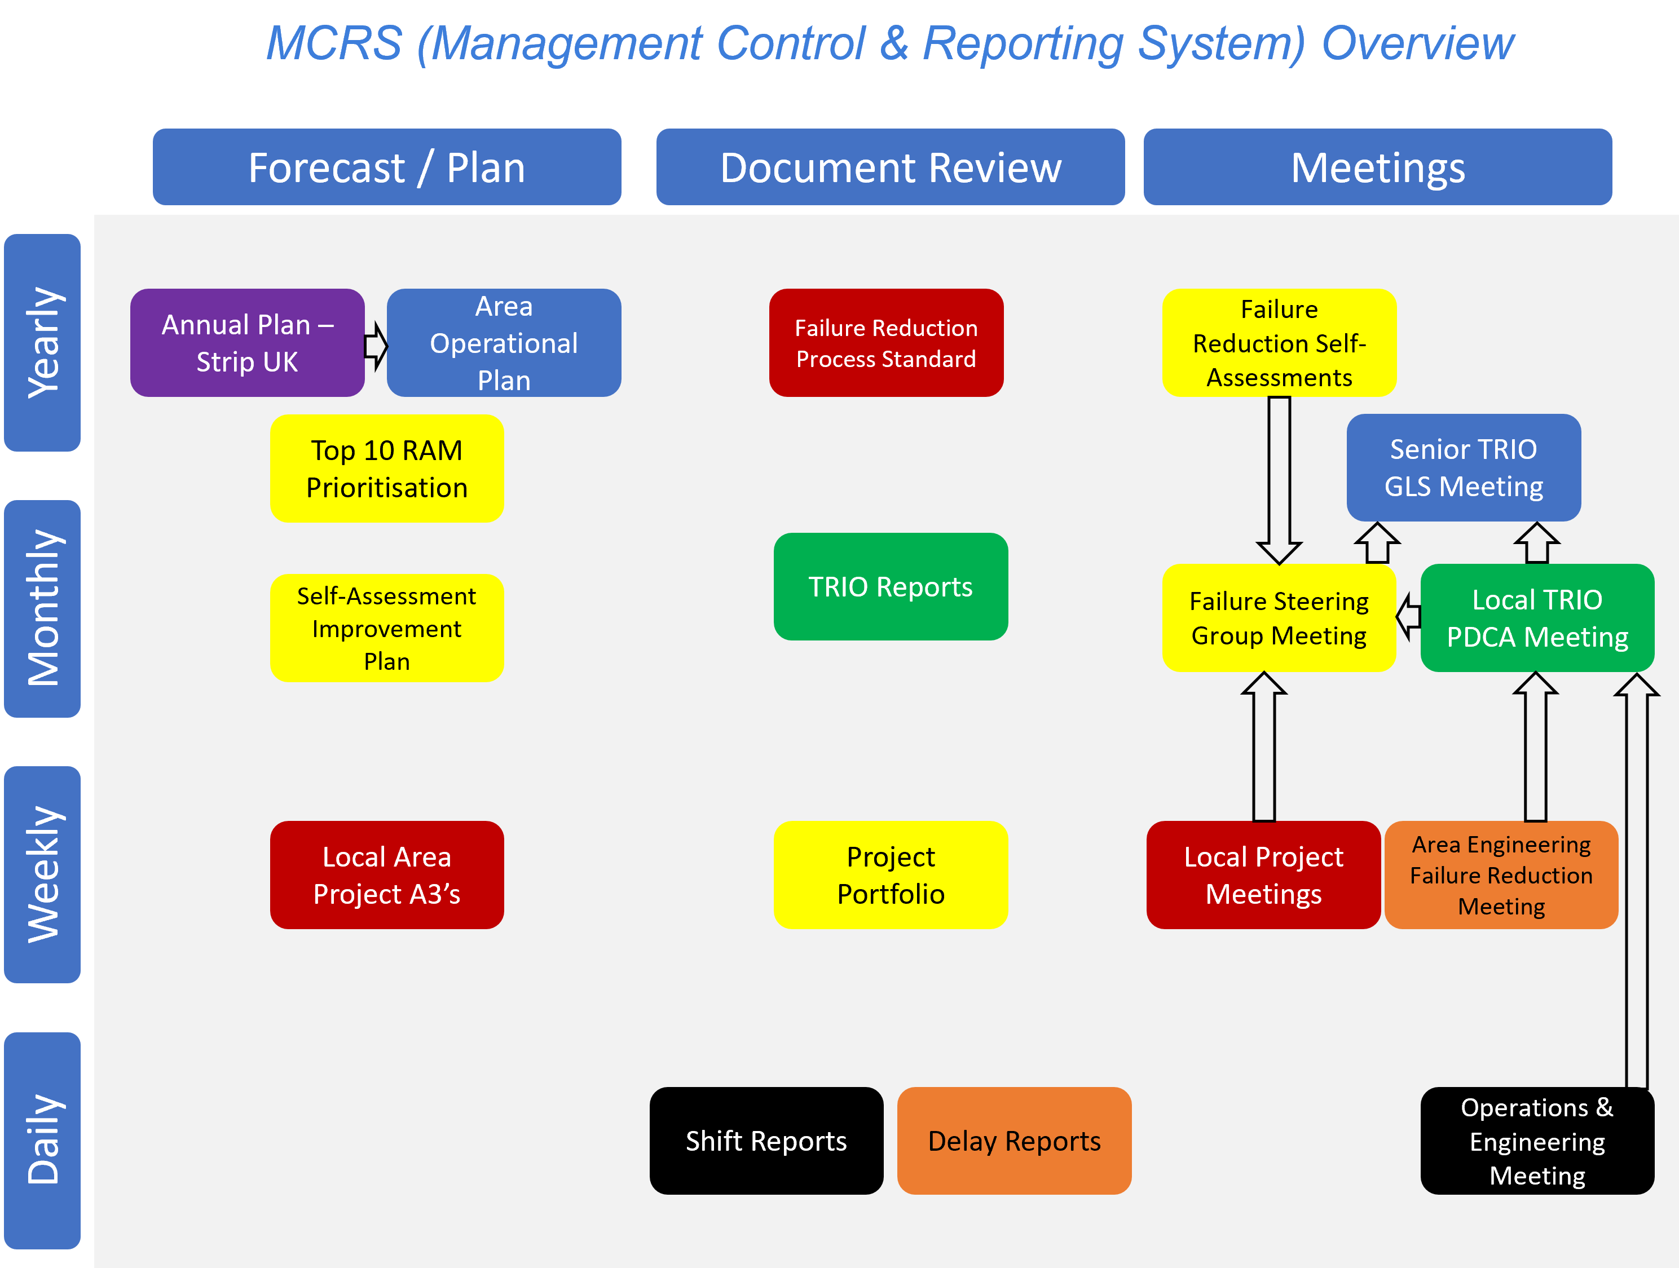
Figure 4 - Management & Control Reporting System

Voice of the Customer / Critical to Quality
Our mission statement as the harbour engineering team is “Deliver process stability and asset availability, whilst maximising efficiency.”
The voice of the customer is delivered through feedback sessions and daily meetings where the previous 24hrs of operations are reviewed and discussed. This gives the production leader (customer) an opportunity to voice their frustrations and provide insight on delays.
Figure 5 shows a snippet of customer feedback captured during one of the daily meetings in the form of a KANO model.
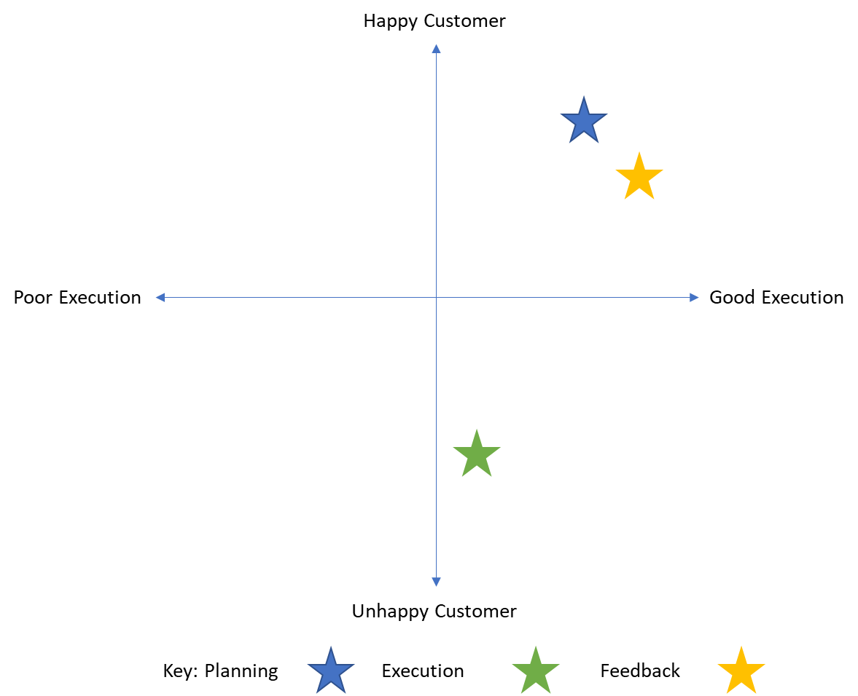
Figure 5 – KANO Model (Matzler, 1996)

Project Scope
Project Name | Project Manager | Date
Harbour Asset Availability (Reliability) Improvement | David Adams | 01/11/2022
Business Justification
Harbour Asset Availability has dropped below AP target of 95%, this has considerable financial impact on the business (~£2M p.a)
Project Scope
Inclusions
- Delay Analysis of Ship Discharge Unloaders
- Engineering associated delays
- Spares Rationalisation
- Frequency of Maintenance Activities
Exclusions
- Change of KPI target
- Operational associated delays
Business Objectives
- Achieve minimum 95% Asset Availability
- Reduce demurrage costs (failure to discharge in time)
- Reduce Maintenance Activities and Costs
- Reduce Spares Costs
- Implement Continuous Improvement of Failure Reduction Process
Project Deliverables
- Identify Top Contributors to Asset Availability (Top 10)
- Implement solution to No.1 Engineering delay (Related to work function)
- Improve and implement department failure reduction processes
Constraints
- No additional time or labour resource to complete project
- Project to be completed in addition to front-line engineering activities
Assumptions
- Access to company data to complete data analysis
- Proposed solutions require business case for funding
- External specialist contractor may be required to supply solutions
(Tata Steel UK, 2022)

Project Charter
TATA Engineering Project Charter
Project Name | Harbour Asset Availability (Reliability) Improvement | Business/Dept. | Port Talbot Harbour
Change Agent | David Adams | Tel. Number | 3480
Champion | Mark Powys | Tel. Number | 5065
Start Date | 01/11/22 | End Date | 31/01/23
Project Details
Description | Improve Asset Reliability using Six Sigma methodology to determine most valuable workstreams
Business Case | Delays to the unloading of raw material vessels incurs increased maintenance costs and increased demurrage costs
Problem Statement | Harbour Ship Unloader Cranes are not achieving 95% Asset Availability required to meet AP targets
Process Function | Harbour Engineering
Project Start | Define cause and create effective solutions to reduce delays
Project End | Once mitigations or changes have been made and been proven to be effective
Project Goals | Measure | Current | Goal
Improve Asset Availability | $Max Uptime=\left(Berth Occupancy×24hr Operation\right),$  $Actual Uptime=Max Uptime-Downtime$,  $$Availibility \left(\%\right)= \left(\frac{Actual Uptime}{Max Uptime}\right)×100.$$ | 84% | 95%
Reduce demurrage costs | Monthly Demurrage Report | £2M pa | £1M pa
Reduce Maintenance costs | Monthly Accounting Report | £1.5M pa | £1.3M pa
Team Members | David Adams (Area Engineer), Corey Tristram (Area Inspector),
Support Required | Mark Powys (Engineering Manager), Mark Davies (Production Manager), Kirsty Hamlyn (Spares and Planning Manager)
Risks/Constraints | Management of Change procedure must be adhered to
(Tata Steel UK, 2020)

Measure

Identify Measurement Variation

Delay Duration
The CMMS system is used for the manual inputting of delay duration data, because the plant is 24/7 operation, there are multiple users which can lead to inconsistent data recording.

Delay Description
The CMMS system is used for the manual inputting of delay description data. There is no standardised list of delay description values which can cause for inaccuracies in repeatable occurrences due to user preference/bias.

Delay Type
The CMMS system is used for the manual inputting of delay type data. The operations team leader is the user that inputs the delay type data, sometimes there is a requirement for the user to determine that the delay type is an operational delay that could affect their personal KPI’s, this could lead to inaccurate data recording.

Berth Occupancy
The Berth Occupancy is a calculation that is completed within the CMMS system using the official vessel berth document data and the official dispatch document data. These are legal documents that are completed accurately under threat of legal prosecution.

Maintenance Costs
The cost of maintenance is recorded within the CMMS system, planned maintenance costs are determined by fixed labour and spares costs. Unplanned maintenance incorporate these costs plus additional costs arising through external sources (i.e. overtime, spares, call-out charges, express delivery etc.) This data has to be sorted and apportioned by the area engineer.

Determine Data Type
Measure Title | Data Required | Data Type | Data Source | Data Collection Method | Constraints | Resource Required
Delay Duration | Duration that the asset was unable to unload vessel at berth | Discrete | CMMS | Manual entry by operations team leaders | Reliant on accurate reporting by users | 1 person to record data,  1 person to extract and analyse the data
Delay Description | Description of delay including asset and component affected/responsible for the delay | Discrete | CMMS | Manual entry by operations team leaders | Measurement variability due to different users | 1 person to record data,  1 person to extract and analyse the data
Delay Type | Type of Delay that has occurred | Discrete | CMMS | Manual entry by operations team leaders | Measurement variability due to different users | 1 person to record data,  1 person to extract and analyse the data
Berth Occupancy | Amount of time and overall percentage of berth occupancy | Discrete | Official vessel berth document data,  Official dispatch document data | Manual entry by operations team leaders | Reliant on accurate reporting by users | 2 persons to record data,  1 person to input data  1 person to extract and analyse the data
Maintenance Costs | Value of planned maintenance compared to unplanned maintenance | Discrete | CMMS | Manual apportioning of Cost data by Area Engineer | Reliant upon accurate | 1 person to apportion correct values to planned and unplanned maintenance  1 person to extract and analyse the data
(Breyfogle, 2003)

Develop Data Collection Plan
Delay Data is currently collected by operations team leader and is inputted into the CMMS package SAP.
Maintenance Data is recorded automatically within the CMMS from the work that is planned and recorded, it is apportioned into the correct cost centre (planned/unplanned) by the area engineer after it has been scheduled, and then feedback as ‘completed’.

Perform Measurement System Analysis
The current measurement system is relying on human judgment to interpret the delays and input the data into the CMMS package. It is evident from the raw data that the human element leads to data that is incorrect or inaccurate.

Data Collection and Assess Process Capability
Table 3 – Example of Raw Data: All Delays 2019-2022
Type/ Category | Start | Duration | Description/Reason
Operational | 13/01/2019 19:40 | 1h 0m | LOUD NOISE COMING FROM PAN FEEDER
Electrical | 16/01/2019 19:10 | 48m | Hold gearbox reached 67deg awaiting to cool down
Mechanical | 16/01/2019 19:15 | 22m | Noise / shaking coming from front trolley .Mech investigated unable to see cause .
Electrical | 16/01/2019 21:25 | 28m | Hold gearbox temps reached 63.8 deg , left to cool down
Electrical | 17/01/2019 01:00 | 40m | Hold Gearbox high temps 65deg
Electrical | 13/02/2019 15:30 | 20m | DCC breaker tripped on overload, advised to grab less material.
Electrical | 15/02/2019 09:22 | 16m | driver lost all motions and had and alarm up Hold dc breaker closed safety relay.
Mechanical | 18/02/2019 06:00 | 12h 0m | Changing Boom hangers.
Electrical | 18/02/2019 10:49 | 2h 16m | Tripped out on the Hold motion. Fuse sourced from NO4 Unloader to replace blown fuse.
Operational | 20/02/2019 06:40 | 47m | High ship
Hydraulics | 20/07/2021 18:00 | 40m | Brake Fault

Analyse

Process Analysis Methods
The Raw data is exported from the CMMS package as seen in Table 3 and is processed using Microsoft Excel. The raw data is not suitable for determining frequency of repeat occurrences, the data requires interpretation and alteration.
Table 4 Shows an example of the raw hydraulic delay data, This data is substantially qualitative. Qualitative data cannot be measured objectively, and is therefore open to more subjective interpretation. After interpreting the raw data, I was able to process it into groups, this creates quantitive data which allows for statistical analysis. The processed data is shown in Table 5.
Once the data has been processed, it can then be analysed to produce trends and pareto charts, this summary is shown in Table 6.
Table 4 – Example of Raw Data: Hydraulic Delays 2019-2022
Type/ Category | Start | Duration | Description/Reason
Hydraulics | 23/08/2019 00:01 | 39m | Rail clamp would not raise, mechanical topped up with oil
Hydraulics | 21/02/2020 06:00 | 1h 20m | L/S/E rail clamp pack low on oil and out on over temp. Oil sourced and topped up.
Hydraulics | 22/02/2020 10:45 | 50m | L/S/W Rail clamp hydraulic union worked loose unable to raise clamps. Tightened up and topped up with oil.
Hydraulics | 06/06/2020 21:00 | 15m | Low oil alarm WSW rail clamp pack. Clamps not raising.
Hydraulics | 07/06/2020 03:22 | 16m | Low oil alarm WSW rail clamp pack. Clamps not raising.
Hydraulics | 07/06/2020 10:00 | 40m | Driver reported WSW rail clamp issues. Unable to raise rail clamps. Oil top up required.
Hydraulics | 07/06/2020 15:16 | 20m | rail clamps came on with an over temp oil alarm. Craft topped up oil
Hydraulics | 07/06/2020 19:05 | 20m | Oil level required full top up due to major leak on rail clamp pack
Hydraulics | 07/06/2020 22:35 | 20m | Oil level required full top up due to major leak on rail clamp pack
Hydraulics | 27/08/2020 08:23 | 8m | Topped up oil on Waterside East Rail clamp pack.
Hydraulics | 29/01/2021 00:02 | 20m | W/S/E Rail clamp pack topped up with oil.
Hydraulics | 02/02/2021 23:04 | 16m | Rail Clamp oil level low, oil topped up
Hydraulics | 07/06/2021 16:24 | 1h 8m | Water side east over temp oil alarm. unable to raise rail clamps
Hydraulics | 06/07/2021 02:45 | 1h 13m | L.S.E rail clamp activated due to low oil level. Grab stuck under coaming
Hydraulics | 08/07/2021 12:36 | 17m | Water side east rail clamp oil level low
Hydraulics | 05/08/2021 18:15 | 20m | Driver unable to reset rail clamp, mechanical topped with oil and No3&4 rail clamps unpinned
Hydraulics | 23/03/2022 03:10 | 24m | WSE rail clamp oil pack low.
Hydraulics | 22/04/2022 14:00 | 11m | Long travel rail clamps came on. Driver couldn't raise. W/W pack low oil
Hydraulics | 15/10/2022 20:05 | 18m | Oil packs topped up.
Hydraulics | 16/10/2022 00:28 | 17m | WSE rail clamp failed to raise, oil topped up and No6 position Rail clamp pinned off due to oil leak found evident.

Table 5 – Example of Processed Hydraulic Delays 2019-2022
Type/ Category | Start | Duration | Asset | Delay
Hydraulics | 23/08/2019 00:01 | 39m | Rail Clamps | Low Oil Level
Hydraulics | 07/02/2020 23:50 | 8m | Rail Clamps | Low Oil Level
Hydraulics | 21/02/2020 06:00 | 1h 20m | Rail Clamps | Low Oil Level
Hydraulics | 22/02/2020 10:45 | 50m | Rail Clamps | Low Oil Level
Hydraulics | 06/06/2020 21:00 | 15m | Rail Clamps | Low Oil Level
Hydraulics | 07/06/2020 03:22 | 16m | Rail Clamps | Low Oil Level
Hydraulics | 07/06/2020 09:25 | 10m | Rail Clamps | Low Oil Level
Hydraulics | 07/06/2020 10:00 | 40m | Rail Clamps | Low Oil Level
Hydraulics | 07/06/2020 15:16 | 20m | Rail Clamps | Low Oil Level
Hydraulics | 07/06/2020 19:05 | 20m | Rail Clamps | Low Oil Level
Hydraulics | 07/06/2020 22:35 | 20m | Rail Clamps | Low Oil Level
Hydraulics | 27/08/2020 08:23 | 8m | Rail Clamps | Low Oil Level
Hydraulics | 30/10/2020 22:20 | 36m | Long Travel Drives | Low Oil Level
Hydraulics | 14/11/2020 04:30 | 25m | Long Travel Drives | Low Oil Level
Hydraulics | 29/11/2020 21:13 | 13m | Rail Clamps | Low Oil Level
Hydraulics | 29/01/2021 00:02 | 20m | Rail Clamps | Low Oil Level
Hydraulics | 02/02/2021 23:04 | 16m | Rail Clamps | Low Oil Level
Hydraulics | 17/04/2021 09:40 | 15m | Close motion assembly | Low Oil Level

Table 6 – Processed and Summarised data: Hydraulic Delays 2019-2022
Reason | Sum of Duration | Frequency | Percentage | Accumulative
Low Oil Level | 1249 | 43 | 27% | 27%
High Oil Temperature | 898 | 35 | 19% | 46%
Valve U/S | 885 | 4 | 19% | 66%
Pump U/S | 463 | 3 | 10% | 76%
Hydraulic hose damaged | 355 | 4 | 8% | 83%
Brake Fault | 301 | 8 | 7% | 90%
Rail Clamp Issues | 160 | 3 | 3% | 93%
Adjustment required | 153 | 1 | 3% | 97%
Long Travels Tripped | 75 | 3 | 2% | 98%
Tension Issues | 60 | 2 | 1% | 99%
Pressure switch U/S | 25 | 1 | 1% | 100%

Graphical Analysis Tools

Pareto Charts
The Pareto Chart in Figure 6 clearly shows that the largest contributor to delays are hydraulic type delays.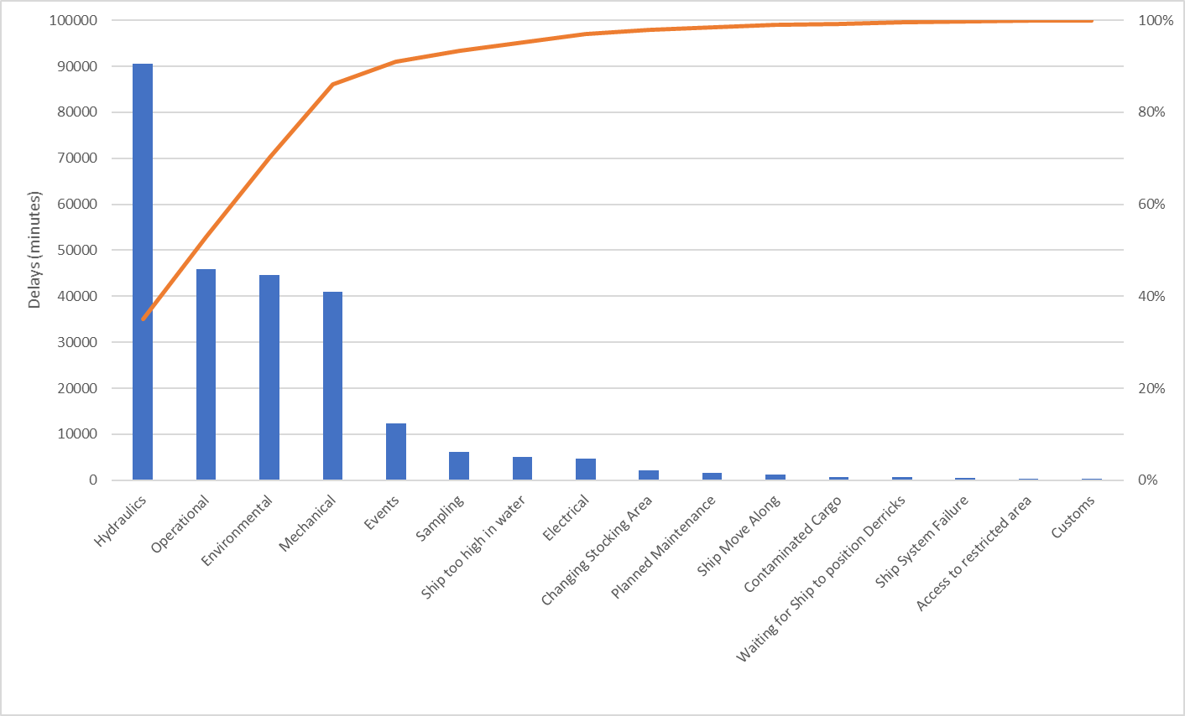
Figure 6 – Pareto Analysis Chart: Delay Types 2019-2022
The Pareto Chart in Figure 7 clearly shows that the largest contributor to the hydraulic delays is low oil level. This requires further exploration and analysis to determine root cause and provide a suitable solution.

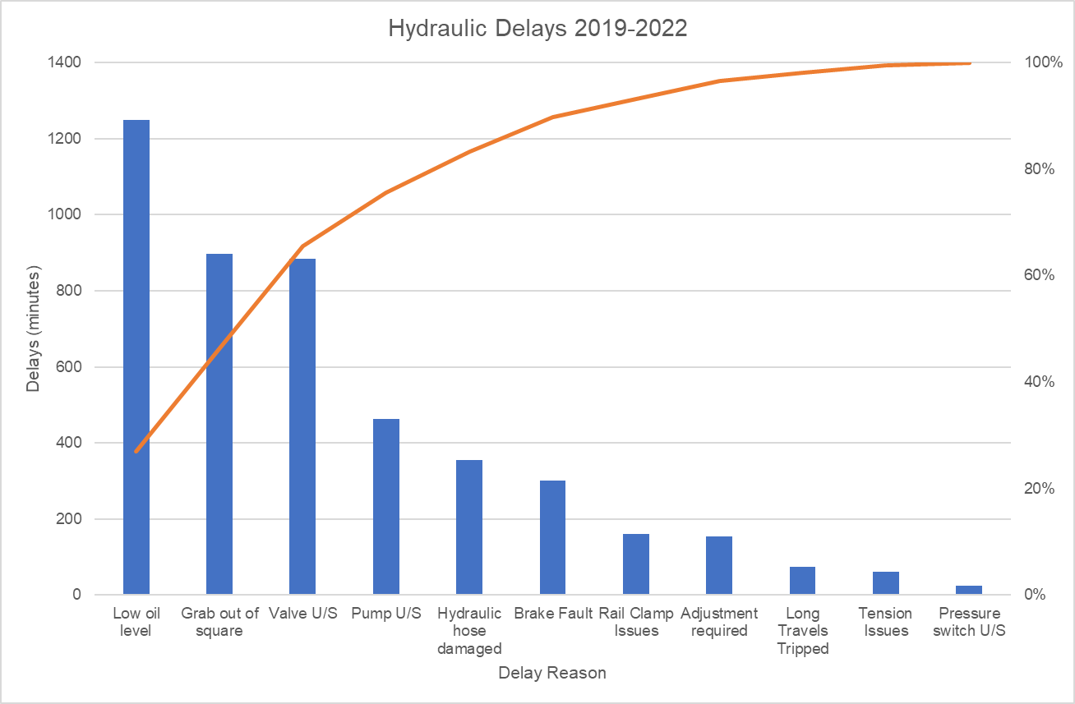
Figure 7 – Pareto Analysis Chart: Hydraulic Delays 2019-2022
(Pyzdek, 2003)

Why Root Cause Analysis
The 5 Whys analysis technique is a simple, yet effective method for identifying the underlying causes of a problem by asking "why" questions 5 times or until the root cause of a problem is identified. (Mandal, 2015)
Figure 8 - 5 Why Analysis Diagram of Low Oil Level Delays

Fishbone (Ishikawa) Diagram
The fishbone diagram in Figure 9 shows the root cause analysis method used for determining causes of low oil level delays.
Figure 9 – Low Oil Level Fishbone Diagram
(Jayanthi, 2013)

Improve

Generate Improvement Alternatives
There are multiple improvements that can be made to reduce the delays associated with low oil level.
- Increased/Improved Preventative Maintenance Regime
- Installation of Oil Level sensors
- Automatic System top-up
- Installation of fixed pipework

Improve FMEA Phase
Figure 10 shows the new FMEA for low oil level, it shows the reduction in RPN number after implementation of low level sensors.
Figure 10 – Revised FMEA

Perform Cost/Benefit Analysis

Cost/Benefit Matrix
Figure 12 – Cost/Benefit Matrix for proposed improvements
It is shown in Figure 12, that the installation of low-level sensors connected to an alarm system in the PLC will provide the largest impact with the lowest implementation cost. This would be the first solution to be implemented given the criteria.
It is also worth noting the environmental impact on oil loss from a hydraulic system and the potential safety risk that it creates. For the purposes of this project, the main goal is to reduce operational delays, a secondary project to implement further improvements which reduces the number of leaks that could occur would be beneficial in these areas.

Eisenhower Matrix
The Eisenhower priority matrix shown in Figure 11 is used to prioritise and delegate solutions and their workload efficiently and effectively.
Figure 11 – Eisenhower Matrix (Alrawashdeh, 2018)

Pilot Proposals
It is proposed to use a digital level sensor, with the PLC program modified to generate a warning output at 60% level and fault output at 20% level feedback. The warning output would allow the system to continue to operate, with the fault output, stopping the system. The proposed PLC program is pictured in Figure 15 and Figure 16.
The sensor type used was selected using the material data sheet in Appendix 2: MPM4706 Digital Level Transmitter Datasheet and comparing the specifications to the application parameters. This will be used in addition to the current level indication method that is pictured in Figure 13. This is to enable maintenance technicians to view the oil level without referring to the PLC for its feedback signal.
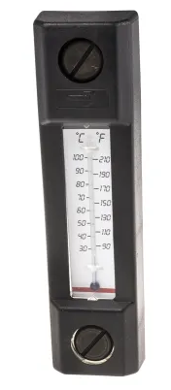
Figure 13 – Current Level Indication Method
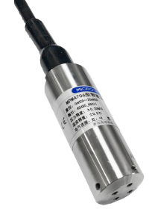
Figure 14 – Proposed Digital Level Sensor
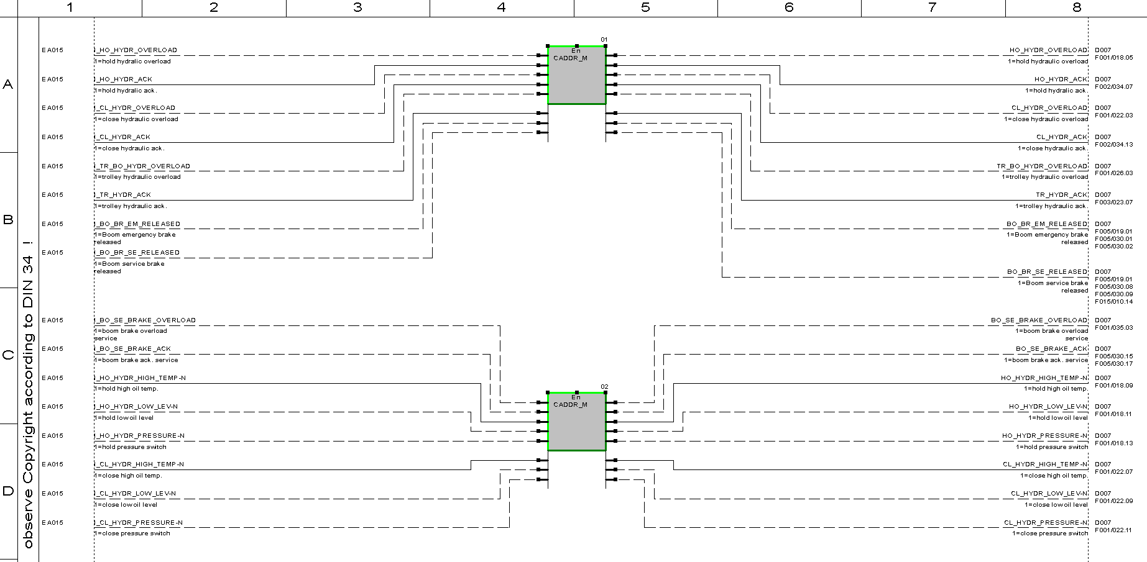
Figure 15 – Proposed PLC Program including level sensors (1)
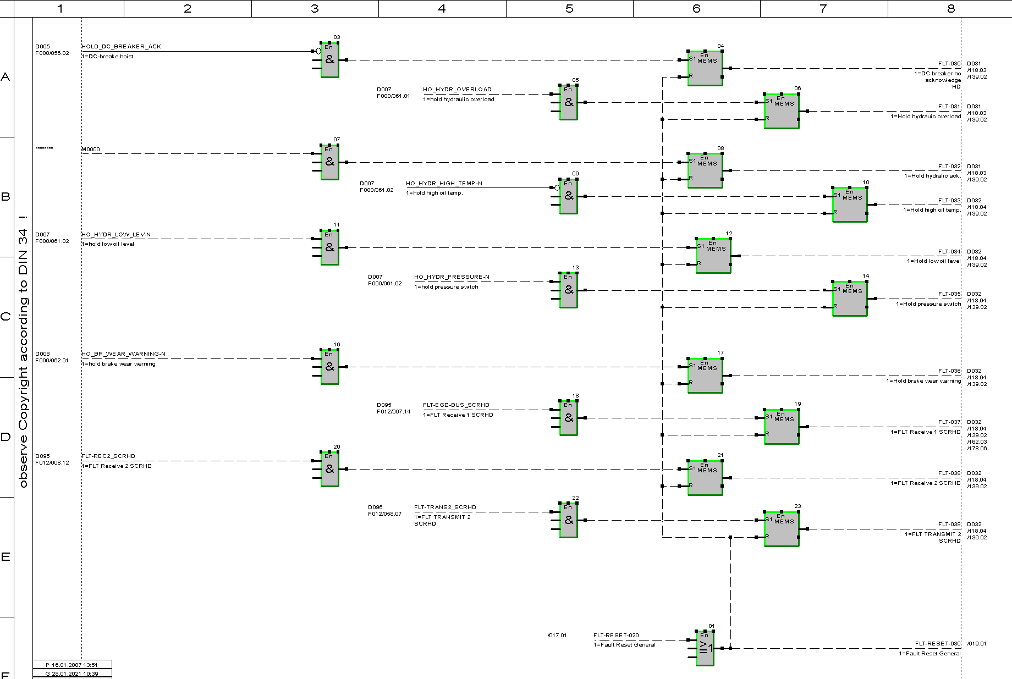
Figure 16 – Proposed PLC program including level sensors (2)

5.4.1 Future State Process Map
The process map has been amended to show the process with the low level warning system in place, this is shown in Figure 17, it is worth noting that the system can remain in operation whilst the maintenance personnel investigates the issue, whereas in the previous state, there would be no early warning and the maintenance personnel would only investigate the issue once the system had tripped on thermal overload.
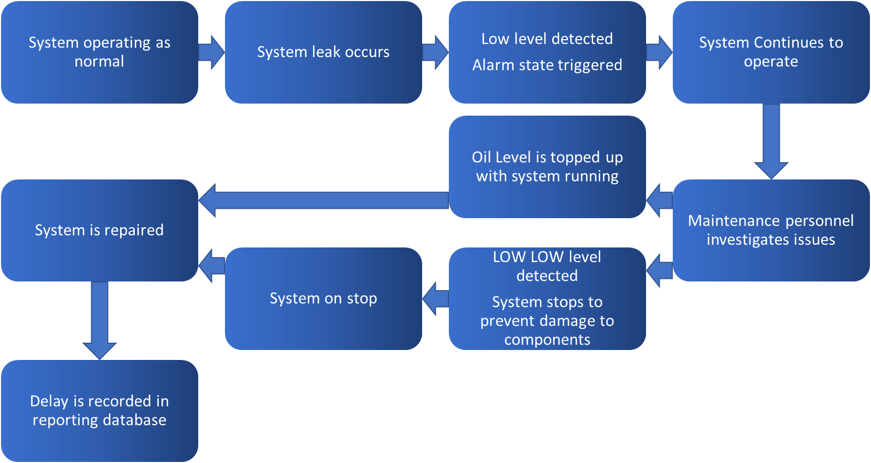
Figure 17 – Future-state Process Map

Implementation Plan
Figure 18 shows the use of a Gantt chart to provide a visual representation of the project schedule and help identify critical path activities and resource conflicts. It was also used to track project progress and to communicate project status to stakeholders. (Fleming, 2016)
Figure 18 – Gantt Chart - Project Implementation Plan

Validate Improvements

Asset Availability
It is clear from the delay data shown in Figure 19, that following the installation of the oil level sensors, the project goal of 95% Asset Availability has been achieved. 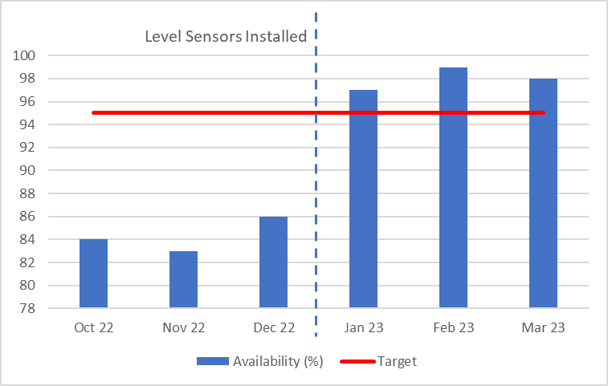
Figure 19 – Asset Availability Oct 22 – Mar 23
The causation of this is supported by the significant reduction in hydraulic delays. This data is shown in Figure 20.
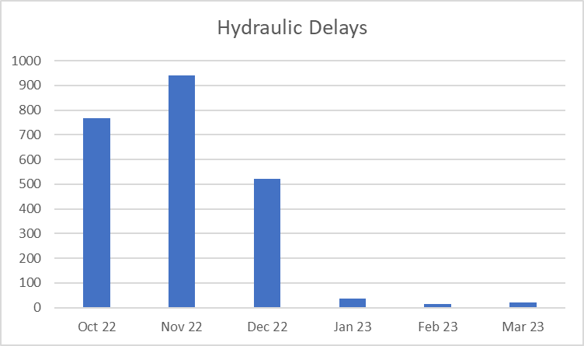
Figure 20 – Hydraulic Delays Oct 22 – Mar 23

Demurrage Costs
The demurrage cost reduction target was set as £1M reduction over the financial year, although the full data set is not yet available to demonstrate, using the data that is available since implementation of the improvements, it is fair to say that this target will be achieved. This is shown in Table 8.

Table 8 – Demurrage Data 2022 - 2023
Month | Demurrage Costs (£M)
Jan-22 | 0.11
Feb-22 | 0.12
Mar-22 | 0.13
Apr-22 | 0.15
May-22 | 0.16
Jun-22 | 0.11
Jul-22 | 0.1
Aug-22 | 0.1
Sep-22 | 0.1
Oct-22 | 0.4
Nov-22 | 0.4
Dec-22 | 0.2
Jan-23 | 0.11
Feb-23 | 0.06
Mar-23 | 0.08
Total YTD 2023 | 0.25
Average Month 2023 YTD | 0.083333333
Predicted Total 2023 | 1

Maintenance Costs
The maintenance cost reduction target was set as £200K reduction over the financial year, however this target has already been met in just three months since implementation of the improvements This is shown in Table 9.
Table 9 – Maintenance Cost Data 2022 -2023
Month | Maintenance Costs
Jan-22 | £ 100,000.00
Feb-22 | £ 111,000.00
Mar-22 | £ 136,000.00
Apr-22 | £ 107,000.00
May-22 | £ 121,000.00
Jun-22 | £ 144,000.00
Jul-22 | £ 150,000.00
Aug-22 | £ 131,000.00
Sep-22 | £ 114,000.00
Oct-22 | £ 153,200.00
Nov-22 | £ 188,000.00
Total 2022 | £ 1,455,200.00
Dec-22 | £ 104,000.00
Jan-23 | £ 7,600.00
Feb-23 | £ 3,200.00
Mar-23 | £ 4,400.00
Total YTD 2023 | £ 15,200.00
Average Month 2023 YTD | £ 5,066.67
Predicted Total 2023 | £ 60,800.00

Control
To ensure ongoing benefit and improvement, it is important to monitor and audit the current data measurement systems and ensure that the improvements and changes made are adhered to and remain in use in the future.
A regular monthly audit of the SAP CMMS software, with regards to delay data, has been set up as a mandatory work instruction. This will allow myself and other members of the project team to audit the data that is being recorded and deliver any refresher training to the inputters/interpreters if the data begins to vary or become inaccurate.

Conclusion
I believe that this report documents the successful implementation of a Six Sigma project. Utilizing the DMAIC process, I identified areas of improvement, analysed data, and implemented changes to reduce delays and improve operational stability and efficiency.
The DMAIC process provided myself with a structured approach to problem-solving, enabling me to focus on improving the department process and asset reliability. I relied on data-driven decision-making, using statistical tools and techniques to identify root causes and implement effective solutions.
The project charter was to deliver 3 targets,
- 95% Asset Availability
- £1M Reduction in Demurrage Costs
- £200K Reduction in Maintenance Costs
As a result of following the DMAIC process, I have seen a significant improvement in asset reliability, reduction in demurrage costs, sizeable savings with maintenance costs and an overall more efficient operation.
Moving forward, I will continue to monitor and evaluate the department’s processes to maintain the standards that have now been set. Utilizing the six sigma methodology has allowed me to establish a framework for continuous improvement that can be applied to other problems within the department and yield further benefits.
In conclusion, the successful implementation of this Six Sigma project demonstrates the value of the DMAIC process in improving quality and efficiency.

Bibliography
Alrawashdeh, M. A. &. A. A. M., 2018. Time management in engineering projects: Urgent-important matrix approach. Journal of Engineering, Design and Technology, pp. 437-448.
Breyfogle, F. W., 2003. Implementing Six Sigma: Smarter solutions using statistical methods (2nd ed.). s.l.:John Wiley & Sons..
Fleming, Q. W. &. K. J. M., 2016. Earned Value Project Management (4th ed.). s.l.:Project Management Institute.
Jayanthi, P. &. B. V., 2013. Implementation of Six Sigma DMAIC methodology in a manufacturing industry.. Journal of Industrial Engineering and Management,, pp. 548-572.
Mandal, A. &. D. T., 2015. A Case Study of Defects Reduction in a Rubber Gloves Manufacturing Process by Applying Six Sigma Principles and DMAIC Problem Solving Methodology. Quality and Reliability Engineering International, pp. 509-520.
Matzler, K. H. H. H. B. F. &. S. E., 1996. How to delight your customers.. Journal of Product and Brand Management, pp. 6-18.
Microsensor Corp, 2022. Digital Level Transmitter. [Online]
Available at: https://www.microsensorcorp.com/Product-details_Digital-Level-Transmitter-MPM4706.html
Pyzdek, T., 2003. The Six Sigma Handbook: The Complete Guide for Greenbelts, Blackbelts, and Managers at All Levels (2nd ed.). s.l.:McGraw-Hill Education.
Tata Steel Europe, 2021. Corporate Policy: Failure Reduction RASCI. s.l.:s.n.
Tata Steel Europe, 2022. At a glance. [Online]
Available at: https://www.tatasteeleurope.com/about-us/at-a-glance
Tata Steel UK, 2020. Project Charter Template. s.l.:s.n.
Tata Steel UK, 2022. Corporate Guidelines on Project Management. s.l.:s.n.

Appendices

Appendix 1: Failure Reduction Process RASCI (Responsible, Accountable, Support, Consulted, Informed) (Tata Steel Europe, 2021)
3.3.1
3.3.2.1
3.3.2.2

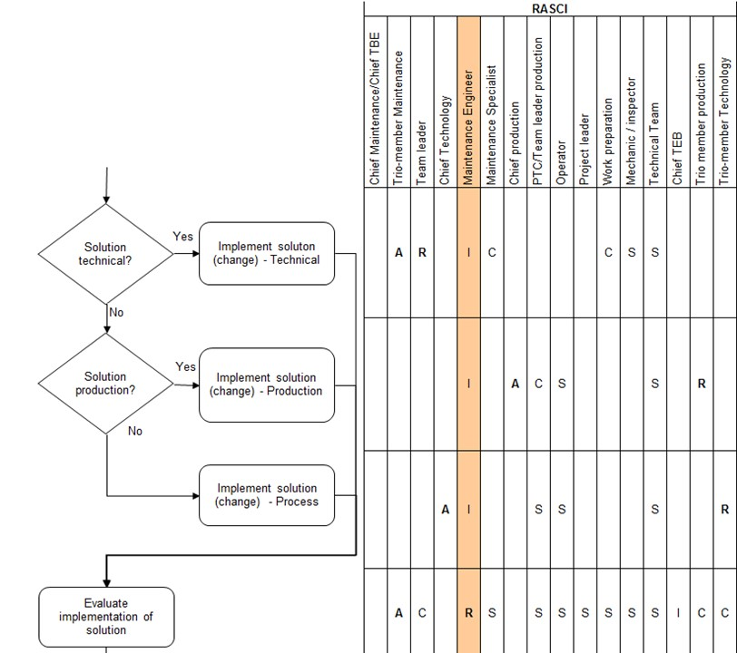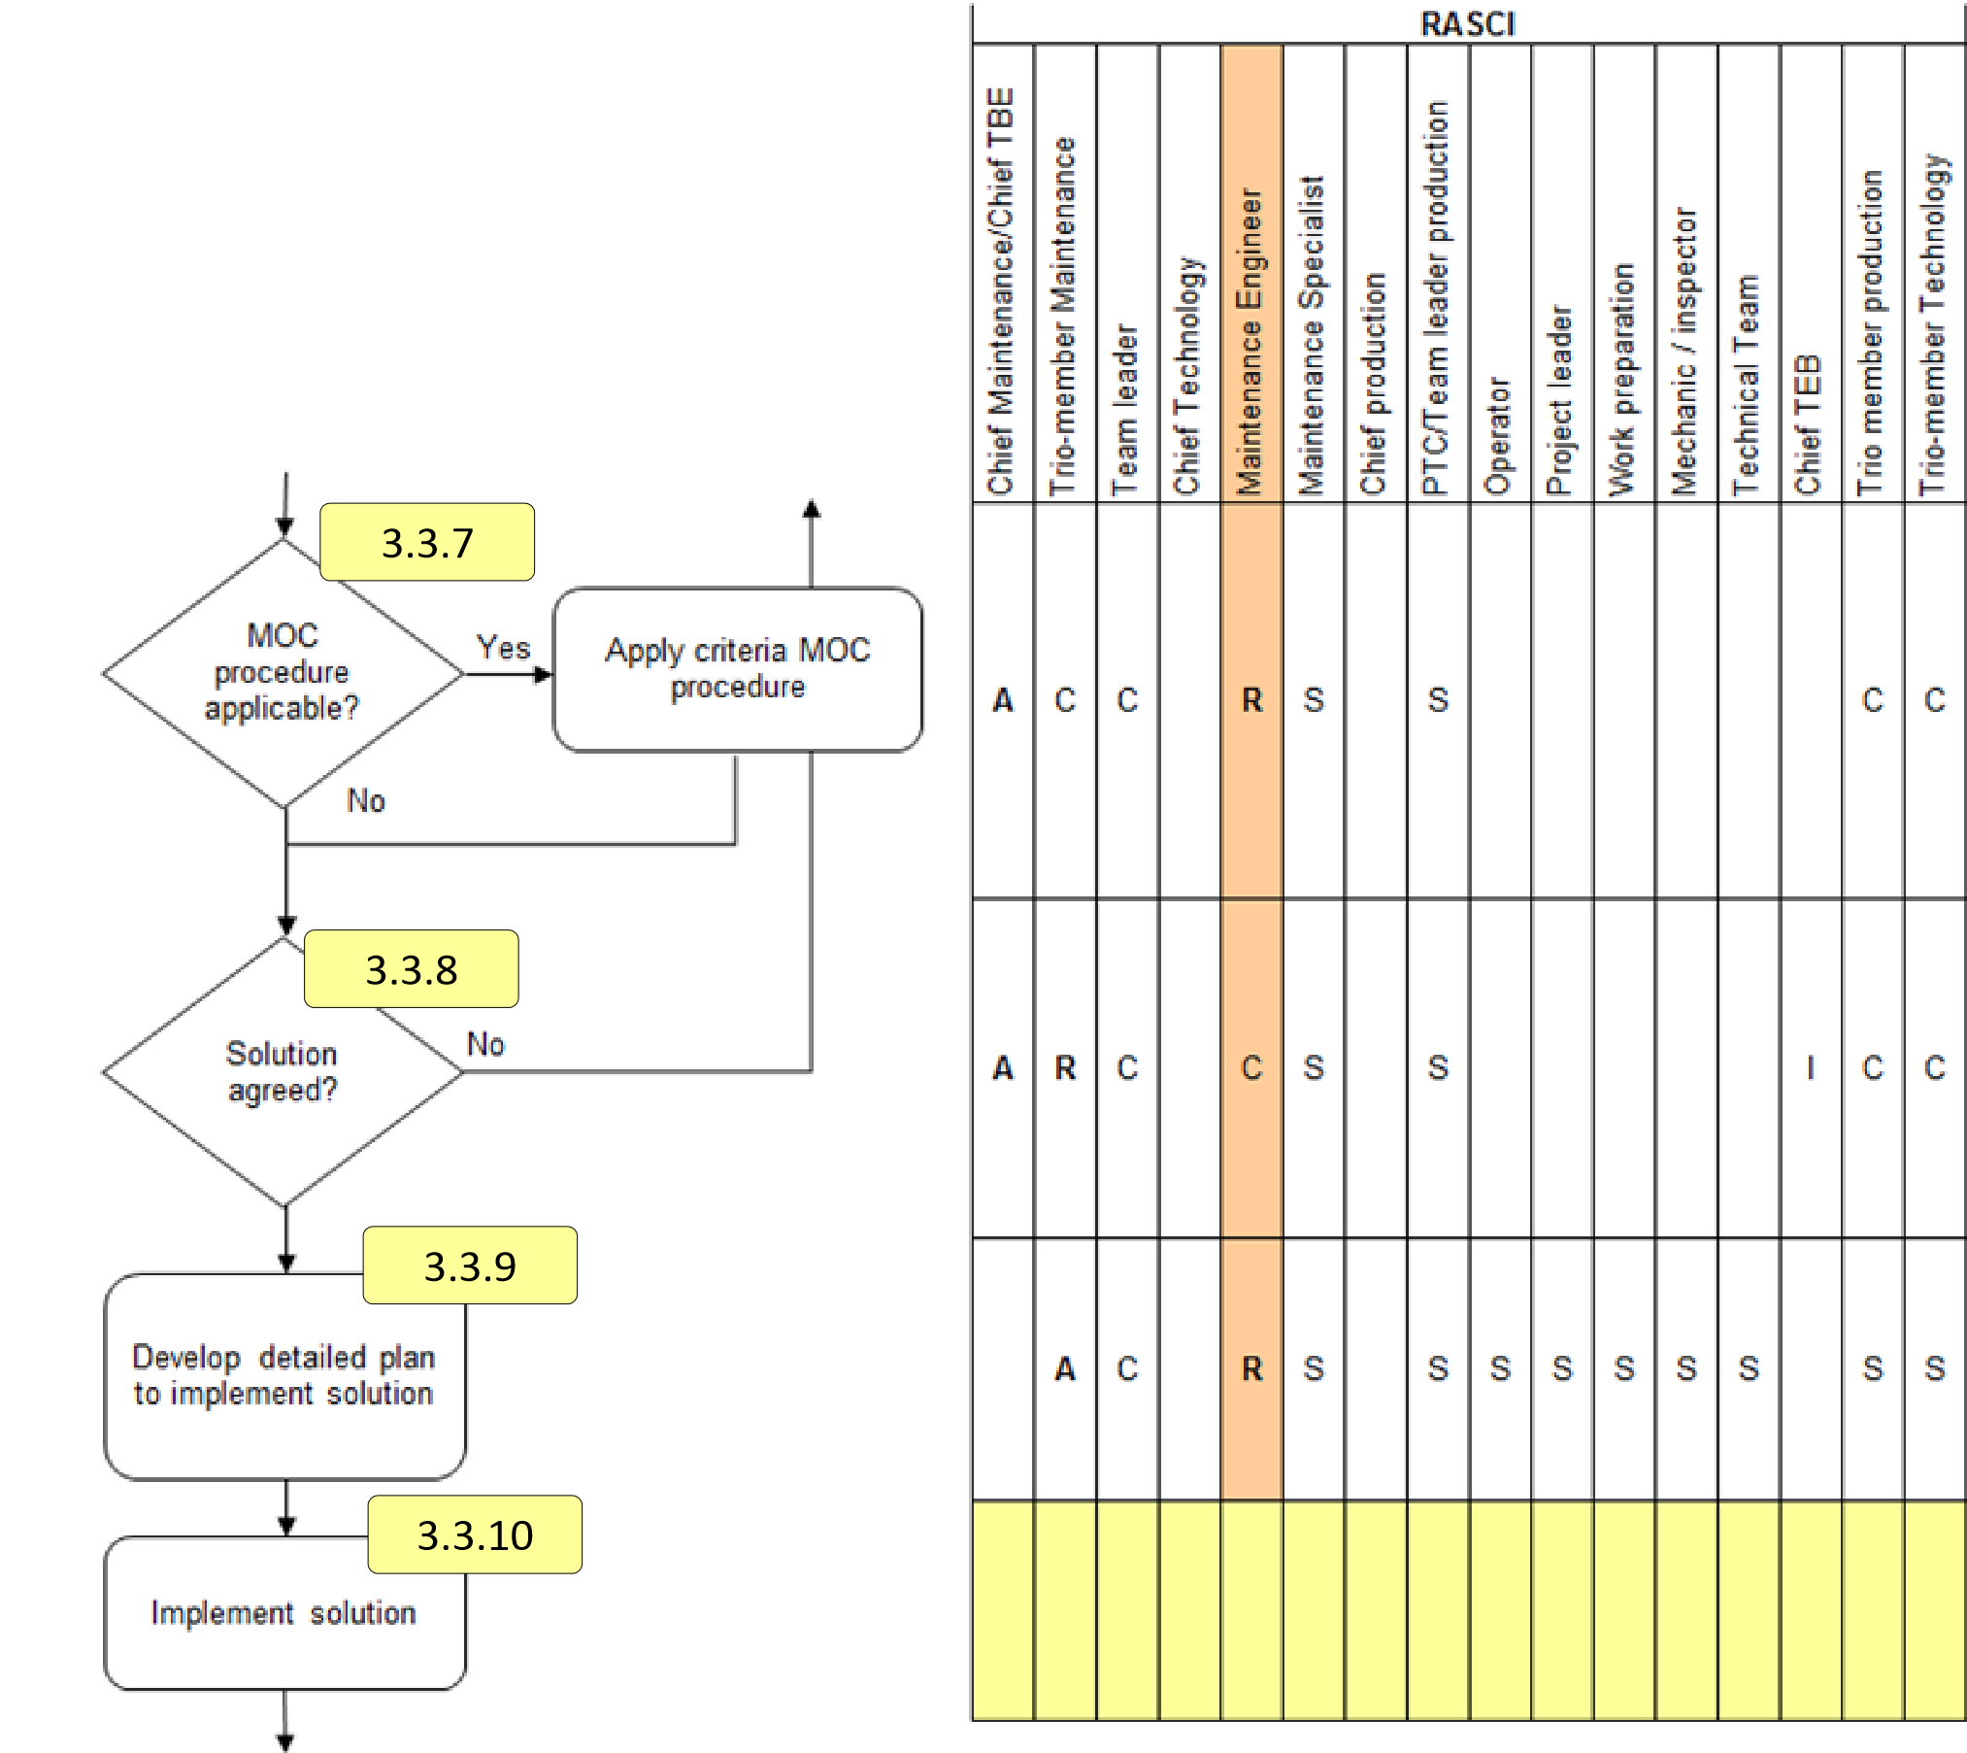
3.3.11

3.3.2.3
3.3.2.4
3.3.2.5
3.3.2.6

3.3.3
3.3.4
3.3.5
3.3.6

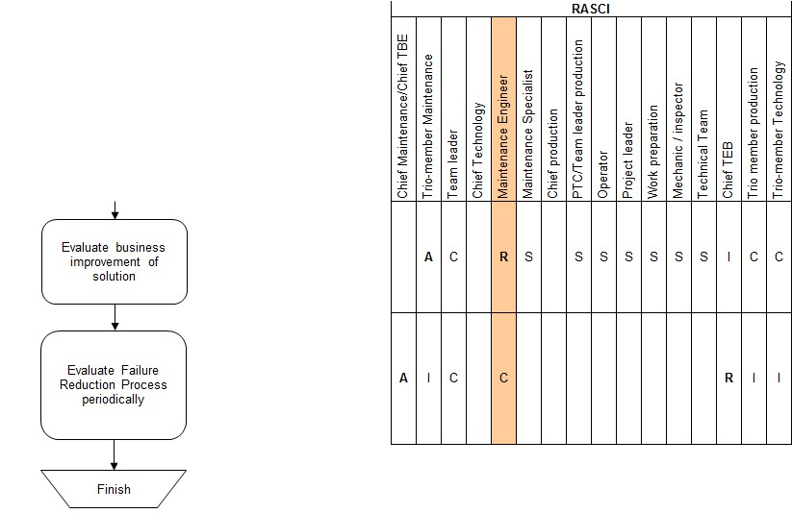

Appendix 2: MPM4706 Digital Level Transmitter Datasheet (Microsensor Corp, 2022)


