Portfolio Part 1 – HPHI – 5902
Primary Resource Document Review and Analysis – Remember Belgium
Recruitment poster printed and distributed in October 1914 by David Allen and Sons Ltd, Harrow, Middlesex with supporting text from British papers ‘The Times’ and ‘The Telegraph’ which were both originally written and published on 12th September 1914.
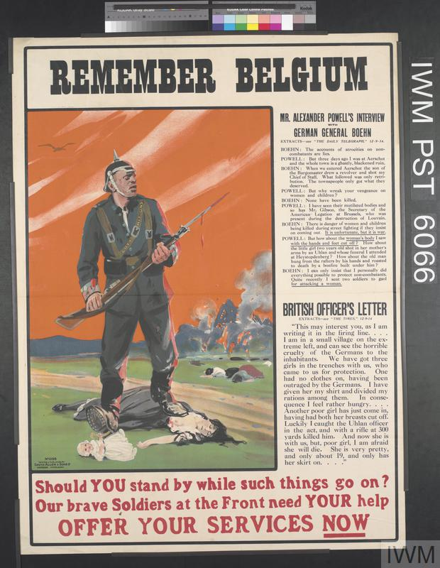
‘Remember Belgium’ is the headline for a recruitment poster circulated in Britain and France to assist in recruitment for the war. The poster contains a prominent image of a German solider with trampling over the body of a Flemish woman with bodies in the background and a burning village smoldering. The soldier's bayonet dripping with blood suggesting that he didn't shoot these civilians but butchered them with cold steel. The image contains a small child or a doll with the German solider seemingly oblivious with his next step crushing the child. The solider has a belt around his torso, which reads, 'Gott mit uns' [God is with us] referencing the shock of a fellow Christian nation committing these acts against fellow Christians. The poster attempts to invoke strong emotions of guilt to the men and women who have not yet enlisted by showing the new era of total war descending on the continent.
This image invoked great outrage at the time with the image of innocent Flemish civilians being killed and neutral Belgium going up in flames by German soldiers in the opening weeks of the conflict. The Poster initially helped to drive recruitment in the British Isles at the time as Britain did not have forced conscription at the beginning of the conflict but was soon used to justify the entry of neutral nations to join the allies. The ‘Remember Belgium’ became a powerful rallying cry and was repeated in various propaganda to garner further support for the war in multiple countries. You can clearly see the purpose of these posters were to invoke a sense of sympathy for the Flemish people and to portray the Germans as the aggressor that broke the civilized conventions of warfare by disregarding civilian life.
Atrocities were carried out by the Germans in Belgium in the opening weeks of the war with estimates of around 4000 Belgium civilians being killed, the vast majority men of fighting age but the acts were often exaggerated and even fabricated entirely for propaganda purposes. These stories were reported across Britain, France and the USA.
Interestingly within the Poster we have a transcript of an interview with a German general attempting to defend the actions. Alexander Powell was an American journalist who extensively covered the conflict from the front and helped to build support for the war back home. General Boehn suggests that the actions undertaken were justified due to attacks on German soldiers by the civilian population. This report seems to have a little bit of hypocrisy as similar targeting of civilian populations and guerilla activity was carried out on a far larger scale by the Americans in the Philippines and the British in Boer war. What this poster achieves is raising the resentment towards the German people and soldiers, the graphic description provided by the British officer of a young women who had her breasts cut off helps to demonize the enemy. There were lots of reports of these atrocities being carried out during the war from bayonetting babes, rape, and torture of civilians to name a few. Ultimately, it's very difficult to verify these claims but we do know that many stories were exaggerated and even fabricated to assist in war propaganda. The press at this time gave prominence to these stories even in the absence of factual verified information. A notable example would be the story of German soldiers liquefying the bodies of soldiers and civilians to make glycerin was totally fabricated and in 1925 the truth emerged long after its effects had been established. These tactics are used today with the pinnacle of war propaganda being the murder of babies, the embodiment of innocence. The latest conflict in Palestine showed us the power of propaganda with reports of babies being cooked in ovens, women raped and crucified and child beheadings most of which are now proven to be false, but the reports have served their purpose.
To deny any atrocities took place would be a fallacy and what took place in early August were war crimes, but the role of British propaganda helped to fuel the dehumanization of the Germans and move global opinion towards the Allied cause. What we are witnessing with this poster is the early development of highly emotive black propaganda which ultimately led to the US involvement in the war. As the war progressed and the press effectively reacted to German actions including the Zepplin bombings, costal bombardments and the sinking of Lusitania British and global propaganda became darker and more caricature. As the war progressed, we see even greater examples of this typified by Australian artist Norman Lindsey whose work includes apish depictions of German soldiers; this was expressed from multiple artists including Harry Hoops.
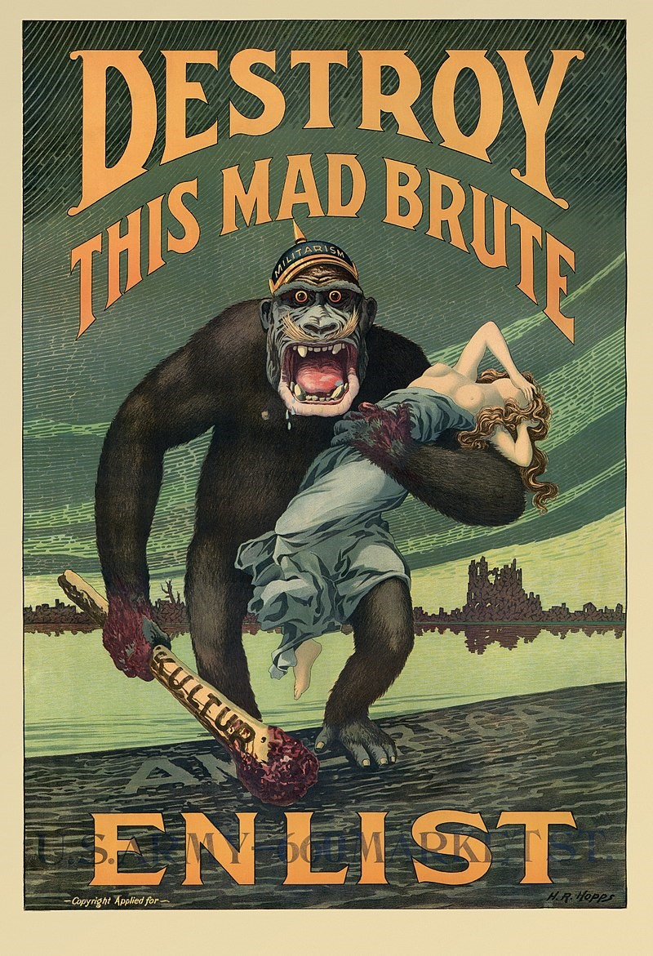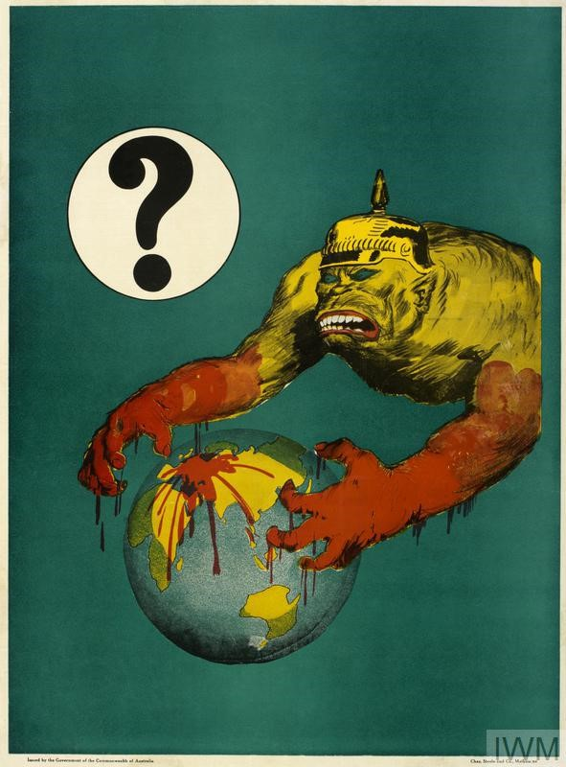
Ultimately Germany’s actions during the opening stages of the war provided all the propaganda material needed for the allies to launch a successful campaign to enlist men for the British Empire and arose passions in neutral countries to join the war. The Germans continued actions against civilian targets in 1915 with naval bombardments of coastal towns; zeppelin raids and the sinking of the Lusitania essentially united a larger multinational force against them that would bring their eventual defeat. These acts were successfully used in propaganda depicting the German soldiers and people as barbaric and uncivilized and something the world needed to unite against and defeat in the name of civilization. As mentioned previously, crimes were committed against humanity on both sides, but it seems the propaganda machine of the allies was by far the more successful.
By Matthew Simpson

Bibliography
Baggot, Blaine and Winter, Jay – The Great War and the Shaping of the 20th Century – BBC Books 1996
DeGroot, Gerard – Back In Blighty, The British at Home in World War 1 – Published by Vintage books 2014
Ferguson, Niall – The Pity Of War – The Penguin Press 1998
Gregory, Adrain – The Last Great War, British Society and the First World War – Cambridge University Press 2008
Macdonald, Lyn - 1914-1918 Voices and Images of the Great War – Penguin Books 1988
Strachan, Hew – The First World War – Simon and Schuster UK LTD 2003
Pogge von Strandmann, Hartmut - Chapter 5, The Mood In Britain 1914
Ringmar, Erik - ‘The spirit of 1914’: A redefinition and a defence - https://journals.sagepub.com/doi/abs/10.1177/0968344516650476

The Last Great War, British Society and the First World War
By Adrian Gregory – Book Review
Introduction
In this short essay I will be reviewing Adrian Gregory’s 2008 book, The Last Great War, British Society and the First World War. I will be focusing on Chapters 1 ‘Going to War’ as this revisionist evidence to the attitudes of the British population prior to the outbreak surprised me the most. The most notable recollection upon reading his book is how meticulously researched his book is. Gregory’s examination of British Society pre declaration of war and during exams, the various facets of British life which include a varied perspective from different sections of British society from the working classes and socialist leaning press to the middle classes and the more conservative outlooks. Gregory sheds a revisionist attitude on a war that helped shape the 20th century and has brought a fresh outlook for me when looking into WW1 and its impacts on the people of the British Isles.
The most fascinating thing to me upon reading this book is his ability to weave together multiple perspectives and using a huge quantity of primary sources ranging from letters, diaries, newspapers and official government records to paint a detailed and balanced view of British society during the Great War. I am impressed by how Gregory can present a multifaceted view of wartime society in Britain, and he uses experiences of soldiers, civilians and policy makers who are all grappling with the challenges of this new total war on the continent. Reading this book supplied me with an all-encompassing view of the Great War and his compelling evidence hits upon themes of how a society mobilized for war in this new era of total war.
Gregory expertly delves into themes of gender, class, trauma of war and process of war memory and commemoration and helps the reader to come to terms with the mood of the nation at this time. The complexities of society at this time and how they responded to the war helped me understand the mood of the nation and its people during these dark days and I can reflect the similarities of major world changing events from the 21st century as well.
The biggest point that will help with future understanding of the conflict is how diverse the responses were of the population to the outbreak of war and especially the sentiment of non-intervention pre declaration of war in the general population.
Author – Adrain Gregory
Adrian Gregory is an established historian who specializes in the study of World War I and in particular its societal impacts. He is currently a Professor of Modern History at Pembroke College, University of Oxford and is a revisionist historian relooking at familiar beliefs and conceptions of WW1. He has authored multiple books on the various aspects of WW1 and seems to be extremely well respected in his field. We can clearly see this from the esteemed academic historians that have endorsed this book. From these endorsements and confirmed after reading the book I can see this is directed at academics due to the sheer detail in his work combined with a substantial number of references to primary sources it would not be an easy read for casual readers. Greory’s research is commended and respected for its in-depth analysis and his attention to details and after reading this book I can see his impartiality and his focus on the facts. Gregory strives to maintain objectivity and impartiality a quality sadly few historians share today, and he is known for his evidence-based analysis rather than having any ulterior motives or political viewpoints within his writings.
Although Gregory has a relatively low public profile unlike fellow historian Dan Snow, his work speaks for itself, and it’s a refreshing take on the common conceptions.
Content
The book is essentially a revising of popular perception of WW1 and is an episodic view of British Society during this period. I will be reviewing three chapters that captivated me the most and really helped build my understanding of this period.
Chapter 1, ‘Going to War’ really established the difference between popular memory and historical understanding. The view of the build-up to war was of this jingoistic attitude towards the build-up and declaration of war was most certainly there but on what scale Gregory dives into. This chapter really helped me understand that the country was very much divided and from my interpretation was against intervention from most of the population pre-war. Gregory use of resources to counter the jingoistic attitude evidence is compelling and sound. He mentions that the decision for war was taken by the few and the endorsement by the population was certainly fiction.
When we think of WW1, we seldom think of the anti-war movements and sentiments the preluded the conflict and Gregory brings these to the forefront. His evidence shows that the anti-war sentiment was widespread and touched different classes from different beliefs and backgrounds. The visually startling images of crowds gathered around Buckingham Palace on the August the 3rd flags aloft and full of enthusiasm for the declaration of war is somewhat distorted. The images seen might suggest hundreds of thousands of people flocking to revel in the jingoistic attitudes, but Gregory looks at the London tramway receipts as one piece of startling evidence to suggest numbers where only up fractionally upon the previous year. His estimates of an additional 10,000 people in the capital of a city of 7 million are a stark reminder of the power of images and their uses.
Chapter one really helped me understand the polarisation of the country at this time and the sheer number of people opposed to the conflict was far greater than we were led to believe. I must point out that Gregory also makes good use of evidence to show that although there where large proportions of the public that where antiwar pre declaration, in fact the nation rallied once war was declared. I witnessed first-hand in 2003 when over 1,000,000 people descended upon London for the biggest gathering of the population demanding no war. Gregory helped me to understand this perspective with evidence from the Kentish Mercury who wrote,
“ I can not help myself, we have fought for peace to the last moments, but if war has got to come, you and I must shoulder the burden...’
One of the more startling things he writes about is the failure of the socialist movements across Europe to combine and work together in defiance of potential war. It seems the British socialists were far more enthusiastic to strike in protest than their European counterparts, Gregory notes that the British saw this as a failure of their German and French counterparts to unite, potentially suggesting the war was more enthusiastically embraced on the continent that at home.
What came across most quintessentially British in the book is the sense of rallying together regardless of your opposition the conflict and Gregory provides plenty of evidence to show a more united Britain after war is declared. This great sense of duty and sacrifice were commonly accepted across the spectrum of the population and that they would endure and overcome the obstacles in their path. The British stiff upper lip?
Gregory writes about the irrationalities of the days and weeks before the declaration of war when segments of the population were irrational behaviour was witnessed, the rush for goods and provisions, the hording of supplies and the vastly inflated prices of basic staples and luxury items. I can also see the comparisons with the irrational behaviour in people during the covid pandemic and understand when the future is not certain people do the most bizarre things.
Gregory’s book offered me a real comprehensive examination of the societal impacts of World War I on Britain pre-war, during and post conflict. He structures the book episodically and with a clear timeline of events. From providing evidence of how the war affected the dynamics and relationships between the social groups especially the role of women and how it empowered them for future roles in the 20th century.
Conclusion
This book enabled me to get a greater understanding of the mood of the British population during this time. Gregory’s work helps everyone who reads this to understand the effect of a new type of war had on the people, this new total war. The book excels in reliving the physical and psychological toll it has on the soldiers who fought it and the population at home supporting and living through these times. He provides the sources and evidence to show me how this war shaped the people of Britain during and long after the war had ended. The ritual remembrance of this conflict, which is sparsely even remembered by the Americans who lost over 100,000 men, shows us the importance of this conflict and the shaping of attitudes. Overall, this book is an excellent read helping not only British people re-establish their understanding of this period but helps other nations understand the British people even to this day.

By Matthew Simpson

Bibliography
Baggot, Blaine and Winter, Jay – The Great War and the Shaping of the 20th Century – BBC Books 1996
DeGroot, Gerard – Back In Blighty, The British at Home in World War 1 – Published by Vintage books 2014
Ferguson, Niall – The Pity Of War – The Penguin Press 1998
Gregory, Adrain – The Last Great War, British Society and the First World War – Cambridge University Press 2008
Macdonald, Lyn - 1914-1918 Voices and Images of the Great War – Penguin Books 1988
Strachan, Hew – The First World War – Simon and Schuster UK LTD 2003
Pogge von Strandmann, Hartmut - Chapter 5, The Mood In Britain 1914
Ringmar, Erik - ‘The spirit of 1914’: A redefinition and a defence - https://journals.sagepub.com/doi/abs/10.1177/0968344516650476

Gregory, Adrian – The Last Great War, Page 44, Propaganda: the last ‘Black Legend’
Gregory, Adrian – The Last Great War, Page 41, Propaganda: the last ‘Black Legend’
Destoy This Brute – Enlist, Harry R Hoops https://upload.wikimedia.org/wikipedia/commons/6/6e/Harry_R._Hopps%2C_Destroy_this_mad_brute_Enlist_-_U.S._Army%2C_03216u_edit.jpg
https://www.iwm.org.uk/collections/item/object/16786 - Norman Lindsey

