lily labeau

Skills for the Workplace
Module Assignment Submission
Student Name: | Kiel Jennings
Student Number: | 2015373
Module No: | BMSK4007
Module Title: | Digital Skills and Personal Branding

Statement of Confirmation of Authenticity
By the act of making this submission, the student declares that this is the work of the student named above. The work has not, in whole or in part, been knowingly presented elsewhere for assessment, or where assessment has been built on a previous assessment, this has been identified. Where materials have been used from other sources it has been properly acknowledged. If this statement is untrue, the student acknowledges that an assessment offence has been committed.
Attention is drawn to the plagiarism and unfair practice policies of both the University and of ILM.
Permission for ILM to use this script
ILM uses learners’ submissions – on an anonymous basis – for assessment standardisation. By submitting, both the centre and the learner agree that ILM may use this script on condition that identifying information is removed. However, if you are unwilling to allow ILM use this script, please refuse by ticking the box: □

Table of Contents
What has been the impact of 21st Century Technologies on the modern workplace? 3
Evaluate the appropriate use of modern technologies and social media in the workplace generally 3
Explore the use of modern technologies and social media in own workplace 6
How can Personal branding help YOU? 8
Your LinkedIn Profile to promote your Personal Brand 10
Evaluate the value of other social media platforms to enhance networking and career prospects 11
Examine the impact of Personal Branding on your own employability 14
Discuss personal and professional security and safety online. 18
References 21
Appendix 1 CRAAP Analysis 23
Appendix 2 24

What has been the impact of 21st Century Technologies on the modern workplace?

The impact of 21st Century technology has been to merge previous technologies into easy to use devices. This has led to us becoming more connected both professionally and personally. Hardware continues to get faster and cheaper, but now its also smaller than ever with a Mobile Phone able to do many times the magnitude of calculations early computers could do.

Evaluate the appropriate use of modern technologies and social media in the workplace generally

Cloud Storage: Keeps data from being stored on a local hard drive, and so a company provided it has access to the internet or network can access its data from any device, and anytime.
Benefits Include:
Scalability: If the company grows in size, it can pay for more storage, conversely if it shrinks, it can reduce payments by reducing the amount of storage it needs.
Physical Security from Theft or Natural Disaster: With nothing physical for an opportunist thief to take there is a reduction of risk of data being stolen. Further, in case of natural disaster if there is an inability to access computers from one area because of power loss, the company can still access the data from a remote area or another location provided they still have access to the network.
Cost: Costs to the business are kept low as they don’t have to invest in infrastructure such as servers, wiring, the electricity to run them and keep them cool.
Disadvantages:
Migration: If a company should want to move to a different cloud storage provider, this has proved difficult previously, and is known as Vendor Lock-In. The difficulties lie in legal constraints, substantial costs or technological incompatibilities
Requires Internet: While being able to access anywhere may be an advantage, if the internet connection fails, then the company has no access to its data
Security & Privacy: There have been numerous occasions where cloud data has been accessed for nefarious reasons. In 2014 there was Celebgate where Apples iCloud was compromised, Dropbox had a security glitch which leaked customers information, and Codespace had to close down after a hacker deleted all the information held on its servers.

The modern workplace has been transformed in the last two decades by the digitisation of our work. This is no more evident than by the boom in Smartphone usage. Smartphones are a conglomeration of various technologies packaged together to make a “one size fits all” item that can do many things.
These technologies include:
High Speed Data Modems
Touchscreen Glass
Mobile Operating Systems
Cameras (for Mobile Phones)
Global Positioning System (GPS)
Fingerprint Scanners

Increased access to the internet has meant that 41% of workers now think they can work more flexibly.

Source: Mathew Boyle (Updated 10 Nov 2020) Mobile Internet Statistics.

The above graph shows that most working aged adults in the UK have a mobile with internet access
With the proliferation of the mobile phone, it became a natural progression to move software from the desktop PC environment to the Mobile world. While Mobile or Smartphone growth has been increasing PC usage has been inversely decreasing.

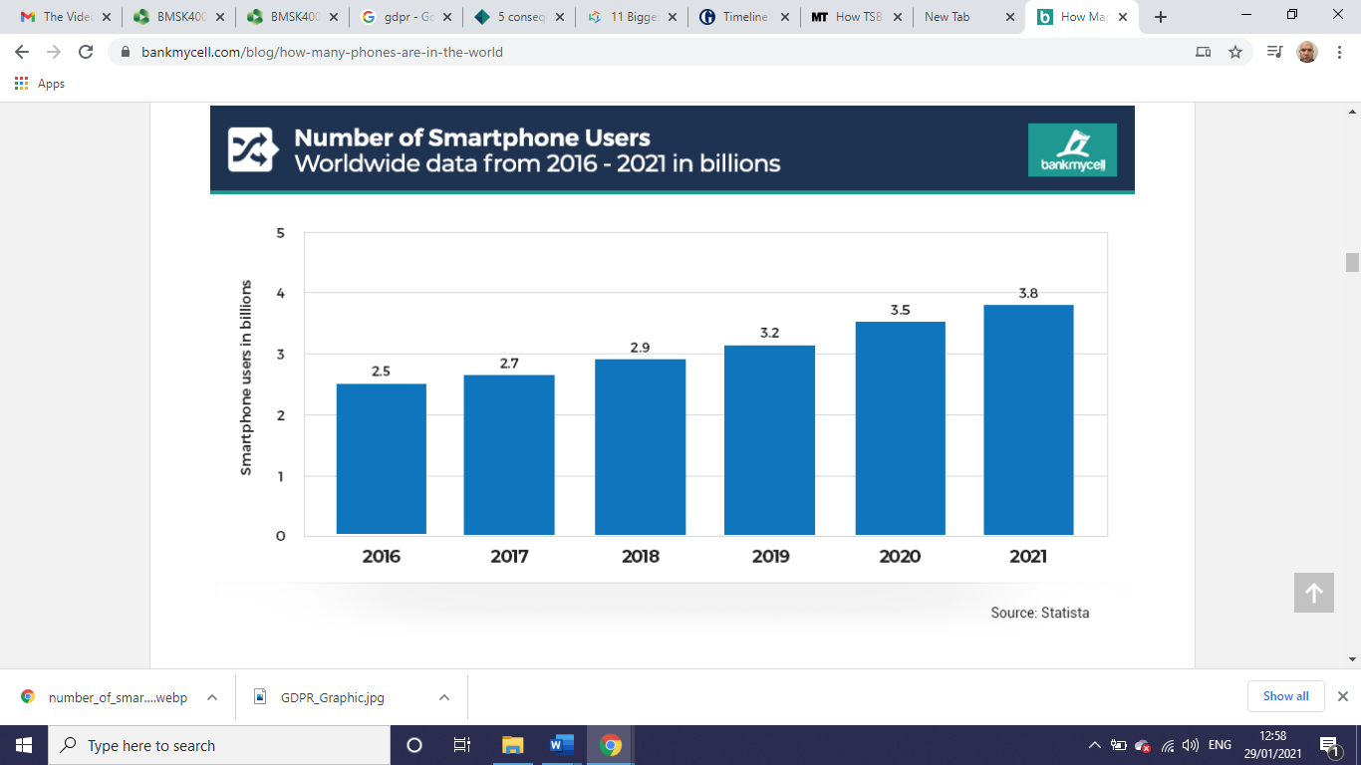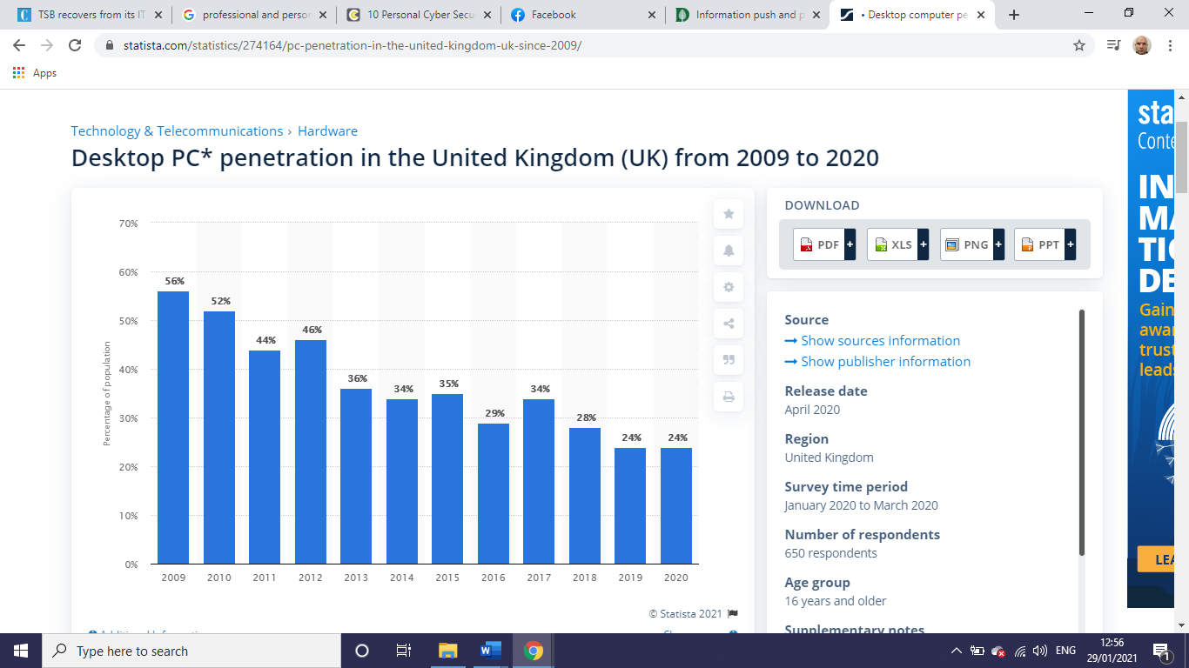
Graph from Statista.com
This can be attributed to the mobility of a mobile, in that it doesn’t need cables, it has built in input devices (touchscreen glass, microphones, cameras) and weighs a lot less. Whereas a PC is static, needing to be plugged in unless it’s a laptop, but even then, it still requires to be in range of wi-fi or to be plugged into a network and usually has very limited battery life.
One of the drawbacks to having this mobility combined with connectivity is that employers will continuously send information to their workers, even when the workers are at home. In 2016 France passed a law requiring companies of over 50 staff to draw up guidelines in order that staff are not supposed to be able to send or answer emails out of hours.
Overall, the boom in Smartphone use, or mobile devices (this includes tablets) has led to an upsurge in productivity. Employees can now share information, video call clients on the other side of the world, access financial records and nearly everything else work related from wherever they are in the world. The downside to all of this connectivity is that employees may feel they never leave work, although it should be manageable with good personal skills to allow people to have time off that they need in order to return to work refreshed, be it an evening, a weekend or holiday they are taking off.

Explore the use of modern technologies and social media in own workplace

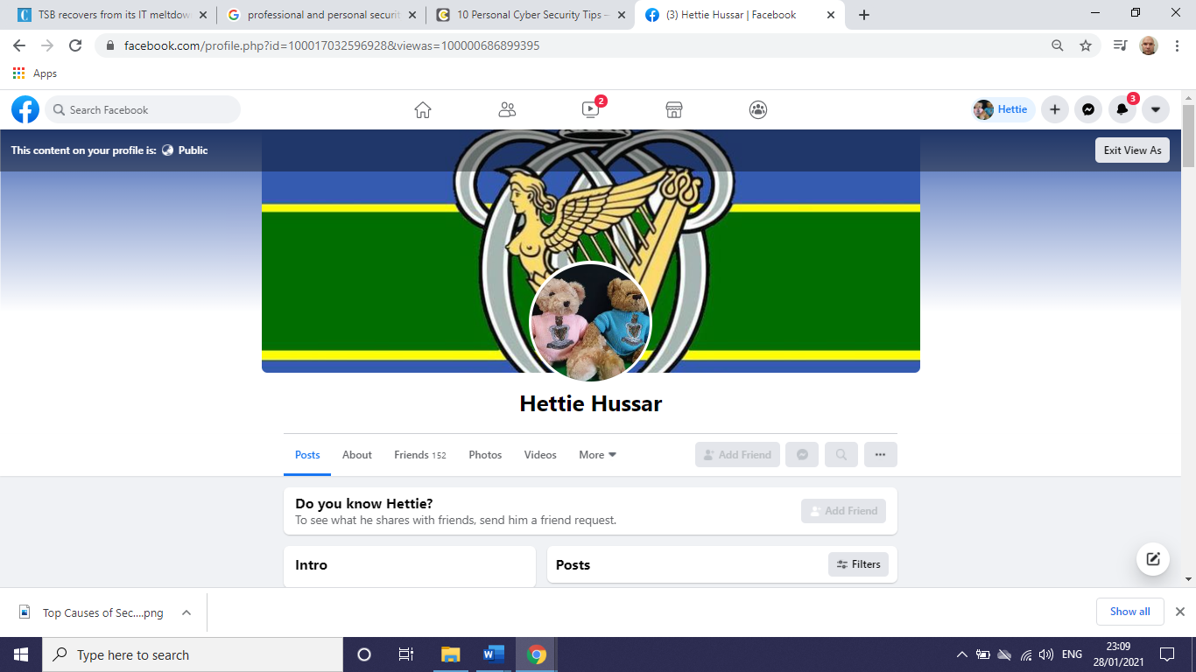

My current department with my employer uses Facebook as its main way of communicating with our Soldiers/Clients families.
The majority of our posts are from other Stakeholders who are attempting to advertise facilities or events for people in the local area. Most of this information is of a push nature not so much in anticipation of our clients needs, but in regards that 1 post may affect one family, or one client.
All members of the team have Facebook loaded onto their Smartphones, but it’s usually left to me to handle the posting of information.
Part of the strength is that before Social Media we would have held briefings held in our place of business where we would invite the families in, now by simply spending a few minutes creating a post we can reach families that don’t live near us in a seconds. This can sometimes be drawn into a conversation using messenger services (WhatsApp, FB Messenger or even email).
The negatives of being online is that we can draw negative reactions or feedback from some clients.
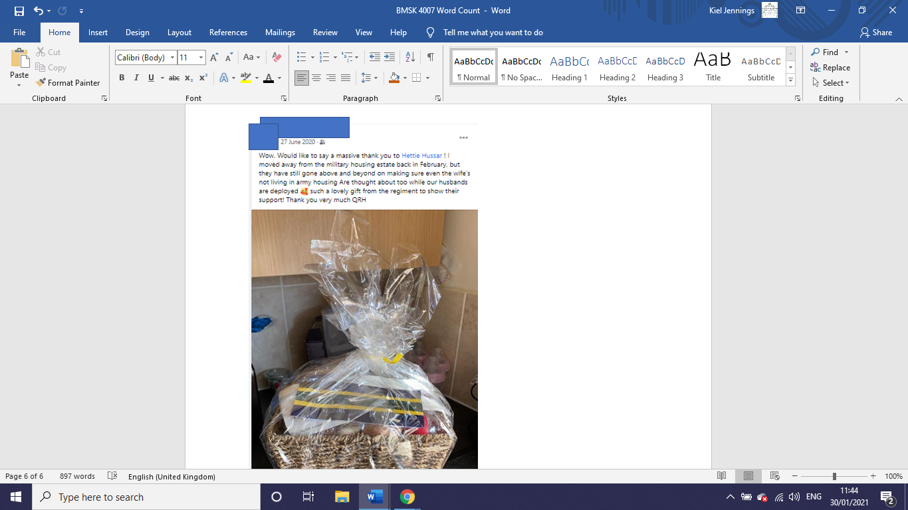

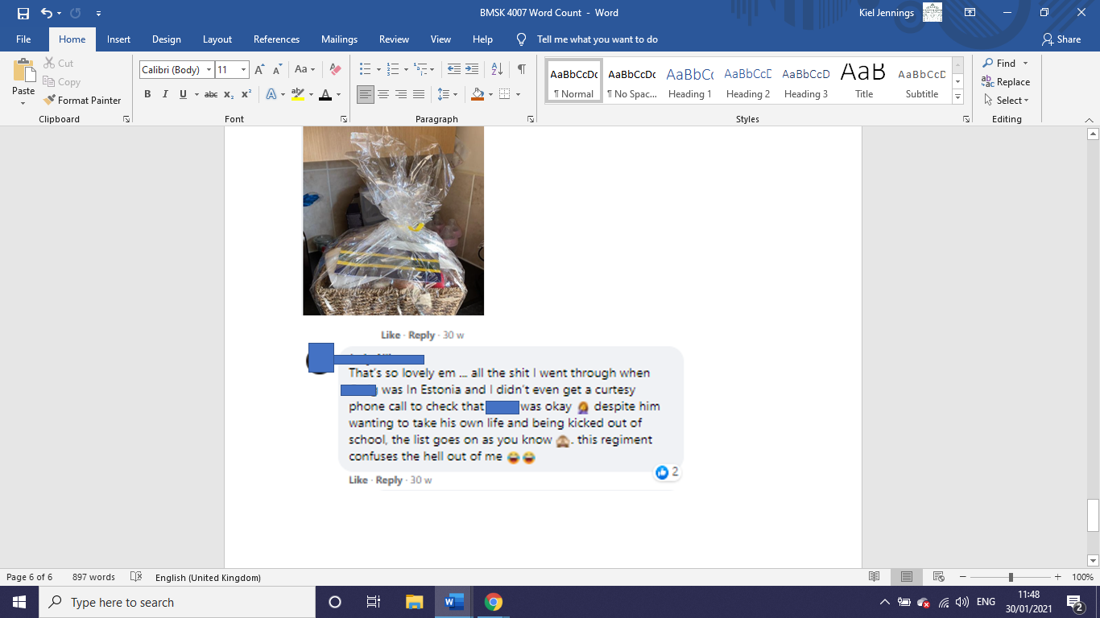
The above post and comment is taken from a FB post where we had sent our families that had deployed soldiers a hamper to let them know we were thinking of them as the Covid-19 Pandemic had struck. The comment was from another wife who felt she had not been supported through her husband’s deployment. She negates to mention that she had not spoken to anybody in our department about the situation apart from a phone call that we had made to her to ensure that everything was ok, and if she needed support, we offered her all of our contact details.
Essentially, it is very easy for negative comments to be made from disgruntled people that may have a grievance or unresolved issue. As an organisation we can’t be drawn into public arguments, as it damages reputation and has the possibility for confidential information to be leaked out. The positive we take is that we have very few comments like this, which shows that most people are content in the support we offer and the work we do.
Another negative is the time it takes to create content, and engage with clients on it. When we are asked by another organisation to post, but we know our clients/families and know there will be little to no interest in it, it feels like a waste of time, and this can have an effect on morale. Security of the page is a threat, and if it were to be compromised this could cause massive reputational damage. A sister organisation employed a new P.A and gave them access to the department’s SM account, on their lunch break, the new employee had been liking posts from Far-Right groups as well as Nigel Farage. It was caught early on, and nobody had seen that the page was following these pages before it was rectified, but it was very close to being a major incident.
The opportunities arise with “networking” and forming bonds with different organisations and agencies and improving our supply of services to people.
The department also has a “Duty Phone” this is an emergency contact phone for people requiring our assistance out of hours. We only changed to a Smartphone when we returned to the UK in 2019, and before we had a non-internet enabled phone, and a desktop PC in the office.
With the Smartphone, we can literally speak to people in crisis and at the same time book appointments with professionals or research advice and information so that our services can be even more timely. We also have iPads, but because the sim cards have been removed for budgetary reasons they are not as helpful as they used to be. Originally, they were used to get people into their homes almost like an Estate Agent would have (history of property, numbers of keys, location of stop cocks etc) and they were used everywhere within the local area, now this is confined to an area with wi-fi connectivity. They are now predominantly used as a distraction device when a parent comes in with a child.

How can Personal branding help YOU?

Personal branding should be important as most companies will look at Social Media at some point in the recruitment process. Some will look at specific sites such as LinkedIn because of its professional nature, whereas some companies will look at Facebook to see what type of person you are.
Surveys show that 57% of companies have found inappropriate posts on social media which have stopped them hiring somebody.
These include:
- Candidate posted provocative or inappropriate content (40%)
- Candidate posted content on them drinking or taking drugs (36%)
- Candidate had discriminatory comments related to race, religion, gender etc (31%)
- Links to criminal behaviour (30%)
- Poor Communication skills (27%)
- “Bad Mouthing” previous employer or fellow employees (25%)
- Unprofessional screen name (22%)
- Lied about an absence (16%)

For these reasons it’s important to manage ones own personal branding in order to maximise any opportunities in the future. One possible option open to people is to restart their Social Media accounts. For Facebook this means deleting your current account which brings disadvantages to it. This could be that you may lose content you want to keep, or may not be able to connect with people in your old account because of privacy settings that may have changed. Some employers also take a dim view of people with little or none Social Media presence as it indicatively shows the person may have something to hide. The simplest answer is to ensure you know what you are publishing on your social media accounts as you may never know when a night in the pub may come back to haunt you.

Your LinkedIn Profile to promote your Personal Brand

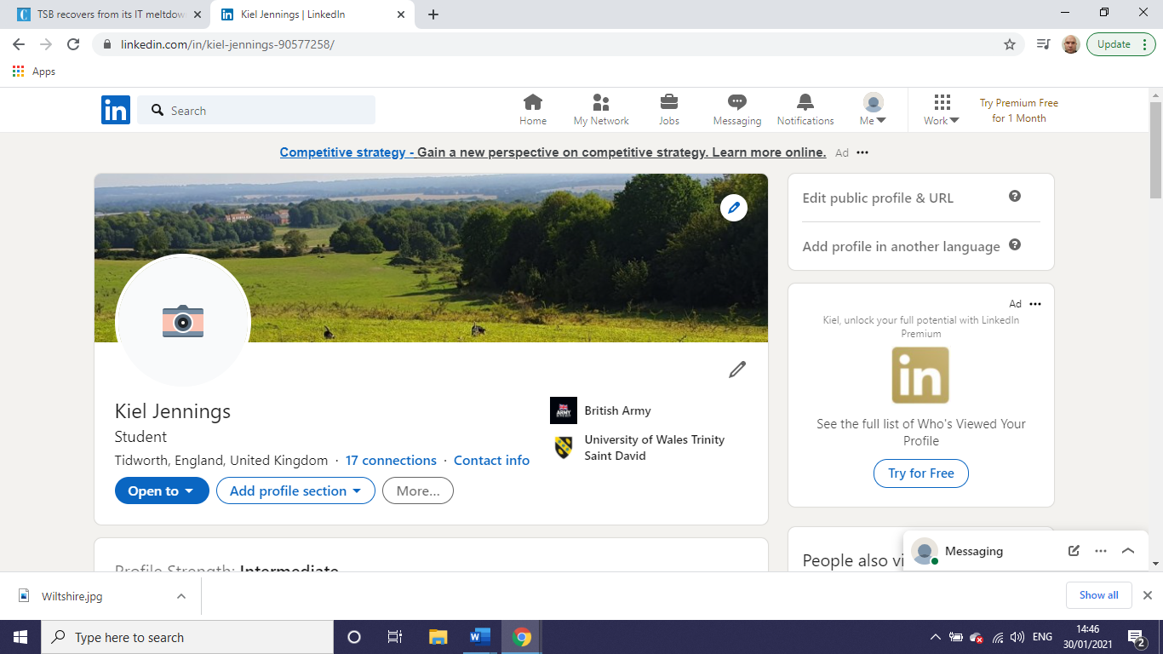

My LinkedIn profile is not particularly strong. That being said, I am not currently in the employment market, so my interest in building it up at the moment is limited.
I have asked a professional photographer if I can do a professional headshot shoot once the latest lockdown is over. Most of my current photos are selfies, and these shouldn’t be used as LinkedIn profile pictures as they are not strong enough for a professional presence. The photos that are not selfies are of me participating in my hobbies and interests and there is a separate section dedicated to this on the site. I have used a picture of one of my favourite areas to walk my dog as the banner picture.
My intent for the personal picture is to follow guidelines laid down by Meero Team in “11 Tips to Follow for the Perfect Linkedin Profile Picture in 2020” and use a picture of me in normal everyday work clothes so it shows an honest representation of me.
One thing I haven’t considered before is after meetings, networking with people and adding them to my LinkedIn account. My mindset is still Facebook orientated and I’m careful with who I add to my friends list. I feel I can be more open on LinkedIn with who I add as there is less personal content and more professional content going to be available to people on there.

Evaluate the value of other social media platforms to enhance networking and career prospects
 Instagram: Instagram is excellent for visual representations of one’s brand. Competitive fields such as Marketing or fitness or Skills/Creative industries will find this platform useful as it allows them to have a digital shop window. Someone in accountancy may not get as much benefit from it though.
Facebook:

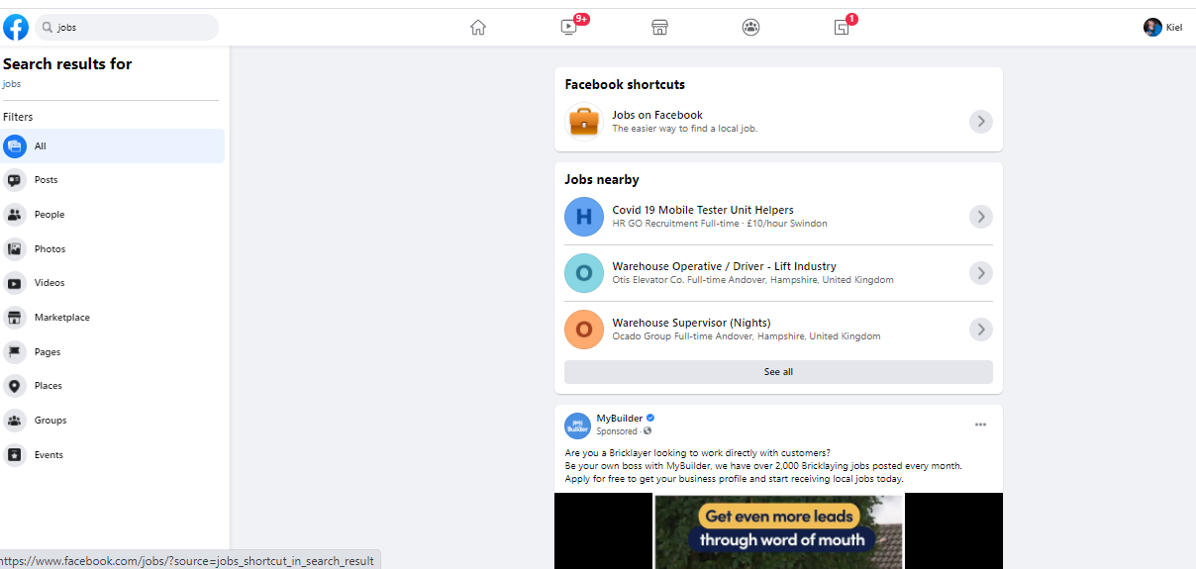
Facebook appears to be a Nesting Doll of Apps. Within the main page there are parts of the site that lead to different groups, marketplaces and a jobs section:

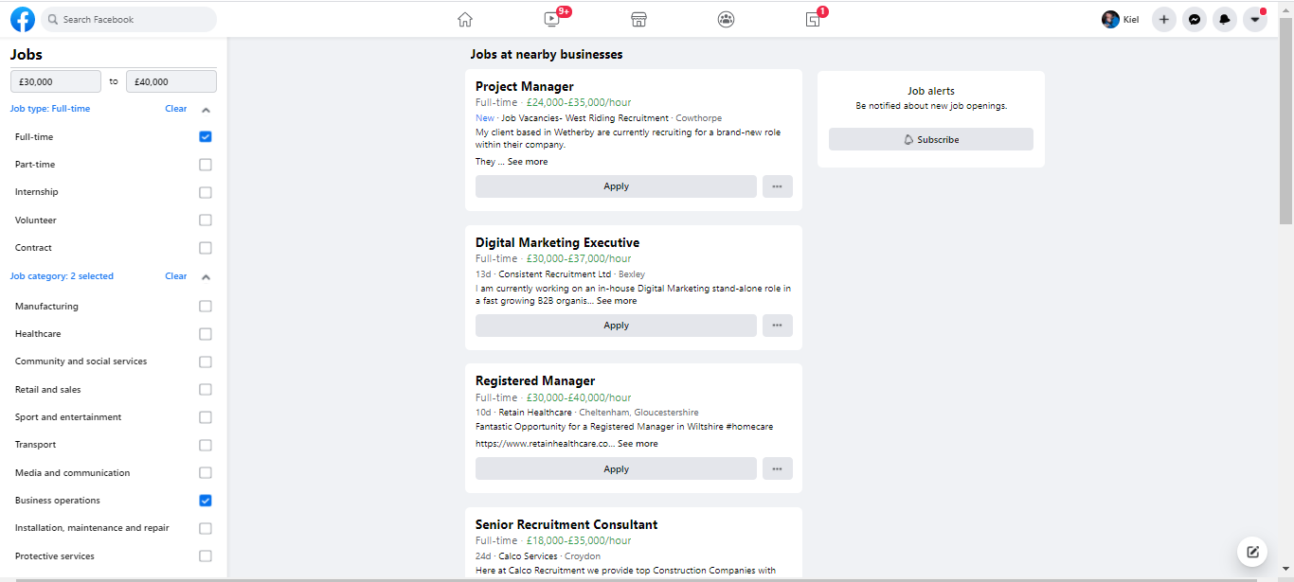
By selecting some filters in the left column, it provided me with a list of potential jobs according to location, salary and industry/area I was interested in.
It appears to be very basic though, with very limited options for narrowing down a field. I’d also call into question any job I may be applying for on Facebook, but that might just be my preference with an outdated thought process behind it.
 TikTok: Relatively new to the social media field. I would describe it as a Instagram but for video content, but the same principles would appear to apply to it, as in good for creative content, and not so good for non-creative jobs.
Twitter: Because twitter limits the amount of characters per tweet, everything has to be snappy or bite size. This means when searching for a subject to look at, you can quickly pick up the relevance of that post to what you’re linking it to.
A tweet on Personal Branding
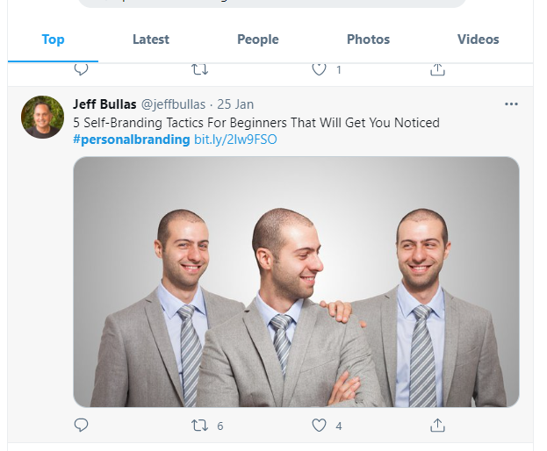
Leads directly to the authors blog for a more in depth analysis, or for the full article.
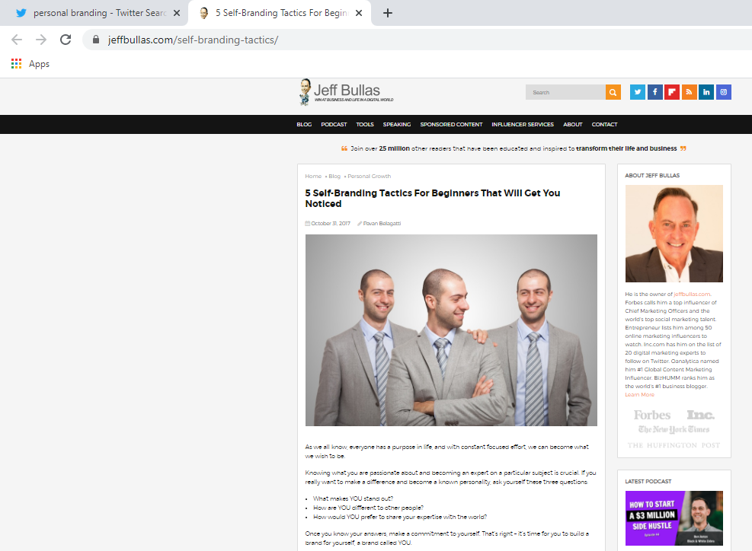

Other Social Media sites: While looking at other sites, I’ve noticed a trend in that if social media fails, it does so almost with a cliff edge, and users will quickly move onto the next site. The best example of this is probably MySpace. At one point it had a larger market share than Facebook.
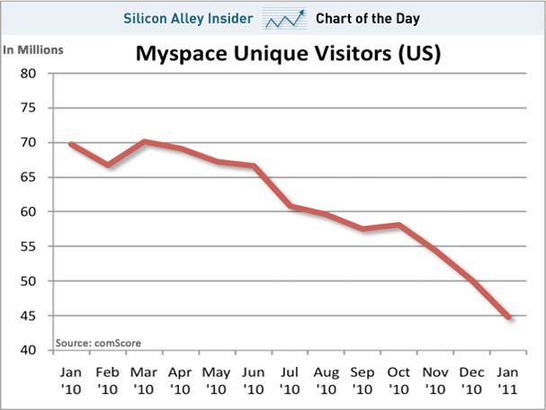
Jay Yarrow (2011) Business Insider Chart of the Day
Large companies are not immune to this either, in 2019 Google closed down its Social Media site Google+ to personal users, although it maintains some elements for businesses. The warning that I take from this is that people need to diversify their personal brand across a number of sites so that if one is taken down, be it through non-popularity or a security breach, you still have the availability to engage with clients or businesses.

Examine the impact of Personal Branding on your own employability
Facebook:
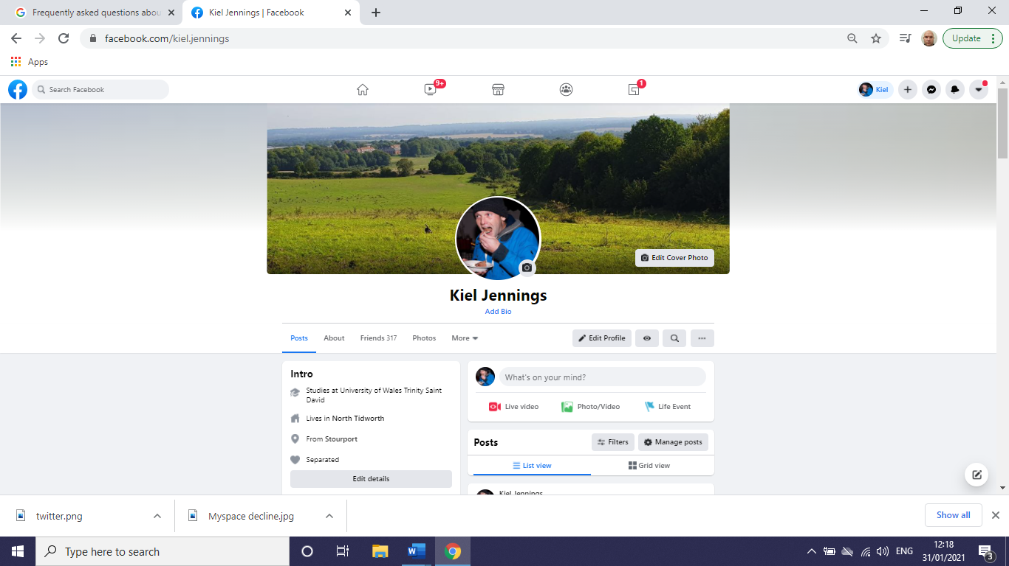
Initially my Facebook looks fairly clean, my profile picture could do with an update, but is still relevant as I still enjoy eating cake. Information is fairly up to date in my Intro. Looking at my timeline I create very little content, but do share lots. Most of this is aimed at comedy. I very rarely punch down, but try to punch up.
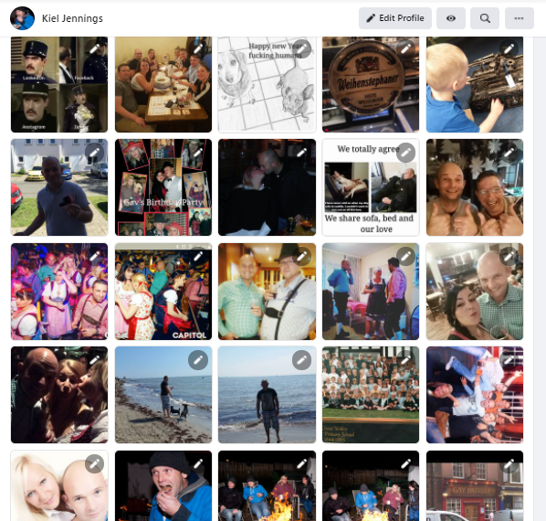
My photo timeline still needs some work doing to it. There are no longer some glaringly bad photo’s that I have been tagged in, but I would still like to tidy it up a little bit (remove my ex-wife!)
Instagram:
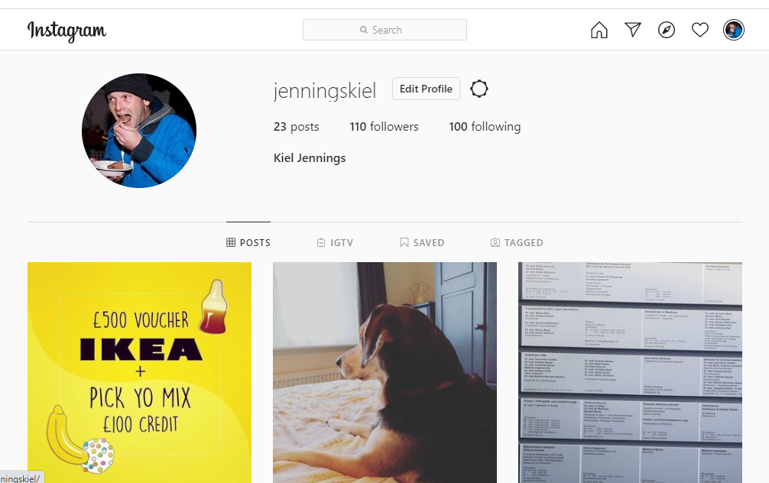
My Instagram is incredibly limited, I have 23 posts, most of which are dog related. I’m not a keen photographer, and take very few selfies, so while I do have a presence it is incredibly limited. If I wanted to increase my presence, I may start taking more photographs while Im participating in my interests and hobbies.

Twitter:
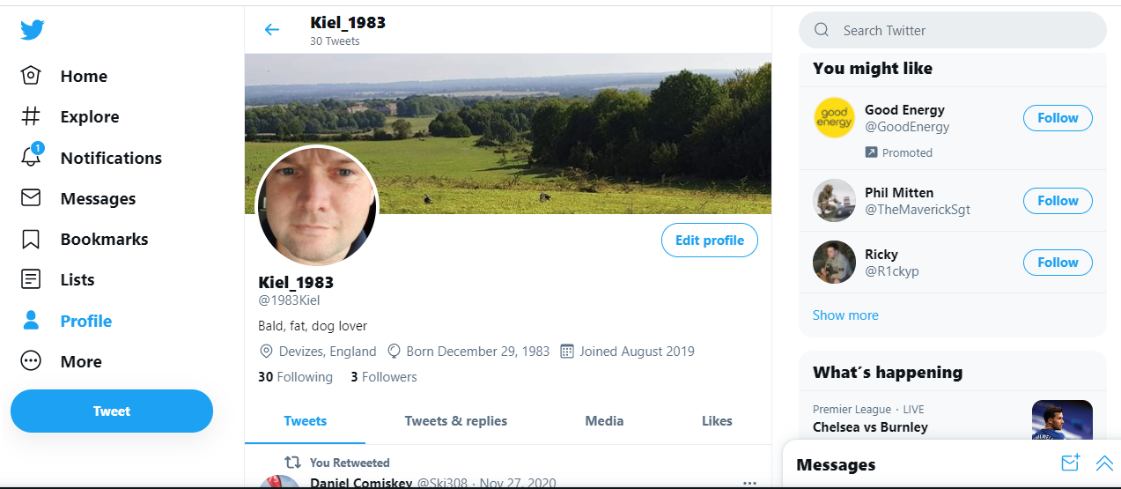
My twitter feed/page is entirely uncontroversial. It’s been active since 2019 and I’ve made 30 posts. I have 3 followers, and follow 10 times as many people and groups back. I could read some self-help guides for becoming more of an influencer on the platform but I find lots of people on twitter are incredibly angry, so I very stay around long enough to follow threads. When looking for future employment, I may start following companies who are leaders in the fields I want to go into, but seeing as I’m undecided I will keep my powder dry so as not to influence the algorithms that are in place.

Google:
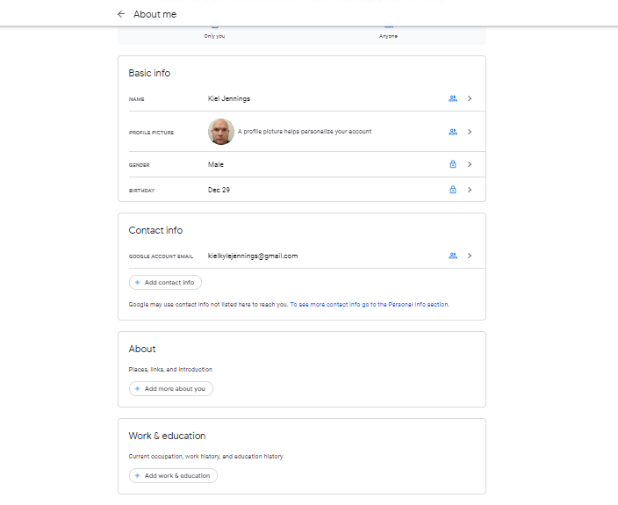
My google account is very limited as I use it as a search engine only. Due to it being an American company, I distrust the information it holds on me, and so I would like to input as little as possible until it is fully behind GDPR regulations.

Discuss personal and professional security and safety online.
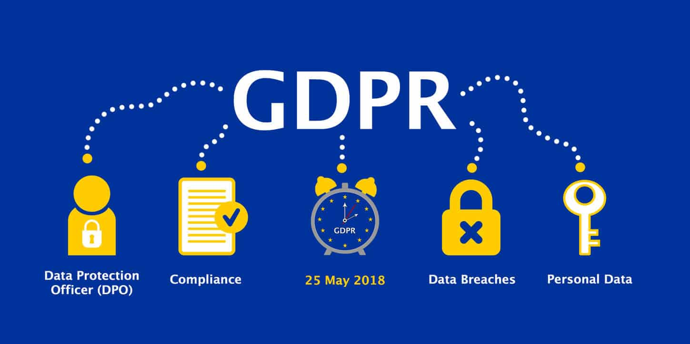

All companies are to ensure they comply with the General Data Protection Regulation (GDPR). Failure to do so can lead to substantial fines. Examples of these are Google for £50,000,000 for multiple infractions including not giving enough control to customers of their personal data, and not enough information to them about how their data is handled. H&M for €35,258,707.95 for processing sensitive personal information on their employees without it being a specific purpose, and for not having strict controls on the data.
Another consequence of not handling data correctly could be reputational damage. In 2018 TSB Bank wanted to update its Internet Banking facilities, from the 20th April and for more than a month some customers were unable to access their bank accounts, with some people saying money had been taken out without their consent, and others finding large deposits being put in. Polls taken afterwards saw confidence in the bank sink to 55%, and it became the lowest rated bank in the UK Market. As of 2020 it sat in 16th position only outperforming Clydesdale, RBS and Tesco Bank. The implications of mishandling data and finances are clear.
With many companies still experiencing Data Breaches the individual still needs to ensure they protect themselves on the internet. Be it Internet Banking or using Social Media Apps. Essentially the user has to trust almost nothing. Keeping Anti-Virus Software up to date, as well as running firewalls or using VPNs when on Public Wi-Fi will help protect the individual.
Hovering over a link will show you where you will be taken if you click it

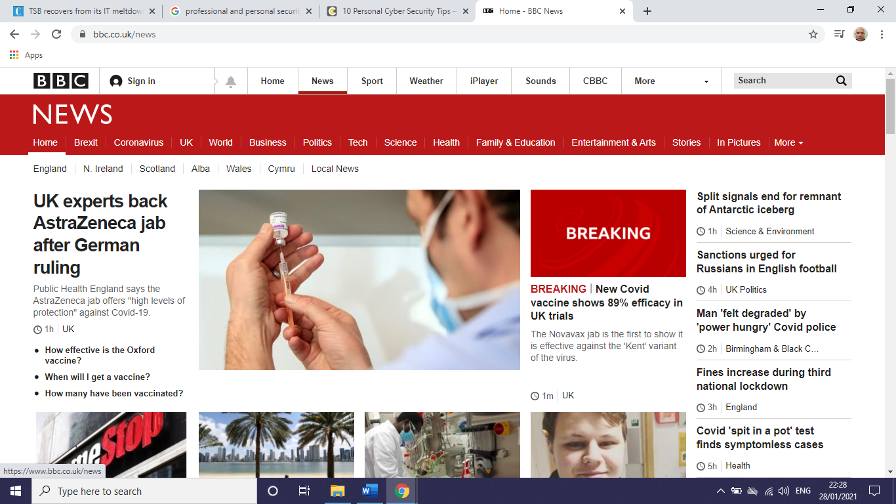
The cursor hovering over the “NEWS” Tab, the address is displayed in the bottom left

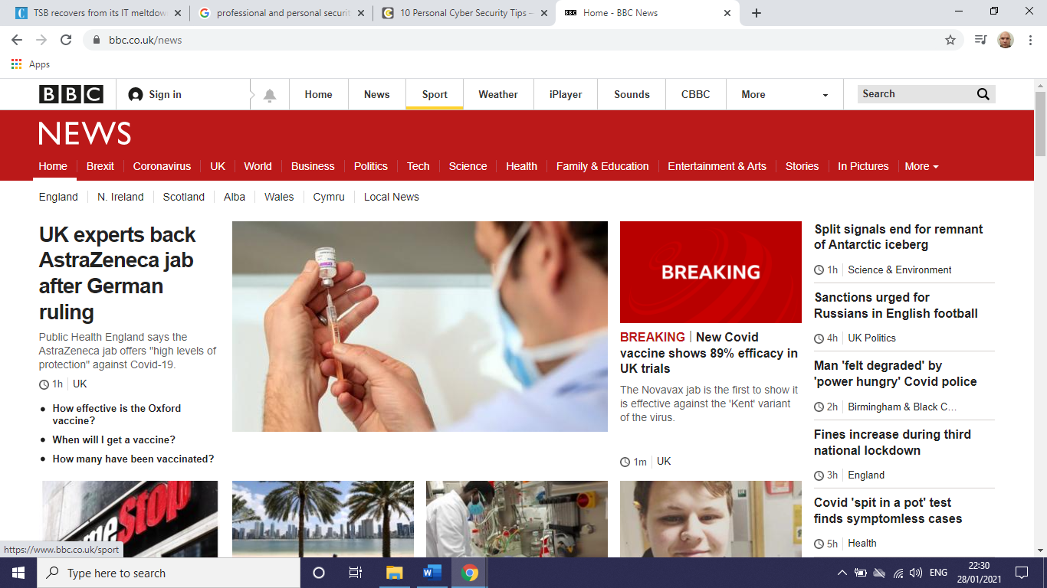
With it hovering over the “SPORT” tab it shows the link to the sports pages
If the link in the bottom left was to be to a completely unrelated website, you should question the integrity of that web page and leave.

Top Causes of Security Breaches
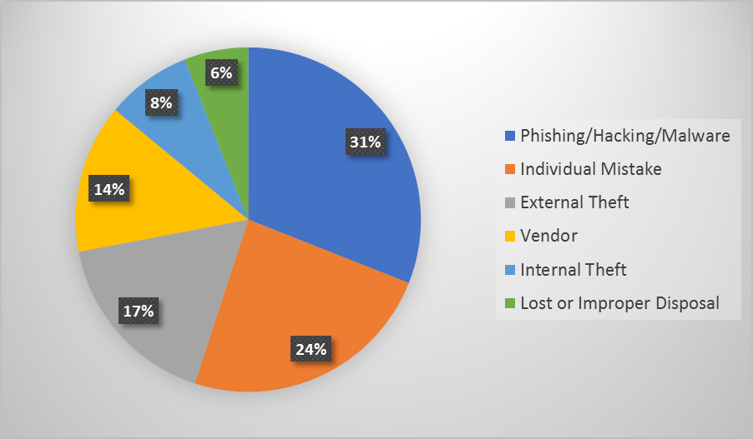
Image from https://cipher.com/blog/10-personal-cyber-security-tips-cyberaware/
Looking at the Pie Chart we can see that 55% of Breaches (Phishing/Hacking/Malware and Individual Mistakes) are preventable by the user, by having better personal security and educating others, these can be avoided.
To avoid Phishing Hacking and Malware as a general rule I ignore unsolicited e-mails from unknown or untrusted sources, and nine times out of 10, I will delete them without even opening them.
Professionally, you should abide by your employer’s policies on digital security. This may involve reporting possible breaches, but it’s better to be honest and report than to allow the issue to grow. In the last year my employer has had 546 data breaches, with some being sent to the ICO for further investigation.

References

Angelo Young & Michael B Sauter (2020) Most Important Inventions of the 21st Century, https://eu.usatoday.com/story/money/2020/01/09/21-most-important-inventions-of-the-21st-century/40934825/. 17th Jan 2021.

Jack Gold (2017) 11 Tech Breakthroughs That Led to Todays Smartphones, https://www.computerworld.com/article/3222855/11-tech-breakthroughs-that-led-to-todays-smartphones.html 24 Jan 2021

OFCOM (2018) A Decade of Digital Dependence https://www.ofcom.org.uk/about-ofcom/latest/features-and-news/decade-of-digital-dependency 24 Jan 2021

Mathew Boyle (2020) Mobile Internet Statistics https://www.finder.com/uk/mobile-internet-statistics#:~:text=Research%20suggests%2084%25%20of%20UK,with%2098%25%20owning%20a%20smartphone. 24/01/2021

Bank My Cell (2021) How Many Smartphones are in the World https://www.bankmycell.com/blog/how-many-phones-are-in-the-world 29th Jan 2021

Opara-Martins, J., Sahandi, R. & Tian, F. (2016). ‘Critical analysis of vendor lock-in and its impact on cloud computing migration: a business perspective’ . J Cloud Comp 5, Article Number 4 https://doi.org/10.1186/s13677-016-0054-z
The Telegraph (2019) Five Consequences of a GDPR Breach https://www.telegraph.co.uk/business/risk-management-solutions/consequences-of-gdpr-breach/ 28th Jan 2021

Tessian Blog (2020) 11 Biggest GDPR Fines of 2020 (So Far) https://www.tessian.com/blog/biggest-gdpr-fines-2020/ 28th Jan 2021
Angela Monoghan (2018) Timeline of Trouble: How the TSB IT Meltdown Unfolded https://www.theguardian.com/business/2018/jun/06/timeline-of-trouble-how-the-tsb-it-meltdown-unfolded 28th Jan 2021

Angharad Carrick (2020) Ranked: Monzo and Starling Top List of UKs Best Banks https://www.cityam.com/digital-banks-beat-brick-and-mortar-rivals-to-provide-best-service-for-customers/ 28th Jan 2021
Cipher Blog (2020) 10 Personal Cyber Security Tips - #CyberAware https://cipher.com/blog/10-personal-cyber-security-tips-cyberaware/ 28th Jan 2021

George Cybenko (1997) The Foundations of Information Push and Pull https://www.dartmouth.edu/~gvc/push.html 28th Jan 2021

BBC News (2016) French Workers Get ‘Right to Disconnect’ From Emails Out of Hours https://www.bbc.co.uk/news/world-europe-38479439 30th Jan 2021
Meero Team (2019) 11 Tips to Follow for the Perfect Linkedin Profile Picture in 2020 https://www.meero.com/en/news/corporate/411/11-Tips-To-Follow-For-The-Perfect-Linkedin-Profile-Picture-In-2019 29th Jan 2021

Saige Driver (2020) Keep it Clean: Social Media Screenings Gain in Popularity https://www.businessnewsdaily.com/2377-social-media-hiring.html 30th Jan 2021

Woodrow Mercer (2016) Can Social Media Stop You Getting a Job? https://www.woodrowmercer.com/blog/2018/09/can-social-media-stop-you-getting-a-job
30th Jan 2021
Catherine Knowles (2021) Ministry of Defence Reports 546 Potential Data Breaches Over the Year https://securitybrief.eu/story/ministry-of-defence-reports-546-potential-data-breaches-over-the-year 31st Jan 2021

Appendix 1- CRAAP Analysis on a Reference

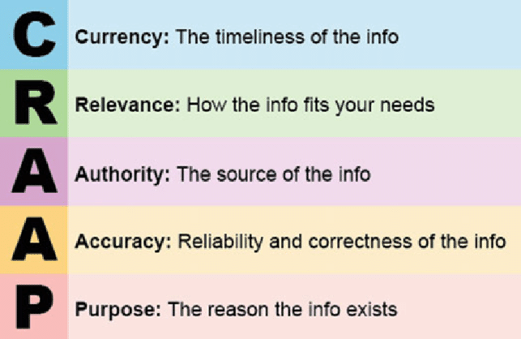
Reference Analysed:
Angelo Young & Michael B Sauter (2020) Most Important Inventions of the 21st Century, https://eu.usatoday.com/story/money/2020/01/09/21-most-important-inventions-of-the-21st-century/40934825/. 17th Jan 2021.
C- The article was published in 2020, and so is still relevant. The only new inventions that could be added to the list from the last 12 months that I can think of are Corona Virus Vaccines.
R- There are 21 items in the article, I think looking at it initially, I’d like to write about 6 of those items.
1. E-Readers
2. Mobile Operating Systems
3. Online Streaming
4.Small Satellites
5. Tokenization
6. Touchscreen Glass

- With a weekly print circulation of 726,906, a digital only subscriber base of 504,000, and an approximate daily readership of 2.6 million, USA Today is ranked first by circulation on the list of newspapers in the United States.

- There appears to be no figures relating to sales of items, just what the authors believe to be the most important inventions this century.

P- Written as an interest piece.

Appendix 2

SWOT analysis of Social Media with my current employer

Strength:  -Quickly disseminate information to a large audience.  -Allows contact with clients  -Gain valuable insights | Weakness:  -Possible Negative feedback  -Open for possible embarrassment  -Time Consuming for employees  -Access of the SM platform (Computer, Mobile, Tablet) and associated security of these devices
Opportunities:  -Development of partnerships with different organisations and agencies.  -Targeted posts | Threats:  -Ignoring of posts from clients  -Security  -Regulations mean we need to be careful of what we share on SM (e.g., no personal opinions on politics)

Asked for feedback from my colleagues and also from another department with a similar profile.
There were anecdotes and horror stories of members of staff being given access to the work Facebook site and liking or following right wing political sites.

Bibliography:
UK Statistics on Internet use 15/01/21
https://www.ons.gov.uk/peoplepopulationandcommunity/householdcharacteristics/homeinternetandsocialmediausage

Linjuan Rita Men, Julie O’Neil, Michele Ewing (2020) Examining the effects of internal social media usage on employee engagement, Public Relations Review Volume 46 Issue 2 June 2020 101880

Angelo Young & Michael B Sauter (2020) Most Important Inventions of the 21st Century, https://eu.usatoday.com/story/money/2020/01/09/21-most-important-inventions-of-the-21st-century/40934825/. 17th Jan 2021.

Social Media Use, https://www.gov.uk/government/organisations/ministry-of-defence/about/social-media-use, 24th Jan 2021.

Mathew Boyle (2020) Mobile Internet Statistics https://www.finder.com/uk/mobile-internet-statistics#:~:text=Quick%20overview,up%20from%2066%25%20in%202018. 24/01/2021

Statista (2021) Percentage of households with mobile phones in the United Kingdom (UK) from 1996 to 2018 https://www.statista.com/statistics/289167/mobile-phone-penetration-in-the-uk/ 24/01/2021

Ofcom (2018) A Decade of Digital Dependency https://www.ofcom.org.uk/about-ofcom/latest/features-and-news/decade-of-digital-dependency 24/01/2021

Pew Research (2019) Mobile Fact Sheet https://www.pewresearch.org/internet/fact-sheet/mobile/
24 Jan 2021

Swalih (2021) Modern Technology: Definition, Examples and Applications https://www.techquintal.com/types-of-technology/ 25 Jan 2021

Pro’s & Cons of Cloud Storage https://www.securestorageservices.co.uk/article/11/pros-and-cons-of-cloud-storage 25 Jan 2021

Luisa Akingbade (2016) Cloud storage problems, benefits and solutions provided by data de-duplication. International Journal of Engineering and Innovative Technology https://www.researchgate.net/publication/341447215_Cloud_storage_problems_benefits_and_solutions_provided_by_data_de-duplication_International_Journal_of_Engineering_and_Innovative_Technology_56_70-77 25 Jan 2021

Top 13 Advantages and Disadvantages of Social Media. https://www.webfx.com/internet-marketing/social-media-marketing-advantages-and-disadvantages.html 25 Jan 2021
Andrea Broughton, , Beth Foley, Stefanie Ledermaier and Annette Cox (2013) The Use of Social Media in the Recruitment Process https://archive.acas.org.uk/media/3720/The-use-of-social-media-in-the-recruitment-process/pdf/The-use-of-social-media-in-the-recruitment-process.pdf 30th Jan 2021

Goldie Chan (2018) 10 Golden Rules of Personal Branding https://www.forbes.com/sites/goldiechan/2018/11/08/10-golden-rules-personal-branding/?sh=4651bd3c58a7 30th Jan 2021.

Ana Andjelic (2019) Building a Personal Brand isn’t Always About Looking Good https://www.fastcompany.com/90366736/building-a-personal-brand-isnt-always-about-making-yourself-look-good 30th Jan 2021

Chandra Wood (2017) What are the Pros & Cons of Restarting Your Facebook Account https://www.quora.com/What-are-the-pros-and-cons-of-restarting-your-Facebook-account
30th Jan 2021

Vladlena Benson, Fragkiskos Filippaios, Stephanie Morgan (2009) ‘Online Social Networks: Changing the face of business education and career planning’ International Journal of eBusiness

Sultana, Nayeema & Shahriar, Shamsul Huq Bin & Akter, Silvia & Rahman, Maria. (2018). EVALUATING THE EFFECTIVENESS OF FACEBOOK AS THE SOURCE OF JOB ADVERTISEMENTS IN BANGLADESH: AN EMPIRICAL STUDY. Academy of Marketing Studies Journal. 22. 1-16.

