Ralitsa Nikolova (1806089)

ER Diagram
Short description:
There are many stores and every store has a number of employees who can work in only 1 store each. One customer can be served by only one specific store according to their address (area of operation of the store).
Every customer can make a booking, which booking is recognised by the number of the invoice generated after the staff member processes the booking.
The different ingredients are supplied by different suppliers, where one supplier can supply multiple ingredients, but every ingredient has only one specific supplier.
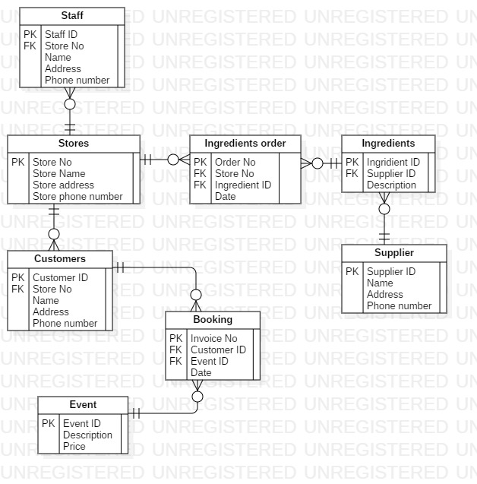

Use Case Diagram
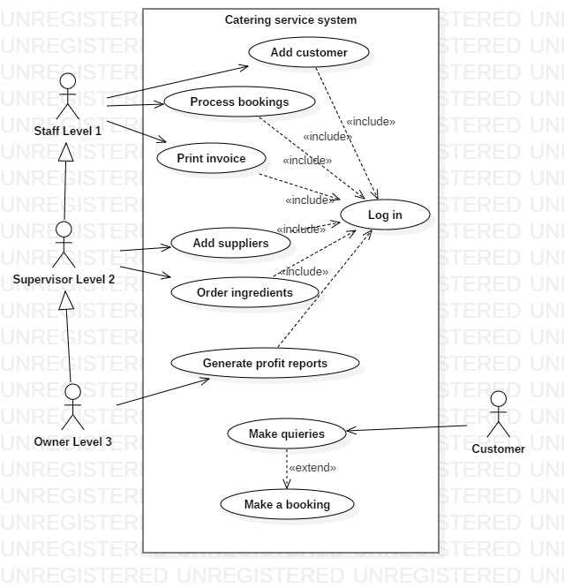

Data Flow Diagram Level 0
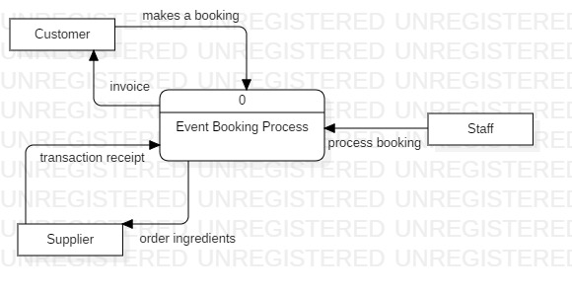
DFD Level 1


