

Student Name: Vishal Pareshbhai Kathiriya

Student ID: 2528421

Module Name: HUMAN CAPITAL MANAGEMENT
Module Code: LCMB7023
Lecturer’s Name: Dr Lakshani Mendis
Term 1
Integrated HR Blueprint
Aether Innovation Personnel And Perfomance Alignment
Option 2 : Fostering Innovation and Future Work Practices

Executive Summary
Aether Innovations is a zero-growth, 300-size technologically oriented corporation which experiences extreme turnover and deteriorating customer satisfaction. The report suggests a combined human-capital reaction with the focus on the culture of innovation and the cross-functional implementation and a disciplined hybrid work model. The external data is evident: employee engagement decreased all over the world, down to 23 percent to 21 percent in 2024, and manager engagement declined to 30 percent to 27 percent, which indicates a greater threat to performance and customer results (Gallup, 2025). Concurrently, the properly designed hybrid work may enhance the levels of satisfaction and reduce the number of quit rates by a third without negatively affecting the performance (Bloom, Han and Liang, 2024). The report suggests innovation sprint, intrapreneurship routes, psychologically safe leadership, cross-functional product teams, and building manager capability and performance management by outcomes. It claims that work design and culture should become one system. It* is then followed by a brief personal reflection that employs the reflective cycle employed by Gibbs to demonstrate how the module has influenced my personal learning, development planning and style of applying AI as an augmenting tool as opposed to a replacement of human judgment.

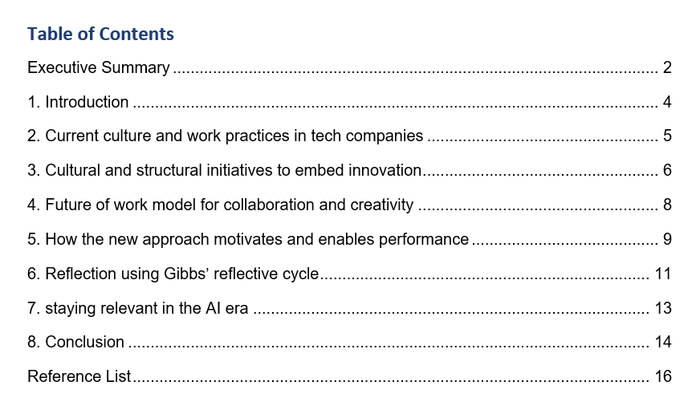

1. Introduction
The case of Aether is common in a scaling technology company whose business objectives have surpassed its human systems. Innovation, retention and quality of service may be eroded shortly in high-growth environment due to fragmented collaboration, overloaded managers and blurred cultural norms. Since no internal survey information was issued in the scenario, the current external benchmarks in this report are used to diagnose probable reasons and plan an achievable reaction. The case is that Aether does not require disjointed HR efforts; instead, it requires a joined-up model where culture, structure, hybrid work, learning and leadership support each other. The recommendations are thus aimed at creating an environment that allows employees to share ideas, traverse silos, experiment without any form of recklessness and continue to be motivated to produce good customer results.
Table 1: Aether Innovations: scenario diagnosis and likely people implications
Scenario symptom | Likely people/system cause | Strategic implication
Flat growth | There is no rapid movement of ideas across functions; managers are not interested in learning but rather delivery. | Restructure innovation practises and multi-skilled ownership.
High staff turnover | Poor engagement, stress, ineffective development visibility and hybrid poor coordination. | Motivation, manager retention and retention architecture.
Falling customer satisfaction | Isolated problem solving and poor feedback between employees and customer results. | Relate in-house culture to service quality and learning with the customer.
Source: Author synthesis based on the scenario brief and cited external benchmarks.
2. Current tech company culture and work behaviors
2. Current tech company culture and work behaviors

2. Current tech company culture and work behaviors
In the technology industry, there are work practices that are prevalent across the industry. The product development is more structured in terms of agile approaches, short-project cycles and web-based collaboration tools. Flexible work arrangements are also still being used by companies in an attempt to gain access to limited talent, expand recruitment base and eliminate commuting related tensions. However, the contemporary practice is not only positive. According to the report on workplace in 2025 by Gallup, global employee engagement decreased to 21 percent in 2024 and manager engagement decreases to 27 percent, which is significant as managers represent approximately 70 percent of the difference in team engagement (Gallup, 2025). Deloitte (2024) also states that 85 percent of leaders have experienced more challenges in evaluating productivity in hybrid workplaces and that half of employees are concerned about the increased stress that is negatively impacting their mental well-being. Remote work in technology companies, in particular, may result in more patterned collaboration, as well as a greater number of bridges among teams and less asynchronous communication, which complicates knowledge sharing and impulsive innovation (Yang et al., 2022). This is to say that work as a hybrid is not a culture by itself; it only works when it is assisted by a deliberate team design, effective and inclusive norms and management. In the case of Aether, the issue that is most probable is not the flexibility as such, but the fact that the operating model of innovation and coordination is not developed.
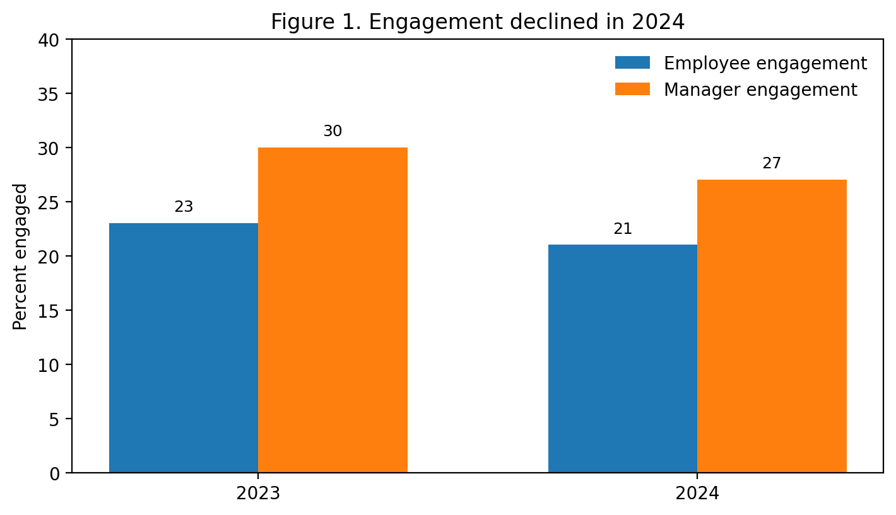
Source: Gallup (2025).

3. Culture and structure to foster creativity
Aether should redefine its culture by using three design principles such as psychological safety, cross-functional execution and disciplined experimentation. The reason as to why psychological safety is fundamental lies in that people never place forward bold ideas, they never explore assumptions and learn through errors when they are embarrassed or punished. “Psychological safety is a shared belief that the team is safe for interpersonal risk-taking” (Edmondson, 1999) a shared perception of the group being safe to undertake interpersonal risk taking, which is in turn also related to a higher amount of team learning, efficacy, and productivity (Patil et al., 2023). Practically, Aether must teach leaders to operate on an open retrospective, welcome dissent, divide the critique of ideas and criticism of the person and appreciate positive voice behaviour. This would eliminate the silence and assist in bringing out innovation sooner.
The second one is structural. Instead of operating on functional silos, Aether needs to structure strategic work on cross-functional teams consisting of product, engineering, customer success, data and people representatives. These groups ought to possess well-articulated customer or product issues in 8- to 12-weeks. This approach helps to expedite the problem solving process and have commercial, technical and customer perspectives in the same room. According to the recent study on team design conducted by Deloitte, cross-functional teams are also more likely to record efficiency and innovation improvements as they learn to share experiences with each other and have the confidence to take action (Deloitte, 2024).
Third, Aether needs to systematise experimentation by using innovation sprints and intrapreneurship pathways. The quarterly innovation sprint would enable employees to experiment with service enhancement, AI-based working processes or product solutions on small budgets and well-defined review standards. This is further structured than the intermittent hackathons in that it relates experimentation to strategy, customer pain points and executive sponsorship. Blomkvist et al. (2024) discover that one of the best predictors of the intrapreneurial intentions of employees is the top management support, the achievement recollection and the culture of risk-taking. Aether would thus design an in-house flow of ideas comprising three steps; pitch prototype and scale. Employees whose ideas are advanced are entitled to be given time allowances, coaching and recognition. This gives a cultural message that innovation is the mandate of everybody other than the prerogative of the R&D.
These efforts are supposed to be supported by focused people systems. Collaboration, learning agility and customer orientation should be evaluated during recruitment, and not technical depth. It should not be the output but team health, development and experimentation that should be considered in the evaluation of managers. The internal communication method should also be changed to be less concerning the broadcasting of information and more so shared learning which can be presented in the form of demo days and knowledge libraries as well as post-sprint short reviews. Through the lens of culture offered by Schein and Schein (2017), such recurrent practices will eventually result in the observable artefacts, values and assumptions that characterise the way work is done at Aether.
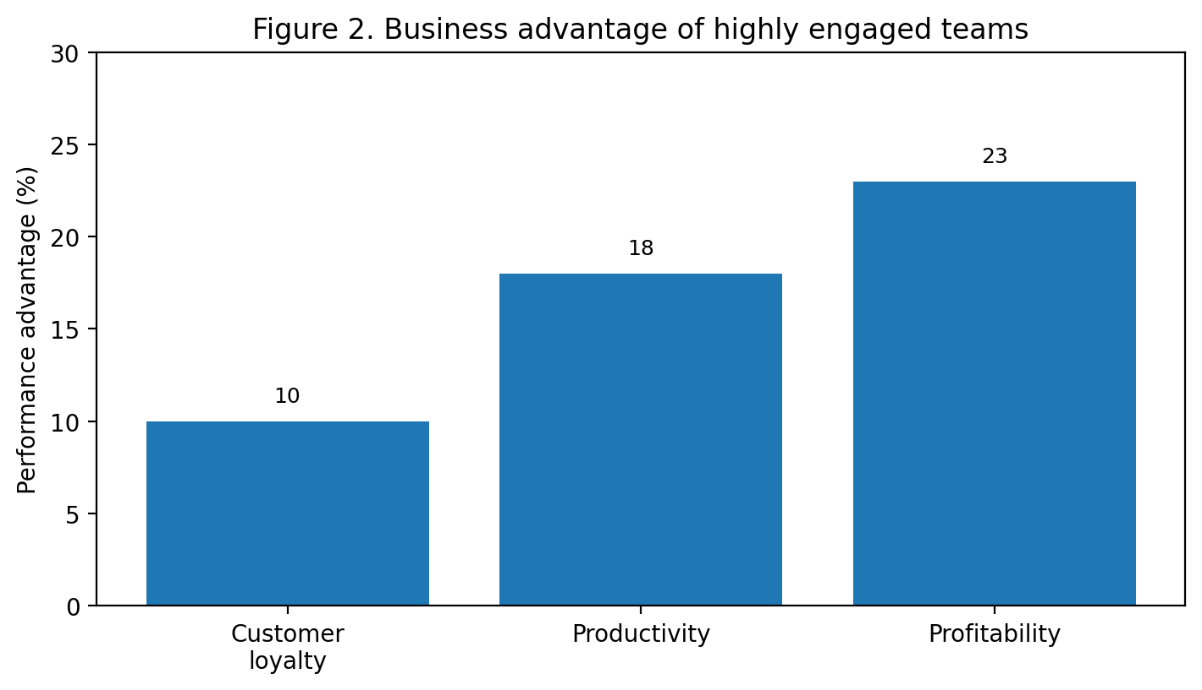
Source: Gallup (2026), based on its meta-analysis of business-unit performance.

4. Future work paradigm for creativity and cooperation
The best model that fits best in the future of work of Aether is an integrated hybrid system, as opposed to complete remote work or mandatory full-office attendance. In a giant randomised controlled trial within a Chinese technology firm, the researchers discovered that hybrid working was beneficial in job satisfaction with a threefold lower turnover rate and it did not harm performance ratings (Bloom, Han and Liang, 2024). The policy analysis of Stanford also implies that approximately 70 percent of companies are shifting to some type of hybrid employment due to the balance between the office atmosphere and teamwork and the focus and independence of home employment (Bloom, 2024).
In the case of Aether, coordination within the team with shared rhythm is the most appropriate design: two days in the office every week to work as a team, innovation workshops, coaching and problem-solving with customers; and the possibility to work remotely and flexibly during the week to concentrate on a particular work area, documentation, intensive technical work. Clear rules of collaboration should be with this model. Ideation, conflict resolution or onboarding meetings must be conducted face to face where feasible. They should also migrate routine updates to asynchronous channels in order to de-load the calendar. Remote workers should be trained on the concept of hybrid inclusion, ensuring that managers do not discriminate against them in terms of being seen or getting promoted or making decisions. Eurofound (2023) emphasises that hybrid working is most effective when organisations establish autonomy, adapt jobs to telework, and buttress the management capacity and engage employees in decision-making processes. Aether is to adopt hybrid work as a deliberate, rather than a benefit.
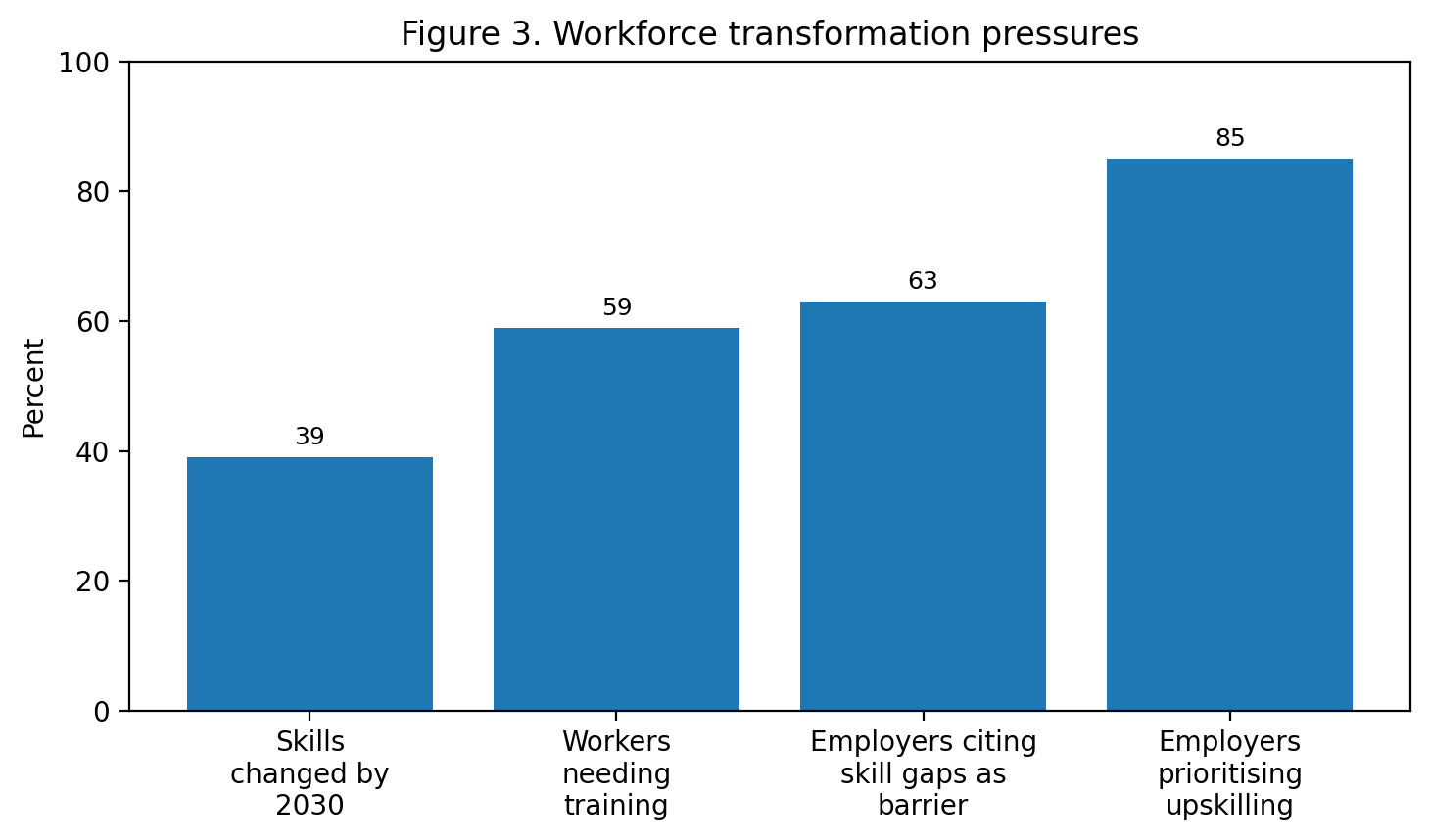
Source: World Economic Forum (2025)

5. The way the new approach motivates and facilitates performance.
The proposed model should improve the motivation as it would increase the autonomy, competence, and relatedness discussed in the self-determination theory (Ryan and Deci, 2000). Flexible work and intrapreneurial space, competence through learning, feedback and visible problem ownership, relatedness through cross-functional teamwork and psychologically safe management, give employees autonomy, competence, relatedness and competence, respectively. Such terms are of a commercial interest. The engagement meta-analysis conducted at Gallup indicates that highly engaged teams perform 10 percent better than low-engagement teams when it comes to customer loyalty, 18 percent about productivity, and 23 percent about profitability (Gallup, 2026). Otherwise put, improved employee experience is not a by-product: it is a path to improved customer experience and enhanced organisational performance. At Aether, strategic activity, hence, involves turning culture into a performance system through aligning leadership behaviour, team design, hybrid work and recognition with innovation and quality of service.

6. Gibbs reflective cycle reflection
Using the Gibbs (1988) reflective cycle, I can note that this module has changed my vision in relation to HRM. Initially, my primary association with HR was recruitment, administration of training, and policy compliance. Although all those functions continue to be relevant, the module did demonstrate to me how human capital is a strategic system that defines innovation, adaptability and customer outcomes. I have found this change a challenge and helpful since I had to think less about isolated HR practices and rather the relationships between culture, motivation, structure and performance.
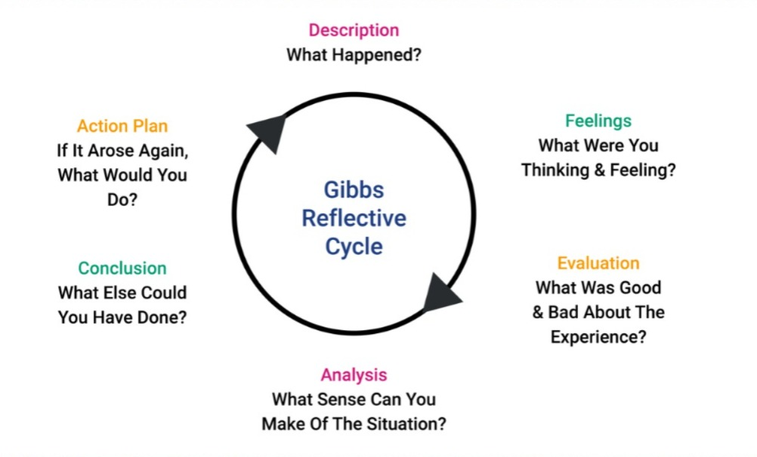
Figure 4: Understanding Gibbs’ Reflective Cycle (Dynamic Training, 2026)
The response I got when I initially encountered the module was that present-day HR is far more analytical and commercially important than I previously thought. Themes like psychological safety, engagement, hybrid work and skills strategy helped me realise that people management has become the centre of organisational resilience. Sometimes I felt the theoretical workload overwhelming me particularly in attempting to relate traditional models to emerging problems like distributed work and AI issues. Nevertheless, this challenge was fruitful as it made me go beyond description and pose the question of what types of organisational conditions are effective in promoting people to work.
The concept of integration was the most significant learning experience to me. I got to know that innovation is not born out of command telling the employees to be creative. It is a combination of culture, management behaviour, job design, learning opportunities and fair recognition. I also came to understand that hybrid work is not necessarily good or bad, its impacts vary depending on its organization. This disproved my previous belief that only flexibility will enhance motivation. The evidence indicated that autonomy is necessary to be accompanied by coordination, inclusion and managerial competence. I now more clearly see the reason why some organisations can be energized by hybrid work and others lose their unity.
This education has had an impact on my personal development thoughts. To work in innovative organisations in future, I should have more than technical knowledge to make a contribution. I require improved communication skills, the self-confidence to work in any functions, and the self-discipline to continue learning the technology as it evolves. I must also have reflective habits in order to make experience improvement and not repetition. The model by Gibbs comes in handy in this case since reflection is transformed into action. I am planning to continue in four areas, namely people analytics, digital collaboration, problem solving and leadership communication. I would also like to enhance my skill of applying theory to practical recommendations, as such is what was demanded in this assignment. Generally, the module has provided me with a better foundation in how I would design my personal approach to learning and development on the basis of curiosity, adaptability and a growth mindset.
The other valuable thing that I learned during this module is that innovation is not a chance event; it should be backed up by deliberate people practices, trust and lifelong learning. Previously, I used to believe that organisational success was primarily a matter of technology, either finance or strategy. Nonetheless, this module made me understand that individuals are the ones who bring change, innovation and customer value. This knowledge has altered my thinking of my personal professional growth. I have come to understand that the culture of innovation begins with the individual attitudes, including being open-minded to receive feedback, being ready to take risks and learning as one makes errors. Considering my personal style, I can observe that I occasionally tend to avoid ambiguity since I would rather have a structure and predictable results.
However, this module has revealed to me that ambiguity is usually a source of growth, as well as teamwork and experimentation with ideas. I also wish that in the future I would be more active in soliciting feedback as well as engaging in team work and building the courage to share original ideas. I also understand that the leadership is not restricted to the formal managerial positions. In an individual contributor role, I would also be able to shape the culture by motivating others, imparting knowledge and being a positive role model of growth attitude. This wisdom will make me a more flexible and future oriented professional.

7. staying relevant in the AI era
The transformation of work pace is going on with AI and I do not think that the best way to answer it is in the negative. Instead, I ought to be made into an individual, who will be able to work with AI and make it add the aspect of judgment, which cannot be replaced by AI. The is showing that 75% of those working in knowledge workplaces are already using AI at work and 78% of those who use AI are bringing their own AI to work, and in most instances at a pace that organizations cannot control (Microsoft and LinkedIn, 2024). In the meantime, according to the World Economic Forum (2025) in the year 2030, one out of every 5 workers will need training, 39 percent of the current sets will be irrelevant and 85 percent of employers will prioritize upskilling. The information presented gives an opportunity to conclude that the relevance presupposes combining digital fluency and human peculiar benefits.
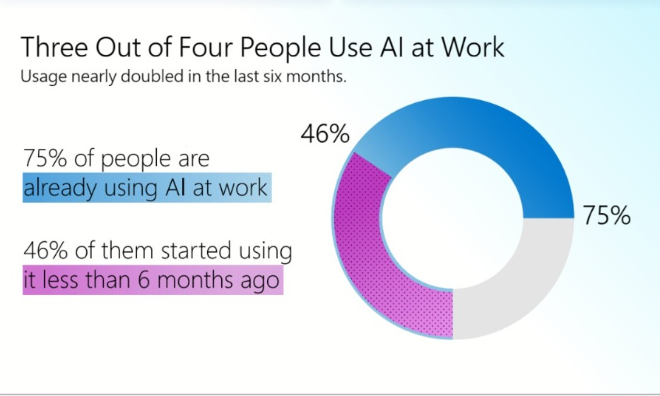
Figure 5: Usage of AI at work; Source: Microsoft and LinkedIn (2024)
Personally, I would apply AI in the first-draft research assistance, studying and summarising data with too many details, identifying patterns in data, automation of repetitive tasks and alternative solutions. I would not trust AI when making ultimate decisions, ethical choices, relationship management or subtle communication. These domains remain contextual, empathetic, responsible and critical. I would thus not compete with AI only in terms of speed, but rather use AI to free time so as to do more valuable work, like analysis, collaboration and creative problem solving. In that regard, AI is supposed to augment my ability, rather than specify it. The long term protection against substitution is to be flexible, thoughtful and truly of use in those cases in which there is trust, interpretation and human understanding at play.

8. Conclusion
The culture and work design can be handled as one strategic system to enable Aether Innovations grow, retain and customer satisfaction. The data confirms the strategy based on the principle of psychological safety, cross-functional teams, rigorous experimentation and a hybrid model coordinated. These would not only enhance the employee motivation and innovation but also customer outcomes and organisational resilience. The reflection also demonstrates that the major message of the module is that one should engage in constant development. It will be the combination of technological literacy and intuition, flexibility and people-centred leadership that will pay off in the long term in a labour market that is dynamically altered by AI and fast change.

Reference List
Bloom, N. (2024) ‘Hybrid is the future of work’. Stanford Institute for Economic Policy Research. Available at: https://siepr.stanford.edu/publications/policy-brief/hybrid-future-work
Bloom, N., Han, R. and Liang, J. (2024) ‘Hybrid working from home improves retention without damaging performance’, Nature, 630(8018), pp. 920–925. researchgate.net/publication/381373698_Hybrid_working_from_home_improves_retention_without_damaging_performance
Blomkvist, K., Engzell, J., Kappen, P. and Zander, I. (2024) ‘How organizational conditions affect employees’ intentions to engage in intrapreneurial new venturing’, Technovation, 135, 103046. https://www.sciencedirect.com/science/article/pii/S0166497224000968
Deloitte (2024) ‘2024 Global Human Capital Trends’. Available at: https://www.deloitte.com/lv/en/about/press-room/deloitte-2024-global-human-capital-trends.html
Dynamic Training. (2026) Understanding Gibbs’ Reflective Cycle | Dynamictraining.org.uk. https://www.dynamictraining.org.uk/learner-pulse/study-skill-gibbs-reflective-cycle/
Edmondson, A.C. (1999) ‘Psychological safety and learning behavior in work teams’, Administrative Science Quarterly, 44(2), pp. 350–383. https://psycnet.apa.org/record/1999-03028-001
Eurofound (2023) The future of telework and hybrid work. Luxembourg: Publications Office of the European Union. Available at: https://assets.eurofound.europa.eu/f/279033/0e1e84b3e0/ef22028en.pdf
Gallup (2025) State of the Global Workplace 2025. Available at: https://www.gallup.com/workplace/349484/state-of-the-global-workplace.aspx
Gallup (2026) ‘The benefits of employee engagement’. Available at: https://www.gallup.com/workplace/236927/employee-engagement-drives-growth.aspx
Gibbs, G. (1988) Learning by doing: A guide to teaching and learning methods. Oxford: Further Education Unit. https://thoughtsmostlyaboutlearning.wordpress.com/wp-content/uploads/2015/12/learning-by-doing-graham-gibbs.pdf
Microsoft and LinkedIn (2024) 2024 Work Trend Index Annual Report: AI at Work Is Here. Now Comes the Hard Part. Available at: https://assets-c4akfrf5b4d3f4b7.z01.azurefd.net/assets/2024/05/2024_Work_Trend_Index_Annual_Report_Executive_Summary_663b2135860a9.pdf
Patil, R., Raheja, D.K., Nair, L., Deshpande, A. and Mittal, A. (2023) ‘The power of psychological safety: Investigating its impact on team learning, team efficacy, and team productivity’, The Open Psychology Journal, 16, e187435012307090. https://openpsychologyjournal.com/VOLUME/16/ELOCATOR/e187435012307090/FULLTEXT/
Ryan, R.M. and Deci, E.L. (2000) ‘Self-determination theory and the facilitation of intrinsic motivation, social development, and well-being’, American Psychologist, 55(1), pp. 68–78. https://selfdeterminationtheory.org/SDT/documents/2000_RyanDeci_SDT.pdf
Schein, E.H. and Schein, P.A. (2017) Organizational culture and leadership. 5th edn. Hoboken, NJ: Wiley. https://static1.squarespace.com/static/5df3bc9a62ff3e45ae9d2b06/t/5f77427644fb0f733519de2a/1601651323950/Organizational+Culture+and+Leadership+-+Schein.pdf
World Economic Forum (2025) The Future of Jobs Report 2025. Available at: https://reports.weforum.org/docs/WEF_Future_of_Jobs_Report_2025.pdf
Yang, L., Holtz, D., Jaffe, S., Suri, S., Sinha, S., Weston, J., Joyce, C., Shah, N., Sherman, K., Hecht, B. and Teevan, J. (2022) ‘The effects of remote work on collaboration among information workers’, Nature Human Behaviour, 6(1), pp. 43–54. https://pubmed.ncbi.nlm.nih.gov/34504299/

