THEORYS & COMMUNICATION MODELS
CARINA RIBEIRO
2026806
MODULE TITLE: EFFECTIVE TEAM AND COMMUNICATION
MODULEBCODE: BMSW4002
MISS: JOY BATU

Introduction:

Communications
Communication is an act of being able to trade information, Ideas or Emotions from one place or person to another (Skills You Need, 2021). This can be through Speaking, Writing and Listening (Common Sense Media, 2021).
Being able to communicate has led countries be able to unite, trade and help each other in difficult moments. It has helped Families to still stay connected even from a distance. Especial through social media, as well as the internet, before Covid and now during Covid, it gives someone an opportunity to teach, share ideas and making memories with a stranger.
Active Listening is to listen and respond to another person or source in a way that can improve each other’s understanding, concentrating without getting to lose or distraction in thoughts. “However, active listening can be difficult to master and will, therefore, take time and patience to develop” (Skills You Need, 2021)
Channel of Communication- Face to Face conversations, Written letters, Brochures, Reports, Phone calls, Emails, Radio, Television, and other Technology and Internet (including social media).
Being able to choose the right communicator channel is very important for the target audience as not everyone uses the same communication channels especially today.
Categories of Communications
Verbal Communication; Includes Face to Face, Telephone calls, Radio, Television or Media outlet and Internet.
The tone of one’s voice can give clues to the mood or emotional state of the person.
Non-Verbal Communication-Body language, Gesture, Emojis and Art.
Written Communication- Letters, Emails, Books, Magazines, Brochures, social media and other Internet outlets.
Visualization Communication- Television, Charts, Logo, maps and other internet outlets.

Model Of Communications
Shannon Weaver 1948
Shannon and Weaver models of communication was first introduced in 1948 and it has been adapted and improved a few times and was reintroduced in 1949. It has been used as a foundation to create other models; it is also referred to as “the mother all models”.
Claude Shannon was a Mathematician and Warren Weaver was a Scientist, who decided to work together to find out how early computers, radios and televisions translates in communication. Later, they discovered that the theory also applies to human communication.

Concepts in Shannon Weaver Model
Sender
The person or source who creates the message and sends to the receiver(s).
Encoder(transmitter)
When the sender is using a machine to convert the message into code or binary data and send it through a medium.
Channel
Is the medium used to send message; Includes Face to Face, Telephone calls, Radio, Television or social media and Internet outlets.
Decoder
The machine used to convert signal and binary data back into message, or the receiver who translate message if it is face-to-face conversation.
Receiver
The person or place that the messages was intended for, they must decode the message before understanding it and interpreting. They will provide feedback according to their understanding of the message. In some cases, the machine can also be the decoder.
Noise
As we know communication has its complexity, there are always a possibility of interference which was introduced to the public as “Noise” by (Schramms and Weaver, 1948). Which can be something as simple as environment noise, bad network signal and other barriers. Channel can have noises as well, that might make it harder for the receiver to decode properly and cause problems while communication.
For an example the case study of Maria and Pedro showed us many ineffective communications such us when the “noise” interferes their communication due to Pedro being on a building site, so the environmental noise in the building site played its roll in their miscommunication.
Also, in the case of “The Professor and The Village People, the “noise” in this case was the Language barrier, so that caused misunderstanding, confusion to the Village people.
Shannon Weaver model did not have a full understanding of communication as they did not apply Feedback to their model. Had there been feedback it would have been a complete model. That way Pedro could have cleared any misunderstanding with Maria, and the Village people could had asked the professor questions so that they could understand him.
There has been plenty of time in my workplace when noise have played out as interference such as when music is playing quite loud in the saloon, so it interferes with our communication and causes confusion and misunderstanding. Or when there a language barrier due to different culture and background.
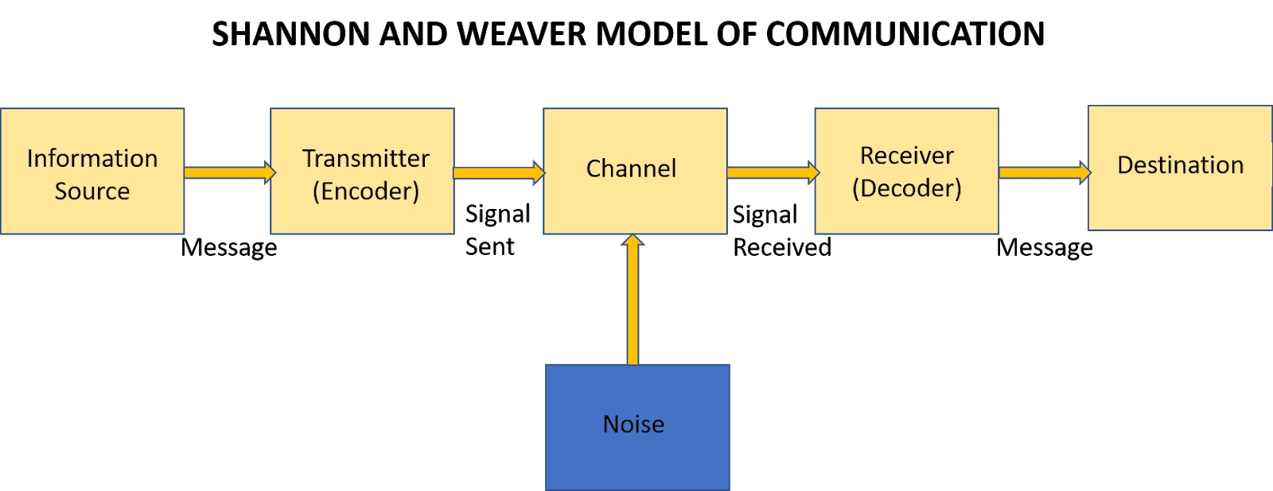

Schramm’s Model of Communication 1954
Wilbur Schramm is a known communication theorist, who use the “Shannon Weaver model of Communication” to build his own Model and introduced it in 1954. Schramm believes that “encoding and decoding are the two most important factors of an effective communication” and that without these factors being completed successfully “communication cannot flow between individuals” (Schramms, 1954). He mentioned that communications are not fulfilled unless the sender gets a response from the receiver, since communication is a “two way” street between the Sender and the Receiver. The receiver can send a verbal or non-verbal feedback to the sender. Schramms noted that a person’s Knowledge, Experience, cultural background has an influence when it comes to communication, since people from diverse culture and religion are prone to translate things differently.
Barriers/Noise
- Language, speaking different language can cause is misunderstanding and confusion, due to different words being spoken and different meanings.

- Culture, not sharing the same culture can lead to mis communication and misunderstanding as you have different beliefs, values and religion. What one may find appropriate and Respectful may be an offence to the other persons culture.

- Knowledge, not sharing the same knowledge can lead the way to confusion as the recipient(s) will not understand the information delivered to them.

- Psychological state can play a part in how a message is being transferred. If the person is moody or emotional, they can send or receive a message in non-appropriate tone.
Technical difficulties and other Internet problems can also stop communication to be a success.
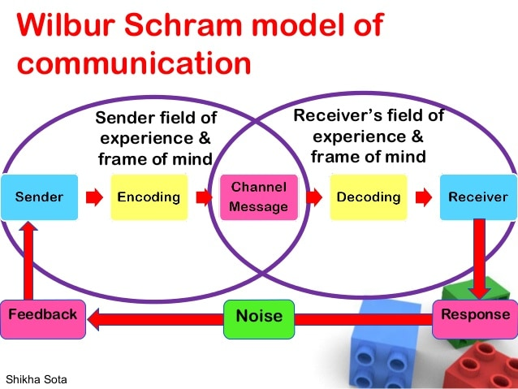

Berlo’s SMCR Model of Communication 1960
David Berlo published his model of communication “Sender-Message-Channel-Receiver (SMCR)” in 1960, he used “Shannon Weaver’s Model of Communication (1949)” to create his own. His model of communication is quite identical as the other models, His model falls in the same category as “Shannon and Weaver 1954” since none of them speaks about feedback. Once the sender sends the message, they have no way of knowing if the message was sent as a whole or partially to the receiver.
He speaks about the 4 main important components when it comes to communication, which are; Sender, Message, Channel and Receiver (SMCR) and factors that can affect each of them when communicating. He also spoke about factors that can affect the sender, also has the same impacted on the receiver.
Factors that can affect Communications
Communication Skills- if the communication skills of the sender are excellent such as speaking, presenting, reading, writing, listening and so on, then the massage will be communicated better than if the sender had a poor communication skill and same goes for the receiver.
Attitude- a person’s concentration span can lead to boredom and zooning out, which can affect communication, as well as the persons mood.
Knowledge- Having an understanding and knowledge on the subject the sender is speaking about makes the communication flow effortlessly.
Social System- the persons beliefs, value, law, country and religion have a substantial impact when it comes to communications as it is their rights and what adds to their characters.
Culture- What one may find acceptable and respectful in one’s culture, can be completely unacceptable and disrespectful in another’s culture.
The Model believes that for the communication to be effective, the sender and the receiver must be very similar as a person in all factors.
The “Professor and The Village People” and “Barry and the communication barriers” is a perfect example why Culture, Knowledge and Social System can affect communication and causing misunderstanding and confusion and if they were able to send a response to the sender to clear the confusion the communication would have been successfully.
Factors that affect Message
Structure- whether the message is written in formal or non-formal
Code- Language, tone used in the text, video…
Element- the way the message is created, is it verbal or is it nonverbal?
Channel- the human 5 sense (hearing, seeing, touching, smelling and tasting) contributes to communication
The criticisms that the model received were that it is a very complex model and that did not mention noise or feedback, nor did it mention any barriers to communication.
The main issue his model faced was when he mentioned that the human five sense is a “Channel”, although seeing and hearing contributes to our communications however it is not a channel as it is part of a natural human gifts.

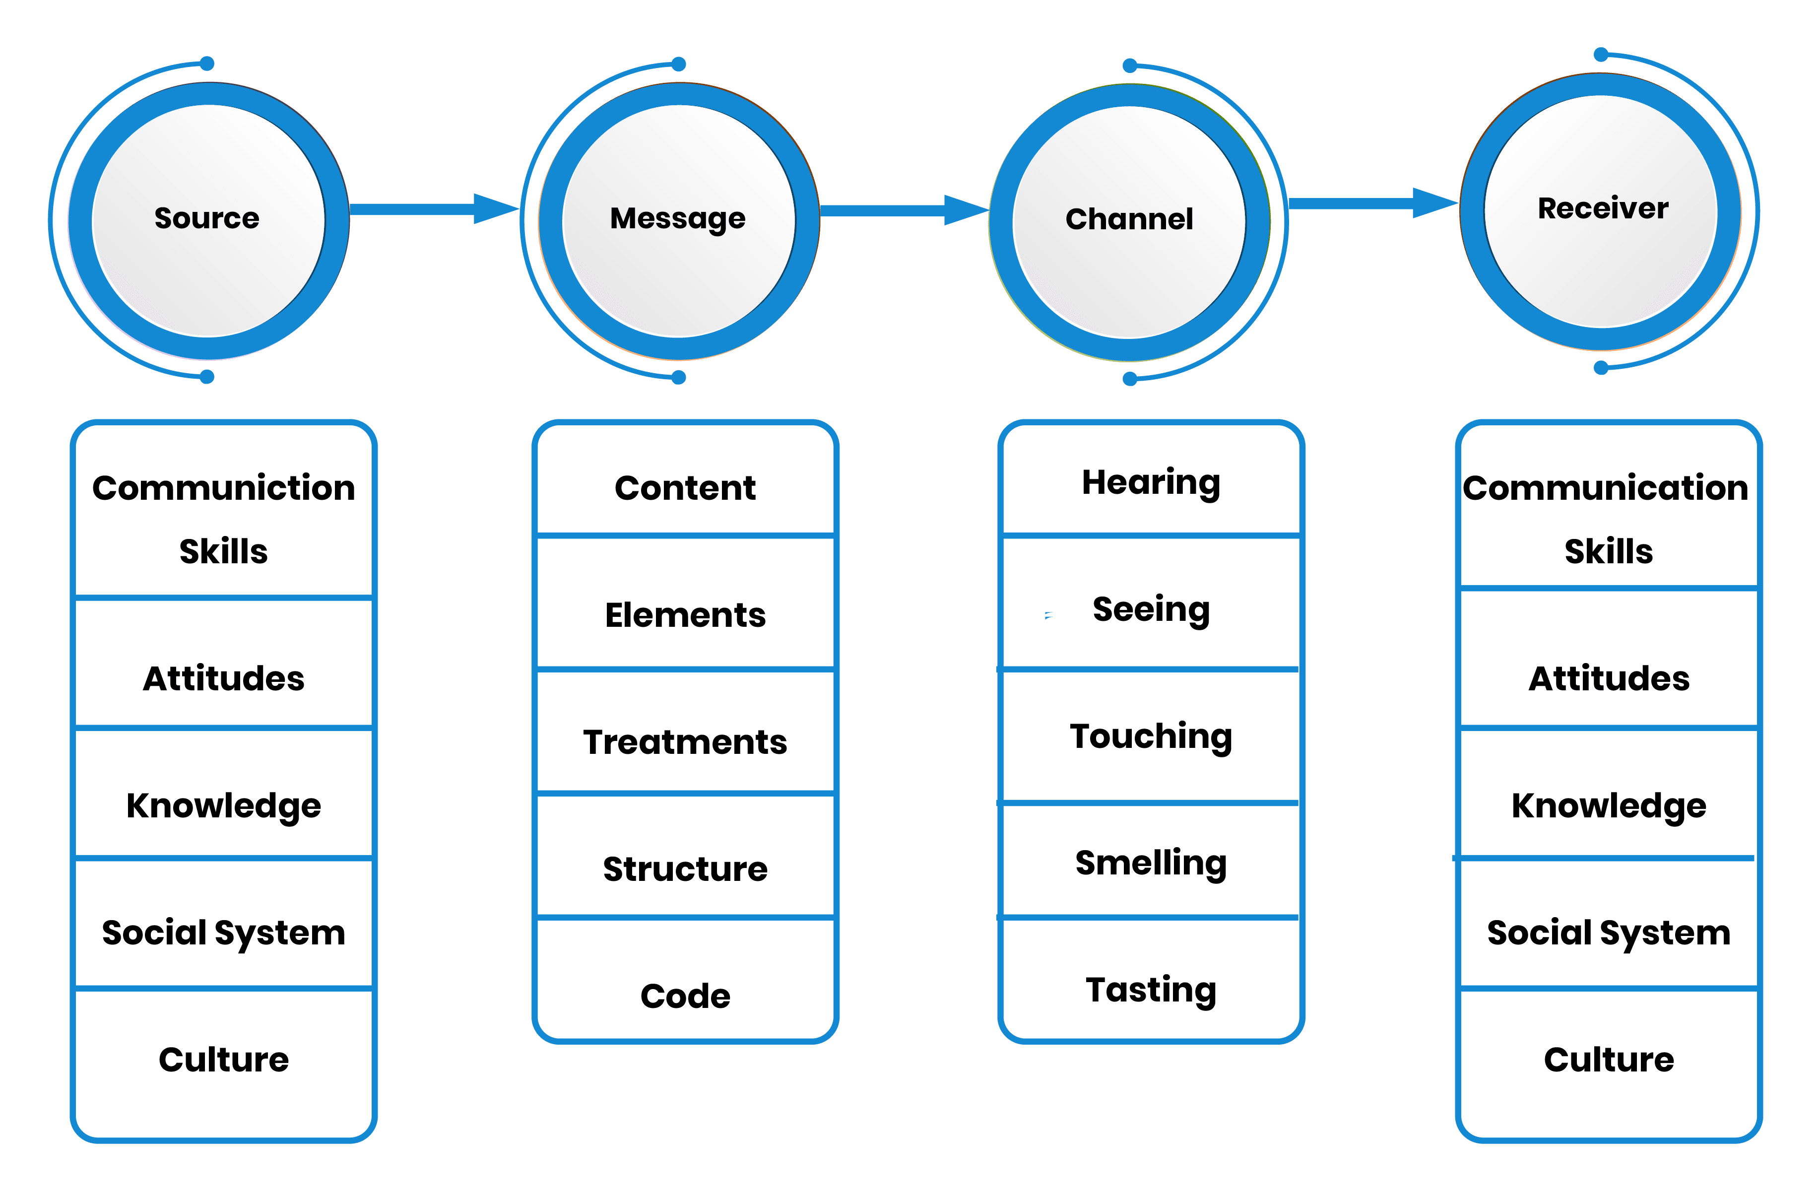
Conclusion
All three models help to prove communication work in their own way, by supporting one another, where the other lack. Whether it is the feedback that (Schramms,1954) mentioned, or it is the noise that (Shannon and Weaver ,1949) speaks about. Or the importance of encoding, decoding and understanding that background, culture and social system has an impact (Berlo,1960).
In this century we have more barriers that can affect our communications, although we are more advanced than before. When it comes to the internet and social media we have connection problem, hacking problems that happens very often and system crashing like we experienced in 2021.
When Facebook crashed, it was long for the rest of its other social owned by them to follow the same fate. As well as power cut that people experience in different part of the country or world. As well as communicating through message on social media can cause misunderstanding as you can not heart their tone, so the message can be miss translate and cause an uproar as we have experienced several times this year.
When it comes to writing letters, not only do you have to send it on time for it to reach its location at the time you intend too, but the weather can also have an impact on the delivery, whether it is a snowstorm, or windy that can cause things to fall on the road and train tracks and raise safety upon the delivery.
Having studied these models I have learnt how communication work, and fact factors affects it and the barriers that can have an affection when communicating and it has improved my communication skills also.

Communication Definition & Meaning - Merriam-Webster
What is Communication? Verbal, Non-Verbal & Written | SkillsYouNeed
the-shannon-weaver-model-of-communication-theory-script.pdf (stockton.ac.uk)
shannon weaver model of communication - Bing images
Schramm Communication Model, a communication theory | toolshero
Schramm's Model of communication - QS Study
schramm model of communication - Bing images
https://www.commonsensemedia.org/character-strengths-and-life-skills/what-is-communication
https://www.skillsyouneed.com/ips/active-listening.html
https://www.usip.org/public-education-new/what-active-listening

