Name: Tim Kirk
Student No: 1710839
Module: HPAR5001

Art, Agency and Saxon Ship-building:
Can Reconstructing the Sutton Hoo Ship Enlighten the Saxon Mindset to the Modern Scholar?

Abstract

‘Agency’ has become an important concept in Anthropology and Archaeology, particularly since the posthumous publication of Alfred Gell’s “Art and Agency: An Anthropological Theory” (Gell, 1998). Gell primarily focussed on the linkage between the ‘Agency’ of an artist in creating the work of art and, in turn, the ‘Agency’ that the artwork has upon its creator and audience. As case studies, he cited artworks such as Duchamp’s “Fountain” and believed that such mundane articles such as mousetraps can have both art and agency. This belief had been informed by fieldwork in Melanesia - where his observations of the Trobriand Islanders and the decorated prow boards of their trading canoes led to the formative paper “The Technology of Enchantment and the Enchantment of Technology” (Gell, 1992) – and in Andhra Pradesh, India (Macfarlane, 2003:123)
This essay will investigate the concept and history of Agency and endeavour to investigate how a specific artefact, the Sutton Hoo ship, might be related to and interpreted through art and agency.

The origins of ‘Agency’
‘Agency’ as a concept derives from the philosophers of the Enlightenment period – that time dating from the mid-eighteenth century through to the mid-late nineteenth century when in Europe, Great Britain and North America the concepts of orders such as the Church and the State and the individual’s place within those orders was challenged by philosophers such as Rousseau, Kant and Locke and led to the French Revolution. In France, Jean-Jacques Rousseau (and others) argued that freedom could only be obtained by acts of self-will on the part of the individual (Emirbayer and Mische, 1998:965). This was in direct conflict with the notions of Church and State and whilst an over-simplification, could be identified as one of the causes of the French Revolution. Immanuel Kant looked at this from a slightly different perspective; he theorized that most individuals existed in a state of “nonage” – a lack of understanding of an individual’s abilities, rights and responsibilities caused by the all-encompassing oversight of Church and State – and that only by a conscious act of will could a person overcome this and reach a state of ‘enlightenment’ (see Kant, 1784). Rousseau, in particular, was highly influenced by Kant’s theories (Hobsbawm, 1962:305). However, it was the Scottish philosopher John Locke’s rejection of tradition in favour of a freedom based upon self-interest which directly led to the concept of ‘Agency’ as “the capacity of human beings to shape the circumstances in which they live” (Gunn, 2009:26).
Therefore, “….a subject who self-consciously acts or causes change is said to possess agency. Hence, a subject with agency is an agent. An agent does not, necessarily, need to be a subject however, nor does a subject necessarily possess agency” (Gunn, 2009:27).
The Twentieth-Century philosopher Martin Heidegger expanded on these theories and extended them to include objects as having agency. In what became known as “Heidegger’s Hammer”, he suggested that a tool - such as a hammer - could exist in two states: it could, as the weighted extension of an actors hand be simply a tool and be “Ready-at-Hand” to knock in a nail and join two pieces of wood together, or to break up the constituent pieces of an object. But it could also be seen, when sitting on a bench or in a tool-box, in contrast to Kant’s philosophy, as being “Present-at-Hand” – there, as an object, waiting to be used and having agency acting upon the agent as the correct tool for a certain job (Cerborne, 1999:312-313).

Gell’s theory of ‘Art and Agency’
Gell extends this further; in an artwork, be that a painting or drawing or even a modern-art ‘installation’ such as Duchamp’s “Fountain”, Gell contends that as well as the ‘agent’ or artist having agency over the artwork, the artwork has agency over the viewer of the artwork (or as Gell called the viewer, “the Index”) and the agent with a power to affect the agent (Hirsch, et. al:1997:23).
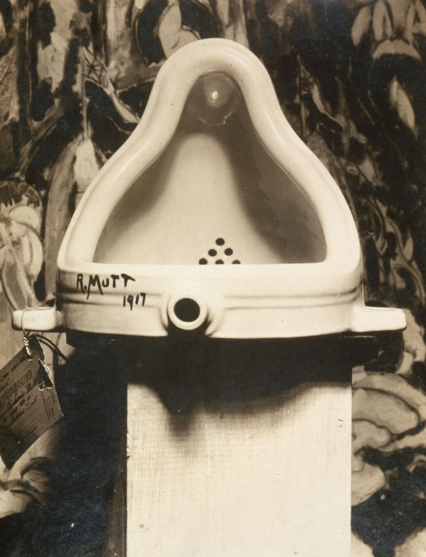
Marcel Duchamp’s “Fountain”, 1917 (Source: public domain, via Wikipedia)

The attraction for Gell in this piece “…was the intentional complexity it embodied and its puzzling qualities: the actual choice of artefact among those possible, how it was physically displayed (i.e. in a manner so that it could not be used, its arcane but potent signature (‘R. Mutt’), and so on. …[Gell] re-phrased this in anthropological terms as how it was possible that ‘art’ could be seen in anything” (Hirsch, et al: 1997:23).

Gell’s theory has been controversial; it has been criticised for being “a sometimes confused argument” and as “borrowing from a wide range of intellectual currents” (Derlon and Jeudy-Ballini, 2010:129). However, perhaps this criticism should be viewed with reference to Gell’s own critique of his literary style; at the very beginning of ‘The Art of Anthropology’ (again published posthumously, in 1999) he states “All the essays in this volume began life as texts intended to be delivered out loud to audiences, mostly at seminars. They are not really essays for reading so much as scripts to be performed” (Gell, 1999:2). This statement, perhaps, sheds light on Gell’s approach to his written work; his preference was to communicate through the medium of seminars where lively debate could be sparked by both the content and the style of delivery and, for him, this took pre-eminence over the clear and cohesive exposition of a theory – something that an intellectual reading of a written could not immediately do (Macfarlane, 2003:7). Further, it should be taken into account that the works were published posthumously and Gell was unable to complete a final edit or to proof-read the finished versions.

A key to Gell’s work on agency is that a part of its function is to deliberately affect the perception of the Index (‘the viewer’ or ‘consumer’ of the art or article) as is clearly set out in the ‘Technology of Enchantment and the Enchantment of Technology’ (1992). Here, Gell proposes that the function of the highly decorated bow Splashboard of the Trobriand Islanders canoe is to ‘enchant’ their potential trading partners in order to gain a better rate of exchange for the goods that they are offering – as Gell puts it, “sometimes art objects are explicitly intended to function as weapons in psychological warfare” (Gell, 1992:44).

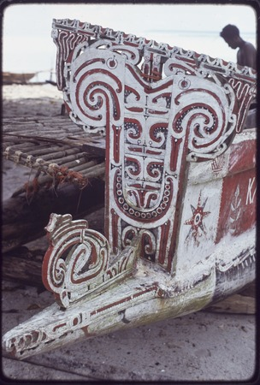
Bow Splashboard of a Trobriand Island Canoe
(Source: Wikimedia)

Interpreting Gell
In his 2013 work, “Making”, Tim Ingold writes of the linkage between what he describes as “the four ‘A’s” – Anthropology, Archaeology, Art and Architecture (Ingold, 2013:10). Ingold describes a linkage between these four arts and suggests that to understand them, both individually and in their relationship to each other, it is not sufficient merely to study them from the outside, but rather it is necessary to know them intimately by immersing ourselves in the act of creating (Ingold, 2013:1). He quotes Gell (1998:13) and interprets him to mean “…that it should be possible to trace a chain of causal connections, in reverse [my italics], from the final object to the initial intentions that allegedly motivated its production, or to the meaning that might be attributed to it” (Ingold, 2013:7). Thus, if this is correct, it should be possible to understand the agency and the motivations of ancient peoples in creating their world and the objects within them and which come down to the present generations as archaeological artefacts.

Case Study – Reconstructing the Sutton Hoo Ship
The Sutton Hoo Ship-burial was first excavated in 1939 by Basil Brown, a local Suffolk archaeologist, at the request of Mrs. Edith Pretty, a landowner at Sutton, near Woodbridge in Suffolk (Bruce-Mitford, 1975; Crossley, 1942; Phillips, 1940). As he dug into the burial mound from ground level, Brown quickly began to uncover rows of heavily-corroded iron nails which he recognised as coming from a ship-burial due to having excavated a similar mound on the same site the previous summer and in which he found the imprint of a small clinker-built burial ship. The burial had been robbed out, but Brown supposed that it dated to the Viking period (9th-11th Century A.D.). However, as the 1939 excavation continued and the size of the ship began to become apparent, the excavation was taken over by archaeologists from the British Museum led by C.W. Phillips (Phillips 1940:9). Numismatically, thanks to the find of forty coins subsequently dated to the Meringovian period, the burial was eventually ascribed to around 600-630 in date and is now generally attributed to Raedwald, King of the East Angles who died in 624-625 A.D. (Bruce-Mitford, 1975:350). The ship was eventually found to be some twenty-seven metres long by four and a half metres wide and with a height of nearly four metres (Tanner, et al., 2020:7). A burial chamber was discovered which was found to encompass grave goods “the richness and craftsmanship [of which was] unparalleled in Anglo-Saxon burials” (Pitt: 2019:1).
Once the grave goods were discovered, it was natural that investigation into these should take precedence; “the main discoveries were made in the last week of July and it was a fortnight before they had all been lodged in the British Museum” (Phillips, 1940:14). However, the requirement for haste under the threat of looming conflict with Germany meant that the imprint of the ship – all timber had decomposed in the acid soil – had been damaged and there was little time to investigate key areas such as the shape of the keel and the stem- and stern-posts, although a small excavation was made of the outside of the stem area and sections cut in two places, fore and aft to try to establish the keel section by Lieut.-Commander J. K. Hutchison of the British Museum. Rivet locations were measured and a plan was made of the overall layout of the rivet locations and plank edges (Phillips:1940:9).
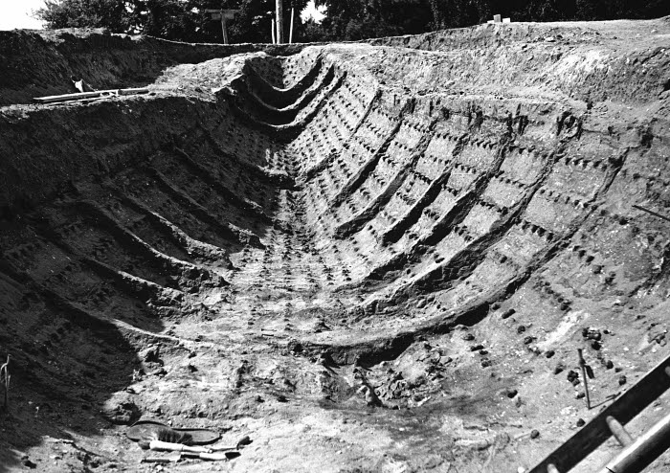
The 1939 excavation showing the stern (looking West) and the damage caused to the imprint of
the ship.
Source: Bruce-Mitford (1975:393) Fig. 300.
Copyright: Trustees of the British Museum

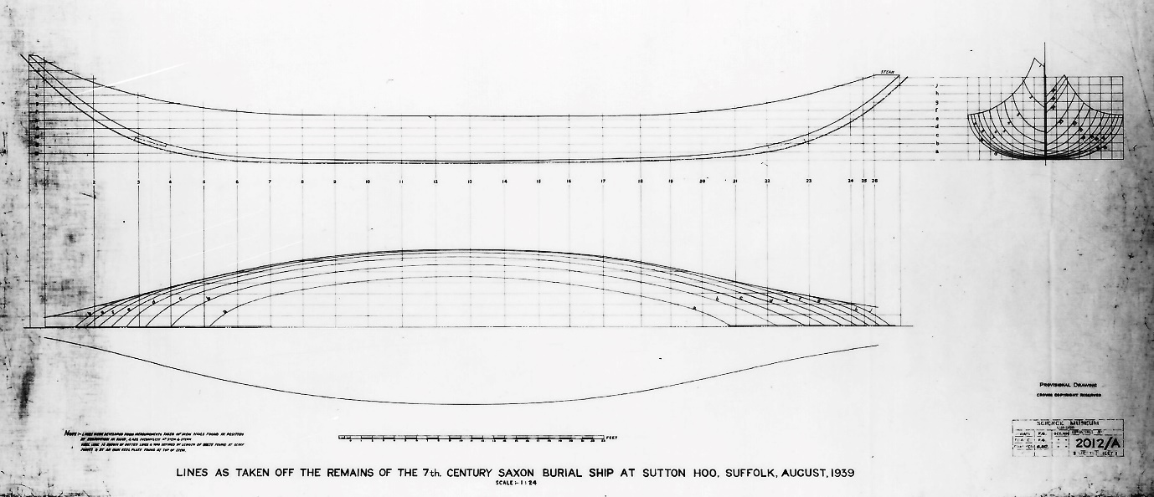
Provisional, 1940, lines drawing of the Sutton Hoo Ship Source: Bruce-Mitford, (1975:259) Fig. 185
Copyright: Trustees of the British Museum.

For the duration of the war, and afterwards, the excavation was simply covered with withies and bracken and during the war the site was used for training tank crews resulting in damage to the stern of the imprint (Tanner, et al., 2020:9). However, a second excavation was undertaken from 1965-68 using modern (for that time) techniques and although the site was somewhat damaged and decayed, valuable information was obtained, both regarding the grave goods, the presence of a body and the ship itself (see Bruce-Mitford, 1975; Green, 1988).

The artefacts were given to the nation by Mrs. Pretty after an inquest found that they were not treasure trove (Bruce-Mitford, 1975:726). After being securely kept for the duration of World War Two they have since been thoroughly curated and investigated. However, despite a number of attempts, it was not until around 2010 that the ship itself really began to be investigated and a serious attempt to understand and even reconstruct it was begun; this author and colleagues from the International Boatbuilding Training College (IBTC) were asked to consult on the specification for a boatshed and museum for the building and display of the reconstruction in 2011. In 2015, The Sutton Hoo Ships Company (henceforth SHSC) was formed as a charitable trust to oversee the design, construction, testing and eventual disposal of a full-size reconstruction of the Ship (Tanner, et al. 2020:5).

This author has worked as a boatbuilder and shipwright since 1996 and in Summer 2019 worked as a volunteer shipwright on the project. In September 2019, he was invited to become the Lead Shipwright (see https://www.saxonship.org).

The work has required both the up-skilling of many of the volunteers to understand the techniques and practices of modern wooden boatbuilding, and the ability to reverse engineer these techniques to those understood to be used in the Saxon period though archaeological, iconographic and textual evidence.
Modern digital reconstruction techniques, as applied by researchers at Southampton University, generated a 3-d digital model of the imprint of the Ship as found in the 1939 excavation and enabled the as-measured imprint to be corrected for distortion due to the Ship being interred with a heel of some six degrees to port, a keel fractured either due to age and usage or to issues such as manhandling to the burial site (situated some ½ mile from the River Deben at an elevation of around 100 feet above sea-level) and the disintegration of the Ship during the site formation process, leading to both the rotting-off of the ends and the separation of the upper planking from the stem- and stern-posts (Tanner, et al. 2020:8-12). These reconstruction techniques also identified an issue with the original measurement and subsequent drawing of the Ship by Commander Hutchison in 1942 – the ‘rocker’ of the keel (the upward curvature of the keel at the ends as viewed from the side) was shown to be greater than as originally drawn by the positioning of rivet lines along the keel/garboard planking. This increased ‘rocker’ gives benefits both in manoeverability and in the ease of beaching and re-launching the Ship, but also causes potential difficulties in construction due to the increased curvature and the necessity of finding suitable curved timber today (Tanner, et al. 2020:19).
As an Experimental Ship and Boat Archaeology (EBSA) project it was determined to work to the protocols set out by Coates et al. in 1995 and as more clearly defined by for this project by Carver (2015):

Phase 1: Design (propose hypotheses and publish the design)
Phase 2: Construction (construct the ship, assess and publish the experience)
Phase 3: Testing (test the ship in differing conditions and publish the results)
Phase 4: Publication (complete publication and dispose of the ship to a good home)

(Tanner, et al., 2020:6)

Phase One was completed with the publication of the Design and its rationale (see drawing below and Tanner, et al., 2020) and Phase Two commenced in July 2019 with the training of volunteers and the lofting (drawing out to full-size from a “Table of Offsets”) of certain parts of the ship. These included the stem- and stern-posts to make patterns (to select suitable curved timber in woodland), sections of the midships cross-section of the hull to produce a full-size model of this part of the ship (to investigate rowing positions and internal structure, knowledge of which is incomplete), and the whole ship at a scale of 1:5 (to produce a scale model from which to take patterns and dimensions for the full-size build).

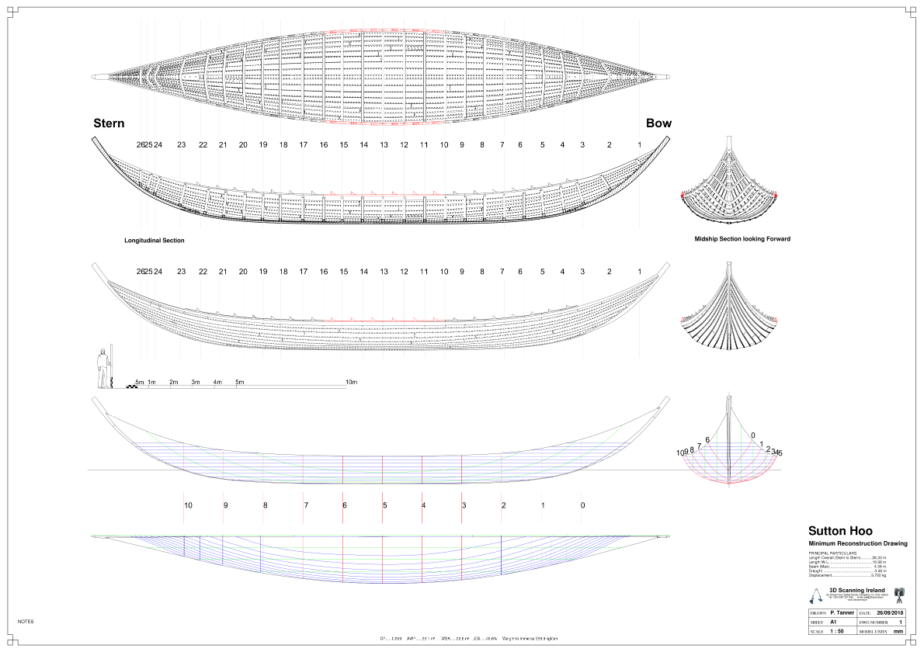
Minimum Reconstruction Drawing of the Sutton Hoo Ship by P. Tanner, 2018 (Source: SHSC)

This is where it begins to be possible to see the Agency of the ancient shipwrights; the earliest known texts regarding the design of ships date from the mid-Sixteenth Century and before that, as far as we know at present, ships were built purely ‘by eye’ and various ‘rules of thumb’ through the experience of the Master Shipwright (Steffy, 1998:128). In trying to build a reconstruction and to build accurately as recorded in the earlier excavations (it was decided that a maximum tolerance of +/- 2.5% would be used – pers. com. J. Barnard and P. Clay, SHSC directors, July 2019) whilst maintaining tooling and techniques as known to likely be used in the period, it would be necessary to ‘reverse engineer’ (see comments by Ingold, above) the digitally derived and rectified ‘Minimum Reconstruction Drawing’ and to use ‘bevel boards’ and ‘ells’ for measurement of dimensions (Tanner, et al. 2020:6). A bevel board is a piece of timber with known angles of planking (from a datum such as the flat top of the keel) for each design station or frame location. An ‘ell’ is a trimmed stick marked with distances from a known point such as a string-line stretched above the centreline of the keel (Dhoop and Olaberria, 2015:101). These techniques are thought to have been used, certainly as far back as the Viking period and have been successfully used at Roskilde, Denmark in the reconstruction of the Skuldelev ships of the 10th and 11th Century (see https://www.vikingeskipsmuseet.dk). It is believed that Saxon technology did not include the use of large saws and that all conversion of timber was performed by the use of axes (Williamson, 1999; Goodburn, 1986). Whilst the technology of the Sutton Hoo Ship is related to the Viking style, it does appear to be a separate and defined technology; the keel is of the plank-type (as in the earlier Nydam ship), whereas the Viking ships have ‘T’-shaped keels; frames were fixed to planking with trenails whereas Nydam utilised rope stitching to secure the frames (Bruce-Mitford, 1975:379). Thus, it might be seen that the Sutton Hoo ship is a key linkage between the earlier Saxon technology and the later Viking technology.

The management of this build today is very different to the likely management of building in antiquity; the king (or his commissioning ‘agent’) would select a builder – possibly the one who, by long experience or by accident and luck had made the most progress in building strong, efficient and fast ships – who could walk out into the local forest and, by eye, select the timber most suitable in terms of required length and breadth, of straightness of grain and of lack of side branches, and at the King’s order bring whole communities together to build for their leader. Today, we have to comply with regulatory standards set by international convention, industrial workshop regulations, health and safety legislation etc.

One example of this is the first oak log delivered for planking of the ‘midships model’. This was selected from a forest some 100 miles away from the workshop, felled by chainsaw, delivered by truck, offloaded by mechanical hydraulic lifting aids (Hi-ab crane and engine hoists) and situated in the workshop. It was then determined to split the two sections (one of 5m length, the other of 4m, approximately 1.2m in diameter and weighing approximately 3 tonnes and 2.5 tonnes, respectively) in the traditional way using axes, mauls and wooden wedges. Each log was to be ‘cleaved’ (split) in half, then into quarters, eighths and sixteenths and each sixteenth then converted to a board 30mm thick by specially commissioned Saxon-pattern axes. However the log, which was expected to split in half truly, took a split with approximately a seventy degree twist along its length, rendering it useless to conversion by traditional methods (if we had proceeded, each finished board would have assumed the same degree of twist as the splitting and subsequent conversion would follow the line of the grain in the wood and be unsuitable for planking).
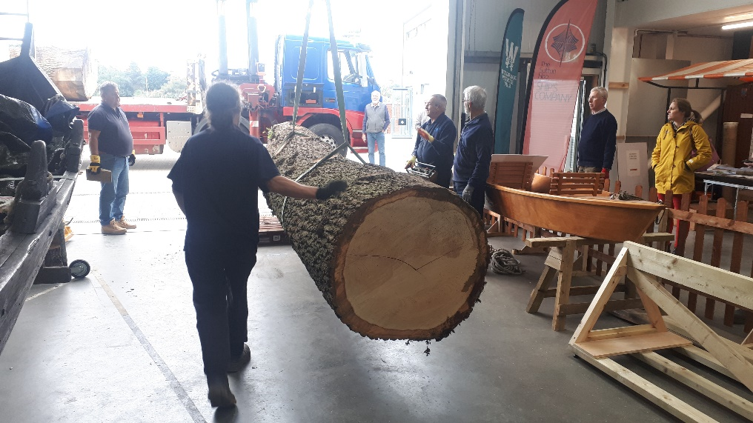
Delivery of the first log into the workshop (Photo: Author)

This was not a good start; a valuable resource was now useless using traditional techniques. Whilst donated as a gift to the project, the log was commercially worth around £5,000 at 2019 prices. The issue was rectified by instead of using for planking, cutting sections for the keel of the ‘midships model’ using chainsaws and finishing these by hand using traditional tools. Others parts of the log have been used for making wooden clamps and other, smaller parts of the ship. However, it has been indicative of some of the issues involved, both for modern shipwrights used to obtaining timber from a sawmill ‘in the board’ and of the ‘agency’ and experience of the ancient shipwrights and foresters in assessing the qualities of potential timber. It also shows something of the ‘agency’ shown by the material on the ‘actors’.

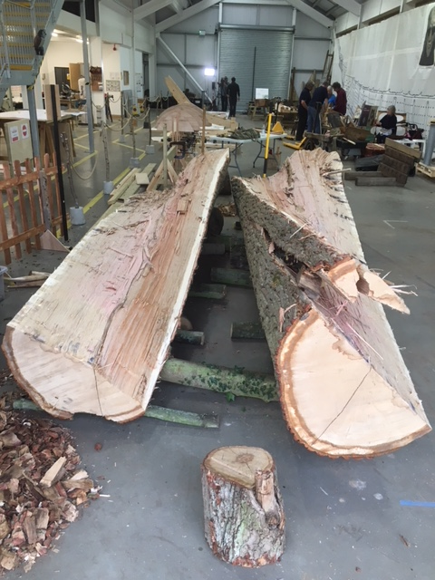
First log after splitting (Photo: SHSC) First tree, before felling. With hindsight it is possible to see the spiralling of the bark, leading to the twist when split.
(Photo: SHSC)

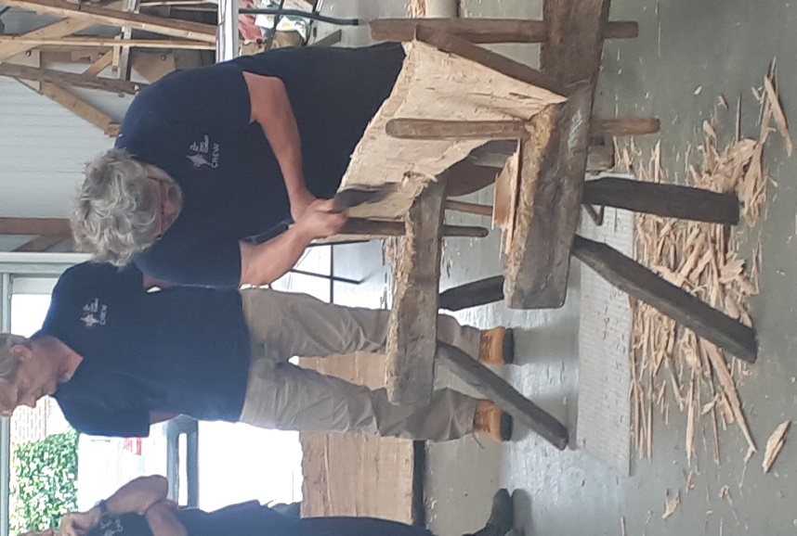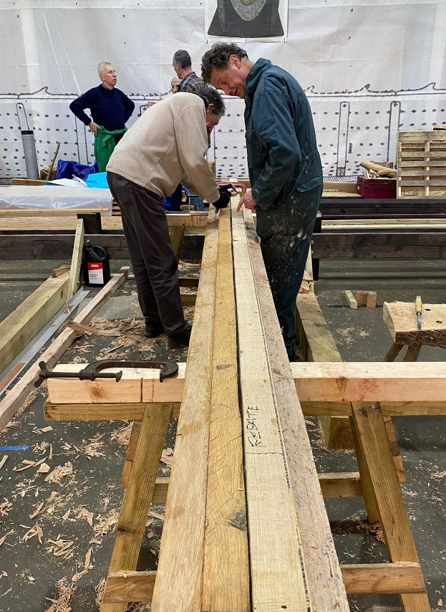
Dr. Damian Goodburn instructing volunteers in Volunteers converting first log into sections for the
the use of axes to cleave and finish boards keel of the midships section model.
(Photo: SHSC) (Photo: Author)

In not splitting ‘true’, the damaged log forced us, as agents, to look at other ways to successfully utilise the timber and for a short while caused no little concern to the shipwrights. That the decision to utilise modern tools and techniques to rectify the situation was indicative both of our lack of skill and understanding at this stage of the project and how the agency of an inanimate object can force agents to react to unforeseen circumstances.

Conclusion

Unfortunately, the advent of Coved 19 has brought the project to a temporary halt. However, it is already clear to see ‘Agency’, as proposed by Gell, at work within the project to reconstruct the Sutton Hoo Ship. It has been clear to see this, not only in the work of the participants in the project, but also in members of the public who visit the workshop. Along the back wall is hung a full size banner representing the profile of the ship which causes a mix of incredulity, disbelief and admiration, both at the task which has been taken on, but possibly more so at the skills of Saxon craftsmen and the political power and will available 1400 years ago to undertake such a project, not as a one-off experiment, but as a necessary part of daily life and culture. As it is looked to re-start the project, this writer can clearly see many issues, such as planking the ship and attaching the planking to the stem- and stern-posts, and the interior layout of the ship – not to mention the launching and rowing of such a vessel – which will present many problems and opportunities where issues of Art and Agency can be further, and more clearly investigated.

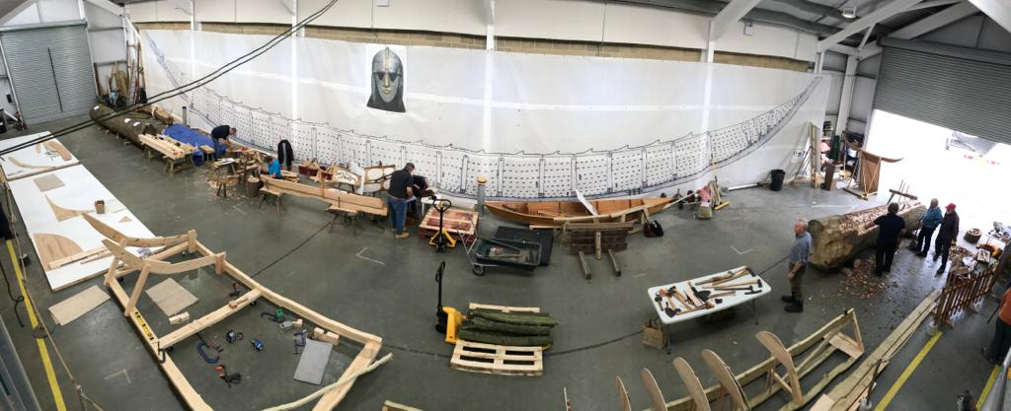
A panoramic view of ‘the Longshed’ showing the full-size banner hung on the back wall and the state of progress in October 2019 (Photo: J. Barnard)

Bibliography

Bruce-Mitford, R. (1975). “The Sutton Hoo Ship Burial, Volume 1”. London: The Trustees of the British Museum.
Carver, M. (2015). “The Sutton Hoo (mound 1) Ship. A scope of works for its experimental design, reconstruction and trials”. (unpublished paper for Woodbridge Riverside Trust).
Cerborne, D. (1999). Composition and Constitution: Heidegger’s Hammer in “Philosophical Topics” Vol.127, No.2 pp.309-329. Available at: https://www.jstor.org/stable/43154325. Last accessed 07.05.2020.
Coates, J, et al. (1995). Experimental Boat and Ship Archaeology: Principles and Methods in “International Journal of Nautical Archaeology” vol.24 issue 4, pp. 293-301. Available at: https://www.doi.org/10.1011/j1095-9270.1995.tb00742.x. Last accessed 10.05.2020.
Crossley, A. (1942). Survey of the 6th Century Saxon Burial Ship in “Transactions of the Newcomen Society” vol.23, issue 1, pp.109-116. Available at: https://www.doi.org/10.1179/tns.1942.010. Last accessed 10.05.2020.
Derlon, B. and Jeudy-Ballini, M. (2010). The Theory of Enchantment and The Enchantment of Theory: The Art of Alfred Gell (trans. Reay-Jones) in “Oceania”, vol.80, no.2, pp. 129-142. Available at: https://www.jstor.org/stable/25699954. Last accessed 07.05.2020.
Dhoop, T. and Olaberria, J-P. (2015). Practical Knowledge in the Viking Age: the use of Mental Templates in Clinker Shipbuilding in “International Journal of Nautical Archaeology” vol.44, issue 1, pp. 95-110. Available at: https://www.doi.org/10.1111/1095-9270.12081. Last accessed 15.07.2019.
Emirbayer, M. and Mische, A. (1998). What is Agency? In “American Journal of Sociology”, vol.103 no.4, pp. 962-1023. Available at: https://www.jstor.org/stable/10.1086/231294. Last accessed 07.05.2020.
Gell, A. (1992). The Technology of Enchantment and the Enchantment of Technology, in Coote, J. and Shelton, A. (eds.) “Anthropology, Art and Aesthetic”. Oxford: Clarendon Press.
Gell, A. (1998). “Art and Agency: An Anthropological Theory”. Oxford: Clarendon Press.
Gell, A. (1999). “The Art of Anthropology; Essays and Diagrams” (ed. Hirsch, E.). Oxford: Berg Publishers.
Goodburn, D. (1986). Do we have Evidence of a Continuing Saxon Boatbuilding Tradition? In International Journal of Nautical Archaeology, vol. 15, issue 1, pp.39-47. Available at: https://www.doi.org/10.1011/j.1095-9270.1986.tb00541.x. Last accessed 11.05.2020.
Green, C. (1988). “Sutton Hoo: The Excavation of a Royal Ship Burial. London: The Merlin Press Ltd.
Gunn, J. (2009). Agency in Littlejohn, S. and Foss, K., (eds.) “Encyclopaedia of Communication Theory”. Thousand Oaks, Cal.: SAGE Publications, Inc.
Hirsch, E., Kuchler, S., Pinney, C. and Dunlop, I. (1997). Obituary – Alfred Gell in “Anthropology Today” vol.13, no.2, pp.21-23. Available at: https://www.jstor.org/stable/2783042. Last accessed 26.04.2020.
Hobsbawm, E. (1962). “Age of Revolution”. London: Weinfeld and Nicholson.
Kant, I. (1784) “Practical Philosophy” (trans. Macgregor, M. (1996)). Cambridge: Cambridge University Press.
Macfarlane, A. (2003). Alfred Gell(1945-1997) in “Proceedings of the British Academy” vol.120, pp.123-147. Available at: https://www.therai.org.uk/archives-and-manuscripts/obituaries/alfred-gell. Last accessed 09.05.2020.
Phillips, C. (1940) The Sutton Hoo Ship Burial: 1. The Excavation in “Antiquity” vol.14, issue 53, pp.6-27. Available at: https://www.doi.org/10.1017/S0000359800014745. Last Accessed 10.05.2020.
Pitt, G. (2019). The enigmatic Sutton Hoo Ship-Burial: Fresh Insights from Assemblage Theory in “Parergon” vol.36, no.1 pp.1-29. Available at: https://www.doi.org/10.1353/pgn.2019.0000. Last accessed 09.05.2020.
Steffy, J.R. (1998). “Wooden Shipbuilding and the Interpretation of Shipwrecks”. London: Chatham Publishing.
Tanner, P., Whitewright, J. and Startin, J. (2020). The Digital Reconstruction of the Sutton Hoo Ship in “International Journal of Nautical Archaeology” vol.49, issue1, pp.5-28. Available at: https://www.doi.org/10.1111/1095-9270.12394. Last accessed 10.05.2020.
Williamson, R. (1999). “Regia Anglorum – Anglo-Saxon and Viking Crafts -Woodworking”. Available at: https://www.regia.org/research/life/woodwork. Last accessed 11.05.2020.

