 APPENDIX GA36d
LEVEL 7 ASSESSMENT SPECIFICATION
Student name: | Rebecca Turner | Student ID number: | 1700132
Programme: | Secondary PGCE
Module: | Curriculum Development and Enhancement
Module code: | ECSP7002 | Contribution to Overall Module Assessment (%): | 100%
Lecturer: | Helen Denny | Internal Verifier:
Assignment Title: | Research Study including Ethics Form | Word count (or equivalent): | 10.000 words in total including an Ethics form (to be given in on January 11th 2019)
Submission deadline: | May 13th 2019 | Return date of provisional marks & written feedback: | June 10th 2019
Submission method: | All written assessments, where practical and possible, must be submitted via Turnitin unless otherwise instructed by the Lecturer. (Please DO NOT put this assessment specification into Turnitin or it will match many similarities with other students’ submissions.)  Alternative submission method (if applicable):  Late submission of the assessment will result in a late penalty mark.  Penalties for late submission: Up to one week late, maximum mark of 50%. Over one week late, 0%. Only the Extenuating Circumstances Panel may approve a change to submission dates.
Academic honesty / referencing: | Academic honesty is required. In the main body of your submission you must give credit to authors on whose research and ideas your work is based. Append to your submission a reference list that indicates the books, articles, etc. that you have used, cited or quoted in order to complete this assessment.
Introduction

This assignment aims to respond to the following question, ‘Does the element of competition effect male pupils’ academic development’. In order to do so, I will conduct, analyse and evaluate a small-scale action research (AR) project into the use of competition strategically within ‘Assessment for Learning’ (AFL). Additionally, I will draw upon academic and professional literature to inform my practice and reflection. The AR will be conducted at the school where I am carrying out my first Geography student teacher placement (PTE1), which will be referred to as School X to keep anonymity. School X is a community comprehensive school, located in the local authority of Caerphilly. It is an all-boys school, with a mixed gender sixth form. According to My Local School (2019), in 2018 there were 785 pupils on roll. With above average rates of 22% of pupils eligible for Free School Meals and 25% have Special Educational Needs (Estyn, 2018). Likewise, 43.8 % of KS4 achieved the level 2 threshold including English/Welsh and Maths. Corresponding this indicator with the school currently sitting within Estyn’s amber support category suggests areas for improvement. For the AR, I have selected a year 8 mixed ability class, containing 26 pupils, on the basis that they are ahead in the scheme of work. This allows me more time to conduct the pre-diagnostic and post-diagnostic tests, along with competitive interventions. My decision to focus on competition arose from seeing first-hand how my pupils engaged well within competitive activities where they could compete against one another. Particularly in sporting activities.

Literature Review
Assessment for Learning
Over the most recent decades, the term ‘Assessment for Learning’ (AFL) has become a popular and well-recognised term within education (Sambell et al, 2013). To develop a deeper understanding of AFL within the classroom, AR will employ formative and diagnostic assessments (Tummons, 2007). AFL is a crucial and central aspect of good teaching practice and learning. There has been countless research and literature expressing its importance and the need for AFL within the classroom (Black et al, 2004). AFL has been defined like a complex process of interpreting evidence whereby teachers decide where the pupil is with their learning, where they need to go and how they are going to get there through personalised targets and goals (ARG, 2002). It can help drive teaching in a more positive direction that is fully effective. William (2011) argues the importance of AFL in highlighting the gap between pupils’ current and desired performance. To which teachers can self-evaluate and reflect upon the effectiveness of their teaching and prompting the teacher to conduct necessary self-improvement to better their practice (Pollard, 2014). Norton (2009) refers to teachers as being active learners who continuously learn and evolve as they progress through their career. A view that corresponds with the view of Darling-Hammond and Snyder (2000) who refers to excellent teachers as those who constantly study and refine their teaching. AFL can be deemed as enhancing the process of future planning to maximise students learning within the classroom (Earl, 2012).

Wallace (2009:19) states ‘’At the heart of AFL is the belief that everyone can make progress’’, an interesting statement that accentuates that AFL is not only beneficial to a teacher but pupils also. By teachers implementing assessment regularly within their scheme of work, they are essentially providing the learners with feedback regarding their current level of progress (Chan et al, 2014). A factor that is supported by Barbara (2010) with regards to providing pupils with the opportunity to take ownership of their learning and evaluate themselves. AFL is responsible for offering pupils feedback on their performance which they develop plans to advance their learning towards their aspired goals (Heritage, 2018). It motivates learners to engage with their learning to ensure they develop their knowledge to succeed and reach satisfying grades. Relating back to Wallace’s statement whereby everyone can progress; ALF notifies pupils that it is ok for mistakes to happen, as long as they learn from it. AFL differs from ‘Assessment of Learning’ (AOL) which centres on what the students have learned, instead AFL focuses on the continuous cycle of self-evaluation and self-improvement, amongst teachers and pupils (Boud and Falchikov, 2008). However, it must be noted that both AOF and AFL are both strategies that enable learning but from my study, AFL has proven more successful by furthering pupils learning. As far as cultivating pupils to develop vital skills like critical thinking, self-awareness, and reflection (McLoughlin and Luca, 2002).

Difference in attainment

Although AFL stimulates good teaching and learning practice, pupil’s academic attainment can be impacted by a number of factors. For example, Theodosiou-Zipiti and West (2012) remark ethnicity as being an influential factor, whilst Reardon (2011) identifies another factor, family income. Reardon factor correlates with FSM, a factor that Ward (2013) and many others recognise as having a bearing on attainment. In oppositions to these factors, a common factor, well-acknowledged by teachers, researchers, and literature, is gender. There has been and still is a gap between girls’ attainment and boys’ attainment. A concept referred to as the ‘gender gap’ where girls’ attainment is notably greater than boys’ attainment. Wilkins (2011) provides a negative representation of the attainment difference by labelling the boys as ‘‘failing boys’’. According to Gillborn and Mirza (2000) in 2000, the Department of Education released data, establishing the gender gap as increasing. A view that was proven right by Harding and Harris’ (2016), 2016 publication in the Daily Mail, where they denote the gender gap in GCSE attainment being the largest yet to date. Again, Harding and Harris’ believe it is going to continue to increase further. Despite, the fact researchers like Knowles et al (2002) support the gender gap to a certain extent, on the basis educated girls generate more economic gains than boys. Whereas Nopo (2012) admits that girls are also underachieving in some subjects. Though it is rare for a pupil to thrive every subject, boys are still underachieving. A reason for the gender gap is maturity, it has been affirmed that girls mature a lot earlier than boys, commonly towards the beginning of adolescence (Buchmann et al, 2008). Downey and Vogt Yuan (2005) claim girls’ attainment is superior because girls care more about their education, so they pay attention in class, put more effort into their work and behave well within lessons. Vecchione et al (2014) agree with Downey and Vogt Yuan argument, by claiming girls exhibit stronger motivation with their education and the realisation of its importance in reaching a better quality of life as an adult. Referring back to Wilkin’s label, it can be argued that pupils may succeed in some subjects and aspects but are likely to fail in others, for no one is perfect or a failure.

Undoubtedly girls perform better in education than boys, but why. Buchmann et al claim the difference in gender attainment where girls surpass boys, begins in early childhood and maintains throughout education. A view which links to Owens (2016) interpretation of boys’ attainment being due to them experiencing far more early behaviour problems than girls. Such events and experiences can trigger later behaviour problems within adolescent years and could be a possible reason for some boys’ underachievement in education. Owens also argues that boys have difficulties in self-regulation and paying attention, which implies they need a look of external support from teachers and have shorter attention spans than girls. Likewise, Cotton et al (2015) correspond with Downey and Yogt Yuan and Vecchione et al, by suggesting boys are less passionate, less motivated and careless with their education. By stating they tend to do the minimum and leave everything to the last minute. In contrast, Wilkins believes the dynamics of schools, attributes of teaching practice and pedagogical training, favours a feminised character, which creates a gender order. To which boys to struggle in adapting and flourishing academically. However, Roemer (2006) recognises education as providing and endorsing equal opportunities for boys and girls. Consequently, dismissing Wilkins’ view of a feminine educational system and operations. Nevertheless, the need to increase attainment levels, especially boy’s, is verified in research, literature and governmental documents (Ward). However, due to School X being an all-boys school, the attainment gap between boys and girls was absent. Nonetheless, it is a well-documented concept and efforts should be made to push boys to achieve higher. Therefore, I believe teachers should be innovative in their teaching to try and encourage this.

The Element of Competition

As mentioned, this assignment will focus on an AR into the implementation of competition within lessons, particularly for AFL. Firstly, it is important to understand the meaning of competition. It is defined by Collin’s Dictionary (2019) as an activity where pupils or groups of pupils, compete against one another, in order to win the competition. Thus, defeating their rivals. Competition is often observed as a strategy that can only be used in PE lessons, where pupils are encouraged to participate in sporting activities. However, Guthrie et al (2000) recognises it as a motivational-strategy that can be applied in any subject and classroom setting. In addition, they define it as an approach which involves pupils trying to be superior to their classmate. Dijkgraaf et al (2012) declare competition as enriching the quality of secondary education, regarding teaching and learning practice.

Children become familiar with competition from a young age. For instance, in primary schools, children are encouraged to participate in events/activities like sports day, by their teachers. An event which parents and guardians often attend and further encourage their child’s participation. Parents, guardians and, teachers support the use of competition because they consider it as ‘harmless fun’ which is healthy for children’s’ development. Nonetheless, each person exhibits competitiveness, for it is a trait of the human mind (Brown et al, 1998). The Psychology Today (2019) website poses the concept of ‘competitiveness’ being a biological trait which people develop with the basic need of human survival. However, whether the use of competition in lessons, will be beneficial or detrimental to learners is questionable, and more importantly its effect on pupils’ academic development.

As specified by Yu et al (2000) competition was used in traditional classrooms, which suggests it to be an old strategy and possibly, a trustworthy because it has continued to be used over the years. It may be assumed that competition is a strategy used to push pupils to achieve higher, to overlap with the frequent changes in teaching practice and school policies (Noe et al, 2017). Moreover, Chen and Chen (2014) recognises competition as being a significant factor for pupils learning. This suggests it to be a beneficial tool to employ in lessons, possible for character building. Thus, most subject teachers have and continue to implement competition within their lessons to increase pupil’s engagement. Whether through the use of rewards, leader boards or plain fun. According to Reupert and Woodcock (2010) rewards help to incentivise pupils and promotes good behaviour because pupils know they will receive a treat in return for their efforts. Davis et al (2006) comment the use of rewards being more effective with boys than girls. Datta Gupta et al (2011) claims girls tend to shy away from competitiveness, whilst boys respond well and engage with the activity or opportunities. Similarly, leader boards require pupils competing with one another, each wanting to be the winner. This is recognised as something that also boosts pupils to spend more time on tasks, focus more and put more effort in (Cropper, 1998; Landers and Landers, 2014). As well as competing to receive rewards or because they want to be seen to be better than their peers, pupils also appreciates competing against one another as being ‘plain fun’ and enjoyable (MacPhail et al, 2008). Thus, Cropper appreciate the use of rewards to accumulate a pupil’s intrinsic motivation to deepen their learning.

It is unquestionable that teachers use competition as a way to foster pupils’ involvement and excitement into an activity or lesson (Yu et al). A motivational-enriched strategy that can be used in everyday practice, in play, work, and education (Butler and Kedar, 1990). Although competition is implemented in teaching and learning, the effects it can have on pupil’s wellbeing, development and performance are unclear (Chen and Chen). A lot of literature conveys competition as negative in regard to increased anxiety, stress and depression among pupils (King et al, 2011; Yu et al; Burleigh and Meegan, 2017). With competition, there will always be winners and losers, as recognised by King et al and Yu et al. In addition, it put pupils under pressure to perform well and those who do not can become anxious at their seemingly poor performance. In addition, this could cause them to feel bad about themselves, often referring to themselves as ‘dull’ or a ‘loser’. These reasons correspond with Palmer (2005) argument that competition should be avoided in teaching and learning. Yu et al, advocates for pupils to have the option to be anonymous in competitive activity, to ensure pupils well-being. A view supported by Chen and Chen.

Contrary to this belief, Wilkins identifies the effects of competition to be positive. He claims it increases the pupil’s self-belief and makes them feel good about themselves, through being recognised by teachers. However, King et al, 2011, Yu et al, Burleigh and Meegan, 2017, Cropper, 1998 would disagree with this, as they would say that this positive effect is something that only happens to the higher ability pupils who perform well. Again, pupils who do not perform as well become demotivated and anxious at their low performance. Still, Wilkins considers competition as a chance for pupils to showcase their ability and passion for the subject. This links to Cropper (1998) who accepts competition urges pupils to perform at the best of their abilities. Due to the conflicting beliefs, when using competitions, teachers must think carefully about its effectiveness and its consequences (Chen and Chen; Yu et al).

I believe pupils should be recognised by their teachers in every lesson, the teacher should ensure they establish a good relationship with their pupils. Moreover, the type of competition teachers should use is also disputed in the literature. Yu et al and Burleigh and Meegan explore face-to-face competition and conclude it to be damaging to a child’s well-being. Burleigh and Meegan stress competition creates tension amongst pupils. It could be extremely stressful for learners to compete against pupils who tend to achieve better grades. For the learners may feel that it’s impossible for them to win and avoid participating with the school activity or work (King et al). Whilst Cheng et al (2009) accepts less able students may struggle and fail and the loss of interest. Though competition engages pupils, pupils refer to it as a ranking of ability (Cheng et al). Thus, causing pupils to make minimal effort to do well (Lam et al, 2004). However, teachers must be careful when implementing competitive activities in lessons. They must closely monitor the pupils and be ready to intervene if any negative effects occur, such as tension, disputes or frustration, etc. Yu et al propose teachers provide pupils with the opportunity to participate but be anonymous. Their paper understands that pupils prefer anonymity; it protects their well-being, is less harmful to friendships, less stressful and more enjoyable. Due to this preference, I believe teachers should definitely employ anonymity in any competitive situation.

Olitsky (2011) says competition worsens social inequalities. A notion which relates to Levy et al who sees pupil’s performance as being affected by class hierarchy and social status, factors that are commonly related to wealth and popularity. Those pupils who want to be at the top of the hierarchy will be disinclined to help peers. Whilst those who do not care about the hierarchy or see themselves as being towards the bottom will care to help peers. Lam and Seaton (2016) agree with Levy et al, pupils’ attitudes and behaviour is influenced by social status. Contrary to this belief, Wilkins identifies the effects of competition to be positive. He claims it increases the pupil’s self-belief and makes them feel good about themselves, through being recognised by teachers. I believe pupils should be recognised by their teachers in every lesson, the teacher should ensure they establish a good relationship with their pupils. Moreover, Latsch (2017) opposes the view of competition increase stress, as he acknowledges competition as facilitating pupils to overcome stressful situations. A view that corresponds with Olitsky who encourages the use of ‘friendly competition’.

Consequently, the type of competition that teachers should use in their teaching practice, is also disputed in the literature. For Yu et al and Burleigh and Meegan explore face-to-face competition and conclude it to be damaging to a child’s well-being. A view which is opposed by Wilkins, who judges it to be a positive and worthwhile tool, by enabling pupils to present their cleverness. A chance to gain recognition and feel good. On the other hand, Cropper backs Yu et al and Burleigh and Meegan belief that face to face competition causes negative effects on the pupils who do not perform well. However, he states that effects caused are short-lived. Thus, competition does not leave any lasting effects on pupil’s wellbeing or behaviour. A different type of competition that can be used in teaching and learning, is a group/team. An approach which Cropper favours more and values it more beneficial for pupils, for it generates negligible negative effects. Similarly, Olitsky judges group competition as being more pupil-friendly, a way to eliminate inequalities. She further identifies competition preventing isolation, hierarchization, and individualism, as pupils communicate and work as a team. Thus, promoting teamwork. Lam and Seaton disagree with Olitsky.

Furthermore, Cropper concedes competition as an appropriate teaching tool, which encourages individual competition. As well as promoting self-improvement (Watson, 2007). A concept that pushes pupils to aim higher and yet an important factor of AFL (Owens; McLoughlin and Luca). However, the element of competition delivers benefits and drawbacks. The majority of literature acknowledges it as motivating and encouraging pupil’s participation in their lessons, heightening their focus on acquiring the lesson content to succeed. Lubienski (2003) argues competition provides openings for educational innovation, which in return, betters pupils achievement. Nevertheless, the negative publicity surrounding the effects of competition, cannot go unnoticed. Teachers have a duty of care to ensure pupils well-being is not harmed but maintained. It is highly likely that teachers are going to continue to use competition within their lessons. However, I believe teachers need to monitor the pupils closely when they are participating and keep a close eye on those pupils who didn’t perform well. This way the teacher can intervene and support the pupil to combat the negative effects caused by the activity if any arose. In addition, group competition is the best approach to use, it reduces the negative effects as pupils see their failure as a group effort, instead of it being solely their fault. The literature surrounding competition’s effect on pupils’ academic development is vague, but the conclusions drawn from this AR project will provide better insight.

School Policy and Practice

Competition can be observed by schools as they try to achieve the best GCSE/A Level results in the local region, to be seen as the best school (Braun et al, 2010; Lubienski). In order for schools to make the necessary improvements and changes to succeed, improvement plans, or policies are devised. Unfortunately, School X’s school policy was unavailable, but I was able to access its improvement plan (SIP) and the Geography department improvement plan 2018-2019 (DIP). While competition is not specified in either of the plans, there are areas where it can be used or incorporated to meet the priorities. The departmental priority of ‘securing the pupils’ progress’ concentrates on improving grades by monitoring the pupil’s answers for 6-8-mark questions. Although competition doesn’t usually involve extensive writing, it can enhance self-regulatory and self-improvement where pupils are encouraged to improve their literacy (Watson; Owens; Mcloughlin and Luca; Lubienski). As the AR project will provide the opportunity for pupils to review their results from the competitive pre-diagnostic test. A concept that could be referred to as DIRT time where pupils are also provided with feedback as to how to improve. DIRT time is itemised in the SIP and also comes under another departmental priority, improve the quality of teaching and learning. When allowing pupils time to reflect on their performance, the teacher could use the suggested strategies from the SIP, Pause-Pose-Pounce-Bounce, Question Matrix/ higher-order questioning (Blooms Taxonomy), which encouraging pupils to see where they went wrong and use a higher level of thinking (Blooms, 1956). As mentioned, applying competition in lessons can drive pupils to achieve higher (Noe et al), and encourages teachers to tweak their teaching practice to make it more effective (Pollard). Factors that link to the previous point made on schools aiming for better exams results. Furthermore, the SIP mentions delivering high-quality teaching, especially for FSM pupils.

A different departmental priority is improving pupils’ skills, which involves working other staff members to ensure pupils are challenged in line with the LNF. Moreover, to focus on improving the literacy of ‘pink pupils’ by using structure strips. This priority parallels the SIP priorities regarding improving pupil’s literacy, reading, and writing. It refers to improving pupils oracy, which will be promoted through one of the competitive interventions, the hot seat challenge where pupils need to orally respond to as many questions as possible before the time runs out. A strategy Coultas (2006) states work well with encouraging pupils to use subject-specific vocabulary. Similarly, SIP highlights the need for teachers to urge pupils to develop and use subject-specific vocabulary confidently. This works well with competition because pupils will constantly be using and expanding their subject-specific vocabulary when playing competitive activities. This ties in the SIP strategy, ‘Vocabulary Builder’ where key terms are taught and repeated in lessons to ensure pupils understanding. Alternatively referred to as the ‘drill and practice scheme by Yu et al. Karpicke and Roediger (2008) acknowledges repetition as enhances pupil’s retention. Ensuring pupils have a sound knowledge of the lesson content will help them provide detailed and elaborated answers. This reflects the SIP’s priority of improving pupils writing. The other school priorities are improving pupils reading, with regards to the effective use of inference and deduction and improving literacy. All concepts that can be promoted through competition, for it will encourage pupils to focus more on lesson content (Cropper; Landers and Landers). The competitive activities planned will challenge pupils understanding of graphs, statistics, key terms, and key information. Through incorporating statistics and graphs, the competitive activities further meet the school priority of improving pupil’s numeracy skills.

Methodology and Ethics

Before the AR project was conducted, it is vital for me to the pupils to consent to their participation. A process where each pupil is informed about the AR project, its aim, the purpose and what will happen to their results and data. Thus, each pupil will consent to their participation but be made aware that they can decline to participate and withdraw from the project at any given time (BERA, 2011). Consent can be provided either, spoken or written. Failure to get pupils consent could cause distress on the pupil (Etherington, 2007). Essentially, it is unethical for any research or teacher to use the data of pupils/participants if they have not consented, and the data should not be used (Scherer et al, 2016). As Burgess (2005) admits, at the centre of any ethical research is voluntary informed consent from the pupils or participate, for it is of utmost importance.

Over recent years, the urge for teachers to conduct and engage in AR projects have grown significantly (Pollard). Most commonly encouraged by the government through the changes and implementation of the national curriculum. AR is a way for teachers to establish the best possible way to modify their teaching to resemble the curriculum. As previously stated by Norton, teachers are active learners who advance with their teaching practice over the years, as they gain more experience. AR is recognised in countless literature as a valuable process which helps to enhance the standard of teaching and learning delivered in school lessons (Dillon and Maguire, 2011; Hopkins, 2014). Arthur (2012) claims teachers who perform AR projects, help to bridge the gap between pedagogical theory and teaching practice. Whilst Santamaria (2009) accepts the existence of a gap, Korthagen (2018) acknowledges it to be significantly large. More importantly, the gap between literature and practice is mentioned within the SIP, which aims at reclosing the gap. Moreover, the gap suggests not enough teachers are performing research in their lessons, and this needs to change. AR enables teachers to take further control and responsibility for their teaching and the learning of their pupils. It further coincides with McAteer (2013) notion that there is a need for more evidence regarding teaching practice in the classroom setting. Where decisions are made on factual evidence, rather than assumption (Pollard). Thus, AR comprises of an organised method into how well pupils learn in their lessons and the efficacy of the teaching practice (Mills, 2003).

Teachers are not solely practitioners but researchers who can bring about improvements (Chow et al, 2015; Hopkins). Accordingly, pupils become co-researchers, ’Radical agents of change’ that can provide indispensable insight into teaching and learning (Bland and Atweh, 2007; Fielding, 2001; Bovill et al, 2011; Mills). Consistent with Leitch et al (2007) who observes this factor to empower students, whilst generating a lot of benefits which outweigh any problems. If there are any. I disagree with Wang et al (2010) who believes educational research or AR in the classroom does not have any practical worth. I appreciate the benefits of AR and how it encourages teachers to be innovative and reflective with their teaching practice (Macintyre, 2012). As teachers perform the strategic action of planning, acting, observing and reflective, in the desire to increase standards (Arthur; Hopkins; Pollard; Fitzgerald et al, 2013).

This assignment centres around an AR project into competitive AFL. Hughes (2014) concedes competitive AFL as influential on pupils achieving higher attainment. The findings of this AR will conclude whether Hughes’ view is true, or should it be discredited. Let’s not forget the aim of this assignment is to answer the predominant question ‘Does the element of competition effect male pupils’ academic development’, and to do so I will need to generate a volume of data that will provide a clear indication as to whether competition enhances pupil’s attainment or not. Thus, I have selected to apply a quantitative approach to my research and methodology. McMillan and Schumacher (2014) support the use of quantitative research because it Is based on statistics, creating objective data that can show academic progression. It produced reliable evidence that can show patterns and anomalies. Quantitative parades a well-structured approach to research methodology, whilst qualitative uses a more semi or unstructured approach (Kumar, 2019).

Moen (2006) remarks qualitative research exhibits a shift from statistical data to the concept of voice, which suggests this approach centres around the social reality of people. A view corresponded by Golafshani (2003) who documents qualitative research being non-statistical which focuses on the opinions, meanings, motivations, and reasons for people’s actions. Moreover, Denscombe (2014) agrees with the use of qualitative research as it explores beyond the data, to the social reality which could result in the contradiction of the data. This implies that the data may not always show the social truth. However, it cannot be ignored that data needs to be analysed in order to see the pupil’s performance and a qualitative approach is limited because it fails to produce expanse of data. Therefore, any findings and conclusions draw could be deemed invalid and unreliable (Morse, 1999). Qualitative possesses a narrative style which needs a strong involvement from the researcher (Thomson and Holland, 2003). Some may observe qualitative research as being biased by the means of the findings and conclusions are formed from the researcher’s interpretations. These reasons further strengthen my decision to use a quantitative approach.

Quantitative research is effective in establishing the necessary data to answer any research question (Lodico et al, 2013). In addition, it can provide informed feedback regarding performance. A notion sustained by Rahman (2016) who appreciates a quantitative approach to research a powerful tool for displaying teacher and pupil performances. However, he accepts it neglects to take into account the classroom environment, resources or pupils’ attitudes to learning. A factor that links back to the importance of engaging and motivating pupils with their learning. Nonetheless, Somekh and Lewin (2011) advocate the use of a quantitative approach to research as it encourages reflective and rich practice. Conversely, a lot of literature inspire the use of a mixed-method approach where both quantitative and qualitative approaches are used (Arthur; Kumar; McMillan and Schumacher; Fraenkel et al, 2011). Therefore, I have decided to use questionnaires and activities that consist of a lot of questioning as to my methods. My pre and post-diagnostic tests will questionnaires that comprise of a multiple-choice basis. Whilst my competitive interventions will be the hot seat challenge and splat, all activities that I believe to be engaging and useful.

Evaluation

The pre-diagnostic assessing took place as a starter activity in the first lesson of the sequence. As mentioned I decided upon using a questionnaire to gather the required data. Whilst my pre and post diagnostic assessing comprises of questionnaires, I presented them to the pupils in a quiz manner. From my reading into literature, I came across digital game-based learning (DGBL). A method that will provide quantitative data, whilst enabling the teacher to observe pupils to develop qualitative data also, a mixed-method approach. Recent years have seen a push to promote digital competence in education, from the establishment of the ‘Digital Competence Framework’ and highlighted within the new ‘Successful Futures’ (Donaldson, 2015). Teachers are encouraged to promote the use of ICT in their lessons, for it is extremely important for students but also for teacher’s professional development (Fitzgerald et al, 2013; Tomte et al, 2015). Prensky (2003) remarks DGBL as an effective learning tool that can enhance lessons in various ways. The most important way, in enhancing pupil’s engagement and motivation (MacPhail, Guthrie et al; Dijkgraaf; Datta Gupta et al; Wilkins; Yu et al). Similarly, Erhel and Jamet (2013) argue DGBL creates deeper learning. Yet, Huizenga et al (2017) emphasises DGBL as parading the element competition but also claims when the competition is not included, pupils look for alternative ways to compete. Consequently, the literature around DGBL portrays it as positive, so I decided to incorporate it into my pre and post-diagnostic assessment.

When researching DGBL, I came across Quizizz. A tool Ifenthaler and Schweinbenz’s (2013) appreciate for being an effective and interactive way to gather the data. Mei et al (2018) also agree with the use of Quizizz in lessons. Accordingly, Quizizz demonstrated how easy it was to employ competition in the classroom (Guthrie et al; Butler and Kedar). I was able to collaborate my wish to promote digital competence through DGBL, whilst also ensuring it’s a quantitative approach. Quizizz enabled me to create an interactive quiz, where I was able to input my own questions to generate the required data to show the pupils current performance. The data will show the gap of where each pupil is at, to where I want them to be (Williams). Likewise, it will establish the foundations of my AR project, which I can use to inform my planning of the competitive interventions for the next lessons (Earl; ARG). When planning the pre-diagnostic assessment, I was restricted to delivering it within the classroom setting. Consequently, whilst the pupils would be participating through the device, it still meant the pupils would be competing face-to-face. A situation Yu et al; Burleigh and Meegan and Cropper all recognise to be the most damaging approach to the competition, regarding pupil’s well-being. However, before starting the quiz, I provided the pupils with the opportunity to be anonymous, granted they informed me of their alternative name. Thus, valuing Yu et al and Chen and Chen view of the importance of anonymity to prevent any negative effects from occurring to any pupil’s wellbeing. This proved to be an effective tactic as pupils weren’t aware of who was who.

Again, for ethical reasons, I reiterated the purpose of the AR project and what it entails, I also highlighted that pupils did not have to participate if they did not wish to (BERA). I asked pupils to put their hands up if they wanted to participate, which the majority did so. However, a few pupils were hesitant and want to know exactly what the AR involved, when I informed them that it was based around competition and them competing against one another, the reluctant once were quick to put their hands up. This insinuates that boys responded positively to the element of competition (Datta Gupta et al ). Thus, all 24 present pupils put their hands up to participate and seemed enthusiastic to do so. Therefore, competition can be valued as a motivational and stimulating strategy to use in teaching and learning (Guthrie et al). When informing them about competition, it did generate a lot of chit-chat amongst the pupils with many being boastful saying how they are ‘going to win’ and how their friend is ‘going down’. This can be processed as a representation of the pupil’s enthusiasm to compete (Butler and Kedar). Conversely, it could be perceived to correlate with a class hierarchy a social status, as the chit-chat was amongst the extrovert pupils (Levy et al; Lam and Seaton; Olitsky).

Despite the fact the pupils originally responded well to competition, as they progressed through the quiz, some pupils’ attitudes changed. As the pupils competed, their performance was shown through a live leader board on the class interactive board. A useful tool that presented immediate feedback to the pupils’ performance (Glanden and Ulrich 2005). Landers and Landers support the use of leader board on the account of increasing pupils focus. However, I would disagree with this statement. I realised the pupils were overexcited with the opportunity to compete, that they failed to acknowledge the significance of them completing the assessment. Appendix 3 shows the performance of the pupils. For ethical reasons, I have provided the pupils with a letter instead of their name. The range of performance was expected, due to it being a mixed ability class. The graph shows the highest percentage achieved was by pupils H, K and, V. All three are categorised as higher-ability. This finding would parallel Cheng et al’s view of competition consisting of the ranking of ability. In contrast, pupils P, S and W answered the least questions correctly. This provides an anomaly to Cheng’s view, whilst both P and S are considered lower ability, I recognise as pupil W being middle-ability. I believe this anomaly was a result of competition clouding the pupils’ focus.

Regarding competition having negative effects, even being anonymous, I witnessed some introvert pupils got stressed and frustrated when they made errors. Likewise, as they progressed through the competition, they gave the impression of losing interest. One pupil even stated ‘‘this is pointless, I’m not going to win’’. Unfortunately, competition always has winners and losers. This discovery supports King et al; Yu et al and Burleigh and Meegan view of a competition being a negative tool to employ in classes. Alternatively, I believe the element of competition positively affected other introvert pupils who performed well, as many seemed to respond well by smiling and often applauded when they did well. This matches Wilkins belief of competition boosting pupils’ self-confidence. Contrary to this, the element of competition didn’t seem to affect extrovert pupils. Nonetheless, at this stage of the AR project, I was unable to conclude as to whether competition meets Dijkgraaf notion of enriching teaching and learning.

From the pre-diagnostic test results, it showed the pupils failed to know the key aspects of development and due to this, it hindered their ability to succeed in many of the questions. Alternatively, at the end of the Quiz, pupils were given the opportunity to reflect upon their performance; providing them with feedback into their areas of weaknesses to which they should aspire to improve upon (Chan et al; Heritage). Consequently, promoting self-improvement and self-evaluation (Pollard, McLoughlin and Luca; Watson). I decided to encourage the pupils to engage with their learning and take responsibility, so I opted to implement the ‘hot seat’ challenge, for my first intervention. Each pupil of the class was provided time to come up with an answer, regarding what they’ve learned about the topic, Development. The topic to which the pre and post-diagnostic tests are based on. I randomly selected a pupil to sit on the ‘hot seat’, they were given a minute to answer as many of their peers’ questions as possible. A strategy that was effective by challenging the pupil’s knowledge, whilst being an opportunity for them to show what they know, their academic ability (Wilkins). Yet, some selectees were reluctant to be in the hot seat. It was up to the pupils to state whether the hot seat pupil was correct or wrong. This enabled the rest of the class to get involved, although they weren’t in the hot seat. The intervention proved effective in challenging the few pupils who had a go in the hot seat, but unfortunately, it had no impact on those who didn’t. Therefore, the effectiveness of this strategy, regarding enhancing pupils’ academic development is questionable. Moreover, whilst there was an element of competition as those in the hot seat had to get the most correct, it was the only minor. Similarly, after the first three challenges, those who weren’t in the hot seat lost interest (Cheng et al).

As the hot seat challenge, the second intervention, splat’ I decided upon, presented benefits and limitations. It differs from the hot seat; it involves two pupils competing against each other. I displayed a question on the board then revealed a new slide with four answer choices, the first to point to the correct answer and say splat, won. Acting upon Cheng et al’s view of competition comprising of ability ranking, I ensure the game was fair by selecting pupils of the same ability to compete. The questions asked mirrored and repeated the key aspects of development. The strategy demonstrated a higher element of competition than the hot seat challenge. Likewise, the pupils seemed to respond more positively to splat and they were enthusiastic to participate as many pupils put their hand up to compete or remarked ‘can I go next’. Majority of the pupils selected the correct answers, those who didn’t often neglected to read the question properly. For example, one question was what the correct term for the UK’s development is, select the full term. One pupil selected the abbreviation instead. I included trick answers like this to ensure pupils read the question properly, an important skill they will need when it comes to their GCSEs. Additionally, by the vast number of pupils answer correctly, it shows the pupils have academically developed, to know the answers. This intervention was more of a qualitative method than quantitative, it still showed academic progression (McMillan and Schumacher). Splat ascertained to be a motivational tool which promoted pupils’ involvement and excitement (Yu et al). It is a competitive strategy, but it involves only a small proportion of the pupils being able to compete. As a result, those who didn’t lost interest. This could lead to negative effects on pupils’ well-being because they could be sad that they lost or didn’t get picked (King et al; Yu et al; Burleigh and Meegan). In addition, when the first competition occurred, I noticed there were more pupils cheering for one pupil, an extrovert pupil. This corresponds with Levy et al’s concept of class hierarchy and social status, affecting pupils’ attitudes to the competition. Thus, to make it fair I split the class, so the pupils on the left side were competing with the right. I then purposely selected pupils from both sides to compete and told each side, thus the pupils were equally supported. Eradicating any social inequalities, that originally occurred (Olitsky).

The final stage of the AR project was the post-diagnostic test. Once more, I opted to conduct this activity as a starter, whereas the interventions were plenary. This allowed the pupils as much time as they needed to complete the quiz, minimising the pressure placed upon them to finish. When informed of the activity, the pupils were enthusiastic to participate and again there was the boastful chit-chat amongst pupils (Guthrie et al; Butler and Kedar; MacPhail). To understand what they were particularly enthusiastic about, I asked the pupils why. I received a variety of responses, the common once is because it’s fun and they have the chance to beat the whole class, whilst others said it was due to them have the opportunity to better their scores. Majority of the pupils selected alternative names, those who didn’t were extrovert pupils who were not phased to display their performance. Before the quiz started, I emphasised to the pupils that I wasn’t concerned about winning but seeing whether pupils have advanced from the pre-diagnostic test. In the hope, it would encourage the pupils to not feel stressed or anxious (King et al). Unexpectedly none of the pupils were reluctant to participate or displayed any negative signs to show they weren’t comfortable participating. Pupils positively seemed to remain throughout the quiz, even among those who were trailing. In an attempt to prevent any negative effects on pupil’s well-being, I opted to not display the leader board until after each pupil had finished. This was effective in getting the pupils to focus more on the questions and quiz, rather than what position they were in (Cropper; Landers and Landers). Although I could observe how well the pupils were performing and their behaviour, particularly when they answered correctly.

Revealing the leader board flaunted the pupils’ competitiveness. They boasted to one another about their performance, particularly the extrovert pupils. Those who did not perform as well continued to show a positive attitude. Once again, I reminded the pupils that it wasn’t about winning but improving. This promoted the pupils to focus on their performance, instead of the winning or losing that comes with the element of competition. It prompted the pupils to feel good about their improvement and boosted their self-belief (Wilkins) Appendix 4 displays pupils’ performance in both the pre and post diagnostic tests. It shows that each pupil progressed by answering more questions correctly. With a quarter of the pupils achieved 100%, among these pupils were pupils H, K and V. All would be recognised as high ability, bar pupil C who would be categorised as middle ability. This anomaly demonstrates that the element of competition does not always correlate with the ranking of ability (Cheng et al). On the other hand, pupil P was amongst the lowest performance but still showed significant improvement, especially considering he is a SEN pupil. Moreover, pupils S and W improved notably. Pupil G presented the lowest performance, however like P, he is a SEN pupil who unfortunately was absent during the lessons between the pre and post diagnostic tests. Nevertheless, he still showed an impressive improvement considering the circumstances. However, whilst the pupils have displayed academic growth, the question of whether competition was responsible still stands.

Conclusion

‘Does the element of competition effect male pupils’ academic development’ was the focus of the AR project and this assignment. The quantitative data shown in appendix 4 shows pupils performances differed from the pre-diagnostic to the post-diagnostic test. In a positive manner as each pupil academically advanced, increasing the number of questions they answered correctly. Consequently, their improvement dismisses Wilkins concept of ‘failing boys’. Notably, pupils have progressed at different stages, a factor which is expected from a mixed ability class. By pupils’ advancement, the element of competition can be identified as the driving force behind their development. Thus, supporting Dijkagraaf’s view of the competition enhancing teaching and learning.

As highlighted by Golafshani, the qualitative data is non-statistical and is based on my observation and interpretation of pupils’ attitudes and behaviour to the tests and intervention. For this reason, some might agree with Morse and deem the data as unreliable. Contrary, I believe it is necessary to support or dismiss some of the views mentioned in the literature review. The pre-diagnostic test presented a divide among the pupils regarding their attitudes to the competition. The majority were enthusiastic and excited to compete against their peers. Whilst there were a few who were reluctant to participate. From these pupils’ comments like ‘I’m not going to win’ or ‘he’s smarter than me’ it shows that their hesitation was due to their perception of competition involving the ranking of ability. Unfortunately, competition does conclude with winners and losers, with higher ability pupils frequently being the winners. The results from both tests do resemble the ranking of ability, as the higher ability pupils achieved the highest marks while the lower ability pupils achieved the lowest. However, there are a few anomalies among the results. Due to these anomalies, I support Cheng et al’s view to a certain extent. During the pre-diagnostic tests, I observed the pupils who stated the comments to make a minimal effort with the Quiz. Therefore. this proves how competition not only affects a pupils’ self-belief but the effort they put into their work (Lam et al). Thus, this would hinder their performance and result.

Moreover, competition can be seen to generate negative effects on pupils’ well-being. As I observed pupils display frustration and stress regarding their performance and position Cheng et al; Lam et al; King et al; Yu et al). I believe the leader board stressed the negative effects and pupils were able to comment on other pupil’s positions. It can be concluded that competition can cause negative effects on pupils (Burleigh and Meegan). However, the attitude of the pupils who were originally reluctant or displayed negative effects, changed over the sequence of the lessons. the pupils experienced the pre-diagnostic test on Wednesday and the hot seat challenge on Thursday. Those pupils who were reluctant to participate or seemed to get stressed, frustrated or anxious during the test, arrived on Thursday lesson with a positive attitude, knowing at some stage there would be a competition. Therefore, if any negative effects occur, they are short-lived and has no lasting effect on the pupils (Cropper). Likewise, the more they experienced competitive scenarios, the more they seemed to display positive attitudes. As the majority of pupils showed enthusiasm and excitement and those who didn’t, changed their attitudes, competition can be referred to as positive, engaging, motivational tool (Guthrie et al; Butler and Kedar) Both the qualitative and quantitative data signifies the element of competition to be beneficial and trustworthy tool for teaching and learning (Yu et al; Chen and Chen). Pupils enthusiasm to compete against one another, reflect upon their attitude to learning. By pupils knowing they will compete, they will focus more in class to ensure they have the knowledge to answer the questions in the competition (Landers and Landers). The element of competition inspires pupils to achieve higher and academically develop (Noe et al).

Overall, implementing the element of competition within the lessons has been a success. Pupils engaged well with the activities and appeared to enjoy the opportunity to compete against their friends (MacPhail). The element of competition and the activities employed in the classroom proved to be an innovative way for AFL (Macintyre; Arthurs; Hopkins; Pollard and Fitzgerald et al). However, competition took away from the severity of the assessments, as pupils’ excitement during the pre-diagnostic test, hot seat challenge and, splat hindered their focus on the task. The feedback from the pre-diagnostic test informed my planning of the post-diagnostic test and I believe I bettered my practice by eradicating the negative effects that come with competition, by hiding the leader board during the test (Earl; Pollard; Norton). This urged pupils to try harder and focus more. Feedback from the pre-diagnostic test presented the pupils with their performance and areas to which they needed to improve upon. Consequently, it prompted pupils to take responsibility and ownership of their learning to and act upon the feedback (Heritage; Chan et al; Barbara; McLoughlin and Luca). So, pupils bridged the gap from where they were to where they wanted to be (Williams). Proven by the improvement of each pupil.

To conclude the element of a competition can, affect pupil’s academic development by prompting pupils to take responsibility of their learning, to achieve higher, to focus more on lesson content, all in the hope to have the strongest knowledge to win the competition.

Limitations and Future Development

Whilst the question of ‘Does the element of competition effect male pupils’ academic development’ has been answered, as pupils progressed over the sequence of lessons where competition was implemented. There are limitations of the AR project which could question this conclusion. The main limitation being the uncertainty of impact competition had on pupils’ academic development. Undoubtedly. competition can be a motivation and engaging tool for teachers to use (Guthrie et al). Pupils continued to study the topic of development over the sequence of lessons, where the key terms would have been repeated and developed upon. Therefore, it is unclear whether the pupils’ progression is due to them studying the topic more in depth or whether it was due to competition being implemented which prompted pupils to engage with their learning more. Therefore, the finding of this AR project cannot support Dijkagraaf’s view of it enriching teaching or learning because of the uncertainty. Next time, I would ask pupils for feedback regarding how they believed competition effected their learning, this would help strengthen my conclusions for the effectiveness of competition. Thus, providing a better insight into the effectiveness of competition (Bland and Atweh, 2007).

Alternatively, another limitation was the data gathered, as quantitative data was only collected from the pre and post-diagnostic tests. If data had been gathered during the interventions, it would provide a greater insight of the pupils’ progressions and maybe the reasons for it. Whilst the element of competition is discussed within the literature review, there is only limited references to the impact it can have on pupils’ academic development. The mass of the literature explores the effects it can have on pupils’ wellbeing. For these reason, and the uncertainty of the motivations behind the pupils’ progression, the overarching questions of ‘does the element of competition effect male pupils’ academic development’ is vaguely answered. Consequently, the evaluation and concluded contained a lot of qualitative data in order to address the references in the literature review. In spite of this, the qualitative data is generated from my interpretations and observations and could be seen as biased and rejected (Morse; Kumar). if I got the pupils to provide written evidence regarding their view of competition, this would of eradicate this limitation, as the pupils’ responses could be used to support my interpretations and statements. I could have also asked the class teacher or teaching assistants for their views and opinions.

To strengthen the evidence regarding the effects of competition on pupils’ academic development, I could have included more classes in the AR project. This would generate more quantitative and qualitative data, particularly if the classes involved different year groups. As the selected class was an all-boys class, I was unable to address any of the mentioned literature concerning the attainment gap between boys and girls, Whilst schools do provide equal opportunities for boys and girls, the way they interact, and their views differ (Roemer). For this reason, if I was to conduct another AR project I would opt for a mixed-gender classes.
This AR project has made me aware of necessary steps I must take next time to provide more data to draw upon and support my conclusions. More importantly, to be able to conclude and state whether competition does or doesn’t affect the academic development of male pupils. Whilst it can be perceived to enhance pupils’ attitude to their learning, I lack enough data to provide a definite answer as to whether it does promote academic development.

References

Arthur, J. (Ed.). (2012). Research methods and methodologies in education. Sage publications.
Assessment Reform Group (ARG) (2002) Assessment for Learning: 10 Principles. Cambridge: University of Cambridge Faculty Reform Group. Available at: https://www.aaia.org.uk/content/uploads/2010/06/Assessment-for-Learning-10-principles.pdf [Accessed 31 Mar. 2019]
Barbara, H. (2010). Student Ownership: Learning in a Student-Centered Art Room. Art Education, 63(4), pp.40-46.
Black, P., Harrison, C., Lee, C., Marshall, B. and Wiliam, D. (2004). Working inside the Black Box: Assessment for Learning in the Classroom. Phi Delta Kappan, 86(1), pp.8-21.
Black, P., Harrison, C., Lee, C., Marshall, B. and Wiliam, D. (2011). Assessment for learning. Berkshire: Open University Press.
Bland, D. and Atweh, B. (2007). Students as researchers: engaging students’ voices in PAR. Educational Action Research, 15(3), pp.337-349.
Bloom, B. (1956). Taxonomy of educational objectives. New York: D. McKay.
Bovill, C., Cook‐Sather, A. and Felten, P. (2011). Students as co‐creators of teaching approaches, course design, and curricula: implications for academic developers. International Journal for Academic Development, 16(2), pp.133-145.
Boud, D. and Falchikov, N. (2008). Rethinking assessment in higher education. London: Routledge.
Braun, A., Maguire, M. and Ball, S. (2010). Policy enactments in the UK secondary school: examining policy, practice and school positioning. Journal of Education Policy, 25(4), pp.547-560.
British Educational Research Association (BERA) (2011) Ethical guidelines for educational research. Available at: https://www.bera.ac.uk/researchers-resources/publications/ethical-guidelines-for-educational-research-2011 (Accessed: 17 April 2019).
Brown, S., Cron, W. and Slocum, J. (1998). Effects of Trait Competitiveness and Perceived Intraorganizational Competition on Salesperson Goal Setting and Performance. Journal of Marketing, 62(4), p.88.
Buchmann, C., DiPrete, T.A. and McDaniel, A., (2008). Gender inequalities in education. Annu. Rev. Sociol, 34, pp.319-337.
Burgess, R.G. (eds), 2005. The ethics of educational research. Routledge.
Burleigh, T. and Meegan, D. (2017). Risky prospects and risk aversion tendencies: does competition in the classroom depend on grading practices and knowledge of peer-status?. Social Psychology of Education, 21(2), pp.323-335.
Butler, R. and Kedar, A. (1990). Effects of intergroup competition and school philosophy on student perceptions, group processes, and performance. Contemporary Educational Psychology, 15(4), pp.301-318.
Chan, P.E., Graham-Day, K.J., Ressa, V.A., Peters, M.T. and Konrad, M., (2014). Beyond involvement: Promoting student ownership of learning in classrooms. Intervention in School and Clinic, 50(2), pp.105-113.
Chen, Z. and Chen, S. (2014). When educational agents meet surrogate competition: Impacts of competitive educational agents on students' motivation and performance. Computers & Education, 75, pp.274-281.
Cheng, H., Wu, W., Liao, C. and Chan, T. (2009). Equal opportunity tactic: Redesigning and applying competition games in classrooms. Computers & Education, 53(3), pp.866-876.
Chow, K., Chu, S., Tavares, N. and Lee, C. (2015). Teachers as researchers: A discovery of their emerging role and impact through a school-university collaborative research. Brock Education Journal, 24(2).
Collinsdictionary.com. (2019). Competition definition and meaning | Collins English Dictionary. [online] Available at: https://www.collinsdictionary.com/dictionary/english/competition [Accessed 8 Apr. 2019].
Cotton, D., Joyner, M., George, R. and Cotton, P. (2015). Understanding the gender and ethnicity attainment gap in UK higher education. Innovations in Education and Teaching International, 53(5), pp.475-486.
Coultas, V. (2006). Investigating talk in challenging classrooms-boys enjoy the power of talk. English in Education, 40(2), pp.40-54.
Cropper, C. (1998). Is Competition an Effective Classroom Tool for the Gifted Student?. Gifted Child Today, 21(3), pp.28-31.
Darling-Hammond, L. and Snyder, J. (2000). Authentic assessment of teaching in context. Teaching and Teacher Education, 16(5-6), pp.523-545.
Datta Gupta, N., Poulsen, A. and Villeval, M. (2011). Gender Matching And Competitiveness: Expertimental Evidence. Economic Inquiry, 51(1), pp.816-835.
Davis, K., Winsler, A. and Middleton, M. (2006). Students' Perceptions of Rewards for Academic Performance by Parents and Teachers: Relations With Achievement and Motivation in College. The Journal of Genetic Psychology, 167(2), pp.211-220.
Denscombe, M. (2014). The good research guide: for small-scale social research projects. Maidenhead, England: McGraw-Hill/Open University Press.
Dijkgraaf, E., Gradus, R. and de Jong, J. (2012). Competition and educational quality: evidence from the Netherlands. Empirica, 40(4), pp.607-634.
Dillon J and Maguire M (2011) Eds Becoming a Teacher: Issues in Secondary Teaching 4th Edition, Maidenhead: OU Press
Donaldson, G., 2015. Successful futures: Independent review of curriculum and assessment arrangements in Wales. Welsh Government.
Downey, D. and Vogt Yuan, A. (2005). Sex Differences in School Performance During High School: Puzzling Patterns and Possible Explanations. The Sociological Quarterly, 46(2), pp.299-321.
Earl, L. (2012). Assessment as Learning: Using Classroom Assessment to Maximize Student Learning. Corwin Press.
Estyn (2018) A report on School X. CardiffMylocalschool.wales.gov.uk. (2019). School X [online] Available at: http://mylocalschool.wales.gov.uk/School/6764075?lang=en [Accessed 31 Mar. 2019].
Etherington, K. (2007). Ethical Research in Reflexive Relationships. Qualitative Inquiry, 13(5), pp.599-616.
Erhel, S. and Jamet, E. (2013). Digital game-based learning: Impact of instructions and feedback on motivation and learning effectiveness. Computers & Education, 67, pp.156-167.
Fielding, M., (2001). Students as radical agents of change. Journal of educational change, 2(2), pp.123-141.
Fitzgerald, L., Wong, P., Hannon, J., Solberg Tokerud, M. and Lyons, J. (2013). Curriculum learning designs: Teaching health assessment skills for advanced nursing practitioners through sustainable flexible learning. Nurse Education Today, 33(10), pp.1230-1236.
Fraenkel, J.R., Wallen, N.E. and Hyun, H.H., (2011). How to design and evaluate research in education. New York: McGraw-Hill Humanities/Social Sciences/Languages.
Gillborn, D. and Mirza, H.S., (2000). Educational inequality: Mapping race, class and gender: A synthesis of research evidence.
Glendon K., Ulrich D. (2005). Using games as a teaching strategy. Journal of nursing education, 44(7), p.338.
Golafshani, N., (2003). Understanding reliability and validity in qualitative research. The qualitative report, 8(4), pp.597-606.
Guthrie, J., Wigfield, A. and VonSecker, C. (2000). Effects of integrated instruction on motivation and strategy use in reading. Journal of Educational Psychology, 92(2), pp.331-341.
Harding, E., Harris, S., (2016). Gender gap widest in 14 years as 'mature' girls leave boys trailing. Daily Mail (London, England), p.14.
Heritage, M. (2018). Assessment for learning as support for student self-regulation. The Australian Educational Researcher, 45(1), pp.51-63.
Hopkins, D. (2014). A teacher's guide to classroom research. McGraw-Hill Education (UK).
Hughes, G., (2014). The Effects of Competition on Assessment for Learning. In Ipsative Assessment (pp. 53-70). Palgrave Macmillan, London.
Huizenga, J., ten Dam, G., Voogt, J. and Admiraal, W. (2017). Teacher perceptions of the value of game-based learning in secondary education. Computers & Education, 110, pp.105-115.
Ifenthaler, D. and Schweinbenz, V. (2013). The acceptance of Tablet-PCs in classroom instruction: The teachers’ perspectives. Computers in Human Behavior, 29(3), pp.525-534.
Johnson, R. and Onwuegbuzie, A. (2004). Mixed Methods Research: A Research Paradigm Whose Time Has Come. Educational Researcher, 33(7), pp.14-26.
Karpicke, J. and Roediger, H. (2008). The Critical Importance of Retrieval for Learning. Science, 319(5865), pp.966-968.
Keen Wong, A.C., 2012. Action Research in Teaching and Learning: A Practical Guide to Conducting Pedagogical Research in Universities - By Lin S. Norton. Teaching Theology and Religion, 15(3), pp.302–303.
King, R., McInerney, D. and Watkins, D. (2011). Competitiveness is not that bad…at least in the East: Testing the hierarchical model of achievement motivation in the Asian setting. International Journal of Intercultural Relations, 36(3), pp.446-457.
Korthagen, F. (2018). Making teacher education relevant for practice: The pedagogy of realistic teacher education. ORBIS SCHOLAE, 5(2), pp.31-50.
Knowles, S., Lorgelly, P. and Owen, P. (2002). Are educational gender gaps a brake on economic development? Some cross-country empirical evidence. Oxford Economic Papers, 54(1), pp.118-149.
Kumar, R., (2019). Research methodology: A step-by-step guide for beginners. Sage Publications Limited.
Lam, V. and Seaton, J. (2016). Ingroup/Outgroup Attitudes and Group Evaluations: The Role of Competition in British Classroom Settings. Child Development Research, 2016, pp.1-10.
Lam, S., Yim, P., Law, J. and Cheung, R. (2004). The effects of competition on achievement motivation in Chinese classrooms. British Journal of Educational Psychology, 74(2), pp.281-296.
Landers, R. and Landers, A. (2014). An Empirical Test of the Theory of Gamified Learning. Simulation & Gaming, 45(6), pp.769-785.
Lätsch, A. (2017). Do perceived helpfulness and competition in classroom contexts moderate or mediate the association between perceived stress and socio-emotional strengths and difficulties from early to middle adolescence?. Learning and Individual Differences, 58, pp.31-40.
Leitch, R., Gardner, J., Mitchell, S., Lundy, L., Odena, O., Galanouli, D. and Clough, P. (2007). Consulting pupils in Assessment for Learning classrooms: the twists and turns of working with students as co‐researchers. Educational Action Research, 15(3), pp.459-478.
Levy, I., Kaplan, A. and Patrick, H. (2004). Early Adolescents’ Achievement Goals, Social Status, and Attitudes Towards Cooperation with Peers. Social Psychology of Education, 7(2), pp.127-159.
Lodico, M., Spaulding, D. and Voegtle, K. (2013). Methods in educational research. San Francisco, Calif.: Jossey-Bass.
Lubienski, C. (2003). Innovation in Education Markets: Theory and Evidence on the Impact of Competition and Choice in Charter Schools. American Educational Research Journal, 40(2), pp.395-443.
Lunce, L.M., 2006. Simulations: Bringing the benefits of situated learning to the traditional classroom. Journal of Applied Educational Technology, 3(1), pp.37-45.
Macintyre, C., (2012). The art of action research in the classroom. David Fulton Publishers.
MacPhail, A., Gorely, T., Kirk, D. and Kinchin, G., (2008). Children's experiences of fun and enjoyment during a season of sport education. Research quarterly for exercise and s/port, 79(3), pp.344-355.
McAteer, M. (2013). Action research in education. Sage.
McLoughlin, C. and Luca, J. (2002). A learner-centred approach to developing team skills through web-based learning and assessment. British Journal of Educational Technology, 33(5), pp.571-582.
McMillan, J. and Schumacher, S. (2014). Research in education. 7th ed. Harlow: Pearson Education.

Mei, S., Ju, S. and Adam, Z. (2018). Implementing Quizizz as Game Based Learning in the Arabic Classroom. European Journal of Social Sciences Education and Research, 12(1), p.208.
Mills, G. E. (2003). Action research: A guide for the teacher researcher (2nd ed.). Upper Saddle River, NJ: Pearson.
Moen, T. (2006). Reflections on the Narrative Research Approach. International Journal of Qualitative Methods, 5(4), pp.56-69.
Morse, J. (1999). Myth #93: Reliability and Validity Are Not Relevant to Qualitative Inquiry. Qualitative Health Research, 9(6), pp.717-718.
Noe, R., Hollenbeck, J., Gerhart, B. and Wright, P. (2017). Human resource management: Gaining a Competitive Advantage. New York: McGraw-Hill Education.
Ñopo, H., (2012). THE PARADOX OF GIRLS' EDUCATIONAL ATTAINMENT. Americas Quarterly, 6(3), pp.100–104.
Olitsky, S. (2011). The role of fictive kinship relationships in mediating classroom competition and supporting reciprocal mentoring. Cultural Studies of Science Education, 6(4), pp.883-894.
Owens, J. (2016). Early Childhood Behavior Problems and the Gender Gap in Educational Attainment in the United States. Sociology of Education, 89(3), pp.236-258.
Palmer, D. (2005). A Motivational View of Constructivist‐informed Teaching. International Journal of Science Education, 27(15), pp.1853-1881.
Pollard A (2014) Reflective Teaching,4th Edition, London: Continuum
Posselt, J. and Lipson, S. (2016). Competition, Anxiety, and Depression in the College Classroom: Variations by Student Identity and Field of Study. Journal of College Student Development, 57(8), pp.973-989.
Prensky, M. (2003). Digital game-based learning. Computers in Entertainment, 1(1), p.21.
Psychology Today. (2019). The Psychology of Competition. [online] Available at: https://www.psychologytoday.com/gb/blog/socially-relevant/201506/the-psychology-competition [Accessed 10 Apr. 2019].
Rahman, M. (2016). The Advantages and Disadvantages of Using Qualitative and Quantitative Approaches and Methods in Language “Testing and Assessment” Research: A Literature Review. Journal of Education and Learning, 6(1), p.102.
Reardon, S.F., (2011). The widening academic achievement gap between the rich and the poor: New evidence and possible explanations. Whither opportunity, pp.91-116.
Reupert, A. and Woodcock, S. (2010). Success and near misses: Pre-service teachers’ use, confidence and success in various classroom management strategies. Teaching and Teacher Education, 26(6), pp.1261-1268.
Roemer, J. (2006). Democracy, Education, and Equality. Cambridge: Cambridge University Press.
Sambell, K., McDowell, L. & Montgomery, C., 2013. Assessment for learning in higher education, Routledge.
Santamaria, L.J., (2009). Culturally responsive differentiated instruction: Narrowing gaps between best pedagogical practices benefiting all learners. Teachers College Record, 111(1), pp.214-247.
Scherer, Y., Foltz-Ramos, K., Fabry, D. and Chao, Y. (2016). Evaluating Simulation Methodologies to Determine Best Strategies to Maximize Student Learning. Journal of Professional Nursing, 32(5), pp.349-357.
Somekh, B., & Lewin, C. (Eds.). (2011). Theory and methods in social research. Sage.
Theodosiou-Zipiti, G. & West, M., (2012). Attainment Gap - The Teacher Perspective. The Cyprus Review, 24(1), pp.99–117,11.
Thomson, R. and Holland, J. (2003). Hindsight, foresight and insight: The challenges of longitudinal qualitative research. International Journal of Social Research Methodology, 6(3), pp.233-244.
Tomte, C., Enochsson, A., Buskqvist, U. and Kårstein, A. (2015). Educating online student teachers to master professional digital competence: The TPACK-framework goes online. Computers & Education, 84, pp.26-35.
Tummons, J., (2007). Assessing learning in the lifelong learning sector 2nd ed., Exeter: Learning Matters.
Vecchione, M., Alessandri, G. and Marsicano, G. (2014). Academic motivation predicts educational attainment: Does gender make a difference?. Learning and Individual Differences, 32, pp.124-131.
Wallace, S. (2009). A Dictionary of education. Oxford: Oxford Univ. Press.
Wang, Y., Kretschmer, R.E. and Hartman, M.C., (2010). Teacher-as-researcher: Theory-into-practice. American annals of the deaf, 155(2), pp.105-109.
Ward, S. (2013). A student's guide to education studies. Abingdon: Routledge.
Watson, M., 2018. Competition in the Classroom. In Learning to Trust. Oxford University Press, pp. Learning to Trust, Chapter 10.
Wiliam, D. (2011). What is assessment for learning?. Studies in Educational Evaluation, 37(1), pp.3-14.
Wilkins, A. (2011). Push and pull in the classroom: competition, gender and the neoliberal subject. Gender and Education, 24(7), pp.765-781.
Yu, F., Chang, L., Liu, Y. and Chan, T. (2002). Learning preferences towards computerised competitive modes. Journal of Computer Assisted Learning, 18(3), pp.341-350.

Appendixes

Appendix 1: School Improvement Plan: Skills focus 2018-2019

Priority Area / Intended outcome:

- Ensure that the provision for the progressive development of pupil skills improves. There will be a particular focus on making sure that i) oracy improves in that many pupils speak in a fluent, considered way consistently and use precise language and subject specific vocabulary confidently ii) Reading improves in that ,any pupils make effective use of inference / deduction well and that effective support reduces the number of pupils who have weak reading skills iii) Writing improves in that many pupils produce work that is suitably structured, lively and engaging, shows a strong awareness of audience and that effective support reduces the number of pupils who make limited progress over time e.g. by making too many basic errors iv) Numeracy improves in that many pupils carry out basic mathematical calculations effectively, that only a few do not show suitable precision when creating graphs / charts and that effective support is provided to reduce the number of pupils that lack confidence in their number skills or how to apply mathematical concepts in different situations. v) Welsh language skills improve in that most pupils have not only a sound vocabulary but have confidence in speaking or writing Welsh

Planned Activities

1. Appoint SLT lead for literacy. Ensure there is a clear job description with well defined roles / responsibilities and robust line management procedures.

2. Review, monitor and evaluate LSP literacy action plan. This should include strategies that promote pupils;
- using more than brief oral responses
- speaking in a fluent, considered way
- consistently using precise language
- using subject specific vocabulary confidently
Socratic Smackdown and Role Modelling to support the objectives outlined above

- making effective use of inference and deduction when reading
- use a suitable range of reading strategies to locate important facts in texts.
- Interpret important messages in text
- Introduce an effective reading scheme (Accelerated reader)
Use of PEE/PEEL/PEET/Q Matrix across the curriculum and Accelerated Reader to support the objectives outlined above

- writing in a lively and engaging way
- writing with a strong sense of audience
- producing writing that is technically secure
- producing writing that is suitably structured
- producing writing that does not include basic errors
Use of structure strips, Vocabulary Builder and whole school approach to spelling to support the objectives outlined above

Strategies should include:
HT1:
- Vocabulary Builder - Build pupils’ vocabularies by explicitly teaching key words in your subject and repeating key words as often as possible. Test pupils on the spelling and meaning of key words. [keyword tests at the beginning of every lesson for GCSE so that pupils will get 2/2 on a mark questions in the exam]
- Thinking Time - Ensure you give pupils thinking time before expecting a response to a question. Allow pupils to discuss responses in pairs and allow them to rehearse an answer. [
- Role Modelling - Model the kind of language you expect to hear from pupils in answers and during class/group discussions.
- Q-Matrix - Use fewer ‘What?’’ questions and more ‘Why?’ and ‘How?’ questions. [Bloom]
- Pause-Pose-Pounce-Bounce
- Higher-order questioning (Blooms)

HT2: The above strategies are not yet fully embedded and are to continue as an ongoing focus in HT2.

HT2
KB to deliver a training session to staff on 8th November recapping the above along with training for a whole school literacy drive on:
- Oracy focus: Socratic Smackdown
- Reading focus: PEE/PEEL/PEET [guided writing tasks to improve 15 marks questions once a fortnight]
- Writing focus: Structure strips [“]
- Vocabulary focus: whole school approach
- Spelling focus: whole school approach to correction

Good practice from the PE department to be shared at this session on the use of PEEL and Structure strips as tools to support literacy.
The implementation and effectiveness of these strategies will be monitored and evaluated via work scrutiny, learning walks and lesson observations.
3. Ensure lesson observations and the scrutiny of pupils’ work focus sharply on the progress pupils make in literacy skills. Teachers should take every opportunity to
- plan and deliver lessons that meets the literacy needs of all learners [differentiation – reading materials so all pupils can access resources; further differentiate GCSE resources so less able pupils can access all resources with a particular focus on the readability of texts. This is done by redrafting the scheme of work one unit in advance]
- use effective questioning [Bloom?]
- provide effective verbal and written feedback [planning DIRT time into lessons]
- extend verbal responses
- explain concepts precisely [increasing the accuracy of kay concept responses- but it doesn’t say how – pupils getting full marks on the a questions – so key word tests?]
- Use the strategies outlined above for improving literacy
NB particular attention should be paid to scrutinising the progress of eFSm pupils

4. Ensure that students in need of literacy support are identified. Ensure that learner support plans are created, monitored and evaluated. Ensure appropriate links are made between designated SLT support staff and ALNCO.

Ensure that eFSM students in need of literacy support are identified and supported. Ensure that learner support plans are created, monitored and evaluated. Interventions to particularly focus on those pupils scoring 85-115 NRT. Identification / support strategies to include
- A virtual “war room” for eFSm pupils by year group (include pupil level data, eFSm 1 page profiles)
- Review of literature for best practice re: closing the gap
- An individualised approach to addressing barriers to learning and emotional support at an early stage (via 1 page profile and individual learning pathways)
- A focus on high quality teaching / revision targeted at eFSM pupils
- Targeted LSA support for disadvantaged pupils Half termly monitoring of data
- The Accelerated Reader package will provide targeted support for pupils in the 85-115 NRT bracket as well as providing appropriate challenge for 115+.

5. Revise SLT lead for numeracy roles and responsibilities. Ensure there is a clear job description with well defined roles / responsibilities and robust line management procedures.

6. Review, monitor and evaluate LSP numeracy action plan. This should include strategies that promote pupils;
- Carrying out basic mathematical calculations effectively
- Showing suitable precision when creating graphs and charts
- Making appropriate choices about how to apply mathematical concepts
- Applying mathematical concepts in different situations
See numeracy strategy for additional details

7. Ensure lesson observations and the scrutiny of pupils’ work focus sharply on the progress pupils make in numeracy skills. Teachers should take every opportunity to
- plan and deliver lessons that meets the numeracy needs of all learners
- use effective questioning
- provide effective verbal and written feedback
- extend verbal responses
- explain mathematical concepts precisely
8. Ensure that students in need of numeracy support are identified. Ensure that learner support plans are created, monitored and evaluated. Ensure appropriate links are made between designated SLT support staff and ALNCO.

Appendix 2: Departmental Improvement Plan
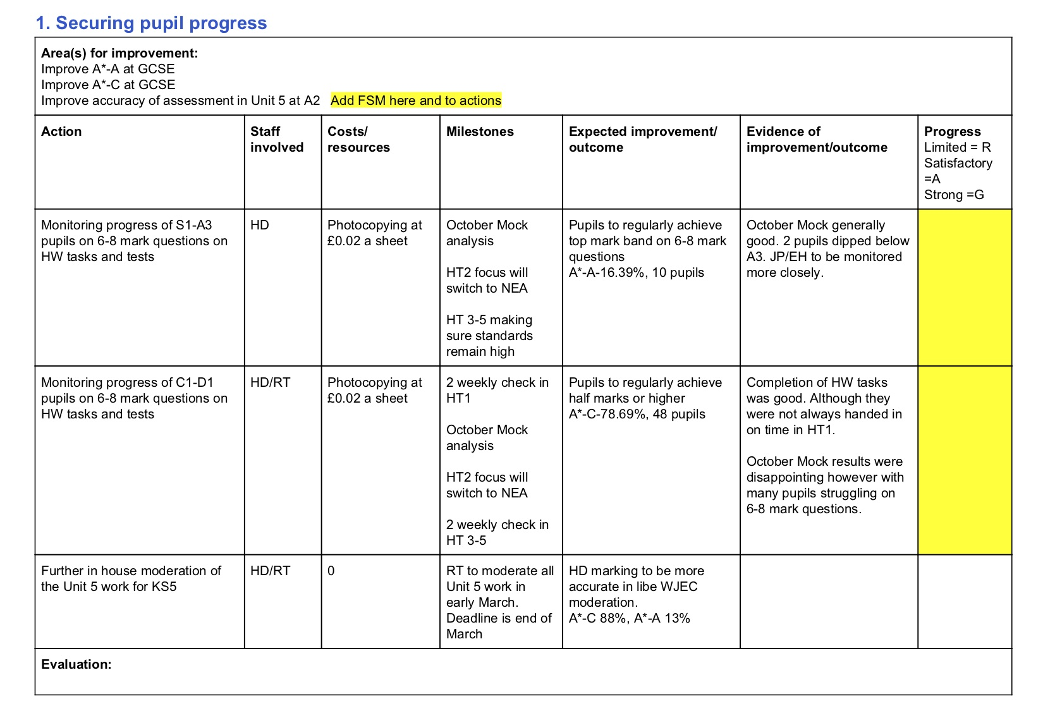
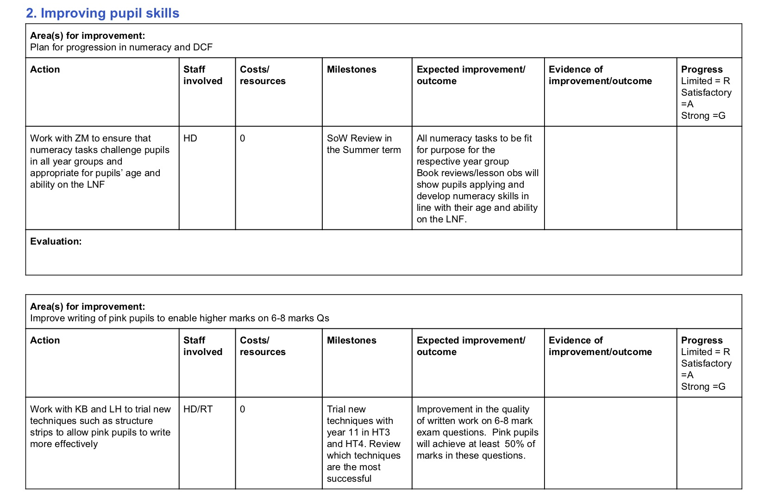
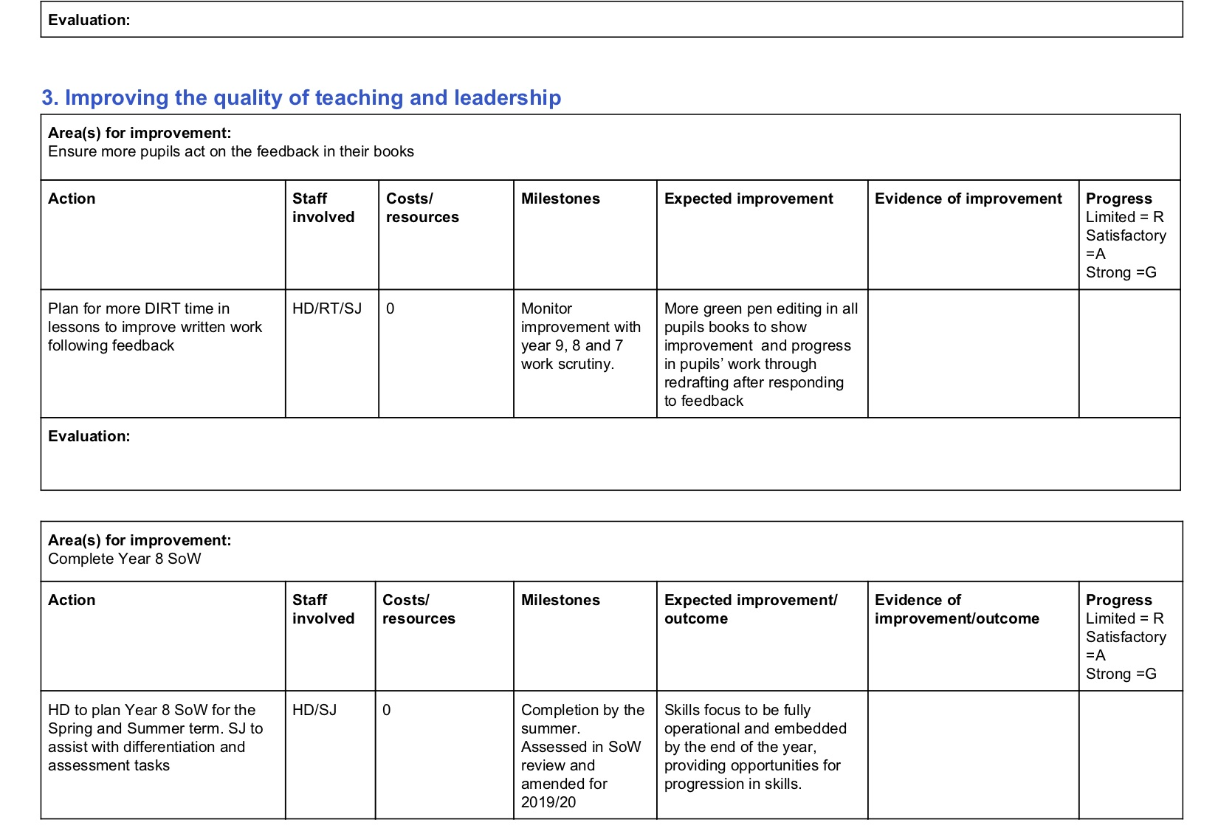
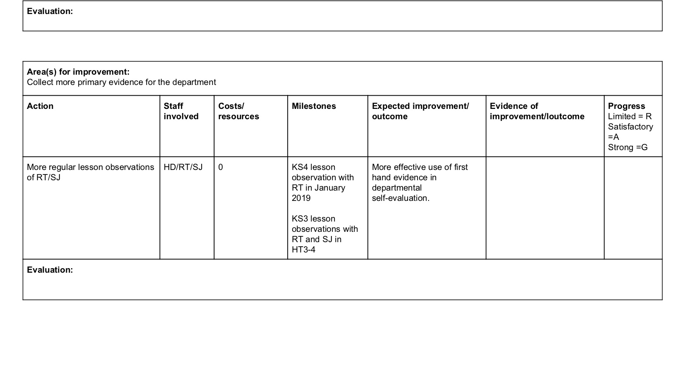
Appendix 3: Results from pre-diagnostic tests

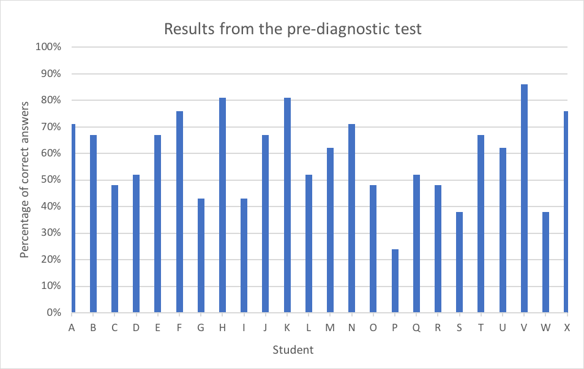

Appendix 4: Results from pre and post-diagnostic tests



