
Skills for the Workplace
Module Assignment Submission
Student Name: | Andrea Page
Student Number: | 1811448
Module No: | BMSK6001
Module Title: | Emergent Leadership Skills for the Workplace

Statement of Confirmation of Authenticity
By the act of making this submission, the student declares that this is the work of the student named above. The work has not, in whole or in part, been knowingly presented elsewhere for assessment, or where assessment has been built on a previous assessment, this has been identified. Where materials have been used from other sources it has been properly acknowledged. If this statement is untrue, the student acknowledges that an assessment offence has been committed.
Attention is drawn to the plagiarism and unfair practice policies of both the University and of ILM.
Permission for ILM to use this script
ILM uses learners’ submissions – on an anonymous basis – for assessment standardisation. By submitting, both the centre and the learner agree that ILM may use this script on condition that identifying information is removed. However, if you are unwilling to allow ILM use this script, please refuse by ticking the box: □
Table of Contents

Introduction 2
Understanding Leadership 3
Gender Barriers in Leadership 4
Famous Leaders 5
Section 1: Evaluate own ability to use a range of leadership styles, in different situations and with different types of people, to fulfil the leadership role 5
Section 2: Critically assess a recognised leadership model or theory in relation to its ability to impact on an individual’s workplace performance 10
Adair’s Action-Centered Leadership Model 10
Tannenbaum and Schmidt model 11
Hersey and Blanchard model 12
Kouzes and Posner Model – The Leadership Challenge 12
Section 3: Assess your own ability to set direction, motivate, delegate and empower others to bring about a workplace change 14
Motivation 14
Maslow’s Hierarchy of Needs 15
Hertzberg two-factor theory 15
Empowerment and Delegation 16
Conclusion 17
Appendix 1: Daniel Goleman’s Six Leadership Styles 19
Appendix 2: Results of the Leadership Style questionnaire 20
Appendix 3: Adair’s Action-Centered Leadership 22
Appendix 4: Tannenbaum and Schmidt Situational Leadership Model 23
Appendix 5: Hersey and Blanchard Leadership Model 24
Appendix 6: Kouzes and Posner The Leadership Challenge Model 25
Appendix 7: Maslow’s Hierarchy of Needs 26
Appendix 8: Hertzberg two-factor theory 27
References 28
Bibliography 30

Introduction

For this assignment I have been tasked with writing a report on the topic of leadership in the workplace. The report will explore and explain in detail the research on the range of different leaderships styles required in different situations dependent upon the types of personalities of the people involved to enable the leader to fulfil the leadership role. The report will also include a critical analysis and reflection of the author’s own preferred leadership style/s resulting from an on-line assessment. This section will conclude with evidence of different leadership styles the author portrayed during real workplace situations.
Section two will require the author to critically assess a recognised leadership model and the impact this model imposes on an individual’s workplace performance. The author will also compare this model with other historical leadership theories and modelling techniques to identify any similarities in the theories on leadership in the workplace. The author will conclude this section by linking the theories to workplace scenarios.
The final section of this report will require the author to assess the ability to set direction in the workplace, by exploring the how the vision of a leader enables and drives a successful proposed change in the workplace. The report will include how a leader of a change proposal empowers and delegates pieces of work to employees, by understanding and clearly defining what motivates, inspires and energises them to follow their lead; not by pushing and pulling them in the right direction but by firstly satisfying their basic human needs using the theory of Maslow’s Hierarchy of Needs as an excellent example.
The author will attempt to draw conclusions to findings in the research of the topic throughout the report, culminating in a final overall conclusion.

Understanding Leadership

Whilst researching leadership for this report the author was initially confused by the complex meaning of leadership and its different factors and dimensions. Research reveals that leadership is sometimes described as a ‘trait’ or an ability, a skill or a behaviour and is also described as a relationship or ‘process’. The CIPD describe leadership as:
‘The process of influencing people to achieve a common goal’
Traditionally the question: ‘Are leaders born or made?’ continues to be debated across the globe with many scholars believing it is inbred. Prior to this report, the author believed that to be a leader one would have to be highly intelligent, an expert in their role and remain distant from their followers. However, due to the vast research available on leadership styles, the author’s research has shown that leadership is a skill that can be learnt; therefore, the author believes that leaders can be made and that you are not born a leader. Hersey and Blanchard (1980) state that there are certain behaviours displayed by successful leaders and they agree that these behaviours can be learned and practiced and are not a trait or talent held by birth. Adair (2013) agrees that it is possible to develop skills to be a leader by learning from experience and practice, however, he also argues that the role of leaders and managers are the same stating that their roles are integrated. Kotter (2001) argues that management and leadership are different but that they complement each other, managers promote stability whilst leaders visualise change, stating that one cannot function without the other
Handy (1993) states that leadership requires a different style and approach according to the situation, skills and experience of the employee or team, agreeing with Hersey and Blanchard (1980) and their situational leadership model stating that although a leader will have their own innate style of leadership, a leader’s strength is recognising that one style maybe effective for one team member but may not be as effective for another. Handy states that “leadership is about followership” arguing that you can only be the sort of leader followers are comfortable with, more importantly, he describes a leader as a ‘visionary’ stating that ‘a leader shapes and shares a vision which gives point to the work of others’.
Kotter (2001) states that a leader’s role is not to make plans, solve problems or organise people but purely to enable and prepare an organisation through change by helping them to cope while they struggle through the complexities of change. Kouzes and Posner (2012) agree, stating that leaders ‘get people moving’ by energising and mobilising them.
In conclusion, the author believes that describing leadership as a skill makes it available to all because skills can be learnt and developed overtime by receiving feedback from others, with practice, learning by mistakes and experience. Finally, the author believes that leaders are primarily there to achieve results, and to take full responsibility should results not go according to plan. Leaders motivate and inspire their followers by recognising their achievements whilst creating a vision for the future direction of the organisation. The various styles of leadership and their differences will be explored in further detail in section one.

Gender Barriers in Leadership

A common theme in the author’s literature research is that men differ from women in their leadership styles. Historically, men believed that an aggressive, dominant and directive leadership style was a benefit in the workplace, however, Lammers and Gast (2017) argue that women will have the advantage over men due to their noticeable leadership style of excellent people skills, such as empathy, communication and cooperativeness which are thought to be more effective for leadership in the 21st century. However, the results of their study revealed that people still visualise leaders as predominantly male, with women less likely to succeed men in leadership roles, for example, the study revealed that women are required to be more highly qualified to be offered similar roles to men. The author believes that by emphasising women’s warm interpersonal traits is to disadvantage women because ‘leadership’ to the uneducated is still regarded as a male dominated, competitive role, conveying a message that women are not suited to the role of leader.

Famous Leaders

There are many famous leaders whose keynote speeches are constantly remarked upon such as the inspiring speech by Martin Luther King Jr. which was voted the top speech of the century by the opinions of 137 leading American scholars. King delivered his speech during the civil rights march on Washington 28 August 1963. He visualised his dream within the context of the civil rights struggle dreaming of a day when his own children ‘would live in a nation where they will not be judged by the colour of their skin but by the content of the character’. The author believes that this speech is still relevant in the 21st century and is still a subject of much debate with the recent 2020 ‘black lives matter’ movement. The author’s understanding of the content of the speech portrayed a vision for harmony and for people to respect, trust and work together as a cohesive unit which great leaders strive for. Effective leaders create convincing visions that can guide people’s behaviour.

Section 1: Evaluate own ability to use a range of leadership styles, in different situations and with different types of people, to fulfil the leadership role

A breakthrough Harvard Business Review study in 2000 by Goleman set out to explore and explain the links among leadership and emotional intelligence and how the atmosphere in the working environment can impact upon an employee’s ability to innovate, as well as their commitment to the organisation. The study further explored the standards people set and the understanding people have about the values and mission of the organisation together with an indication on how employee performance is rewarded and valued. The study took 3 years to complete with over 3,000 middle-level managers taking part and the goal of the study was to uncover specific leadership behaviours and determine each leadership style’s effect on bottom-line profitability.
The research discovered that a manager’s leadership style was responsible for 30% of the company’s profitability. The author believes that this fact is not to be ignored. For example, the author’s previous employer the NHS, hired costly external change consultants to oversee the restructuring of the Human Resources department believing that this would lead to a quick, harmonious and cooperative exercise. In hindsight, simply inspiring the department managers to be more energetic with their leadership style by leading from the front in an honest, trusted, decisive manner and by being respectful of others and understanding their needs, would according to research yield better results in a more cost efficient manner.
The results of the study uncovered six leadership styles (Appendix 2) collated on the data received on the managers observed behaviour, with the study specifically looking at their behaviour on their physical reaction to a crisis; how they motivated and inspired their employees; and how effectively they managed a change initiative. The six styles are briefly explained below.
1. Coercive
‘Do as I say’. The author believes that this is the most aggressive style of leadership and can sometimes be referred to as ‘dictatorial’. However, the study revealed that this style can be useful in situations where followers are shocked into working differently, for example if the business is failing and they are facing redundancy.
2. Authoritative
Prior to the author’s research on this style the author believed this style to be a ‘commanding’ style, however, research reveals that this style is ‘visionary’. An authoritative leader mobilises the team towards a common vision with a real focus on the end goal.
3. Affiliative
This style is also recognised as a ‘supportive style’, revolves around people and promotes the importance of teamwork. Employees are given the freedom to do their job in a way that they think is effective.
Upon reflection, during the author’s previous role of leading the recruitment team at Cardiff and Vale NHS Trust, the author recognises that this was a preferred style of leadership of the author. By creating an environment of sharing ideas and inspiration revolving around a highly communicative atmosphere, the author was creating a loyal and trusting team of workers and performance was praised regularly. The author was constantly ensuring that others alternative viewpoint was taken seriously to enable the communication channel to flow. However, the author agrees with the study that the disadvantage of this style is that the leader maybe reluctant to address poor performance for fear of ‘upsetting’ the team harmony, as well as the difficulty new employees may have ‘fitting in’ if the culture of the team is too cohesive.
4. Coaching
The coaching style leader helps employees to find their own unique strengths and weaknesses, by encouraging them to establish long term development goals and ways to achieve them. However, the study revealed that this style is rarely used with managers citing that they did not have the time to coach employees, Goleman believes that leaders who ignore this style are missing out on the positive impact it can bring on production and performance stating that this style helps employees to visualise where they ‘fit’ in the organisation which in turn boosts morale and leads to an increase in motivation.
The author will continue this section by analysing and reflecting upon the results of the two objective self-assessments undertaken which indicated that the authors preferred leadership style was a democratic and a pacesetting leadership style (Appendix 3). The author will attempt to provide workplace examples of when the author used each of these styles in a workplace setting together with two different types of people.
5. Democratic
This style of leadership values the team’s contribution and thoughts on decision making by asking ‘what do you think’? A democratic leader listens to employees concerns and ensures that they have an input.
Upon reflection, the author believes that this style suited their role perfectly when firstly promoted to recruitment manager responsible for managing 20 employees. The author had no real management experience and was afraid of making the wrong choices when deciding the best way forward. The author also wanted acceptance and to be ‘liked’. The author’s research reveals that this style is useful when a leader is looking for ideas and guidance from knowledge workers, however, the disadvantage of this style is there are many meetings with no firm decisions made which can cause confusion and the leader may lose control of the final decision. In conclusion and upon reflection the author believes that the author may have come across in meetings as being indecisive and not in control of the situation. An example of the author using this style of leadership is explained in the following paragraph.
Review of existing Admin and Clerical Agency
The agency is used for short term immediate cover in cases of urgent admin staff shortages. Following an audit meeting with the contract providers it was evident that they were not delivering to the standard the author required and a new tender for the contract was required. Whilst the author had a view which direction to follow, the author empowered the assistant recruitment manager to manage the change of agency and provide the author with recommendations based on their best judgement. As a result, analysis and consideration of the options was reached through a consensus approach.
The author’s learning outcome using this style of leadership allowed team members to experience ownership and accountability. They were able to demonstrate their capability with the project as well as gaining personal satisfaction that the author trusted them to make the right decision, which impacted on their motivation and commitment to the department.
The negative aspect of adopting a democratic approach to this situation was that the author was unable to have an impact on the recommendations and some of the decisions made in assessing alternative providers, was outside of their control, however, the author trusted the decision made.
6. Pacesetting
The pacesetting leader sets high standards for themselves and their employees and expects them to know what to do. Upon reflection, the author can relate to this style of leadership due to the author’s trait as a perfectionist. An example of the author using this style of leadership is explained in the following paragraph.
Internal investigation
The author reverts to this style when there is a need to get results within a tight deadline. An example of this is when a member of the HR management team was investigating an alleged act of disability discrimination during a selection for a job interview with one of the Trust’s managers. The author’s perception was that the manager was not spending enough time on bringing the allegation to a timely conclusion as well as not acting in accordance with the policy. This was partly due to the culture of the organisation which has small pockets of a non-urgency attitude. The author took control of the situation by taking a proactive approach and setting specific timescales and targets for completion to drive the investigation forward to a conclusion. Whilst this approach did speed up the investigation, the author’s relationship with the HR manager conducting the investigation was difficult and had the potential to become confrontational. The author had to reflect and practice self-management control by thinking before acting.
Finally, the study revealed that the most effective leaders switch styles flexibly as and when required. The author demonstrated this skill by the two different examples shown above; the former with a team member and the latter with a HR manager. Goldman believes that the top four styles a leader should master are authoritative, democratic, affiliative and coaching which were shown to have the best working environment and performance results.
In conclusion, the author’s research into leadership styles reveal that there is no right way to lead as the internal and external environment dictate how the leader needs to adapt their style to each situation, they find themselves facing. Handy (1993), argues that a leaders style is not an indication of how hard and effectively employees will work, he believes it has more to do with the conditions employees work; areas of responsibility, shared decision making, job role, trust in the leader which are all linked to job satisfaction and performance and ultimately lead to self-actualization. Section 2 of the report will explore and compare popular leadership models and how these model’s impact on the successful performance of a team and the individual.

Section 2: Critically assess a recognised leadership model or theory in relation to its ability to impact on an individual’s workplace performance

Adair’s Action-Centered Leadership Model

The authors preferred leadership model is Adair’s Action-Centered Leadership model (Appendix 3) which was first published in 1973. The author chose this model due to its simple, easy to understand, remember and its ability to adapt to one’s own situation to leading a team to success. Adair’s model promotes the main functions of leadership by providing the necessary tools for leaders and managers to follow when faced with a task. Adair’s model comprises of 3 overlapping and interacting circles which he believes a task needs to have a success:
Achieving the task – the vision of the leader, focusing on the aims and purpose of the task by setting SMART objectives, the achievement of these objectives is a major criterion of a successful task. The leader explains the ‘why, what, where and how’ you are doing the task and making a change in order to gain the teams ‘buy-in’ by selling the task and crucially motivating the individuals to action.
Individual needs – attending to the psychological needs, for example; recognition for a job well done, satisfaction from making a difference, feeling of belonging to a group which underlines the fact that people need people to develop their personality and achieve.
Team maintenance need – the ability to create and promote unity and ensure that there are no threats or disruptions from external sources and the whole team is pulling in the right direction. The author likens this need to the ‘iceberg effect’ whereby there are unseen disruptive forces lurking underneath which will require the leader to use his emotional intelligence social and social awareness skills to recognise and manage the situation. Lencioni (2002) proposed that there are 5 dysfunctions of a team:
- Absence of trust
- Fear of conflict
- Lack of commitment
- Avoidance of accountability
- Inattention to results
He argues that this is because they are made up of individuals who have varied interests, strengths and weaknesses.
In conclusion, the main principle of Adair’s 3 circles of need is that they overlap with each having a direct influence on each other. For example, if the task achieved its purpose, the individual needs of the team have been met, and the whole team senses a feeling of pride. However, if there has been confusion and a slight disagreement in the team cohesiveness (a failure in team maintenance), performance in the task will suffer and individual team members needs will be compromised, therefore, the model believes you cannot be successful in the task unless all 3 needs have been satisfied. However, the Chartered Management Institute (CMI) argue that Adair’s model is out dated, too simple and it merely states the obvious whilst they believe it is not fit for the 21st century workplace where the emphasis today is on leaders leading change, empowering, enabling and fostering innovation they say it is too rigid. The author disagrees with these findings and believes the model to be an easy to follow tick box method of implementing a change in the organisation which the author believes is the reason why this model is still popular in today’s working environment.

Tannenbaum and Schmidt model

The Tannenbaum and Schmidt model (Appendix 3) promotes a leadership model appropriate to the situation whereby leaders must show their ability to adapt or adjust their leadership style according to the situation – situational leadership style. Rehman et al (2020), believes that there is no right way to lead, and agrees with the model, stating that a leadership style depends solely on the situation and how leaders switch their behaviour depending on the situation they find themselves in. Oakland (2003), argues that a directive/telling approach is required at the beginning of a task which gradually leads to a delegation approach as the individual team members gain more experience and begin to have successful outcomes when milestones are reached. This style reverts from a less directing supportive approach to a more independent trusting delegative style once members have gained experience and are developed.

Hersey and Blanchard model

Hersey and Blanchard (1979) describe a similar approach to the Tannenbaum and Schmidt model whereby directive behaviour moves from high to low depending on how employees are being trained, developed and growing in confidence which leads to a delegating style of management and a low support working environment. Employees are required to be patient when leaders follow this model as there is no quick and easy way to jump from level 1 to level 4 – it is a long drawn out journey which the author believes is the correct way to be developed and which has similarities to a job rotation scheme for new starters working in different departments acquiring new knowledge which creates confidence and experience along the way.
In conclusion, a study by Jia et al (2007), revealed that making the right choice of leadership style behaviour according to the situation has proven to carry more value in terms of job satisfaction, involvement and commitment as well as showing a positive link to job outcomes such as retention and performance by creating an experience of belonging to the organisation, its values and its brands. The author believes that the situational approach has links into the Adair model of team needs, whereby teams who are recognised for a job well done gain in confidence and are motivated to increase their skills, and are willing to take on more responsibility within their job role.

Kouzes and Posner Model – The Leadership Challenge

The leadership challenge model (Appendix 5) recognises that leaders engage in what they believe are the ‘5 practices of exemplary leadership; model the way, inspire a shared vision, challenge the process, enable others to act and encourage the heart. They believe that these 5 practices can be practiced by anyone who accepts the ‘leadership challenge’ by being inspired by moving from the ordinary to the extraordinary. They believe that communicating stories about past experiences is a powerful way to teach people about shared values and ‘what’s important, what’s not, what is and what could be’:
Model the Way - leaders who aspire to gain commitment from others to achieve high standards must be models of the behaviour that they expect from others
Inspire a shared vision – leaders cannot demand commitment; they must enlist others through communicating an exciting clear vision
Challenge the process – create a climate of innovation, experimentation and taking risks
Enable others to act – Lead by empowering those around you, give others a voice in the decision-making process
Encourage the heart - Recognise contributions by showing appreciation for individual excellence
In conclusion, the author believes that this model links into Adair’s 3 overlapping circle model; there is concern for the team bonding, both models encourage individuals to have a say in the decision making process which leads to a climate of empowerment, and the task is communicated clearly with a strong vision by the leader, promoting a ‘can do’ attitude. Kouzes and Posner believe that credibility is the foundation of leadership – ‘they walk the talk’ and they believe that a leader’s role is to inspire people to do things differently and is about the relationship between the leader and their followers.
Finally, the author believes that presenting and communicating a realistic exciting vision balanced with a creating thinking approach is the key to getting people on board in the first instance. The author’s experience of communicating any change in the workplace whether it a large or small change, automatically begins with employees immediately thinking ‘how will this impact me / what’s in it for me?’ so it is crucial that the leader understands what motivates their employees and how they communicate, inspire and ‘sell’ the change prior to informing staff. The leader is taking his followers on a ‘journey’, therefore, the leader’s vision has to believe it can work for the better of the organisation and the individual, otherwise how can the leader expect others to believe that the change proposed is the right way for the organisation to go?
The following section will explore how motivation, delegation and empowering employees in the affect changes in the workplace.

Section 3: Assess your own ability to set direction, motivate, delegate and empower others to bring about a workplace change

Historically, the recruitment department managed the information regarding the recruitment process on multiple separate spreadsheets. Single spreadsheets were in place for applications received, applicants shortlisted, applicant interviews together with a new starter spreadsheet. The older adult generation also kept a duplicate handwritten account of this information in a notebook. The author quickly realised when arriving in the department as the new recruitment manager, that this system was difficult to manage, inefficient and the duplication of information was time wasting. The author had a vision of installing a new standalone integrated recruitment database system whereby the information was input one time only and changes to each stage of the recruitment process were made by one click only.
The author was aware that this change would require staff to completely change their way of working over the past 10 years and it was the authors role to ‘sell’ the change as a positive move in the right direction whilst emphasising the benefits, aware that some staff would feel that the change would bring job losses, uncertainty, and the need to work faster. The author would also need to be aware of their social awareness skills in recognising the emotional make-up of others due to some staff being resistance to the change.
The author proceeded to communicate the benefits of the vision with passion in order to engage and motivate the staff to gain their trust believing that this was the way forward for the department.

Motivation

The author’s research into motivating and getting employees on board for a change revealed many motivational theories with the author choosing Maslow’s Hierarchy of Needs (Appendix 6) and Hertzberg two-factor theory (Appendix 7) due to their popularity and simplicity. Through the work of these two theorist’s leaders and managers have become to understand what motivates people at work.

Maslow’s Hierarchy of Needs

Maslow categorised needs as follows:
Self-actualization needs
Esteem needs
Belonging and love needs
Safety needs
Physiological needs
Maslow assumed that needs are only motivators when they are unsatisfied, suggesting that these needs work in the order above. The lower-order needs (physiological and safety) are dominant until satisfied, for example if you are hungry your needs for status or esteem will be unimportant – only food matters at that time. A further example would be if you were warm and had shelter, adding further warmth would not motivate you.

Hertzberg two-factor theory

Hertzberg’s research into how to motivate employees believed that in any work situation you can tell the difference between the factors that satisfy and those that dissatisfy workers. He describes the dissatisfiers also called ‘extrinsic motivators’ as things to do with the conditions of work, such as company policy, salary, supervision, physical working conditions and relationships with colleagues, whereas he believes the satisfiers, also called ‘intrinsic’ are achievement, recognition, the work itself, responsibility and advancement. Therefore, the author believes that although the dissatisfiers are essential to have in the workplace they do not motivate employees, for example; the need for achievement and promotion is a prime motivator but the salary increase that comes with this is not, just being recognised for some staff is enough to motivate them.
The author can relate to Hertzberg’s theory as the promotion the author received to recruitment manager included a large salary increase but the biggest motivating factor was the author’s manager recognising and trusting the author’s ability to do the job. Upon reflection, the author’s previous role as cabin crew the motivating factor was not the salary but the working conditions of travelling, night stops with days off abroad and enjoying the company of colleagues.
The author focused on the motivation factors of sense of achievement, recognition for a job well done and responsibility when communicating the positive impact of a change of recruitment system. The author also practised the skills of delegation and empowerment.

Empowerment and Delegation

Coun et al (2021), described empowerment as ‘Empowering leadership can be defined as a leadership behaviour through which leaders delegate authority to their employees in order to promote autonomous and self-directed decision making’.
Oakland (2003) states that successful organisations place great importance on empowering their employees in order to create a working environment that was likely to lead to employees taking further responsibility for their actions. Empowerment is often linked to delegation with the author’s research revealing that when you empower employees you as a manager trust them to do the job as the staff chosen are knowledgeable and experienced in their role, whereas a manager who delegates is required to supervise at a distance the work delegated, although not closely as this will break the trust. Empowerment is telling people ‘what to do, not how to do it’.
Whilst undertaking the change in the department the author delegated responsibility to the assistant recruitment manager for managing the organisation and roll out of the training for the new system which was taking place off-site and included an overnight stay. This alone created a sense of excitement, enthusiasm and buy-in to the new system. They were to report to the author on a regular basis and report any issues with the training.
Finally, the author continued to communicate the decisions made at every stage of the process with key dates and milestones reached which kept staff informed of the progress of the project. The new computer system was installed successfully, staff were trained to use it to its full potential. However, some staff were resistant to the change in the beginning and continued to record new appointments made into their handwritten notebooks. When questioned, it was revealed that they did not fully trust the system, and this was rectified by further refresher training and communicating the benefits of the system.
In conclusion, by delegating responsibility for the roll out of the training, the author was boosting the morale of the team, and the author was able to practice time management skills by focusing on the strategic aspects of the process; procurement, implementation and communication of the new system.

Conclusion

The author has concluded from the literature, that there is no right way to lead as the internal and external dimensions of the environment require the leader to adapt and change direction to fit that particular situation, leadership should not be viewed as a ‘one size fits all’ process.
The author believes that the responsibility of a leader is not to be underestimated in the context of leading the organisation through a change process. Getting employees on board, motivating, inspiring and gently pushing them along to focus on the positives and not to dwell on the negatives of change demands a leader who ‘leads from the heart’. The author believes a good example of this type of leader is the current England football team manager from observing his behaviour with the team he is a leader who leads by example from the front, the players trust him and he is calm and level headed at all times, determined and sets high standards and takes full responsibility for failure. This is the type of leader the author would aspire to be, someone who cares about their employees and provides them with opportunities to grow and develop.

Appendix 1: Daniel Goleman’s Six Leadership Styles

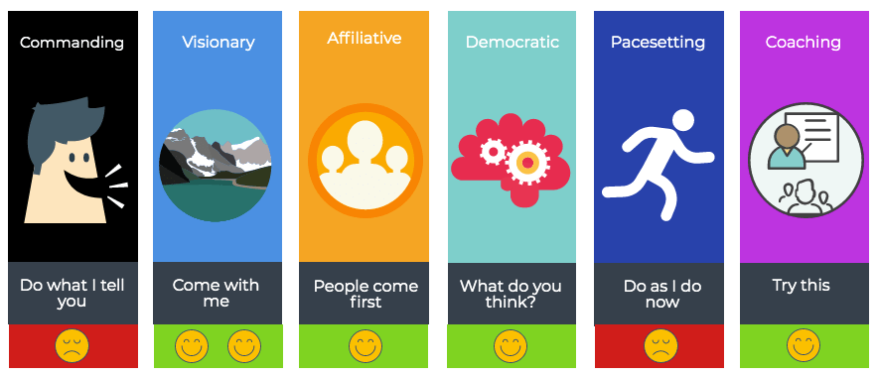
Image taken from: https://secretstotheirsuccess.com/leadership-styles/daniel-golemans-six-leadership-styles/

Appendix 2: Results of the Leadership Style questionnaire

Chapter 4 Understanding Philosophy and Styles 93
4.2 Leadership Styles Questionnaire
Purpose
- To identify your style of leadership
- To examine how your leadership style relates to other styles of leadership
Directions
- For each of the statements below, circle the number that indicates the degree to which you agree or disagree.
- Give your immediate impressions. There are no right or wrong answers.
Statements | Strongly disagree | Disagree | Neutral | Agree | Strongly agree
1. Employees need to be supervised closely, or they 1 2 3 4 5 are not likely to do their work.
2. Employees want to be a part of the decision-making process. | 1 | 2 | 3 | 4 | 5
3. In complex situations, leaders should let followers 2 3 4 5 work problems out on their own.
APPLICATION
1
4. It is fair to say that most employees in the general population are lazy. | 1 | 2 | 3 | 4 | 5
5. Providing guidance without pressure is the key to 1 2 3 4 5 being a good leader.
6. Leadership requires staying out of the way of followers as they do their work. | 1 | 2 | 3 | 4 | 5
7. As a rule, employees must be given rewards or 1 3 4 5 punishments in order to motivate them to achieve organizational objectives.
2
8. Most workers prefer supportive communication from their leaders. | 1 | 2 | 3 | 4 | 5
9. As a rule, leaders should allow followers to appraise 1 2 3 4 5 their own work.
10. | Most employees feel insecure about their work and need direction. | 1 | 2 | 3 | 4 | 5
11. Leaders need to help followers accept responsibility 1 2 3 4 5 for completing their work.
12. | Leaders should give followers complete freedom to solve problems on their own. | 1 | 2 | 3 | 4 | 5
13. The leader is the chief judge of the achievements of 1 3 4 5 the members of the group.
2
14. | It is the leader’s job to help followers find their “passion.” | 1 | 2 | 3 | 4 | 5
94 I N T R O D U C T I O N T O L E A D E R S H I P
4.2 Leadership Styles Questionnaire
(continued)
Statements | Strongly disagree | Disagree | Neutral | Agree | Strongly agree
15. In most situations, workers prefer little input from the 1 2 3 4 5 leader.
16. | Effective leaders give orders and clarify procedures. | 1 | 2 | 3 | 4 | 5
17. People are basically competent and if given a task 1 2 3 5 will do a good job.
4
18. | In general, it is best to leave followers alone. | 1 | 2 | 3 | 4 | 5
Scoring
- Sum the responses on items 1, 4, 7, 10, 13, and 16 (authoritarian leadership).
- Sum the responses on items 2, 5, 8, 11, 14, and 17 (democratic leadership).
- Sum the responses on items 3, 6, 9, 12, 15, and 18 (laissez-faire leadership).
Total Scores
Authoritarian Leadership ______12
APPLICATION
Democratic Leadership _______²¹
Laissez-Faire Leadership ______12
Scoring Interpretation
This questionnaire is designed to measure three common styles of leadership: authoritarian, democratic, and laissez-faire. By comparing your scores, you can determine which styles are most dominant and least dominant in your own style of leadership.
If your score is 26–30, you are in the very high range.
If your score is 21–25, you are in the high range.
If your score is 16–20, you are in the moderate range.
If your score is 11–15, you are in the low range.
If your score is 6–10, you are in the very low range.
Building Your Leadership Profile
If you have the interactive eBook version of this text, log in to access the Leadership Profile Tool. After completing this chapter’s questionnaire, you will receive individualized feedback and practical suggestions for further strengthening your leadership based on your responses in this questionnaire.
Visit edge.sagepub.com/northouseintro4e for a downloadable version of this questionnaire.

Appendix 3: Adair’s Action-Centered Leadership

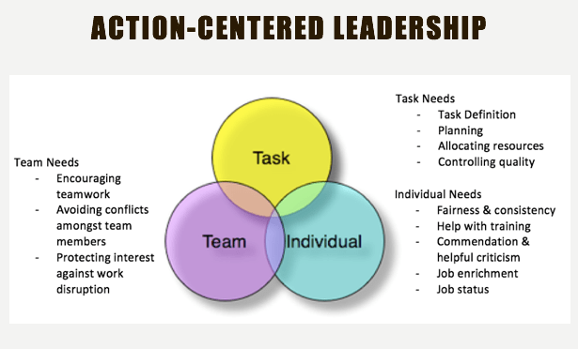

Image taken from: https://alexandraceambur.com/2016/10/24/most-effective-leadership-management-styles/

Appendix 4: Tannenbaum and Schmidt Situational Leadership Model

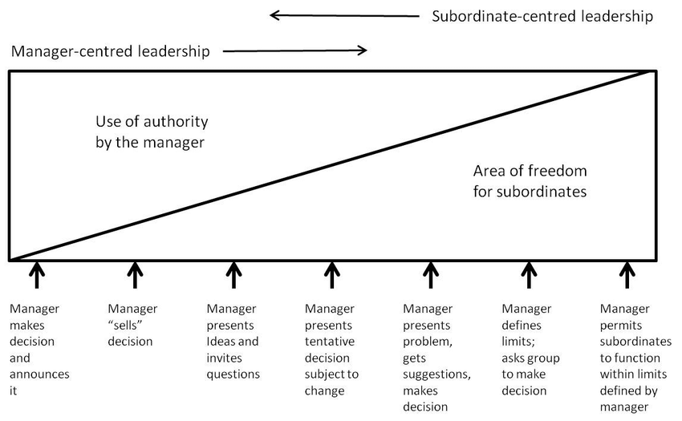

Image taken from: https://www.researchgate.net/figure/Continuum-of-leadership-behaviour-Tannenbaum-Schmidt-1973-exhibit-1-p4_fig1_323736322

Appendix 5: Hersey and Blanchard Leadership Model

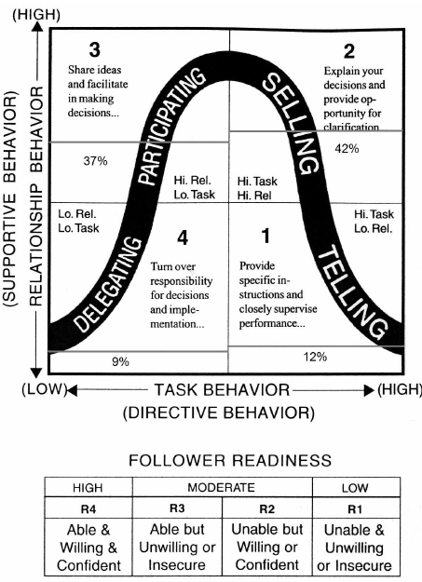

Appendix 6: Kouzes and Posner The Leadership Challenge Model

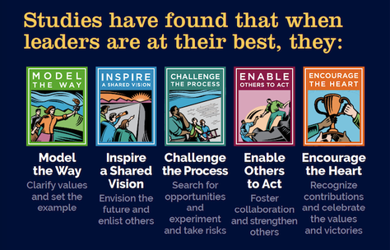

Image taken from: https://workplacepsychology.net/2017/07/02/book-review-the-leadership-challenge-6th-edition/

Appendix 7: Maslow’s Hierarchy of Needs



Image taken from: https://www.simplypsychology.org/maslow.html

Appendix 8: Hertzberg two-factor theory

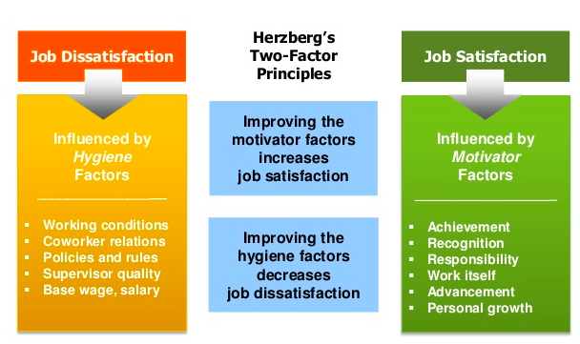

Image taken from: https://courses.lumenlearning.com/wmintrobusiness/chapter/reading-two-factor-theory/

References

ADAIR, J., 2013. Develop Your Leadership Skills. 2nd ed. edn. London: London : Kogan Page
ARMSTRONG, M., 1999. Managing activities. London: London : Institute of Personnel and Development.
CIPD: Leadership Factsheet:
https://www.cipd.co.uk/knowledge/strategy/leadership/factsheet (accessed 3 July 2021)
COUN, M.,J.H., PETERS, P., BLOMME, R.J. and SCHAVELING, J., 2021. ‘To empower or not to empower, that’s the question’. Using an empowerment process approach to explain employees’ workplace proactivity. International journal of human resource management, , pp. 1-27.
GOLEMAN, D., 2000. Leadership that Gets Results. Harvard business review, 78(2), pp. 78-90.
HANDY, C.B.,(Charles Brian), 1993. Understanding organizations. 4th ed. edn. Harmondsworth: Harmondsworth : Penguin.
Harvard Business Review: Empowering Employees
https://hbr.org/2015/05/6-myths-about-empowering-employees (accessed 23rd June 2021)
HERSEY, P. and BLANCHARD, K.H., 1979. LIFE CYCLE THEORY OF LEADERSHIP. Training and development journal, 33.
Herzberg motivational theory:
https://www.managementstudyguide.com/herzbergs-theory-motivation.htm (Accessed 1st July 2021)
JIA, X., CHEN, J., MEI, L. and WU, Q., 2018. How leadership matters in organizational innovation: a perspective of openness. Management decision, 56(1), pp. 6-25.
KOTTER, J.P., 2001. What Leaders Really Do. Harvard business review, 79(11), pp. 85-97.
LAMMERS, J. and GAST, A., 2017. Stressing the Advantages of Female Leadership Can Place Women at a Disadvantage. Social psychology (Göttingen, Germany), 48(1), pp. 28-39.
Leadership questionnaire:
https://edge.sagepub.com/northouse8e/student-resources-0/leadership-questionnaires (accessed on 26th June 2021)
LENCIONI, P.M., 2003. The trouble with teamwork. Leader to Leader, 2003(29), pp. 35.
Martin Luther King Jnr. Speech:
https://www.youtube.com/watch?v=smEqnnklfYs (accessed 30th June 2021)
MASLOW, ABRAHAM H. (ABRAHAM HAROLD), 1998. Maslow on management. New York: New York : Wiley.
OAKLAND, J.S., 2003. Total quality management : text with cases. 3rd ed. edn. Amsterdam; Oxford: Amsterdam; Oxford : Butterworth-Heinemann.
100 speeches of the century:
https://news.wisc.edu/i-have-a-dream-leads-top-100-speeches-of-the-century/ (Accessed 10th July 2021)
REHMAN, S.U.R., SHAHZAD, M., FAROOQ, M.S. and JAVAID, M.U., 2020. Impact of leadership behavior of a project manager on his/her subordinate's job-attitudes and job-outcomes. Asia Pacific management review, 25(1), pp. 38-47.
TANNENBAUM, R. and SCHMIDT, W.H., 1958. How to Choose A Leadership Pattern. Harvard business review, 36(2), pp. 95-101.
Women in the labour market:
https://www.ons.gov.uk/employmentandlabourmarket/peopleinwork/employmentandemployeetypes/articles/womeninthelabourmarket/2013-09-25 (accessed 25th June 2021)

Bibliography

ABU-TINEH, A., KHASAWNEH, S.A. and AL-OMARI, A., 2008. Kouzes and Posner's transformational leadership model in practice. Leadership & organization development journal, 29(8), pp. 648-660.
ADAIR, J., 2013. Develop Your Leadership Skills. 2nd ed. edn. London: London : Kogan Page.
ARMSTRONG, M., 1999. Managing activities. London: London : Institute of Personnel and Development.
COUN, M.,J.H., PETERS, P., BLOMME, R.J. and SCHAVELING, J., 2021. ‘To empower or not to empower, that’s the question’. Using an empowerment process approach to explain employees’ workplace proactivity. International journal of human resource management, , pp. 1-27.
Chartered management institute:
https://www.managers.org.uk/~/media/Campus%20Resources/John%20Adair%20-%20Action-centred%20leadership.ashx (accessed 3rd July 2021)
CIPD: Leadership Factsheet:
https://www.cipd.co.uk/knowledge/strategy/leadership/factsheet (accessed 3 July 2021)
EAGLY, A.H., 2007. Female Leadership Advantage and Disadvantage: Resolving the Contradictions. Psychology of Women Quarterly; pwq, 31(1), pp. 1-12.
FIEDLER, F.E., 1965. Engineer the Job to Fit the Manager. Harvard business review, 43(5), pp. 115-122.
GOLEMAN, D., 2000. Leadership that Gets Results. Harvard business review, 78(2), pp. 78-90.
GRAHAM, R.N.J. and WOODHEAD, T., 2021. Leadership for continuous improvement in healthcare during the time of COVID-19. Clinical radiology; Clin Radiol, 76(1), pp. 67-72.
HANDY, C.B.,(Charles Brian), 1993. Understanding organizations. 4th ed. edn. Harmondsworth: Harmondsworth : Penguin.
Harvard Business Review: Myths about empowering employees:
https://hbr.org/2015/05/6-myths-about-empowering-employees (accessed 23rd June 2021)
HERSEY, P. and BLANCHARD, K.H., 1979. LIFE CYCLE THEORY OF LEADERSHIP. Training and development journal, 33.
Herzberg motivational theory:
https://www.managementstudyguide.com/herzbergs-theory-motivation.htm (Accessed 1st July 2021)
JIA, X., CHEN, J., MEI, L. and WU, Q., 2018. How leadership matters in organizational innovation: a perspective of openness. Management decision, 56(1), pp. 6-25.
KOTTER, J.P., 2001. What Leaders Really Do. Harvard business review, 79(11), pp. 85-97.
LAMMERS, J. and GAST, A., 2017a. Stressing the Advantages of Female Leadership Can Place Women at a Disadvantage. Social psychology (Göttingen, Germany), 48(1), pp. 28-39.
LENCIONI, P.M., 2003. The trouble with teamwork. Leader to Leader, 2003(29), pp. 35.
Martin Luther King Jnr. Speech:
https://www.youtube.com/watch?v=smEqnnklfYs (accessed 30th June 2021)
MASLOW, ABRAHAM H. (ABRAHAM HAROLD), 1998. Maslow on management. New York: New York : Wiley.
OAKLAND, J.S., 2003. Total quality management : text with cases. 3rd ed. edn. Amsterdam; Oxford: Amsterdam; Oxford : Butterworth-Heinemann.
PERKINS, D.D. and ZIMMERMAN, M.A., 1995. Empowerment theory, research, and application. American Journal of Community Psychology; Am J Community Psychol, 23(5), pp. 569-579.
REHMAN, S.U.R., SHAHZAD, M., FAROOQ, M.S. and JAVAID, M.U., 2020. Impact of leadership behavior of a project manager on his/her subordinate's job-attitudes and job-outcomes. Asia Pacific management review, 25(1), pp. 38-47.
RYAN, R.M. and DECI, E.L., 2000. Intrinsic and Extrinsic Motivations: Classic Definitions and New Directions. Contemporary educational psychology; Contemp Educ Psychol, 25(1), pp. 54-67.
SCHIRMER, P., CROWLEY, J.C., BLACKER, N.E., BRENNAN, R.R., LEONARD, H.A., POLICH, J.M., SOLLINGER, J.M. and VARDA, D.M., 2008. APPENDIX B; Leadership Qualities That Junior Officers Most Admire and Wish to Emulate. Leader Development in Army Units. 1 edn. RAND Corporation, pp. 87-90.
SUTHERLAND, A.M. and DODD, F., 2008. NHS Lanarkshire's leadership development programme's impact on clinical practice. International journal of health care quality assurance, 21(6), pp. 569-84.
TANNENBAUM, R. and SCHMIDT, W.H., 1958. How to Choose A Leadership Pattern. Harvard business review, 36(2), pp. 95-101.
What is Leadership? Intent-Based Leadership with L. David Marquet
https://www.youtube.com/watch?v=PjAm6F3uRc8 (accessed 26th June 2021)
Women in the labour market:
https://www.ons.gov.uk/employmentandlabourmarket/peopleinwork/employmentandemployeetypes/articles/womeninthelabourmarket/2013-09-25 (accessed 25th June 2021)

