

Title: Assessment Component 1-Essay
Program: Master of Business Administration
Module: Marketing Management
Module Code: LCMB7024
Submission Date: 27/03/2025
Submission Date: 28/03/2025
Word: 2697

Submitted To:
Dr Haoran Liu
Prof. in Marketing Management
University of Wales Trinity Saint David

Submitted By:
Md Zahid Hasan Sojib
Id: 2426919
Advantages of Being a Pioneer
One of the most important factors that determines the growth trajectory and competitive advantage of a company is whether or not it chooses to be a pioneer in the industry or a follower in the market. Pioneers are the first to proceed in a certain direction(S. Kim et al., 2022 such as Google and Samsung, make use of the foundation that was established by pioneers(Ali et al., 2025). This is why they are able to innovate. Followers, despite the fact that they have the benefits of market validation and reduced initial risks, need to be strategic in order to differentiate themselves from established rivals in order to avoid being missed in the market. Being a pioneer in the market entails the introduction of a product or technology before any competitors(Bertoni et al., 2020).
First-Mover Advantage
Pioneer companies have the unique benefit of gaining an early foothold in the market, which is crucial for establishing a strong brand presence and customer loyalty. This advantage allows them to capture the attention and loyalty of customers before competitors even enter the market(J. Kim & Ahn, 2024). In many cases, pioneers become the go-to choice for customers due to their early innovation and market establishment. For example, Apple Inc. revolutionized the smartphone industry with the release of the iPhone, a product that introduced an entirely new approach to mobile phones. Apple's early market entry created a powerful brand identity and allowed the company to secure market leadership for years to come, leaving competitors with the difficult task of catching up.
Figure:1 Effect pioneer as technological changes
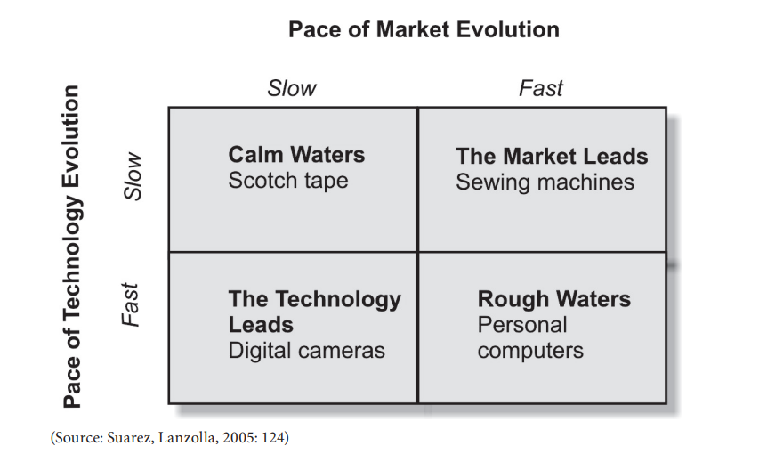
There are four possible combinations. “Calm Waters” represents the situation where both technology and market grow slowly. The gradual evolution of both factors allows pioneers to create long-lasting dominant positions. The slow pace of technology evolution makes it difficult for followers to differentiate their products.
Pricing Power
One of the most significant advantages for pioneers is their ability to set prices and shape customer expectations. This pricing power stems from the fact that their products are seen as innovative or groundbreaking, giving customers an incentive to pay more for the newness and perceived quality(S. Kim et al., 2022). A prime example of this is Tesla, which introduced its electric vehicles at higher prices, particularly with the Model S. Despite its premium pricing, Tesla was able to maintain its position as a market leader in electric vehicles due to its innovation status and brand association with advanced, sustainable technology.

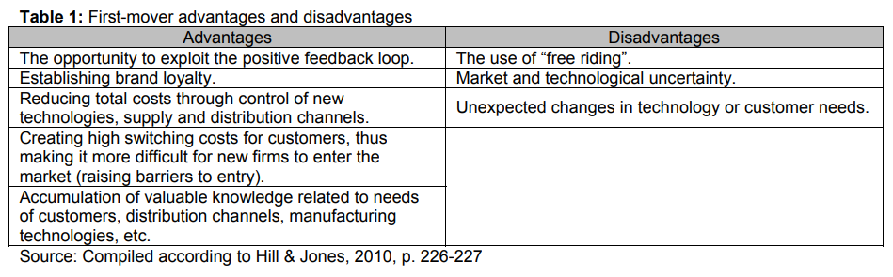
Innovation Leadership
Pioneers are often seen as leaders in innovation, which enhances their reputation and attracts early adopters who are eager to embrace new technologies. The perception of being at the forefront of innovation can significantly boost a company's public image and create lasting customer loyalty(Gupta et al., 2021). For instance, Amazon started as an online bookstore but quickly expanded to become a global e-commerce giant. Its early adoption of customer-centric services, such as one-click purchasing and fast shipping, solidified its reputation as an innovator in the e-commerce space and set the stage for its later dominance in various industries.
Barriers to Entry for Competitors
By being the first to introduce a new product or technology, pioneers often create significant barriers to entry for future competitors(Frederick, 2022). For example, companies like Apple and Tesla have both built strong brand loyalty, protecting their market share from potential competitors. Apple's ecosystem, which integrates hardware, software, and services, creates a significant entry barrier for new companies attempting to challenge its position.
Advantages of Being a Follower
Follower companies enter the market after the pioneers, and while they miss the initial first-mover advantage, they can still leverage several strategic benefits by learning from the experiences of the pioneers and adapting their approach accordingly.
Reduced Risk
One of the most significant advantages of being a follower is the reduced risk associated with market entry. Followers can learn from the successes and failures of the pioneers, avoiding costly mistakes that could otherwise hinder their progress(Rémy et al., 2024). By analyzing the initial market response, followers can fine-tune their product offerings, reducing the chances of failure. Google is a prime example of a successful follower. While Google entered the search engine market after pioneers like AltaVista and Yahoo, it learned from the shortcomings of these early players. Google's superior functionality, user-friendly interface, and innovative algorithms allowed it to outperform its predecessors and dominate the search engine market.
Lower Development Costs
Followers often benefit from lower research and development costs compared to pioneers. Since followers enter the market after the product or technology has already been introduced, they can bypass some of the early development challenges and directly replicate or improve upon the existing product(Ali et al., 2025). This results in cost savings and more efficient development cycles. For example, Samsung entered the smartphone market after Apple's iPhone launch but was able to capture significant market share by offering competitive features and enhancing its product design(Jahanshahi et al., 2024). Samsung's ability to build on Apple's success and avoid early-stage development hurdles gave it a competitive edge while keeping costs lower.
Improved Product Offering
Followers can refine and enhance their product offerings based on customer feedback that has already been gathered by the pioneers.
Microsoft's Xbox is a perfect example of this advantage. The gaming console market was already dominated by Sony's PlayStation when Microsoft entered with its Xbox. However, Microsoft's careful consideration of customer feedback and its technological expertise allowed it to refine its offering, ultimately introducing features like Xbox Live and an extensive game library that differentiated it from the competition.
Market Validation
Followers have the benefit of market validation, meaning they can observe the reception of a new product or technology before committing significant resources. This allows them to strategically plan their entry into the market based on solid consumer demand and avoid entering a market that may not be as receptive as initially thought(Ray & Sharma, 2020). In the case of eBay, the company entered the e-commerce space after Amazon had already proven the viability of online shopping. eBay capitalized on the established market demand by focusing on a unique auction-based model, positioning itself as a leader in online marketplaces.
Table2: Key Examples of Pioneer and Follower Companies
Category | Pioneer Example | Follower Example
Smartphones | Apple (iPhone) | Samsung (Galaxy)
E-commerce | Amazon | eBay
Electric Vehicles | Tesla | Rivian
The table highlights pioneer and follower companies in smartphones, e-commerce, and electric vehicles. Pioneers introduced innovations, while followers adapted strategies for competitive advantage. Apple pioneered smartphones with the iPhone in 2007, revolutionizing mobile technology. Samsung, a follower, refined Apple's innovations with larger screens and advanced cameras. Amazon transformed e-commerce with fast delivery and personalized shopping. eBay, a follower, differentiated itself with an auction-based consumer-to-consumer model(Ray & Sharma, 2020). Tesla led the EV market with high-performance electric cars and autonomous driving. Rivian, a follower, entered later, focusing on electric trucks and sustainability.
Product Life Cycle Strategies for Growth and Competitive Advantage
Strategies for Pioneer Companies
Pioneer companies are the first to introduce new products or technologies to the market, and as such, they play a key role in shaping the product life cycle(Huikkola et al., 2025). Their strategies must be carefully designed to manage each phase of the product life cycle effectively and maintain a competitive advantage over time.
Introduction Phase
During the introduction phase, the focus is on creating awareness and educating potential customers about the new product or service. Since the product is new to the market, there is often little to no existing demand, so pioneers must employ aggressive marketing strategies to generate interest and inform consumers of the product's value. A common strategy is high pricing (skimming), where pioneers set the initial price high to recover the costs of research and development (R&D) while capitalizing on the novelty of the product, targeting early adopters who are willing to pay a premium for innovative solutions(Huikkola et al., 2025). For instance, Dyson, known for its innovative vacuum cleaners and bladeless fans, uses extensive marketing campaigns to highlight the uniqueness and functionality of its products.
Growth Phase
Once the product begins to gain traction, it enters the growth phase. During this period, the company should expand its market reach by targeting broader demographics and geographic regions. The goal is to increase the product's penetration in the market and build a more substantial customer base(Foss & Klein, 2024). Additionally, innovation becomes crucial in this phase. Pioneer companies must continue to differentiate their offerings by introducing new features or improving existing ones to maintain a competitive edge and retain customers. For example, Tesla introduced more affordable models, such as the Model 3, to broaden its customer base and target the mass market. By continuing to innovate, Tesla was able to maintain its leadership in the electric vehicle (EV) market while also expanding its reach to more price-sensitive customers.
Maturity Phase
As the product reaches its maturity phase, the focus shifts to maintaining profitability and market share. One key strategy is cost leadership, where the company seeks to achieve economies of scale to reduce production costs(Foss & Klein, 2024; Spann et al., 2025). By increasing production volume and optimizing operations, the company can maintain profitability while possibly lowering prices to stay competitive. This helps to retain existing customers and reduce the risk of them switching to competitors. Coca-Cola is a prime example of a company that has mastered the maturity phase. Despite being a well-established brand with significant market share, Coca-Cola continues to maintain its competitive edge by focusing on brand loyalty through consistent advertising and promotions, ensuring that customers continue to choose Coca-Cola over other soft drinks.
Decline Phase
During the decline phase, product demand typically decreases due to changes in consumer preferences, market saturation, or the introduction of new technologies. To combat this, pioneer companies often resort to diversification—introducing related products or pivoting to new technologies to extend the product life cycle or enter new markets(Spann et al., 2025). However, not all pioneers successfully navigate this phase. Kodak, once a leader in the photography industry, failed to innovate and adapt during the digital photography revolution. Despite being a pioneer in film-based photography, Kodak's inability to transition to digital technology led to its obsolescence as the market shifted away from traditional cameras and film.
Strategies for Follower Companies
Follower companies enter the market after the pioneers and generally aim to capture market share by learning from the pioneers' successes and mistakes(Spann et al., 2025). Their strategies differ from those of pioneers, as they typically do not have the advantage of being first, but they can still find success by capitalizing on the lessons learned from the pioneers.
Introduction Phase
In the introduction phase, follower companies typically employ market penetration pricing, where they offer products at competitive prices to attract customers and gain market share quickly. Since the product is not new, they often use aggressive pricing to encourage consumers to choose their offering over the pioneer's. Another key strategy for followers is to develop a strong value proposition, emphasizing how their product is differentiated from the pioneer's(Loon & Chik, 2018). This could be through features, quality, or affordability. For instance, Xiaomi entered the smartphone market by offering feature-rich smartphones at lower prices compared to Apple and Samsung. The company quickly gained market share, particularly in emerging markets, by emphasizing the value customers received for the price.
Maturity Phase
In the maturity phase, followers may choose to focus on niche targeting, identifying underserved customer segments that the pioneers may have overlooked. By tailoring their products to meet the specific needs of these segments, followers can differentiate themselves from the pioneers and capture a loyal customer base(Foss & Klein, 2024). Additionally, continuous product improvement is essential for maintaining competitiveness. Followers must keep their offerings fresh by regularly updating features and responding to customer feedback. Huawei, for example, entered the mature smartphone market by targeting enterprise customers, offering specialized features such as improved security and business-related applications. This niche focus allowed Huawei to carve out a significant presence in the corporate market.
Decline Phase
As the product reaches its decline phase, followers must adapt to emerging trends or shift to new product categories(Experiential Marketing, 2019). This can involve innovating or pivoting to industries with more growth potential. An example of a company that successfully adapted during the decline phase is LG. After exiting the smartphone market, LG redirected its focus to home appliances and automotive components, leveraging its technological expertise to remain competitive in these new areas.
Chart: Product Life Cycle Stages for Pioneer and Follower Companies

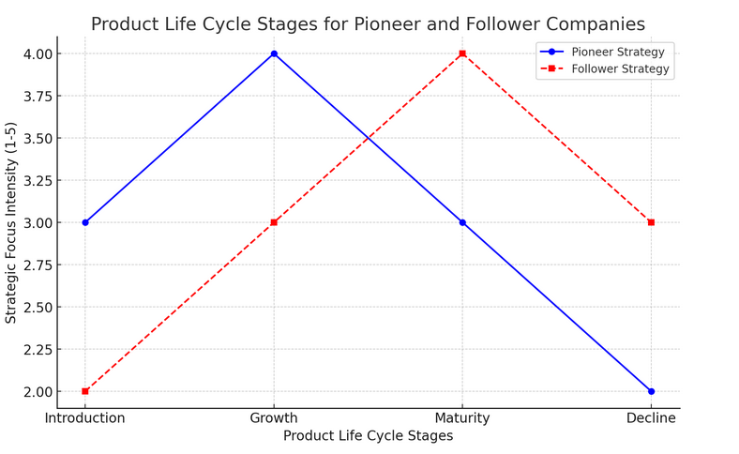

Explanation of the Chart: Product Life Cycle Stages for Pioneer and Follower Companies
The chart visually represents the strategic focus intensity of pioneer and follower companies across the four stages of the product life cycle: Introduction, Growth, Maturity, and Decline. The two lines—one for pioneers (blue solid line) and one for followers (red dashed line)—illustrate how each company type prioritizes its efforts at different stages.
First-Mover Advantage
Pioneer companies gain an early foothold in the market, often establishing a dominant brand presence. They capture customer loyalty before competitors enter. Example: Apple Inc. with the iPhone revolutionized the smartphone industry, creating a strong brand identity and securing market leadership.
Pricing Power
Pioneers can set prices and shape customer expectations. By being the first, they can implement premium pricing due to the novelty of the product. Example: Tesla with electric vehicles initially introduced higher-priced models like the Model S, leveraging its innovation status.
Innovation Leadership
Pioneers are seen as innovators, which can enhance their reputation and attract early adopters(Loon & Chik, 2018). Example: Amazon revolutionized e-commerce with its online bookstore, gaining a reputation for innovation and customer-centric services.
Barriers to Entry for Competitors
Pioneers often create significant barriers for competitors, such as strong customer loyalty, economies of scale, and intellectual property.
Advantages of Being a Follower: Follower companies enter the market after the pioneer, observing and learning from their successes and failures. Advantages include:
Reduced Risk
Followers benefit from the lessons learned by pioneers, avoiding costly mistakes(J. Kim & Ahn, 2024). Example: Google was a follower in the search engine market but outperformed pioneers like AltaVista by improving functionality and user experience.
Lower Development Costs
Followers save on research and development by replicating or improving existing products(S. Kim et al., 2022). Example: Samsung entered the smartphone market after Apple but captured significant market share by offering competitive features.
Improved Product Offering
Followers refine and enhance products based on customer feedback from pioneers. Example: Microsoft's Xbox entered the gaming console market after Sony's PlayStation, leveraging its technological expertise to deliver unique features.
Strategies for Follower Companies
Introduction Phase
Market Penetration Pricing: Offer products at competitive prices to attract customers(Rémy et al., 2024). Value Proposition: Emphasize differentiation from the pioneer. Example: Xiaomi entered the smartphone market with affordable yet feature-rich products.

Growth Phase
Aggressive Expansion: Increase distribution channels and leverage economies of scale. Collaborations: Partner with other firms to improve offerings. Example: Microsoft partnered with game developers to enhance the Xbox ecosystem.
Maturity Phase
Niche Targeting: Focus on underserved customer segments. Continuous Improvement: Regularly update products to match customer preferences(Ali et al., 2025). Example: Huawei entered mature smartphone markets by targeting enterprise customers.
Decline Phase
Adaptation: Shift to emerging trends or new product categories. Example: LG exited the smartphone market to focus on home appliances and automotive components(Jahanshahi et al., 2024).
Chart: Product Life Cycle Stages for Pioneer and Follower Companies
A graphical representation showing the key strategies for pioneers and followers at each stage of the product life cycle is added in the explanation field.

Conclusion
Both pioneer and follower strategies offer unique advantages and risks. Pioneers benefit from first-mover advantages like brand loyalty and innovation leadership, while followers capitalize on market validation and reduced risks. Successful companies adapt their strategies at different stages of the product life cycle to ensure growth and maintain competitive advantage. This comparative analysis demonstrates that the success of either strategy depends on effective implementation and responsiveness to internal and external factors. In a market that is always shifting and developing, businesses may position themselves to gain a sustainable competitive advantage by gaining knowledge from their previous triumphs and mistakes.
Reference:
Ali, I., Golgeci, I., Gligor, D., & Arslan, A. (2025). Unlocking the potential of prosocial motives in fostering environmental and socialinnovation: the roles of creativity-relevant skills and business moral values. Journal of Business and Industrial Marketing. https://doi.org/10.1108/JBIM-09-2023-0495
Bertoni, F., Bonini, S., & Capizzi, V. (2020). Digitization in the Market for Entrepreneurial Finance: Innovative Business Models and New Financing Channels ETP Special Issue. https://ssrn.com/abstract=3942659
Foss, N. J., & Klein, P. G. (2024). Do we Need a ‘New Strategy Paradigm’? No. Journal of Management Studies. https://doi.org/10.1111/joms.13081
Frederick, D. P. (2022). SRINIVAS PUBLICATION Dsouza Prima Frederick, (2022); International Journal of Case Studies in Business, IT and Education (IJCSBE) A Refereed International Journal of Srinivas University. India. International Journal of Case Studies in Business, 6(1), 2581–6942. https://doi.org/10.5281/zenodo.5978946
Gupta, P., Steward, M., Narus, J., & Seshadri, D. V. R. (2021). Pursuing Digital Marketing and Sales Transformation in an Emerging Market: Lessons from India’s Tata Steel. Vikalpa, 46(4), 197–208. https://doi.org/10.1177/02560909211054700
Huikkola, T., Kohtamäki, M., & Rabetino, R. (2025). Becoming a Circular Ecosystem: Altering Nested Identities, Positions, Capabilities, and Boundaries in Waste-Management Organizations. Organization & Environment. https://doi.org/10.1177/10860266251324228
Jahanshahi, A. A., Cakir, F. S., Kalaycioglu, O., & Adiguzel, Z. (2024). Driving innovation from within: the role of a supportive workplace in fostering managerial innovation in Turkey’s export-oriented machinery sector. In Middle East J. Management (Issue Y).
Kim, J., & Ahn, S. (2024). The platform policy matrix: Promotion and regulation. Policy and Internet. https://doi.org/10.1002/poi3.414
Kim, S., College, B., & Schifeling, T. (2022). Good Corp, Bad Corp, and the Rise of B Corps: How Market Incumbents’ Diverse Responses Reinvigorate Challengers.
Loon, M., & Chik, R. (2018). Efficiency-Centered, Innovation-Enabling Business Models of High Tech SMEs: Evidence from Hong Kong.
Rassanjani, S., Herizal, H., Mukhrijal, M., Alqarni, W., & Usman, B. (2021). Managing creativity and innovation in the 4th industrial revolution: Learning from giants. Journal of Innovation in Business and Economics, 5(01), 15–22. https://doi.org/10.22219/jibe.v5i01.15390
Ray, K., & Sharma, M. (2020). Qualitative study of challenges and strategies of Indian IT organizations toward global branding. Benchmarking, 27(2), 708–731. https://doi.org/10.1108/BIJ-09-2018-0279
Rémy, E., Roux, D., Arnould, E., Askegaard, S., Beudaert, A., Galluzzo, A., Giannelloni, J.-L., & Marion, G. (2024). Look up! Five research proposals for rethinking marketing in a post-growth society. Recherche et Applications En Marketing (English Edition), 39(1), 73–93. https://doi.org/10.1177/20515707231221614
Spann, M., Bertini, M., Koenigsberg, O., Zeithammer, R., Aparicio, D., Chen, Y., Fantini, F., Zhe Jin, G., Morwitz, V., Popkowski Leszczyc, P., Ana Vitorino, M., Yalcin Williams, G., Yoo, H., Chen NYU Shanghai, Y., & Yalcin Williams Austin, G. U. (2025). Algorithmic Pricing: Implications for Marketing Strategy and Regulation.

