AJAX.Net
Advanced Web Development

9/14/2011
Swansea Metropolitan University
Mike Dacey

Introduction to AJAX.Net

AJAX.Net provides AJAX components in ASP.NET to integrate cross-browser script libraries with the ASP.NET server side Web application framework.

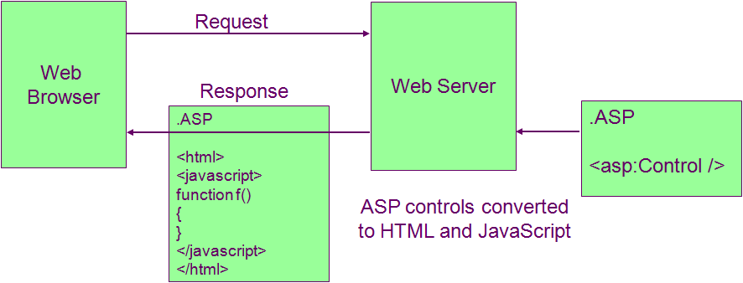

AJAX.Net is divided into a client framework running a JavaScript library on the browser and server framework to support it running on the web server.

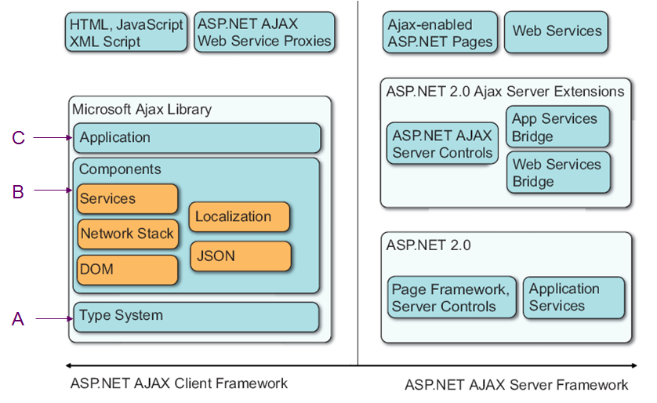

The client framework consists of a Microsoft Ajax Library, also known as the core library and consists of a set of JavaScript files that can be used independently from the server features. It provides three core levels of functionality.

- A type system adds object-oriented programming support to JavaScript including classes, inheritance, interfaces, and event-handling. It also extends existing JavaScript types e.g the String and Array types
- The components layer support for JSON serialization, network communication, localization, DOM interaction, and ASP.NET application services like authentication and profiles. It allows building of reusable modules providing controls and behaviours on a page.
- An application layer (a more descriptive title is the application model). Similar to the page lifecycle in ASP.NET it provides an event-driven programming model to work with DOM elements and controls lifecycle of an application in the browser.

The server framework provides three extensions to ASP.Net, AJAX Server Controls, a Web Services Bridge and an Application Services Bridge.

The additional ASP.Net AJAX server controls include <ScriptManager>, <UpdatePanel>, etc. To allow web services to be called from JavaScript using AJAX, the Web Services Bridge extends ASP.Net to generate dynamic JavaScript to create Ajax Web Services Proxies that the client JavaScript can call to invoke web service methods (see later notes). Finally, the Application Services Bridge allow client JavaScript to use ASP.Net services such as authentication and profiles.

ScriptManager Control

The ScriptManager control is central to AJAX functionality in ASP.NET. The control manages all ASP.NET AJAX resources on a page. This includes downloading Microsoft AJAX Library scripts to the browser and coordinating partial-page updates that are enabled by using UpdatePanel controls.
When partial-page rendering is supported, the ScriptManager control renders script to enable asynchronous postbacks and partial-page updates. The regions of the page to be updated are designated by using UpdatePanel controls. The ScriptManager control handles the asynchronous postbacks and refreshes only the regions of the page that have to be updated.

Only one should ever be added to any page.

Partial Page Rendering

Only the contents of the UpdatePanel is updated by the server. Partial-page rendering reduces the need for synchronous postbacks and complete page updates when only part of the page has to be updated. It also improves the user experience because it reduces the screen flicker that occurs during a full-page postback and improves Web page interactivity. The ability of an ASP.NET page to support partial-page rendering is controlled by the following factors:
- The ScriptManager control's EnablePartialRendering property must be true (the default value).
- There must be at least one UpdatePanel control on the page.
- The SupportsPartialRendering property must be true (the default value). If the SupportsPartialRendering property is not set explicitly, its value is based on browser capabilities.

Be careful when using MasterPages, a page can contain only one ScriptManager control in its hierarchy. To use UpdatePanel controls with master pages, you can put a ScriptManager control on the master page. In this scenario, the master page provides a ScriptManager control for every content page. If you do not want partial-page updates enabled for individual content pages, you can disable partial-page updates for those pages. Alternatively, you can put the ScriptManager control on each content page.
You might do this if only some of the content pages will contain UpdatePanel controls.

Always add ScriptManager control before any other AJAX controls:

<%@ Page Language="C#" AutoEventWireup="true" CodeBehind="BasicASPNet.aspx.cs" Inherits="BasicAjaxNetCSharp.BasicASPNet" %>

<!DOCTYPE html PUBLIC "-//W3C//DTD XHTML 1.0 Transitional//EN" "http://www.w3.org/TR/xhtml1/DTD/xhtml1-transitional.dtd">

<html xmlns="http://www.w3.org/1999/xhtml">
<head id="Head1" runat="server">
<title>Untitled Page</title>
</head>
<body>
<form id="form1" runat="server">
<div style="height: 173px">
<asp:ScriptManager ID="ScriptManager1" runat="server">
</asp:ScriptManager>

</div>
</form>
</body>
</html>

UpdatePanel Controls

An UpdatePanel control allows sections of a page to be partially rendered without a postback. It must be used in conjunction with the ScriptManager control to enable partial-page rendering. You can use multiple UpdatePanel controls to update different page regions independently.

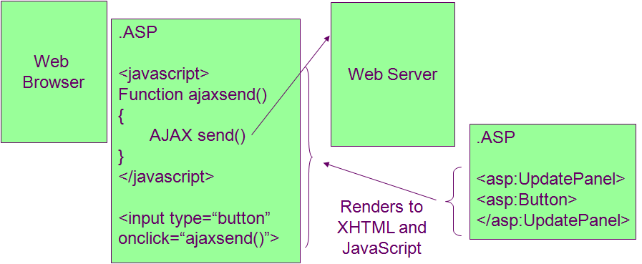

When the page that contains one or more UpdatePanel controls is first rendered, all the content of all UpdatePanel controls are rendered and sent to the browser. On subsequent asynchronous postbacks, the content of each UpdatePanel control may or may not be updated depending on the panel settings and on client or server logic for individual panels. These panels may be nested and can contain many ASP.Net controls including GridViews or Repeaters.

Unfortunately, all this magic doesn’t come without a performance penalty. When we want cause an update on an UpdatePanel, a full page post back occurs and all the form data on the webpage including the hidden fields are all sent back to the server not just the controls in the panel. The Web server executes the full page lifecycle as normal so we get the same performance hit that we would have had for a standard form postback. However, only the content that is necessary to update the UpdatePanel contents is sent back to the client so we win a little here. Remember all the data is posted backed and in terms of resources and consumption on the server the entire page life cycle is executed as usual.

<%@ Page Language="C#" AutoEventWireup="true" CodeBehind="BasicASPNet.aspx.cs" Inherits="BasicAjaxNetCSharp.BasicASPNet" %>

<!DOCTYPE html PUBLIC "-//W3C//DTD XHTML 1.0 Transitional//EN" "http://www.w3.org/TR/xhtml1/DTD/xhtml1-transitional.dtd">

<html xmlns="http://www.w3.org/1999/xhtml">
<head id="Head1" runat="server">
<title>Untitled Page</title>
</head>
<body>
<form id="form1" runat="server">
<div style="height: 173px">
<asp:ScriptManager ID="ScriptManager1" runat="server">
</asp:ScriptManager>

<asp:UpdatePanel ID="pane1" runat="server">
<ContentTemplate>
Updateable content goes here!!
</ContentTemplate>
</asp:UpdatePanel>
</div>

</div>
</form>
</body>
</html>

Any ASP.Net controls contained within an UpdatePanel which cause a page post back, will update the contents of the panel itself.

The UpdatePanel control has an UpdateMode property that determine when the panel will be updated. By default (if you don’t explicitly set it) it is set to “Always”, and the UpdatePanel control's content is updated on every postback that originates from the page. This includes asynchronous postbacks from controls that are inside other UpdatePanel controls and postbacks from controls that are not inside UpdatePanel controls.

Say we add a button:

<%@ Page Language="C#" AutoEventWireup="true" CodeBehind="BasicASPNet.aspx.cs" Inherits="BasicAjaxNetCSharp.BasicASPNet" %>

<!DOCTYPE html PUBLIC "-//W3C//DTD XHTML 1.0 Transitional//EN" "http://www.w3.org/TR/xhtml1/DTD/xhtml1-transitional.dtd">

<html xmlns="http://www.w3.org/1999/xhtml">
<head id="Head1" runat="server">
<title>Untitled Page</title>
</head>
<body>
<form id="form1" runat="server">
<div style="height: 173px">
<asp:ScriptManager ID="ScriptManager1" runat="server">
</asp:ScriptManager>

<asp:Label ID="label1" runat="server" /> Not affected by update

<asp:UpdatePanel ID="pane1" runat="server">
<ContentTemplate>
<p>This label is updated when Button One is clicked
or when any other panel is updated</p>
<asp:Label ID="label2" runat="server" />
<asp:Button ID="button1" Text="Button One"
runat="server" onclick="button1_Click" />
</ContentTemplate>
</asp:UpdatePanel>

</div>
</form>

using System;
using System.Collections.Generic;
using System.Linq;
using System.Web;
using System.Web.UI;
using System.Web.UI.WebControls;

namespace BasicAjaxNetCSharp
{
public partial class BasicASPNet : System.Web.UI.Page
{
protected void Page_Load(object sender, EventArgs e)
{
label1.Text = DateTime.Now.ToLongTimeString();
label2.Text = DateTime.Now.ToLongTimeString();
}

protected void button1_Click(object sender, EventArgs e)
{
// Do nothing
}
}
}

When the button is clicked the page is loaded again, Page_Load() is called and we change the time displayed in the label. Remember this is using AJAX, so only the label2 is re-displayed and shows the updated time.

Lets add a second update panel:

<%@ Page Language="C#" AutoEventWireup="true" CodeBehind="BasicASPNet.aspx.cs" Inherits="BasicAjaxNetCSharp.BasicASPNet" %>

<!DOCTYPE html PUBLIC "-//W3C//DTD XHTML 1.0 Transitional//EN" "http://www.w3.org/TR/xhtml1/DTD/xhtml1-transitional.dtd">

<html xmlns="http://www.w3.org/1999/xhtml">
<head id="Head1" runat="server">
<title>Untitled Page</title>
</head>
<body>
<form id="form1" runat="server">
<div style="height: 173px">
<asp:ScriptManager ID="ScriptManager1" runat="server">
</asp:ScriptManager>

<p>This label is part of the main page and is updated
when the entire page is refreshed</p>
<asp:Label ID="label1" runat="server" />

<asp:UpdatePanel ID="pane1" runat="server">
<ContentTemplate>
<p>This label is updated when Button One is clicked
or when any other panel is updated</p>
<asp:Label ID="label2" runat="server" />
<asp:Button ID="button1" Text="Button One"
runat="server" onclick="button1_Click" />
</ContentTemplate>
</asp:UpdatePanel>

<asp:UpdatePanel ID="panel2" UpdateMode="Always" runat="server">
<ContentTemplate>
<asp:Label ID="label3" runat="server" /><br />
</ContentTemplate>
</asp:UpdatePanel>

</div>
</form>
</body>
</html>

using System;
using System.Collections.Generic;
using System.Linq;
using System.Web;
using System.Web.UI;
using System.Web.UI.WebControls;

namespace BasicAjaxNetCSharp
{
public partial class BasicASPNet : System.Web.UI.Page
{
protected void Page_Load(object sender, EventArgs e)
{
label1.Text = DateTime.Now.ToLongTimeString();
label2.Text = DateTime.Now.ToLongTimeString();
label3.Text = DateTime.Now.ToLongTimeString();
}

protected void button1_Click(object sender, EventArgs e)
{
// Do nothing
}
}
}

What happens if we click button1 again?
Actually the contents of both UpdatePanels change because they are both using the default UpdateMode of “Always”.

If the UpdateMode property is set to Conditional, the UpdatePanel control's content is updated in the following circumstances:

- When you call the Update method of the UpdatePanel control explicitly.
- When the UpdatePanel control is nested inside another UpdatePanel control, and the parent panel is updated.
- When a postback is caused by a control that is defined as a trigger by using the Triggers property of the UpdatePanel control. In this scenario, the control explicitly triggers an update of the panel content. The control can be either inside or outside the UpdatePanel control that the trigger is associated with.
- When the ChildrenAsTriggers property is set to true (the default value) and a child control inside of the UpdatePanel control causes a postback. Child controls of nested UpdatePanel controls do not cause an update to the outer UpdatePanel control unless they are explicitly defined as triggers.

Warning: The combination of setting the ChildrenAsTriggers property to false and the UpdateMode property to Always is not allowed and will throw an exception.

Add another UpdatePanel but this time make it’s UpdateMode “Conditional”:

<%@ Page Language="C#" AutoEventWireup="true" CodeBehind="BasicASPNet.aspx.cs" Inherits="BasicAjaxNetCSharp.BasicASPNet" %>

<!DOCTYPE html PUBLIC "-//W3C//DTD XHTML 1.0 Transitional//EN" "http://www.w3.org/TR/xhtml1/DTD/xhtml1-transitional.dtd">

<html xmlns="http://www.w3.org/1999/xhtml">
<head id="Head1" runat="server">
<title>Untitled Page</title>
</head>
<body>
<form id="form1" runat="server">
<div style="height: 173px">
<asp:ScriptManager ID="ScriptManager1" runat="server">
</asp:ScriptManager>

<p>This label is part of the main page and is updated
when the entire page is refreshed</p>
<asp:Label ID="label1" runat="server" />

<asp:UpdatePanel ID="pane1" runat="server">
<ContentTemplate>
<p>This label is updated when Button One is clicked
or when any other panel is updated</p>
<asp:Label ID="label2" runat="server" />
<asp:Button ID="button1" Text="Button One"
runat="server" onclick="button1_Click" />
</ContentTemplate>
</asp:UpdatePanel>

<asp:UpdatePanel ID="panel2" UpdateMode="Always" runat="server">
<ContentTemplate>
<p>This label is updated by Button Two which is
outside of this panel</p>
<asp:Label ID="label3" runat="server" /><br />
</ContentTemplate>
</asp:UpdatePanel>

<asp:UpdatePanel ID="UpdatePanel3"
UpdateMode="Conditional" Set this!!
runat="server">
<ContentTemplate>

<asp:Label ID="label4" runat="server" /><br />

This button is inside the panel so causes this panel<br />
to update because the ChildrenAsTriggers property is<br />
defaulted to true. It causes all three panels to update<br />
because the update modes of the other panels are set to<br />
Always.<br />

<asp:Button ID="button2" Text="Button Two" runat="server" />

</ContentTemplate>
</asp:UpdatePanel>

It causes all panels a & 2 to update because the update modes<br />
of these panels are set to Always.<br />
<asp:Button ID="button3" Text="Button Three" runat="server" />

</div>
</form>
</body>
</html>

using System;
using System.Collections.Generic;
using System.Linq;
using System.Web;
using System.Web.UI;
using System.Web.UI.WebControls;

namespace BasicAjaxNetCSharp
{
public partial class BasicASPNet : System.Web.UI.Page
{
protected void Page_Load(object sender, EventArgs e)
{
label1.Text = DateTime.Now.ToLongTimeString();
label2.Text = DateTime.Now.ToLongTimeString();
label3.Text = DateTime.Now.ToLongTimeString();
label4.Text = DateTime.Now.ToLongTimeString();
}

protected void button1_Click(object sender, EventArgs e)
{
// Do nothing
}
}
}

If we click on button1 what happens?

UpdatePanel1 and UpdatePanel2 will change as we expect but UpdatePanel3 doesn’t.

If we click button2 what happens?
All three panels change. Why does panel 1 & 2 change? Remember they are using the default UpdateMode of “Always” so they will change whenever any panel does a postback.

If you notice, button3 is not in any panel and represents ASP.Net controls that we have decided do not need to use AJAX. What if we click it? As before, panels 1 and 2 change as we would expect.

Triggers

Sometimes you want a control that’s outside of a panel to cause that panel to be updated then we can use a Trigger for this.

UpdatePanels may have Triggers that can either be:
- AsyncPostBack triggers
These allow controls that are outside a panel to be triggers for an UpdatePanel control. Controls that are triggers for an update panel cause a refresh of the panel's content after an asynchronous postback.
- PostBack triggers
These allow controls inside an UpdatePanel to cause a postback instead of performing an asynchronous postback. Only useful if you want to perform an operation that takes some time to complete and the user should not initiate it again until it is complete. (Typically we would never use these)

Say we add a button4 to the page that we want to cause panel3 to update:

<%@ Page Language="C#" AutoEventWireup="true" CodeBehind="BasicASPNet.aspx.cs" Inherits="BasicAjaxNetCSharp.BasicASPNet" %>

<!DOCTYPE html PUBLIC "-//W3C//DTD XHTML 1.0 Transitional//EN" "http://www.w3.org/TR/xhtml1/DTD/xhtml1-transitional.dtd">

<html xmlns="http://www.w3.org/1999/xhtml">
<head id="Head1" runat="server">
<title>Untitled Page</title>
</head>
<body>
<form id="form1" runat="server">
<div style="height: 173px">
<asp:ScriptManager ID="ScriptManager1" runat="server">
</asp:ScriptManager>

<p>This label is part of the main page and is updated
when the entire page is refreshed</p>
<asp:Label ID="label1" runat="server" />

<asp:UpdatePanel ID="pane1" runat="server">
<ContentTemplate>
<p>This label is updated when Button One is clicked
or when any other panel is updated</p>
<asp:Label ID="label2" runat="server" />
<asp:Button ID="button1" Text="Button One"
runat="server" onclick="button1_Click" />
</ContentTemplate>
</asp:UpdatePanel>

<asp:UpdatePanel ID="panel2" UpdateMode="Always" runat="server">
<ContentTemplate>
<p>This label is updated by Button Two which is
outside of this panel</p>
<asp:Label ID="label3" runat="server" /><br />
</ContentTemplate>
</asp:UpdatePanel>

<asp:UpdatePanel ID="UpdatePanel3"
UpdateMode="Conditional"
runat="server">
<ContentTemplate>

<asp:Label ID="label4" runat="server" /><br />

This button is inside the panel so causes this panel<br />
to update because the ChildrenAsTriggers property is<br />
defaulted to true. It causes all three panels to update<br />
because the update modes of the other panels are set to<br />
Always.<br />

<asp:Button ID="button2" Text="Button Two" runat="server" />

</ContentTemplate>
<Triggers>
<asp:AsyncPostBackTrigger ControlID="button4"
EventName="Click" />
</Triggers>
</asp:UpdatePanel>

It causes all panels a & 2 to update because the update modes<br />
of these panels are set to Always.<br />
<asp:Button ID="button3" Text="Button Three" runat="server" />

<asp:Button ID="button4" Text="Button Four" runat="server" />

</div>
</form>
</body>
</html>

What happens if we click button4?
Actually all the panels change, panel 1 & 2 because they are using the default UpdateMode and panel3 because we used the trigger.

AJAX.Net Web Services

Simple web services can be created in Visual Studio, using.asmx files (right click on the ASP.Net Web Project).

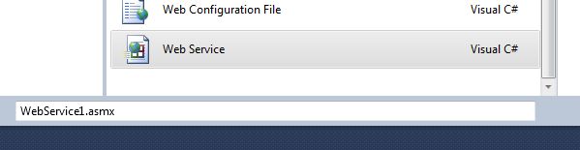

It should be noted that this is a old style web services (.Net2) and the more up to date method is to use WCF and .svc services. However, they are still used today for simple services and are easier to implement. Furthermore, they integrate nicely with AJAX.Net, which is the built into ASP.Net to support web services. Later we will use REST services which are more commonly used for web applications, and they will be built using WCF.

To be honest, AJAX.Net is probably not widely used as it was always considered to be a bit of a mess. In my opinion, jQuery is the way to go. However, it is worth a brief look at because it integrates fairly cleanly with ASP.Net and you may want to stay in the .Net world come what may!!!
You can use jQuery with AJAX.Net web services, I won’t go into it but I do have some notes if you want them.

Here’s a simple web services to return a “Hello World” message.

using System;
using System.Collections.Generic;
using System.Linq;
using System.Web;
using System.Web.Services;

namespace BasicAjaxNetCSharp
{
/// <summary>
/// Summary description for WebService
/// </summary>
[WebService(Namespace = "http://tempuri.org/")]
[WebServiceBinding(ConformsTo = WsiProfiles.BasicProfile1_1)]
[System.ComponentModel.ToolboxItem(false)]
[System.Web.Script.Services.ScriptService] Uncomment this line
public class WebService : System.Web.Services.WebService
{

[WebMethod] Add attribute before method
public string HelloWorld(string user)
{
return "Hello World from " + user;
}
}
}

Notice the two changes highlighted above, ScriptService is enabled and the method is flagged as a WebMethod. These two changes convert the service into an AJAX enabled service (i.e. for AJAX.Net use), and the service returns JSON data and dynamically creates the JavaScript proxy code to use the service. The AJAX Web service proxy code mimics the service by providing JavaScript functions that duplicate the service methods signatures (names & arguments) and these functions contain the necessary AJAX code to call the associated service method.

The service returns the JavaScript when the URI finished with /js, and you can actually view the code being returned by just typing this in the URL in the browser. For example, assuming the file is WebService.asmx, run it and modify the URI to add /js something like this:

http://localhost:1287/WebService.asmx/js

The results look something like this:

Type.registerNamespace('BasicAjaxNetCSharp');
BasicAjaxNetCSharp.WebService=function() {
BasicAjaxNetCSharp.WebService.initializeBase(this);
this._timeout = 0;
this._userContext = null;
this._succeeded = null;
this._failed = null;
}
BasicAjaxNetCSharp.WebService.prototype={

..... Lots of extra code here !!!

BasicAjaxNetCSharp.WebService.HelloWorld= function(user,onSuccess,onFailed,userContext) {BasicAjaxNetCSharp.WebService._staticInstance.HelloWorld(user,onSuccess,onFailed,userContext); }

Using AJAX.Net you call the services method by specify the namespace, web service and method name as follows:
namespace.webservice.webmethod(comma separated arguments,
successCallback,
failCallback,
userContext)

userContext is some data you specify which will also be returned in the callback functions in addition to the web service data. Often you don’t need this, so leave it out.

Looking at the above service, to call HelloWorld we would use:

BasicAjaxNetCSharp.WebService.HelloWorld("Bob James", argument
CallComplete, success callback
CallFailed); fail callback

Here’s an example where the user name is read from a text box and the message is displayed in an alert window.

<%@ Page Language="C#" AutoEventWireup="true" CodeBehind="UsingWebService1.aspx.cs" Inherits="BasicAjaxNetCSharp.UsingWebService1" %>

<!DOCTYPE html PUBLIC "-//W3C//DTD XHTML 1.0 Transitional//EN" "http://www.w3.org/TR/xhtml1/DTD/xhtml1-transitional.dtd">

<html xmlns="http://www.w3.org/1999/xhtml">
<head runat="server">
<title></title>
<script type="text/javascript">

function PageLoad()
{
}

function CallService()
{
BasicAjaxNetCSharp.WebService.HelloWorld(
document.getElementById("text1").value,
CallComplete,
CallFailed);
}

// Service completed successfully
// result = the return value e.g. “Hello World from Bob James”
function CallComplete(result)
{
window.alert("Call successful " + result);
}

// Some error occurred
// result = some error message
function CallFailed(result)
{
window.alert("Call failed " + result.get_message());
}

</script>
</head>
<body>
<form id="form1" runat="server">
<div>
<asp:ScriptManager ID="ScriptManager1" runat="server"> Add this
<Services>
<asp:ServiceReference Path="~/WebService.asmx" /> Add this
</Services>
</asp:ScriptManager>

<asp:TextBox ID="text1" runat="server" />

<!-- Button is rendered as <input type="submit" />
<!-- Return false from OnClientClick to prevent default submit
behaviour of button. IE doesn't care, but for Firefox omitting this
will cause the service method fails -->
<asp:Button ID="readbutton" Text="Call Service"
OnClientClick="CallService(); return false;"
runat="server" />
</div>
</form>
</body>
</html>

To use AJAX.Net you need to add a ScriptManager and a ServiceReference, these should only be added to the page once (be careful when using MasterPages).
Hint: In AJAX.Net you can replace document.getElementById() by the simple shorthand $get(), so the above would become:

BasicAjaxNetCSharp.WebService.HelloWorld($get("text1").value,
CallComplete,
CallFailed);

Here’s an example that passes two numbers to a web service:

BasicAjaxNetCSharp.ExceptionGenerator.Divide(parseInt($get("num1").value),
parseInt($get("num2").value),
CallComplete,
CallFailed);

For debugging purposes (bad in real world), you may want to display the cause of any crash in the web service by changing the error callback:

function CallFailed(result)
{
$get("errors").innerHTML = Display in page somewhere
"<b>" + result.get_exceptionType() + "</b>"
+ " : " + result.get_message()
+ "<br/>" + result.get_stackTrace();
}

AJAX.Net Returning Complex Data (Objects)

This turns out to be very easy. Say we want to return a message which we will create as a C# object using a Message class. We need to tell the service that it has to generate JavaScript proxy code for our new class, so we add an attribute GenerateScriptType and specify the Message class. Now you can just return objects from C# to JavaScript.

using System;
using System.Collections.Generic;
using System.Linq;
using System.Web;
using System.Web.Services;

namespace BasicAjaxNetCSharp
{
public class Message Here’s the class
{
public string _msgText;
public int _sentTime;
}

/// <summary>
/// Summary description for ComplexDataService
/// </summary>
[WebService(Namespace = "http://tempuri.org/")]
[WebServiceBinding(ConformsTo = WsiProfiles.BasicProfile1_1)]
[System.ComponentModel.ToolboxItem(false)]
[System.Web.Script.Services.ScriptService] Remember this!!
[System.Web.Script.Services.GenerateScriptType(typeof(Message))] Add
public class ComplexDataService : System.Web.Services.WebService
{
[WebMethod]
public Message ReadMessage()
{
Message msg = new Message();
msg._msgText = "Hello World";
msg._sentTime = 22;
return msg;
}
}
}

Sometimes you want to store some small amount of data between web service accesses, for example as the user moves between pages. Of course, we would use a session variable for this. To use sessions set the EnableSession attribute for the web method [WebMethod(EnableSession=true)]. In ASP.Net the session variables are accessed through the HttpContext, using a collection called Session. A collection is a dynamic ‘array’ of name value pairs, if a named element doesn’t exist it is automatically created the first time you put a value in it.

HttpContext.Current.Session["Message"] = msg;

For fun, we’ll alter the above example to receive an store a message along with the current time. Then ReadMessage() can return this data as an object.

using System;
using System.Collections.Generic;
using System.Linq;
using System.Web;
using System.Web.Services;

namespace BasicAjaxNetCSharp
{
public class Message Here’s the class
{
public string _msgText;
public int _sentTime;
}

/// <summary>
/// Summary description for ComplexDataService
/// </summary>
[WebService(Namespace = "http://tempuri.org/")]
[WebServiceBinding(ConformsTo = WsiProfiles.BasicProfile1_1)]
[System.ComponentModel.ToolboxItem(false)]
[System.Web.Script.Services.ScriptService] Remember this!!
[System.Web.Script.Services.GenerateScriptType(typeof(Message))] Add
public class ComplexDataService : System.Web.Services.WebService
{

[WebMethod(EnableSession=true)]
public bool SendMessage(string msg)
{
HttpContext.Current.Session["Message"] = msg;
HttpContext.Current.Session["Time"] = DateTime.Now.Second;
return true;
}

[WebMethod(EnableSession=true)]
public Message ReadMessage()
{
Message msg = new Message();
msg._msgText = (string)HttpContext.Current.Session["Message"];
msg._sentTime = (int)HttpContext.Current.Session["Time"];
return msg;
}
}
}

Notice I’ve used the GenerateScriptType attribute applied to the class, so that any method the class can now use the Message class. You can also associate this attribute to a single method, if only that method will be using the class.

Here’s the client side:

<%@ Page Language="C#" AutoEventWireup="true" CodeBehind="UsingWebServices5.aspx.cs" Inherits="BasicAjaxNetCSharp.UsingWebServices5" %>

<!DOCTYPE html PUBLIC "-//W3C//DTD XHTML 1.0 Transitional//EN" "http://www.w3.org/TR/xhtml1/DTD/xhtml1-transitional.dtd">

<html xmlns="http://www.w3.org/1999/xhtml">
<head runat="server">
<title></title>
<script type="text/javascript">

function PageLoad()
{
setInterval("ReadMessage();", 10000);
}

function SendMessage()
{
BasicAjaxNetCSharp.ComplexDataService.SendMessage(
$get("msg").value,
DoNothing,
DoNothing);
}

function DoNothing(result)
{
}

function ReadMessage()
{

BasicAjaxNetCSharp.ComplexDataService.ReadMessage(GotMessage,
CallError);

setInterval("ReadMessage();", 10000);
}

function GotMessage(result)
{
// result = an object of type Message (see ComplexDataService.cs)
$get("messages").innerHTML = result._msgText;
$get("senttime").innerHTML = result._sentTime;
date = new Date();
$get("ticks").innerHTML = date.getSeconds();
}

function CallError(result)
{
window.alert("Exception occurred: " + result.get_exceptionType());
}

</script>
</head>
<body onload="PageLoad();">
<form id="form1" runat="server">
<div>
<asp:ScriptManager ID="ScriptManager1" runat="server">
<Services>
<asp:ServiceReference Path="~/ComplexDataService.asmx" />
</Services>
</asp:ScriptManager>

<asp:TextBox ID="msg" runat="server" />

<asp:Button ID="send" Text="Send Message"
OnClientClick="SendMessage(); return false;"
runat="server" />

<asp:Panel ID="messages" runat="server" />
<asp:Panel ID="senttime" runat="server" />
<asp:Label ID="ticks" runat="server" />
</div>
</form>
</body>
</html>

Notice, how reading the C# Message object has been converted to a JavaScript object so we can just read the attributes:

result._msgText;
result._sentTime;

JavaScript Classes Revisited

When we are sending JSON between the browser and server, it would be nice if we could “send” C# objects and map them to equivalent JavaScript objects. We can do this using jQuery extend method (see the JSON notes).

Assuming we have a JavaScript Student class, an example would be:

var jsonString = '{ "name":"Mike", "age":21 }';
var jsonData = JSON.parse(jsonString);

var student = new Student(); Create object
$.extend(true, student, jsonData); Copy the data
window.alert("Student obj name " + student.GetName()); Use a method

Also we talked about using a Web service to send back C# objects in JSON, say we have a C# class like this:

namespace BasicAjaxNetCSharp
{
public class Dog
{
private string _breed;
private int _age;

// Default Constructor
public Dog() // Needed for serialization. Why??
{
}

public Dog(string breed, int age)
{
_breed = breed;
_age = age;
}

public string Breed
{
get
{
return _breed;
}
set
{
_breed = value;
}
}

public int Age
{
get
{
return _age;
}
set
{
_age = value;
}
}
}
}

Here’s the code for a service to return an array of C# Dog objects:

namespace BasicAjaxNetCSharp
{
/// <summary>
/// Summary description for MyDogsService
/// </summary>
[WebService(Namespace = "http://tempuri.org/")]
[WebServiceBinding(ConformsTo = WsiProfiles.BasicProfile1_1)]
[System.ComponentModel.ToolboxItem(false)]
[System.Web.Script.Services.ScriptService] Uncomment this!!
public class MyDogsService : System.Web.Services.WebService
{
[WebMethod]
[System.Web.Script.Services.GenerateScriptType(typeof(Dog))] Add
public Dog[] ReadDogs()
{
Dog[] dogs = new Dog[2];

dogs[0] = new Dog("Alsation", 5);
dogs[1] = new Dog("SheepDog", 4);

return dogs; Send back array of C# Dog objects
}
}
}

Notice I’ve used the GenerateScriptType attribute on the method instead of the class, because I only want this method to use the Dog class. Otherwise associate with the class so any method can use it.

On the client side we call the service to read back the JSON and create the corresponding JavaScript objects:

<%@ Page Language="C#" AutoEventWireup="true" CodeBehind="UsingWebServicejQuery6.aspx.cs" Inherits="BasicAjaxNetCSharp.UsingWebServicejQuery6" %>

<!DOCTYPE html PUBLIC "-//W3C//DTD XHTML 1.0 Transitional//EN" "http://www.w3.org/TR/xhtml1/DTD/xhtml1-transitional.dtd">

<html xmlns="http://www.w3.org/1999/xhtml">
<head runat="server">
<title></title>
<script src="Scripts/jquery-1.4.1.js" type="text/javascript"></script>
<script type="text/javascript">

$(PageReady);

function PageReady()
{
// Add event handlers to buttons
$("#readButton").click(AjaxReadClick);
}

function AjaxReadClick(e)
{
e.preventDefault();

$.ajax({
cache: false,
type: "POST",
url: "WebSumService.asmx/ReadDogs",
data: "{}",
contentType: "application/json; charset=utf-8",
dataType: "json",
success: AjaxReadSuccessful,
error: AjaxError
});
}

// JavaScript Dog class definition
Dog.prototype =
{
Breed: "",
Age: 0,

Bark: function ()
{
window.alert("I'm a "
+ this.Breed
+ " and I am barking loudly!!!");
}
}

// Constructor
function Dog()
{
// Do nothing
// We'll read the values we are sent
}

function AjaxReadSuccessful(json, status, req)
{
var dogs = json.d; .d is required to read the JSON data
var text = "";

for (var i = 0; i < dogs.length; i++)
{
var dog = new Dog();
$.extend(true, dog, dogs[i]);
dog.Bark(); Make each dog Bark !!!
}
}

function AjaxError(req, status, error)
{
window.alert("Got error\nstatus: " + status
+ "\nrequestStatus: " + req.status
+ "\nrequestRdyStatus: "
+ req.readyState + "\n"
+ req.statusText);
}
</script>
</head>
<body>
<form id="form1" runat="server">
<div>

<br /><asp:Button ID="readButton" Text="Read Dogs" runat="server" />

</div>
</form>
</body>
</html>

The JavaScript Dog class is defined and then we look through the array of JSON, creating new Dog objects and merging the new values with the object. Just for fun we call the method we provided with the JavaScript class.

for (var i = 0; i < dogs.length; i++)
{
var dog = new Dog();
$.extend(true, dog, dogs[i]);
dog.Bark(); Make each dog Bark !!!
}

Of course, you would probably store the JavaScript objects in array to be used somewhere else in you code.

var dogs = new Array();
var dog;

for (var i = 0; i < dogs.length; i++)
{
dog = new Dog();
$.extend(true, dog, dogs[i]);
dogs[i] = dog;
}

