

MODULE CODE: LCBB4003
Introducing the Modern Workplace Assessment 1
Organizational structure and culture, and their impacts on the performance of Uber UK
Module Lecture: Gregory Cowan
Student Name: Robert Alexandru Merghisescu
Student ID: 1907185

May 2020
Organizational structure and culture, and their impacts on the performance of Uber UK

Introduction

This essay represents the business structure and culture of Uber UK. Also, it shows the impact of its structure and culture on the performance of the company. In the first part of the essay, the structure and culture of the company are discussed. The company follows a flat organizational structure among the four basic organizational structures of a company. The logic behind the conclusion of this structure is discussed in the essay. Then the organizational structure of Uber UK is discussed from the dimensions of Hofstede's cultural dimensions model. Here it is also discussed how the new CEO has made the culture effective and friendly for the organization through change management (Kaplan, and Manners, 2016). Then in the second phase of the essay, the impact of this flat structure and company culture on the performance of the company is discussed. Here the positive sides of using a flat structure and also holding a positive culture are discussed.

Structure and culture of Uber, UK
Structure of a company indicates the leadership, management and operation process that a company follow to operate their day to day operations. The structure generally deals with employee structure of the company like who reports to whom, who is obliged to whom and so on. Generally, there are four famous organizational structure –

Figure: Four organizational structure.
Source: (Thompson, and Wildavsky, 2012)
Divisional structure, this is the structure where the company is divided into different divisions. Each division has its own upper level, mid-level and operational level employees. The employees of one division are subject to report in his own division but bot the other divisions. Chain of command is strong in this structure and less confusion and contradiction arises among employees. Functional structure, this is the traditional organization structure where the employees are divided and allocated according to their expertise and knowledge base. This structure also ensures less confusion and contradiction and also ensures greater output because employees are assigned accordingly. Matrix structure, the matrix is the most difficult and confusing structure where the employees report to more than one bosses. This structure is effective but it arises confusion and contradiction sometimes. Flat structure, this is the least confusing organizational structure. This is the structure where there is very few and sometimes no mid-level employees between top management and lower level or operational level employees (Schein, 2017). For example, the structure shown below is the flat structure. It is visible that there is no mid-level manager between the CEO and other divisional employees.
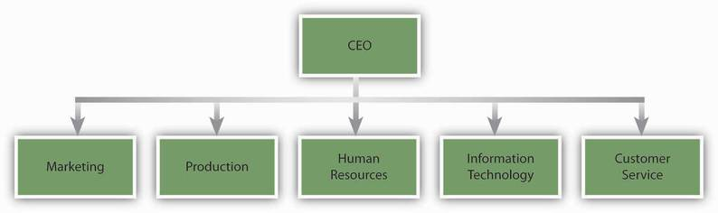
Figure: Flat organizational structure
Source: (Woodside, 2015)
As it is already discussed that the selected organization here is the Uber UK, now the structure of this company will be discussed. Uber UK follows a flat structure in its operation and employee management. Chief executive officer holds a higher position in the structure. After the position of CEO, the Senior Vice President and the Chief Officers of every functions and division are subject to report to the CEO. Also, the Head of other operations is subject to report to the CEO. We can see that there are no unnecessary mid-level divisions in the structure of the organization. The organizational structure of Uber is shown in the figure below –
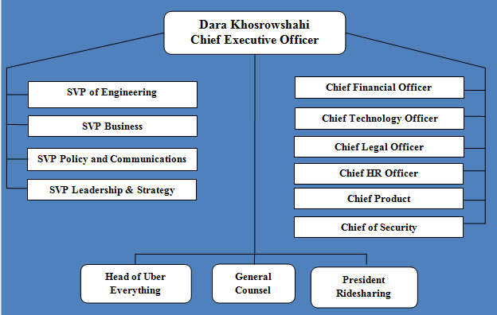
Figure: Organizational structure of Uber UK.
Source: (Aslam, and Woodcock, 2020)

Here we can see that the senior vice president of engineering business, communication and leadership report directly to the CEO. Also the chief of financial, legal, human resource and other operations also report directly to the CEO. On the other hand, head of everything, general counsel and president of ridesharing also report to the CEO. There is no unnecessary mid-level management or division. So it is visible from the structure that it follows a flat structure. Just like the cultural issue, Uber was facing difficulties in its leadership style. The leadership style of its previous CEO was considered as bad leadership. But the new CEO shaped the leadership strategy as well as the cultural issue. He follows a democratic style in leadership which comply with the flat structure of the company. Throughout his leadership, he teaches employees to remain focused on their goal, to take risky measures when necessary and to keep everything simple.
Hofstede’s cultural dimension model shows cross-cultural communication if companies. There are six dimensions of the culture of a company. Hofstede's model is shown in the figure below-
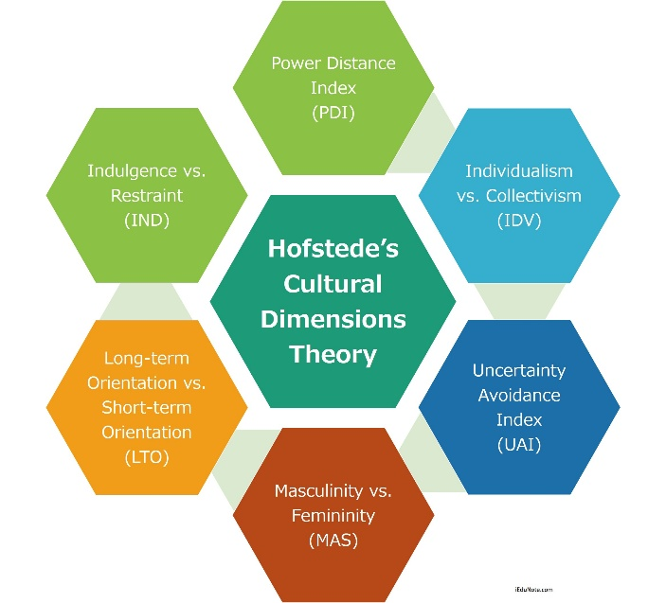
Figure: Hofstede’s cultural dimensions model
Source: (Harrington, 2012)

Individualism and collectivism show how much a company is separated from its peer and competing firms or how much a company is integrated into groups and social gatherings. As Uber's business policy involves communication with a lot of customers it follows collectivism. Power distance index indicates how much power the top level holds in the organizational structure. As Uber follows fiat structure, the operational level employees can reach to its CEO and power distance is very low. Uncertainty avoidance index indicates how much unclear information the society and customer base of a company expect and accept from that company. As Uber UK is a public limited company since 2019, it shares all its information and reports to the public. Masculinity vs. femininity, this dimension indicates how much the culture of the company discriminate among gender, race, ethnicity and other demographic factors. The main point of this dimension is gender discrimination (Com, 2017). Uber UK was facing gender discrimination and sexual harassment cases in the organization in back 2017. After that, the new CEO was appointed and he took steps to solve these issues through the following three steps.

Figure: Lewin's Change Model.
Source: (Epstein and Manzoni, 2014)
Unfreezing, here the CEO consulted with all the employees and took their votes regarding whether a change in culture us needed or not. After all the company employees voted in support of the changes they fixed the changes they need to carry. Implementing, in this stage, the CEO decided some agendas to achieve through the help of the employees. Like the customer relationship, no discrimination and fare office environment and so on. And finally, the last stage was refreezing where the company employees were working to adopt the new changes in the company. Now the culture of Uber UK is fully compiled with its business structure and suitable for its huge customer base and employees.

Contribution of these factors in the performance of Uber, UK
As it has already been discussed that the Uber UK follows a flat organizational structure and it has a culture of collaboration and employee participation which is tangential with the structure of the company. This structure and culture of this company have some positive impact on the performance of the company which is discussed below -

Figure: Contribution of these factors in the performance of Uber
Source: (Guerra-López, 2011)
Cost-effectiveness, first of all, the flat organizational structure is cost-effective. As there is no mid-level divisional and management, there is no need to employ a mid-level manager. This factor reduces the cost that the company may need to incur if they employ mid-level managers. Also, the culture of collaboration and employee engagement reduces the cost of the company. Employees become aware of their steps and decisions. Fast decision making, the flat structure makes the decision-making process of a company faster than that of a company using a Hierarchical structure in its operation. The Uber uses flat structure it gets the opportunity of faster decision making (Gomez-Mejia, and Franco-Santos, 2016). For example, a typical functional structured company needs the approval of its decision from top-level, kid-level and operational level managers of every single division which is very time-consuming.
Employee satisfaction, as the opinions of every employee are considered, employee satisfaction is an automatic consequence of flat organizational structure. Employees feel their importance in decision making and operation of the company which make them satisfied. Also, the culture that Uber follows, make its employees enthusiastic about their work and workplace. Employee engagement is the basis of employee satisfaction. Effective communication, as there is less or no mid-level division in the structure, there is less possibility of confusions, contradiction and miscommunication. Each senior vice president and chief Officers report directly to the CEO. Communication is very smooth and effective in a flat organizational structure. In a matrix structure, one employee reports to multiple bosses which creates miscommunication and misunderstanding. These things ultimately lead to employee dissatisfaction (Robbins and Judge, 2013). Employee retention and good moral, flat organizational structure give identical recognition to every employee so employee satisfaction is created. As a consequence of employee satisfaction, retention rate increases. The employee retention of Uber UK increased at a rate of 12% after the cultural refreezing in 2017. Also when the employees feel prioritised in the organization their morality increases towards the organization. Employees consider the resources of the company as their own resources. Wastage of resources becomes lower than before.
Increase innovation, as the flat structure is like brainstorming it increase innovation in the company. Innovative thoughts may arrive from any divisions of the company. So this facility is not available in other organizational structures. As those structures don't consider the opinions of low and operation level employees. For example, in a functional structured organization, the higher-level authorities take a decision and the mid and operational level implement the decision. They may face some situation in implementing the decision which may arise new innovative ideas in their mind. But they don’t have the authority to express their opinions and decisions in a functional structure. This is the major difference and advantage of flat structure from other organizational structures. Generate a new idea, this factor is more or less discussed in the innovative idea section. Also, sometime ideas may arise in the mind of operational level employees as they implement all the decision practically so this is more probable that they face difficulties which arise ideas like cost-cutting policy, increase output policy and so on (Hopkins, 2016). They have the authority to express their opinion on the top level which is the exceptional characteristics of flat structure and which increase the performance of the company. Customer satisfaction, if the culture of the company in such a way that the employees are satisfied and friendly to each other’s, the employees are bound to behave properly with their customers. Before the cultural refreezing, Uber said that its major challenge is the behaviour of its riders and culture. After the cultural change in 2017, Uber is successful to hold a positive culture and increase its performance through its positive culture and customer satisfaction.

Conclusion

A flat structure is a structure followed by mostly small and start-up companies. But Uber is the difference between this because Uber is a large company but it follows the flat organizational structure. The positive sides of using flat organizational structure have already been discussed in the essay. But each organizational structure has some negative impact so does the flat structure. It may create complexities in decision making if all the operational level employees and management don't agree with the decision. Also, sometimes operational level employees overestimate their power and give unrealistic feedback which is not possible to comply with (Wentland, 2019). Also, the sometimes flat structure may have a bad impact on the culture of the company. As we can see that each structure has some negative sides so it is up to the company whether which structure to use and which they think is absorbable with its negative impacts.

References
Aslam, Y. and Woodcock, J., 2020. A History of Uber Organizing in the UK. South Atlantic Quarterly, 119(2), pp.412-421.
Computer Law Review International, 2017. UK: Uber Drivers as Employees. 18(6).
Epstein, M. and Manzoni, J., 2014. Performance Measurement and Management Control. Amsterdam: Elsevier JAI.
Gomez-Mejia, L., Berrone, P. and Franco-Santos, M., 2016. Compensation and Organizational Performance.
Guerra-López, I., 2011. Performance Evaluation.
Harrington, J., 2012. Organizational Structure and Information Technology. New York, NY: Prentice-Hall.
Hopkins, B., 2016. Cultural Differences and Improving Performance. London: Taylor and Francis.
Kaplan, D. and Manners, R., 2016. Culture Theory. Prospect Heights, Illinois: Waveland Press, Inc.
Robbins, S. and Judge, T., 2013. Essentials of Organizational Behavior.
Schein, E., 2017. Organizational Culture and Leadership. Hoboken, New Jersey: Wiley.
Thompson, M., Ellis, R. and Wildavsky, A., 2012. Cultural Theory.
Wentland, D., 2019. Organizational Performance in a Nutshell. Charlotte, NC: Information Age Pub.
Woodside, A., 2015. Advances in Business Marketing and Purchasing. Bingley, UK: Emerald.

