Learning in the Digital Era

(BA GAMES)

E-Portfolio

Michael Dawe (2206831)

Contents:

E-portfolio.....................................................................................................................................3
Assignment part 1.........................................................................................................................3
Assignment part 2.........................................................................................................................4
Assignment part 3.........................................................................................................................4
Assignment part 4.........................................................................................................................5

The E-Portfolio can be found online at https://2206831.wixsite.com/my-site.
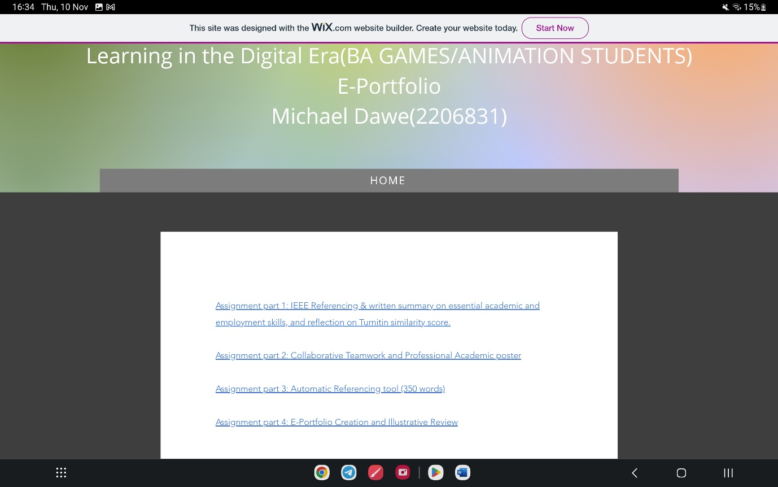
Screenshot of homepage of my e-portfolio.
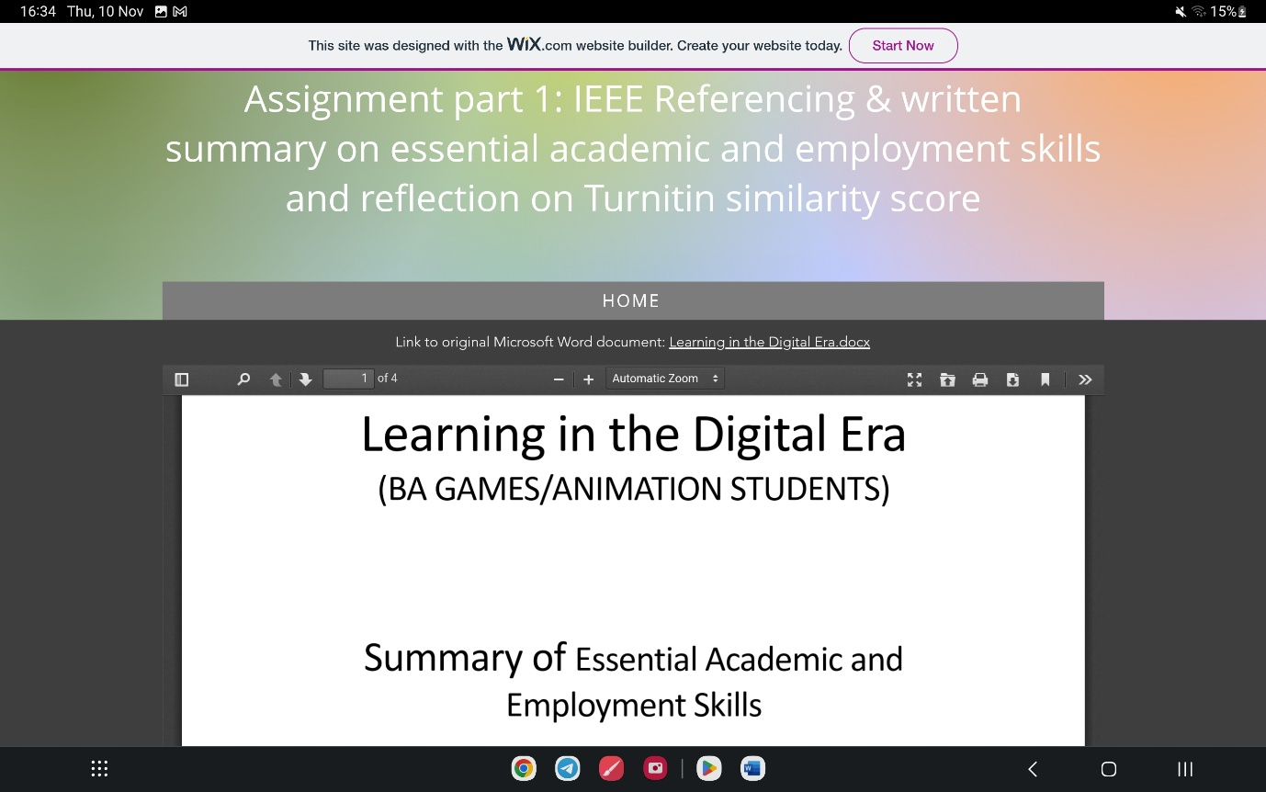
Screenshot of assignment part 1 in my e-portfolio.
Link to Academic poster: https://uowtsd-my.sharepoint.com/:i:/g/personal/2206831_student_uwtsd_ac_uk/Ec-tzpyHfqtDs0aEPx4A-T4BNcCG_Bo5nQDFajwqo7wmbg?e=jDp2th
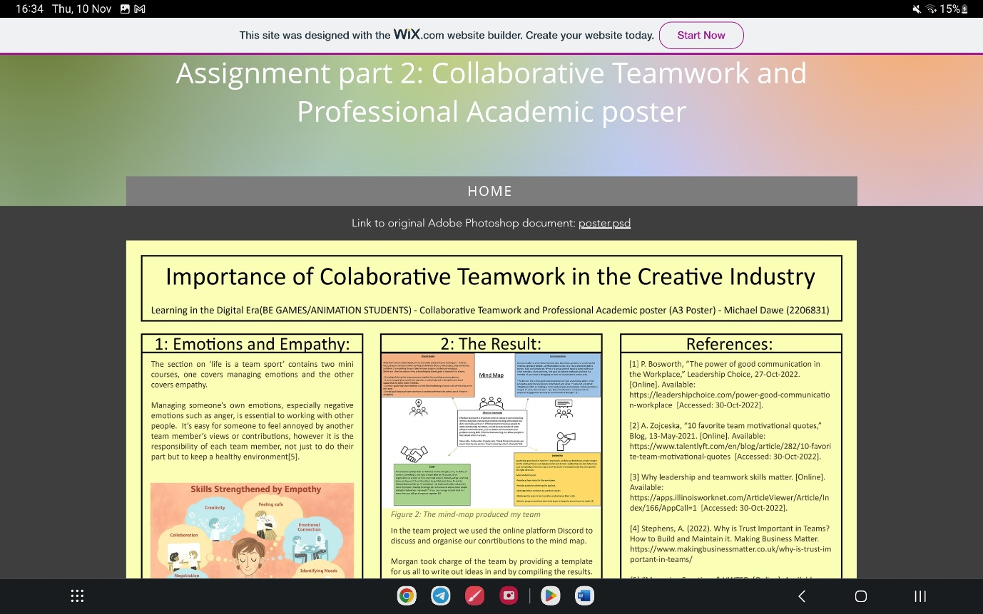
Screenshot of assignment part 2 in the e-portfolio.
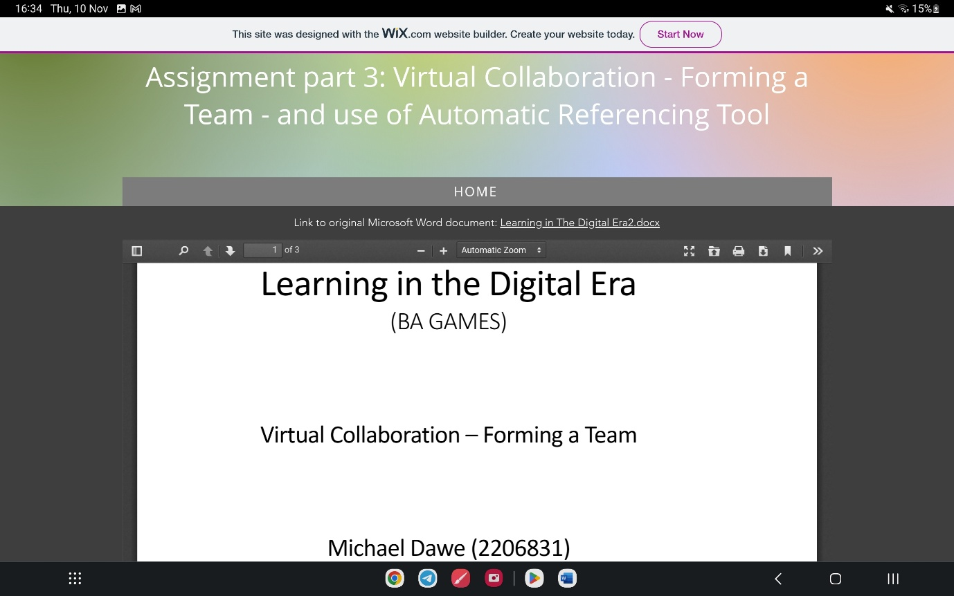
Screenshot of assignment part 3 answer.
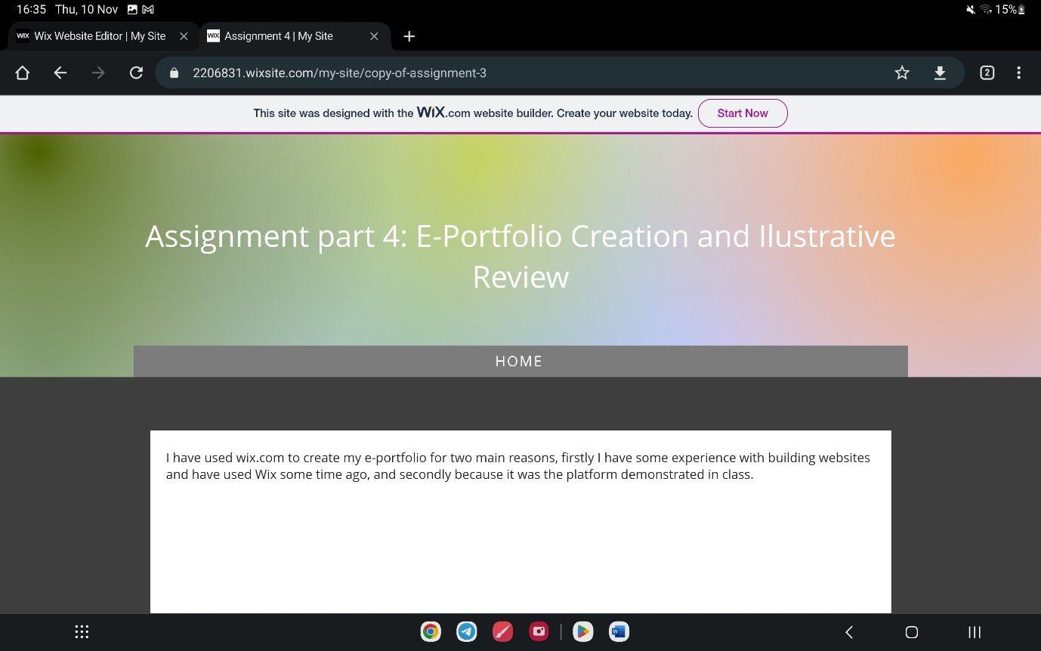
Screenshot of assignment part 4b in my e-portfolio.

