Project Title: Retention strategies for millennials in the Food & Beverage Department at SALT of Palmar.

Name: Viswanand Venkatasami

Student ID: 1715881

Module Number: BMPF4008

Module Name: Work Based Learning Project

Word Count: 3220 words

Date of Submission: 30th April 2019

Table of contents
Content Page Number

Section 1

Project Proposal
- The Topic 3
  - Rationale 3
  - Intended Impact 3
  - The Proposed Methodology 3
  - Ethics and Insider Researcher 4

Section 2

Project Report
2.0 Introduction 5
2.1 Literature Review 5
2.2 Methodology 6
2.3 Findings 8
2.4 Conclusions and Recommendations 11
2.5 References 12

Section 3

3.0 Appendices 13

Section 4

Ethics
4.0 Ethical Approval Form 15

Section 1- Project Proposal

1.0 The Topic
Retention strategies for millenials in the Food & Beverage Department at SALT of Palmar.

1.1 Rationale
SALT of Palmar is a new resort in The Lux Collective which opened in November 2018. Employees spent four months in training so that they could be aligned to the purpose,values and brand concept. As many of our employees are millenials we are concerned that we may fail to retain them as there is a large interest in opportunities on cruise ships.It has thus been decided that we need to understand the needs of our employees so that we can retain them. In the last 3 months, over 35% of team members in the Food & Beverage department resigned from their respective jobs. This is of particular interest to the researcher who leads the team in the Food and Beverage department. To this end the aim of this research project is to find out how we can retain our trained and skilled personnel for the Food & Beverage department at SALT of Palmar.

1.2 Intended Impact
This research aimed at:
- Understanding the needs of millennials at the workplace
- Analysing the satisfaction level of team members over the past few months.
- Determining suitable retention strategies based on the outcome of the study
- Finding ways to enhance the management of team members to better cope with the change in management and new organisational ways.

1.3 The Proposed Methodology
Methods
Survey: From literature, quantitative approaches are preferred when testing cause-effect relations; as a result, structured questionnaire were used.
The questionnaire was relatively short, using 0 – 5 likert scale taking a maximum of 10 minutes to complete. A response rate of 60%, that is, around 30 responses were targeted.
Observation: Participants were observed to monitor their performance and behaviour at work and towards their team members.
Interview: Participants were called for a face to face interview which will not last for more than 10 minutes. During the interview team members could voice out their views if they were not satisfied with the company and their comments were noted with strict confidentiality without affecting their current job position and/or future career prospects.

1.4 Ethics and Insider Researcher
Only professional ethics were considered throughout this survey. Filling of the questionnaire was on a voluntarily basis. All the responses were processed anonymously and the raw data from the survey was kept confidential. All the questionnaires were shredded once analysis was completed.

Section 2- Project Report
2.0Introduction
This study investigates team members’ needs so that trained and skilled personnel can be retained in the Food & Beverage department at SALT of Palmar. Outof our 30 team members 20 are millennials. This project shall study their performance and behaviour at the workplace and the challenges they faced. The aims of the research were to understand team members personal and job satisfaction over the past few months at SALT of Palmar. This study was conducted inorder to retrieve maximum information about Team Member’s working environment including their working conditions. The responses from the interviews conducted provided strong ground for fundamental arguments against the reasons for high employee turnover in hotels. Following this study, suitable retention strategies were determined for the Food & Beverage department and recommendations for improvements to the styles of training conducted were made. The measures of collecting data was from questionnaires, observation and face-to-face interviews. Face to face interviews provided a platform where the respondents were more at ease to provide factual answers.

2.1 Literature Review
Training and development motivates employees to remain loyal to the organization and create a cohesive workforce. Heathfield (2008) and her fellow colleagues substantiated the need for continued support in employee training and demonstrated its effect on employee development. Training and development is critical for employee retention strategy.
According to James & Mathew (2012), employees are the assets of an organization. Therefore, organizationscannot afford to lose their best employees. Organizations are trrying their level best to retain their talentthrough the implemention of effective retention strategies. High Employee Turnover has an impact on productivity and sustainability of the organization.
The study of Ramlall (2003) demonstrated that 86% of employers experience difficulty in attracting new employees and 58% experience difficulty retaining their employees. Widely used retention strategies by most organisations are compensation and rewards for the outstanding job done and Star of the month award for the department for job satisfaction. Moreover, we can lay more emphasis into consideration in training and development in order to motivate employees to pursue furthercareers in the company. This shall eventually help organisations better manage employee turnover. In order to have the best retention strategy, we need to understand and analyze why employees are likely to leave and what are the main issues and challenges they are facing.
The purpose of this study is to critically analyze the various work done in the field of employee retention and highlight factors responsible for employee departure and the retention strategies implemented to retain them. Also, in line with the study done by Singh (2019),more emphasis will be put on the factors such as leadership style of superiors, ability to exercise control with respect to decision-making and problem-solving, desire for career advancement and skills development, flexible working and ever increasing aspiration on retention of key employees.
As per Hyman & Summers (2004), the UK has operated a lightly systematized way to help employees balance their work and domestic obligations, an approach which employers have welcomed and which they and Government consider to be successful. Domestic responsibilities are still conducted primarily by women irrespective of their employment status. The researchers have found that many employees continue to face difficulty in reconciling their work and domestic responsibilities.

2.2 Methodology
The focus of the data gathering was to collect the opinions of the Food and Beverage team members. The methodology was mostly quantitative.
For this project, 3 methods were used namely:
- A 0-5 Likert scale survey questionnaire was used as research instrument to collect primary data from all team members within the Food & Beverage Department at SALT of Palmar. The option of e-mail questionnaire was not chosen as not all team members from the Food & Beverage Department are computer literate and some did not even have an e-mail address. The questionnaire consisted of 10 questions and the table below shows the distriution of the targetted 30 participants. The questionnaire was distributed to the team members and the aim was to gather their views on employee retention for the Food & Beverage Department.

Outlets | Demi Chef de Rang/ Barista | Chef de Rang/ Supervisor/ Bartender
The Restaurant | 6 | 5
In Room Dining | 3 | 1
Pool Bar | 2 | 3
Beach Bar | 2 | 2
Roof Top Bar | 2 | 2
The SALT Bakery | 2
TOTAL | 17 | 13
The questionnaire was filled by the team members mainly after service time in order not to interrupt the smooth running of Food & Beverage operations. They were informed that participation was voluntary and it would take no more than 10 minutes to complete as it will be on a 0-5 Likert scale questionnaire. A pilot test was run with the Executive Assistant/Food & Beverage Manager to check for any corrections. Responses from the conducted survey were analysed and tabulated on a spreadsheet to have a better overview on the responses from the participants. (See Appendix 1).
- On-the-job observation was conducted for 3 days whereby team members performance and behaviour was observed. The main objective of the observation was to collect data about employee retention strategies at SALT of Palmar.

Following the responses collected from the survey, participants were called one by one for a face to face interview to voice out their views about when and why they have been frustrated with the work and unsatisfied with the company. Telephone interview was not chosen as some participants could be reluctant to voice out their views.

As an insider researcher, all team members involved in the project were reassured that all information was treated as confidential and was therefore used for academic purposes only and that they understood it would not affect their jobs or chances of promotion etc if the responseswere negative.

2.3 Findings

Survey Questionnaire
A survey using 0-5 Likert scale questionnaire was done with 30 Food & Beverage team members aged between 20 to 42 years old. There were only 25 respondents aged between 24-34 years old from the restaurant, bar and in room dining who responded to the survey. The key findings which are in favour of retaining millennials at SALT of Palmar are as follows:
Question 1 was about Employee Job Satisfaction and the responses showed that 92% team members felt that they were personally accomplished with their work, 100% responded that their jobs make good use of their skills and abilities. 96% were satisfied with their respective jobs and they experienced personal growth such as updating skills, learning different jobs and were rewarded for the quality of their efforts. This response can be supported by the following: daily on-the-job training sessions were conducted, implementation of coffee expert sharing skills and knowledge by conducting theory and practical training sessions of latte art at The SALT Bakery to all Food and Beverage outlets team members irrespective of their job position.100% respondents liked to go to work and this was a very good sign for SALT of Palmar.96% team members believed that all employees were recognized as individuals and were motivated to see the success of SALT of Palmar. 96% of the participants said they have a clear path for career advancement and this could be justified by the brand concept at SALT of Palmar whereby we are emerging as a whole towards sustainability, freshly sourced local and homemade products to our guests.
Question 2was about Employee Retention and 92% said the company did an excellent job in keeping employees informed about matters affecting them, 92% answered that their supervisors and manager visibly demonstrated a commitment to quality, encouraged them to be at their best and they are satisfied with the information received from the management on what was going on in all the Food and Beverage outlets namely - The Restaurant, Pool Bar, Beach Bar, The Roof Top Bar and The Salt Bakery. 84% respondents believed that the company is flexible with respect to their family responsibilities. It was a good figure for the respondents working in the hotel sector as there were times when occupancy was high or if there was any special event and they had to work extra hours for which they were remunerated accordingly and as a result they were limited to meet their family responsibilities.Upon being asked if they would advise a friend to apply for a job at SALT of Palmar, 92% responded positively. Also they were briefed about the facilities offered to the team members at SALT which the management believed no other hotels in Mauritius was offering to their team members.
Question 3was about how long team members were planning to stay in employment at SALT of Palmar and interesting figures were obtained as 48% of the respondents answered they will work with the company for more than 2 years and 28% believed that they will work for more than 1 year. These figures could be justified by the responses collected from questions 1 and 2. However 24% team members stated that they would leave the company as soon as they got an opportunity and this was a major concern for the team and the management.12% team members did not answer whether the variety of tasks that their positions require was too many, enough or not enough. There might have been some confusion at some point for the respondents as it was not clear to them if the tasks were too many, enough or not enough.

Observation
In terms of team members’ performance and behavior in the Food and Beverage Department at SALT of Palmar it has been noted that most of the team members working in The Restaurant deliver the best of themselves. However, due to the low manning, very often they had to work extra hours during which some team members’ energy level was quite low and the weariness could be easily noticed from their facial expression which could create a negative impression ‘vis-à-vis’ guests who stayed over more than a week.Guestscould have developed the wrong perception that the employees were being exploited or were wrongly manipulated without knowing that the team members were remunerated or refunded accordingly for the extra hours worked.As discussed with the Human Resources Department during the one to one meeting the option of promotion strategy will be applied to fill in the vacant posts by giving the team members the opportunity to enhance their career within the company and encourage them to apply if they feel they are the right candidate for the post available.
There appeared to be a lack of cooperation between Restaurant & Bar team members and following interview which was done, Restaurant team members said that Bar team members never give them a helping hand when it comes to busy service hours whereby Restaurant team members are encountering difficulties in ensuring prompt service while Bar team members are more relaxed. Also when it comes to replacing a colleague who is on medical or any other special leave, team members are somewhat reluctant and this can cause a negative impact to run the operations smoothly as the brand standards that have been set needs a lot of attention to details and proper supervision. The team member at the SALT Bakery is busy only during breakfast service for the preparation of hot beverages namely coffee, tea and infusions. After breakfast service, there are not so many orders for hot beverages and the latter prefers to relax on his work station rather than cooperate with other team members who badly need some help at the Restaurant and Bar.

Interview
Following a one to one interview which was conducted with 5 team members from different levels of hierarchy in each Food & Beverage outlet, the comments below were noted:
The Restaurant team member believes that he is satisfied with his salary but however he has to do lots of extra hours and this affects his personal life balance as he gets to spend very minimum time with his family and friends. Anotherteam member from the Restaurant said she will leave the company as soon as she will get another opportunity because of the low manning due to which she feels very tired and she said she already went for an interview at another hotel where she had applied for a higher job position and she was awaiting a reply from the interviewer. She also mentioned that she wants to pursue her studies and work towards her career growth in the field of Food & Beverage. Upon considering these facts the Human Resources department enquired if she was interested to apply for the same post at SALT of Palmar and she agreed. The latter was called for a second interview whereby her competences were evaluated and she is actually under probation for a period of 3 months before being promoted as ‘Chef de Rang’ at SALT of Palmar.
The SALT Bakery team member pointed out that the team members from The Restaurant and Bar usually exclude him from the team due to which he is somewhat hesitant and completely ignores the situation when his colleagues need help and support. The Bar team member at the Pool Bar said he does not get any support from his fellow colleagues and they never want to take any responsibility. They rely on him all the time to get the tasks done and most of the time he is challenged by the team members namely the Bartenders who do not always obey to his instructions. Following his comments that were noted by the Human Resources department, it was agreed with the Restaurant Manager and Assistant Restaurant Manager to oversee the Bar operations and extend support to the Bartenders whenever required.
The In Room Dining team membersaid he is happy with his job and would not hesitate to give a helping hand either in The Restaurant or at The SALT Bakery during busy service hours. He is often scheduled to work overnight and he has no complaints against this. He seized this opportunity to thank the management for all the training and support given for 5 months.

2.4 Conclusions and Recommendations
This study enabled the researcher to identify team members’ needs and to determine suitable retention strategies for trained and skilled team members and create a positive working environment between Generation X and Millenials for the Food & Beverage Department at SALT Of Palmar.
Promotion strategy was adopted for the team member who believed they were capable of shouldering more responsibilities and work towards their personal development and career growth.
After discussion with the Human Resources Department the following recommendations were considered for the project. The option of refunding the team member a day off for the extra hours worked has been considered.
The team members who are likely to leave the company will be briefed about the facilities offered to the team members at SALT which the management believes no other hotels in Mauritius offer to their team members.
It was mentioned in the respective job profiles that the team member could be prone to multitasks whenever required while ensuring flexibility accordingly.
Activity based training sessions will be conducted whereby all Food & Beverage outlets team members will be merged together which will result in them getting to know themselves better and develop the positive working attitude.
Retention measures that could be implemented is to have additional manning for the Food and Beverage department so that the team members will not feel exhausted and frustrated while working extra hours. It has been agreed with the Human Resources Department to recruit additional team members for the Food & Beverage Department.

2.5 References
- Heathfield, S. M. (2008). Training and development for employee motivation and retention. The Lama Review, 20(2), 20

- James, L. & Mathew, L. (2012). Employee Retention Strategies: IT Industry. SCMS Journal of Indian Management, 9(3)

- Ramlall, Sunil. (2003). Organizational Application Managing Employee Retention as a Strategy for Increasing Organizational Competitiveness The Cost of Employee Turnover. Applied H.R.M. Research, 8(2), 63-72.

- Singh, Diwakar. (2019). A Literature Review on Employee Retention with Focus on Recent Trends. International Journal of Scientific Research in Science, Engineering and Technology. pp. 425-431.

- Hyman, Jeff & Summers, Juliette. (2004). Lacking balance? Work-life employment practices in the modern economy. Personnel Review.Vol. 33, pp. 418-29.

Section 3

3.0 Appendices

Survey Questionnaire
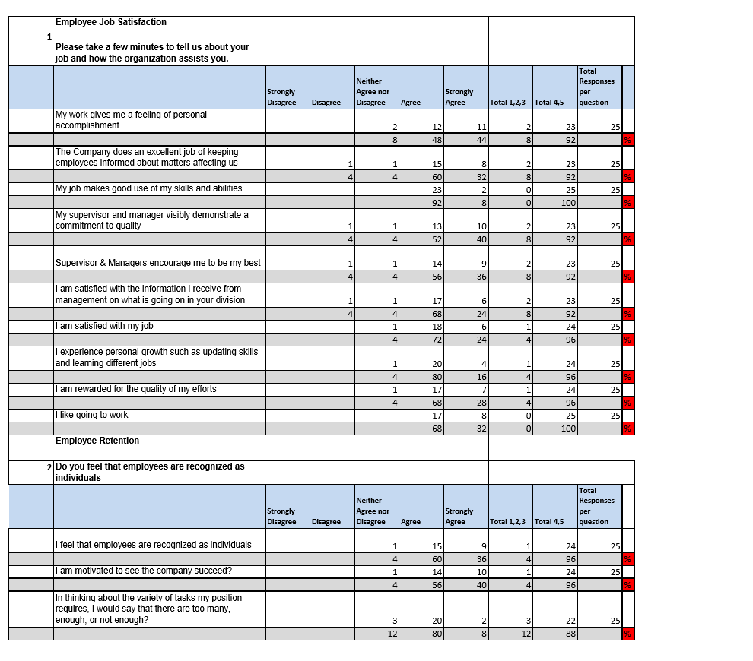
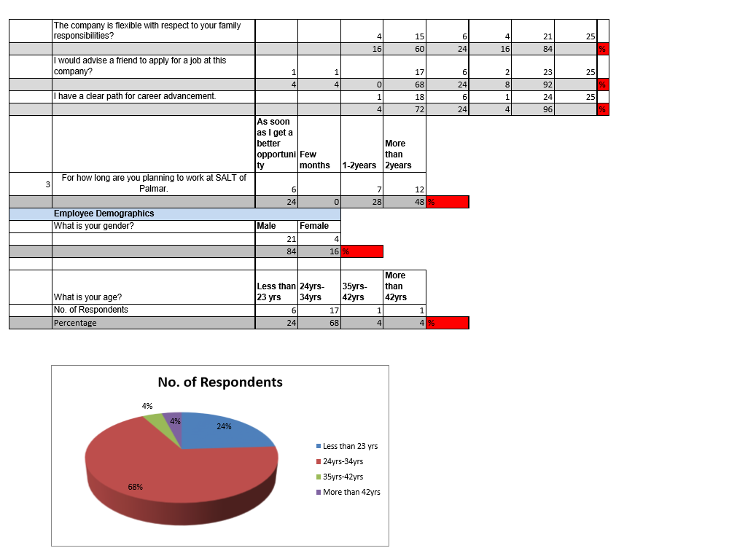

Section 4

Ethics

4.0 Ethical Approval Form

APPLICATION FOR ETHICAL APPROVAL

In order for research to result in benefit and minimise risk of harm, it must be conducted ethically. A researcher may not be covered by the University’s insurance if ethical approval has not been obtained prior to commencement.

The University follows the OECD Frascati manual definition of research activity: “creative work undertaken on a systematic basis in order to increase the stock of knowledge, including knowledge of man, culture and society, and the use of this stock of knowledge to devise new applications”. As such this covers activities undertaken by members of staff, postgraduate research students, and both taught postgraduate and undergraduate students working on dissertations/projects.

The individual undertaking the research activity is known as the “principal researcher”.

Ethical approval is not required for routine audits, performance reviews, quality assurance studies, testing within normal educational requirements, and literary or artistic criticism.

Please read the notes for guidance before completing ALL sections of the form.

This formmustbe completed and approved prior to undertaking any research activity.Please see Checklist for details of process for different categories of application.

SECTION A: About You (Principal Researcher)

Full Name: |  |  | ViswanandVenkatasami
Tick all boxes which apply:
Member of staff: | ☐ | Student: |  | ☒ | Honorary research fellow: |  | ☐
Faculty/School/Centre: |  |  | WIWBL
Campus: |  |  | Carmarthen
E-mail address: |  |  | vvish1307@gmail.com
Contact Telephone Number: |  |  | +230 57914121
For students:
Student Number: |  |  | 1715881 |  |  | Undergraduate |  | ☒
Programme of Study: |  |  | Cert HE in Professional Practice |  |  | Taught Postgraduate |  | ☐
Director of Studies/Supervisor: |  |  | Tessa Oosthuizen |  |  | Research |  | ☐

SECTION B: Approval for Research Activity

Has the research activity received approval in principle?  (please check the Guidance Notes as to the appropriate approval process for different levels of research by different categories of individual) |  | YES | ☒ | NO | ☐
 |  |  |  | Date
If Yes, please indicate source of approval (and date where known): | Research Degrees Committee |  | ☐
 | Faculty Research Committee |  | ☐
 | Other (write in)  WIWBL Ethics Board Representative |  | ☒
Approval in principle must be obtained from the relevant source prior to seeking ethical approval.

SECTION C: External Ethical Guidance Materials

Please list the core ethical guidance documents that have been referred to during the completion of this form (including any discipline-specific codes of research ethics, and also any specific ethical guidance relating to the proposed methodology). Please tick to confirm that your research proposal adheres to these codes and guidelines.
LUX* Resorts and Hotels Code of Conduct and Ethics | ☒
 | ☐
 | ☐

SECTION D: External Collaborative Research Activity

Does the research activity involve collaborators outside of the University? |  | YES | ☐ | NO | ☒
If Yes, please provide the name of the external organisation and name and contact details for the main contact person:
Institution
Contact person name
Contact person e-mail address

Where research activity is carried out in collaboration with an external organisation
Does this organisation have its own ethics approval system? | YES | ☐ | NO | ☐
If Yes, please attach a copy of any final approval (or interim approval) from the organisation

SECTION E: Details of Research Activity

Indicative title: | Retention strategies for Food & Beverage Department.
Proposed start date: |  | Proposed end date: | 22 -04-19
Purpose of research activity (including aims and objectives)
Outline the purpose, aims and objectives of the research activity, including key research questions. Show briefly how existing research has informed the proposed activity and explain what the research activity will add and how it addresses an area of importance. (Maximum 300 words)
Background
As a Supervisor, I am responsible to lead the team members in the Food & Beverage Department while ensuring that they are satisfied and motivated to work within the organisation and provide a transformational experience to our guests at Salt of Palmar. It has been only 1 month since the opening of Salt of Palmar and prior to the opening of this new hotel, all the team members were under training for 4 months whereby they were invited to discover the purpose, values and brand concept of Salt of Palmar together. Due to the competition in the hospitality industry and craze for cruise ship job opportunities, our main concern is to diagnose team members’ needs and find out how we can retain our trained and skilled personnel in the Food & Beverage department at Salt of Palmar. In addition, the majority of the team members are Millennials and to study their behaviour at the workplace and the challenges they face will be helpful for my research.
Aims
The aims of the research will therefore be:
- to find out how satisfied team members are with the company over the past few months
- to determine why and when team members have been particularly satisfied or frustrated
- to assess how helpful on-the-job training sessions has been to team members over the past few months
- to study the behaviour and needs of millennials at the workplace
- to find out as to which learning styles the team members prefer
- to make recommendations for improvements to the styles of training conducted
- to determine suitable retention strategies
Personal Learning Outcomes
The learning outcomes after doing the research will be:
- To get a better overview of retention strategies
- To better understand team suitable employee engagement strategies to dive satisfaction and minimise frustration
- How to retain trained and skilled team members specifically within the Food & Beverage department
Previous Research
- I have read an article on ‘The Labour Retention Strategies in UK’, which presents the evidence from a small study of the strategies used by hotel managers to retain their employees.
- I have read an article on ‘Managing the Modern Millennial’, which shows the behaviour and expectations of Millennials in the workplace.

References
- Riley Michael, Service Industries Journal. Jul90, Vol. 10 Issue 3, p614-618. 5p.
- Paul Paz, PizzaToday.com, April 2015, p54-55. 2p.

Proposed methods
Provide a brief summary of all the methods that may be used in the research activity, making it clear what specific techniques may be used. If methods other than those listed in this section are deemed appropriate later, additional ethical approval for those methods will be needed. (Maximum 600 words)
Methodological Position
This research is mainly concerned with team members’ in the Food & Beverage department. It emphasizes on their views and expectations with regard to the working conditions. This study shall help understand their point of frustration, and retrieve maximum information from them and welcome their ideas and comments. This can be achieved by making use of quantitative data, and hence I propose that methodology is mixed, with both quantitative aspects (survey) and qualitative aspects (interviews).
Participants
Participants will comprise any adult team member of the Food and Beverage department. All contact details of any team member are kept securely on a company database by the Human Resources Department.
Methods
- Survey: the purpose of the survey is to establish trends in team membersatisfaction within the department.

- First of all, a questionnaire based on learning styles survey will be done in order to know about the participants’ preferred learning style and group them accordingly.
- All participants will be called for a meeting in small groups and batches whereby the purpose of the research will be explained, and anonymity assured.
- A WhatsApp group will be created where the participants will be informed about the date, time and place where the survey will be held well in advance.
- A paper-based questionnaire will include questions on career growth and learning opportunities through training, remuneration, personal goals, passion, and overall satisfaction of team members within the Food &Beveragedepartment. The questionnaire will be relatively short, taking a maximum of 10 minutes to complete, it is anticipated that the response rate will be around 60%, and hence around 30 responses are expected. Questions will be predominantly quantitative in nature, using a 0-5 Likert Scale, with 5 indicating highest levels of satisfaction. At the end of the questionnaire, participants will be invited to voice out their problems and difficulties encountered and potential availability for interview. The purpose of these points will be explained, and it will be made clear that response is not compulsory and information shared by participants will be treated as confidential and anonymous.
- Interviews: the purpose of interviews is to obtain more detailed qualitative information which could help to explain responses obtained via the survey and questionnaire. Team members indicating their availability for an interview will be called in alphabetical order.
- Interviews will be face to face, and should take approximately 15-20 minutes, with responses recorded by means of interviewer notes, and anonymised for the purposes of analysis. Questions will ask about reasons for responses provided in the survey, and will be open-ended so that participants can give long, detailed responses if they wish. Participants will be asked if they are willing to indicate their areas of development, and where appropriate, if those areas of development influenced their responses and opinions. Any discussion of issues will adhere to LUX* Resorts and Hotels Code of Conduct and Ethics.
- Observation: Participants will be observed to monitor their performance and behaviour at work and towards their team members.

Analysis- All information collected from team members will be treated as anonymous and confidential.

Survey: responses will involve percentage calculations for each aspect of team member satisfaction for each scale value, and these will be summarised and tabulated.
Interview: responses will be analysed by themes, so that the key factors influencing responses can be ascertained. It is appreciated, however, that given the small sample size involved, outputs will be indicative only
Observation: responses will determine the participants’ motivation and willingness to work and grow within the company.

Location of research activity
Identify all locations where research activity will take place.
This will be based at Salt of Palmar

Research activity outside of the UK
If research activity will take place overseas, you are responsible for ensuring that local ethical considerations are complied with and that the relevant permissions are sought. Specify any local guidelines (e.g. from local professional associations/learned societies/universities) that exist and whether these involve any ethical stipulations beyond those usual in the UK (provide details of any licenses or permissions required). Also specify whether there are any specific ethical issues raised by the local context in which the research activity is taking place, for example, particular cultural sensitivities or vulnerabilities of participants.
Mauritius

SECTION F: Scope of Research Activity

Will the research activity include: | YES | NO
Use of a questionnaire or similar research instrument? | ☒ | ☐
Use of interviews? | ☒ | ☐
Use of diaries? | ☐ | ☒
Participant observation with their knowledge? | ☒ | ☐
Participant observation without their knowledge? | ☐ | ☒
Use of video or audio recording? | ☐ | ☒
Access to personal or confidential information without the participants’ specific consent? | ☐ | ☒
Administration of any questions, test stimuli, presentation that may be experienced as physically, mentally or emotionally harmful / offensive? | ☐ | ☒
Performance of any acts which may cause embarrassment or affect self-esteem? | ☐ | ☒
Investigation of participants involved in illegal activities? | ☐ | ☒
Use of procedures that involve deception? | ☐ | ☒
Administration of any substance, agent or placebo? | ☐ | ☒
Working with live vertebrate animals? | ☐ | ☒
Other primary data collection methods, please explain in this box | ☐ | ☐

If NO to every question, then the research activity is (ethically) low risk and may be exempt from some of the following sections (please refer to Guidance Notes).

If YES to any question, then no research activity should be undertaken until full ethical approval has been obtained.

SECTION G: Intended Participants

Who are the intended participants: | YES | NO
Students or staff at the University? | ☐ | ☒
Adults (over the age of 18 and competent to give consent)? | ☒ | ☐
Vulnerable adults? | ☐ | ☒
Children under 18? | ☐ | ☒
Prisoners? | ☐ | ☒
Young offenders? | ☐ | ☒
Those who could be considered to have a particularly dependent relationship with the investigator or a gatekeeper? | ☐ | ☒
People engaged in illegal activities? | ☐ | ☒
Others (please identify): | ☐ | ☒

Participant numbers and source
Provide an estimate of the expected number of participants. How will you identify participants and how will they be recruited?
Participants will comprise any adult team member of the food & beverage departmentwho is currently working at Salt of Palmar. The maximum number is 50, but number of expected respondents is expected to be around 30.

Information for participants: | YES | NO | N/A
Will you describe the main researchprocedures to participants in advance, so that they are informed about what to expect? | ☒ | ☐ | ☐
Will you tell participants that their participation is voluntary? | ☒ | ☐ | ☐
Will you obtain written consent for participation? | ☐ | ☐ | ☒
Will you explain to participants that refusal to participate in the research will not affect their treatment or education (if relevant)? | ☒ | ☐ | ☐
If the research is observational, will you ask participants for their consent to being observed? | ☐ | ☐ | ☒
Will you tell participants that they may withdraw from the research at any time and for any reason? | ☒ | ☐ | ☐
With questionnaires, will you give participants the option of omitting questions they do not want to answer? | ☒ | ☐ | ☐
Will you tell participants that their data will be treated with full confidentiality and that, if published, it will not be identifiable as theirs? | ☒ | ☐ | ☐
Will you debrief participants at the end of their participation, in a way appropriate to the type of research undertaken? | ☒ | ☐ | ☐
If NOto any of above questions, please give an explanation

Information for participants: | YES | NO | N/A
Will participants be paid? | ☐ | ☒ | ☐
Is specialist electrical or other equipment to be used with participants? | ☐ | ☒ | ☐
Are there any financial or other interests to the investigator or University arising from this study? | ☐ | ☒ | ☐
Will the research activity involve deliberately misleading participants in any way, or the partial or full concealment of the specific study aims? | ☐ | ☒ | ☐
If YESto any question, please provide full details
SECTION H: Anticipated Risks

Outline any anticipated risksthat may adversely affect any of the participants, the researchers and/or the University, and the steps that will be taken to address them.

If you have completed a full risk assessment (for example as required by a laboratory, or external research collaborator) you may append that to this form.
Risks to participants
For example: emotional distress, financial disclosure, physical harm, transfer of personal data, sensitive organisational information
No risks are anticipated

If research activity may include sensitive, embarrassing or upsetting topics (e.g. sexual activity, drug use) or issues likely to disclose information requiring further action (e.g. criminal activity), give details of the procedures to deal with these issues, including any support/advice (e.g. helpline numbers) to be offered to participants. Note that where applicable, consent procedures should make it clear that if something potentially or actually illegal is discovered in the course of a project, it may need to be disclosed to the proper authorities
No such issues are anticipated, and any arising will be dealt with using company policies and codes of practice

Risks to investigator
For example: personal safety, physical harm, emotional distress, risk of accusation of harm/impropriety, conflict of interest
No risks are anticipated. Any issues arising will be dealt with using company policies and codes of practice

University/institutional risks
For example: adverse publicity, financial loss, data protection
No risks are anticipated

Adverse outcomes
List measures put in place to limit any adverse effects or outcomes of research activity where appropriate. Include any emergency protocols.
- Low response rate of survey: if response rate is below 20%, the survey procedure will be repeated with all team members working in the Food & Beverage department

Disclosure and Barring Service
If the research activity involves children or vulnerable adults, a Disclosure and Barring Service (DBS) certificate must be obtained before any contact with such participants. | YES | NO | N/A
Has a DBS certificate been obtained? | ☐ | ☐ | ☒

SECTION I: Feedback, Consent and Confidentiality

Feedback
What feedback will be provided to participants, how will this be done and when?
It will be explained to participants within the introductory meeting that feedback on outcomes of the research will be made available to them upon request

Informed consent
Describe the arrangements to inform potential participants, before providing consent, of what is involved in participating. Describe the arrangements for participants to provide full consent before data collection begins. If gaining consent in this way isinappropriate, explain how consent will be obtained and recorded.
The purpose of the research will be explained to participants during the introductory meeting, and it will also be indicated clearly that participation is voluntary, with participation implying consent.

Participation in interviews will require participants to volunteer, and informed consent would be obtained via Whatsapp group before interviews take place

Confidentiality / Anonymity
Set out how anonymity of participants and confidentiality will be ensured in any outputs. If anonymity is not being offered, explain why this is the case.
Survey: the survey questionnaires ensure anonymity of responses
Interviews: interviewees will be selected in alphabetical order, and responses will be anonymised before analysisby the use of codes.

SECTION J: Data Protection and Storage

In completing this section refer to the University’s Research Data Management Policy and the extensive resources on the University’s Research Data Management web pages (http://uwtsd.ac.uk/library/research-data-management/).
 | YES | NO
Does the research activity involve personal data (as defined by the Data Protection Act)?  “personal data” means data which relate to a living individual who can be identified—  (a) from those data, or  (b) from those data and other information which is in the possession of, or is likely to come into the possession of, the data controller, and includes any expression of opinion about the individual and any indication of the intentions of the data controller or any other person in respect of the individual. | ☐ | ☒
If YES, provide adescription of the data and explain why this data needs to be collected:
Does it involve sensitive personal data (as defined by the Data Protection Act)?  “Sensitive personal data” means personal data consisting of information as to –  (a) the racial or ethnic origin of the data subject,  (b) his political opinions,  (c ) his religious beliefs or other beliefs of a similar nature,  (d) whether he is a member of a trade union (within the meaning of the Trade Union and Labour Relations (Consolidation) Act 1992),  (e) his physical or mental health or condition,  (f) his sexual life,  (g) the commission or alleged commission by him of any offence, or  (h) any proceedings for any offence committed or alleged to have been committed by him, the disposal of such proceedings or the sentence of any court in such proceedings. | ☐ | ☒
If YES, provide adescription of the data and explain why this data needs to be collected:

Will the research activity involve storing personal data on one of the following: | YES | NO
Manual files (i.e. in paper form)? | ☒ | ☐
University computers? | ☐ | ☒
Private company computers? | ☒ | ☐
Home or other personal computers? | ☐ | ☒
Laptop computers/ CDs/ Portable disk-drives/ memory sticks? | ☐ | ☒
“Cloud” storage or websites? | ☐ | ☒
Other – specify: | ☐ | ☒
For all stored data, explain the measures in place to ensure data confidentiality, including details of password protection, encryption and anonymisation:
It will not be compulsory for team members to include their names and job title in the surveys conducted. All documentation will be destroyed after submission of the assignment.

Will the research activity involve any of the following activities: | YES | NO
Electronic transfer of data in any form? | ☒ | ☐
Sharing of data with others at the University? | ☐ | ☒
Sharing of data with other organisations? | ☐ | ☒
Export of data outside the European Union or importing of data from outside the UK? | ☐ | ☒
Use of personal addresses, postcodes, faxes, emails or telephone numbers? | ☒ | ☐
Publication of data that might allow identification of individuals? | ☐ | ☒
Use of data management system? | ☐ | ☒
Data archiving? | ☐ | ☒
If YESto any question, please provide full details, explaining how this will be conducted in accordance with the Data Protection Act (and/or any international equivalent):
This study will make use of a company database which is used for normal administrative purposes.

List all who will have access to the data generated by the research activity:
The researcher only

List who will have control of, and act as custodian(s) for, data generated by the research activity:
Data generated by this research will be filed accordingly and accessible to the researcher only unless feedback is requested by team members. Data will be anonymous and used only for the research purposes outlined. All data will be erased/ destroyedonce analyses are complete.
Give details of data storage arrangements, including where data will be stored, how long for, and in what form. Will data be archived – if so how and if not why not.

SECTION K: Declaration

The information which I have provided is correct and complete to the best of my knowledge. I have attempted to identify any risks and issues related to the research activity and acknowledge my obligations and the rights of the participants.

In submitting this application I hereby confirm that I undertake to ensure that the above named research activity will meet the University’s Research Ethics and Integrity Code of Practice
Signature of applicant: |  | Date:

For students:
Director of Studies/Supervisor: | Tessa Oosthuizen
Signature:
Date: | 5-12-18

For staff:
Head of School/Assistant Dean: | a.fillery-travis
Signature:
Date:

Checklist: Please complete the checklist below to ensure that you have completed the form according to the guidelines and attached any required documentation:
☒ | I have read the guidance notes supplied before completing the form.
☒ | I have completed ALL RELEVANT sections of the form in full.
☒ | I confirm that the research activity has received approval in principle
 | I have attached a copy of final/interim approval from external organisation (where appropriate)
 | I have attached a full risk assessment (and have NOT completed Section H of this form) (where appropriate)
☒ | I understand that it is my responsibility to ensure that the above named research activity will meet the University’s Research Ethics and Integrity Code of Practice.
☒ | I understand that before commencing data collection all documents aimed at respondents (including information sheets, consent forms, questionnaires, interview schedules etc.) must be confirmed by the DoS/Supervisor, module tutor or Head of School.

RESEARCH STUDENTS AND STAFF ONLY
All communications relating to this application during its processing must be in writing and emailed to pgresearch@uwtsd.ac.uk , with the title ‘Ethical Approval’ followed by your name.
You will be informed of the outcome of your claim by email; thereforeit is important that you check your University and personal email accounts regularly.

STUDENTS ON UNDERGRADUATE OR TAUGHT MASTERS PROGRAMMES should submit this form (and receive the outcome) via systems explained to you by the supervisor/module leader.

This form is available electronically from the Academic Office web pages: http://www.uwtsd.ac.uk/academic-office/

Application Process

All staff research projects and all research students must submit the Ethical Approval Form to the University Ethics Committee via the Academic Office (pgresearch@uwtsd.ac.uk). Staff research directly in relation to personal study for taught undergraduate or Masters programmes should be submitted via the Faculty procedures explained below.

Taught masters and taught undergraduate research Ethical Approval Forms are considered within Faculties. Faculties will provide details of the specific processes for this. Where the Ethical issues within any single ethical application are of particular concern the Faculty will refer these to the University Ethics Committee. Any student activity that involves the collection of primary data needs to undergo Ethical approval, this includes assignment work as well as dissertations.

Notes for guidance in completion of this form

Section A: About You
Please complete all relevant sections

Section B: Approval for research activity
Research proposals must be approved in principle before applying for Ethical Approval. The proposal approval only becomes final when the ethical approval is received.

The process for proposal approval varies according the individual and programme of study:
- Research students, by application on form PG1 to the Research Degrees Committee
- Taught students by review of research proposal within Faculties (Faculties provide specific details of these processes)
- Staff, by agreement by the Head of School/Assistant Dean

Section C: External Ethical Guidance materials
Many discipline areas are required to operate with the discipline specific codes of research ethics (for example health, psychology, education etc.), any such codes must be listed and you must tick to confirm that you have consulted with these.

Section D: External Collaborative Research Activity
Provide details of the external collaborative partners, where appropriate you might want to submit a copy of the external collaboration agreement with the Ethical Approval Form. If the partner requires the research to be subject to its own internal Ethical approval process then please provide details of that process and a copy of any final (or interim) approvals received from the organisation.

Section E: Details of Research Activity
Remember that the individuals reviewing this Ethical Approval Form may not have seen your research proposal, and also may not be experts in the specific area of your research. The information provided should therefore be jargon free and clearly stated.
Indicative Title: please use the same title as used on the research proposal.
Purpose:the Ethical approval process will want to ensure that the methods you propose are adequate and appropriate to address the research aims and objectives. Excessive additional data collection can be seen as unethical.
Proposed Methods:the Ethical approval process seeks to ensure that you understand the methods that are intended, and that the implementation of those methods will be appropriate and without unnecessary impact on respondents. Please be specific.
Location: this needs to mention geographical location and also local situation (for example, within Local Authority Offices in Cardiff, using a private room but close to other individuals). If you are collecting data within an organisationalsetting then you need to explain the permissions that you have obtained to do this.
Research Activity outside of the UK: please complete this section in detail, and note any guidance you have received. Also describe your own familiarity (or not) with the location that you will be utilising.

Section F: Scope of Research Activity
Please tick ALL of the research activities that might be undertaken. If any additional types of activity are intended then please add an extra box and describe these.
If you have answered no to all questions in F then sections G and J do not need to be completed. Section H should be considered, and may be completed. Signatures are still required in section K.

Section G: Intended Participants
Please tick all categories that might apply.
Numbers& Source: if you are using a series of different methods or research activities please list numbers for each stage/phase. Be clear about how you will find respondents. Will you use intermediaries, and if so how? How will you ensure compliance with your sampling strategy?
Information for participants: all participants should be appropriately informed about the research, what is expected of them and what will happen to the information that they provide. The Ethical review process does not ask to see this documentation, but requires this to be reviewed and approved by the Director of Studies in the case of research students, the supervisor/module tutor in relation to students on taught programmes and the Head of School/Assistant Dean in relation to staff research.

Section H: Anticipate Risks
All research carries some level of risk. The answers you provide to questions in this section will be reviewed to ensure that you have an appropriate understanding of the type of risks involved and how you can mitigate against these risks.If you have completed a full risk assessment, as required for example for laboratory work, field work, clinical tests, diving operations, or by a collaborative partner, you may append that to this form. In that case, please tick the box indicating this has been provided. You will not then be required to complete Section H.
Risk to participants Think very carefully about how your actions/questions/discussions might affect the people you are involving as participants. You might identify the risk as small but it would still be a risk. Many types of question have the potential to make respondents less content with their life / job; you need to recognise and try to ameliorate any such effects
If these are business owners, time with you may reduce profit.
In some locations physical risk is very real to both participants and yourself, please consider this.
Risk to you, the researcherThink about where you will meet people, if there are any dangers involved in the location. If you are meeting people as individuals think about using a public place. In general do not visit people in their own homes or remote locations.If you are talking to individuals about certain issues think about how their responses might affect you emotionally. What about the risk of collecting insufficient data?
Risk to the University When undertaking your research, you are acting as a member of the University (student or staff). Professionalism is important, so it is important to be well organised and well prepared. Punctuality, clarity etc. are all part of this. What will you do to ensure this? You must ensure you do not harm the good name of the University in any way and do nothing to undermine the reputation of the research it conducts and sponsors. Upholding high standards of conduct and integrity are vital in this regard. You must also conduct the research in such a way to minimise the potential for claims of negligence made against the University, its researchers and any collaborating individual or organisation. In this respect you should always comply with ethical, legal and professional frameworks, obligations and standards as required by statutory and regulatory authorities, as well as the university’s Research Integrity and Ethics Code of Practice. Research misconduct in this respect can take many forms, including:
- fabrication: making up results or other outputs (eg, artefacts) and presenting them as if they were real
- falsification: manipulating research processes or changing or omitting data without good cause
- plagiarism: using other people’s material without giving proper credit
- failure to meet ethical, legal and professional obligations: for example failure to declare competing interests; misrepresentation of involvement or authorship; misrepresentation of interests; breach of confidentiality; lack of informed consent; misuse of personal data; and abuse of research subjects or material
- improper dealing with allegations of misconduct: failing to address possible infringements such as attempts to cover up misconduct and reprisals against whistle-blowers

Adverse Outcomes. Think carefully about the possibilities, and cover here

Section I: Feedback, Consent and Confidentiality
Feedback to participants: outline your approach. Will interview transcripts be shared with respondents to check accuracy? Will summaries of questionnaire analysis be made available to respondents in some way? Will an overview report be provided? How and when?
Informed consent: Draft letter / e-mail / or heading (or footer) section of questionnaire must be approved by DoS/supervisor (if research student), supervisor/module tutor if taught student, or Head of School / Assistant Dean if a member of staff.
Confidentiality/Anonymity. Explain clearly how you will ensure confidentiality and anonymity.

Section J: Data Protection and Storage
Before completing this section it is necessary to read the University’s Research Data Management information. The questions that follow are designed to ensure compliance with the Data Protection Act as well as established research protocols.

Many research activities will involve electronic transfer of data and use of data management systems in the summarisation and analysis of data. You will need to explain these in relation to compliance with the Data Protection Act.
Think carefully about who will have access to your data, this will include supervisors and examiners. Also that a thesis will be made available via the University library and the British Library system. If you are seeking an access bar for a period of time after completion then mention it here. If you will provide a copy of your findings, or intend to give a presentation, to a facilitating/supporting/accessing organisation then explain that in this section. But also think about the general principle of data sharing, as explained in the Research Data Management information.
In terms of storage of data please ensure security, and also mitigate against loss of data.

Section K: Declaration
Ensure the appropriate countersignatures have been provided
Look carefully at the checklist and ensure that you comply with and tick all that are relevant to your research.

