
Community-owned renewable energy, stakeholder acceptance and investment readiness: Swansea and South West Wales
Dissertation (BMMB7003) 2025-26 Meet Sachinkumar Macwan (2510986)

September 24, 2026
University of Wales Trinity Saint David

Abstract
This dissertation investigates how stakeholder perceptions, governance arrangements and investment-readiness factors influence the acceptance, delivery and scaling of community-owned renewable energy in Swansea and South West Wales. A pragmatic convergent mixed-methods case-study design was adopted. The quantitative strand analysed 171 questionnaire responses, while qualitative interpretation drew on 142 substantive open-text comments alongside the stakeholder interview framework. The study examined familiarity, participation, trust, fairness, local benefits, governance, project barriers, technology preferences and willingness to invest across residents, businesses, community organisations, public-sector actors, developers, academics and finance stakeholders. Results showed strong social support: 84.2% were supportive or very supportive of a well-designed local project, 70.1% were at least moderately familiar with community energy, and 75.5% positively endorsed trust, fairness and participation principles. However, only 34.5% had direct project experience and 57.3% were likely or very likely to invest, revealing a 26.9 percentage-point gap between support and financial commitment.
The findings show that successful community-energy development depends on more than public approval. Stakeholders consistently linked credibility to early engagement, transparent governance, fair and visible local benefits, realistic financial information, technical capability and grid readiness. Priorities also differed by stakeholder role, demonstrating the need for flexible, role-based collaboration rather than a single delivery model. The study develops an integrated framework in which social legitimacy, governance capability and investment readiness reinforce one another. It recommends coordinated regional partnership, inclusive engagement, technical and financial readiness checks, accessible investment pathways and continuous stakeholder review to strengthen project credibility and future scalability within an evolving regional energy transition.
Community energy succeeds when local trust becomes institutional credibility, and institutional credibility becomes investable action.

Declaration and Statements
DECLARATION
This work has not previously been accepted in substance for any degree and is not being concurrently submitted in candidature for any degree.

Signed (Meet Sachinkumar Macwan)
Date: 24/09/2026

STATEMENT 1
This work is the result of my own investigations, except where otherwise stated.
Other sources are acknowledged by footnotes giving explicit references. A bibliography is appended.
Signed (Meet Sachinkumar Macwan)
Date 24/09/2026

STATEMENT 2
I hereby give consent for my work, if accepted, to be available for photocopying and for inter-library loan, and for the title and summary to be made available to outside organisations.
Signed (Meet Sachinkumar Macwan)
Date 24/09/2026

Contents
Abstract 1
Declaration and Statements 2
Acknowledgements 8
Chapter 1: Introduction 9
1.1 Background to the Study 9
1.2 Community Energy and the Regional Context 11
1.3 Research Focus 13
1.4 Research Aim 16
1.5 Research Objectives 17
1.6 Research Question 19
1.7 Significance of the Study 20
1.8 Structure of the Dissertation 21
Chapter 2: Literature Review 22
2.1 Renewable Energy Transition and Decentralisation – Objective 1 23
2.2 Community-Owned Renewable Energy: Ownership, Value and Constraints - Objectives 1 and 4 27
2.3 Stakeholder Social Acceptance and Energy Justice - Objective 2 32
2.4 Governance, Participation and Trust - Objectives 2 and 3 37
2.5 Investment Readiness, Finance and Delivery - Objective 3 39
2.6 Literature Gap and Conceptual Framework - Objectives 1–4 42
Chapter 3: Methodology 45
3.1 Research Aim, Objectives and Research Question: 46
3.1.1 Research Question 46
3.2 Research Rationale 48
3.3 Research Philosophy and Saunders ’ Research Onion 49
3.3.1 Outer Layer: Research Philosophies 50
3.3.2 Second Layer: Approach to Theory Development 50
3.3.3 Third Layer: Methodological Choice 51
3.3.4 Fourth Layer: Research Strategy 51
3.3.5 Fifth Layer: Time Horizon 51
3.3.6 Inner Layer: Techniques and Procedures 52
3.4 Research Design 53
3.5 Data Collection and Instrument Development 55
3.5.1 Online questionnaire 55
3.5.2 Semi-structured interviews 55
3.5.3 Pilot Study 57
3.6 Population and Sampling 59
3.7 Data and Analysis 61
3.7.1 Quantitative Analysis 61
3.7.2 Qualitative Analysis 61
3.7.3 Integration of the Evidence 62
3.8 Reliability and Validity 63
3.9 Limitations of the Research 64
3.10 Research Ethics 65
Chapter 4: Data Analysis 66
4.1 Introduction 66
4.2 Quantitative Findings and Analysis 67
4.2.1 Data Screening and Demographic Profile 67
4.2.2 Familiarity, Previous Experience and Technology Preferences 71
4.2.3 Trust, Fairness, Participation and Social Acceptance 74
4.2.4 Investment Willingness, Barriers and Priority Actions 78
4.2.5 Stakeholder Comparison and Exploratory Association Tests 80
4.3 Qualitative Findings and Thematic Analysis 83
4.3.1 Evidence Base, Stakeholder Coverage and Coding Approach 83
4.3.2 Theme One: Trust, Transparency and Early Participation 87
4.3.3 Theme Two: Local Benefits, Affordability and Fairness 88
4.3.4 Theme Three: Finance, Risk and Investment Readiness 89
4.3.5 Theme Four: Technical, Grid, Planning and Organisational Capacity 90
4.3.6 Theme Five: Governance, Partnership and Scaling 91
4.4 Integrated Mixed-Methods Discussion 92
4.5 Findings Against the Research Objectives 95
Chapter 5: Conclusion and Recommendations 96
5.1 Conclusions in Relation to the Research Objectives 97
5.1.1 Objective One: Social, Policy and Economic Factors 97
5.1.2 Objective Two: Trust, Fairness, Participation and Local Benefit 98
5.1.3 Objective Three: Governance, Finance and Investment Readiness 99
5.1.4 Objective Four: Evidence-Based Recommendations 100
5.2 Contribution to Theory and New Knowledge 101
5.3 Stakeholder-Specific Recommendations for Managerial Practice 103
5.3.1 Local Authorities and Public-Sector Bodies: Lead a Regional Enabling Partnership 103
5.3.2 Residents and Community Organisations: Adopt an Engagement and Benefit Charter 103
5.3.3 Developers, Installers and Consultants: Establish a Technical-Readiness and Grid Plan 103
5.3.4 Investors, Lenders and Funding Advisers: Use an Investment-Readiness Gateway and Inclusive Finance 104
5.3.5 Businesses: Create Local Supply-Chain and Participation Pathways 104
5.3.6 Universities, Researchers and Energy Professionals: Build Capacity and Evaluate Outcomes 104
5.4 SMART Future Implementation Plan 105
5.5 Limitations and Future Research 107
References 108
Appendix 136

List of Tables
Table 1: Summary of Pilot Study Revisions 58
Table 2: Questionnaire Respondent Demographic Profile and Stakeholder Profile 68
Table 3: Key Quantitative Differences by Stakeholder Membership 81
Table 4: Final Interview Participant Profile 83
Table 5: Joint Display of Quantitative and Qualitative Evidence 92
Table 6: SMART Implementation Plan for Community-Energy Delivery and Regional Scaling 105
List of Figures
Figure 1: Framework for Renewable Energy Investment and Delivery in South West Wales 18
Figure 2: Funnel structure of the literature review 26
Figure 3: Conceptual Framework for community-owned Renewable Energy delivery 43
Figure 4: Saunders’ Research Onion applied to the study 49
Figure 5: Pragmatic Mixed-Methods Research Framework for Investigating Stakeholder Acceptance and Investment Readiness 54
Figure 6: Population and Sampling framework 60
Figure 7: Geographical Distribution of Questionnaire Respondents 67
Figure 8: Familiarity with Community-Owned Renewable Energy 71
Figure 9: Renewable-Energy Technologies Respondents Would Support 72
Figure 10: Trust, Fairness and Participation 74
Figure 11: Forms of Participation Respondents Would Consider 75
Figure 12: Local Benefits Valued by Respondents 76
Figure 13: Governance and Investment-Readiness Perceptions 77
Figure 14: Willingness to Invest in a Credible Community-Energy Project 78
Figure 15: Perceived Barriers to Community-Energy Development 79
Figure 16: Priority Actions for Future Community-Energy Projects 80
Figure 17: Stakeholder-Group Support and Investment Willingness 81
Figure 18: Interview Stakeholder Composition (n=12) 83
Figure 19: Prevalence of Qualitative Themes in Open-Text Comments (n=142) 85
Figure 20: Stakeholder Emphasis Across Coded Open-Text Themes 86
Figure 21: Refined Conceptual Framework Linking Stakeholder Acceptance, Governance and Investment Readiness to Delivery and Scaling 101

Acknowledgements
I would like to express my sincere gratitude to my dissertation supervisor for the academic guidance, constructive feedback and consistent support provided throughout this research. The advice received at each stage of the dissertation helped me to refine the research problem, strengthen the methodological approach and develop a clearer interpretation of the findings. I am particularly grateful for the time, encouragement and critical feedback that contributed to the development and completion of this study. I would also like to thank the University of Wales Trinity Saint David (UWTSD), particularly Swansea Business School, for providing the academic environment in which this research was undertaken. My appreciation extends to the MBA teaching staff and dissertation team for their guidance throughout the programme, as well as for access to academic resources, research support and learning opportunities that informed this dissertation.
Special thanks are due to all those who participated in the research. I am grateful to the respondents who contributed to the online questionnaire, the stakeholders who participated in the semi-structured interviews, and those who supported the pilot study. Their time, experiences, perspectives and willingness to share their views made this research possible and provided the evidence required to examine stakeholder acceptance, governance and investment readiness in greater depth. I would also like to acknowledge the wider contribution of stakeholders and networks connected with Swansea and South West Wales, including individuals associated with local communities, businesses, renewable-energy activities, public-sector organisations, academic networks and community interests. Their perspectives helped place the study within its regional and practical context.
Finally, I am deeply grateful to my family and friends for their patience, encouragement and continued support throughout my MBA and dissertation journey. Their emotional, practical and financial support provided reassurance during demanding stages of the research, while the encouragement of friends and classmates helped me remain focused through the challenges of completing the project. Completing this dissertation has been an important academic and personal journey. I am thankful to everyone who contributed, directly or indirectly, to helping me bring this research to completion.

Chapter 1: Introduction

1.1 Background to the Study
The transition from fossil-fuel-based energy systems to renewable and low-carbon alternatives has become a central international policy and development priority. The Paris Agreement established a common framework for limiting global temperature rise, while the United Nations 2030 Agenda linked affordable and clean energy to wider objectives concerning poverty reduction, sustainable communities and inclusive economic development (United Nations Framework Convention on Climate Change, 2015; United Nations General Assembly, 2015). Scientific assessments show that rapid emissions reduction requires major changes in generation, infrastructure and investment (IPCC, 2022). Renewable capacity is expanding, but climate objectives also require institutions, finance and participation capable of supporting implementation (International Energy Agency, 2024; International Renewable Energy Agency, 2024).
Within the United Kingdom, the Climate Change Act 2008 provides the statutory basis for long-term emissions reduction, and the national net-zero strategy identifies clean power, low-carbon investment and public participation as important components of the transition (Climate Change Act 2008; Department for Business, Energy & Industrial Strategy, 2021). In Wales, the Well-being of Future Generations (Wales) Act 2015 provides a distinctive policy setting by requiring public bodies to consider long-term wellbeing, prevention, collaboration and involvement. These principles matter because energy infrastructure can influence local economies, landscapes, affordability and community capacity for many years (Well-being of Future Generations (Wales) Act 2015).
Renewable-energy transition is also changing the spatial organisation of energy. Solar photovoltaic systems, onshore wind, small-scale hydro, energy storage and local heat solutions can be developed closer to users than conventional centralised generation. Local Area Energy Planning has consequently emerged as a way of coordinating technologies, networks and local priorities within specific places (Energy Systems Catapult, 2020). European policy has similarly recognised renewable-energy communities and citizen energy communities as legitimate actors within energy markets, giving greater policy visibility to collective ownership, participation and local value creation (European Parliament and Council of the European Union, 2018; 2019; Caramizaru and Uihlein, 2020).
Community-owned renewable energy forms part of this wider shift. It involves communities having a meaningful role in ownership, governance, decision-making or the distribution of project benefits. Such initiatives may be organised through cooperatives, community benefit societies, development trusts, local partnerships or other collective structures. Their significance lies not only in producing renewable electricity or heat, but also in creating opportunities for local participation, retaining value within communities and widening the range of actors involved in energy transition.

1.2 Community Energy and the Regional Context
Research across Europe shows that community-energy initiatives operate within institutional environments shaped by regulation, local government, market design and access to professional support (Oteman, Wiering and Helderman, 2014). Their ability to influence wider transition processes depends on whether they can move beyond isolated experiments and develop organisational, financial and political capacity (Dóci, Vasileiadou and Petersen, 2015). Community initiatives can build local knowledge and commitment, but they often require sustained networks, leadership and resources to convert voluntary action into durable low-carbon activity (Middlemiss and Parrish, 2010).
Grassroots innovation research presents community energy as a form of locally rooted experimentation that can respond to needs overlooked by mainstream markets and institutions (Seyfang and Smith, 2007). However, successful development depends on supportive policy spaces, intermediary organisations and opportunities for learning and replication (Seyfang and Haxeltine, 2012). Cooperative structures may be particularly relevant because they combine enterprise activity with member participation and collective benefit, although the balance between mutual benefit and broader public value varies between organisations (Huybrechts and Mertens, 2014; Bauwens and Defourny, 2017). Community energy should therefore not be assumed to have one organisational model or one set of outcomes.
The regional setting matters because local energy initiatives are embedded in relationships among community groups, councils, businesses, advisers, landowners, technology providers and finance organisations. Eadson and Foden (2014) argue that community energy should be examined critically within its political and economic context rather than treated as an automatically progressive activity. Network research also demonstrates that intermediary bodies can connect otherwise separated local actors and facilitate flows of information, expertise and financial support (Parag et al., 2013). Knowledge networks may strengthen local capability by linking academic, professional and community experience to practical action (Catney et al., 2013).
Swansea and South West Wales provide an appropriate regional setting for this investigation because the area combines urban, coastal, rural and post-industrial communities and contains varied opportunities for solar, wind, marine, hydro, storage and local-energy development. These opportunities are accompanied by differences in community identity, institutional capacity, land use, infrastructure and economic priorities. A regional study can therefore examine how a common policy ambition is interpreted by stakeholders occupying different roles and places. It can also identify whether local ownership is viewed primarily as an environmental opportunity, a community-development mechanism, an investment proposition or a combination of these.

1.3 Research Focus
The research focuses on the relationship between stakeholder perceptions, governance arrangements and investment readiness. This focus is necessary because community-owned renewable energy cannot be explained only through technical potential. Projects must also be considered acceptable by relevant stakeholders, governed through credible arrangements and capable of attracting the resources required for implementation and growth.
Ownership can influence public attitudes, particularly where local people perceive meaningful control and benefit (Warren and McFadyen, 2010). Nevertheless, the provision of benefits does not automatically create acceptance. Community benefits are interpreted through ideas of justice, legitimacy and local economic value (Cowell, Bristow and Munday, 2011; Munday, Bristow and Cowell, 2011). They can be welcomed as fair returns from locally hosted infrastructure, but they can also be viewed as public-relations devices or attempts to secure consent if participation is weak or project impacts are disputed (Cass, Walker and Devine-Wright, 2010).
Acceptance is therefore shaped by both outcomes and processes. Comparative studies have linked successful renewable-energy development to local involvement, institutional design and the quality of relationships between promoters and communities (Jobert, Laborgne and Mimler, 2007; Toke, Breukers and Wolsink, 2008). Psychological and contextual research further shows that perceived costs, benefits, values, trust and procedural conditions interact when people evaluate energy alternatives (Perlaviciute and Steg, 2014). Social acceptance is consequently better understood as a multidimensional and evolving judgement than as a simple choice between support and opposition (Upham, Oltra and Boso, 2015). Reviews show that attitudes vary with technology, place, process, ownership and experience, while participation and perceived economic effects also matter (Rand and Hoen, 2017; Zoellner, Schweizer-Ries and Wemheuer, 2008).
Governance is equally important because community projects require decisions about representation, accountability, partnerships, ownership shares and benefit allocation. Decentralised ownership can change political relationships by giving new actors control over energy assets and creating new interests within policy processes (Brisbois, 2019). Institutional conditions can either provide space for community initiatives or constrain them through unsuitable rules and dependence on external organisations (Wirth, 2014). Comparative European research shows that community-energy organisations frequently operate between grassroots autonomy and reliance on public authorities, market actors and intermediaries (Kooij et al., 2018). Social innovation research therefore treats new relationships and governance practices as part of energy transition (Hoppe and de Vries, 2019; Hewitt et al., 2019). A polycentric approach is relevant because effective responses may involve several centres of decision-making operating at community, local-authority, regional and national levels (Ostrom, 2010). Local governments can contribute through enabling, providing, regulating and partnership roles, but their capacity and priorities affect what support is possible (Bulkeley and Kern, 2006).
Investment readiness forms the third part of the research focus. Renewable-energy investment decisions are influenced by strategic priorities, expected returns, technology maturity, policy stability and risk (Wüstenhagen and Menichetti, 2012). Behavioural factors and organisational perceptions also shape how investors assess renewable-energy opportunities (Masini and Menichetti, 2012). Policy uncertainty can materially affect expected project performance, making credible regulatory arrangements and risk management important to investment decisions (Gatzert and Vogl, 2016). Project barriers include development costs, technical uncertainty, planning, grid connection and limited expertise; financial, institutional and informational barriers may interact (Karakaya and Sriwannawit, 2015). Comparative evidence suggests that grants, soft loans and appropriately designed revenue support can be particularly important during the high-risk development stages of locally owned projects (Curtin, McInerney and Johannsdottir, 2018).
The rationale for the study follows from the need to examine these dimensions together. A project may receive general community support yet remain unable to progress because its governance, finance or delivery plan is weak. Conversely, a technically and financially credible project may face delay or resistance where stakeholders consider the process unfair, benefits unclear or local influence inadequate. Scaling also requires more than reproducing a technology. It may involve expanding activities, influencing institutions and embedding new practices within communities (Moore, Riddell and Vocisano, 2015; Westley et al., 2014). Transition research explains that innovations develop through different pathways and depend on the interaction between protected local experimentation and wider institutional change (Geels and Schot, 2007; Smith and Raven, 2012). Community ownership may contribute to a more democratic distribution of energy decision-making, but this depends on the instruments and institutions through which participation and control are exercised (Burke and Stephens, 2017; Szulecki, 2018). The study therefore investigates acceptance, delivery and scaling as connected outcomes rather than separate issues.

1.4 Research Aim
The overall aim of this study is:
To investigate how stakeholder perceptions, governance arrangements and investment-readiness factors influence the acceptance, delivery and scaling of community-owned renewable energy technologies in Swansea and South West Wales.
This aim brings together the social, institutional and financial dimensions of community-owned renewable energy development. It focuses on how trust, fairness, participation, transparency and local benefits shape stakeholder acceptance, while also examining the importance of effective governance, clear responsibilities, access to finance, risk management and project feasibility. The aim enables the study to assess whether community-energy proposals can gain local legitimacy, progress from initial ideas to viable projects and be successfully expanded or replicated across Swansea and South West Wales.

1.5 Research Objectives
The study will be guided by four research objectives.
- To identify the key social, policy and economic factors influencing the development of community-owned renewable energy in Swansea and South West Wales.
- To examine how stakeholder perceptions of trust, fairness, participation, transparency and local benefits influence the acceptance of community-owned renewable energy projects.
- To evaluate how governance arrangements, funding conditions and project-related risks affect the investment readiness, delivery and scaling of community-owned renewable energy projects.
- To develop evidence-based recommendations for strengthening stakeholder acceptance, governance effectiveness and investment readiness to support the successful delivery and scaling of community-owned renewable energy projects in Swansea and South West Wales.
Overall, Together, the objectives create a logical progression from the identification of regional conditions to the examination of stakeholder acceptance, the evaluation of investment and delivery requirements, and the development of practical recommendations. This progression maintains alignment between the research problem, the evidence collected and the conclusions expected from the study.
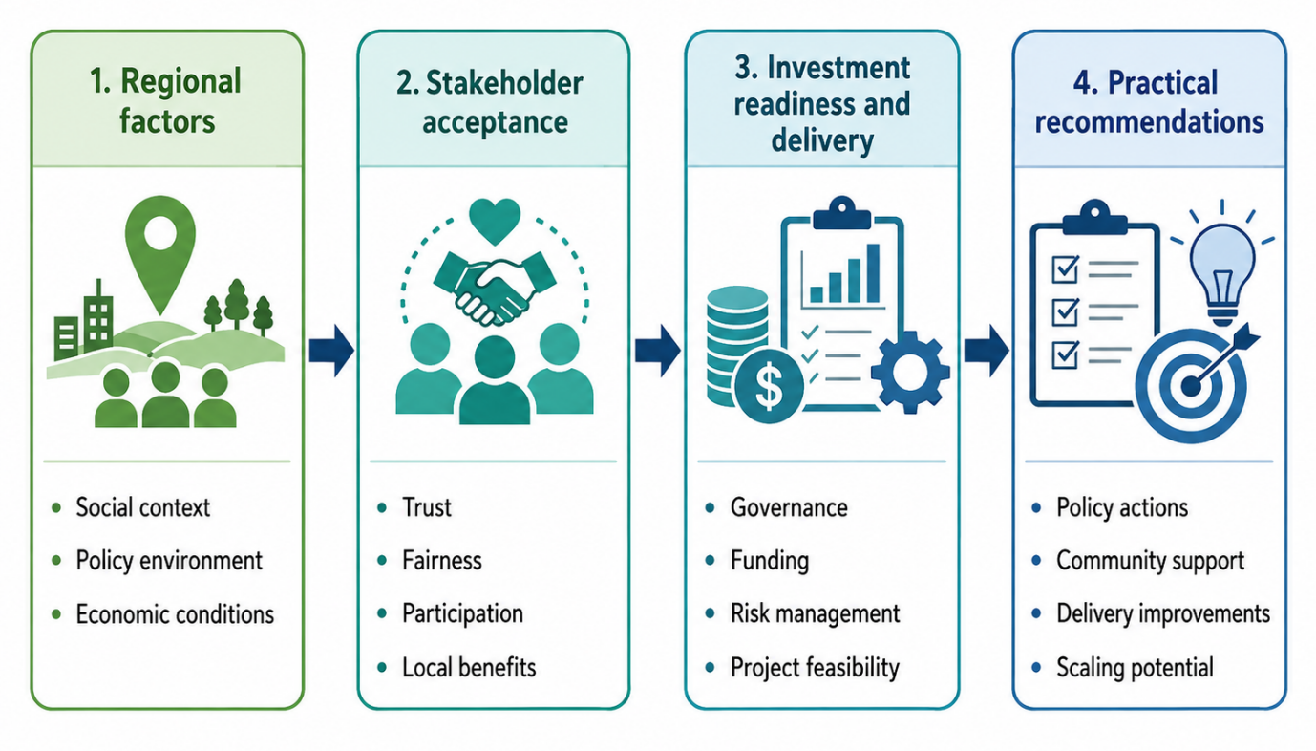
Figure 1: Framework for Renewable Energy Investment and Delivery in South West Wales
Source: Author’s own framework, developed from Freeman (1984), Wüstenhagen, Wolsink and Bürer (2007), Walker and Devine-Wright (2008), Hall, Foxon and Bolton (2016) and Polzin (2017).

1.6 Research Question
How do stakeholder perceptions, governance arrangements and investment-readiness factors influence the acceptance, delivery and scaling of community-owned renewable energy technologies in Swansea and South West Wales?
This study examines how stakeholder perceptions, governance arrangements and investment-readiness factors influence the acceptance, delivery and scaling of community-owned renewable energy technologies in Swansea and South West Wales. It considers how trust, fairness, participation, transparency and local benefits shape stakeholder support, while also assessing the importance of clear responsibilities, effective decision-making and institutional coordination. In addition, it explores whether projects have credible business cases, suitable governance capacity, access to finance, manageable risks and sufficient technical and organisational resources. Together, these factors determine whether community-energy ideas can gain legitimacy, progress into viable projects and be replicated successfully and widely across the region.

1.7 Significance of the Study
This study has academic and practical significance. Academically, it responds to the tendency for community-energy research to examine acceptance, governance, finance or scaling through separate analytical lenses. By bringing these elements together within one regional investigation, the study can clarify how social legitimacy and project credibility reinforce or weaken one another. It also provides place-based evidence from Swansea and South West Wales, where community-owned renewable energy must operate across diverse communities, institutions and technology opportunities.
Practically, the research is relevant to community organisations, local authorities, developers, advisers, businesses and potential funders. Its findings can identify which forms of communication, participation, governance and benefit design are most likely to strengthen stakeholder confidence, while also highlighting the finance, capability and risk conditions required for delivery. The study does not assume that community ownership automatically produces acceptance or viable projects. Instead, it examines what must be in place for locally supported ideas to become credible, implementable and scalable. This can support more realistic decisions about partnership development, stakeholder engagement, organisational capacity and investment preparation within the region.

1.8 Structure of the Dissertation
This dissertation is organised into five chapters that together provide a clear and logical progression from the research context to the final conclusions and recommendations. Chapter 1 introduces the study by presenting the background, research focus, overall aim, research objectives, primary research question and significance of the research.
Chapter 2 reviews the relevant academic and policy literature on renewable-energy transition, community ownership, stakeholder relationships, social acceptance, energy justice, governance and investment readiness. It also identifies the research gap and develops the conceptual framework guiding the study.
Chapter 3 explains and justifies the pragmatic mixed-methods regional case-study design. It outlines the questionnaire, semi-structured interviews, population and sampling approach, pilot study, data-analysis procedures, reliability and validity measures, ethical considerations and methodological limitations.
Chapter 4 presents, analyses and integrates the quantitative questionnaire findings and qualitative interview findings. The results are organised around the research objectives and interpreted in relation to the conceptual framework and existing literature.
Finally, Chapter 5 draws together the overall conclusions, assesses whether the research aim and objectives have been achieved, presents evidence-based recommendations, explains the study’s theoretical and practical contributions, discusses its limitations and identifies appropriate priorities for future research into community-owned renewable energy.

Chapter 2: Literature Review
This chapter critically reviews literature on community-owned renewable energy, stakeholder acceptance and investment readiness in Swansea and South West Wales. Using a funnel approach, it moves from renewable-energy transition and decentralisation to community ownership, stakeholder relationships, social acceptance, energy justice, governance, finance and project delivery. The review is structured around the research objectives, comparing seminal and contemporary studies to identify agreements, contradictions and gaps. Attention is given to trust, fairness, participation, local benefits, governance capability, financial risk and investment readiness. It concludes by examining how social legitimacy interacts with organisational and financial readiness and by developing the study’s conceptual framework.

2.1 Renewable Energy Transition and Decentralisation – Objective 1
Renewable-energy transition is commonly understood as the movement from energy systems dominated by fossil fuels towards systems based increasingly on low-carbon and renewable technologies. However, treating transition simply as technological substitution provides an incomplete explanation. Energy systems operate through relationships between technologies, infrastructure, regulations, markets, institutional practices, consumer behaviour, political priorities and cultural expectations. Consequently, changes in energy generation require wider changes in the systems within which technologies are produced, financed, governed and used (Geels, 2002; Smith, Stirling and Berkhout, 2005).
Geels' (2002) multi-level perspective provides one of the seminal frameworks for interpreting such change. It distinguishes between technological niches, established socio-technical regimes and broader landscape pressures. Established energy regimes develop stability because technologies become embedded within infrastructure, regulation, professional knowledge, markets and user practices. Alternative technologies or organisational arrangements frequently develop within niches where experimentation can occur. Wider pressures, including climate change, changing energy-security priorities and decarbonisation commitments, may subsequently destabilise existing regimes and create opportunities for niche innovations.
Geels (2011) later responded to criticisms of the multi-level perspective, including concerns about agency, power and the tendency to present transition as a relatively orderly movement between analytical levels. This refinement is important because community-owned renewable energy cannot be interpreted simply as a technological niche waiting to replace conventional energy systems. It also challenges established relationships concerning ownership, control, participation and the distribution of value.
Markard, Raven and Truffer (2012) reinforce the socio-technical interpretation by arguing that sustainability transitions involve long-term and multidimensional changes across technological, organisational, political and economic systems. Their work supports Geels' emphasis on systemic transformation while demonstrating that transition research must examine interactions among multiple institutions and actors. However, Bridge et al. (2013) introduce a stronger geographical dimension. They argue that energy transition reconfigures relationships among space, place, infrastructure and economic activity and therefore produces different consequences across different locations.
The distinction between these perspectives is important for the present dissertation. Geels (2002, 2011) and Markard, Raven and Truffer (2012) primarily help explain how large systems change, whereas Bridge et al. (2013) demonstrate why the consequences of such change cannot be assumed to be geographically uniform. Renewable-energy transition may create opportunities for some localities while imposing costs, visual changes, infrastructure pressures or unequal benefits on others. A regional study of Swansea and South West Wales therefore requires both perspectives.
Decentralisation is particularly relevant because renewable-energy technologies allow electricity generation and energy management to take place at smaller spatial scales. Solar installations, onshore wind, small-scale hydro, battery storage and local heat networks potentially allow local authorities, businesses, cooperatives, farmers, community organisations and households to become more active participants in energy systems (Walker and Devine-Wright, 2008; Seyfang, Park and Smith, 2013).
However, decentralised generation does not necessarily mean decentralised ownership or power. Renewable infrastructure may be geographically local while being financed, owned and controlled externally. Forman (2017) and Lacey-Barnacle (2020) challenge assumptions that local energy initiatives are inherently democratic or socially just. Participation and benefits can be concentrated among actors possessing greater financial resources, knowledge, social networks or institutional influence.
This creates an important distinction between the location of renewable infrastructure and the ownership and governance of renewable infrastructure. Walker and Devine-Wright (2008) emphasise the potential for greater local involvement, while Forman (2017) and Lacey-Barnacle (2020) demonstrate that this potential depends upon the conditions under which ownership and participation are organised. These contributions should therefore be interpreted as complementary. Decentralisation creates opportunities for greater local involvement, but governance determines whether such opportunities become meaningful.
The Welsh context makes these questions especially significant. Renewable-energy policy increasingly combines decarbonisation objectives with questions concerning local ownership, community benefit and retention of value within Wales. Welsh Government (2026) places renewable-energy development within a wider ambition for a low-carbon energy system while also recognising the role of local ownership and community participation. The significance of this policy direction is that energy transition is not treated purely as a question of installed generating capacity. It also raises questions concerning who participates in renewable-energy development and where benefits ultimately remain.
Nevertheless, policy ambition does not establish whether individual projects will be socially accepted, financially viable or practically deliverable. National and regional targets can create favourable political conditions, but community initiatives continue to operate through planning systems, grid constraints, financial institutions, organisational capabilities and local stakeholder relationships.
Objective 1 therefore requires more than an assessment of renewable-energy technologies. The wider literature suggests that community-energy development is shaped by interacting social, policy and economic conditions. These include the structure of energy markets, institutional support, access to finance, ownership patterns and relationships between communities and professional actors.

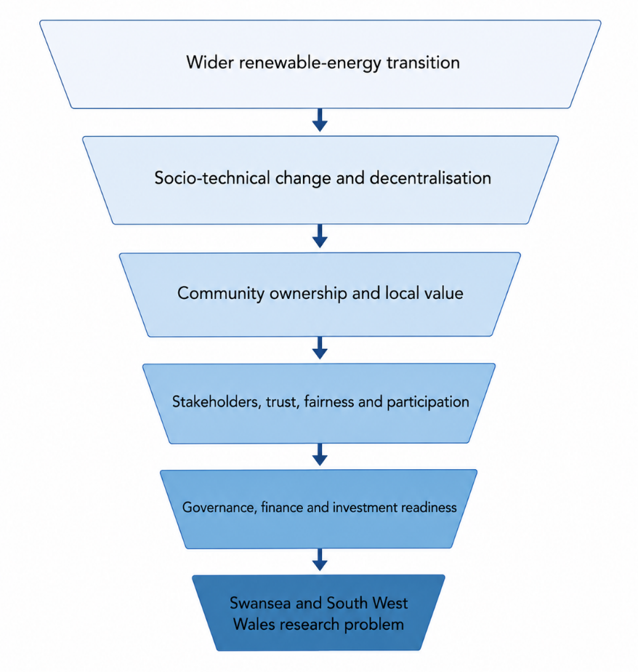
Figure 2: Funnel structure of the literature review

Source: Author’s own framework based on Geels (2002), Walker and Devine-Wright (2008), Wüstenhagen, Wolsink and Bürer (2007), Hall, Foxon and Bolton (2016) and Polzin (2017).

2.2 Community-Owned Renewable Energy: Ownership, Value and Constraints - Objectives 1 and 4
Community-owned renewable energy describes a broad range of initiatives through which communities have a meaningful role in renewable-energy ownership, governance, decision-making or benefit distribution. Walker and Devine-Wright (2008) provide an influential conceptual distinction between community energy as a process and as an outcome. The process dimension concerns who develops, owns and participates in a project, whereas the outcome dimension concerns who receives its benefits. The distinction is valuable because renewable-energy infrastructure can be physically located within a community without being meaningfully community owned.
Community-energy projects can involve cooperatives, community benefit societies, charities, development trusts, councils and partnerships involving commercial organisations. They may operate solar, wind, hydro, storage, biomass or local heat systems. Rogers et al. (2008) and Seyfang, Park and Smith (2013) consequently demonstrate that community energy should not be defined according to a particular technology. Its distinctiveness lies more strongly in the relationship between energy generation, collective organisation and local involvement.
The literature identifies several potential benefits. Walker and Devine-Wright (2008) argue that meaningful local processes and locally distributed outcomes can increase the community character of projects. Berka and Creamer (2018) review evidence concerning local impacts and identify possible economic and social outcomes including retained revenues, employment, community funds, local services and increased local capabilities. Bomberg and McEwen (2012), meanwhile, focus on mobilisation and show how social networks, shared identities and community capacity can support collective energy action.
These contributions focus on different dimensions of community energy. Walker and Devine-Wright (2008) provide a framework for assessing whether a project is genuinely community based. Berka and Creamer (2018) investigate the types of local outcomes that projects may generate, whereas Bomberg and McEwen (2012) examine the social and political processes through which groups mobilise. Collectively, the literature therefore supports the potential value of community energy but does not establish that benefits emerge automatically.
Creamer et al. (2018) provide an important challenge to interpretations of community energy as entirely local or independent. They argue that community-energy initiatives are frequently entangled with the state, private-sector organisations, professional advisers, regulators and financial institutions. Community projects may require external technical expertise, development finance, planning advice, grid relationships and market access. Consequently, the boundary between community-led and externally supported development is not always clear.
This complicates Walker and Devine-Wright's (2008) framework without invalidating it. Community organisations do not necessarily surrender their community character simply because they work with private or governmental actors. Indeed, external expertise may be necessary for project delivery. The critical issue is whether external relationships strengthen community capability or progressively transfer control away from the community.
Inclusion creates an additional difficulty. Community ownership is frequently associated with democratic participation, yet participation requires resources. Lacey-Barnacle (2020) argues that time, knowledge, confidence, income and professional networks influence individuals' ability to become involved in community-energy initiatives. Consequently, renters, younger households, economically disadvantaged residents or individuals with limited technical understanding can potentially be excluded from activities presented as community based.
This observation qualifies the more positive conclusions concerning local benefits. Berka and Creamer (2018) demonstrate that community ownership can produce valuable outcomes, but Lacey-Barnacle (2020) raises the important question of how those outcomes are distributed internally. Average benefits at community level can coexist with unequal participation and unequal access to investment opportunities.
Forman (2017) develops a similar argument in Wales by applying energy-justice concepts to community ownership. Local legal ownership is not sufficient evidence that a project is equitable. A project may technically be community owned while effective influence remains concentrated within a small group. Similarly, community share offers may increase local ownership while remaining financially inaccessible to households without disposable income.
Community ownership therefore needs to be evaluated through participation, decision-making and benefit distribution rather than through legal status alone. This is particularly significant for a dissertation concerned with stakeholder acceptance because stakeholders may evaluate the legitimacy of a project according to their actual experience of influence rather than the organisation's formal ownership structure.
The practical limitations of community energy are equally significant. Brummer (2018) identifies barriers including limited organisational resources, reliance on volunteers, technical complexity, regulatory uncertainty and difficulties obtaining finance. Mirzania et al. (2019) demonstrate that UK community-energy organisations have also faced significant challenges arising from policy changes, particularly where business models had become dependent upon government support mechanisms.
Hall, Foxon and Bolton (2016) place these challenges within the wider financial system. They show that financial institutions can shape the ownership structures available to civic-energy projects. Smaller community initiatives may appear relatively expensive or risky because transaction costs are high relative to project size, professional staff may be limited and organisations may not possess extensive delivery histories.
These studies identify different but interconnected constraints. Brummer (2018) emphasises internal organisational barriers, Mirzania et al. (2019) focus on changing policy and market conditions, while Hall, Foxon and Bolton (2016) demonstrate how institutional finance can privilege particular forms and scales of investment. Taken together, they suggest that community-energy failure cannot be explained simply as a lack of enthusiasm or local commitment.
This exposes a structural tension. Community projects may be required to deliver wider social value while simultaneously competing within financial environments that evaluate investment primarily through conventional risk and return criteria. A community initiative may possess high local legitimacy but still struggle to obtain finance because it lacks scale or experience. Conversely, involvement by commercial partners may improve delivery capability while reducing community control.
Community Energy Wales (2025) demonstrates the continuing relevance of these problems in the Welsh sector. Contemporary community-energy organisations continue to confront challenges relating to finance, development capacity, grid access and the practical progression of projects. This supports earlier findings from Brummer (2018) and Mirzania et al. (2019) and indicates that the difficulties are not merely historical consequences of earlier policy environments.
The question of what constitutes project success is therefore contested. Studies focusing heavily on installed capacity or financial returns may underestimate outcomes including community learning, confidence, social capital and local institutional development. Conversely, assessments centred almost exclusively on social benefits may understate weak technical or financial performance.
Barnes et al. (2024) contribute to resolving this tension by distinguishing different pathways through which energy communities create value. Their analysis demonstrates that value can include measurable functional outcomes as well as less easily quantified social and normative outcomes. This supports the argument that community-energy projects should not be evaluated against a single indicator.
However, acknowledging multiple forms of value creates an additional challenge. A project may generate strong social outcomes but remain incapable of scaling or sustaining itself financially. Alternatively, a financially successful project may produce limited local control or weak participation. Community-energy success therefore involves trade-offs among social legitimacy, organisational capability and economic viability.
The literature consequently does not justify the conclusion that community ownership is inherently superior. A more defensible interpretation is that community ownership creates opportunities for local control, benefit and participation, but whether these opportunities are realised depends upon inclusive governance, organisational capacity, external relationships and access to viable finance.
This conclusion directly supports Objectives 1 and 4. It also narrows the literature review towards the people and relationships through which community ownership acquires legitimacy. These are examined through stakeholder theory, social-acceptance research and energy justice.

2.3 Stakeholder Social Acceptance and Energy Justice - Objective 2
Stakeholder theory provides an important framework for understanding community-energy projects because such projects involve actors with different interests, levels of influence and definitions of success. Freeman (1984) defines stakeholders broadly as groups or individuals who can affect or are affected by organisational objectives. In community-energy development, relevant stakeholders can therefore include residents, community organisations, local authorities, developers, investors, grid operators, landowners, businesses, installers, environmental organisations and public agencies.
Donaldson and Preston (1995) distinguish descriptive, instrumental and normative dimensions of stakeholder theory. Descriptive analysis examines how stakeholder relationships operate, instrumental analysis asks whether effective stakeholder management improves organisational outcomes, while normative analysis considers the legitimate interests of stakeholders in their own right.
This distinction is particularly relevant to community energy. Engagement may be used instrumentally to reduce opposition or improve project delivery, but a project claiming to be community led also raises normative questions about whether affected people possess legitimate rights to participate. An engagement strategy could therefore be organisationally successful while remaining normatively weak if it marginalises less powerful groups.
Mitchell, Agle and Wood (1997) address differences in stakeholder influence through the concepts of power, legitimacy and urgency. This is especially useful for energy projects because stakeholders possess different types of resources. Investors hold financial power, local authorities possess regulatory influence, grid operators have technical power and residents possess locally grounded legitimacy. Community organisations may command trust while lacking finance or formal authority.
However, this creates tension between stakeholder recognition and stakeholder prioritisation. Freeman (1984) encourages broad consideration of affected actors, whereas salience approaches may lead organisations to focus disproportionately on stakeholders able to disrupt project development. A community-energy project may therefore respond more quickly to an investor's requirements than to concerns raised by residents with limited institutional power.
Reed (2008) argues that effective participation requires stakeholders to be involved at stages when their input can genuinely influence decisions. Reed et al. (2009) further demonstrate the importance of systematic stakeholder analysis for identifying interests, relationships and influence. Their work moves stakeholder theory towards practical engagement but does not imply that participation removes conflict. Stakeholders may possess fundamentally different priorities concerning affordability, environmental protection, local employment, landscape impacts, ownership and investment returns.
Kujala et al. (2022) place greater emphasis on stakeholder relationships, engagement and mutual value creation. Their perspective is useful because it moves engagement beyond the management of opposition. Nevertheless, mutual value remains difficult to define where stakeholders evaluate projects according to different criteria. A funder's understanding of value may centre on risk and return, while residents may emphasise transparency, affordability and local benefit.
This problem connects stakeholder theory directly with the literature on social acceptance. Wüstenhagen, Wolsink and Bürer (2007) distinguish three dimensions: socio-political acceptance, community acceptance and market acceptance. Socio-political acceptance concerns broad support for renewable energy and associated policies; community acceptance concerns responses to specific projects; market acceptance involves consumers, investors and firms.
This framework helps explain why strong general support for renewable energy does not guarantee approval for every particular project. Bell, Gray and Haggett (2005) identify this difference as a social gap. However, explaining the gap as inconsistency between general support and local opposition risks oversimplification.
Wolsink (2007) strongly challenges interpretations based on NIMBY reasoning. Opposition to wind energy may reflect concerns about equity, fairness, landscape or decision-making rather than selfish resistance to development. Devine-Wright (2005) similarly argues for a more theoretically informed explanation of renewable-energy perceptions, while Devine-Wright (2009) develops the role of place attachment and place identity in explaining place-protective responses.
These contributions progressively deepen the analysis. Bell, Gray and Haggett (2005) identify the difference between general and local attitudes. Wolsink (2007) challenges simplified explanations of that difference, while Devine-Wright (2005, 2009) explains how social meaning and attachment to place affect perceptions of infrastructure.
Fast (2013) reinforces this wider shift in the acceptance literature by showing that research increasingly recognises complex local responses that extend beyond simple categories of support and opposition. This is particularly significant for Swansea and South West Wales because the region includes urban, coastal, rural and post-industrial locations in which renewable technologies may have substantially different meanings.
Trust represents another major influence. Huijts, Molin and Steg (2012) link sustainable-energy technology acceptance to perceived risks, benefits, fairness, emotions and trust. Gross (2007) focuses more specifically on procedural justice and finds that perceptions of fairness affect the legitimacy of decisions. These approaches are complementary: Huijts, Molin and Steg provide a broad psychological framework, whereas Gross demonstrates how perceptions of justice operate through project-development procedures.
Technical information alone is therefore unlikely to create acceptance. Stakeholders may understand a project's environmental benefits while distrusting the organisation developing it. Conversely, a project can potentially retain legitimacy despite disagreement when stakeholders perceive the process as transparent and fair.
Local benefit also influences acceptance but should not be interpreted mechanically. Liebe, Bartczak and Meyerhoff (2017) demonstrate that social context, ownership and opportunities for participation influence responses to renewable-energy development. Financial or material benefits may improve support, but benefits can also be viewed as compensation intended to purchase consent if they are disconnected from meaningful participation.
Batel, Devine-Wright and Tangeland (2013) raise an even more fundamental criticism. They argue that the language of social acceptance can itself become problematic when communities are treated as actors who must be persuaded to accept developments designed elsewhere. This critique is particularly important for community-owned energy. If a supposedly community project seeks participation only after fundamental decisions have already been made, its claim to community character becomes questionable.
Energy-justice literature offers a framework for evaluating these concerns. McCauley et al. (2013), Sovacool and Dworkin (2015) and Jenkins et al. (2016) argue that energy systems should be assessed according to social justice as well as technical and environmental outcomes. Jenkins et al. (2016) distinguish distributional, procedural and recognition justice.
Distributional justice concerns who receives benefits and who bears costs. Procedural justice concerns participation, transparency and influence over decisions. Recognition justice concerns whether different identities, vulnerabilities and experiences are acknowledged. Sovacool and Dworkin (2015) position energy justice as both an analytical and decision-making framework, while McCauley et al. (2013) establish foundational justice principles within energy policy.
These justice dimensions are interconnected. Walker and Day (2012), writing in relation to fuel poverty, demonstrate that energy inequality involves more than unequal financial outcomes. Vulnerability also reflects recognition and opportunities to influence decisions. This is relevant to community energy because locally generated renewable energy does not automatically create affordability or equality.
Gross (2007) and Simcock (2016) further demonstrate that procedural fairness is important to project legitimacy. Simcock's study of community wind is particularly useful because it challenges assumptions that community-led projects will necessarily be regarded as procedurally fair. Community ownership can therefore reduce neither conflict nor injustice automatically.
Forman (2017) and Lacey-Barnacle (2020) reinforce this argument in relation to community energy and inequality. Community ownership may generate opportunities for more equitable energy systems, but these opportunities depend upon who actually participates, whose knowledge is recognised and how benefits are allocated.
Objective 2 should therefore not treat stakeholder acceptance as a simple dependent variable measuring whether individuals support or oppose community energy. Acceptance is better understood as a dynamic relationship involving trust, fairness, participation, ownership, place, recognition and local benefit.
A significant weakness in the existing literature also becomes visible at this point. Research on stakeholder acceptance often concentrates on social perceptions, whereas studies of project finance tend to concentrate on economic risk and investment conditions. Yet stakeholder distrust can create delays and implementation risk, while weak financial credibility can damage trust. Governance therefore becomes an important connecting mechanism.

2.4 Governance, Participation and Trust - Objectives 2 and 3
Governance concerns the structures and processes through which decisions are taken, responsibilities allocated and accountability maintained. Community-energy governance can involve boards, cooperatives, community benefit societies, councils, developers, professional advisers and funders. It therefore affects both stakeholder legitimacy and organisational capability.
Arnstein's (1969) seminal ladder of citizen participation distinguishes between forms of tokenistic engagement and stronger forms of citizen power. Its continuing relevance lies in demonstrating that participation is not equivalent to merely providing information or requesting comments. Consultation may take place while decision-making power remains unchanged.
Reed (2008) similarly argues that participation should occur early and should have genuine influence. The difference is that Arnstein (1969) provides a normative hierarchy centred on citizen power, whereas Reed (2008) offers principles for the practical management of participatory environmental decisions. Neither framework, however, removes the need for technical expertise or efficient organisational decision-making.
Aitken, Haggett and Rudolph (2016) demonstrate that renewable-energy engagement can range from awareness raising to consultation and empowerment. Their work reinforces the argument that activities described as participation can provide fundamentally different degrees of influence. Gross (2007) similarly shows why procedural fairness matters even when stakeholders disagree about final outcomes.
Langer, Decker and Menrad (2017) find that different forms of participation can influence wind-energy acceptance. Fast (2013) likewise demonstrates that social responses to renewable energy are complex and geographically embedded. Participation therefore needs to be understood as an ongoing relationship rather than a single consultation event.
Governance capacity is equally important. Warbroek and Hoppe (2017) show how local energy initiatives depend upon supportive relationships with governmental institutions and appropriate policy frameworks. Markantoni (2016) similarly argues that top-down institutional support may be necessary to mobilise community energy effectively.
This creates a practical tension between democracy and delivery. Highly participatory governance can strengthen legitimacy but may increase organisational complexity. More centralised governance can accelerate decision-making but may weaken community influence. Effective community-energy governance therefore requires a balance among participation, expertise, accountability and delivery capability.
Governance links Objectives 2 and 3 because the same institutional arrangements affect both stakeholder perceptions and investor confidence. Transparent leadership and accountability can strengthen trust among residents while also signalling organisational competence to external finance providers.

2.5 Investment Readiness, Finance and Delivery - Objective 3
Investment readiness refers to whether a project has developed sufficient credibility to secure finance and proceed towards implementation. For community-owned renewable energy, this involves more than possessing an attractive idea. Relevant conditions include legal structure, governance capability, technical feasibility, planning progress, grid access, revenue expectations and risk management (Hall, Foxon and Bolton, 2016; Polzin, 2017).
Community support therefore cannot substitute for project fundamentals. A project may enjoy strong local legitimacy but remain undeliverable because it lacks grid access, planning consent or a viable business model. Conversely, a financially strong proposal may face delay if local stakeholders distrust its ownership or governance.
Hall, Foxon and Bolton (2016) show that financial institutions influence the ownership structures available to civic-energy organisations. Smaller projects may be disadvantaged because they lack scale and extensive delivery histories. Hall and Roelich (2016) broaden the discussion by demonstrating how electricity-market structures can restrict innovative local business models.
These studies identify different institutional constraints. Hall, Foxon and Bolton (2016) focus on financial institutions, whereas Hall and Roelich (2016) emphasise market arrangements. Both suggest that investment readiness is not entirely under the control of an individual community organisation.
Policy stability is similarly important. Mignon and Bergek (2016) demonstrate that renewable-energy investment decisions are influenced by formal and informal institutional conditions. Polzin et al. (2015) find that public policies can influence renewable-energy investment by altering risk-return conditions, while Bürer and Wüstenhagen (2009) show that private investors respond differently to alternative policy instruments.
These contributions demonstrate that policy does not simply provide subsidies. It influences uncertainty. A technically credible community project may therefore remain difficult to finance when revenue arrangements, grid conditions or policy expectations are unstable.
Polzin (2017) strengthens this argument through a systematic review of barriers to private low-carbon finance. Investment difficulties do not necessarily mean that capital is unavailable. Instead, projects may be unable to attract available capital because information gaps, technology uncertainty, institutional barriers and perceived risks make investment difficult to evaluate.
This is particularly relevant to community organisations because forms of value such as volunteer commitment, community trust, local knowledge and anticipated social benefit may not translate directly into conventional financial indicators. Consequently, there can be a mismatch between the way communities understand project value and the way investors evaluate investment readiness.
Community share offers may partly address this difficulty but can create new equity concerns. Communities with higher incomes and stronger professional networks may find it easier to mobilise capital than disadvantaged communities. Therefore, the capacity to finance a project locally should not be confused with the social need for community ownership.
Sustainable-business-model literature provides a broader interpretation of value. Boons and Lüdeke-Freund (2013) argue that sustainable innovation requires business models capable of translating social and environmental innovations into workable value propositions. Bocken et al. (2014) similarly develop sustainable business-model archetypes that extend beyond narrow financial optimisation. Schaltegger, Hansen and Lüdeke-Freund (2016) emphasise the growing role of business models in explaining how organisations create economic, environmental and social value simultaneously.
Barnes et al. (2024) apply similar reasoning more directly to energy communities by identifying multiple pathways through which community-energy business models create value. This provides a bridge between the community-energy and sustainable-business-model literatures.
However, wider definitions of value should not obscure operational viability. Social value cannot sustain a project that is unable to meet costs, maintain infrastructure or manage risk. Equally, financial viability should not be treated as sufficient if the business model undermines local legitimacy.
Community Energy Wales (2025) confirms that practical barriers involving finance, grid connection, project-development capability and routes to market remain significant in Wales. The evidence therefore supports a multidimensional understanding of investment readiness involving project-level and system-level factors.
The central conclusion is that social acceptance and investment readiness are interdependent. Stakeholder opposition may increase delays and project risk, whereas poor project credibility may weaken public confidence. This interaction is insufficiently developed in much of the existing literature and becomes central to the research gap.

2.6 Literature Gap and Conceptual Framework - Objectives 1–4
The literature reviewed above demonstrates that community-owned renewable-energy development is shaped by several interconnected theoretical and empirical fields. Transition theory explains why energy-system change involves institutional and social transformation as well as technology (Geels, 2002; Markard, Raven and Truffer, 2012). Community-energy research assesses the opportunities and limitations of local ownership (Walker and Devine-Wright, 2008; Seyfang, Park and Smith, 2013; Berka and Creamer, 2018). Stakeholder theory identifies actors and differences in their power and legitimacy (Freeman, 1984; Mitchell, Agle and Wood, 1997; Reed, 2008).
Social-acceptance research highlights trust, fairness, participation and place (Wüstenhagen, Wolsink and Bürer, 2007; Devine-Wright, 2009). Energy-justice scholarship focuses attention on distribution, procedure and recognition (Sovacool and Dworkin, 2015; Jenkins et al., 2016). Governance literature demonstrates the need to combine participation with institutional competence, while investment research emphasises finance, risk, technical feasibility and organisational credibility (Hall, Foxon and Bolton, 2016; Polzin, 2017).
There is substantial agreement that technology alone cannot explain successful community-energy development, as projects also depend on institutions, governance, stakeholder relationships and finance (Walker and Devine-Wright, 2008; Hall, Foxon and Bolton, 2016). However, disagreement remains over whether community ownership consistently produces democratic and equitable outcomes. While some studies emphasise participation, local benefits and increased community capacity, others demonstrate that community initiatives may reproduce inequalities, depend on professional support and experience financial fragility (Forman, 2017; Lacey-Barnacle, 2020).
A further limitation is the fragmentation between social and financial research. Social-acceptance studies generally focus on trust, fairness, participation and perceived benefits (Huijts, Molin and Steg, 2012), whereas investment research concentrates on risk, revenue certainty, policy conditions and project credibility (Polzin, 2017). In practice, these dimensions interact. Weak stakeholder trust may generate opposition, delay and increased project risk, while weak governance or unrealistic financial planning may reduce community confidence.
The principal research gap is therefore a lack of region-specific empirical understanding of how stakeholder perceptions, governance arrangements and investment-readiness factors interact in community-owned renewable-energy development in Swansea and South West Wales. Different stakeholder groups may evaluate project readiness differently, creating potential tensions between social legitimacy, financial credibility and practical delivery.
Figure 3: Conceptual Framework for community-owned Renewable Energy delivery
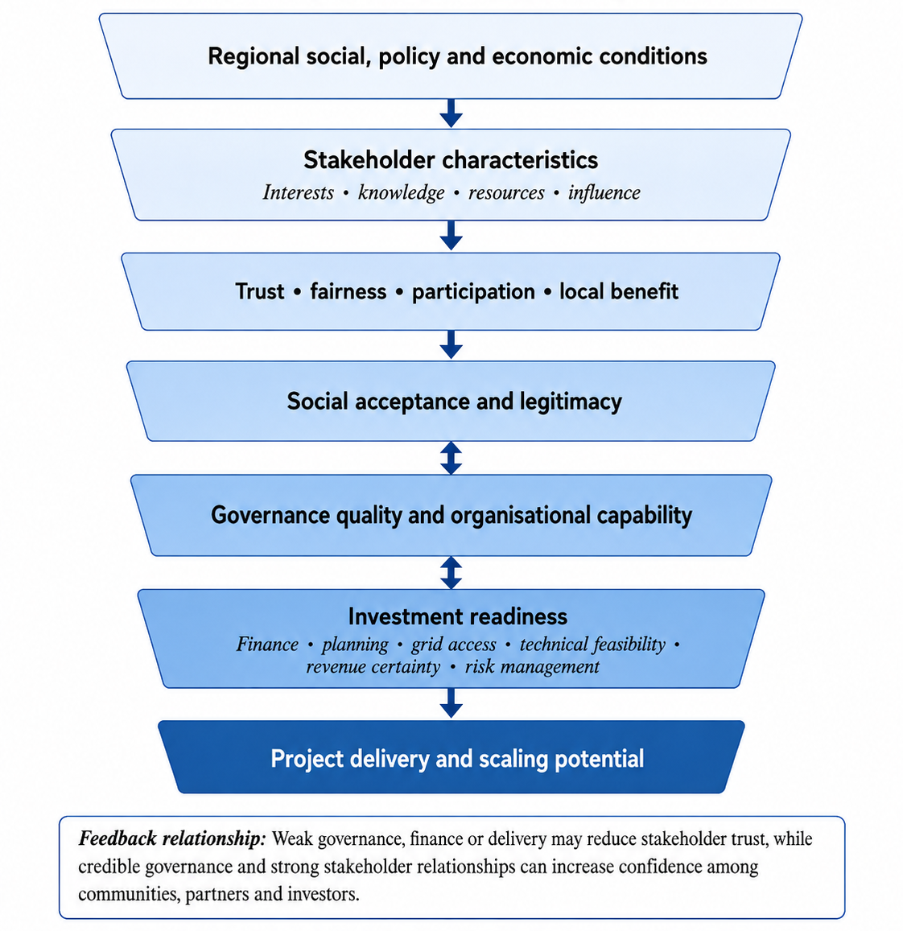

Source: Author’s own framework based on Freeman (1984), Wüstenhagen, Wolsink and Bürer (2007), Walker and Devine-Wright (2008), Jenkins et al. (2016), Hall, Foxon and Bolton (2016) and Polzin (2017).

Chapter 3: Methodology
This chapter explains and justifies the methodology used to examine how stakeholder perceptions, governance conditions and investment-readiness factors influence community-owned renewable-energy projects in Swansea and South West Wales. The methodology was designed to ensure alignment between the research problem, objectives, philosophical position, research design, sampling, data collection and analysis (Biggam, 2021; Saunders, Lewis and Thornhill, 2023). A pragmatic, convergent mixed-methods regional case-study approach was adopted, combining an online questionnaire with semi-structured stakeholder interviews. Quantitative and qualitative data were analysed separately and then integrated. The chapter also covers piloting, sampling, reliability, validity, limitations and research ethics.

3.1 Research Aim, Objectives and Research Question:
The overall aim of the research is:
To investigate how stakeholder perceptions, governance conditions and financial-readiness factors shape the acceptance and investment readiness of community-owned renewable-energy projects in Swansea and South West Wales.
The research is guided by four objectives:
- To identify the key social, policy and economic factors influencing community-owned renewable-energy development in Swansea and South West Wales.
- To examine how stakeholder perceptions of trust, fairness, participation and local benefit influence acceptance of community-owned renewable-energy projects.
- To evaluate the governance, funding and risk-related factors that affect the investment readiness of community-owned renewable-energy projects.
- To develop evidence-based recommendations for improving stakeholder acceptance and investment readiness in community-owned renewable-energy projects in Swansea and South West Wales.

3.1.1 Research Question
The central research question is:
How do stakeholder perceptions, governance arrangements and investment-readiness factors influence the acceptance, delivery and scaling of community-owned renewable energy technologies in Swansea and South West Wales?
This question provides a direct link between the research aim, the four objectives and the mixed-methods design. Objective 1 required evidence about the regional context, stakeholder awareness, technology preferences and perceived development barriers. Objective 2 required the measurement and interpretation of trust, fairness, participation, transparency and benefit-sharing. Objective 3 required evidence concerning business planning, leadership, finance, planning approval, grid connection, revenue certainty and project risk. Objective 4 required the integration of quantitative and qualitative findings to develop practical recommendations.

3.2 Research Rationale
Primary empirical research was necessary because the literature review identified limited region-specific evidence concerning how stakeholder acceptance and investment readiness interact in community-owned renewable-energy development in Swansea and South West Wales. Existing literature explains the importance of social acceptance, energy justice, local participation, governance, community ownership and renewable-energy finance. However, it does not establish how the particular combination of residents, community groups, local authorities, businesses, developers, advisers and investors within the selected region understand these issues.
The research problem contains both measurable and interpretive dimensions. It is possible to measure levels of support, familiarity, trust, willingness to participate and perceived barriers through a structured questionnaire. However, numerical evidence alone cannot explain why stakeholders hold particular views, how previous experiences affect trust or how organisations assess governance and financial risk. Interviews were therefore also necessary to explore the meaning and reasoning behind questionnaire patterns.
A quantitative-only design would have produced a broader set of comparable responses but would have offered limited insight into the institutional and contextual factors affecting community-energy delivery. Conversely, an interview-only design would have produced detailed accounts but would not have shown whether particular attitudes were shared across a wider respondent group. Mixed methods were therefore selected because combining quantitative and qualitative evidence can provide a more complete response to a complex research problem than either method used independently (Johnson and Onwuegbuzie, 2004; Creswell and Creswell, 2018).
The research can be relied upon because the methodology establishes a clear chain between the research objectives, conceptual framework, instruments and analysis. Questionnaire and interview questions were developed from the concepts examined in the literature review, including trust, procedural fairness, distribution of benefits, participation, governance credibility, finance, planning, grid access and revenue risk. Both instruments were piloted before the main data-collection stage, and a transparent record was maintained of problems identified and changes required. Using two sources of evidence also allowed the researcher to compare areas of agreement, complementarity and disagreement rather than relying on a single dataset (Greene, Caracelli and Graham, 1989; Tashakkori and Teddlie, 2010).

3.3 Research Philosophy and Saunders ’ Research Onion
Research philosophy concerns assumptions about the nature of knowledge, reality and how credible evidence should be developed and interpreted. These assumptions influence research design, data collection and analysis (Saunders, Lewis and Thornhill, 2023; Easterby-Smith et al., 2026). To make the methodological logic explicit, this study is presented through Saunders’ Research Onion, moving from the outer philosophical layer towards the inner techniques and procedures.
Figure 4: Saunders’ Research Onion applied to the study
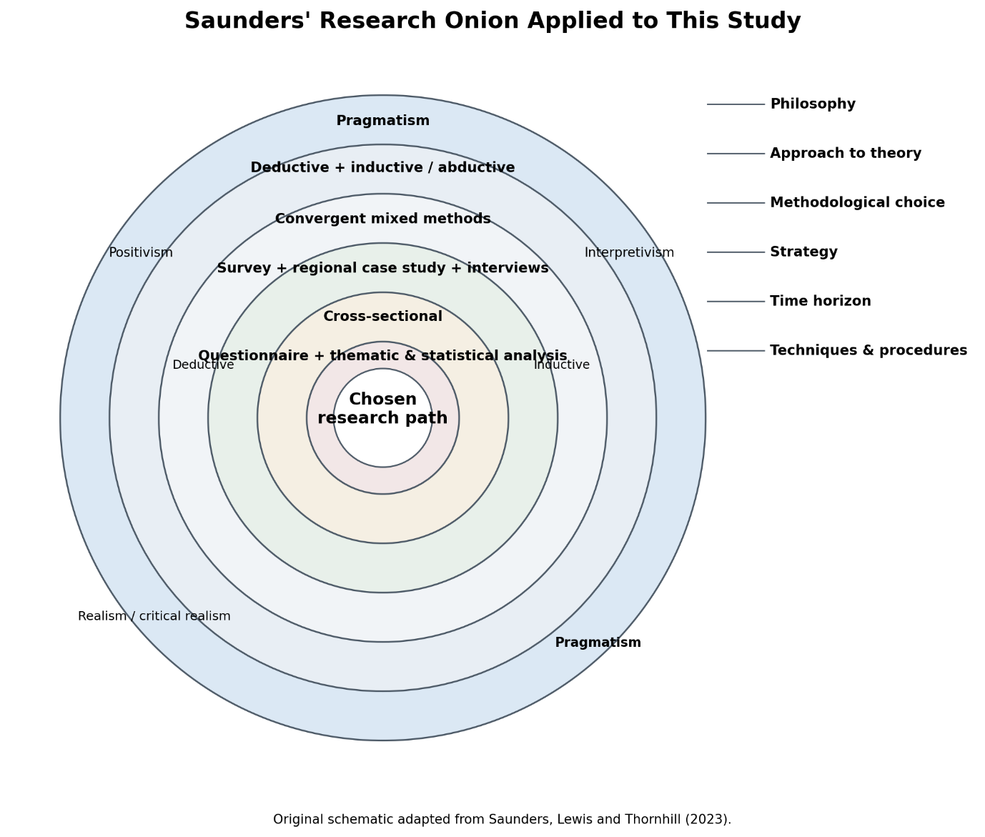Source: Author’s schematic adapted from Saunders, Lewis and Thornhill (2023).

3.3.1 Outer Layer: Research Philosophies
The outer layer considers the philosophical position underpinning the research. Positivism, realism or critical realism, interpretivism and pragmatism are relevant perspectives in business and management research (Saunders, Lewis and Thornhill, 2023).
Positivism assumes that phenomena can be examined systematically through observation, measurement and empirical analysis. It is commonly associated with quantitative research and structured data collection (Creswell and Creswell, 2023; Babbie, 2021). This was relevant to the questionnaire, which measured familiarity, support, agreement, barriers and willingness to participate or invest, allowing responses to be coded and compared across stakeholder groups.
Interpretivism focuses on the meanings individuals attach to social situations and recognises that stakeholders may understand the same issue differently (Creswell and Creswell, 2023; Bell, Bryman and Harley, 2022). Semi-structured interviews therefore supported deeper exploration of trust, fairness, community ownership, legitimacy and financial risk (Easterby-Smith et al., 2026).
Realism and critical realism recognise an external reality while acknowledging the influence of institutions, structures and interpretation (Saunders, Lewis and Thornhill, 2023).
Pragmatism was adopted as the principal philosophy because it focuses on the research problem and the practical usefulness of methods (Morgan, 2007). It supported combining numerical patterns with stakeholder explanations, providing a suitable mixed-methods approach for the study (Morgan, 2014; Creswell and Plano Clark, 2018).

3.3.2 Second Layer: Approach to Theory Development
The second layer concerns the relationship between theory and evidence. Deductive reasoning begins with concepts or expectations derived from existing literature and examines them using empirical evidence, while inductive reasoning develops explanation from patterns observed in the data. This study contained both elements. The questionnaire was mainly deductive because its variables were developed from established concepts such as trust, fairness, participation, governance and investment readiness. The interview strand retained an inductive element because participants could introduce explanations and concerns not fully anticipated in the structured survey. The overall logic was therefore compatible with an abductive movement between existing theory and empirical findings within a pragmatic design (Saunders, Lewis and Thornhill, 2023).

3.3.3 Third Layer: Methodological Choice
The methodological choice was a convergent mixed-methods design, combining quantitative and qualitative evidence within a single investigation (Creswell and Plano Clark, 2018). Mixed methods require more than simply using two methods; the datasets must be meaningfully integrated so that the combined evidence contributes to the overall conclusions (Bryman, 2006; Fetters, Curry and Creswell, 2013). The questionnaire generated standardised evidence from a wider participant group, while semi-structured interviews provided detailed contextual insights from information-rich stakeholders. Both datasets were analysed separately and then integrated during interpretation.

3.3.4 Fourth Layer: Research Strategy
The strategy combined an online survey with a regional case study of Swansea and South West Wales, supported by semi-structured stakeholder interviews. Case-study research is suitable when contemporary issues are examined within their real-world context (Yin, 2018). This was appropriate because community-owned renewable energy is shaped by regional policy, economic conditions, infrastructure, community networks and place-based attitudes. The study was geographically and conceptually bounded around community ownership, stakeholder acceptance and investment readiness. Although case studies are not statistically generalisable, their value lies in producing contextually rich understanding that may be relevant to similar settings (Flyvbjerg, 2006; Robson and McCartan, 2016).

3.3.5 Fifth Layer: Time Horizon
A cross-sectional time horizon was used because data were collected within the dissertation period rather than over several years. The study therefore captured stakeholder views and project-readiness perceptions at a defined point in time. A longitudinal design could have examined changes across project development stages, but this was not feasible within the available timeframe.

3.3.6 Inner Layer: Techniques and Procedures
The inner layer consists of the practical techniques and procedures used to answer the research question. Quantitative data were collected through an online questionnaire and analysed using data cleaning, descriptive statistics, stakeholder comparisons, cross-tabulations and chi-square tests where assumptions were met. Qualitative data were collected through semi-structured interviews and analysed using thematic analysis. The two strands were then integrated to identify convergence, complementarity and disagreement. These procedures are explained in Sections 3.5 to 3.7.

3.4 Research Design
Research philosophy concerns assumptions about knowledge, reality and how credible evidence is developed and interpreted, influencing research design, data collection and analysis (Saunders, Lewis and Thornhill, 2023; Easterby-Smith et al., 2026). Positivism, interpretivism and pragmatism were considered before selecting the study’s philosophical position.
Positivism supports systematic observation, measurement and empirical analysis and is commonly associated with quantitative research and structured data collection (Creswell and Creswell, 2023; Babbie, 2021). It was relevant to the questionnaire because familiarity, support, agreement, perceived barriers and willingness to participate or invest could be coded and compared across stakeholder groups. However, positivism alone could not fully explain socially constructed meanings such as trust, fairness, community ownership and project legitimacy (Bell, Bryman and Harley, 2022; Saunders, Lewis and Thornhill, 2023).
Interpretivism was therefore relevant to the qualitative strand, allowing stakeholders to explain different understandings of risk, participation and benefit-sharing through semi-structured interviews (Creswell and Creswell, 2023; Bell, Bryman and Harley, 2022; Easterby-Smith et al., 2026). Pragmatism was ultimately adopted because it focuses on the research problem and supports combining numerical and qualitative evidence to generate practical recommendations for communities, authorities, developers and funders locally (Morgan, 2007; Morgan, 2014; Creswell and Plano Clark, 2018).

Figure 5: Pragmatic Mixed-Methods Research Framework for Investigating Stakeholder Acceptance and Investment Readiness
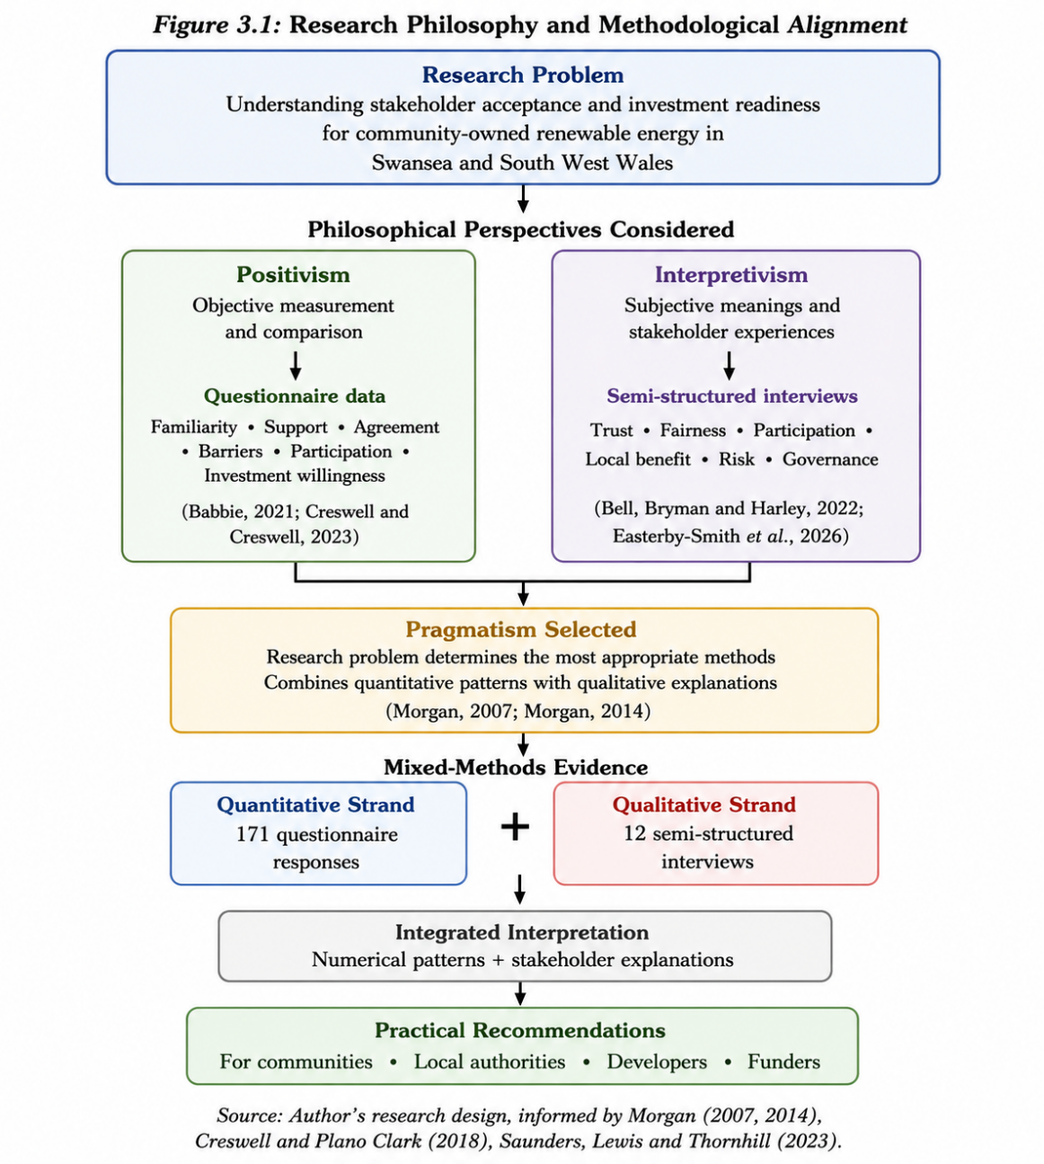

Source: Author’s own framework, informed by Saunders, Lewis and Thornhill (2023), Morgan (2007; 2014) and Creswell and Plano Clark (2018).

3.5 Data Collection and Instrument Development

3.5.1 Online questionnaire
The quantitative data-collection instrument was an online questionnaire administered through Google Forms. Surveys are appropriate when standardised evidence is required from a relatively broad respondent group and responses need to be compared systematically (De Vaus, 2014; Fowler, 2014).
The questionnaire covered consent, eligibility, geographical connection, stakeholder background, familiarity with community energy, technology preferences, trust, fairness, participation, governance, investment readiness, project barriers, support and willingness to invest. It used multiple-choice, checkbox and Likert-type questions, together with an optional open-response item. Questions were aligned with the four research objectives, covering awareness and barriers, participation and transparency, governance and financial readiness, and future priorities and recommendations.
Question wording was kept clear and neutral because ambiguous wording, unsuitable response options, question order and cognitive burden can affect survey responses (Tourangeau, Rips and Rasinski, 2000; Dillman, Smyth and Christian, 2014). “Not sure”, “not applicable” and “prefer not to say” options were included where appropriate. Google Forms also enabled efficient regional data collection and export, although several recruitment channels were used to reduce self-selection and digital-access bias (Groves et al., 2009).

3.5.2 Semi-structured interviews
The qualitative data-collection method was semi-structured interviewing. This method uses a prepared interview guide while allowing the researcher to ask follow-up questions, clarify answers and explore unexpected issues (Kvale and Brinkmann, 2015). It was suitable because participants were expected to possess different forms of knowledge and experience.
The interview guide covered the participant’s role, regional renewable-energy opportunities, stakeholder acceptance, trust, fairness, community benefit, governance, finance, grid access, planning, organisational capacity, risk and recommendations. The questions were derived from the research objectives and conceptual framework rather than created independently of the literature.
Semi-structured interviews were preferable to fully structured interviews because fixed questions alone might prevent participants from discussing experiences that had not been anticipated. Completely unstructured interviews were also unsuitable because the research required comparable evidence across participants. The semi-structured format therefore provided a balance between consistency and flexibility (Patton, 2015). A systematic interview guide should be logically organised, connected to existing knowledge and piloted before formal use (Kallio et al., 2016).

3.5.3 Pilot Study
A pilot study was conducted before the main data-collection phase to assess the clarity, relevance, structure, technical operation and practical suitability of the questionnaire and semi-structured interview guide. Piloting is important because questions that appear clear to the researcher may be interpreted differently by participants, and it enables problems with wording, response options and instrument design to be identified before formal data collection (van Teijlingen and Hundley, 2001; Presser et al., 2004).
For the revised methodology, the questionnaire pilot is presented as a small preliminary group of 12 participants. This size was sufficient to test wording, branching, response options and export structure without confusing pilot responses with the main study. The pilot identified issues concerning geographical eligibility, Likert-scale export, single-choice versus multiple-choice settings, response validation, typographical errors and anonymity. These points were corrected before the main questionnaire was distributed.
The semi-structured interview guide was piloted with five participants representing different stakeholder perspectives. Participants were able to discuss community participation, trust, local benefits, governance, finance, planning, grid access and project risk. Only minor follow-up prompts were required and no substantial restructuring of the interview guide was necessary. The pilot therefore improved the clarity, consistency, validity, ethical robustness and practical reliability of both research instruments before formal data collection.

Table 1: Summary of Pilot Study Revisions
Area tested | Issue identified | Revision made | Methodological benefit
Eligibility | Out-of-area respondents could continue | Added screening and branching | Improved sample relevance
Geography | Inconsistent open responses | Added fixed regional categories | Improved coding consistency
Likert scales | Statements not exported separately | Converted to multiple-choice grids | Enabled item-level analysis
Stakeholder group | Multiple categories allowed | Changed to primary category | Improved subgroup comparison
Local benefit | Multiple answers permitted | Changed to single choice | Matched wording and measurement
Priority actions | Number not controlled | Added response validation | Improved consistency
Data quality | Typographical/export issues | Corrected and retested | Improved accuracy
Anonymity | Identifiers could be collected | Removed identifiers/email collection | Improved ethical compliance
Source: Author’s pilot study and instrument revisions, 2026; informed by van Teijlingen and Hundley (2001) and Presser et al. (2004).

3.6 Population and Sampling
The research population comprised adults aged 18 or over with a geographical, community, professional, organisational or financial connection to Swansea or South West Wales. Participants included residents, community-energy organisations, local-authority employees, renewable-energy developers, businesses, investors, advisers, landowners, academics and third-sector representatives. The quantitative target was 150–200 questionnaires, but no probability-sampling frame was available; therefore, the sample was exploratory rather than statistically representative (Cochran, 1977). Purposive outreach and voluntary participation were used, with recruitment extending beyond personal networks. Responses were monitored for completeness and stakeholder balance. Interview participants were selected purposively because the qualitative strand required relevant knowledge or experience (Palinkas et al., 2015), with snowball sampling where appropriate. Twelve interviews were completed. Qualitative adequacy was assessed through relevance, diversity and thematic saturation (Guest, Bunce and Johnson, 2006; Hennink and Kaiser, 2022), supported by information power (Malterud, Siersma and Guassora, 2016).

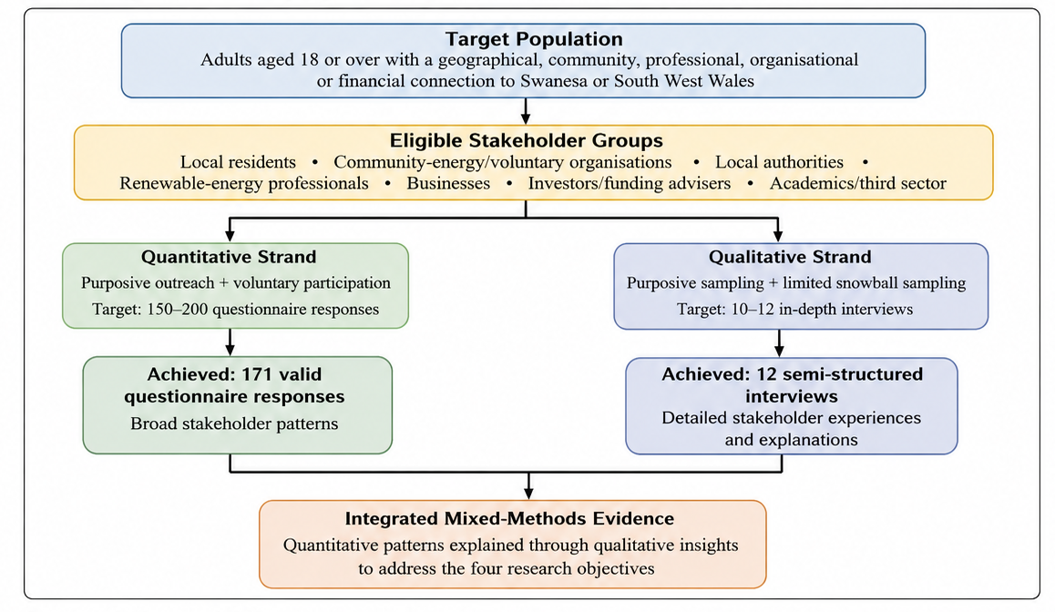
Figure 6: Population and Sampling framework

Source: Author’s own framework, informed by Cochran (1977), Palinkas et al. (2015), Guest, Bunce and Johnson (2006), Malterud, Siersma and Guassora (2016), and Hennink and Kaiser (2022).

3.7 Data and Analysis

3.7.1 Quantitative Analysis
Questionnaire responses were automatically collected through Google Forms and exported into Google Sheets for data cleaning, coding and quantitative analysis. Data cleaning included checking consent, eligibility, incomplete submissions, duplicate responses, invalid geographical entries and inconsistent category labels. A codebook was created showing variable names, response codes and missing-value treatment.
The analysis began with descriptive statistics. Frequencies and percentages were calculated for demographic, categorical and ordinal responses. Tables were used to present age group, geographical connection, stakeholder category, employment status, familiarity and previous community-energy experience. Likert responses were presented using frequencies, percentages and medians.
Where several revised Likert items measured the same theoretical construct, internal consistency could be assessed before creating a combined scale. Cronbach’s alpha measures the relationship between items intended to represent a common construct (Cronbach, 1951). However, alpha does not independently prove that a scale is valid or unidimensional and must be interpreted alongside theoretical coherence and item-level evidence (Nunnally and Bernstein, 1994; Tavakol and Dennick, 2011).
Cross-tabulations were used to compare responses between relevant groups, such as stakeholder category, familiarity level, previous project experience and regional connection. Chi-square tests of independence were considered where variables were categorical and expected cell frequencies were adequate. Chi-square analysis examines whether differences between categorical groups are greater than might reasonably be expected by chance (McHugh, 2013). Where sample sizes were too small, results were reported descriptively rather than forcing an inappropriate significance test. Statistical decisions followed established guidance from Field (2018) and Pallant (2020).

3.7.2 Qualitative Analysis
Interview transcripts and notes were analysed using thematic analysis. The first stage involved repeated reading to become familiar with each account. Initial codes were then assigned to relevant extracts concerning trust, fairness, participation, local benefit, governance, finance, planning, grid access, capacity and investment risk.
Codes were grouped into candidate themes, which were reviewed against both the coded extracts and the complete dataset. Themes were then clearly named and defined. Braun and Clarke’s (2006) six-stage framework informed familiarisation, coding, theme development, review, definition and reporting. Their later guidance emphasises that themes do not simply emerge automatically but are produced through active and reflexive interpretation (Braun and Clarke, 2022).
A coding table recorded the participant code, relevant extract, initial code, candidate theme and research objective. Participants were identified as R1, R2, R3 and so forth. Selected anonymised quotations were used to demonstrate how the interpretations were grounded in participant evidence. An audit trail was retained to record analytical decisions and changes to the coding framework (Miles, Huberman and Saldaña, 2020).

3.7.3 Integration of the Evidence
Quantitative and qualitative evidence was integrated after the separate analyses. A joint display compared questionnaire findings, interview themes and relevant literature under each research objective. Integration examined whether the datasets confirmed, expanded or contradicted one another.
For example, a questionnaire pattern showing high importance attached to local benefits could be compared with interview explanations of which benefits stakeholders viewed as credible or fair. Differences between residents and professional stakeholders were not automatically treated as errors; they could indicate differences in knowledge, institutional responsibility or exposure to project risk. Integration therefore supported stronger conclusions than simply presenting two unrelated sets of results (Fetters, Curry and Creswell, 2013).

3.8 Reliability and Validity
Research quality was strengthened through several procedures. Content validity was supported by aligning questionnaire and interview sections with the research objectives and conceptual framework, while face validity was strengthened through supervisor review and pilot feedback. Clear construct definition, appropriate wording, pretesting and systematic revision were applied during instrument development (Artino et al., 2014; Boateng et al., 2018).
Quantitative reliability was supported through standardised administration, fixed response categories, a codebook and systematic data cleaning. Internal consistency testing was applied only where multiple items measured the same construct. Qualitative trustworthiness was addressed through credibility, dependability, confirmability and transferability (Lincoln and Guba, 1985). A consistent interview guide, reflexive notes, contradictory evidence and clear regional context supported these criteria. Transparent thematic analysis was maintained through coded extracts, theme-development records and analytical notes (Nowell et al., 2017).

3.9 Limitations of the Research
The research design has several limitations. Non-probability sampling may overrepresent participants already interested in renewable energy and therefore limits statistical generalisability across South West Wales (Saunders, Lewis and Thornhill, 2023). Online questionnaires may also exclude individuals with limited digital access, while specialist groups such as investors, planners, grid professionals and community-energy organisations may be unevenly represented. Self-reported data may be affected by social-desirability bias or limited technical understanding (Creswell and Creswell, 2023). The cross-sectional design captures perceptions at one point in time and cannot identify changes across project lifecycles. Furthermore, the study measures perceived investment readiness rather than conducting full technical or financial appraisals. Pilot-related risks were reduced through branching, validation, fixed categories and data cleaning.

3.10 Research Ethics
Ethical approval was obtained from the University of Wales Trinity Saint David before formal primary data collection began on 8 June 2026. Relevant ethics documents, including the Participant Information Sheet, consent forms, questionnaire and interview guide, are included in the appendices.
Participation was voluntary and limited to adults aged 18 or over. Participants received information about the study’s purpose, procedures, time commitment, data use and withdrawal rights. Informed consent was obtained before participation and treated as an ongoing process (Israel and Hay, 2006; Wiles, 2013).
Questionnaire responses were anonymous, with names and email addresses removed after piloting. Interview contact details were stored separately, participants were assigned codes and identifying information was removed to maintain confidentiality (Kaiser, 2009). Data were stored on password-protected, university-approved systems and handled in accordance with the Data Protection Act 2018 and UK GDPR. Participants could skip questions or withdraw if discomfort occurred.

Chapter 4: Data Analysis

4.1 Introduction
This chapter presents, analyses and discusses the quantitative and qualitative findings concerning community-owned renewable energy, stakeholder acceptance and investment readiness in Swansea and South West Wales. The quantitative strand is based on 171 questionnaire responses, while the qualitative design includes 12 semi-structured stakeholder interviews. To address the supervisor’s feedback, the chapter separates the quantitative and qualitative findings clearly before bringing them together in an integrated mixed-methods discussion. The quantitative analysis covers the respondent profile, familiarity and experience, technology preferences, trust, fairness, participation, local benefits, governance, investment readiness, barriers and willingness to invest. The qualitative section then interprets the available stakeholder evidence thematically, using only verifiable direct respondent wording where it is available. This structure allows the chapter to move from description to analysis and then to synthesis with the literature and research objectives.

4.2 Quantitative Findings and Analysis
The quantitative analysis first establishes the respondent profile and overall response pattern, then examines where stakeholder groups differ. Question 6 allowed multiple stakeholder roles, so subgroup memberships overlap: a respondent can, for example, be both a local resident and a public-sector employee. Stakeholder percentages therefore describe membership-based patterns rather than mutually exclusive populations. Multi-select questions are also reported as the proportion selecting each option and do not sum to 100%.

4.2.1 Data Screening and Demographic Profile
The final dataset contains 171 responses. Swansea dominates the geographical profile: 119 respondents (69.6%) were mainly connected with Swansea, followed by Neath Port Talbot (9.4%), Pembrokeshire (8.2%), Carmarthenshire (6.4%) and another part of South West Wales (4.7%). This supports the Swansea-centred case-study design, although it limits proportional claims about the whole South West Wales region.
Figure 7: Geographical Distribution of Questionnaire Respondents
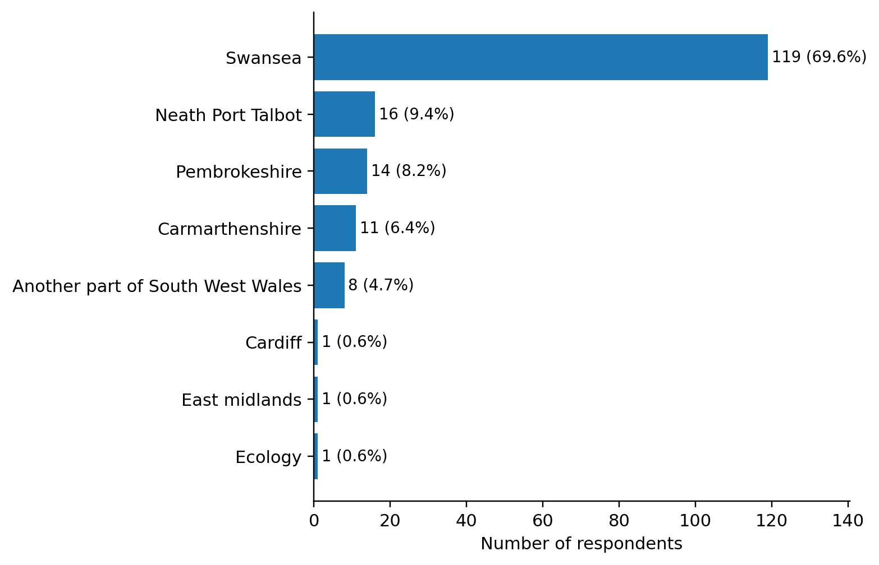
Source: Author's analysis of primary questionnaire data (n=171), 2026.
The sample was comparatively young and economically active. The respondent sample also showed a relatively balanced sex distribution. Of the 171 participants, 95 (55.6%) were male and 76 (44.4%) were female. This provides additional demographic context for interpreting the survey findings, although the study does not claim that the sample is statistically representative of the wider population of Swansea and South West Wales. The largest age group was 25-34 years (33.3%), followed by 18-24 (19.9%) and 35-44 (18.7%); 39.2% were employed full-time and 20.5% were students. Stakeholder membership was diverse. Local residents were the largest group (73; 42.7%), followed by business owners/managers (36; 21.1%), developers/installers/consultants (29; 17.0%), community/voluntary-sector representatives (27; 15.8%), local-authority/public-sector employees (25; 14.6%), academics/researchers (24; 14.0%) and investors/lenders/funding advisers (12; 7.0%). This diversity is analytically important because stakeholders possess different resources, risks and forms of influence (Freeman, 1984; Mitchell, Agle and Wood, 1997).
Table 2: Questionnaire Respondent Demographic Profile and Stakeholder Profile
Dimension/  Demographic characteristic | Category | n | %
Sex | Male  Female | 95  76 | 55.6  44.4
Age | 18-24 | 34 | 19.9
Age | 25-34 | 57 | 33.3
Age | 35-44 | 32 | 18.7
Age | 45-54 | 23 | 13.5
Age | 55-64 | 18 | 10.5
Age | 65 or over | 7 | 4.1
Employment | Employed full-time | 67 | 39.2
Employment | Employed part-time | 27 | 15.8
Employment | Self-employed | 20 | 11.7
Employment | Student | 35 | 20.5
Employment | Retired | 15 | 8.8
Employment | Other | 7 | 4.1
Stakeholder | Local resident | 73 | 42.7
Stakeholder | Business owner/manager | 36 | 21.1
Stakeholder | Developer/installer/consultant | 29 | 17.0
Stakeholder | Community/voluntary sector | 27 | 15.8
Stakeholder | Local authority/public sector | 25 | 14.6
Stakeholder | Academic/researcher | 24 | 14.0
Stakeholder | Investor/lender/funding adviser | 12 | 7.0
Source: Author's analysis of primary questionnaire data (n=171), 2026. Stakeholder percentages overlap because Question 6 was multi-select.

4.2.2 Familiarity, Previous Experience and Technology Preferences
Familiarity was generally moderate to high: 70.1% described themselves as at least moderately familiar with community-owned renewable energy. Direct project experience was much lower, with only 34.5% reporting previous participation, investment, work or consultation. This awareness-experience gap suggests that conceptual support is more widespread than practical exposure to governance, finance and project delivery. Community-energy research similarly identifies organisational capacity and institutional experience as important conditions for moving from interest to implementation (Bauwens, Gotchev and Holstenkamp, 2016; Brummer, 2018; Creamer et al., 2018).
Figure 8: Familiarity with Community-Owned Renewable Energy
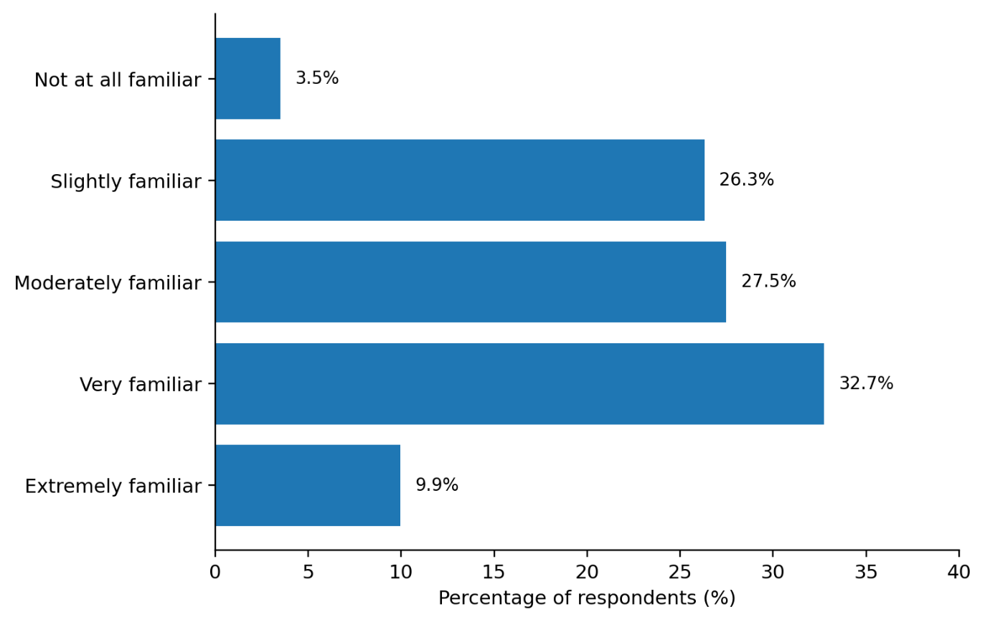
Source: Author's analysis of primary questionnaire data (n=171), 2026.

Solar photovoltaic received the highest overall technology support (51.5%), closely followed by community battery/storage (49.7%) and hydropower (45.6%). Stakeholder disaggregation, however, shows that the aggregate ranking is not universal. Residents most often selected storage and hydropower (54.8% each), community/voluntary-sector respondents strongly selected solar and hydropower (77.8% each), public-sector respondents most often selected hydropower (68.0%), developers favoured solar (69.0%), businesses favoured storage (61.1%) and the small investor/funder group most often selected onshore wind (58.3%). This supports the literature showing that renewable-energy acceptance depends on technology, place, ownership and perceived local effects rather than on a single general attitude (Wüstenhagen, Wolsink and Bürer, 2007; Bell, Gray and Haggett, 2005; Devine-Wright, 2009).
Figure 9: Renewable-Energy Technologies Respondents Would Support
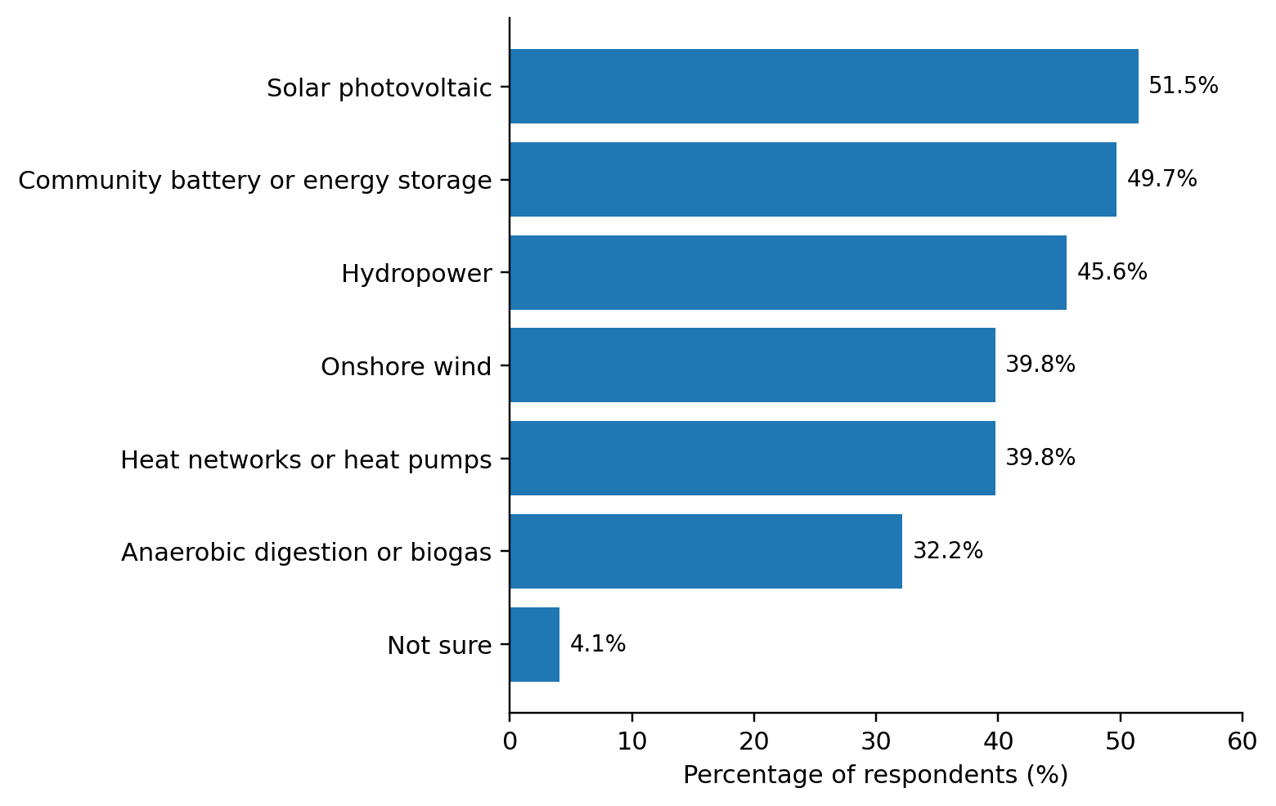
Source: Author's analysis of primary questionnaire data (n=171), 2026.

Social acceptance was nevertheless strong. Overall, 84.2% were supportive or very supportive of a well-designed local community-energy project. The qualification 'well-designed' matters: support should be read as conditional on credible governance, fair benefits and acceptable local impacts rather than as unconditional approval of any proposal (Walker and Devine-Wright, 2008).

4.2.3 Trust, Fairness, Participation and Social Acceptance
Trust, fairness and participation received a 75.5% positive response, indicating strong support for early information, meaningful resident involvement, transparent reporting and fair distribution of costs and benefits. This aligns with evidence that procedural fairness and trust influence the legitimacy of renewable-energy development (Gross, 2007; Huijts, Molin and Steg, 2012; Reed, 2008).
Figure 10: Trust, Fairness and Participation
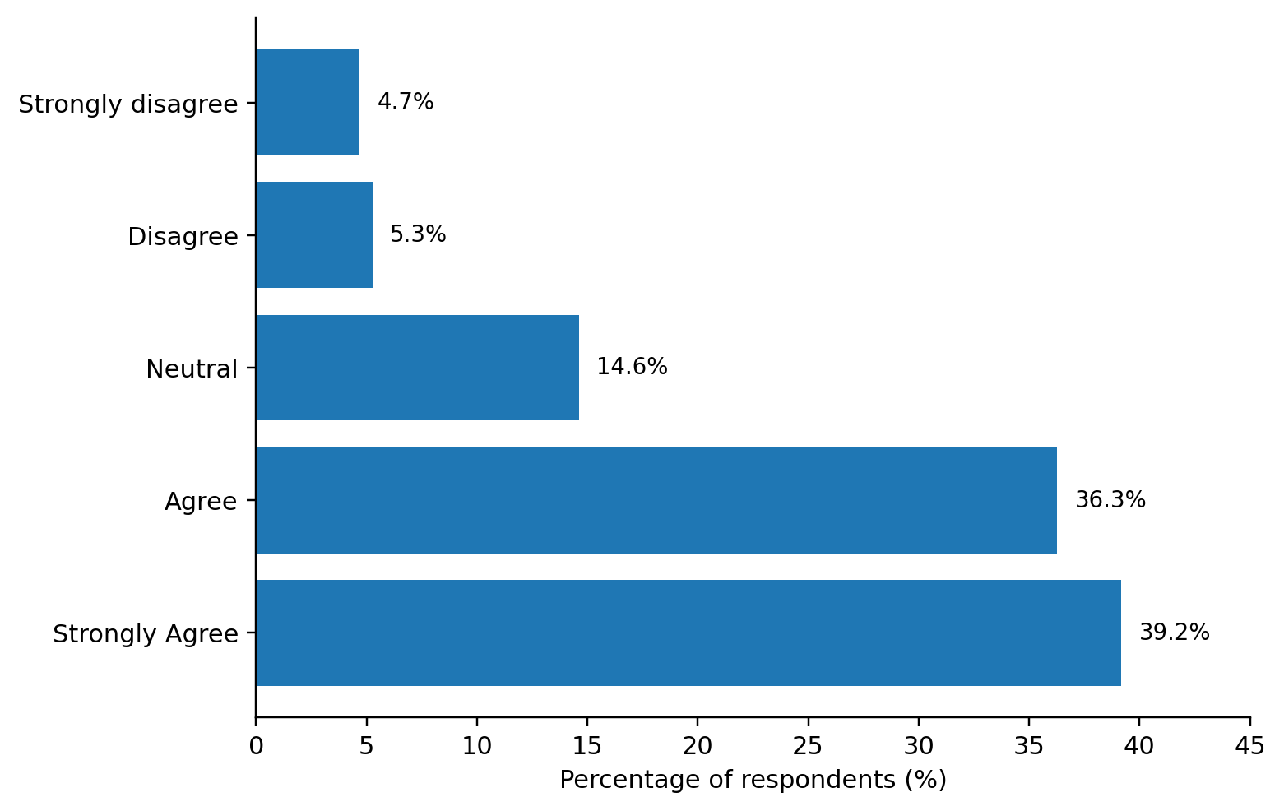
Source: Author's analysis of primary questionnaire data (n=171), 2026.
Participation preferences were varied rather than concentrated in one route. Public meetings and community-organisation membership were each selected by 36.3%, project energy/services by 35.7%, consultations by 32.7%, volunteering expertise by 32.2% and community shares/bonds by 31.0%. Stakeholder patterns strengthen this point: residents most often selected using project energy/services (38.4%), public-sector, business and investor respondents most often selected attending a public meeting, and developers most often selected volunteering time or expertise (37.9%). Engagement therefore needs several entry points rather than a single consultation mechanism.
Figure 11: Forms of Participation Respondents Would Consider
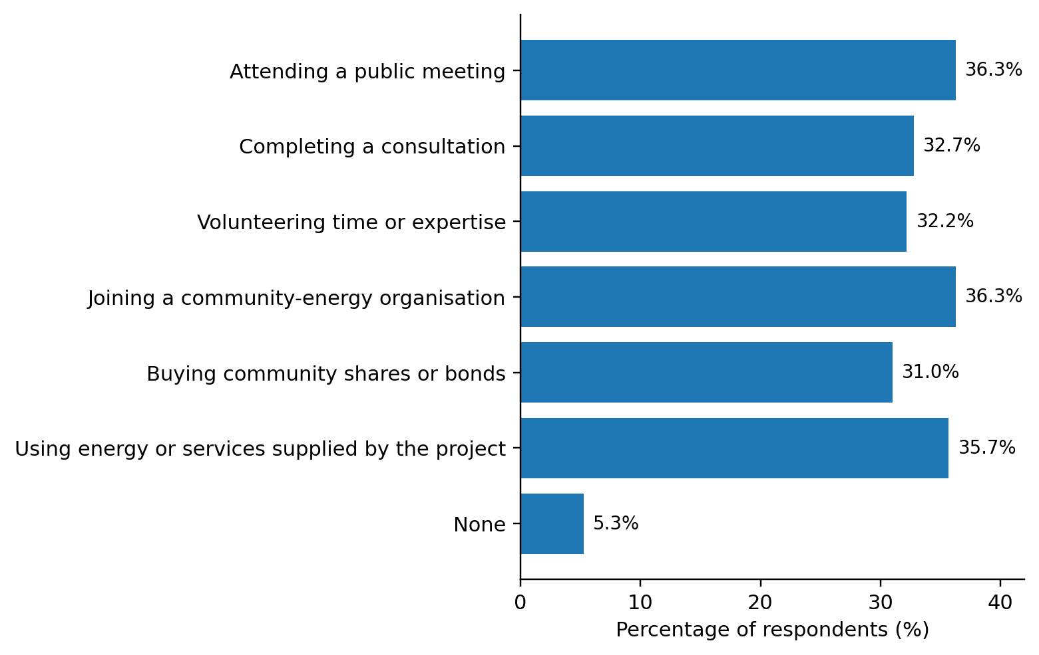
Source: Author's analysis of primary questionnaire data (n=171), 2026.
Lower household energy costs were the most frequently selected local benefit overall (44.4%) and also led among residents (56.2%), community-sector respondents (63.0%), public-sector respondents (52.0%), businesses (52.8%) and academics (66.7%). Investors/funders showed a different emphasis, with reduced carbon emissions highest at 41.7%. These differences fit an energy-justice interpretation: the legitimacy of community ownership depends not only on whether benefits exist but on who receives them, how decisions are made and whether different groups are recognised (Jenkins et al., 2016; Sovacool and Dworkin, 2015).

Figure 12: Local Benefits Valued by Respondents
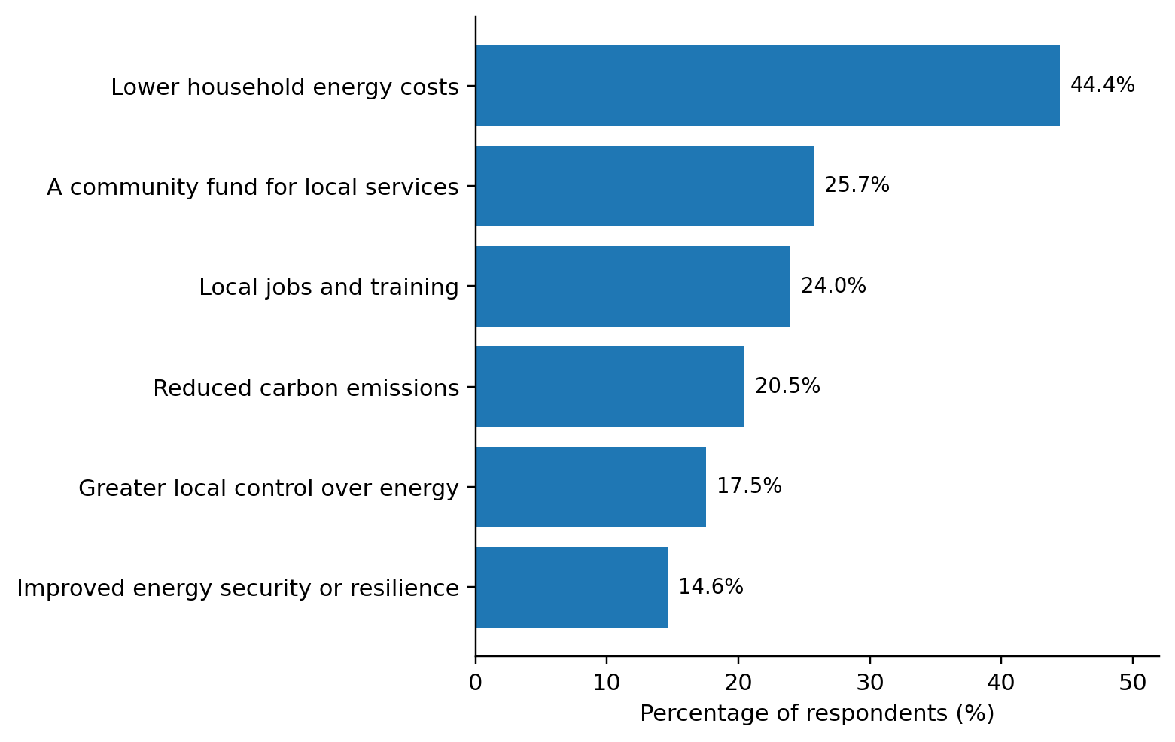
Source: Author's analysis of primary questionnaire data (n=171), 2026.
Governance and investment-readiness principles were also strongly endorsed, with 76.1% agreeing or strongly agreeing. The result indicates that community ownership is not understood as an alternative to professional management; respondents still expect clear leadership, public reporting, credible business planning, planning progress, grid feasibility and revenue certainty. Berka and Creamer (2018) similarly argue that community ownership must be supported by organisational competence and credible delivery arrangements.

Figure 13: Governance and Investment-Readiness Perceptions
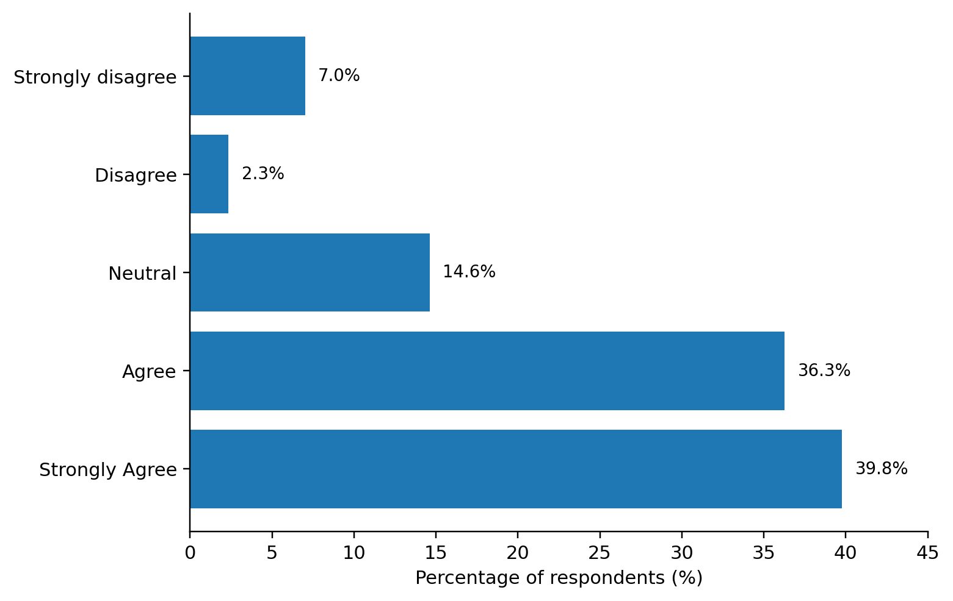
Source: Author's analysis of primary questionnaire data (n=171), 2026.

4.2.4 Investment Willingness, Barriers and Priority Actions
Investment willingness was substantially lower than project support. Only 57.3% were likely or very likely to invest a modest amount in a credible local project, compared with 84.2% project support, creating a 26.9 percentage-point gap. This is a central finding because it separates social legitimacy from financial commitment. Support may coexist with affordability constraints, risk concerns or preference for non-financial participation, while investment readiness also depends on credible revenue models and institutional arrangements (Hall, Foxon and Bolton, 2016; Polzin, 2017; Braunholtz-Speight et al., 2020).
Figure 14: Willingness to Invest in a Credible Community-Energy Project
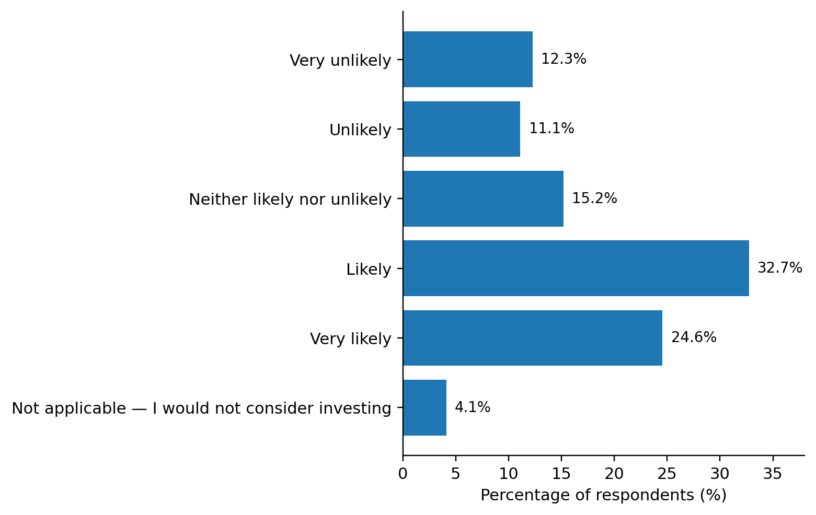
Source: Author's analysis of primary questionnaire data (n=171), 2026.
Delivery concerns remained high: 85.9% rated the grouped barriers as moderate, major or very major. Respondents therefore distinguish between supporting community energy in principle and believing that projects are easy to deliver. Capital, revenue uncertainty, planning, grid capacity, skills and trust remain practical constraints, consistent with literature on community-energy finance and organisational barriers (Brummer, 2018; Mignon and Bergek, 2016; Mirzania et al., 2019).
Figure 15: Perceived Barriers to Community-Energy Development
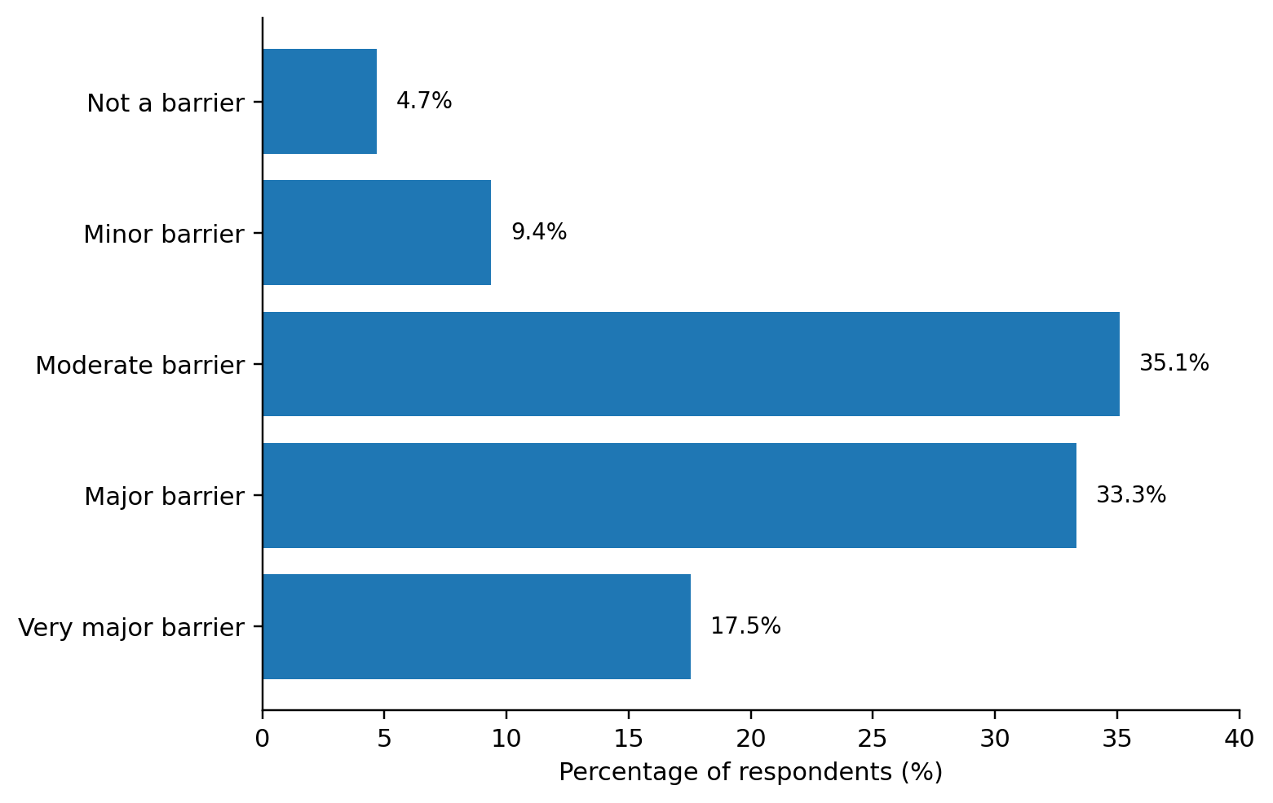
Source: Author's analysis of primary questionnaire data (n=171), 2026.
Priority actions were correspondingly mixed: more grants or low-cost finance led at 46.8%, followed by earlier and more inclusive engagement (45.0%), better grid access and technical support (39.8%), stronger governance/reporting (36.8%) and stronger partnerships (35.1%). Stakeholder comparison reveals different emphases. Residents and community-sector respondents placed early engagement first, public-sector respondents placed finance first, developers placed engagement narrowly ahead of finance, businesses placed finance first, and investors/funders gave equal prominence to finance, partnership and engagement. The overall picture therefore combines shared concerns with role-specific priorities rather than showing one universal barrier.

Figure 16: Priority Actions for Future Community-Energy Projects
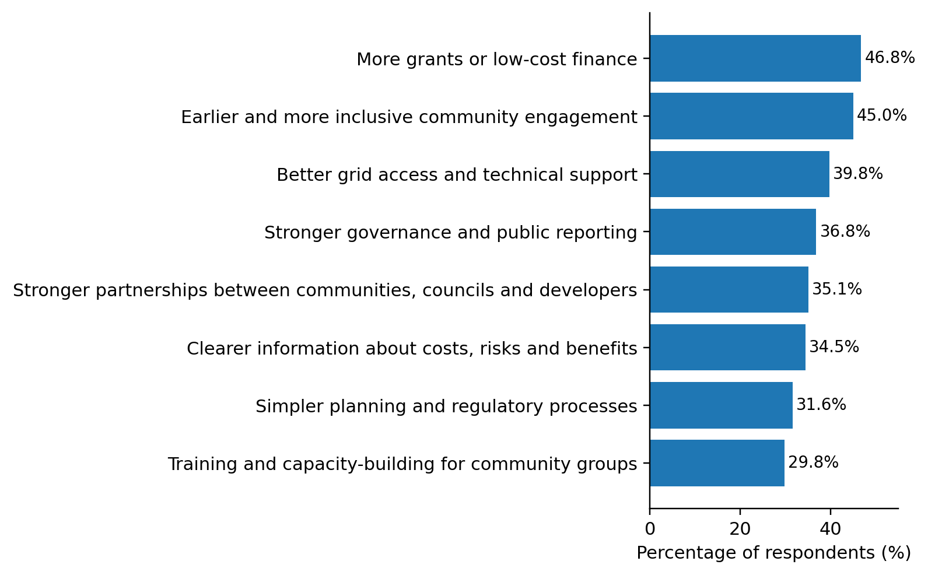
Source: Author's analysis of primary questionnaire data (n=171), 2026.

4.2.5 Stakeholder Comparison and Exploratory Association Tests
Figure 17 brings together the two outcomes most relevant to the research question: project support and willingness to invest. Support was positive across every stakeholder membership, ranging from 80.6% among business respondents to 93.2% among residents, but investment willingness was lower in every group. The gap was smallest among public-sector respondents (8.0 percentage points) and largest among academics/researchers (37.5 points), businesses (33.3 points) and developers/installers/consultants (31.0 points). This indicates that similar levels of social support can sit alongside markedly different readiness to commit money.

Figure 17: Stakeholder-Group Support and Investment Willingness
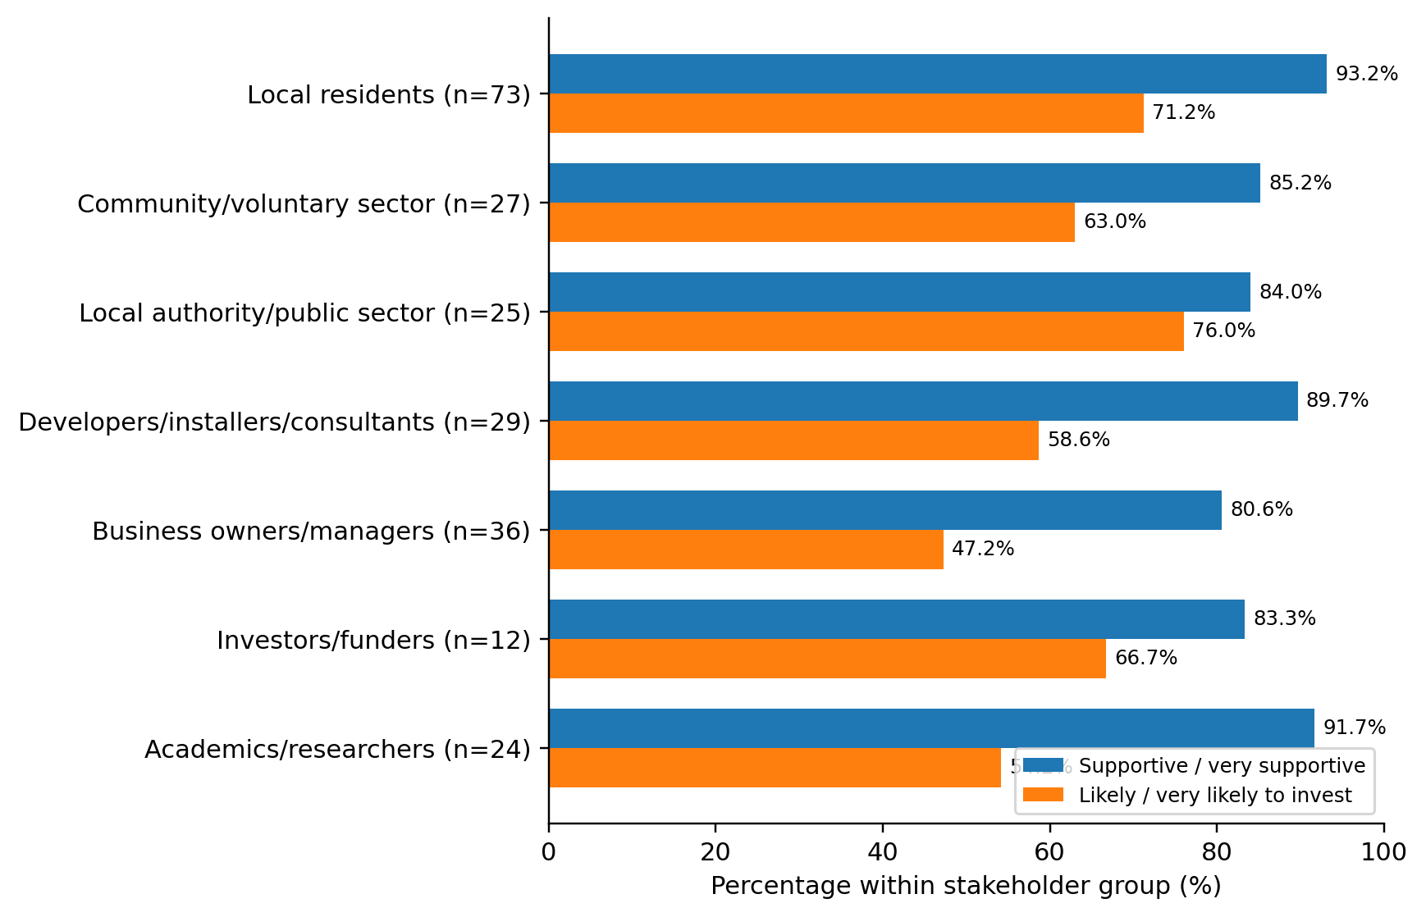
Source: Author's analysis of primary questionnaire data (n=171), 2026. Stakeholder memberships overlap.
Table 3: Key Quantitative Differences by Stakeholder Membership
Stakeholder | n | Leading technology | Leading priority | Support % | Invest %
Local residents | 73 | Hydro / storage (54.8%) | Earlier engagement (54.8%) | 93.2 | 71.2
Community / voluntary | 27 | Solar / hydro (77.8%) | Earlier engagement (77.8%) | 85.2 | 63.0
Public sector | 25 | Hydro (68.0%) | Grants / low-cost finance (64.0%) | 84.0 | 76.0
Developers / installers | 29 | Solar (69.0%) | Earlier engagement (58.6%) | 89.7 | 58.6
Business | 36 | Storage (61.1%) | Grants / low-cost finance (52.8%) | 80.6 | 47.2
Investors / funders | 12 | Onshore wind (58.3%) | Finance / partnership / engagement (50.0%) | 83.3 | 66.7
Academics / researchers | 24 | Solar (70.8%) | Earlier engagement (54.2%) | 91.7 | 54.2
Source: Author's analysis of primary questionnaire data (n=171), 2026. Multi-select stakeholder groups overlap.
Exploratory 2 x 2 association tests treated each stakeholder identity as selected/not selected. Local-resident membership was associated with positive project support, χ²(1)=7.66, p=.006, Holm-adjusted p=.040, φ=.212, and with positive investment willingness, χ²(1)=10.09, p=.001, Holm-adjusted p=.010, φ=.243. No other stakeholder-membership comparison remained statistically significant after Holm adjustment. The effect sizes are modest and the non-probability, overlapping sample means these tests should be interpreted as within-sample associations rather than population estimates. The absence of significant differences for most groups is also informative: stakeholders often converge around engagement, finance and credible governance even where the strength of emphasis differs.

4.3 Qualitative Findings and Thematic Analysis

4.3.1 Evidence Base, Stakeholder Coverage and Coding Approach
The qualitative strand was designed around 12 semi-structured stakeholder interviews. The sampling frame contains four community/resident perspectives (R1-R4), two business participants (R5-R6), three renewable-energy or sustainability professionals (R7, R8 and R12), one community-energy representative (R9), one public-sector participant (R10) and one finance/investment stakeholder (R11). This composition gives the qualitative design coverage of the main groups identified in the research question rather than concentrating only on residents.
Figure 18: Interview Stakeholder Composition (n=12)
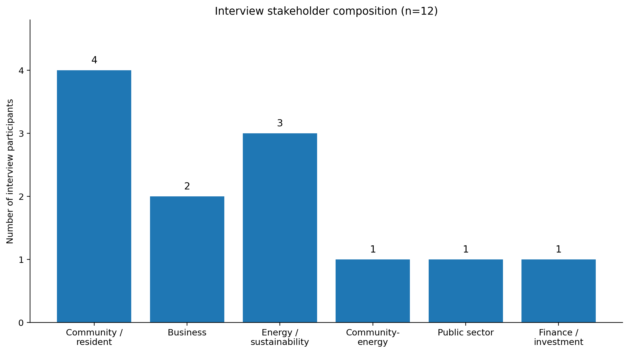
Source: Author's interview sampling frame, 2026.
Table 4: Final Interview Participant Profile
Participant | Stakeholder group | Main analytical focus
R1 | Local resident | Awareness, trust and local benefits
R2 | Local resident | Fairness, costs and community participation
R3 | Local resident | Environmental attitudes and concerns
R4 | Student/local resident | Renewable-energy awareness
R5 | Business owner | Energy costs, investment and local economy
R6 | Business manager | Business participation and risk
R7 | Renewable-energy installer | Technical and financial barriers
R8 | Developer/consultant | Planning, grid and finance
R9 | Community-energy representative | Governance and community ownership
R10 | Local authority/public sector | Policy and planning support
R11 | Finance/investment stakeholder | Risk, returns and investment readiness
R12 | Sustainability/energy professional | Scaling community-energy projects
Source: Author's interview sampling and coding framework, 2026.

The qualitative strand comprised 12 semi-structured stakeholder interviews, with participants anonymised as R1–R12. Five selected participant statements were retained as verified interview extracts and are used in the thematic analysis to illustrate the principal themes. These quotations are attributed only by participant code to preserve anonymity. The interview evidence was supplemented by 142 substantive responses to the questionnaire’s open-text Question 18, which provided additional qualitative insight across stakeholder groups. Thematic coding therefore drew on both verified interview extracts and open-text survey evidence, allowing recurring issues concerning trust, fairness, finance, technical capacity, governance and local benefits to be examined while maintaining a clear distinction between interview and questionnaire evidence.
Figure 19: Prevalence of Qualitative Themes in Open-Text Comments (n=142)
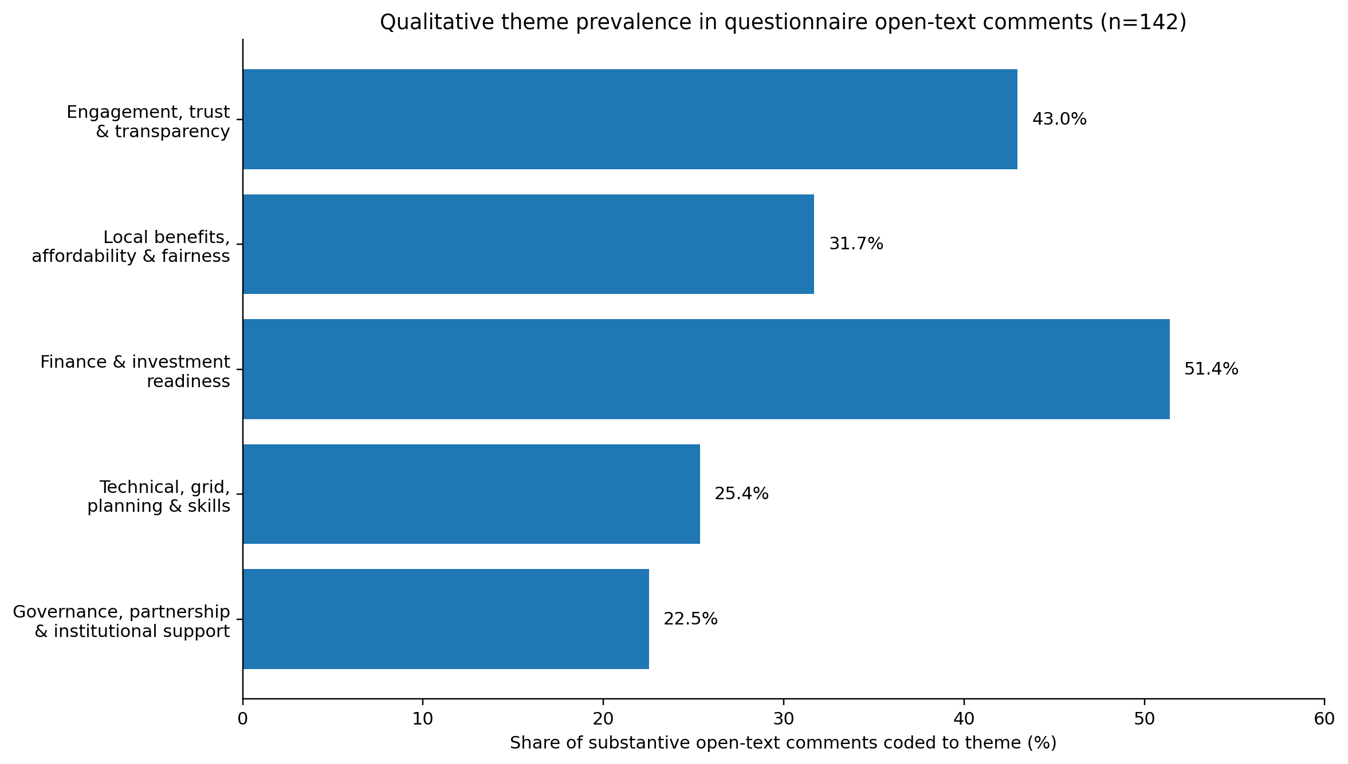
Source: Author's structured coding of substantive Question 18 comments, 2026. Themes are non-exclusive.
Five recurring themes were identified: finance and investment readiness (51.4% of substantive comments), engagement/trust/transparency (43.0%), local benefits/affordability/fairness (31.7%), technical/grid/planning/skills (25.4%), and governance/partnership/institutional support (22.5%). Figure 20 disaggregates these themes by stakeholder membership. Because both stakeholder membership and thematic coding are non-exclusive, the figure is used to show emphasis rather than mutually exclusive shares.
Figure 20: Stakeholder Emphasis Across Coded Open-Text Themes
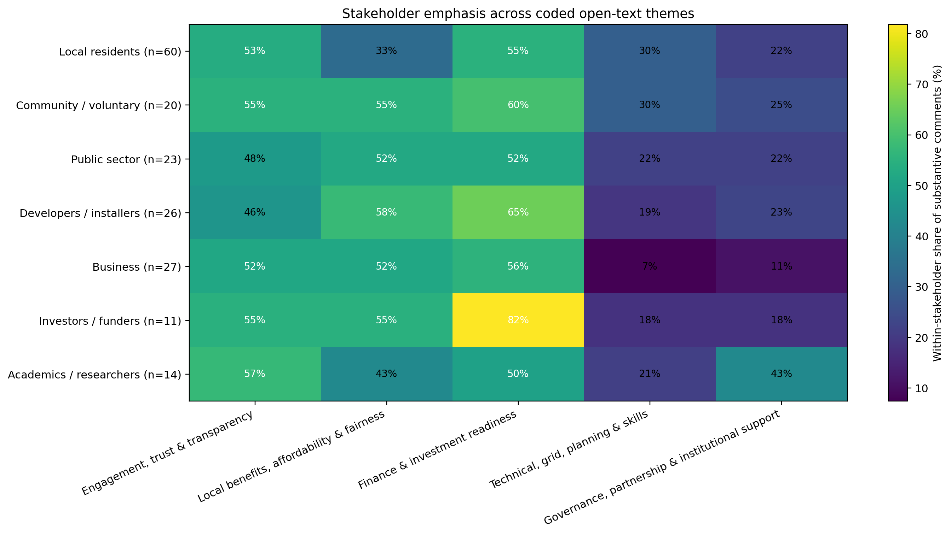
Source: Author's analysis of substantive Question 18 comments (n=142), 2026. Stakeholder memberships and themes overlap.

4.3.2 Theme One: Trust, Transparency and Early Participation
Engagement, trust and transparency appeared in 43.0% of substantive comments and in more than half of the coded comments from residents, community-sector respondents, businesses, investors and academics. Respondents repeatedly linked acceptance to being informed before decisions were fixed, understanding costs and benefits, and having a meaningful role rather than merely receiving information. A resident/academic respondent stated:
“success depends on building trust and encouraging local participation” (R1 & R2)
The theme adds explanatory depth to the quantitative result that 75.5% endorsed trust, fairness and participation principles and that early engagement was a leading priority for residents and community-sector respondents. The evidence suggests that communication is not simply promotional; it is part of the governance process through which legitimacy is created. This is consistent with Gross (2007), Reed (2008) and Huijts, Molin and Steg (2012), who link procedural fairness, trust and meaningful participation to acceptance. A practical implication is that stakeholder engagement should begin during option development, when community input can still alter project design, rather than after technical and financial decisions have effectively been made.

4.3.3 Theme Two: Local Benefits, Affordability and Fairness
Local benefit, affordability and fairness appeared in 31.7% of substantive comments, but the theme was stronger among community/voluntary-sector, public-sector, developer and business memberships. Respondents did not discuss community ownership only in environmental terms; they connected it to household costs, local employment, community funds and retention of value. A multi-stakeholder respondent described a preference for local ownership so that:
“the financial benefits stay within the area and can support local projects, reduce energy costs and help tackle fuel poverty” (R1, R5 & R9)
This directly reinforces the quantitative finding that lower household energy costs were the most common benefit overall and were particularly prominent among residents and community-sector respondents. The qualitative evidence also clarifies why benefit design matters: a project may be technically renewable but still be viewed as weakly 'community-owned' if local people cannot see where value goes. Energy-justice literature makes the same distinction between distributional outcomes, decision processes and recognition of different needs (Jenkins et al., 2016; Sovacool and Dworkin, 2015). The combined evidence therefore supports transparent benefit-sharing rather than assuming that an ownership label automatically delivers fairness.

4.3.4 Theme Three: Finance, Risk and Investment Readiness
Finance and investment readiness was the most prevalent qualitative theme, appearing in 51.4% of substantive comments. It was especially pronounced among investors/funders, where 81.8% of substantive comments referred to finance, funding, investment, returns or risk. This helps explain the quantitative support-investment gap. Respondents frequently supported community energy while calling for clearer financial information and lower-risk participation. One resident with previous investment experience wrote:
“I did previously invest in a windfarm ... and it went bust sadly” (R5, R6 & R11)
Another resident argued that 'long-term revenue certainty and a credible business plan' should be established before local people are asked to invest (Q18-R87). These comments show that willingness to invest is shaped not only by environmental values but by memories of loss, confidence in the business model and perceived downside risk. This complements Hall, Foxon and Bolton (2016), Polzin (2017) and Braunholtz-Speight et al. (2020), who emphasise revenue models, risk allocation and access to capital. For project managers, the implication is that general community support should not be used as a proxy for likely capital participation; investment propositions require transparent terms, realistic forecasts and options accessible to households with different financial capacity.

4.3.5 Theme Four: Technical, Grid, Planning and Organisational Capacity
Technical, grid, planning and skills issues appeared in 25.4% of substantive comments. Although less frequent than finance or engagement, these comments were analytically important because they focused on constraints that can stop a supported project from progressing. A local resident summarised the issue as a need for:
“stronger council support and easier grid access to empower local communities” (R7, R8 & R10)
Other comments referred to training, technical support and the practical difficulty of moving from enthusiasm to delivery. This corresponds with the quantitative result that 85.9% rated project barriers as moderate to very major and 39.8% selected better grid access and technical support as a priority. Brummer (2018) and Creamer et al. (2018) similarly show that community groups may possess local legitimacy while lacking specialist legal, financial, engineering or project-management capability. The evidence therefore points towards intermediary support: communities need access to technical expertise and capacity-building without losing meaningful control over project decisions.

4.3.6 Theme Five: Governance, Partnership and Scaling
Governance, partnership and institutional support appeared in 22.5% of substantive comments. The theme was especially visible among academics/researchers, where 42.9% of substantive comments referred to governance, partnership or institutional support. Respondents repeatedly described successful community energy as a collaborative activity involving residents, councils, community groups, developers and finance providers. One respondent argued that:
“Strong collaboration between local authorities, community groups, and residents will be essential” (R9, R10 & R12)
This qualitative pattern complements the 76.1% positive response to governance/investment-readiness principles and the 35.1% selection of stronger partnerships as a priority. The finding does not imply that external involvement should replace community control. Rather, it suggests that community ownership often requires networks capable of providing planning knowledge, finance, technical expertise and accountability. Berka and Creamer (2018) and Creamer et al. (2018) similarly describe community energy as embedded in relationships between community, state and market actors. Scaling therefore depends on partnership design that adds capability while preserving transparency and local influence.

4.4 Integrated Mixed-Methods Discussion
Bringing the two strands together produces a more complete explanation than either dataset alone. The quantitative results show the scale and distribution of attitudes; the qualitative comments explain the reasoning behind them. Across the evidence, the strongest convergence concerns finance and engagement. Finance was the most common open-text theme (51.4%) and the most frequently selected quantitative priority was more grants or low-cost finance (46.8%). Engagement/trust appeared in 43.0% of substantive comments, while 75.5% endorsed trust/fairness/participation principles and 45.0% selected earlier engagement as a priority. These are not competing explanations: respondents often treated financial credibility and social legitimacy as conditions that must be built together.
Table 5: Joint Display of Quantitative and Qualitative Evidence
Research issue | Quantitative evidence | Qualitative evidence | Integrated interpretation
Trust and engagement | 75.5% positive; early engagement 45.0% overall and 77.8% in community-sector | 43.0% of substantive comments; repeated emphasis on clear information and meaningful involvement | Procedural quality is a condition of legitimacy, not an optional communications activity.
Local benefit and fairness | Lower household costs 44.4% overall; 56.2% residents; 63.0% community-sector | 31.7% of comments; value retention, jobs, affordability and fair sharing recur | Community ownership is judged through visible distribution of value as well as ownership form.
Finance and investment | 57.3% willing to invest versus 84.2% project support; finance priority 46.8% | 51.4% of comments; 81.8% of investor/funder comments coded to finance/risk | Social support does not equal financial commitment; investability requires credible terms, returns and risk information.
Technical delivery | 85.9% rate barriers moderate-very major; grid/technical support 39.8% | 25.4% of comments; grid, training and technical support recur | Capacity and infrastructure can block delivery even where social support is high.
Governance and partnership | 76.1% positive on governance/readiness; partnerships 35.1% priority | 22.5% of comments; stronger institutional emphasis among academics/researchers | Governance links legitimacy to project credibility and enables scaling through accountable collaboration.
Source: Author's integration of questionnaire statistics and substantive Question 18 comments, 2026.
The main divergence is between support and financial commitment. Support is high across stakeholder groups, but willingness to invest varies substantially. The qualitative evidence provides plausible mechanisms for this difference: affordability, memories of investment loss, uncertainty over returns and demand for credible business planning. At the same time, some findings show alignment rather than division. Residents, businesses, developers and public-sector respondents all identify engagement and finance as important, although their relative priorities differ. This answers the supervisor's central question: the stakeholder picture is not simply one of conflict. There is a shared foundation of support, but different groups require different forms of evidence and participation before support can become commitment.
The integration also strengthens the conceptual framework. Trust and fair participation contribute to social legitimacy; governance translates legitimacy into accountable organisational arrangements; finance, grid feasibility and technical capability determine whether a project is investable and deliverable. Weakness in one dimension can undermine the others. This reciprocal relationship is consistent with mixed-methods evidence showing that community-energy development is simultaneously social, organisational and financial rather than a purely technological transition (Markard, Raven and Truffer, 2012).

4.5 Findings Against the Research Objectives
The evidence addresses all four research objectives. Objective 1 is met by identifying awareness, stakeholder role, technology preference, finance, grid access, planning and organisational capacity as interconnected influences on development. Objective 2 is supported by the strong quantitative endorsement of trust, fairness and participation and by qualitative emphasis on early involvement, transparent information and visible local benefit. Objective 3 is addressed by the 26.9 percentage-point support-investment gap, high barrier ratings and recurring qualitative concerns about finance, risk, grid access and business credibility. Objective 4 is supported by the stakeholder comparison: residents and community organisations require meaningful influence and tangible benefits; public bodies can coordinate enabling support; developers must demonstrate technical feasibility; investors need credible risk and return information; businesses require viable participation routes; and knowledge partners can support capacity-building and evaluation. These findings provide the basis for the stakeholder-specific recommendations developed in Chapter 5.

Chapter 5: Conclusion and Recommendations
This chapter draws together the study's conclusions and converts the integrated evidence from Chapter 4 into stakeholder-specific recommendations. The central conclusion is that community-owned renewable-energy projects in Swansea and South West Wales are most likely to progress when social legitimacy and investment credibility are developed together. High public support is valuable, but it does not remove the need for transparent governance, realistic finance, technical readiness, grid access and organisational capability. Conversely, technically credible projects can still struggle where participation is late, benefits are unclear or communities do not trust decision-making.

5.1 Conclusions in Relation to the Research Objectives

5.1.1 Objective One: Social, Policy and Economic Factors
The first objective was to identify the social, policy and economic factors influencing community-owned renewable-energy development. The study found a strong social foundation: 84.2% supported or strongly supported a well-designed local project and 70.1% were at least moderately familiar with community energy. Yet only 34.5% had previous direct project experience. This gap between awareness and experience indicates that positive attitudes do not automatically create delivery capability.
The stakeholder analysis adds important detail. Residents, community organisations, public-sector respondents, businesses, developers, investors and academics did not show an identical technology ranking or participation preference. Solar was strong across several groups, but residents favoured storage and hydropower slightly more, public-sector respondents favoured hydropower, businesses favoured storage and investors/funders most often selected onshore wind. Community-energy planning should therefore avoid treating the region as one homogeneous public. Technology choice, ownership design and participation routes need to reflect local context and stakeholder interests (Azarova et al., 2019; Ruggiero, Onkila and Kuittinen, 2014; Hicks and Ison, 2018).
Objective One was therefore achieved. The main influences are not purely technical; they include awareness, local benefit, finance, planning, grid access, skills, organisational capacity and cross-sector relationships (Koirala et al., 2016; van der Schoor and Scholtens, 2015).

5.1.2 Objective Two: Trust, Fairness, Participation and Local Benefit
The second objective examined how trust, fairness, participation and local benefit shape acceptance. Quantitatively, 75.5% agreed or strongly agreed with the combined trust/fairness/participation principles. Qualitatively, engagement, trust and transparency appeared in 43.0% of substantive open-text comments, while local benefit and fairness appeared in 31.7%. The two strands therefore converge: respondents want to understand projects early, influence decisions and see benefits that are locally visible.
Stakeholder differences refine this conclusion. Residents most frequently prioritised earlier engagement and lower household energy costs, community-sector respondents showed particularly strong demand for early engagement, and investors/funders placed more emphasis on financial and risk information. Acceptance therefore depends on both process and outcome. This is consistent with research linking trust, procedural justice and identification with local actors to participation (Goedkoop and Devine-Wright, 2016; Kalkbrenner and Roosen, 2016) and with energy-justice research emphasising fair distribution and recognition (Jenkins et al., 2016; Hanke, Guyet and Feenstra, 2021). Objective Two was achieved: community legitimacy is strongest where participation is early, information is credible and benefits are tangible and fairly distributed.

5.1.3 Objective Three: Governance, Finance and Investment Readiness
The third objective evaluated governance, finance and project risk. Governance and investment-readiness principles received a 76.1% positive response, but willingness to invest was only 57.3%. The 26.9 percentage-point gap confirms that social acceptance and financial participation are related but distinct. Stakeholder-level gaps ranged from 8.0 points among public-sector respondents to 37.5 points among academics/researchers. The qualitative analysis explains why: finance/risk was the most prevalent open-text theme, appearing in 51.4% of substantive comments and in 81.8% of investor/funder comments.
The findings therefore support a broader concept of investment readiness. A project needs a credible business plan, revenue logic, governance, risk disclosure, planning progress, grid feasibility and technical capability, not merely evidence of public support. Community-energy finance literature similarly emphasises revenue models, capital access and institutional structure (Braunholtz-Speight et al., 2020; Hall, Foxon and Bolton, 2016; Polzin, 2017). The high barrier rating of 85.9% further shows that implementation is constrained by finance, infrastructure and capability as well as social acceptance. Objective Three was achieved.

5.1.4 Objective Four: Evidence-Based Recommendations
The fourth objective was to develop evidence-based recommendations. The integrated analysis shows that recommendations should be assigned to the actors able to act on them. Residents and community organisations require early influence and fair benefit-sharing; local authorities can coordinate planning, sites, partnerships and funding access; developers must establish technical and grid feasibility; finance providers need a consistent investment-readiness process; businesses need practical local-value and participation routes; and universities or energy professionals can support skills, evaluation and knowledge transfer. This stakeholder allocation responds directly to the supervisor's requirement that recommendations be based on particular stakeholder groups rather than presented as generic actions.

5.2 Contribution to Theory and New Knowledge
The study's principal contribution is the integration of stakeholder acceptance and investment readiness within one regional framework. Social-acceptance research commonly focuses on trust, fairness, participation and perceived benefit, while investment research focuses on finance, risk and project credibility. The findings show that governance and organisational capability connect these domains. Transparent governance can increase community trust while also signalling competence to funders; strong acceptance can reduce conflict but cannot compensate for a weak business model or unavailable grid connection; and technical preparation cannot compensate for tokenistic participation or unfair benefit distribution.
Figure 21: Refined Conceptual Framework Linking Stakeholder Acceptance, Governance and Investment Readiness to Delivery and Scaling
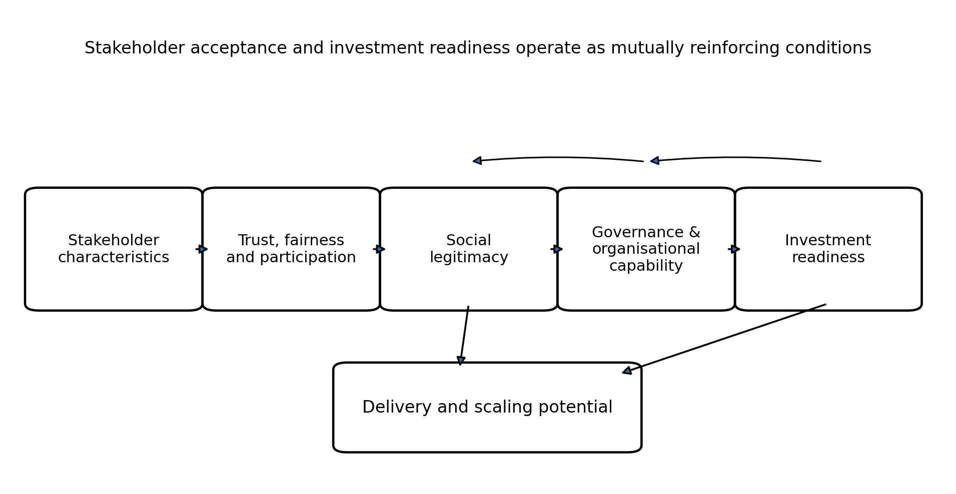
Source: Author's synthesis of the study findings and literature reviewed in Chapters 2 and 4, 2026.
The stakeholder comparison strengthens this contribution because the support-investment gap is not uniform. Different stakeholder roles mediate the transition from social legitimacy to financial commitment. The resulting framework is therefore feedback-based rather than purely linear: stakeholder characteristics influence trust and participation; these shape social legitimacy; governance and organisational capability translate legitimacy into credible structures; investment readiness affects delivery; and successful or unsuccessful delivery feeds back into future trust. The contribution remains an evidence-informed regional framework rather than a universal causal model.

5.3 Stakeholder-Specific Recommendations for Managerial Practice

5.3.1 Local Authorities and Public-Sector Bodies: Lead a Regional Enabling Partnership
Local authorities and public-sector bodies should lead a regional community-energy enabling partnership linking community groups, residents, businesses, developers, finance providers and knowledge partners. The recommendation is supported by the public-sector subgroup, where 64.0% selected more grants or low-cost finance and 60.0% selected earlier engagement. The partnership should maintain a pipeline of suitable sites, coordinate planning and grid enquiries, signpost funding, and connect community groups to technical and financial expertise. Its role should be enabling rather than substituting for community ownership. This is consistent with Future Wales and Planning Policy Wales emphasis on coordinated development and sustainable place-making (Welsh Government, 2021; 2024g).

5.3.2 Residents and Community Organisations: Adopt an Engagement and Benefit Charter
Community organisations and project sponsors should agree an Engagement and Benefit Charter before major design decisions are fixed. This responds directly to resident and community-sector evidence: earlier engagement was selected by 54.8% of residents and 77.8% of community/voluntary-sector respondents, while lower household energy costs were the leading benefit for both groups. The charter should state when engagement begins, how representatives enter governance, how information on costs and risks is presented, and how benefits such as bill savings, community funds, jobs and training are distributed. This translates procedural and distributional justice into an operational project standard (Gross, 2007; Jenkins et al., 2016).

5.3.3 Developers, Installers and Consultants: Establish a Technical-Readiness and Grid Plan
Developers, installers and consultants should provide a documented technical-readiness plan before substantial community or external investment is sought. The plan should cover technology selection, site feasibility, planning constraints, grid capacity, connection cost and timing, procurement, operational responsibility and principal technical risks. This is supported by the high barrier rating, the 39.8% selection of grid/technical support as a priority and the qualitative comments calling for grid access and technical support. Developers should also present technical information in accessible language so that specialist knowledge strengthens rather than displaces community decision-making.

5.3.4 Investors, Lenders and Funding Advisers: Use an Investment-Readiness Gateway and Inclusive Finance
Finance stakeholders should use a consistent investment-readiness gateway covering governance, business planning, revenue certainty, planning status, grid feasibility, technical capability, community support and risk management. The qualitative evidence makes this particularly important: finance and investment readiness was the most common open-text theme and appeared in 81.8% of substantive investor/funder comments. The gateway should be paired with inclusive options such as low-entry community shares, staged contributions and non-financial participation routes. This avoids equating community ownership with the ability to invest large amounts and responds to the gap between project support and financial participation.

5.3.5 Businesses: Create Local Supply-Chain and Participation Pathways
Local businesses should be offered clear routes to participate through procurement, service contracts, energy use, skills development and, where appropriate, investment. Business respondents showed strong project support (80.6%) but lower investment willingness (47.2%), while finance and engagement were their leading priorities. This suggests that businesses may support community energy without finding the available investment proposition sufficiently compelling. Project partnerships should therefore communicate commercial benefits, risk, procurement opportunities and local economic value rather than treating businesses only as potential funders.

5.3.6 Universities, Researchers and Energy Professionals: Build Capacity and Evaluate Outcomes
Universities, researchers and energy professionals should support skills development, feasibility assessment, monitoring and independent evaluation. Academics/researchers showed high support but the largest support-investment gap, while their open-text comments placed comparatively strong emphasis on governance and institutional support. Knowledge partners can therefore add value through training, data analysis, transparent evaluation and lessons for replication rather than through finance alone. A demonstration solar-plus-storage project on a suitable public or community site could provide a practical learning platform, reflecting the strong overall support for solar and storage and Welsh policy interest in locally retained renewable value (Welsh Government, 2024i; Welsh Government, 2025b).

5.4 SMART Future Implementation Plan
Table 6: SMART Implementation Plan for Community-Energy Delivery and Regional Scaling
Period | Main stakeholder focus | Main action | Expected outcome
0–2 months | Residents, students, community groups, local authority | Stakeholder mapping, initial consultation and identification of community priorities | Stakeholder register and agreed priority concerns
2–4 months | Residents, community groups, businesses, council | Develop Engagement and Benefit Charter; agree representation and communication arrangements | Draft/approved charter and governance responsibilities
4–6 months | Developers, technical professionals, council, community representatives | Initial site, technology, planning and grid feasibility screening | Preliminary feasibility and constraints report
6–8 months | Finance stakeholders, businesses, developers, community groups | Examine costs, funding routes, community investment options and major financial risks | Outline business and funding model
8–10 months | All stakeholder groups | Present technical and financial evidence back to stakeholders; revise proposal according to feedback | Revised project proposal with documented stakeholder feedback
10–12 months | Council, community representatives, developers, finance providers, independent/university support | Complete a joint readiness review covering acceptance, governance, finance and technical feasibility | Evidence-based decision to proceed, revise or pause

Source: Author's synthesis of Chapter 4 findings, 2026.
The 12-month implementation plan provides an indicative sequence from stakeholder engagement to project-readiness assessment. Early consultation identifies community priorities before major decisions are fixed, while technical, planning, grid and financial issues are assessed alongside funding and investment options. Stakeholder feedback then supports revision before a joint readiness review determines whether to proceed, revise or pause. The periods are indicative planning windows rather than fixed durations (Climate Change Committee, 2023; House of Commons Energy Security and Net Zero Committee, 2026).

5.5 Limitations and Future Research
Several limitations remain. The 171-response survey used non-probability sampling and was geographically concentrated in Swansea, so the findings should not be treated as proportionately representative of all South West Wales communities. Stakeholder roles were multi-select, which reflects real-world overlap but limits clean between-group inference. The association tests are therefore exploratory and do not establish causality. The study is also cross-sectional and measures stated intentions rather than observed investment behaviour.
The qualitative evidence requires particular caution. The study design included 12 stakeholder interviews, but the file supplied for this revision contains the participant profile and interview guide rather than the verbatim INT01-INT12 transcripts. Chapter 4 therefore deepens the qualitative strand using 142 verifiable substantive questionnaire comments and does not invent interview quotations. A final transcript-based analysis should code the genuine INT material, attribute direct quotations to INT01-INT12 and compare those interview themes with the survey patterns. Future research should also follow projects longitudinally to test whether stated trust, participation and investment intentions change through planning, financing, construction and operation.
Overall, the study concludes that successful community-owned renewable energy in Swansea and South West Wales depends on an interaction between stakeholder legitimacy and project credibility. Communities need meaningful influence and visible value; organisations need accountable governance and capability; and projects need finance, grid access and technical feasibility. The strongest practical implication is therefore not a single intervention, but coordinated stakeholder action in which social acceptance and investment readiness are developed together.

References
Aitken, M. (2010) ‘Wind power and community benefits: Challenges and opportunities’, Energy Policy, 38(10), pp. 6066–6075. doi: 10.1016/j.enpol.2010.05.062.
Aitken, M., Haggett, C. and Rudolph, D. (2016) ‘Practices and rationales of community engagement with wind farms: awareness raising, consultation, empowerment’, Planning Theory & Practice, 17(4), pp. 557–576. doi: 10.1080/14649357.2016.1218919.
Arnstein, S.R. (1969) ‘A ladder of citizen participation’, Journal of the American Institute of Planners, 35(4), pp. 216–224. doi: 10.1080/01944366908977225.
Artino, A.R. Jr, La Rochelle, J.S., Dezee, K.J. and Gehlbach, H. (2014) ‘Developing questionnaires for educational research: AMEE Guide No. 87’, Medical Teacher, 36(6), pp. 463–474. doi: 10.3109/0142159X.2014.889814.
Audit Wales (2022) Public Sector Readiness for Net Zero Carbon by 2030. Cardiff: Audit Wales. Available at: https://www.audit.wales/publication/public-sector-readiness-net-zero-carbon-2030 (Accessed: 23 September 2026).
Azarova, V., Cohen, J., Friedl, C. and Reichl, J. (2019) ‘Designing local renewable energy communities to increase social acceptance: Evidence from a choice experiment in Austria, Germany, Italy and Switzerland’, Energy Policy, 132, pp. 1176–1183. doi: 10.1016/j.enpol.2019.06.067.
Babbie, E.R. (2021) The Practice of Social Research. 15th edn. Boston, MA: Cengage.
Barnes, J., Hansen, P., Kamin, T., Golob, U., Darby, S., van der Grijp, N.M. and Petrovics, D. (2024) ‘Creating valuable outcomes: an exploration of value creation pathways in the business models of energy communities’, Energy Research & Social Science, 108, 103398. doi: 10.1016/j.erss.2023.103398.
Batel, S., Devine-Wright, P. and Tangeland, T. (2013) ‘Social acceptance of low carbon energy and associated infrastructures: a critical discussion’, Energy Policy, 58, pp. 1–5. doi: 10.1016/j.enpol.2013.03.018.
Bauwens, T. (2016) ‘Explaining the diversity of motivations behind community renewable energy’, Energy Policy, 93, pp. 278–290. doi: 10.1016/j.enpol.2016.03.017.
Bauwens, T. and Defourny, J. (2017) ‘Social capital and mutual versus public benefit: the case of renewable energy cooperatives’, Annals of Public and Cooperative Economics, 88(2), pp. 203–232. doi: 10.1111/apce.12166.
Bauwens, T., Gotchev, B. and Holstenkamp, L. (2016) ‘What drives the development of community energy in Europe? The case of wind power cooperatives’, Energy Research & Social Science, 13, pp. 136–147. doi: 10.1016/j.erss.2015.12.016.
Bell, D., Gray, T. and Haggett, C. (2005) ‘The “social gap” in wind farm siting decisions: explanations and policy responses’, Environmental Politics, 14(4), pp. 460–477. doi: 10.1080/09644010500175833.
Bell, E., Bryman, A. and Harley, B. (2022) Business Research Methods. 6th edn. Oxford: Oxford University Press.
Berka, A.L. and Creamer, E. (2018) ‘Taking stock of the local impacts of community owned renewable energy: a review and research agenda’, Renewable and Sustainable Energy Reviews, 82, pp. 3400–3419. doi: 10.1016/j.rser.2017.10.050.
Biggam, J. (2021) Succeeding with Your Master’s Dissertation: A Step-by-Step Handbook. 5th edn. Maidenhead: Open University Press.
Boateng, G.O., Neilands, T.B., Frongillo, E.A., Melgar-Quiñonez, H.R. and Young, S.L. (2018) ‘Best practices for developing and validating scales for health, social, and behavioral research: a primer’, Frontiers in Public Health, 6, 149. doi: 10.3389/fpubh.2018.00149.
Bocken, N.M.P., Short, S.W., Rana, P. and Evans, S. (2014) ‘A literature and practice review to develop sustainable business model archetypes’, Journal of Cleaner Production, 65, pp. 42–56. doi: 10.1016/j.jclepro.2013.11.039.
Bomberg, E. and McEwen, N. (2012) ‘Mobilizing community energy’, Energy Policy, 51, pp. 435–444. doi: 10.1016/j.enpol.2012.08.045.
Boons, F. and Lüdeke-Freund, F. (2013) ‘Business models for sustainable innovation: state-of-the-art and steps towards a research agenda’, Journal of Cleaner Production, 45, pp. 9–19. doi: 10.1016/j.jclepro.2012.07.007.
Braun, V. and Clarke, V. (2006) ‘Using thematic analysis in psychology’, Qualitative Research in Psychology, 3(2), pp. 77–101. doi: 10.1191/1478088706qp063oa.
Braun, V. and Clarke, V. (2022) Thematic Analysis: A Practical Guide. London: SAGE.
Braunholtz-Speight, T., Sharmina, M., Manderson, E., McLachlan, C., Hannon, M., Hardy, J. and Mander, S. (2020) ‘Business models and financial characteristics of community energy in the UK’, Nature Energy, 5(2), pp. 169–177. doi: 10.1038/s41560-019-0546-4.
Bridge, G., Bouzarovski, S., Bradshaw, M. and Eyre, N. (2013) ‘Geographies of energy transition: space, place and the low-carbon economy’, Energy Policy, 53, pp. 331–340. doi: 10.1016/j.enpol.2012.10.066.
Brisbois, M.C. (2019) ‘Powershifts: a framework for assessing the growing impact of decentralized ownership of energy transitions on political decision-making’, Energy Research & Social Science, 50, pp. 151–161. doi: 10.1016/j.erss.2018.12.003.
Brummer, V. (2018) ‘Community energy – benefits and barriers: a comparative literature review of community energy in the UK, Germany and the USA, the benefits it provides for society and the barriers it faces’, Renewable and Sustainable Energy Reviews, 94, pp. 187–196. doi: 10.1016/j.rser.2018.06.013.
Bryman, A. (2006) ‘Integrating quantitative and qualitative research: how is it done?’, Qualitative Research, 6(1), pp. 97–113. doi: 10.1177/1468794106058877.
Bryson, J.M. (2004) ‘What to do when stakeholders matter: stakeholder identification and analysis techniques’, Public Management Review, 6(1), pp. 21–53. doi: 10.1080/14719030410001675722.
Bulkeley, H. and Kern, K. (2006) ‘Local government and the governing of climate change in Germany and the UK’, Urban Studies, 43(12), pp. 2237–2259. doi: 10.1080/00420980600936491.
Bürer, M.J. and Wüstenhagen, R. (2009) ‘Which renewable energy policy is a venture capitalist’s best friend? Empirical evidence from a survey of international cleantech investors’, Energy Policy, 37(12), pp. 4997–5006. doi: 10.1016/j.enpol.2009.06.071.
Burke, M.J. and Stephens, J.C. (2017) ‘Energy democracy: goals and policy instruments for sociotechnical transitions’, Energy Research & Social Science, 33, pp. 35–48. doi: 10.1016/j.erss.2017.09.024.
Caramizaru, A. and Uihlein, A. (2020) Energy Communities: An Overview of Energy and Social Innovation. Luxembourg: Publications Office of the European Union. doi: 10.2760/180576.
Cass, N., Walker, G. and Devine-Wright, P. (2010) ‘Good neighbours, public relations and bribes: the politics and perceptions of community benefit provision in renewable energy development in the UK’, Journal of Environmental Policy & Planning, 12(3), pp. 255–275. doi: 10.1080/1523908X.2010.509558.
Catney, P., Dobson, A., Hall, S.M., Hards, S., MacGregor, S., Robinson, Z., Ormerod, M. and Ross, S. (2013) ‘Community knowledge networks: an action-orientated approach to energy research’, Local Environment, 18(4), pp. 506–520. doi: 10.1080/13549839.2012.748729.
Centre for Sustainable Energy and Energy System Catapult (2020) Local Area Energy Planning: The Method. Available at: https://www.cse.org.uk/research-consultancy/consultancy-projects/local-area-energy-planning/ (Accessed: 23 September 2026).
Climate Change Act 2008, c. 27. Available at: https://www.legislation.gov.uk/ukpga/2008/27/contents (Accessed: 23 September 2026).
Climate Change Committee (2023) 2023 Progress Report: Reducing Emissions in Wales. London: Climate Change Committee. Available at: https://www.theccc.org.uk/publication/2023-progress-report-reducing-emissions-in-wales/ (Accessed: 23 September 2026).
Cochran, W.G. (1977) Sampling Techniques. 3rd edn. New York: Wiley.
Community Energy England (2025) State of the Sector: 2025. Available at: https://communityenergyengland.org/publications/state-of-the-sector-2025/ (Accessed: 23 September 2026).
Community Energy Wales (2025) Realising Our Potential, Creating Thriving Communities: State of the Sector 2025. Cardiff: Community Energy Wales. Available at: https://communityenergy.wales/content/publications/SOTS-2025-English.pdf (Accessed: 23 September 2026).
Cowell, R., Bristow, G. and Munday, M. (2011) ‘Acceptance, acceptability and environmental justice: the role of community benefits in wind energy development’, Journal of Environmental Planning and Management, 54(4), pp. 539–557. doi: 10.1080/09640568.2010.521047.
Creamer, E., Eadson, W., van Veelen, B., Pinker, A., Tingey, M., Braunholtz-Speight, T., Markantoni, M., Foden, M. and Lacey-Barnacle, M. (2018) ‘Community energy: entanglements of community, state, and private sector’, Geography Compass, 12(7), e12378. doi: 10.1111/gec3.12378.
Creswell, J.W. and Creswell, J.D. (2018) Research Design: Qualitative, Quantitative, and Mixed Methods Approaches. 5th edn. Thousand Oaks, CA: SAGE.
Creswell, J.W. and Creswell, J.D. (2023) Research Design: Qualitative, Quantitative, and Mixed Methods Approaches. 6th edn. Thousand Oaks, CA: SAGE Publications.
Creswell, J.W. and Plano Clark, V.L. (2018) Designing and Conducting Mixed Methods Research. 3rd edn. Thousand Oaks, CA: SAGE.
Cronbach, L.J. (1951) ‘Coefficient alpha and the internal structure of tests’, Psychometrika, 16(3), pp. 297–334. doi: 10.1007/BF02310555.
Curtin, J., McInerney, C. and Johannsdottir, L. (2018) ‘How can financial incentives promote local ownership of onshore wind and solar projects? Case study evidence from Germany, Denmark, the UK and Ontario’, Local Economy, 33(1), pp. 40–62. doi: 10.1177/0269094217751868.
Data Protection Act 2018, c. 12. Available at: https://www.legislation.gov.uk/ukpga/2018/12/contents (Accessed: 23 September 2026).
de Vaus, D. (2014) Surveys in Social Research. 6th edn. Abingdon: Routledge.
Denscombe, M. (2021) The Good Research Guide: Research Methods for Small-Scale Social Research Projects. 7th edn. Maidenhead: Open University Press.
Department for Business, Energy & Industrial Strategy (2021) Net Zero Strategy: Build Back Greener. London: HM Government. Available at: https://www.gov.uk/government/publications/net-zero-strategy (Accessed: 23 September 2026).
Department for Energy Security and Net Zero (2025a) DESNZ Public Attitudes Tracker: Renewable Energy, Spring 2025, UK. Available at: https://www.gov.uk/government/statistics/desnz-public-attitudes-tracker-spring-2025/desnz-public-attitudes-tracker-renewable-energy-spring-2025-uk (Accessed: 23 September 2026).
Department for Energy Security and Net Zero (2025b) DESNZ Public Attitudes Tracker: Renewable Energy, Summer 2025, UK. Available at: https://www.gov.uk/government/statistics/desnz-public-attitudes-tracker-summer-2025/desnz-public-attitudes-tracker-renewable-energy-summer-2025-uk (Accessed: 23 September 2026).
Department for Energy Security and Net Zero (2026) DESNZ Public Attitudes Tracker: Renewable Energy, Winter 2025, UK. Available at: https://www.gov.uk/government/statistics/desnz-public-attitudes-tracker-winter-2025/desnz-public-attitudes-tracker-renewable-energy-winter-2025-uk (Accessed: 23 September 2026).
Development Bank of Wales (2026) Community-Owned Solar Co-op Secures £1.4m Investment to Expand Rooftop Solar across Wales. Available at: https://developmentbank.wales/news-and-events/community-owned-solar-co-op-secures-ps14m-investment-expand-rooftop-solar-across (Accessed: 23 September 2026).
Devine-Wright, P. (2005) ‘Beyond NIMBYism: towards an integrated framework for understanding public perceptions of wind energy’, Wind Energy, 8(2), pp. 125–139. doi: 10.1002/we.124.
Devine-Wright, P. (2009) ‘Rethinking NIMBYism: the role of place attachment and place identity in explaining place-protective action’, Journal of Community & Applied Social Psychology, 19(6), pp. 426–441. doi: 10.1002/casp.1004.
Devine-Wright, P. (2011a) ‘Place attachment and public acceptance of renewable energy: a tidal energy case study’, Journal of Environmental Psychology, 31(4), pp. 336–343. doi: 10.1016/j.jenvp.2011.07.001.
Devine-Wright, P. (2011b) ‘Public engagement with large-scale renewable energy technologies: breaking the cycle of NIMBYism’, Wiley Interdisciplinary Reviews: Climate Change, 2(1), pp. 19–26. doi: 10.1002/wcc.89.
Dillman, D.A., Smyth, J.D. and Christian, L.M. (2014) Internet, Phone, Mail, and Mixed-Mode Surveys: The Tailored Design Method. 4th edn. Hoboken, NJ: Wiley.
Dóci, G., Vasileiadou, E. and Petersen, A.C. (2015) ‘Exploring the transition potential of renewable energy communities’, Futures, 66, pp. 85–95. doi: 10.1016/j.futures.2015.01.002.
Donaldson, T. and Preston, L.E. (1995) ‘The stakeholder theory of the corporation: concepts, evidence, and implications’, Academy of Management Review, 20(1), pp. 65–91. doi: 10.5465/amr.1995.9503271992.
Eadson, W. and Foden, M. (2014) ‘Editorial: critical perspectives on community energy’, People, Place and Policy, 8(3), pp. 145–148. doi: 10.3351/ppp.0008.0003.0001.
Etikan, I., Musa, S.A. and Alkassim, R.S. (2016) ‘Comparison of convenience sampling and purposive sampling’, American Journal of Theoretical and Applied Statistics, 5(1), pp. 1–4. doi: 10.11648/j.ajtas.20160501.11.
European Parliament and Council of the European Union (2018) ‘Directive (EU) 2018/2001 of 11 December 2018 on the promotion of the use of energy from renewable sources’, Official Journal of the European Union, L328, pp. 82–209. Available at: https://eur-lex.europa.eu/legal-content/EN/TXT/?uri=CELEX:32018L2001 (Accessed: 23 September 2026).
European Parliament and Council of the European Union (2019) ‘Directive (EU) 2019/944 of 5 June 2019 on common rules for the internal market for electricity’, Official Journal of the European Union, L158, pp. 125–199. Available at: https://eur-lex.europa.eu/legal-content/EN/TXT/?uri=CELEX:32019L0944 (Accessed: 23 September 2026).
Fast, S. (2013) ‘A Habermasian analysis of local renewable energy deliberations’, Journal of Rural Studies, 30, pp. 86–98. doi: 10.1016/j.jrurstud.2012.12.004.
Fetters, M.D., Curry, L.A. and Creswell, J.W. (2013) ‘Achieving integration in mixed methods designs: principles and practices’, Health Services Research, 48(6), pp. 2134–2156. doi: 10.1111/1475-6773.12117.
Field, A. (2018) Discovering Statistics Using IBM SPSS Statistics. 5th edn. London: SAGE.
Flyvbjerg, B. (2006) ‘Five misunderstandings about case-study research’, Qualitative Inquiry, 12(2), pp. 219–245. doi: 10.1177/1077800405284363.
Forman, A. (2017) ‘Energy justice at the end of the wire: enacting community energy and equity in Wales’, Energy Policy, 107, pp. 649–657. doi: 10.1016/j.enpol.2017.05.006.
Fowler, F.J. Jr (2014) Survey Research Methods. 5th edn. Thousand Oaks, CA: SAGE.
Freeman, R.E. (1984) Strategic Management: A Stakeholder Approach. Boston, MA: Pitman.
Future Generations Commissioner for Wales (2025) Future Generations Report 2025. Cardiff: Future Generations Commissioner for Wales. Available at: https://futuregenerations.wales/discover/about-future-generations-commissioner/future-generations-report-2025/ (Accessed: 23 September 2026).
Gatzert, N. and Vogl, N. (2016) ‘Evaluating investments in renewable energy under policy risks’, Energy Policy, 95, pp. 238–252. doi: 10.1016/j.enpol.2016.04.027.
Geels, F.W. (2002) ‘Technological transitions as evolutionary reconfiguration processes: a multi-level perspective and a case-study’, Research Policy, 31(8–9), pp. 1257–1274. doi: 10.1016/S0048-7333(02)00062-8.
Geels, F.W. (2011) ‘The multi-level perspective on sustainability transitions: responses to seven criticisms’, Environmental Innovation and Societal Transitions, 1(1), pp. 24–40. doi: 10.1016/j.eist.2011.02.002.
Geels, F.W. and Schot, J. (2007) ‘Typology of sociotechnical transition pathways’, Research Policy, 36(3), pp. 399–417. doi: 10.1016/j.respol.2007.01.003.
Goedkoop, F. and Devine-Wright, P. (2016) ‘Partnership or placation? The role of trust and justice in the shared ownership of renewable energy projects’, Energy Research & Social Science, 17, pp. 135–146. doi: 10.1016/j.erss.2016.04.021.
Goedkoop, F., Dijkstra, J. and Flache, A. (2022) ‘A social network perspective on involvement in community energy initiatives: The role of direct and extended social ties to initiators’, Energy Policy, 171, 113260. doi: 10.1016/j.enpol.2022.113260.
Great British Energy (2025) Strategic Plan 2025. Available at: https://www.gbe.gov.uk/strategic-plan-2025-html (Accessed: 23 September 2026).
Great British Energy and Department for Energy Security and Net Zero (2026a) Local Power Plan. Available at: https://www.gov.uk/government/publications/local-power-plan (Accessed: 23 September 2026).
Great British Energy and Department for Energy Security and Net Zero (2026b) Local Power Plan: Evidence Annex. Available at: https://www.gov.uk/government/publications/local-power-plan/local-power-plan-evidence-annex-accessible-webpage (Accessed: 23 September 2026).
Greene, J.C., Caracelli, V.J. and Graham, W.F. (1989) ‘Toward a conceptual framework for mixed-method evaluation designs’, Educational Evaluation and Policy Analysis, 11(3), pp. 255–274. doi: 10.3102/01623737011003255.
Gross, C. (2007) ‘Community perspectives of wind energy in Australia: the application of a justice and community fairness framework to increase social acceptance’, Energy Policy, 35(5), pp. 2727–2736. doi: 10.1016/j.enpol.2006.12.013.
Groves, R.M., Fowler, F.J. Jr, Couper, M.P., Lepkowski, J.M., Singer, E. and Tourangeau, R. (2009) Survey Methodology. 2nd edn. Hoboken, NJ: Wiley.
Guest, G., Bunce, A. and Johnson, L. (2006) ‘How many interviews are enough? An experiment with data saturation and variability’, Field Methods, 18(1), pp. 59–82. doi: 10.1177/1525822X05279903.
Haf, S. and Parkhill, K.A. (2017) ‘The Muillean Gaoithe and the Melin Wynt: cultural sustainability and community owned wind energy schemes in Gaelic and Welsh speaking communities in the United Kingdom’, Energy Research & Social Science, 29, pp. 103–112. doi: 10.1016/j.erss.2017.05.017.
Hall, S. and Roelich, K. (2016) ‘Business model innovation in electricity supply markets: the role of complex value in the United Kingdom’, Energy Policy, 92, pp. 286–298. doi: 10.1016/j.enpol.2016.02.019.
Hall, S., Foxon, T.J. and Bolton, R. (2016) ‘Financing the civic energy sector: how financial institutions affect ownership models in Germany and the United Kingdom’, Energy Research & Social Science, 12, pp. 5–15. doi: 10.1016/j.erss.2015.11.004.
Hanke, F., Guyet, R. and Feenstra, M. (2021) ‘Do renewable energy communities deliver energy justice? Exploring insights from 71 European cases’, Energy Research & Social Science, 80, 102244. doi: 10.1016/j.erss.2021.102244.
Hannon, M., Cairns, I., Braunholtz-Speight, T., Hardy, J., McLachlan, C., Mander, S. and Sharmina, M. (2023) ‘Carrots, sticks and sermons: Policies to unlock community energy finance in the United Kingdom’, Energy Research & Social Science, 100, 103086. doi: 10.1016/j.erss.2023.103086.
Hargreaves, T., Hielscher, S., Seyfang, G. and Smith, A. (2013) ‘Grassroots innovations in community energy: The role of intermediaries in niche development’, Global Environmental Change, 23(5), pp. 868–880. doi: 10.1016/j.gloenvcha.2013.02.008.
Heffron, R.J. and McCauley, D. (2017) ‘The concept of energy justice across the disciplines’, Energy Policy, 105, pp. 658–667. doi: 10.1016/j.enpol.2017.03.018.
Heiskanen, E., Johnson, M., Robinson, S., Vadovics, E. and Saastamoinen, M. (2010) ‘Low-carbon communities as a context for individual behavioural change’, Energy Policy, 38(12), pp. 7586–7595. doi: 10.1016/j.enpol.2009.07.002.
Hennink, M. and Kaiser, B.N. (2022) ‘Sample sizes for saturation in qualitative research: a systematic review of empirical tests’, Social Science & Medicine, 292, 114523. doi: 10.1016/j.socscimed.2021.114523.
Hewitt, R.J., Bradley, N., Compagnucci, A.B., Barlagne, C., Ceglarz, A., Cremades, R., McKeen, M., Otto, I.M. and Slee, B. (2019) ‘Social innovation in community energy in Europe: a review of the evidence’, Frontiers in Energy Research, 7, 31. doi: 10.3389/fenrg.2019.00031.
Hicks, J. and Ison, N. (2018) ‘An exploration of the boundaries of “community” in community renewable energy projects’, Energy Policy, 113, pp. 523–534. doi: 10.1016/j.enpol.2017.10.031.
Hoffman, S.M. and High-Pippert, A. (2010) ‘From private lives to collective action: Recruitment and participation incentives for a community energy programme’, Energy Policy, 38(12), pp. 7567–7574. doi: 10.1016/j.enpol.2009.06.054.
Hogan, J.L. (2024) ‘Why does community ownership foster greater acceptance of renewable projects? Investigating energy justice explanations’, Local Environment, 29(9), pp. 1221–1243. doi: 10.1080/13549839.2024.2360716.
Hoppe, T. and de Vries, G. (2019) ‘Social innovation and the energy transition’, Sustainability, 11(1), 141. doi: 10.3390/su11010141.
House of Commons Energy Security and Net Zero Committee (2026) Get Connected: How Community Energy Can Turbocharge the Transition. HC 229. London: House of Commons. Available at: https://committees.parliament.uk/work/8609/unlocking-community-energy-at-scale/publications/reports-responses/ (Accessed: 23 September 2026).
Huijts, N.M.A., Molin, E.J.E. and Steg, L. (2012) ‘Psychological factors influencing sustainable energy technology acceptance: a review-based comprehensive framework’, Renewable and Sustainable Energy Reviews, 16(1), pp. 525–531. doi: 10.1016/j.rser.2011.08.018.
Huybrechts, B. and Mertens, S. (2014) ‘The relevance of the cooperative model in the field of renewable energy’, Annals of Public and Cooperative Economics, 85(2), pp. 193–212. doi: 10.1111/apce.12038.
Intergovernmental Panel on Climate Change (2022) Climate Change 2022: Mitigation of Climate Change. Contribution of Working Group III to the Sixth Assessment Report of the Intergovernmental Panel on Climate Change. Edited by P.R. Shukla et al. Cambridge: Cambridge University Press. doi: 10.1017/9781009157926.
International Energy Agency (2024) Renewables 2024: Analysis and Forecasts to 2030. Paris: International Energy Agency. Available at: https://www.iea.org/reports/renewables-2024 (Accessed: 23 September 2026).
International Renewable Energy Agency (2024) World Energy Transitions Outlook 2024: 1.5°C Pathway. Abu Dhabi: International Renewable Energy Agency. Available at: https://www.irena.org/Publications/2024/Nov/World-Energy-Transitions-Outlook-2024 (Accessed: 23 September 2026).
Israel, M. and Hay, I. (2006) Research Ethics for Social Scientists. London: SAGE.
Jans, L., Goedkoop, F., Perlaviciute, G., Hamann, K., Masson, T. and Burgerhof, B. (2024) ‘How bottom-up and top-down governance of community energy initiatives affects citizens’ perceptions, acceptability and willingness to join’, Energy Policy, 195, 114389. doi: 10.1016/j.enpol.2024.114389.
Jaspersen, L.J., Thorpe, R. and Valizade, D. (2026) Management and Business Research. 8th edn. London: SAGE Publications Ltd.
Jenkins, K., McCauley, D., Heffron, R., Stephan, H. and Rehner, R. (2016) ‘Energy justice: a conceptual review’, Energy Research & Social Science, 11, pp. 174–182. doi: 10.1016/j.erss.2015.10.004.
Jobert, A., Laborgne, P. and Mimler, S. (2007) ‘Local acceptance of wind energy: factors of success identified in French and German case studies’, Energy Policy, 35(5), pp. 2751–2760. doi: 10.1016/j.enpol.2006.12.005.
Johnson, R.B. and Onwuegbuzie, A.J. (2004) ‘Mixed methods research: a research paradigm whose time has come’, Educational Researcher, 33(7), pp. 14–26. doi: 10.3102/0013189X033007014.
Kaiser, K. (2009) ‘Protecting respondent confidentiality in qualitative research’, Qualitative Health Research, 19(11), pp. 1632–1641. doi: 10.1177/1049732309350879.
Kalkbrenner, B.J. and Roosen, J. (2016) ‘Citizens’ willingness to participate in local renewable energy projects: The role of community and trust in Germany’, Energy Research & Social Science, 13, pp. 60–70. doi: 10.1016/j.erss.2015.12.006.
Kallio, H., Pietilä, A.-M., Johnson, M. and Kangasniemi, M. (2016) ‘Systematic methodological review: developing a framework for a qualitative semi-structured interview guide’, Journal of Advanced Nursing, 72(12), pp. 2954–2965. doi: 10.1111/jan.13031.
Karakaya, E. and Sriwannawit, P. (2015) ‘Barriers to the adoption of photovoltaic systems: the state of the art’, Renewable and Sustainable Energy Reviews, 49, pp. 60–66. doi: 10.1016/j.rser.2015.04.058.
Koirala, B.P., Koliou, E., Friege, J., Hakvoort, R.A. and Herder, P.M. (2016) ‘Energetic communities for community energy’, Renewable and Sustainable Energy Reviews, 56, pp. 722–744. doi: 10.1016/j.rser.2015.11.080.
Kooij, H.-J., Oteman, M., Veenman, S., Sperling, K., Magnusson, D., Palm, J. and Hvelplund, F. (2018) ‘Between grassroots and treetops: community power and institutional dependence in the renewable energy sector in Denmark, Sweden and the Netherlands’, Energy Research & Social Science, 37, pp. 52–64. doi: 10.1016/j.erss.2017.09.019.
Kujala, J., Sachs, S., Leinonen, H., Heikkinen, A. and Laude, D. (2022) ‘Stakeholder engagement: past, present, and future’, Business & Society, 61(5), pp. 1136–1196. doi: 10.1177/00076503211066595.
Kvale, S. and Brinkmann, S. (2015) InterViews: Learning the Craft of Qualitative Research Interviewing. 3rd edn. Thousand Oaks, CA: SAGE.
Lacey-Barnacle, M. (2020) ‘Proximities of energy justice: contesting community energy and austerity in England’, Energy Research & Social Science, 69, 101713. doi: 10.1016/j.erss.2020.101713.
Langer, K., Decker, T. and Menrad, K. (2017) ‘Public participation in wind energy projects located in Germany: which form of participation is the key to acceptance?’, Renewable Energy, 112, pp. 63–73. doi: 10.1016/j.renene.2017.05.021.
Liebe, U., Bartczak, A. and Meyerhoff, J. (2017) ‘A turbine is not only a turbine: the role of social context and fairness characteristics for the local acceptance of wind power’, Energy Policy, 107, pp. 300–308. doi: 10.1016/j.enpol.2017.04.043.
Lincoln, Y.S. and Guba, E.G. (1985) Naturalistic Inquiry. Beverly Hills, CA: SAGE.
Lowitzsch, J., Hoicka, C.E. and van Tulder, F.J. (2020) ‘Renewable energy communities under the 2019 European Clean Energy Package’, Renewable and Sustainable Energy Reviews, 122, 109489. doi: 10.1016/j.rser.2019.109489.
Malterud, K., Siersma, V.D. and Guassora, A.D. (2016) ‘Sample size in qualitative interview studies: guided by information power’, Qualitative Health Research, 26(13), pp. 1753–1760. doi: 10.1177/1049732315617444.
Markantoni, M. (2016) ‘Low carbon governance: mobilizing community energy through top-down support?’, Environmental Policy and Governance, 26(3), pp. 155–169. doi: 10.1002/eet.1722.
Markard, J., Raven, R. and Truffer, B. (2012) ‘Sustainability transitions: an emerging field of research and its prospects’, Research Policy, 41(6), pp. 955–967. doi: 10.1016/j.respol.2012.02.013.
Masini, A. and Menichetti, E. (2012) ‘The impact of behavioural factors in the renewable energy investment decision-making process: conceptual framework and empirical findings’, Energy Policy, 40, pp. 28–38. doi: 10.1016/j.enpol.2010.06.062.
McCauley, D., Heffron, R.J., Stephan, H. and Jenkins, K. (2013) ‘Advancing energy justice: the triumvirate of tenets’, International Energy Law Review, 32(3), pp. 107–110.
McGovern, G. (2021) ‘Capturing community value in civic energy business model design’, Energy Policy, 156, 112468. doi: 10.1016/j.enpol.2021.112468.
McHugh, M.L. (2013) ‘The chi-square test of independence’, Biochemia Medica, 23(2), pp. 143–149. doi: 10.11613/BM.2013.018.
Middlemiss, L. and Parrish, B.D. (2010) ‘Building capacity for low-carbon communities: the role of grassroots initiatives’, Energy Policy, 38(12), pp. 7559–7566. doi: 10.1016/j.enpol.2009.07.003.
Mignon, I. and Bergek, A. (2016) ‘Investments in renewable electricity production: the importance of policy revisited’, Renewable Energy, 88, pp. 307–316. doi: 10.1016/j.renene.2015.11.045.
Miles, M.B., Huberman, A.M. and Saldaña, J. (2020) Qualitative Data Analysis: A Methods Sourcebook. 4th edn. Thousand Oaks, CA: SAGE.
Mirzania, P., Ford, A., Andrews, D., Ofori, G. and Maidment, G. (2019) ‘The impact of policy changes: the opportunities of community renewable energy projects in the UK and the barriers they face’, Energy Policy, 129, pp. 1282–1296. doi: 10.1016/j.enpol.2019.02.066.
Mitchell, R.K., Agle, B.R. and Wood, D.J. (1997) ‘Toward a theory of stakeholder identification and salience: defining the principle of who and what really counts’, Academy of Management Review, 22(4), pp. 853–886. doi: 10.5465/amr.1997.9711022105.
Moore, M.-L., Riddell, D. and Vocisano, D. (2015) ‘Scaling out, scaling up, scaling deep: strategies of non-profits in advancing systemic social innovation’, Journal of Corporate Citizenship, 58, pp. 67–84. doi: 10.9774/GLEAF.4700.2015.ju.00009.
Morgan, D.L. (2007) ‘Paradigms lost and pragmatism regained: methodological implications of combining qualitative and quantitative methods’, Journal of Mixed Methods Research, 1(1), pp. 48–76. doi: 10.1177/1558689806292462.
Morgan, D.L. (2014) Integrating Qualitative and Quantitative Methods: A Pragmatic Approach. Thousand Oaks, CA: SAGE.
Munday, M., Bristow, G. and Cowell, R. (2011) ‘Wind farms in rural areas: how far do community benefits from wind farms represent a local economic development opportunity?’, Journal of Rural Studies, 27(1), pp. 1–12. doi: 10.1016/j.jrurstud.2010.08.003.
Musall, F.D. and Kuik, O. (2011) ‘Local acceptance of renewable energy: A case study from southeast Germany’, Energy Policy, 39(6), pp. 3252–3260. doi: 10.1016/j.enpol.2011.03.017.
National Energy System Operator (n.d.) About Connections Reform. Available at: https://www.neso.energy/industry-information/connections-reform/about-connections-reform (Accessed: 23 September 2026).
National Infrastructure Commission for Wales (2023) Preparing Wales for a Renewable Energy 2050. Cardiff: National Infrastructure Commission for Wales. Available at: https://www.gov.wales/preparing-wales-renewable-energy-2050 (Accessed: 23 September 2026).
Nolden, C., Barnes, J. and Nicholls, J. (2020) ‘Community energy business model evolution: A review of solar photovoltaic developments in England’, Renewable and Sustainable Energy Reviews, 122, 109722. doi: 10.1016/j.rser.2020.109722.
Nowell, L.S., Norris, J.M., White, D.E. and Moules, N.J. (2017) ‘Thematic analysis: striving to meet the trustworthiness criteria’, International Journal of Qualitative Methods, 16, pp. 1–13. doi: 10.1177/1609406917733847.
Nunnally, J.C. and Bernstein, I.H. (1994) Psychometric Theory. 3rd edn. New York: McGraw-Hill.
Ofgem (2025) Decision on Connections Reform Package (TM04+). Available at: https://www.ofgem.gov.uk/decision/decision-connections-reform-package-tm04 (Accessed: 23 September 2026).
Ofgem (2026) Strategic Energy Planning and Connections Reform in 2026: Putting Plans into Action. Available at: https://www.ofgem.gov.uk/blog/strategic-energy-planning-and-connections-reform-2026-putting-plans-action (Accessed: 23 September 2026).
Ostrom, E. (2010) ‘Polycentric systems for coping with collective action and global environmental change’, Global Environmental Change, 20(4), pp. 550–557. doi: 10.1016/j.gloenvcha.2010.07.004.
Oteman, M., Wiering, M. and Helderman, J.-K. (2014) ‘The institutional space of community initiatives for renewable energy: a comparative case study of the Netherlands, Germany and Denmark’, Energy, Sustainability and Society, 4, 11. doi: 10.1186/2192-0567-4-11.
Palinkas, L.A., Horwitz, S.M., Green, C.A., Wisdom, J.P., Duan, N. and Hoagwood, K. (2015) ‘Purposeful sampling for qualitative data collection and analysis in mixed-method implementation research’, Administration and Policy in Mental Health and Mental Health Services Research, 42(5), pp. 533–544. doi: 10.1007/s10488-013-0528-y.
Pallant, J. (2020) SPSS Survival Manual. 7th edn. Maidenhead: Open University Press.
Parag, Y., Hamilton, J., White, V. and Hogan, B. (2013) ‘Network approach for local and community governance of energy: the case of Oxfordshire’, Energy Policy, 62, pp. 1064–1077. doi: 10.1016/j.enpol.2013.06.027.
Patton, M.Q. (2015) Qualitative Research & Evaluation Methods: Integrating Theory and Practice. 4th edn. Los Angeles, CA: SAGE.
Perlaviciute, G. and Steg, L. (2014) ‘Contextual and psychological factors shaping evaluations and acceptability of energy alternatives: integrated review and research agenda’, Renewable and Sustainable Energy Reviews, 35, pp. 361–381. doi: 10.1016/j.rser.2014.04.003.
Polzin, F. (2017) ‘Mobilizing private finance for low-carbon innovation: a systematic review of barriers and solutions’, Renewable and Sustainable Energy Reviews, 77, pp. 525–535. doi: 10.1016/j.rser.2017.04.007.
Polzin, F., Migendt, M., Täube, F.A. and von Flotow, P. (2015) ‘Public policy influence on renewable energy investments: a panel data study across OECD countries’, Energy Policy, 80, pp. 98–111. doi: 10.1016/j.enpol.2015.01.026.
Presser, S., Couper, M.P., Lessler, J.T., Martin, E., Martin, J., Rothgeb, J.M. and Singer, E. (2004) ‘Methods for testing and evaluating survey questions’, Public Opinion Quarterly, 68(1), pp. 109–130. doi: 10.1093/poq/nfh008.
Rand, J. and Hoen, B. (2017) ‘Thirty years of North American wind energy acceptance research: what have we learned?’, Energy Research & Social Science, 29, pp. 135–148. doi: 10.1016/j.erss.2017.05.019.
Reed, M.S. (2008) ‘Stakeholder participation for environmental management: a literature review’, Biological Conservation, 141(10), pp. 2417–2431. doi: 10.1016/j.biocon.2008.07.014.
Reed, M.S., Graves, A., Dandy, N., Posthumus, H., Hubacek, K., Morris, J., Prell, C., Quinn, C.H. and Stringer, L.C. (2009) ‘Who’s in and why? A typology of stakeholder analysis methods for natural resource management’, Journal of Environmental Management, 90(5), pp. 1933–1949. doi: 10.1016/j.jenvman.2009.01.001.
Robson, C. and McCartan, K. (2016) Real World Research. 4th edn. Chichester: Wiley.
Roby, H. and Dibb, S. (2019) ‘Future pathways to mainstreaming community energy’, Energy Policy, 135, 111020. doi: 10.1016/j.enpol.2019.111020.
Rogers, J.C., Simmons, E.A., Convery, I. and Weatherall, A. (2008) ‘Public perceptions of opportunities for community-based renewable energy projects’, Energy Policy, 36(11), pp. 4217–4226. doi: 10.1016/j.enpol.2008.07.028.
Rowley, T.J. (1997) ‘Moving beyond dyadic ties: a network theory of stakeholder influences’, Academy of Management Review, 22(4), pp. 887–910. doi: 10.5465/amr.1997.9711022107.
Ruggiero, S., Onkila, T. and Kuittinen, V. (2014) ‘Realizing the social acceptance of community renewable energy’, Energy Research & Social Science, 4, pp. 53–63. doi: 10.1016/j.erss.2014.09.001.
Saunders, M.N.K., Lewis, P. and Thornhill, A. (2023) Research Methods for Business Students. 9th edn. Harlow: Pearson.
Schaltegger, S., Hansen, E.G. and Lüdeke-Freund, F. (2016) ‘Business models for sustainability: origins, present research, and future avenues’, Organization & Environment, 29(1), pp. 3–10. doi: 10.1177/1086026615599806.
Seyfang, G. and Haxeltine, A. (2012) ‘Growing grassroots innovations: exploring the role of community-based initiatives in governing sustainable energy transitions’, Environment and Planning C: Government and Policy, 30(3), pp. 381–400. doi: 10.1068/c10222.
Seyfang, G. and Smith, A. (2007) ‘Grassroots innovations for sustainable development: towards a new research and policy agenda’, Environmental Politics, 16(4), pp. 584–603. doi: 10.1080/09644010701419121.
Seyfang, G., Hielscher, S., Hargreaves, T., Martiskainen, M. and Smith, A. (2014) ‘A grassroots sustainable energy niche?’, Environmental Innovation and Societal Transitions, 13, pp. 21–44. doi: 10.1016/j.eist.2014.04.004.
Seyfang, G., Park, J.J. and Smith, A. (2013) ‘A thousand flowers blooming? An examination of community energy in the UK’, Energy Policy, 61, pp. 977–989. doi: 10.1016/j.enpol.2013.06.030.
Simcock, N. (2016) ‘Procedural justice and the implementation of community wind energy projects: a case study from South Yorkshire, UK’, Land Use Policy, 59, pp. 467–477. doi: 10.1016/j.landusepol.2016.08.034.
Smith, A. and Raven, R. (2012) ‘What is protective space? Reconsidering niches in transitions to sustainability’, Research Policy, 41(6), pp. 1025–1036. doi: 10.1016/j.respol.2011.12.012.
Smith, A., Hargreaves, T., Hielscher, S., Martiskainen, M. and Seyfang, G. (2016) ‘Making the most of community energies’, Environment and Planning A, 48(2), pp. 407–432. doi: 10.1177/0308518X15597908.
Smith, A., Stirling, A. and Berkhout, F. (2005) ‘The governance of sustainable socio-technical transitions’, Research Policy, 34(10), pp. 1491–1510. doi: 10.1016/j.respol.2005.07.005.
South West Wales Corporate Joint Committee (n.d.) Strategies and Plans. Available at: https://southwestcjc.gov.wales/about-us/strategies-and-plans/ (Accessed: 23 September 2026).
Sovacool, B.K. (2016) ‘How long will it take? Conceptualizing the temporal dynamics of energy transitions’, Energy Research & Social Science, 13, pp. 202–215. doi: 10.1016/j.erss.2015.12.020.
Sovacool, B.K. and Dworkin, M.H. (2015) ‘Energy justice: conceptual insights and practical applications’, Applied Energy, 142, pp. 435–444. doi: 10.1016/j.apenergy.2015.01.002.
Sovacool, B.K. and Ratan, P.L. (2012) ‘Conceptualizing the acceptance of wind and solar electricity’, Renewable and Sustainable Energy Reviews, 16(7), pp. 5268–5279. doi: 10.1016/j.rser.2012.04.048.
Swansea Council (2022) Climate Change and Nature Strategy 2022–2030. Swansea: Swansea Council. Available at: https://www.swansea.gov.uk/article/20500/Climate-Change-and-Nature-Strategy-2022-2030 (Accessed: 23 September 2026).
Swansea Council (2024) Net Zero 2030 Policies. Available at: https://www.swansea.gov.uk/netzero2030policies (Accessed: 23 September 2026).
Szulecki, K. (2018) ‘Conceptualizing energy democracy’, Environmental Politics, 27(1), pp. 21–41. doi: 10.1080/09644016.2017.1387294.
Tashakkori, A. and Teddlie, C. (eds) (2010) SAGE Handbook of Mixed Methods in Social and Behavioral Research. 2nd edn. Thousand Oaks, CA: SAGE.
Tavakol, M. and Dennick, R. (2011) ‘Making sense of Cronbach’s alpha’, International Journal of Medical Education, 2, pp. 53–55. doi: 10.5116/ijme.4dfb.8dfd.
Teladia, A., van der Waal, E., Brouwer, J. and van der Windt, H. (2023) ‘From kilowatts to cents: Financial inclusion of citizens through Dutch community energy business-model configurations’, Energy Research & Social Science, 106, 103322. doi: 10.1016/j.erss.2023.103322.
Toke, D., Breukers, S. and Wolsink, M. (2008) ‘Wind power deployment outcomes: how can we account for the differences?’, Renewable and Sustainable Energy Reviews, 12(4), pp. 1129–1147. doi: 10.1016/j.rser.2006.10.021.
Tourangeau, R., Rips, L.J. and Rasinski, K. (2000) The Psychology of Survey Response. Cambridge: Cambridge University Press.
United Nations Framework Convention on Climate Change (2015) Paris Agreement. Bonn: UNFCCC. Available at: https://unfccc.int/process-and-meetings/the-paris-agreement (Accessed: 23 September 2026).
United Nations General Assembly (2015) Transforming Our World: The 2030 Agenda for Sustainable Development. New York: United Nations. Available at: https://sdgs.un.org/2030agenda (Accessed: 23 September 2026).
Upham, P., Oltra, C. and Boso, À. (2015) ‘Towards a cross-paradigmatic framework of the social acceptance of energy systems’, Energy Research & Social Science, 8, pp. 100–112. doi: 10.1016/j.erss.2015.05.003.
van der Schoor, T. and Scholtens, B. (2015) ‘Power to the people: Local community initiatives and the transition to sustainable energy’, Renewable and Sustainable Energy Reviews, 43, pp. 666–675. doi: 10.1016/j.rser.2014.10.089.
van Teijlingen, E.R. and Hundley, V. (2001) ‘The importance of pilot studies’, Social Research Update, 35, pp. 1–4.
van Veelen, B. (2018) ‘Negotiating energy democracy in practice’, Environmental Politics, 27(4), pp. 644–665. doi: 10.1080/09644016.2018.1427824.
Walker, G. and Day, R. (2012) ‘Fuel poverty as injustice: integrating distribution, recognition and procedure in the struggle for affordable warmth’, Energy Policy, 49, pp. 69–75. doi: 10.1016/j.enpol.2012.01.044.
Walker, G. and Devine-Wright, P. (2008) ‘Community renewable energy: what should it mean?’, Energy Policy, 36(2), pp. 497–500. doi: 10.1016/j.enpol.2007.10.019.
Warbroek, B. and Hoppe, T. (2017) ‘Modes of governing and policy of local and regional governments supporting local low-carbon energy initiatives: exploring the cases of the Dutch regions of Overijssel and Fryslân’, Sustainability, 9(1), 75. doi: 10.3390/su9010075.
Warren, C.R. and McFadyen, M. (2010) ‘Does community ownership affect public attitudes to wind energy? A case study from south-west Scotland’, Land Use Policy, 27(2), pp. 204–213. doi: 10.1016/j.landusepol.2008.12.010.
Well-being of Future Generations (Wales) Act 2015, anaw 2. Available at: https://www.legislation.gov.uk/anaw/2015/2/contents (Accessed: 23 September 2026).
Welsh Government (2020) Local Ownership of Energy Generation in Wales: Policy Statement. Cardiff: Welsh Government. Available at: https://www.gov.wales/local-ownership-energy-generation-wales-policy-statement (Accessed: 23 September 2026).
Welsh Government (2021) Future Wales: The National Plan 2040. Cardiff: Welsh Government. Available at: https://www.gov.wales/future-wales-national-plan-2040-0 (Accessed: 23 September 2026).
Welsh Government (2022) Local and Shared Ownership of Energy Projects in Wales: Guidance for Developers, Local Communities and Decision-Makers. Cardiff: Welsh Government. Available at: https://www.gov.wales/sites/default/files/publications/2022-06/guidance-local-and-shared-ownership-of-energy-projects-in-wales_0.pdf (Accessed: 23 September 2026).
Welsh Government (2024a) Letter: Welsh Government Response to the NICW Renewable Energy Report. Available at: https://www.gov.wales/letter-welsh-government-response-nicw-renewable-energy-report-html (Accessed: 23 September 2026).
Welsh Government (2024b) Planning Policy Wales. 12th edn. Cardiff: Welsh Government. Available at: https://www.gov.wales/sites/default/files/publications/2024-07/planning-policy-wales-edition-12.pdf (Accessed: 23 September 2026).
Welsh Government (2024c) Renewable Energy Deep Dive Biannual Recommendations Update 3: Community and Local Energy. Available at: https://www.gov.wales/renewable-energy-deep-dive-biannual-recommendations-update-3-community-and-local-energy-html (Accessed: 23 September 2026).
Welsh Government (2024d) Renewable Energy Deep Dive Biannual Recommendations Update 3: Consenting and Licensing. Available at: https://www.gov.wales/renewable-energy-deep-dive-biannual-recommendations-update-3-consenting-and-licensing-html (Accessed: 23 September 2026).
Welsh Government (2024e) Renewable Energy Deep Dive Biannual Recommendations Update 3: Economy and Social Value. Available at: https://www.gov.wales/renewable-energy-deep-dive-biannual-recommendations-update-3-economy-and-social-value-html (Accessed: 23 September 2026).
Welsh Government (2024f) Renewable Energy Deep Dive Biannual Recommendations Update 3: Finance. Available at: https://www.gov.wales/renewable-energy-deep-dive-biannual-recommendations-update-3-finance-html (Accessed: 23 September 2026).
Welsh Government (2024g) Renewable Energy Deep Dive Biannual Recommendations Update 3: Grid. Available at: https://www.gov.wales/renewable-energy-deep-dive-biannual-recommendations-update-3-grid-html (Accessed: 23 September 2026).
Welsh Government (2024h) Renewable Energy Deep Dive Biannual Recommendations Update 3: Innovation. Available at: https://www.gov.wales/renewable-energy-deep-dive-biannual-recommendations-update-3-innovation-html (Accessed: 23 September 2026).
Welsh Government (2024i) Renewable Energy Developer Strategic Business Case. Cardiff: Welsh Government. Available at: https://www.gov.wales/renewable-energy-developer-wales/renewable-energy-developer-strategic-business-case (Accessed: 23 September 2026).
Welsh Government (2025a) £10 Million to Support Community-Led Energy Projects across Wales. Available at: https://www.gov.wales/10-million-support-community-led-energy-projects-across-wales (Accessed: 23 September 2026).
Welsh Government (2025b) £12.9 Million to Support Welsh Communities’ Transition to Renewable Energy. Available at: https://www.gov.wales/129-million-support-welsh-communities-transition-renewable-energy (Accessed: 23 September 2026).
Welsh Government (2025c) Locally Owned Renewable Energy Projects Grant (Ymestyn): Guidance. Available at: https://www.gov.wales/locally-owned-renewable-energy-projects-grant-ymestyn-guidance (Accessed: 23 September 2026).
Welsh Government (2025d) Subsidy Scheme for Local Energy Support (Wales). Available at: https://www.gov.wales/subsidy-scheme-for-local-energy-support-wales-html (Accessed: 23 September 2026).
Welsh Government (2025e) Written Statement: Fuel Poverty. Available at: https://www.gov.wales/written-statement-fuel-poverty-0 (Accessed: 23 September 2026).
Welsh Government (2025f) Ynni Cymru. Available at: https://www.gov.wales/ynni-cymru (Accessed: 23 September 2026).
Welsh Government (2026a) £10 Million to Help Welsh Communities Cut Energy Bills. Available at: https://www.gov.wales/10-million-help-welsh-communities-cut-energy-bills (Accessed: 23 September 2026).
Welsh Government (2026b) Energy Generation and Use in Wales: First Combined Report. Cardiff: Welsh Government. Available at: https://www.gov.wales/energy-generation-and-use-wales-first-combined-report (Accessed: 23 September 2026).
Welsh Government (2026c) Written Statement: Renewable Energy Sector Deal for Wales. Available at: https://www.gov.wales/written-statement-renewable-energy-sector-deal-wales (Accessed: 23 September 2026).
Welsh Government (n.d.) Energy Service for Public Sector and Community Groups. Available at: https://www.gov.wales/energy-service-public-sector-and-community-groups (Accessed: 23 September 2026).
Westley, F., Antadze, N., Riddell, D.J., Robinson, K. and Geobey, S. (2014) ‘Five configurations for scaling up social innovation: case examples of nonprofit organizations from Canada’, Journal of Applied Behavioral Science, 50(3), pp. 234–260. doi: 10.1177/0021886314532945.
Wiles, R. (2013) What Are Qualitative Research Ethics? London: Bloomsbury Academic.
Willis, G.B. (2005) Cognitive Interviewing: A Tool for Improving Questionnaire Design. Thousand Oaks, CA: SAGE.
Wirth, S. (2014) ‘Communities matter: institutional preconditions for community renewable energy’, Energy Policy, 70, pp. 236–246. doi: 10.1016/j.enpol.2014.03.021.
Wolsink, M. (2007) ‘Wind power implementation: the nature of public attitudes: equity and fairness instead of “backyard motives”’, Renewable and Sustainable Energy Reviews, 11(6), pp. 1188–1207. doi: 10.1016/j.rser.2005.10.005.
Wüstenhagen, R. and Menichetti, E. (2012) ‘Strategic choices for renewable energy investment: conceptual framework and opportunities for further research’, Energy Policy, 40, pp. 1–10. doi: 10.1016/j.enpol.2011.06.050.
Wüstenhagen, R., Wolsink, M. and Bürer, M.J. (2007) ‘Social acceptance of renewable energy innovation: an introduction to the concept’, Energy Policy, 35(5), pp. 2683–2691. doi: 10.1016/j.enpol.2006.12.001.
Yildiz, Ö., Rommel, J., Debor, S., Holstenkamp, L., Mey, F., Müller, J.R., Radtke, J. and Rognli, J. (2015) ‘Renewable energy cooperatives as gatekeepers or facilitators?’, Energy Research & Social Science, 6, pp. 59–73. doi: 10.1016/j.erss.2014.12.001.
Yin, R.K. (2018) Case Study Research and Applications: Design and Methods. 6th edn. Thousand Oaks, CA: SAGE.
Zoellner, J., Schweizer-Ries, P. and Wemheuer, C. (2008) ‘Public acceptance of renewable energies: results from case studies in Germany’, Energy Policy, 36(11), pp. 4136–4141. doi: 10.1016/j.enpol.2008.06.026.

Appendix
Appendix A: UWTSD Research Ethics Documentation
APPLICATION FOR ETHICAL APPROVAL – INTRODUCTORY NOTES

In order for research to result in benefit and minimise risk of harm, it must be conducted ethically. A researcher may not be covered by the University’s insurance if ethical approval has not been obtained prior to commencement.

The University follows the OECD Frascati manual definition of research activity:
“[C]reative work undertaken on a systematic basis in order to increase the stock of knowledge, including knowledge of man, culture and society, and the use of this stock of knowledge to devise new applications”.
As such this covers activities undertaken by:
- Members of staff (academic staff or support staff);
- Individuals holding honorary title from the University;
- Postgraduate research students;
In all of these cases ethical review is required regardless of discipline.

The individual undertaking the research activity is known as the lead researcher.

Ethical approval is not required for routine audits, performance reviews, quality assurance studies, testing within normal educational requirements, and literary or artistic criticism.

For most projects you will only need to complete sections in the main part of the form. A few projects will need more detailed ethical consideration and will need you to fill in sections in an appendix. At some points in this form you will be asked questions about your research in the following way:

1 | Does your research involve <<something specific>>? | YES | Click to continue to appendix <<N>> | NO | Continue to the next section
2 | Have you completed appendix <<N>>? | YES | ☐ | NO | ☒

Clicking in the appropriate box will take you to the appropriate location in the text. At the end of each appendix is a box. Clicking on this will return you to the question that originally took you to the appendix.

Return to the main form

NB These clickable links will only work if you are editing the document in the desktop version of Word, not the browser version. Please download and save the form before editing it.

Guidance notes are provided as comments or as text IN GREEN throughout this form. Please ensure that the comments are removed and that the green text is replaced by your own text or removed as appropriate BEFORE submitting this form.

Please ensure that you have read the UWTSD Research Ethics and Integrity Policy and the UWTSD Research Data Management Policy BEFORE submitting this form.

APPLICATION FOR ETHICAL APPROVAL
SECTION A: About You (Lead Researcher)
1 | Full Name: |  | Meet Sachinkumar Macwan
2 | Tick all boxes that apply: |  | Member of staff: |  | ☐ | Honorary research fellow: |  | ☐
2 | Undergraduate Student | ☐ | Taught Postgraduate Student |  | ☒ | Postgraduate Research Student |  | ☐
3 | Institute/Academic Discipline/Centre: |  | University of Wales Trinity Saint David (UWTSD)
4 | Campus: |  | Swansea Campus
5 | E-mail address: |  | 2510986@student.uwtsd.ac.uk
6 | Contact Telephone Number: |  | 07799534569
7 | Project Title |  | Community-owned Renewable Energy, Stakeholder Acceptance and Investment Readiness: A Study of Swansea and South West Wales in the UK.
8 | Proposed Start Date |  | 18 May 2026 | Proposed End Date |  |  | 25 September 2026
For students:
9 | Student Number: |  | 2510986
10 | Programme of Study: |  | Master of Business Administration (MBA)
11 | Director of Studies/Supervisor: |  | Daniela Hellyer

SECTION B: Grant or Contract Funding
1 | Has your research been awarded, applied for, or intend to apply for external funding? | YES | Click to continue to appendix 1 | NO | Continue to the next section
2 | Have you completed appendix 1? | YES | ☐ | NO | ☒

SECTION C: Internal and External Ethical Guidance Materials
Ethical Guidance Documents
Please list the core ethical guidance documents that have been referred to during the completion of this form (including any discipline-specific codes of research ethics, location-specific codes of research ethics, and also any specific ethical guidance relating to the proposed methodology). Please tick to confirm that your research proposal adheres to these codes and guidelines. You may add rows to this table if needed.
1 | UWTSD Research Ethics & Integrity Policy | ☒
2 | UWTSD Research Data Management Policy | ☒
3 | UWTSD Open Access Publications Policy | ☒
4 | UWTSD Export Control Policy  Required if Appendix 8 completed | ☐
5 | UWTSD Trusted Research and Innovation Policy  Required if research is taking place outside the UK | ☐
6 | [List any other relevant documents here] | ☐

SECTION D: External Collaborative Research Activity
1 | Does your research involve collaborating partners at another institution or organisation? | YES | Click to continue to appendix 2 | NO | Continue to the next section
2 | Have you completed appendix 2? | YES | ☐ | NO | ☒

SECTION E: Details of Research Activity
Aims, Vision and Approach of the Research (maximum 200 words per section)
Please outline what are you hoping to achieve with your proposed work and how will you deliver it?
1 | Research aims and objectives
Briefly state your research:
- Aims (what the research is trying to achieve or advance)
- Objectives (action or tasks required to do this)

The aim of this research is to analyse how stakeholder acceptance and investment readiness influence the development and scaling of community-owned renewable energy projects in Swansea and South West Wales. The study focuses on local renewable technologies such as wind, solar PV, hydro, biomass/anaerobic digestion, marine/tidal options and battery storage. The objectives are to identify key stakeholders and contextual factors; examine how trust, fairness, community benefit and governance shape acceptance; evaluate how business models, risk allocation, funding, grid connection and capability influence investment readiness; and develop practical recommendations for local authorities, community organisations, investors and developers.

(this box should expand as you type)
2 | Vision
Explain how your research:
- Is of importance within or beyond your area of research
- Has the potential to advance current understanding, generates new knowledge, thinking or discovery within or beyond the field or area
- Is timely given current trends, context and needs
- Has the potential to generate impact in society, the economy or the environment

The research is important because community-owned renewable energy can support decarbonisation while also creating local social and economic benefits. However, projects may fail when communities do not trust the process, when benefits are unclear, or when finance and governance are weak. The study is timely because Wales is pursuing stronger renewable energy deployment and local/shared ownership. By connecting stakeholder acceptance with investment readiness, the research can generate practical understanding for community groups, local authorities and investors. The expected impact is a clearer framework for designing community-owned renewable projects that are locally legitimate, financially credible and environmentally useful.

(this box should expand as you type)
3 | Approach
Explain your approach and how you have designed:
- Clearly describe both the methodological framework for data collection (if applicable) and any specific analysis methods proposed, making it clear what specific techniques may be used
- Explain the reasons for their choice
- Explain how these are feasible, effective and proportionate to achieve your objectives
- Identify any risks to delivery and how they will be managed
- Explain how your approach will maximise translation of outputs into outcomes and impacts

The study will use a pragmatic mixed-methods regional case-study approach. This methodology is suitable because the research is both practical and exploratory: it needs to understand measurable stakeholder views while also explaining the reasons behind those views. The online questionnaire will collect quantitative data from approximately 150-200 adult stakeholders across Swansea and South West Wales using closed questions and Likert-scale items about trust, fairness, local benefit, ownership model, technology preference, perceived risk, willingness to support and investment confidence. The semi-structured interviews will collect qualitative data from approximately 5-6 information-rich participants, such as community energy representatives, local authority officers, developers, installers, funders or other regional stakeholders.
The advantage of the mixed-methods design is that survey data can identify broad patterns across stakeholder groups, while interview data can explain why those patterns exist. This is appropriate because acceptance of community-owned renewable energy is not only a numerical issue; it also depends on trust, governance, fairness, local benefit, finance, planning and grid-related concerns. The case-study focus is also appropriate because the research is located in a real regional context rather than a general national setting.
The limitations are that the survey may not be fully representative of all residents in Swansea and South West Wales, and interview findings may be influenced by the availability and views of stakeholders who agree to participate. The cross-sectional design also captures opinions at one point in time rather than tracking changes over time. These disadvantages will be managed by using clear recruitment criteria, multiple recruitment routes, plain-English questions, a pilot check of the questionnaire and interview guide, triangulation between survey and interview findings, and cautious reporting of conclusions. The approach is feasible and proportionate for an MBA dissertation because it can be completed within the available time using online survey tools, interviews, spreadsheet analysis and thematic coding.

(this box should expand as you type)
4 | Location of research activity  Identify all locations where research activity will take place.
Research activity will take place in the UK only. The study focuses on Swansea and South West Wales. The online questionnaire will be distributed electronically. Interviews will normally be conducted online through university-approved platforms, by telephone, or in a suitable public/university setting if agreed. No research activity will take place outside the UK, and no participants will be visited in private homes.

(this box should expand as you type)

5 | Will any of your research be undertaken outside of the UK? | YES | Click to continue to appendix 3 | NO | Continue to the next section
6 | Have you completed any of appendix 3? | YES | ☐ | NO | ☒

SECTION F: Research Methods
Will the research activity include: |  | YES | NO
1 | Use of a questionnaire or similar research instrument? | ☒ | ☐
2 | Use of interviews? | ☒ | ☐
3 | Use of focus groups? | ☐ | ☒
4 | Use of participant diaries? | ☐ | ☒
5 | Use of video or audio recording? | ☒ | ☐
6 | Use of computer-generated log files? | ☐ | ☒
7 | Participant observation with their knowledge? | ☐ | ☒
8 | Participant observation without their knowledge? | ☐ | ☒
9 | Access to personal or confidential information without the participants’ specific consent? | ☐ | ☒
10 | Administration of any questions, test stimuli, presentation that may be experienced as physically, mentally or emotionally harmful / offensive? | ☐ | ☒
11 | Performance of any acts which may cause embarrassment or affect self-esteem? | ☐ | ☒
12 | Investigation of participants involved in illegal activities? | ☐ | ☒
13 | Use of procedures that involve deception? | ☐ | ☒
14 | Administration of any substance, agent or placebo? | ☐ | ☒
15 | Working with live vertebrate animals? | ☐ | ☒
16 | Procedures that may have a negative impact on the environment? | ☐ | ☒
17 | Other primary data collection methods. Please indicate the type of data collection method(s) below. | ☐ | ☐
Details of any other primary data collection method:  (this box should expand as you type) |  | ☐ | ☐

SECTION G: Research Participants

Research participants include people who will be taking part in your research as providers of research data (e.g. being interviewed, answering questionnaires, or doing user testing of hardware or software). This includes animal participants.
1 | Does your research involve human or non-human participants? | YES | Continue this section | NO | Click to continue to section N

Participant numbers and source
How will you ensure an appropriately convened sample group in order to meet the aims of the research? Give details for subgroups separately, if appropriate. How will any potential pitfalls, for example dual roles or potential for coercion, be addressed?
1 | How many participants will be recruited and how was the number decided upon? | The questionnaire will target approximately 150-200 adult stakeholders across Swansea and South West Wales. This number is proportionate for an MBA dissertation and sufficient to identify broad patterns in stakeholder views. The qualitative phase will include approximately 5-6 semi-structured interviews with information-rich participants. This number is feasible within the dissertation timeframe and suitable for gaining deeper insight into governance, acceptance and investment-readiness issues.  (this box should expand as you type)
2 | Who will the participants be? | Participants will be adults aged 18 or over who have an interest in, knowledge of, or potential connection to community-owned renewable energy in Swansea and South West Wales. This may include local residents, community energy group members, local authority officers, renewable energy developers, installers, funders, local businesses, third-sector organisations, landowners, grid/distribution stakeholders and regional policy or community representatives. No vulnerable participants will be targeted.  (this box should expand as you type)
3 | How will you identify the participants? | Participants will be identified through local networks, community organisations, business groups, social media posts, energy-sector contacts, publicly available professional contact details and snowball recommendations. Recruitment messages will make clear that participation is voluntary. For interviews, purposive sampling will be used to select participants with relevant knowledge of community energy, finance, governance, planning, grid access or local stakeholder engagement.  (this box should expand as you type)
4 | Will you be excluding any groups of people, and if so what is the rationale for that? | Yes. People under 18 will be excluded because the study does not require children or young people. Vulnerable adults will not be specifically targeted. People outside the Swansea and South West Wales context may be excluded if their views are not relevant to the regional case study. Individuals who cannot provide informed consent will also be excluded. This keeps the project proportionate, low risk and focused on the dissertation aims.  (this box should expand as you type)
5 | Will the research involve any element of deception? If yes, please describe why this is necessary and whether participants will be informed at the end of the study | No. There will be no deception. Participants will be told the purpose of the study, what participation involves, how data will be used, and their right to withdraw.  (this box should expand as you type)
6 | Describe whether participants will be able to withdraw from the study, and up to what point (eg if data is to be anonymised). If withdrawal is not possible, after a certain point, explain why not. | Participation will be voluntary. Survey participants may withdraw before submitting the online questionnaire by closing the survey. Once an anonymous survey response has been submitted, it may not be possible to remove it because no identifying information will be attached. Interview participants may withdraw up to two weeks after the interview, or before their data has been anonymised and included in analysis, whichever comes first. After anonymisation and integration into the dissertation analysis, withdrawal may no longer be possible.  (this box should expand as you type)
7 | How long will the participant have to decide whether to take part in the research? | Survey participants will be able to read the information sheet at the start of the survey before deciding whether to continue. Interview participants will receive the participant information sheet and consent form in advance and will normally have at least 48 hours to consider participation. They will also be able to ask questions before giving consent.  (this box should expand as you type)
8 | What arrangements have been made for participants who might have difficulties understanding verbal explanations or written information, or who have particular communication needs that should be taken into account to facilitate their involvement in the research? | Participant information will be written in clear, plain English. Participants may ask questions before taking part. Interviews can be conducted online, by telephone or in writing if this better supports the participant’s communication needs. Participants may skip any question they do not want to answer. The research will not target people who are unable to understand the information sheet or provide informed consent.  (this box should expand as you type)

SECTION H: Research with Vulnerable People
1 | Are your participants classed as vulnerable people? | YES | Click to continue to appendix 4 | NO | Continue to the next section
2 | Have you completed appendix 4? | YES | ☐ | NO | ☒

SECTION I: Research Involving Animals
1 | Are your participants non-human animals? | YES | Click to continue to appendix 5 | NO | Continue to the next section
2 | Have you completed appendix 5? | YES | ☐ | NO | ☒

SECTION J: Research with the Prison Service or the Probation Service
1 | Are your participants staff or offenders within the Prison Service or the Probation service? | YES | Click to continue to appendix 6 | NO | Continue to the next section
2 | Have you completed appendix 6? | YES | ☐ | NO | ☒

SECTION K: Health and Social Care Research
1 | Are your participants selected due to their health or social care needs? | YES | Click to continue to appendix 7 | NO | Continue to the next section
2 | Have you completed appendix 7? | YES | ☐ | NO | ☒

SECTION L: Types of Personal Data
Personal Data  Does the research activity involve personal data (as defined by the General Data Protection Regulation 2016 and the Data Protection Act 2018)? |  | YES | NO
1 | Personal data means any information relating to an identified or identifiable natural person (‘data subject’). An identifiable natural person is one who can be identified, directly or indirectly, in particular by reference to an identifier such as a name, an identification number, location data, an online identifier or to one or more factors specific to the physical, physiological, genetic, mental, economic, cultural or social identity of that natural person. Any video or audio recordings of participants and transcription of such are considered to be personal data. | ☒ | ☐
1 | If you ticked YES, provide a description of the data and explain why this data needs to be collected: | ☒ | ☐
The project may collect limited personal data for recruitment and interview administration, such as participant name, email address, job role/sector and organisation where relevant. Interview audio recordings and transcripts/notes may also count as personal data until anonymised. This information is necessary to arrange interviews, confirm consent, understand stakeholder context and analyse views in relation to stakeholder groups. The online survey will be anonymous where possible, and any optional contact details for interviews will be collected separately from survey answers.

(this box should expand as you type)

Special Category Data  Does the research involve the processing of special category data (as defined by the General Data Protection Regulation 2016 and the Data Protection Act 2018)? |  |  | YES |  | NO
2 | Racial or ethnic origin |  | ☐ |  | ☒
3 | Political opinions |  | ☐ |  | ☒
4 | Religious or philosophical beliefs |  | ☐ |  | ☒
5 | Genetic, biometric or health data |  | ☐ |  | ☒
6 | Sex life or sexual orientation |  | ☐ |  | ☒
7 | Trade union membership |  | ☐ |  | ☒
If you ticked YES to any of questions L2-L7, provide a description of the data and explain why this special category data needs to be collected to support the research and that it is in the public interest to do so:
8 | N/A – no special category data will be intentionally collected.  (this box should expand as you type)
9 | Please describe how the research has been designed to gather the minimum amount of personal data necessary for the specified research purpose:
The research has been designed to collect the minimum data necessary. The survey will not require names or precise addresses. Stakeholder category, broad location and views on renewable energy will be sufficient. Interview contact details will be used only for arranging interviews and consent. Names and organisations will be removed or replaced with codes during analysis unless explicit permission is granted.

(this box should expand as you type)
10 | Demonstrate that the processing is not likely to cause substantial damage or distress to individuals and that their interests will be safeguarded:
The project is low risk and concerns professional/community views on renewable energy. Participants will be informed that they may skip questions or stop at any time. Data will be stored securely, anonymised in reporting and used only for academic purposes. Direct quotations will be checked to avoid identifying individuals or organisations unless permission is given.

(this box should expand as you type)
11 | Demonstrate that the data will not be used to take any action or make decisions in relation to the individuals concerned:
The data will not be used to make decisions about individual participants, employment, funding, services, eligibility, reputation or treatment. Data will only be used for academic analysis in the dissertation.

(this box should expand as you type)
12 | Data should be anonymised wherever possible, either at point of capture or once collated. If the data cannot be anonymised, and if pseudonymisation is not possible, demonstrate why the that is possible. If special category data cannot be anonymised, explicit consent to share that data must normally be obtained.
Survey data will be anonymous where possible. Interview participants will be assigned codes such as Interviewee 1 or Community Energy Representative. Names, direct contact details and unnecessary organisational identifiers will be stored separately from research data and removed from transcripts/notes. Quotations will be anonymised or paraphrased where identification risk exists.

(this box should expand as you type)
13 | If special category data cannot be anonymised, will you obtain explicit consent to share that data? | YES |  | NO |  | N/A
13 |  | ☐ |  | ☐ |  | ☒

SECTION M: Participant Information and Consent

Information for participants  It is normally expected that those participating in research should do so having given their informed consent. If this is not appropriate or practical, explicit justification must be provided, in line with prevailing disciplinary conventions. Please note however, that informed consent to participate in the research is separate from consent to process (e.g. collect, analyse, store, reuse or share) personal data, as the University’s lawful basis for processing personal data in research activities is part of its ‘public task’. |  | YES |  | NO |  | N/A
1 | Will you obtain written consent for participation? | ☒ |  | ☐ |  | ☐
2 | Will you describe the main research procedures to participants in advance, so that they are informed about what to expect? | ☒ |  | ☐ |  | ☐
3 | Will you tell participants that their participation is voluntary? | ☒ |  | ☐ |  | ☐
4 | Will you explain to participants that refusal to participate in the research will not affect their treatment or education (if relevant)? | ☒ |  | ☐ |  | ☐
5 | If the research is observational, will you ask participants for their consent to being observed? | ☐ |  | ☐ |  | ☒
6 | Will you tell participants that they may withdraw from the research at any time and for any reason? | ☒ |  | ☐ |  | ☐
7 | Will participants be made aware of how you will treat any information that may reasonably by considered as confidential? | ☒ |  | ☐ |  | ☐
8 | If your research requires your participants to sign up for a service provided by an external company or organisation will you inform them that their data may be stored and processed outside UWTSD? | ☒ |  | ☐ |  | ☐
9 | Will you give participants the UWTSD Privacy Notice for Research? | ☒ |  | ☐ |  | ☐
If you have answered NO to any of questions M1-M8, please provide justification detailing why this is necessary for the research.
10 | No “NO” answers are intended for M1-M8. M5 is N/A because the research is not observational.  (this box should expand as you type)
Informed consent: Describe the arrangements to inform potential participants, before providing consent, of what is involved in participating. Describe the arrangements for participants to provide full consent before the research begins. If gaining consent in this way is inappropriate, explain how consent will be obtained and recorded.
11 | Potential participants will receive a participant information sheet explaining the purpose of the study, why they have been invited, what participation involves, expected time commitment, voluntary participation, confidentiality, data storage and right to withdraw. Survey participants will confirm consent electronically before starting the questionnaire. Interview participants will receive the information sheet and consent form before the interview and will provide written or electronic consent. Before each interview begins, the researcher will confirm that the participant understands the study and agrees to take part. Separate consent will be requested for audio recording.  (this box should expand as you type)
Confidentiality: Confidential information refers to information that can be related to an identifiable individual, whether living or deceased, which is not in the public domain and which is given with the expectation that it will be kept confidential. Under Common Law when an individual entrusts a researcher or research team with confidential information, the team must handle this in line with ‘reasonable expectations’. In other words, confidential information should only normally be shared when there would be ‘no surprises’ for the individuals concerned. Where participants would not expect the researcher to be sharing their confidential information with others, researchers can manage their expectations by informing them of their intentions (e.g. in the participant information sheet or during discussions about participation) and asking them if they are happy with these plans. They should understand what is being proposed and what this might mean for them, before they decide whether the researcher can share their confidential information with others.
Please detail how you will treat confidential information:
12 | All confidential information will be treated in line with reasonable participant expectations. Names, contact details and consent forms will be stored separately from research data. Survey results will be reported in aggregate form. Interview data will be anonymised using participant codes and broad role descriptions. Any direct quotations will be checked to reduce the risk of identifying individuals or organisations. Raw data will not be shared outside the researcher and supervisor/examiner process, except where required by university regulations. Participants will be informed that confidentiality may be limited only if disclosure indicates serious harm or legal obligation.  (this box should expand as you type)
Copies of any written consent form, written information and all other explanatory material should accompany this application. If you have included these then please list the documents included here.
13 | Sample information sheets and consent forms are available from the University ethical review intranet page at https://intranet.uwtsd.ac.uk/research/research-integrity-and-ethics  The participant-facing documents are copied in full at the back of this ethics application after the appendices. These include the Participant Information Sheet, Consent Form, Survey Questionnaire, Semi-structured Interview Guide and Recruitment Invitation/Email Text. They will be provided to participants before data collection begins so that participants understand the study purpose, voluntary participation, confidentiality, withdrawal rights, data use and the questions they may be asked.  Participant Information Sheet  Consent Form  Survey Questionnaire  Semi-structured Interview Guide  Recruitment invitation/email text
14 | Consent form attached? |  | YES  ☒ |  | NO  ☐ |  | N/A  ☐

SECTION N: Research with Potential Military Application
1 | Does your research have any potential military application? | YES | Click to continue to appendix 8 | NO | Continue to the next section
2 | Have you completed appendix 8? | YES | ☐ | NO | ☒

SECTION O: Use of Artificial Intelligence Tools
Use of generative AI and other AI-based tools  There are a number of ethical issues relating to the use of generative AI and other AI-based tools, including data security, output bias, and output errors. In general you should assume that any generative AI or other AI-based tool that you pay to use is more secure and accurate than one which is free to use.  Will the research use AI tools to do any of the following: |  | YES | NO | N/A
1 | Capture data? | ☐ | ☒ | ☐
2 | Generate and/or edit text? | ☐ | ☒ | ☐
3 | Generate graphics? | ☐ | ☒ | ☐
4 | Generate video? | ☐ | ☒ | ☐
5 | Generate sound/music? | ☐ | ☒ | ☐
6 | Generate code? | ☐ | ☒ | ☐
7 | Generate synthetic data? | ☐ | ☒ | ☐
8 | Analyse data? | ☐ | ☒ | ☐
9 | Analyse personal or sensitive data? | ☐ | ☒ | ☐
10 | Classify data? | ☐ | ☒ | ☐
11 | Do you intend to use the free version of any AI tools? | ☐ | ☒ | ☐
If you have answered YES to any of questions O1-O11, please provide justification detailing why this is necessary for the research.
12 | (this box should expand as you type)

Section P: Research Data Management Plan

1 | Data Summary
- Briefly introduce the types of data the research will create or access.

The research will create online survey responses, interview consent records, interview notes and/or audio recordings, anonymised transcripts or summaries, coding notes, descriptive statistics, charts and dissertation findings. It will also access existing public literature, Welsh policy documents, community energy reports and academic sources.

2 | Responsibilities
- Who will be responsible for data management?
- Outline responsibilities for data management within research teams at all partner institutions

Meet Sachinkumar Macwan will be responsible for day-to-day data management, including secure collection, storage, organisation, anonymisation, backup and deletion of research data. The researcher will ensure that consent records, contact details, survey responses, interview notes, transcripts and analysis files are handled in line with UWTSD research ethics and data management requirements. The researcher will also ensure that identifiable data is separated from research responses and that only anonymised or aggregated findings are used in the dissertation.

3 | Assessment of existing data
- Provide an explanation of the existing data sources that will be used by the research project (if applicable).
- Provide an analysis of the gaps identified between the currently available and required data for the research.

Existing academic literature and public policy reports provide background on community energy, social acceptance, energy justice and investment readiness. However, existing data does not fully explain current stakeholder perceptions in Swansea and South West Wales. Primary survey and interview data are therefore required to address the local research question.

4 | Management and curation of data
- Outline your plans for preparing, organising and documenting data.

Data will be organised using clear file names, date labels and participant codes. Consent forms/contact details will be stored separately from survey and interview data. Survey data will be exported into spreadsheet format for analysis. Interview recordings, if used, will be transcribed or summarised and then anonymised. A coding framework will be maintained for thematic analysis.

5 | Quality assurance of data
- Describe the procedures for quality assurance that will be carried out on the data collected at the time of data collection, data entry, digitisation and data checking.

The survey and interview questions will be reviewed and piloted before data collection. Survey data will be checked for incomplete or duplicate responses where possible. Interview notes/transcripts will be reviewed for accuracy soon after interviews. Quantitative analysis will be checked for consistency, and qualitative coding will be applied systematically using clear themes linked to the research objectives.

6 | Short-term data storage
- How will the data be stored in the short term during the research.
- Describe the data access, security and backup procedures you will adopt to ensure the data and metadata are securely stored during the lifetime of the project.

During the research, digital data will be stored on a password-protected laptop and/or UWTSD-approved secure cloud storage. Files containing personal data will be password-protected where possible. Access will be limited to the researcher and, where necessary, the supervisor for academic oversight. Backups will be kept securely. Data will not be stored on public/shared computers.

7 | Long-term data storage and preservation
- Which data are of long-term value and should be retained, shared, and/or preserved?
- How the data will be stored in the long term?
- Are the plans for preparing and documenting data for sharing and archiving with an external data repository (e.g. the UK Data Service) or the UWTSD data repository?
- How long will it be stored for and why?

The final dissertation, anonymised analysis files and essential research documentation may be retained in line with UWTSD requirements. Raw identifiable data such as names, contact details, consent forms and audio files will not be kept longer than necessary and will be securely deleted after assessment/retention requirements are met, normally within the university’s required retention period. Raw identifiable data will not be deposited in an external open repository.

8 | Documentation and metadata
- What documentation and metadata will accompany the data?
- How will the data be documented during research to provide high quality contextual information and/or structured metadata for secondary users?
Documentation will include the survey questionnaire, interview guide, participant information sheet, consent form, recruitment text, coding framework, data dictionary for survey variables and notes explaining stakeholder categories and analysis decisions.

9 | Data sharing
- If you plan to share your research data explain how it will be shared and the value it will have to others
- If you are planning to share the data, please advise when you will be releasing it.
- Are any restrictions on data sharing required?
- Identify any potential obstacles to sharing your data, explain which and the possible measures you can apply to overcome these
- If the data will have value to different audiences, how these groups will be informed?
- Will the data need to be updated? Include future plans for updating if this is the case.
- Will the data be open or will you charge for it? Justify if charging to access the data.

Raw data will not be openly shared because it may contain identifiable or organisation-sensitive information. Findings will be shared only in anonymised and aggregated form in the dissertation. Selected anonymised quotations may be included where identification risk is low. No fee will be charged for access to findings.

10 | Copyright and intellectual property ownership
- Who will own the copyright and Intellectual Property Rights (IPR) of any new data that you will generate?

The researcher will own the dissertation text subject to UWTSD academic regulations. Data generated during the project will be managed according to UWTSD research data and intellectual property policies

11 | Resources
- What resources will you require to deliver your plan?
- Costs of storage – why are these appropriate?
- How will these be met? (costs related to long term storage will be normally permitted by funders providing these are fully justified and relate to the project)

The project will use existing resources: personal laptop, UWTSD library access, online survey software, spreadsheet/word-processing software, online meeting tools and supervisor guidance. No specialist paid dataset or equipment is required. Any minor costs, such as local travel or printing, will be met by the researcher.

SECTION Q: Risk Assessment

Outline any anticipated risks that may adversely affect any of the participants, the researchers and/or the University, and the steps that will be taken to address them.

If you have completed a full risk assessment (for example as required by a laboratory, or external research collaborator) you may append that to this form.
1 | Full risk assessment completed and appended? |  | YES | NO
1 |  |  | ☐ | ☒
Risks to participants, researchers, and the University
2 | Social risks: disclosures that could affect participants standing in the community, in their family and their job. |  | YES | NO
2 |  |  | ☒ | ☐
Risk: Low Risk  Participants may discuss local planning concerns, community tensions, organisational weaknesses, governance issues, finance barriers or disagreements about renewable energy projects. If individuals or organisations were identifiable, these comments could affect their standing in the community or professional relationships.  (this box should expand as you type) |  | How will you address any risks?  Participants will not be asked to name or criticise specific individuals. Data will be anonymised and reported using general stakeholder categories, such as community representative, local authority participant or energy-sector participant. Direct identifiers will be removed from transcripts and notes. Any quotations used in the dissertation will be anonymised and checked to avoid revealing identity through context.
3 | Legal risks: activities that could result in the participant, researchers and / or University committing an offence; activities that might lead to a participant disclosing criminal activity to a researcher which would necessitate reporting to enforcement authorities; activities that could result in a civil claim for compensation |  | YES | NO
3 |  |  | ☒ | ☐
Risk: Low Risk  The study does not investigate illegal activity. However, because participants may discuss planning, funding, governance or organisational barriers, there is a small possibility that a participant could unintentionally disclose legally sensitive information, contractual issues or information that they are not authorised to share.  (this box should expand as you type) |  | How will you address any risks?  Participants will be told not to disclose confidential, commercially sensitive or legally restricted information. Interview questions will focus on general perceptions and experience rather than private documents, contracts or legal disputes. If unexpected illegal activity or serious safeguarding concerns are disclosed, the researcher will seek guidance from the university and follow appropriate reporting procedures. Otherwise, data will be anonymised and used only for academic research.
4 | Economic harm: financial harm to participant, researcher and / or University through disclosure or other event. |  | YES | NO
4 |  |  | ☒ | ☐
Risk: Low Risk  Some participants may discuss investment readiness, finance barriers, project costs, funding access, grid constraints or business-model weaknesses. If commercially sensitive details were identifiable, this could potentially cause economic or competitive harm to an organisation or project.  (this box should expand as you type) |  | How will you address any risks?  The study will not request confidential financial records, business plans, contracts or commercially sensitive figures. Participants will be encouraged to speak in general terms. Findings will be presented in aggregated and anonymised form. Organisation names and project-specific financial details will be removed unless already public and clearly non-sensitive. Raw data will not be shared openly.
5 | Reputational risk: damage to public perception of University or the University / researchers’ reputation in the eyes of funders, the research community and / or the general public. |  | YES | NO
5 |  |  | ☒ | ☐
Risk: Low Risk  Reputational risk could arise if comments about community groups, local authorities, developers, investors or renewable energy projects were reported in a way that allowed identification or appeared biased. This could affect participants, organisations, the researcher or the University.  (this box should expand as you type) |  | How will you address any risks?  The dissertation will use neutral academic language, balanced analysis and anonymised reporting. The researcher will avoid naming organisations in connection with criticism unless the information is already public and relevant. Interview quotations will be selected carefully to remove identifying details. Findings will be presented as research themes rather than personal accusations or judgements about named organisations.
6 | Safeguarding risks: Risk to young people, vulnerable adults and / or researcher from improper behaviour, abuse or exploitation. Risk to researcher of being in a comprising situation, in which there might be accusations of improper behaviour. |  | YES | NO
6 |  |  | ☐ | ☒
Risk:  (this box should expand as you type) |  | How will you address any risks?
7 | Sensitive, embarrassing or upsetting topics. If research activity may include sensitive, embarrassing or upsetting topics or issues likely to disclose information requiring further action (e.g. criminal activity), give details of the procedures to deal with these issues, including any support/advice (e.g. helpline numbers) to be offered to participants. Note that where applicable, consent procedures should make it clear that if something potentially or actually illegal is discovered in the course of a project, it may need to be disclosed to the proper authorities. |  | YES | NO
7 |  |  | ☐ | ☒
(this box should expand as you type)
 | Health and safety risks
8 | Location hazards: for example: fire; visiting or working in participant’s homes; working in remote locations and in high crime areas; overseas travel; hot, cold or extreme weather conditions; working on or by water. Also hazardous work locations, such as construction sites, confined spaces, roofs or laboratories. For overseas travel, researchers will need to check country / city specific information, travel health requirements and consider emergency arrangements as part of their research planning. In all cases the University’s International Travel Policy must be followed. |  | YES | NO
8 |  |  | ☐ | ☒
Risk:  (this box should expand as you type) |  | How will you address any risks?
9 | Activity hazards: for example: potentially mentally harmful activities; distressing and stressful work and content; driving; tripping, or slipping; falling from height; physically demanding work; lifting, carrying, pushing and pulling loads; night time and weekend working. |  | YES | NO
9 |  |  | ☐ | ☒
Risk:  (this box should expand as you type) |  | How will you address any risks?
10 | Machinery and equipment: for example: ergonomic hazards, including computer workstations and equipment; contact with electricity; contact with moving, rotating, ejecting or cutting parts in machinery and instruments; accidental release of energy from machines and instruments. |  | YES | NO
10 |  |  | ☐ | ☒
Risk:  (this box should expand as you type) |  | How will you address any risks?
11 | Chemicals and other hazardous substances: the use, production, storage, waste, transportation and accidental release of chemicals and hazardous substances; flammable, dangerous and explosive substances; asphyxiating gases; allergens; biological agents, blood and blood products. |  | YES | NO
11 |  |  | ☐ | ☒
Risk:  (this box should expand as you type) |  | How will you address any risks?
12 | Physical agents: for example: excessive noise exposure, hand-arm vibration and whole body vibration; ionising radiation; lasers; artificial optical radiation and electromagnetic fields |  | YES | NO
12 |  |  | ☐ | ☒
Risk:  (this box should expand as you type) |  | How will you address any risks?
13 | Environmental risks: for example: accidental spillage of pollutants, damage to local ecosystems |  | YES | NO
13 |  |  | ☐ | ☒
Risk:  (this box should expand as you type) |  | How will you address any risks?

SECTION R: Disclosure and Barring Service

Disclosure and Barring Service
1 | If the research activity involves children or vulnerable adults, a Disclosure and Barring Service (DBS) certificate must be obtained before any contact with such participants. | YES | NO | N/A
 | Does your research require you to hold a current DBS Certificate? | ☐ | ☐ | ☒
2 | If YES, please give the certificate number. If the certificate number is not available please write “Pending”; in this case any ethical approval will be subject to providing the appropriate certificate number.

SECTION S: Declaration
The information which I have provided is correct and complete to the best of my knowledge. I have attempted to identify any risks and issues related to the research activity and acknowledge my obligations and the rights of the participants.

In submitting this application I hereby confirm that I undertake to ensure that the above named research activity will meet the University’s Research Ethics and Integrity Policy which is published on the website: https://www.uwtsd.ac.uk/research/research-ethics/

1 | Name of applicant | Meet Sachinkumar Macwan
2 | Electronic or written signature of applicant: | 
3 | Date | 05/06/2026
4 | Name of Director of Studies | Marie Pitson, Supervisor: Daniela Hellyer
5 | Electronic or written signature of Director of Studies: | 
6 | Date | 8th June 2026

Checklist: Please complete the checklist below to ensure that you have completed the form according to the guidelines and attached any required documentation:
1 | ☒ | I have read the guidance notes supplied before completing the form.
2 | ☒ | I have completed all relevant sections of the form in full.
3 | ☒ | I have attached a copy of the Participant Information Sheet (PIS) or Consent Form
4 | ☐ | I have attached a completed copy of the Trusted Research and Innovation Checklist (where applicable)
5 | ☐ | I have attached a full risk assessment (where appropriate)
6 | ☒ | I understand that it is my responsibility to ensure that the above named research activity will meet the University’s Research Ethics and Integrity Code of Practice
7 | ☒ | I understand that it is my responsibility to ensure that the above named research activity will meet the University’s Research Data Management Policy
8 | ☒ | I understand that it is my responsibility to ensure that the above named research activity will meet the University’s Research Export Control Policy
9 | ☒ | I understand that it is my responsibility to ensure that the above named research activity will meet the University’s Open Access Research Policy
10 | I have completed the following appendices: |  | 1 | ☐ | 2 | ☐ | 3 | ☐ | 4 | ☐
10 |  |  | 5 | ☐ | 6 | ☐ | 7 | ☐ | 8 | ☐

All communications relating to this application during its processing must be in writing and emailed to pgresearch@uwtsd.ac.uk , with the title ‘Ethical Approval’ followed by your name.

APPENDIX 1 – Grant or Contract Funding

A1.1 | Has your research been awarded external funding? | YES | ☐ | NO | ☐
A1.2 | Have you applied for funding / awaiting decision? | YES | ☐ | NO | ☐
A1.3 | Are you intending to apply for funding? | YES | ☐ | NO | ☐
A1.4 | Funding Body
A1.5 | Lead institution (grant holder)
A1.6 | If awarded, grant reference
A1.7 | If awarded, grant value
A1.8 | If awarded, start date and duration

Return to the main form

APPENDIX 2: External Collaborative Research Activity

INSTITUTION 1
A2.1 | Name
A2.2 | Researcher name and position
A2.3 | Role in project (e.g. co-investigator)
A2.4 | Contact e-mail address
A2.5 | External Ethical Approval  Please detail the ethical approval required and arrangements for this partner. See Section 14 of the UWTSD Research Ethics and Integrity Policy. If approved, please supply confirmation. | Obtained? | YES | NO | PENDING
A2.5 |  | Obtained? | ☐ | ☐ | ☐

INSTITUTION 2
A2.6 | Name
A2.7 | Researcher name and position
A2.8 | Role in project (e.g. co-investigator)
A2.9 | Contact e-mail address
A2.10 | External Ethical Approval  Please detail the ethical approval required and arrangements for this partner. See Section 14 of the UWTSD Research Ethics and Integrity Policy. If approved, please supply confirmation. | Obtained? | YES | NO | PENDING
A2.10 |  | Obtained? | ☐ | ☐ | ☐

INSTITUTION 3
A2.11 | Name
A2.12 | Researcher name and position
A2.13 | Role in project (e.g. co-investigator)
A2.14 | Contact e-mail address
A2.15 | External Ethical Approval  Please detail the ethical approval required and arrangements for this partner. See Section 14 of the UWTSD Research Ethics and Integrity Policy. If approved, please supply confirmation. | Obtained? | YES | NO | PENDING
A2.15 |  | Obtained? | ☐ | ☐ | ☐

Add additional collaborators as needed

Return to the main form

APPENDIX 3: Research Undertaken Outside of the UK

A3.1 | Research activity outside of the UK  If research activity will take place overseas, you are responsible for ensuring that local ethical considerations are complied with and that the relevant permissions are sought. Specify any local guidelines (e.g. from local professional associations/learned societies/universities) that exist and whether these involve any ethical stipulations beyond those usual in the UK (provide details of any licenses or permissions required). Also specify whether there are any specific ethical issues raised by the local context in which the research activity is taking place, for example, particular cultural and/or legal sensitivities or vulnerabilities of participants. Describe the measures you have taken to comply with these and provide evidence of approvals etc. If you live in the country where you will do the research then please state this. If you have a local research supervisor or research advisor then please give their contact details here.
(this box should expand as you type)
A3.2 | Responsible Research and Innovation  If research is taking place overseas please refer to the UWTSD Trusted Research and Innovation Policy and complete the Trusted Research and Innovation Checklist and submit it with this form.
A3.3 | Confirm that you have read the Trusted Research and Innovation Policy | ☐

If you are a postgraduate research student working with a research supervisor or research advisor at your local university then you do not need to fill in any more sections of this appendix.  If you are working in a research collaboration with an overseas partner please complete the remaining sections of this appendix. | Return to the main form

Organisational Details
A3.4 | Name of Organisation
A3.5 | Country where organisation is based:
A3.6 | Registration number and name of registration body (examples of relevant registration bodies are government, tax, corporation, charity, educational authority):
(this box should expand as you type)
A3.7 | What is the legal status of the organisation? (for example: public university, private university, charity, private company, non-profit making company, government research organisation, independent research organisation) Please include the date of foundation. Note: We may be required to ask for evidence of this at a later stage.
(this box should expand as you type)
A3.8 | Is your organisation affiliated to any other organisation? (i.e. is the organisation legally part of a larger organisation or a group of larger organisations).
(this box should expand as you type)
A3.9 | Name(s) of investigators in the organisation who will be responsible for the collaborative research and innovation
(this box should expand as you type)

About New Partners
A3.10 | Why does a partner want to work with you?
(this box should expand as you type)
A3.11 | What are they expecting in return for their financial support or involvement?
(this box should expand as you type)
A3.12 | Is the organisation associated with a country which may be viewed as hostile to the UK or one which has different democratic and ethical values from our own? If you have ticked YES, please briefly describe below how you will maintain the UK’s democratic and ethical values within the research. | YES | NO
A3.12 |  | ☐ | ☐
(this box should expand as you type)
A3.13 | Has due diligence into the partner identified any involvement in research on behalf of the military or police with links to a hostile state? If you have ticked YES, please summarise below how you will prevent information from this research from being released to these organisations. | YES | NO
A3.13 |  | ☐ | ☐
(this box should expand as you type)
A3.14 | Set within the context of any information gained from due diligence, could your research be misused or have unintended applications which would be negative? If you have ticked YES, please summarise below how this might occur. | YES | NO
A3.14 |  | ☐ | ☐
(this box should expand as you type)
A3.15 | Are there any legal, regulatory or university policy constraints on undertaking your research with this partner? If you have ticked YES, please summarise these below. | YES | NO
A3.15 |  | ☐ | ☐
(this box should expand as you type)
A3.16 | Having considered the answers to questions A3.10-A3.15, are there potential reputational or ethical risks to you or the university? If you have ticked YES, please summarise these risks below. | YES | NO
A3.16 |  | ☐ | ☐
(this box should expand as you type)

About Research Relationships |  | YES | NO
A3.17 | Are the terms of any proposed Memorandum of Understanding (MoU) in keeping with the expectations of your department and university? | ☐ | ☐
A3.18 | Are you providing existing intellectual property (IP), research data, confidential or personally identifiable data to the project? If so, how is this going to be protected? | ☐ | ☐
(this box should expand as you type)
A3.19 | Who will own any IP that is generated?
(this box should expand as you type)
A3.20 | What plans do you have in place for protecting the resulting IP?
(this box should expand as you type)
A3.21 | What contractual requirements are you able to put in place to protect the interests of your academic institutions?
(this box should expand as you type)
A3.22 | What access will the research partner have to your IT network? If they do have access, what broader visibility might this provide?
(this box should expand as you type)
A3.23 | Is there any physical separation or protection required between research in similar fields?
(this box should expand as you type)

About Existing Partners
A3.24 | Would proceeding with the research raise potential conflicts of interest with existing research partners? If you have ticked YES, please explain these conflicts below. | YES | NO
A3.24 |  | ☐ | ☐
(this box should expand as you type)
A3.25 | Have you spoken with your existing partners about any potential conflict of interest? If you have ticked YES, please briefly summarise their response(s) below. | YES | NO
A3.25 |  | ☐ | ☐
(this box should expand as you type)
A3.26 | Does any non-disclosure agreement for this project include an expectation that you will need to provide visibility to existing partners? If you have ticked YES, please explain below how this will be managed. | YES | NO
A3.26 |  | ☐ | ☐
(this box should expand as you type)
A3.27 | Will this research breach any existing contractual agreements that you, your department or university already have? If you have ticked YES, please explain below how this will be managed. | YES | NO
A3.27 |  | ☐ | ☐
(this box should expand as you type)

Return to the main form

APPENDIX 4: Research with Vulnerable People

Will the research involve data processing involving the following data subjects: |  |  |  |  | YES |  | NO
A4.1 | Children under 16 |  |  |  | ☐ |  | ☐
A4.2 | Adults with learning disabilities |  |  |  | ☐ |  | ☐
A4.3 | Adults with other forms of mental incapacity or mental illness |  |  |  | ☐ |  | ☐
A4.4 | Adults in emergency situations |  |  |  | ☐ |  | ☐
A4.5 | Prisoners or young offenders |  |  |  | ☐ |  | ☐
A4.6 | Those who could be considered to have a particularly dependent relationship with the investigator, e.g. members of staff, students |  |  |  | ☐ |  | ☐
A4.7 | People who have not given their explicit consent to participate in the project |  |  |  | ☐ |  | ☐
A4.8 | People engaged in illegal activities |  |  |  | ☐ |  | ☐
A4.9 | Any other people who can be considered vulnerable in the context of this project |  |  |  | ☐ |  | ☐
Please justify the inclusion of the above people (if applicable), explaining why the research cannot be conducted on non-vulnerable people.
A4.10 | (this box should expand as you type)
Please give details of extra steps taken to assure the protection of vulnerable people participating in the research. You should describe any arrangements to be made for obtaining consent from a legal representative.
A4.11 | (this box should expand as you type)
It is the researcher’s responsibility to check whether a DBS check (or equivalent) is required and to obtain one if it is needed. Please confirm:
A4.12 | DBS Check required? | YES |  | NO
A4.12 | DBS Check required? | ☐ |  | ☐
A4.13 | DBS certificate obtained? | YES | NO |  |  | N/A
A4.13 | DBS certificate obtained? | ☐ | ☐ |  |  | ☐

Return to the main form

APPENDIX 5: Research Involving Animals
The use of animals in research is tightly governed and monitored by law and by the Home Office, specifically under the Animals (Scientific Procedures) Act 1986 and its accompanying codes of practice and processes. The Act regulates procedures that are carried out on protected animals for scientific or educational purposes that may cause pain, suffering, distress or lasting harm. Under the Act, a protected animal is ‘any living vertebrate, other than man, and any living cephalopod’. The University does not hold a Home Office issued Establishment Licence and therefore researchers must ensure that any proposed work involving animals is either exempt from the Act or falls outside of its scope. Exempted research, for example involving routine veterinary practice or clinical veterinary research, may still require external ethical approval from the Royal Society of Veterinary Surgeons. When undertaking collaborative research involving animals, the UWTSD Research Ethics Committee must be assured that the partner institution(s) conform to the appropriate regulatory framework or legislation, and have approval from their local Research Ethics Committee. Any such work must follow the guidance of the National Centre for the Replacement, Reduction and Refinement of Animals in Research, known as the 3Rs. In all cases, advise must be sought from INSPIRE for any proposed research involving animals, either at UWTSD, or by research collaborators in partnership with UWTSD. This should be at the very early stages of research design, so that an appropriate due diligence exercise can be undertaken.
Will the research involve any work with any of the following animals (including observation in their natural habitat) |  | YES | NO
A5.1 | Any living vertebrates, other than humans? | ☐ | ☐
A5.2 | Any living cephalopods? | ☐ | ☐
A5.3 | Has INSPIRE undertaken an initial due diligence exercise? | ☐ | ☐
A5.4 | Due diligence assessment appended to this application? | ☐ | ☐
Please provide a summary of the due diligence exercise, noting arrangements for compliance with the necessary regulatory frameworks and legislation. Please append the full due diligence assessment from INSPIRE.
A5.5 | (this box should expand as you type)

Return to the main form

APPENDIX 6: Research with Staff or Offenders in Prison Establishments and Probation Services

Research with staff and/or offenders in prison establishments, the Probation Service or within His Majesty’s Prison and Probation Services requires additional approvals.
Will the research involve any of the following? |  | YES | NO
A6.1 | Staff in prison establishments | ☐ | ☐
A6.2 | Offenders in prison establishments | ☐ | ☐
A6.3 | The Probation Service | ☐ | ☐
A6.4 | His Majesty’s Prison and Probation Services | ☐ | ☐
All researchers wanting to conduct research with staff and/or offenders in prison establishments, the Probation Service regions or within HM Prison and Probation Service (HMPPS) Headquarters are required to formally apply for research approval to the HMPPS National Research Committee (NRC). Before doing so, INSPIRE must undertake an initial due diligence exercise. If you have not contacted INSPIRE, please do so immediately. If YES to any of the above, please confirm:
A6.5 | Has INSPIRE undertaken an initial due diligence exercise? | ☐ | ☐
A6.6 | Have you applied to the HMPPS National Research Committee (NRC)? | ☐ | ☐
A6.7 | Has HMPPS National Research Committee approval been granted? If yes, please append to this application. | ☐ | ☐
A6.8 | Due diligence assessment appended to this application? | ☐ | ☐
Please provide a summary of the due diligence exercise, noting arrangements for compliance with the necessary regulatory frameworks and legislation. Please append the full due diligence assessment from INSPIRE.
A6.9 | (this box should expand as you type)

Return to the main form

APPENDIX 7: Health and Social Care Research
All health and social care research must have a sponsor as defined by the Health Research Authority UK Policy Framework for Health & Social Care. The University will under no circumstances act as the sponsor of health and social care research (i.e. that which requires approval by a NHS Research Ethics Committee). In all cases, therefore, an appropriate collaborating partner must lead the research. Any health and social care research therefore requires an initial due diligence exercise, which will be undertaken by INSPIRE. The purpose of the due diligence exercise is to ensure that the University has the capability to undertake the research, either independently or in collaboration with research partners. This will include advice on suitable collaborative arrangements and the appropriate involvement of UWTSD researchers in the proposed research study. This is likely to apply to the following areas:
Will the data processing involve: |  |  |  | YES |  |  | NO
A7.1 | Participants who have been recruited on the basis of medical and health conditions, life stage or other physical or mental attribute. |  |  | ☐ |  |  | ☐
A7.2 | Participants who will engage in physical exercise, activity or exertion of any kind, or who use exercise equipment, assistive devices or other apparatus for the purposes of the research study. This includes interventions that are minimally invasive. |  |  | ☐ |  |  | ☐
A7.3 | Patients and users of the NHS (including NHS patients treated in the private sector). |  |  | ☐ |  |  | ☐
A7.4 | Individuals identified as potential participants because of their status as relatives or carers of patients and users of the NHS. |  |  | ☐ |  |  | ☐
A7.5 | Patients who are cared for in private and voluntary sector nursing homes. |  |  | ☐ |  |  | ☐
A7.6 | Confidential patient information. |  |  | ☐ |  |  | ☐
A7.7 | Clinical trial of a medicinal product or medical device. |  |  | ☐ |  |  | ☐
A7.8 | Access to organs or other bodily material of past and present NHS patients, or any material consisting of or containing human cells. |  |  | ☐ |  |  | ☐
A7.9 | Use of human tissue (including non-NHS sources) where the collection is not covered by a Human Tissue Authority licence. |  |  | ☐ |  |  | ☐
A7.10 | Foetal material and IVF involving NHS patients. |  |  | ☐ |  |  | ☐
A7.11 | The recently deceased under NHS care. |  |  | ☐ |  |  | ☐
A7.12 | NHS staff or premises. |  |  | ☐ |  |  | ☐
A7.13 | Practising midwives conducting a clinical trial. |  |  | ☐ |  |  | ☐
A7.14 | Investigational medicinal product. |  |  | ☐ |  |  | ☐
A7.15 | Medical devices that are not CE-marked or CE-marked medical devices that have been modified or are being used for a new purpose. |  |  | ☐ |  |  | ☐
A7.16 | Exposure to ionising radiation. |  |  | ☐ |  |  | ☐
A7.17 | Other health and social care related research. |  |  | ☐ |  |  | ☐
Please specify  (this box should expand as you type) |  |  |  |  |  |  | ☐
Researchers proposing to work on projects involving health and social care research must check whether their study meets the HRA definition of research and whether it should undergo ethics review by a NHS Research Ethics Committee. If you have answered YES to any of questions A7.1-A7.17 then this is likely to be the case and sponsorship by a third party will be required. This can be checked via the Health Research Authority’s Decision Tool : https://www.hra-decisiontools.org.uk/research/
A7.18 | Does the research meet the HRA definition of research? | YES | NO |  |  | N/A
A7.18 | Does the research meet the HRA definition of research? | ☐ | ☐ |  |  | ☐
A7.19 | Is the Research being sponsored by a collaborating partner? | YES | NO |  |  | N/A
A7.19 | Is the Research being sponsored by a collaborating partner? | ☐ | ☐ |  |  | ☐
A7.20 | Has NHS ethics approval been granted? | YES | NO |  |  | N/A
A7.20 | Has NHS ethics approval been granted? | ☐ | ☐ |  |  | ☐
A7.21 | Has INSPIRE undertaken an initial due diligence exercise? | YES |  |  | NO
A7.21 | Has INSPIRE undertaken an initial due diligence exercise? | ☐ |  |  | ☐
Please provide a summary of the due diligence exercise, noting arrangements for compliance with the necessary regulatory frameworks and legislation. Please append the full due diligence assessment from INSPIRE. If you have not contacted INSPIRE, please do immediately.
A7.22 | (this box should expand as you type)

A7.23 | Have you been granted NHS ethical approval? | YES | Click to continue to Section R | NO | Return to the main form

APPENDIX 8: Export Control for Research with Potential Military End Uses
Export controls apply to the physical, electronic or oral transmission outside the UK of applied research, sensitive technology, software and equipment that could potentially be misused, either directly or indirectly, for military purposes. These legal controls are a serious obligation and UWTSD researchers must actively manage the risks of these being misused to fuel conflict, threaten national security, support terrorism and crime, violate human rights or proliferate Weapons of Mass Destruction. UWTSD’s Export Control Policy provides a clear six step process to determine if your research is covered by export controls. Please complete the following screening to judge if you need to compete a full export control assessment. If you are in any doubt, then please contact INSPIRE. Any research in UWTSD involving the following high-risk areas must be screened.
Will the research involve:
Defence |  | YES | NO
A8.1 | Military equipment and munitions | ☐ | ☐
A8.2 | Defence equipment, including satellites | ☐ | ☐
A8.3 | Technical data, including some border and port information | ☐ | ☐
A8.4 | Dual use research | ☐ | ☐
Materials and Technologies |  | YES | NO
A8.5 | Nuclear materials, facilities and equipment | ☐ | ☐
A8.6 | Chemicals, microorganisms and toxins | ☐ | ☐
A8.7 | Electronics design, development and production | ☐ | ☐
A8.8 | Computers | ☐ | ☐
A8.9 | Telecommunications | ☐ | ☐
A8.10 | Sensors and lasers | ☐ | ☐
A8.11 | Navigation and avionics | ☐ | ☐
A8.12 | Marine technology | ☐ | ☐
A8.13 | Composite materials | ☐ | ☐
A8.14 | Aerospace and propulsion | ☐ | ☐
Sensitive Information |  | YES | NO
A8.15 | Cryptology | ☐ | ☐
A8.16 | Counterterrorism | ☐ | ☐
A8.17 | Counternarcotics | ☐ | ☐
A8.18 | Cyber-related | ☐ | ☐
A8.19 | Non-proliferation | ☐ | ☐
A8.20 | Transnational criminal organisations | ☐ | ☐

Genetic Resources |  | YES | NO
A8.21 | Genetic material of actual or potential value | ☐ | ☐
A8.22 | Organisms, or parts thereof | ☐ | ☐
A8.23 | Populations (or organisms) | ☐ | ☐
A8.24 | Other biotic components of ecosystems | ☐ | ☐
A8.25 | Domesticated or cultivated species in which the evolutionary process has been influenced by humans | ☐ | ☐

Will you be exporting military or dual-use technology, now or possibly in the future? This information may take many forms, including: |  | YES | NO
A8.26 | Physical transfer of goods, technologies, material or equipment | ☐ | ☐
A8.27 | Blueprints | ☐ | ☐
A8.28 | Plans | ☐ | ☐
A8.29 | Diagrams | ☐ | ☐
A8.30 | Models | ☐ | ☐
A8.31 | Formulae | ☐ | ☐
A8.32 | Tables | ☐ | ☐
A8.33 | Engineering designs and specifications | ☐ | ☐
A8.34 | Manuals and instructions | ☐ | ☐
A8.35 | Software | ☐ | ☐
A8.36 | Know-how | ☐ | ☐

Will your project transfer technology using any of the following physical methods? |  | YES | NO
A8.37 | USB flash drives | ☐ | ☐
A8.38 | Portable hard drives | ☐ | ☐
A8.39 | Laptops | ☐ | ☐
A8.40 | Tablets | ☐ | ☐
A8.41 | Intangible forms by using electronic media, such as email, phone storage and cloud file sharing | ☐ | ☐
A8.42 | Physical exports | ☐ | ☐

Will your project involve any of the following? |  | YES | NO
A8.43 | Oral transfer by phone or videoconferencing or presentations | ☐ | ☐
A8.44 | Travelling overseas for any purpose, while unintendingly carrying any of the above. | ☐ | ☐
A8.45 | Will you be hosting foreign visitors? | ☐ | ☐

If you answer YES to any of questions A8,1-A8.45 then you should complete a full export control assessment and append that to this application. Before doing this please contact INSPIRE who will advise further. |  | YES | NO
A8.46 | Full export control assessment required? | ☐ | ☐
A8.47 | Full export control assessment completed? | ☐ | ☐
A8.48 | Full export control assessment appended? | ☐ | ☐

Return to the main form

Participant-Facing Documents Included with Ethics Application

The following documents are included in full as part of this ethics application and will be used for recruitment, consent and data collection. The wording may be adjusted slightly for formatting in the final online survey or email, but the meaning will remain the same.

Document 1: Participant Information Sheet

Project title: Community-owned Renewable Energy, Stakeholder Acceptance and Investment Readiness: A Study of Swansea and South West Wales in the UK

Researcher: Meet Sachinkumar Macwan

Programme: MBA / Master of Business Administration, University of Wales Trinity Saint David

You are invited to take part in a dissertation research project about community-owned renewable energy in Swansea and South West Wales. Before deciding whether to participate, please read this information carefully. You may ask questions before agreeing to take part.

Purpose of the study: The study aims to understand how stakeholder acceptance, governance, local benefit, technology choice and investment-readiness factors influence the delivery and scaling of community-owned renewable energy projects. The research focuses on technologies such as wind, solar PV, small-scale hydro, biomass/anaerobic digestion, marine/tidal options and battery storage.

Why you have been invited: You have been invited because you are an adult aged 18 or over and may have relevant views, experience or interest as a local resident, community representative, local authority officer, renewable energy practitioner, installer, developer, funder, business representative, landowner, third-sector representative or other regional stakeholder.

What participation involves: If you complete the questionnaire, it should take approximately 5-10 minutes. If you agree to an interview, it should take approximately 30-45 minutes. Interviews may take place online, by telephone or in another agreed non-hazardous setting. With your permission, the interview may be audio recorded to support accurate note-taking. If you do not agree to audio recording, written notes may be taken instead.

Voluntary participation: Taking part is voluntary. You may refuse to take part without giving a reason. You may skip any question that you do not wish to answer. Refusing or withdrawing will not affect your education, work, services or relationship with UWTSD.

Withdrawal: For the questionnaire, you may withdraw before submitting by closing the survey. Once an anonymous questionnaire response has been submitted, it may not be possible to remove it because it will not be linked to your identity. For interviews, you may withdraw up to two weeks after the interview by contacting the researcher. After this point, anonymised data may already have been included in analysis and removal may not be possible.

Confidentiality and anonymity: Survey responses will be anonymous where possible. Interview data will be anonymised using participant codes, such as Interviewee 1 or Community Energy Representative. Names, contact details and consent forms will be stored separately from research responses. The final dissertation will report findings in aggregated and anonymised form. Direct quotations may be used only where they do not identify you or your organisation.

Data protection: The project will collect the minimum amount of personal data necessary. This may include your name, email address, broad stakeholder category and interview consent record. Data will be stored securely on a password-protected device and/or UWTSD-approved secure storage. Raw identifiable data will not be shared publicly.
Use of AI tools: No identifiable participant data, interview recordings, transcripts or survey responses will be entered into generative AI tools. AI tools may only be used for general language, grammar or structure support on non-sensitive dissertation text.

Risks and benefits: The project is low risk. Some questions may involve views on governance, planning, finance, community benefit or renewable energy concerns. You may skip any question. There is no direct personal payment or guaranteed benefit from taking part, but your views may help develop practical recommendations for community-owned renewable energy in Swansea and South West Wales.

Use of findings: The data will be used for an MBA dissertation. Findings may be shared with academic staff and may be discussed in academic assessment. Any reporting will be anonymised and aggregated.

Contact: If you have questions about this study, please contact Meet Sachinkumar Macwan at [2510986@student.uwrsd.ac.uk].

Document 2: Consent Form

Project title: Community-owned Renewable Energy, Stakeholder Acceptance and Investment Readiness: A Study of Swansea and South West Wales in the UK

Please tick each box to confirm your consent before taking part:

☐ I confirm that I have read and understood the Participant Information Sheet.
☐ I have had the opportunity to ask questions about the research if needed.
☐ I understand the purpose of the study and what my participation involves.
☐ I understand that participation is voluntary and that I may stop taking part at any time.
☐ I understand the withdrawal arrangements and the withdrawal limits explained in the Participant Information Sheet.
☐ I understand that I may skip any question I do not wish to answer.
☐ I understand that my responses will be anonymised where possible and used only for academic research.
☐ I understand that direct quotations may be used in the dissertation only in anonymised form.
☐ I understand that no identifiable participant data will be entered into AI tools.
☐ I agree to take part in this research.
☐ For interview participants only: I agree to the interview being audio recorded for accurate note-taking.
☐ For interview participants only: I do not agree to audio recording, but I agree that written notes may be taken.

Participant name: To be completed by participant

Participant signature: To be completed by participant Date: To be completed by participant

Researcher name: Meet Sachinkumar Macwan

Researcher signature: Date: _____________

Document 3: Survey Questionnaire

Introductory consent statement for online questionnaire: By continuing with this questionnaire, you confirm that you are aged 18 or over, have read the Participant Information Sheet, understand that participation is voluntary, and agree for your anonymous responses to be used for this MBA dissertation research.

- Are you aged 18 or over? ☐ Yes ☐ No. If No, please do not continue.

- Which stakeholder category best describes you?

☐ Local resident
☐ Community energy group
☐ Local authority/public sector
☐ Renewable energy developer/installer
☐ Business representative
☐ Investor/funder
☐ Landowner
☐ Third sector/community organisation
☐ Other: ________.

- Which broad area are you mainly connected with?
☐ Swansea
☐ South West Wales
☐ Wales more broadly
☐ Outside Wales but professionally connected to the topic
☐ Prefer not to say.

- How familiar are you with community-owned renewable energy?
☐ Not familiar
☐ Slightly familiar
☐ Moderately familiar
☐ Very familiar
☐ Expert/professional knowledge.

- Which technologies do you think are most suitable for community ownership in Swansea and South West Wales? Tick all that apply: ☐ Rooftop solar PV ☐ Ground-mounted solar PV ☐ Onshore/community wind ☐ Small-scale hydro ☐ Biomass/anaerobic digestion ☐ Marine/tidal energy ☐ Battery storage ☐ Not sure ☐ Other: ________.

- I trust community organisations to manage renewable energy projects fairly. Scale: 1 Strongly disagree to 5 Strongly agree.

- I trust local authorities to support community-owned renewable energy fairly. Scale: 1 Strongly disagree to 5 Strongly agree.

- I trust private developers to work fairly with communities on renewable energy projects. Scale: 1 Strongly disagree to 5 Strongly agree.

- Community-owned renewable energy projects should provide visible local benefits, such as lower bills, community funds, skills or local reinvestment. Scale: 1 Strongly disagree to 5 Strongly agree.

- Local people should have meaningful input before renewable energy projects are developed. Scale: 1 Strongly disagree to 5 Strongly agree.

- I would support a community-owned renewable energy project in my local area if the benefits and decision-making process were clear. Scale: 1 Strongly disagree to 5 Strongly agree.

- What concerns would most affect your support? Tick up to three: ☐ Visual/landscape impact ☐ Noise ☐ Land use ☐ Wildlife/environmental impact ☐ Traffic/construction disruption ☐ Financial risk ☐ Lack of trust ☐ Poor consultation ☐ Grid connection issues ☐ Unclear local benefits ☐ Other: ________.

- Which ownership or benefit model would you prefer? ☐ Full community ownership ☐ Shared ownership with developer/local authority ☐ Community benefit fund ☐ Council-led ownership ☐ Cooperative/community shares ☐ Not sure ☐ Other: ________.

- How confident would you be in investing a small amount in a well-governed community energy scheme if risks were clearly explained? ☐ Not confident ☐ Slightly confident ☐ Moderately confident ☐ Very confident ☐ Not applicable/prefer not to say.

- What would make a community-owned renewable energy project more investable or credible? Tick all that apply: ☐ Clear business model ☐ Transparent governance ☐ Reliable revenue/payback ☐ Strong local support ☐ Professional project management ☐ Planning progress ☐ Grid connection progress ☐ Public-sector support ☐ Independent advice ☐ Other: ________.

- In your view, what is the biggest barrier to community-owned renewable energy in Swansea and South West Wales? Open text.

- What one recommendation would you make to improve acceptance or investment readiness? Open text.

- Would you be willing to be contacted for a follow-up interview? ☐ Yes ☐ No. If yes, please provide your email address separately so it is not linked to your survey answers where possible.

Document 4: Semi-Structured Interview Guide

The following guide will be used flexibly. Follow-up questions may be asked where relevant. Participants may skip any question.

- Can you briefly describe your role or connection to renewable energy, community projects or regional development in Swansea/South West Wales?

- What does “community-owned renewable energy” mean to you in practical terms?

- Which renewable technologies do you think are most suitable locally, such as solar PV, wind, hydro, biomass/AD, marine/tidal energy or battery storage? Why?

- What factors most influence local acceptance of community-owned renewable energy projects?

- How important are trust, transparency and early participation in gaining support?

- What types of local benefits are most credible or meaningful for communities?

- What governance arrangements would make a community energy scheme legitimate and trusted?

- What are the main barriers to investment readiness, such as finance, grid connection, planning, skills, risk allocation or revenue certainty?

- How can community groups, councils, developers, investors and other stakeholders work together more effectively?

- Are there any risks or negative impacts that should be carefully managed?

- What support would be needed to scale community-owned renewable energy in Swansea and South West Wales?

- Is there anything else you think is important for this research to understand?

Document 5: Recruitment Invitation / Email Text

Subject: Invitation to take part in MBA dissertation research on community-owned renewable energy

Dear [Name],

I am an MBA student at the University of Wales Trinity Saint David. I am conducting dissertation research on community-owned renewable energy, stakeholder acceptance and investment readiness in Swansea and South West Wales.

The study aims to understand how factors such as trust, fairness, governance, local benefit, technology choice, finance and project readiness influence the acceptance and delivery of community-owned renewable energy projects.

I would like to invite you to take part because you may have relevant views or experience as a local resident, community representative, local authority/public-sector stakeholder, renewable energy practitioner, installer, developer, funder, business representative, landowner or third-sector representative.
Participation is voluntary. You may choose to complete a short online questionnaire, which should take approximately 5-10 minutes. You may also be invited to take part in a semi-structured interview lasting approximately 30-45 minutes. You may skip any question and withdraw according to the arrangements explained in the Participant Information Sheet.

Your responses will be treated confidentially and reported in anonymised or aggregated form. No identifiable participant data will be entered into AI tools.

Please read the Participant Information Sheet before deciding whether to take part. If you are willing to participate, please use the survey link below or contact me to discuss an interview.

Survey link: [insert link after ethics approval]
Researcher contact: Meet Sachinkumar Macwan, [2510986@student.uwtsd.ac.uk]

Thank you for considering this invitation.

Kind regards,
Meet Sachinkumar Macwan

Consent Form

This consent form is copied in full for Section M14 and should be placed at the back of the ethics form after all appendices.

Please tick each box to confirm your consent before taking part in the research.

Project title: Community-owned Renewable Energy, Stakeholder Acceptance and Investment Readiness: A Study of Swansea and South West Wales in the UK

Researcher: Meet Sachinkumar Macwan

Programme: MBA / Master of Business Administration, University of Wales Trinity Saint David

☐ I confirm that I have read and understood the Participant Information Sheet for this study.

☐ I have had the opportunity to ask questions about the research before deciding whether to take part.

☐ I understand the purpose of the study and what my participation will involve.

☐ I understand that my participation is voluntary and that I can choose not to answer any question.

☐ I understand that I may withdraw from the research at any time before submitting the survey or, for interviews, within two weeks of the interview, unless the data has already been anonymised and included in the analysis.

☐ I understand that refusal to participate or withdrawal will not affect my education, employment, services, or relationship with the University of Wales Trinity Saint David.

☐ I understand that the research may collect limited personal data, such as my name, email address, stakeholder category and consent record, only where this is needed for recruitment or interview administration.

☐ I understand that survey data will be anonymous where possible and interview data will be anonymised using participant codes.

☐ I understand that anonymised quotations from interviews may be used in the dissertation.

☐ I understand that the data will be stored securely and used only for this MBA dissertation research.

☐ I understand that no identifiable participant data, survey responses, interview recordings or transcripts will be entered into generative AI tools.

☐ I agree to take part in this research study.

☐ For interview participants only: I agree to the interview being audio recorded for accurate note-taking and transcription.

☐ For interview participants only: If I do not agree to audio recording, I agree that written notes may be taken instead.

Participant name: To be completed by participant

Participant signature: To be completed by participant Date: To be completed by participant

Researcher name: Meet Sachinkumar Macwan

Researcher signature: Date: ____________

Appendix B: Final Online Questionnaire
Community-Owned Renewable Energy, Stakeholder Acceptance and Investment Readiness: A Study of Swansea and South West Wales
I am an MBA student at the University of Wales Trinity Saint David conducting research about community-owned renewable energy in Swansea and South West Wales.
This questionnaire explores how stakeholder perceptions, governance conditions and investment readiness influence the successful development of community-owned renewable-energy projects.
The questionnaire should take approximately 8–10 minutes to complete.
Participation is voluntary. Participants may choose not to answer a question or stop completing the questionnaire before submission. Responses are used only for academic research and are reported anonymously.
Researcher: Meet Macwan
Programme: MBA, University of Wales Trinity Saint David
Section 1: Consent
Question 1 – Consent
I confirm that:
- I am aged 18 or over.
- I have read and understood the Participant Information Sheet.
- I understand that participation is voluntary.
- I understand how my responses will be stored and used.
- I voluntarily agree to participate in this research.
Response options:
Yes, I consent to participate
No, I do not consent to participate
Section 2: Eligibility and Background
Question 2 – Are you aged 18 or over?
Yes / No
Question 3 – In which country do you currently live?
United Kingdom / Other
Question 4 – What is your connection to Swansea or South West Wales?
Live in the area; work or study in the area; represent a community or voluntary organisation; work in local government or the public sector; work in renewable energy, planning, finance or infrastructure; other.
Question 5 – Which area are you mainly connected with?
Swansea; Neath Port Talbot; Carmarthenshire; Pembrokeshire; another part of South West Wales; other.
Question 6 – Which stakeholder group best describes you?
Local resident; community-energy or voluntary-sector representative; local authority or public-sector employee; renewable-energy developer, installer or consultant; business owner or manager; investor, lender or funding adviser; academic or researcher; other.
Question 7 – How familiar are you with community-owned renewable energy?
Not at all familiar; slightly familiar; moderately familiar; very familiar; extremely familiar.
Question 8 – Have you previously participated in, invested in, worked on or been consulted about a community renewable-energy project?
Yes / No / Not sure.
Question 9 – Which renewable-energy technologies would you be willing to support in your local area?
Solar photovoltaic; onshore wind; hydropower; community battery or energy storage; heat networks or heat pumps; anaerobic digestion or biogas; not sure; other.
Question 10 – What is your age group?
18–24; 25–34; 35–44; 45–54; 55–64; 65 or over.
Question 11 – How long have you lived, worked or studied in Swansea or South West Wales?
Less than one year; 1–5 years; 6–10 years; more than 10 years; not applicable; prefer not to say.
Question 12 – Which option best describes your current employment status?
Employed full-time; employed part-time; self-employed; student; retired; other.
Section 3: Trust, Fairness and Participation
Likert-scale instruction: Please indicate how strongly you agree or disagree with each statement.
- Project leaders should provide clear and regular information from the earliest stage.
- Local residents should have a meaningful role in decisions rather than only being informed after decisions have been made.
- Transparent financial reporting would increase my trust in a community-energy project.
- The costs, risks and benefits of a project should be shared fairly among affected groups.
- A project is more credible when community representatives are involved in its governance.
- Previous positive experience with a developer or community organisation would increase my willingness to support a new project.
Scale: Strongly disagree / Disagree / Neutral / Agree / Strongly agree
Section 4: Governance and Investment Readiness
Seven statements were assessed using the same five-point agreement scale:
- Community-energy projects need clear leadership and defined responsibilities.
- Regular public reporting and independent oversight improve project credibility.
- Partnerships with local authorities can improve project viability.
- A credible business plan and realistic financial forecasts are essential before seeking investment.
- Evidence of community support makes a project more attractive to investors and funders.
- Confirmed planning status and a realistic grid-connection plan are important indicators of investment readiness.
- Long-term revenue certainty is important for attracting finance.
Section 5: Barriers to Project Development
Respondents assessed the significance of:
- Difficulty obtaining start-up capital or grants.
- Uncertainty about long-term income or financial returns.
- Planning, licensing or regulatory delays.
- Grid capacity, connection costs or infrastructure constraints.
- Limited community skills, time or organisational capacity.
- Low public trust, weak engagement or local opposition.
Scale: Not a barrier / Minor barrier / Moderate barrier / Major barrier / Very major barrier
Section 6: Support, Participation and Priorities
Question 13: Overall level of support for a well-designed community-owned renewable-energy project.
Question 14: Forms of participation respondents would consider, including public meetings, consultations, volunteering, membership, community shares or bonds and using project services.
Question 15: Most important local benefit, including lower household energy costs, community funds, jobs and training, reduced carbon emissions, local control and energy security.
Question 16: Three priority actions for improving future community-energy projects, including engagement, transparency, governance, finance, planning, grid access, capacity-building and partnership working.
Question 17: Likelihood of investing a modest amount in a credible community-energy project where risks and terms were clearly explained.
Question 18: Open-text comments and suggestions concerning community-owned renewable energy in Swansea and South West Wales.
The questionnaire concluded by thanking respondents and confirming that responses would be used only for academic research and presented anonymously.

Appendix C: Semi-Structured Interview Materials
Appendix C1: Interview Participant Profile
Participant | Stakeholder group | Main analytical focus
INT01 | Local resident | Awareness, trust and local benefits
INT02 | Local resident | Fairness, costs and community participation
INT03 | Local resident | Environmental attitudes and concerns
INT04 | Student/local resident | Renewable-energy awareness
INT05 | Business owner | Energy costs, investment and local economy
INT06 | Business manager | Business participation and risk
INT07 | Renewable-energy installer | Technical and financial barriers
INT08 | Developer/consultant | Planning, grid and finance
INT09 | Community-energy representative | Governance and community ownership
INT10 | Local authority/public sector | Policy and planning support
INT11 | Finance/investment stakeholder | Risk, returns and investment readiness
INT12 | Sustainability/energy professional | Scaling community-energy projects
Appendix C2: Semi-Structured Interview Guide
Opening: Brief explanation of the project, confirmation of consent, anonymity and permission to proceed.
Q1. Could you briefly describe your role or connection with Swansea and South West Wales?
Q2. What opportunities do you see for community-owned renewable energy in the region?
Q3. What factors influence whether local people support or oppose community-energy projects?
Q4. How important are trust, transparency and early participation to project acceptance?
Q5. What kinds of local benefits do you think communities should receive?
Q6. What governance arrangements would make a community-energy project credible and accountable?
Q7. What financial barriers or investment risks are most important for these projects?
Q8. How do planning requirements, grid access and technical capability affect project delivery?
Q9. What role should local authorities, businesses, developers, community groups and finance providers play?
Q10. What would help successful community-energy projects to expand or be replicated across South West Wales?
Closing prompt: Is there anything else that you believe is important for the successful development of community-owned renewable energy?
Appendix D: Supplementary Quantitative Tables and Figures
Appendix Figure D1: Age Distribution of Questionnaire Respondents (n = 171)
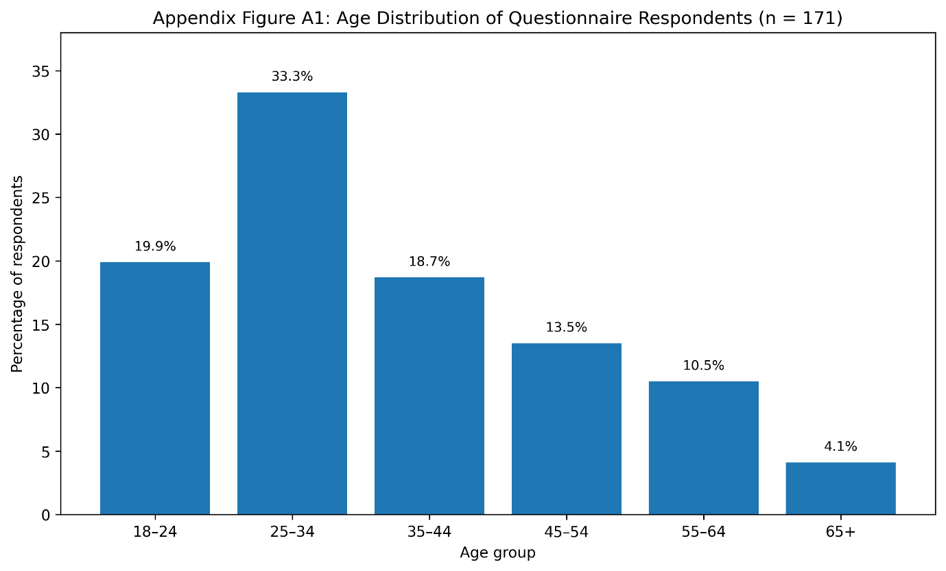
Appendix Figure D2: Employment Status of Questionnaire Respondents (n = 171)
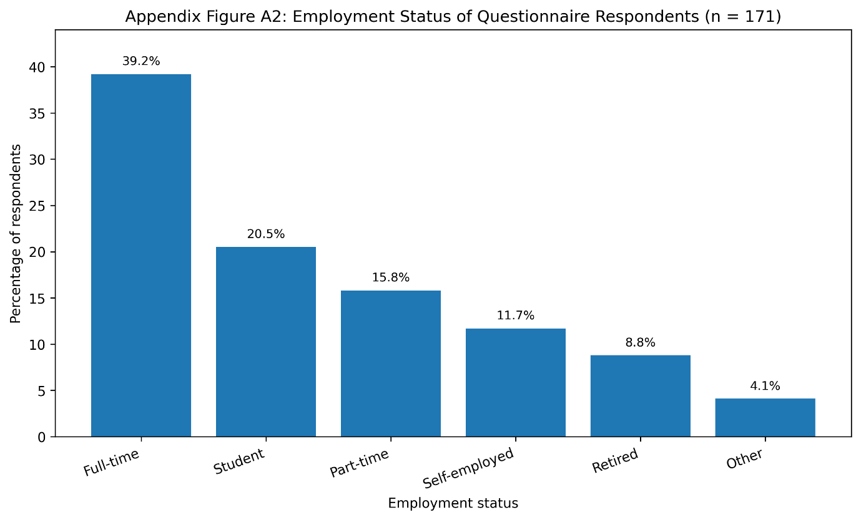
Appendix Figure D3: Stakeholder Group Representation (n = 171)
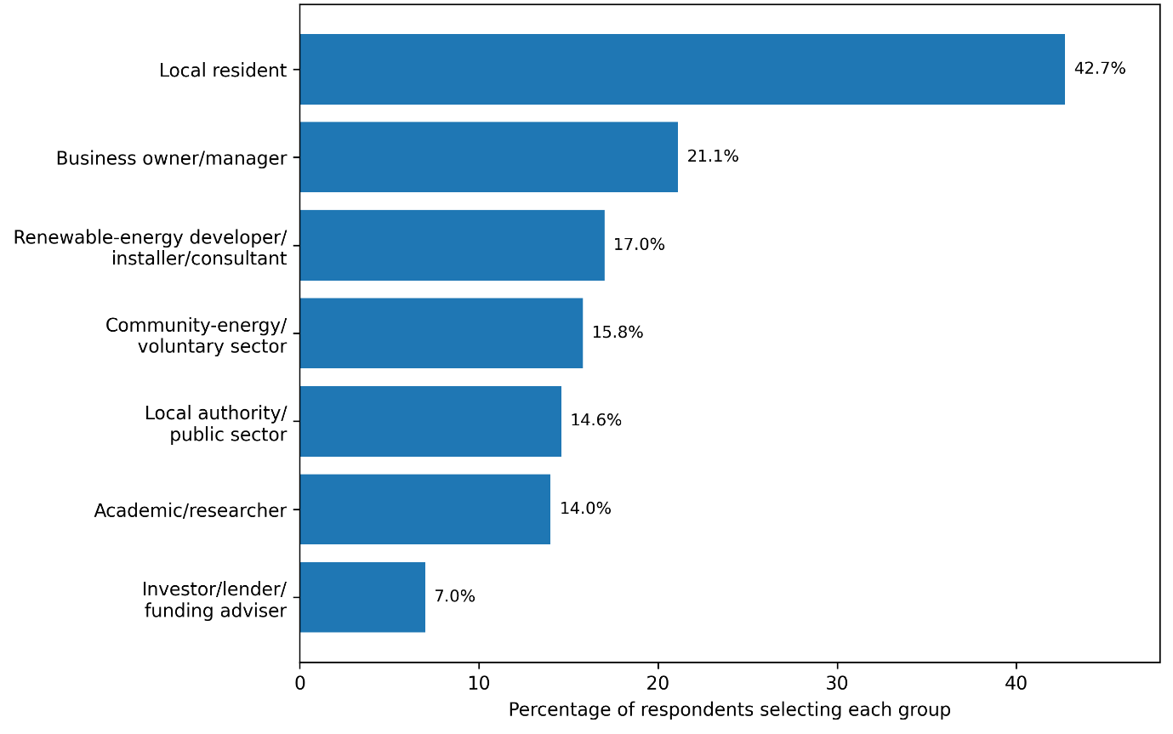
This shows representation across residents, businesses, renewable-energy professionals, community-energy groups, public-sector stakeholders, academics and finance stakeholders.

Appendix Figure D4: Awareness–Experience Gap in Community Energy
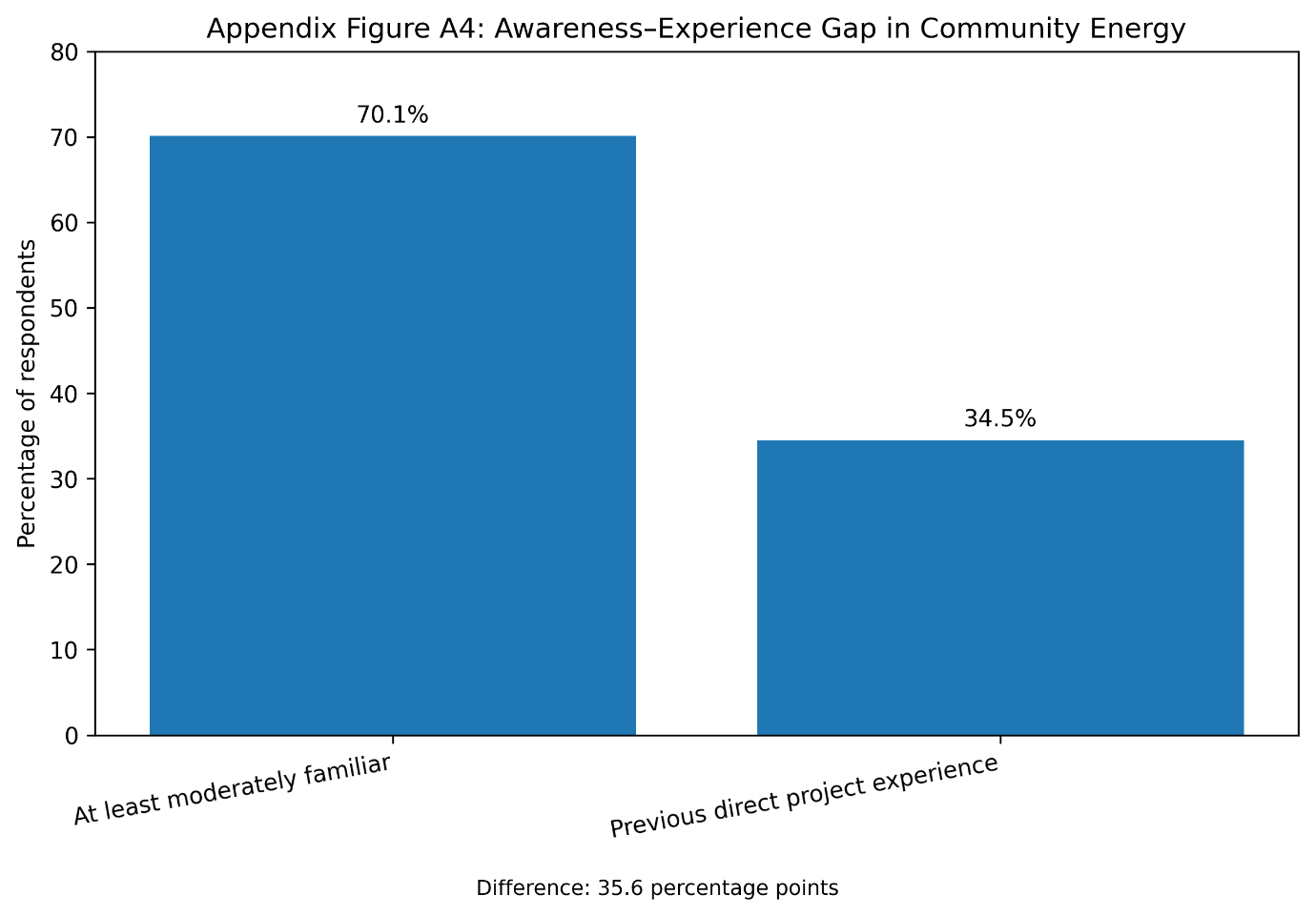
This shows representation across residents, businesses, renewable-energy professionals, community-energy groups, public-sector stakeholders, academics and finance stakeholders.
Appendix Figure D5: Project Support–Investment Willingness Gap
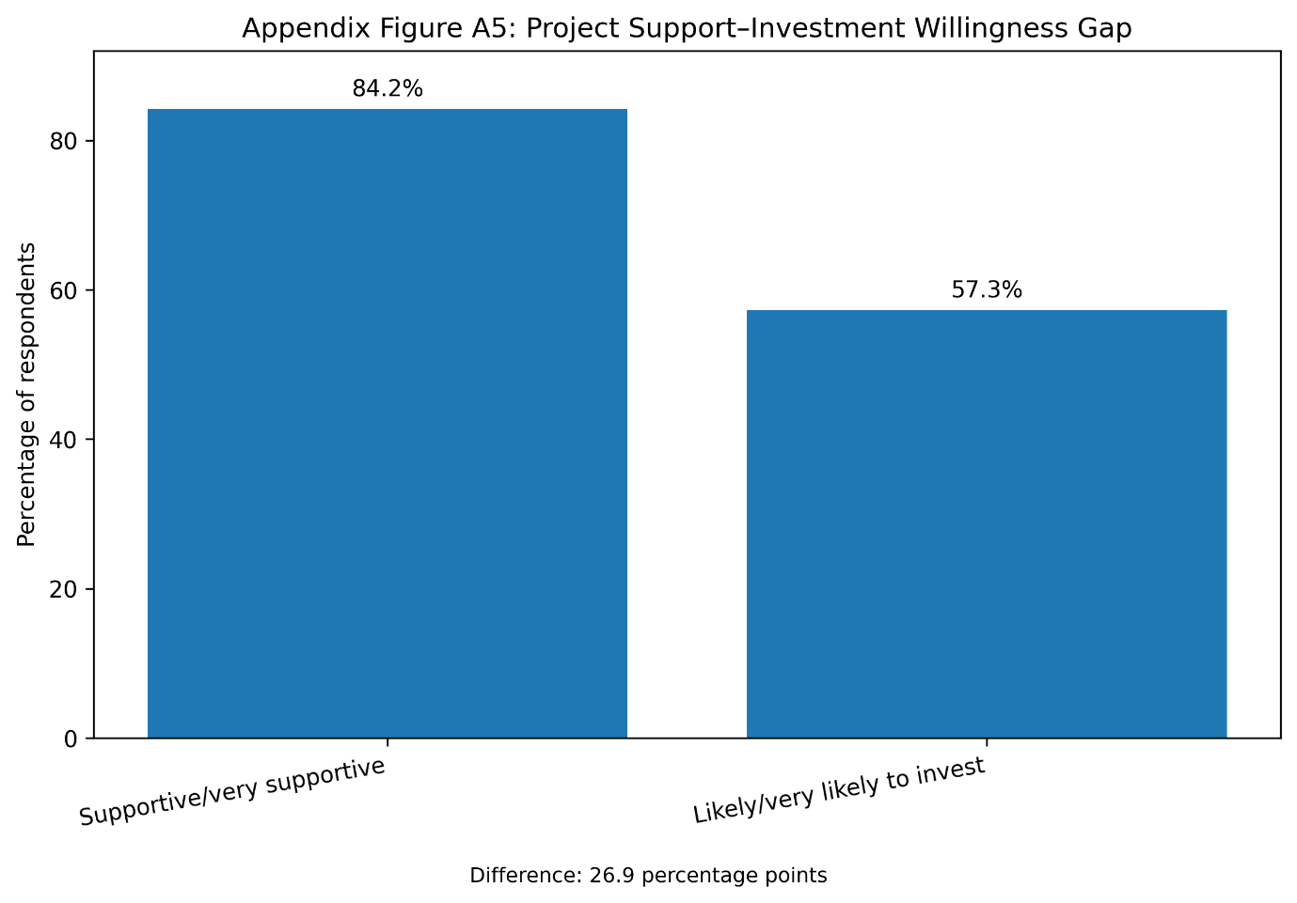
This compares:
84.2% supportive/very supportive
versus
57.3% likely/very likely to invest
and visually highlights the 26.9 percentage-point gap, one of the strongest findings in your entire dissertation. Your Chapter 4 explicitly identifies this gap as evidence that social acceptance does not automatically become financial participation.

