

Module: Fundamentals of construction technology

Site investigation Case study

Harrison Davies

Contents
Aims and Objectives 3
Site Study- 3
Site Location: 3
Fundamentals of a Desk top study: 3
• Walkover study 4
• Geological survey 4
• Topographical surveys 4
• Soil survey 4
• Unexploded bomb survey 4
• Site accessibility 4
Geological Study: 4
Site Construction Phase: 6
Building regulations: 6
Structure: Approved document A 6
Site preparation and resistance to contaminates and moisture: Approved document C 6
Toxic substances: Approved Document D 6
Drainage and waste disposal: Approved Document H 7
Significant areas of the site: 7
Flood Protection: 7
Marriot hotel services: 8
Patio area: 8
South East Corner: 8
Foundation design: 9
Pile and Raft foundation: 9
Bibliography 10

Aims and Objectives
The purpose of this report is to provide factual information about a plot of land near the Marriot Hotel in Swansea that could be used for a new project. A new restaurant will be built on the seafront as part of the project. I'll conduct a site and ground analysis of the region, detailing the history of the property, the development phase, and the foundations that will be required. I'll also let you know if there are any issues that could jeopardise the project.

A complete site survey is required before beginning the building and design phase of a project to analyse the area of interest. A site survey is essential for all projects since it uncovers any concerns that could cause complications during the construction process and provides us with particular information about the location.

Site Study-

Site Location:

Address- Swansea, SA1 3SS

Grid reference- Northings (Y): 192443 metres. Eastings (X) 265366 metres.

Size of the building:

The ground floor level of the building is going to approximately 300 square metres. The layout of the building will include a restaurant, Café bar, ice-cream parlour, kitchen and a food store all on the ground floor of the building. The first floor of the building will contain a manager’s apartment and staff facilities.

The Location of the site will be by the Marriot hotel Swansea. The building will be placed in the south west corner of the car park. The building will be positioned close to the shore.
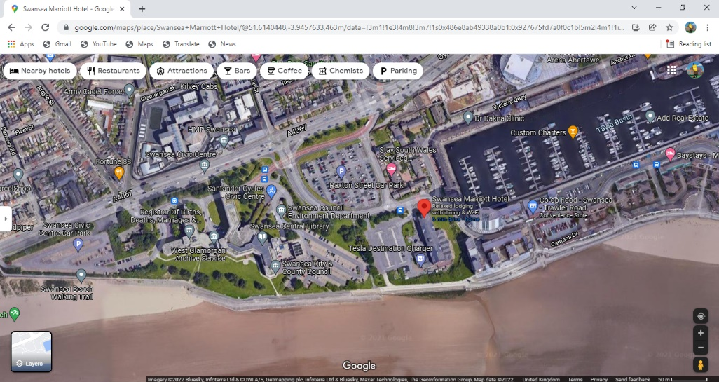

(Google Maps, 2022)

Fundamentals of a Desk top study:

Before beginning a project, every site should conduct a desk top study. It will provide information on what is above and below ground in the area. These procedures, in my opinion, are critical since they will provide useful information before the project enters the building phase.

- Walkover study – A walkover study would entail taking a look around the site to see if there are any serious issues.

- Geological survey – There are three primary components to a geological survey. Strength, deformation properties, and hydraulic qualities are among them. This is to ensure that the earth is suitable for the foundation design on the site. The area surrounding the site has a long and illustrious history; in 1859, Swansea had an industrial boom. The Mariana, as we know it now, was a very busy dock as a result of this. Copper was a prominent material for shipping and was carried to the Swansea ports in large quantities. Copper smelting became a very big industry in the lower Swansea valley, because of this there could be a lot of ground contamination in the area. Wales was also very popular for the mining industry a lot of coal was shipped from Swansea. Because of how busy the docks they had to extend the area.

- Topographical surveys – This type of survey is used to distinguish between natural and man-made terrain. Because the site is so close to the shore, it is critical to conduct this assessment to determine the type of ground beneath it, as sand is extremely weak and can cause a variety of structural issues.

- Soil survey – This is used to calculate how much topsoil will need to be removed from the site before the foundations can be built. It can also tell you whether there are any pollutants poisoning the earth at the site's location.

- Unexploded bomb survey – Because of the docks' popularity, Swansea docks were frequently bombarded during WW11. This is very crucial to do because if explosives are not found, it might result in fatal casualties. Unfortunately, this procedure is extremely costly, but it is critical for the area and the site.

- Site accessibility – The best possible access point to the site needs to be used as the extra traffic going to the site can cause congestion in Swansea.

Geological Study:

Swansea has a long history of industrial development, as mentioned on page 4. A geological investigation will assist us in determining what lies beneath our property.

The site is near to the ancient Mumbles railway line. This was a well-known Welsh railway. The railway was first created in 1807, with carriages being moved by horsepower. It was the first railway in the world to begin carrying people. They began testing the usage of steam locomotives between 1878 and 1885 and 1892 and 1896. The railway was extended to the Southend of the Mumbles in 1893 and 1898. Finally, in 1929, electric trains took over the line, which they have maintained to this day. The Swansea Mumbles Railway was decommissioned on January 5, 1960.

Map of where the Mumbles – Swansea Railway use to run.

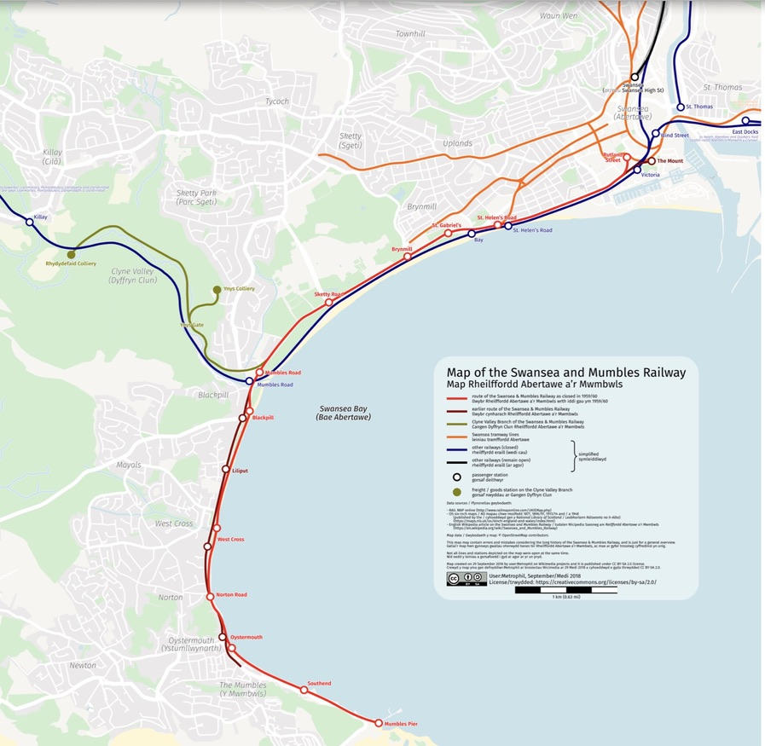
Because of the railway's technological developments over time, the ground beneath it would have seen a lot of development. Because the railway runs so close to our location, the earth may be contaminated and may include old constructions that haven't been removed, among other things. If historic structures are discovered, this might cause a slew of issues. The structures may have historical significance and will need to be investigated. This would slow down the procedure on the job site and potentially raise the project's cost.

(Mumbles Railway)

Site Construction Phase:
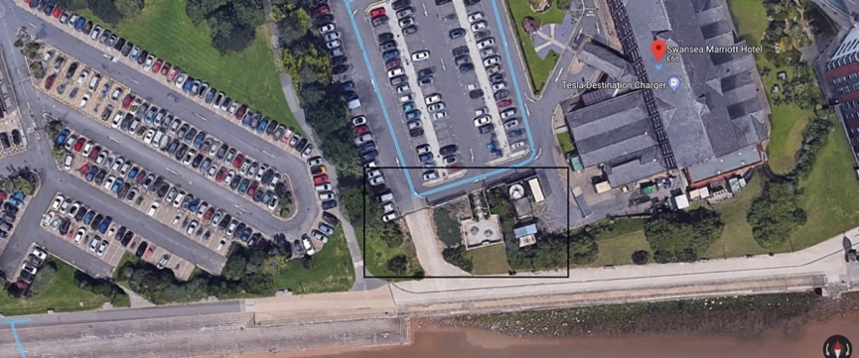

(Google Maps, 2022)

This is the location of the site; the area of the site is around 300 square metres. It is located in the Marriot Hotel's parking lot in Swansea. As you can see from the photos, the location is fairly near to the beach. This could cause some issues with the building's architecture. The ground research will be crucial in assisting us with the foundation design. The materials selected for the cladding and outside will also be crucial, as they must be able to withstand the elements while still blending in with the surroundings.

Building regulations:

Building regulations are a required part of the construction of a building since they ensure the safety, environmental impact, and structural integrity of the structure. From the information I've acquired on the site, I'll provide the buildings that I believe are significant.

Structure: Approved document A
This document explains how to comply with building laws and ensure the building's structural safety and stability. It ensures that the structure does not collapse, fall, or sink. This is crucial to me because the land we're building on isn't very strong, and if the proper building laws aren't followed, the building could sink or fall.

Site preparation and resistance to contaminates and moisture: Approved document C
This document explains how to keep the structure dry and safe from water and moisture. This restriction, I believe, is critical for our site because it is so close to the water's edge, and the building may be subjected to severe weather. We want to make sure the structure is weather-resistant.

Toxic substances: Approved Document D
This document states that it focuses on the health and safety of toxic chemicals not penetrating through the building. I believe that this is important regulation for the site because the history of the industrial developments in the area caused a lot of ground contamination. I want to make sure that our building is safe from harmful chemicals.

Drainage and waste disposal: Approved Document H
This rule specifies that sewage and garbage must be appropriately disposed of so as not to pollute the environment. This is something I believe. Regulation is critical since global warming is a major issue in today's globe, and we don't want to contaminate any marine life because the location is so close to the sea. This will ensure that we appropriately dispose of our waste.

(GOV.UK, 2010)

Significant areas of the site:

Flood Protection:

The first point of importance is the site's proximity to the water. This is critical for the location since rising sea levels are becoming more common as a result of climate change. There is a risk of catastrophic floods in coastal places around the world. They will have to incorporate a flood protection system while negotiating the building's design.
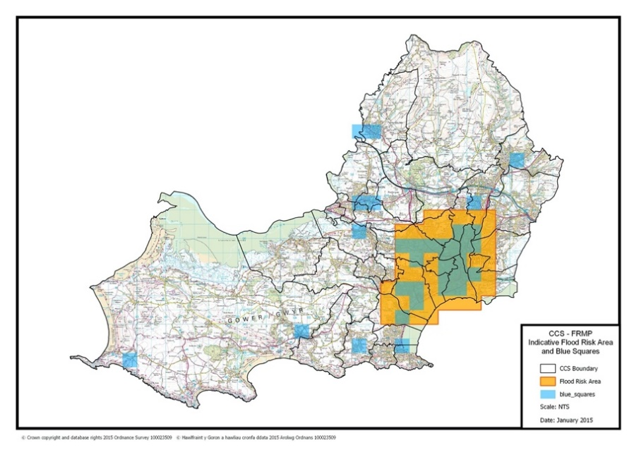
The map above is from a January 2015 study conducted by Swansea City Council. The study looked at areas that were at risk of flooding from the sea and major rivers. They were in charge of gathering data so that local flood authorities could prepare for flood threats and create flood risk maps.

(swansea.gov.uk)

“A service level agreement was signed between Welsh Government (WG), Natural Resources Wales (NRW) and the Environment Agency (EA) for the production of these maps and JBA Consultants were contracted to produce the maps on behalf of EA, NRW and LLFAs. The modelling used in producing the maps is considered to be more accurate than previous flood maps and these were completed and later published in December 2013.”
The location is within the flood zone, as shown on the map. This creates extra issues for the site because the building would require more design work and compliance with specific standards, which increases the site's complexity and price.

Marriot hotel services:

Patio area:
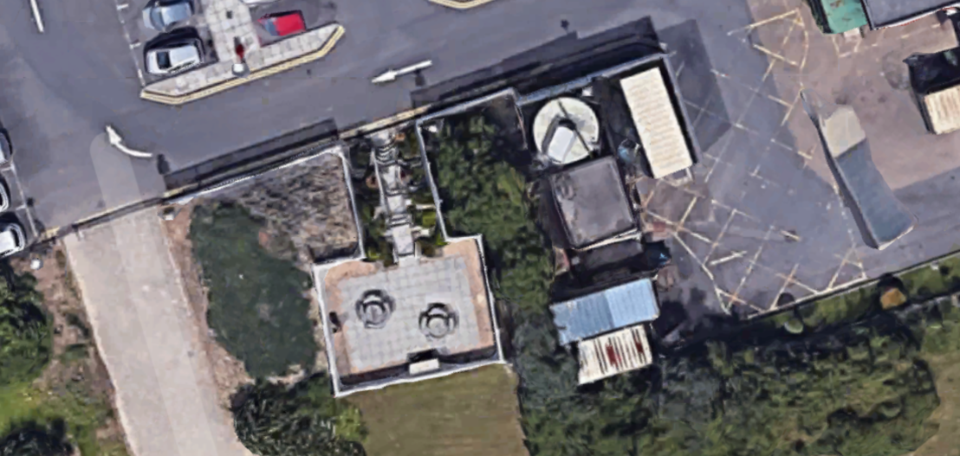

(Google Maps, 2022)

The patio is built on an elevated platform. Before construction could begin, there would have to be an excavation operation to level the ground. This would also imply that a formal agreement to relocate and demolish the patio area with the Marriot Hotel would be required before the project could commence.

South East Corner:
The South East corner is also point of interest.

(Google Maps, 2022)

Outside the Marriot hotel, as shown in the photo, there is a storage unit or facility. It's possible that this will be utilised to store garbage or chemicals. I couldn't locate any reliable information about what this is, however it would be necessary to conduct research before to the construction step. There would have to be a formal arrangement with the Marriot hotel to allow this section of the land to be demolished.

Foundation design:

The foundation design is crucial for every project because it is what supports the structure.

Pile and Raft foundation:

The ground beneath the location is made up of blown sand, which suggests that the ground type isn't particularly robust, as indicated by the geological investigation. Based on my observations and the information I've obtained; I've come to the conclusion that a pile foundation with a raft foundation on top of it would be the best foundation for site construction.

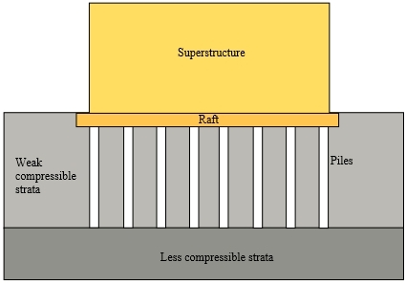

(Designing Buildings , 2020)

Because the earth isn't particularly strong, I believe this foundation style is most suited for this location. Because sand isn't strong enough to employ a shallow foundation, this foundation allows you to drill down with the pile to discover strong ground. Once the piles are in place, the raft foundation may be built on top of them, providing a stable base for the building. This foundation will also aid in the distribution of the building's load over the specified area, which will aid in the building's settlement and prevent parts of the structure from sinking.

Bibliography
Designing Buildings . (2020, 09 15). Retrieved from Designing Buildings : https://www.designingbuildings.co.uk/wiki/Piled_raft_foundation
Google Maps. (2022, 01 02). Retrieved from https://www.google.com/maps/place/Swansea+Marriott+Hotel/@51.6140448,-3.9457633,463m/data=!3m1!1e3!4m8!3m7!1s0x486e8ab49338a0b1:0x927675fd7a0f0c1b!5m2!4m1!1i2!8m2!3d51.614058!4d-3.9444482
GOV.UK. (2010, 04 09). Retrieved from https://www.gov.uk/government/collections/approved-documents
Mumbles Railway. (n.d.). Retrieved from Mumbles Railway: https://mumblesrailway.wordpress.com/
swansea.gov.uk. (n.d.). Retrieved from swansea.gov.uk: https://archive.swansea.gov.uk/floodriskmanagementplan

