BMSK4001: Assessment 1

Student Name: Martin Nikolov
Student Number: 1814619
Module Title: Academic and Employability Skills

Introduction
The purpose of this report is to present an informed, critical self-reflection about my personal employability skills. This report will attempt to explore what skills I currently possess, and what skills I need to develop and expand on to improve further. This report will focus on the perspective of the hospitality sector in the United Kingdom.
My current employment is in the hospitality sector – and personally, I feel satisfied in this industry. I am presently employed as an assistant hotel manager where I am responsible for making sure that all guests and visitors have a pleasant experience, including handling much of the logistical and human direction work to oversee operations, most often during the night shift.

Current Skills
The Cambridge English dictionary defines ‘Employability’ as the “Skills and abilities that allow one to be employed.” In this perspective, there are two different types of skills and abilities that influence one person’s employability: interpersonal skills and professional skills (Groot & Brink, 2000). This subsection will explore both of these skills sequentially.

Interpersonal Skills
The most desirable trait for employability in most business sectors is communication. Employers have a strong preference for workers who exhibit positive communication skills because it is effective communication that makes a workforce successful, especially so in a people-focused business such as hospitality where patrons demand and appreciate the service of qualified professionals. I think that I am not very well when it comes to communication. I consider myself to be rather introverted, and normally struggle when it comes to detailed conversations outside of the work environment. On work, however, I feel confident and can normally deal with any number of people comfortably.
To understand more about my interpersonal skills, I took the employability test from Kent University’s employability services (Kent University, n.d.). Their 32-questions assessment examined my perceptions about normal occurrences, and came with the following results:
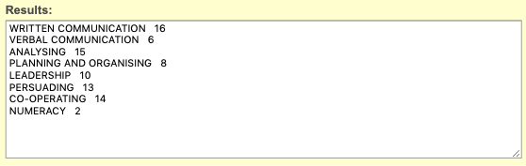
From a maximum possible of 16 points, I scored the highest in written communication. However, my worst performance was with verbal communication and numerical understanding (I am not very good at understanding statistics). The latter is not so useful when it comes to hospitality management because the statistical work is often simplified by the software that we use, so I am not very worried about that score. Verbal communication, however, is something that I should be working more towards as to be able to express myself clearly. It is commonly observed that people who are good at verbal communication are able to better negotiate for themselves and generally find better professional success. It is also pertinent to note that verbal communication proficiency is not something that can be necessarily tied to introversion or extroversion – rather even an introverted person should have good verbal communication skills for any personal or professional interaction.
However, I am a good diplomat and proficient at analysing qualitative scenarios. Both of these qualities are highly desirable in the hospitality sector because most hotels are concerned with creating a positive customer experience and positive public perception, and thus the people who are good at customer management, mannerism, calmness, and analytical approach to common problems are valued. Both of these qualities, I think, make me very much employable in the hospitality sector, which is a positive result for me. I also scored a 10 at leadership, and because it is my ambition and plan to take on more of a leadership position by becoming the General Manager of an hotel, I think that this lays a good groundwork for future professional success. I would now need to focus on finding my faults to rectify them, and to focus on my strengths to accentuate and emphasise on them.
I do feel that this questionnaire was not very detailed enough, but nonetheless it is better than guessing what my skills are, especially when people often inject their own biases into their self-evaluations. It is often not easy, or possible, for people to accurately evaluate their qualities in their own minds and thus the perceptions of others, or the use of a quantitative model, can enhance personal self-understanding.
Johari Window
Johari Window is a conceptual framework that allows people to understand their qualities that are known only to themselves, to others, and their personal blind spots. This window allows one to measure what others think about them, and what they know about themselves. In this perspective, the Johari Window can potentially be used as a tool to understand one’s interpersonal qualities. The figure below provides an analysis of my Johari Window, on which I received contribution from my work boss and a colleague at my workplace. I think that this window is both a strong representation of my qualities, and a lesson for me on my blind spot – something that I should know about myself, to recognise, and the improve upon (Davies, et al., 1999).
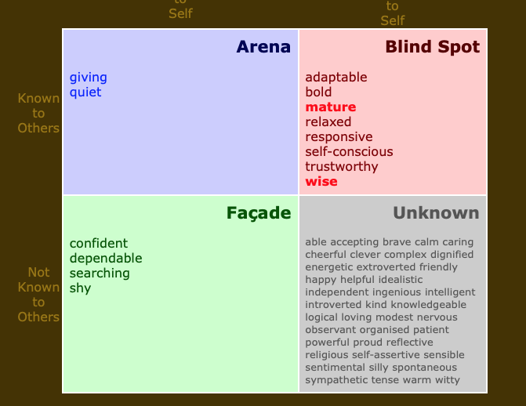
Source: kevan.org
This result of the window shows that the prime qualities about me, that I know and others know about me, is that I am a reserved and quiet person who is often open to diplomacy and negotiation with others – someone who is willing to give to reduce conflict and to find agreeable common solutions to problems that involve other people. The qualities that are my façade, or qualities that others do not know about me, but I know inside, are that I consider myself to be a confident and dependable person. I never want to go against team consensus and cause harm or discomfort to people, but I think this also has to do with my non-confrontational and shy personality. I do fear that my inherent shyness and unwillingness to engage in conflict with other people will lead me to being overlooked in a competitive race for career ascension.

Professional Skills
The professional skills that determine a person’s employability include their technical know-how and practitioner (i.e. non-common) knowledge about their occupation. A popular way to exemplify and demonstrate proficiency in the occupation overall, and in specific parts of it, is to obtain a formal certification that comes through demonstrating a keen academic and practitioner understanding about the subject. There are several recognised certification systems used in the United Kingdom for the hospitality, food, and event management sectors – all the three industries within the hospitality sector that I am interested to invest myself into.
At the present, I hold two different certifications. I have a level 1 and 2 certifications in Hospitality Management. I also have a level 1 certificate in Event Management. I obtained these certificates through self-paced study and examination. These certificates are widely respected in the hospitality sector and often demonstrate how much a person is invested into the industry. However, attaining these certificates is often not an absolute necessity, but they can serve as powerful barriers to filter out people who do not necessarily have the practitioner knowledge to work effectively in the hospitality sector – the right has to be earned through proper time investment, rather than industry-hopping.
An Employer’s Perspective
When an employer is looking to recruit a new member into the workforce for any position, they have to consider the key employable characteristics they expect to fill the position. Employing someone with an aggressive and outspoken personality as the customer support and services manager is not arguably a good idea. Employers look to balance the negative and positive elements of a person, including their interpersonal skills and professional skills, to determine their employability. As the Johari Window above demonstrates, a person’s personality can have multiple dimensions that they may or may not even be aware of.
The employers can potentially conduct a personality assessment test to understand the self-perceptions of the potential candidates to understand if whether they possess the correct characteristics for a job position. A managerial candidate will ideally need to express some strong leadership qualities, and an understanding of this can increase the effectiveness of a hire (Alonso, 2015).
In the perspective of professional skills, an employer can also set certain level certifications as barriers and filters to people who are applying for a position. Therefore, if a hotel is looking for a highly experienced general manager, or kitchen manager, they can require certifications that essentially serve as time-barriers. Only someone who has spent a considerable time in the hospitality sector will possess the top-level certifications about the sector. This certificate is virtually a guarantee that the person possesses significant knowledge about the industry and the position. Although the CV of a professional fulfils a similar purpose, most certifications can be added onto a CV, making it much more ‘stronger’.
As an employer, when judging between two similar candidates for a position, after evaluating their interpersonal skills, I would use certificates possessed to make a final decision about which person is the most interested in a career in the sector, which will demonstrate that they are passionate about their work in the profession/industry.

Expansion for Future
My current plan for the future is to improve both my interpersonal and professional aptitudes. As the data presented in this assignment has shown, I have some glaring interpersonal weaknesses that I should be focused on, especially my significant weaknesses with numerical analysis and verbal communication. I should focus on taking up adequate exercises in groups to complete these weaknesses, particularly my problem with verbal communication. For other weaknesses, I think that I should look forward to taking more short courses from the university to understand more about statistical analysis, workforce management, leadership, business administration, and other modules, all of which will help me develop non-industry specific but strong interpersonal skills. The combination of these qualities will help be become more employable and attractive to potential recruiters.
On the professional scale, I plan to expand my investments. Although I current work in the hotel management scene, I still want to explore more venues that might be possible for an expansion. I do not necessarily want to keep working for hotels, and instead move onto other ventures including catering and event planning – some business model that I can fall back on to launch my own small business. Therefore, my current ambitions for the future is to diversify my portfolio of acknowledgeable certificates. This will include acquiring higher level certificates for hotel management, event management, and tourism management.
I also want to expand onto the restaurant and food management side of hotel management, because I think that kitchen management is amongst the more challenging occupations in the sector. To complete this objective, I would need to invest into getting the proper HAACP, food allergy management, and food safety certificates.
I will concur that most of these plans are for the long-term approach to my career. In the short-term, it is my ambition to continue my education at the university to acquire key interpersonal and professional skills. I am also looking forward to achieving the next level certificate in hotel management, which is my short-term goal. I think that after these two goals are complete, my skillset will have expanded exponentially, which should qualify me for a higher-level position.

Conclusion
This report has been a very knowledge experience for me. Prior to undertaking the readings for this report, I was not placing a lot of importance (or even acknowledging) interpersonal skills and how they impact my employability. I am far too focused on courses and formal certificates that I overlooked the importance of interpersonal development. In this report, I evaluated my interpersonal and professional skills that I currently possess, and my action plan for the future. I also included a short perspective of what an employer would consider when it comes to hiring in the hospitality sector.

Bibliography
Alonso, R., 2015. Recruitment and selection in organizations. LSE Research Online Documents on Economics, , (), p. .
Davies, A., Dick, B. & Hase, S., 1999. The Johari Window and the Dark Side of Organisations. ed. (): Southern Cross University.
Groot, W. & Brink, H. M. V. D., 2000. Education, training and employability.. Applied Economics, , 32(5), pp. 573-581.
Kent University, n.d. Analyse your employability. [Online]
Available at: https://www.kent.ac.uk/ces/sk/skillstest.html

