STUDENT NAME AND ID:
WIOLETA TERESA KNYSZ | 1919631

MODULE:
LEADERSHIP AND MANAGEMENT IN THE SKILLS FOR THE WORKPLACE

ASSIGMENT:
KNOWLEDGE AND INFORMATION MANAGEMENT SKILLS FOR THE WORKPLACE
BMSW5106_LON

LECTURER:
MOHAMED KALAM

DATE: 13 JANUARY 2022

TABLE OF CONTENT

- Introduction

- Knowledge Management - a new generation power.

- Amazon as a top KM organisation

Importance of Knowledge Management for the e-commerce business.
From TACTIC to EXPLICIT- the knowledge’s transformation based on SECI Model.
The excellence of AWS Framework.
What are the KM techniques and procedures reigning at Amazon?
- High Quality Performance thanks to EFQM Model
- Chasing the modern world- The Choo Sense Making Model.
- Meyer and Zack KM cycle.
E-commerce KM outcomes.

- Nobody is perfect.

- Conclusion.

- List of References.

- Appendices.

Introduction

The hard times of the twenty first century bringing the epidemic and restrictions, quickly verified what enterprises are able to maintain regardless of prevailing conditions. And most of all, that only knowledge, or rather conscious reliable management of that mastery, can ensure unprecedented success.

The report will be based on international huge retail company, Amazon, which operates on the basic of knowledge management.
The organisation is an exquisite example because that e-commerce business not only survived in difficult times, but even gained more turnover in its operation. All thanks to the knowledge- obtaining the desired data, skilfully transforming information, sharing a, and using those essentials in appropriate way.

The purpose of this paper is to show the power of acquiring and disposing of knowledge. And in demonstration of this, the organization will be x-rayed in several ways in the context of KM, using key tools such as SECI and EFQM models, Mayer and Zack KM Life Cycle theory, AWS Framework and The Choo Sense Making Model.
All the above-mentioned techniques have their application in order to manoeuvre collected particular facts and details to achieve strictly defined goals and objectives.

To be precise, knowledge is the main factor of creation and performance depends on the ability of those managing the organisation to acquire, invent new expertness and generate clever activities (Tzortzaki & Mihiotis, 2014). How Amazon uses this KM intelligence to pump up colossal revenues, will be presented in the report.
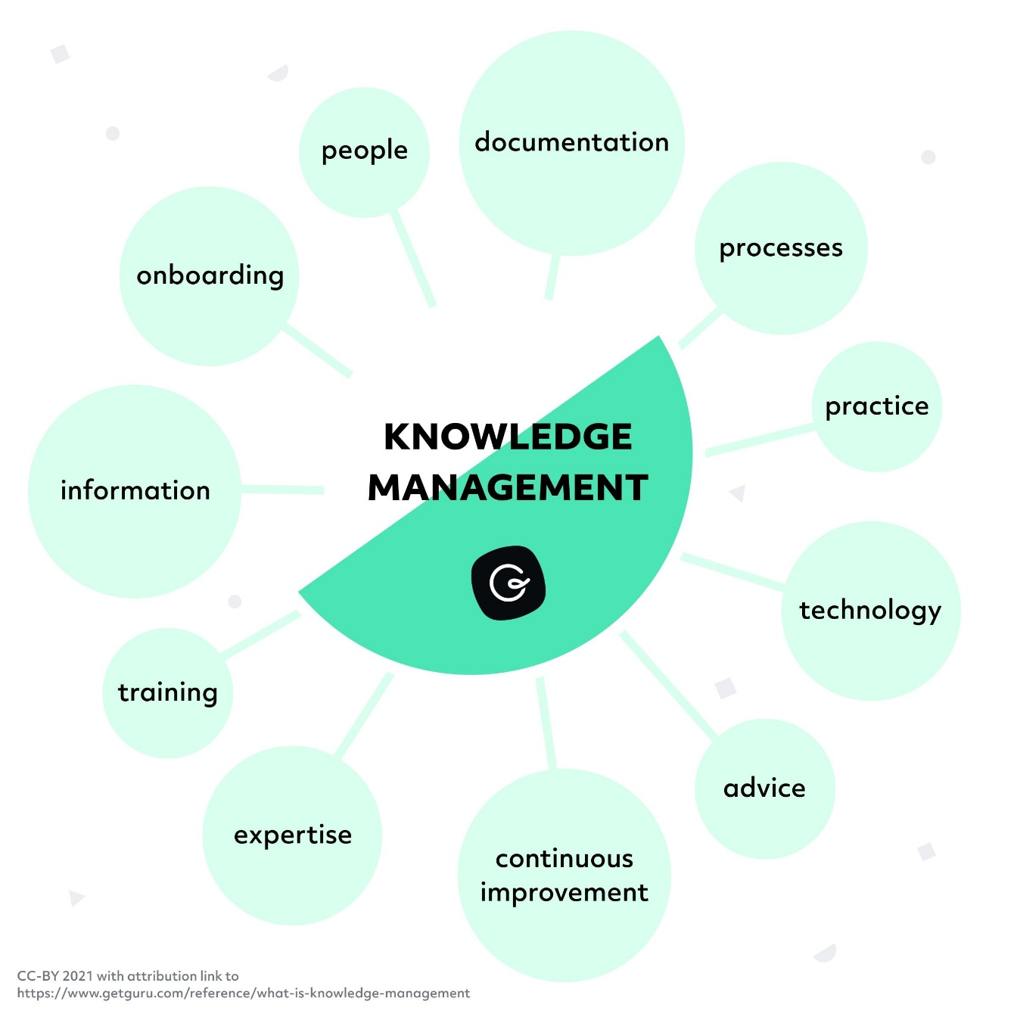

Knowledge Management- a new generation power

Knowledge Management (KM) is a smart technique of acquiring, collecting, designing, applying knowledge from the command centre of (if applicable) easy access in organization (Guru Technologies Inc, 2022).
When organizations base on gaining information necessary for their performance, they give themselves the opportunity for innovative processes and savings (Guru Technologies Inc, 2022). Therefore, knowledge is one of strong core competencies, pure investment and the skilful use of that asset is crucial for any business (Guru Technologies Inc, 2022).

The KM technique is even more amazing if every individual will be considered as walking information career (Koening, 2018).
According to Koeing (20218), someone went as far as to boldly, but true observation that pharmaceutical companies do not operate on products created in form of medicines, but intelligence. So how important seems to be not missing the data collection and organizing information, effective communication within the company and with the external environment (Koeing, 2018), to produce the source of revenue (Koeing, 2018).
Experiences and observations of stakeholders (employees and target group) are a treasury of the knowledge. Only those who feel the power of this treasury can move forward and build the innovative business based on the unique asset – knowledge.

Amazon as a top KM organization

There is probably no better example of that fantastic approach to knowledge management than the world-famous internet based American enterprise called Amazon. Almost everything that characterized this company is the consequence off effective operation of intangible material.
The Amazon showcase perfectly introduce everything about mission, vision, and principles of the organization (Amazon 2022). The company operates based on four crucial fundamentals (Amazon, 2022):
- being totally obsessed about their clients, not on the competitors (Amazon, 2022)
- engagement in performance at the highest level (Amazon, 2022)
- fascination with modern solutions (Amazon, 2022)
- looking to the future (Amazon, 2022)
In the light of the e-commerce market, this puts Amazon at the forefront of the best employers, the best environment to work and the command centre for all businesses around the globe (Amazon, 2022).
Amazon makes a wonderful use of its knowledge management and completes the customer's ‘information files’ with the purchase history and data related to the clients, thanks to which they become and endless source of purchases (Hall, 2022).

Importance of Knowledge Management for the e-commerce business.

As you can see, the dependence on knowledge management of businesses operating in virtual world is huge (Clover. 2018).
In twenty first century, people want quick and easy access to purchases or obtaining answers, and that means that knowledge must be organize in such a way that, with a single click or a short phrase input, it will bring the customer to the desired issue (Document360 Team, 2019). That can be boldly compared to using the express checkout in stores on hanging up when customers are connected to the telephone queue (Cocument360 Team, 2019).
Amazon has arranged and provided the content on the site in an exquisite way, as straightforward as the web browser bar (Document360 Team, 2019). Otherwise, what would be significance of having knowledge asset if its effective sharing would border on a miracle (Document360 Team, 2019)?
Simple indexing and product placement allowed the company to meet broad customer needs (Document360, 2019). Thanks to this, Amazon website is attractive and easy to walk around, so it is a first place when a product is searched for in many households.

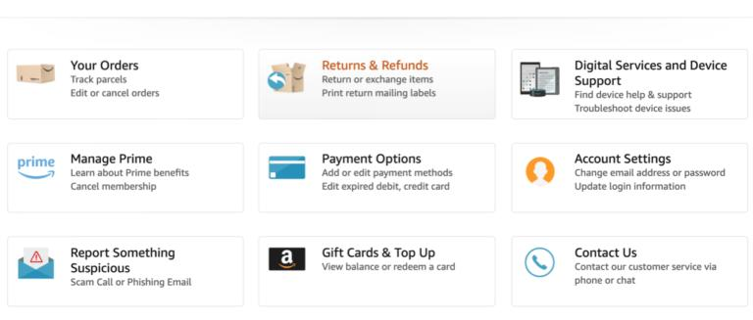
Pic: <https://document360.com/blog/best-knowledge-management-system-examples/>.

From TACTIC to EXPLICIT- the knowledge’s transformation based on SECI Model.

Knowledge Management as a set of methods for collecting and transferring information, supported with breakthrough theory of knowledge formation from 1995 of Nonaka and Takeuchi (SECI Model), creates a connection of a huge amount of data with technology, leading to an innovative knowledge (Bandela et. al, 2017).
SECI Model assumes that generation of knowledge consists of the dependence between hidden and overt ‘know to how’ which involves various activities of working with knowledge in manoeuvres as below (Bandela et. al, 2017):
- socialization = tactic – tactic (Bandela et. al. 2017)
Sharing knowledge and exchanging experiences through in direct interpersonal contact (WordPress, 2022)
- externalization = tactic – explicit (Bandela et. al, 2017)
Tactic knowledge at this stage is transformed into a form that can be understood and interpreted, which allows other to use it (WordPress, 2022).
- combination = explicit – explicit (Bandela et. al. 2017)
Here the knowledge that has been dressed in the in a tangible and visualized form may merge with other form of the previously content translated of the tactical knowledge (WordPress, 2022)
- enhancement = explicit – tactic (Bandela et. al. 2017)
At this stage, the documented knowledge must be assimilated and understood (WordPress, 2022). Internalization process enriches the tactical knowledge of the individual by absorbing mentally visualized information (WordPress, 2022).
These four stages of knowledge management are proof of how dynamic and endless the process of gathering the knowledge is (WordPress, 2022).

Explicit knowledge has a material or otherwise visualized arrangement that enables an individual to understand and gather the information related to it (Surbhi, 2020). That can be documents, recordings or published online contents.
On the other hand, tactical knowledge consists of perceptions, sensations, experiences (Surbhi, 2020), everything that has arisen emotionally or mentally in a person’s mind.
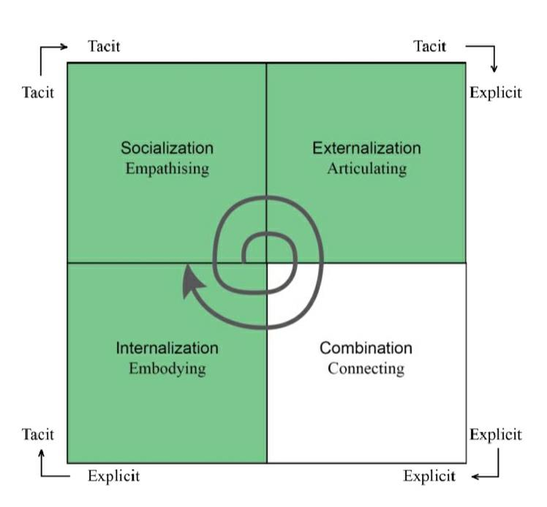
Pic: <https://www.researchgate.net/figure/The-SECI-model-with-highlighted-areas-of-interest-1-Fig-3-A-proposed-model-of-four_fig3_304021707>.

How does this system translate to Amazon? Jeff Bezos building the empire knew that the foundation is respect for the advancement of knowledge (Tibben et. all, 2006). His strategy shows two significant approaches- employing people with experience related to e-commerce business and critical thinking that contrasts within industry (Tibben et. at, 2006).

A lot of emphasis was placed on tactical knowledge. The recruiting team has been instructed to capture individuals with different mind and perspectives, as that would be an excellent seed of innovation (Tibben et. al, 2006). And when Bezos was building the online crew with job advertisement ‘building the history’ he was not wrong (Tibben et. al, 2006). The creation of the e-commerce empire started with content management and interpersonal connection (Tibben et. al, 2006). The knowledge has been generated, shared, and effectively absorbed, which goes in accordance with SECI model when tactic to tactic and tactic to explicit approaches are passed (Tibben et. al, 2006).

Other SECI model steps can be noticed as well:

TACTIC – TACTIC
website technology framework (Tibben et. al, 2006) - exchanging vision, ideas, and experiences
possibility of leaving feedback builds the relationship with the client (Tibben et. al, 2006) – exchanging the experiences between customers, gathering knowledge from the target group

TACTIC – EXPLICIT
website environment going online (Tibben et. al, 2006) - the vision has a FORM
customers information collected from their personal domains – codified data has been used in terms of gaining the customers' needs and expectations and used in performance and progression (Tibben et. al, 2006)
saving the customers’ history (searching result and purchases) on the Amazon website (Tibben et. al, 2006) for further advertisements and campaigns

EXPLICIT – EXPLICIT
collaboration – various businesses place their products on Amazon website (Tibben et al, 2006)

EXPLICIT – TACTIC
conclusions drawn from commercial achievements

In summary, productive management of ‘hidden' knowledge leads to organizational success (Tibben et. al, 2006).

The excellence of AWS Framework.

Cooperation with massive number of companies, door to door online sales with even same day delivery, several types of products available on the website was not satisfactory for Amazon. The organization was and it is still constantly looking for every opportunity to take to be an active part or even the leader in modern and innovative world. This is how Amazon expended the operation to the most desirable topic – a cloud program.

The software system is as demanding as building structure, without a solid foundation it has no value and on the contrary, it poses a great risk (Belt, 2018).
Amazon Web Services (AWS) is born out of the mind and the concern of creating the most solid, structured, effective, and quick to recover online storage environment (Belt, 2018).

The AWS has already captured the market and Amazon declared promise of:

FUNCTIONAL ON THE HIGHEST LEVEL - support in operations to deliver the best value (Belt, 2018)

SAFETY - security improvement to all levels thanks to ability to trace all information and making data not accessible to everyone (Belt, 2018)
TRUSTWORTHY - making the cloud recover quickly, test to prevent failure and introduce automatic changes (Belt, 2018)

EFFECTIVENESS OF PERFORMING THE TASK AND FUNCTION - ability to offer new technologies in comprehensible way to all in minutes (Belt, 2018)

COST REDUCTION - ability to deliver the value at lower price include finance management, resource provision and payment strategy, planning of expenses and reduction of unnecessary costs thanks to smart solutions (Belt, 2018)

The characteristics of Amazon Web Services pillars are a response to the needs of twenty first century. The AWS system is another proof of how desire and management of knowledge influences the innovativeness of an organization. The key is to look for the tactical responses for each HOW.

What are the KM techniques and procedures reigning at Amazon?

- High Quality Performance thanks to EFQM Model

The EFQM Model (European Foundation for Quality Management) was introduced in 1992 (the very first version) to support businesses in all sized in expanding and accomplishing their master plans, thus provoking an increase standard of enterprises (Harris, 2021).
EFQM Model in 2020 version assumes route, performance and outcomes following tree questions: Why? How? What?

WHY WAS THE COMPANY CREATED? mission, culture, and strategies (Harris, 2021)

Amazon mission is to meet customers’ needs and expectations of the online purchases on three principles: choice, cost, and satisfaction (Cuofano, 2022)- simple but very demanding at the same time.
Bezos emphasizes that establishing high standard of an organization is based on what you can learn, what is domain-specific, what stands out from the rest and what you can transfer realistically (Cuofano, 2022). All through observation and proven knowledge (Cuofano, 2022).
Thanks to massive engagement in knowledge management, Amazon was hailed as the number one enterprise in the category of ‘Customer Obsession’ 8 years in row (Cuofano, 2022).

HOW IS THE COMPANY GOING TO IMPLEMENT ASSUMPTIONS? stakeholders, performance, and value (Harris, 2021)

Amazon is a diverse company, bringing together everyone and everything (Cuofano, 2022). From the products of own label to the products of third parties, publication of advertisements, branded AWS online storage platform, memberships, streaming services and more (Cuofano, 2022). In addition, the Bezos associates twelve subordinated companies including among others, grocery, bookstores, and audio product manufacturer (Cuofano, 2022).
Performance based on knowledge management strategies has the greatest recognition in implementing assumptions. Amazon uses the Working Backwords Method, where creation of products and services begins in the target group specification, thus identifying costumers’ needs (Cuofano, 2022). Definition of the approach is simple... ‘base your sales strategies not on the idea of what you want to sell, but on work from very end- to whom and why you want to sell... then the people will get into it’ (Cuofano, 2022).

WHAT ARE THE OUTCOMES? (Harris, 2021)

Research made is America showed that nearly fifty percent of online sales go through Amazon (Yin & Jeffries, 2021). Not only that, the reality is also that in order to function in e-commerce industry, businesses must be part of Amazon, filling their store shelving (Yin & Jeffries, 2021). Sellers have unanimously stated that being a ‘part’ of Amazon cost them a lot, but they are not able to sell that much stock outside of that innovative platform (Yin & Jeffries, 2021).

Bezos was striving for leading powerful enterprise through innovation and obsession with customer needs. He relied on the creativity and engagement of employees giving them freedom to create ideas in ‘Dream Big’ form by putting themselves in costumers’ place (NOBL, 2020). Most importantly, the progress cannot be made without new approaches, that is why Bezos requires Amazon’s crew to have an open mind, different perspectives, and balance in creation without restrictions (NOBL, 2020).

- Chasing the modern world- The Choo Sense Making Model.

Introducing innovation requires the application of knowledge management models. The Choo Sense Making model has significance meaning as it perfectly fits the decision-making process (Patel, 2021).
That approach needs to go through three fundamental steps (Patel, 2021):

SENSE- MAKING (Patel, 2021)

The company’s goal is to meet the market demands which are extremely dynamic and complex (Patel, 2021).
What does Amazon do? Exactly what the Choo model assumes. The company implements activities aimed at interpreting the content, quickly adapting the business to the customers profiles, thus creating competition.

KNOWLEDGE CREATION (Patel, 2021)

The above-mentioned brainstorming that Bezos relied on, applies at the second step of implementing the Choo Model. Thanks to this, the enterprise rapidly operates the obtained data, creates a new idea (Patel, 2021) and acquires own asset – wisdom. At this stage, Amazon introduces new products and services, collaboration with entrepreneurs, extends its activity on every possible level, in order to become a worldwide place of everything.

DECISION-MAKING MASTERY (Patel, 2021)

On the last step the organization must act rationally and be prepared for another version then one previously assumed, especially if it is more possible to implement (Patel, 2021)

- Meyer and Zack KM cycle.

Meyer and Zack Model is another significant technique of managing the knowledge, especially in transforming the acquired and held information into usable knowledge and included processes of (Patel, 2021):

DATA / INFORMATION GAINING - emphasis on the quality of information collected (Patel, 2021)

REFINEMENT – transforming information into knowledge, so that is effortless to store and redeem if needed later (Patel, 2021)
What does Amazon do?
Algorithm.
Amazon search engine responds quickly to customer request and displays such products and in such order to keep them at virtual store (Burns, 2020) as long as it is possible. Similarity of the words and content is crucial (Burns, 2020).

STORAGE PLUS RETRIEVAL - software or physical form of information storing (Patel, 2021)
What does Amazon do?
As an example, there are two great manoeuvres on the Amazon website according to the ‘Basket’ section. Costumers have an opportunity to add as many products as they are interested in to buy to the BASKET or divide the basket into two groups of products, for purchasing now and moving the rest to SAVE FOR LATER, both sorted without a time limit.

DISTRIBUTION - various methods of knowledge transmission (Patel, 2021)
What does Amazon do?
The company uses different photos perspectives, a short video advertising and showing products in real conditions (Burns, 2020). In addition, Amazon uses pop-up windows with products related or being watched by others to interest buyers.
Ratings and feedbacks add value to the item displayed (Burns, 2020).

PRESENTATION - knowledge packaging (Patel, 2021)
What does Amazon do?
Each product is packed with high quality photos and a specific description in the title, including the type of the item, company, colour and measurements (Burns, 2020).
How a given item appears in searches determines the customer's further decisions and Amazon already in first impression does great (Burns, 2020).

*** attractive catalogue = a lot of traffic on the website = big sale ***

E-commerce KM outcomes.

The main benefit of knowledge management for the organization is delivering the market novelties (Towns, 2016) and the expansion of the target group at the same time. Amazon has grown in terms of innovation by joining the music streaming industry to extend the promise of comprehensive buying experience (Towns, 2016).
Collecting data helps in determining the detailed characteristics of the things that drive the sale and influencing customer’s purchase decisions through appropriately generated banner adds or advertising campaigns (Clover, 2018).
The knowledge asset, especially in the e-commerce business, has particular importance because each brand on the market, and Amazon and their knowledge asset is fantastic example, may be a determinant of a new industrial era (Towns, 2016). However, looking at Amazon’s achievements, with cooperation between organization, ‘together you can do more’ (Towns, 2016) and this is what creates the greatest achievement of humanity thanks to constant enriching the knowledge asset.

Nobody is perfect

Amazon is considered as massive online store offering products at favourable prices. But there is a catch. According to Gaus (2019), an investigation has been carried out into of operation of Bezos’s enterprise and many products have been found unsafe or unregulated, and their tempting price is tied to imports from China. This may lead to lawsuits, where Amazon will be held liable not only under the crime responsibility but also financially in order to cover losses, health detriments and solving the issues (Gaus, 2019).
But here we are dealing with a concealment of information or a deliberate refusal to collect reliable data for pure profit. It is hard to believe that such an excellent company in knowledge management could overlook the quality control.

That brings with another point that puts Amazon in a slightly less credible and trustworthy light. Third-parties pay huge fees for the ability to operate on the Bezos`s online shopping platform and although Amazon gets incredible revenue on it, at the same time competes with this business. So, it may turn out that a leading e-commerce enterprise, treads on very thin ice, and as smooth as it jumped from innovation to innovation, it may disappear so quickly.

Conclusion

Amazon deserves a lot of admiration and applause for fantastic and skilful knowledge management. The organization has provided humanity with wonderful and innovative opportunities, for even demanding costumers and all kind off businesses. The company perfectly gather the data, process the information, and shares the knowledge with others. Bezos is well aware that knowledge and wisdom are on a par with gold. But the enterprise should not forget that people values loyalty and honesty above all. By keeping an eye on it, with this approach and behaviour it can really last forever.

List of References

Amazon.com Inc., (2022), “Who We Are”, Amazon.com Inc., accessed 10 December 2021, <https://www.aboutamazon.com/about-us>.
Bandela C. et al., (21 December 2017), “Knowledge management and the entrepreneur: Insights from Ikujiro Nonaka's Dynamic Knowledge Creation model (SECI)”, publishes by Elsevier B. V., downloaded 10 December 2021, available online <https://www.sciencedirect.com/science/article/pii/S2096248717300061>.
Belt D., (15 May 2018), “The 5 Pillars of the AWS Well-Architected Framework”, Amazon Web Services, accessed 10 December 2021, <https://aws.amazon.com/blogs/apn/the-5-pillars-of-the-aws-well-architected-framework/>.
Burns A., (30 January 2020), “3 Reasons Why High Quality Content & Imagery Is Crucial on Amazon”, Styla Inc., accessed 10 December 2021, <https://blog.styla.com/en/3-reasons-why-high-quality-content-imagery-is-crucial-on-amazon>.
Clover H., (8 November 2018), “3 Reasons Why eCommerce Must Have Knowledge Management”, KMS Lighthouse, accessed 10 December 2021, <https://www.kmslh.com/3-reasons-why-ecommerce-must-have-knowledge-management/>.
Cuofano G., (n. d), “Amazon Mission Statement and Vision Statement In a Nutshell”, GI Digital Ventures SRLS, accessed 10 December 2021, <https://fourweekmba.com/amazon-vision-statement-mission-statement/#:~:text=Amazon's%20mission%20statement%20is%20to,and%20endeavors%20to%20offer%20its>.
Document360 Team, (1 October 2019), “The Very Best Knowledge Management System Examples”, Document360, accessed 10 December 2021, <https://document360.com/blog/best-knowledge-management-system-examples/>.
Gaus A., (10 December 2019), “Amazon’s 3 Biggest Challenges for 2020”, THESTREET INC., accessed 10 December 2021, <https://www.thestreet.com/investing/amazons-biggest-challenges-for-2020>.
Guru Technologies Inc, (2022), “What is knowledge management?”, Guru Technologies Inc, accessed 10 December 2021, <https://www.getguru.com/reference/what-is-knowledge-management>.
Hall M., (n. d), “Amazon.com American Company”, Britannica, accessed 10 December 2021, <https://www.britannica.com/topic/Amazoncom>.
Harris E., (27 May 2021), “What Is the EFQM Excellence Model and How Useful is it For You?”, Triaster Ltd., accessed 10 December 2021, <https://blog.triaster.co.uk/blog/what-is-the-efqm-excellence-model-and-how-useful-for-you>.
Koening Michael E. D., (15 January 2018), “What is KM? Knowledge Management Explained”, KMWorld, accessed 10 December 2021, <https://www.kmworld.com/About/What_is_Knowledge_Management#:~:text=A%20new%20definition%20of%20KM&text=%22Knowledge%20management%20is%20a%20discipline,of%20an%20enterprise's%20information%20assets.&text=Both%20definitions%20share%20a%20very%20organizational%20and%20corporate%20orientation>.
NOBL, (19 February 2020), “What We Can Learn From Amazon’s Planning Process”, NOBL, accessed 10 December 2021, <https://academy.nobl.io/10x-thinking-and-cross-functional-goals-what-we-can-learn-from-amazons-planning-process/>.
Patel R., (28 July 2021), “Models of Knowledge Management (KM Models) Explained”, CloudTutorial, accessed 10 December 2021, <https://www.thecloudtutorial.com/knowledge-management-models/>.
Surbhi S., (30 July 2020), “Difference Between Explicit Knowledge and Tactic Knowledge”, Key Differences, accessed 10 December 2021, <https://keydifferences.com/difference-between-explicit-knowledge-and-tacit-knowledge.html>.
Tibben et. al., (2006), “Unlocking the secrets of Amazon: understanding tactic knowledge and its implications for e-business", Faculty of Informatics, University of Wollongong, Australia, downloaded 10 December 2021, available online <https://ro.uow.edu.au/cgi/viewcontent.cgi?referer=https://www.google.com/&httpsredir=1&article=10306&context=infopapers>.
Towns J., (1 July 2016), “How Does Amazon Push the Envelope?”, Wellspring, accessed 10 December 2021, <https://www.wellspring.com/blog/2016/07/01/how-does-amazon-push-the-envelope>.
Tzortzaki M. & Mihiotis A., (20 March 2014), “A Review of Knowledge Management Theory and Future Directions”, John Wiley & Sons Inc., accessed 1 November 2021, <https://onlinelibrary.wiley.com/doi/abs/10.1002/kpm.1429>.
WordPress, (n d), “SECI model (Nonaka & Takeuchi)”, WordPress, accessed 10 December 2021, <https://knowledgeandmanagement.wordpress.com/seci-model-nonaka-takeuchi/>.
Yin L. & Jeffries A., (14 October 2021), “How We Analyzed Amazon’s Treatment of Its “Brands” in Search Results”, The Markup, accessed 10 December 2021, <https://themarkup.org/amazons-advantage/2021/10/14/how-we-analyzed-amazons-treatment-of-its-brands-in-search-results>.

Appendix



