

Developing Workplace Critical Thinking
  - BMSK5001
1710017 | University of Wales Trinity Saint David | 31/05/2019

Executive Summary
In this report the researcher choose to analyse Admirals culture to demonstrate the need of values beliefs and attitude in the workplace and how to maintain an ideal working environment.
This report will demonstrate the impact of work values, beliefs and attitudes can have in a healthy working environment from a manager perspective using a management theory that is ideal for their organisation success.

Contents
Executive Summary 1
Terms of Reference 3
Procedures 4
Introduction 5
Findings 6
Conclusion 7
Recommendations 8
Appendices 9
Reference List 10
Bibliography 11

Terms of Reference

This report is for the use of Julie Thomas, lecturer at University of Wales Trinity Saint David.
This report was compiled by 1710017.
The purpose of this report is to critically analyse the impact of values, belief and attitude in the workplace.
The importance of identifying a management theory relevant to your role and critically assess its impact on your own beliefs, attitudes and values.
The deadline for this report is the 31/05/2019.

Procedures

The following report is being conducted by a range of different academic sources such as:
- Academic books
- Journals
- Valid newspaper
- Articles
- Valid websites.

Introduction
Admirals Group was founded by Henry Engelhardt and the ideas was launched in 1993 with a concept of a 1 brand, zero customer and 57 employees and now consists of some of the most renowned car insurances brand within the UK which includes bell, elephant .co.uk and diamond car insurance. It employs over 2000 employees in its head office in Cardiff and Swansea and currently hold over 1.3million drivers car insurances (Admiral Group plc). In this report the researcher will analyse the impact of values, beliefs and attitudes at Admirals.
The researcher will identify and apply a management theory relevant to a manager job role and critically assess the impact of the beliefs, attitudes and values from a manager point of view within the organisation mentioning the effect of these values within Admirals group.
According to Barrett Value Centre: “when we use our values to make decisions, we make a deliberate choice to focus on what is important to us. When values are shared, they build internal cohesion in a group.”

Findings
Beliefs of Admiral
What are Beliefs in the workplace? Belief in the workplace are the assumptions we make about ourselves and others in the world, about how we imagine things to be. Beliefs are about how we think things really are. Beliefs tend to be deep set of values from our up bringing childhood. At Admiral’s they believe that happy people make happy customers and happy customers help increase profits. (Admiral Group plc)
Attitude at Admiral
What is an attitude in the workplace? An Attitudes in the workplace is a way of replying to people and situations based on their beliefs, values and assumptions. How employees react to situation can reflect on their behaviour and attitude. At Admiral’s there attitude is a simple yet effective one “people who enjoy what they do, do it better.” (Admiral Group plc)
Values at Admiral’s
What are values at the workplace? Values at the workplace are about how we’ve learnt to think things out, the way people behave, especially in terms of qualities such as honesty, integrity and transparency which when people are asked what are their values tend to be the main core values of the organization. At Admiral’s their business is founded on values of trust, integrity and honesty because they know that consistency and innovation is important to the consumers. (Admiral Group plc)
Admirals’ beliefs, attitudes and values.
At Admirals their beliefs, attitudes and values is a mix culture of honesty, wholehearted and open organization that focuses on four key elements: communication, equality, reward and recognition and fun. Their commitments are focused on customers, people, community and environment. The impact of these values in the workplace help employees work together towards a common goal. Values at work allows teams to be creative and motivate one and other which encourages innovation and improves the cohesion of the workplace. According to Wales online Mr. Steven said:” it’s our people that make Admiral such a special place to work and we want them to feel supported and valued and enjoy the time spend in work”. (Admiral Group plc)
These working values belief and attitudes creates an ideal working environment due to there business model on how Admiral group believe in good value financial products to their customers, excellent and convenient services to all customers, a great place for our people to work and a good returns for our shareholders over time. As seen in (figure 1) it shows the relationship between the beliefs and values to our attitudes and our resulting behaviour. What sets Admiral Groups apart from other businesses is that they go out there way to make an excellent working environment as Admirals believe if people like what they do they will do it better a simple yet effective moto of the company which has been proven successful over many years. Admiral work force look forward to come in to work which lead to excellent customer services and satisfaction. (Admiral Group plc)
Admirals Groups concept of management theory is more in line with the Mcgregor theory Y They believe if there staff are happy then that creates a happy working environment which reflects with their job of customer service and customers satisfaction. It also believes in staff reward and recognition as mentioned in Mcgregor theory Y he assumes that employees are happy to work, are creative, and enjoy taking on additional duties. Theory Y managers and supervisors are sometimes called hands-off managers they tend to usually give their employees more freedom and trust with the hopes that the result will be happier workers who will go the extra mile for the company. (Mindtool.com)
Admiral success goes hand in hand with having a strong culture they believe in people who like what they do, do it better and hence why they invest into making sure that admirals group is a happy working environment where they are challenged, have equal opportunities and career development and fun Is a must this is why they have managed to retain the can do work ethic and start up mentality since 1993 which is still in place and doing as good as the first day. At Admiral they value there customers, there people, there community and the environment. Without customers Admiral Group would be inexistent, their customers are essential to them and their future and excellent service is paramount to them. At Admirals they make sure that their employees are happy and stay with them with there 4 pillar system which is doing really well and it is proven by multiple awards for best business to work for and that there people have a centric style at work. Admiral local community is very important to them as well and play a very important role through charity and giving sponsorship there aim is to appeal to employees charity or local events close to their heart and contribute and support them and last but not least their environment at Admiral they encourage employees to participate into recycling and energy projects to reduce the ozone impact energy efficiency and create a good working environment. According to W.Sullivan:” the progress of becoming a value-led organisation requires the investment of time and management”. (Journal of change management vol.2 p.253)
Management theory definition is a collection of ideas which set general rules on how to manage an organisation. Management theory helps guide managers and employers relate to their business in its knowledge of goals. Management theory helps implement of effective means to achieve goal set and how to motivate staff to perform to the best of their knowledge within their workforce. (Business dictionary.com)
Maslow theory of motivation identified that not all employees are motivated in the same way and do not all move up the hierarchy at the same pace. They may therefore have to offer a slightly different set of enticements from employee to employee. At admirals they believe in the ministry of fun all employee must participate and have fun. Fun is a big part of working for Admiral Group and we celebrate as many events and occasions as possible (Admiral Group plc).

Manager role within the organisation is to shape the attitudes of employees make them understand the company’s values and use it to guide employees to create a successful business morale. At Admiral they believe in a corporate framework which enables efficient decisions making and ensure that there is a right balance of skills and experience to assess and manage the Group operates. At Admiral there objective are clear continue development, continuous growth of the company and maximize the value of their core business. (Admiral Group plc)
The impact of a good management theory has landed Admiral to be the best firm to work for in the UK, not only that but Admiral is Wales only FTSE 100 company and took the prestigious title at the Sunday Timed best company to work for award. Management theory helps manager keep their employees motivated, risk of mitigation, more focus on their management teams maintain a sustainable operation and effective solutions for any potential problem if any arise by using a controlled test and learn strategy this helps Admiral to measure any challenges ahead and an effective solution to the problem. According to David Steven: “our strategy is simple continue to progress in the UK car insurance market while taking what we do well to new markets and products: keep doing what we are doing and do it better year after year".
At Admirals they believe that happy employees make happy customers, and happy customers make a successful company (see figure2). Working at Admiral, whatever you do, you’ll be making a valuable impact to the business. That’s why Admirals has an Our Share Scheme is a way of thanking their employees hard work this scheme allows staff to finance anything from travelling to a childhood dream (Admiraljobs.co.uk). Admirals’ motivation theory is rewarded through incentive schemes that place emphasis on the quality of service provided to our customers. As mentioned in Maslow motivation theory:” The deficit principle claims that once a need is satisfied, it is no longer a motivator because an individual will take action only to satisfy unmet needs. Admirals’ testimonial of their distinctive culture, dedication and passion for their people are key to ensuring the best possible service for their customers and delivering another year of strong results as far from Admiral Records results see staff in £3,600 profit in share about 10.000 of their employees will receive free shares after report was posted on record year profit. (bbc.co.uk/news Admiral record results see staff in £3,600 profit share).
Benefit of an effective management theory improves managerial performance, employee retention and reliability, improved production, overcoming the barriers of communication, clear accountabilities for their actions, and cost efficient by saving time and reduces conflicts, ensures efficiency and consistency in overall performance. Effective performance program helps improve standard performance which is reviewed on the basis of quality and quantity of work and effective communication and feedback is a must in any organization in Admiral they believe that communication is crucial and henry Englehardt believes in good communication and treating people with respect and fairness (Admiral Group plc).

Conclusion
In conclusion the impact of values, attitudes and beliefs have a great importance in any organisation to be a successful at what they do. It reflect within the organisation growth and performance. The impact of each individual values and beliefs play an important role within the workplace as not all employees have the same values but adhere to the company work ethics to promote a healthy working environment and do be the best at what they do. Having a good management theory in place within the organisation values helps manager to actually implement these values which lead to a great working environment for the workers having a good understanding of organization’s values helps business development and healthy growth in profit and leads to company’s future expansion. According to Henry Engelhardt:” our strategy is simple continue our profitable growth in the UK and what we know and do it elsewhere” (Admirals group plc). At Admirals their motivation of staff and customer retention has a successful rate in their management performance as happy staff equal to happy customers they have been using the same management theory since 1993 till now they must be doing something right as they have won many awards for their work ethnics their customer satisfaction and best company to work form 19 years in a row. According to Admiral group plc: Over the years our individuals, our departments, our brands and the company as a whole have won various awards, both regionally and nationally ,Admiral Group has won, something everyone here is very proud of (Admiral Group plc).

Recommendations
The only recommendation the researcher would give to any organization would be to adopt Admirals management theory they have been doing amazingly well out performing themselves compare to other car insurances for starters and there management theory of fun seems like an interesting theory which every employee swear by. Admirals’ workers look forward coming to work and provide excellent customer service. Admirals’ employers’ aim is to create a complete working environment and support staff whenever possible. (Admiral Group plc).

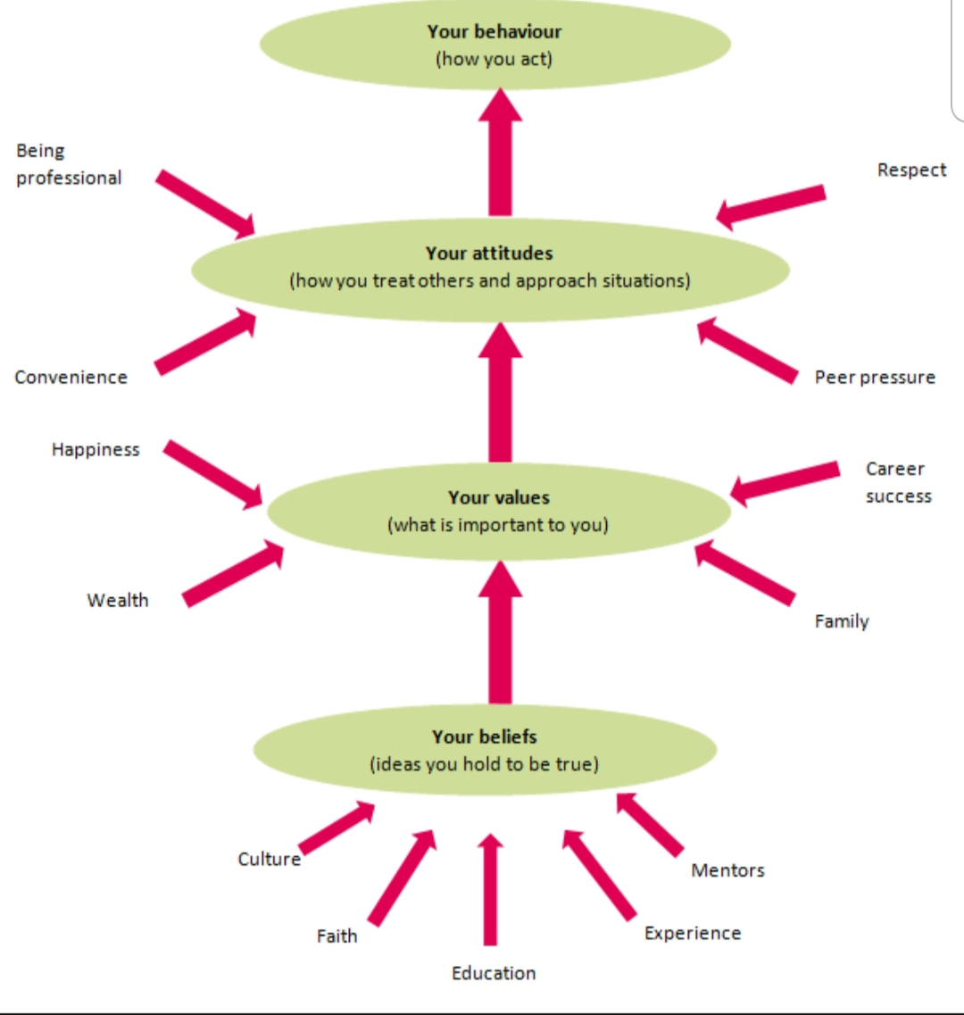
Appendices

(Figure1)
(www.iaa.govt.nz)

Admirals business Model
A great place to work we go out of our way to make this a GREAT place to work. There are four pillars to our culture: communication, equality, reward and fun. It is upon these pillars that the performance of our staff rests.

A great place to work
Low capital employment

Satisfied Customers

Shareholder returns
Profitability

Profitability Admiral continues to focus on profitability both in the short, medium and long term, and will continue to do what is right for the long term success of the business.
Low capital employed Sharing risk with co- and reinsurance partners is an important part of Admiral’s business. Our model is based on reinsurance relationships underpinned by strong underwriting results, with Admiral itself only providing the capital backing for a minority of its business.
Shareholder returns we believe that keeping management hungry for cash keeps them focused on the most important aspects of the business. We don’t starve our businesses, but neither do we allow them the luxury of excess capital.
(figure2)
https://admiralgroup.co.uk/sites/default/files_public/annual-report/2015/03/2014-full-year-results-annual-report.pdf p12

Reference List

https://www.valuescentre.com/mapping-values/values/why-values-are-important (accessed on: 20/05/2019)

http://www.businessdictionary.com/definition/management-theory.html(accessed on: 21/05/2019)

https://www.mindtools.com/pages/article/newLDR_74.htm (accessed on: 21/05/2019)

https://www.iaa.govt.nz/for-advisers/adviser-tools/ethics-toolkit/personal-beliefs-values-attitudes-and-behaviour/ (accessed on: 29/05/2019)
https://admiraljobs.co.uk/inside-admiral/post/81/Admiral-share-scheme-means-the-world-to-our-staff%20target= (accessed on: 30/05/2019)
https://admiralgroup.co.uk/sites/default/files_public/annual-report/2015/03/2014-full-year-results-annual-report.pdf (accessed on: 30/05/2019)
https://www.bbc.co.uk/news/uk-wales-47482247?intlink_from_url=https://www.bbc.co.uk/news/topics/cj5pd62kpe6t/admiral-group&link_location=live-reporting-story (accessed on: 31/05/2019)
https://admiralgroup.co.uk/our-culture/our-awards (accessed on 31/05/2019)

Bibliography
Journal of Change Management Vol.2,3 p247-245

