Module Name: Data Handling and Business Intelligence
Module Code: LCBB5000

Student ID: 2006643
Barbara Berto

Table of Contents
Part 1 3
Introduction 3
Description of the Excel Ice Cream Data 4
Participants 5
Relationship and Correlation result 6
Conclusion of the Analysis 12
Evaluation of the usage of Excel and conclusion 12
Part 2 15
Introduction 15
Description of the Covid-19 data 16
Data analysis 17
Cases Statistics of the continents 17
Death Cases in Continents 20
Highest and Lowest death cases and correlation 22
Correlation result 25
Text Mining Methods 26
Evaluation of Excel and SPSS with the conclusion 27
References 27

Part 1

Introduction
This report attempts to successfully discuss and demonstrate the analysis of the 200 students’ choice of Ice Cream flavour in the case of choosing three flavours. Besides, the discussion would create a good rapport with the data set of the scores of the Video and Puzzle game by portraying supportive descriptive statistics (Seles et al., 2018). In the later discussion, the analysis would link the discussion on how the business and modern business management can be facilitated by using the advanced tools and commands of Excel in taking the business decision (Nurbasari et al., 2019). In the case of relating the favourite Ice Cream Flavour with both male and female students in the data set, the correlation, graphs and charts of excel would be used while the interpretation of the insights taken from the analysis would be concluded in the later discussion.

Description of the Excel Ice Cream Data
In the given data set of Excel, the main data factors have been segmented and divided into two broad categories including the Ice Cream Flavour and Gaming scores in the Video and Puzzle games played by both males and females students of the school. In this regard, the Excel sheet has combined the 200 students’ responses where the male and female have been noted and shown with the value of 0 and 1 for effective calculation (Szárnyas et al., 2018). While each student has been asked for noting and selecting their favourite Ice Cream Flavour in the data set, they selected their favourite Ice Cream Flavours as per their preferences that have been shown in the manner of the quantifiable measurement with the value of 1, 2 and 3 for the Vanilla, Chocolate and Strawberry (Niu et al., 2021). In the case of noting the value for the gaming scores in two different games including Video and Puzzle, each gaming score of the students has been noted in the manner of ID basis notation. All the data has been presented with the unique ID for each respondent.
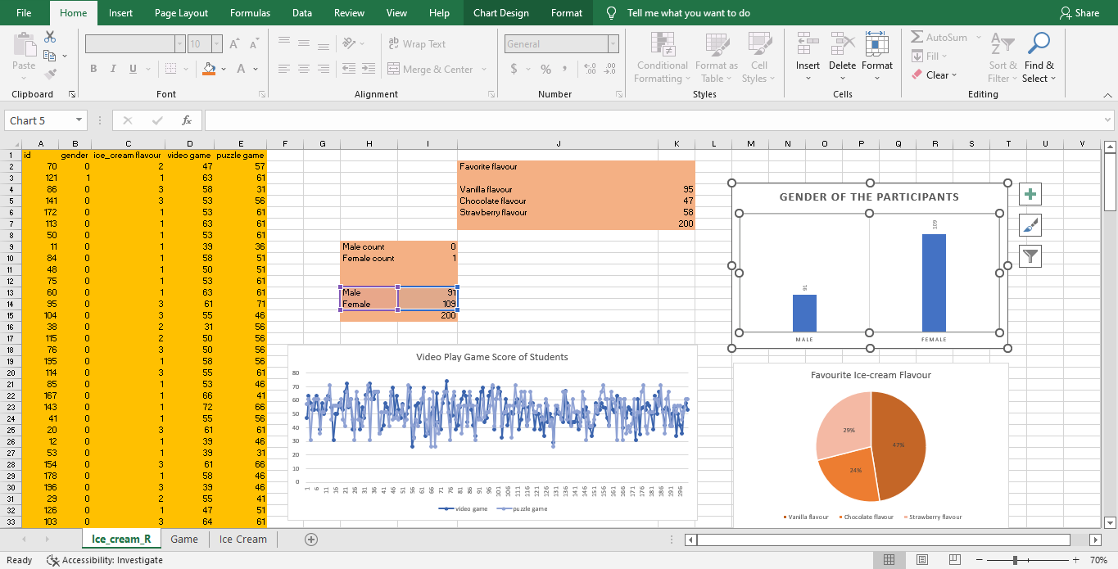

Participants

Figure: Participants’ Demography
Among the 200 students as stated and demonstrated in the data set, 91 respondents have successively reported the marking of the male and female while other 109 respondents have pointed out the response as female. In this regard, it can be concluded that the number of Male respondents is essentially lower than the female respondents or the students of the given survey results.

Relationship and Correlation result
In this section, the discussion has included the relationship between the male and female participants with their favourite Ice Cream flavour and comparing which group of participants like which flavour most.
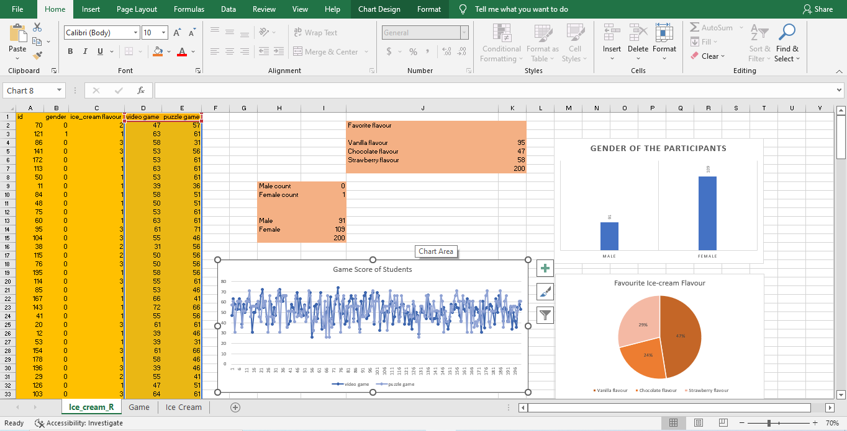
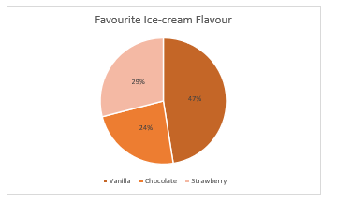
Figure: Pie Chart of Favourite Ice-cream Flavour
The above chart has indicated that the three choices regarding the most favourite Flavour have been identified and shown in the calculation which included Vanilla, Chocolate and Strawberry (Awan et al., 2021). In the reference to the data set, the figure has indicated that 24% of the respondent prefer Chocolate as their favourite Ice Cream Flavour which is the lowest in the calculation while 29% of the students think their favourite Ice Flavour is Strawberry. The highest number of students which is 47% of the respondents have marked that they prefer Vanilla Flavour mostly.

Figure: Game Scores
The above figure has indicated that two games scores which have been played by both male and female students have diverse scores trend which included the up and downward scores line for the Video game and Puzzle which have been reportedly participated by the reported students (Le et al., 2019). Here, the average score of the Video game is 0.40 lower than the calculated scores of the Puzzle game. About the descriptive statistics of Excel, the highest score obtained in the games included 74 and 71 points for the Video and Puzzle games respectively. \
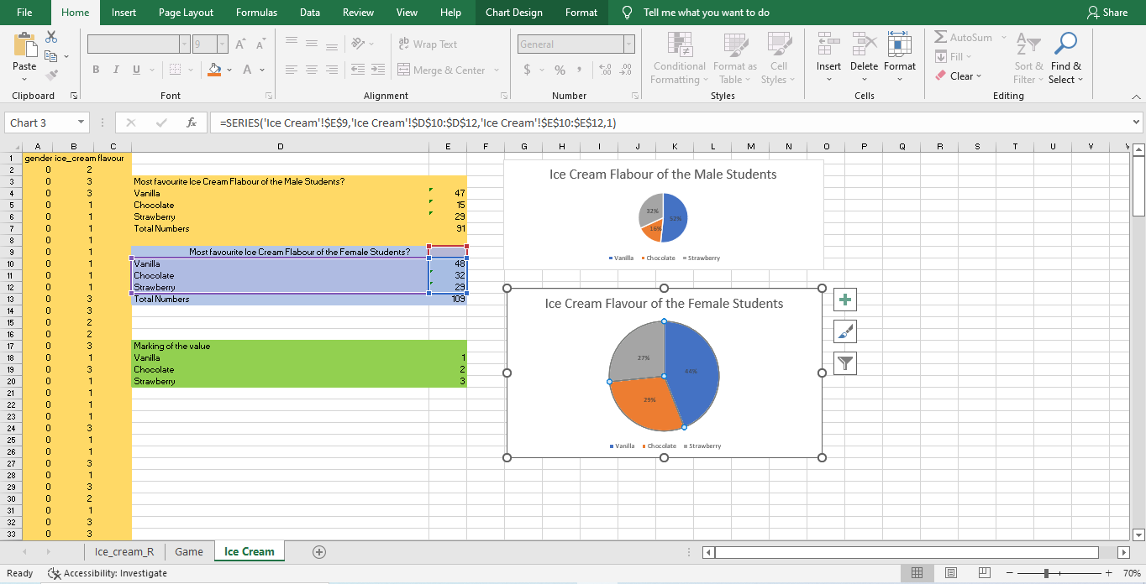

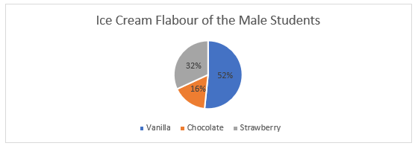
Figure: Males students’ choice of Ice Cream Flavour
The indicated figure has shown that among the three ice cream flavours chosen by the male students in the survey, the about 16% of the male students agreed that they prefer Chocolate as their most likely Ice Cream Flavour while 32% of the male respondents think Strawberry as their most favourite flavour (Ouyang et al., 2018). The highest number of students or 52% of the students have secured their choice for Vanilla. Therefore, it can be concluded that mostly the male students prefer the Vanilla in their Ice Cream.
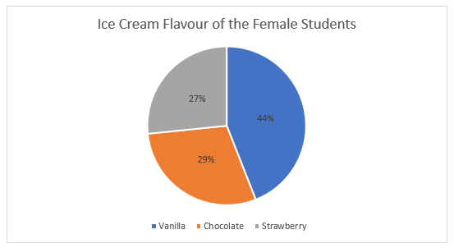
Figure: Female students’ choice of Ice Cream Flavour
The figure demonstrated the female student's choices regarding the three Ice Cream Flavours. In the case of the highest number of female respondents in the survey, 44% have secured their response towards the favourite of Vanilla while the lowest vote has been cast for the Strawberry with 27% responses in favour of this choice. Thus, while asking, about 29% of the total female students have incorporated that they prefer Chocolate Flavour. In the conclusion, it can be said that Vanilla is the favourite Ice Cream Flavour for most female students.

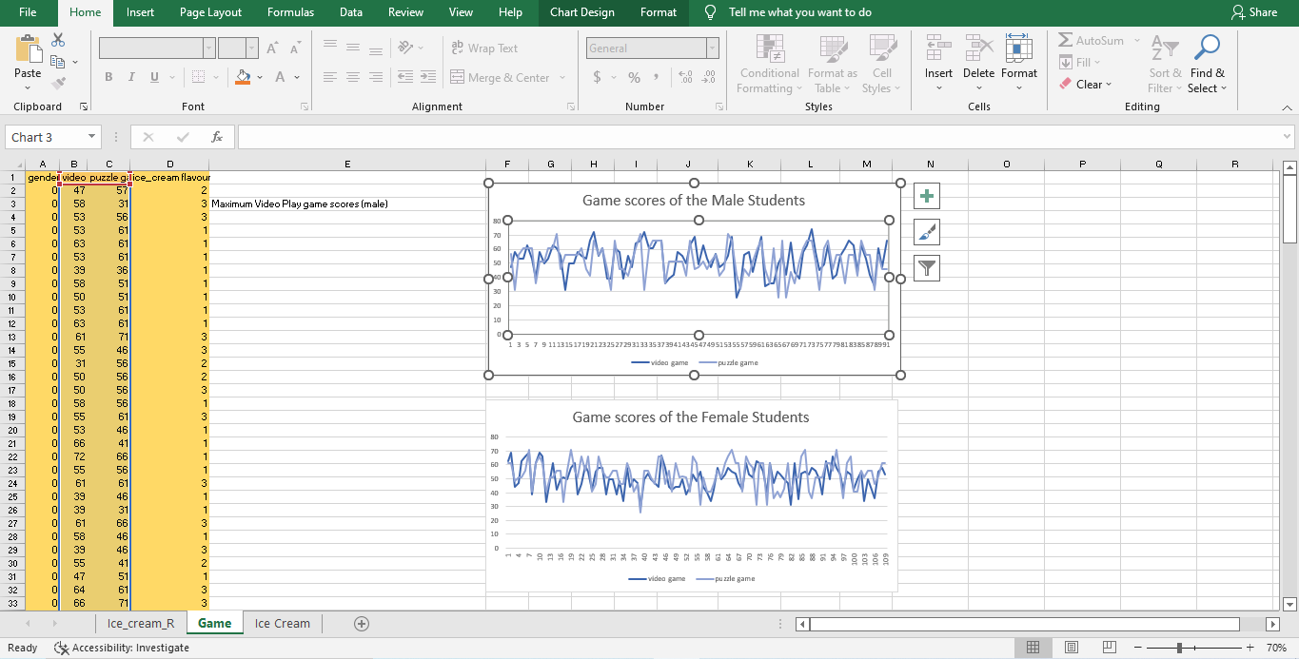

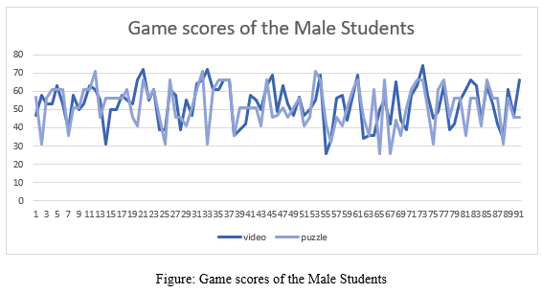
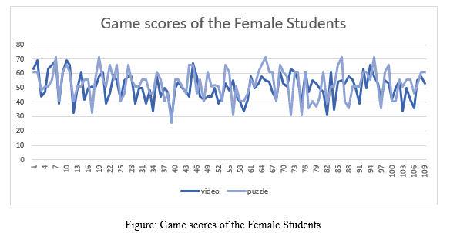
The above two figures have incorporated the gaming scores which have been obtained by both male and female students. In the case of finding the relationship between the gaming scores of male students, as the number of respondents or users of the game increases, the scores of the video games have been increased while the game scores of the Puzzle game have been decreased (Santoso et al., 2019). Here, the analysis has signified those Males students have secured the highest video game score of 74 and the lowest score of 26 points while the Puzzle game scores have indicated that male students have secured their highest score of 71 and lowest of 26 points. Compared with the female students who have participated in the same game, the score of 60 and 29 points have pointed out the highest and lowest gaming score respectively. Thus, in puzzle gaming, the score of 71 and 26 points have secured the status of highest and lowest puzzle game score of the female students.

Conclusion of the Analysis
To conclude the analysis regarding the students’ preferences in the case of Ice Cream Flavour including Vanilla, Chocolate, Strawberry etc, the relationship between the male and flavours have incorporated the finding that while both male and female students have chosen the Vanilla as their most favourite flavour, the male and female students are different in taking the Chocolate and Strawberry flavour as most of the male students have chosen the Strawberry as their favourite flavour while female taken the Chocolate. Then, the case trendline regarding the gaming scores of the Video and Puzzle has indicated that male students have secured the highest gaming score in the Video game while the female students have secured the highest scores in the Puzzle game. In this regard, the concluding finding has indicated that male students are doing well in a video games while puzzle gaming scores are positively linked to Female students.

Evaluation of the usage of Excel and conclusion
Iqbal et al. (2018) have defined Excel as a statistical tool which incorporates calculations and facilitates the users to use the tools of the descriptive and analytical functions to find the association among the quantifiable variables. Referring to the usage of Excel for business management, there are mainly three phases of usage of Excel including Pre-processing, Analysing and Visualising the results.
Use of Excel in data Pre-processing
Pre-processing can be defined as a way of organising and structuring the data set from the huge amount of data which helps the managers of the business to implement the commands and tools concerning the findings of the analysis (Oumkaltoum, 2019; Nimmagadda et al., 2018; Saiz-Rubio & Rovira-Más, 2020)). In the case of processing the data in the business management, the procurement data and collection of the different quotes which have been submitted in the opening tender by the company (Karthikeyan & Benjamin, 2019). For example, the Retail company Tesco may direct their managers to pre-process the data for getting useful information before the analysis such as sorting the data in the manner of lowest to highest bidder and categories the quotes as the costs of the tender.
Use of Excel in Data Analysis
Analysis can be defined as a scientific method of developing the motion or the problem statement which is converted into a different statistical and mathematical model for calculating or finding the relationship between the variables (Ilin et al., 2018). In the case of finding the relationship between the sales and costs of the production, the managers of the different enterprises such as Sainsbury use the trend analysis and correlation analysis tools from Excel by the user of the command as Data analytics and real-time pivot charts dashboard which help them to find the bivariate relationship between the monthly data of sales and production costs (Zhu et al., 2019). As a result, modern business enterprises can easily get insights into whether their production costs are higher than the sales figure which have been reported by the regional managers.
Use of Excel in Data Visualisation
Visualisation can be defined as a successive way of displaying a large amount of data in a cohesive and consistent manner which helps the managers or the board of directors decide on a good assumption (Oumkaltoum, 2019). In the case of using Excel for the data visualisation, the most used tools and menus of Excel can include Charts, Pie and Graphs which help the managers to show the percentage of the sales of the different product categories with the segmented category (Nimmagadda et al., 2018). Besides, the sales performance of different retail stores can be easily portrayed using Bar Charts and Column charts to show the highest to lowest sales of the enterprise.
In the summary of the above evaluative discussion, it has been found that Excel is a statistical application which can be used for data pre-processing, analysis of the processed data and visualisation of the analysed data. With the use of the commands and functions which are aligned in the Excel sheets such as IF, Count, Mean, Max, Pivot functions etc, the business managers can easily convert a huge amount of data regarding their financing, sales, purchase, employees’ performance, production etc for taking an effective business decision. Besides, the quick and customisable features of the graphs, charts and other data visualiser can help managers as well as the board of directors take the insights or generate quick sales performance insights for investing in the product development.

Part 2

Introduction
This part aims to discuss the use of the SPSS as a statistical application in the daily use of the business while the case given with the data of the Covid-19 cases reported to the authority has been analysed using the descriptive statistics and correlation commands of this application (Paul et al., 2018). Here, the discussion would be followed by the highest to lowest cases while the use of the histogram and pie charts have allowed demonstrating the analysis using the visualisation tools of the SPSS. Later, the usefulness and evaluative discussion on Excel and SPSS would be added.

Description of the Covid-19 data
In the case of Covid-19 data which have been given in the current case, there are three continents’ data are available in the data set where the data set has categorised the data with the manner of showing the data for each month, year and date which indicated the regular data collection. In this regard, the continents data included Europe, Asia and America (Ershadi et al., 2020). Thus, the supporting data factors also indicated the country code, country name and population codes for each country of the continent. In this regard, the researcher has omitted these factors to include the following data only from the final SPSS data for handling the essential data.
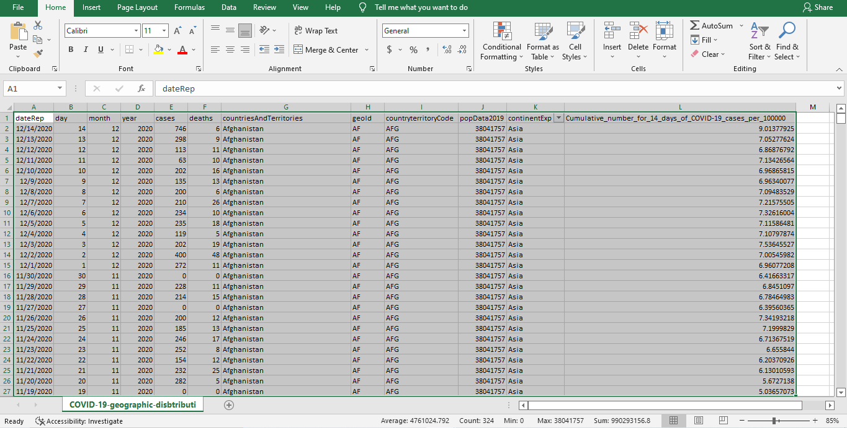
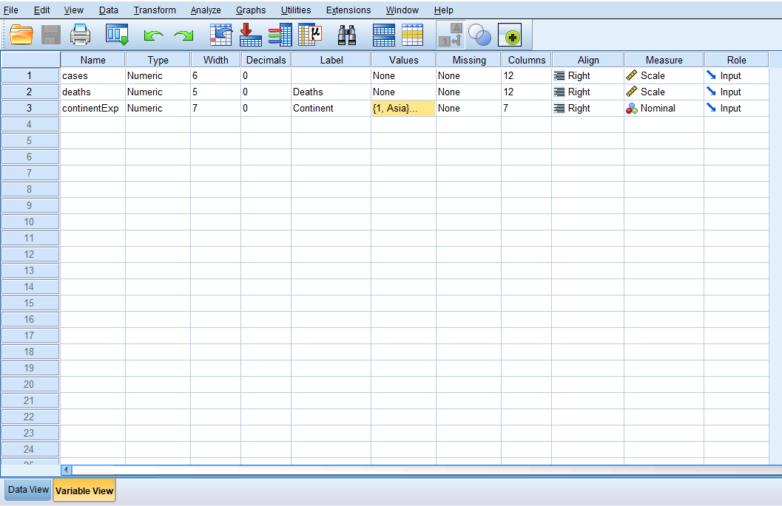
Figure: Variable View

Data analysis

Cases Statistics of the continents
In the following section, the descriptive statistics driven by the Screenshots of working regarding the reported affected cases in Covid-19 on three continents have been shown.
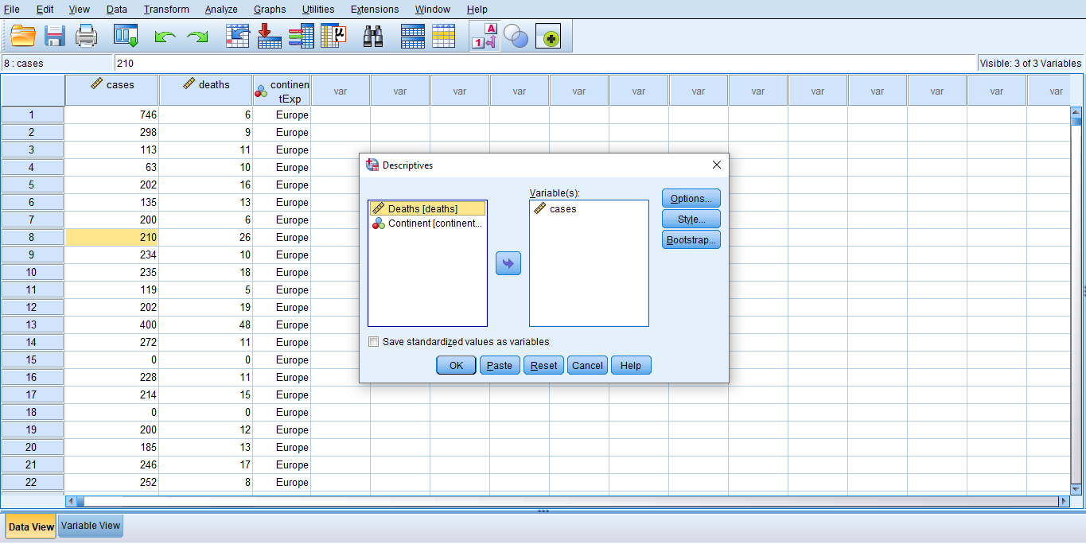

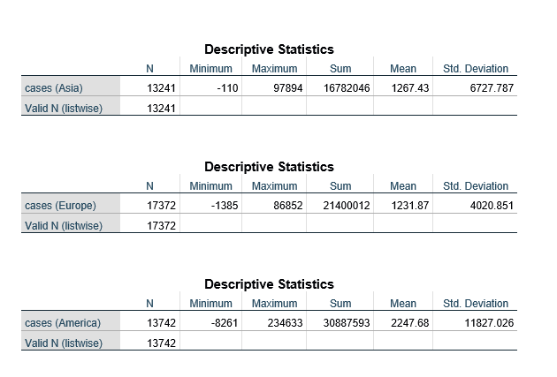

The above results on the descriptive statistic on the Cases of Covid-19 reported information regarding the total covid-19 cases for each continent (Konrad et al., 2019). In the case of Asia, the sum of daily reported cases has indicated the value of 16782046. The sum of the Europe Covid-19 cases has been accounted for 21400012 while the highest cases have been calculated in America with the sum value of 30887593. In this regard, it can be concluded that America has been affected with the highest number of counted cases of Covid-19.

Death Cases in Continents
In the following section, the descriptive statistics driven by the Screenshots of working regarding the Death cases of three continents have been shown.

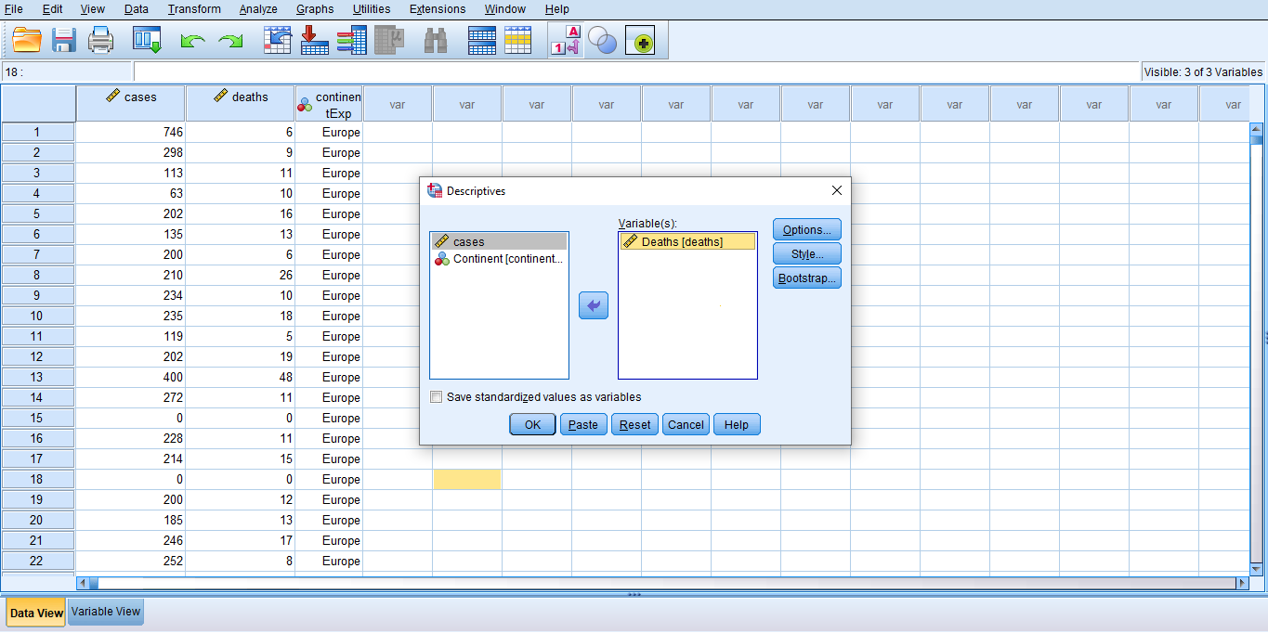

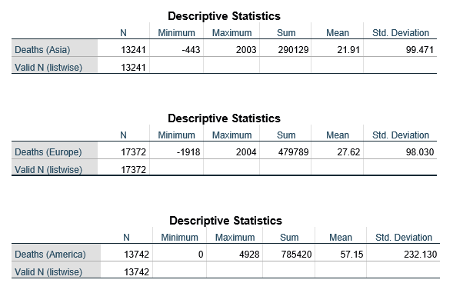

The above tables have incorporated the results regarding the Death cases which have been reported to the Authority in the Covid-19 where the three continents’ data have been shown including Europe, Asia and America. Here, the value of 290129 death cases have been reported to Asia and 479789 death cases have been reported to Europe. In the rest of the results, America has been accounted for with the value of 785420 for the individual death case in the Covid-19 data analysis in the SPSS.

Highest and Lowest death cases and correlation
In this section, the highest and lowest death rate in the three continents have been shown with the use of Histogram and Pie charts designed in the SPSS application which are given below-
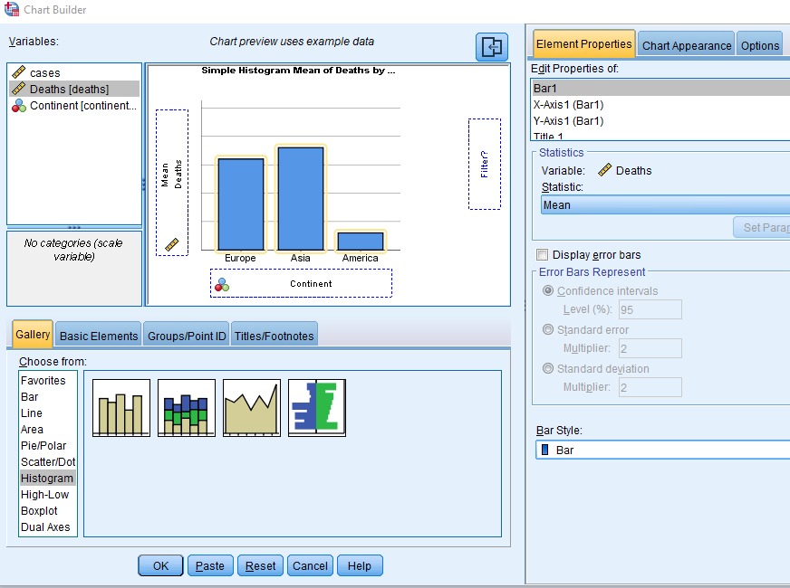

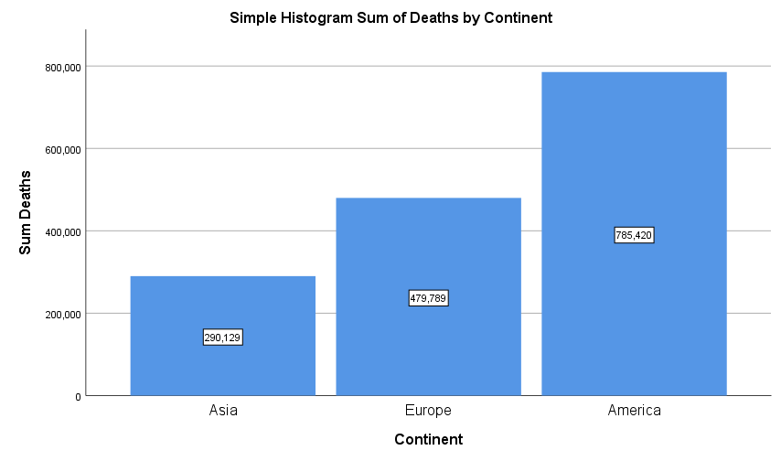
Figure: Histogram for Death by Continent
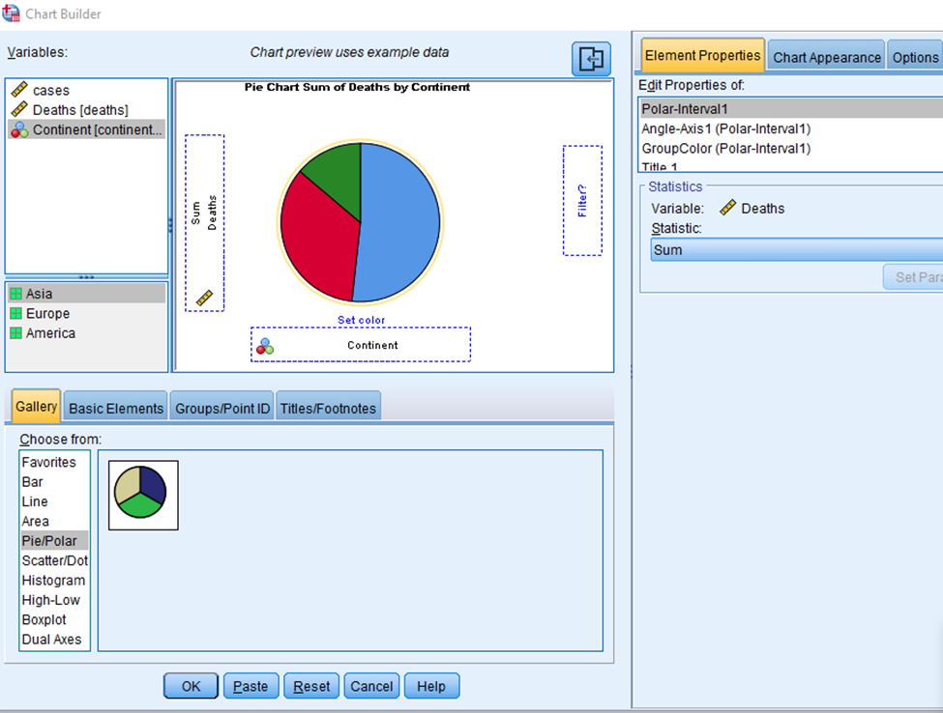

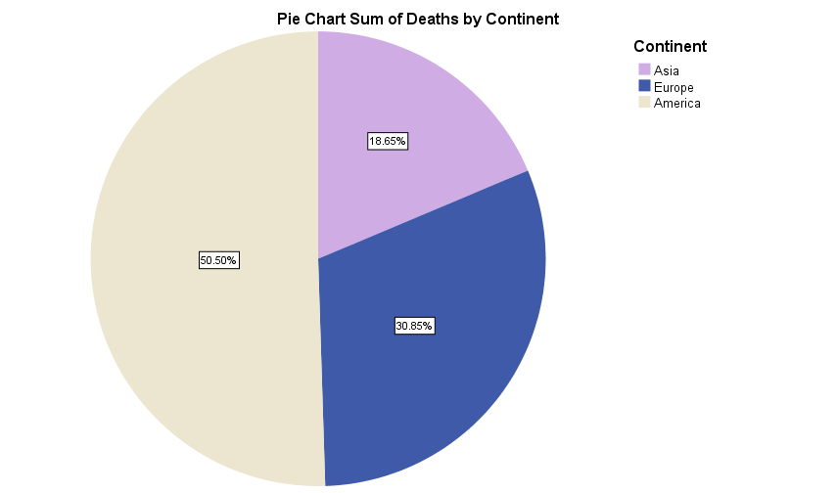
Figure: Pie Chart for death percentage by continent
The above figures with histogram and Pie charts have indicated the value of the death cases which have been reported to the authority, in the case of showing the death cases in the Histogram, the sum of 290129 has been considered as the lowest death value for Asia, 479789 death cases have been reported in the favour of Europe and 785420 death cases have been reported to the concern of America which is considered as the highest death value among the three continents. Thus, the percentage figure of the Death cases in the three continents has been demonstrated using the Pie chart where the lowest percentage of 18.65% has been considered for the death rate of Asia while the 30.85% death rate has been considered for Europe. Thus, again the highest death rate has been calculated in the favour of America with the value of 50.50%.

Correlation result
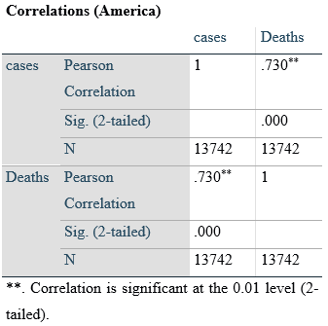
In the case of finding the correlation between the value of the affected cases and death cases in America, the Pearson Chi-square value has found a successive strong relationship between the reported variables of cases and death with the coefficient of .730. The above result has indicated that the successive strong relationship is statistically highly significant with α<0.05. Therefore, it can be concluded that the correlation value has indicated that as the number of cases has been reported in America, the rate of death cases has increased over time.

Text Mining Methods
Term Method
According to Ershadi et al. (2020), the term method is a way of defining a large number of texts with a specific term and individual theme where the individual command is used to define a set of texts (Qu et al., 2019). For example, the terms such as Site on and Site off are commonly used in the manufacturing business sectors of the UK which have lowered the time of execution and operational complexity with one universal command.
Phrase method
A set of Terms are combined to make the phrase in the Text Mining where the semantic tools are aligned for implementing less ambiguity (Sharipov et al., 2020). For example, the trainers in the UK retail stores commonly use the phrase turning on-site and off-site training for calculating the percentage of the attendee in the monthly training session in the data set.
Concept method
The concept method is associated with clustering where the culture of words and texts are combined to form the concept which is likely to be used in the conceptual development (Aleksandrova et al., 2018). In business management, a group of the same customer dissatisfaction factors can be grouped for a specific product as a concept to help managers understand the reason for dissatisfaction.
Pattern Taxonomy
A rule and standard defined method of text mining where several guidelines and programs are written for making the flow of text a coherent manner (Ciccio et al., 2020). For example, the managers can use the flowchart in the SPSS for making the decision about customer refund requests.

Excel and SPSS evaluation and the concluding remarks
SPSS is advantageous in facilitating a large number of sales figures and marketing data where several regional managers report the daily sales data (Pal et al., 2021). Besides, it helps the managers to appoint advanced analysis tools such as crosstab, data transformation and correlation analysis. Thus, its complex commands and less user interface make it difficult for fresh managers (Massaro, 2021). In the case of using Excel, the business managers can use highly easy commands and tools such as sum, min, max, mode, and descriptive analysis for taking the business decision with a moderate amount of marketing and Human Resource data. Besides, it is also beneficial for taking a lower amount of storage in the system which takes less time than SPSS for running the application in the start-up (Haaker et al., 2021). Thus, Excel has limitations in the case of advanced correlation techniques such as Partial, Canonical and mixed models’ analysis which lower the scope of doing advanced relations between the marketing and purchase data.
In conclusion, this part has shown the results on the Covid-19 affected cases and death cases/rates with the use of SPSS commands of descriptive statistics where the total sum of the reported cases and death cases have been shown with the mean, mode and maximum value. Besides, the histogram and pie figures are incorporated to show that America has the maximum death rate in the Analysis. In the last section, the text mining methods have been elaborated while the pros and cons of using the SPSS and Excel in business management have been discussed as well in this part.

References
Aleksandrova, S.V., Aleksandrov, M.N. and Vasiliev, V.A., (2018), September. Business continuity management system. In (2018) IEEE International Conference" Quality Management, Transport and Information Security, Information Technologies"(IT&QM&IS) (pp. 14-17). IEEE.
Awan, U., Kanwal, N., Alawi, S., Huiskonen, J. and Dahanayake, A., (2021). Artificial intelligence for supply chain success in the era of data analytics. In The fourth industrial revolution: Implementation of artificial intelligence for growing business success (pp. 3-21). Springer, Cham.
Ciccio, C.D., Meroni, G. and Plebani, P., (2020). Business process monitoring on blockchains: Potentials and challenges. Enterprise, Business-Process and Information Systems Modeling, pp.36-51.
Ershadi, M., Jefferies, M., Davis, P. and Mojtahedi, M., (2020). Towards successful establishment of a project portfolio management system: business process management approach. The Journal of Modern Project Management, 8(1).
Haaker, T., Ly, P.T.M., Nguyen-Thanh, N. and Nguyen, H.T.H., (2021). Business model innovation through the application of the Internet-of-Things: A comparative analysis. Journal of Business Research, 126, pp.126-136.
Ilin, I., Levina, A., Lepekhin, A. and Kalyazina, S., (2018), December. Business requirements to the IT architecture: a case of a healthcare organization. In Energy Management of Municipal Transportation Facilities and Transport (pp. 287-294). Springer, Cham.
Iqbal, M., Kazmi, S.H.A., Manzoor, A., Soomrani, A.R., Butt, S.H. and Shaikh, K.A., (2018), March. A study of big data for business growth in SMEs: Opportunities & challenges. In (2018) International conference on computing, mathematics and engineering technologies (iCoMET) (pp. 1-7). IEEE.
Karthikeyan, C. and Benjamin, A., (2019). An exploratory study on business data integrity for effective business; a techno business leadership perspective. International Journal of Research in Social Sciences, 9(4), pp.167-201.
Konrad, C., Jacobs, G., Rasor, R., Riedel, R., Katzwinkel, T. and Siebrecht, J., (2019). Enabling complexity management through merging business process modeling with MBSE. Procedia CIRP, 84, pp.451-456.
Le, D.N., Le Tuan, L. and Tuan, M.N.D., (2019). Smart-building management system: An Internet-of-Things (IoT) application business model in Vietnam. Technological Forecasting and Social Change, 141, pp.22-35.
Massaro, M., (2021). Digital transformation in the healthcare sector through blockchain technology. Insights from academic research and business developments. Technovation, p.102386.
Nimmagadda, S.L., Reiners, T. and Wood, L.C., (2018). On big data-guided upstream business research and its knowledge management. Journal of Business Research, 89, pp.143-158.
Niu, Y., Ying, L., Yang, J., Bao, M. and Sivaparthipan, C.B., (2021). Organizational business intelligence and decision making using big data analytics. Information Processing & Management, 58(6), p.102725.
Nurbasari, A., Lukiyanova, M.N., Nguyen, P.T., Shichiyakh, R.A. and Shankar, K., (2019). Role of social media in the successful implementation of business user data management. Opcion, 35(88), pp.2899-2921.
Oumkaltoum, B., (2019), April. Toward A Business Intelligence Model for challenges of interoperability in egov system: Transparency, Scalability and Genericity. In (2019) International Conference on Wireless Technologies, Embedded and Intelligent Systems (WITS) (pp. 1-6). IEEE.
Ouyang, C., Adams, M., ter Hofstede, A.H. and Yu, Y., (2018), October. Towards the design of a scalable business process management system architecture in the cloud. In International Conference on Conceptual Modeling (pp. 334-348). Springer, Cham.
Pal, A., Tiwari, C.K. and Haldar, N., (2021). Blockchain for business management: Applications, challenges and potentials. The Journal of High Technology Management Research, 32(2), p.100414.
Paul, P., Aithal, P.S. and Bhimali, A., (2018). Business informatics: with special reference to big data as an emerging area: a basic review. International Journal on Recent Researches in Science, Engineering & Technology (IJRRSET), 6(4), pp.21-29.
Qu, Y., Ming, X., Ni, Y., Li, X., Liu, Z., Zhang, X. and Xie, L., (2019). An integrated framework of enterprise information systems in smart manufacturing system via business process reengineering. Proceedings of the Institution of Mechanical Engineers, Part B: Journal of Engineering Manufacture, 233(11), pp.2210-2224.
Saiz-Rubio, V. and Rovira-Más, F., (2020). From smart farming towards agriculture 5.0: A review on crop data management. Agronomy, 10(2), p.207.
Santoso, P., Purwanto, A. and Asbari, M., (2019). Influence of Implementation Chain of Custody Forest Management System FSC-STD-40-004 V3-0 to Business Performance of Paper Industriesia in Banten Indonesia. International Journal of Management and Humanities (IJMH), 4(4), pp.32-36.
Seles, B.M.R.P., de Sousa Jabbour, A.B.L., Jabbour, C.J.C., de Camargo Fiorini, P., Mohd-Yusoff, Y. and Thomé, A.M.T., (2018). Business opportunities and challenges as the two sides of the climate change: Corporate responses and potential implications for big data management towards a low carbon society. Journal of Cleaner Production, 189, pp.763-774.
Sharipov, F.F., Krotenko, T.Y. and Dyakonova, M.A., (2020), April. Talent management: needs and prospects for business development in the digital economy. In International Online Forum named after A. Ya. Kibanov" Innovative Personnel Management” (pp. 514-518). Springer, Cham.
Szárnyas, G., Prat-Pérez, A., Averbuch, A., Marton, J., Paradies, M., Kaufmann, M., Erling, O., Boncz, P., Haprian, V. and Antal, J.B., (2018), June. An early look at the LDBC social network benchmark's business intelligence workload. In Proceedings of the 1st ACM SIGMOD Joint International Workshop on Graph Data Management Experiences & Systems (GRADES) and Network Data Analytics (NDA) (pp. 1-11).
Zhu, L., Wu, Y., Gai, K. and Choo, K.K.R., (2019). Controllable and trustworthy blockchain-based cloud data management. Future Generation Computer Systems, 91, pp.527-535.

