3/24/2025
University of Wales Trinity Saint David
London campus
E-Portfolio Link:
Module Name: Learning In the Digital Era
Module Code: ACCA 4025

Student Name: Assad Al Shroui
Student ID: 2519146
Group: 2

Lecturer’s Name: Koushik Modak

LDE Assignment 1
E-Portfolio
Table of Contents
Introduction 2
Main Body 2
Task 1: Essential Academic and Employment Skills for the future career Path 2
Task 1 (a): Report on Essential Academic and Employment Skills 2
Task 1 (b): Evaluation of Task 1 (a) based on Similarity report 2
Task 2: Collaborative Mind Map and Individual Poster 2
Mind Map (Collaborative) 2
Poster (Individual) 2
Task 3: Virtual Collaboration and RefWorks 2
Report on Virtual Collaboration 2
Step-by-step process of using RefWorks with visuals 2
Task 4: E-Portfolio Creation and Evaluation 2
Task 4 (a): E-Portfolio Creation 2
Task 4 (b): Illustrative Review of E-Portfolio tool Selection 2
Conclusion 2
References 2
Task 1 References: 2
Task 3 References: 2

Introduction

Main Body

Task 1: Essential Academic and Employment Skills for the future career Path

Task 1 (a): Report on Essential Academic and Employment Skills
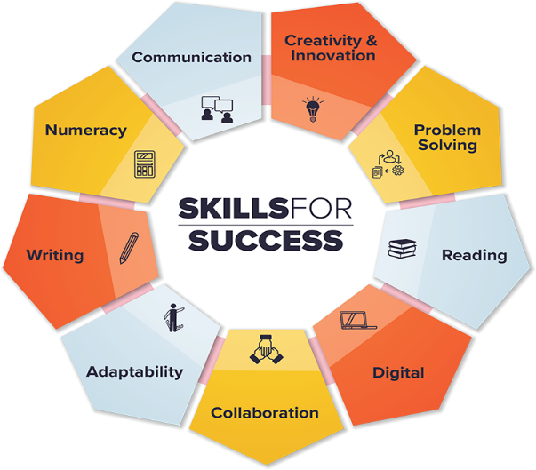
[1]
Essential academic and employment skills play a key role in helping students succeed both in higher education and the modern workplace. In today’s competitive environment, employers expect graduates to demonstrate not only technical knowledge but also transferable skills such as communication, teamwork, and adaptability. Developing these abilities during academic study prepares individuals to transition effectively into professional roles.
Academic skills such as research, critical thinking, and time management form the foundation of successful learning. Research skills enable students to identify reliable sources and evaluate information objectively, while critical thinking allows them to assess arguments and draw sound conclusions. Time management, as noted by Cottrell [1], involves prioritizing tasks, setting achievable goals, and maintaining discipline to meet deadlines. Mastering these academic skills helps students become independent learners who can perform effectively under pressure.

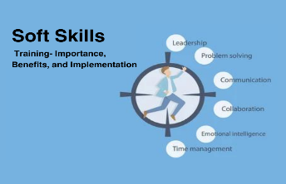

employment or “soft” skills complement academic strengths. Strong communication promotes collaboration and ensures clarity when working within teams. Teamwork, adaptability, and problem-solving are also highly valued by employers seeking flexible and creative staff [2]. In addition, digital literacy has become essential in almost every field, as technology shapes how organisations operate. According to Tushar and Sooraksa [3], combining academic competence with soft skills significantly enhances employability in the 21st-century job market.
In conclusion, academic and employment skills are interdependent. Students who develop effective study habits, manage their time efficiently, and build strong interpersonal and digital skills will be well-equipped to succeed in both education and their future careers.

Figure 1: Soft Skills [4]

Task 1 (b): Evaluation of Task 1 (a) based on Similarity report
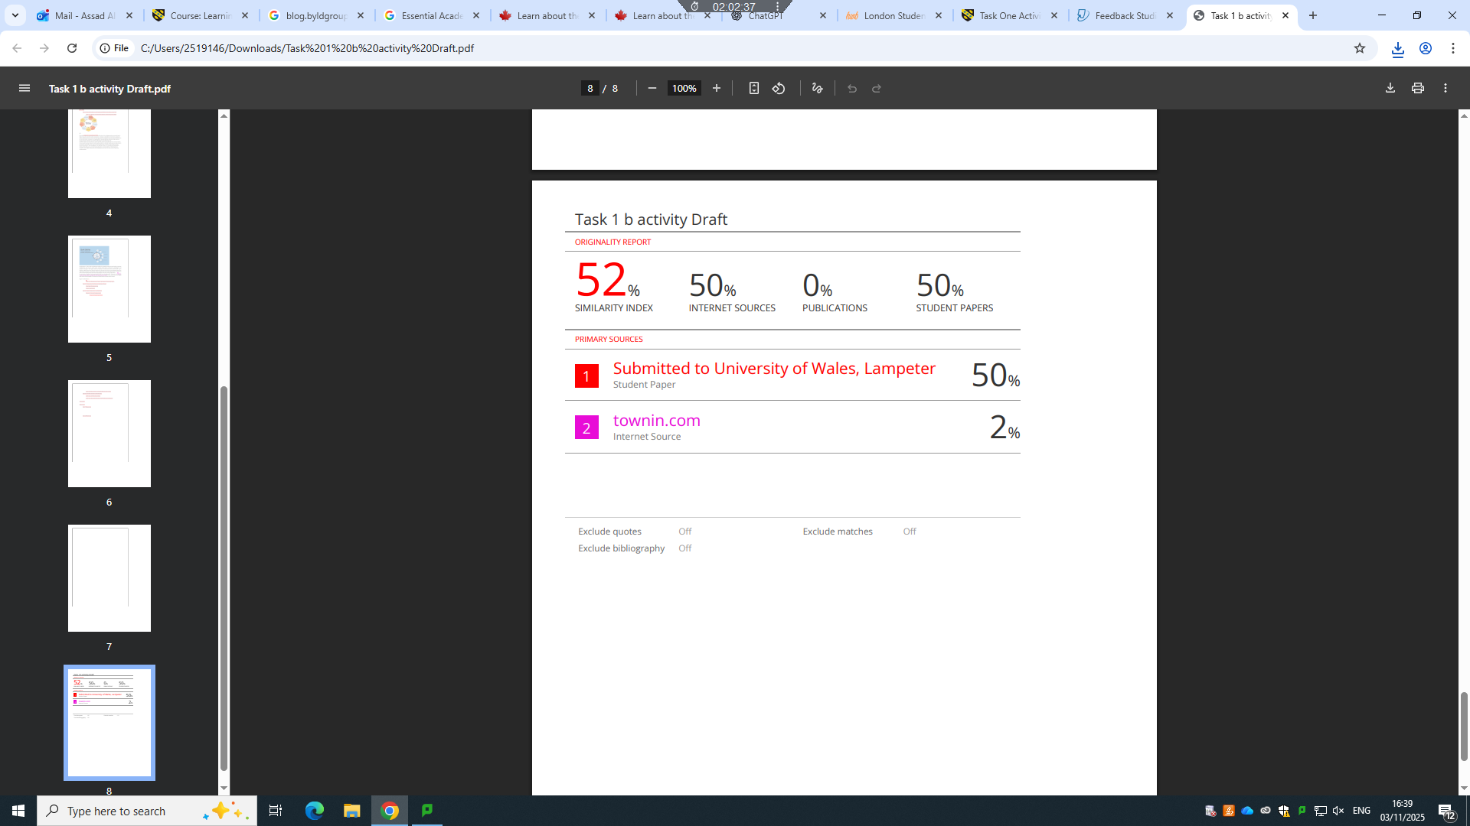
1st paragraph: The similarity report for my task b shows a similarity index of 52%, which is quite high; however, most of the matched text comes from the assignment questions and instructions, rather than copied material. This explains why the percentage appears elevated. The content I wrote was based on my own understanding, but since the assignment required me to include certain key phrases or headings from the task sheet, the system detected them as similarities. My overall grade for this task is 52, which reflects both the quality of my work and the need to improve in paraphrasing and originality.

2 paragraphs From my side, I can make improvements by rephrasing the assignment questions in my own words before answering and by reviewing how I present information from sources. I will also ensure that my in-text citations and references are correctly formatted. In future assignments, I plan to reduce similarity by avoiding direct repetition of task wording and by explaining ideas using my own expressions and examples. These steps will help improve both my writing quality and my academic integrity score.

Task 2: Collaborative Mind Map and Individual Poster

Mind Map (Collaborative)

Mind map link: https://mm.tt/map/3845110229?t=PGtNGMuiKT
Mind Map Pic
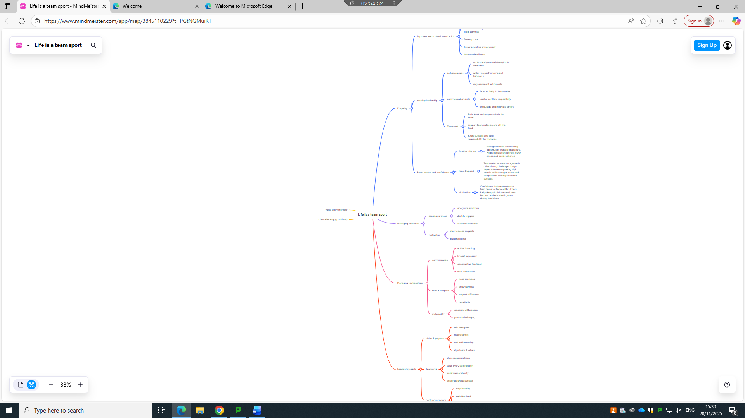

Poster (Individual)
Poster Link:

https://www.canva.com/design/DAG3qZEtCSs/pBXbO3mzeo8XzuMiJA_6uw/edit?utm_content=DAG3qZEtCSs&utm_campaign=designshare&utm_medium=link2&utm_source=sharebutton
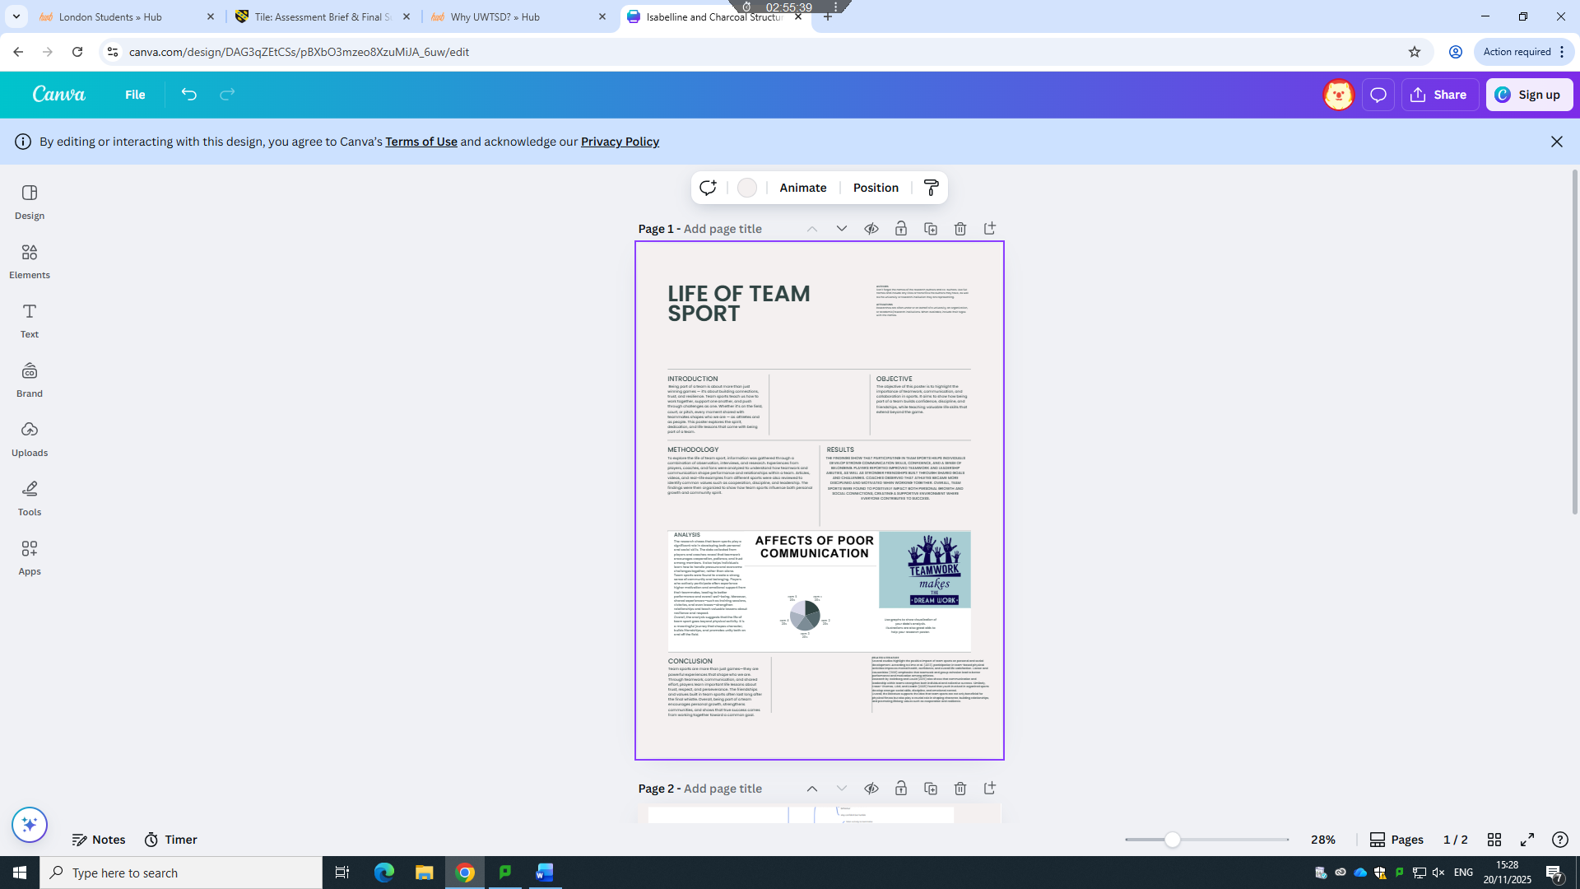
Poster Pic

Task 3: Virtual Collaboration and RefWorks

Report on Virtual Collaboration
Working on Topic 1, “Forming a Team,” gave me a clear idea of how different a virtual team feels compared to working face-to-face. At the start, our group had to organise everything online, so the forming stage mainly involved introducing ourselves, setting up a group chat, and agreeing on how we would communicate. Most of our discussions took place through messages, since it was easier than arranging calls around everyone’s schedule. Even though it was simple, this stage was slightly awkward because no one really knew each other yet, and people were still trying to figure out their roles in the group. As we moved forward, a few disagreements appeared. This was basically the storming stage. Some people preferred doing tasks in a certain way, while others had different ideas about structure and deadlines. Because we were communicating online, messages sometimes came across the wrong way or sounded harsher than intended. This caused a bit of tension. To sort this out, we decided to jump on a quick call, which helped clear things up much faster than texting. Hearing each other’s voices made it easier to understand and avoid misunderstandings. After resolving those issues, things improved a lot. Once we settled the communication problems, we properly entered the norming stage. Everyone understood their part, and we started working more smoothly as a team. We used shared documents to keep track of progress, and people felt more confident giving feedback because expectations were clearer. Gradually, we developed a routine that worked for everyone. By the time we reached the performance stage, the group was working efficiently. Everyone focused on completing their tasks, and the overall work quality improved because we checked each other’s sections before finalising them. Collaboration felt more natural, even in a virtual environment. Using RefWorks was straightforward. I logged into my account, created a folder for this assignment, and added sources using the “Add” or “Import” options. After organising the references, I used the Word add-in to insert citations and automatically generate the IEEE reference list. Overall, this task showed me that virtual teamwork needs clear communication, quick problem-solving, and patience, but it can still work very effectively when everyone contributes, and digital tools are used well.
FORMING A TEAM

REFERENCE
[1] B. W. Tuckman, “Developmental sequence in small groups,” Psychological Bulletin, vol. 63, no. 6, pp. 384–399, 1965.
[2] B. W. Tuckman and M. A. C. Jensen, “Stages of small-group development revisited,” Group & Organization Management, vol. 2, no. 4, pp. 419–427, 1977.
[3] L. L. Martins, L. L. Gilson and M. T. Maynard, “Virtual teams: What do we know and where do we go from here?,” Journal of Management, vol. 30, no. 6, pp. 805–835, 2004.

Step-by-step process of using RefWorks with visuals
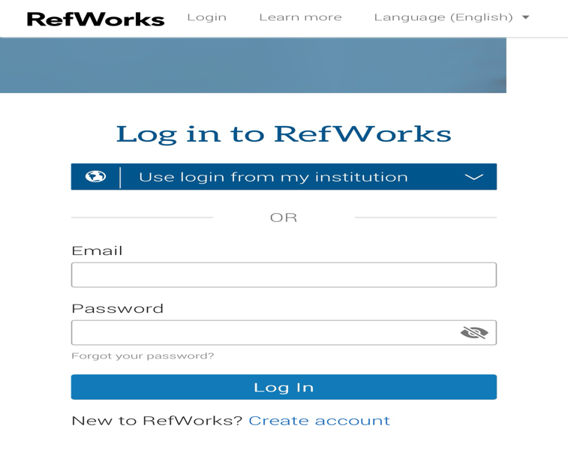
- 1: First, I open RefWorks in my browser and log in to my account.
2 Then put your logins in
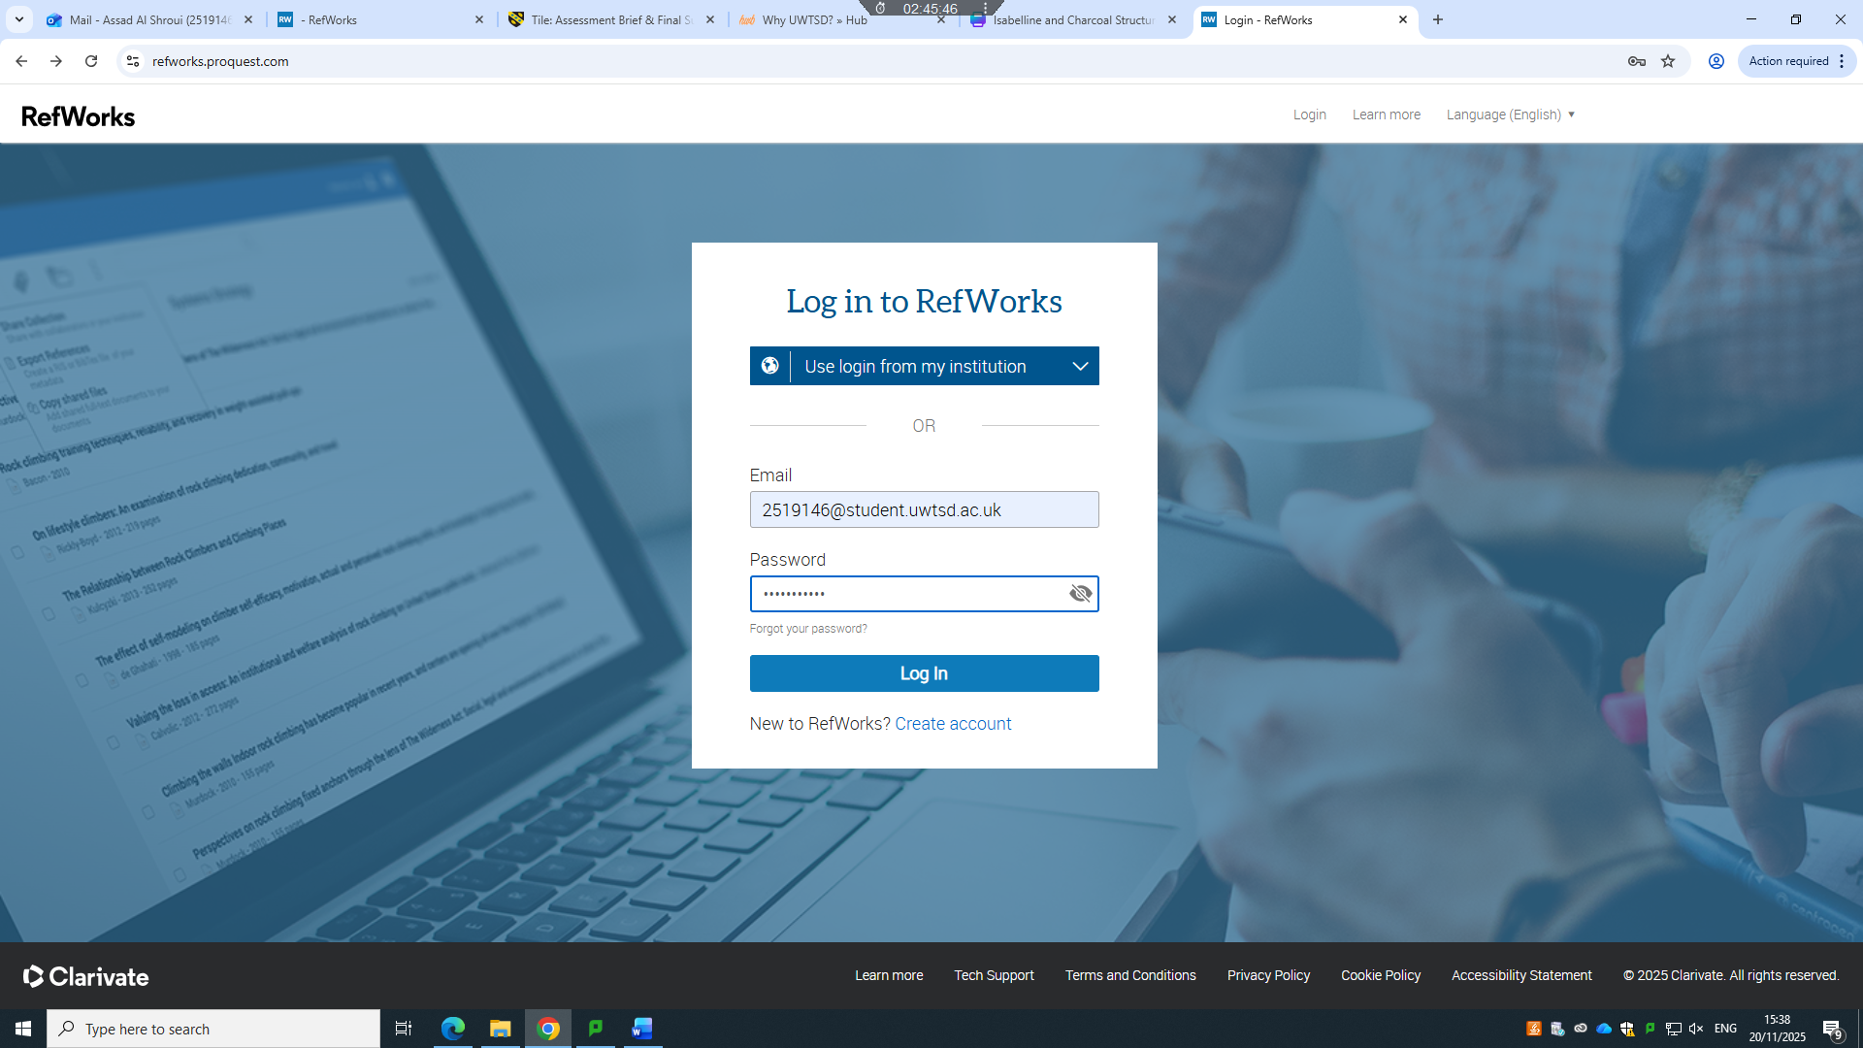
3 this should appear
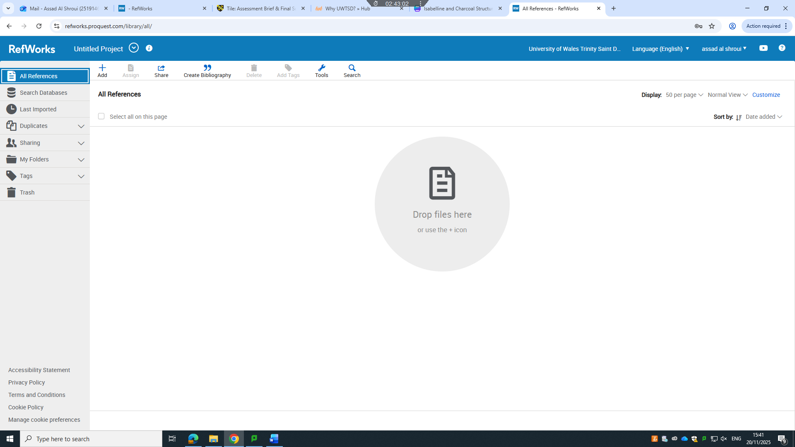
Then select My folders name it how you want
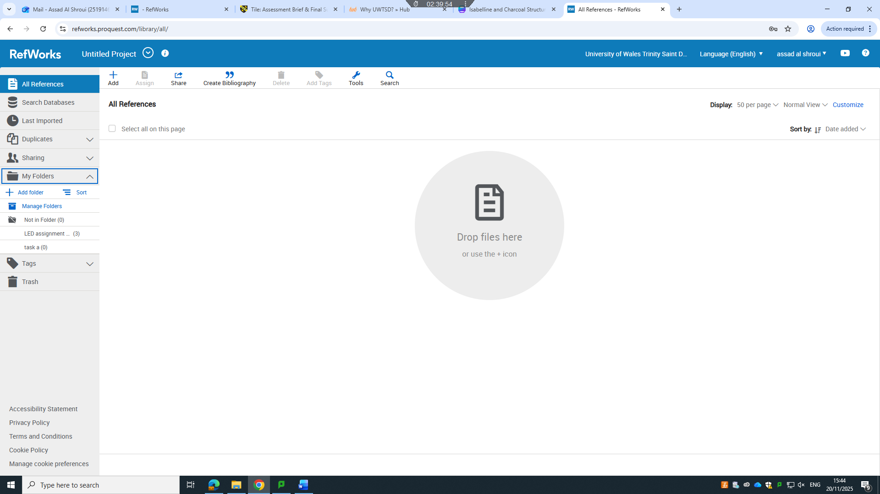
Using RefWorks is very simple. First, I logged into my RefWorks account and created a new folder for my assignment. Then I added my sources by clicking the “Add” or “Import” buttons, which let me upload articles or paste citation details. After the references were saved, I organised them in the folder, so they were easy to find later. When I started writing my assignment, I used the RefWorks add-in in Word to insert in-text citations. At the end, I clicked the option to automatically create the reference list. RefWorks made the whole citation process clear, simple, and fast.

Task 4: E-Portfolio Creation and Evaluation Task 4 (a): E-Portfolio Creation. https://2519146.wixsite.com/assad

Task 4 (b): Illustrative Review of E-Portfolio tool Selection

An e-portfolio is a digital space where learners collect, organise, and present evidence of their learning, skills, and achievements. Selecting the right e-portfolio tool is essential because it influences usability, accessibility, personalisation, and how effectively learners can communicate their competencies. This review compares several commonly used e-portfolio platforms to illustrate important considerations when choosing the most appropriate tool

Conclusion

References

Task 1 References:

Task 3 References:

