Quality Rules And Root Cause Analysis: Areas of Improvement Regarding The Operational Management of Teeming Ladle Refractory Linings At Tata Steel Port Talbot

Student Name: Colten Jones Student Number: 2114369

Introduction and Background Information
As a Higher Apprentice in Refractory Engineering at Tata Steels Port Talbot plant I perform regular checks on the condition and operational performance of all refractory materials used in my sector, the Basic Oxygen Steelmaking (BOS) plant. Refractory materials performance can significantly affect the operations and costs of a steel plant, the steel industry alone consumes approximately 2/3 of all refractories worldwide yearly. A refractory is a material that is resistant to decomposition by heat, pressure and/or chemical attack whilst also retaining its strength and structure. There are many different types of refractories used in Tata Steel Port Talbot but for this report we will classify the materials by their physical form, shaped and unshaped. Shaped refractories are those which have a specific shape when sent to the customer (bricks). Unshaped refractories (also termed monolithic) are any materials installed as a form of suspension that hardens over time to form a joint less lining. Examples include concretes, ramming mixes, and gunning mixes.
A teeming ladle is a steel shell lined with refractory materials and is a vital asset to the functioning of a steel plant with the function of transporting liquid steel produced in the BOS Vessel through secondary steelmaking units and eventually to a casting facility where steel slabs are made.
Figure 1: Full lining of teeming ladle showing working barrel, slagline and bottom refractory bricks.
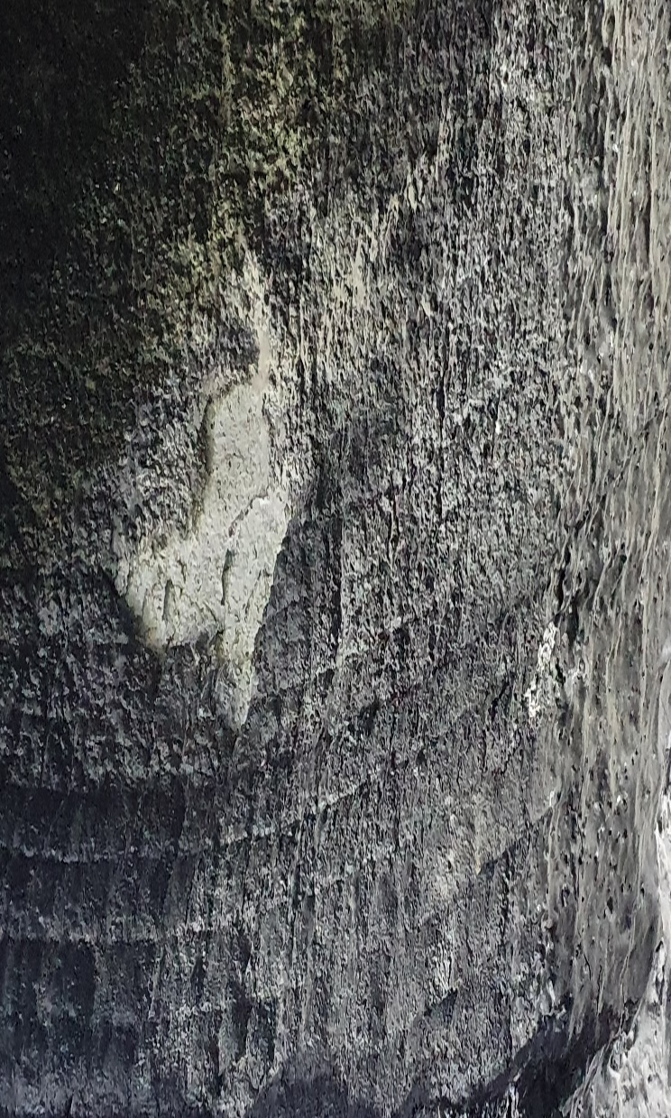
The efficient monitoring and daily operation is key to utilise the use of refractories to their full potential, the accurate adherence to heating/drying profiles along with controlled thermal conditioning is the key factor in this. At the Bos Plant the average expectancy of a ladle is 155 lives, with one life being defined as the tapping of molten steel from the Bos converter through to the teeming of the steel through a continuous casting machine. There are many factors that can shorten this life expectancy, for example, long dwell times. Long dwell describes an extensive length of time that the liquid steel remains in the teeming ladle before being teemed into a continuous casting machine which increases levels of chemical corrosion and thermal stress on refractory materials. Another example is the addition of alloying elements to attain the desired chemical structure of the liquid steel. Aluminium is often added during secondary steel making processes, this addition has the result of mechanical erosion of the surface of refractory linings with the potential formation of cracks and steel penetration which results in fragments of these materials spalling. Aluminium also results in the production of a highly basic slag which has a severe impact of refractory linings, this is why refractory bricks with a high Magnesium Oxide-Carbon content are installed at the top of teeming ladles where the contact time with this basic slag is at its highest.

Figure 2: Damage to refractory bricks on T/L 2 as a result of poor operational management. Ladle was pulled from service on 115 lives (71.9%) for full reline of material on 08/01/2022.
The early loss of this ladle can cost the company tens of thousands of pounds as the ladle had not been used to its full potential and in terms of costs of refractory materials and labour costs incurred during the following reline. Following the premature removal of this ladle from service an investigation that was conducted concluded that this was a result of poor operational man management of the ladle fleet, and a combination of factors were thought to have been the problem. The ladle had suffered 11 long dwell times whilst full with molten steel and had been dropped from the service fleet on seven separate occasions. This dropping from the service fleet meant that the refractory bricks were subjected to extreme changes in temperature ranging from > 1700℃ when filled with molten steel right down to room temperature when dropped from service. When subjected to extremely high temperatures the bricks will expand to a predetermined size which is taken into consideration during their installation, when allowed to cool to room temperature these expanded bricks will then shrink considerably and this often results in permanent linear change, PLC (Olubambi et al., 2014). Exposure to high fluctuations in temperature often results in loss of brickwork and is a major factor to consider in the operational management of the ladle fleet.
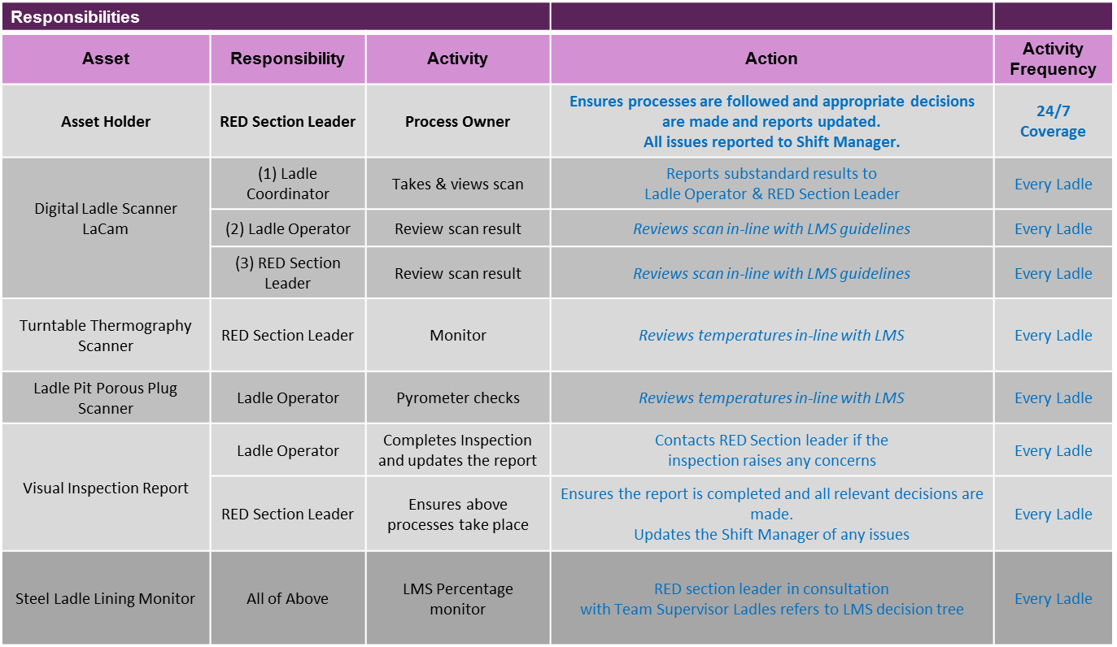
To aid in the management of the teeming ladle fleet an intranet based software system, the Ladle Management System (LMS), is used to assess the condition of the refractory ladle lining based of five key tools; digital ladle scanner, thermal shell temperature, porous plug temperature, visual inspection, and a steel ladle lining monitor (penalty points based system).
Table 1: Roles and responsibilities of individuals in the management of the ladle fleet.
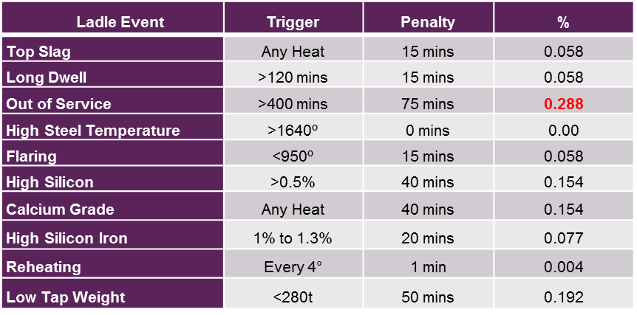
Table 2: Penalty points based steel ladle monitoring system displaying the several events which impact the campaign of a ladle refractory lining and the % added to the ladles projected life if such an event occurs.

This report aims to identify any potential areas of improvement in the management of the teeming ladle fleet and the use of a range of tools will be used to aid in the root cause analysis of problems, analysis of potential areas for improvement, and set up an action plan for these improvements to be made. The Refractory Engineering Department (RED) as Tata Steel Port Talbot should be striving to minimise the number of ladles being dropped out of service by activities such as gradall use for the removal of skulls, along with flaring being kept to a minimum. This report will aim to identify the overall severity of the many parameters impacting ladles and provide a plan/method to reduce this number.

Data Collection & Analysis

Table 3: Causes of ladle drop-outs from 1st April 2021- 31st January 2022. NKK/WB/PP = NKK Corporation ladle gate/well block/porous plug. All data sourced from Tata Steel Port Talbot, Steel and Slab intranet.
It should be pointed out that that the dropping of ladles from service based on LMS software (100%) and or reaching the precalculated maximum of 155 lives is what is desired to be occurring. As previously stated he LMS software was designed to assist in the operational management of the ladle fleet with calculations of various stresses which the ladles incur during their campaign taken into consideration. This eliminates the potential for the refractory lining being used beyond a point at which it no longer possesses the properties that is required for employee’s safety in such a dangerous industry. This means that the ladles refractory lining has reached the full potential of its time in service in consideration with the cost of installation and steel which has been transported from the BOS converter, through secondary steelmaking, and to the continuous casting bay. For this reason LMS data will not be included in the following data and root cause analysis.

Table 4: Cumulative frequency and percentage of causes behind ladles being dropped out of service.
Cause of Drop Out | Frequency | Cumulative Frequency | Cumulative %
Striker Panel | 24 | 24 | 38.70967742
Gradall | 15 | 39 | 62.90322581
NKK/WB/PP | 8 | 47 | 75.80645161
Slagline/Top Ring | 6 | 53 | 85.48387097
Mechanical Issue | 6 | 59 | 95.16129032
Policy | 2 | 61 | 98.38709677
Flare Issue | 1 | 62 | 100

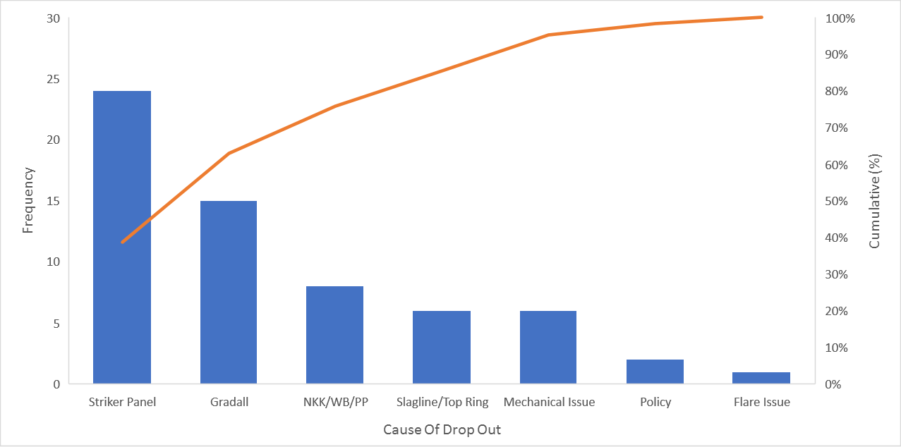

Figure 3: Pareto chart displaying frequency and cumulative percentage frequency of all ladle drop out from 1st April 2021 – 31st January 2022.
Following the 80/20 rule figure 3 shows that that striker panel, gradall, NKK,WB/PP, and slagline top ring damage were the main causes of ladle drop out over the ten month period. From observations made on plant, although no data has been collected to confirm this, striker panel, slagline, and top ring damage is usually caused by the use of a gradall with a pointed chisel attached when performing deskulling and the removal of slag.
Root Cause Analysis
Following the determination of gradall damage being one of the main factors behind ladle drop outs the reasons behind this must now be deciphered. A gradall with a pointed chisel attached is often used throughout a ladles campaign. It is used to remove hardened slag/skulls from the surface of the refractory lining inside the ladle, remove slag from the top ring plates, and to remove well blocks and porous plugs when needed to be changed.

Table 5: ‘5 Why analysis’ on the removal of Teeming Ladle 7 from service on 22/01/2022.
The ‘5 why analysis of Teeming Ladle 7’ has shown that the use of a pointed chisel was the reason behind the damage caused to the refractory lining. It has previously been suggested on many occasions that the damage caused by the use of the pointed chisel needs to be reviewed and improvements made which will be discussed in the action plan.
The issue with the data in this report is that the factors that have been pin-pointed and recorded as the reasons behind ladles being removed from service are more often than not interlinked in the complex process of the steel industry. For example over the ten month period eight ladles were dropped from service as a result of faults with NKK/WB/PP. Although data has not been collected observations and trends suggest that damage caused here to the well blocks and porous plugs is often down to burring by the use of the gradall. Also damage caused to the striker panel should not be justified to be the result of one factor, problems with flaring, thermal cycling, tapping temperature and addition of alloys all play a role in this situation. The use of ‘5 why analysis’ here oversimplifies the process for problem exploration as this is a complex process with many factors often working coherently to result in issues with refractories. Granted the ‘5 whys analysis’ has been useful in identifying the use of a pointed chisel as a simple area for improvement, but the forcing down a single pathway to identify one root cause as the target for solutions in such a complex process should be used with caution (Saied et al., 2019). In a report written by Alan J Card, “The problem with ‘5 whys’, he states that in complex processes with multi-variables a single string of ‘whys’ could result in a blinkered view of the complex causal pathways with the potential of leading to an incident.

Action Plan
Following the identification of the use of a pointed chisel being a potential area for improvement two improvements will be suggested. One potential improvement would be the use of a rounded chisel on the gradall when performing deskulling and slag removal activities on ladles.
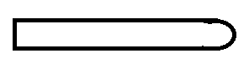

Figure 4: Simple diagram of proposed rounded chisel for use on gradall.

This use of this rounded chisel could potentially reduce the level of damage as it would reduce the likelihood of penetration of the chisel into the refractory linings, and, could also reduce the amount of burring damage to well blocks porous plugs.
Another potential improvement would be the use of a halla machine in place of the gradall.

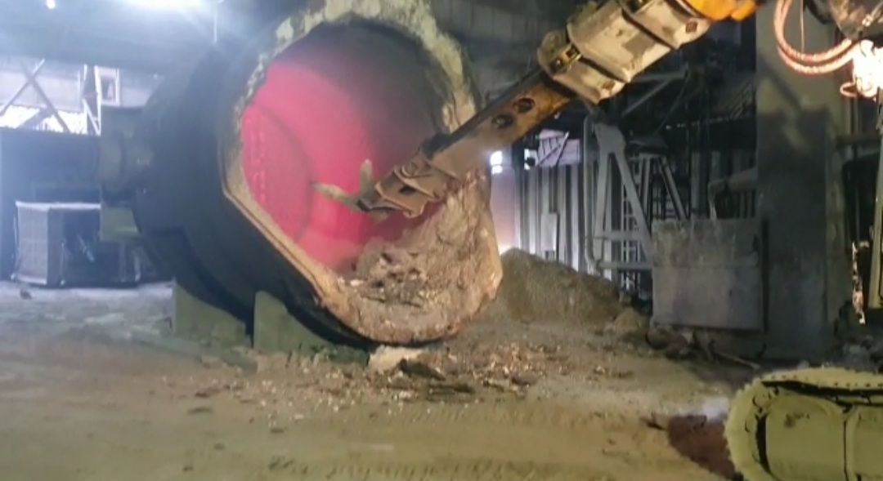
Figure 5: Halla with pick attached used for the removal of skulls from hot metal ladle at the Port Talbot Plant.
The halla is the preferred method of choice for the removal of skulls from hot metal lades because it has been found that less damage is caused the refractory lining on the slag line and pouring lip during such activities. The trial of halla usage on performing slag and skull removal on teeming ladles should be considered. The process takes a significant shorter length of time when using a gradall but if the amount of damage being caused and the number of ladles being dropped from service prematurely are both reduced then this surely is an improvement that needs consideration.
Furthermore, an investigation into the total number of ladles being removed from service following gradall damage should be conducted. Observations made by employees suggests that gradall damage is resulting is the cause behind many more ladles being dropped from service than is recorded in the LMS data, the extent of this level of damage needs to be assessed.

References
Card, A. J. (2017). The problem with 5 whys’. BMJ Quality and Safety, 26, 671–677.
Olubambi, P. A., Andrews, A., & Mothle, T. S. (2014). Strength behavior of magnesia-based refractories after thermal cycling. International Journal of Applied Ceramic Technology, 11, 524–529.
Saied, E., Galal, N. M., & El-Sayed, A. E. (2019). Material and energy wastes reduction in steel production through the application of lean manufacturing tools. In Proceedings of the International Conference on Industrial Engineering and Operations Management (pp. 2346–2353).

