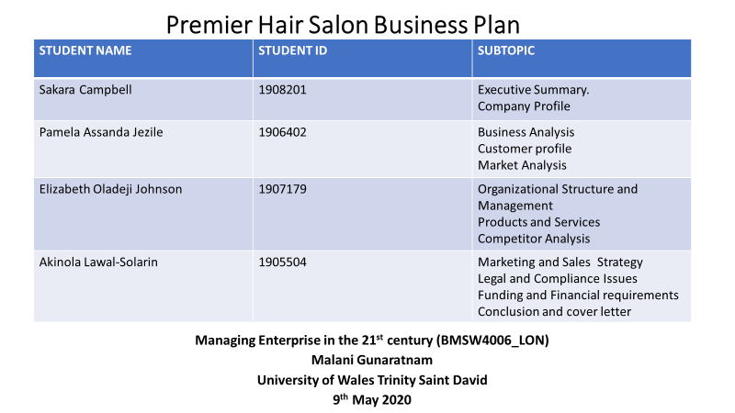

Table of Contents
- Executive summary……………………………………………………………………………1
The team……………………………………………………………………………………………………………...2

- Company profile…………………………………………………………………………………3

- Business analysis…………………………………………………………………………………5

- Customer profiles………………………………………………………………………………..5

- Market analysis…………………………………………………………………………………….6
Competitor profile…………………………………………………………………………………………………..6
SWOT analysis………………………………………………………………………………………………………...6

- Competitor analysis……………………………………………………………………………….8

- Marketing and sales strategy………………………………………………………………….9

- Organizational structure and management……………………………………………10

- Products and services…………………………………………………………………………….15

- Legal and compliance issues……………………………………………………………….17

- Funding and financial requirements…………………………………………………….17

- References …………………………………………………………………………………………22
13. Appendix A……………………………………………………………………………………………..24
14 Appendix B…………………………………………………………………………………………….28

Premier Hair Stylist Business Plan
1.0 Executive Summary
Premier hair stylist is a mobile hair dressing and barbering company set up in a truck it was founded by four people coming together, each holding excellent background skills to make the company be the best of its kind.
Some of the products and services that premier stylist provide is that when it comes round to the seasonal times of the year we provide a discounted service to all our customers, we do this for our customers so they can remain loyal to our business as they can see we are a business that always puts our customers first.
We provide the highest level of hair dressing and barbering with each of our stylist having no less than 3 years’ experience and being qualified professionally in their craft.
We provide products such as:
. Variety of human wigs handmade and designed for the client
. Assorted hair attachments
. Hair extensions
. Hair creams (relaxers and texturizers)
. Hair shampoos and conditioner’s
We provide services such as
. haircuts and style
. hair shaving and styling
. cornrows, plaits, and braids
. relaxing and style and texturize and style
. sew ins (hair extensions) and style
. hair colouring
Our main objectives is to fill the gap in the hair and beauty industry where clients usually have to wait really long waiting times just to be seen, even if they are coming for a quick shape up or just simple cornrows the wait could sometimes be way longer than the service you require. Our objective is to be able to fit in and see all our clients in a timely fashion without the waiting times. We can testify to this because we have no walk-in service so no queue or waiting time, how you book your special allocated space is through our mobile app.
The hair and barbering industry is a very profitable market generating over £7.5 billion in profit for the UK economy in 2017 the hair and barbering industry is always growing with salon shops and barber shops popping up all other the country but by finding something different gives us at premier hair stylist the advantage in the market to grab a lot of customers from our competitors.
The market industry in hair and barbering “Shampoo holds the largest market share in the haircare segment and is estimated to grow to $30 billion USD by 2023 compared to $24 billion USD in 2016. Although 2019 has barely started, the United States has generated a revenue of $12 million USD in the haircare market alone”.20 Feb 2019 this shows that by providing the basic service as in washing our clients hair with shampoos we will be making profit and an impact on the market, this is a great time to be joining the hair and barbering industry as there is plenty of profit to be made in an overall view.
Premier hair stylist has competition from other hairdressers and barber shops, we also have competition from new entrants because they have the power of cutting our prices in half and using our business ideas to try and compete with us. Our competitors are the local hair and beauty salons located in Brixton where we are based in our mobile truck, they have the ability of utilising on our business strategies but by keeping up to date with our competition we are constantly giving our loyal customers chances to win discount off their services and providing online promotions. Premier hair stylist also have the competitive advantage over our competitors as you have no waiting time with us and the experience you receive is specialised to you, because we give our clients the chance to pick from our perfectly selected hair dressers and barbers by going on our app you can see your stylist before you even reach the truck with an detailed description of each stylist and experience for our clients to pick through and find the best stylist to fit the service required. None of our competitors have given their clients what we at premier hair stylist provide.
The potential growth for premier hair stylist is that we become a leading trend in the hair industry with mobile trucking going everywhere all over the country and expanding it worldwide, we are so 21st century by keeping up to date with what our clients wants and likes we can provide an experience like no other giving us the best potential to grow and take over in many areas in little than over 3 years.
An overview on our funding requirements for premier stylist is estimated at £55,000 this is the amount for us to ensure we have enough money to get all equipment and materials needed to install the hair salon and barber inside the truck, making sure we keep to the highest standards for all products used in the final look.

The team
Sakara campbell is a qualified hair dresser level 3 and was an executive consultant for Samsung for many years her experience shows that she has the skills for running the mobile hair dressing truck as she is a qualified hair dresser and best fit to handle all ground floor problems. She is also trustworthy and has the skills to adapt to any challenging situation finding the best solution for the company this is a transferable skill gained working as a Samsung executive.
Akin Lawal-Solarin is a professional project manager and has been a project coordinator for 4 years, he has worked as part of a team in delivering different kinds of projects from conception to actual deliverables this only aids in the success in our business idea as we have somebody on our team that knows how to get things done. Customer relation, designing and implementing social media and digital marketing strategies is among some of the qualities our team member holds.
Asanda Pamella Jezile is an artist in the music industry, who has also worked in hospitality. Asanda is a great relevance to the business as she has skills of team building and teamwork, working under pressure always pushing the team forward in a positive way finding the best way to keep the business moving forward and everyone working together.
Elizabeth Oladeji Johnson is a skincare specialist and makeup artist for 23 years. Elizabeth brings to the team her background knowledge of the beauty industry which works hand in hand with hair dressing. She is very organised with excellent administrative skills therefore she is the one who handles all the administration for the company because of her professional experience.
2.0 Company Profile
History
Premier hair stylist was started in 2020, by four individuals who came together to come up with the best salon and barber experience for our cliental with four stylist in our trucks at all times and da availability of any of our other stylist with just a click of a bottom on our business app.
We want to give our customers a great experience without compromising on time, most people know to get your hair done can sometimes have you wait lengthy times just to be seen. Living in the 21st century we must recognise that we are living in a fast-paced world, where people do not want to have to wait for something as simple as getting your hair done.
We came up with the best idea to base ourselves in a mobile truck in the heart of London Brixton, so we are accessible to the fast moving world around us, just by downloading our app and doing some simple registration within minutes your own personal stylist will be waiting to assist you with getting the glamourous look or quick shape up without the hassle of waiting to be seen.
Vision
Our vision at premier hair stylist is to become well established in the hair and beauty industry to be able to expand our trucks to all major cities.
Mission
Our mission is to serve our clients giving them the best salon experience with a premier stylist in a convenient location.
To leave every client satisfied with their 5-star treatment and excited to come back.
We will provide the highest standard when it always comes to safety and professionalism.
Potential availability
Our potential availability is very convenient as we have access to our mobile truck from 9am to 6pm and you can access our mobile app service 24 seven to book your stylist or barber.
Short term objectives our short-term objective is that within weeks, or months we have settled in the local community and build strong relationships with our cliental and surrounding businesses. Another objective is that we have established our business in social media by promotion helping us to become a trending business online attracting more customers.
Medium term objectives our midterm objectives which is between 3 to 5 years is to have set up more trucks in London in high population areas with a multi culture presence such as Hackney Dalston and central London places like the west end and Victoria.
Our social media presence should be well known, by building strong relationships with top brands and companies expanding the quality and services we can provide for to our clients
We should also be able to be seeing profit coming back into the business allowing us to be able to build bigger trucks therefore being able to employ more stylist and barbers.
Long term objectives our long-term goals are to have managed to successfully run 5 larger trucks in major parts of London giving the opportunity for an expansion of employees and wider range of clients. We do this by being the number 1 hair dressing experience and by improving our online app making sure it’s easy and quick to use for all our cliental and adapting the necessary changes to be able to meet all clients’ needs for example making changes from using an app to being and active online server so clients can go on our website and book. Building stronger relations with our employees and being able promote them in the business to becoming a general manager in our company therefore creating lots of opportunity for the local community. After 10 years in the industry we should have the product knowledge and brand knowledge to be able to be to make our own hair products to use on our client’s hair with having built the right industry connections.
In 10 years’ time finding an making connections worldwide being able to look to open a truck in the united states in a long term objective looking at our return of investment we are making double what we started with so expanding worldwide and building connections is a long term objective for premier stylist.
Business structure
General manager – the general manager is the person on the shop floor who manages the hair dressers and the barbers and overall all managerial roles in the truck, they are there to show support and someone the clients can speak to other than the stylist.
Sales manager -the sale manager oversees promoting and selling of all products that we provide in the truck.
HR manager – the Hr manger is in charge of human resources so they control who get hired and who gets fired, they over sea the overall structure of the business also they are in control of providing opportunities to go on training to develop everyone’s skills.
Marketing manager – the marketing manager finds trends a demand for products and services and then finds the best strategy to market the products and services.
Hairdresser 1 – The hair stylist holding level 4 or equivalent in hair dressing.
Hairdresser 2- The hair stylist holding level 4 or equivalent in hair dressing.
Barber 1 – The barber holding level 4 or equivalent in barbering an cutting.
Barber 2 - The barber holding level 4 or equivalent in barbering an cutting.

3.0 Business Analysis
Introduction
Our business plan is a profit organisation, which means that we would want to make more money than it expends. With our business our aim is to use variety of tactics to make a profit. We are a partnership therefore we all have agreed to get into a business with a view of making a profit together. We will be making the decisions and the profit will be shared between us.
Financial Target
Premier stylists aim is to have a least in the first year one thousand, five hundred and sixty customers. Simplified, is to have thirty customers per week in a year. The target region is Brixton. Brixton is very popular in south east London. It is known for its huge range of what they sell, their community is international. They have a lot of independent shops, such as hair salons, nail salons, off licence shops and many more. They are especially known for selling a wide range in the African and Caribbean culture.

4.0 Customer Profiles
The customers that we are targeting are multiracial customers, people from different backgrounds and culture who all want to get the best service at Premier Stylists. What they require, will be given because we aim to manage, a relationship with the customers, handling their requests that require a return. This business plan can address booking procedures especially, as there are many salons that have an issue when it comes to this which leads to a bad reputation and makes the brand lose customers due to this. As this is in a truck, we are making it in an area where there are a lot of businesses and good in Brixton, we don’t want a client having problems/trouble trying to book in the salon truck when other clients have booked outside the business place, which is why we want to do it online. This is to avoid clients, coming to book in the salon and leaving because there is no organization with time, that is consuming and that is where we lose customers. Bookings will be online on our social media page. Each month, we will be announcing our slots that are out available, out at a certain time, so that the customer can pay a non-refundable deposit, to secure the booking , the customer can chose what they require , then pay the rest of money in cash, on the day of their appointment, once they have booked, when and what time, they will arrive to the truck as this truck is not going to move anywhere .

Premier Stylists aim is to have a flourishing business , meaning that we want to offer a unique service that comes with a price that is worth it .We do not want the customers to feel unease when it comes to paying for the services , if we do not do this we will lose customers. We are aware that sometimes, increasing the price will lose a few customers, therefore, we want to be fair and reasonable, to the customers and ourselves, as we are a profit organization. How we will do this, will be by also, using our social media to also put out weeks’ notice price changes, such as Easter holidays, summer holidays and Christmas holidays. We will also do deals; this is good to also gain customers which will add a lot of profit. Without these holidays, still we will have a weeks’ notice which will be added to at least five to ten percent. Certain services will be reasonable and certain services will be increased. However, it will not massively change, as we don’t want to surprise our customers badly. Our tactics which we believe, will add more customers will be by adding value. By adding value to each service, it will make the customers, less likely to feel like they are at unease. Whether they may be reasonable, to use it may not be able to be reasonable to them therefore by adding value such as a hand massage, a ten pound off discount, on their third hair appointment, or even a competition on social media for everyone to enter to be a winner to have a free appointment .

5.0 Market Analysis
Competitor profile
The analysis of the competitive environment, in which a business works. Forces: ‘Threat of new entrants.’ New entrants have the liability, to cap prices because they are attractive when the prices are higher. ‘The Bargaining power of supplier’ – powerful suppliers, can be able to use a negotiating leverage to charger higher. We are going to have weeks’ notice of any changes. We want to gain more favourable terms. ‘Bargaining power of buyers ‘– powerful buyers, are those who have the right to take the prices down and demand more value, in products or services. ‘Threat of substitutes products or services’ – Products and services in our business, that serve the same basic need as the industry’s product, in a different way. ‘Rivalry amongst existing competitors ‘– When rivalry amongst competitors is intense profitability it will be lower.
The new entrants would be able to pay the higher costs. Geographically because it is in Brixton, we will learn what they expect. The threat of substitute is being able to still sell products, like any other stores differently such as hair applicators, hair clippers, hair dyes etc. we want to sell things that a basic, hair supply store can but differently in a truck, limited edition because we are premium. That is what will make us different. The powerful buyers, are the winners of the competition, once you win the social media activity ,you get to have a free appointment, we want someone with a good profile on social media as they will collaborate with us, which will benefit us to get costumers, the winner will be an ambassador of our brand, this will also, give out discount codes every month for a limited time only, people will be intrigued to come and want to experience our service, because we will also have a good boost, from the ambassador . We are aware, that the rivalry amongst competitors will make the profit be low. Again, therefore, we will not take all prices higher, certain will be high and low.

SWOT Analysis
Another analysis, we also take into consideration is the SWOT analysis. Our strength is that we are locating a business that is not even in a building, the experience for the customers will feel different because of the environment. The fact that we are in an area that normally has business – hair salons. we are showing people that we are using one of the five Porter forces ‘ Threat of substitutes products or services’ we sell the same hairstyles, we sell that same haircuts but in a truck which is creative , we are providing what the customers basic needs are differently. The weakness is that we can at least try to avoid losing customers and avoid complaints about where it is, a client can come to us and get a good service and recommend our us to someone. That person can be very interested to come but once they find out where we are located, it may pull that individual away, due to travelling purposes and time services. Outsiders may think that we are very expensive and intimidating, when they see a truck, that provides the same needs as a hair salon in a shop.
The opportunities are the trends that we are taking consideration. This will make a great massive impact, because of the music that’s being played, people can suggest their music, what they want to play when they are in the truck, each person can write in order what song after the other. It’s a value that we also want to add, to create a fun environment for the customers. The opportunities that we have with technology, is good because we can promote our work on social media. That is a positive opportunity, once we have people who support us. However, not everyone uses technology ,so we will have an iPad and a phone to ring, to still get in contact as there are also older people, who may not be able to use social media as much as others do, therefore when they call , we will book for them on the iPad . Technology is good, because we will still gain customers, and the elderly can still pay the deposit on the phone. Our strengths can also open opportunities, because we want to be ahead of time, the latest hairstyle, the latest music to play. We want to have a variety, of customers therefore we want to have top professional hair stylists, who can be able to style any type of hair for any person from a different ethnic/background. This will open opportunities.
We are aware, that there will be threats such as other businesses, that that are in the market, threats can be the number of customers that come to our truck. Brixton is a big area, that has many other businesses that have just opened or, have been there since, therefore, we do have to keep in mind that we may not get as much customers at the beginning, because we are just starting.
Using the competitor analysis, with the SWOT format I will be discussing the beauty salon SHEER HAIR. From personal experience and friends.
Strength
- Social media platform gives them the recognition and they have loyal customers that come, and they have new customers
Weakness
- There are many complaints about the booking procedures. Their rule is that whoever pays online instead of cash they can come anytime to their hair appointment and push in through Infront of the people who have not paid online but who are paying in cash.
Opportunities
- The opportunities they have is that they are able to invest in their own hair line to sell. They also now have a clothing line and a nail shop called ‘Sheer Nails’ and a makeup shop called ‘Sheer Glow’. This profit organisation has started somewhere and has branched out to different things which makes a business a triple threat but in a positive way.
- They still sell the basic needs in a different way, apart from the booking procedures.
Threats
- The threats that they may have could be one of the business that they have. Because they have three businesses, one of them may not be as strong as the other so another business can be stronger than one of the three that the Sheer company has.

We have conducted a survey to understand our market, industry regions, customers, and competitors. We asked people general questions about how they would feel about our modern, futuristic plan, which is different, especially in the scene. We have been able to see, that most people are up to date by the fact that, they agree with our plan and are supportive. As we are an advanced hair business, with the use of technology all the responses agreed that a booking procedure is better online. They agreed that by adding a value, to a pricey service will make them feel at ease. The people who responded are mixed in ages, from eighteen to fifty and up. They also agreed that for every festive season, any weeks’ notice for any discount prices up on social media, is professional. Only thirteen percent, out of one hundred responded that the location is too far. Sixty-three percent responded to it not being problem that travelling is not an issue. Twenty five percent responded that they believe travelling to get the best service is worth it.
As a profit organisation we did consider the elderly who maybe could not access social media. In our survey we asked if it was fine to book through a phone call if they do not know how to do the booking procedure. The strength is that they agreed that they can book online. A phone call is not needed.
Our modern plan is approved by the responses. We can pursue it.
https://forms.office.com/Pages/DesignPage.aspx#FormId=-REPTm4EBUWcuNshUjEeIbR_y3wMNj1Bi6IaSbHPRjVUQU9INjRSNkhZUkdWVU9VWlpJNVpXMTlZVC4u
6.0 Competitor Analysis
Beauty salon business is very competitive business and it attracts competitions in style, technics, cultural market, and demographic focus. Defeating the competitors in a market can look a lot like an impossibility when attracting the middle-aged customers where your business and that of your competitors fight to gain territory. However, competitors, in the long run, only a few manage to beat (or coexist) with their competitors and survive in the business world. Fleisher and Bensoussan (2015: 09) support the idea to” gather information about” for the purpose of planning and making vital decisions on marketing-business strategy.
Competitor Analysis
 | Strength | Weakness
Asian Beauty Lounge | Funding | Limited Services
Caucasian Beauty Salon | Massive clientel | Styling Techniques

7.0 Marketing and Sales Strategy
Background
According to NHBF hair and beauty industry statistics (2017), with the hair and beauty industry generating over £7.5billion in profit for the UK economy in 2017 and an impressive growth of 45% in number of hairdressing, beauty and barbering salon in the last five years, there is no better time for Premier hairstylist to get a share of the market.
Location: The Brixton area, a district in south London, where Premier barbering and hairstylist salon will be located is mainly a residential area and a multiethnic community. It has an outstanding high street and sizable retail sector which makes it an ideal location for the business.
Target customers: Our services extend to the multicultural nature of the populace in the region including men, women, girls, and boys of all ages.
Marketing strategy
Overview:
Our marketing strategy is designed around a strong online presence for the business brand. Most of our marketing budget will be allocated to social media marketing.
Place: One of Premier Hairstylist’s strength and competitive advantage is the strategic location of our shop. The business will be located right in the high traffic area of the Brixton high street where potential customers can easily find us. By combining words and phrases that sends out positive messages, inspiring logo and bright colors for the signage and the shop, we aim to stand out from our competitors. Our first-class customer service from the first moment they meet us to after service will be designed to give them the ultimate customer satisfaction. This will be done not just from the excellent hair service received, but by the friendly yet professional disposition of our staff and the safety, comfort, and relaxation they experience while in our shop.
Pricing: Premier Hairstylist realizes that the hair cutting, and styling market is highly competitive, therefore, the penetration strategy form of pricing will be adopted in the beginning to gain market share quickly. After we have gained a foothold in the market, we will revert to value-based pricing that is setting our price based on what our customers believe our service is worth. Our plan is to keep our cost to an average of 30%.
Product (Service): Our service is designed ultimately to give our customers the highest satisfaction. To do this, a market research will be conducted by crafting a survey to know what our potential customers need or want from their barbers and hairstylist. Apart from the professionalism, reliability, creativity, and artistry displayed by our stylist and barbers, our services will be known for being the quickest and having the best quality at the same time. The products sold will also be of the best quality.

Promotion:
Flyers: The business will be promoted through colorful flyers that will be distributed throughout the Brixton environ and beyond and during carnivals and festivals that regularly hold during summertime.
Social Media: The Premier hair salon brand will have a strong online presence through Instagram and Facebook page. A professional and eye-catching website will be created, and the salon will be made visible on the google search result by opening google my business account. This is to ensure that our business is one of those that comes up on the first page when a search for hair salon is made.
Newspaper: Paid adverts will be placed in the local newspaper.
Word of mouth: Ultimately, we aim for our Premier barbering and hair salon brand to spread by relying on the word of mouth from our highly satisfied customers. Two referral cards will be given to satisfied customers to give to their contacts.
B2B: Businesses such as wedding planners and social event planners will be specifically targeted for strategic partnership to offer home grooming services for their clients.
Sales strategy:
Our sales strategy will be based mainly around our special premier hair salon business App which can easily be downloaded on android and iOS phones. This app will be featured in all our advertising materials. The App will serve as a tool to ensure we eliminate the usual long waiting times that is characterized by many other hair salons. This will be one of our strong competitive advantage.
The functions of the App include:
- For booking appointment.
- Check barbers and hairstylist availability and calendar.
- Choose hairstyle.
- Correspondent and feedback.

On the back end, the App will be used to keep track of customers being serviced and used to build a strong customer database.
Add on services: we aim to increase sales by offering add on service and special discounts on special days such as Mother’s Day, fathers’ day, children’s day.

8.0 Organizational Structure and Management
Brief introduction
Hairdressing salon business is considered to be lucrative although it takes so much hard work to get to that stage but in actual fact everyone wants to look good at all times and one of the ways is by fixing their hair either a woman or a man. Personal care, beauty and health services continue to be in great demand in the market even though it may require a lot of capital but that will depend on what is offered and where it is offered.
Therefore, it has become a trend business not for beauty professionals alone but also for large entrepreneurs who have decided to invest more and more in hairdressers and barbershops either as own business or franchise. Like any other entrepreneurial idea, a basic recommendation to start in a business plan is to have a clear organisational and management plan. That allows market analysis, establishing a business model, building a financial plan, defining a work team and the strategies that will be executed to ensure profitability.

Workforce –Managerial functions
Although it may not appear relevant it is however important for the beauty salon to organise its workforce before commencing business so that all the positions will be occupied by skilled workers. A good team of skilled workers occupying a series of roles and positions for which they must be responsible. In addition to achieving greater effectiveness in carrying out the work, this organization is very important so that there is a good atmosphere within the team. Let us not forget that we work with the public in mind, so the relationship between the staff members must be the best possible. Among the managerial functions in a business or organisation, include planning, controlling, leading, and organizing (Nickels, et al: 2010). These functions run simultaneously towards building a strong structure in a business. Being a manager entails more than just carrying the post, but it also requires of communication, planning, listening and organisational skills. The Human Resource Manager (HR Manager) is responsible for organising the business structure and team management in my team.
According to Koontz and Weihrich (2006: 77), managerial function is a "standard across industries". Thus, it does not matter whether it is a private or public organization, a managerial function needs to meet the criteria mentioned above. Nickels, et al, (2010) state that the qualities of an effective manager are demonstrated in the successful achievement of the organisation through planning, leading, organizing, and business control. The understanding that a manager needs to have a plan, organize the business according to the plan, ensure that others work according to the plan by means of leadership, and analyse the effectiveness of the plan, entails knowledge of the system. Beauty Salon business requires so much commitment, technical skills, management of finance, accounting, and market innovation as well as a practical business plan. In effect, it is important to employ the right people in each role.
Here are some detailed action plan for this business structure.
- Determine the business physical structure and location
- Determine the number of hired personnel, type of working contract, and remuneration.
Those are the two templates that will guide the structure of Premier Stylists business. Miles and Snow (2003) argue that a business structure specifies the way a business is governed. It is also considered a "legal requirement" (Miles and Snow, 2003: to have a business structure because it is important for tax calculations, exemptions, or other business incentives.
- Physical structure:
Premier Stylists will be in a truck in the busiest and brightest area of Brixton Market. Koiko et al, (2007: 28) argue that the importance of a good business location as a "viable strategy to get the most attention" from potential customers. As earlier mentioned, the business is a unisex hair dressing and barbing salon.
Reception and customers waiting area
The reception will be furnished with a desk and table for the receptionist, a three-seater couch for customers, a wall-mounted LED-Television, and a Free Wi-Fi.
- Hair styling and Barbing hall
The hall will be designed to accommodate six work zones with professional beauty salon seats, all the technical equipment’s (including four dryers, towel drawer, washing basins, electric combs, two barbers clippers, scissors, combs, six stool chairs, a long-stretched mirror, and glass display shelves for products). It is the technical space for the delivery of all kinds of the business services.
- Management office
Management office accommodates the salon manager and other visiting managers. It will have a standard office upholstery with three chairs and a drawer table. It will also have a wall shelf for files and other documents for information back up.
- General staff room
This space will be designated to staff of Premier Stylists. It will have a four-seater dining table, a kitchen cupboard, furniture, stove, kettle, utensils, and six small lockers. It will be available as staff breaktime space.
- Customer's toilet
In case of emergency needs, customers may use the toilet to ease themselves. It will have a standard toilet furnishing, a constant supply of toilet papers, hand soap, and regular maintenance services.
Equipment
The salon requires furnishing with the best technology in the beauty salon business. The following table of content presents a brief overview of imminent needs for equipment.
Items | Computer | Chairs/ Couch | TV | Dryer/ Clippers/ Scissors/Combs | Product shelf/ Tables | Kitchen equipment | CCTV camera | Other
Hall | 1 | 6 | 1 | 12 | 6 | 0 | 3 | 2
Reception | 1 | 1 | 1 | 0 | 1 | 0 | 1 | 2
Manager's office | 1 | 3 | 0 | 0 | 1 | 0 | 1 | 2
Staff Room | 0 | 6 | 1 | 0 | 1 | 6 | 0 | 2
Toilet | 0 | 0 | 0 | 0 | 0 | 0 | 0 | 7

Hired Personnel
The cost of hiring people to work for your business, according to Marsden (1999) is the biggest expense for business owners. Hence, it is very important to carefully select efficient and loyal staff for a new business. Premier Stylists intends to hire four staff to occupy the following positions in the business:
- Salon Manager
The salon manager coordinates the activities in the salon and conducts supervisory job. Present staff activity feedback to the HR Manager, supervise payments and general accounting functions. Also, inspiring other workers to work hard in achieving a high-performance goal (Marsden, 1999). This position can be occupied by any of the four business directors or managers.
- Stylists and Technicians
Stylists and Technical positions entail different kinds of stylists therefore hairdressers may occupy freelance positions in the business. This will be explained in the subsequent paragraphs.
- Salon apprentices.
They help stylists and technicians by assisting them in their functions if required, salon apprentices are mainly in the business learning the skills of hair dressing and could later become part of the business at the end of their training.
Types of Remuneration:
Employees of Premier Stylists are categorized in two different levels, such as contract and freelance employees. Specifically, every non-managerial position will be occupied by freelance employees. Marsden (1999) wrote about the categorization of workers remuneration based on the utility of their functions and as a good financial strategy for businesses. So, contract employees are offered a steady contract and placed on monthly living wage salary. Consequently, freelance workers such as the salon assistants, receptionist, stylists, and technicians are offered commission-based contracts in order to use the Premier Stylists business establishment per day. In effect, freelance employees’ schedules are based on their commitments to the job and list of clients. Basically, freelancers can hire each sitting space in our business facilities at the cost of one hundred pounds (£100) per day for 2 hairdressers and one hundred and fifty pounds (£150) for barbers. This means that the four sitting spaces in the business are expected to generate five hundred pounds (£500) per day to the business. An additional consideration on engaging the services of freelancers which may also be cost effective for the business by collecting commission for each client they introduce to the business. On this note, Premier Stylist will not incur additional expenses on the payment of staff once the facility has been opened for business. It is, therefore, the function of the four management personnel to determine the necessary work routine for the business.

Below is a brief chart of the organisational structure at the Premier Stylist salon:
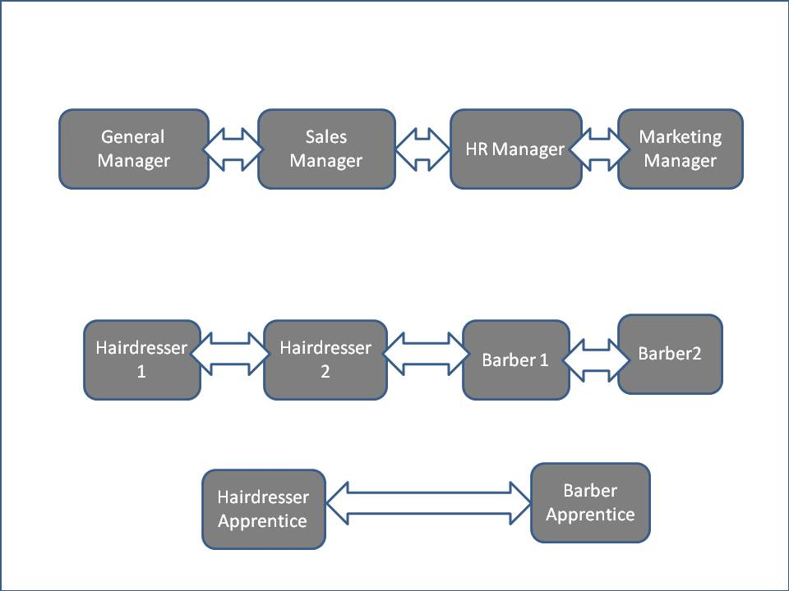
Chart of Organisational Structure
9.0 Products and Services
Premier Stylist has carefully selected unique types of products and services for its clients. These products are selected to meet a determined client group, especially from African and Asian origin. A variety of hair treatment products that suits clients from the geographical denomination can be found in Premier Stylists. Allen and Grodzki (2005: 77) wrote about finding a "niche" in the market for a successful business experience. They argued that the underlining question in every business idea is to attract clients and generate good income. Premier Stylists is aware that the world of cosmetics and beauty is growing by leaps and bounds, and this is a great opportunity to implement clear marketing strategies with excellent products and services for hairdressers. People are increasingly concerned about their physical appearance, looking good this includes both men and women. This must be highlighted, because one of the keys to the boom in this sector is the notable increase in business generated by the male public, traditionally less significant in everything that has to do with aesthetics and personal care and hygiene. The following are the products that clients can purchase from the business:
- Assorted wigs
- Assorted hair attachments
- Weave on
- Hair cream relaxer
- Hair shampoo

Those products are made available in store for clients purchase, given that they are important products for our services, their availability facilitates the effectiveness of our services to our clients.
Services
Focusing on a very specific market niche is one of the best strategies to succeed in the business world. Premier Stylists intends to provide executive quality and effective services to our clients. This business is designed around afro-beauty services. So, the higher the quality of our services, the chances we must beat the competition.
- Hair cuts
- Hair shaving and styling
- Hair plaiting and braiding
- Relaxing hair
- Weave on hair fixing
- Hair colouring.

10.0 Legal and Compliance issues
Taxes: Premier hair salon is a business structure based on partnership and as such will be registered with the HMRC and thereby comply with all its associated rules which may include business taxes, local taxes, income tax and national insurance on business earnings. (startups, 2000)
Business License: Premier hair salon will be registered with the local council who will issue the business with a premises license. This is to permit the business function legally. A copy of this license will be displayed on the premise. (startups, 2000)
Health and Safety:
- All equipment and tools used in the salon will be checked by carefully reading any instruction that comes with them to make sure they are used safely and hygienically.
- Preferably, sterile single-use instruments should be used.
- All reusable equipment that can be contaminated with blood must be sterilized.
- Instructions in manual must always be adhered to. This is to ensure equipment are working efficiently and effectively.
- Work are must always be kept clean.
- Sterilization procedures must be written out and adhere to. (startups, 2000)

Covid_19: we will abide by all government regulation to ensure our business environment is covid-19 compliant.

First Aid: First aid kit will be on-site, and staff will be trained in first aid.
Insurance: As a standard, Premier hair salon insurance needs will include the following.
- Public liability insurance
- Products liability insurance
- Employer’s liability insurance
- Treatment insurance (startups, 2000)

Business bank account: Business account and merchant account will be opened in order to conduct business and accept credit and debit card payment. (startups, 2000)

11.0 Funding and financial requirements
The initial investment cost required to get the project running is estimated at £55,000.
Sources of Finance
Personal savings: The partners of this business comprises of four individuals who shall make an equal contribution of £2,500 each. £10,000 in total.
Family Loans: Partners of the business shall approach members of their family with money to spare to solicit for loans that will be paid back at an agreed interest rate.
Government-backed Start Up Loans: This is another opportunity that we intent to explore in the bid to source funds for the business. The government backed Start Up Loan scheme which began in 2012 has been of huge help to about 68,000 businesses who has benefited up to £543.8 till date. The scheme is well known for helping businesses who have faced obstacle in getting funds elsewhere. Under the scheme up to £25,000 can be borrowed for over one to five years. It has a fixed interest rate of 6% and no early repayments is required. Another major benefit of the scheme is the free mentoring program which lasts for 12 months. Hawley, A (2020)

Revenue Worksheet

Account | Amount | Explanation
Numbers of days open weekly | 6 | 1 off day for staff
Numbers of days open yearly | 311 | Assuming business is not opened on Christmas day
Average sales
Weekly sales | £3,500 | Projected weekly sales
Monthly sales | £14,000 | Projected monthly sales
Yearly sales | £168,000 | Projected yearly sales
Average sales per day | £540.20 | Yearly sales divided by number of days opened.

Sales Mix %
Hair service from 4 rented chairs | 80% | Percentage of sales projected in hair service sales.
Hair products | 20% | Percentage of sales projected in hair products.
Sales Mix £
Hair service | £134,400 | Total revenue at 80%
Hair products | £33,600 | Total revenue at 20%

Controllable worksheet
Account | Amount | Explanation
Revenue
Hair service from 4 rented chairs | £134,400 | Revenue worksheet
Hair products | £33,600 | Revenue worksheet
Total Revenue | £168,000 | Revenue worksheet
Costs of products sold %
Hair products | 50% | Targeted cost percentage of food sold
Hair products | £16,800 | Hair product revenue multiplied by 50%

Total costs of products sold | £16,800 | Costs of hair products
As a % | 10% | Cost of hair products divided by total revenue
Gross profit | £151,200 | Cost of hair product taken from revenue
As a % | 90% | Gross profit divided by total revenue
Labor costs %
Management | fixed | Salary of one partner working full time

Management | £28,000 | Salary of one partner working full time
Sub Total | £28,000 | Labour cost before statutory Benefits
Statutory Benefits at 4% | £2,330 | Payroll Taxes
Total Labour | £30,330 | Labour plus Payroll Taxes
Operational Profit | £120,870 | Gross profit less cost of labour
As a % | 72% | Operational profit divided by Total Revenue

Financial Forecast Worksheet
Account | Amount | Explanation
Total Revenue | £168,000 | From Revenue worksheet
Gross profit | £151,200 | From Controllable Cost worksheet
Operational profit | £120,870 | From Controllable Cost Worksheet
As a % | 72% | From Controllable Cost Worksheet
Expenses | monthly
Advertising and Promotion | 3% £5,055 | Funds allocated for promoting the business stated as a % of Total sales
Hair treatment supplies | 4% £6,740 | Supplies needed to treat customer’s hair stated as a % of Total sales

Bank charges | £50 £600 | Fees to maintain current bank account
Insurance | £100 £1,200 | Liabilities
Legal and accounting | £59 £600 | Fees for remittance of taxes
General maintenance | £100 £1,200 | For equipment etc.
Telecommunication | £50 £600 | Landline, mobile phone and internet
Utilities | £200 £2,400 | Water, gas, etc.
Web and app maintenance | £15 £180 | Web hosting
Total Expenses | £18,575
Income | £102,295
As a % | 60.7% | Income divided by Total Revenue

Start-Up Costs
Account | Amount | Explanation
Business Set-Up
Customized trailer | £19,500 | Mobile trailer specially designed for hair salon shop
Furniture and fixtures | £6,500 | Seats, mirror, lights etc.
Equipment | £6,000 | Clippers, hair dryers, sterilizers, etc.
Legal and advertising | £2,500 | License fees, promotional and adverting fees.
Utility deposits | £1,000 | Gas and electric
POS | £4,000 | Subscriptions and printers included
Inventory | £8,000 | Hair treatment products and other products
Bank charges | £500 | To set up and debit machine
Total Expenses | £45,500 | To start the business
Working Capital | £10,000 | To serve as a “backup” during initial month of operation
Total | £55,500 | Expenses and allowance for working capital

Sales Forecast

 | Jan | Feb | Mar | Apr | May | Jun | Jul | Aug | Sep | Oct | Nov | Dec
Stylist 1 | £2k,400 | £2,400 | £2,400 | £2,400 | £2,400 | £2,400 | £3,600 | £3,600 | £3,600 | £3,600 | £3,600 | £3,600
Stylist 2 | £2,400 | £2,400 | £2,400 | £2,400 | £2,400 | £2,400 | £3,600 | £3,600 | £3,600 | £3,600 | £3,600 | £3,600
Barber 1 | £3,600 | £3,600 | £3,600 | £3,600 | £3,600 | £3,600 | £4,800 | £4,800 | £4,800 | £4,800 | £4,800 | £4,800
Barber 2 | £3,600 | £3,600 | £3,600 | £3,600 | £3,600 | £3,600 | £4,800 | £4,800 | £4,800 | £4,800 | £4,800 | £4,800
Product | £7,200 | £8,000 | £8,200 | £9,000 | £10,000 | £10,500 | £11,500 | £12000 | £12000 | £12,500 | £13,000 | £14,000
Total | £19,200 | £20,000 | £20,200 | £21,000 | £22,000 | £22,500 | £29,300 | £29,800 | £29,800 | £30,300 | £30,800 | £31,800

Conclusion
We believe that with our well thought out business plan and the gap that exists for our brand of hair salon service in the hair beauty industry, the proposed venture is viable and profitable. With an initial investment of £55,000 coupled with a team of talented and dedicated individual, this dream can become a reality.

References
Allen, W., and Grodzki, L., (2005), The Business and Practice of Coaching: Finding Your Niche, Making Money & Attracting Ideal Clients. New York: W.W. Norton & Company Publication.
Fleisher, C. S., and Bensoussan, B. E., (2015). Business and Competitive Analysis: Effective Application of New and Classic Methods, New York: FT Press.
Kolko, J.D., Neumark, D. Lefebvre-Hoang, I., (2007). Business Decisions and Employment Dynamics in California, California: Public Policy Institute Publication.
Koontz, H., and Weihrich, H., (2006) Essentials of Management, London: Tata McGraw-Hill.
Marsden, D., (1999). A Theory of Employment Systems: Micro-Foundations fo Societal Diversity. London: Oxford University Press.
Miles, R.E., and Snow, C.C., (2003). Organizational Strategy, Structure, and Process. London: Standford University Press.
Nickels, W. G., McHugh, J., McHugh, S., (2010) Understanding Business. London: McGraw-Hill/Irwin.
NHBF hair and beauty industry statistics (2019) Industry statistics for hairdressing, barbering and beauty. Available at: https://www.nhbf.co.uk/documents/hair-and-beauty-industry-statistics/ (Accessed: 3rd May 2020)
Start-ups (2020) Beauty salon and legislation and regulations. Available at: https://startups.co.uk/beauty-salon-legislation-regulations-health-and-safety/ (Accessed: 3rd May 2020)
Hawley, A. (2020) Start up loans: How to apply. Available at: https://startups.co.uk/start-up-business-loans/ (Accessed: 4th May 2020)
10 Surprising Statistics You Didn't Know About the Hair Industry
s-schwartz.com › statistics-and-trends › hair-industry-statis

20 February 2019

Appendix A
Power point slides
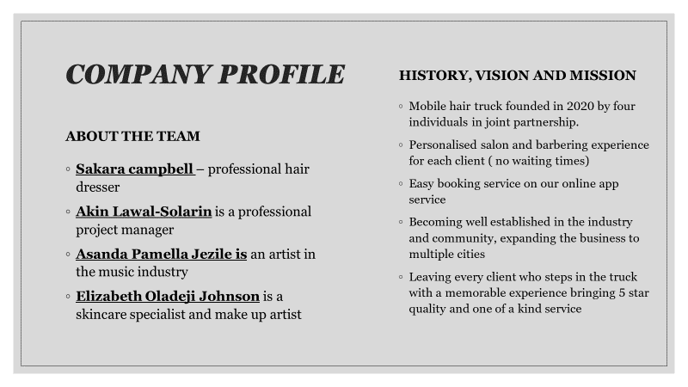

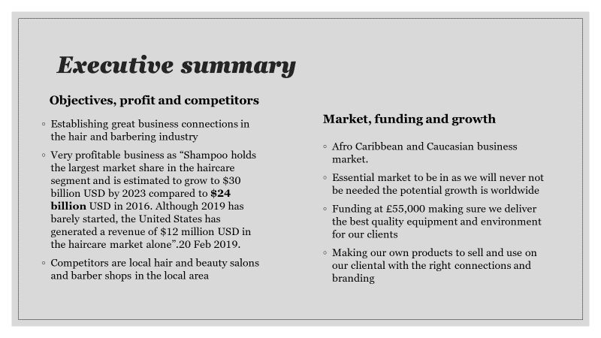

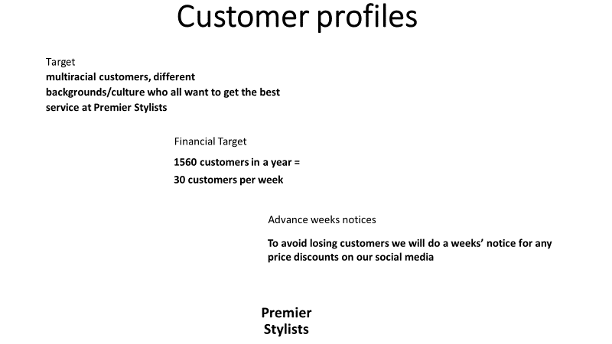

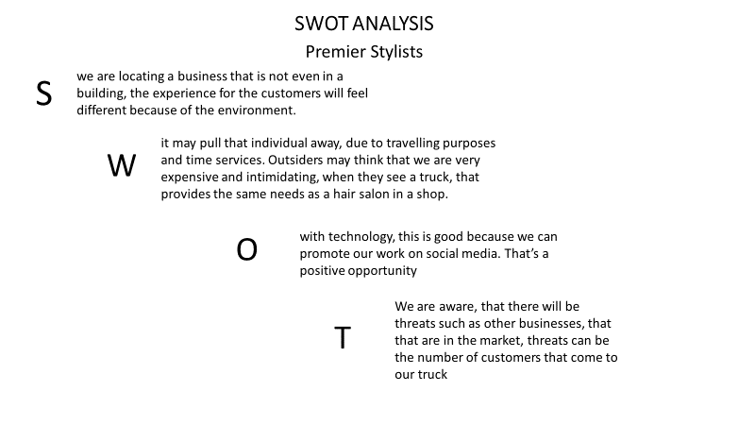

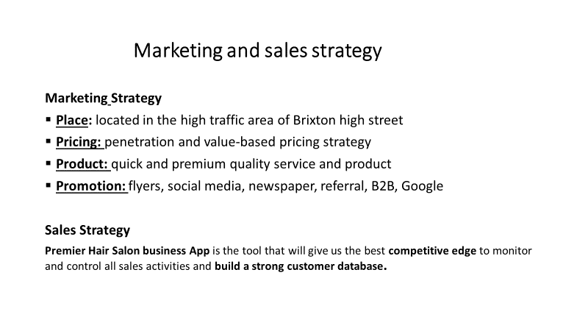

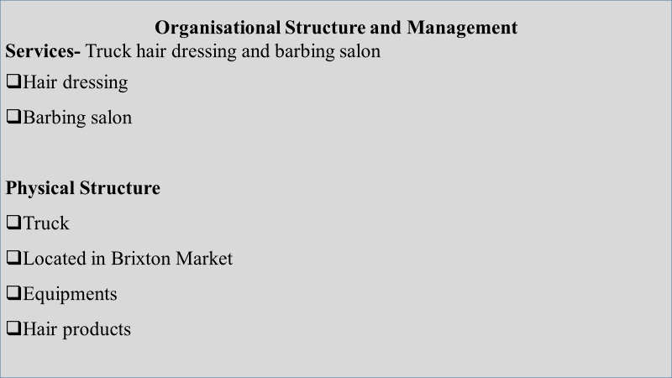

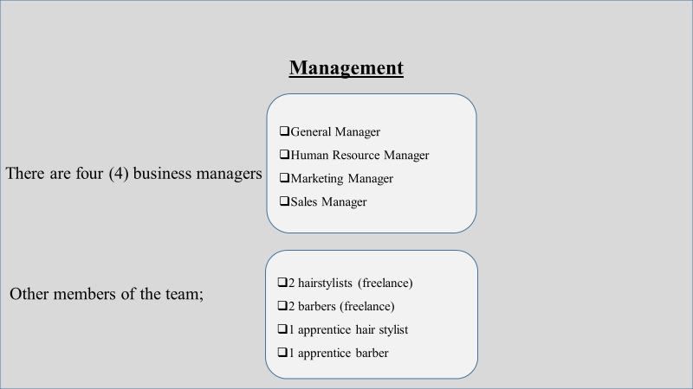

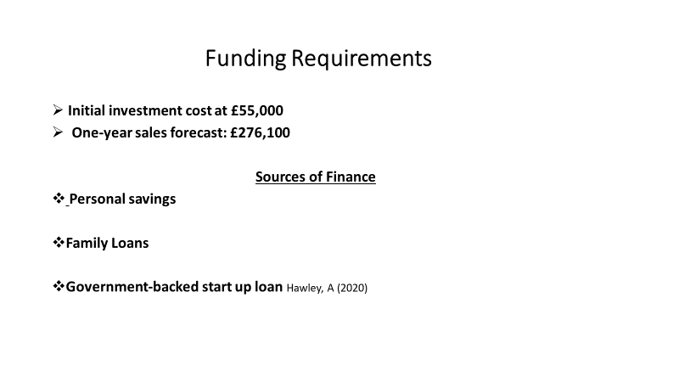

Appendix B
Cover letter
Malani Gunaratnam
Winchester House, 11 Cranmer Rd, London SW9 6EJ

Dear Ms Malani Gunaratnam,
We are writing to express our interest to let you know that we are a group of talented and dedicated entrepreneurs with over 4 years’ experience of starting up and running various small businesses. Currently, we have just started a hair salon business which is set to take the market by storm based on our innovative modus operandi.
We intend to capture a fair share of the hair beauty market by offering one of the quickest yet premium quality hair service. This will be made possible by means of our Premier hair salon business App which will be used by our esteemed clients to book appointments in advance and used to build and keep track of our customer base. Our hair stylist and barbers are friendly, exceptional, and well known for their professionalism, reliability, creativity, and artistry. Our business environment has been deliberately designed with our customer in mind to give an atmosphere of comfort, relaxation and safety as well as being Covid-19 compliant.
We are confident that the Premier Hair Salon brand will make a significant difference in the hair beauty industry while offering innovative service to our customers. We look forward to having an interview with you to discuss our business plan and hopefully building a long lasting mutually beneficial business relationship with you. You may contact us at your earliest convenience and thanks in advance for your kind consideration.
Yours Sincerely,
The premier hair salon team.

