Menu Engineering
Crafting a Memorable Dining Experience Menu for a Special Occasion

Name: Alexandru Ciprian Plaveti
Student ID number: 2246419
Module: Food and Beverage Operation BMIH4002
Lecturer: Antoinette Milne
Word count: 420

Restaurant Concept
A restaurant concept acts as a baseline for all the operations, culture, menu, design, and overall identity. The concept of a restaurant underlines components that give every restaurant a unique and dignified touch (Cousins, et al. 2019). For ensuring the success of every restaurant, an undeniable concentration on underlying a solid concept is essential. A solid concept of a restaurant is beneficial for the positive reputation of the place and enlarged publicity. More and more customers are attracted to restaurants, which has a strong concept.
For the new restaurant to be introduced to the Trinity Hotel Chain in the UK, it is imperative to pay attention to providing aligning experiences to the customers as the four-star hotel chain is popular. The concept of the new restaurant will be based on fine dining experiences for the guests. The new restaurant concept will provide a fine multiple-course meal to the guests while offering views of the city in addition to a welcoming and calming ambience. This will enhance the dining experience of the customers and will provide better satisfaction to them (Davis, et al. 2018). The ambience will focus on a pastel interior, which will add to the calming experience provided to the guests, along with famous art pieces in vibrant colours, which will give a relaxing mixture of experiences to the guests.
In addition to ensuring a strong restaurant concept, making decisions regarding the customer types and segments will be equally of the same significance (Motarjemi and Lelieveld, 2014). Since Trinity Hotel offers services to vacationers and business travellers, the target audience of the new restaurant will be the same. These target audiences will ensure that the dining experience is appropriately enjoyed by the guests and that the higher business performance of the new restaurant is guaranteed.
The new restaurant will actively concentrate on providing seven-course French cuisine to the guests to ensure that the ambience is in complete alignment with the taste experienced by the target audience of the new restaurant. The selected menu will be beneficial for maintaining the reputation of the four-star hotel as a luxurious service provider. Vacationers and business travellers enjoy luxury and refined tastes in terms of food, and as a result, French cuisine is a famous choice among these guests (Cousins, 2020). French menu will align with the tasteful requirements of the target audience. Based on these points, the seven-course French menu will offer delicate delights to the guests and, at the same time, will ensure a reputation and better services to the customers.
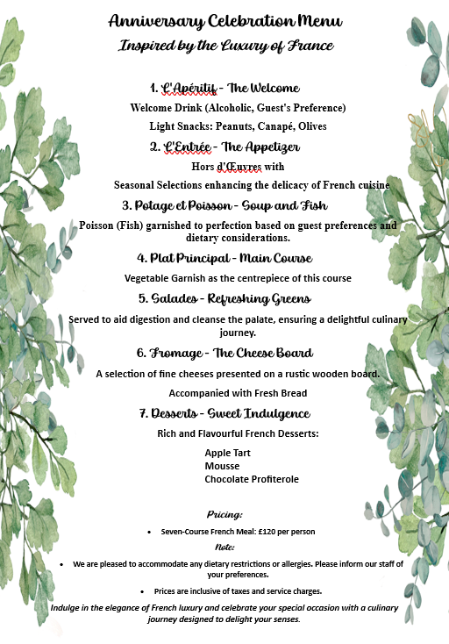

References
- Cousins, J., (2020). Food and beverage service. London: Hodder Education Group.
- Cousins, J., Foskett, D., Graham, D. and Hollier, A., (2019). Food and beverage management: For the hospitality, tourism and event industries. Oxford:Goodfellow.
- Davis, B., Lockwood, A., Pantelidis, I.S. and Alcott, P., (2018). Food and beverage management. Routledge.
- Motarjemi, Y. and Lelieveld, H., (2014). Food safety management: A practical guide for the food industry. Amsterdam: Academic Press.

