Business Decision Making

Name of the Student: Mihail Dimitrov Milchov

Author Note

Introduction
The Poster showing the Physical activity for adults and older adults, what are the ways of getting into physical activities, benefits it has and what risks are reduced a person being into physical activities. The importance of physical activities is getting more and more highlighted as people are shifting towards more virtual services and digitalization. People specially adults are busy with their livelihood first busy with college life and then getting into corporate sector as income source. People do not have to do any physical activities because things are getting much more advanced as days goes by. Starting from morning with coffee machine, toast maker, washing machine, vehicles to travel, laptops and other technical things for example having almost completely wiped out anything to do physically. So, the poster is trying to make aware and remind to people how avoiding physical activities increases chances of various issue in the body. There has been gradual increase in chances of several diseases as the physical activities get reduced. A paper says about the relationship between Technology and physical activities among children’s that the inadequate activities that it is influenced by the education standard of students, usage of different gadgets and being busy into screens(1).

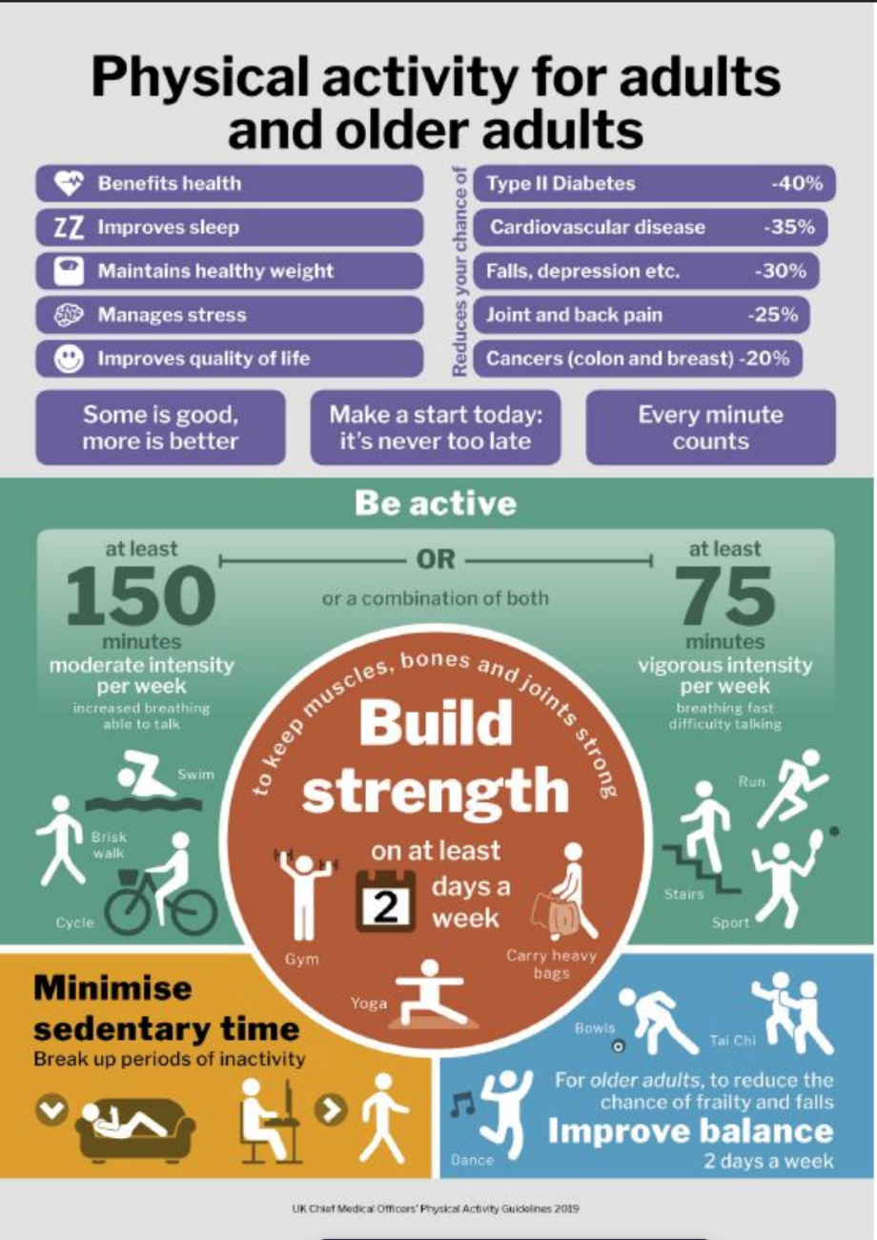

The poster shows the physical activity for adults and older adults taken from UK Chief Medical Officers Physical Activity Guidelines 2019. The poster messages on how the activities that are being performed helps for better health, strength or improving balance of adults and older adults. On the upper region the poster talks about the benefits of doing physical activity for adults and older adults. Some benefits provided are Benefits health, improves sleep, reduces type diabetes by 45%, cardiovascular disease by 35%, depression by 35%, joint and back pain by 25% and cancers by 20%. It talks about being active can be of two ways – moderate intensity which is being active 150 minutes by doing swimming, brisk walk or cycling and vigorous intensity at least 75 minutes per week by running, walking through steers and doing sports activities. The poster also explains to break up the time of sedentary which means a person sitting or laying down to walking. For improving balance, a person needs to dance, bowls or tai Chi 2 days in a week. For improving the build strength by keeping muscles, bones and joints strong a person needs to perform gym, Yoga or carry heavy bags at least 2 days in a week. So, it is overall a very good poster covering of several points adults and older adults requires to by physically active and fit reducing the chances of several diseases and health issues.
Color – The color provided in the poster is quite good contrast and highlighting. The only issue is found in the mid-section it is seen that the background section and words/alphabet are both green in color for which the words are not highlighting which is a problem. The heading is black and background is white which is good contrast, small boxes with blue color and written in white is clear to be understood. The circle in the middle with brown color and text written in white color is clear. The green box text is very small and some text written in green color is not clearly visible. In lower region the black color text with orange background is the best in all of them as it is very eye catching. The blue box at the end can be darker such that the text in white is much more clearly visible (2).
Text - Some words are very small to be seen, but this depends on the size of the screen. If the screen is big the words can be easily visible. Some text could have been different types as all text are in same format be it heading, sub heading or other texts such that it could have more clearly differentiated. All the text seems to be of same type and style (3).
Graphs – There is no as such graphs in the poster but it contains some human signs which highlights several postures an adult should perform for physical activity as a symbol.
Graphics – The poster is well structured and presented and very much effective consisting of several boxes and a circle dividing the highlighted points and sub headings.
Cognition – the poster consists of thinking, judging, problem solving and other aspects helping to gain knowledge and make these as comprehension.
Some graphs and scatter plot can be added if possible, showing the relationship of doing physical exercise and different independent variables like different diseases, sleep, stress whether there is any relationship. This will make the analysis more prominent with proper explanations.
The poster could have made some comparisons like identifying some differences whether there is difference between the average lifespan of people following physical to those not following with a sample data. Also, it can add what and how much consequences it can create physical activities are followed. The poster can take help of some researches conducted previously comparing these two. The poster can also add what other factors affect the persons to undertake physical activity. Like in most of the cases it is found that persons who has more wealth, or busier with working schedule tends to make less physical activity than the person who have to move around to earn money which is also a physical activity.
The document has been nicely presented with good layout and structure such that lot of points has been covered in the poster. The poster is also well structured because the line is properly differentiated with boxes and circles and no texts are merging with one another. The poster is quite readable and visually eye catching and easy to understand. No such spelling or grammar is found to be inaccurate.

References
- Alotaibi D, Mortada T, Alwhaibi R. InHealthcare 2020 Dec (Vol. 8, No. 4, p. 488). Multidisciplinary Digital Publishing Institute.
- makesigns, 2022. Scientific Poster Design and Layout | Fonts, Colors, Contrasts, Screen vs. Print. [online] makesigns.com.
- Moran, M., 2022. 22 Best PowerPoint Color Schemes to Make Your Presentation Stand Out in 2022. [online] Design Bombs. Available at: <https://www.designbombs.com/best-powerpoint-color-schemes/.

