
Rethinking business conference
By Jordan John Coller

January 16, 2018
uwtsd Carmarthen
Associate professor: Dr. Roisin Mullins
Module: Generating Business Data and Analysis (BMSP4004)

Introducing Business Idea
The Carmarthen Business School intends to run an annual economically-friendly conference, soon to be known as “Rethinking Business Conference”. This report will analyse 35 venues that are located closely within the Welsh coastal path. Suitable venue locations must fit the criteria of The Future Generations Act, this conveys a sense of economically-friendly behaviour within the conference.

This report will consist of titles covering topics such as; The roles of a business analyst (otherwise known as “BA” as a term of abbreviation) this will explain how a BA is important and how they benefit businesses, however the report will also convey key points such as the disadvantages and limitations of implementing a BA when building a conference idea. Another topic could concern “The purpose of a database”, this topic will regard the functions of using a database, database design lifecycle, tools used to capture data and information and what are the benefits gained when using database tools. The report will include a full spread-sheet report with all 35 venues that were considered when shortlisting the most practical venues acquired. This topic will also concern different trends regarding databases. The report will include information concerning the rationale behind what venue was picked for the conference, while also containing information with why the selected venue was chosen, this will include comparisons between the chosen venue and other venues that may also benefit the conference but weren’t chosen. The Future Generations Act will be taken into account when choosing a venue for this task. This will include; what in particular about the venue fits the criteria and why is it relevant to the task given. This report will regard where certificates are available when requiring qualifications concerning sustainability status.

The roles of a business analyst
The roles of a business analyst includes engaging upon, as well as investigating a business’s ideas and problems that are put forth by management and then aiding them in formulating options, possible conclusions and also recommendations for business cases. Their role is essentially “project manager” as they support businesses in promoting courses of action through objectives, the development of strategies and redefining tactics of business cases. A BA’s responsibilities may involve the action of delivering the content of selected options, this may include options such as; new business processes and more advanced and efficient information technology systems, the redefining of tactics so an objective operates more efficiently and to identify tactical options.

Roles and advantages of implementing a business analyst within the task
Business analysts ensure that all missions and strategies fall in line with the objectives needed to perform the business’s tasks and goals. In the terms of this report, the BA will be supporting the implementation and operation of certain tactics needed to find a venue for a suitable conference. This will be supported by such tactics as; recommending an option of venues and aiding the task with options regarding how the venue fits the criteria of the Future Generations Act. (Cadle, Paul & Turner, 2010)

Disadvantages of implementing a business analyst within the task
The advantages of implementing a BA within the task are extremely important, however it may result in some disadvantages. These disadvantages could include factors concerning the high labour costs when hiring a BA. Evidence for this can be compared by researching the national average salary of 1,523 Business analysts in the UK, which is stated to be £40,000 per year according to the Glassdoor website. Although, this could vary between the size and capital of the business. Another disadvantage could regard the time it takes to create a database, as it may be vastly time consuming before the moment of it becoming efficient takes place. However, it could be assumed for The Carmarthen Business School to have previously hired an existing BA, therefore concluding in no costs incurred due to the business school continuously performing decisions because the existing analyst is a prior member to the business. ("Salary: Business Analyst in the UK", 2018)

The Future Generations act and how it’s relevant
The future generations act is a law passed by The Welsh Government on 1st April 2016, the future generations act supports the idea of making the public more aware of climate change. This is can be achieved by educating public bodies to think long-term when regarding the environment to help prevent non-sustainable acts from future businesses and public. This is implemented by the Welsh government to achieve improvements concerning the Welsh economic, social, environmental and cultural well-being. This law is needed to help support future generations a better quality of life free of possible future challenges such as climate change and global poverty before it becomes worse. The 7 goals are expected to be met by the contributions of businesses, for example; higher-education in Wales. Certificates concerning sustainability are achieved by the completion of the INSPIRE course/module and is beneficial to businesses and public bodies if the status of sustainability is deemed essential. Figure 1-1 shows the set goals of the future generations act in which the Welsh government wish to achieve. The task given fits the criteria of the goal named “A globally responsible Wales”. This is conveyed by the nature of the project being sustainability based. (Well-being of Future Generations (Wales) Act 2015, 2015) ("Welsh Government | Well-being of Future Generations (Wales) Act 2015", 2015)

Figure 1-1

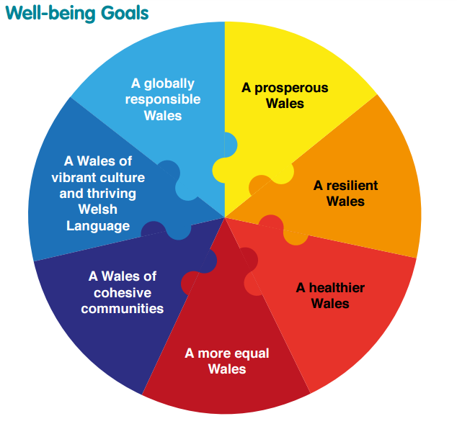
(Well-being of Future Generations (Wales) Act 2015, 2015)

Purpose of a Database
When searching for a suitable venue to host the convention, the program “Access” was used. This program is efficient when storing and analysing data. There are many properties of a database, the most important and relevant to this task include;

The avoidance of data redundancy
The use of a single table may create problems concerning data redundancy. This is when information is duplicated, this is unnecessary within a database and is avoided by creating multiple separate entities and splitting the data between them. As shown below in figure -1, there is an example of a table that conveys data concerning the entity’s “phone number” and “name” attributes becoming redundant several times. (Roman, 2002)

Figure 2-1

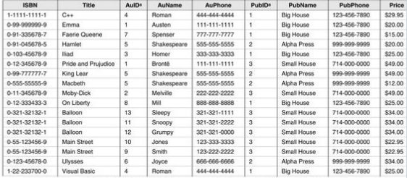

(Roman, 2002)

Transforms data into information
Databases are used to store and transform the data collected into meaningful information that may support a business’ next course of action therefor it is important and efficient to collect data. This is used to present decision makers with, so the analyst can provide them with accurate and efficient information. This improves the decision making process. ("Power Generation Information Manager", n.d.)

Optimises data management
Databases such as access that use procedural languages also use optimising routines to produce outputs that provide less computation, this can be more practical for management who might not understand non-optimised information. (Roman, 2002)

Ensures integrity
This ensures the accuracy and consistency within the database to avoid any unintended changes could cause a business to fail when working towards a goal or objective. (Roman, 2002)

Ensures an efficient design
By ensuring a database is formatted with an efficient design can benefit an organisation by conveying the data and information collected in an easy and optimal fashion. Failure to do so could result in errors within the database, thus leading a business into failure. (Roman, 2002)

Database Design Lifecycle
The lifecycle of a database supports and is linked to the organisations information system, this is fundamental component to it. The database lifecycle is not strictly sequential, however it does involve some repetition of the previous stages within the lifecycle, this is through “feedback loops.” Small business with a small amount of users can be easier to maintain, however databases with many users can become complex due to its lifecycle. Below is an model (figure 2-1) of the stages within a database’s lifecycle. Although there are more than five stages, these are the typical stages within a lifecycle and they all are fundamental to the lifecycle of a database. (Connolly & Beg, 2005)

Figure 3-1

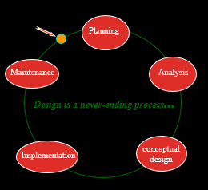

(Coronel & Rob, 2006)

Database planning – The planning of stages and how the future stages can become recognised as efficient and effective. One of the most important first steps of planning would involve clearly defying a mission statement for the database system. This is incorporated within this task by the planning of which type of venues will be most suitable and the recognition of the mission statement. (Eg. To find 8 welsh counties, 2 towns within each county that can be located close to the coastal path and then approximately 3 venues within each town) (Connolly & Beg, 2005)

Analysis – This involves the collection and analysis of information needed so it can be supported by data. Some limitations to this stage could regard the information collected being inaccurate therefor hindering the end result. This can be avoided by proper planning, recognising and defining the problems that need to be solved beforehand. Regarding the mission/task given, this is relevant to the stage as data is analysed for to see which venues could be suitable. For example, the records were defined to ensure accurate information was being entered into the database. This was defined by ensuring accurate information provided from external venue websites and search engines such as Google. (Connolly & Beg, 2005)

Conceptual Design – This stage is when the information and data is validated to suit the businesses’ specific requirements. This step may require several phases to function efficiently, these phases are called E-R modelling steps (entity relationship model), these steps include the identification, analysis and refinement of the business rule, the identification of the main entities that will be used, followed by the definition regarding relationships between each entity to be later defined when concerning each entity’s attributes and primary keys along with each entity’s foreign keys, all of which create efficiency and functionality within a database. After these steps are achieved, the result will conclude in a working entity relationship model. This was incorporated within the creation of the database. For example: each entity’s relationship was defined and assigned to another entity that functions efficiently between itself. This was created by assigning relationships with primary keys and foreign keys (eg. One to many: One town can have many venues) (Connolly & Beg, 2005)

Implementation – After the completion of the previous 3 stages (if you choose to test the database with a prototype or not) the database is now in position to be implemented. Database implementation is achieved by the programming language of SQL (Access structured query language.) SQL is a critical tool used to manage a relational database. There are a few operations that can only be performed through SQL that cannot be performed through just the Access graphical interface, this makes SQL fundamental to learn. Security provisions such as ADOX (Microsoft ADO extension) can be used to prevent the threat of third party security breaches, this extension program is beneficial to prevent manipulation. Another program that could be used would concern VBA, this creates a user password and secures a database by encrypting data. Although these extensions and programs are beneficial to securing a database as well increasing its functionality, it could is argued to be expensive to maintain through hiring a BA, it is also expensive to buy beneficial programs, without considering the costs of training to use such programs due to how complex the implementing stage can become. In the case of the task given, SQL was used to create queries and manage the relationship database. (Connolly & Beg, 2005)

Maintenance – General maintenance is achieved through manipulating data and performing practical maintenance checks and actions to ensure the database continues to perform suitably. A security audit is regarded as a form of maintenance, this is when user permissions for certain other users are edited to perform in its desired way. ("Security Auditing Overview", 2018)

Rationale

After the four query checks (provided in the figures below), it then opens an opportunity to compare which venue would be the most suitable to host the convention. Queries are used and are made to help short-list which data entities would be the most suitable for this task. For example: Figure 5-1 is a query formed list that conveys the most economically-friendly venues. Although fitting the criteria of the future generations act is a desired attribute, it may become less cost efficient, for example: The price per room for “All Nations Centre” is gits the criteria, however the price per room costs £400, without travel costs, although it is reasonably simple to travel to as it is close to public transport and efficient routes from the M4. Figure 5-2 indicates the most technologically efficient venue, however being recognised as convenient by providing equipment and WIFI, many venues that do, do not fit the criteria of the future generations act. In figure 5-3 the query conveys the capacity of each venue compared to the quantity of people attending.

The venue/entity selected to host the venue can be indicated within Figure 5-4 as it concerns information regarding the most cost efficient venue, this information indicates “The Northop Hall” is the most cost efficient. However also being recognised as cost efficient, while also providing equipment and fitting the criteria of the future generations act. The distance of the venue from The Carmarthen Business School needs to be addressed as it is over 150 miles away and travel costs may not be efficient, however public transport could be provided and is an option, if so, this is an efficient decision. ("Northop Hall", 2018)

Tools to store the information captured

Microsoft Access
Microsoft Access is a Program/ tool which enables the user to create desktop databases, this program allows the user to store and analyse data to be later transformed into meaningful data and is fundamental to this mission, and however there are many other programs that work similarly. Access enables a lesser sense of complexity to users who have only acquire basic knowledge regarding the program. Access allows the user to create browser-based data applications that enables user-added entities to build upon the already existing data therefor creating the meaningful information. However, the main user can control what data and values can be entered. This data is then assigned suitably through E-R modelling. Data is then stored automatically in an Access structured query language. ("Microsoft Access", n.d.)

Websites
Gathering information from official websites is a beneficial way to ensure accuracy to data inputs. An example of a website that was used to gather information regarding the venue entities would be; www.conferences-uk.org.uk.

Trends
Almost everything any public body buys or possibly contributes as information to a business that stores data generates a trend. These are documented as statistics. As a hypothetical example; 90,000 public bodies buy a certain type of shoe every week, this is also stored within the shoe company’s database. This allows businesses to forecast possible sales.

Queries and desired attributes (With Appendices)
Queries within a database are beneficial to data storing because it helps run queries that may be too complex without programs such as Access. Referring to the database, this topic involves collecting the data of 35 entities that concern which venue will be the most efficient. This is performed by entering each entity individually and creating queries to help shortlist which venue would be suitable to hold a conference. The rationale provides entities with attributes relating to factors such as;
- Price efficiency: This ensures the venue is affordable between 50 delegates. This is determined with named attributes such as; price per delegate, cost for facilities and cost per room.
- Size of venue: The size of venue is important as the conference consists of 50 delegates that are seated. The size of the venue is determined with named attributes such as; capacity compared to the number of people attending and conference rooms.
- Location: This regards entities such as; County and Town. These entities are important as it helps determine how far the conference is to each person attending and what town and county the said conference will be hosted in. These factors will convey how accessible the venue will be when concerning bus routes and how close it is to main road-routes. An increase in distance for some attending can have disadvantages because of the many people attending may not drive, thus making it difficult to attend.
- Convenience (technological): This is determined through the YES/NO attributes such as; Equipment, this would be beneficial because if equipment were to be inclusive within the venue, it would be more convenient opposed to hiring/driving an extra van to bring the Business School’s own equipment. Another factor would concern if the venue provides WIFI as it is beneficial to conferences.
- Future Generations Act criteria: The database provides a Yes/No attribute, when if selected “yes” during the analysing lifecycle stage would then mean the venue fits the criteria of The future generations act. This would regard anything from eco-friendly electrical outputs to solar panels used to generate energy for the building.

Another concern for the conference could include factors regarding the time of year in which the conference is held, this includes factors such as; the time of year in which the conference is hosted this can result in energy saving due to the lower amount heating and lighting needed if it were to be summer. However, air conditioning could be a possible hindrance to this assumption. In figure 4-1 it shows which entities were taken into consideration when searching for a suitable venue. ("Seasonal energy tips", 2018)

Figure 4-1

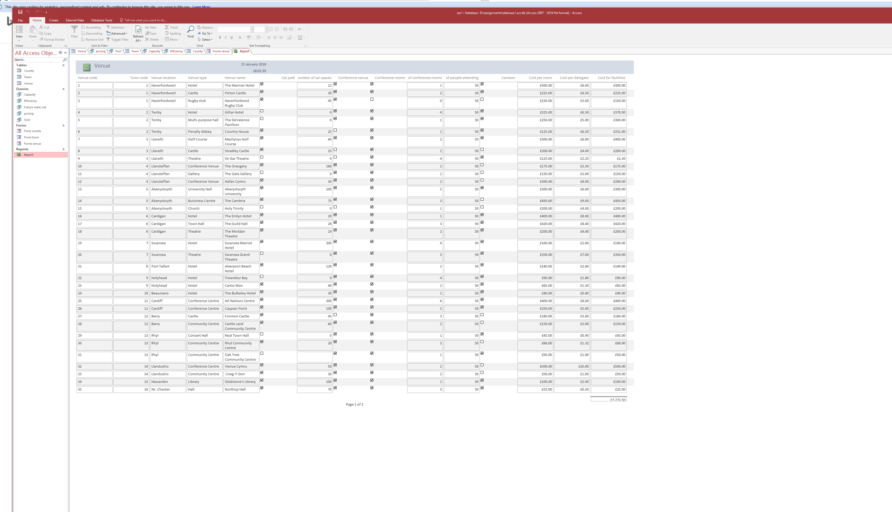

Figure 5-1

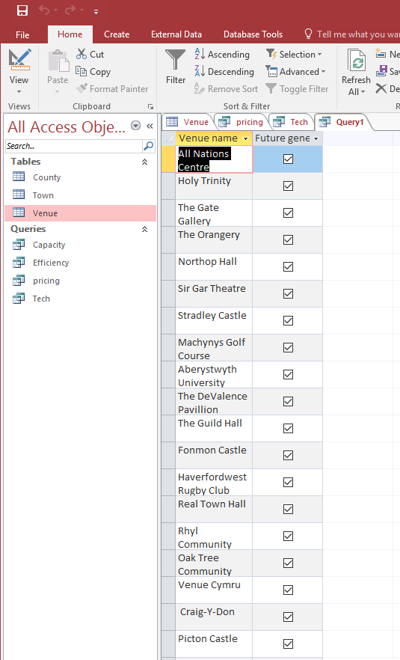

Figure 5-2
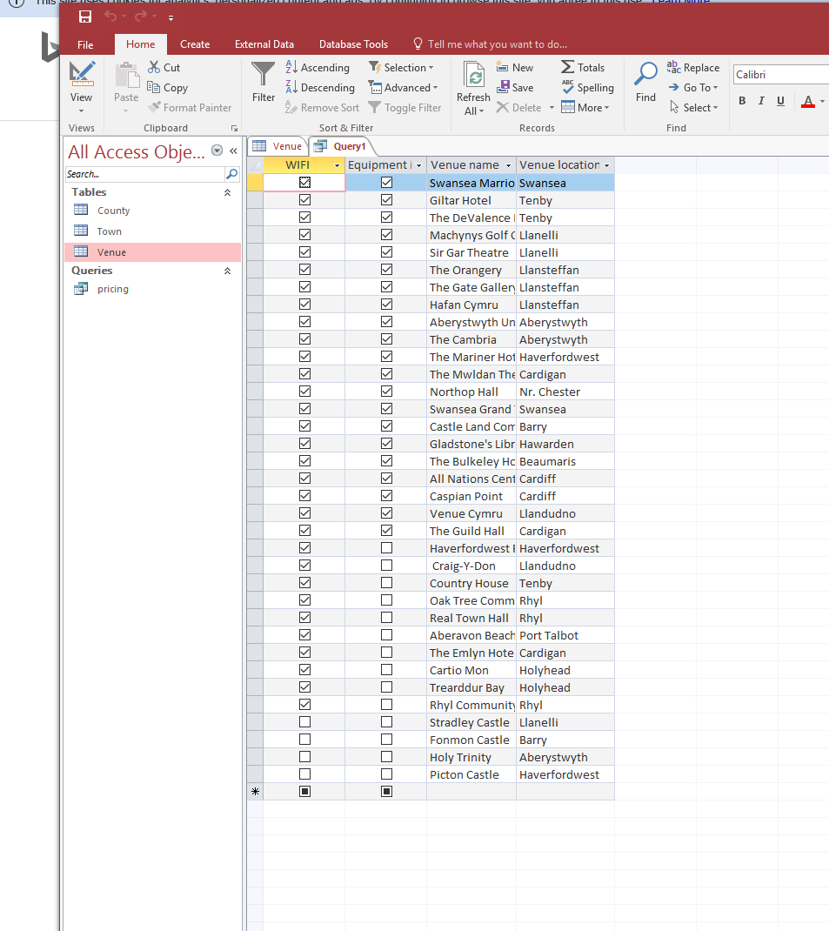

Figure 5-3

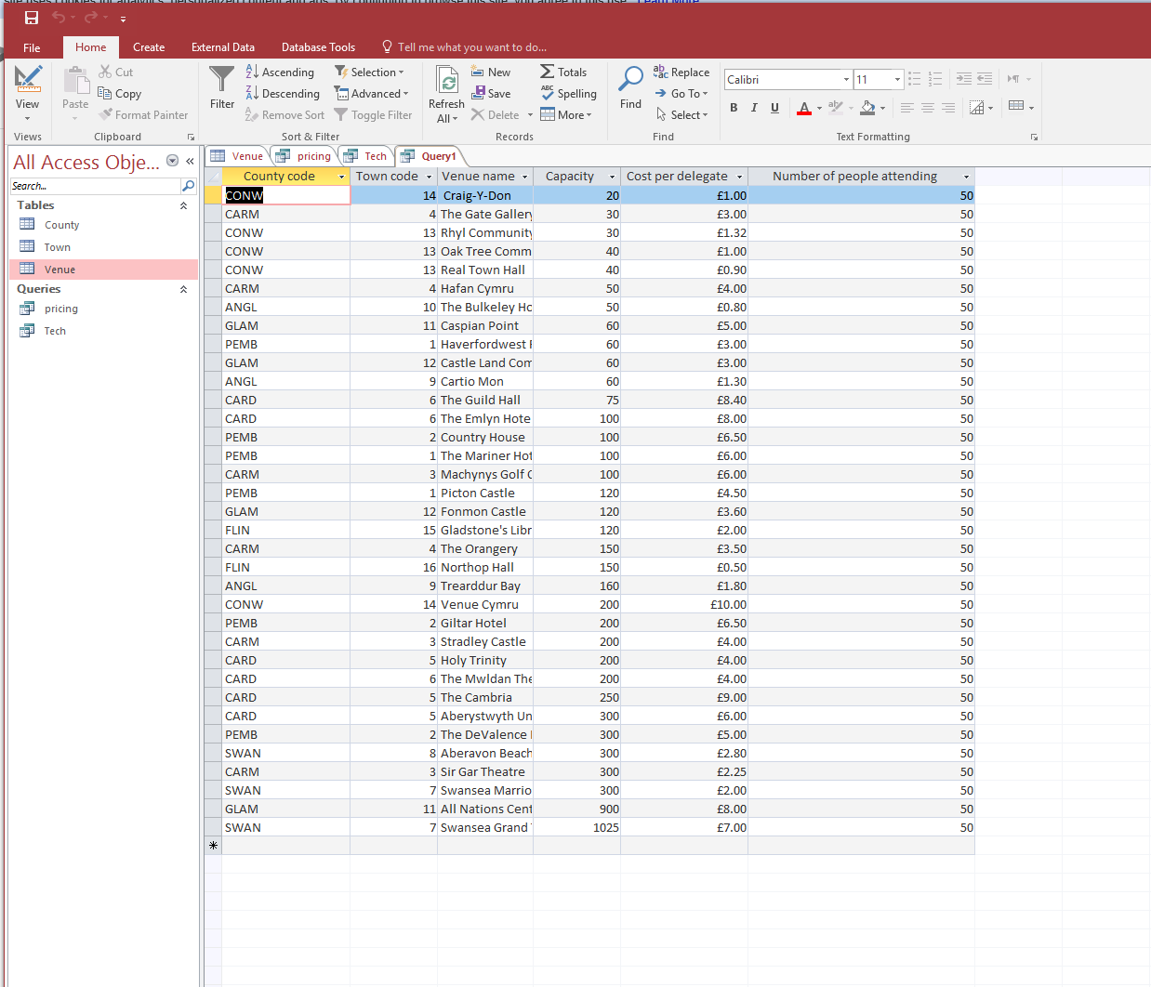

Figure 5-4

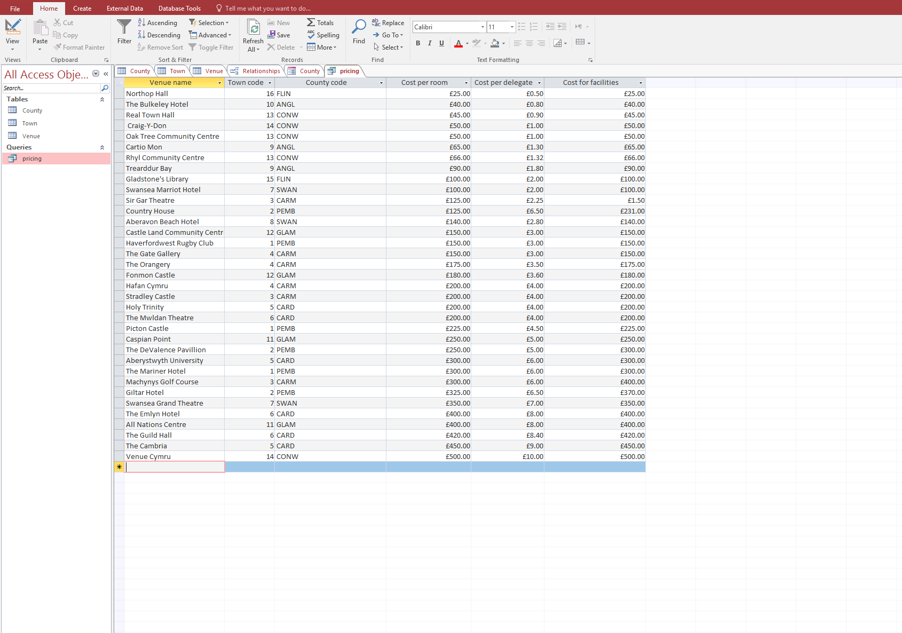

Forms
Generating forms in Access creates a user interface for the database application. You can bind forms to control permissions and data shares between each certain user. For example: In a hospital, General Practitioners may acquire and require certain information such as medical records, opposed to a receptionist that requires data such as names and pending/prior appointments. Here are some forms acquired throughout the mission, these forms are produced for each record and is shown in figure 6-1, 6-2 and 6-3 below. ("Introduction to forms", 2018)

Figure 6-1

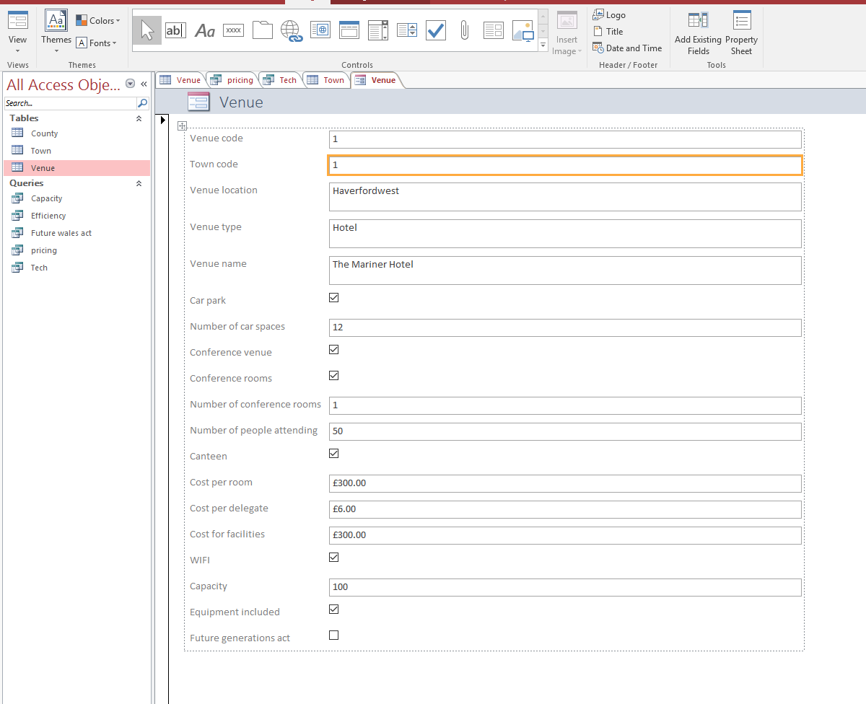

Figure 6-2

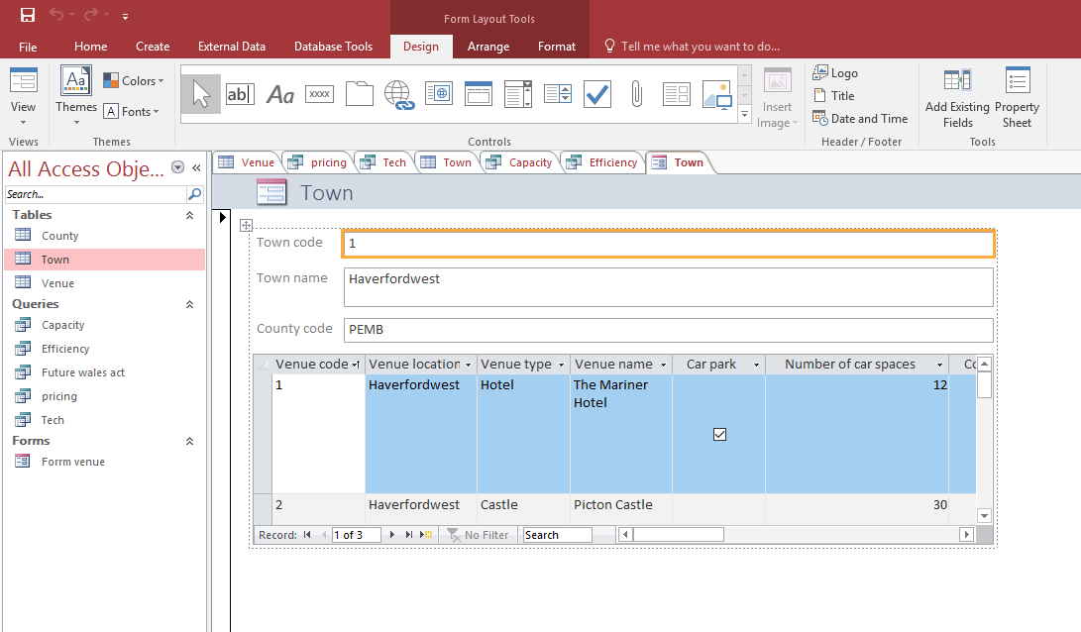

Figure 6-3

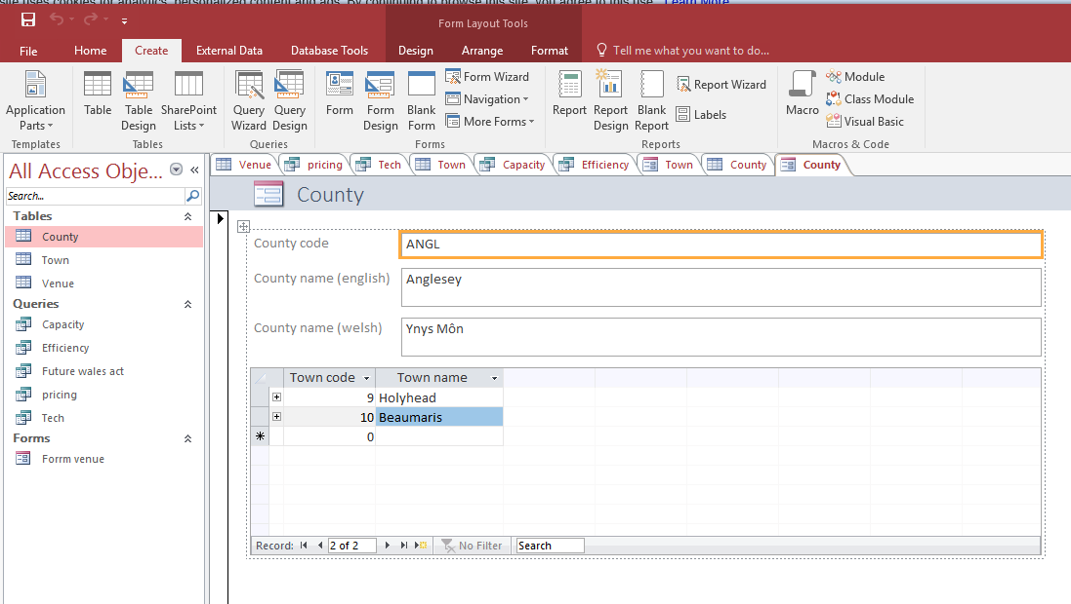

References
- Cadle, J, Paul, D, & Turner P. (2010). Business Analysis Techniques. BCS, 1-259. Retrieved from http://www.bcs.org/upload/pdf/business-analysis-techniques.pdf
- Connolly, T., & Beg, C. (2005). Database systems (4th ed., pp. 283-300). Essex, England: Pearson Education Limited.
- Coronel, C, & Rob, P (2006). DATABASE SYSTEMS (7th ed.). [S.l.]: CENGAGE LEARNING.
- Introduction to forms. (2018). Microsoft. Retrieved 17 January 2018, from https://support.office.com/en-gb/article/Introduction-to-forms-e8d47343-c937-44e8-a80f-b6a83a1fa3ae
- Microsoft Access. Microsoft Store. Retrieved 17 January 2018, from https://www.microsoft.com/en-gb/store/d/access-2016/cfq7ttc0k5dn?activetab=pivot%3aoverviewtab
- Northop Hall. (2018). Google Maps. Retrieved 17 January 2018, from https://www.google.co.uk/maps/dir/Northop+Hall+Country+House+Hotel+%26+Chequers+Restaurant,+Chester+Road,+Northop+Hall,+Flintshire+CH7+6HJ/University+of+Wales+Trinity+Saint+David,+Mount+Pleasant,+Swansea+SA1+6ED/@52.3574431,-4.3777207,8z/data=!3m1!4b1!4m13!4m12!1m5!1m1!1s0x487ad00b1a8868dd:0x91e48456c72b050a!2m2!1d-3.0850335!2d53.1980287!1m5!1m1!1s0x486ef566142579cf:0x14c520a91dca472f!2m2!1d-3.948239!2d51.62406
- Power Generation Information Manager. Library.e.abb.com. Retrieved 16 January 2018, from https://library.e.abb.com/public/d3484fde982a12dac125726500349b25/1KGD%20400131%20PGIM%205.0%20Leaflet.pdf
- Roman, S. (2002). Access database design and programming (3rd ed., pp. 4-80). Sebastopol CA: O'Reilly. Retrieved from https://www-dawsonera-com.ezproxy.uwtsd.ac.uk/readonline/9780596516598
- Salary: Business Analyst in the UK. (2018). Glassdoor.co.uk. Retrieved 16 January 2018, from https://www.glassdoor.co.uk/Salaries/london-business-analyst-salary-SRCH_IL.0,6_IM1035_KO7,23.htm
- Seasonal energy tips. (2018). Eonenergy.com. Retrieved 16 January 2018, from https://www.eonenergy.com/for-your-home/saving-energy/how-you-can-help-yourself/seasonal-tips
- Security Auditing Overview. (2018). Technet.microsoft.com. Retrieved 16 January 2018, from https://technet.microsoft.com/en-us/library/dn319078(v=ws.11).aspx
- Welsh Government | Well-being of Future Generations (Wales) Act 2015. (2015). Gov.wales. Retrieved 16 January 2018, from http://gov.wales/topics/people-and-communities/people/future-generations-act/?lang=en
- Well-being of Future Generations (Wales) Act 2015. (2015) (2nd ed., pp. 1-12). Retrieved from http://gov.wales/docs/dsjlg/publications/150623-guide-to-the-fg-act-en.pdf

