

A critical evaluation and the identification of next teaching and learning steps focusing
on a case study of an individual learner or a group
of learners, based on an observed critical incident

by
Derek Lockhart

Supervisor: Peter Lloyd
Second Marker:

Module ECAD 6007

29th Oct 2019

Table of Contents

Introduction 3
Observations 4
Methodology 5
Four purposes of the new curriculum 7
Literature Review 8
Reflect / Evaluation & next steps 13
Conclusion 15
References 16
Appendix A 17
Appendix B 20
Appendix C 23
Appendix D 27
Appendix E 30

Introduction

An analysis and critical evaluation of a critical incident observed in a school context. Critical incidents are used in reflective practice to allow a dispassionate review of events to facilitate future improvements in practice. The observation was carried out by a non-participant observer on a year 10 class during a theory physical education (PE) lesson and is referred to under anonymity in accordance with the BERA(2019) guidelines. The observation highlights three areas for further research behaviour management, Additional Learning Needs (ALN) and Assessment for Learning (AfL). The incident is reflected as to its impact on the four purposes as described by the new curriculum model(Donaldson, 2015). Further, the incident is reflected upon as to possible methods to improve the management of such incidents and the effect they have on learners.

Observations

These observations were carried out at a PGCE placement school. The placement school will be referred to as School X in accordance with the BERA procedures(BERA, 2019). School X is a large South Wales city Secondary school. The school provides education for circa 1100 pupils of mixed gender using the English language medium. School X has a free school meal rate of under 7%, this is significantly below the UK national average of 12.4%(Department for Education, 2018), this suggests that the school is in a fairly affluent area, the correlation of the proportion of free school meals as an indication to rates of social deprivation is an accepted metric (Ilie, Sutherland and Vignoles, 2017), this correlation was consistent with the observed local surroundings and residences.
The classes observed ranged from year 7 – 10 and this report will focus on an observation of a year 10 class. The class in question were a mixed sex group of 27 in a physical education theory lesson. The class was composed of middle set children who were completing personal fitness profiles.
The observations were carried out as a non-participant observer although the observer was introduced to the class as they were welcomed to the room.
A combined heat map and sociogram is shown in Appendix E. The heat map shows the pupil-teacher interaction that was observed during the lesson and highlights distinctly where the teacher’s attention was being taken due to the constant background interruptions. Further, the sociogram of pupil-pupil interaction shows the groups of pupils whose interactions were creating the most distractions and shows that despite the teachers attempts to negate this by separating the main detractors, the groups behaviour continued. The other social groups in the class, on the whole, managed to continue their work, after the lesson was completed the class were all held until order was properly restored, this was only accomplished when another social group (orange) voiced their dissatisfaction with the group behaviour.

Methodology

The information for this critical incident analysis was collected by nonparticipant observation. A participant observer (Kawulich, 2005) is one who observes and collects part of their data as a direct and immediate result of their actions and input, this has the disadvantage in that since they are generally otherwise occupied they miss a prime opportunity to use a specific practice and observe its outcome or effect(Kennedy-Lewis, 2012, p. 4). A non-participant observer is not otherwise distracted or occupied and can observe effects as they present themselves, although whether any observer within a classroom could be truly non-participant is debateable, where it is entirely likely that students behaviour will be affected by the presence of the observer irrespective of how inconspicuous they attempt to be(Spradley, 1980, p 58–60). This is analogous to the Hawthorne effect, where the subjects of the observation will alter their behaviour consciously or subconsciously simply because they know they are being observed (McCarney et al., 2007). The data collection could have been carried out by other methods primarily either interview or questionnaire.
A questionnaire can be a blunt instrument for a complex social situation such as a classroom incident, it would be unlikely to be flexible enough to collect worthwhile data without being cumbersomely long that would reduce the likelihood of respondents completing the dataset
An video recording of an incident would provide an increase in the data that was available to the observer and allow the observer to replay to ensure any valuable datapoints can be revisited, however it would also be subject to the Hawthorne effect if the subjects were aware that the recording was taking place. Since any recording equipment fitted into a familiar classroom would be immediately obvious to the learners, this is unlikely.
The interview method may be in a structured format or an unstructured format, in this instance an unstructured format would have been the most appropriate as this would have allowed an informal and flexible interaction with those involved in the incident that would have adapted as their perception became apparent. This would allow the interviewer to adapt their questioning to whoever they were querying and would allow aspects of Brookfield’s four lenses to be used to increase the perspective that is captured. Brookfield four lenses are based on the perspectives of how observers would interpret an event based on their differing roles.
Autobiographically, which is based on our personal experience as learners where we, by default, will try to emulate that which we have considered as good practice and attempt to avoid those which we viewed as negative experiences, with regard to a critical incident would questioning be biased toward the interviewers past experiences. A student’s perspective is one where they feel they are under your perceived authority and may try to avoid an answer that impacts negatively on their future. A colleagues and also when compared to theoretical practice in literature, which allows the practice to be compared to current and new theory(Brookfield, 1998).

Four purposes of the new curriculum

Observation four was carried out during a Physical Education Theory lesson. The lesson almost broke down completely due to the behaviour of a small group of four - six male pupils (Group Y) with one pupil being the main disruptor. The students in question seemed to be disappointed that they were to complete a theory lesson instead of their hoped for practical lesson, preferably a game of Rugby. The groups behaviour constantly disrupted the class with the teacher spending an inordinate amount of time attempting to control their behaviour and refocus their energies on the work at hand. The groups behaviour culminated with the vocal ringleader of the group (Pupil Z) rising, unbidden and effecting a full contact rugby tackle on a peer who was writing on the board.
Pupil Z completed no written work during the lesson whatsoever, however, when engaged by the teacher enquiring what he knew about the task at hand, the pupil knew exactly the purpose of the lesson, the answers to the work he should be attempting and when it should be completed by. Pupil Z was an obviously bright and capable learner, although the author has no access to the pupils record there appeared to be no blatant indications of additional learning needs beyond their inability to remain focused to the directed task.
The teacher attempted multiple techniques to attempt to curtail the behaviour and encourage productive work, with varying methods ranging from ignoring the behaviour through minor admonition, threats of consequences to promises of detention. Although each method that was tried did temporarily curtail the behaviour, it soon returned to unacceptable levels. At the end of the lesson, order was only restored due to peer pressure, the teacher held the entire class until as a group they stood quietly behind their chairs waiting to be dismissed and as the remainder of the class, predominately female, lost patience in the group and their ring leader for cutting into their lunch break. During conversations after the class dismissed the teacher revealed that this type of behaviour was commonplace with the group and incidents such as this were the prime reason, he was leaving teaching. This behaviour seemed to be in character for the group and came as no surprise to the teacher nor the remainder of the class.
Among the four purposes of the new curriculum, Donaldson states they are to help make all children and young people “Ambitious and capable learners who are ready to learn throughout their lives”, further it states the aim to make the, “Enterprising , creative contributors who are ready to play a full part in life and work.”(Donaldson, 2015). It was easily seen during the lesson observation that group Y were in no way ambitious learners with respect to the class at hand. Although the group were obviously bright enough to achieve, they only contribution to the class was negative and distinctly selfish.

Literature Review

From this incident it would seem clear that that the behaviour management of the pupils was a prime task for the teacher throughout the lesson that limited the quantity and quality of the time available to deliver. The Welsh Government (2010, p. 15) states that an effective teacher must have both teaching skills to deliver the learning and behaviour management skills to allow to take place effectively. This would seem to suggest that the actual ability to teach is only half the job. Further, it leaves open to question whether teaching or the ability to ensure teaching can take place is the important element. Dalgarno (2011, p. 61) found that not only was behaviour management possibly the most important skill required of a teacher, it was also the lack of this skill, that led to the majority of student and newly qualified teachers to leave the profession. Similarly, the Department of Education (Coopergibson Research, 2018, p. 28) found that experiences of behaviour management issues were one of the three main reasons for teachers, particularly newly qualified teachers, for leaving the profession. Therefore, it would seem reasonable to deduce that support for newly qualified teachers in behavioural management would be a prime target to increase retention. This would also aid the effectiveness of lessons and therefore the educational outcome for each learner. Postholm (2013, p. 389) would seem to agree and defines the aim of classroom management as being the creation and sustainment of “productive and supportive learning communities”. Cowley (2006, p. 27) makes many suggestions to subtly control a large group of learners such as the use of non-verbal signals such as the “deadly stare” and also to simply “Wait for silence”, it may seem simple and obvious however, with the case in point it was this simple expedient, in concert with peer pressure that eventually brought the class under control.
Bringing a class under control would seem a secondary option with the prime choice being to not lose control in the first place. Cowley gives further suggestions to this and places particular emphasis on planning a lesson to fully engage students (2006, pp. 77–83). It may seem obvious that a learner who is not engaged and therefore not fully occupied will begin to get up to no good, most parents would probably agree that a young mind is an active mind and will make its own entertainment when bored. Abram (2018, p. 1)would seem to also agree and suggests a list of reasons as to the root causes of misbehaviour, at the head of this list Abram uses the acronym HALT, for Hungry, Angry, Alone/Bored and Tired. Given that the incident in question happened immediately prior to lunch and during a lesson in which they were neither interested nor engaged then this would seem to fit with the observed in at least two of these cases, further investigation could of course reveal that all four of Abram’s root causes were applicable to the situation observed. The causes of poor behaviour are varied, however Morgan (2007, p. 40) states that poor behaviour is always a deliberate choice that has been made by the learner. By the time learners reach secondary school they are, to the greater extent, self-aware of their own tendencies and their personal triggers that can begin specific behaviours, it is therefore a choice to let those natural behaviours show. Further, as learners in secondary schools are, by nature, approaching young adulthood, their actions and the choices that precipitated them have an impact on the surrounding community as a whole and their appreciation of this is an essential part of their social education. With regards to the case in point, the behaviour of the group had a negative impact on the wider class, and it was this consequence that brought the situation to a close. This would seem to be in agreement with Glasser who proposed the Choice Theory (Glasser, 1997), this theory postulates that our behaviours, which stem from the choices we make, are hard wired into us and are based on survival, love freedom fun and power, and more importantly the experiences that are remembered when a past experience where one of these core needs have been met or threatened. This suggests that choice theory falls nearer the constructivism approach to understanding behaviour. Constructivism, based on the work of Piaget,(Piaget, 1971) shows behaviour is influenced by a learners knowledge, experiences and their interpretation of where they see themselves in society.

ALN
The teacher was not in a position to disclose to the author if any of the learners involved had been diagnosed as having any particular Additional Learning Need (ALN) and whether this may have been a contributing factor in their behaviour, however given the prevalence of ALN within the average classroom this was possible. The Welsh Government reports that 23 percent of school learners have some form of a Special Education Need (SEN) (2018, p. 2). The report further confirms that the academic achievements of learners with SEN are lower than the average student. The ALN system is a replacement for the previous SEN and is being introduced by the Welsh Government over the period 2018 to 2023. The Welsh Government define a learner as having an ALN if they have been diagnosed with a “learning difficulty or disability which calls for additional learning provision (ALP)“.
Although the author is not qualified to assess whether any of the students involved did so due to obvious ALN traits, the behaviour observed was consistent with personal experience as a parent of Attention Deficit Hyperactivity Disorder (ADHD). ADHD is defined by the National Health Service (NHS)(NHS, 2019) as a behavioural disorder with symptoms that include inattentiveness, hyperactivity and impulsiveness. It is traits such as these that were observed during the incident in question, further Mulholland (2017, p. 2)finds that learners with ADHD have a tendency to be unable to remain quietly in their seats and find difficulty to engage with tasks that require sustained attention, they have also been known to attempt to camouflage these tendencies by making their condition part of their classroom character and this will inevitably lead to disruption of the kind noted. The result of this behaviour inevitably leads to poorer academic achievement to the detriment of the learner over their whole schooling and the consequent impact on their future.
Other conditions that also fall under the ALN umbrella include all those previously covered by the SEN system and now includes those persons with Learning Difficulties and Disabilities up to the age of 25. Within schools this change will include a change of role and title with the SEN Coordinator (SENCo) now retitled ALNCo. The role of the ALNCo is to coordinate the Individual Education Plans (IEPs) that will be created based on formative assessment to support the specific needs of the learner and defines their support needs their specific targets and their progress towards it although the delivery will be mainly under the purview on the class teacher. On leaving school learners will transfer to an Individual Development Plan that will support them as they transition through early adulthood and the workplace(National Assembly for Wales Research Service, 2017, p. 24)(Dewis Wales, 2019)(erw, 2019).

The incident in question highlights the problem of formative assessment of learners that consistently complete no work during a lesson. The pupil in question made no progress on the task at hand during the lesson, further it was revealed during conversation that it was common for the student not to manage to complete any work, however the student in question was bright and, as stated, was fully conversant with the task requirements, it appeared therefore that it was a straight choice of the student to not complete the task. Formative assessment is where a student’s performance is used to feed back into the teaching methods used such that they can be modified to a learners need with the aim of improving the learners outcomes(Vjollca, 2019, p. 163).
Black and Wiliam (1998, pp. 2–4) answered whether there is evidence that the improvements in formative assessment has a corresponding increase in standards achieved. It was found that their analyses of a range of studies found that good formative assessment practices can leading to a one to two grade increase in GCSE performances. Assessment for Learning (AfL) is a similar strategy that includes elements of formative and summative assessment where all are centred on the needs of the learner and are used as feedback to highlight to learners the best way forward, the process aims to include the learner and give them ownership of their learning(Cheryl A, 2005, pp. 3–5).

Reflect / Evaluation & next steps

This incident has highlighted to the author the issues faced by teachers with regards to behaviour management and the impact that this has on the learners within the class as a whole. The teacher in question faced a situation that may have begun outside class, and was therefore not of all his own making however, the lesson in use was not of interest to the students and was a required part of the curriculum, whether the students were unaware that it was a scheduled lesson or a change of plan was unclear, it would seem possible that should the learners been clearly aware that the PE lesson was to be a theory lesson rather than practice then the issue may not have taken place. Ofsted recommend that a good plenary would also include a link to past and future lessons(2003, p. 27), there may also be an opportunity to improve any online planners available to students to reflect the import of an upcoming lesson.
The author was not party to the specific personal situation of the learners nor had access to information regarding any ALN requirements, however knowledge of any particular issues allows the teachers to either adjust the delivery to meet identified needs or, where appropriate to make allowances for any ongoing situation the learner may be going through outside the classroom(Cowley, 2006, p. 122). Likewise any change in demeanour or behaviour that may highlight a new or changed situation outside the school should be highlighted through the safeguarding policies in place in the school(Welsh Government, 2019b).
The use of sanctions in the classroom is one method of encouraging good behaviour and therefore enabling learning, however the use of the threat of sanctions that are not carried through, are no sanctions at all, further they are likely to only encourage poor behaviour as unruly learners strive to find the limits of their freedoms. Therefore, any sanctions to be used must be clearly worked out and be in line with school policy furthermore they should be known to the pupils and when applied they must be carried through(Cowley, 2006, p. 65).
Since there is unlikely to be such a thing as a perfect lesson, then that does not mean we should not attempt to get closer to it(Ross Morrison, 2014). Critical reflection is a method of analysing initially in retrospect an experience in education with the aim of improving future practice, the reflection should centre around the student experiences and the learning outcomes (King, 2008). Models for critical reflection allow the reflection to be done by use of directing questions that focus the practitioner, Brookfield’s lenses, as previously discussed and Gibbs reflective cycle may be used. The Gibbs reflective model (Gibbs and Great Britain. Further Education Unit., 1988) similarly breaks down the reflective cycle into distinct phases, after an initial experience, a descriptive analysis can be carried out including the feelings of those involved and how it affected them, this analysis should raise conclusions that can be formed into an action plan that will complete a positive feedback cycle of improvement.
For this observation field notes were compiled using UWTSD supplied proforma (UWTSD, 2019) which include questions adapted from Fletcher-wood (Fletcher-Wood, 2016)as shown in Appendix D.
This approach will be used to create an honest reflection of the authors future practice as the course progresses. The author has a self-known habit of harsh criticism of their own personal performance, using ARC model should allow more constructive self-criticism and therefore provide constructive steps for improving professional practice.

Conclusion

The report used a non-participant observation to analyse a critical incident within a classroom, the critical incident was analysed using inference squares and the ARC Model to arrive at subjects appropriate of further research. The incident observed was a behaviour management centred and raised questions about its root cause that could have possibly come from an ALN issue and has an ongoing effect in that an AfL strategy is difficult when so little work is produced by a bright and capable student. Given the pressure the teacher was under during the lesson it is apparent that rational analysis of the situation and its cause and effects will provide methods for this student to respond appropriately and with as much professionalism when similar situations occur during their practice. The use of good behaviour management techniques are an essential part of a teacher’s skillset and without which effective learning cannot take place. The use of any behaviour management technique must be in keeping with the school published policy and applied fairly and consistently across the school whilst allowing a teacher to understand the causes of poor behaviour. This fits in with the new Professional Standards for Teaching and Leadership which oblige teachers to extend professional learning through reflection and openness to constructive criticism, which including through collaboration with other teachers, will improve individual pedagogy(Welsh Government, 2019a).

References
BERA (2019) Ethics and guidance | BERA, BERA Ethics and Guidlines. Available at: https://www.bera.ac.uk/resources/all-publications/resources-for-researchers (Accessed: 18 October 2019).
Black, P. and Wiliam, D. (1998) Inside the Black Box: Raising Standards Through Classroom Assessment. London: Kings College London.
Brookfield, S. (1998) Critically Reflective Practice, The Journal of Continuing Education in the Health Professions.
Cheryl A, J. (2005) Dr Cheryl A Jones assessment for learning. London. Available at: www.LSDA.org.uk (Accessed: 28 October 2019).
Coopergibson Research (2018) Factors affecting teacher retention: qualitative investigation.
Cowley, S. (2006) Getting the buggers to behave. Continuum.
Dalgarno, A. (2011) ‘Using Online Blogs to Develop Student Teachers’, Behaviour Management Approaches. Australian Journal of Teacher Education, 36(5), p. 36. doi: 10.14221/ajte.2011v36n5.4.
Department for Education (2018) Schools, pupils and their characteristics: January 2018.
Dewis Wales (2019) Additional Learning Needs - Dewis Wales. Available at: https://www.dewis.wales/additional-learning-needs-cyp (Accessed: 28 October 2019).
Donaldson, G. (2015) Successful Futures. doi: ISBN 978 1 4734 3044 0.
erw (2019) Update - Additional Learning Needs and Education Tribunal [Wales] Act 2018 | Education Through Regional Working. Available at: https://www.erw.wales/news/update-additional-learning-needs-and-education-tribunal-wales-act-2018/ (Accessed: 28 October 2019).
Fletcher-Wood, H. (2016) Ticked off : checklists for teachers, students, school leaders. Carmarthen: Crown House Publishing.
Gibbs, G. and Great Britain. Further Education Unit. (1988) Learning by doing : a guide to teaching and learning methods. FEU.
Glasser, W. (1997) Choice theory : a new psychology of personal freedom. New York: HarperPerennial.
Ilie, S., Sutherland, A. and Vignoles, A. (2017) ‘Revisiting free school meal eligibility as a proxy for pupil socio-economic deprivation’, British Educational Research Journal. Blackwell Publishing Ltd, 43(2), pp. 253–274. doi: 10.1002/berj.3260.
Kawulich, B. B. (2005) ‘Participant observation as a data collection method’, Forum Qualitative Sozialforschung, 6(2). doi: 10.17169/fqs-6.2.466.
Kennedy-Lewis, B. L. (2012) ‘When a Teacher Becomes a Researcher: Using Self-Narrative to Define One’s Role as Participant Observer’, Theory into Practice, 51(2), pp. 107–113. doi: 10.1080/00405841.2012.662865.
King, S. E. (2008) Inspiring Critical Reflection in Preservice Teachers, Physical Educator; Winter.
McCarney, R. et al. (2007) ‘The Hawthorne Effect: A randomised, controlled trial’, BMC Medical Research Methodology, 7. doi: 10.1186/1471-2288-7-30.
Morgan, J. (2007) The teaching assistant’s guide to managing behaviour. Continuum.
Mulholland, S. M. (2017) ‘ADHD: The Untold Truths of the ADEP (Australian Deficit in Educational Policy)’, International Journal of Disability, Development and Education. Routledge, 64(1), pp. 1–18. doi: 10.1080/1034912X.2016.1164835.
National Assembly for Wales Research Service (2017) Additional Learning Needs and Education Tribunal (Wales) Bill.
NHS (2019) Attention deficit hyperactivity disorder (ADHD) - NHS. Available at: https://www.nhs.uk/conditions/attention-deficit-hyperactivity-disorder-adhd/ (Accessed: 28 October 2019).
Ofsted (2003) The national literacy and numeracy strategies and the primary curriculum. London.
Piaget, J. (1971) Psychology and epistemology. New York: Grossman.
Postholm, M. B. (2013) ‘Classroom Management: what does research tell us?’, European Educational Research Journal, 12, p. 2013. doi: 10.2304/eerj.2013.12.3.389.
Ross Morrison, M. (2014) There is no such thing as an Outstanding (one-off) lesson! #GrimReaper | TeacherToolkit, @TeacherToolkit. Available at: https://www.teachertoolkit.co.uk/2014/02/10/there-is-no-such-thing-as-an-outstanding-one-off-lesson-grimreaper/ (Accessed: 28 October 2019).
Spradley, J. P. (1980) Participant Observation. New York: Holt, Rinehart and Winston.
Tracie, A. (2018) ‘What causes children to misbehave? - MSU Extension’, Michegan State University Extension. Michegan State University, p. 1. Available at: https://www.canr.msu.edu/news/what_causes_children_to_misbehave (Accessed: 27 October 2019).
UWTSD (2019) UWTSD Observation/Field Notes, UWTSD - Moodle 19/20. Available at: https://moodle.uwtsd.ac.uk/mod/folder/view.php?id=193314 (Accessed: 29 October 2019).
Vjollca, A. (2019) ‘Teachers’ Attitudes and Practices Towards Formative Assessment in Primary S...: EBSCOhost’, Journal of Social Studies Education Research, 10(3), pp. 161–175. Available at: https://web-b-ebscohost-com.ezproxy.uwtsd.ac.uk/ehost/detail/detail?vid=0&sid=33 (Accessed: 28 October 2019).
Welsh Government (2010) Practical Approaches to Behaviour Management in the Classroom A handbook for classroom teachers in secondary schools Information Practical Approaches to Behaviour Management in the Classroom. Available at: www.wales.gov.uk/educationandskills (Accessed: 23 October 2019).
Welsh Government (2018) Additional learning needs (ALN) transformation programme.
Welsh Government (2019a) Professional standards - Hwb, Information on professional standards that apply to practitioners in Wales. Available at: https://hwb.gov.wales/professional-development/professional-standards (Accessed: 29 October 2019).
Welsh Government (2019b) Working Together to Safeguard People Information sharing to safeguard children Non-statutory guide for practitioners Social Services and Well-being (Wales) Act 2014. Welsh Government.

Appendix A
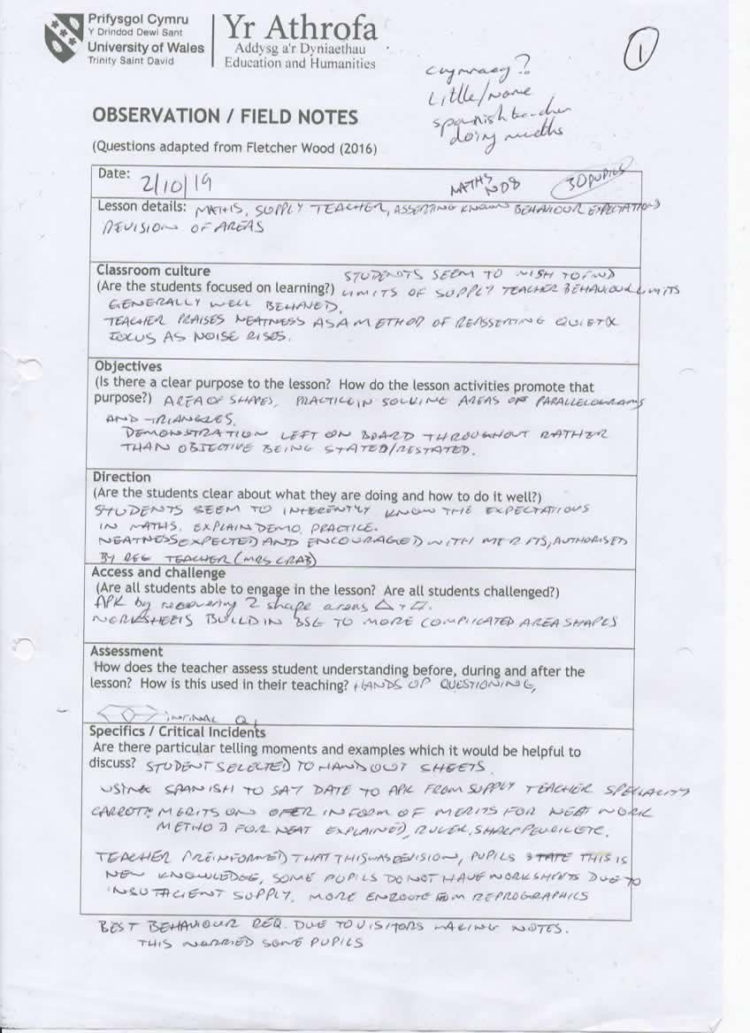

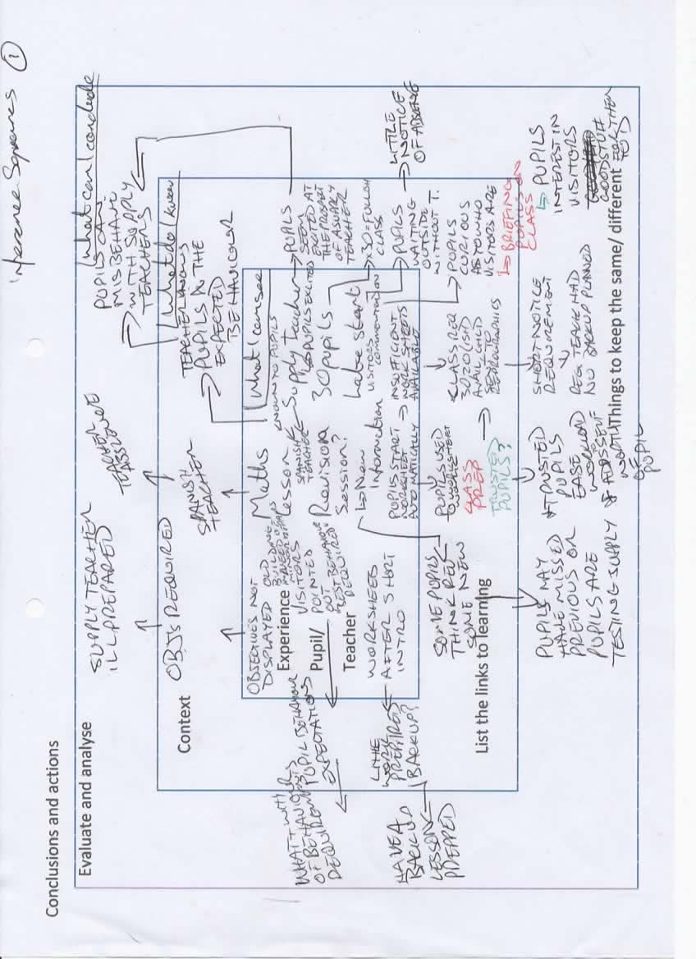

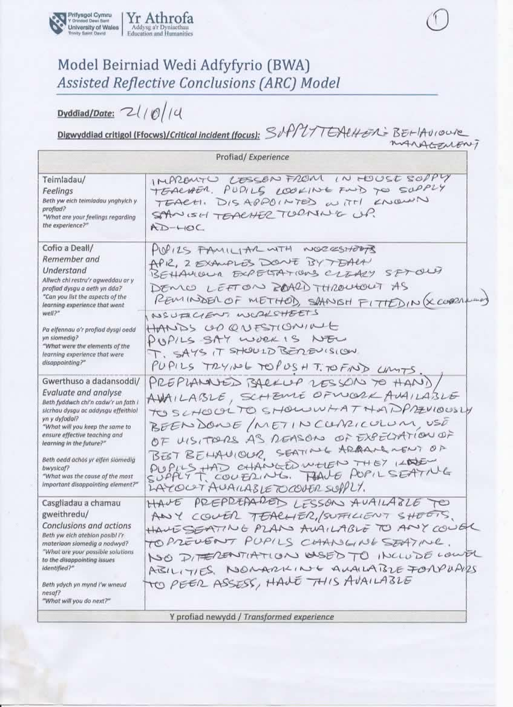

Appendix B
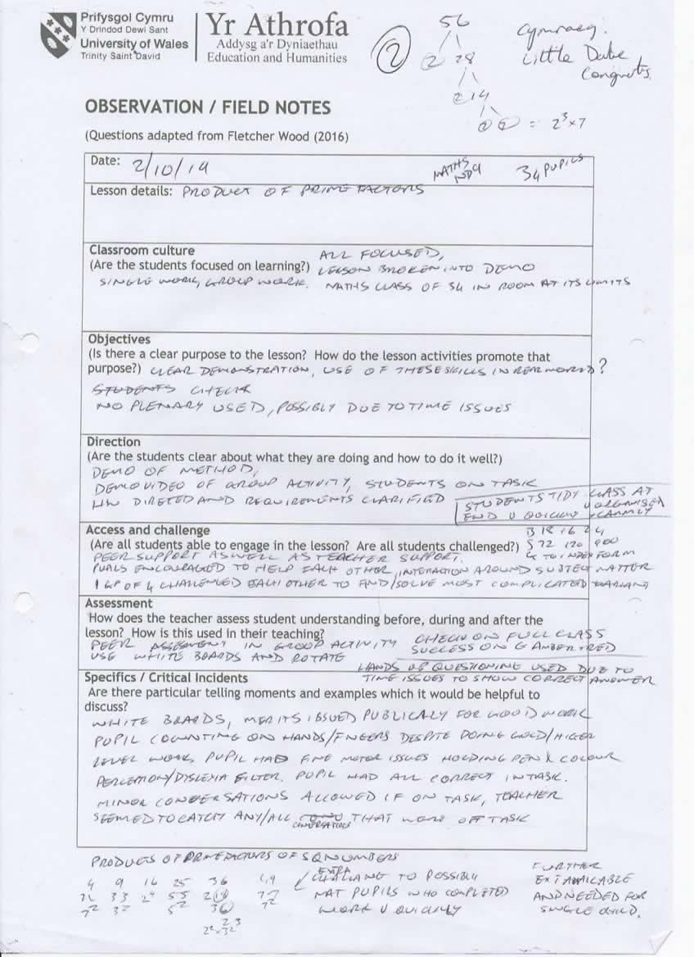

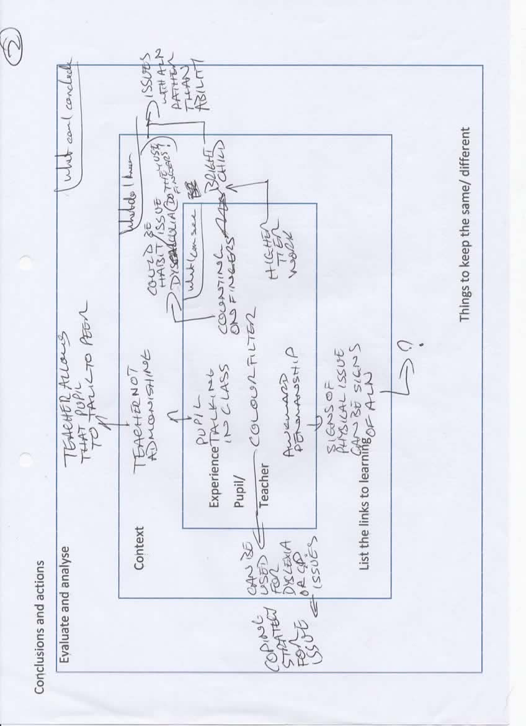

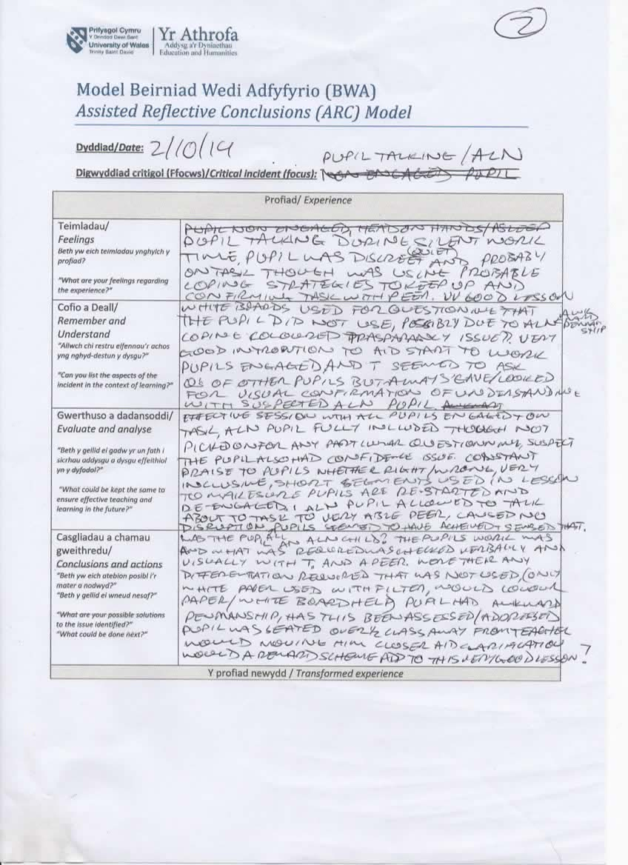

Appendix C
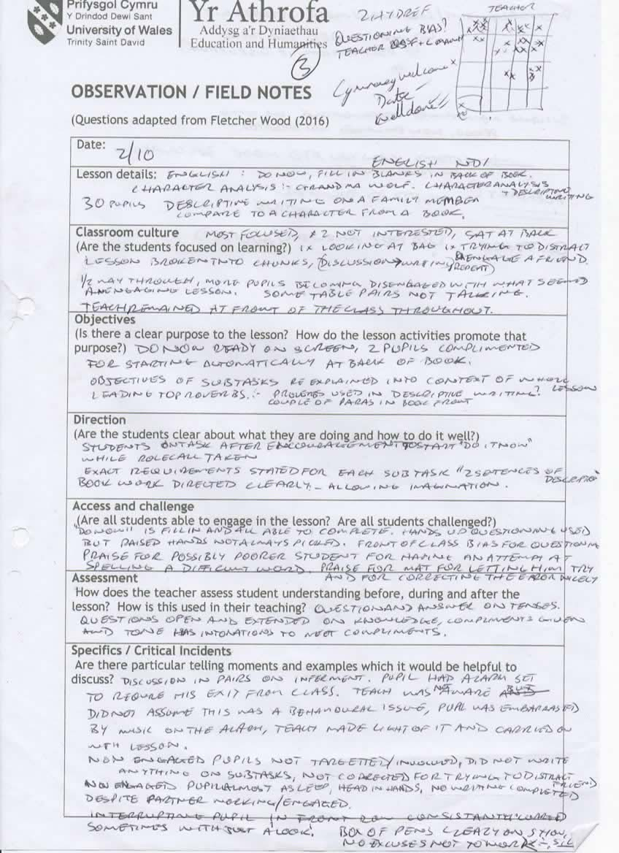

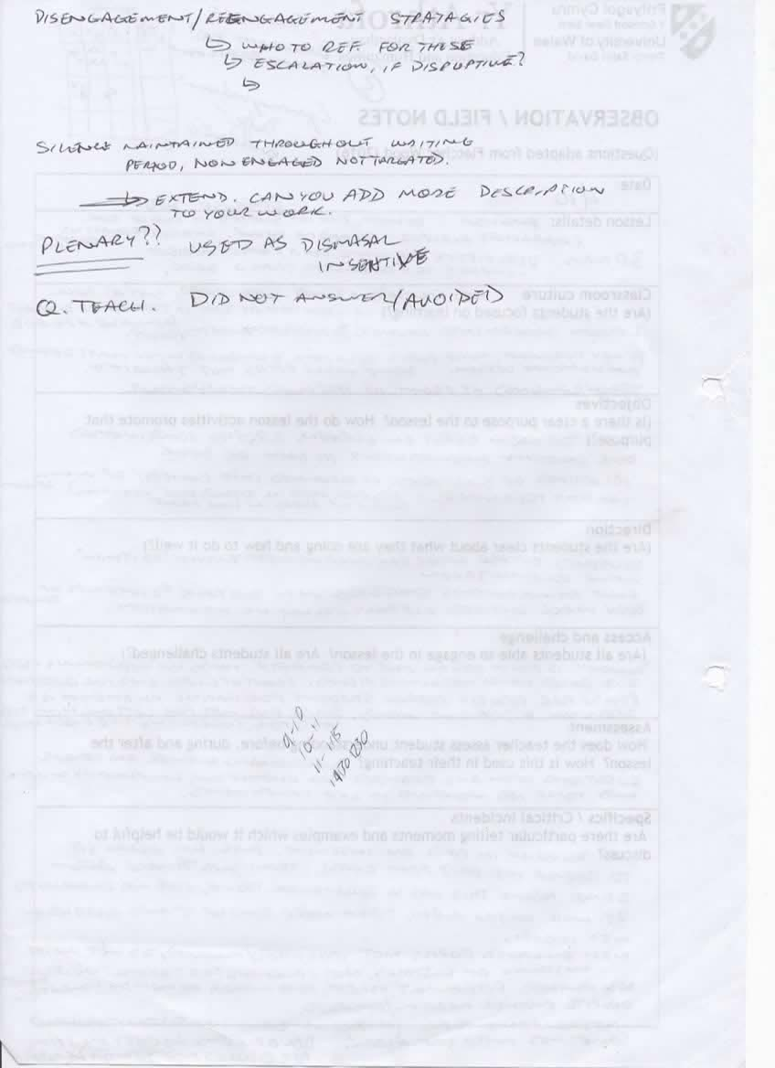

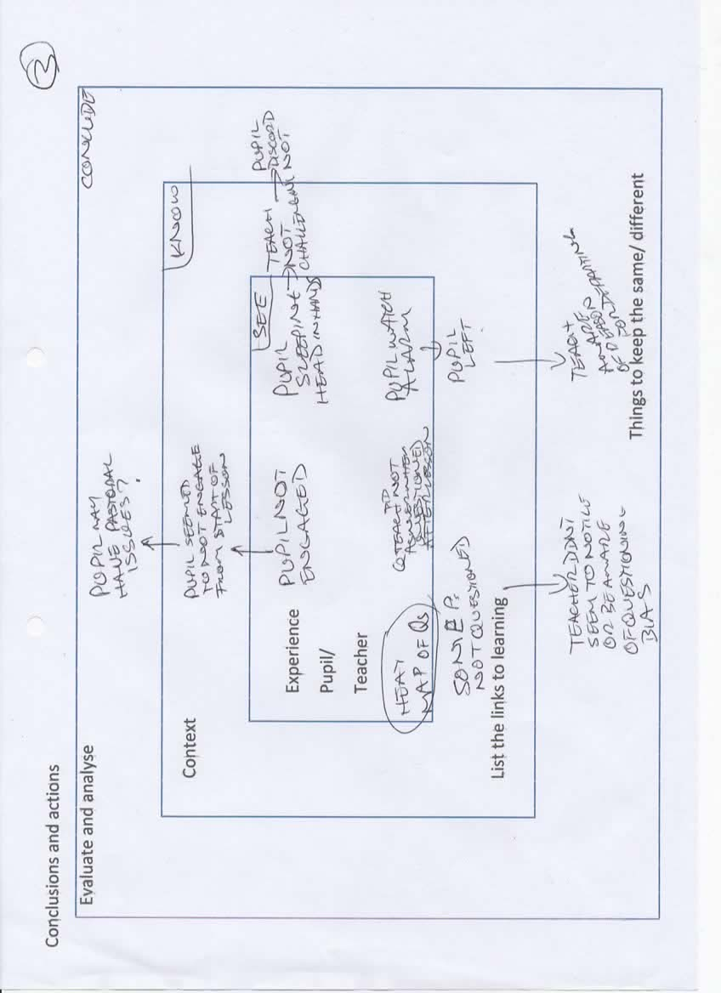

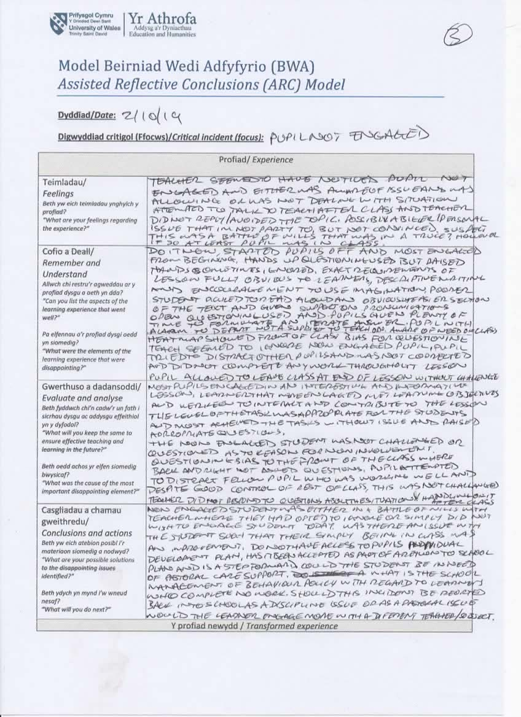

Appendix D
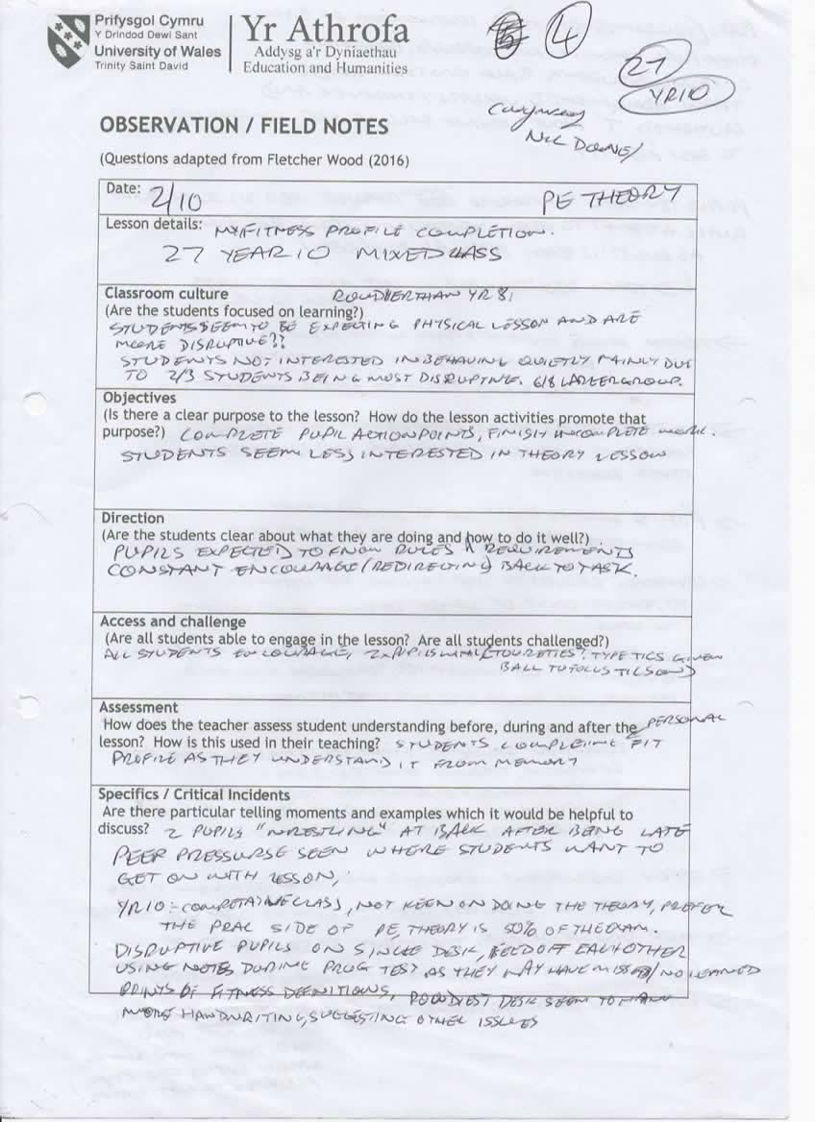

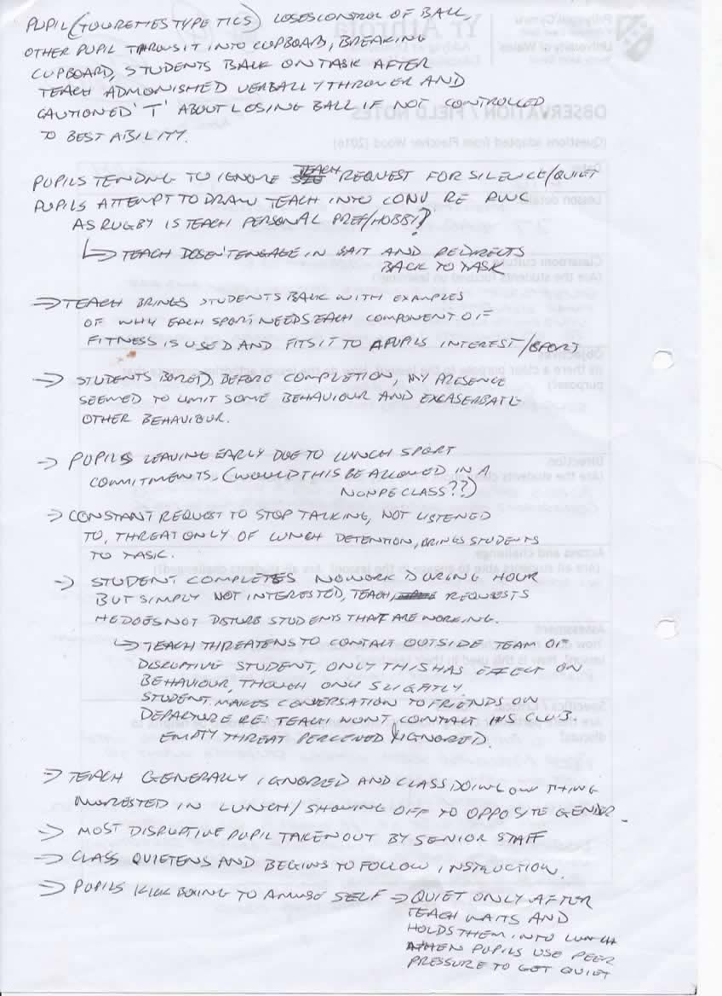

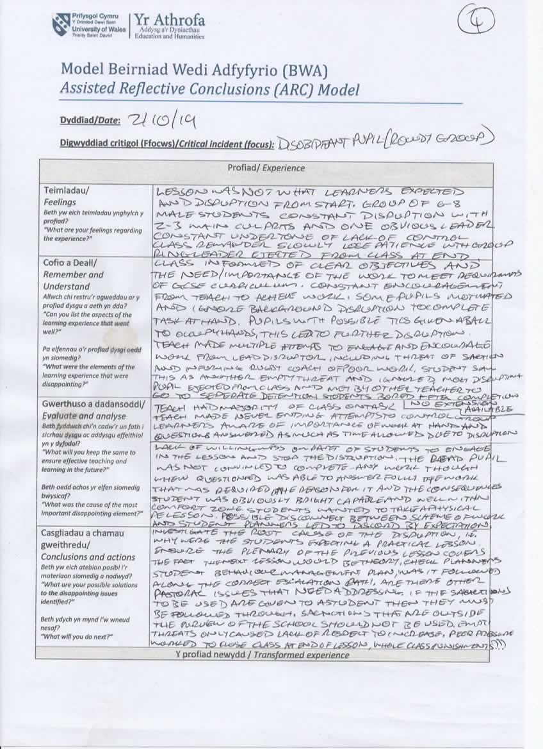

Appendix E

Not Used
9
2
9
12
3
1
1
1
1
2
4
22
Observer
Teacher

