

LOCATION: Swansea | LLEOLIAD: abertawe
LEVEL 4 | LEFEL 4
EXAMINATION PERIOD | CYFNOD ARHOLIADAU
may 2019 | mai 2019

MODULE CODE: ACDB4002 / ACDA4006
Electrical & Electronic Principles
TIME: 2 HOURS
answer all questions

Equipment or materials required – Calculator, Graph paper
Adnoddau neu ddefnyddiau sydd eu hangen – cyfrifiannell, papur graff

Formula sheet and graph paper are after questions

Detach graph paper and place in your Answer book write your student number and question number on any graph paper used
ANSWER ALL QUESTIONS

- For the circuit shown in Fig. Q1, calculate:
  - The total resistance.
[2 Marks]
  - The total current if the battery voltage was 12V
[1 Mark]
  - The current flowing through the 500Ω resistor
[4 Marks]
  - The total power dissipated by the circuit
[1 Mark]
  - The power dissipated by the 1500Ω resistor
[4 Marks]
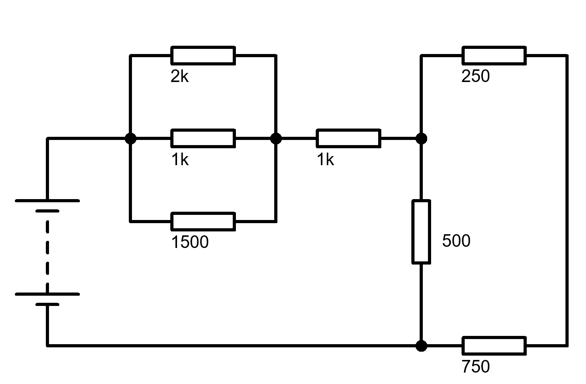
Fig. Q1

- For the circuit shown in Fig. Q2:
  - Show with the aid of a diagram, where you would place an ammeter and voltmeter to determine the current and voltage associated with R1. Re-draw the circuit.
[1 Mark]
  - Calculate the effective circuit resistance
[2 Marks]
  - Calculate the power dissipated in R2
[1 Mark]

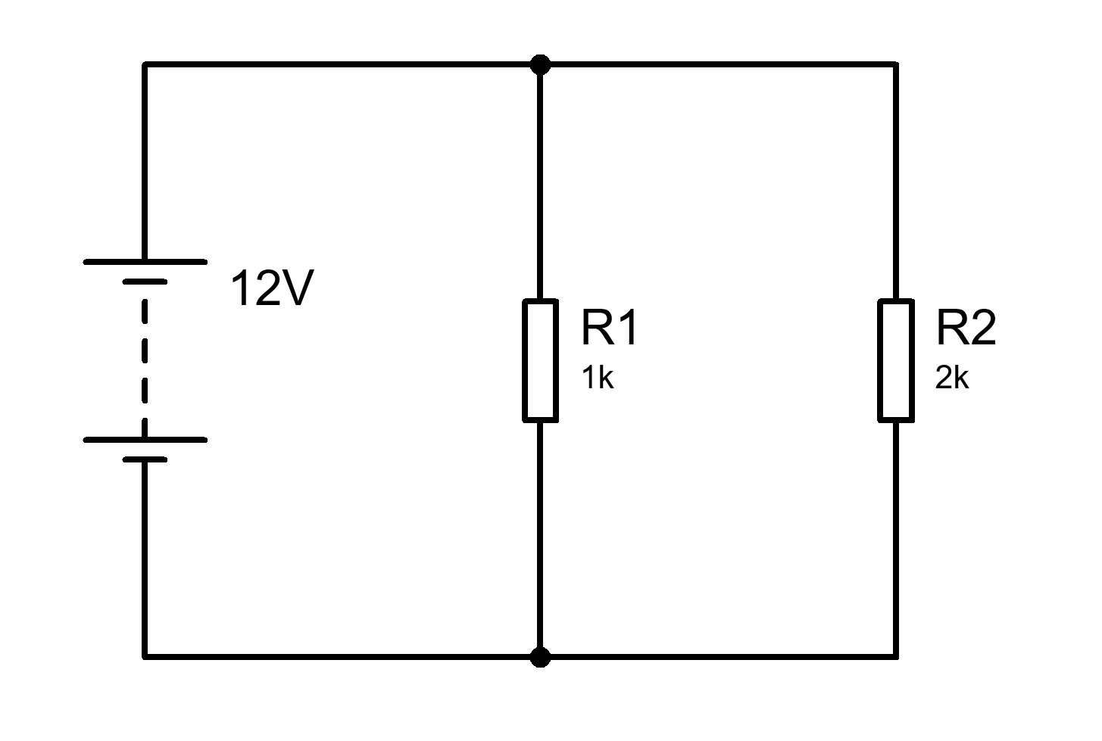
Fig. Q2

- Determine Vs for the following circuits and draw phasor diagrams showing each of the voltages.

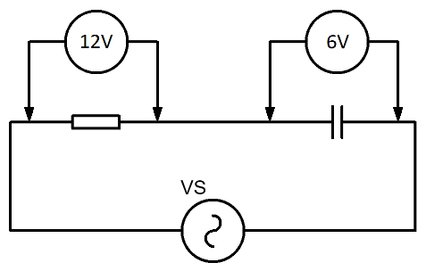
Fig. Q3
[2 Marks]

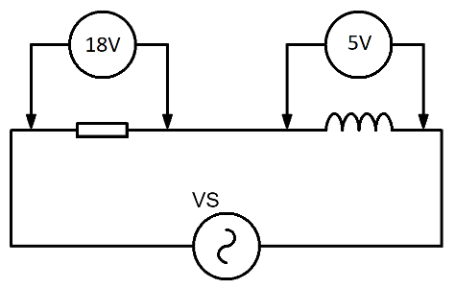
Fig. Q4
[2 Marks]

- For the circuit shown in Fig. Q5:
- Complete the table below and plot a graph of capacitor voltage against time for the switch in the position as shown for times between 0 seconds and 0.5 seconds.

Time (seconds) | Capacitor Voltage (V)
0
0.1
0.2
0.3
0.4
0.5

[6 Marks]

- After the capacitor is fully charged the switch is pressed such that the capacitor is now in circuit with R2. Plot a graph of the capacitor voltage against time for times between 0 seconds and 1 second.
[6 Marks]

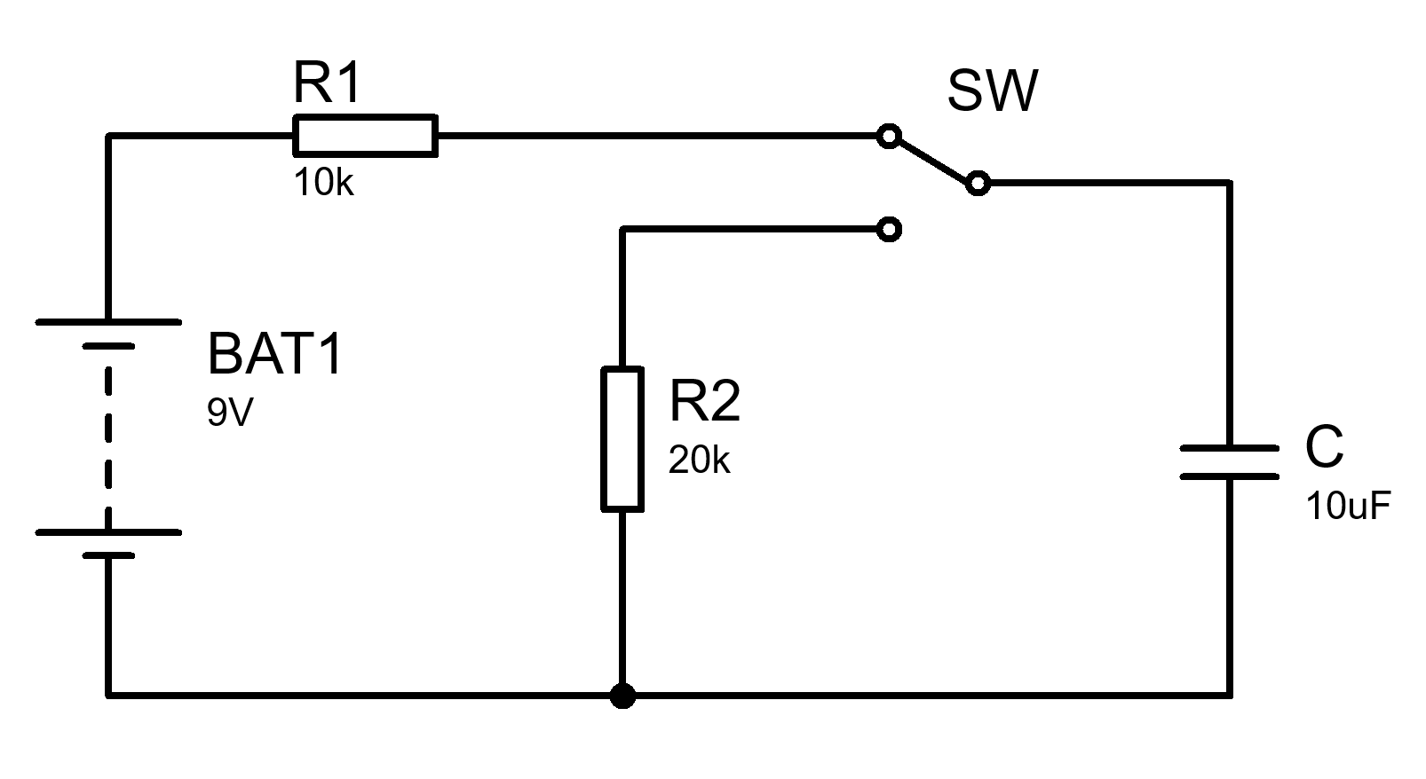
Fig. Q5

- For the circuit shown in Fig. Q6:
- Calculate the total impedance
[2 Marks]
- Calculate the circuit current and phase angle
[3 Marks]
- Calculate the voltage drop across the resistor
[1 Marks]
- Calculate the voltage drop across the inductor
[1 Marks]
- Calculate the voltage drop across the capacitor
[1 Marks]
- Draw a phasor diagram labelling the component voltages, supply voltage and circuit current
[6 Marks]
- Calculate the resonant frequency
[2 Marks]
- Determine the Q factor of the circuit
[2 Marks]

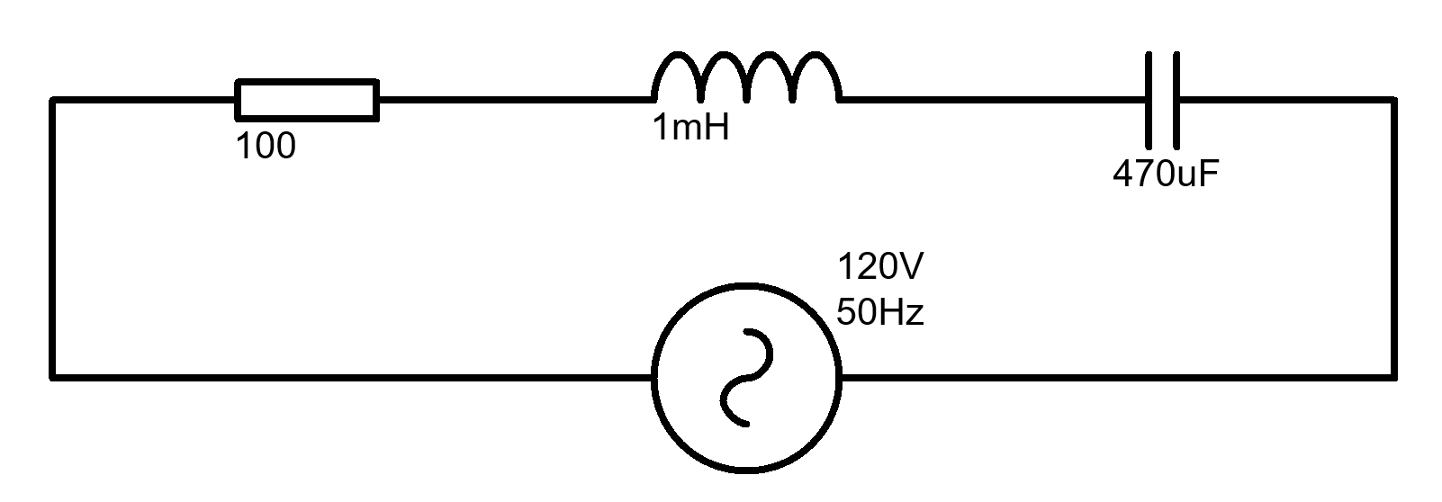
Fig. Q6

Formulae Sheet
$$V=IR$$  $$I=\frac{V}{R}$$  $$R=\frac{V}{I}$$ | $$P=VI$$  $$V=\frac{P}{I}$$  $$I=\frac{P}{V}$$ | $$P=\frac{V^{2}}{R}$$  $$P=I^{2}R$$ | $$R_{T}=R_{1}+R_{2}+…+R_{n}$$  $$\frac{1}{R_{T}}=\frac{1}{R_{1}}+\frac{1}{R_{2}}+…+\frac{1}{R_{n}}$$ | $$V_{Out}=V_{in}\frac{R_{B}}{R_{A}+R_{B}}$$
$$X_{C}=\frac{1}{2πfC}$$  $$X_{C}=-j\frac{1}{ωC}$$ | $$X_{L}=2πfL$$  $$X_{L}=jωL$$ |  | $$\frac{1}{C_{T}}=\frac{1}{C_{1}}+\frac{1}{C_{2}}+…+\frac{1}{C_{n}}$$  $$C_{T}=C_{1}+C_{2}+…+C_{n}$$ | $$f_{res}=\frac{1}{2π\sqrt{LC}}$$
$$X_{T}=X_{L}-X_{C}$$  $$Z=R+j\left(X_{L}-X_{C}\right)$$  $$\left|Z\right|=\sqrt{R^{2}+{\left(X_{L}-X_{C}\right)}^{2}}$$ | $$φ=\tan^{-1}{\frac{X_{T}}{R}}$$  $$pf=\cos{φ}$$ |  | $$L_{T}=L_{1}+L_{2}+…+L_{n}$$  $$\frac{1}{L_{T}}=\frac{1}{L_{1}}+\frac{1}{L_{2}}+…+\frac{1}{L_{n}}$$ | $$ω=2πf$$
$$τ=RC$$  $$V_{C}=V_{s}\left(1-e^{{-t}/τ}\right)$$  $$I_{C}=\frac{V}{R}\left(e^{{-t}/{RC}}\right)$$  $$V_{C}=V_{0}\left(e^{{-t}/τ}\right)$$  $$I_{C}=-\frac{V}{R}\left(e^{{-t}/{RC}}\right)$$ | $$τ=\frac{L}{R}$$  $$V_{L}=V\left(e^{{-Rt}/L}\right)$$  $$V_{L}=-V\left(e^{{-Rt}/L}\right)$$  $$I_{L}=\frac{V}{R}\left(1-e^{{-Rt}/L}\right)$$  $$I_{L}=\frac{V}{R}\left(e^{{-Rt}/L}\right)$$ |  | $$f=\frac{1}{2πRC}$$  $$A_{V}=20\log{\frac{V_{out}}{V_{in}}}$$  $$A_{P}=10\log{\frac{P_{out}}{P_{in}}}$$ | $$Q=\frac{X_{L}}{R}$$  $$Q=\frac{X_{C}}{R}$$  $$Q=\frac{f_{R}}{f_{U}-f_{L}}$$  $$Q=\frac{1}{R}\sqrt{\frac{L}{C}}$$
$$V_{B} \text{=}\frac{\text{RB2}}{\text{(}\text{RB}\text{1 + }\text{RB}\text{2)}}\text{×} V_{CC}$$  $$V_{E}=V_{B}-0.7$$  $$I_{C}=I_{E}$$  $$V_{C}=V_{CC}-\left(I_{C}×R_{C}\right)$$  $$Av=\frac{v_{c}}{v_{b}}$$  $$V_{E}=10\%V_{CC}$$  $$R_{IN}=\frac{1}{\frac{1}{R_{1}}+\frac{1}{R_{2}}+\frac{1}{\left(h_{FE}×R_{E}\right)}}$$  $$R_{OUT}=R_{C}$$  $$A_{V}≈-\frac{R_{C}}{R_{E}}$$ |  |  | $$V_{out}=-\frac{R2}{R1}×V_{in}$$  $$V_{out}=\left[1+\frac{R2}{R1}\right]×V_{in}$$  $$V_{out}=\frac{R2}{R1}×\left[V_{2}-V_{1}\right]$$  $$V_{out}=-\frac{R2}{R1}×\left[V_{1}+V_{2}\right]$$  $$V_{out}=-\left[\frac{R}{R1}×V_{1}+\frac{R}{R2}×V_{2}+…+\frac{R}{Rn}×V_{n}\right]$$

Diwedd/End


