
APPENDIX GA36a

LEVEL 4 ASSESSMENT SPECIFICATION

Student name: | MAX AARON | Student ID number: | 2014490
Programme:
Module: | Material Science and Building Services
Module code: | ACBA4006 | Contribution to Overall Module Assessment (%): | 50%
Lecturer: | Allan Nantel | Internal Verifier: | Dr. K.Ranasinghe
Assignment Title: | Construction Materials | Word count (or equivalent): | 2500 words
Submission deadline: | 2nd March 2021 | Return date of provisional marks & written feedback: | Within 20 working days
Submission method: | All written assessments, where practical and possible, must be submitted via Turnitin unless otherwise instructed by the Lecturer. (Please DO NOT put this assessment specification into Turnitin or it will match many similarities with other students’ submissions.)  Alternative submission method (if applicable):  Late submission of the assessment will result in a late penalty mark. Penalties for late submission: Up to one week late, maximum mark of 40%. Over one week late, 0%. Only the Extenuating Circumstances Panel may approve a change to submission dates.
Academic honesty / referencing: | Academic honesty is required. In the main body of your submission you must give credit to authors on whose research and ideas your work is based. Append to your submission a reference list that indicates the books, articles, etc. that you have used, cited or quoted in order to complete this assessment.

A report focussing on:

The Use of Steel and Concrete in Building Framework

Prepared for:

Alan Nantel

Prepared by:

Max Aaron

Table of Contents
Yale University Paul Rudolph Hall 3
Empire State Building 4
Concrete Framework 6
Steel Framework 6
Conclusion 7
References 7

Yale University Paul Rudolph Hall

Designed by the architect Paul Rudolph in 1963 and built in downtown New Haven Connecticut, the university building is one of Americas earliest examples of brutalist architecture (Anon., n.d.). Rudolph was concerned with the method of natural lighting which he felt was important due to the nature and purpose of the building, and felt it contributed the character and psychological implication of space. Rudolph also created space illusions by incorporating steps between two spaces to create virtual separation between them (Anon., n.d.).
The design plan of the building consisted of four large concrete columns that define the central 9 square grid, and also accommodate the mechanical services in the building. Vertical circulation was designed by having two additional squares, this therefore allowed for vertical circulation flows to be kept outside the 9 square grid (Anon., n.d.).

Similar to other brutalist type buildings, the Rudolph Hall was constructed using mostly ribbed, brush hammered corduroy concrete. By pouring concrete into vertically ribbed wood forms that were later stripped away, Rudolph was able to obtain strong vertical striations on the surfaces. This treatment for exposed concrete does not stain easily and creates an interesting interior visual (Anon., n.d.). The Structure is 114,000 ft2 and nine stories high constructed by use of cast-in-place heavy concrete (Anon., 2009).

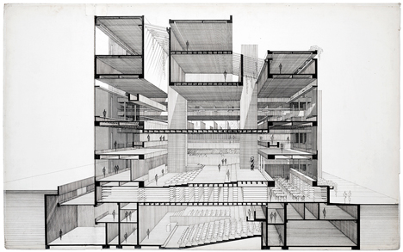
Figure 1 (Mairs, 2014)

When considering the social and environmental sustainability of the project, Paul Rudolph claimed that concrete naturally has the capability of being weather resistant which is beneficial in northeast American cities, but also through the nature of the chosen style of corrugated forming systems it allowed for the aggregates to be exposed to show off the various beautiful colours (Anon., 2020). Quoted by Paul Rudolph “The stain of the concrete was contained within the grooves, whereas the leading edges were constantly washed by the rain. It broke down the scale of walls and caught the light in many different ways because of its heavy texture. Light was fractured in a thousand ways and the sense of depth was increased. As the light changed the walls seemingly quivered, dematerialized, took an additional solidity” (Anon., 2020).

Empire State Building

The Empire State Building in New York City is one of the most famous skyscrapers in the world standing at 381m tall and has 100 floors. The building was the tallest in the world until 1971, whereas today it is now the fourth tallest building in the United States (Anon., 2021). The building was constructed in less than 14 months using a hot riveted steel frame meaning the frame is a lot stronger than if it was built using joints of welds or bolts, as the rivets apply pressure between the two surfaces (Anon., 2021). The construction project of the Empire State Building used Gantt Charts (Anon., 2021).

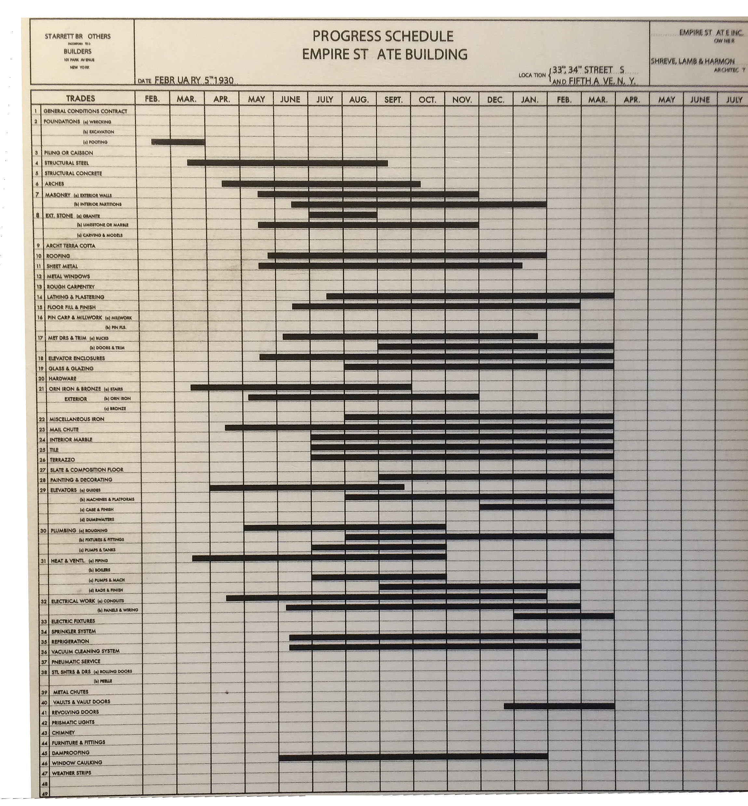

Figure 2, (Anon., 2021).

There were various materials used in the construction of the structure, including 60,000 tons of steel, and 740 tons of aluminium and stainless steel. The steel frame forms a 3-d grid made up of the steel columns and beams, however because the building is so tall in structure there are no column free spaces on any of the floors (WBGH, 2000).

Efficiency was key in the construction of the building as steel beams and stonework were prepared off site and then delivered onto the site to be installed by workers, sometimes at hundreds of feet above the ground riveting steel girders (Grabianowski, n.d.)

The construction plan consisted of building the vertical circulation, mail chutes, toilets, shafts and corridors in the centre of the structure, and surrounding would be office space, which decreases in size as the building size increases due to a pyramid like shaped design. 210 steel columns would make up the vertical frame, where 12 ran through the entire height of the building. When installing the steel girders, large cranes were used to install them at higher levels (Rosenburg, 2019).

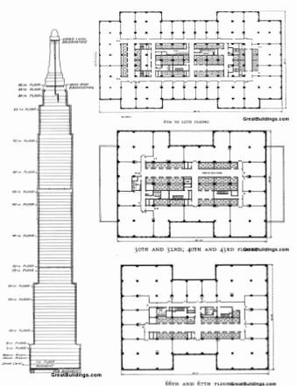

Figure 3 (Anon., n.d.)

Due to the nature of the structure, being so tall, a substantial concrete foundation had to be installed to withstand and support the weight of the steel framework of the building. The steel was prefabricated steel manufactured to 2mm tolerances, and installed to complete the framework in 3 days, which was then finished in an outer skin of stone (Ryan, 2009)

In the last 10 years a restoration program for the Empire State Rebuild worth $550 million has taken place to improve the energy efficiency within the building. The projects aim was to optimise energy usage by implementing such things as reducing heat loss energy from elevators by using reflective barriers, to using adjustive lighting systems. This project has improved the sustainability of the building and reduced its total carbon footprint (Anon., 2021). To put this into perspective the retrofit will save the building $4.4 million in energy costs per year and in the next 15 years the buildings greenhouse gas emissions will have reduced by 105,000 tons (Schneider, 2013).

Concrete Framework

When discussing durability, concrete excels in its ability to last long without much deterioration. This is because concrete is good at resisting weathering, chemicals, abrasion, and even natural disasters, and still continues to maintain its engineering properties. This means that concrete can also be considered to be very sustainable as it requires very little maintenance which therefore helps the environment by conserving resources and reduces waste, as well as reducing the pollution that is caused during the manufacturing process of the material (Anon., 2019).

Concrete is the most widely used substance in the world, after water of course. So, in terms of concretes impact on the environment during its production stage, it is something very important to evaluate and consider. It is said that 2.8 billion tons of carbon dioxide has been emitted into the atmosphere and it is responsible for 4 to 8% of the worlds C02, and in calculation we have already passed the point where concrete outweighs the carbon mass of every tree in the world. However, concrete isn’t seen as troublesome as It sounds as concrete isn’t derived from fossil fuels. But when looked into in greater depth, it can be understood that it has a massive effect on the environment, and for all the wrong reasons. Concrete production uses 1/10th of the worlds industrial water usage, increases the risk of respiratory diseases through dust, and the sites where concrete is manufactured are heavy pollutants, as well as the vehicles that transport the material. (Watts, 2019)

Concrete as a material in the use of building framework and outer structure is designed to last in good stead for 30 years, but because of its high durability the buildings often last for anywhere as long as 50 to even 100 years or longer. Furthermore, because of its long durability, when a building made of concrete is brought down it usually isn’t because of deterioration, and therefore the frame and structure of the building can be repurposed (Anon., 2019).

Steel Framework

Steel is a very durable material as it is a compound metal, so it has many different useful properties, and it is also very weather resistant. As it is highly resistant to most elements steel is very useful in environments where wind speed can be high, there are frequent storms, and there are sometimes difficult conditions. Furthermore, because steel is able to withstand such harsh weather conditions and strong winds, structures with steel frames are able to stand taller, without buckling or breaking. Steel is similar to concrete in that it maintains it’s look quite well even through harsh weathering, and also steel is resistant to corrosion. Steel is also similar to concrete as its very versatile and can be shaped and moulded into many desired designs (Anon., n.d.).

The main material in the production of steel is iron ore which requires a high amount of energy and therefore causes a high amount of air pollution in the forms of carbon dioxide, carbon monoxide, nitrous oxide, by using diesel generators, trucks and other equipment. Mining of iron ore also causes heavy metal water pollution and acidity which can go on for thousands of years. In perspective to concrete, the production of steel adds 3.3 million tons to global warming annually (Anon., 2020).

When steel framework is built onsite it is assembled by use of steel components. The design and thought implication prior to the assembly is paramount in creating a structure that has “buildability”. The use of lifting with cranes and placing the steel into position means high cost, but quick installations due to the steel being prefabricated unlike some of the building process of concrete framework (Anon., n.d.). Steel is also very adaptable in terms of use as it can be used to form a frame for a building, but also reinforcing bars, steel sheets, and also non-structural applications such as for heating, cooling, and interior ducting (WorldSteel, n.d.). Steel is also very versatile as it can be reused throughout its lifecycle. As seen with its use in scaffolding, steel components are easily buildable and demountable, and therefore on a larger scale when a building is no longer needed then the steel framing can be demounted, checked, cut, and reused in the building of another structures framework (SteelConstruction.info, 2020).

Conclusion

Both Steel and Concrete as framework materials offer great versatility, durability and ease of assembly. Furthermore, they both also have their disadvantages with such characteristics like CO2 emissions and their adverse effect on global warming. With consideration, both materials are highly valuable to the construction industry and have provided many years of successful and innovative engineering like with structures like the Paul Rudolph Hall and the Empire State Building, and the framework materials will certainly continue to lead the construction industry.

References
Anon., 2009. Concrete Restoration of Yale University’s Paul Rudolph Hall. [Online]
Available at: http://www.hoffarch.com/assets/News19.pdf
Anon., 2019. Concrete Technology - Durability. [Online]
Available at: https://www.cement.org/learn/concrete-technology/durability
Anon., 2020. Paul Rudolph Heritage Foundation. [Online]
Available at: https://www.paulrudolphheritagefoundation.org/195802-art-architecture-building
Anon., 2020. The World Counts. [Online]
Available at: https://www.theworldcounts.com/challenges/planet-earth/mining/environmental-impact-of-steel-production/story
Anon., 2021. Empire State Building, New York. [Online]
Available at: https://www.designingbuildings.co.uk/wiki/Empire_State_Building,_New_York
Anon., 2021. Sustainability. [Online]
Available at: https://www.esbnyc.com/about/sustainability
Anon., n.d. [Online]
Available at: https://www.pinterest.co.uk/pin/823455113094731074/
Anon., n.d. Image Building Systems. [Online]
Available at: https://imagebuildingsystems.com/steel-101-the-durability-of-steel/
Anon., n.d. Rudolph Hall. [Online]
Available at: https://en.wikiarquitectura.com/building/rudolph-hall/
Anon., n.d. Steel Construction Info. [Online]
Available at: https://www.steelconstruction.info/Construction
Grabianowski, E., n.d. Empire State Building Completed. [Online]
Available at: https://science.howstuffworks.com/engineering/structural/empire-state-building.htm
Mairs, J., 2014. Brutalist buildings: Yale Art and Architecture Building, Connecticut by Paul Rudolph. [Online]
Available at: https://www.dezeen.com/2014/09/26/yale-art-and-architecture-building-paul-rudolph-brutalism/
Rosenburg, J., 2019. The Empire State Building. [Online]
Available at: https://www.thoughtco.com/the-empire-state-building-1779281
Ryan, V., 2009. The Empire State Building. [Online]
Available at: https://technologystudent.com/culture1/empire1.htm
Schneider, D. R., 2013. How The Empire State Building is Redefining Sustainability and Supporting the Economy in New York City. [Online]
Available at: https://blog.nationalgeographic.org/2013/05/08/how-the-empire-state-building-is-redefining-sustainability-and-supporting-the-economy-in-new-york-city/
SteelConstruction.info, 2020. SteelConstruction.info. [Online]
Available at: https://www.steelconstruction.info/Recycling_and_reuse#Reuse
Watts, J., 2019. The Guardian. [Online]
Available at: https://www.theguardian.com/cities/2019/feb/25/concrete-the-most-destructive-material-on-earth
WBGH, 2000. Empire State Building. [Online]
Available at: https://www.pbs.org/wgbh/buildingbig/wonder/structure/empire_state.html
WorldSteel, n.d. World Steel. [Online]
Available at: https://www.worldsteel.org/steel-by-topic/steel-markets/buildings-and-infrastructure.html

Student FEEDBACK FORM

Generic Assessment Criteria | Marks available | Marks  awarded
1. Engagement with Literature Skills  . | 20
2. Knowledge and Understanding Skills | 30
3. Cognitive and Intellectual Skills | 30
4. Practical Application Skills | 10
5. Transferable Skills for Life and Professional Practice | 10

Assessment Mark (Assessment marks are subject to ratification at the Exam Board. These comments and marks are to give feedback on module work and are for guidance only until they are confirmed. ) | Late Submission Penalties (tick if appropriate) |  | %
 | Up to 1 week late (40% Max) |  | %
 | Over 1 week late (0%) |  | %

