

Impact of GHRM on Employees Engagement

Student’s Name : Vrajeshkumar B. Gohel
Student’s ID Number : 2216495
Supervisor’s Name : Husam Alharahsheh

Abstract
Green Human resource management has become essential in current market scenario to manage employee in international market and maintain their wellbeing with environment friendly ecosystem. This study has analysed the recent literature collecting secondary data to review existing theories and identified research gap. Importance of GHRM is known in the market but its application for enterprises and expected competitive advantages and disadvantages are still unknown. GHRM has become popular after United Nation has declared Sustainable development goals and Pandemic situation. Now, it is essential to know the relationship between GHRM and employee engagement in different sized organisation. For this reason following objectives are selected to find result that support in the decision making of different sized organisation in terms of GHRM implementation.
- To analyse the Advantages of GHRM
- To determine the challenges of GHRM
- To identify the relationship between GHRM and Employee engagement
Primary data collection method and Quantitative research approach has been undertaken in this research to find the result of the research questions. A set of questionnaire has been prepared and around 71 responses has been collected from potential participants maintaining ethical consideration. The survey has been conducted using Google Form and findings has been represented using pie charts. The statistical outcomes of real time data has been quantitatively analysed to draw the conclusion for this study. The findings has indicated that GHRM should be implemented in every organisation to sustain their competitiveness in long run but small organisations have to focus on their available resource before making investment decision in GHRM due financial burden.

Table of Contents
Chapter 1: Introduction 8
Introduction 8
Rational 8
Problem statement 10
Research Aims and objectives, and questions 11
Explanatory variables and dependent variables 11
Research scope 11
Research Significance 12
Summary 13
Chapter 2: Literature Review 14
Introduction 14
Conceptualisations of GHRM 14
Using Sustainable Environmental practises in Human Resource Management 16
GHRM practises' contribution to organisational commitment 17
GHRM and environmental cooperation 18
Advantage of GHRM 19
Challenges of Implementing GHRM 21
Relationship between GHRM and Employee Engagement 22
Theoretical Analysis 24
Motivation Theory 24
Triple Bottom Line Theory 27
Literature gap 29
Summary 30
Chapter 3: Methodology 31
Introduction 31
Positivism philosophy 31
Deductive research approach 32
Quantitative research strategy 32
Data collection and Sample size 33
Random sampling 33
Ethical consideration 33
Descriptive research design 34
Primary data collection using the survey method 34
Reliability and Validity 35
Sample size and target population 35
Summary 36
Chapter 4: Findings and Discussion 37
Introduction 37
Findings and Analysis 37
Discussion 47
Summary 53
Chapter 5: Conclusion and Recommendation 54
Conclusion 54
Recommendation 54
Linking with objective 56
Objective 1: Analyse the Advantages of GHRM 56
Objective 2: Determine the challenges of GHRM 56
Objective 3: Identify the relationship between GHRM and Employee engagement 57
Research limitation 58
Future scope 58
6. Reflection 58
Reference list 62
Appendices 74
Appendix 1: Survey Question 74

List of Figures
Figure 1.1: GHRM publication in organisations from 2011 to 2020 9
Figure 2.1 Conceptualisations of GHRM 15
Figure 2.2: Advantage of GHRM 20
Figure 2.3: Motivation Need Theory 24
Figure 2.4: Tripple Bottom Line theory 28
Figure 4.1: Gender 37
Figure 4.2: Occupation 38
Figure 4.3: Income level 39
Figure 4.4: Age group 39
Figure 4.5: Resident 40
Figure 4.6: GHRM influences employee engagement 40
Figure 4.7: GHRM motivates employees in the workplace 41
Figure 4.8: GHRM affects employee communication 42
Figure 4.9: GHRM affects employee health 43
Figure 4.10: Green HRM affects or can influence organisations' prestige 44
Figure 4.11: Biggest barrier 44
Figure 4.12: Environmental Awareness 45
Figure 4.13: Employee framework 46
Figure 4.14: Relationship 46
Figure 4.15: Department 47

Chapter 1: Introduction

Introduction :
GHRM has fascinated the current year and has become a crucial component of firms in which HR plays a significant role in encouraging green workroom regulations. GHRM is a considerable source of competitive advantage that combines human and ecological sustainability. For this to be implemented successfully, GHRM must be widely adopted by its employees since employee engagement is favourable regarding the psychological state associated with the workplace and defined by positive dedication and absorption. Therefore, from this vantage point, connecting green employee engagement with implementing GHRM makes sense. This study investigated how GHRM methods affect environmental performance. These procedures include eco-friendly performance management, rewards and pay, and education and training. This section outlines the context of the research and selects research questions and objectives.

Rational :
It is crucial to adhere to these GHRM principles in today's fast-paced world, where the manufacturing and production industries dominate. GHRM is a practice of using green resources in the workplace that ensure employees' health and take care of the environment (Pham, Tučková and Jabbour, 2019). Decreasing energy consumption, ensuring efficient resource utilisation, and preserving a sustainable environment are essential in today's world. This study's objective is to demonstrate the effects of GHRM practises, a single-dimension construct, on both individual and non-green outcomes to emphasise employee environmental ideals and their relationship to and influence on other ideas. Based on a meta-analysis of 10 years of GHRM, it is clear that the publication of GHRM has significantly increased in the last decade. It is a trending matter that HR managers are encountering to improve their employee engagement (Paulet, Holland and Morgan, 2021). The growing demand for sustainability in organisations has also increased the demand for GHRM in an organisation, and employees feel better when they are engaged with an organisation that operates an environment-friendly business.
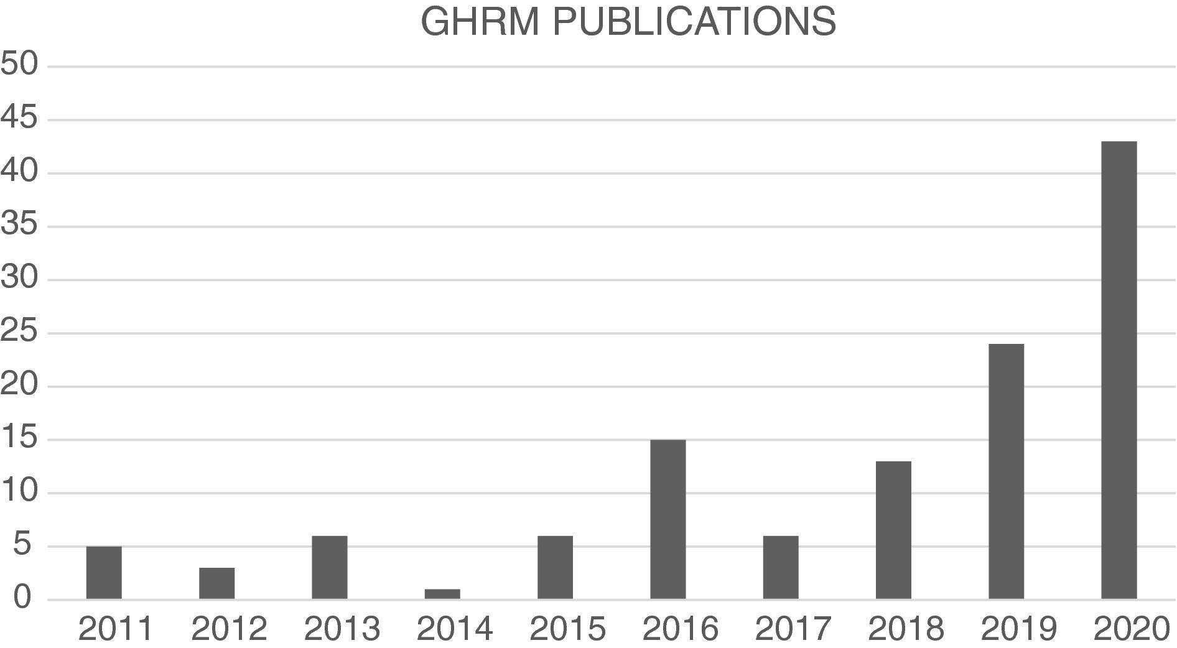

(Paulet, Holland and Morgan, 2021)

GHRM provides clear objectives to the employees and consistently motivates them to work more efficiently to get recognition and establish themselves in a reputed position. Natural environmental practices have become essential for almost every industry, and it is crucial to attract employees and retain them in the current world (Pham et al., 2020). Investigating the connections between job engagement, normative commitment, and continuity also be interesting. This study aims to assess the conceptual model of staff members familiar with environmental management principles and practices and with practical experience applying them.
This chapter highlights briefly the literature’s repeated appeal to update GHRM since it appears that GHRM is heading in the opposite direction of its foundations, with the primary purpose of enhancing employee well-being. Tremendous progress has been made in the GHRM sector in terms of advances. Over the last 30 years, the research has provided more than enough empirical proof that employees and their management bring organisational success. However, the challenge of interpreting success in terms of results emerges here. Given numerous outcomes, empirical research results were primarily defined as economic outcomes, ignoring those linked to employees. Naturally, GHRM resource-related outcomes included many studies. Nonetheless, they mostly acted as a crucial mediator between GHRM and an organisation's financial performance. As a result, GHRM was considered a means rather than a goal in itself, and The pursuit of the performance-GHRM connection has come at the expense of employee happiness. Ironically, such disregard for employee concerns contributes to the effectiveness of GHRM discipline. Changes in society and the labour market have prompted organisations to seek innovative methods of managing GHRM resources to retain these resources in the future.

Problem statement :
Employers and practitioners demonstrate that integrating employee involvement with participation in various sustainability projects is achievable in order to improve organisational ecological performance. The cutting-edge strategy for ensuring environmental sustainability is GHRM. Many innovative techniques have demonstrated how companies manage sustainable development cleverly and successfully by encouraging social responsibility and a feeling of environmental responsibility within teamwork (Suganthi, 2019). The secondary effects of GHRM on employee engagement, which results in green employee empowerment are notable and significant (Mousa and Othman, 2020). Separately, green values weaken the connection between green employee empowerment and OBCE, which asserts that strategies for sustainability link to structure GHRM at all levels. It is unclear to HR managers to what extent GHRM influences employee engagement. In the fast-paced world, every employee is growth seeking, and his or her motivation to change his or her jobs frequently. Still, GHRM-powered organisations have retained employees, and their employee turnover is low. The problem is that it needs to be clarified whether the reason behind the low employee turnover in some organisations is GHRM or not.
Numerous additional research studies have discussed GHRM in developing nations. Studies show that employee green HRM practices affect long-term performance and evaluate how well the GHRM practice packages are implemented (Paillé, 2020). The implementation of GHRM in professional organisations with particular reference to developing nations. Ensures that the earth remains an excellent place to live if environmentally responsible policies are followed. Private or governmental organisations incorporate various diverse, fundamental, environmentally friendly initiatives into their daily operations, and they significantly contribute to assuring a greener environment. GHRM substantially affects organisations' adoption and promotion of green practices and on-the-job employee training. By carefully adhering to ISO14000 standards, it aids employers in establishing a positive reputation in the sector. Greening is a newly popular idea that supports firms in achieving corporate and societal profitability (Benevene and Buonomo, 2020). People are becoming more aware of the concept of becoming green and are beginning to gravitate toward green products or favour the goods or services of businesses that give back to society over those that prioritise profit and efficiency.

Research Aims and objectives, and questions :
Aim
This research aims to analyse the impact of GHRM on employee engagement to resolve employee engagement crises in the market.
Research Objectives
- To analyse the Advantages of GHRM
- To determine the challenges of GHRM
- To identify the relationship between GHRM and Employee engagement
Research questions
- What are the advantages of GHRM?
- What are the challenges of implementing GHRM?
- What is the relationship between GHRM and Employee engagement?

Explanatory variables and dependent variables :
The explanatory variable of this study is GHRM, and the dependent variables of this research are Employee satisfaction, Employee engagement, health and well-being of employees, social development, Environmental development and sustainable development goals.

Research scope :
For instance, longitudinal research was conducted in various corporate and geographic environments. It is possible to study each aspect of GHRM practice in depth and connect it with employee engagement, employee satisfaction and corporate citizenship behaviour and commitments. These studies have significant ramifications for speeding the performance and growth of businesses (Chowdhury, Ghosh and Ghosh, 2022). The employee's inner drive, which is not formally mandated, leads to proactive behaviours. These efforts include prioritising environmental concerns, starting environmental program regulations and motivating others. On the other hand, GHRM is an in-role behaviour described as the degree to which employees carry out their duties in an eco-friendly way. GHRM emphasise the extent to which primary tasks about environmental protection are carried out. It displays how eager workers are to carry out their duties in an environmentally sustainable manner (Riyanto, 2020). It aids in implementing green strategy and helps businesses gain an edge over rivals in the market. Extreme climate change is a significant issue for the entire planet, which is why governments and international environmental organisations are enforcing regulations those businesses, must adhere to stay in business. Due to various factors, one of the world's emerging nations already encounters much red tape while conducting business (Manawa et al., 2022). Therefore, companies and managers must refrain from concentrating on green operations individually, as this results in increased cost consumption.

Research Significance :
The research study revives societal support for the GHRM practices in high demand. The significance made in this study for management and staff about the consideration and use of GHRM and eco-friendly conduct is advantageous. Future researchers who perform similar investigations on the same variable and provide results that are more accurate will also benefit from this research (Fawehinmi et al., 2020). The subject matter experts for their kind words of support and for sharing their intelligent and laudable comments. This helps the business's managers and employees become more environmentally friendly (Amrutha and Geetha, 2019). Overall, the findings of this research study offer academics, professionals, managers, and supervisors helpful viewpoints. The study examines psychological ownership's potential mediating effects on an association between GHRM and employee engagement (Alqudah et al., 2021). Its target audience is those who work in the production sector's automotive, chemical, and food subsectors. The manufacturing industry was specially chosen for the study because it produces goods that are more tangible and has a higher potential to hurt the environment. The principles of conservatism and boosting employee morale and satisfaction, GHRM guidelines promote sustainable resource use. Inside enterprises. Green adoption of GHRM is required since it increases employee engagement.

Summary :
This section analysed context of a relationship between GHRM and Employee engagement. It is possible to thoroughly identify each GHRM practice component and connect it with corporate citizenship behaviour and commitments, employee engagement, and employee satisfaction. Many innovative techniques have demonstrated how companies cleverly and successfully manage sustainable development by encouraging social responsibility and a feeling of environmental responsibility within teamwork. This section has clearly evaluated the research context and proposed the aim of this study that will help in developing understanding the entire research procedure and its significant in current market.

Chapter 2: Literature Review :

Introduction :
This chapter aims to identify the link between GHRM practices and Employee Engagement. Title “Green human resource management” is used in literature to denote the systematic and deliberate fusion of conventional. This investigation explores the essential ideas, frameworks, models, and theories in the domains of GHRM and Employee engagement, demonstrating their interconnection. This research examines the current knowledge landscape, identifies relevant ideas and theories, and studies the research techniques and tactics used in this context, building on established academic arguments. This research will look for conflicts, contradictions in findings, and unsolved problems in order to provide a solid foundation for the concept.

Conceptualisations of GHRM :
Environmental deterioration has become increasingly newsworthy throughout the years. With the trend of going GHRM, environmental care plays a significant and broad role in eco-friendly operations. A crucial component of the company's plan for going to GHRM. Sustainability is the only way to save threatened habitats, and in today's rapidly evolving world, it is a fresh idea. To safeguard and preserve natural resources and achieve the objectives of sustainable development, GHRM has developed (Amjad et al., 2021). GHRM initiatives and investments are increasing among business professionals, the financial sector, healthcare facilities, and academic institutions.
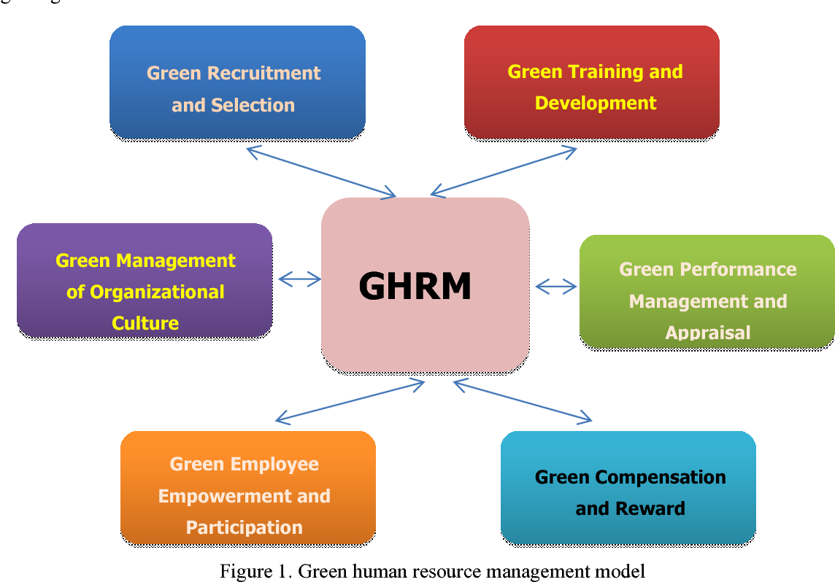
( Amjad et al., 2021)
In the 21st century, where rapid industrialisation growth is causing resource destruction, degradation, and depletion as well as a variety of diseases that pose a health risk due to environmental contamination, greening the populace through the application of GHRM's sustainability principle helps reverse these trends (Kerdawy, 2019). It centres on the homogenous approach toward heterogeneity implementation of GHRM in various working institutions. It solely focuses on a theoretical framework for grasping GHRM as a potential area for future study. The organisation meets it is organisational, environmental, and sustainability goals, improves business efficiency in each business activity, and eliminates waste by making the best use of its resources by greening its workforce through green policies and practices.
As a result, GHRM seeks to establish a green road toward HRM policies through Environmental management and assists businesses, societies, and educational institutions in navigating their green paths to realise their ambitions for environmental sustainability through adopting the policies (Aboramadan, 2020). GHRM policies aim to promote the origins of conservatism while boosting employee morale and happiness. Businesses are encouraged to use resources sustainably that needs GHRM. Globally, GHRM is thriving. People, corporations, and society undergo a significant transformation. GHRM gives commercial enterprises and younger generations an essential lesson about the need to protect the environment and wildlife. When enterprises, banks, hospitals, and academic institutions adopt green technology over time, they benefit significantly from implementing a well-structured GHRM policy (Shafaei, Nejati and Yusoff, 2020). The benefits of Green HRM include improved brand perception and a better reputation in the eyes of society, in addition to excellent results in corporate success, staff productivity, and morale.

Using Sustainable Environmental practises in Human Resource Management :
This section examines how GHRM helps organisations achieve environmental sustainability goals when staff members believe their employer is environmentally conscious. According to the conditional process analysis's findings, perceived organisational support for sustainability successfully communicates the advantages of green employee engagement in contrast to its effects on Performance Management and training for personal environmental performance (Paillé, 2020). Notably, the impacts of GPM, green training, and green employee engagement only translate into perceived administrative support for the environment when employees show high levels of satisfaction with organisational environmental participation. It is well known that GHRM offers a competitive advantage, particularly when achieving environmental performance. However, a study of the relevant literature finds that little is known about how GHRM policies inspire employees to operate sustainably and support workplace greening.
The GHRM procedures improve employee behaviour about the environment. According to the authors, organisations may encourage employee eco-friendly behaviour by including green aspects and clarifying green duties throughout HRM areas such as job design, performance reviews, and rewards when implementing GHRM activities. Other studies show that employees are more inclined to support organisational environmental sustainability activities when their employers support the environment. Perceived corporate support for the environment (POS-E) creates a work environment that supports individual environmental performance through the attitudes and behaviours of environmental personnel (Malik et al., 2020). With an increase in greening organisations and, more specifically, the role those employees play in this process; the subject of organisational support has recently come up again. The term “POS-E” (Roscoe et al., 2019) refers to the perception among employees that their company cares about environmental issues and tries to offer the resources necessary to encourage staff engagement in workplace ecological efforts. Businesses demonstrate their commitment to the environment from the workers' standpoint, or POSE, by supplying staff with the tools they require to support their environmentally conscious conduct.
While the GHRM rules do not directly affect employee participation, they do address training and performance in the environment. The nation benefits from the fact that POS-E communicates the results of ecological education without addressing how a person performs in terms of the environment. Cantor and colleagues claimed that people needed to be adequately rewarded for engaging in environmentally friendly behaviour to account for the lack of influence of incentive application (Singh et al., 2020). According to Pelletier et al. (1996), individual unhappiness with environmental policy affects later ecologically responsible activities, such as the decline in conservation and recycling. Environmental policies do not guarantee that everyone is happy with their surroundings. Instead, they assume that people who disagree with environmental policy are more inclined to take action that is within their power to protect the environment.

GHRM practises' contribution to organisational commitment :
Businesses may benefit from a wide range of benefits integrated into GHRM, including attracting new talent and retaining existing employees, lowering costs and gaining a competitive edge, and increasing total firm productivity in overall employee, the environment, productivity, business sustainability, and efficiency. Organisational commitment is the willingness of the staff to remain with the business and contribute to accomplishing its goals (Shoaib et al., 2021). Many companies have implemented GHRM strategies to enhance environmental sustainability, primarily focusing on reducing environmental pollution and deterioration. Workforce greening is a technique for improving employee commitment, motivation, and general competence. Organisational commitment is influenced by employee identification, loyalty, and involvement. Companies should undertake initiatives to inspire their personnel to continue to be devoted.
Changing employee attitudes and enhancing overall workforce performance are frequent goals of HRM techniques (Alserhan and Shbail, 2020). The advantages gained through GHRM approaches are supported by the facts. Walmart used GHRM as an example, claiming to have saved $12,000 using less paper. Due to the increased importance of environmental awareness, HR has adopted GHRM techniques, including cost cutting. GHRM prioritises resource and ecological conservation the highest (Pandey, 2020). The term “green human capital” indicates the whole amount of employee knowledge, skill, experience, wisdom, creativity, and commitment to "looking green innovation or environmental preservation that was rooted in people rather than businesses.
One of the cornerstones of organisational science is the concept of green human capital, which has been crucial in the adoption of green resource management methods. It has been said that the knowledge and skills of employees in sustainability play a vital role in the adoption of green human resources management. (Islam and others, 2020). On the other hand, it has also been noticed that when workers feel their employer is devoted to environmental sustainability, their knowledge and abilities develop, enhancing their loyalty to the business. The argument put forward here is that green human capital moderates the relationship between GHRM and employee engagement.

GHRM and environmental cooperation :
There is increasing business demonstration pressure. Many sophisticated people embrace the clarity of their impact on the environment. Follow environmental management techniques and other green methods to lessen the dangers to the environment that come with their activity. GHRM is a pathway that joins environmental considerations into HRM strategies and practices (Aboramadan, 2020). It highlights the role of employees in accepting ecologically responsible behaviour and provides sustainability goals to the organisation. Central to GHRM is that employees are one of the specific agents of change. Organisations play an essential role in creating employee attitudes towards sustainability through training and providing opportunities for engaging in green resources. Addressing environmental challenges requires a re-evaluation of firm measures.
Organisational effectiveness and HRM experts need a formulated understanding and alternative strategic paths that environmentally sustainable businesses follow. GHRM practices are central drivers of HRM in factors such as accepting employee management, involvement of humans and diffusion of environmental knowledge (Alqudah et al., 2021). Learning by the organisation is approved and essential for applying employment management practices that are important to achieving more proactive employee management. According to the ability motivation opportunity hypothesis, researchers claimed that the alignment between HRM and GSCM helps to implement environmental cooperation.
Green employees are encouraged towards green orientation when organised, trained, developed to improve performance and then given opportunities to engage in coincidental actions. If staff members are appropriately taught, supported, and given the freedom to do so, With customers and suppliers, they are more inclined to undertake environmental engagement (Benevene and Buonomo, 2020). Training builds awareness and new skills for analysing ecological issues that suppliers and customers face. As a result, knowledge and skills increase if motivation and opportunity are lacking. This is accurate, given how difficult it is to find solutions to the environmental problems providers and consumers face (Amanov, 2023).
When developing an employment system, some firms may restrict their employment struggles to a select group of supply chain and environmentally friendly implementation staff. Green supply chain management is upstream and aims to reduce the total effects on the environment of downstream supply forward and backward movement. Using an integrative framework, this research built on earlier work to produce a deeper comprehension of the impact of GHRM on environmental cooperation, specifically based on the above theory.

Advantage of GHRM :
Nowadays, Green HRM offers various benefits, including accepting green HR leadership. That results in significant efficiency, better employee engagement and lower costs. It helps employees to reduce their carbon footprint through several ways, like virtual interviews. GHRM plays a vital role in the organisation and society in reducing environment-related problems. Organisations formulate GHRM practices and train people to raise environmental awareness regarding environmental protection (Malik et al., 2020). The organisation conducts an environmental audit to increase organisational culture, help people think about pollution, and help those invaded impurely. Moreover, It promotes eco-friendly goods and educates workers and community members on the more prudent use of natural resources.
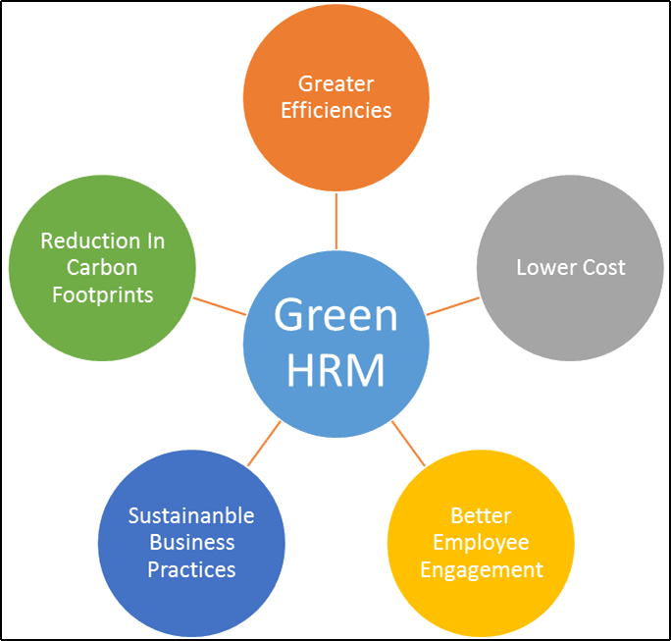
(Malik et al., 2020)
Implementing GHRM is a crucial step on the right path for a workplace that benefits both the employer and the employees. GHRM ensures that the workroom is healthy and productive by enabling workers to convey their concerns and use their rights. For the advancement and growth of the company, GHRM delivers astonishing results. They are crucial for representation, public relations, and partnerships between organisations. Goal setting is a critical component of GHRM's performance management systems, which link the Professional and team goals of employees to the larger goals of the organisation. Employees will find it easier to understand not just their impact but also that of their colleagues because everyone will be able to observe how they contribute to larger goals (Nisar et al., 2021). Setting objectives is critical to creating an atmosphere in which employees collaborate for the company's long-term success in a democratic and accountable culture. Using GHRM to manage employees at every point of their life cycle demonstrates that the business will assist them after the hiring stage (Pham, Tučková and Jabbour, 2019). Employees have the chance to advance their careers, which, according to 94% of workers, will cause them to remain at their firms for a more extended period. Employees will be happier and more dependable as a positive byproduct of focused, motivated personnel (Pham et al., 2020). Unexpected GHRM scenarios inevitably arise, and teams will be required to cope with them while keeping up with regular work, whether it be an unforeseen turnover or a shift in corporate priorities.
It supports organisations to reduce costs without losing talent, lowering the company's total cost because it becomes more efficient in its use of electricity, water and manufactured goods. GHRM helps businesses save on requirement costs by not losing qualified candidates. The online requirement system has the advantage of being utterly transformative as it makes the requirement process more accessible and more cost-effective. The use of GHRM techniques helps the organisation to establish a name for itself in society; additionally, it promotes resource conservation and the use of more affordable eco-friendly products (Shoaib et al., 2021). Today, most conscious consumers look for companies that accept environmental standards, and companies that follow equal-friendly HR policies also benefit greatly. It helps to reap green products and savings from waste elimination, and promoting such standards also indirectly improves consumer satisfaction.

Challenges of Implementing GHRM :
This study was initiated because there is little current research on implementation issues in GHRM practices. However, because adopting technology to ensure a green approach is costly, prior research has indicated concerns about the financial value of green practices in businesses. It also presents a deficiency, as evidenced by research findings of economic Benefits from GHRM practises in organisations that damage other organisational operations. One obstacle to applying GHRM practises in firms is the need for a managerial understanding of employee management. There must be green courses in universities worldwide to practise organisational green implementation.
On the other hand, the maintenance expenses of green practices and a lack of help from staff and higer management have also been noted as significant obstacles to GHRM adoption at institutions. Companies must overcome several obstacles while using GHRM. Candidates who balance environmental and corporate responsibility with competence are hard to come by (Suganthi, 2019). GHRM exercises are expensive to implement in the early stages. It has been found that older workers are resistant to adopting complex greenways. There needs to be a defined metric to measure employee performance as there is a significant gap in HR touch. A HR touch gap is observed while managing online events. Literacy is better in several countries, and advanced knowledge needs acute technical equipment shortage.
Lack of infrastructure and advanced technology. Lack of knowledge about the environment and sustainable development goals. The main problem of the organisation is the implementation problem. Lack of funds to improve environmental conditions. Lack of awareness about environmental protection and green HRM (Singh et al., 2020). Absenteeism is one of the challenges raised by the interviews in adopting GHRM practices. Organisational documents and satisfactory progress Documentation of rules and policies themselves are important controls for integrating HRM practises. Eco-friendly practices and support GHRM practices to conserve established resources. This lack of budget is a costly problem for top management, and managing conversion technology requires investment in fixed assets and human capital. Make it an essential operation as required by human intervention.
Along with awareness, knowledge, and empowerment, empowerment also refers to the freedom to act and be creative. In the end, the HR division had to create its teams and competencies. accelerated the shift from constructing effective GHRM to conventional and environmentally friendly HR practises (Shafaei, Nejati and Yusoff, 2020). In addition, building skills was challenging, as individuals needed organisational support for financial and non-financial issues. In this study's literature review, the researcher identified various challenges of GHRM implementation. The primary obstacles to implementing GHRM include low levels of knowledge, a lack of regulations, managerial interest and organisational support, expensive training costs, and significant staff turnover.

Relationship between GHRM and Employee Engagement :
Behavioural HRM provides that green practices affect organisational performance through work attitude and employee behaviour.According to behavioural research, the most important element in influencing an employee's propensity for green activity is their HRM system. GHRM practices impact workplace sustainability practices for various reasons (Roscoe et al., 2019). A core focus of GHRM is letting people know about the company's green focus, promoting a person's environmental principles during the recruiting and selection process and encouraging employees' green awareness, which is probably increased by training in green ideals.
Green HRM is developing the mindset of employees engaged in environmentally friendly activities by imparting green training practices (Pham, Tučková and Jabbour, 2019). These practices improve employees' knowledge, skills, abilities, and expectations. That their organisation adopts some environmentally conscious HR policy is one of the determinants of the practice impacts on employee productivity in the HRM claims literature. According to the supply price feet theory, an employee's action if the corporation uses polite, cordial, linked green HR practices, it will align with its green policy.These tactics are intended to strengthen employee roles. When their companies give staff members rewards that reflect green performance, green behaviour workers are more likely to become involved and support environmental preservation activities. The motivation factor of AMO relates to the employees involved in environmental initiatives (Nisar et al., 2021). Employers are encouraged to carry out their duties in a manner that is consistent with their ecological knowledge and conduct by using customised evaluation tools and compensation structures.
Clarifying the company's environmental standards and objectives also gives staff members constructive feedback to support long-term performance development and how staff members view the significance of their work. It sharpens their creativity to put up more effort and commitment, and it steers them to role and extra-role performance in accomplishing the firm's environmental goals. These eco-friendly HR practices and policies are linked to favourable behaviours and employee attitudes, which lessen the environmental effect of firms and increase company sustainability (Mousa and Othman, 2020). GHRM application engages workers in green dedication and pro-environmental behaviour. Using green knowledge management, top management ensures the execution of GHRM principles to improve environmental performance. In addition, decision-makers should focus on protecting and enhancing the knowledge of their employees (Malik et al., 2020). GHRM improves employees' sustainable and environmental behaviour; consequently, business connects with human resource sustainability and green problems on employees' organisational commitment, and GHRM improves employees' environment-friendly behaviour. Moreover, businesses must connect HRM, environmental issues, and the organiser's commitment to employees. This research finds that GHRM practices increase employees' eco-commitment. Furthermore, the finding implies that GHRM and employee bonds are detected by green commitment.

Theoretical Analysis :

Motivation Theory
The motivation needs theory explains what motivates people to act in specific ways. An individual is characterised as uninspired when they lack the drive or stimulation to complete a job, as opposed to motivated individuals who are energised and actuated to attain a specific objective. In this sense, the word “motivation”—that is what prompts someone to conduct in a given way or, at the very least, promotes a predisposition for specific behaviour—is the root of the phrase “motivation”. Numerous theories intended to provide motivation solutions have been developed due to various methodologies utilised by academics. Maslow’s motivation theory describes how people behave and function by considering their psychological, physical, economic, and physiological characteristics. Maslow's motivation theory, which is the main focus of this study, is specific in that it emphasises why people act the way they do and how that motivation affects behaviour.
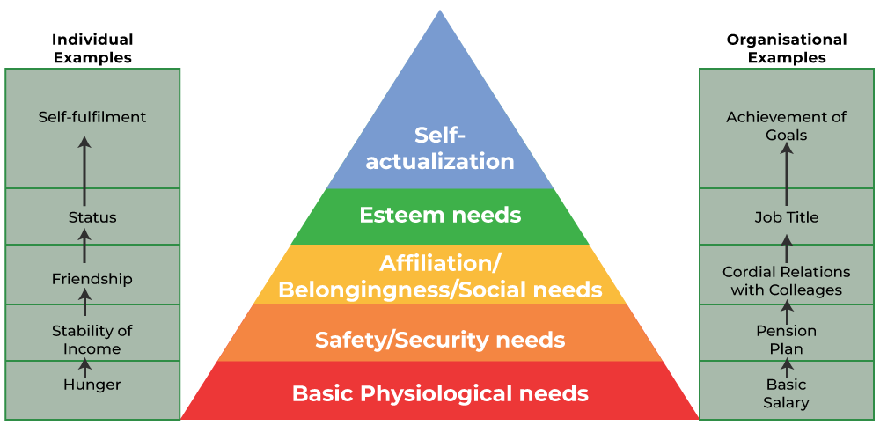
( Forgeeks, 2022)
Basic physiological needs
These necessities for human survival include food, thirst, shelter, sleep, sex, etc. These demands are at the bottom of the hierarchy and have the most power in terms of motivation in GHRM. The primary physiological demands in the context of organisational needs in GHRM include salary and other monetary incentives.
Safety needs
In GHRM, humans consider safety from future uncertainty and other dangers after meeting fundamental physiological demands. The goal of safety and security needs in GHRM is to ensure that the individual satisfies physiological demands now and in the future. It encompasses protection against death, injury, disease, and other bodily hazards in GHRM.

Social needs
In GHRM, social requirements are vital once physiological and safety demands are met. These involve the need for love, companionship, affection, and social contact. The need for belonging and approval is a significant motivator of human behaviour in GHRM. In GHRM, one example of social or belonging requirements is the establishment of informal groups in the workplace.
Esteem needs
According to Maslow's hierarchy of requirements, fulfilment of esteem needs comes second. In GHRM, these demands are related to a need for respect and acknowledgement from others. Esteem requirements include autonomy, attention, position, praise from others, and prestige in GHRM. Such demands in GHRM generally drive higher-level personnel.
Self-actualisation needs
As a result, the manager's efforts—that depend on his capacity to become aware of motivation theories—ultimately motivate employees. Motivation needs theories are categorised based on their definitions and purposes, but substantial research indicates that they may be connected, leading to employee satisfaction. It offers an additional conceptual examination of the connection between passion and organisational achievement and the idea of organisational performance. The last part compares the ideas and their effects on organisational performance. Maslow’s motivation theory predicts that an individual's requirements will influence human behaviour. People engage in particular behaviours to satisfy demands such as hunger, success, or financial reward. Theories also include specific recommendations for ways management may encourage and assist its people as they work towards self-actualisation.
Finally yet importantly, Maslow’s motivation theory also implies that individuals have a variety of desires, which shows that diverse things influence people for different reasons. The effectiveness of processes and the results of motivated behaviour are all topics covered by motivation need theories of actions. Learning motivation may be assumed to relate to the systems and mechanisms explaining how learning or a learning action comes about and its results. Knowing motivation theories is essential since they may improve employee performance and conduct. It is fascinating to see the results of the thorough analysis the CIPD made of the data supporting and refuting many well-accepted theories of motivation. However, employees continue to be enticing and helpful if they are utilised to promote beneficial behaviour and employee engagement.
Employee contentment, motivation, and productivity all increase when workers are part of a culture that recognises the value of psychological security and how these elements affect economic success. On the other hand, toxic corporate cultures go against people's safety needs, particularly social stability, emotional stability, financial stability, order, and predictability. As a result, actions start to serve the self. Even if the ambition to succeed may still exist among employees, it comes at the price of authenticity and perhaps even pleasure and mental health at work. The idea of reciprocity is the foundation of this philosophy. When workers are treated with respect, they develop a favourable opinion of the business. According to the self-determination hypothesis, when workers customise their work, find meaning in it, and complete it on their own, they perceive their work as having greater significance, leading to a rise in motivation, performance, and job satisfaction.
Tremendous HR executives know that the probability that someone will give them enormous value increases when they are treated kindly, somewhat, and with attention. However, finding the time or creating the mechanisms that support employee performance takes time and effort for HR directors. They should create the best conditions to help individuals and their organisations flourish.

Triple Bottom Line Theory
The TBLT is the foundation for the idea of sustainable development. Economic, environmental development and social goals are linked and mutually beneficial, according to the theories of sustainable development. As a result, how to balance the environmental, economic, and social elements of financial activity must be considered in a company's development plan Liang et al. (2022). This implies that the proposed financial alternatives should be financially lucrative, beneficial, and ethical for society and the environment. As has been emphasised, a sustainable business promotes sustainable development while enhancing the economy, society, and environment.
The purpose of this special issue is to assist in preventing such a situation from happening by guiding GHRM research. Practice toward a more strategic and forward-looking position in pioneering the adoption of TBL methodologies utilising green human and social capital-centric perspectives in organisations. The transition to a more sustainable business model demands the GHRM leaders as a new generation of CEOs and business leaders who are not simply obedient to shareholders are on the horizon (Muñoz-Pascual, Curado and Galende, 2019). By proposing a new model of sustainable GHRM that transcends the TBL orientation and implores us to embrace common good GHRM, This special issue broadens our understanding of sustainable GHRM from a macro perspective. In addition to addressing time and spatial consideration in sustainable GHRM strategic development, the paradox theory is used to understand how to engage the multiple TBL goals at once successfully (Shim et al., 2021). Two more contributions are exploring resource-based models for including various levels of Sustainable GHRM strategic transformation and the creation of sustainable GHRM institutional entrepreneurship.
People
This metric assesses an organisation's social effect, which includes its commitment to all stakeholders, including workers, suppliers, consumers, inhabitants of local communities, and others. The influence on the subsequent generations of humans can also be considered. This bottom line may be measured by factors such as a safe working environment, fair pay, diversity, equity, and inclusion programs, and the utilisation of small and minority (Liang et al., 2022). “People” focuses on organisations' effects on the environments in which they operate, often known as corporate responsibility. Millions of individuals are being left behind, particularly the poor and marginalised, due to gender, age, handicap, ethnicity, or geographic location.

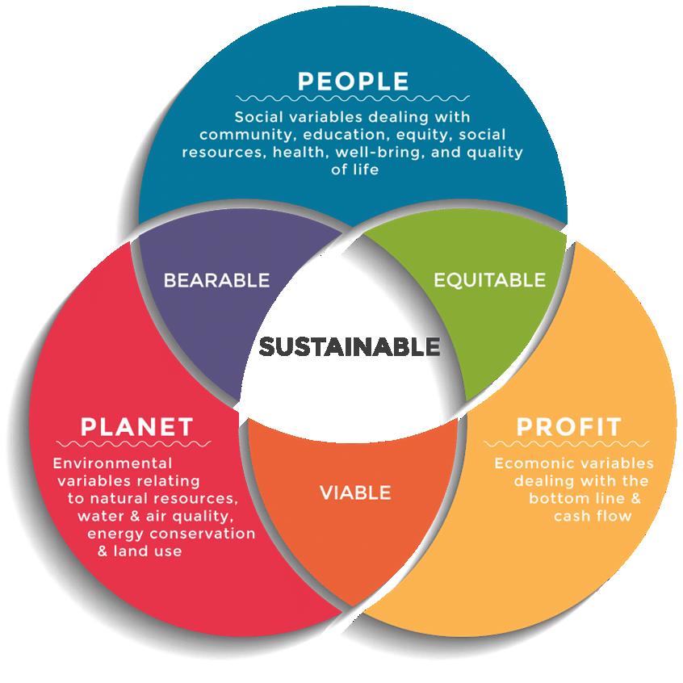
( Muñoz-Pascual, Curado and Galende, 2019)
Plant
This assesses an organisation's environmental effect as well as its attempts to function sustainably. A significant indicator is lowering carbon footprints through lowering greenhouse gas emissions through reduced energy use and consumption measures. The IT department may play a significant role by introducing green computing projects that improve the energy efficiency of data centres and IT systems (Muñoz-Pascual, Curado and Galende, 2019). Establishes businesses that lessen an organisation's environmental impact. This might involve reducing waste in manufacturing operations, using recycled materials whenever feasible, teaching employees about the value of recycling, and contracting recycling services for corporate offices.
Profit
Organisations frequently use financial outcomes to assess company success. However, as part of the TBL, this bottom line extends beyond mere profit calculations. It might involve ethical business practices and treating consumers and suppliers fairly. A corporation's additional economic value for its commercial partners and communities might also be considered (Shim et al., 2021). Because of these concerns, this is frequently referred to as prosperity rather than profit, emphasising that it is more than just how much money a firm generates. It might be challenging to measure the bottom lines of people and the planet to the same degree as the financial bottom line.

Literature gap :
Despite the growing interest, there is a substantial knowledge gap about the connection between green human resources management and employee engagement in organisations and among individuals. This research literature addresses the powerful effects of GHRM on organisational performance and environmental sustainability. The specific systems through which Green HRM practices affect employee engagement are generally unnoticed. Researchers have yet to address the implications of how green initiatives such as green training, green leadership, and eco-friendly workplace practices affect employees' emotional connection to their organisation. The relationship between Green HRM and employee engagement needs to be looked into. Green office procedures raised the standard of green spaces. It provides employers with physical happiness. The area that needs attention is the specific role of communication. Organisations that implement Green HRM practices should communicate their initiatives effectively to employees. Clear communication and its environmental impact diffuse a sense of motivation among employees and contribute to engagement. Gaps in the literature were filled through surveys. Researchers uncover the complex relationships between Green initiatives and employee engagement by testing the behaviour of employees in organisations that have accepted Green HRM practices. Find out this literature gap; it provides an understanding of these concepts and creates environmentally conscious workplaces.

Summary :
The literature review examined the impact of GHRM on employee engagement. The study is linked to a comprehensive search of publications and industry reports in retrieved academic databases. The findings of this literature review yielded several implications for the impact of GHRM on employee engagement. This literature review explains the importance of GHRM and environmental cooperation and provides proper knowledge about the advantages of GHRM. It presents the challenges of implementing GHRM and contributes a theory about the relationship between GHRM and Employee engagement. It also provides a theoretical analysis of motivation needs and this research's triple bottom line theory. This literature properly explains the literature gap about the impact of GHRM on employee engagement. Based on this literature review next section will discuss the methodological approach that will be undertaken in the data collection and analysis process to prepare most effective research result.

Chapter 3: Methodology

Introduction
This study using a survey design since it allows researchers to evaluate respondents' views and opinions. The Methodology employed a quantitative survey approach to obtain data from the employees. A cost-effective and time-efficient survey approach was used to obtain a large number of replies from the targeted demographic. The researcher interferes with the investigation to a little level. This study used the survey questionnaire to assess the GHRM concept on employee engagement. This research will use positivism philosophy, deductive research approach, Quantitative research strategy, and primary data collection method following ethical consideration.

Positivism philosophy
The effect of GHRM on employees is examined from a positivist philosophical perspective using empirical observations and data analysis. The positive philosophy emphasises social reality and only aids in analysing GHRM in the current economic climate. Research typically adheres to the positivist ideology to gather information and perform the survey (Dzwigol, 2020). This philosophy allows us to examine employee behaviour and determine the effects of GHRM. Researchers briefly illustrate how GHRM positively affects employees’ behaviours use the positivist concept (Amanov, 2023).
Philosophical paradigms are models developed from worldviews or belief systems concerning the nature of understanding and existence. A scientific community shares philosophical paradigms, which influence how a community of researchers operates in response to an enquiry. Thus, a paradigm is a worldview, a complete framework of ideas, values, and research methodologies. Positivism emphasises the issue's objective reality, whereas interpretivism emphasises its subjective reality. The positivist paradigm, sometimes known as the scientific way of doing research, is intimately tied to quantitative research. Positivism is typically concerned with a single, tangible reality. Science is dominated by positivism, which holds that science quantitatively measures independent facts about a single threatening reality.

Deductive research approach
Generally, the Deductive research approach possibly explains causal relationships between concepts and variables (Abu-Taieh, Hadid and Mouatassim, 2020). It quantifies notions and, to some extent, generalises study findings. The deductive research strategy carries no risk. It assumes the theory deduces the hypothesis, expressing a notion in practical terms and indicating relationships between two variables.
According to current thought, a deductive approach develops a view and then constructs a research strategy to evaluate the idea. Deduction is the process of going from the particular to the universal. An idea or case study that asserts a causal relationship or correlation is frequently accurate. Deductive research evaluates how well the connection or link holds up under various fictitious conditions (Devezer et al., 2021). The deductive process is explained by hypotheses generated from the theory's assertions. Inductive reasoning concludes from premises. Induction begins with observations and searches for patterns within them, unlike a deduction, which starts in an anticipated way.

Quantitative research strategy
Quantitative research comprises the systematic analysis of phenomena by collecting quantifiable data and using mathematical numerical methodologies. Quantitative research distributes surveys, online polls, and questionnaires to gather data from current and potential respondents (Bauer and Scheim, 2019). The outcomes of this form of research are expressed quantitatively after rigorous analysis of these data, which is one of its essential characteristics. Foreseeing a product or service's future and making improvements is feasible.
Structured techniques like Polls, questionnaires, and surveys are used to collect quantitative data. The information gathered from survey respondents using these organised procedures is thorough and vital. Substantial sample size is utilised in quantitative research to ensure the target market is adequately represented (Bauer et al., 2021). The proper sampling methods must be used to choose the right sample size to improve the study's objectives. Closed-ended queries are created following the study's objectives. Because they make gathering quantitative data easier, these questions are commonly employed in quantitative research. Several research-related topics are evaluated before collecting feedback from respondents.

Data collection and Sample size
Employees in GHRM areas were the focus of the study because, according to the firms' HR managers, they were more likely to be aware of green practices than employees in other departments were. The questionnaire was given to the workers in electronic form, along with a cover letter detailing the study's goals, with the help of each company's HR department. Closed-ended self-administered questionnaires were used to gather information for the survey. Sample size in qualitative research is the growing popularity of focus group research. Because the dialogue is focused rather than tangential or meandering, focus groups are likely referred to as such data collection strategies (Lakens, 2022). Unless the approaches are integrated, which usually results in the quantitative focus groups' results being the weaker part of the project, many focus groups are typically conducted. Around 15 Questions are set in this study to collect quantitative data from target participants who are the employees of different MNCs who have faced or have not faced the GHRM.

Random sampling
Random sampling, the method of chance, is the most popular technique for selecting a sample from the population for several reasons. Although this approach is considered the most accurate representation of the population, sampling error still exists, just as it does with sampling techniques. Each general public member has an equal probability of being chosen as a sample member in an effective random selection (Berndt, 2020). The reasoning for simple random sampling is that it removes bias from the selection method and should produce representative samples. Compared to other sampling techniques, sample random sampling has the most negligible sample bias when appropriately used. One of the key benefits of this method is the broad sample frame that is accessible, which makes it simple to construct the sample group by choosing samples.

Ethical consideration
Participants must actively enter the study, although they only exited once. Participants are given adequate information and assurance regarding their participation as a result, enabling them to fully comprehend its consequences and freely decide whether to take part (Zawacki-Richter et al., 2022). The privacy and anonymity of respondents are of the utmost significance, and language that is derogatory, discriminatory or otherwise undesirable is avoided when formulating questions for questionnaires, interviews or focus groups.

Descriptive research design
A descriptive study is a statement of the existing situation without variable control. Analytical research also aims to explain how or why something came to be. Comparatively, descriptive investigations merely try to determine, characterise, or identify. By obtaining information that enables them to characterise the situation in detail than was possible without using this technique, descriptive research aims to answer existing concerns about the problem. Descriptive studies explain different facts about the phenomenon (Siedlecki, 2020). Useful for analysing subjects and issues that cannot be measured. The opportunity to view the occurrence in a natural setting that is entirely unaltered and unaltered. The possibility of combining qualitative and quantitative data collection techniques. More quickly, quantitative experiments and decision-making applications of research findings. Statistical testing and verification are not possible for descriptive research. Research findings include some bias because statistical tests were not used (Vaismoradi et al., 2019). The majority of descriptive studies cannot be repeated because they are observational. Studies that only describe phenomena are not used to determine their causes.

Primary data collection using the survey method
Depending on the type of questions they asked, different survey methodologies were categorised as quantitative. Using percentages, pie charts, and data tabulations, analysis of answers to closed-ended questions with multiple-choice answer alternatives is done using quantitative approaches. Open-ended survey questions, also called unconstrained questions, are analysed using qualitative methods, on the other hand. Primary data is gathered, critically assessed, and discussed using open-ended questions without computations or statistics. Cost-effectiveness and identical questions are asked of every respondent—the possibility of collecting the primary data in less time (Lasater et al., 2019). The researcher had minimal to no bias when acquiring the data. Unlike in interviews, respondents often have enough time to think about their answers before replying. Contact respondents who reside far away through an internet survey. Respondents who did not fully understand the question chose answers at random (Harrison, Reilly and Creswell, 2020). In closed-ended surveys, respondents did not add any more commentary because there was no pertinent question. It is possible that responders need help understanding the query and a high non-response rate and inadequate or incorrect data will be gathered.

Reliability and Validity
There is no reliable mechanism to guard against the influence of the subjectivity of a single observer. Hence, reliability is a worry when just one observer supplies the data. Subjectivity is often strongly related to reliability difficulties. Therefore, the degree of dependability of the task will be harmed when a researcher approaches the investigation emotionally or subjectively. Research validity refers to how well the requirements of the scientific research technique were followed when the study's conclusions were drawn. Concurrent validity, idea validity, face validity, external validity, validity associated with criterion, internal reliability, and content validity are the primary types of study validity. Selecting an appropriate period for the inquiry is crucial. When choosing a method, it is crucial to consider the study's characteristics (Surucu and Maslakci, 2020). It is necessary to select the optimum sample strategy for the inquiry. The answer sets' answer alternatives should not be forced upon the responders. Realising that there will always be threats to the study's validity and reliability is essential. Researchers must make every effort to reduce these risks to the absolute minimum.

Sample size and target population
This study focused on employees who work in the GHRM field. This study's target population is GHRM workers. This study chose a representative sample size from the group of interest. To generalise findings from an empirical study, a suitable sample size that economically represents the population of interest must be collected. The population determines the sample size, which might be unknown or unknown. This study estimated the sample size based on a limited population. Given the simplicity of its procedure and the few resources available, this study investigated the convenience sampling technique. The sample size is critical for lowering costs and speeding up the data gathering. The sample size is an essential aspect of any empirical investigation that aims to conclude a population from a sample. Sampling is critical for gathering information from sources. Seventy-one management personnel were chosen as the population sample size. Preliminary investigation revealed that size and profitability had little influence on the outcome factors. Stratified sampling aims to give a more efficient sample, providing a more perfect and accurate sample size. Before beginning data analysis, the assumptions about sample size, variable scale, multivariate normal distribution, and outliers will be double-checked.

Summary
The research used a quantitative survey approach to assess the influence of GHRM on employee engagement. The study used a positivist ideology, emphasising actual observations and data research to analyse the impacts of GHRM. The deductive research design sought to demonstrate causal links between ideas and variables. A quantitative research method was used to obtain data from GHRM personnel, which included organised procedures such as questionnaires. The study employed random sampling to identify participants, with ethical issues, reliability, and validity being prioritised. The poll asked about demographics, GHRM attitudes, and its influence on employee engagement. A sample of 71 GHRM management professionals was chosen.

Chapter 4: Findings and Discussion

Introduction
Findings and analysis section of this study will reflect the outcomes of the survey questionnaire using pie chart. Quantitative analysis of each survey question will be conducted to analyse pros and cons of GHRM in developing employees engagement in the workplace. This section will conduct a thematic discussion in order to evaluate the findings in a more effective way and understand the preparation of result. This section is crucial for his research to develop conclusion and make recommendation according to it.

Findings and Analysis
Question 1
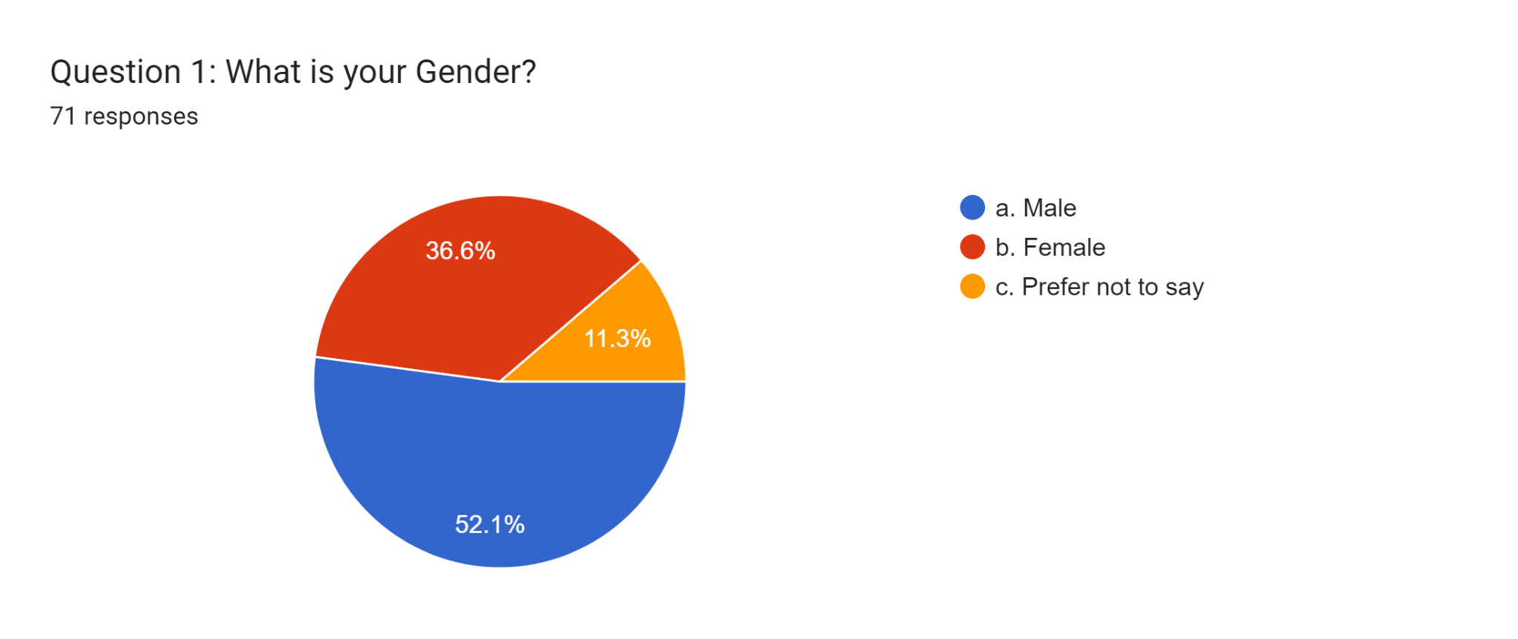
(Google Form)
71 respondents to the survey provided the data for this study. Nearly 11.3% are women and 52.1% of men participated in this survey, with 11.3% of participants choosing not to indicate their gender. This demographic information shows that there are no partial preferences in this situation and that the fundamental data for the GHRM is gathered from a variety of sources. In this main data set, men make up the majority of the respondents.

Question 2

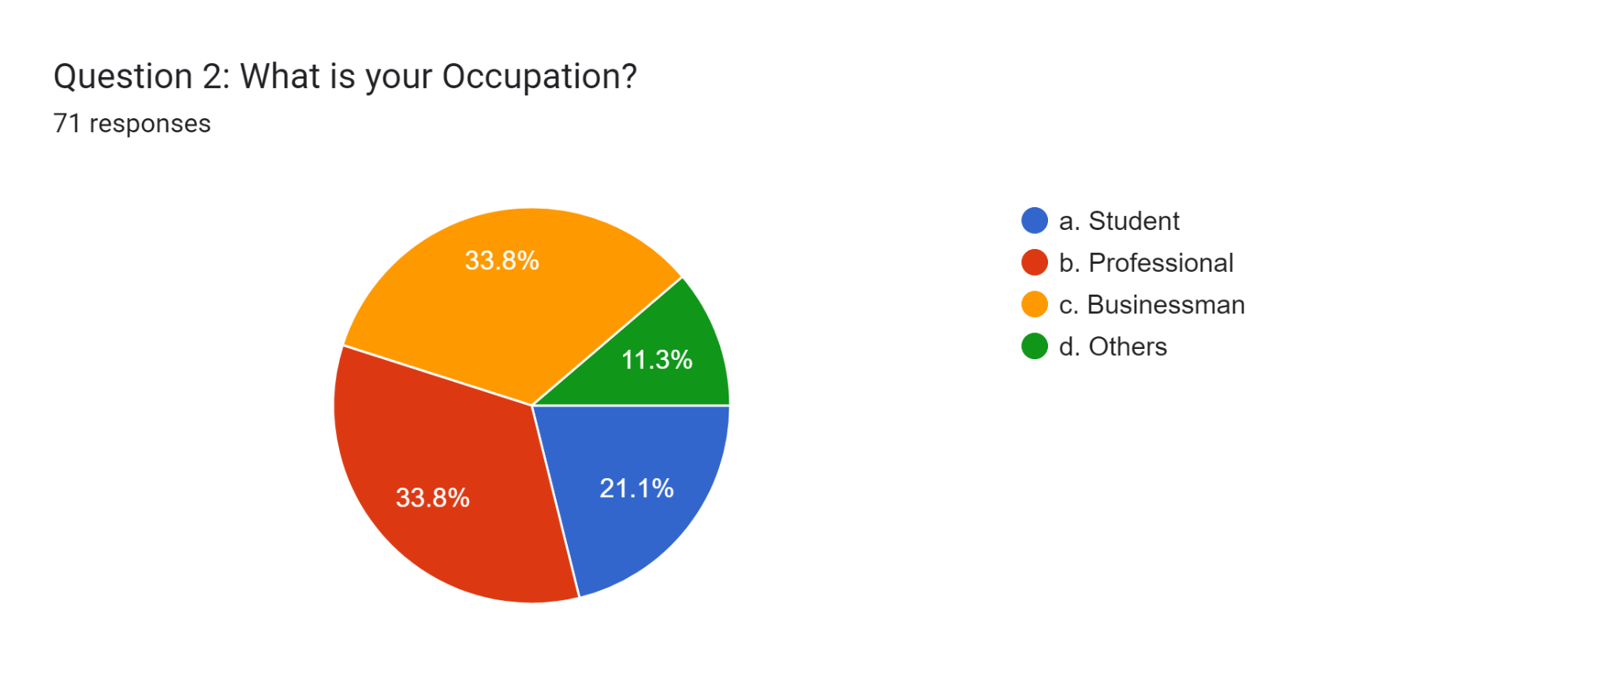
(Google Form)

The research data was collected from 71 respondents. Almost 21.1% of participants are students, around 33.8% are professionals, approximately 33.8% are business people, and almost 11.3% have other occupations. According to this demographic data, It is evident that the majority of the respondents to this primary research, which sought to understand the connection between GHRM and employee engagement, are businesspeople and professionals. The wide variety of vocations draws attention to the participants in this study's broad demographic makeup.

Question 3
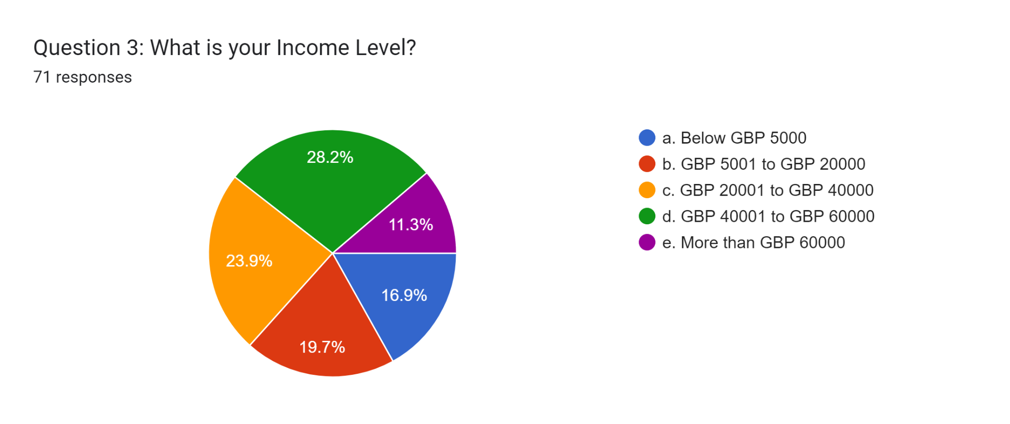
(Google Form)
During the survey, 71 participants were asked about their level of income, and it was discovered that the majority participants were earned GBP 40001 to GBP 60000. Around 28.2% of participants earn approximately GBP 40001 to GBP 60000. Almost 23.9% of participants earn GBP 20001 to GBP 40000, around 19.7% of participants earn GBP 5001 to GBP 20000, approximately 16.9% of participants below GBP 5000, and there are only 11.3% of participants earn More than GBP 60000. Based on the Google form, most participants have GBP 40001 to GBP 60000 earnings per annum.

Question 4
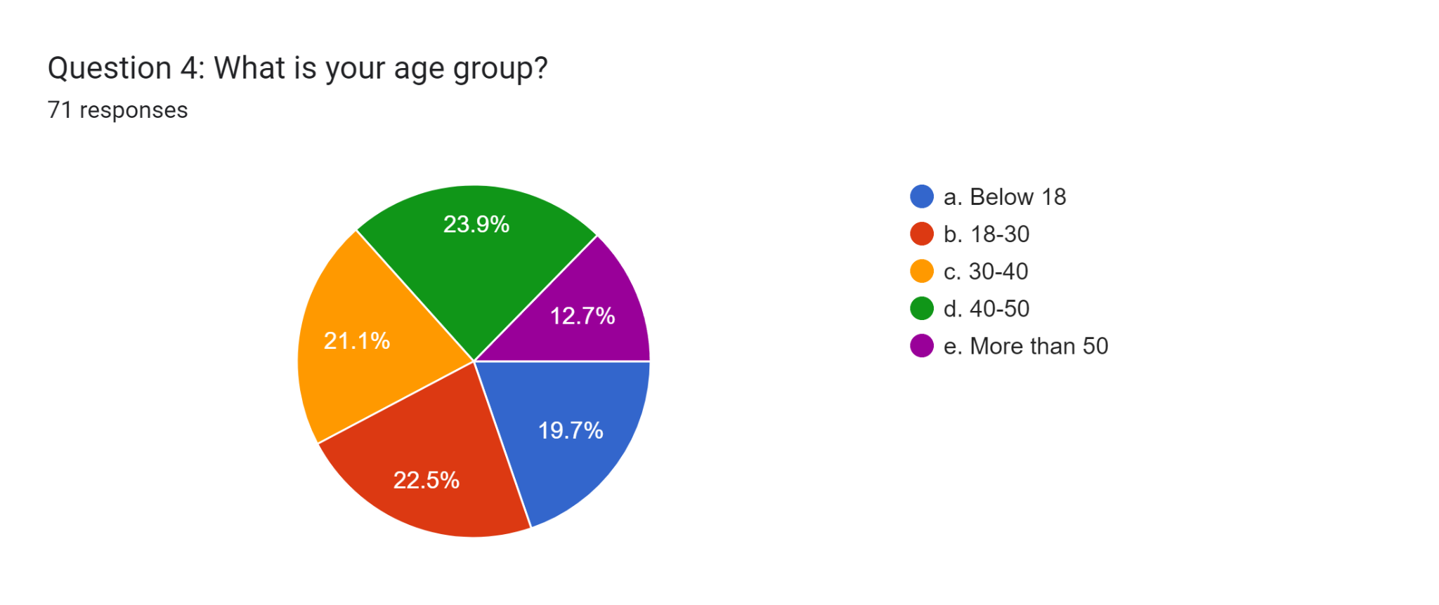
(Google Form)
Among 71, Respondents are categorised into a group to identify the data set's demographic overview. Around 19.7% of participants belong to those below 18, and 22.5% belong to 18 to 30 years old. Almost 21.1 % of participants are in the 30 to 40 age group, and approximately 23.9% are in the 40 to 50 age group. Among the participants, just 12.7% are over 50. It is evident that the majority of participants are between the ages of 40 and 50, and they have specific awareness of the impact of GHRM on employee engagement.

Question 5
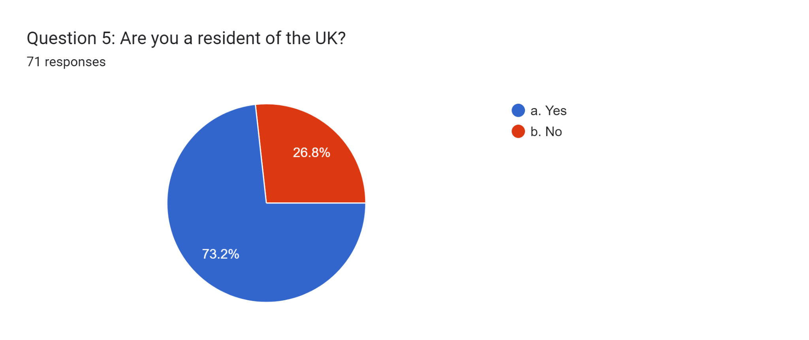
(Google Form)
Another demographic question is asked of the potential respondents whether they are residents of the UK or not. Millions of visitors are there in the UK because this country is highly dependent on the Employee engagement of GHRM. According to the Google form data, around 73.2% of participants are residents of the UK. On the other hand, Almost 26.8% of participants are non-residents.
Question 6
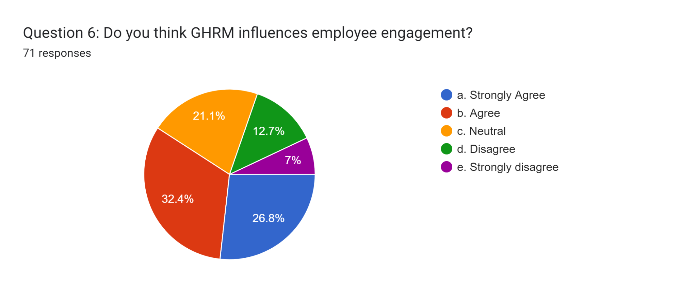
(Google Form)

Seventy-one participants participated in this survey. Almost 32.4% of the participants agreed that GHRM influences employee engagement, and approximately 12.7% disagreed that GHRM does not influence employee engagement. Around 21.1% of participants were neutral when this question was asked. Almost 7% of respondents strongly disagree with this statement. The majority of the participants concur with this statement. This response distribution reveals a variety of viewpoints on the connection between GHRM practices and employee engagement, illuminating the complexity of the subject and the participants' various opinions.
Question 7
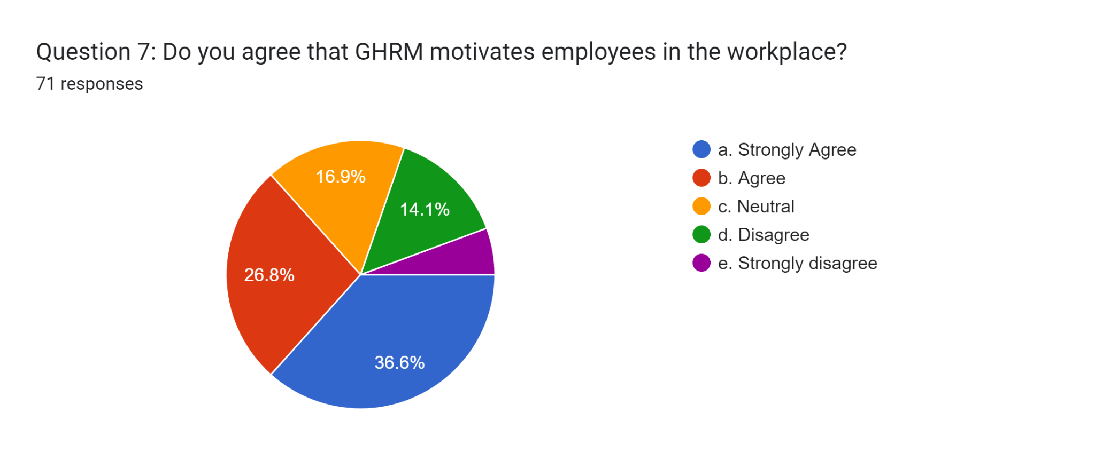
(Google Form)

This survey questionnaire has 71 participants. Almost 26.8% of responders agree that GHRM motivates employees in their workplace. Approximately 14.1% of participants disagree with this question, and 5.6% strongly disagree that GHRM does not motivate employees because of a lack of knowledge of GHRM. When these questions are asked, almost 16.9% of participants are neutral because they need specific ideas about GHRM. These survey questions were collected through Google Forms.
Question 8

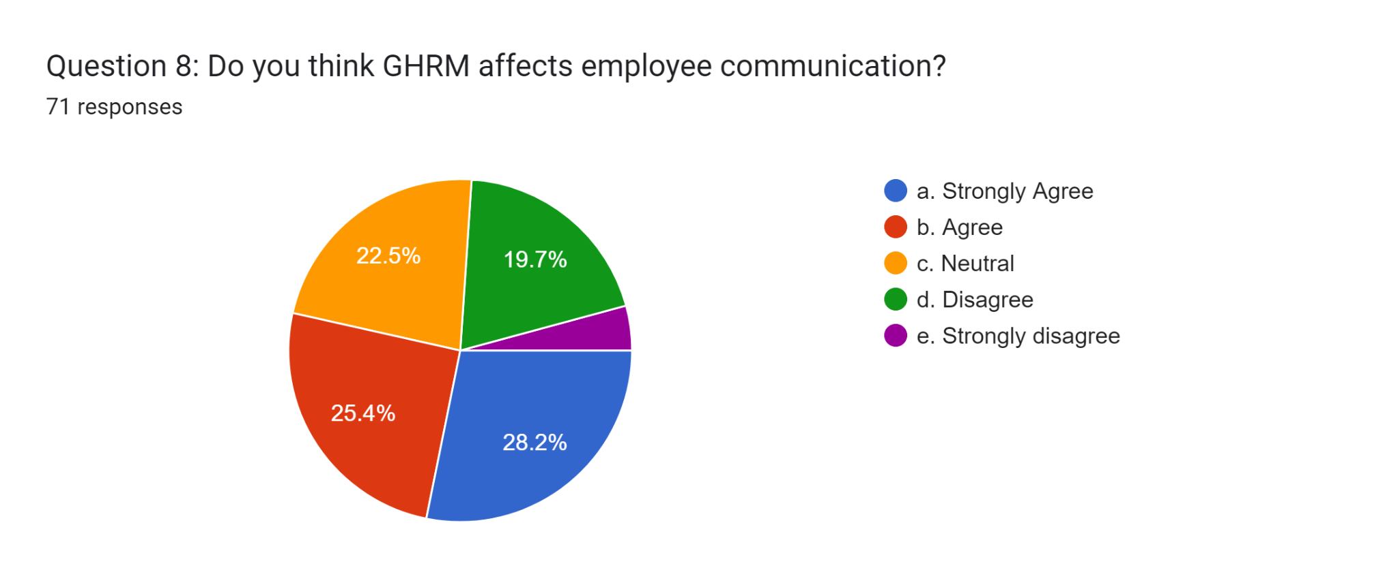
(Google Form)
There is a range of ideas among the participants on how GHRM affects employee communication. Almost 28.2% strongly agreed that GHRM indeed affects employee communication significantly. Additionally, around 25.4% of participants agree with this statements. Among the respondents, Approximately 22.5% had a neutral position, and did not present their view, GHRM affects employee communication. However, just 4.2% of respondents strongly agreed that GHRM affects employee communication, compared to 19.7% who disagreed.

Question 9
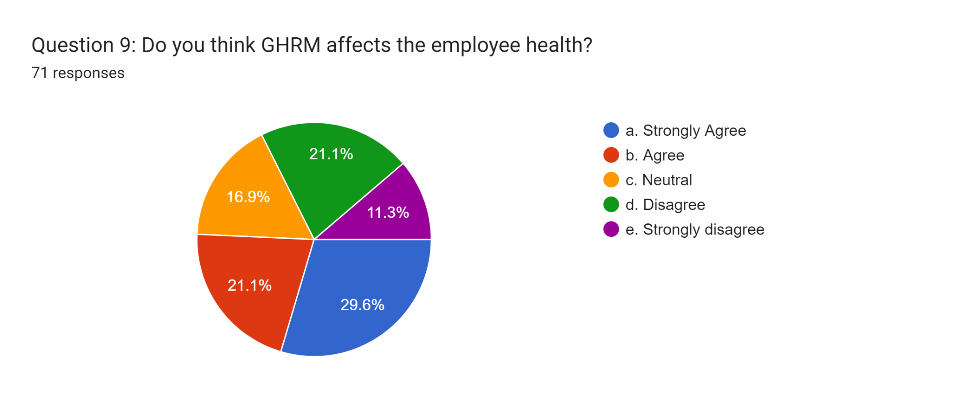
(Google Form)
This research data was collected from 71 participants. The participant's viewpoints regarding the effect of GHRM on employee health reflect a spectrum of opinions. Around 29.6% strongly agreed that GHRM affects employee health significantly. Additionally, 21.1% of participants agree with this statement. Among the participants, 16.9% held a neutral position because they were unaware of GHRM. On the other hand, 21.1% disagreed with the idea that GHRM affects employee health, while a smaller proportion of 11.3% strongly disagreed with this question.
Question 10
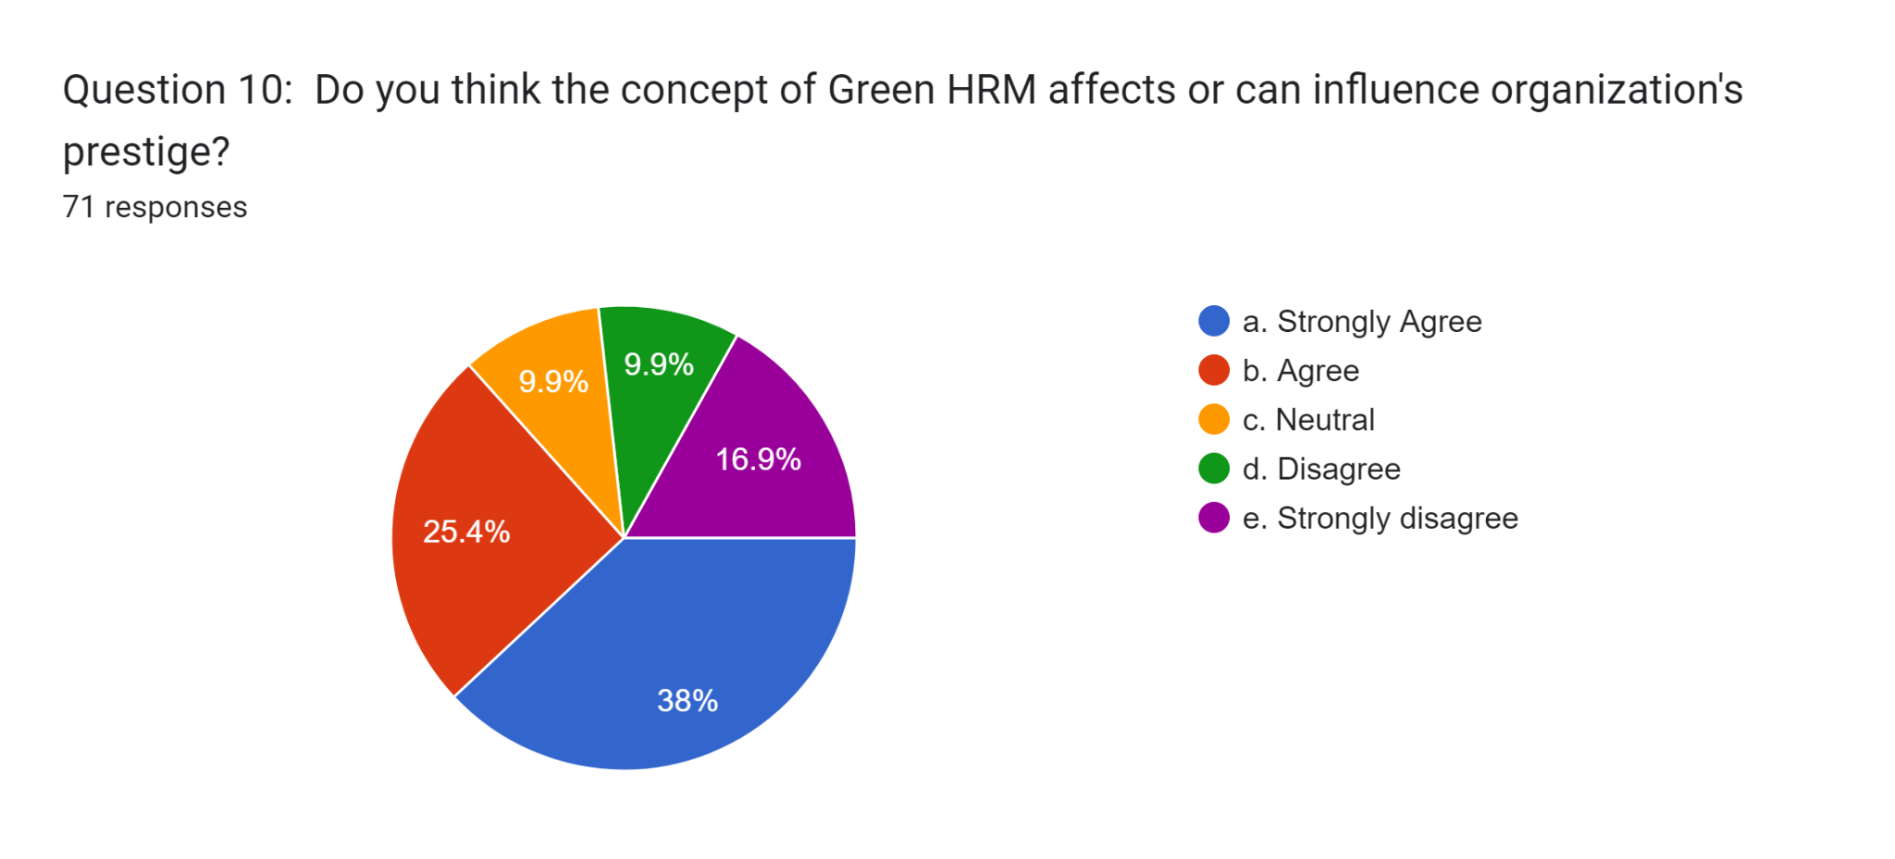
(Google Form)
The data collected among the 71 participants, advised on the effect of green HRM on an organisation's prestige, varied significantly. Almost 38% of participants strongly agreed that the Green HRM influences an organisation's prestige. Almost 25.4% of participants agree with these statements. As opposed to that, a minor participant, Around 9.9%, held a neutral stance because of the unclear concepts of organisational prestige. Similarly, approximately 9.9% disagreed with the idea. A notable 16.9% of participants strongly disagreed with the question that Green HRM affects an organisation's prestige.
Question 11
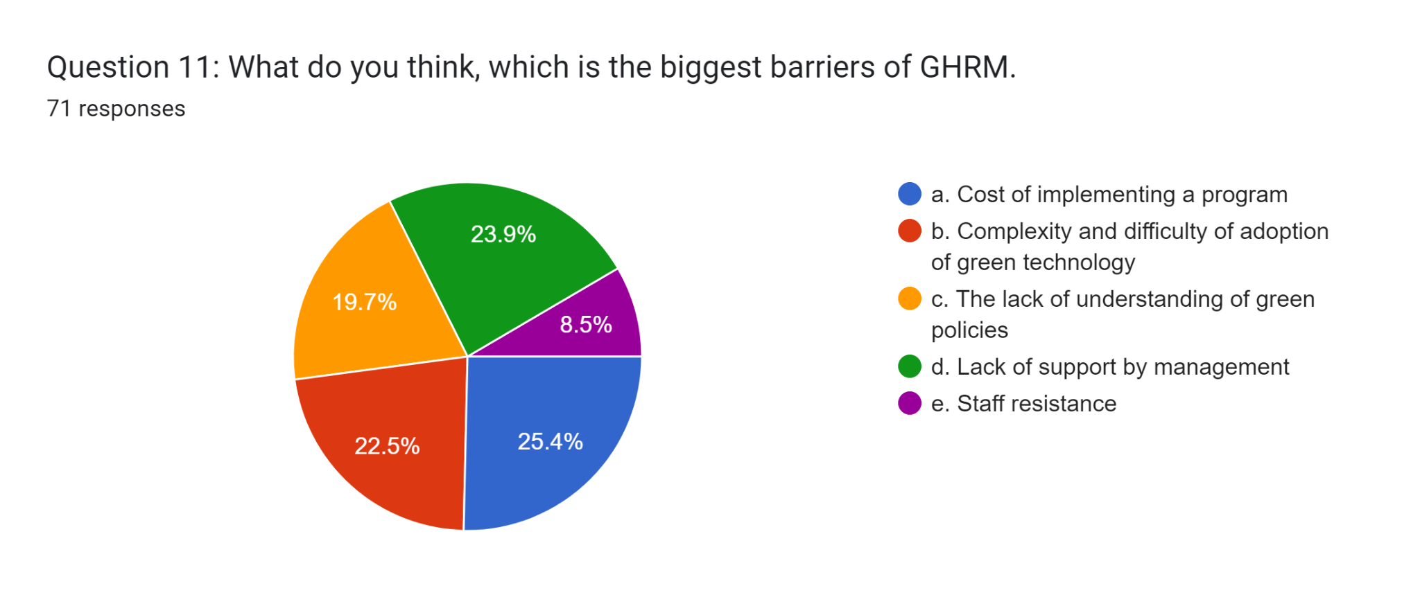
(Google Form)
Respondents are asked about the most significant barriers to GHRM implementation. Approximately 23.9% of the 71 participants said that management's lack of support was a problem. Around 19.7% of those, participating in Green policies must be better understood. Almost 22.5% of participants said that the complex nature and difficulty of adopting green technologies. Approximately 25.4 % of participants mentioned the cost of implementing a program. On the other hand, only 8.5% of participants said that staff resistance is a barrier to GHRM implementation.
Question 12
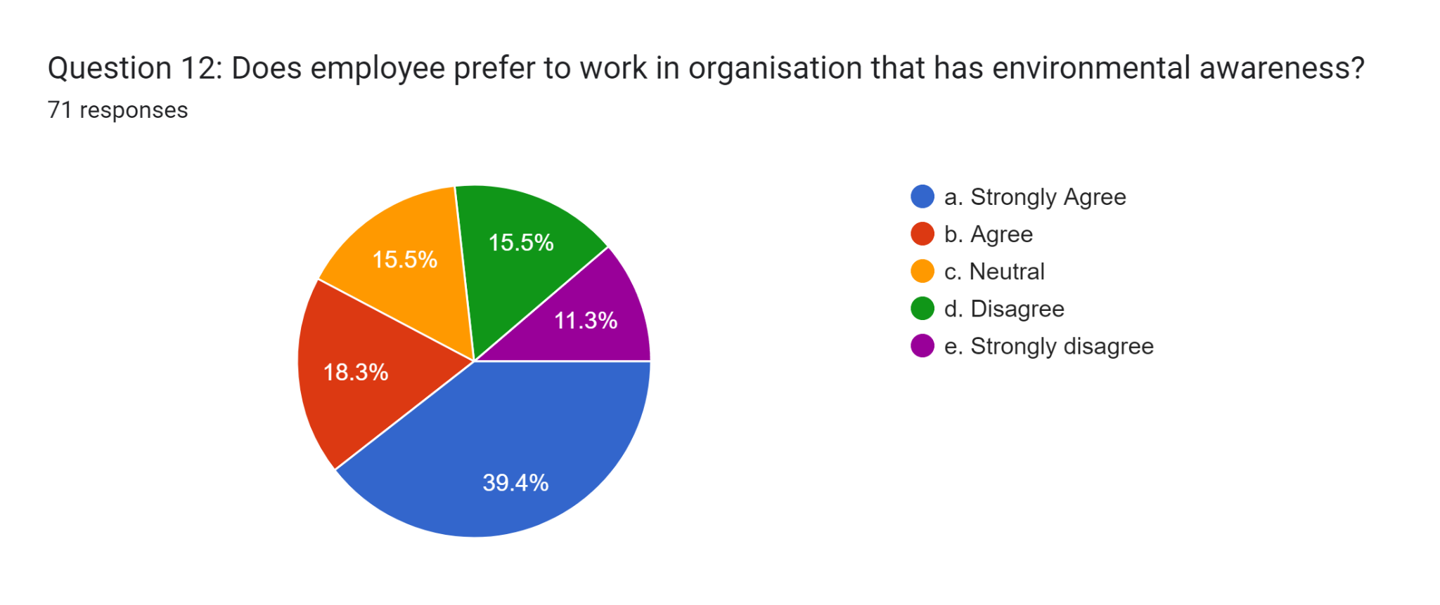
(Google Form)
The question asked by the participants about whether employees prefer to work in an organisation that has environmental awareness. It was found that among 71 participants, 15.5% of respondents strongly agree that employees prefer to work in an organisation that has environmental awareness. Around 15.5 % of respondents stayed neutral and did not provide their answers. Almost 18.3% of participance agree with the statement, and approximately 39.4% strongly agree that the employee prefers to work in an organisation with environmental awareness. On the other hand, only 11.3 % of respondents strongly disagree. Most of the respondents strongly agree about environmental awareness.

Question 13
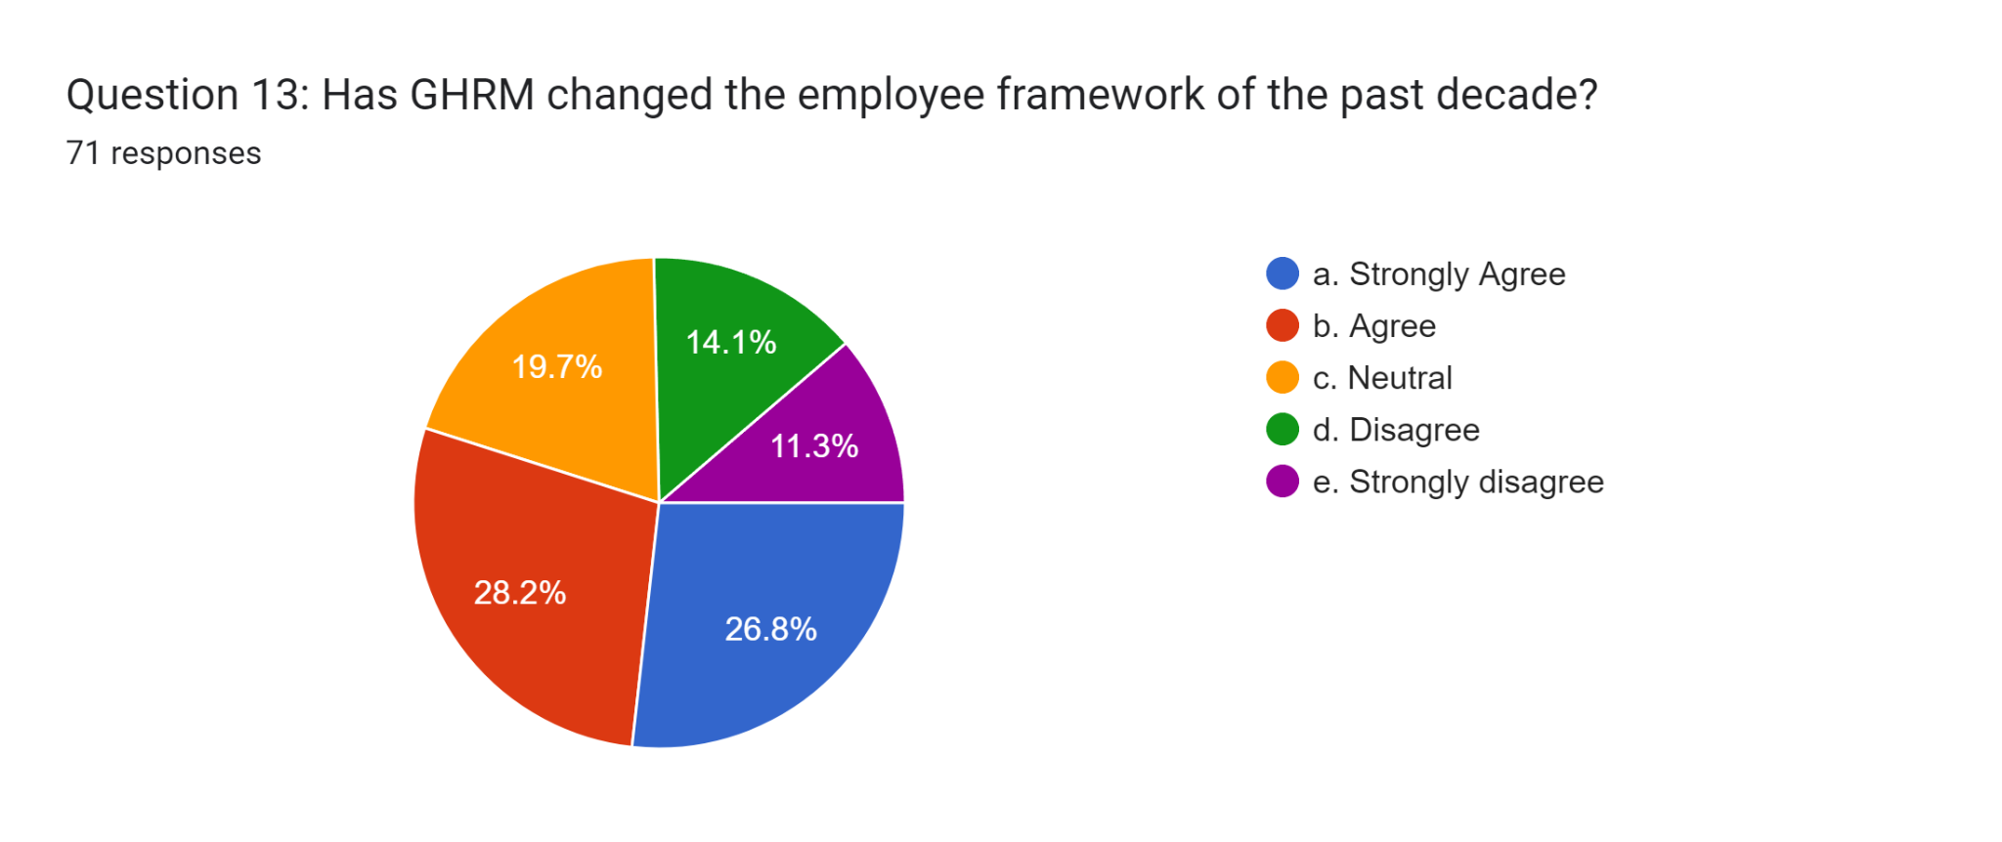

(Google Form)
The participants asked this particular question: GHRM has changed the employee framework of the past decade. In response, almost 28.2% of participants, which was the highest response, agree that the GHRM has changed the employee framework of the past decade. However, 19.7% stated neutral or gave no positive or negative answer, and approximately 26.8% of participants strongly agreed. Almost 11.3% of participants strongly disagreed, and 14.1% only disagreed.
Question 14
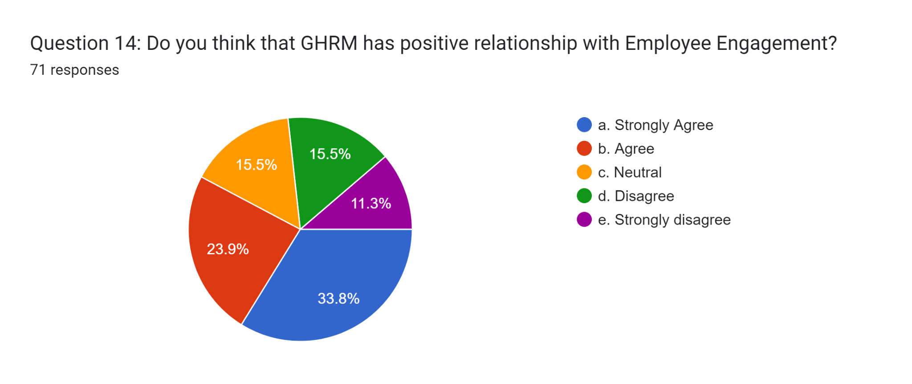
(Google Form)
Among 71 participants, the questions were asked whether GHRM has a positive relationship with Employee Engagement. It was found that almost 33.8% of participants strongly agreed. Approximately 23.9% of participants agreed that the GHRM has a positive relationship with Employee Engagement. On the other hand, 15.55% of participants did not give any positive or negative response. Almost 15.5% of participants disagreed, and 11.3% strongly disagreed that the GHRM has a positive relationship with Employee Engagement.
Question 15
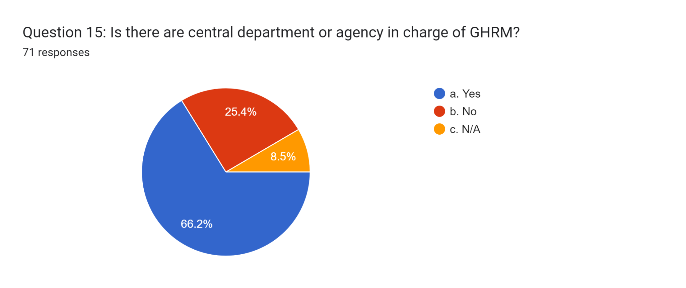
(Google Form)
The participants asked the last question of whether there are GHRMs overseen by a central department or organisation. In this context, it is estimated that around 66.2% of participants are in charge of a critical office or organisation of GHRM. Nearly 25.4% of participants differ from the central department or agency in GHRM. On the other hand, only 8.5% of participants are N/A.

Discussion :
According to the findings, a sizable majority agreed that GHRM does affect employee engagement. As a HRMstrategy that puts the environment, first, green HRM has several advantages for business. Its favourable effect on employee engagement is one of its main advantages. GHRM promoted a workplace culture aligned with contemporary environmental ideals by incorporating sustainable practices and environmental issues into HR policy (Aboramadan, 2020). The alignment raised employees' engagement by enhancing their feeling of purpose, job happiness, and pride in helping an organisation practice environmental responsibility. Employees who felt supported and cared for were more likely to be involved in their work, so GHRMs' focus on employee well-being and engagement was a natural fit (Ababneh, 2021). Work-life balance, wellness programs, and skill development were often promoted by GHRM, all of which boosted employee engagement and strengthened dedication to the organisation's objectives. The dedication of GHRM to sustainability and corporate social responsibility was well received by staff members, especially those who placed a high value on moral and ethical issues (Wang, Wang and Wu, 2022). A stronger emotional bond that results from this resonance further increases employee engagement. The focus on sustainability and employee welfare at GHRM may increase staff engagement. Eco-friendly practices and employee-focused initiatives were combined, which helped the environment while also fostering a more engaged and motivated staff.
According to the findings, most participants strongly agreed that GHRM motivates employees in the workplace because it helps organisations reduce costs without sacrificing talent. Businesses grow significantly and experience considerable operating savings by reducing their carbon footprints when ecologically conscious and actively promoting a modern, welcoming environment (Tanveer, Yusliza, and Fawehinmi, 2023). Employees who are more committed to their jobs and are happier at work are more productive and sustainable. Create a workplace environment where co-workers’ safety and health are valued. GHRM improved the rate of staff retention. An improved reputation. When a company makes a green effort at work, it might take advantage of the opportunity to promote positive Public Releases (Chowdhury, Mendy and Rahman, 2023). Press Releases are a tool that businesses use to promote their environmental initiatives to the media in order to increase sales and bring in new clients. Reducing the company's impact on the environment. There are significant utility cost savings. Even small businesses significantly lower their electricity costs by implementing energy-efficient and waste-reduced solutions. Being environmentally friendly is made more accessible by governments, water supply agencies, and electric companies in local communities that offer tax incentives and refunds (Arzamasova and Esaulova, 2021). Through training and rewards, employers incentivise personnel to devise strategies for utilising fewer damaging products for the environment.
This study found that most participants strongly agreed that GHRM affects employee communication. Green projects fall under the purview of higher-level executives, and managerial job descriptions have to contain green objectives. It enables businesses to save costs without sacrificing talent. Because it used power, water, and manufactured items more efficiently, it reduced a company's overall expenses (Hameed et al., 2021). It contributed to improved staff commitment and job happiness, which raised productivity. Create a culture where employees care about one another's well-being. Small businesses have decreased electricity bills by using more affordable and energy-efficient technology (Omarova and Jo, 2022). By utilising GHRM techniques, the firm establishes a positive reputation in society.
Additionally, it promotes resource preservation and the use of less expensive, environmentally friendly items. Community service, Environmental audits, waste management, improving workplace cultures, and other initiatives all help a firm build its brand recognition. The company's staff retention rate increased using green human resource management techniques. When workers discover their employer cares about society and the environment, they feel happy (Ojo and Raman, 2019). Employing GHRM allowed businesses to cut hiring costs without jeopardising skilled workers. The hiring process benefits from fully converting to an online hiring system since it is streamlined, expedited, and costs less.
According to the findings, most participants strongly agreed that GHRM affects employee health. GHRM acknowledges employee's contributions to building a more sustainable business. It was the result of people doing well and is evidence that a company's strategic sustainability goals are being met (Shoaib et al., 2021). GHRM was crucial to reaching bigger goals, including cost savings, bettering corporate social responsibility practices, and increasing employer branding for businesses. The workforce's awareness and comprehension of environmental values were high. Environmentally conscious ideals are now included in each employee's values. The workers always acted sustainably when doing their duties in the office and production settings (Choudhary and Datta, 2022). Employees were capable of doing a variety of tasks within the organisation in an ecologically responsible manner. The company's Green Business idea was successfully implemented because of the employees' high degree of responsibility and dedication. The fact that they worked for an environmentally conscious firm pleased the employees. Employees were proud of the business's standing as a green enterprise (Islam et al., 2020). Green management practices are also advantageous to businesses since they minimise costs and adverse environmental consequences, reducing various government initiatives. It promotes assisting with innovation, process improvement, technique development, and quality enhancement.
This study found that most participants strongly agreed that Green HRM affects or influences an organisation's prestige. In the business world, promoting concerns relating to the environment is facilitated through green human resource management (Ali et al., 2020). They were helping companies minimise costs without sacrificing talent. Organisations make significant operating savings by reducing their carbon footprint when they are environmentally conscious and actively promote a modern, welcoming environment. Employees who are more committed to their jobs and are happier at work are more productive and sustainable. Create a workplace environment where employees' health and safety are valued (Ashraful, Niu, and Rounok, 2021). When a company attempts to be green at work, it may take advantage of the opportunity to nurture good PR. Businesses use press releases to advertise their environmental initiatives to the media to draw in more clients and increase revenue. Tax advantages and refunds: Going green is made more accessible by governments, municipal governments, water supply organisations, and electric companies that offer tax benefits and refunds (Yusliza et al., 2021). Some government agencies, commercial firms, and non-profit groups only accept proposals from businesses that meet strict green requirements. Additionally, some companies mandate that their procurement departments only use products and services from companies that follow certain environmental standards.
According to the findings, the significant obstacles to GHRM were complexity and difficulties in adopting green technologies. Management's resistance to change results from a need for more organisational support. Employees were doing real work if they believed the company assist them. Innovation complexity reflects how a company feels the technology should be understood and used. Adopting green technology requires various experiences (Kodua et al., 2022). Finding out about green practices was challenging. It helped businesses hire trained, qualified labour by creating a massive pool of competent people based on the requirements for the various employment positions. GHRM supervisors managed the entirety of an organisation’s hiring process (Tanveer, Yusliza, and Fawehinmi, 2023). Using GHRM, a company may efficiently retain talented employees for extended periods. It was responsible for monitoring the working conditions provided to staff members and ensuring they have better compensation, tidy workspace, conveniences and more fabulous benefits. Employees were able to establish long-lasting relationships with the company as a result. It periodically settles disputes and responds to all queries from the workforce (Al-Shaibani, Naz and Rudnák, 2021). Human resource management’s improved handling of all employee concerns supports the efficient running of a corporation.
Evaluating the primary data, does the employee prefer to work in an organisation that has environmental awareness? Human resource management greatly influences an organisation's ability to retain talented workers for a more extended period. More extended time is used to monitor the working conditions offered to employees and guarantee that they receive hygienic working conditions, better pay, additional benefits, and amenities. The outcome was long-term worker relationships with the organisation (Already et al., 2022). GHRM has an impact on an organisation's general productivity and profitability. The one kept an eye on how each resource was being used and made sure there was little waste. GHRM makes a company more effective by placing the right person in the proper position (Gill et al., 2023). It identifies the work, prospers questions, and occasionally resolves disputes. GHRM helps an organisation run more efficiently by addressing all employees' issues more effectively. Employee engagement is essential to achieving the intended goals and objectives. GHRM encourages the workforce by providing social services and paying workers based on performance (Higgins and Gulati, 2003). In order to establish their motivations and boost overall staff morale, it was necessary to assess their output level.
According to the findings, most participants agreed that GHRM changed the employee framework over the past decade. To ensure business continuity, building solid relationships between management and employees is a priority for GHRM (Ercantan and Eyupoglu, 2022). It meets all of the demands of the workers and pays them fairly. By incorporating employee feedback into the policy-making process, GHRM improves communication between the employer and employees. Employee engagement needs to be stressed more and has recently been an HR professional's concern (Holland, Dowling and Brewster, 2021). Companies are having difficulty attracting and retaining employees and coping with phenomena such as the Great Resignation and quiet resignation that point to a lack of engagement. A more engaged workforce resulted from improved relationships between workers and their jobs, motivating elements like career growth and ongoing acknowledgement, and clear goals defined through GHRM. Because of your staff's focus and engagement, clients were happier and more devoted (Brunetto and Beattie, 2019). If people care about achieving their goals, feel like they belong at work, and align with the company's values, customers and employees will be happier and more productive.
According to the findings, most participants strongly agree that GHRM has a positive relationship with Employee Engagement. Teams were needed to respond to unforeseen HR conditions while out of their routine tasks, whether it was an unexpected turnover or a change in corporate objectives (Saks, 2021). Responding to indicates proactively or as they happen requires time and lowers the productivity of HR and any other teams. GHRM's early readiness and other vital HR operations do not have to grind to a standstill when putting out a fire to GHRM's strategy. It also lowers the negative consequences on the other competing teams. For instance, HR teams must act quickly to fill open positions if three salespeople leave their jobs unexpectedly because the lost productivity influences the team's quotas (Budriene and Diskiene, 2020). Two new sales employees hired a few months ago are ready to complete their on boarding and contribute to the team. GHRM has a headcount plan that considers potential attrition to a GHRM strategy. The recruiters have a pool of qualified candidates for the sales team and promptly hire a third member. They then create a list of potential candidates to carry on the headcount approach that led to these results.
According to the findings, most participants agreed with the central department or agency in charge of GHRM. The proper applicants proved to be a very challenging undertaking without a carefully thought-out recruitment strategy. When doing a task as crucial as hiring, human resource management is the best friend (Huo et al., 2020). They wrote job descriptions that were precisely customised to each specific duty in addition to quickly precisely every qualified applicant. After hiring, training was necessary to provide a smooth transition for the new employees into the business (Blom et al., 2019). While in training, I was to check their work effectiveness and help them comprehend and fulfil their duties. This entire procedure maintains the distinctiveness of the workplace if productivity is at its highest level. The GHRM division monitors employee turnover. The total performance of any business suffers from high staff turnover, which also adversely damages that firm's reputation. The GHRM department was, therefore, always working to lower employee turnover in all different kinds of businesses (Beletskiy and Fey, 2020). The labour was a company's most precious asset, so employing new personnel required tremendous attention. It costs twice as much to hire and train a new employee as a replacement as it costs to pay a single person.

Summary :
According to the findings, GHRM has a considerable influence on a variety of organisational factors, including employee engagement, communication, health, and prestige. Participants generally evaluated GHRM favourably, with some seeing implementation challenges. The importance of environmental knowledge and its favourable implications on employee choices was also emphasised. The report emphasises the significance of GHRM in developing an efficient and engaged workforce. The study emphasised the relevance of GHRM in increasing employee communication, health, and general well-being. The conversation also focused on the obstacles to implementing green technology, as well as the importance of human resource management in recruiting, training, and decreasing employee turnover.

Chapter 5: Conclusion and Recommendation

Conclusion :
The results demonstrate that GHRM practises such as staff selection, employee development, and learning practices boost a pharmaceutical company's competitive advantage in Thailand. Employee development boosts a company's capacity to compete and strengthens its competitive edge. Additionally, learning practices help employees learn about new technologies available on the market and improve the company's competitive edge. Given that a sizable portion of participants were citizens of the UK, the statistics demonstrated the UK's importance as a centre for employee involvement through GHRM. This highlights the significance of GHRM in the workforce and environmental policy in the UK. The poll uncovered a range of opinions on how GHRM affects employee engagement. A wide range of viewpoints arose; illustrating this connection's complicated and nuanced nature, even though most respondents felt that GHRM positively increases employee engagement. Participants' opinions on how GHRM influences workplace factors, such as communication, motivation, and health, were divided.
This demonstrates the complexity of GHRM's potential influence and implies that its outcomes are variable depending on organisational conditions. Some respondents thought GHRM positively correlated with employee engagement, highlighting the potential advantages of implementing GHRM practices. Most participants said they like to work for companies that appreciate the environment, showing how critical green efforts are to employees. The fact that the significant participants said that their businesses had a central department or agency in charge of GHRM suggests increased institutional backing for green HR activities. This study offers insightful information on respondents' attitudes and demographics about GHRM and its business consequences. The findings indicate the potential advantages of GHRM practises in boosting employee engagement and organisational reputation and offer a broad spectrum of viewpoints. Organisations aiming to establish their green HRM practices may find these insights helpful.

Recommendation :
The findings of this study suggest that GHRM practices both directly promote employee well-being and indirectly raise levels of engagement and perceived efficacy among workers. The literature also emphasises how GHRM practises, and regulations assist organisations in navigating commercial and economic uncertainty. Applications are highlighted, especially those related to development and selection. When employees view their social exchange relationship with an organisation as positive in terms of GHRM practises, they are more likely to express satisfaction with their jobs, feel a sense of personal accomplishment in their work, and engage in their work more successfully. Based on the findings followings are the recommendations that are as follows:
- First of all the companies have to evaluate their resources and analyse their capability to develop GHRM in their organisation, if a company is capable enough to incorporate GHRM they should implement it to enhance employee engagement.
- GHRM reacquires specialised knowledge and capabilities to improve employee engagement, if a company does not have the resources they have to adapt strategic planning and sustainable goals to develop GHRM.
- Small and medium sized organisations are recommended to develop strategic move towards GHRM as this study has proved that GHRM has positive relation with employee engagement.
Recognise that there are differing views on how GHRM influences workplace communication. Consider developing venues and platforms that enable open and honest environmental talks among employees to optimise the beneficial effects of GHRM on communication. Understand how respondents' incomes are distributed. Develop GHRM efforts with employees of all income levels in mind. Make sure everyone can afford and access eco-friendly practices. Establish precise measures to measure how GHRM activities affect employee engagement.
Regularly evaluate these practices' efficacy and make necessary modifications to ensure they align with company objectives. As a result, HR and business executives must ensure the GHRM function is doing all possible to effectively achieve its goals and contribute to achieving corporate objectives.

Linking with objective :

Objective 1: Analyse the Advantages of GHRM
Businesses must do an environmental audit that highlights recycling, benefits society, and its citizens. It will support eco-friendly products and educate employees and organisation members on using natural resources. It helps firms cut costs without sacrificing talent. A company's overall costs decrease as its use of water, power, and manufactured goods becomes more efficient. It assists in fostering more employee dedication and job satisfaction, which boosts output. Make an environment where workers are concerned about one another's general well-being. By utilising less expensive and energy-efficient technology, small businesses also lower their electricity bills. Green HRM comprises implementing eco-friendly HR initiatives that boost output, cut expenses, and boost engagement and retention of staff members, all of which contribute to firms reducing their employee carbon footprints. These programs include electronic filing, job and car sharing, teleconferencing, online training and hiring, virtual interviews, recycling, and telecommuting. Green human resource management has made it essential for businesses to promote environmental issues. Developing policies and practices, educating personnel about environmental issues, and implementing environmental protection laws are all requirements for firms. The Green HRM assists companies in enhancing their brands' reputations. Companies must do environmental audits if they wish to change their organisational culture, reduce pollution, better manage waste, benefit society, and assist people most impacted by pollution.

Objective 2: Determine the challenges of GHRM
Employee retention is challenging in the face of severe competition for talent, challenging typical GHRM difficulty that most firms and businesses encounter. The increased benefits larger organisations offer frequently result in employees leaving smaller businesses. A systematic on boarding procedure for each employee, which is highly beneficial in keeping staff longer, helps to overcome this. Due to how swiftly most organizations function, performance management is also starting to provide a challenge for efficient human resource management. Businesses must provide the essential training to their employees at the same time. A typical GHRM problem that many firms face is the design of employee remuneration. This is especially true for smaller companies, which cannot compete with the higher payroll of larger or more established companies. A performance-based remuneration scheme for employees, which would motivate them to work more effectively in addition to their wage, is the best solution to this problem. In the modern world, technology is developing and changing quickly, and introducing new technologies creates difficulties in every field, including GHRM. Smaller businesses, in particular, must quickly adapt to this evolving technology or risk falling behind their rivals. Informing the team about all such technological breakthroughs and giving them the appropriate training to become familiar with them is an effective strategy. Management changes will undoubtedly hamper any organisation's ability to manage its human resources effectively. As a company or organization grows and expands, its strategies, internal structures, and operational processes alter.

Objective 3: Identify the relationship between GHRM and Employee engagement
Previous studies have demonstrated how GHRM procedures help to improve employee opportunities, skills, and motivation. Opportunities-enhancing procedures provide employees with greater authority and enable them to use their potential to further the objectives of the business. In contrast, skill-increasing procedures, Therefore, using GHRM methodologies to understand employee engagement may be beneficial. It is the degree of devotion and zeal a worker feels for their employer, job, and the company. Engaged employees are more productive, have better working relationships with one another and their managers, and are likely to stick with the company for an extended period. Engagement of employees is a crucial concept. The degree to which an individual is devoted to their job, employer, and company. Employees that are more engaged at work are more productive, have better working relationships with their managers and other employees, and are also more likely to stay with the company for an extended period of time. Although there have been few empirical studies on the relationship between GHRM and employee environmental commitment in the context of the environment, it is asserted that paying attention to developing an environmental management system can strengthen the green attitudes of employees who are environmentally committed at work. Employees must adapt their attitudes, behaviours, and social norms to reflect the green organisational culture and goals. They become more committed to and conscious of their responsibilities for environmental issues due to their regular and active engagement in workplace environmental efforts that help employees comprehend the organisation's environmental aims and policies.

Research limitation :
It became clear that there had been certain restrictions as this paper was being written. It needs to be more empirical to research on GHRM and worker engagement are connected. The thorough survey and analysis of 71 individuals shed light on several crucial factors about which, there is scant understanding. There is little current literature on the difficulties since worker engagement is nebulous and has not been thoroughly researched until recently. The tiny number of responses must adequately represent the entire group, including the perspectives of other GHRM representatives, managers, and leaders nationwide. Additionally, the research is exclusive to the viewpoint of the employers. As a result, rather than immediately studying the employees' viewpoints, a foundation will be established before the interviews.

Future scope :
Therefore, additional research is required that focuses more on how GHRM affects employees' moral standards psychologically. Academicians will get a clear get a knowledge about GHRM and create understanding about the importance of GHRM in international business. On the other hand, the business organisations are able to make their HR decisions to develop a inclusive environment for their employees. Additionally, additional empirical investigations have to be carried out to concentrate more on multiple confounding factors representing several points of view rather than just one's employee reports. Further study may concentrate on creating surveys that produce more dependable and longitudinal outcomes to lessen the potential of inflated results: the research's future directions and the establishment of businesses' unbiased perspectives. Future trends include social media technologies, mobile applications, and an increased emphasis on work-life balance, transparency and feedback.

Reflection :
Description
I have noted that more than telling individuals what to do or how to do research to accomplish it is required. Worker performance, especially of top executives, is determined by various variables. If the right plan is implemented, the standard of their goods may improve. When the work efficiency of a single employee is damaged in any way, the entity's overall performance is harmed. This suggests that leadership should be keen to resolve the issue. One of the most critical factors influencing employee motivation is remuneration. Employees are motivated tend to work more. When I reviewed, the topic's lesson notes I discovered the strength of inspiration. It has been observed that the CEO's salary differs from that of lower personnel. Bonds and stocks motivate top executives, whereas junior staff are compensated depending on their efficiency. Teaching emphasises the growth of practice skills rather than knowledge gain. I study to appreciate the importance of GHRM on employee engagement. I use survey questions that explain the impact of GHRM on employee engagement.

Feelings
Regarding rewards, I have learnt that it is critical to understand who should receive what based on their managerial position. Giving the senior executives a part in the firm delighted them. On the other hand, junior employees are always thrilled when they are promoted or given monetary benefits. It was a fruitful experience because everyone who was involved won in the end. I went through the slides to examine how employees' attitudes change when there is a performance concern. I discovered that each employee prefer a situation where their company and performance were both excellent. The presentations and notes demonstrate why no one wants to work for a failing company. I noticed that a single company's performance directly influences the feelings of its employees. I still have a lot to learn about how to engage people effectively, and scholars are constantly inventing new ideas and practices. This study can contribute to the profession while making a genuine difference in employees' lives. The research can be complex and laborious, and finding good data might be challenging.

Evaluation
Employees, according to my observations, are highly motivated by rewards. According to the lecture presentations, the only way to enhance worker output is to give them a valuable incentive. Sometimes, a pay increase may be necessary. Employees may think senior management needs to do more. According to the statements,this might affect how individuals manage their duties. Their overall output, which includes overtime, may be significantly lower than what they previously produced during regular working hours if they feel ignored. I have observed with concern that a company should take employee remuneration seriously. This means that if workers request compensation changes, action must be taken to resolve the issue. Management must evaluate the incentive situation and make adjustments in light of worker expectations.

Analysis
The study has made me recognise the importance of incentives in defining employee motivation. Based on the class notes, the top management unit, like the lower staff, needs rewards. The only difference is the type of GHRM required by the firm. These notes taught me that an employee's degree in GHRM inside a company significantly influences their performance. It is only possible to expect good performance from an engaged employee.
I discovered that when leadership fails to consider the plight of its employees, it is almost impossible to create positive outcomes for them. I also noticed that managers must try to understand their employees' needs. Employees may only sometimes speak out when dealing with a situation that influences them.
Instead, they react in a way that notifies management of a problem. The managers are responsible for figuring out the issue and remedy it before it grows out of control. I encountered several challenges during my investigation since I needed additional journals, publications, and newspapers.

Conclusion
In conclusion, I can say that my research skill, survey skill and analytical skill has been developed. I have understood the application of multiple methodological approach such as positivism philosophy, deductive approach, descriptive research design and other relevant research techniques that has a significant contribution in primary research strategy. I have realised how vital GHRM is for every staff member, from junior officers to senior executives. Going forward, I strongly advise the GHRM unit to do periodic employee reviews to determine how their rewards should be altered. This will reduce workplace concerns such as complaints and even revolt. According to our class notes, the employees' motivation influences their performance. As an administrator, I may do many things to support and inspire workers. As an ethical manager, study will keep employees engaged so they may perform to their full potential. Management should always respond to staff issues as soon as they arise. When it is evident that employees are serious about their demands, leadership should move fast to find an approach that protects all sides' interests. I want to see the Advantages, challenges, and relationship between GHRM and Employee engagement. I learned about GHRM guidelines promoting sustainable resource use.

Action plan
I intend to work hard to build relationships with my friends. During my placement, I will be working with various teachers, and I want to discuss my nerves with each of them. I have already had a great conversation with one instructor, and we have established a three-week team-teaching plan to alleviate some of my stress. I plan to do this with the other teachers to let them understand my feelings. In order to strengthen my general research expertise, I use statistical tools such as SPSS and Excel to analyse quantitative data acquired through survey resources.

Reference list :
A Pandey, A.P. (2020). Green HRM: An organizational commitment. JIMS8M: The Journal of Indian Management & Strategy, 25(1). https://www.indianjournals.com/ijor.aspx?target=ijor:jims8m&volume=25&issue=1&article=002.
Ababneh, O.M.A. (2021). How do green HRM practices affect employees’ green behaviors? The role of employee engagement and personality attributes. Journal of Environmental Planning and Management, 64(7), pp.1–23. https://doi.org/10.1080/09640568.2020.1814708.
Aboramadan, M. (2020). The effect of green HRM on employee green behaviors in higher education: the mediating mechanism of green work engagement. International Journal of Organizational Analysis, ahead-of-print(ahead-of-print). https://doi.org/10.1108/ijoa-05-2020-2190.
Abu-Taieh, E., Hadid, I.H.A. and Mouatasim, A.E. (2020). Cyberspace. [online] Google Books. BoD – Books on Demand. https://books.google.com/books?hl=en&lr=&id=eqf8DwAAQBAJ&oi=fnd&pg=PA27&dq=+Methodology&ots=cKV_7SdaRb&sig=4ZbzgIZx6ao_8KPpWosusGF1-Tc [Accessed 21 Aug. 2023].
Acquah, A., Nsiah, T.K., Antie, E.N.A. and Otoo, B. (2021). LITERATURE REVIEW ON THEORIES MOTIVATION. EPRA International Journal of Economic and Business Review, 9(5), pp.25–29. https://doi.org/10.36713/epra6848.
Al Kerdawy, M.M.A. (2019). The Role of Corporate Support for Employee Volunteering in Strengthening the Impact of Green Human Resource Management Practices on Corporate Social Responsibility in the Egyptian Firms. European Management Review. https://doi.org/10.1111/emre.12310.
Ali, Md.C., Islam, K.M.A., Chung, S., Zayed, N.M. and Afrin, M. (2020). A Study of Green Human Resources Management (GHRM) and Green Creativity for Human Resources Professionals. International Journal of Business and Management Future, 4(2), pp.57–67. https://doi.org/10.46281/ijbmf.v4i2.857.
Almomani, R.Z.Q., Banyhamdan, K.M. and Al-Ghdabi, R.R. (2019). The Impact of Green Human Resource Management (GHRM) Practices on Environmental Orientation of Chemical Industrial Companies in Jordan: The Moderating Role of Employee Environmental Knowledge. Journal of Advanced Research in Dynamical and Control Systems, 11(10-SPECIAL ISSUE), pp.297–308. https://doi.org/10.5373/jardcs/v11sp10/20192805.
Alqudah, M.N.K.M., Yusof, Y., Elayan, M.B. and Paramita, C. (2021). Green Human Resource Management and Organizational Environmental Sustainability During Covid-19 Pandemic: A Conceptual Framework. https://doi.org/10.2991/aebmr.k.211117.023.
Alreahi, M., Bujdosó, Z., Kabil, M., Akaak, A., Benkó, K.F., Setioningtyas, W.P. and Dávid, L.D. (2022). Green Human Resources Management in the Hotel Industry: A Systematic Review. Sustainability, 15(1), p.99. https://doi.org/10.3390/su15010099.
Alserhan, H. and Shbail, M. (2020). The role of organizational commitment in the relationship between human resource management practices and competitive advantage in Jordanian private universities. Management Science Letters, 10(16), pp.3757–3766. http://growingscience.com/beta/msl/4091-the-role-of-organizational-commitment-in-the-relationship-between-human-resource-management-practices-and-competitive-advantage-in-jordanian-private-universities.html.
Alshaabani, A., Naz, F. and Rudnák, I. (2021). Impact of Green Human Resources Practices on Green Work Engagement in the Renewable Energy Departments. International Business Research, 14(6), p.44. https://doi.org/10.5539/ibr.v14n6p44.
Amanov, A. (2023). METHODOLOGY FOR STUDY AND ANALYSIS OF EVALUATION CRITERIA. Журнал иностранных языков и лингвистики, 5(5). https://phys-tech.jdpu.uz/index.php/fll/article/view/8182.
Amjad, F., Abbas, W., Zia-UR-Rehman, M., Baig, S.A., Hashim, M., Khan, A. and Rehman, H. - (2021). Effect of green human resource management practices on organizational sustainability: the mediating role of environmental and employee performance. Environmental Science and Pollution Research, 28. https://doi.org/10.1007/s11356-020-11307-9.
Amrutha, V.N. and Geetha, S.N. (2019). A systematic review on green human resource management: Implications for social sustainability. Journal of Cleaner Production, 247(1), p.119131. https://doi.org/10.1016/j.jclepro.2019.119131.
Arzamasova, G. and Esaulova, I. (2021). Analysis of the environmental employee engagement: A case of a Russian enterprise. Upravlenets, 12(3). https://doi.org/10.29141/2218-5003-2021-12-3-5.
Bauer, G.R. and Scheim, A.I. (2019). Methods for analytic intercategorical intersectionality in quantitative research: Discrimination as a mediator of health inequalities. Social Science & Medicine, [online] 226, pp.236–245. https://doi.org/10.1016/j.socscimed.2018.12.015.
Bauer, G.R., Churchill, S.M., Mahendran, M., Walwyn, C., Lizotte, D. and Villa-Rueda, A.A. (2021). Intersectionality in quantitative research: A systematic review of its emergence and applications of theory and methods. SSM - Population Health, [online] 14(1), p.100798. https://doi.org/10.1016/j.ssmph.2021.100798.
Beletskiy, A. and Fey, C.F. (2020). HR ambidexterity and absorptive capacities: A paradox‐based approach to HRM capabilities and practice adoption in MNC subsidiaries. Human Resource Management. https://doi.org/10.1002/hrm.22039.
Benevene, P. and Buonomo, I. (2020). Green Human Resource Management: An Evidence-Based Systematic Literature Review. Sustainability, 12(15), p.5974. https://doi.org/10.3390/su12155974.
Berndt, A.E. (2020). Sampling Methods. Journal of Human Lactation, [online] 36(2), pp.224–226. https://doi.org/10.1177/0890334420906850.
Blom, R., Kruyen, P.M., Van Thiel, S. and Van der Heijden, B.I.J.M. (2019). HRM Philosophies and Policies in Semi-autonomous Agencies: Identification of Important Contextual Factors. The International Journal of Human Resource Management, pp.1–26. https://doi.org/10.1080/09585192.2019.1640768.
Blom, R., Kruyen, P.M., Van Thiel, S. and Van der Heijden, B.I.J.M. (2019). HRM Philosophies and Policies in Semi-autonomous Agencies: Identification of Important Contextual Factors. The International Journal of Human Resource Management, pp.1–26. https://doi.org/10.1080/09585192.2019.1640768.
Braun, V. and Clarke, V. (2019). To saturate or not to saturate? Questioning data saturation as a useful concept for thematic analysis and sample-size rationales. Qualitative Research in Sport, Exercise and Health, 13(2), pp.1–16. https://doi.org/10.1080/2159676x.2019.1704846.
Brunetto, Y. and Beattie, R. (2019). Changing role of HRM in the public sector. Public Management Review, 22(1), pp.1–5. https://doi.org/10.1080/14719037.2019.1645876.
Budriene, D. and Diskiene, D. (2020). EMPLOYEE ENGAGEMENT: TYPES, LEVELS AND RELATIONSHIP WITH PRACTICE OF HRM. Malaysian E Commerce Journal, 4(2), pp.42–47. https://doi.org/10.26480/mecj.02.2020.42.47.
Chowdhury, S.R., Ghosh, D.A. and Ghosh, D.S. (2022). Employee Involvement With Green Human Resource Management Policies And Practices In Manufacturing Units: A Descriptive Study. Journal of Positive School Psychology, 6(9), pp.1196–1208. https://journalppw.com/index.php/jpsp/article/view/12389 [Accessed 18 Aug. 2023].
Chowdhury, S.R., Mendy, J. and Rahman, M. (2023). A Systematic Literature Review of GHRM: Organizational Sustainable Performance Reimagined Using a New Holistic Framework. Sustainability, 15(9), p.7513. https://doi.org/10.3390/su15097513.
Devezer, B., Navarro, D.J., Vandekerckhove, J. and Ozge Buzbas, E. (2021). The case for formal methodology in scientific reform. Royal Society Open Science, 8(3). https://doi.org/10.1098/rsos.200805.
Dudovskiy, J. (2019). Deductive Approach (Deductive Reasoning) - Research-Methodology. Research-Methodology. https://research-methodology.net/research-methodology/research-approach/deductive-approach-2/.
Dzwigol, H. (2020). Tools for Adjusting Research Methods and Techniques to Research Processes. Economic Herald of the Donbas, (4 (62)), pp.110–118. https://doi.org/10.12958/1817-3772-2020-4(62)-110-118.
Ercantan, O. and Eyupoglu, S. (2022). How Do Green Human Resource Management Practices Encourage Employees to Engage in Green Behavior? Perceptions of University Students as Prospective Employees. Sustainability, 14(3), p.1718. https://doi.org/10.3390/su14031718.
Fawehinmi, O., Yusliza, M.Y., Mohamad, Z., Noor Faezah, J. and Muhammad, Z. (2020). Assessing the green behaviour of academics. International Journal of Manpower, 41(7), pp.879–900. https://doi.org/10.1108/ijm-07-2019-0347.
Gill, A.A., Farrokh, S., Haider, M.U. and Zubair, R. (2023). Think Green: Impact of Green Human Resource Management on the Green Performance of Employees through the Mediating Role of Green Work Engagement. Pakistan Journal of Humanities and Social Sciences, 11(2), pp.2189–2195. https://doi.org/10.52131/pjhss.2023.1102.0512.
Hameed, Z., Naeem, R.M., Hassan, M., Naeem, M., Nazim, M. and Maqbool, A. (2021). How GHRM is related to green creativity? A moderated mediation model of green transformational leadership and green perceived organizational support. International Journal of Manpower, ahead-of-print(ahead-of-print). https://doi.org/10.1108/ijm-05-2020-0244.
Harrison, R.L., Reilly, T.M. and Creswell, J.W. (2020). Methodological Rigor in Mixed Methods: An Application in Management Studies. Journal of Mixed Methods Research, 14(4), p.155868981990058. https://doi.org/10.1177/1558689819900585.
Higgins, M.C. and Gulati, R. (2003). Getting Off to a Good Start: The Effects of Upper Echelon Affiliations on Underwriter Prestige. Organization Science, 14(3), pp.244–263. https://doi.org/10.1287/orsc.14.3.244.15160.
Holland, P., Dowling, P. and Brewster, C. (2021). HRM and the smart and dark side of technology. Asia Pacific Journal of Human Resources, 60(1). https://doi.org/10.1111/1744-7941.12319.
Huo, W., Li, X., Zheng, M., Liu, Y. and Yan, J. (2020). Commitment to Human Resource Management of the Top Management Team for Green Creativity. Sustainability, 12(3), p.1008. https://doi.org/10.3390/su12031008.
Irshaidat, R. (2019). Interpretivism vs. Positivism in Political Marketing Research. Journal of Political Marketing, 21(2), pp.1–35. https://doi.org/10.1080/15377857.2019.1624286.
Islam, M.A., Jantan, A.H., Yusoff, Y.M., Chong, C.W. and Hossain, M.S. (2020). Green Human Resource Management (GHRM) Practices and Millennial Employees’ Turnover Intentions in Tourism Industry in Malaysia: Moderating Role of Work Environment. Global Business Review, p.097215092090700. https://doi.org/10.1177/0972150920907000.
Labaree, R.V. (2023). Research Guides: Organizing Your Social Sciences Research Paper: Quantitative Methods. https://libguides.usc.edu/writingguide/quantitative#:~:text=Quantitative%20research%20deals%20in%20numbers.
Lakens, D. (2022). Sample size justification. Collabra: Psychology, 8(1), p.33267. https://doi.org/10.1525/collabra.33267.
Laosirihongthong, T., Samaranayake, P., Nagalingam, S.V. and Adebanjo, D. (2019). Prioritization of sustainable supply chain practices with triple bottom line and organizational theories: industry and academic perspectives. Production Planning & Control, 31(14), pp.1207–1221. https://doi.org/10.1080/09537287.2019.1701233.
Lasater, K.B., Jarrín, O.F., Aiken, L.H., McHugh, M.D., Sloane, D.M. and Smith, H.L. (2019). A Methodology For Studying Organizational Performance. Medical Care, 57(9), pp.742–749. https://doi.org/10.1097/mlr.0000000000001167.
Liang, X., Zhang, X., Paulet, R. and Zheng, L.J. (2022). A Literature Review of the COVID-19 Pandemic’s Effect on Sustainable HRM. Sustainability, 14(5), p.2579. https://doi.org/10.3390/su14052579.
Malik, S.Y., Cao, Y., Mughal, Y.H., Kundi, G.M., Mughal, M.H. and Ramayah, T. (2020). Pathways towards Sustainability in Organizations: Empirical Evidence on the Role of Green Human Resource Management Practices and Green Intellectual Capital. Sustainability, 12(8), p.3228. https://doi.org/10.3390/su12083228.
Mohammad Ashraful, A., Niu, X. and Rounok, N. (2021). Effect of green human resource management (GHRM) overall on organization’s environmental performance. International Journal of Research in Business and Social Science (2147- 4478), 10(4), pp.99–116. https://doi.org/10.20525/ijrbs.v10i4.1230.
Mousa, S.K. and Othman, M. (2020). The impact of green human resource management practices on sustainable performance in healthcare organisations: A conceptual framework. Journal of Cleaner Production, 243(1), p.118595. https://doi.org/10.1016/j.jclepro.2019.118595.
Mukherji, A. and Bhatnagar, J. (2022). Conceptualizing and theorizing green human resource management: a narrative review. International Journal of Manpower, 43(3), pp.862–888. https://doi.org/10.1108/ijm-06-2021-0376.
Munawar, S., Yousaf, D.H.Q., Ahmed, M. and Rehman, D.S. (2022). Effects of green human resource management on green innovation through green human capital, environmental knowledge, and managerial environmental concern. Journal of Hospitality and Tourism Management, 52, pp.141–150. https://doi.org/10.1016/j.jhtm.2022.06.009.
Muñoz-Pascual, L., Curado, C. and Galende, J. (2019). The Triple Bottom Line on Sustainable Product Innovation Performance in SMEs: A Mixed Methods Approach. Sustainability, 11(6), p.1689. https://doi.org/10.3390/su11061689.
Nawaz Khan, A. (2022). Is green leadership associated with employees’ green behavior? Role of green human resource management. Journal of Environmental Planning and Management, pp.1–21.https://doi.org/10.1080/09640568.2022.2049595.
Nejati, M., Rabiei, S. and Chiappetta Jabbour, C.J. (2017). Envisioning the invisible: Understanding the synergy between green human resource management and green supply chain management in manufacturing firms in Iran in light of the moderating effect of employees’ resistance to change. Journal of Cleaner Production, 168, pp.163–172. https://doi.org/10.1016/j.jclepro.2017.08.213.
Nejati, M., Rabiei, S. and Chiappetta Jabbour, C.J. (2017). Envisioning the invisible: Understanding the synergy between green human resource management and green supply chain management in manufacturing firms in Iran in light of the moderating effect of employees’ resistance to change. Journal of Cleaner Production, 168, pp.163–172. https://doi.org/10.1016/j.jclepro.2017.08.213.
Nisar, Q.A., Haider, S., Ali, F., Jamshed, S., Ryu, K. and Gill, S.S. (2021). Green Human Resource Management Practices and Environmental Performance in Malaysian Green Hotels: The role of Green Intellectual Capital and Pro-Environmental Behavior. Journal of Cleaner Production, p.127504. https://doi.org/10.1016/j.jclepro.2021.127504.
Ojo, A.O. and Raman, M. (2019). Role of Green HRM Practices in Employees’ Pro-environmental IT Practices. Advances in Intelligent Systems and Computing, pp.678–688. https://doi.org/10.1007/978-3-030-16181-1_64.
Ojo, A.O. and Raman, M. (2019). Role of Green HRM Practices in Employees’ Pro-environmental IT Practices. Advances in Intelligent Systems and Computing, pp.678–688. https://doi.org/10.1007/978-3-030-16181-1_64.
Omarova, L. and Jo, S.-J. (2022). Employee Pro-Environmental Behavior: The Impact of Environmental Transformational Leadership and GHRM. Sustainability, [online] 14(4), p.2046. https://doi.org/10.3390/su14042046.
Paillé, P. (2020). Leveraging green human resource practices to achieve environmental sustainability. Journal of Cleaner Production, 1(1), p.121137. https://doi.org/10.1016/j.jclepro.2020.121137.
Pham, N.T., Tučková, Z. and Chiappetta Jabbour, C.J. (2019). Greening the hospitality industry: How do green human resource management practices influence organizational citizenship behavior in hotels? A mixed-methods study. Tourism Management, [online] 72(1), pp.386–399. https://doi.org/10.1016/j.tourman.2018.12.008.
Riley, R.D., Ensor, J., Snell, K.I.E., Harrell, F.E., Martin, G.P., Reitsma, J.B., Moons, K.G.M., Collins, G. and van Smeden, M. (2020). Calculating the sample size required for developing a clinical prediction model. BMJ, [online] p.m441. https://doi.org/10.1136/bmj.m441.
Roscoe, S., Subramanian, N., Jabbour, C.J.C. and Chong, T. (2019). Green human resource management and the enablers of green organisational culture: Enhancing a firm’s environmental performance for sustainable development. Business Strategy and the Environment, 28(5), pp.737–749.
S Riyanto , S.R. (2020). Green Human Resource Management Practices Among Palestinian Manufacturing Firms- An Exploratory Study. Journal of Resources Development and Management. https://doi.org/10.7176/jrdm/52-05.
Saks, A.M. (2021). Caring human resources management and employee engagement. Human Resource Management Review, 32(3), p.100835.
Senyo, P.K. and Osabutey, E.L.C. (2021). Transdisciplinary perspective on sustainable multi-tier supply chains: a triple bottom line inspired framework and future research directions. International Journal of Production Research, pp.1–16. https://doi.org/10.1080/00207543.2021.1946194.
Shafaei, A., Nejati, M. and Mohd Yusoff, Y. (2020). Green human resource management. International Journal of Manpower, ahead-of-print(ahead-of-print). https://doi.org/10.1108/ijm-08-2019-0406.
Shim, J., Moon, J., Lee, W.S. and Chung, N. (2021). The Impact of CSR on Corporate Value of Restaurant Businesses Using Triple Bottom Line Theory. Sustainability, [online] 13(4), p.2131. https://doi.org/10.3390/su13042131.
Shoaib, M., Abbas, Z., Yousaf, M., Zámečník, R., Ahmed, J. and Saqib, S. (2021). The role of GHRM practices towards organizational commitment: A mediation analysis of green human capital. Cogent Business & Management, 8(1), p.1870798. https://doi.org/10.1080/23311975.2020.1870798.
Siedlecki, S.L. (2020). Understanding Descriptive Research Designs and Methods. Clinical Nurse Specialist, [online] 34(1), pp.8–12. https://doi.org/10.1097/NUR.0000000000000493.
Singh, S.K., Giudice, M.D., Chierici, R. and Graziano, D. (2020). Green innovation and environmental performance: The role of green transformational leadership and green human resource management. Technological Forecasting and Social Change, 150(1), p.119762. https://doi.org/10.1016/j.techfore.2019.119762.
Stratton, S.J. (2021). Population research: Convenience Sampling Strategies. Prehospital and Disaster Medicine, 36(4), pp.373–374.
Suganthi, L. (2019). Examining the relationship between corporate social responsibility, performance, employees’ pro-environmental behavior at work with green practices as mediator. Journal of Cleaner Production, 232, pp.739–750. https://doi.org/10.1016/j.jclepro.2019.05.295.
Surucu, L. and Maslakci, A. (2020). Validity and Reliability in Quantitative Research. Business & Management Studies: an International Journal, 8(3), pp.2694–2726. https://doi.org/10.15295/bmij.v8i3.1540.
Tanveer, M.I., Yusliza, M.Y. and Fawehinmi, O. (2023). Green HRM and hospitality industry: challenges and barriers in adopting environmentally friendly practices. Journal of Hospitality and Tourism Insights. https://doi.org/10.1108/jhti-08-2022-0389.
Torr, O., Randall, T., Knowles, R., Giles, D. and Atkins, S. (2020). Reliability and Validity of a Method for the Assessment of Sport Rock Climbers’ Isometric Finger Strength. Journal of Strength and Conditioning Research, Publish Ahead of Print. https://doi.org/10.1519/jsc.0000000000003548.
Tweneboa Kodua, L., Xiao, Y., Adjei, N.O., Asante, D., Ofosu, B.O. and Amankona, D. (2022). Barriers to green human resources management (GHRM) implementation in developing countries. Evidence from Ghana. Journal of Cleaner Production, 340, p.130671. https://doi.org/10.1016/j.jclepro.2022.130671.
Úbeda-García, M., Claver-Cortés, E., Marco-Lajara, B. and Zaragoza-Sáez, P. (2021). Corporate social responsibility and firm performance in the hotel industry. The mediating role of green human resource management and environmental outcomes. Journal of Business Research, 123, pp.57–69. https://doi.org/10.1016/j.jbusres.2020.09.055.
Vaismoradi, M., Jones, J., Turunen, H. and Snelgrove, S. (2019). Theme Development in Qualitative Content Analysis and Thematic Analysis. Journal of Nursing Education and Practice, 6(5), pp.100–110. https://doi.org/10.5430/jnep.v6n5p100.
Walker, K., Yu, X. and Zhang, Z. (2020). All for one or all for three: Empirical evidence of paradox theory in the triple-bottom-line. Journal of Cleaner Production, 275, p.122881. https://doi.org/10.1016/j.jclepro.2020.122881.
Wang, L., Wang, R. and Wu, J. (2022). Impact of green human resource management practices on employee engagement from the perspective of banking employees. International Journal of Information Systems and Change Management, 13(2), p.148. https://doi.org/10.1504/ijiscm.2022.129261.
Yong, J.Y., Yusliza, M., Ramayah, T., Chiappetta Jabbour, C.J., Sehnem, S. and Mani, V. (2019b). Pathways towards sustainability in manufacturing organizations: Empirical evidence on the role of green human resource management. Business Strategy and the Environment, 29(1), pp.212–228. https://doi.org/10.1002/bse.2359.
Yong, J.Y., Yusliza, M-Y., Ramayah, T. and Fawehinmi, O. (2019a). Nexus between green intellectual capital and green human resource management. Journal of Cleaner Production, 215, pp.364–374. https://doi.org/10.1016/j.jclepro.2018.12.306.
Yusliza, M.-Y., Tanveer, M.I., Ramayah, T., Kumar, S.C., Saputra, J. and Noor Faezah, J. (2021). PERCEIVED GREEN HUMAN RESOURCE MANAGEMENT AMONG EMPLOYEES IN MANUFACTURING FIRMS. Polish Journal of Management Studies, 23(1), pp.470–486. https://doi.org/10.17512/pjms.2021.23.1.29.
Zawacki-Richter, O., Kerres, M., Bedenlier, S., Bond, M. and Katja (2022). Systematic Reviews in Educational Research Methodology, Perspectives and Application. https://library.oapen.org/bitstream/handle/20.500.12657/23142/1007012.pdf#page=59.

Appendices :

Survey questions



