University of Wales Trinity Saint David
School of Engineering
Feasibility Study of Electric Vehicles to Reduce Carbon Impact
Sustainability through Technology
Christopher Robbins
P146163
B.Sc.
11/12/17
Motorsport Engineering

Abstract
In this report, it shows that governments (UK) are really enforcing the move away from ICE (internal combustion engine) with a ban of new petrol and Diesel vehicles.
The short-term effects of an electric vehicle switch over is dramatic in the areas of social and economic as some people will not accept and approve thus will not buy an electric vehicle but as it becomes the norm the economical impact will be less in the long term as will the social effect.
In relation to environmental, it is difficult to say at this point what the effects will be as this is the future, but research suggests that technological improvements to electric vehicles will show an improvement in the carbon foot print of transportation.

Acknowledgements

To show a great appreciation to every one of the lecturers and staff at the University of Wales Trinity Saint David. Without the resources and knowledge shown by the staff, none of this work thus far would have been possible. An additional thank you to close friends and family.

List of Figures

Figure 1: Model 3 Tesla Battery Pack (Smart Stock News, 2017). 6
Figure 2: Nissan Leaf battery pack (Howard, 2017). 6
Figure 3: Government survey on electric powered vehicles (GOV.UK, 2017). 10
Figure 4: A predicted graph of Lithium-ion battery cost against a timeline with a projected breakthrough between 2015-2020 (Jussani, A. and Albertin, J- 2013). 11
Figure 5: Showing how much energy percentage a Diesel uses against an electric vehicle through the process of extracting this energy (Jussani, A. and Albertin, J- 2013). 12

Table of Contents
Abstract 1
Acknowledgements 2
List of Figures 3
Table of Contents 4
1. Introduction 5
1.1 Introduction into the report of electric propulsion vehicles- 5
1.2 Background 5
2. Research 6
2.1 Current examples of electric propulsion vehicles and their advantages and disadvantages. 6
2.2 The fundamentals of electric propulsion 7
2.3 Alternative methods away from electric powered vehicles 7
2.3.1 Hybrid 7
2.3.2 Biofuels 7
3. Discussion 8
3.1 PESTLE- Analysis of electric propulsion vehicles within urban and rural communities for automotive. 8
3.1.1 Political- 9
3.1.2 Economical- 9
3.1.3 Social/ Cultural- 10
3.1.4 Technological- 11
3.1.5 Environmental- 12
3.1.6 Legislation- 13
3.2 SWOT 14
4. Conclusion 15
4.1 Would a complete switch over to electric propulsion from the ICE powered vehicles be a viable plan in relation to PESTLE in the automotive sector? 15
5. References 16

Introduction

Introduction into the report of electric propulsion vehicles-

An in-depth look at the feasibility of widespread development of electric propulsion vehicles within the automotive industry. This paper will consider manufacturing and maintenance, of batteries, as well as the life cycle of electric powered vehicles. There will be a consideration into the effectiveness of electric power over the internal combustion engine and its carbon impact and the implementations of a large-scale change in the short and long term.
The mass development of electric propulsion will be highly questioned within the rural and urban outlay to see what problems might occur from the change and how it effects people’s way of life. The technology may be very important and an improving factor on urban/city emissions but the practicability of use within the rural stage may bring it to a disadvantage e.g. charging facilities.

Background-

Electric vehicles have been around for as long as the internal combustion engine (ICE) and longer but the same problem that plagued them then still does to this day. The possibility of electric powered vehicles came around in the early 1800’s but the process was incredibly crude and inefficient and people continued using horses and steam travel to get around.
Through to the late 1800’s the push to make electric powered vehicles and battery units more efficient was the forefront for many scientists and inventors and engineers. Thomas Edison believed that electric powered vehicles would be more superior against other modes of transport (Petroleum, steam etc.) and worked to make a more efficient battery to power future vehicles. This was until Henry Ford released the Ford Model-T into mass production which made petroleum powered vehicles more affordable and available and placed electric powered vehicles at a disadvantage (Energy.gov, 2017).

Research

Current examples of electric propulsion vehicles and their advantages and disadvantages.

Many manufactures have produced electric and hybrid cars for the automotive industry but still the use of Petrol and Diesel engines seem to still be more popular for buyers.
A current list of some Electric and Hybrid vehicles:
Excluding the hybrid vehicles, the longest range for a fully electric vehicle is only 124 miles (Nissan Leaf). Compared to the 400 miles of a Peugeot 3008 Hybrid4 the electric powered cars are a long way off and this does effect sales of potential customers.
- Toyota Prius- Petrol Hybrid, range- ≥300 miles.
- Renault Twizy- Fully electric, range- 60 miles.
- Peugeot 3008 Hybrid4- Diesel Hybrid, range- ≥400 miles.
- Honda Insight- Petrol Hybrid, range- ≥300 miles.
- Lexus CT200H- Petrol Hybrid, range- ≥300 miles.
- Nissan Leaf- Fully electric, range- ≤124 miles.
- Vauxhall Ampera- Petrol Hybrid, range- ≥300 miles.
- Chevrolet Volt- Petrol Hybrid, range- ≥300 miles.
- Smart ForTwo Electric- Fully electric, range- ≤87 miles.
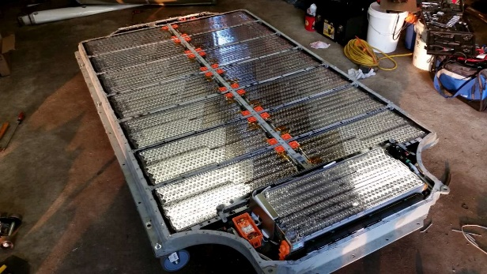
(Telegraph-2017)

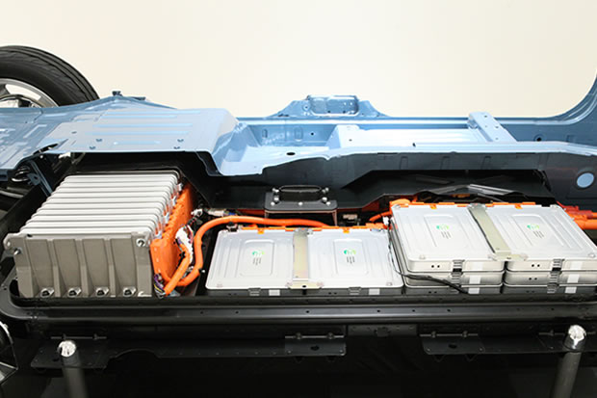
Figure 1: Model 3 Tesla Battery Pack (Smart Stock News, 2017).

A whole Tesla Model 3 battery pack which would be hidden under the floor, could be limited to 75Kw/h (Smart Stock News, 2017).
Figure 2: Nissan Leaf battery pack (Howard, 2017).
A Nissan Leaf battery pack which is placed under the floor pan (Howard, 2017).

The fundamentals of electric propulsion

An electric motor can deliver maximum torque at start-up and thereby provide rapid acceleration. They are tough and reliable units and manufactures like the fact of instant power and research and development is being made to increase their range and public image (Ernat, J., Harris, W., and Trzaska, T-SAE, 2017).

Alternative methods away from electric powered vehicles

Hybrid
The process of hybrid vehicles use power generated from an internal combustion engine as well as a battery pack and motor. Some hybrids work by just using battery and electric motor power and the internal combustion engine just charges the battery (series) whilst others can use both battery and internal combustion units to power the road wheels (Parallel). On a parallel type unit, a controller decides when to switch between the electric power and traditional power (Hse.gov.uk, 2017).
According to Hybrid Center, the arrangement of parallel hybrids makes them more effective for motorway driving at higher, more persistent speeds. On the other hand, series hybrids are more efficient for city driving because of their drivetrain assembly decreases the strain on the engine in stop and start situations (Lake, 2017).

Biofuels
Vehicle that run on conventional fuels like Petrol and Diesel create air pollutants when the fuels are burnt in a combustion process, another downside to these fuels are that they are oil based which is a non-renewable resource (Energy.gov, 2017). Biofuels include biodiesel and cellulosic ethanol, fuels which are renewable fuels which are highly unlikely to run out. Unfortunately, as process for power production is still a combustion processes these renewable fuels are still bad for the environment via their pollutants. Ethanol can be mixed with petroleum to increase the octane rating for a more efficient burn and to reduce emissions e.g. carbon monoxide. It is made by a mix of starch and sugars but scientists are finding alternative processes to achieve ethanol production.

Discussion

PESTLE- Analysis of electric propulsion vehicles within urban and rural communities for automotive.

Political | - Government grants.
Economical | - Cost of implementation.  - Reduce Tax and/or insurance.
Social-Cultural | - More accidents as sound pollution from vehicles decreases.  - More charging stations taking up vital land space or not being many around rural areas.  - Negative change- difficulty to involve within lifestyle e.g. farmers and heavy transportation.
Technological | - Increase upgrades within electric propulsion.
Legislation | - All systems need to meet the same requirements e.g. euro emission standards for current vehicles and MOT’s.
Environmental | - Green in terms of the vehicle producing emissions.  - Large carbon foot print in terms of production and shipping of parts worldwide.  - Chemicals used in the batteries.
Table 1: PESTLE Analysis for electric vehicles.

A PESTLE analysis is a model in marketing ethics. Furthermore, this concept is used as a device by companies to track the environment they’re working in or are planning to launch a new project/product/service etc. (PESTLE Analysis, 2017).

- Political-
In relation to government grants this will persuade/ convince the public to go electric if they get something back from making the switch. If the public see that they can save money by this switch that is a bonus to change from conventional powered vehicles e.g. petrol, diesel (Ft.com, 2017).
Another possible bonus to buyer in-relation to the government is a decrease in road tax and possibly insurance to attract more buyers who would previously be bias to the internal combustion powered vehicles.
The UK government has already pledged to ban all new Petrol and Diesel vehicles from 2040 showing a real push to an alternative power source for transportation (BBC News, 2017).

- Economical-

How financially friendly will a complete switch to purely electric vehicles and the lifespan of battery powered cars? Also, some or none manufactures will give out warranties to cover the lifespan, of not just the vehicle but the battery itself to try and attract more customers but a massive problem is the lifecycle of batteries compared to ICE. Another key point is infrastructure, as there needs to be a sufficient amount of charging points like there are fuel stations to meet the demand with the increase in electric powered cars. Especially, within rural areas it may not be as cost effective to install more charging station and the efficiency of electric vehicles in very rural/ agricultural area may limit sales of electric vehicles (Vaughan, 2017).

Research and development of batteries should be the maximum focus point to achieve great performance, reduce cost and weight, the practicality of recharging and environmental effects arising from the production and disposal of the batteries (Jussani, A. and Albertin, J- 2013).

- Social/ Cultural-
There could be an increase in accidents involving electric powered vehicles because of the reduced noise pollution they create thus leading into possible claims and lawsuits. Also, there may not be enough charging stations around certain areas because of difficulty with delivering transportation to these areas e.g. very rural areas with limited good quality roads. This can also be a negative with the need of more charging stations- more natural land may be taken away and it may affect specific ecosystems in that area (Gov.uk, 2017).

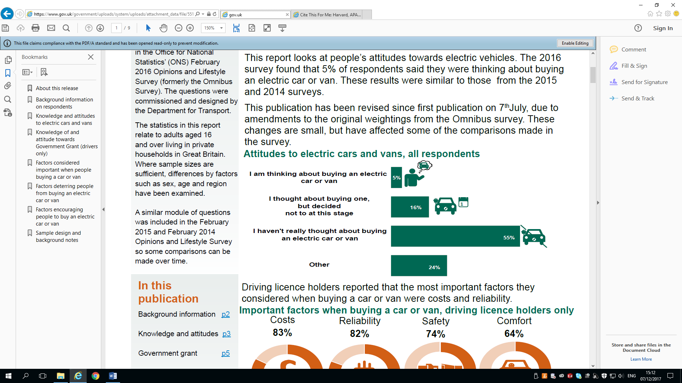
In rural areas where farms are prominent electric vehicle may not fit into the needs of heavy working loads, long operating hours and the needs of many agricultural farmers and rural industries where they rely on heavy goods vehicles e.g. truck, Lorries, tractors and combine-harvesters etc.
Figure 3: Government survey on electric powered vehicles (GOV.UK, 2017).
As lithium-ion batteries are effected by temperature the possibility that the batteries used reduce in operating time if they are predominantly used in places such as Iceland against use in warmer climates of Africa.
A government study survey carried out found that 5% of the survey applicants thought about buying and electric car or van but a majority of 55% said that they hadn’t really thought about buying an electric car or van (GOV.UK, 2017).

- Technological-
A positive note as all vehicles will be electric powered there will be more and more enhancements and improvements within this technology with battery’s hopefully getting more efficient and reliable (Visual.ons.gov.uk, 2017).
If vehicle size and performance remain continuous at modern levels, electric propulsion systems can reduce or eradicate the transport sector's dependence on petroleum. However, continued dependence on fossil-fuels without active carbon capture for producing electricity and hydrogen constrain the GHG emission and energy decreases to roughly 60% below that of current spark-ignition equipment (Kromer, M. and Heywood, J-SAE, 2009).
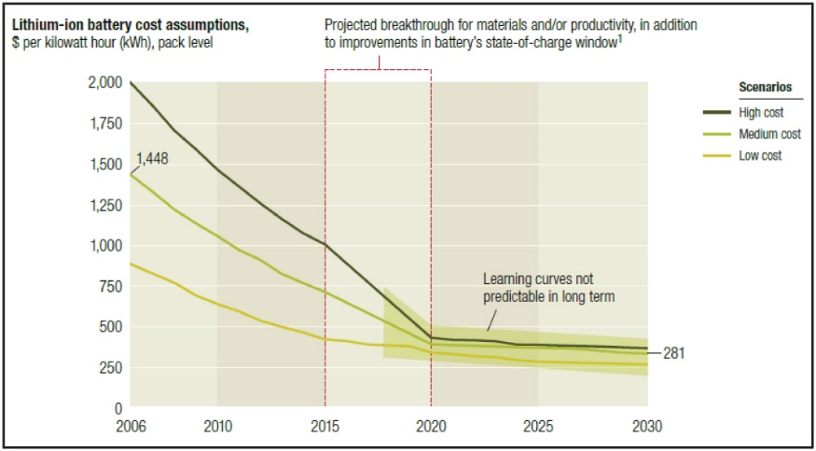
More money still needs to be invested into alternative methods to power the automotive sector vehicles to increase research and development as there are multiple positives to all electric vehicles but so much is known about the ICE (internal combustion engine) and still research and development continues to increase its efficiency and carbon foot-print.
Figure 4: A predicted graph of Lithium-ion battery cost against a timeline with a projected breakthrough between 2015-2020 (Jussani, A. and Albertin, J- 2013).

- Environmental-
As an electric vehicle on a road an electric car is very efficient as it emits no air pollution and only very minimal noise pollution but the manufacturing process of electric vehicles and the materials used to create these batteries are not as environmentally friendly. Also, what recycling process would be put into place for used/ broken batteries? Surely the most obvious way would be to re-use these batteries for their materials for use within future batteries or alternative products (Gov.uk, 2017).
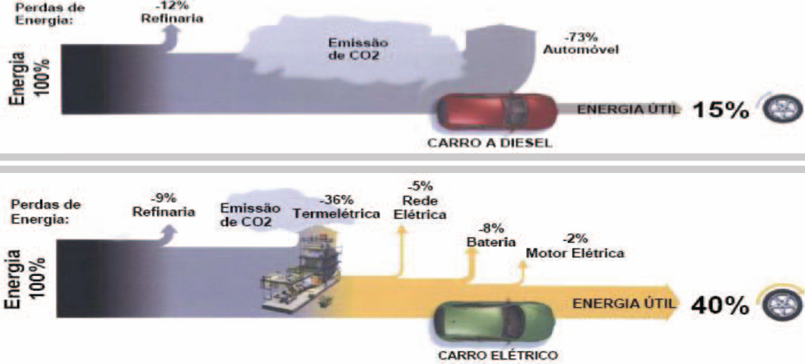

Figure 5: Showing how much energy percentage a Diesel uses against an electric vehicle through the process of extracting this energy (Jussani, A. and Albertin, J- 2013).

In figure 4 an SAE research paper shows that despite the long and un-environmentally friendly way that the electric power is generated the power unit still uses more of the energy produced 40% against 15% of a Diesel. The process of refining the oil to diesel and to be used within a diesel automotive vehicle only 15% of that energy is used giving a waste of 85% waste against a 60% waste. Still both aren’t incredibly efficient but this description shows electric vehicles to use a higher percentage of the energy created (Jussani, A. and Albertin, J- 2013).
To meet the increase in electrical demand there would need to be more electrical power station e.g. coal, hydro, wind, nuclear- to meet the increase in demand and these depending on the type aren’t all renewable and environmentally friendly. ‘In the automotive sector, the hybrid option is ensuring excellent results both in terms of environmental and operational range (Trancossi, M., Dumas, A., Stewart, P., and Vucinic, D, 2014).
- Legislation-
If electric vehicles are the norm will there be equivalent legislation e.g. Euro emission standards and MOT’s- for these vehicles so that they are maintained up to a safe road-worthy manner (Parliament.uk, 2017).
For example, a global effort to reduce CO₂ emissions, the European Union (EU) introduced CO₂ emission regulations for passenger cars with a 95 gCO₂.km⁻¹ goal set for 2020. The standard of vehicle emissions is because 29% of Greenhouse Gas (GHG) emissions comprises of transport emissions and the passenger car subsidises 12% towards the total transport emissions (Groenewald, J., Marco, J., Higgins, N., and Barai, A- SAE, 2016).
Government legislation has already been put into place involving electric cars and automated vehicle showing that even though electric vehicles aren’t the highest percentage of vehicles on the road the government are thinking ahead with a future world of electric vehicles. A direct quote below shows the governments input and interest into the future of electric vehicles on the road.
‘Other measures set out in the Bill will mean easier access to infrastructure for electric vehicles. They could also ensure the right infrastructure is in place for the growing market for electric vehicles’ (Gov.uk, 2017).

SWOT

Strengths-  - Reduced emissions in terms of the vehicle being driven (not including manufacturing).  - Public images.  - Sound pollution and air pollution reduced from vehicle.  - Better for congestive traffic where people’s health from emissions is at risk. | Weaknesses-  - Possible loss of jobs in industry where less knowledge of electric propulsion is known compared to the internal combustion engine.  - Cost of implementation and development of improved products.  - Safety- sound pollution reduced could potentially cause accidents.  - Lack of charging points.
Opportunities-  - Government funding i.e. grants.  - Government’s public image if enforced.  - More funding within electric propulsion engineering and research. | Threats-  - Ethics  - Energy concept  - Lack of charging points in rural areas (distance between stations).
Table 2: SWOT Analysis of electric propulsion vehicles.

Conclusion

Would a complete switch over to electric propulsion from the ICE powered vehicles be a viable plan in relation to PESTLE in the automotive sector?

To conclude, an overview of a complete switch over from the conventional internal combustion engine powered vehicles to solely electric in the automotive industry. Through research it suggests that an electric switch over would affect the industry in a negative way in relation to economics in the short term but once technology improves and possible government grants are accepted the increase in sales would out-way the negatives in the long term.
It is impossible at this point to say that electric vehicles are the future but it is known that they will be part of the future through research and development in a more efficient and environmentally friendly vehicle. Until, another method, to power automotive vehicles, is found it seems that more research will still be placed with the ICE (internal combustion engine) because of the vast amount of knowledge and technology that is known within the area.
At this moment in time with the UK government enforcing a whole ban on new Petrol and Diesel vehicles entering the country by 2040 it seems that the electric vehicles are the future or possibly just a stepping stone to an alternative means of environmentally efficient transport.
A final word- if governments release legislation involving electric vehicles it is believed that industry will follow within the manufacture of new technologies including the improvement of electric vehicles but at this moment in time, it is difficult to predict the long term affects of a solely electric vehicle industry and market on the political, economic, social, technological, environmental and legislative areas.

References

- Energy.gov. (2017). The History of the Electric Car. [online] Available at: https://energy.gov/articles/history-electric-car [Accessed 7 Nov. 2017].
- Hse.gov.uk. (2017). Electric and hybrid vehicles. [online] Available at: http://www.hse.gov.uk/mvr/topics/electric-hybrid.htm [Accessed 7 Nov. 2017].
- Lake, R. (2017). The Difference Between Parallel Hybrid Cars & Series Hybrid Cars. [online] LIVESTRONG.COM. Available at: https://www.livestrong.com/article/174905-the-difference-between-parallel-hybrid-cars-series-hybrid-cars/ [Accessed 7 Nov. 2017].
- Smart Stock News. (2017). Tesla Inc. (TSLA) Model 3 Battery Pack May be Limited to 75 kWh. [online] Available at: http://smartstocknews.com/41282-tesla-inc-tsla-model-3-battery-pack-may-be-limited-to-75-kwh/ [Accessed 7 Nov. 2017].
- Energy.gov. (2017). Biofuel Basics. [online] Available at: https://energy.gov/eere/energybasics/articles/biofuel-basics [Accessed 7 Nov. 2017].
- PESTLE Analysis. (2017). What is PESTLE Analysis? A Tool for Business Analysis. [online] Available at: http://pestleanalysis.com/what-is-pestle-analysis/ [Accessed 7 Nov. 2017].
- Ft.com. (2017). Politics not economics propels electric car growth. [online] Available at: https://www.ft.com/content/6b7eb1d8-624f-11e7-8814-0ac7eb84e5f1 [Accessed 7 Nov. 2017].
- Gov.uk. (2017). [online] Available at: https://www.gov.uk/government/uploads/system/uploads/attachment_data/file/551446/electric-vehicles-survey-2016.pdf [Accessed 2 Dec. 2017].
- Visual.ons.gov.uk. (2017). Are we ready to switch to electric cars? | Visual’s. [online] Available at: https://visual.ons.gov.uk/are-we-ready-to-switch-to-electric-cars/ [Accessed 2 Dec. 2017].
- Parliament.uk. (2017). [online] Available at: http://www.parliament.uk/documents/post/postpn365_electricvehicles.pdf [Accessed 7 Dec. 2017].
- Trancossi, M., Dumas, A., Stewart, P., and Vucinic, D., "Increasing Aeronautic Electric Propulsion Performances by Cogeneration and Heat Recovery," SAE Technical Paper 2014-01-2106, 2014.
- Jussani, A. and Albertin, J., "Critical Factors in the Use of Battery for Automotive Propulsion of Urban Family Electric Vehicle," SAE Technical Paper 2013-36-0400, 2013.
- Kromer, M. and Heywood, J., "A Comparative Assessment of Electric Propulsion Systems in the 2030 US Light-Duty Vehicle Fleet," SAE Int. J. Engines 1(1):372-391, 2009.
- Groenewald, J., Marco, J., Higgins, N., and Barai, A., "In-Service EV Battery Life Extension Through Feasible Remanufacturing," SAE Technical Paper 2016-01-1290, 2016.
- Gov.uk. (2017). New measures set out autonomous vehicle insurance and electric vehicle infrastructure - GOV.UK. [online] Available at: https://www.gov.uk/government/news/new-measures-set-out-autonomous-vehicle-insurance-and-electric-car-infrastructure [Accessed 9 Nov. 2017].

