
Consulting Report on
Hilton Garden Inn Bucharest

Completed by StrategiQ Consulting

Student Name: Sorin Ciprian Chelm
Student ID: 2125245

Executive Summary:
This consulting study gives the Hilton Garden Inn Bucharest a strategic plan for how to improve cleaning procedures and make guests happier. The most important thing is to give your guests a great time. The main goals of our suggested method are to deal with important problems, find long-lasting solutions, and make big improvements in service quality and operational efficiency.
Key initiatives include using technology to make housekeeping easier, giving staff thorough training to give them more power, improving the guest experience with personalised amenities and deals, and putting in place strong quality assurance measures to make sure that service is always the same.
Using cutting edge technology will make cleaning much more efficient. Automated scheduling systems and real-time tracking of the state of each room will make the best use of staff and cut down on downtime. Using eco-friendly cleaning methods will not only make cleaning more effective, but it will also be in line with environmentally friendly practices.
Staff will have the skills they need to provide great service thanks to thorough training programmes. The training will cover both hard and soft skills to make sure that workers are ready to meet and go above and beyond what guests expect. Staff morale and productivity will go up if you give them more power through ongoing growth and recognition programmes.
Personalised amenities and focused promotions will be added to make guests' stays memorable. Customising services based on what guests want will make them happier and more likely to stay with you. For instance, you could offer custom welcome gifts, room settings that are just right for each guest, and special deals just for returning guests.
The Hilton Garden Inn Bucharest will be able to run its business more efficiently, provide better service, and make guests happier by using this all-encompassing PESTEL method. Focusing on operational excellence and making sure guests are happy will help it stay at the top of the hotel industry around the world. This plan will bring in new people, keep old ones coming back, and support long-term growth and profits.

The Hilton Garden Inn Bucharest will create amazing guest experiences for years to come by working together, coming up with new ideas, and being dedicated to excellence. The hotel will improve its image and ensure long-term success by always trying to be the best. StrategiQ Consulting is committed to helping Hilton Garden Inn Bucharest on this journey of change. We will be able to run the business smoothly and give guests an experience that can't be beat.
Table of Contents
Executive Summary: 1
Introduction: 3
Analysis 4
SWOT analysis: 4
PESTEL analysis: 7
TOWS analysis: 9
Recommendations and Change Management: 11
Recommendations: 11
Changes in Management Practices: 13
Key Performance Indicators: 14
Associated Costs: 16
Action Plan: 18
Conclusion: 20
References: 21

Introduction:
In the fast-paced and competitive hotel business, upholding high standards of service quality is key to staying ahead of the competition and making sure guests are happy. As a world leader in the hotel industry, Hilton Garden Inn Bucharest is always looking for ways to improve the guest experience and set new standards for quality and creativity (Shen, 2021). But because guest standards are changing and there are problems with the way things are run, cleaning needs to be reevaluated and improved right away to meet and beat guest expectations.
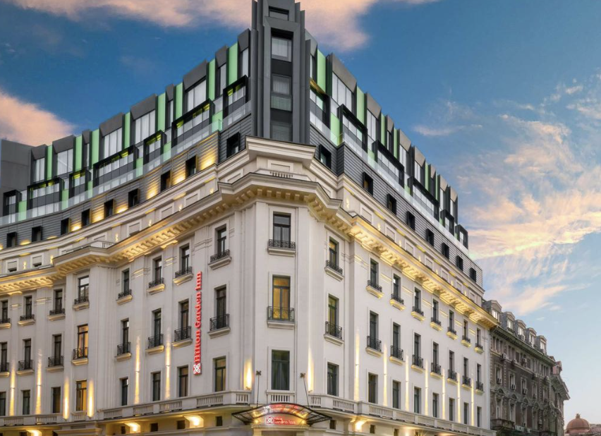
This report is meant to be a complete checklist for Hilton Garden Inn Bucharest to follow in order to improve cleaning and guest happiness. By getting to the heart of the problems, suggesting strategic solutions, and describing specific steps that can be taken, this advising method aims to give Hilton Garden Inn Bucharest the knowledge and plans it The Hilton Garden Inn Bucharest is a new hotel right in the middle of Bucharest's Old Town. It has 201 well-equipped rooms and opened in 2017. There is a fitness centre, an office centre, and meeting rooms at the hotel. At the Garden Grille restaurant on-site, guests can enjoy food from around the world. The National Museum of Romanian History and the Palace of the Parliament, two very important sights, are close by. It's known for being in a good spot, having modern decor, and having helpful staff. The hotel has free Wi-Fi, which makes it a great choice for both work and leisure travellers. Thus, for Hilton Garden Inn Bucharest to keep its top spot in the industry and make guests happier, it needs to improve cleaning methods, use technology more effectively, and give employees more freedom. In this consulting report, important problems and chances will be found, strategic solutions will be suggested, and suggestions that can be put into action will be laid out. Hilton Garden Inn Bucharest can improve business efficiency, service quality, and guest happiness to new heights by taking a comprehensive approach that includes technology, training, improving the guest experience, and quality assurance measures.

Analysis

SWOT analysis:
Hilton Garden Inn Bucharest Hotel has many strengths and growth possibilities, but it also needs to work on its flaws and avoid threats if it wants to stay competitive in the hotel business. By taking advantage of its great location, reputation for luxury, and many ways to make money, along with its commitment to new ideas.
Strengths:
- The Hilton Garden Inn Bucharest is carefully placed in a high-traffic area of Romania that guarantees a steady flow of guests. Its location near major sites, business areas, and transportation hubs makes it very convenient for tourists (Phalippou, 2014). This makes it a good choice for both business and vacation travelers. This great site is so important to the hotel's success; it helps it keep its high usage rates and make money.
- The hotel has a reputation for being luxurious and providing excellent service, which solidifies its position as the best place to stay. Guests have given it good reviews and suggested it to others because it is dedicated to offering luxurious services, individual service, and careful attention to detail. This good word-of-mouth advertising has helped build a loyal customer base and bring in new customers who want to experience high-end service.
- There are a lot of different services at the Hilton Garden Inn Bucharest Hotel that meet the wants and tastes of all of its guests. The hotel provides a wide range of services and features to make the stay better for its guests. These include large, tastefully decorated rooms, fine meals, well-equipped meeting rooms, and fun things to do. These top-notch amenities help keep guests happy and coming back, which sets the hotel apart from others in the same category.

Weaknesses:
- Even though Hilton Garden Inn Bucharest Hotel has some strengths, it also has some problems that could make it less effective and less competitive in the market. One major weakness is that keeping luxury standards comes with high running costs. To keep up its image for quality, the hotel spends a lot of money on things like hiring, repair, energy, and services. These high running costs can make it harder to make money, especially when there aren't many customers or when the economy is unsure (Đurić, 2019).
- Another problem is that the hotel depends on the times of the year for bookings. Like many other hotels, the Hilton Garden Inn Bucharest Hotel's business goes through ups and downs with the seasons, with peak seasons bringing in the most money. The hotel's financial security is at danger because it depends on changes in the seasons. To make the most of off-peak times and increase revenue, the hotel needs to have good revenue management plans in place.
- The hotel and restaurant business is known for having a lot of staff change, and Hilton Garden Inn Bucharest Hotel is no exception. Employee change can mess up operations, lower the level of service, and raise the cost of training, all of which can make guests less satisfied (Çetin, Ultav and Uz, 2019). To fix this problem, you need to put money into programs that help you keep employees, like offering fair pay, chances to learn new skills, and a good work environment that encourages interest and loyalty.
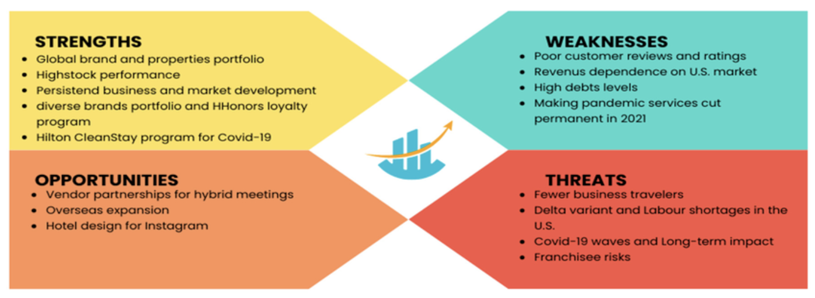

Opportunities:
- Even with these problems, Hilton Garden Inn Bucharest Hotel has a number of chances to become more competitive and keep growing in the long run. By being present in more places, the hotel can take advantage of new travel and tourist trends, find new types of customers, and become less dependent on certain areas or regions.
- In addition, Hilton Garden Inn Bucharest Hotel can improve its online visibility and interact with customers in more ways by spending money on digital marketing strategies and technology solutions. Personalized marketing efforts, social media, and data analytics can help the hotel target the right people, get more direct bookings, and give guests experiences that are unique and meaningful to them (Barnett, 2011).
- Adopting eco-friendly and sustainable practices is another way for Hilton Garden Inn Bucharest to set itself apart and appeal to tourists who care about the environment. The hotel can show its commitment to sustainability by using technologies that use less energy and lowering trash, as well as by getting involved in the community and buying from responsible suppliers. This will also lower running costs and improve the brand's image.
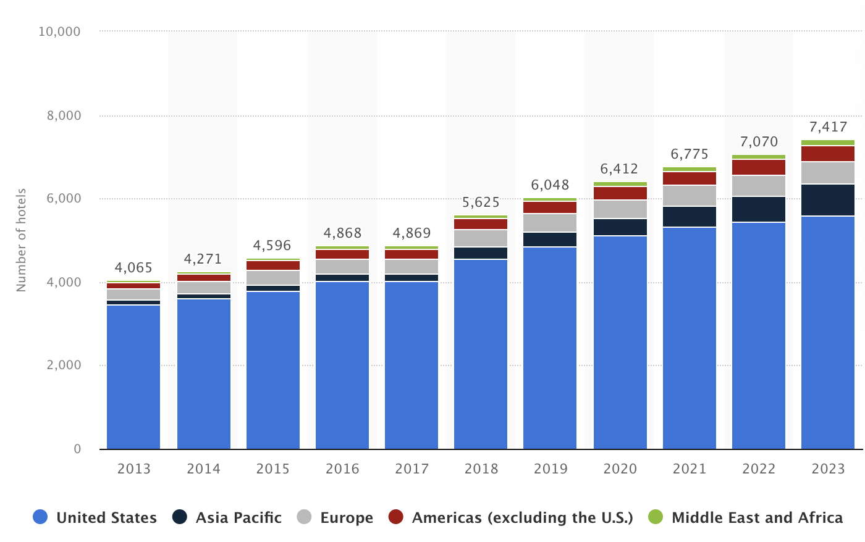

Threats:
- Along with its flaws, Hilton Garden Inn Bucharest Hotel has to deal with a number of threats that could hurt its performance and ability to compete. One big worry is that the hotel business is very competitive. There are a lot of rivals in Romania for Hilton Garden Inn Bucharest market share, such as standard hotels, private accommodations, and other types of housing like holiday rentals and Airbnb. This can make prices and profit margins tight.
- Another thing that could hurt Hilton Garden Inn Bucharest Hotel's finances is economic instability. External factors like economic downturns, health problems, or global events can make it hard for people to travel, spend money, and run businesses normally, which can hurt the hotel's ability to make money and stay in business. To reduce these risks and make sure the business is resilient, it's important to make backup plans and keep the money flexible.

PESTEL analysis:
PESTEL study shows the different outside factors that affect the business situation at Hilton Garden Inn Bucharest Hotel and Resorts. Stable politics, a strong economy, and new technologies all create chances for growth and new ideas. But social trends, environmental concerns, and strict laws create problems that need to be solved in a planned way. Hilton Garden Inn Bucharest can minimize risks, take advantage of chances, and stay competitive in the fast-paced hotel business by knowing and responding to these outside forces.
Political:
Politics have a big effect on how Hilton Garden Inn Bucharest runs its business. Tax laws, job laws, and visa policies and rules made by the government in Romania can have an effect on the hotel industry's costs and the types of people who work there. For example, if tax laws change or the minimum wage goes up, it could affect the hotel's running costs (Rezaee, 2016). To stay profitable, the hotel might have to change its price plans or hiring levels. Also, political unrest and safety worries in target countries can change how people travel and how many tourists come, which has a direct effect on the hotel's income and occupancy rates.
Economic:
The economy is a very important factor in how well Hilton Garden Inn Bucharest Hotel does. Changes in financial factors like GDP growth, inflation rates, exchange rates, and customer trust have a direct effect on the desire for travel and tourism. When the economy is doing well, people may have more money to spend on travel and high-end hotels like the Hilton Garden Inn Bucharest Hotel (Lockyer, 2015). On the other hand, when the economy is bad, people may not be able to afford to travel as much, hotels may have lower occupancy rates, and prices may go up, which can hurt their income and profits.
Social:
People's tastes, hobbies, and travel habits are affected by social factors, which has effects on Hilton Garden Inn Bucharest Hotel's business. Demographic changes, like an older population or changes in family patterns, can affect the kinds of rooms and services that guests want. Also, as people's tastes in environment, health, and unique vacation experiences change, the hotel faces both challenges and possibilities. The hotel can become more appealing and competitive in the market by responding to these social trends by providing eco-friendly initiatives, health programs, and one-of-a-kind guest experiences.
Technological:
New technologies have changed the hotel business and are still affecting how Hilton Garden Inn Bucharest Hotel works. Online booking sites, mobile apps, and property management systems are some of the new technologies that have changed how hotel guests book rooms and connect with the hotel (Kaushik and Guleria, 2020). Using technology-based solutions can make operations run more smoothly, improve the guest experience, and increase sales. But fast changes in technology also bring problems, like the need to keep investing in IT systems and the risk of hacking breaches. Sharing economy platforms like Airbnb could also cause problems.
Environmental:
Environmental sustainability is becoming more important in the hotel business because customers are becoming more aware of it and because of pressure from the government. The Hilton Garden Inn Bucharest Hotel is being closely watched for its impact on the earth, which includes how much energy it uses, how it handles trash, and how much carbon dioxide it releases. Using eco-friendly methods, like lighting that uses less energy, water-saving measures, and recycling programs for trash, not only helps the earth but also saves money and improves a brand's image. Following environmental rules and getting certifications like LEED (Leadership in Energy and Environmental Design) can also show that the hotel cares about the environment and bring in people who care about the same things (Tan, 2020).
Legal:
Legal factors include many rules and laws that the Hilton Garden Inn Bucharest Hotel has to follow, such as job and labor laws, health and safety rules, and zoning codes. Following these laws is very important if you want to avoid legal problems, fines, and damage to your image. For instance, the hotel has to follow rules about food safety in its kitchens, make sure workers are safe at work, and get the right building codes and licenses for any changes or additions. Legal issues also come up with contracts with partners, sellers, and vendors, so the hotel needs to be very careful when negotiating and managing risks to protect its own interests.

TOWS analysis:
Hilton Garden Inn Bucharest has a strong brand image and reputation for luxury and great service, which could be used as a strategic advantage. By playing to this strength, the hotel can improve its place in the market and set itself apart from rivals, drawing picky tourists looking for high-end experiences. For example, the hotel can spend money on tailored marketing efforts that highlight its unique value proposition and high-end services. This will help it contact and interact with its intended audience.
Hilton Garden Inn Bucharest Hotel can also take advantage of the growing trend of health tourism and experiential travel by improving its services and making the guest experience better. With its state-of-the-art facilities and relationships with local wellness providers, the hotel can create wellness packages and experiences that are all-encompassing and focus on the health and happiness of its guests. By giving wellness-focused services like spa treatments, yoga lessons, and healthy food choices, the hotel can draw tourists who care about their health and reach a profitable market group.
Hilton Garden Inn Bucharest Hotel needs to work on its flaws to protect itself from risks as well as using its strengths to take advantage of chances. One big problem with the hotel is that it has high running costs, which can make it less profitable, especially when there aren't many guests or the economy is bad. To fix this problem, the hotel can take steps to save money, like implementing energy-saving programs, streamlining operations, and training programs for staff, which will boost output and lower extra costs.
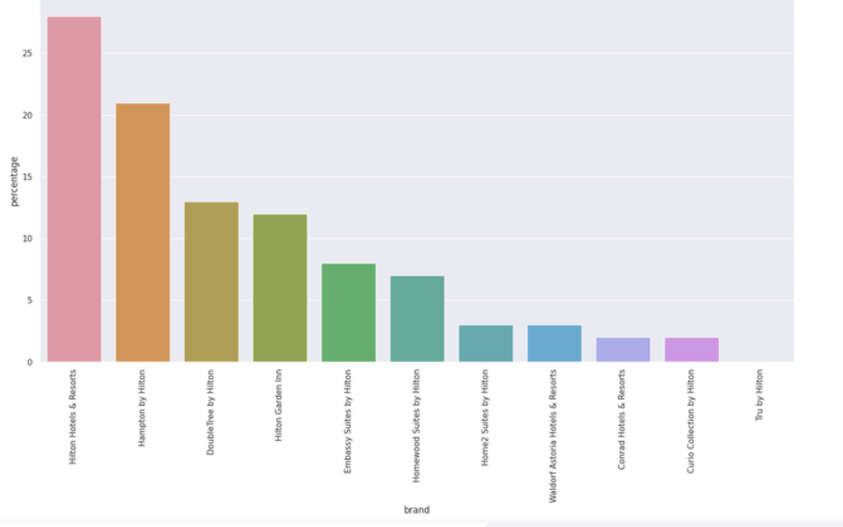
Hilton Garden Inn Bucharest Hotel also needs to take charge of its online image and make sure its guests are happy to avoid the risk of bad reviews and social media criticism (Buhalis et al., 2019). The hotel can quickly handle guest complaints, solve problems effectively, and keep a good brand image by spending in online reputation management tools, guest feedback systems, and training for staff in how to provide excellent customer service. Using quality assurance procedures and standards can also make sure that service delivery and guest experiences are always the same, which will make guests even happier and more loyal.

Recommendations and Change Management:

Recommendations:
At Hilton Garden Inn Bucharest Hotel and Resorts, making sure that cleaning works as efficiently as possible and that guests are happy is very important. The following are detailed suggestions for improving housekeeping issue and improving guest experience:
- Use technology to help: Buy cleaning management software that can do things like assigning rooms, keeping track of supplies, and making schedules automatically. This software can make things run more smoothly, help staff talk to each other better, and give real-time reports on the state of each room, which can cut down on wait times and make guests happier.
- Train and give staff power: Make sure the cleanup staff knows how to clean, what guests want, and how to stay safe by giving them thorough training programs. Allow them to be responsible for their work by supporting effort and problem-solving. This can lead to more work getting done and better service (Goldstein and Naor, 2005).
- Use measures to ensure quality: Maintain high standards of cleanliness throughout the hotel by conducting regular inspections and quality control checks. Using guest comments, doing spot checks, and setting up performance data can help you find places to improve and make sure that the level of service is always the same.
- Streamline processes: Make cleaning processes more efficient by putting jobs in order and cutting down on steps that aren't needed. Floor plans and planning systems can help you find the best ways to clean, cut down on the time it takes to get from one room to another, and get more done.
- Put the needs of guests first: Customize cleaning services based on what your guests want and need. Give guests choices for eco-friendly cleaning products, pillow types, or room temperature settings to make them feel more at ease and satisfied (Iqbal, 2021).
- Improve ways of communicating: Make sure there are good ways for cleaning staff to talk to other sections, like front desk and maintenance. Use cell phones or two-way radios to communicate with guests in real time and quickly solve any problems or requests they may have.
- Spend money on tools and supplies: Give the housekeeping team good cleaning tools and equipment to make sure they clean quickly and well. Maintain and repair equipment on a regular basis to keep it working well and up to standards for cleanliness.
- Green practices should be used: Using cleaning tools that are safe for the earth, using less water and energy, and throwing away less trash are all healthy ways to clean your home. These actions not only meet the needs of guests who want eco-friendly lodging, but they also help the hotel save money and show its dedication to sustainability.
- Improve staff scheduling: Use tools for data analysis and forecasts to make the best staff schedules based on events, guest visits, and availability levels. By matching hiring numbers to demand, the hotel can be more productive, save money on labor, and make sure that guests are served on time.
- Encourage feedback and improvement all the time: Set up a way for the cleaning group to get feedback and keep getting better. Ask the staff for ideas on how to improve the process, pay attention to what your guests have to say, and look over your success numbers on a regular basis to find ways to improve and come up with new ideas (Mitchell, 2018).
- Cross-Train Staff: To make things more flexible and efficient, cross-train your cleaning staff in more than one area. This lets employees help out in other departments during busy times or emergencies, keeping things running smoothly and upholding service standards.
- Follow trends and the best ways to do things: Keep up with the latest trends and best practices in the housekeeping business. To learn about new technologies, techniques, and innovations that can make your business more efficient and your customers happier, go to conferences, workshops, and join industry groups.
- Appreciate and Reward Excellence: Thank the cleaning staff for their hard work, commitment, and great service. To motivate staff and create a culture of excellence in the department, use recognition programs, incentives, or awards.
- Work together with suppliers: Build strong relationships with suppliers and vendors to make sure that cleaning supplies, equipment, and amenities are delivered on time. Talk about good terms, look into buying in bulk, and work together on new products to cut costs and improve efficiency.
- Keep an eye on trends and act on them: Keep an eye on guest reviews, feedback, and industry trends that affect housekeeping on a regular basis. Use this information to spot new trends, address guest concerns, and change the way you clean to keep up with changing guest needs.

Changes in Management Practices:
It is very important for Hilton Garden Inn Bucharest to put in place change management practices and processes in order to improve cleaning and guest happiness. Change management is a planned way to get people, groups, and organizations from where they are now to where they want to be in the future. By using different models and ideas, we can create a structure for handling this process well.
John Kotter came up with the 8-Step Change Model, which is one of the most important models in change management (Earls and Skyrme, 2010). This model shows a planned way to bring about change. It has steps like making people feel like they need to act quickly, building a strong alliance, and sharing the change goal. Applying this model to Hilton's case would first involve showing the possible pros and cons of not making changes in order to show that cleaning and guest happiness need to get better. This makes people feel like they need to act quickly, which encourages them to back the change effort. Next, it's important to get executives, managers, and front-line staff at Hilton Garden Inn Bucharest to work together as an alliance. The change will move forward with the help of this coalition's guidance and backing. It's important to make sure that everyone in the company understands the growth strategy and understands how important it is to improve cleaning and guest happiness. There are three steps in Lewin's Change Management Model that are also useful: unfreezing, changing, and refreezing. Breaking down old ways of thinking and feeling is part of unfreezing, which gets the group ready for change. In the case of Hilton, this could mean holding training classes to teach employees how important it is to follow cleaning standards and measure guest happiness, as well as dealing with any pushback to change. During the change stage, new processes and procedures are put in place to make cleaning better and make guests happier. This could mean buying technology to make cleaning easier, changing training programs to make staff better at their jobs, and setting up ways for guests to give feedback so that you can see in real time how satisfied your guests are. Lastly, refreezing means making sure that the changes are ingrained in the organization's culture so that they will last. Among other things, this could mean recognizing and rewarding workers who go above and beyond to keep the place clean and give guests a great experience, making the desired behaviors more common.
Prosci also came up with the ADKAR Model, which focuses on individual change by listing the five most important things that are needed for change to happen: awareness, desire, knowledge, ability, and encouragement (Pate, 2018). To use this model for Hilton's change initiative, we need to make sure that employees understand why change is needed, want to be a part of it, have the knowledge and skills to make the changes work, and get ongoing support and reinforcement to keep the changes going. Along with these models, change management efforts can be more successful if they use ideas from corporate psychology and behavioral economics. For example, using motivation and reward principles can get workers to accept change and work with you to make cleaning better and make sure guests are happy. Giving regular comments and praise for good work can also boost happiness and involvement, which can help with efforts to keep getting better. Using guest comments, performance measures, and measuring data in a data-driven way can also help you figure out what needs to be fixed and keep track of your progress over time. By looking at patterns and trends, you can make better decisions. For example, Hilton Garden Inn Bucharest can use data to make changes to its cleaning and guest happiness strategies. Last but not least, Hilton Garden Inn Bucharest needs to take a thorough approach to change management in order to improve cleaning and guest happiness. Hilton Garden Inn Bucharest can lead and maintain the desired changes by using models and theories like Kotter's 8-Step Change Model, Lewin's Change Management Model, and the ADKAR Model, along with ideas from organizational psychology and behavioral economics. This will improve the guest experience and keep Hilton Garden Inn Bucharest ahead of the competition in the hospitality industry.

Key Performance Indicators:
It is important to keep track of the effects and success rates of the suggested strategies for better cleaning and guest happiness at Hilton Garden Inn Bucharest in order to judge how well the change management effort is working and make sure that the goals are met. A number of key performance indicators (KPIs) can be used to judge how well the plans were carried out:
1. Guest Satisfaction Scores: Keeping an eye on guest satisfaction scores on a regular basis through polls, reviews, and other feedback tools can help you learn a lot about how your guests feel about their general experience. To see how things have changed over time, you can look at metrics like Net Promoter Score (NPS), guest happiness scores, and specific comments about cleaning services.
2. Housekeeping Performance Metrics* Keeping an eye on certain metrics related to housekeeping tasks, like room cleanliness scores, housekeeping response times, and cleaning task finish rates, can help you figure out how efficient and effective the housekeeping staff is. Comparing success to well-known standards or measures in the same business can help you understand how things are going.
3. Employee Engagement and Satisfaction: Finding out how engaged and happy your employees are with their jobs can be done through polls, focus groups, or one-on-one conversations. This can show how much your employees are on board with the change effort and feel supported in their roles. Higher levels of staff involvement are often linked to happier guests and better business success.
4. Operational Efficiency and Cost Savings: Keeping an eye on key operational measures like cost per filled room, worker productivity, and resource usage can help you find ways to save money and work more efficiently. Putting in place technology solutions or process changes should, ideally, lead to real gains in business measures over time.
5. Repeat Business and Customer Loyalty: Keeping an eye on metrics like retention rates, repeat business, and customer loyalty can help you figure out how the change effort will affect guest happiness and loyalty in the long run. More and more repeat bookings and good word-of-mouth recommendations show that guests were happy with their stays and are likely to come back in the future.
6. Revenue and Profitability: Looking at money-related numbers like RevPAR (revenue per available room), ADR (average daily rate), and profitability margins can help you figure out how happier guests have affected the hotel's total sales. Revenue and income measures that are going up show that efforts in making the guest experience better are paying off.
7. Compliance and Quality Assurance: Making sure that set quality standards and industry rules are followed is important to keep guests happy and trusting. Regular audits, inspections, and quality assurance checks can help find places where rules aren't being followed and push attempts to keep getting better.
8. Benchmarking and Competitive Analysis: Looking at how Hilton's performance stacks up against competitors and industry standards can help you figure out what went well and what needs more work. Comparing yourself to stars in your field and the best ways to do things can help you set realistic goals and push for ongoing growth.
By checking and studying these KPIs on a daily basis, Hilton Garden Inn Bucharestcan accurately see how the suggested strategies for better cleaning and guest happiness are working and how often they are successful. Based on what you learn from the success data, changes can be made to make sure the change project stays in line with the organization's goals and objectives.

Associated Costs:
To figure out how much it will cost to adopt strategies to improve cleaning and guest happiness at Hilton Garden Inn Bucharest Hotels & Resorts, you need to know a lot about the hotel's size, its sources of income, and the level of changes that are wanted. As one of the biggest hotel groups in the world, Hilton Garden Inn Bucharest runs a wide range of properties, from small hotels to huge resorts. Each one has its own set of operating needs and budget concerns (Rezaee, 2016). Hilton Garden Inn Bucharest might have to spend a lot of money on technology investments like tools for managing cleaning and sites for guests to give feedback. It is thought that for a hotel like Hilton, the beginning advances in technology could be anywhere from a few hundred thousand dollars to a few million dollars. This includes the price of software rights, tech equipment, setup, and training for staff members who work at different locations. Training and development programs are very important for improving the skills of workers and the quality of service. Hilton Garden Inn Bucharest has thousands of workers in many different areas. Because of this, the costs of training classes and events could reach tens of thousands to hundreds of thousands of dollars every year. This spending is important to make sure that employees have the skills and information they need to meet the hotel's changing service standards and guests' rising demands (Iqbal, 2021). Updating operations, like buying new cleaning tools and cleaning materials that are better for the environment, is important to keep things clean while having the least amount of impact on the environment. A hotel company as big as Hilton Garden Inn Bucharest might have to pay between tens of thousands and hundreds of thousands of dollars each year to make improvements to how it works. These investments help make things more efficient, last longer, and make guests happier.
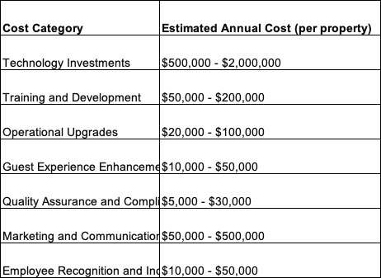
To improve the guest experience with personalized services and perks, you need to be smart about how you spend your money and use your resources. Hilton Garden Inn Bucharest might have to set aside anywhere from a few thousand to tens of thousands of dollars per location every month to improve the guest experience. This could include things like extras in the rooms, special deals, and events that are suited to what the guests want, which will make their stay better overall and make them more loyal. To keep Hilton's image for greatness and make sure guests trust and are happy, quality assurance and compliance means are necessary. Regular quality assurance audits, inspections, and compliance checks can cost anywhere from a few thousand dollars to tens of thousands of dollars per building per year. Making these investments is important to keep service delivery consistent and lower operating risks.
Marketing and communication are very important for getting the word out about Hilton's goal to make guests happier and increase demand. Depending on the hotel's marketing strategy and goals, marketing efforts, promotion, and communication activities could cost anywhere from tens of thousands to millions of dollars each year. These investments help Hilton's brand image and bring in guests who want unique experiences. Recognizing employees and giving them rewards are important for creating a culture of success and inspiring workers to provide excellent service. Hilton Garden Inn Bucharest might have to set aside anywhere from a few thousand to tens of thousands of dollars a year per location for programs that thank employees. This investment recognizes and pays employees for their hard work, which boosts happiness and encourages everyone in the company to focus on the customer.

Action Plan:
The action plan to implement the solutions are provided in the section below:
Action Item | Problem | Solution | Desired Outcome | Time Scale | Planned Budget
Putting technological solutions into action | Housekeeping tasks are less efficient and more likely to go wrong when they are managed by hand. | Use home management tools and mobile apps to help you assign tasks and keep track of them. | Streamlined cleaning tasks, made them more efficient, and cut down on mistakes. | 6 months | $300,000
Getting Better Training | The staff doesn't have enough skills and knowledge to keep up with the changing needs of guests. | Create thorough training programs that focus on cleaning standards, how to deal with guests, and providing excellent service. | Staff that is well-trained and driven to provide excellent service. | 3 months | $50,000
Upgrading staff Tools for Cleaning | Outdated cleaning tools make the job less efficient and effective. | Buy new cleaning tools and cleaning materials that are good for the environment. | Higher standards for cleaning and less damage to the earth. | 6 months | $75,000
Adding improvements to the guest experience | Fewer services and amenities for guests make them less satisfied altogether. | Add personalized services, special deals, and events for guests. | Better experience for guests, more happiness and trust. | Ongoing | $100,000 annually
Doing audits for quality assurance | Guest trust is affected by inconsistent service quality and safety problems. | Do quality assurance tests and compliance checks on a frequent basis. | Service that is always provided, standards that are followed, and resident faith. | Quarterly | $20,000 annually
Starting up advertising campaigns | Not enough people know about the hotel's changes and services. | Start focused marketing efforts that focus on how the cleaning staff and guests will benefit. | More orders, company awareness, and customer interaction. | 3 months | $200,000
Putting in place programs to recognize employees | Low staff enthusiasm and confidence hurt the level of service. | Set up ways for employees to be recognized and rewarded for doing a great job. | Staff happiness, drive, and service performance all got better. | Ongoing | $30,000 annually

Conclusion:
Hilton Garden Inn Bucharest needs to improve cleaning and guest happiness in order to stay competitive and build customer trust in the ever-changing hotel industry. This piece describes a complete consulting method that Hilton Garden Inn Bucharest can use to deal with important problems, put strategy ideas into action, and make real changes in service quality and practical efficiency. Hilton Garden Inn Bucharest can improve its cleaning, organize its operations, and give guests more unique experiences that go above and beyond what they expect by spending money on technology, training programs, guest experience improvements, and quality assurance measures. To keep these improvements going for a long time, it will also be important to create a mindset of ongoing growth and get employees involved.
In the end, Hilton Garden Inn Bucharest can improve its place as a global leader in the hotel industry by putting an emphasis on operating success and guest happiness. This will help the company draw new guests, keep old ones, and grow and profit in a way that lasts. Hilton Garden Inn Bucharest can change the standards of hospitality and create amazing experiences for guests for years to come by working together, coming up with new ideas, and always striving for the best.

References:
Barnett, S.J. (2011). The International Hospitality Business: Management and Operations. Annals of Tourism Research, 28(4), pp.1072–1074. doi:https://doi.org/10.1016/s0160-7383(01)00014-7.
Buhalis, D., Harwood, T., Bogicevic, V., Viglia, G., Beldona, S. and Hofacker, C. (2019). Technological Disruptions in services: Lessons from Tourism and Hospitality. Journal of Service Management, 30(4), pp.484–506.
Çetin, H.A., Ultav, Z.T. and Uz, F. (2019). Reflections of the İstanbul Hilton Garden Inn Bucharest Hotel on Mid-century Hotel Buildings in Turkey. Art-Sanat, pp.57–88. doi:https://doi.org/10.26650/artsanat.2019.12.0016.
Đurić, M. (2019). ‘Hilton’ hotel: Innovative spatial and technological intervention in the Belgrade’s urban fabric. Arhitektura i urbanizam, (48), pp.60–65. doi:https://doi.org/10.5937/a-u0-22119.
Earls, M. and Skyrme, D. (2010). Hybrid managers — what do we know about them? Information Systems Journal, 2(3), pp.169–187. doi:https://doi.org/10.1111/j.1365-2575.1992.tb00074.x.
Goldstein, S.M. and Naor, M. (2005). Linking publicness to operations management practices: a study of quality management practices in hospitals. Journal of Operations Management, 23(2), pp.209–228. doi:https://doi.org/10.1016/j.jom.2004.07.007.
Iqbal, U. (2021). Financial Performance in Daily Hotel and Business Management. Journal of Hotel & Business Management, 05(02). doi:https://doi.org/10.4172/2169-0286.1000e113.
Kaushik, M. and Guleria, N. (2020). The Impact of Pandemic COVID -19 in Workplace. European Journal of Business and Management, [online] 12(15), pp.1–10. doi:https://doi.org/10.7176/ejbm/12-15-02.
Lockyer, T. (2015). The perceived importance of price as one hotel selection dimension. Tourism Management, 26(4), pp.529–537. doi:https://doi.org/10.1016/j.tourman.2004.03.009.
Mitchell, P. (2018). Human Resource Management in the Hospitality Industry. International Journal of Hospitality Management, 16(1), pp.122–123. doi:https://doi.org/10.1016/s0278-4319(97)81212-1.
Pate, L.E. (2018). Using Theories as ‘Overlays’ for Improved Managerial Decision Making. Management Decision, 26(1), pp.36–40. doi:https://doi.org/10.1108/eb001484.
Phalippou, L. (2014). Hilton Garden Inn Bucharest Hotels: A Case Study in Real Estate Private Equity. SSRN Electronic Journal. doi:https://doi.org/10.2139/ssrn.2429357.
Rezaee, Z. (2016). Relevance of Business Sustainability Education for Hospitality Management. Journal of Business and Hotel Management, 02(01). doi:https://doi.org/10.4172/2324-9129.1000106.
Shen, H. (2021). Social Network and Job Satisfaction of Female Migrant Workers in Hotel Industry. Journal of Hotel & Business Management, 5(1). doi:https://doi.org/10.4172/2169-0286.1000120.
Tan, Y. (2020). Hotel-Specific, Industry-Specific and Macroeconomic Determinants of Profitability in London Hotel Industry: Structure-Conduct-Performance or Efficient-Structure Hypothesis? SSRN Electronic Journal. doi:https://doi.org/10.2139/ssrn.2943487.

