Digital Skills Assignment 2
Name: Sarah Rees
Student ID: 1712165
Group Members: Sarah Rees, April Fuge, Natalie Thomas, Leanna Jenkins
Name of Business: LANS Megabus Tearoom’s
Gmail: sarah1712165@gmail.com
Password: Carys123
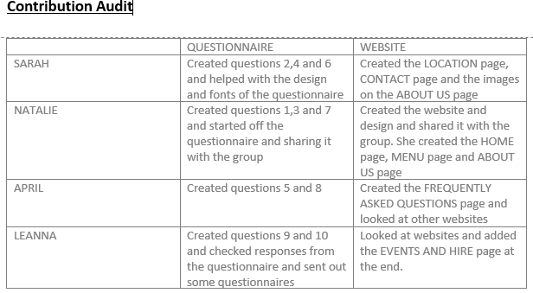

Questionnaire
Below are the 3 questions that I contributed to our questionnaire and the results of my questions from the questionnaires that were distributed.
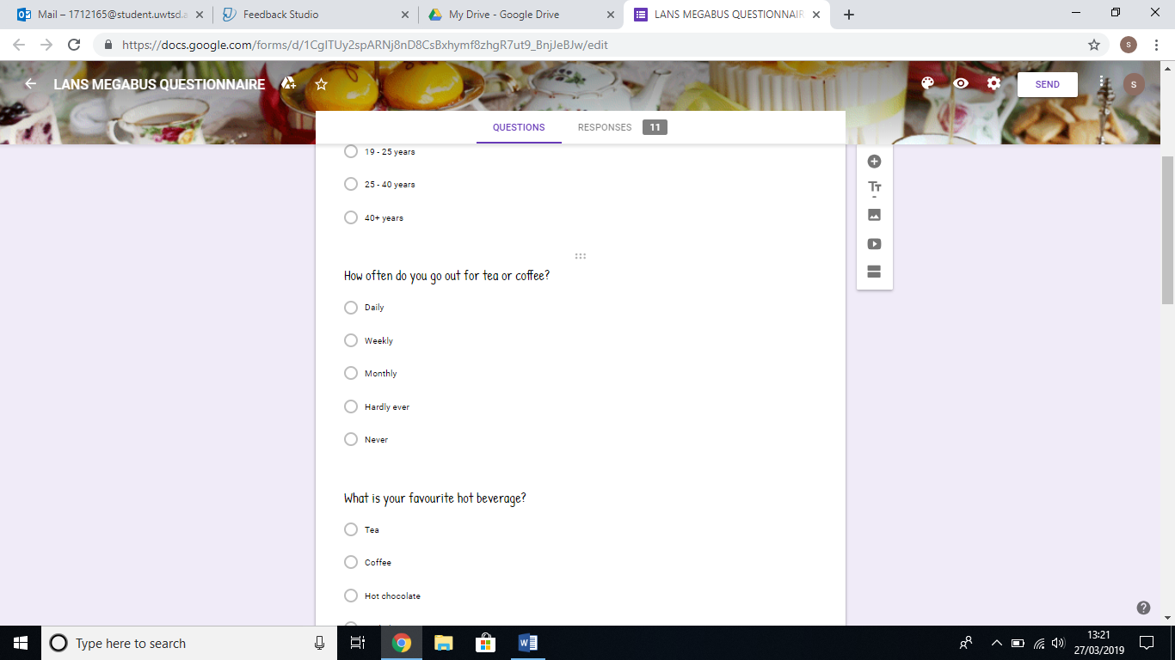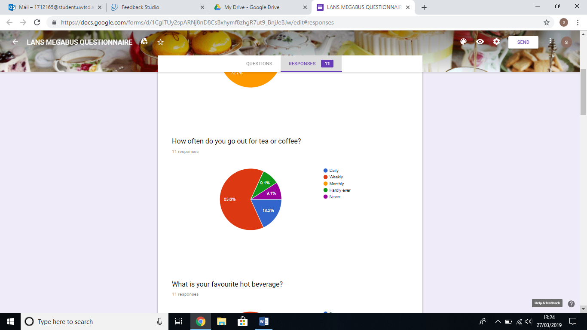
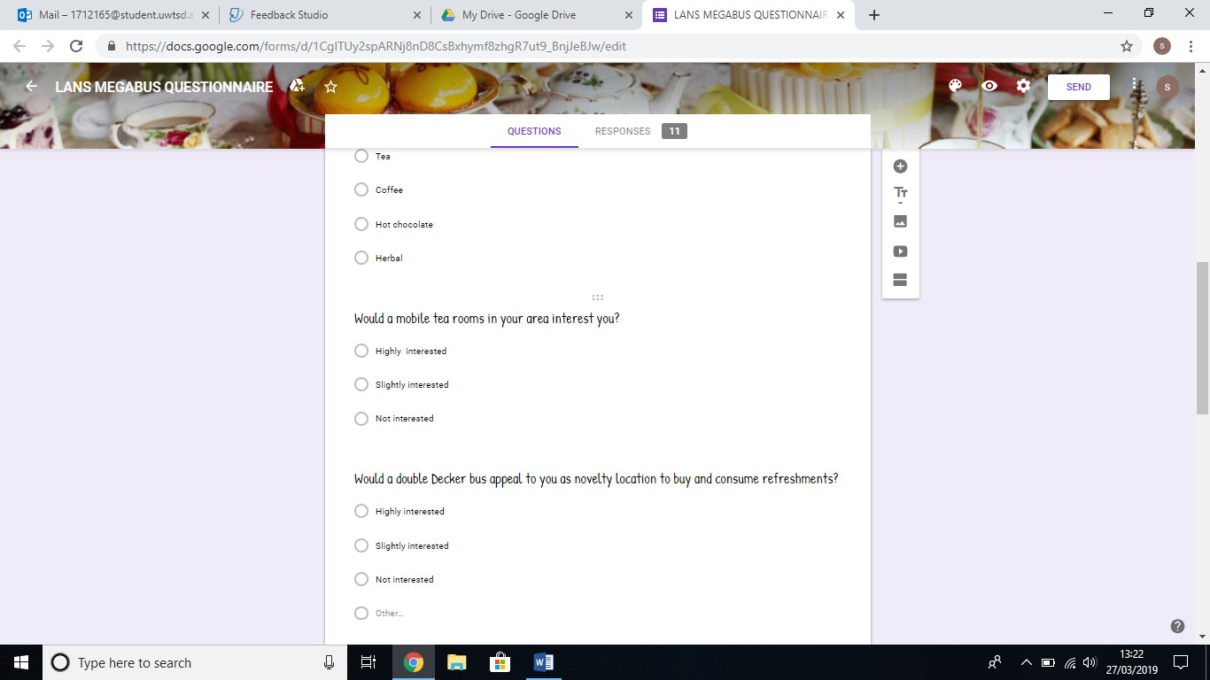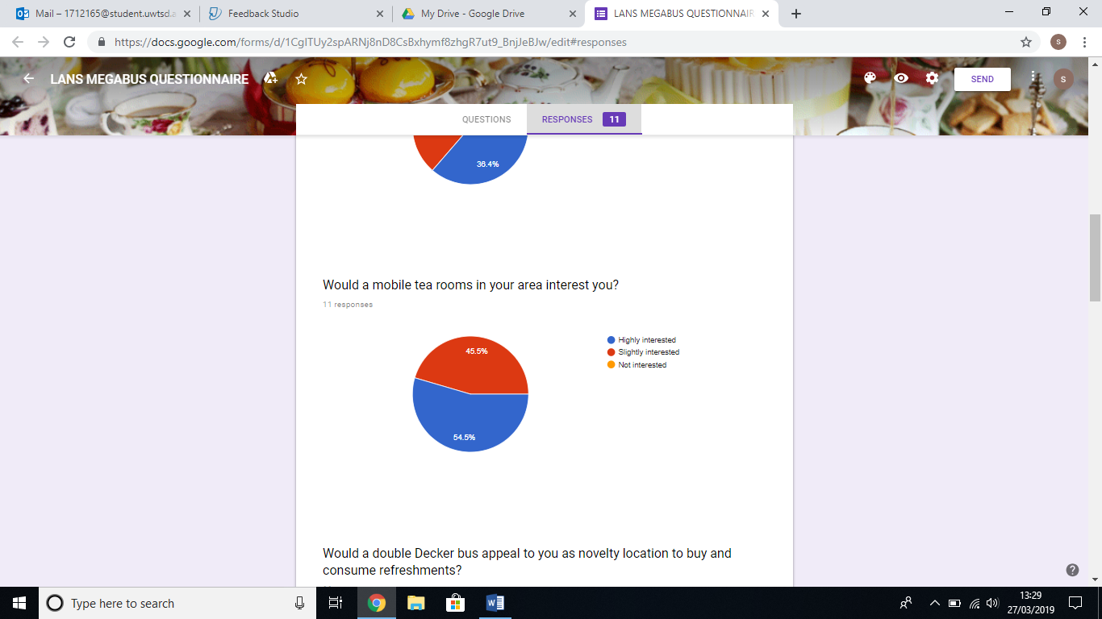

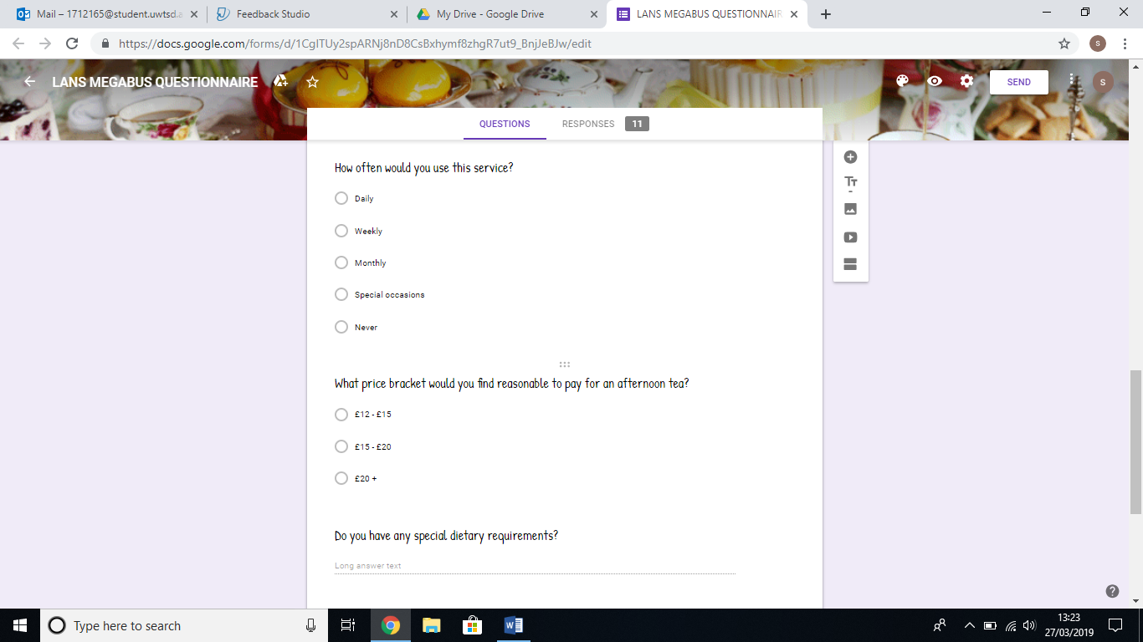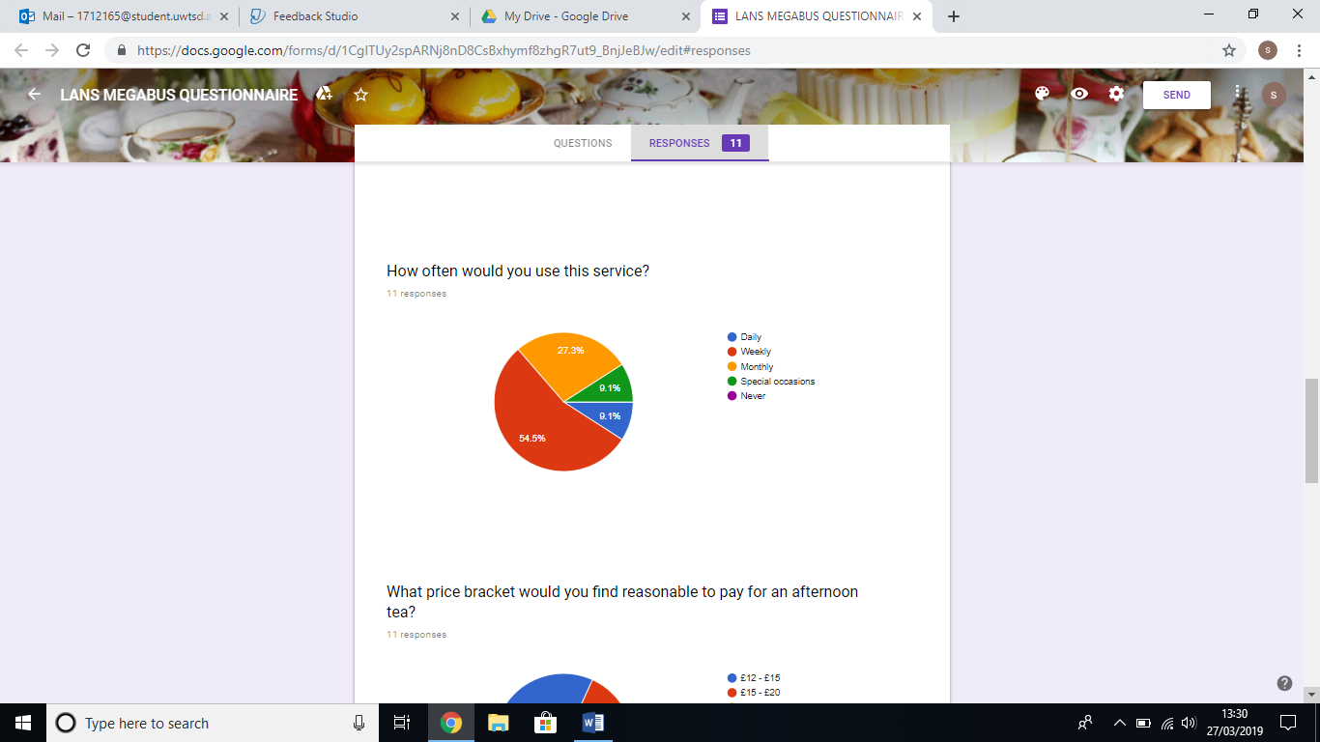The 3 Questions I contributed to the Questionnaire were: -
- How often do you go out for tea or coffee?
- Would a mobile tearoom in your area interest you?
- How often would you use this service?
I chose these questions as I thought they would benefit our business and give us a good idea of how interested people in the area would be in our business.
The results of question 1 showed me that more than half the people went out for tea or coffee on a weekly basis, followed by a healthy percentage of people who went out for tea or coffee on a daily basis meaning ¾ of those questioned could possibly be regular customers.
The results of question 2 showed that all the people questioned were either highly or slightly interested in our mobile tearooms and nobody said that they would not be interested, this showed me our business was favourable as its unique, offers a different service and there is no other business the same as ours in the local and surrounding areas.
The results of question 3 showed me that everyone who were questioned would use our service at some time or other, nobody stated that they would never use our service. More than half the people would use us on a weekly basis and a percentage would be prepared to use our service daily. There were a percentage of people who would like to use our services for special occasions this showed me that this would work out well for our private hire for parties and special occasions.
All the questions that were chosen by the group helped us understand a bit about potential customers what interested them, and which age groups were more interested as our target customers and what we could potentially offer to attract those age groups that were slightly less interested and what price bracket customers were prepared to pay. The results showed us that our business venture was a good idea and could possibly be rather popular.

Website
Below are the screenshots showing my contribution to our business website.

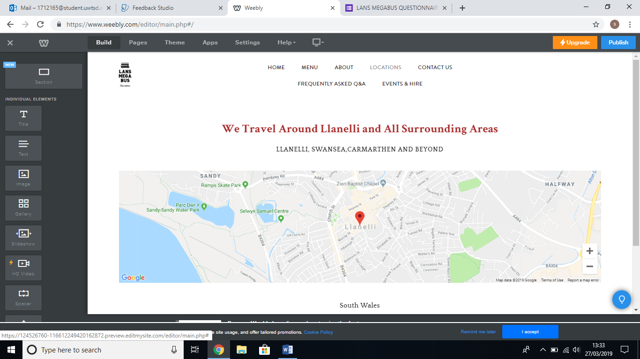
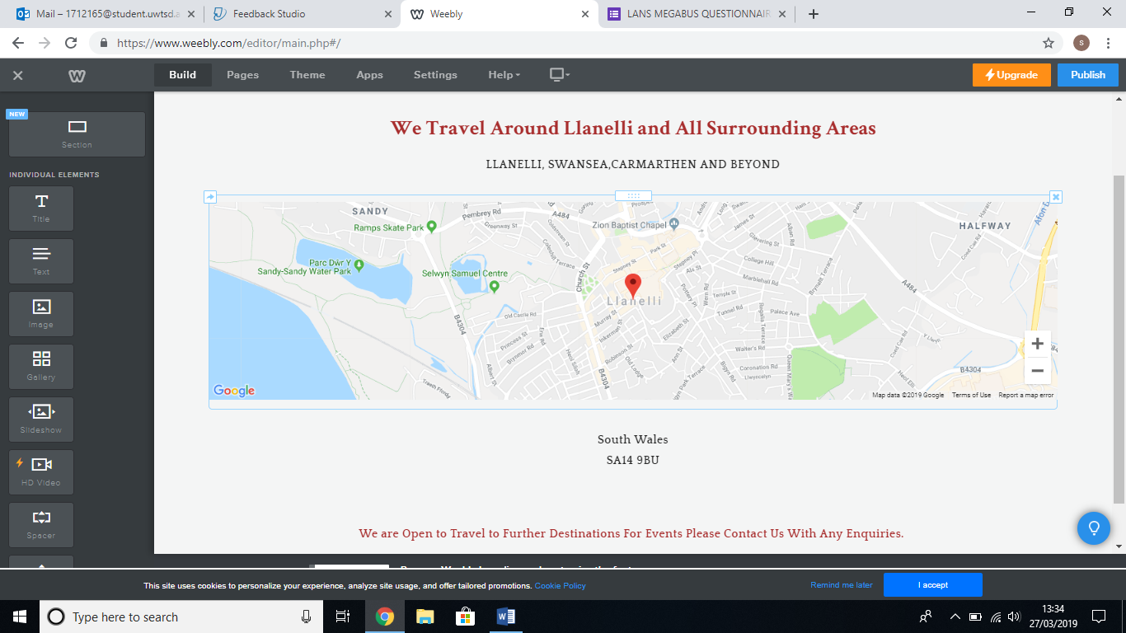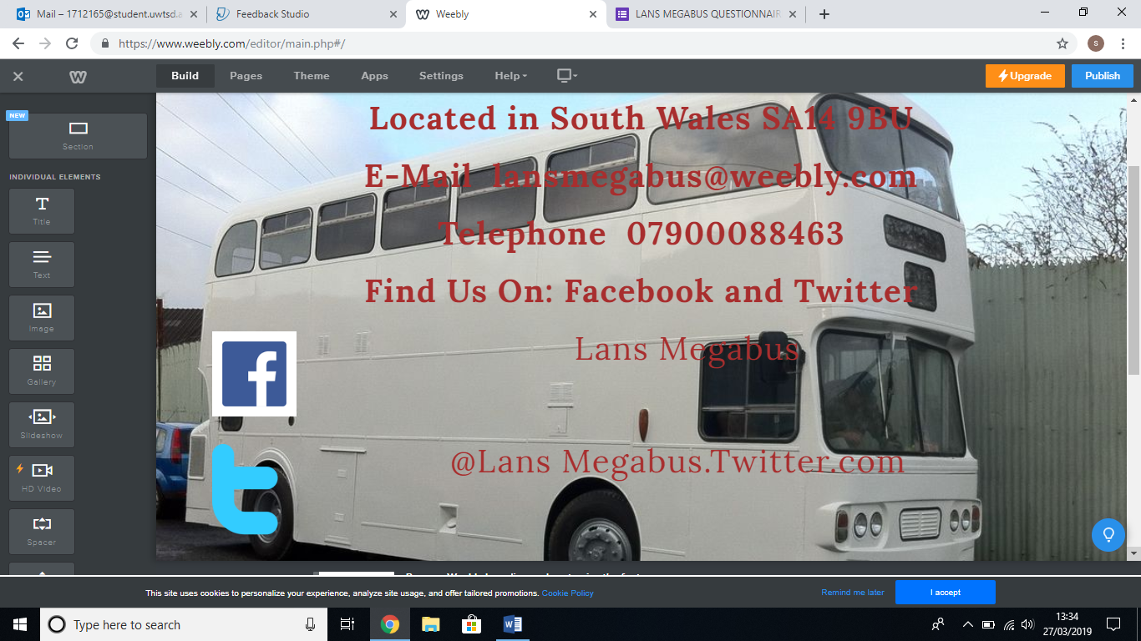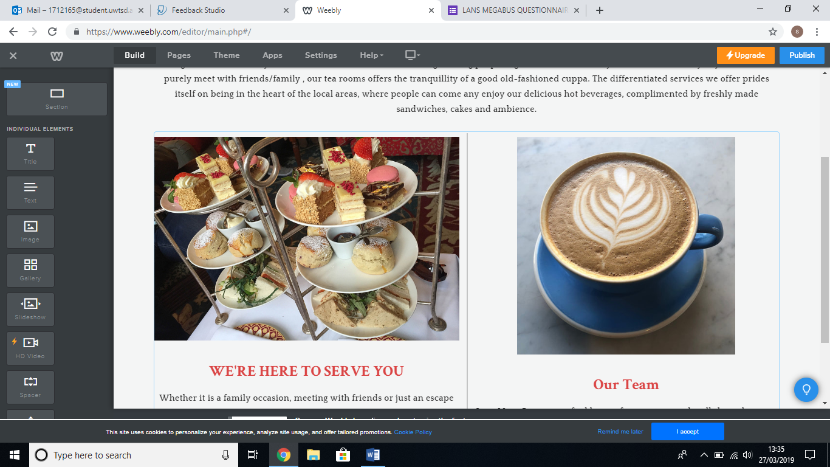
When we set up our website Natalie started off the set up and then shared the website on our google drive for us all to be able to edit and contribute to. I started with the locations page I edited this page and added a map of where our business operates so people could clearly see the areas we operated in and stated that we would be prepared to travel on request. By being more flexible on location this means we can travel on request to places with customers already in place.
I then edited the contact us page. I placed a picture of our double decker bus to the background this allowed people to see the vehicle we were operating from. I then put in important information on how customers can contact us by adding our e-mail address, phone number and places they can find us such as Facebook and Twitter giving customers several options on how they can contact us.
Lastly, I edited the pictures on the about us page to make the page more attractive and appealing to customers and this allowed Natalie to continue editing this page filling it with all the important information our website needed. I think this website is well designed and will attract customers and give them a flavour of what we are about.
Our website is clear, easy to manoeuvre and looks very appealing to customers and is packed full of useful information and menus in which I helped to come up with sandwich fillings. I feel that the website design went very well with the group working as a team contributing some parts and Natalie did a really good job with the design.
Weebly Website Access : sarah1712165@gmail.com Password : Carys123

