
STRATEGIC MANAGEMENT
Sustaining Competitive Advantage in India's Passenger Electric-Vehicle Market
A Strategic Management Report on Tata Motors' Nexon.ev
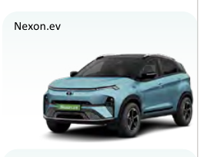
Nexon.ev image source: Tata Motors Passenger Vehicles Limited (2026), Integrated Annual Report 2025-26.
Programme | Master of Business Administration
Module | Strategic Management
Module code | LCMB7003
Lecturer | Ghulam Mujtaba
Student name | Dharmesh Tanwar
Student ID | 2531862
Submission date | 12 August 2026
Word count | 5,347 words

Table of Contents
Table of Contents
Table of Contents 2
Executive Summary 3
1. Organisational Context and Strategic Scope 4
1.1 Organisation, product and market boundary 4
1.2 Mission, vision and business model 4
1.3 Industry position and competitor benchmark 4
2. External and Internal Strategic Analysis 6
2.1 Prioritised PESTEL analysis 6
Political and policy environment 6
Economic environment 7
Social environment 7
Technological environment 7
Environmental environment 8
Legal and regulatory environment 8
2.2 Industry structure: Porter's Five Forces 9
2.3 Internal analysis: VRIO and dynamic capabilities 11
2.4 SWOT/TOWS synthesis 12
3. Comprehensive and Holistic View of the Organisation 13
3.1 CSR, sustainability and ethical alignment 13
3.2 Balanced Scorecard 14
4. Strategic Choices and Implementation 15
4.1 Current business-level strategy and alternatives 15
4.2 SAFe evaluation and recommendation 16
4.3 Standardisation versus adaptation 17
4.4 Implementation roadmap and governance 18
4.5 Conclusion 19
5. Reflective Account Using Gibbs' Reflective Cycle 19
5.1 Description 19
5.2 Feelings and initial assumptions 20
5.3 Evaluation 20
5.4 Analysis 20
5.5 Conclusion 21
5.6 Action plan 21
Reference List 22

Executive Summary
India's electric passenger-vehicle market is expanding rapidly, but market growth is redistributing advantage. FADA data indicate that electric passenger-vehicle retail increased from 47,551 units in FY2022-23 to 199,923 in FY2025-26, an 83.6% rise in the latest year. Tata Motors Passenger Vehicles Limited (TMPVL) simultaneously raised EV volumes to more than 92,000 units, yet its VAHAN electric-vehicle share declined from 83.9% in FY2022-23 to 40.2% in FY2025-26 (FADA, 2024; FADA, 2026; TMPVL, 2026). The decline is partly a normal consequence of category maturation, but it also signals that first-mover advantage is no longer sufficient as Mahindra, MG, Hyundai and other manufacturers compete on dedicated platforms, battery-as-a-service, range, features and ownership guarantees.
The report finds that Tata retains valuable resources: a trusted domestic brand, a large installed EV base, extensive sales and service coverage, engineering scale, and access to Tata Group capabilities in power, finance and digital services. However, most tangible advantages are imitable. The more defensible opportunity is to convert scale and customer data into an integrated ownership-confidence capability. The recommended strategy is therefore focused differentiation supported by selective cost efficiency, rather than a market-share-led price war. It combines transparent battery-health information, residual-value and finance support, verified charging and service-level agreements, software reliability, and realistic total-cost-of-ownership communication.
Implementation should proceed through a three-year, stage-gated programme. The Board should approve expansion only after model-level economics, battery and warranty exposure, charging reliability and service baselines are independently verified. A Balanced Scorecard should link employee and digital capability to service and charging performance, customer trust, repeat purchase and contribution margin. This approach provides a stronger basis for sustained advantage than discounting because it addresses the adoption risks customers find most difficult to evaluate and competitors find most difficult to reproduce as a coherent operating system.

1. Organisational Context and Strategic Scope

1.1 Organisation, product and market boundary
Tata Motors is one of India's longest-established automotive manufacturers, but the relevant analytical unit is narrower: TMPVL and Tata Passenger Electric Mobility Limited, focusing on the Nexon.ev in India's passenger battery-electric compact-SUV market. This boundary excludes Jaguar Land Rover, commercial vehicles and overseas operations except where a corporate capability directly influences Nexon.ev. The product was launched in January 2020 and helped create India's mass-market electric-car category. Its current proposition includes 30 kWh and 45 kWh battery options, an indicative starting price of INR 12.49 lakh, a maximum certified range of up to 489 km on selected variants, and lifetime high-voltage battery coverage for eligible first private owners of the 45 kWh version (Tata Motors, 2020; Tata.ev, 2026a; Tata.ev, 2026b; Tata.ev, 2026c). Certified range and price are important comparison points, but they should not be treated as complete measures of customer value because real-world range, finance cost, charging availability, service quality and resale expectations vary materially.

1.2 Mission, vision and business model
TMPVL's FY2031 vision is to become a leading automotive company recognised for innovative, high-quality and sustainable products, an inspiring workplace and superior stakeholder returns. Its mission emphasises innovative mobility solutions that connect people and responsibly enrich society (TMPVL, 2026). These statements create a demanding strategic test: growth must be accompanied by product dependability, organisational capability and financial returns. The Nexon.ev business model therefore extends beyond manufacturing. Value is created through vehicle design, battery and powertrain integration, software, safety, supplier management, charging access, financing, dealerships, workshops and warranty assurance. Value is delivered through a distributed ecosystem, while value capture still depends mainly on vehicle sales and related services. The weakness is that several decisive customer experiences - charger uptime, financing terms, dealer competence and residual-value confidence - sit partly outside the manufacturer's direct control.

1.3 Industry position and competitor benchmark
TMPVL reported FY2025-26 passenger-vehicle volumes of approximately 641,600 units and more than 92,000 EVs, with EV volumes rising about 43% year on year and VAHAN EV share at 40.2% (TMPVL, 2026). This combines strong absolute growth with pronounced relative erosion. The strategic question is therefore not whether Tata should protect its historical share at any cost, but whether it can grow profitable volume while renewing the basis of differentiation. Market share can fall in a rapidly expanding category without destroying value; conversely, discounting can preserve share while weakening margins, residual values and future investment capacity.
Model | Indicative entry price* | Certified range* | Ownership/technology evidence | Strategic implication
Tata Nexon.ev | INR 12.49 lakh | Up to 489 km | 30/45 kWh; eligible lifetime battery warranty | Accessible compact SUV; established EV base and broad network
MG Windsor EV/Pro | INR 14.70 lakh; lower entry under BaaS | 331-449 km | Battery-as-a-Service; buyback and battery assurance | Reduces upfront and residual-value anxiety
Hyundai Creta Electric | About INR 18 lakh; BaaS option | Up to 510 km | Mainstream SUV brand, connected technology and premium features | Strong brand and technology-led proposition
Mahindra BE 6 | INR 18.90 lakh | 557-682 km | Dedicated INGLO platform; large batteries and lifestyle design | Competes on architecture, range and aspiration

Table 1. Selected competitor benchmark as at 4 August 2026. *Prices and certified ranges are not variant-matched and should not be read as a simple value ranking. Sources: Tata.ev (2026a-b); JSW MG Motor India (2026); Hyundai Motor India (2026a-b); Mahindra & Mahindra (2024).
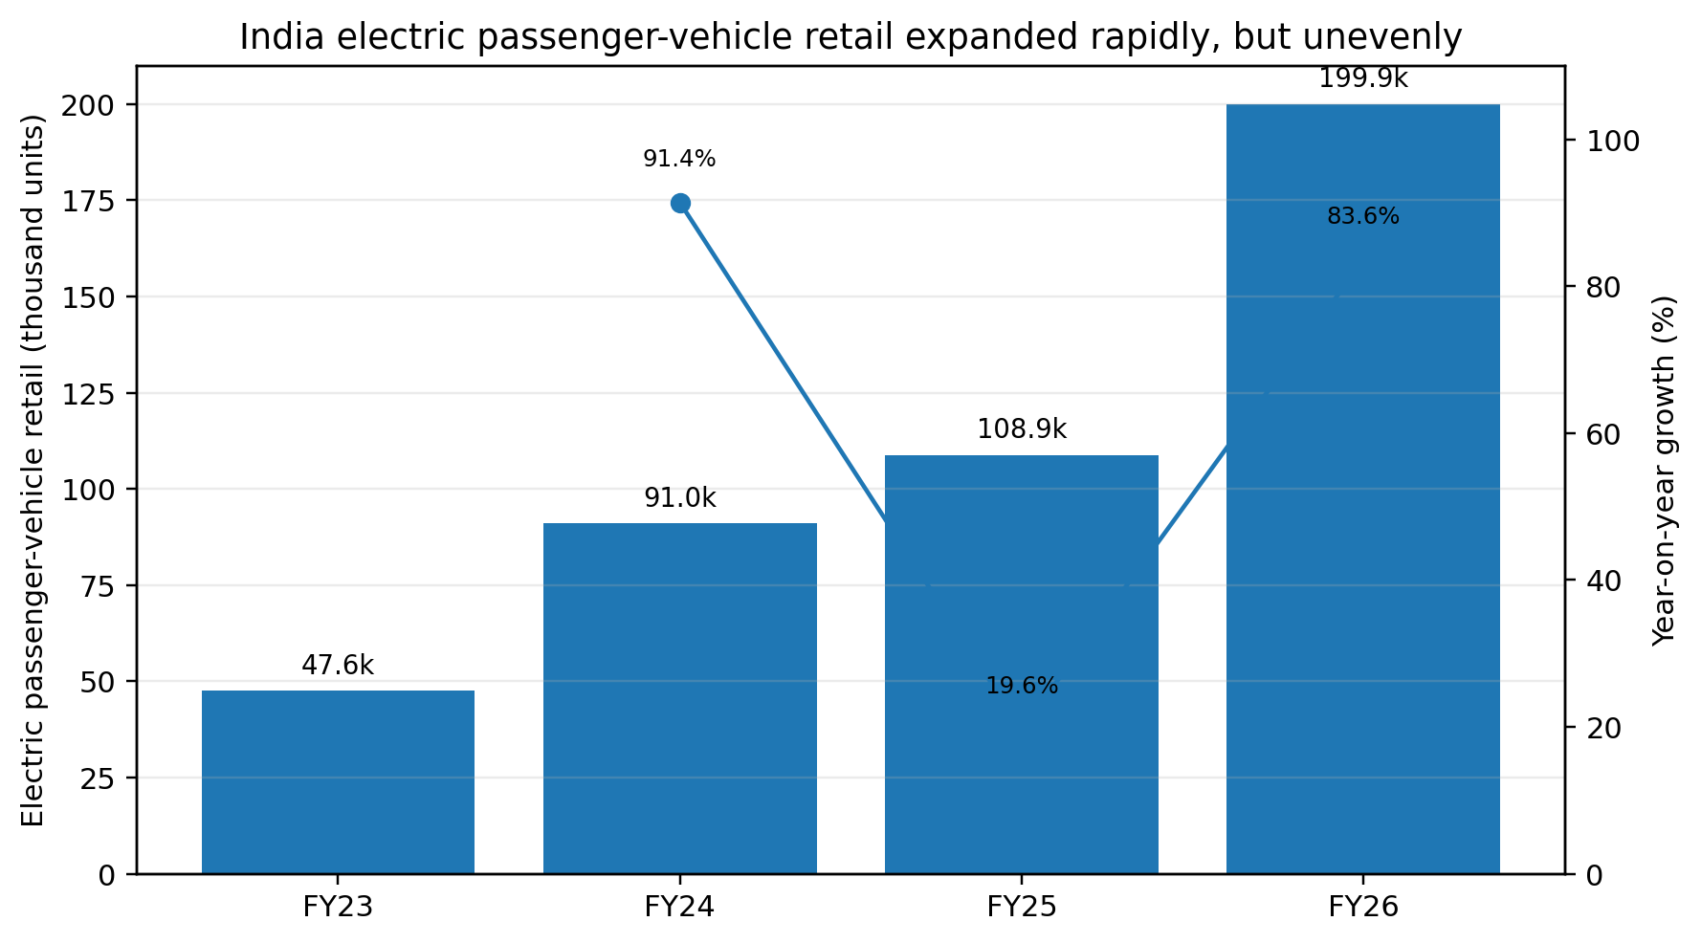
Figure 1. India electric passenger-vehicle retail, FY2022-23 to FY2025-26. Source: FADA (2024; 2025; 2026).
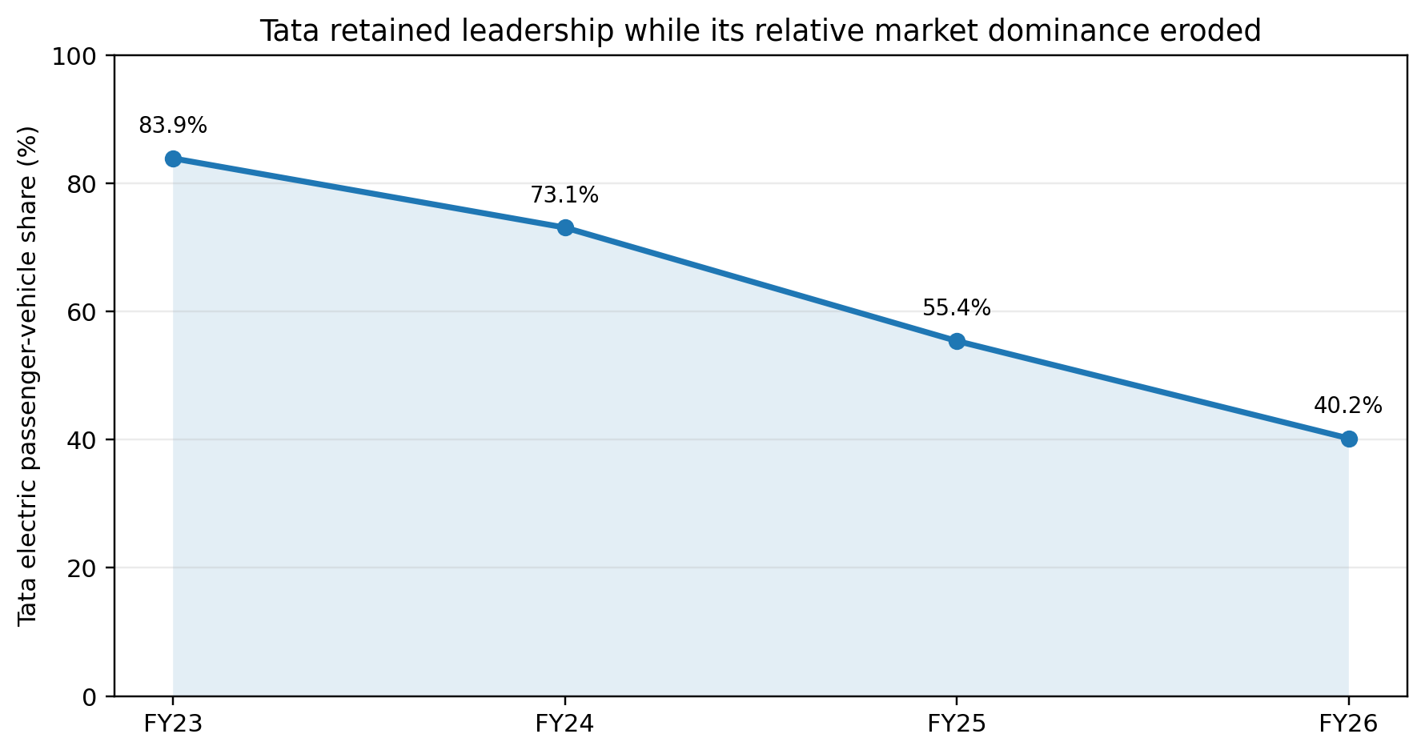
Figure 2. Tata electric passenger-vehicle share, FY2022-23 to FY2025-26. Source: Tata Motors (2025) and TMPVL (2026), using company-reported VAHAN methodology.

2. External and Internal Strategic Analysis

2.1 Prioritised PESTEL analysis

Political and policy environment
India's policy environment supports EV manufacturing and charging, but the support is uneven across vehicle categories. PM E-DRIVE has an outlay of INR 10,900 crore, including INR 2,000 crore for public charging infrastructure, while the PLI-Auto and advanced-chemistry-cell schemes support localisation and advanced manufacturing. The government also reports reduced GST on EVs and chargers, and state-level road-tax waivers are encouraged (PIB, 2026). These measures lower ecosystem barriers and strengthen domestic production, but they do not guarantee private electric-car affordability because PM E-DRIVE demand incentives primarily prioritise two- and three-wheelers, buses, ambulances and trucks. Policy also benefits competitors that can satisfy localisation and investment requirements. Tata should therefore treat policy as an enabling condition rather than a proprietary advantage, and prioritise scalable economics that remain viable if incentives change.

Economic environment
The economic case for Nexon.ev depends on usage intensity, financing cost, electricity tariffs, fuel prices, insurance, battery risk and resale value rather than purchase price alone. CEEW's Indian total-cost analysis shows that competitiveness differs across states and driving patterns (CEEW, 2025). High-mileage urban users may realise substantial operating savings, whereas low-mileage buyers can struggle to recover the price premium. Interest rates and credit availability are therefore strategic variables, not merely financial background. Battery and semiconductor costs also expose the company to exchange-rate and supply volatility. Tata should avoid universal 'EVs are cheaper' claims and provide segment-specific TCO tools with transparent assumptions. Selective financing, battery assurance and residual-value support are preferable to broad price reductions because they address uncertainty without permanently resetting reference prices.

Social environment
Indian adoption studies consistently identify upfront cost, charging availability, range, safety and uncertainty as major EV barriers, while environmental concern, operating-cost savings and technology interest motivate adoption (Bansal et al., 2021; Yadav et al., 2024; Pamidimukkala et al., 2024). The strategic issue is informational as much as technological: buyers cannot easily observe future battery degradation, charger reliability or resale value at the point of purchase. Tata's large installed base gives it a potential evidence advantage, but only if data are converted into credible disclosures and service standards. Social acceptance also varies between metropolitan households with home parking and customers in apartment, smaller-city or highway-intensive contexts. Market communication and infrastructure promises must therefore be adapted by use case rather than assuming a homogeneous national customer.

Technological environment
Competition is shifting from basic electrification to dedicated EV platforms, faster charging, software-defined functions, connected services, battery analytics and alternative ownership models. Mahindra's INGLO-based products illustrate the range and packaging potential of dedicated architecture, while MG and Hyundai use battery-as-a-service to change affordability rather than merely lowering vehicle prices. Nexon.ev's shared-platform economics supported early scale, but could constrain future space, charging performance or feature integration relative to purpose-built rivals. Larger batteries are not an unqualified solution: they improve certified range but increase weight, cost and material exposure. The priority is therefore modular product development, dependable software, accurate range prediction and battery-health intelligence. Dynamic capability - sensing customer barriers, seizing them through new propositions and reconfiguring operations - matters more than a one-off technology feature (Teece, Pisano and Shuen, 1997; Loder, Bohnsack and Pinkse, 2024).

Environmental environment
EVs eliminate tailpipe emissions, but responsible strategy requires lifecycle analysis. Battery production, mineral extraction, manufacturing energy, vehicle mass, electricity generation and end-of-life recovery affect the net outcome. India's coal-intensive grid reduces, but does not necessarily eliminate, lifecycle benefits relative to internal-combustion vehicles; benefits generally improve as the grid decarbonises and renewable charging expands (IEA, 2026; NITI Aayog, 2025). Tata should avoid implying that an EV is impact-free. More credible differentiation would disclose progress on renewable electricity, supplier due diligence, battery recovery, recycled content and second-life use. Smaller, efficient batteries may create better affordability and resource efficiency for many urban users than an industry-wide escalation towards the largest possible pack.

Legal and regulatory environment
Battery safety standards, consumer protection, product liability, data protection, connected-vehicle cybersecurity, software-update governance and battery-waste rules expand the compliance boundary. The lifetime battery warranty on eligible Nexon.ev variants can reduce customer anxiety, but it also creates long-tail financial and conduct risk if exclusions, degradation thresholds or transfer conditions are unclear. Connected-vehicle and charging data create additional duties relating to consent, retention and third-party access. Compliance should therefore be designed into product, software and partner governance. A legally compliant but opaque warranty may still undermine trust; conversely, plain-language coverage and auditable battery-health certificates can become a strategic asset.
External factor | Critical interpretation | Strategic response | Priority
Policy and localisation | Infrastructure and manufacturing support, but incentives also reduce barriers for competitors | Build economics that remain viable without direct car subsidies | High
Affordability and finance | TCO varies by use case; financing and resale uncertainty remain material | Segment-specific TCO, finance and residual-value solutions | High
Trust and adoption | Battery, range, charging and service uncertainty influence demand | Ownership-confidence proposition and realistic disclosure | High
Technology transition | Dedicated platforms, BaaS, software and fast charging change comparison | Modularity, digital reliability and battery intelligence | High
Lifecycle sustainability | Benefits depend on grid, production and end-of-life outcomes | Lifecycle targets and verified circularity | Medium-high
Regulation and data | Safety, warranty, cyber, privacy and waste obligations are expanding | Compliance-by-design and partner controls | High

Table 2. Prioritised PESTEL synthesis. Source: Author analysis from government, industry and academic evidence.

2.2 Industry structure: Porter's Five Forces
Rivalry is high and rising because rapid market growth attracts well-funded incumbents, model proliferation and frequent price or finance innovations. Product comparison now spans range, charging speed, software, warranty, design and ownership models. Buyer power is moderate to high: digital comparison and greater choice reduce switching costs, while fleet and high-mileage customers can quantify TCO. Supplier power is moderate to high in cells, semiconductors, power electronics and specialist software; localisation improves resilience but can create technology lock-in. The threat of entry is moderate because automotive capital, homologation, brand and service networks remain barriers, yet policy and global EV capabilities lower them. Substitution is high because buyers can select petrol, diesel, CNG, hybrid, ride-hailing or public transport; Tata's own multi-powertrain portfolio also creates internal cannibalisation.
The Five Forces implication is that a feature or price advantage will be temporary. Sustainable performance requires a system-level proposition that lowers perceived ownership risk and makes the ecosystem reliable. Pure cost leadership is unattractive because the modest passenger-vehicle EBIT margin reported by TMPVL limits the capacity for a prolonged price war, while rivals can imitate discounts. The model itself has limits: EV competition crosses automotive, energy, finance and software boundaries, and complementors such as charging operators can create or destroy value. Ecosystem governance and dynamic capabilities are therefore necessary additions to industry-structure analysis (Porter, 2008; Jacobides, Cennamo and Gawer, 2018).
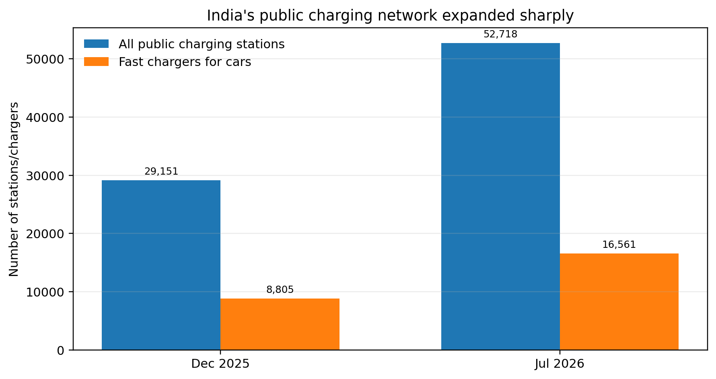
Figure 3. India public charging infrastructure, December 2025 to July 2026. Source: PIB (2025; 2026).
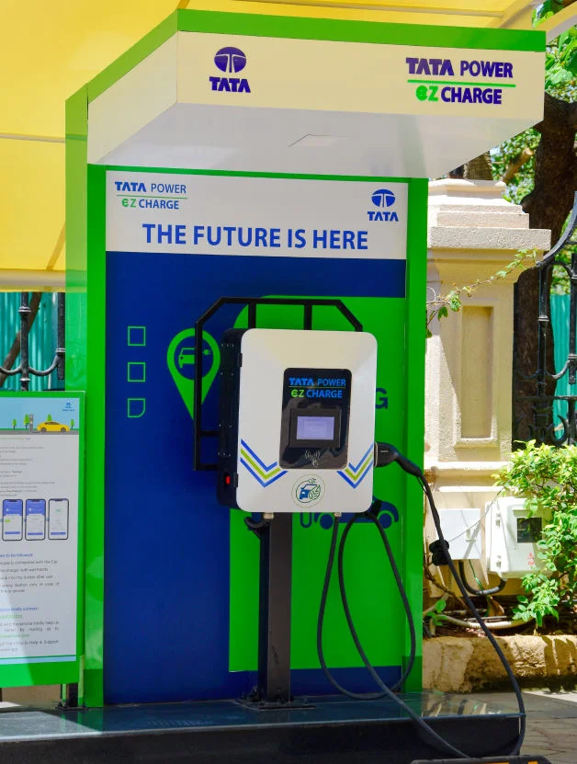
Figure 4. Tata Power EZ Charge infrastructure. Source: Tata Power (2026a).
Reported public charging stations increased from 29,151 in December 2025 to 52,718 in July 2026; fast chargers for cars increased from 8,805 to 16,561 (PIB, 2025; PIB, 2026). Tata Power separately reported more than 6,700 public, semi-public and fleet charging points across more than 690 cities and towns by May 2026 (Tata Power, 2026a). Counts indicate expansion, not service quality. A station can be listed but unavailable because of hardware, payment, network or access failures. Tata should therefore manage charger-session success, uptime, queue time and complaint resolution, not only network size.

2.3 Internal analysis: VRIO and dynamic capabilities
Resource/capability | Valuable | Rare | Imitability | Organisation | Result
Tata brand and safety reputation | Yes | Partly | Imitable by strong incumbents | Well organised | Temporary advantage
Early-mover installed base and vehicle data | Yes | Yes at Indian scale | Difficult if learning is embedded | Only partly organised | Potential sustained advantage
Sales and service footprint | Yes | No among major OEMs | Costly but replicable | Organised | Competitive parity/temporary advantage
Tata Group charging, finance and digital ecosystem | Yes | Relatively rare | Difficult to coordinate and imitate | Partly organised | Potential sustained advantage
Manufacturing scale and local supply base | Yes | No | Replicable with capital | Organised | Competitive parity
Nexon brand recognition and product history | Yes | Temporarily | Imitable over time | Organised | Temporary advantage
Battery-health, service and residual-value learning | Potentially | Potentially | Path dependent | Not yet fully exploited | Latent advantage

Table 3. VRIO assessment. Source: Author analysis using Barney (1991) and company evidence.
The VRIO analysis shows that scale, brand and distribution are useful but insufficient. Major competitors also possess capital, brands and service systems. Tata's harder-to-copy opportunity lies in path-dependent learning from a large EV installed base and in coordinating group capabilities across vehicles, charging, finance and digital services. Yet rarity does not automatically create advantage: data have value only when governance, analytics and frontline processes convert them into lower failure rates, better range prediction, credible battery-health information and faster service. The organisation dimension is therefore the critical weakness.
Dynamic-capability analysis strengthens VRIO because it asks whether Tata can renew resources as competition changes. Sensing requires granular evidence on charger failure, warranty claims, buyer objections, used-EV prices and regional demand. Seizing requires propositions such as battery-health certification, service guarantees and financing tied to verified residual values. Transforming requires dealer incentives, cross-company data standards, supplier controls and clear accountability. Without this reconfiguration, the Tata ecosystem remains a collection of assets rather than an integrated capability. VRIO is also retrospective and can overstate current strengths; dynamic capabilities provide the forward-looking test of whether the organisation can preserve value under technological change.
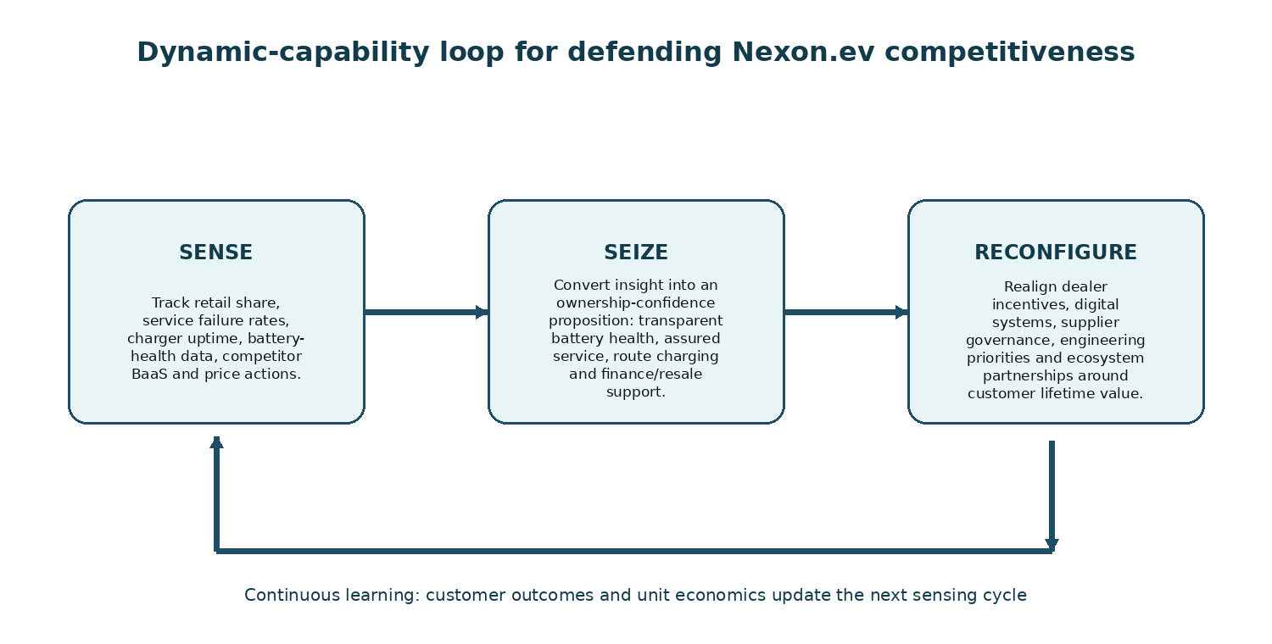
Figure 5. Dynamic-capabilities loop for the proposed strategy. Source: Author-developed from Teece, Pisano and Shuen (1997).

2.4 SWOT/TOWS synthesis
SWOT category | Prioritised issues
Strengths | Early EV experience; strong brand; broad network; large installed base; group ecosystem; product affordability
Weaknesses | Share erosion; uneven service capability; modest margins; shared-platform constraints; fragmented ecosystem accountability
Opportunities | Fast category growth; charging expansion; localisation; battery analytics; financing innovation; smaller-city and fleet demand
Threats | Dedicated-platform rivals; BaaS and price competition; supply volatility; technology obsolescence; safety, cyber and warranty risk

Table 4. Prioritised SWOT synthesis. Source: Author analysis.
The TOWS implication is to use installed-base and ecosystem strengths to exploit growth through ownership assurance, while correcting service and data weaknesses before geographic expansion. Broad discounting would use scale against rivalry but intensify margin and residual-value risk. A long-range product race would respond to dedicated-platform threats but could weaken affordability and increase capital exposure. The most coherent strategy is therefore to use Tata's scale and data to reduce battery, charging, service and resale uncertainty. SWOT is inherently subjective and can become a descriptive inventory; the later SAFe assessment therefore tests competing choices against suitability, acceptability and feasibility (Helms and Nixon, 2010).

3. Comprehensive and Holistic View of the Organisation

3.1 CSR, sustainability and ethical alignment
TMPVL positions sustainability through Project Aalingana and reports targets including net-zero greenhouse-gas emissions for the domestic passenger-vehicle business by 2040, 100% renewable electricity and zero waste to landfill by 2030, water neutrality by 2030 and water positivity by 2040 (TMPVL, 2026). These commitments support the EV strategy by reducing transition risk, strengthening regulatory legitimacy and improving access to sustainability-oriented capital and customers. However, strategic alignment should not be inferred from targets alone. The Board must test whether investment, sourcing, factory energy, battery recovery and product design are consistent with those commitments.
Stakeholder theory requires the company to consider customers, workers, suppliers, communities, governments and future generations rather than treating CSR as philanthropy or reputation management (Freeman, 1984). A utilitarian evaluation supports EV expansion where aggregate reductions in pollution, fuel dependence and operating cost exceed lifecycle harms. Nevertheless, utilitarian reasoning can conceal distributional burdens: mining communities, lower-tier suppliers or customers without home charging may bear costs while urban owners receive benefits. A duty-based approach therefore requires truthful range, battery and warranty communication even when ambiguity would improve conversion. Justice requires that cost-down targets do not transfer safety, labour or environmental risk to weaker suppliers. The triple bottom line adds an operational test across economic, environmental and social outcomes (Elkington, 1997; Crane et al., 2019).
The lifetime battery warranty illustrates the strategic-ethical intersection. It can reduce a major adoption barrier and demonstrate confidence, but it also exposes long-tail warranty, replacement and conduct risk. Ethical implementation requires plain-language exclusions, consistent claim handling, privacy protection for battery data, and disclosure of degradation thresholds. Similarly, charging-network partnerships create a duty not to market access as seamless unless uptime, payment and complaint resolution are measured. CSR becomes strategically credible when it changes operating decisions: smaller and efficient battery options, renewable manufacturing energy, auditable supplier standards, battery take-back, repairability and transparent lifecycle indicators. Carroll's economic, legal, ethical and philanthropic responsibilities are therefore interdependent rather than sequential (Carroll, 1991).
Stakeholder | Material issue | Ethical lens | Required governance
Customers | Battery life, safety, resale and data privacy | Duty/consumer rights | Battery-health certificate; plain-language warranty; privacy-by-design
Communities/environment | Mining, grid emissions and battery end-of-life | Utilitarian and triple bottom line | Lifecycle carbon, recovery and recycled-content targets
Workers/suppliers | Cost-down pressure and labour/environmental risk | Justice and stakeholder theory | Supplier audits, grievance closure and corrective-action KPIs
Investors/Board | Discounting can grow volume while destroying value | Agency and stewardship | Model-level margin, scenario-tested capital gates and transparent assumptions

Table 5. Ethical and CSR governance priorities. Source: Author analysis from Freeman (1984), Carroll (1991), Elkington (1997) and Crane et al. (2019).

3.2 Balanced Scorecard
The Balanced Scorecard translates the recommended strategy into linked financial and non-financial measures (Kaplan and Norton, 1992). The causal logic is that stronger EV skills, data quality and partner governance improve service, charging and software processes; these processes improve trust, satisfaction and repeat purchase; customer outcomes then support profitable volume and return on investment. Targets below are proposed management targets, not reported company commitments. They must be recalibrated after baseline verification.
Perspective | Objectives | KPIs | Proposed targets | Initiatives
Financial | Grow profitable EV volume; protect residual value; control warranty exposure | Contribution margin/vehicle; EV revenue growth; warranty cost/vehicle; customer lifetime value | Positive contribution improvement annually; no discount-led deterioration in residual values | Battery localisation, finance/resale partnerships, benefit tracking
Customer | Increase ownership confidence and loyalty | NPS; complaint rate; repeat purchase; battery-confidence score; charging-session satisfaction | NPS +8 points in pilots; complaint closure within 48 hours; repeat intent +10% | Battery-health certificates, realistic TCO tools, service/charging guarantees
Internal process | Improve service, charging and software reliability | First-time-fix; repair turnaround; charger success; software incidents; warranty cycle time | First-time-fix >90%; priority repairs <48 hours; verified charge success >95% | EV technician accreditation, parts availability, partner SLAs, secure update process
Learning and growth | Build data, battery and ecosystem capabilities | EV training completion; data completeness; analytics use; employee engagement; partner audit closure | 100% relevant frontline certification; >95% critical data completeness; quarterly learning loops | Cross-functional EV academy, data governance, dealer incentives, supplier development

Table 6. Proposed Balanced Scorecard for the ownership-confidence strategy. Source: Author-developed from Kaplan and Norton (1992).
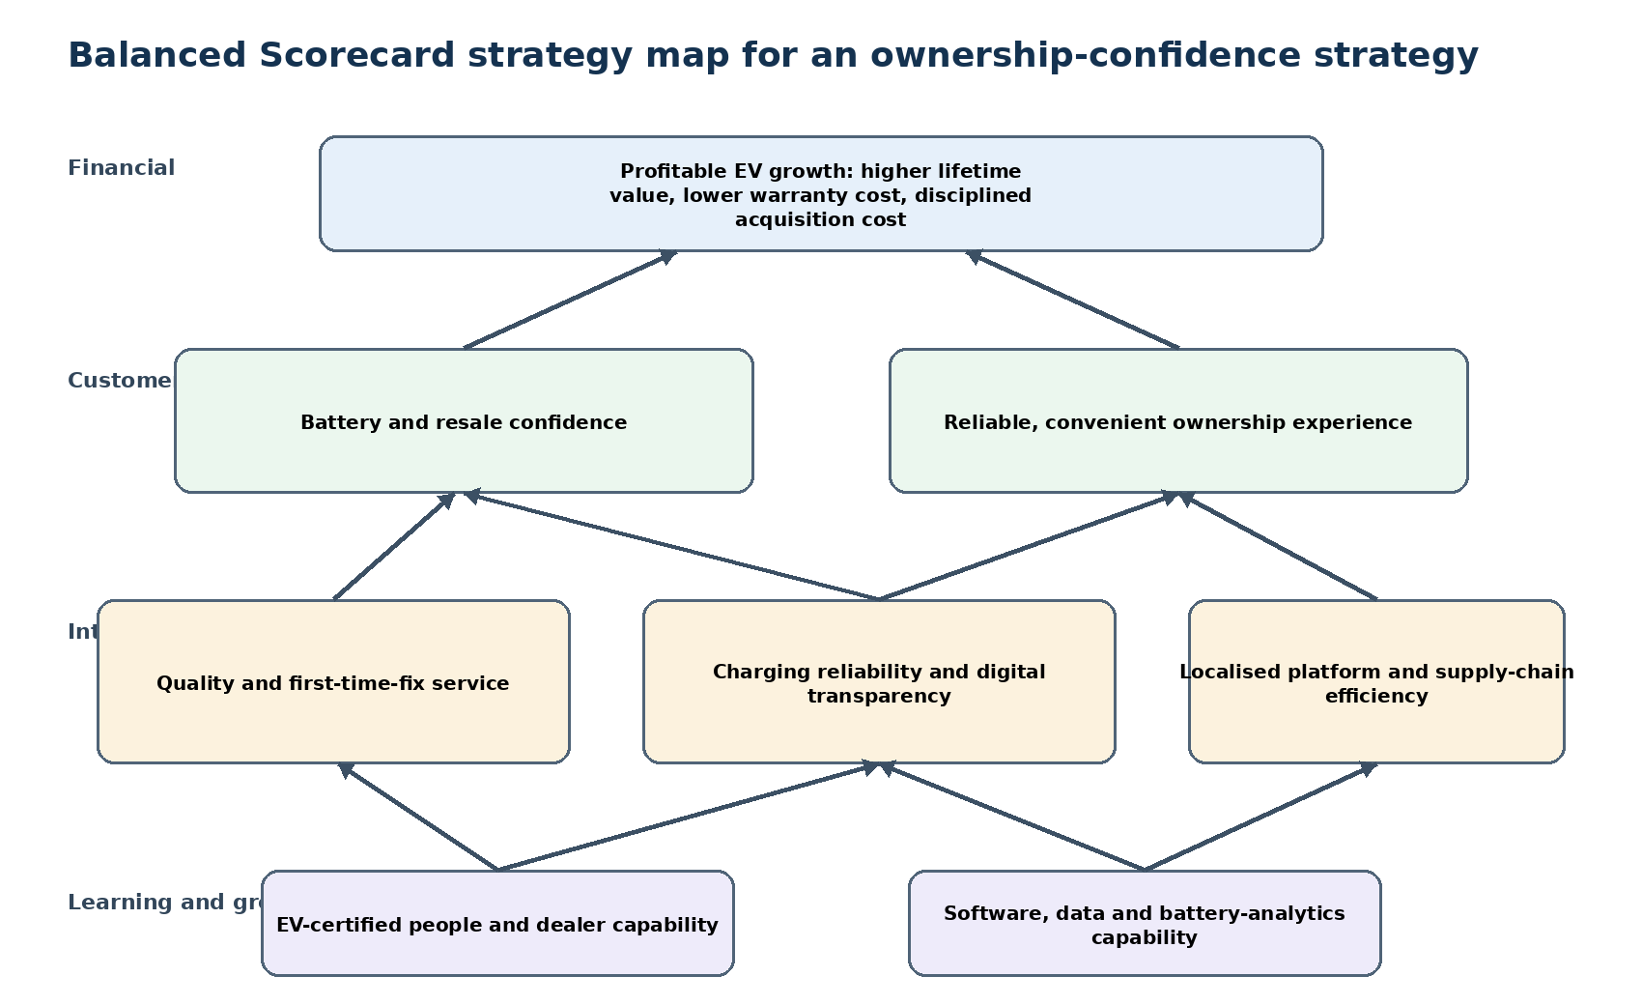
Figure 6. Proposed Balanced Scorecard strategy map. Source: Author-developed.
The scorecard should not become a reporting dashboard detached from decisions. Financial metrics must be model-specific because aggregate growth can conceal unprofitable variants or warranty exposure. Customer measures should be segmented by city tier, charging access, usage and first-time versus replacement buyer. Charger 'uptime' requires a consistent definition and independent verification; process metrics can otherwise be gamed. Finally, causality should be tested through controlled pilots rather than assumed. This addresses a common Balanced Scorecard limitation: correlations between training, satisfaction and profit do not prove that the selected initiatives created the outcome.

4. Strategic Choices and Implementation

4.1 Current business-level strategy and alternatives
Nexon.ev currently reflects a hybrid of accessible pricing and differentiation through safety, brand trust, range options, connected features and ecosystem reach. It is not pure cost leadership because the product competes on more than price and lacks the structural cost evidence required to sustain the lowest-cost position. Nor is it premium differentiation. The most accurate classification is focused differentiation supported by selective cost efficiency. The strategic danger is becoming 'stuck in the middle' if discounting weakens quality and investment while features remain easy to imitate (Porter, 1980). Four credible alternatives should therefore be compared before selecting a direction.
Alternative | Ansoff logic | Strategic benefit | Principal risk/trade-off
A. Broad discounting | Market penetration | Defend share and increase affordability quickly | Easy to imitate; margin, residual-value and brand risk
B. Long-range product race | Product development | Respond to dedicated platforms and range expectations | High capital, battery, weight and affordability exposure
C. Ownership-confidence platform | Product/service development | Differentiate through battery, service, charging, finance and software assurance | Requires difficult cross-functional coordination and transparent performance
D. Geographic expansion | Market development | Reach smaller cities, corridors and fleets | Infrastructure utilisation and service economics vary by location

Table 7. Strategic alternatives. Source: Author analysis using Ansoff (1957).
Alternative A is feasible but strategically weak. It can stimulate demand and clear inventory, yet rivals can respond immediately and customers may delay purchase in expectation of further discounts. Alternative B is suitable for premium segments and future platforms, but using battery size as the primary response may raise cost and undermine Nexon.ev's accessible positioning. Alternative D is a valid second-stage growth path, but premature expansion can reproduce weak service and charging experiences at greater scale. Alternative C addresses the highest-priority adoption barriers and uses resources Tata can potentially organise better than rivals. It should therefore be the core strategy, with selective product improvements and geographic expansion conditional on demonstrated service and charging capability.

4.2 SAFe evaluation and recommendation
Alternative | Suitability (40%) | Acceptability (30%) | Feasibility (30%) | Weighted score /5 | Decision
A. Broad discounting | 2.5 | 2.2 | 4.2 | 2.91 | Reject as primary strategy
B. Long-range product race | 3.8 | 3.0 | 2.8 | 3.28 | Selective future-platform investment
C. Ownership-confidence platform | 4.8 | 4.2 | 4.0 | 4.38 | Recommend
D. Geographic expansion | 3.4 | 3.5 | 3.3 | 3.41 | Stage after capability proof

Table 8. Weighted SAFe evaluation. Scores are consultant judgements and should be stress-tested against internal economics. Source: Author analysis from Johnson et al. (2023).
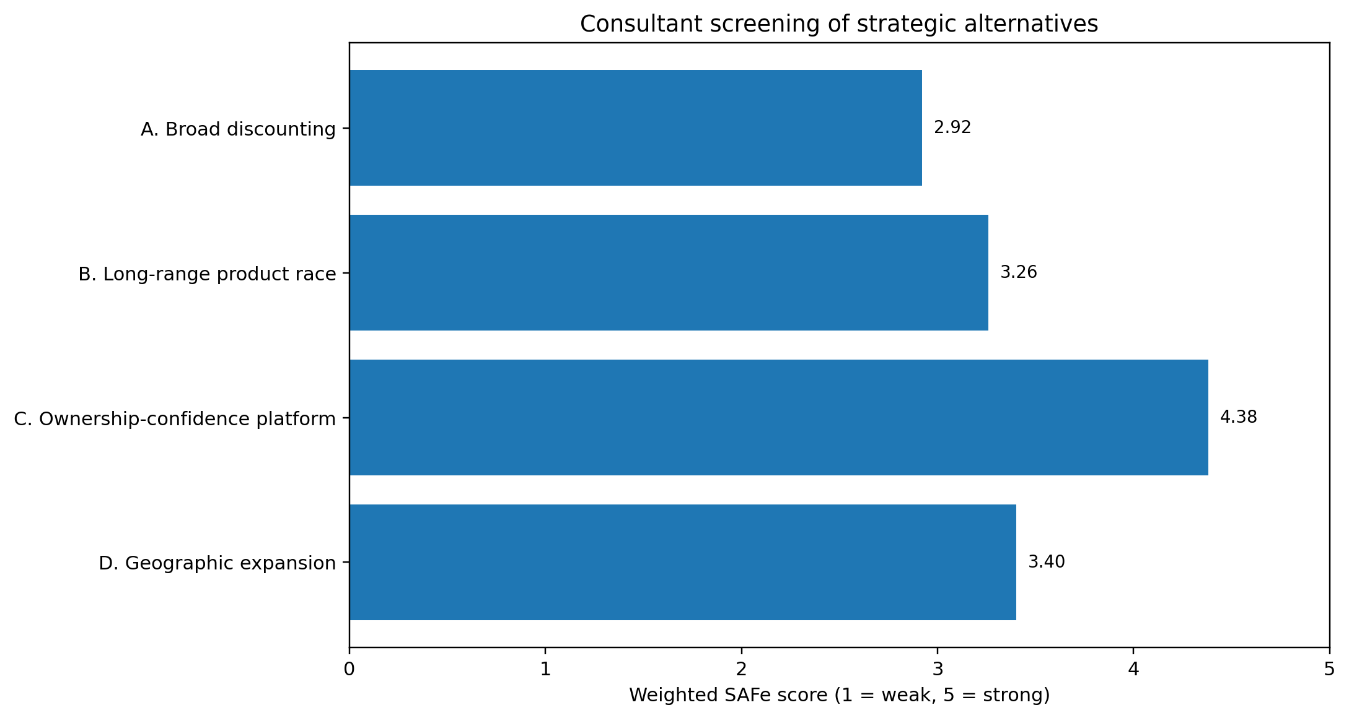
Figure 7. Weighted SAFe comparison of strategic alternatives. Source: Author-developed.
The recommended strategy is an integrated ownership-confidence platform for Nexon.ev. Its customer promise is not simply low price or maximum certified range, but dependable ownership value. Four mutually reinforcing pillars are required: (1) battery-health transparency and residual-value support; (2) verified charging access and session reliability; (3) consistent EV service with time-bound standards; and (4) digital and financing tools that communicate realistic TCO. This proposition is more defensible than a single feature because it depends on accumulated data, process integration, partner accountability and trust.

4.3 Standardisation versus adaptation
Standardisation is necessary for battery safety, cybersecurity, software-release governance, diagnostic data, service procedures and supplier quality. Common standards create scale economies and reduce variation. Adaptation is equally necessary for Indian climate, road conditions, apartment charging, city-tier infrastructure, language, finance and driving intensity. For example, certified range communication should be standardised in method but adapted with scenario-based estimates for temperature, speed and air-conditioning use. Dealer service standards should be common, while parts stocking and mobile support should reflect regional demand. The strategic risk of excessive standardisation is irrelevance; the risk of excessive adaptation is complexity, cost and inconsistent quality. A modular operating model provides the best balance: standardised safety and data architecture with locally configured customer and infrastructure solutions.

4.4 Implementation roadmap and governance
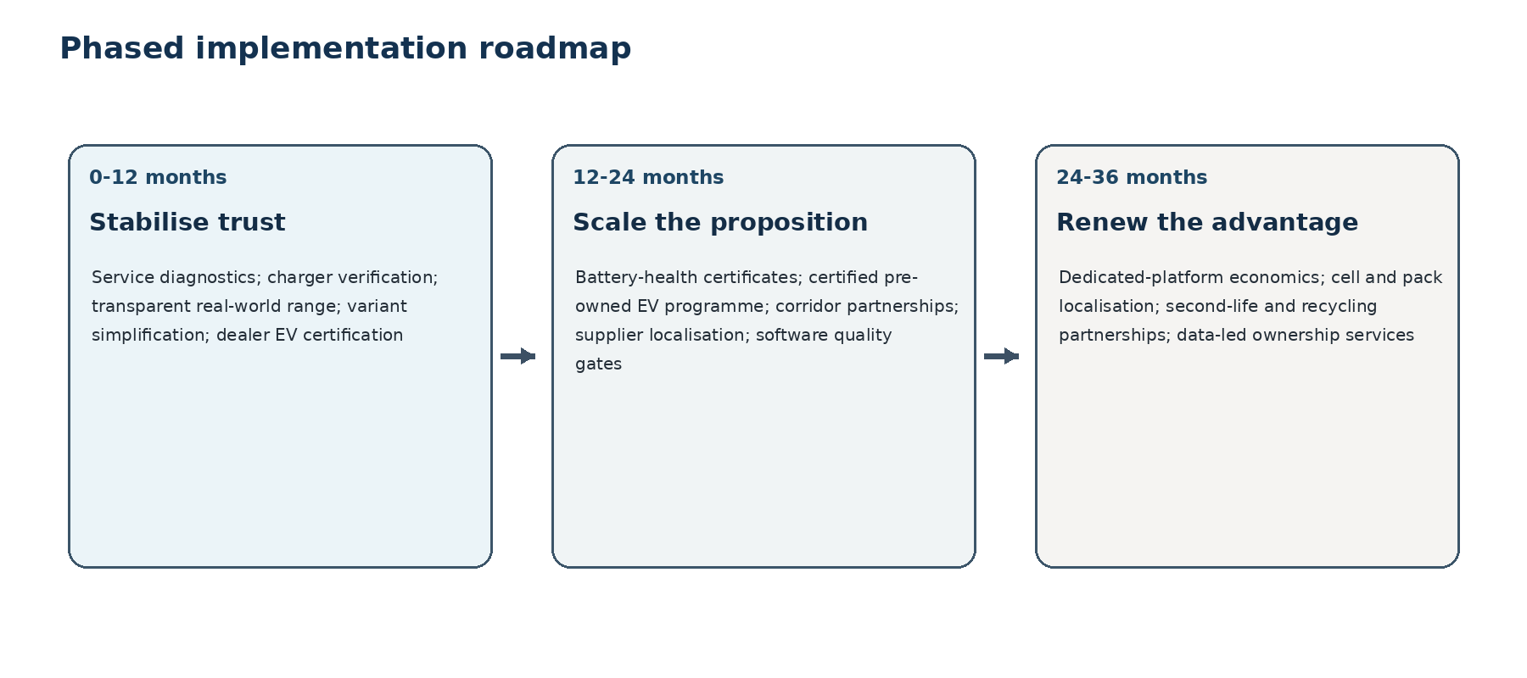
Figure 8. Three-year implementation roadmap. Source: Author-developed.
Implementation should be stage-gated. In months 0-3, Tata should reconcile model-level margin, warranty cost, charger-session success, repair turnaround, parts availability, NPS and residual-value baselines. In months 4-9, controlled pilots in diverse cities should test battery-health certificates, service guarantees, charging SLAs and TCO/finance tools. Months 10-18 should scale only the components that improve customer outcomes without unacceptable cost per vehicle. Months 19-36 should integrate proven capabilities across the Tata EV portfolio and selectively expand geographically. The Board should receive quarterly scorecards with leading indicators, financial outcomes and risk exceptions.
Implementation risk | Potential effect | Mitigation/control
Price war | Margin compression and lower residual values | Separate targeted incentives from permanent list-price cuts; monitor contribution margin
Battery/warranty exposure | Long-tail cost and reputational damage | Cohort degradation analytics, reserve testing, repairability and clear exclusions
Charging partner failure | Broken customer promise | Session-success SLA, independent uptime audit, escalation and alternate-network routing
Dealer/service inconsistency | Low trust and repeat purchase | EV accreditation, parts standards, incentive redesign and mystery-shopper audit
Cyber/privacy incident | Regulatory, safety and reputation loss | Secure development, data minimisation, vendor controls and incident exercises
Expansion before capability | Weak experience replicated at scale | Gate capital by pilot evidence and city-level readiness

Table 9. Principal implementation risks and mitigations. Source: Author analysis.
Four Board gates are recommended. Gate 0 requires reliable baselines before public guarantees. Gate 1 requires pilot evidence of improved service and charging outcomes without unacceptable unit cost. Gate 2 requires scalable results across different city tiers with no material safety, privacy or conduct breach. Gate 3 requires evidence that residual values, repeat purchase, customer lifetime value and contribution margin justify portfolio-wide integration. This governance allows the organisation to pause or correct the strategy rather than treating implementation as irreversible.

4.5 Conclusion
Tata Motors remains strongly positioned in India's expanding passenger-EV market, but historical leadership no longer guarantees future advantage. The external environment favours category growth while intensifying rivalry, buyer choice, technology pressure and regulatory complexity. Internally, brand, scale and distribution provide parity or temporary advantage; the more sustainable opportunity is to organise installed-base data and Tata Group capabilities into a superior ownership system. The Board should therefore prioritise ownership confidence over headline share, broad discounting or an undifferentiated range race. Strategy success should be judged by profitable EV volume, battery and service reliability, customer trust, residual value and repeat purchase, not market share alone.

5. Reflective Account Using Gibbs' Reflective Cycle

5.1 Description
I began the task with a broad idea of analysing Tata Motors in India. My first difficulty was recognising that this scope would combine commercial vehicles, passenger vehicles, Jaguar Land Rover, several powertrains and multiple strategic problems. The assessment required one market and a sufficiently precise product focus, so I narrowed the analysis to Nexon.ev in India's passenger battery-electric compact-SUV market. I then built an evidence hierarchy: company reports for internal strategy and operating metrics, FADA and VAHAN-related evidence for retail registrations, SIAM for industry performance, government sources for policy and charging, manufacturer pages for current product claims, and peer-reviewed literature for adoption barriers and strategic theory. The most complex step was reconciling data that used different definitions, especially wholesales, retail registrations, company volumes and market share.

5.2 Feelings and initial assumptions
At the beginning, I assumed that Tata's falling EV market share meant its strategy was failing and that the obvious recommendation would be lower prices. I also treated growth in charging-station numbers as evidence that range anxiety was becoming less important. As I compared sources, I became less confident in both assumptions. Tata's absolute EV volume had increased significantly while the overall market expanded even faster, so lower share did not automatically mean lower performance. I also realised that station counts do not show whether chargers are accessible, operational or easy to pay for. This created some frustration because simple statistics produced strong headlines but weak strategic conclusions. The uncertainty was useful: it forced me to separate what the evidence directly showed from what I was inferring.

5.3 Evaluation
The strongest part of my process was narrowing the case early enough to connect each framework to the same strategic problem. PESTEL helped identify policy, affordability, trust, technology and regulation, while Five Forces showed why discounts and features would be quickly imitated. VRIO then prevented me from describing every Tata asset as a sustained advantage. The comparison of alternatives was particularly valuable because it exposed the trade-offs of my initial price-led recommendation. However, I also spent too much time collecting information before defining the decisions the data needed to support. Some early notes repeated similar points under PESTEL, SWOT and Five Forces. I improved this by using a source log and by requiring each framework to end with a prioritised implication and a limitation.

5.4 Analysis
The central change in my understanding was moving from market-share protection to value creation. A growing category can reduce an early leader's percentage share while still creating profitable volume. Conversely, a price war can protect share but damage margins, residual values and future investment. This distinction changed the recommendation from discounting to ownership confidence. I also learned that competitive advantage can sit in coordination rather than in an individual resource. Tata's brand, dealers, charging partnerships and data are not automatically rare; the potential advantage lies in integrating them into battery transparency, reliable charging, faster service and resale support. Teece, Pisano and Shuen's (1997) dynamic-capabilities perspective helped me see that strategic resources must be renewed as technology and customer expectations change.
Ethical analysis also altered my approach. Initially, I treated sustainability mainly as a business opportunity created by lower tailpipe emissions. Stakeholder and duty-based reasoning showed that the company also has obligations relating to battery sourcing, truthful range and warranty communication, supplier conduct, data privacy and end-of-life recovery. This made the recommendation more demanding: the ownership-confidence proposition must be supported by transparent evidence rather than marketing claims. The earlier feedback that ethical theory should be explicit was therefore addressed by using stakeholder, utilitarian, justice and duty perspectives to test who benefits, who bears risk and what the company must disclose.

5.5 Conclusion
If I repeated the task, I would define the data dictionary and strategic decision before searching widely. I would record whether each figure represented wholesale, retail, registration or company sales and would capture the date, geographic coverage and limitation at the time of collection. I would also compare alternatives before drafting the recommendation, rather than using frameworks to justify a preferred answer after the fact. Most importantly, I would distinguish a corporate claim from independently verified evidence and avoid interpreting absence of public data as evidence that a risk is immaterial.

5.6 Action plan
For future strategic reports, I will use five controls. First, I will maintain a paragraph-level citation audit so that quantitative and contestable claims are supported. Second, I will create an assumptions register for incomplete or conflicting evidence. Third, I will require at least three feasible alternatives and specify the trade-off rejected in each decision. Fourth, I will test recommendations through implementation metrics, downside scenarios and stakeholder consequences. Fifth, I will schedule a separate review for coherence, word count, referencing and personal reflection. These steps should make my work less descriptive, more transparent and more useful to decision-makers.

Reference List
Ansoff, H.I. (1957) 'Strategies for diversification', Harvard Business Review, 35(5), pp. 113-124.
Bansal, P., Kumar, R.R., Raj, A., Dubey, S. and Graham, D.J. (2021) 'Willingness to pay and attitudinal preferences of Indian consumers for electric vehicles', Energy Economics, 100, 105340. Available at: https://doi.org/10.1016/j.eneco.2021.105340 (Accessed: 4 August 2026).
Barney, J. (1991) 'Firm resources and sustained competitive advantage', Journal of Management, 17(1), pp. 99-120. Available at: https://doi.org/10.1177/014920639101700108 (Accessed: 4 August 2026).
Carroll, A.B. (1991) 'The pyramid of corporate social responsibility', Business Horizons, 34(4), pp. 39-48. Available at: https://doi.org/10.1016/0007-6813(91)90005-G (Accessed: 4 August 2026).
Council on Energy, Environment and Water (CEEW) (2025) Cost of ownership for India's road transport sector. Available at: https://www.ceew.in/publications/cost-of-ownership-for-road-transport-sector-for-different-vehicle-segments-fuels-and-powertrains (Accessed: 4 August 2026).
Crane, A., Matten, D., Glozer, S. and Spence, L. (2019) Business Ethics: Managing Corporate Citizenship and Sustainability in the Age of Globalization. 5th edn. Oxford: Oxford University Press.
Elkington, J. (1997) Cannibals with Forks: The Triple Bottom Line of 21st Century Business. Oxford: Capstone.
Federation of Automobile Dealers Associations (FADA) (2024) Electric vehicle retail data for FY2023-24. Available at: https://auto.economictimes.indiatimes.com/news/passenger-vehicle/electric-vehicle-retail-sales-grow-across-segments-in-fy24-fada/109178997 (Accessed: 4 August 2026).
Federation of Automobile Dealers Associations (FADA) (2025) FADA releases FY2025 and March 2025 vehicle retail data. Available at: https://fada.in/images/press-release/167f3463b1a212FADA%20Releases%20FY%202025%20and%20March%202025%20Vehicle%20Retail%20Data.pdf (Accessed: 4 August 2026).
Federation of Automobile Dealers Associations (FADA) (2026) FADA releases FY2026 and March 2026 vehicle retail data. Available at: https://fada.in/images/press-release/169d329fc83770FADA%20releases%20FY%202026%20and%20March%202026%20Vehicle%20Retail%20Data.pdf (Accessed: 4 August 2026).
Freeman, R.E. (1984) Strategic Management: A Stakeholder Approach. Boston: Pitman.
Helms, M.M. and Nixon, J. (2010) 'Exploring SWOT analysis - where are we now?', Journal of Strategy and Management, 3(3), pp. 215-251. Available at: https://doi.org/10.1108/17554251011064837 (Accessed: 4 August 2026).
Hyundai Motor India (2026a) CRETA Electric: price and highlights. Available at: https://www.hyundai.com/in/en/find-a-car/creta-electric/highlights (Accessed: 4 August 2026).
Hyundai Motor India (2026b) CRETA Electric: performance and certified range. Available at: https://www.hyundai.com/in/en/find-a-car/creta-electric/performance (Accessed: 4 August 2026).
International Energy Agency (IEA) (2026) Global EV Outlook 2026. Paris: IEA. Available at: https://www.iea.org/reports/global-ev-outlook-2026 (Accessed: 4 August 2026).
Jacobides, M.G., Cennamo, C. and Gawer, A. (2018) 'Towards a theory of ecosystems', Strategic Management Journal, 39(8), pp. 2255-2276. Available at: https://doi.org/10.1002/smj.2904 (Accessed: 4 August 2026).
Johnson, G., Whittington, R., Scholes, K., Angwin, D. and Regner, P. (2023) Exploring Strategy. 13th edn. Harlow: Pearson.
JSW MG Motor India (2026) MG Windsor EV: price, specifications and range. Available at: https://www.mgmotor.co.in/vehicles/windsor-ev-electric-car-in-india (Accessed: 4 August 2026).
Kaplan, R.S. and Norton, D.P. (1992) 'The Balanced Scorecard - measures that drive performance', Harvard Business Review, 70(1), pp. 71-79.
Loder, J., Bohnsack, R. and Pinkse, J. (2024) 'Why do (some) German car manufacturers go electric? The role of dynamic capabilities and cognitive frames', Business Strategy and the Environment, 33(2), pp. 1129-1143. Available at: https://doi.org/10.1002/bse.3538 (Accessed: 4 August 2026).
Mahindra & Mahindra (2024) 'Mahindra launches BE 6e starting at INR 18.90 lakh', 26 November. Available at: https://auto.mahindra.com/press-release/mahindra-launches-be-6e-starting-at-indian-rupee-19-lakh-and-xev-9e-starting-at-indian-rupee-22-lakh.html (Accessed: 4 August 2026).
Ministry of Heavy Industries (2025) Operational guidelines for deployment of EV public charging stations under PM E-DRIVE. Available at: https://pmedrive.heavyindustries.gov.in/docs/policy_document/EV%20PCS%20operational%20guidelines_F.pdf (Accessed: 4 August 2026).
NITI Aayog (2025) Electric Vehicles in India. New Delhi: Government of India. Available at: https://niti.gov.in/sites/default/files/2025-08/Electric-Vehicles-WEB-LOW-Report.pdf (Accessed: 4 August 2026).
Pamidimukkala, A., Kermanshachi, S., Rosenberger, J.M. and Hladik, G. (2024) 'Barriers and motivators to the adoption of electric vehicles', open-access review. Available at: https://www.sciencedirect.com/science/article/pii/S2773153724000057 (Accessed: 4 August 2026).
Porter, M.E. (1980) Competitive Strategy. New York: Free Press.
Porter, M.E. (2008) 'The five competitive forces that shape strategy', Harvard Business Review, 86(1), pp. 78-93.
Press Information Bureau (PIB) (2025) 'Electric vehicle charging stations', 16 December. Available at: https://www.pib.gov.in/PressReleasePage.aspx?PRID=2204635 (Accessed: 4 August 2026).
Press Information Bureau (PIB) (2026) 'Charging stations for electric vehicles', 21 July. Available at: https://www.pib.gov.in/PressReleasePage.aspx?PRID=2287125 (Accessed: 4 August 2026).
Society of Indian Automobile Manufacturers (SIAM) (2026) Auto industry performance of Q4 and FY2025-26. Available at: https://www.siam.in/pressrelease-details.aspx?pid=605 (Accessed: 4 August 2026).
Tata Motors (2020) 'Tata Motors launches Nexon EV', January. Available at: https://www.tatamotors.com/press-releases/india-launch-tata-nexon-ev/ (Accessed: 4 August 2026).
Tata Motors (2025) Q4 FY2025 investor presentation. Available at: https://static-assets.tatamotors.com/Production/www-tatamotors-com-NEW/wp-content/uploads/2025/05/Q4-FY25-Investor-presentation.pdf (Accessed: 4 August 2026).
Tata Motors (2025b) 'TATA.ev to boost India's charging infrastructure to 400,000 charge points'. Available at: https://www.tatamotors.com/press-releases/tata-ev-to-boost-indias-charging-infrastructure-to-400000-charge-points/ (Accessed: 4 August 2026).
Tata Motors Passenger Vehicles Limited (TMPVL) (2026) 81st Integrated Annual Report 2025-26. Mumbai: TMPVL.
Tata Power (2026a) 'Ultra-fast EV charging network: Tata Power accelerates EV adoption', 20 May. Available at: https://www.tatapower.com/news-and-media/media-releases/ultra-fast-ev-charging-network (Accessed: 4 August 2026).
Tata Power (2026b) Integrated Annual Report 2025-26. Available at: https://www.tatapower.com/html/integrated-annual-report-2026/business-cluster-review (Accessed: 4 August 2026).
Tata.ev (2026a) Nexon.ev price. Available at: https://ev.tatamotors.com/nexon/ev/price.html (Accessed: 4 August 2026).
Tata.ev (2026b) Nexon.ev specifications. Available at: https://ev.tatamotors.com/nexon/ev/specifications.html (Accessed: 4 August 2026).
Tata.ev (2026c) EV battery warranty and coverage. Available at: https://ev.tatamotors.com/service/warranty.html (Accessed: 4 August 2026).
Teece, D.J., Pisano, G. and Shuen, A. (1997) 'Dynamic capabilities and strategic management', Strategic Management Journal, 18(7), pp. 509-533. Available at: https://doi.org/10.1002/(SICI)1097-0266(199708)18:7%3C509::AID-SMJ882%3E3.0.CO;2-Z (Accessed: 4 August 2026).
University of Wales Trinity Saint David (UWTSD) (2026) LCMB7003 Strategic Management: Level 7 assessment specification. Unpublished module document.
Yadav, R. et al. (2024) 'Are consumers ready to adopt electric vehicles? Analysing motivators and barriers among Indian consumers', Energy Policy, 189, 114092. Available at: https://doi.org/10.1016/j.enpol.2024.114092 (Accessed: 4 August 2026).

