HOTEL PLACEMENT RESEARCH PROJECT

STAFF SHORTAGE AND LABOUR CHALLENGES AT HILTON GARDEN INN RACECOURCE

Module Code: BMIH6008
Laurentiu-Costel Popa
Student ID: 2126893
Project Supervisor: BEN CHONG
Word count: 7067
AI Statement

I confirm that I have not used any AI tools in the research and creation of this assignment. I confirm that I have not presented any AI generated materials as my own work. I confirm I have copies of my drafts, notes, and other resources I used, which I may be asked to provide in evidence.

Abstract

Within this research, a significant area of hospitality management has been highlighted related to staff management. From various reports, it has been highlighted that the sector is passing through a serious issue of staff shortage since the Covid-19 pandemic. The placement hotel, considered for this research, has also faced a similar problem. Scarcity of skilled employees in Hilton Hotel Garden Inn Doncaster Racecourse has started affecting the standard at which the guests usually were treated. Considering the relevance of this study in increasing awareness of proper staff management, specific objectives and research questions were created to be followed in the next part. Literature review has been completed by collecting diverse information from different authentic literature related to hospitality business management. The Herzberg’s theory was explained in this context. It was observed that the problem has prevented diversification of services, maintenance of sustainability and management of working schedule. Applied solutions in different organisations to overcome the problems were elaborated. The case study analysis in the project includes the SWOT, PEST and the Competitor Analysis. The results from finds were correlated with literature sources. It was found that theoretical ideas of different authors appropriately matched the current condition of Hilton Hotel. However, limitations have been increased due to some controversial correlation. The solution of the process in the recruitment and the use of digital technology are provided as the recommendations for the Hilton Hotel Garden Inn in the research.
Table of contents
Introduction 5
Background 5
Overview of Case study 5
Key themes to be explored 6
Purpose, ideas and study questions 6
Literature Review 7
Overview of staff shortage in hospitality sector 7
Factors that contributed to staff shortage in the present hospitality sector 8
Impacts of shortage in employee number on the quality of hospitality services 9
Best employee recruitment and retention techniques 10
Literature Gap 10
Methodology 11
Case Study 12
Background of the organisation 12
SWOT Analysis 15
PEST 16
Competitor analysis 18
Netnography 19
Personal reflection 20
Discussion 20
Conclusion 25
Recommendations 25
References 28

Introduction

Background
The research project is specifically focused on a contemporary critical issue of hospitality management, which is staff shortage. Hospitality business is a significant economic sector of the United Kingdom that supports economic expansion. However, the standard of guest service in such organisations is strongly influenced by the availability and quality of hotel staff (Papadopoulos et al., 2021). Shortage in hotel staff can restrict a hotel from providing a satisfactory level of business services. As per government reports, the hospitality businesses in the UK have employed 3 million people (GOV, 2025). However, the employment is found to be insufficient compared to customer demand. A crisis in service quality has been raised eventually. Such problems in the hospitality sector will be discussed, for example from Hilton Hotel Garden Inn Doncaster Racecourse.
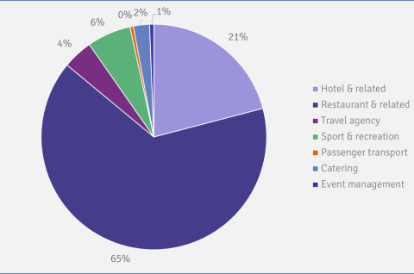
Figure 1: Hospitality and tourism workforce in the UK
(Source: GOV, 2025)

Overview of Case study
In this project, the case study is centred on Hilton Garden Inn from Doncaster, a franchise of the Hilton Worldwide, owned by Arena Racing Company. It is a beautiful hotel located in Leager way street of Doncaster Racecourse (Hiltongardeninn, 2025). The main objective of the hotel is to manage comfort and luxury in the accommodation service for the guests, either work or leisure. Free internet, parking facilities, advanced room amenities, window view and food services are the main business products of this hotel. The diversified service has increased its demand among the domestic and international travellers of the UK. However, the hotel has started facing problems with high employee redundancy due to improper workplace environment, lack of employment opportunities and many others (Ma, 2021). Therefore, the quality in each diversified service line has started degrading, but especially when events are taking place inside hotel, such as weddings, meetings or even in the racecourse day. The current project will elaborate on the interconnection between service quality and staff shortage by showing insights from this hotel.

Key themes to be explored
The overall research project is related to staff shortage issues in contemporary hotel organisations. Staff shortage is such a critical condition in which the presence of human resources in a workforce becomes insufficient against demand for the service (Codling et al., 2022). Hence, the organisations lose their operational excellence. A research project is required to continue with three consecutive steps of reason, impact and solutions (Greetham, 2014). Hence, the key themes will be prepared based on these steps. The first theme will be related to the core reasons that generated staff shortage conditions in Hilton Garden Inn Hotel. The second theme will examine the influence of such condition on service calibre. The third theme is concentrated on the procedure of staff recruitment and retention.

Purpose, ideas and study questions
This investigate aims to analyse the practices through which staff shortage situations in Hilton Hotel Garden Inn Doncaster Racecourse have affected the service performance. The research objectives are:
- To identify the reasons that amplified the staff shortage in Hilton Hotel Garden Inn
- To investigate the consequences of staff shortage in “Hilton Hotel Garden Inn” on the quality of its service
- To explore the ways in which competitor organisations have managed to maintain service quality through staff retention
Research will include which factors have caused staff shortage in Hilton Garden Inn, what are the influences of staff shortage in the present service quality of the hotel and what strategies have taken place in competitor hotels to manage service standards via staff retention.

Literature Review

Overview of staff shortage in hospitality sector
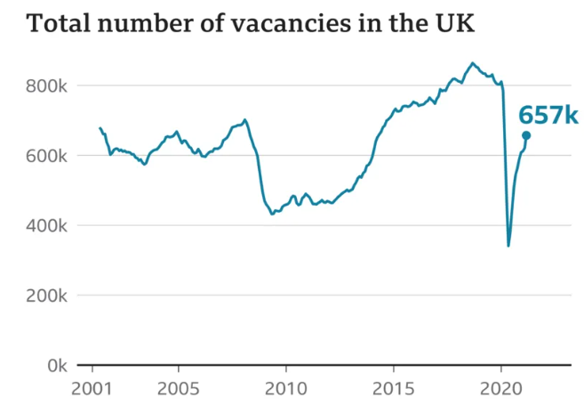
Figure 2: Increase of vacancy in hospitality sector
(Source: BBC, 2021)
The present business operations in the hospitality sector of the UK are going through a downturn due to staff shortage. As per the words of Choi and Choi (2021), staff shortage is a complicated term that clearly defines the insufficient presence of workers in a hotel organisation in comparison with the interest of the guests on achieving service facilities. Currently, the UK-based hotel sector is going through a similar condition. The staff number has been heavily down restricting the businesses to perform successfully. According to Stergiou and Farmaki (2021), the situation has mainly risen during the pandemic situation. As found from a government report, the condition led to permanent closure of 10% of the hotel organisations. It affected the availability of labourers in this sector. People after being jobless from this sector have started to focus on other industries where they can get secured jobs. As per the statement of Rahimi et al. (2023), the hospitality sector has experienced high vacancies in the post pandemic time. In newspaper reports of BBC, it was published that vacancy in the hotel sector was increased to 675k. According to Peso (2022), the loss of financial capability of the hotels to provide proper wages, the imposed workload and the trauma of low job security reduced supply of staff in the hotels. It in turn reduced the organisational performance.

Factors that contributed to staff shortage in the present hospitality sector
Continuous employee redundancies in the hospitality industry have raised major problems for the operating organisations. According to the thoughts of Bardukovan (2022), degradation of professionalism in the HR functions of the hotels is the main reason for staff shortage. HR managers often show favouritism to recruit new employees and avoid selecting capable candidates. Hence, interest of the young generation for employment in the hospitality sector has decreased leading to less recruitment. As argued by Aprilia et al. (2021), the reduction of employee facilities is the main reason for staff shortage. It has already been acknowledged in Herzberg’s theory that achievement and recognition act as staff motivation whereas financial facilities are the hygiene factors to retain staff. Unfortunately, several small and medium size hotels have ignored providing proper facilities to the employees. The efforts of the employees are not properly acknowledged. They are also neglected from incentive and compensation facilities. According to Marinotti and Johnston (2024), a four-star hotel of JGBM Hotel Limited has been accused by its staff as the leaders have failed to provide wages for the past few months. Such conditions negatively influence hotel staff to leave the workplace. Apart from this, Calinaud et al. (2021) stated that, the HR management in the contemporary hotels are defocused on career growth opportunities for the employees. Lack of facilities for career growth in the hospitality sector has demotivated new aspirants towards the sector.
Heavy workload often becomes a reason behind employee redundancy. As stated by Ntounis et al. (2022), guest demand for hospitality service has heavily increased in the post pandemic time owing to the growing trend of tourism. Hence, huge workplace stress has been placed on the hotel staff. Necessity of overtime duty and lack of flexibility has encouraged them to leave the hospitality workforce. Consequently, the staff shortage issue has been intensified.

Impacts of shortage in employee number on the quality of hospitality services
The workforce crisis that arose because of staff shortage has mainly affected the quality of different services available in the hospitality sector. As documented by Joshi and Sathe (2021), hospitality organisations have added various unique services to upgrade guest experience in hotels. Apart from accommodation facilities, various luxurious hotels like Marriott International offer spa services, gym and gaming facilities, personalised food and drinks order and many others. However, a hotel requires capable employees to maintain such additional services. Staff shortage in contemporary hotels have prevented them providing such services. Lack of gym specialists, food specialists and other experts have reduced performance level. According to Filimonau (2021), sustainability maintenance has currently become a key factor to control customer loyalty. Hospitality organisations require additional support from staff to avail energy-efficient services, reduce carbon emission, manage wastes and others. The current shortage of staff has put a barrier into implementing sustainability. Consequently, several hospitality organisations are losing customer loyalty. According to -Lastres et al. (2023), the major problem of staff shortage can be observed in the management of timing within the hotels. Presence of staff in an adequate number assists a hotel to mitigate gusset demand in a fluent manner. The recent rise of staff shortage has increased delay in service delivery. Several hotel companies for instance King Cross Hotel have gained negative review from customers regarding operational performance.
The quality of basic accommodation services has been heavily reduced in the present hotels. In the document of Leta and Chan (2021), it has been mentioned that staff shortage influences the professional capability of existing employees as well. The increase in workload on the present workforce due to high demand generates burnout and decreases their performance level. Different basic hospitality operations including housekeeping, food preparation and others fail to achieve customer satisfaction.

Best employee recruitment and retention techniques
The ongoing crisis of high-standard service has increased awareness among several hospitality organisations. According to Song (2023), resource-based theory has stated that organisations have the urgency of recruiting unique resources through which the best possible outcome can be obtained. By following this theory Marriott Internal has started changing its recruitment strategies. Special focus has been given on expertise of candidates in different areas such as nutritional advice, gaming talent, gym experience and others to continue operating the additional services. As stated by Jones and Comfort (2021), the hospitality organisations are showing concern towards enhancing transparency in recruitment procedure. Premier Inn has implemented a procedure of keeping record of the employee selection procedure to remove bias. HR managers only prioritise skill, experience and knowledge of the candidates to recruit them. As argued by Jones (2024), employee retention is equally important as fair recruitment for a hospitality organisation. Hyatt Hotels follow this perspective to maintain workforce strength. Employees in that hotel are offered monetary rewards in terms of compensation, incentives and salary increment based on their performance. Consequently, the employees have resigned their motivation to be committed to the workplace. Service quality has also upgraded due to the system of financial facilities. As per Tandon et al. (2023), Premier Inn is offering staff education faculties to manage their performance and support them for career development. Such opportunities in that hotel have grabbed the attention of job seekers to the company. Staff shortage has started to reduce in the hotel. Additionally, the staff education revamped service quality.

Literature Gap
Previous literature has defined the proper reasons behind the increase in staff shortage along with its impacts. However, the impact of staff shortage on service quality in terms of operational cost has not been mentioned. Solutions availed by different companies against staff shortage specifically though technology was absent in those literature. These gaps need to be filled with in-depth research.

Methodology
Methodology is the vital part of a research that helps in the setting of the path for data collection. The proper set of the guidance is needed for performing any kinds of research in the business (Collis and Hussey, 2024). It consists of different sets of combining approaches, methods and the designs to get the crucial and informative data in the research. The impact of the staff shortage on the services at Hilton Garden Inn Doncaster needs to be solved after this research. The valuation of the data using the research methods are fundamental to get the perfect set of the consequences (Saunders et al., 2012). The case study that the methodology has focused is on the Hilton hotel and with references to the main topic. The main reason of this investigation was to show the problems that can be found in the background information within hotel industry. This will determine the general ideas on the research topic with the field information.
The in-depth method for collecting the data will have the consequence of the critical analysis. The essence of creative planning and the focus on the quality is important in the step-by-step process of the research (Cottrell, 2014). The initial step has been based on the priority of the background information and the internal factors that influenced the business of the organisation. The rate of employment and the sustaining position of the company in the business sector is analysed. The application of the SWOT analysis framework. The better sense of knowledge on the internal factors has been helpful to find the issues in the operations and the business connections in the industry (Marshall, 2015). The findings of the drawbacks will create a better stage of the analysis on the influence of the staff shortage. The investigation on this problem is reliable on getting the data and results on the topic related to tourism (Veal, 2006). The changing phase of the industry is fast with the influence of a variety of external environments.
The PEST structure has been used for the purpose of getting the information about the external environment that influences the effect on the staff shortage. Competition levels are considered high in the hotel business sector (Jawabreh et al., 2022). However, this analyse reflects the position in hotel industry in Doncaster, for Hilton Garden Inn, to determine the competitive advantages in hospitality sector. The issues can be known better with the process of the competitor within the area of the price and quality. The collection of the combined data will help in stabilising the stage of the discussion and in finding the important information on the topic. The meeting of the result will be based on finding the gaps of the literature. The practical implications of different strategies are important in the tourism sector (AlSuwaidi et al., 2021). It will be helpful to meet the needs of the research and to adjust the recommendations for the future research and perspectives.

Case Study

Background of the organisation
The hospitality business in the UK it is popular and is dominated by different brands to provide the best-in-class hospitality services. The trust of the customers and the loyalty develops a sustainable position in the business for the reputed hotels. The Hilton hotel has been popular for this name in the UK hotel sector for the offerings of the wider range of the premium services and in the essence of providing the luxury. The facilities of the sand beaches and the spa makes an extra addition of the luxury services from the brand in the hotel (Hilton, 2025). It makes the services as the most important factor for the Hilton Garden Inn to survive in the competitive market of Doncaster. The aspect of employee engagement increases the scope for improving the performance of the business (Liu et al., 2022). The staff engagement in the Hilton Hotel has been positive and the efforts of the workforce are used to bring success. The hotel brand operates in the global market and there are about 178 thousand staff engaged in the working (Statista, 2024). The workforce for the hotel is stable in the current sense of the industry while the requirements are there due to the high customer demands in the services.
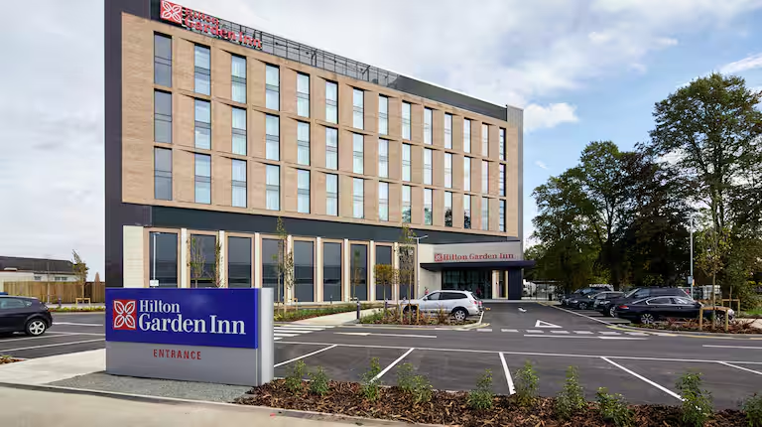
Figure 3: Hilton Hotel Garden Inn
(Source: Hilton, 2025)
The facilities of the Hilton Hotels and its groups are available in Hilton Hotel Garden Inn. The method of consistency is needed to show by any brand for the customer services and it is done by the mentioned brand in the current state. The perceptions and the core experiences of the customers are important to notice in the hospitality sector (Limna and Kraiwanit, 2023). The use of technology and the digital innovation are common, and Hilton Hotel uses it for the analysis of the customer behaviour. The AI powered assistance has been a major upgrade for Hilton Hotels to enhance the customer support services. The main facilities that make the hotel unique in comparison to the surroundings are free Wi-Fi, connecting rooms, fitness centre and the digital rooms.

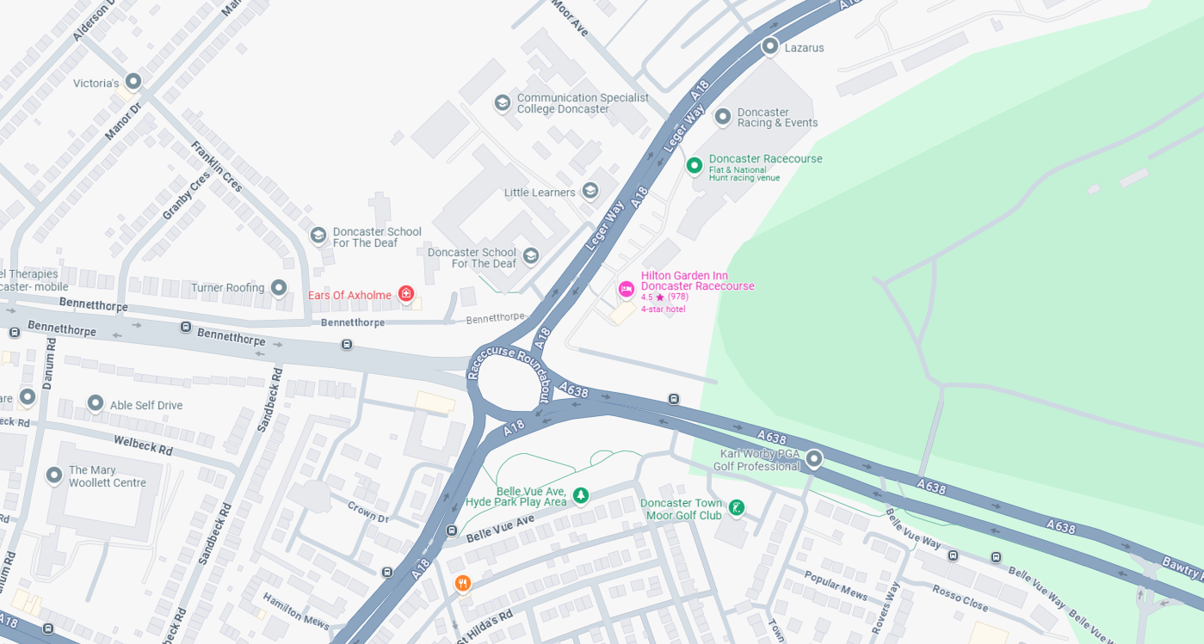
Figure 4: Location of Hilton Garden Inn
(Source: Google, 2025)
The above image has provided the details about the location of the Hilton Hotel Garden Inn in the UK. It has been located at Doncaster Racecourse Leger Way in Doncaster. The facilities of the communication and the transports are needed as essential in the hospitality sector to offer better customer experiences (Chen et al., 2022). It has been maintained well by Hilton Hotel Garden Inn on its prior location. Sightseeing has been the common interest for the tourists on visiting any kinds of locations (Paulino et al., 2024). The location of Hilton Garden Inn has the facilities in this matter as Doncaster Racecourse is nearby from the hotel. The presence of the Lakeside Village and the Yorkshire Wildlife Park is present in the surrounding areas (Hilton, 2025). The innovative approach has made the customer engagement successful in most of the cases for the hotel. The maintenance of sustainability in the business operations can be seen in the hotel industry and in the tourism behaviour (Legrand et al., 2022). The reduction of the carbon emissions has been the aim of the hotel organisations for eco-friendly operations for the tourists. The pricing of the rooms is starting from £89 with the features of LCD tv and the Wi-Fi system (Hilton, 2025). The workforce behind the services is the core strength of the hotel, but it can be challenging when having internal or external influence over some areas.

SWOT Analysis
The framework of SWOT analysis provides the ideas about the internal environment of any organisation of companies. The key strength and the weakness can be gathered well from the results of the SWOT analysis (Green et al., 2023). The application of the framework for Hilton Hotel Garden Inn are as follows
Strengths | Weaknesses
- The offerings of the premium services are the strength of Hilton Hotels Garden Inn. The room services starting from 89 pounds makes the combination of premium services with affordability (Hilton, 2025).  - Good transport connection is an essential part in tourism and hospitality (Plyushteva, 2021). The quality of the services makes the hotel as perfect place to spend holidays and leisure  - The location has the connection of Doncaster, is close to London and motivates the tourist in transportation. | - The customer services and the room experiences has been the issue for Hilton Hotel Garden Inn. The management system of the workers creates problem on several occasions  - The workforce retention cost is high in the present scenario and makes it tough for the employee retention (Ghani et al., 2022). The problem is present in Hilton Hotel Garden Inn and makes it weak for business growth.
Opportunities | Threats
- The sustainable design of the tourism packages is essential in the sector (Coghlan et al., 2023). Hilton Hotel could increase the customer engagement in this aspect.  - The employees in Hilton hotel use AI technology for better customer services. The influence of technology influences the opportunities for smart accommodations (Papagiannidis and Davlembayeva, 2022)  - The reputation in the global stage helps in attracting the foreign tourists to visit the hotel | - The skilled staff shortage is present and increases the crisis in the hospitality sector of the UK (BBC, 2021). It makes the operations of Hilton Hotels tough to maintain the services quality  - The loss in the business has happened in the tourism sector due to the pandemic (Ntounis et al., 2022). That makes it tough when providing top end services for the present case.

Table 1: SWOT Analysis
(Source: Self-created)

PEST
The external factors provide more influence in the development of the business in any organisation. However, the factors that are linked with the PEST analysis shows their influences on problems regarding staff and labour. The analysis of the aspects on Hilton Hotel Garden Inn for in the perspectives of the PEST analysis are as follows:

Political Factors
The political support is needed for any organisations and the business to support the growth. The political areas in the UK are supportive in nature as the democratic policies are followed. The UK government has planned with the ambition of keeping 50 million international tourist visits by 2030 (Gov, 2024). It indicates the hospitality growth of Hilton Hotel is positive in the sense of political support. The issues with the occurrence of Brexit are one of the key problems for the hospital industry in the UK. The Brexit have influenced the issues related with the staff shortages in the hotel market (Forde et al., 2024). Therefore, the lack of workforce within the hotel sector it is a challenge even for Hilton Garden Inn, as this affects the quality of the service for the accommodation or events within the hotel.

Economic factors
Economic support is needed in any business to become successful and to indicate a higher point of expansion. The recent sense of economic stability is positive in the business of Hilton Hotel. The chain volume measures of the GDP in the recent time are about 639,452 million pounds (Gov, 2025). This means that the position of the brand gives them the opportunity to make investments for the contemporary period to have success in hospitality sector and to deal with the changes in the industry. The topics made by the pandemic have affected a high amount of loss in the industry. It has increased the vacancy of the job for the sector to 6.5 per 100 jobs in comparison to 3.5 of other sectors in 2022 (Gov, 2023). The situation has been tough from the view of Hilton Hotels as the recovery planning is still in the process and will take longer time to stabilise in the workforce.
Social factors
The society has been engaged with the growth and stability of the Hilton Hotel as the tourist engagement has made the positive sense of identity. The engagement of the tourists has gradually increased after the pandemic while the staff storage is the key issue. The demands of the skilled staff are there in the UK hospitality sector with the vacancy of nearly 188000 jobs (Theguardian, 2021). It indicates the combined effect of both Brexit and Pandemic made the situation unstable and the search of the labours is high. Hilton Hotels has relied on the EU workers in the services while the immigration issues of the EU workers are tough after Brexit.
Technological factors
The technological growth has been common in different industries and different digital tools are used in the operations of business by Hilton Hotels. The innovation in the mode of digitalisation has been widely noticed in the region of the UK while the issues in the staff shortage has been the key barrier. The highly skilled knowledge is required in the hospitality sector for using the advanced tools and technology (Huang et al., 2021). This affects the services offered by Hilton Hotels and can have a major impact on the brand culture in the context of the business itself.

Competitor analysis
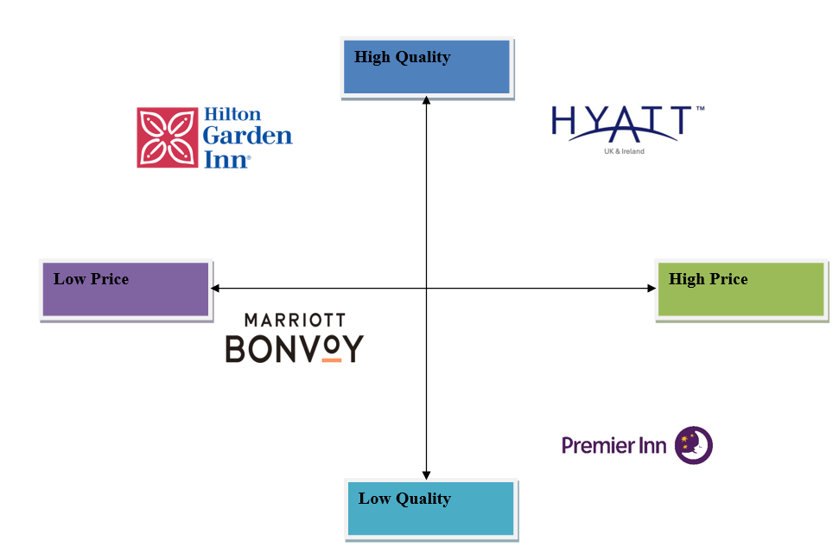
Figure 5: Competitor analysis of Hilton Hotel Garden Inn
(Source: Self-developed)
The above image has provided the knowledge about the hotels brand that are in the domination of the services in the UK. The major competitors of Hilton Hotels Are Premier Inn, Hyatt hotels and Marriott hotels. The main sense of the competition lies in the aspects of the price vs quality. The room price in Marriott starts for 421 pounds for one night (Marriott, 2025). The charges are expensive in comparison to the Hilton Hotels Garden Inn which starts from 89 pounds. The services that are offered by the hotel chain of Hyatt use to have more luxury in comparison to Hilton hotels. The premium features are available in the rooms of Hyatt with the starting price of the room from 323 pounds (Hyatt, 2025). It provides ideas and the knowledge that the service quality and the price both are high in Hyatt. The pricing of the room in Premier Inn is relatively lower than Hilton. The average room price is about 45 pounds for one night (Premierinn, 2025). The pricing is half in comparison to Hilton hotel while the service quality related issues are present. The overall pricing and the balance with the service quality is present in Hilton. The issues with the staff management are the problem. The cost cutting process of Hilton Hotel makes the cutting of a total 22% of the workforce (Forbes, 2020). It has made the issues of the staff shortage in essential areas and the services offered by the organisation.

Netnography
Netnography is the process of finding the data and the information on a particular topic. The qualitative method is used in the procedure of the Netnography to collect the data (Kozinets and Gretzel, 2023).
The scope of the research is essential to know at the beginning stage. The topic in the present form of the research is about the core impact of the staff shortage on the quality and the essence of the services in Hilton Hotel Garden Inn.
The gathering for the information in any research needs the connection with the communities. In the framework of Netnography, the online communities are helpful to deliver the ideas on the trends of tourism (Bansal et al., 2024). It makes the planning perfect to move forward in the next step.
The data collection is done essentially to meet the requirements of the research and to make the stage for the analysis. The data quality matters high in any research that is in the field of the business (Cottrell, 2014). The main data in the perspectives of the current research are on the qualitative method on the mentioned research topic. The data delivers the idea on the way to perform the discussion in the research in alignment with the research objectives.
The next step that is followed by the researcher in Netnography is the evaluation. The evaluation of the data is done with proceeding on the findings and to get the core extraction of the result.
Interpretation: The final step that is involved in Netnography is the interpretation of the result. The activities on qualitative data analysis are reliable to provide the result and the accurate findings (Kozinets and Gretzel, 2023). The critical analysis of the data will provide the area that are needed to solve for the Hilton Hotels in improving the staff engagement on the services.

Personal reflection
The priorities of the data about the hotel industry are important to get the right track in the research. I have learned from practical experience that the main barrier in the staff’s shortage is for the effect of the pandemic and Brexit. The connection of the workers and the issue of the immigration develops the shortage of the labours (Forde et al., 2024). I have noticed from the experiences of the placement that the priority of the management and the Human Resources are needed to execute in a reliable manner for the employee retention. The issue is present in the “Hilton Hotel Garden Inn” and it is needed to solve in my opinion.

Discussion
Influencing factors of staff shortage in Hilton Hotel Garden Inn
Staff shortage is recognized as the most important key issue in the hotel business. An in-depth review of various literature highlighted some valuable implications regarding an ineffective recruitment management in the hospitality sector. Discovered by Marinotti and Johnston (2024), the hospitality organisations have started providing employee opportunities in an inadequate amount. Several organisations, for example, JGBM Hotel Limited have ignored providing wages transparently to the employees. Lack of financial facilities enhanced staff shortage in contemporary hotels. The condition was initiated in the pandemic situation. Business leaders are struggling to provide financial rewards and good salaries to the staff because of the heavy amount of loss during the COVID-19 pandemic (Peso, 2022). Secondary findings with a “case study approach” have raised a similar idea on the staff shortage problem in Hilton Hotel Garden Inn. It is supported by Ghani et al. (2022), that the hotel is currently passing through a difficult phase due to high employee retention cost. It is implied from this revelation that the higher authorities of the placement hotel are facing issues to provide monetary opportunities to the employees. Lack of benefits regarding incentives, high wage and compensation is increasing the rate of redundancy in the hotel. The fact that temporary pause in business operations during the pandemic has also been explored while conducting the case study. As found from the documentation of GOV (2025), pandemic has caused heavy revenue loss in the overall hospitality sector including the placement of Hilton organisations. 639,452 million GBP chain volume measure reduced the capacity of the hotels to provide satisfactory facilities to employees. Consequently, the employee shortage condition occurred.
A controversy can be created between the theoretical concepts of literature and research findings. Brexit is a valuable political area that negatively impacted the overall hospitality industry by assisting staff shortage. Brexit it has been complicated, and the hospitality organisations are recruiting talented employees from other European nationality (Forde et al., 2024). It has been clearly pointed out in the case study finding that Brexit is the main reason that restricted multiple employees from other nations to be recruited in UK hotels. Further, it is also implied that Brexit imposed more workload on the staff of Hilton Hotel by targeting inbound visits from 50 million international travellers (GOV, 2024). Hence, a significant gap has been created between demand for hotel services and the number of available staff in the placement hotel. However, a different implication has been generated in the existing literature. As per the controversy of Bardukovan (2022), lack of employment from different nationalities has been reduced mainly due to lack of transparency. HR managers are more interested in favouritism of the UK-based population that led to staff shortage. Further, the literature sources stated the situation of heavy workload as a potential factor of staff shortage. The implicit reason behind the workload increase was not mentioned. The fact generated a major limitation within the existing literature. However, the limitation was mitigated with the case study-based research finding. Information from a government report regarding the new target of increasing international visits identified a reason behind workload and eventually led to staff shortage. Aside from this, another limitation has been observed in the context of research finding. As per Calinaud et al. (2021), Hotel groups in the UK have failed to provide enough career growth facilities to the employees. The comment was made as a general for the overall industry. Implication of the idea on the case study hotel remained unexplored.
Research conclusions in relation to Hilton Hotel Garden Inn has highlighted an important fact regarding technological impact. Current hotel industry has started embracing digital transformation (Wynn and Lam, 2023). The external influence was also observed in the case of Hilton Hotel. As per Huang et al. (2021), digitalisation in the hotel has increased operational complication. Employees tend to leave the workplace due to this fact. Literature gap, which was concerned with the lack of explanation on the relation of staff shortage with technical trends, was fulfilled with research findings on the PEST model. It was implied that technical complication is a vital factor that contributed to staff shortage in Hilton Hotel.

How staff influence service quality in Hilton Hotel Garden Inn
Overall research findings have assisted identify the changes that occurred in hospitality services after continuous decrease in staff number. According to the literature by Joshi and Sathe (2021), Staff shortage is the main preventing factor that reduces the chances of providing additional luxurious services to the customers. An implication of the idea was observed in the case of Marriott International. The organisation is found to be struggling with providing its extra services such as gym, food management and others due to this fact. Case study findings associated with the price vs quality model. Marriott International was shown to have a low-quality service mainly caused due to inadequate workforce. In the case of Hilton Hotel, a different outcome has been observed. As per the claim made by Hilton (2025), the company has successfully maintained service quality in each additional arena including spa facility and others. It has been argued that high employee engagement in Hilton Hotel has protected the company from losing service quality despite staff shortage. Employee engagement is a critical factor that motivates the staff to maximise effort for serving customers (Michael and Fotiadis, 2022). It is implied from the research findings of statistical trends related to Hilton Hotel that the positive situation of employee engagement acted as a protective factor to maintenance of diversity in the service line.
Sustainability maintenance is identified as another valuable area of hospitality business that has been affected by staff shortage. In the existing literature, it has been implied that current hotels are facing challenges to maintain sustainable practice with the service due to shortage of labour. Different areas including maintenance of energy-efficiency, carbon footprint control and others have failed to be incorporated despite being planned by the hotels (Filimonau, 2021). Contradiction has been generated after the completion of research findings on Hilton Hotel Garden Inn. As per the arguments of Legrand et al. (2022), all hotels under Hilton group have been equipped with appropriate sustainability techniques. Hotel rooms starting from £89 have LED-based equipment that assist energy-efficiency. Hence, the hotel has gained customer loyalty. According to Zheng et al. (2022), staff shortage is a manageable factor in the case of sustainability maintenance. Hotels can continue fostering sustainability with proper equipment. Sustainability in Hilton Hotel and its customer loyalty level is an appropriate example of this fact. Hence, it can be inferred that literature sources have some limitations in accurately explaining the consequences of staff shortage.
It has been clarified from both literature review and research finding that the standard of individual hospitality service can be decreased within a hotel as an effect of inadequate staff. As found from the literature prepared by Liu-Lastres et al. (2023), a delay in service delivery can be observed within a hotel when the demands of customers exceed the number of staff. Maintenance of time and provision of service in a proper manner become difficult for the staff due to the huge difference. Research findings presented in the form of a SWOT model has a similar concept regarding impact of staff shortage. It is identified that the placement hotel has a major weakness regarding the management of guest service. Although the hotel has arranged for different luxurious facilities, the quality of some basic facilities such as guest communication, housekeeping and others have been affected. Absence of properly skilled candidates in the labour market can be a potential reason behind such instability (Davern, 2021). The fact has been implicated in research findings. As per the information collected from The Guardian (2021), 188000 jobs in the hospitality sectors have demand for high-skilled employees. The information has a clear implication that Hilton Hotel is failing to meet the service quality specifically due to shortage of skilled employees.
Literature sources have paid specific attention to the impact of staff shortage on professionalism of hotel staff to elaborate on the degradation of service quality. Heavy workload has chances to deteriorate human health and in turn affect their professional capability (Leta and Chan, 2021). Existing literature has implied that the workplace stress raised from lack of staff has decreased the capability of existing employees in giving maximum effort. However, as per the findings of the case study approach, the service standard has fallen in Hilton Hotel as the recruiters failed to employ appropriate staff for organisational operations. The contradictory ideas have raised limitations regarding the presence of connection between research findings and literature sources.

How retaining and recruitment techniques help in purpose or upgrading service quality at Hilton Garden Inn
It can be seen from the beginning of the actual literature that there is a gap between the present crisis on the area of staff availability and its after-effects on the quality of offered service has already been spread among the hospitality organisations. Recruitment and retaining are the most valuable areas that critically maintain supply of talented staff to offer high-standard services (Bu et al., 2022). Hence, it was observed that the competitors of Hilton Hotel are mainly focused on enhancing their staff retention and employment strategies to manage service quality. The most important competitor of Hilton Hotel, Marriott International has taken a strategy of recruiting people whose talent specifically fits with organisational requirements (Han et al., 2023). Existing literature identifies the technique as an effective approach to operate a diverse service line. However, arguments can be raised from the outcomes of research findings. It is visible from the price and quality format, that Marriott International provides low-grade service compared to Hilton Hotel. The revelation has an implication that Marriott International has failed to manage staff shortage by focusing only on recruitment.
The other competitor, Hyatt Hotel, has taken the most relevant strategy of providing sufficient monetary facilities to the employees. Herzberg’s theory has mentioned the efficiency of facial reward to increase staff retention rate (Wardani et al., 2023). Literature resources have implied application of this theory in the working environment of Hyatt Hotel. According to El-Said et al. (2024), the hotel group benefited the employees with high wages, incentive rate and compensation. In research findings related to the price and quality model, it was noted that Hyatt Hotel has achieved a satisfactory service quality. However, the action of increasing the financial benefit of the employees increased the hotel rate to 323 GBP (Hyatt, 2025). Premier Inn is found to be equally convened from both employee recruitment and employee retention. According to the document of Pavlova (2023), Premier Inn increased transparency in the training procedure through record-keeping techniques. The company also took approaches for career growth and performance improvement so that staff retention can be raised. However, research finding has stated the company has experienced failure to enhance service quality. It is implied that strategies of Premier Inn were insufficient to upgrade service quality.

Conclusion
The topic of the research has been based on the analysis of the staff shortage and its core impact on the service quality. The topic has been set with the reference to the Hilton Hotel Garden Inn in Doncaster. The identification of the issues and the ways to solve the problem are the main objectives in the research. The analysis of the data from the past sources has been done in the section of the literature review. It has provided the basic ideas on the problems that occurred due to staff shortage on the service quality. The problem on the areas of the accommodation of the staff mainly happened due to the combined effect of Brexit and the pandemic. The immigration of EU workers has been stopped because of the rules and the policies of Brexit and the loss in the finance is happening due to Brexit.
The case study approach has been developed in the section of methodology to reflect and solve the main results of the research. The present case evaluation has been done with the use of different frameworks like SWOT and PEST. The competitor analysis has been done to find the main competitors for Hilton Hotel in the region. The organisation has the issues regarding the style of the recruitment and has made the cost cutting in the operation to save the cost. The service quality and the maintenance of the right way of sustainable measure are the issues faced by the management in Hilton Hotels.

Recommendations
The main findings and the discussion in the research were able to provide the knowledge on the research topic. The issues on the staff shortage have made the problems on the service quality and the management functions of Hilton Hotel Garden Inn. The cutting of the workforce and the instability in the costing area are the barriers for Hilton Hotels in reducing the staff shortages in the region. There are several areas and the recommendations that will be helpful to solve the issues for Hilton hotel in the management of the staff and the strategies for future.

Recruitment: The engagement of the new staff in the hotel is required to maintain the high-quality services and to solve the feedback in the quick session. The hiring of the staff and the method of the recruitment is weak in Hilton hotels. The process of online recruitment is reliable in the hospitality industry (Lee et al., 2021). It can be useful to ensure staff engagement more and in reducing the shortage. The report of lack of transparency in the hiring process is reported in the hotels for Hilton. Utilisation of the AI tools makes the staffing process wrong and misses out proper choice of the talent (Hunkenschroer and Kriebitz, 2023). The ethical hiring is needed to perform by the management team in Hilton Hotel Garden Inn to increase the trust and the employee behaviour better.

Rewards and compensation: The development of a reliable and strong workforce can be executed by using the positive intent and the potential of the employees. The confidence can be grown with the power of the motivation provided to the working staff. The benefits of the rewards and the compensation are the prime tools that increase the motivation and the confidence of the employees (Tahiri et al., 2022). Hilton hotels must set the management strategy to gain the trust from the employees and in the creation of the bonding. The wellbeing of the employees is a key area that benefits on the stage of employee happiness (Ghaderi et al., 2023). The HR group of the hotel can develop different wellbeing programs to reduce the workload.

Application of digital tools and technology: The trend of innovation is common in the hospitality sector. Different organisations are taking advantage of it. The AI technology can be seen in the contemporary operations within the hotel industry these nowadays (Ruel and Njoku, 2021). Hilton Hotel can use different technologies with AI for smooth operations in the business. AI in the hospitality operations has the advantages of lowering the cost (Limna, 2023). Hilton Hotel Garden Inn can use the financial resources more in employee retention and that will enhance the employee workforce.
Employee training and skill development: The faster operations and the efficiency in the technological area for hospitality needs the skilled workforce to control. Development of skills gives a good chance to perform in the hotel industry and this can be a major advantage (Hossain et al., 2021). Hilton hotel can arrange the training programs for the employees to boost the talent development and to be ahead in the competition. The higher level of the stress increases the rate of the employee turnover in the business for the hospitality organisations (Michael and Fotiadis, 2022). The methods of training increase the potential and the skills of the staff in managing the time better.

References
AlSuwaidi, M., Eid, R. and Agag, G., 2021. Understanding the link between CSR and employee green behaviour. Journal of Hospitality and Tourism Management, 46, pp.50-61.
Aprilia, L.L.R., Marini, S. and De Vos, S.M.R., 2021. Covid-19 and the work motivation: hotel employees based on Herzberg’s two factor-theory perspective. Journal of Tourism, Hospitality and Culinary Arts, 13(3), pp.53-63.
Bansal, R., Martinho, C., Pruthi, N. and Aggarwal, D., 2024. From virtual observations to business insights: A bibliometric review of netnography in business research. Heliyon, 10(1).
Bardukova, L., 2022. Normative requirements and practical-applied skills of personnel employed in the hotel industry-problems and challenges. Economics and computer science, 2, pp.43-51.
BBC, 2021. Is there a solution to the hospitality staff crisis? [Online] Available at:<https://www.bbc.com/news/business-57817775>[Accessed on: 3rd February 2025].
BBC, 2021. Where have all the UK workers gone? [Online] Available at:<https://www.bbc.com/news/business-57400560> [Accessed on 2nd February 2025].
Bu, X., Cherian, J., Han, H., Comite, U., Hernández-Perlines, F. and Ariza-Montes, A., 2022. Proposing employee level CSR as an enabler for economic performance: The role of work engagement and quality of work-life. Sustainability, 14(3), p.1354.
Calinaud, V., Kokkranikal, J. and Gebbels, M., 2021. Career advancement for women in the British hospitality industry: The enabling factors. Work, Employment and Society, 35(4), pp.677-695.
Chen, Y.C., Yao, H.L., Weng, S.D. and Tai, Y.F., 2022. An analysis of the optimal facility location of tourism industry in plain region by utilizing GIS. SAGE Open, 12(2), p.21582440221095020.
Choi, M. and Choi, Y., 2021. Employee perceptions of hotel CSR activities during the COVID-19 pandemic. International Journal of Contemporary Hospitality Management, 33(10), pp.3355-3378.
Codling, S., Pinnock, J., Barrett, E., Gayle, S., Stephenson, N., Sibblies, N. and Sinclair-Maragh, G., 2022. Factors contributing to staff turnover in the hotel industry: A literature review. People Management-Highlighting Futures.
Coghlan, A., Becken, S. and MacAskill, S., 2023. Designing sustainability changes in a tourist accommodation context from a systems perspective. Frontiers in Sustainable Tourism, 2, p.1289009.
Collis, J and Hussey, R 2014, Business Research, A Practical Guide for Undergraduate and Post Graduate Students, Palgrave, London
Cottrell, S. 2014 Dissertations and project reports : a step by step guide. New York: Pallgrave.
Davern, D., 2021. Talent management, the employer brand, and employee retention: Evidence from the Irish hotel sector. In Talent management innovations in the international hospitality industry (pp. 79-98). Emerald Publishing Limited.
El-Said, O.A., Elhoushy, S., Smith, M. and Youssif, M., 2024. Crisis-driven innovation in hospitality: How do international hotel chains innovate to recover from a global crisis?. International Journal of Hospitality Management, 120, p.103758.
Filimonau, V., 2021. The prospects of waste management in the hospitality sector post COVID-19. Resources, Conservation and Recycling, 168, p.105272.
Forbes, 2020. Hilton Laying Off 22% Of Corporate Workforce [Online] Available at:<https://www.forbes.com/sites/rachelsandler/2020/06/16/hilton-laying-off-22-of-corporate-workforce/> [Accessed on: 2nd February 2025].
Forde, C., Bessa, I., Alberti, G., Dolezalova, M., Ciupijus, Z. and Cutter, J., 2024. Employers' post-Brexit workforce strategies and their use of migrant workers.
Ghaderi, Z., Tabatabaei, F., Khoshkam, M. and Shahabi Sorman Abadi, R., 2023. Exploring the role of perceived organizational justice and organizational commitment as predictors of job satisfaction among employees in the hospitality industry. International Journal of Hospitality & Tourism Administration, 24(3), pp.415-444.
Ghani, B., Zada, M., Memon, K.R., Ullah, R., Khattak, A., Han, H., Ariza-Montes, A. and Araya-Castillo, L., 2022. Challenges and strategies for employee retention in the hospitality industry: A review. Sustainability, 14(5), p.2885.
Google, 2025. Hilton Garden Inn Doncaster Racecourse [Online] Available at:<https://www.google.com/maps/@53.5202146,-1.1091801,16.74z?entry=ttu&g_ep=EgoyMDI1MDEyOS4xIKXMDSoASAFQAw%3D%3D> [Accessed on: 6th February 2025].
Gov, 2023. Tourism Recovery Plan: Update on delivery [Online] Available at:<https://assets.publishing.service.gov.uk/media/6447ec19814c6600128d061d/Select_Committee__TRP_update.pdf> [Accessed on: 10th February 2025].
Gov, 2024. New ambition for 50 million annual visits to UK announced by Tourism Minister [Online] Available at:<https://www.gov.uk/government/news/new-ambition-for-50-million-annual-visits-to-uk-announced-by-tourism-minister#:~:text=A%20new%20ambition%20for%20the,visited%20worldwide%2C%20driving%20economic%20growth.> [Accessed on: 10th February 2025].
Gov, 2025. Gross Domestic Product (GDP) [Online] Available at:<https://www.ons.gov.uk/economy/grossdomesticproductgdp> [Accessed on: 6th February 2025].
GOV, 2025. Hospitality and Tourism workforce landscape [Online] Available at:<https://assets.publishing.service.gov.uk/media/5d67a363ed915d53b4904899/Hospitality_and_Tourism_Workforce_Landscape.pdf> [Accessed on 2nd February 2025].
Grdeb, R.W., Lie, F.B. and Wilderom, C.P., 2023. The origins of SWOT analysis. Long Range Planning, 56(3), p.102304.
Greetham, B. ,2014. How to Write your Undergraduate Dissertation, Palgrave Macmillan, Basingstoke.
Han, Y., Yang, Y. and Mohamed, R., 2023. A bibliometric analysis of work engagement in the hospitality and tourism industry. Journal of Hospitality and Tourism Insights, 6(5), pp.1946-1966.
Hilton, 2025. A leading global, hospitality company [Online] Available at:<https://www.hilton.com/en/corporate/> [Accessed on: 5th February 2025].
Hilton, 2025. Hilton Garden Inn Doncaster Racecourse [Online] Available at:<https://www.hilton.com/en/hotels/dsadrgi-hilton-garden-inn-doncaster-racecourse/> [Accessed on: 1st February 2025].
Hilton, 2025. Hotels in United Kingdom [Online] Available at:<https://www.hilton.com/en/locations/united-kingdom/> [Accessed on: 2nd February 2025].
Hiltongardeninn, 2025. Hilton Garden Inn Doncaster Racecourse [Online] Available at:<https://www.guestreservations.com/hilton-garden-inn-doncaster-racecourse/booking?utm_source=google&utm_medium=cpc&utm_campaign=991006015&gad_source=1&gclid=CjwKCAiAzPy8BhBoEiwAbnM9O1_TUq2K3oYuOUXuzSQs693mGCRBr1InCyoTNokpwws2UYvXI0OFKBoCAAAQAvD_BwE> [Accessed on 2nd February 2025].
Hossain, M.S., Kannan, S.N. and Raman Nair, S.K.K., 2021. Factors influencing sustainable competitive advantage in the hospitality industry. Journal of Quality Assurance in Hospitality & Tourism, 22(6), pp.679-710.
Huang, A.Y., Fisher, T., Ding, H. and Guo, Z., 2021. A network analysis of cross-occupational skill transferability for the hospitality industry. International Journal of Contemporary Hospitality Management, 33(12), pp.4215-4236.
Hunkenschroer, A.L. and Kriebitz, A., 2023. Is AI recruiting (un) ethical? A human rights perspective on the use of AI for hiring. AI and Ethics, 3(1), pp.199-213.
Hyatt, 2025. ABOUT HYATT [Online] Available at:<https://about.hyatt.com/en.html> [Accessed on: 2nd February 2025].
Jawabreh, O., Shniekat, N., Saleh, M.M.A. and Ali, B., 2022. The strategic deployment of information systems attributes and financial performance in the hospitality industry. Information Sciences Letters, 11(5), p.110504.
Jones, P. and Comfort, D., 2021. Modern slavery statements and leading UK hotel companies. Athens Journal of Tourism, 8(3), pp.147-162.
Jones, P., 2024. Wellness in the Global Hospitality and Tourism Industry. Athens Journal of Tourism, 11(3), pp.225-238.
Joshi, A. and Sathe, S., 2021. A study on factors affecting staff turnover in five-star Hotels.
Kozinets, R.V. and Gretzel, U., 2023. Qualitative social media methods: Netnography in the age of technocultures. The Sage handbook of qualitative research, pp.403-420.
Lee, L., Guzzo, R.F., Madera, J.M. and Guchait, P., 2021. Examining applicant online recruitment: The use of fictitious websites in experimental studies. Cornell Hospitality Quarterly, 62(1), pp.76-88.
Legrand, W., Chen, J.S. and Laeis, G.C., 2022. Sustainability in the hospitality industry: Principles of sustainable operations. Routledge.
Leta, S.D. and Chan, I.C.C., 2021. Learn from the past and prepare for the future: A critical assessment of crisis management research in hospitality. International Journal of Hospitality Management, 95, p.102915.
Limna, P. and Kraiwanit, T., 2023. The role of chatgpt on customer service in the hospitality industry: An exploratory study of hospitality workers' experiences and perceptions. Tourism and hospitality management, 29(4), pp.583-592.
Limna, P., 2023. Artificial Intelligence (AI) in the hospitality industry: A review article. International Journal of Computing Sciences Research, 7, pp.1306-1317.
Liu, X., Yu, J., Guo, Q. and Li, J., 2022. Employee engagement, its antecedents and effects on business performance in hospitality industry: a multilevel analysis. International Journal of Contemporary Hospitality Management, 34(12), pp.4631-4652.
Liu-Lastres, B., Wen, H. and Huang, W.J., 2023. A reflection on the Great Resignation in the hospitality and tourism industry. International Journal of Contemporary Hospitality Management, 35(1), pp.235-249.
Ma, R., 2021. Human resource management in multinational companies——from the perspective of Hilton Hotels. In E3S Web of Conferences (Vol. 235, p. 02058). EDP Sciences.
Marinotti, G. and Johnston, A., 2024. Leader ‘leadership’perceptions within a luxury hotel environment. Human Resource Management and Services, 6(2), pp.1-17.
Marriott, 2025. Hotels in London, GB [Online] Available at:<https://www.marriott.com/en-us/destinations/united-kingdom/london.mi> [Accessed on: 5th February 2025].
Marshall, C., 2015, Designing Qualitative Research, 6th Ed, Sage, London.
Michael, N. and Fotiadis, A., 2022. Employee turnover: The hotel industry perspective. Journal of Tourism, Heritage & Services Marketing, 8(1), pp.38-47.
Ntounis, N., Parker, C., Skinner, H., Steadman, C. and Warnaby, G., 2022. Tourism and Hospitality industry resilience during the Covid-19 pandemic: Evidence from England. Current Issues in Tourism, 25(1), pp.46-59.
Papadopoulos, O., Lopez‐Andreu, M. and Jamalian, M., 2021. Violation and lack of awareness of employment rights in the United Kingdom's hotel industry: Isolation, fragmentation and barriers to labour enforcement. Industrial Relations Journal, 52(4), pp.315-330.
Papagiannidis, S. and Davlembayeva, D., 2022. Bringing smart home technology to peer-to-peer accommodation: Exploring the drivers of intention to stay in smart accommodation. Information systems frontiers, 24(4), pp.1189-1208.
Paulino, I., Domènech, A. and Bassols, N., 2024. Do visitors visit what the tours industry supplies? Sightseeing tours versus first-timers’ photos. Tourism Planning & Development, 21(4), pp.416-437.
Pavlova, V., 2023. Encouraging Employee Participation in Environmental Sustainability Practices in Luxury Hotel Company.
Piso, A., 2022. Controlling the clock: Working hours in the UK hotel sector. Research in Hospitality Management, 12(1), pp.1-11.
Plyushteva, A., 2021. Commuting and the urban night: Nocturnal mobilities in tourism and hospitality work. In Tourism and the night (pp. 37-51). Routledge.
Premierinn, 2025. About us [Online] Available at:<https://www.premierinn.com/gb/en/why.html> [Accessed on: 6th February 2025].
Rahimi, R., Akgunduz, Y. and Bilgihan, A., 2023. Impact of COVID-19 on mental health and career anxiety of hospitality and tourism students in the UK. Journal of Hospitality and Tourism Insights, 6(2), pp.892-911.
Ruel, H. and Njoku, E., 2021. AI redefining the hospitality industry. Journal of Tourism Futures, 7(1), pp.53-66.
Saunders, M., Lewis, P. and Thornhill, A. 2012 Research Methods for Business Students, FT/Prentice Hall: Harlow
Song, X., 2023. Employee Satisfaction during the Pandemic: A Content Analysis of Online Reviews on Full-Service Hotel.
Statista, 2024. Employees of Hilton from 2013 to 2023 [Online] Available at:<https://www.statista.com/statistics/297758/number-of-hilton-worldwide-employees/> [Accessed on: 7th February 2025].
Stergiou, D.P. and Farmaki, A., 2021. Ability and willingness to work during COVID-19 pandemic: Perspectives of front-line hotel employees. International Journal of Hospitality Management, 93, p.102770.
Tahiri, A., Kovaci, I., Dimoska, T. and Meha, A., 2022. Impact of motivation on employee performance in the hospitality industry. QUALITY Access to Success, 23(187), pp.58-64.
Tandon, A., Dhir, A., Madan, P., Srivastava, S. and Nicolau, J.L., 2023. Green and non-green outcomes of green human resource management (GHRM) in the tourism context. Tourism Management, 98, p.104765.
Theguardian, 2021. Can hospitality’s recruitment crisis ever be fixed? [Online] Available at:<https://www.theguardian.com/food/2021/aug/15/can-hospitalitys-recruitment-crisis-ever-be-fixed> [Accessed on: 7th February 2025].
Veal, A J 2006, Research Methods for Leisure and Tourism, 3rd Ed, Financial Times/ Prentice Hall
Wardani, L.M.I., Werinusa, J.O.A., Istiqomah, I. and Bustami, M.R., 2023. Job Insecurity, Grit and Work Engagement in The Hospitality Industry During Covid-19. Journal An-Nafs: Kajian Penelitian Psikologi, 8(1), pp.20-36.
Wynn, M. and Lam, C., 2023. Digitalisation and IT strategy in the hospitality industry. Systems, 11(10), p.501.
Zheng, C.J., Wu, J.S. and Zhao, X.R., 2022. How could hospitality employees survive? The individual costs, career decisions and autonomy support of furlough strategies in a crisis. International Journal of Hospitality Management, 106, p.103279.

