Does child-generated success criteria have an impact on pupil engagement of individual year 6 pupils?
Aim
This research project will be focussed around the impact of child-generated success criteria on the engagement of individuals in class, focussing on children’s engagement with the lesson, the topic and with the success criteria. Engagement will be defined in terms of the children’s involvement within the class and their wellbeing. Research took place in two Year 6 classes within the same school in the Swansea district, where we completed six weeks of teaching practice. The school currently holds 516 pupils, with 61 of those pupils in the Year 6 classes. 9% of the school are known to be eligible for free school meals, and the attendance rate of the school is currently 95.6%. The percentage of pupils that reach the desired outcome at the end of KS2 is consistently higher than the local authority and the national average across all core subjects (My Local School, 2018).
We found the topic of success criteria interesting to study because in the classes that we have observed and taught where teacher-generated success criteria has been used there has been little engagement by the children with the success criteria, and engagement with the lesson as a whole varies dependant on the topic. Success criteria is very important within this particular school and are expected to be a part of every maths and English lesson, but often it seemed as if for the teachers they were seen as another box to tick. The general routine involving success criteria is that they would be generated before the lesson by the teacher in the form of a checklist and stuck into the children’s books at the beginning of each lesson. This is the case across the whole school, where the policy is that success criteria should be stuck in books on labels to ensure that the books are kept as neat as possible.
We observed during our teaching practice in the school, both in Year 6 and in Year 2 where we taught for six weeks before we moved to Year 6, that the success criteria may be briefly mentioned, or recapped, but usually there was little or no mention as to why they are important, unless a topic was being introduced. Once the labels are in their books, the children generally pay no attention to them unless they are mentioned within a mini-plenary, or if they are peer or self-assessing their work at the end of a lesson using a tick sheet, in which less engaged children often tick off all of the success criteria whether they have used them or not. According to Emerson, this often happens when children do not understand the success criteria fully (Emerson, 2015), and it can often happen when engagement is slipping at the end of a lesson. The success criteria, for the children in this class, often plays a very little part in learning and they were not afraid to admit this during the focus group interviews.
Success criteria in the Year 6 class is mainly used in Maths and English but can be used in other topics too. In literacy the success criteria can remain the same throughout the teaching of an entire text type, which could be an entire term or half term. An example of this is for the whole half term that the students were in these classes for teaching practice, the success criteria for the text type Persuasive Texts always consisted of the same eight features of persuasive texts that the children were expected to use. These were the use of the following: alliteration, rule of three, rhetorical question, emotive language, fact, opinion, statistics, and an extended success criteria was to use formal language. The children would memorise these success criteria and be able to recount them on command. According to Shirley Clarke (Clarke, 2008) pupils will often quickly learn to write success criteria such as this by memory, but this does not mean that they understand the criteria and it does not mean that it is helping them with their learning.

In some previous lessons during our teaching practice children have thought of their own “top tips” alongside the success criteria, and it was noted that this had a positive impact on the engagement of many of the children. This is because the children fully understand the tips that they have created, which were usually created in pairs or small groups, and how those tips relate to the work. They have chosen specific focuses for themselves because they believe those are the areas that will help them succeed in the lesson and move their learning forward the most. It also allows children to be in charge of their learning and feel more independent, as opposed to just following instructions that their teacher has made (Clarke, cited in Read and Hurford, 2010). Based on all of this, we made the decision to take a step further by asking the children to develop their own success criteria so that we could see how this impacted engagement in comparison to teacher-generated success criteria.

Literature
Most literature on the topic of chid-generated success criteria comes as small sections of writing on the topic of formative assessment or general success criteria, but even so there is a lot of material. The main contributor seems to be Shirley Clarke, who as well as books on the topic has a series of studies on her website from primary schools across the UK. Many of these are specific to child-generated success criteria, and it is interesting to see what other teachers have done to aid the children in this.

Almost every piece of literature has emphasised that children should take more responsibility for their own learning, and that success criteria should be child friendly so that they can understand how they can move their learning forwards themselves (Black and Wiliam, 1998, Clarke, 2008, Read and Hurford, 88-89). Enhancing learning is no longer solely the role of the teacher, although it cannot be effective without the teacher to guide and support the children along the way, as was found during the lesson study.

The literature on the topic does not often mention child-generated success criteria in relation to the engagement of the children with the lesson as a whole, but it does often highlight that the engagement with the success criteria specifically has been known increase as a result of the children generating it themselves. In fact, the literature often does not mention success criteria in relation to the impact on engagement with lessons at all, but rather in terms of the impact on learning as a whole, although the two interlink.

It was also found that success criteria works best when used alongside other methods of formative assessment. According to Clarke’s classroom studies, often teacher generated, co-generated and child-generated success criteria work best when used alongside a comparison of higher level and lower level work so that the children can visualise and recognise what the success criteria actually means and how using it can impact their work and learning. Often, they will point these features out without prompting from the teacher.
The literature did highlight some challenges and limitations that might come from using child-generated success criteria. Often, such as in the school that this study was undertaken, there are strict school-wide policies about success criteria and how they are laid out in books. This forces teachers to think ahead with success criteria and have them ready for the beginning of each lesson, which would make it difficult for child or co-generation (Shirley Clarke Media Ltd., 2018). A way around this might be to have a list of success criteria available and then have the children adapt them or choose the ones that are most relevant to them and their learning.

Another limitation is time and the amount of time it would take to have the children generate their own success criteria each lesson (Shirley Clarke Media Ltd., 2018, Read and Hurtford, 2010). Especially as the classes grow accustomed to generating their own success criteria it will take a chunk out of each lesson, and however beneficial it might be for children to do this teachers only have a certain amount of time to get through a large curriculum. Success criteria can only really be used for topics that the children already have a good understanding of, otherwise the criteria set will not be effective (Didau, 2018, Read and Hurtford, 2010: 98). There is also the case of EAL children and other children with additional learning needs to consider, who might need much more support in this than other children (Read and Hurtford, 2010: 90).

Methodology
The data collection took place in a series of two lessons in two Year 6 classes in the same school. The lessons were themed around PSD and the children’s feelings towards leaving primary school and starting secondary school. This was chosen as it is relevant to their lives, and as the lessons took place six weeks after the two students were last in the classes and the lessons took place on the last day of learning before the end of term, it was deemed appropriate to focus on something that the was relevant to the children but not connected to what they were already doing in class. One limitation of the project is that, although the students taught in classes that they were comfortable with and had taught before, it had been an entire half term since either student had been in school. This meant that as well as not having taught a class for over a month, they were also out of sync with what topics the classes were covering and the children were overexcited by having them back in school. It would have been easier and less disruptive if this research took place during teaching practice, and was not so much of a one off. The success criteria that the children generated were focussed on oracy and discussion, as the aim of the lesson was to develop discussion skills as in the LLC KS2 curriculum.
Lesson one was given to a class of 26, with two extra children from the STF class and a Higher Level Teaching Assistant joining the lesson part way through, around twenty minutes into the lesson. The class is usually made up of 30 children, but three were absent and one child was spending the morning in the STF classroom. Part way through the lesson there was a small disruption as another teacher came in to take a small recording of the children, as a gift to a long serving member of staff for his retirement, and three children involved in the computer club were in and out of the lesson to help with that. Lesson two was given to a class of 31, with some children leaving for five minutes at a time to record some Welsh oracy with a teaching assistant. The lesson followed largely the same structure as lesson one, but with some tweaks based on what happened in the first lesson, which will be mentioned in the analysis.
Regarding the collection of data for the lesson study research, whilst one student taught, the other student was a non-participant observer focussing on three target pupils. This method was used so that the non-participant observer could focus entirely on what was going on in the class. Although both students had taught in both classes in the past, the non-participant observer had much less connection and knowledge of the class that they observed in. This makes it more fair and unbiased as they have less knowledge of different characters in the class and could observe with an unobstructed view of the class.
The observations were taken using an observation schedule, in which the observer recorded the pupils’ engagement at five minute intervals using two Leuven scales; one for Wellbeing and one for Involvement. These were used simultaneously, and all target children were recorded anonymously as child A, B, C, D, E and F on the same scale. The scales, which are very simple to use and interpret, were used alongside notes that were written to support the recordings on the scale. These were brief sentences about what the children were doing at the time of recording and can be found in the appendix.
Involvement was a large factor in the observations, as being engaged involves a lot of the characteristics seen when a person is involved, including “strong motivation, fascination and total implication” (Laevers, 2003: 15). According to Laevers, a high involvement occurs when a child is in the Zone of Proximal Development, which is the best state of mind to be in to enhance learning as the brain is developing at its highest, encouraging deep level learning (Ephgrave, 2015: 3). The Leuven Scale of Involvement is a scale from one to five, in which a five shows the deep level learning and high involvement mentioned. A one on the scale would show minimal learning where a child is passive and unengaged with the lesson. The Leuven Scale of Wellbeing follows the same format, where a one on the scale shows a distressed, unhappy child, which would result in the brain shutting itself down to any learning that might take place, and a five shows an excited and motivated child who’s brain is open and accepting to information and learning (Ephgrave, 2015: 4).
Immediately after the lessons, the three target pupils from each class were involved in a brief discussion, in which a few key questions were asked (see appendix). The focus group discussions were undertaken as a group rather than individually to prevent the children feeling intimidated, although there was a risk that children in the focus group would copy each other’s ideas. The structure of the interviews was quite informal, and although there were pre-made questions the interviews were malleable and more like conversations that flowed quite easily so some topics were covered that were not pre-planned with our questions.
The method used to capture reflections was Brookfield’s Four Lenses, and was used after the lessons took place. The reflection can be found in the Appendix, and the four lenses method worked well with this study as it enabled the capturing of four different viewpoints; an autobiographical view, the view of the pupils, the view of a colleague and the view of the literature (Waite, 2013). It is useful to have all of the different viewpoints in the same place, and this method of reflection covers a lot more than the use of only an autobiographical method, such as the ARC model, which follows closely to Driscoll’s reflective model.
The autobiographical reflection was that Lesson 1 did not work as well as hoped, and that there were many factors influencing that, such as the time in the term and the classroom setting. The children’s reflection was based on the focus group discussion, where the children said that they enjoyed the topic and making their own success criteria. This was the most difficult reflection to write, as during the discussion it was evident that the children were saying what they thought we wanted to hear. The colleague reflection was based on how helpful I had found having another student in the classroom, and the literature reflection showed how I felt more scaffolding had been needed in the class as this had worked much better in other case studies.
The focus children were a sample of three children in each class. There were restrictions set to the number of children used for this in each class, and there were also limitations based on which children we had parental consent to use in the study. The six focus children used represented 10% of Year 6 at the school, which is quite a small percentage. The small number of focus children did make it easier to observe and keep track of what was happening in the lesson. The focus children were chosen by the student that would be teaching each class, and those chosen were a mixture of two boys and a girl from each class. It would have been ideal to have an equal number of each sex in order to compare the difference between sexes properly, but that is something that can be looked into during another study. The attainment levels of the children in the focus group were mid to low level, and their work ethics varied from highly motivated to passive, again in order to see whether this made a difference to the children’s engagement with self-generated success criteria.
Ethical Considerations
Ethics was a very important part of the research and a lot of thought was put into it. Each child was given a consent form for their parents to sign, consenting them to take part in the research. These were handed out a few weeks before the study took place. In both classes less than half of the consent forms were returned, and one parent in class 1 did not give consent for their child to take part. That child spent the lesson, as he spends each morning, in a different class so this was not a problem. In class 1, out of the fifteen consent forms that were returned, one child did not take part in the lesson and two were absent, leaving only twelve children to choose as a focus group. It was a similar case in class 2, with only around half of the consent forms being returned.
As well as consent forms signed by the parents, the children were also asked for verbal assent at the beginning of the lesson and were told at various points that they were always able to change their minds about taking part and that they would not be treated any differently. The focus children were also told this during the interviews after the lesson. The children remained anonymous throughout the entire study, and the class and school names have not been disclosed to anyone.
Lesson study 1 and analysis
The three focus children varied in their engagement throughout the lesson, but all scored highly on the Leuven Scale of Involvement during the spider diagram and feedback to class parts of the lesson, both of which were parts of the lesson that linked with the success criteria the most. They were also consistent with each other in that none of them contributed to any of the class discussions, scoring moderate to low on the Leuven Scale of Involvement.
During group discussions Child A was observed to be chatting with a friend, although seemed to be engaged when listening to the teacher and writing the success criteria and spider diagrams. Child B seemed tired and unfocussed at the beginning of the lesson, but engaged with the drawing and writing parts of the lesson. During group discussions they were seen to be trying to get their group involved with the discussion but other parts of the group were not so interested. Child C’s engagement was observed to be sporadic during the lesson. All three children mentioned during the focus group questions that creating their own success criteria was enjoyable and helped their learning.
It was noted that the children were “mimicking” (Emerson, 2015) a memorised checklist of things to think about when speaking that they had probably used as success criteria for a previous lesson on oracy, and that the teacher-generated success criteria that had been given to Class 1 not only allowed that to happen but encouraged it. Most of the success criteria that the children generated were generic and not challenging or personal to their own learning journeys at all. The majority of groups included “listen to others,” and “eye contact” in their success criteria, with “hand gestures” making an appearance too. Hand gestures would have been relevant in a Pie Corbett or a presentation but would not be necessary to make a successful discussion, so it was decided that in class 2 the teacher-generated success criteria would not be given, and the children would generate their own individual success criteria in the hopes that they would be personal and ambitious for each child. The children were able to discuss their success criteria with one another to bounce off or “magpie” ideas, but the main aim was that each child would have a set of five success criteria individual to themselves.
It was decided after the first class that the second class would benefit with more scaffolding from the teacher in the class discussion. The classes are not used to having whole class discussions for extended periods of time, and in trying to make the lesson more child-led actually not much was achieved, as the children are reliant on the teacher to organise and lead the discussion rather than doing so themselves. Class 1 would have also benefitted from a lot more mention of the success criteria, and almost constant reminders to use them. Many of the teachers involved with Clarke’s studies on success criteria mentioned that if the success criteria was not displayed in a prominent place in the classroom the children would forget to use them (Clarke, 2018). As in Class 2 each child would have their own set of criteria, it would not be possible to display them prominently in the classroom, so it was decided instead that the teacher would mention them a lot more throughout the discussions.
Lesson study 2 and analysis
Lesson 2 was much improved from the first lesson. The children were much more involved in the discussion and were much more engaged with the success criteria. This is a result of much more emphasis being put onto the success criteria by the teacher, and more scaffolding with the discussion than the first lesson, where I tried to make the discussion more child-led than teacher-led. However, improvements could still be made to the second lesson.
Of the three focus children in this class, Child D and Child E were engaged quite well throughout the session, putting hands up during class discussions and being active during group discussions, and Child F had a very low involvement until the end of the lesson when he became more involved and engaged. This child has a history of being less engaged in class and has dyslexia and a slight stutter, and the latter may have affected his involvement in discussions.
According to the observations on the Leuven Scale and notes taken during the lesson, Child F had a low engagement of 1 on the Leuven Scale throughout, and for much of the lesson stared into space. During group discussions, the child mainly listened to the other children although he did make a few inputs. Towards the end of the lesson his involvement increased, moving to a 2 during feedback to class and peaking at 3 during the plenary. Child E and Child D were much more involved in the lesson throughout with both children eager to answer questions, take part in the discussions and do the work, although child D left to do Welsh oracy for a while and child E talked to a friend during some of the class discussion.
As with Class 1, the lesson was a one off in that it was not connected to any prior or future lessons for that particular class. The topic of leaving primary school for secondary school was relevant to their lives as it is a matter of months until it all becomes a reality for them, but in terms of the aims of the lessons, which were to develop their oracy and discussion skills, that was not something that they had covered recently in class. This makes it difficult to come up with ways to improve future lessons, but there are many ways that the lesson could have been changed to improve the engagement and learning.
Of course, many factors influence children’s engagement in class, and these factors might differ from lesson to lesson. Apart from general influences such as the fact it was the last day of learning before a two week holiday (the day after the research took place was a “toy day” rather than a day of learning), and the amount of food, sleep and their home and class environments, the class had just the previous day had a classroom shift where eight tables of four became three tables of ten. This meant that children were seated in a lot larger groups than they were used to working in, and the seating arrangement also involved groups of individuals who would not usually be seated together because of disruption.
If the research lesson took place again it would be better to have the children generate their own success criteria for a writing orientated lesson because both classes mainly associate success criteria with writing, as seen in the lessons as well as in both focus group interviews. It would have been more beneficial to introduce this new method of learning to them in the environment that is most familiar to them, and that they are most comfortable in. A writing task would have also been easier to gain and track results from, as there would have been something solid to look at and compare against. It would have shown how the child engaged with the success criteria and how much it was used, and that could have been compared with similar work in their books that have teacher-generated success criteria labels on them and sometimes a self or peer assessment based off of that. With written work, the amount of work achieved would have been a signifier of how much the children were engaged with the lesson as a whole and that could have been used alongside observation notes and child questioning.
It was misunderstood in the classes that in taking a more child-led approach meant that the teacher should step back and allow the children to get on with it alone, but actually it would have been so much more beneficial for the children to have had more support and scaffolding from the teachers before and during the creation of their success criteria. This is definitely something to consider during future lessons, and is especially relevant if it is an activity that the classes are not used to.
It was clear that the children did not have as much understanding about success criteria than initially thought. During both lessons and focus group sessions the children were asked to explain what success criteria meant to them, and the most common answers were the following:
- “They help us write” / “without success criteria we would still write like we did in Year 1”
- They are “instructions” / “like a game tutorial”
- “They are how we make our work better
Where these answers are right in a way and so the answers were accepted by the teachers and the lesson moved forwards, there is much more to success criteria than what the children said. At no time during the lessons did the children mention any individual impact that success criteria had on them, and nobody mentioned challenge. Alarm bells should have also rung when in class 2, only two children raised their hands to answer what success criteria were used for. This suggests that while the children knew roughly what success criteria were, they did not understand the importance or reason for using them.
For this reason, this should have been discussed in more depth in both classes at the beginning of the lesson, and there should have been much more emphasis on it being ambitious and challenging the children in their learning. Instead of just asking the children what success criteria was and why it was used, and guiding children to the right answer before quickly moving on, it should have been ensured that all children had a complete understanding of the use and importance of success criteria before moving forward. This is a mistake often made during the beginning of a class, especially if it is a more teacher-led part of the lesson. Teachers can often be worried about taking too much time from the lesson or losing the children’s attention during the introduction, so things such as this might be skimmed over with the importance of it not being realised until later with hindsight.
A way to do this that might have had the added benefit of blending the teacher-led introduction into a more hands-on activity for the children would be to use good and bad examples of the work when thinking about success criteria. The examples would be either made by the teacher or taken from previous lessons or years, and although this might take time, it would give the children a visual aid to help them see what makes a piece of work successful or unsuccessful, rather than relying on the “embedded” rules (Clarke, 2008) or success criteria that they have used before during the same pieces of work. An example of this from lesson study is that in both classes “speak clearly” was used as a success criteria by almost all children. It is very generic and would not have been a challenge for most children.
Many classes mentioned during the Shirley Clarke studies that a good way to increase engagement with the success criteria would be to co-create it. This would allow the children have an input into the success criteria and can adapt them to suit themselves, but by co-creating the teacher can make sure that they are suitable and ambitious. Other support that could be given would be that the children could have had access to the oracy strand of the curriculum for Year 6, which they could have used to help them understand what was expected of them and to understand what might help them achieve their learning.

The children did enjoy generating their own success criteria, as can be seen from focus group responses and the Involvement Scale results where the focus children were all engaged. During the focus group interviews children mentioned that making their own success criteria was “better than sticking in labels”, but that success criteria in general are not needed in all lessons. It would be nice for the class to be able to generate or co-generate their success criteria more often and this would help to motivate them in their learning, and to help them see their own progress and how they can achieve more.

Conclusion
It was very interesting to find out that the children understood a lot less about success criteria than expected, but it was nice to see that as expected, the children enjoyed making their own. As mentioned, it would have been much more effective to co-write the success criteria, and a lot more scaffolding should have been put into practice in both lessons, especially as the children had not done the task before and it had not been built up to in previous lessons.
It is true that the children were much more engaged with the success criteria as a result of them making it themselves, but in terms of being engaged with the lesson it is hard to tell. In Class 1 engagement was lower than expected throughout even though the topic was one that they found interesting and useful. Participation with the class discussion was much lower than expected in Class 1, as referred to in the reflection (see appendix).
If the research project had been able to go deeper than one lesson in each class then it would have been interesting to look into the topic further, perhaps in looking at the difference in generating success criteria in small groups, generating it as a class, and generating individual success criteria. It would also have been interesting to see how this method would impact the workload of the teacher, as although they may not have to think of the success criteria themselves, they would have to keep track of numerous different success criteria and how they have been used, how relevant they are for the child, and how learning has been influenced by this.
It would also have been interesting to see whether generating success criteria at the beginning of a lesson is as effective as perhaps thinking about the next lesson’s success criteria at the end of a lesson, where challenges and misconceptions are in the forefront of everyone’s minds and can be made into next steps for the lesson ahead.
Time was a big limitation during the study, and if it was repeated it would be beneficial to draw the study over many lessons rather than just one in each class. Changing the whole outlook and routine of success criteria cannot be done in just one lesson as it probably would have taken a whole lesson to support the children properly in it by more explanations and giving the children access to prior examples to guide them.

Bibliography
Journals
Assessment for Learning 10 Principles. (2010). [ebook] AAIA. Available at: http://www.aaia.org.uk/content/uploads/2010/06/Assessment-for-Learning-10-principles.pdf [Accessed 15 Apr. 2018].
Black, P. and Wiliam, D. (2010). Inside the Black Box: Raising Standards through Classroom Assessment. Phi Delta Kappan, [online] 92(1), pp.81-90. Available at: http://journals.sagepub.com/doi/pdf/10.1177/003172171009200119.
Read, A. and Hurford, D. (2010). ‘I know how to read longer novels’ – developing pupils' success criteria in the classroom. Education 3-13, 38(1), pp.87-100.
Books
Clarke, S. (2008). Active learning through formative assessment. London: Hodder Murray.
Donaldson, G., 2015. Successful futures: Independent review of curriculum and assessment arrangements in Wales. Welsh Government.
Ephgrave, A. (2015). The Nursery Year in Action. Hoboken: Taylor and Francis.

Laevers, F and Heylen, L. (2003). Involvement of Children and Teacher Style
Websites
Shirley Clarke Media Ltd. (2018). Learning objectives and co-constructed success criteria - Shirley Clarke Media Ltd.. Available at: https://www.shirleyclarke-education.org/research/learning-objectives-co-constructed-success-criteria-3/ [Accessed 15 Apr. 2018].
David Didau: The Learning Spy. (2018). Why I struggle with learning objectives and success criteria - David Didau: The Learning Spy. Available at: http://www.learningspy.co.uk/learning/8696 / [Accessed 15 Apr. 2018].
Hattie, J. Visible Learning. (2017). Effect Sizes. Available at: https://visible-learning.org/hattie-ranking-influences-effect-sizes-learning-achievement/ [Accessed 15 Apr. 2018].
Miller, B. (2010). Sydney.edu.au. Available at: https://sydney.edu.au/arts/teaching_learning/academic_support/Brookfield_summary.pdf [Accessed 15 Apr. 2018].
Trevitt, C. (2007). What is critically reflective teaching?. Learning.ox.ac.uk. Available at: https://www.learning.ox.ac.uk/media/global/wwwadminoxacuk/localsites/oxfordlearninginstitute/documents/supportresources/lecturersteachingstaff/resources/resources/CriticallyReflectiveTeaching.pdf [Accessed 15 Apr. 2018].
Waite, M. (2013). 1. Introduction to reflection. Radar.brookes.ac.uk. Available at: https://radar.brookes.ac.uk/radar/items/8dfa1c7d-d4ca-457b-b52c-9568cfd8d867/1/?attachment.uuid=60936db7-77fd-4020-a806-d830f15accfc&attachment.stream=true [Accessed 15 Apr. 2018].

Appendix One - Reflection

SELF – Our Autobiographies as Learners  This was one of my least favourite lessons to teach. I was not as motivated as I have been in previous lessons and I felt out of sync with the class because it had been a whole half term since I had seen them and the seating arrangement had recently changed which made things slightly different to what I had planned. I had never had a discussion based lesson with the class before so that was new for all of us, and the two children that I know would have led the class in a discussion were absent. The children were a lot less engaged with the discussion as I expected, and I think that they needed more scaffolding with the discussion than I thought, and in the future I would definitely scaffold the class more with this and also with creating their success criteria. I will also put more emphasis on the introduction to make sure that the children know exactly what they are doing. | STUDENTS – Our Students’ Eyes  When speaking with the students they all said that they enjoyed the topic of the lesson as it was relevant to them. They also enjoyed making their own success criteria as it was different to what they are usually asked to do in class. The feedback from the children was based around the topic and how they found it helpful to discuss their transition to comp and any worries they have with the class, and also about success criteria in general and their feelings towards it. It did feel sometimes as if the children were saying things to please us, and it would have been more helpful if this was not the case.
PEERS – Our Colleagues’ Experiences  It was nice to have a peer to discuss the lesson with, and we both had very similar views on how the lesson went. It was nice to see during the second lesson how to improve on my own lesson both in terms of teaching and scaffolding and in terms of the changes we made to the success criteria.  It was nice to have another student there to talk about the lesson afterwards, but it would have been better and more helpful if I’d been at my usual standard of teaching, which I was not during this lesson. | SCHOLARSHIP – Theoretical Literature  The literature really opened my eyes to how I can use success criteria in different ways in the classroom, and it definitely showed me that making an activity or a lesson child-led does not mean that I just leave them to it and just supervise. It made me more aware of the sorts of scaffolding I could do, and the different ways in which a child generating their own success criteria can aid their learning. I also learnt more about engagement.

Appendix 2 – Questions
Questions

- Are you looking forward to half term? Do you have any plans? (for rapport)
- What did you enjoy/not enjoy about the lesson? (and why?)
- Why do you think we use success criteria? What do you think would happen if we didn’t use success criteria?
- How do you feel about success criteria in general? What do you like about it/dislike about it? What makes you feel this way?
- How did you feel about generating your own success criteria? (and why?)
- How do you think having success criteria in front of you helps your learning/engagement?
- What within a lesson encourages/makes you want to be involved?

Appendix 3 – Wellbeing Scale
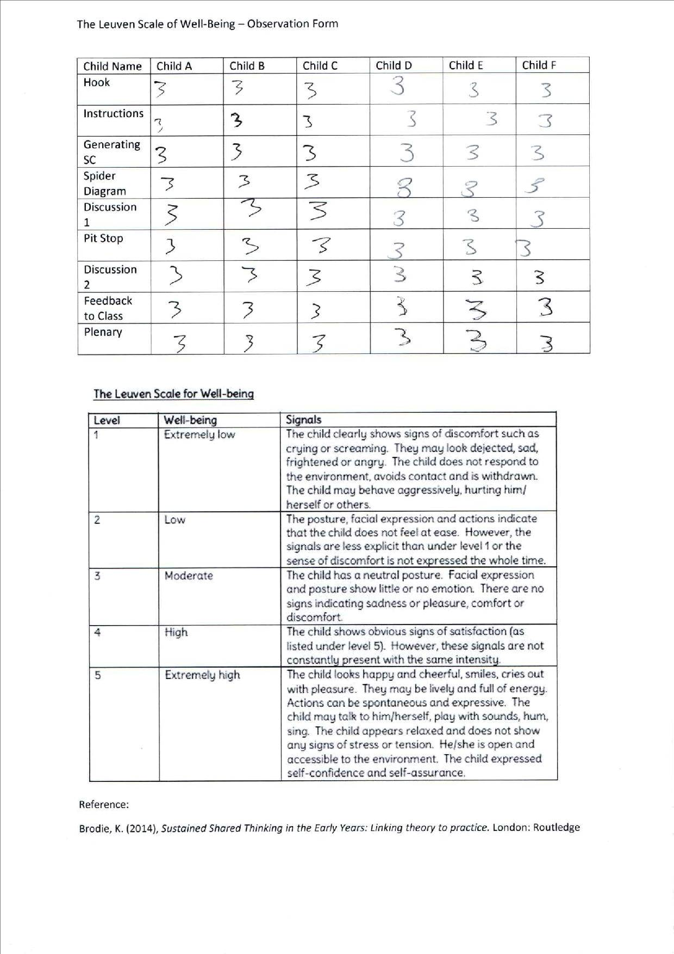

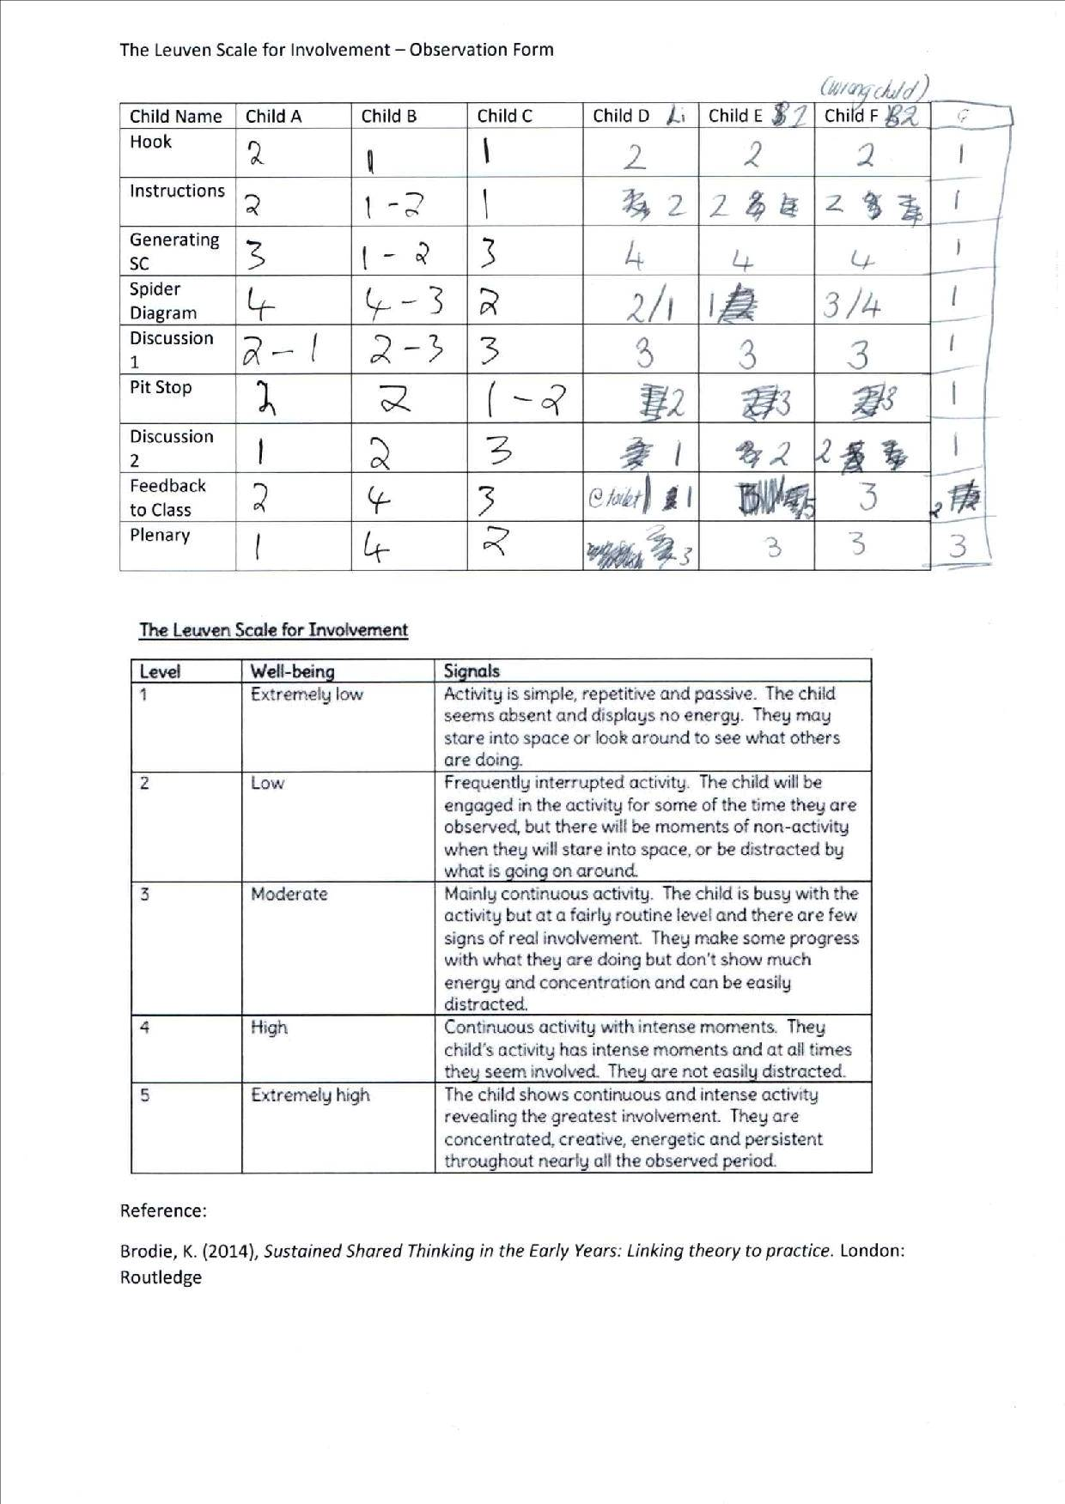
Appendix 4 – Involvement Scale
n.b – The observations for child F is the wrong child, please refer to child G as the results for child F


Appendix 5 – Lesson 1 + focus group notes

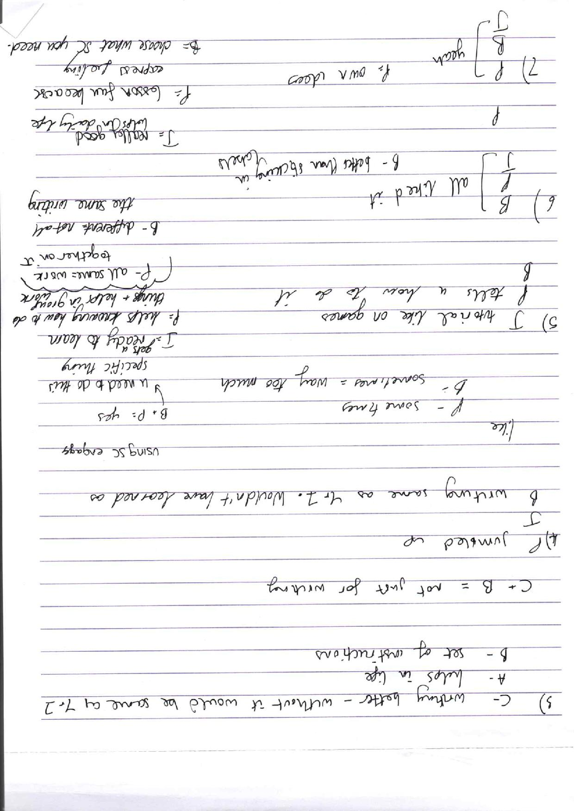

Appendix 6 – Lesson 2 notes
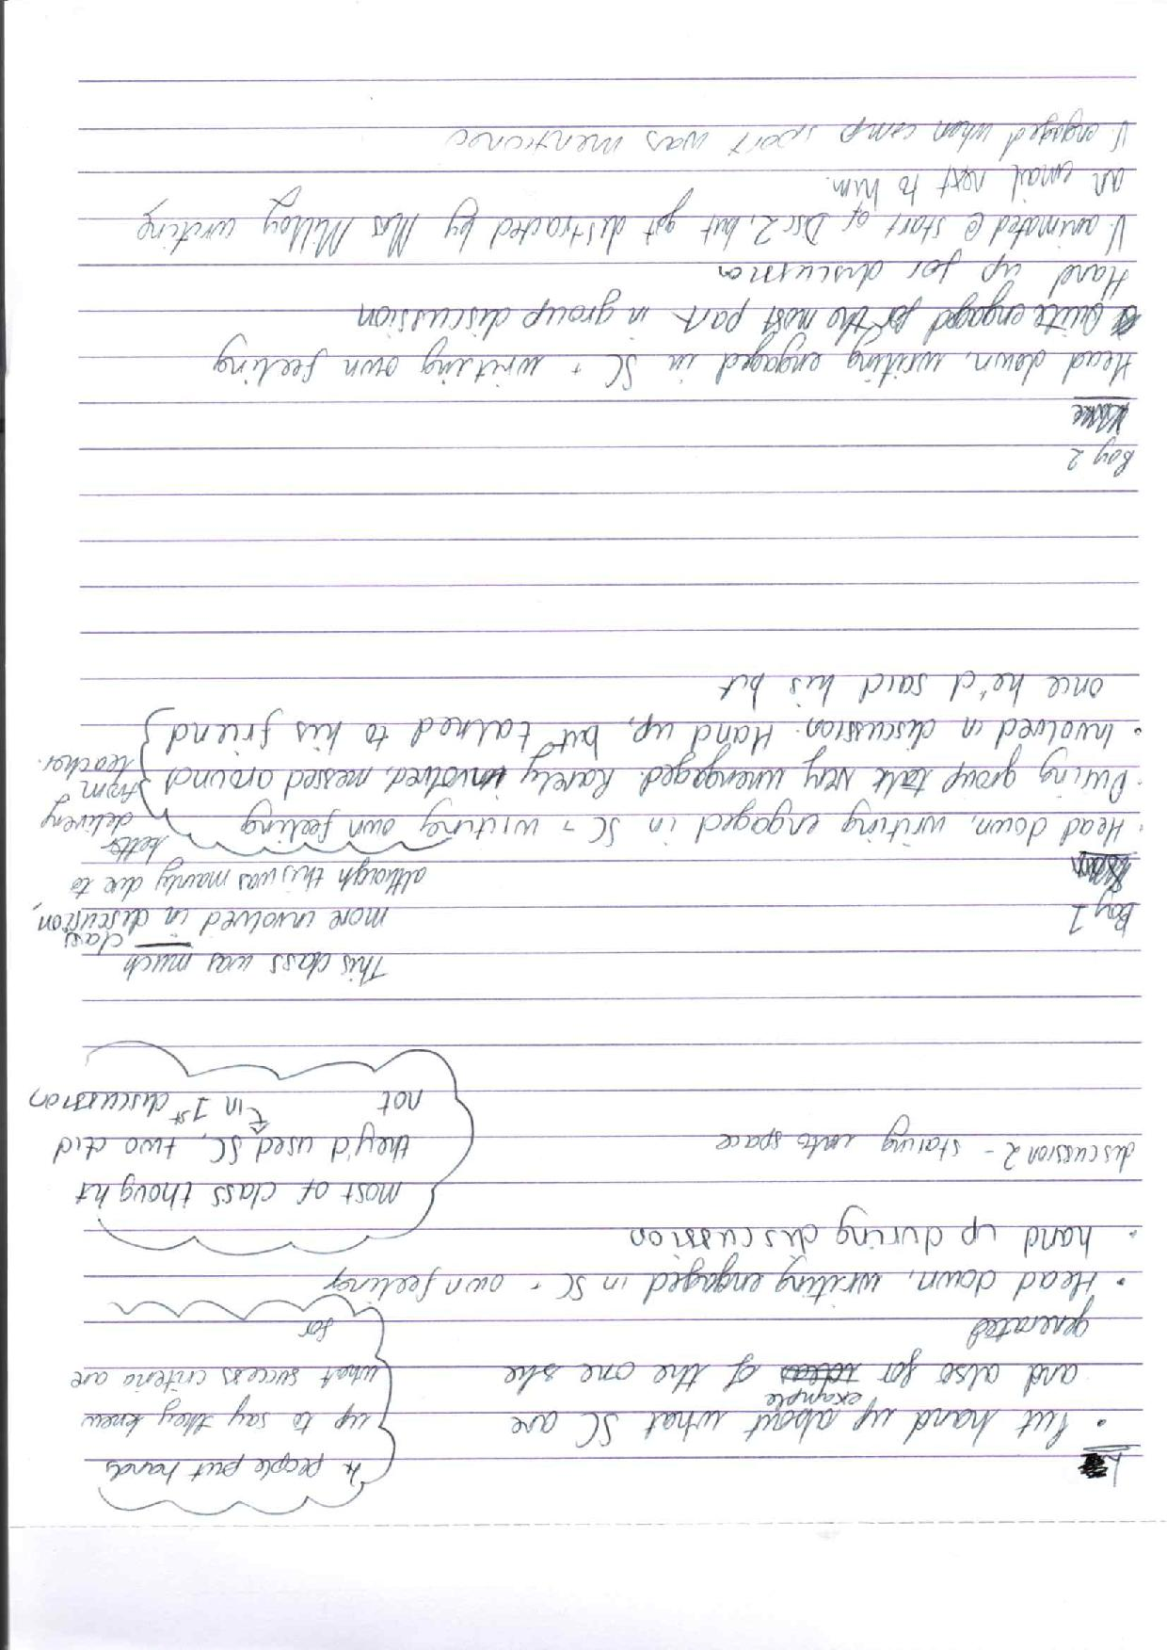



Appendix 7 – Observation Schedule
Observation Schedule:
27th March 2018

9.30am - 10.30am - Lesson One – Alyssa Parr – Year 6 – Observations

10.30am – 10.45am – Focus Interview – Alyssa Parr – Year 6 – 3 Children

10.45am – 12.50pm – Discussion of data and collation of data

1pm – 2pm – Lesson Two – Nicole White – Year 6 – Observations

2pm – 2.15pm – Focus Interview – Nicole White – Year 6 – 3 Children

2.15pm – 3.20pm – Discussion of data and collation of data.

