UNIVERSITY OF WALES TRINITY ST. DAVID
CertHE Skills for the Workplace Problem Solving and Decision-Making Task 1 (Role Play)
Lecturer: Nadeem Mirza.

Oksana Mrsic (2131895)
Term 3 Group 2 (weekend)

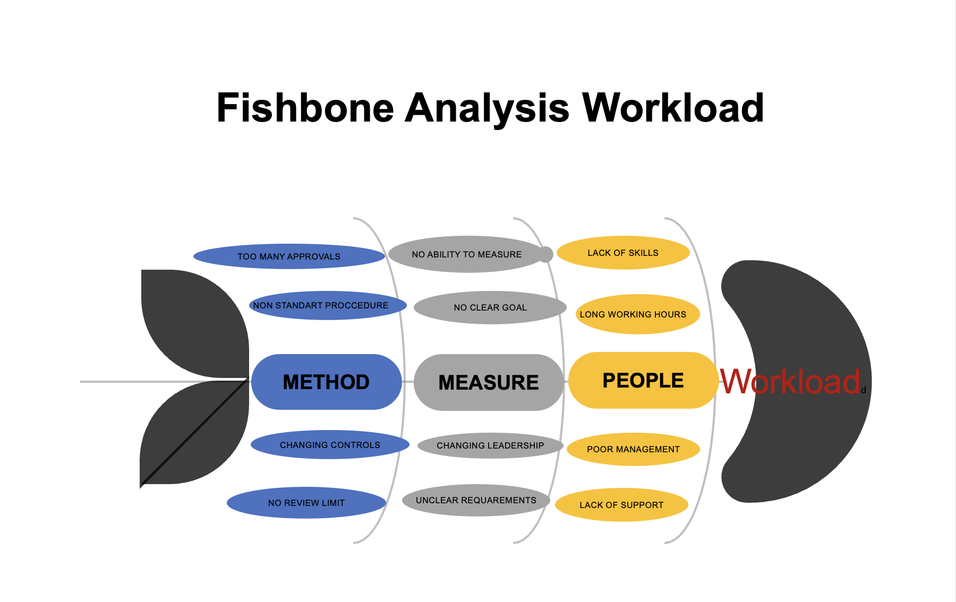

ROLE PLAY PROBLEM SOLVING

Hi Bernard, it’s nice to see you again for our follow-up meeting. In our last conversation, you mentioned that you didn’t feel very happy with working hours. You mentioned you must stay longer every day than you normally have in your shift. As promised, I have done a full evaluation of your work and hopefully have found some clear answers for you, as well as options and ideas on how we can turn this around and help you feel good at your workplace. If you don’t mind, I have a few more questions for you, and then we can hopefully together come up with a good action plan to resolve this in a way that benefits you and the company.
EQ1. Has anything changed since our last meeting regarding extended working hours?
Answer: Unfortunately, no, this issue is still happening on regular bases and I’m really not happy about it.
EQ2. Did you mention this to your superiors?
Answer: Yes, I have tried to point this out, but I was not taken seriously.
EQ3. Did your manager try to help you with this issue?
Answer: Unfortunately, no it seems that this issue is not the priority for them.
EQ4: Do you feel that this has affected your work performance?
Answer: Definitely, I starting to feel very unhappy at work and dread the end of the day, sometimes I feel like not even coming to work.
EQ5. In your opinion, what would be the best course of action to resolve this issue?
Answer: I’m not sure but extra time to finish jobs at the end of the time will be helpful, also some employees
should be told to put effort to finish their work on time so we can all leave on time.

Thank you for answering my questions. This has given me more insight into the problem you face. I think that we can try to raise this issue with management and have a company meeting where we can try to address this all together because it is affecting the whole company. You feel unhappy and stressed because some other people in the business are not finishing their work on time due to a lack of training and possible time allocation or even laziness.
The issue is that you cannot stay longer at work because you need to collect children from school is understandable and should not happen, especially because you always finish your work on time.

- I will suggest to the management that they change the policy so that everyone stays until everyone is finished and allow people to leave when they are finished on time.
- Another option will be to change the working hours, if possible, and leave one hour earlier so you do not get late to collect your children.
- One more option is to ask management to allow more time for finishing tasks at the end of the day to give people time to finish up on time.

I hope we will find a solution with our managerial team for you and for the company. I will pass on all this information, and they will get back to you as soon as they reach their decision. Is there anything you would like me to ask?

Thank you very much for coming today and have a wonderful day ahead.

