Date: 13th May 2018.
Name: Janice Barton.

Course: GLCSH Glass: Contemporary Practice.

Student number: 1702622.

Programme: Contextual Studies.

Module: Ways of Perceiving.

Module code: M4X01559.

Name of Exhibition: Resilience.

Total word count 1318.

This exhibition is called Resilience.
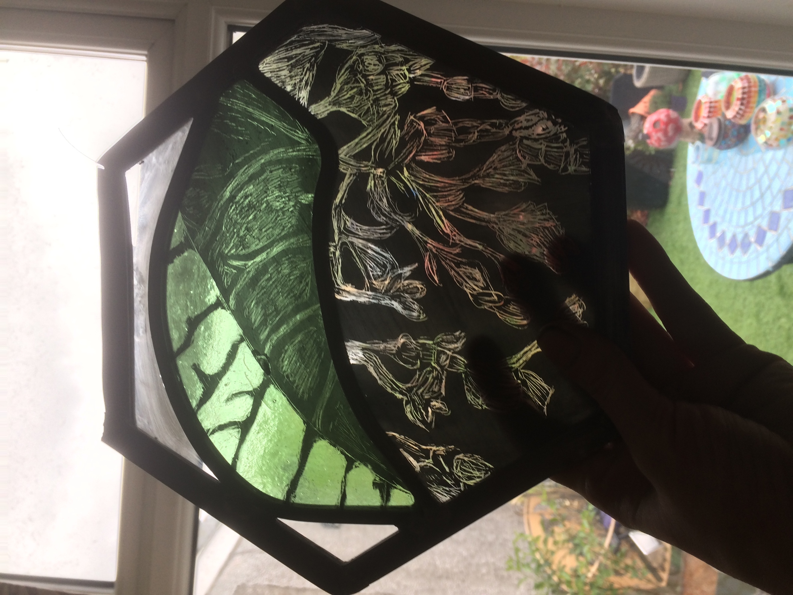
The photograph above is the author’s “baby” glass art sample called Resilience, it was inspired by a Japanese knotweed which is a highly resilient weed, Child and Wade (2000). It is a hexagon because it is one of the strongest and waste efficient shapes. Bees build their honey cells in a hexagon shape for that reason ( https://www.hereva.com/honeycomb-efficient-shape-nature/).
This exhibition will be a work of glass art called Resilience which will celebrate the history of the Craig -Y- Nos Castle and will be installed at the Patti Pavilion in Swansea. It will tell the story of Craig-Y-Nos Castle, incapsulating the happy and distressing times that the building witnessed. ‘There is often a tendency in collective remembrance to romanticise the past and to moderate its dark side. We have observed that the more reunions that have taken place between ex-patients and between ex-patients and staff, the more moderated these memories have become. Importantly, some of the anger clearly present in early conversations has been de- fused by the process of working through shared memories’. Shaw and Reeves. (2009; 8). My aim is therefore to create a piece of glass art which would be enjoyed by those living and visiting Swansea and to tell the spectators its story of resilience.
Resilience is defined by Nelson Mandela as “The greatest glory in living lies not in never falling, but in rising every time we fall.” Guffey and Seefer (2011;265)
The artists who will collaborate to produce this glass piece will be as follows:
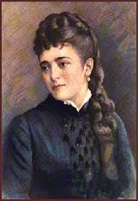
Adelina Patti was a world famous opera singer who built Craig -Y -Nos into the Castle that it is today. She was described as the second most celebrated woman after Queen Victoria. http://www.craigynoscastle.com/adelina_patti.html.
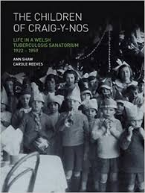
Children of Craig- Y- Nos, survivors who spent years in isolation and confinement away from their families.


Professor Michael Rutter, described as the father of Child Psychiatry. His life time work changed the child welfare profession relating to how children and families are assessed and helped through experiences of stress and trauma.
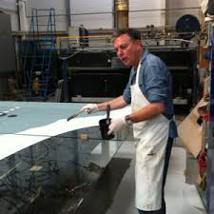
Martin Donlin, glass artist, well known for his symbolism and storytelling in his work.

Adelina Patti (1843-1919) was born into poverty in Madrid, her father was Sicilian and her mother was Italian. She became a world famous opera singer who predominately performed for royalty and the aristocrats. She lived at Craig- Y-Nos, (the rock of the night) from 1887 until 1919, Rogers (2017).
During one of her world tours she visited Ystradgynlais in Wales and fell in love with the area so relocated. According to Rogers (2017) she was a shrewd business woman, who was kind and considerate to her employees and local community. Adelina was viewed as valuing loyalty very highly. For example, if any of her employees were ill she would settle the doctor’s bill. However she there were times when she behaved like a diva either calling people ‘devils or darlings’. Indeed, the county of Swansea held her in such high regard, they gave her the prestigious honour of having the freedom of the cities Brecon and Swansea. Adelina donated her winter garden (glass conservatory) to the County of Swansea in 1918. That building was moved from Craig-Y-Nos Castle to the town of Swansea and was named the Patti Pavillion. Following her death in 1919, her husband sold Craig -Y- Nos to the Welsh National Memorial Trust.
From 1922 until 1959 Craig-Y-Nos became a sanitorium for children suffering from tuberculosis. Reeves and Shaw (2009;9) poignantly incapsulate the children’s experiences as ‘Considering what we now know about the psychological effects of stigmatisation, separation and life-threatening illness, the Children of Craig-Y-Nos could be a story of destruction or defeat but, indeed, it is one of courage and survival. Despite years of illness and lost education and given the limited career opportunities in Wales at the time, many went on to achieve success as doctors, nurses, teachers, writers, journalists, artists, college lecturers, accountants and secretaries. Millionaires, mayors, a hospital administrator, a theatre director and an international rugby player emerged from the plaster cast, the collapsed lung and the confinement of Craig-Y-Nos Castle’. The authors discuss Professor Rutter in their book.
Professor Michael Rutter has had a powerful influence on the author of this text professionally and personally. To practice in any profession, one has to consistently reflect and challenge one’s own work. Professor Rutter courageously challenged the work of the widely acclaimed psychiatrist John Bowlby who asserted a child’s most important relationship was with his/her mother. When presented with Professor Rutter’s research which evidenced that other relationships, for example, father, grandparent were just as important to a child, Bowlby changed his view and agreed with Professor Rutter’s findings.
Professor Rutter was inspired by his mentor Psychiatrist Aubrey Lewis who saw his (Rutter’s) huge potential. Professor Rutter spoke about Aubrey Lewis in a most poignant way in an interview ‘people have got to be bright but I take the awkward ones people won’t have [reference to Aubrey Lewis]. He wanted people who would challenge the wisdom of the moment and have the skills and creativity to do so in a way that would be productive [Professor Rutter]’. Interview with Professor Rutter (2016). https://www.youtube.com/watch?v=d6xz0v3KVjU&t=2414s.
Martin Donlin glass artist is well known for his large scale glass art internationally. At the heart of his work is his ability to put words into visual form, his story telling and his abilty to be sympathetic to the architecture of the building and social space (Knapp, A 1998; 55). Donlin’s use of images are more powerful than words, ‘Literal words often fail to convey the full qualitative and energetic aspects of an experience, whereas the image capture the specific intensities, urgencies, rushes, surges, ebbs and flows, the ‘atmosphere’ of a particular moment or situation’. Sunderland, M (2008;10)
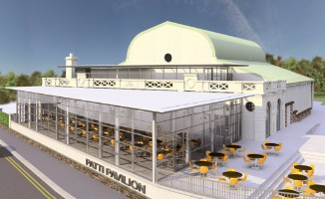
The space for this exhibition is the Patti Pavilion where the glass art will be installed. Currently the main view overlooks a car park, a bus stop and a busy main road which is not the best view when dining out. The glass art would replace the ugly view and hopefully generate discussion about the beautiful design and its relevance to Wales’ social history. Paul Allen (2014;16) opines my vision so eloquently. ‘….There is a belief that ‘The Arts’ can do something that science, politics, academia, media and other disciplines simply cannot. Art has the power to create space for dialogue, art can communicate information which might otherwise be alienating to people, art can bring communities together and make difficult things understandable, and art can inspire people with visions of a sustainable future: in short, art can transform. …’
This work of art and people I have chosen for this exhibition have all shown great resilience in their respective professions. They have exposed their work to the world, thus making themselves vulnerable to critics. Brown (2017) explains that vulnerability is exposure with accurate measures of courage; courage is therefore underpinned by vulnerability. One’s ability to become resilient is therefore dependent upon one’s ability to be vulnerable, which can seem like a paradox but it is explained passionately by Theodore Roosevelt.
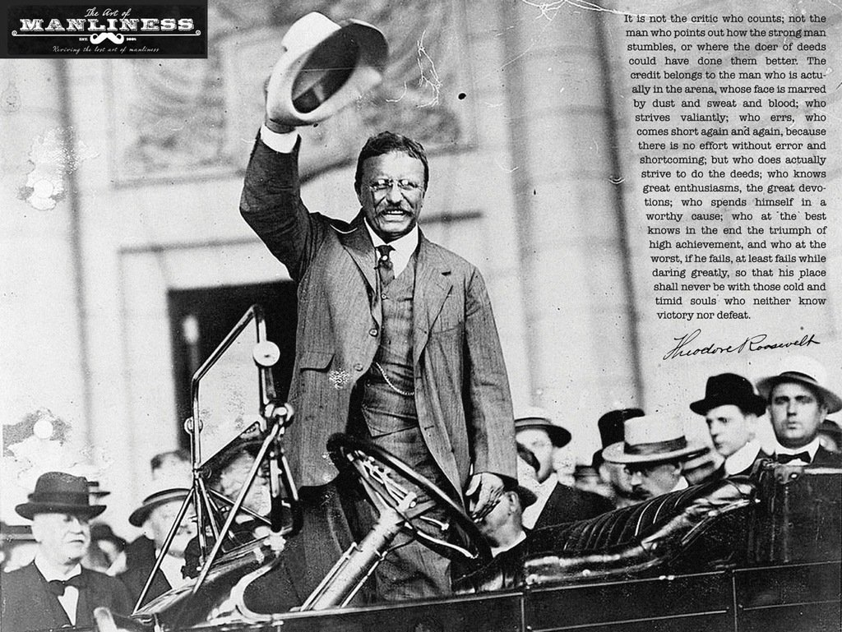
Theodore Roosevelt’s speech about the man in the arena is also applicable to the artists in this exhibition. By bringing together people from different professions with different life experiences and all having the same ambition to create a spectacular work of glass art will be a unique experience for them all. They will all have their life stories immortalised in a glass work.
The natural properties of glass will mean that the glass piece will constantly change in colour, reflection and refraction. This is perhaps a true reflection of life and nature where change is a constant. Part of the human condition is often one of trying to control, however developing resilience is dependent upon one’s ability to adapt and change to external influences. That is perhaps the why the Japanese knotweed survives, despite scientists trying their best to eradicate it; the weed simply adapts and changes to its external environment.

Bibliography

Allen, P (2014; 16). Culture Shift. How do artists responding to Sustainability in Wales.

Becker, C. (1994) The Subversive Imagination. Artists, Society and Social Responsibility. New York. Routledge.

Brown, B. (2017;161) Braving the Wilderness. London. Penguin Random House.

Child, E and Wade, P (2000) The Japanese Knotweed Manual: The Management and Control of an Invasive Alien Weed (Fallopia japonica). UK: Packard Publishing Ltd

Frailberg, S. (1997) The magic years. UK: Prentice Hall & IBD.

Garmezy, Norman. and Rutter, Michael. (1988) Stress, coping, and development in children. Baltimore, Md. Johns Hopkins University Press.

Guffey, E and Seefer, C (2011: 257) Business English. USA. Cengage Learning.

Jackson, K. (2015) Beyond Talk- Creative Art Therapies in Social Work. Social Work Today, Volume 15, page 22

Knapp, K. (1998:55) The Art of Glass. Gloucester, Mass. Rockport Publishers.

Melton, G. (2016: 263) Love Warrior. United States. Fiatiron Books.

Potok, P. (1993). I Never Saw Another Butterfly. Children’s Drawings and Poems From Terezin Concentration Camp, 1942-1944. New York. Schocken Books.

Reeves, C. Shaw, A (2009) The Children of Craig-Y-Nos. Wales. Welcome Trust Centre for the History of Medicine.

Rutter, M. (1972) Maternal Deprivation Reassessed. London. Penguin Books.

Rutter, M. Schopler, E. (1978) Autism. New York. Plenum Press.

Porter, J. (2011) The Glass of Sarah Hall. Germany. Glasmalerei Peter GmbH.

Rogers, Y (2017) Adelina: A Biography of Opera Star Adelina Patti. UK. Book Guild Publishing Ltd

Schneede, U. (1973) Surrealism. New York. Harry. N Abrams,Inc Publishers.

Sharples, M (1999). How we write. London. Routledge.

Sunderland, M. (2008;10) Draw on Your Relationships. London. Speechmark Publishing Ltd.

Taleb, N. (2010). The Black Swan- The Impact of the Highly Improbable. London. Penguin Groups.

Tizaed, B. Varma, V (1992) Vulnerability and Resilience in Human Development. London. Jessica Kingsley Publishers.

Thomsen, B. (2003;11) The Man in the Arena. New York: Forge.

Websites

http://www.craigynoscastle.com/history.htm accessed on 19/03/2018

http://www.craigynoscastle.com/adelina_patti.html Accessed 01/05/2018.

https://www.youtube.com/watch?v=d6xz0v3KVjU&t=2414s accessed 07/04/2018

https://www.hereva.com/honeycomb-efficient-shape-nature/ accessed on 14/04/2018

