Rolling It!

INTENDED PLATFORMS | The target platform for the game currently is Windows. This is because it will be efficient to develop it when compared to the modern-day consoles (PS4, Xbox and Nintendo Switch). A port of the game to consoles could be possible as the game is not resource heavy and has the option to use a traditional controller alongside the keyboard option.

TARGET AGE / DEMOGRAPHIC OF PLAYERS
The ideal customer is the casual player who does not have much time to play longer games due to outside commitments. The game can be picked up and played easily due to its simplicity.

Alternatively, the game could also interest a younger player base too not only due to its easy to pick up-and-play design, but also the game itself is a child friendly experience.

INTENDED PEGI / ESRB RATING
Having looked at the Pan European Game Information (PEGI), the game will feature a childlike setting but will also feature non-realistic violence. This game will be categorised within the PEGI 7 label [1]. Similarly, if the Entertainment Software Rating Board (ESRB) were to rate the game, the ideal label for the software would be the E10+ rating as that would be the closest rating compared to PEGI’s 7 category [2].

CONTRIBUTING TEAM MEMBER: | Calum Case

SECTION 2: GAME OUTLINE

GAME STORY SUMMARY
The story takes place in a world filled with creativity. Creativity is what drives all the many creatures in this world, but one day an evil force has stripped that creativity away from everyone. It is your job to find that creativity spark and bring it back to the creatures on in the world.

You are the only one left with a creative spark and you must traverse many different areas and landscapes to help a variety of creatures find their creative spark back and turn the world back to the way it was before. For example, one area is a snowy tundra filled with mountains with the locals being small floating ghosts that have lost the desire to be creative, you must work with them to return that drive by completing various stages in the snowy tundra area.

Each area of the game will climax with a boss fight that will be somewhat themed around the area that they appear in, for example a desert area has a scorpion boss as scorpions are often seen in dry areas [3].

GAME FLOW
Rolling it is a 3D puzzle action game that takes your custom roller character through many landscapes around the world meeting many types of creatures along the way. Your roller character is on this adventure because an evil force has taken away everyone’s creativity and has left the world in a gloomy and dull state. It is your job to return the world back to normality and get everyone’s creative spark back!

CONTRIBUTING TEAM MEMBER: | Calum Case

SECTION 3: MAIN CHARACTER(S)
& PLAYER CONTROLS

CHARACTER APPEARANCE
Main Character:
The main character is designed to be a happy a brave looking character that can also be customised with cosmetics (similar the Little Big Planet’s Sackboy as seen below). It will feature similar design choices to Sackboy (details like the zip on the body), but the character will look rounder to fit the game’s theme and the name (like round look that Kirby has). The main character had the ability to stand out from the word due to the customisation that will be available as you progress through the different worlds featured in the game. As mentioned by Scott Rogers, the character’s personality will be distinct from a glace giving off happy energy due how they look and how they act [4].

(1)

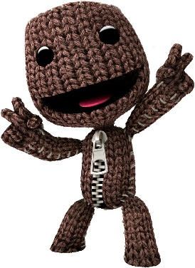
(2)
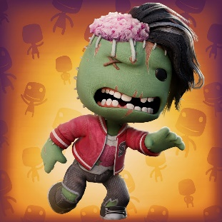
(3)


NPC (Seen in the games Snowy area)
The snow area features small ghosts that will wonder the area giving the player tips on how to progress through the snow area part of the game as they are the local NPCs. Some of the NPCs will be holding small lights, the ghosts that hold slights will help the player solve certain puzzles. For example, the ghosts with the lights being held will be floating above the hole in the stage letting the player know that there is a hazard ahead of them.



Candle will float with small movement

NPC (seen in a garden themed area)
The garden area is based on big garden that feature gnomes as the local creatures that help you the player through the stages. There are many different gnomes featured in this area such as male and female variants that look like stereotypical gnomes. There are also some gnomes that are broken and smashed that are treated like outcasts due to how they look, this was decided to give some variety to the garden section of the game and giving some gnomes some personality.

(4)
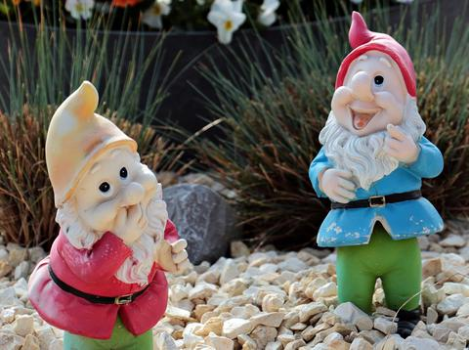
(5)
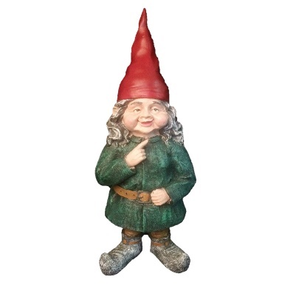

(6)
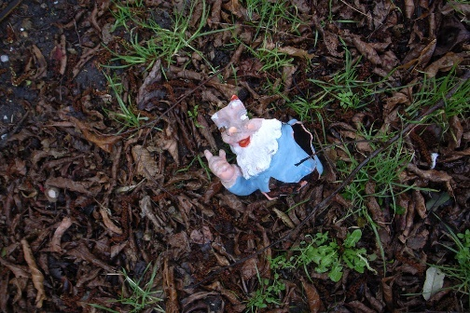
(7)
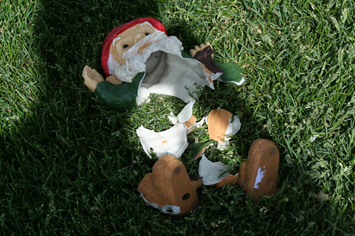

CHARACTER DOSSIER / DETAILS (Add/adjust categories as appropriate)
NAME: | King Gome
GENDER: | Male
SPECIES: | Gnome
AGE: | ??
FACTION: | Gnome
KNOWN ASSOCIATES: | Gnomes, Queen Gnomette

CHARACTER’S BACKSTORY
King Gnome is a relaxed elder gnome that looks over the other gnomes to make sure everything is at peace in the gardens. The King Gnome will only act as a NPC but it’s one of the two important NPCs found in the gardens stage. They relate to the gameplay by giving the character some back story to the local area.

*Main character backstory mentioned above

CHARACTER CONTROLS / PLAYER CONTROLS
Keyboard Control Map:

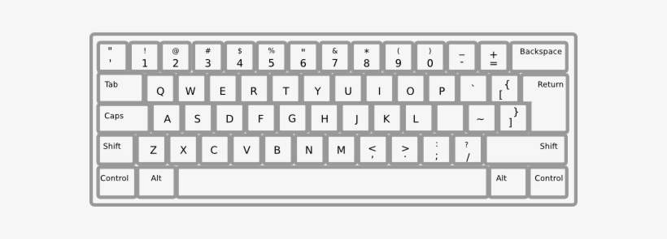

W – Move forward
A - Move left
S- Move backwards
D- Move right

Move around the mouse the control the camera
Mouse left click to navigate menus and click in menus
Return (aka Enter) to pause the game

Controller Map:

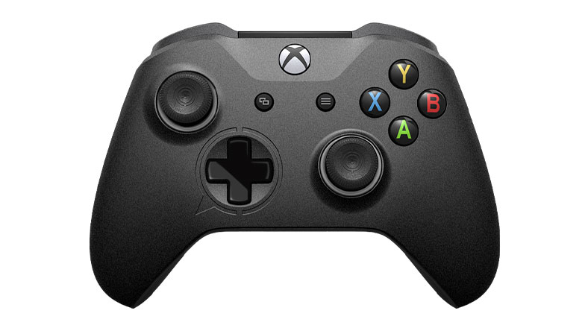

Left stick – move in all directions in game / navigate menus
Start – Pause the game
A – Proceed in menus
B – Back out of menus

CONTRIBUTING TEAM MEMBER: | Calum Case

SECTION 4: GAMEPLAY

SEQUENCE OF PLAY
The game will feature one big story that will have the player exploring many themed areas before the story finishes. There will be 5 unique worlds that the player must play through. The Garden, The desert, The City, Snowy Tundra and the Power Plant. Each world having unique set pieces that make them stand out from eachother, for example. The snowy tundra will feature a big mountain that as you progress though the snowy tundra world the higher will progress up the mountain, the final stage will take place at the top of the mountain.

Once the story is complete, there is almost endless possibilities as the player will be able to create their own stages and upload them online for others to play. The more you progress in the story the more options you will unlock to make your custom stages a lot better. For example, once you finish all the stages that are in the Garden world, you will unlock set pieces seen from that world and will get smaller and minor objects to use in your custom stages.
UNIQUE SELLING POINTS (USPs)
-Charming cast of characters
-Creative concept
-The ability to create and upload your custom-built stages online
-Endless replay ability
-Customize your character
-A mix of challenge and fun

CONTRIBUTING TEAM MEMBER: | Calum Case

SECTION 5: GAME WORLD

GAME WORLD
(Present images and descriptions of the game world here, with short descriptions that outline what the player will find in the environments they are placed in. How do these locations fit into the story?)

World 1: The Gardens
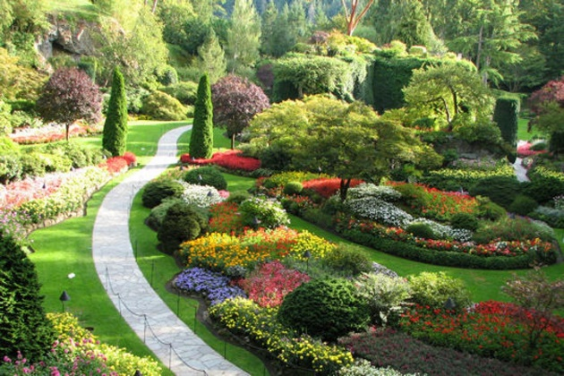
The gardens will be the first world you play in the game and will serve as a more of a tutorial world rather than an actual world with somewhat difficult challenges. The Gnomes will be found in this area.

World 2: The Desert

The desert is the second world in the game and will be the first world to not feature any tutorials. This will be the point of the game where you will start to work by yourself with no help from the game. This world will feature many creatures that live naturally in deserts/ dry areas such as scorpions, camels and birds of prey.

World 3: The City

The city is the third world in the game and will serve as the spiritual halfway point of the game. This world will feature city themed stages and will feature animals that are often seen in big cities such as Rats and pigeons.

World 4: Snowy Tundra

The fourth world in the game is a snowy tundra that has the player start at the bottom of a big snowy hill and will have to scale the mountain throughout the world eventually climaxing with the final stage at the top of the mountain.

World 5: Power Plant
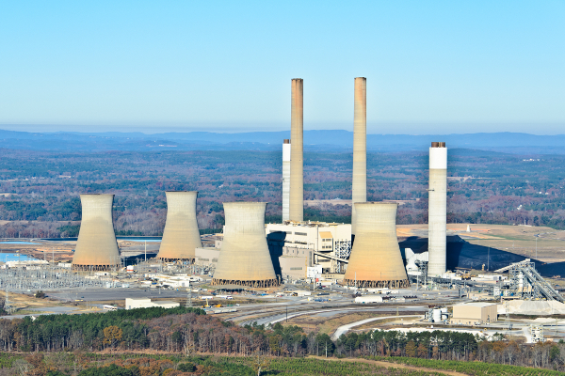
The power plant is the final world in the game and is where the story will finish as you put a stop to the evil power plant that is the cause of the world’s troubles. This will feature the most challenging stages in the game to put the player to the test to see if they can tackle the final world in the game.

LOCATION DETAILS
NAME: | The Gardens
WHAT DOES IT LOOK LIKE? | A rich garden large garden that features many different flowers and plants. Gnomes will also house the area as they are most often seen in the Gardens.
WHAT MOOD IS BEING INVOKED IN THIS LOCATION? | - Happy  - Confident  - Excited
WHAT KIND OF MUSIC WILL BE USED FOR THIS LOCATION? | - Relaxed  - Calm  - Enthusiastic
HOW ARE THE LOCATIONS CONNECTED IN THE GAME WORLD? | Linier progression through the story (Once you finish the Gardens world you will then move on to the second world ect.)

LOCATION DETAILS
NAME: | The Desert
WHAT DOES IT LOOK LIKE? | A large bare bone Desert with a few distinct set pieces such as tumbleweeds and cactus.
WHAT MOOD IS BEING INVOKED IN THIS LOCATION? | - Wonder  - Confused  - Warm feeling
WHAT KIND OF MUSIC WILL BE USED FOR THIS LOCATION? | - Fun  - Wacky  - Strange

LOCATION DETAILS
NAME: | The City
WHAT DOES IT LOOK LIKE? | A fast city with skyscrapers overlooking the world. Cars can be seen to give the city some life as they move around the roads.
WHAT MOOD IS BEING INVOKED IN THIS LOCATION? | - Claustrophobic  - Busy  - Overwhelmed  - Stressed
WHAT KIND OF MUSIC WILL BE USED FOR THIS LOCATION? | - Busy  - Noisy  - Loud

LOCATION DETAILS
NAME: | The Snowy Tundra
WHAT DOES IT LOOK LIKE? | You start off in a snowy area that is eclipsed by a mountain that you will have to climb up to progress through the story.
WHAT MOOD IS BEING INVOKED IN THIS LOCATION? | - Cold  - Mystery  - Spooky
WHAT KIND OF MUSIC WILL BE USED FOR THIS LOCATION? | - Quiet  - Soft  - Slow  - Relaxing  - Creepy

LOCATION DETAILS
NAME: | The Power Plant
WHAT DOES IT LOOK LIKE? | A big power plant, the air almost looks toxic as there is mysterious smoke coming from the power plant.
WHAT MOOD IS BEING INVOKED IN THIS LOCATION? | - Confusion  - Excitement  - Eger to progress
WHAT KIND OF MUSIC WILL BE USED FOR THIS LOCATION? | - Antagonistic  - Fast  - Exciting

GAME FLOW
Below is a flow chart to show how story progression is held.
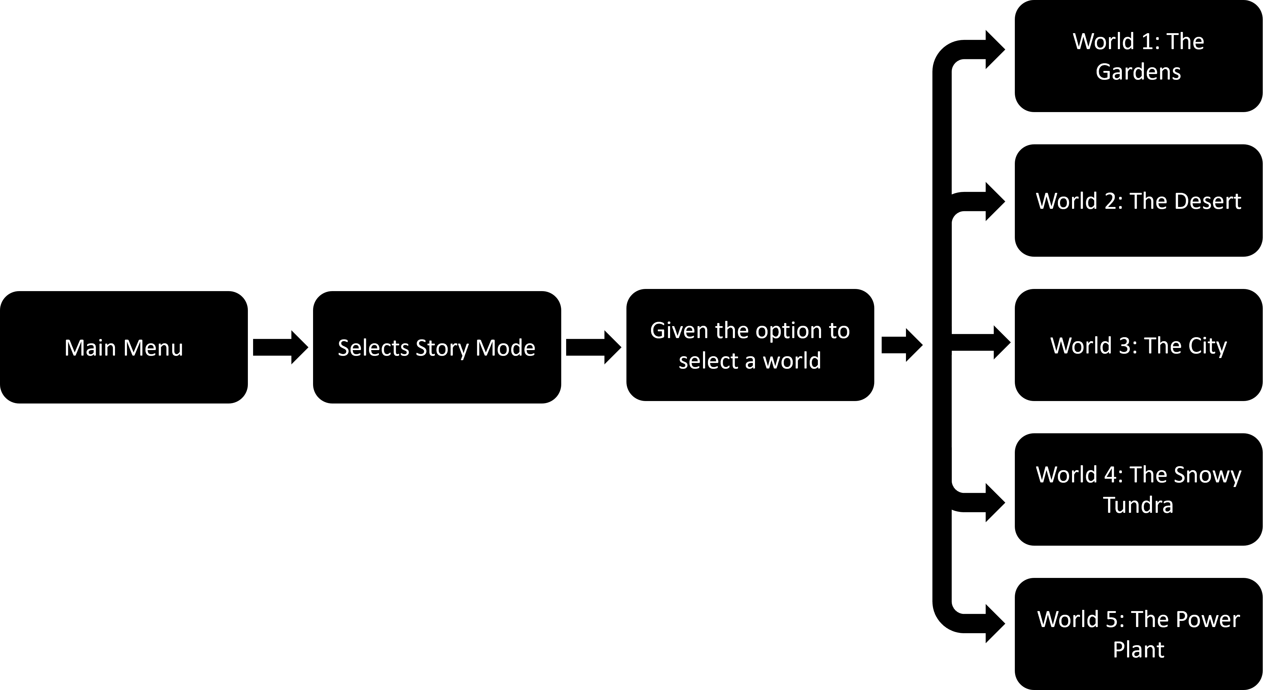

SECTION 6: GAME EXPERIENCE

GAME EXPERIENCE
-Charming
-Cartoonish
-Family Friendly

HOW IS THIS FEELING GOING TO BE PRESENTED TO THE PLAYER?
- Cartoon-like graphics
- The story will be suited for players of all ages
- Family Friendly story writing
- The game isn’t too serious
- Interesting stages and worlds to explore
- Creative ways to beat puzzles by using the environment around you

ARE THERE ANY SPECIAL MODES OR INTERFACES FOR GAMEPLAY?
As you progress through the game you will unlock cosmetics for your custom character as well as unlock set pieces and object for use in the custom stages.

WHAT DOES THE PLAYER FIRST SEE WHEN THEY START THE GAME?
Title Screen:

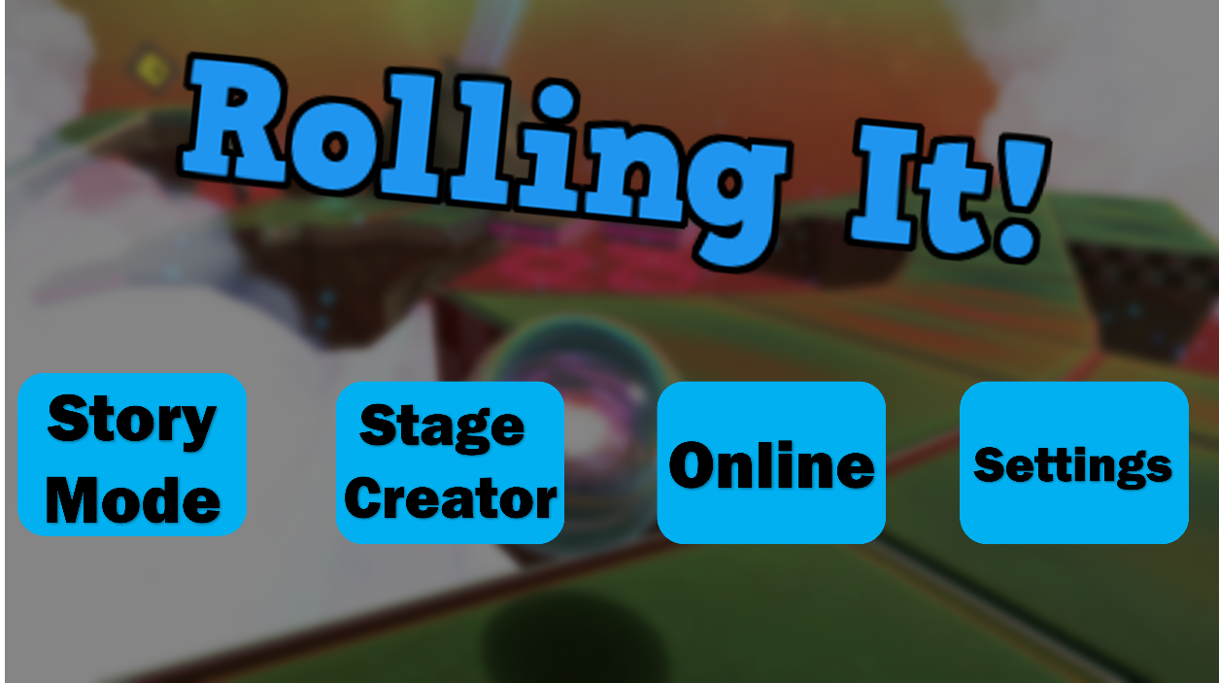

WHAT EMOTIONS ARE MEANT TO BE INVOKED BY THE GAME?
- Happy
- Creative
- Motivated
- Inspired

HOW ARE MUSIC AND SOUND GOING TO BE USED?
For each world in the game, there is only one music track per world, but the song can differ the more you progress through the world. The more you play, the more instruments that will kick into the song giving the original version of the song a complete face lift. This can be seen in LittleBigPlanet’s story mode known as “Interactive Music”. This is the type of music that would fit this game too for its different worlds. Below is an example of where interactive music is used in LittleBigPlanet: https://youtu.be/7v2FmaLNJOU

Each world should sound different and unique from one another. For example, the snowy Tundra will feature a more Russian themed instruments and music while the city will feature music fitting of a big city.

HOW DOES THE PLAYER NAVIGATE THE SHELL MENUS/ SCREENS OF THE GAME?
Here is a flow chart diagram showing how the menus are navigated in the game:
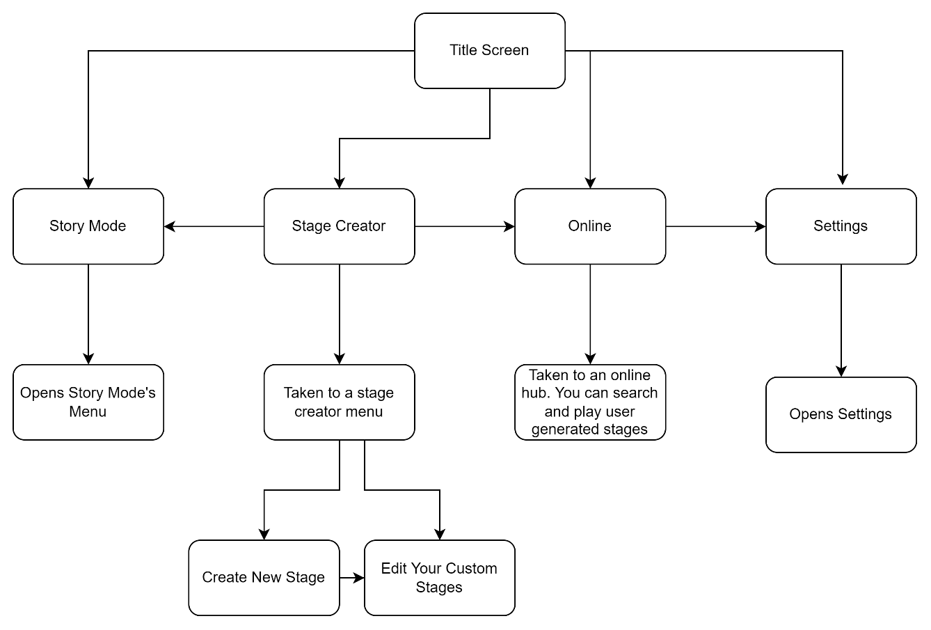

CONTRIBUTING TEAM MEMBER: | Calum Case

SECTION 7: GAMEPLAY MECHANICS

MECHANIC DETAILS
NAME: | Boost Panels
WHAT DOES IT LOOK LIKE? | A panel on the floor of the stage and has red arrows signalling that you get a boost in the direction of the arrows.
EFFECT ON PLAYER: | The boost panel will give the player a speed boost making them fast for a moment.
WHEN WILL IT FEATURE IN THE GAME? | This be featured sporadically throughout the game as some stages will feature a boost panel and some will not.

HAZARD DETAILS
NAME: | Bumper
WHAT DOES IT LOOK LIKE? | The bumper in the game will look like the bumpers commonly seen in the pinball machines.
EFFECT ON PLAYER: | If the player was to hit a bumper, it will then make the player bounce off making them hard to control for a moment.
WHEN WILL IT FEATURE IN THE GAME? | Similarly, to the boost panel, it will be featured at random throughout the game as some stages will feature bumpers while others will not.

POWER-UP DETAILS
NAME: | Balloon
WHAT DOES IT LOOK LIKE? | A red balloon that will be attached to the player.
EFFECT ON PLAYER: | The balloon will only appear when the player is struggling to clear a stage, once you a failed a stage 5 times a balloon will appear giving the player an option for an easier version of the stage.
WHEN WILL IT FEATURE IN THE GAME? | When the player is continuously fails a stage the balloon will appear giving the player an easy mode.

COLLECTIBLE ITEMS
The game will feature a vast variety of collectibles.

Firstly, the game will offer collectibles that are cosmetics that the player can then use to customise their character to their liking. Things like hats, glasses, colour options, face expressions, speed trails, voices are a few examples of what can be collected from the player.

There will also be collectible that will please the players who want to create their own custom stages as throughout the story mode, there will be collectibles that you can collect that will give you objects that you can use for custom stages. For example, you could place down set pieces that are seen in the story mode in your custom stage once you’ve finished said stage in story mode ( a good example being if you finish a stage in the desert you would unlock a cactus object that you can then use in your custom stage.

SECTION 8: ENEMIES

LIST OF ENEMIES
The game will feature enemies that will challenge the player and interfere during certain stages. Some will have a minor impact while others will have a bigger impact. Each world will have their own unique set of enemies that will challenge the player.

ENEMY DETAILS
NAME: | Bugs
WHAT DOES IT LOOK LIKE? | A group of bugs that will appear different from eachother (ants, flies)
ATTACKS: | They will try to eliminate the player by getting in their way making the player think of how to avoid them during the stage.
WHEN WILL IT FEATURE IN THE GAME? | The bugs are seen in the game’s first world, the Garden.
HOW DOES THE PLAYER DEFEAT IT? | The player will have to try and avoid them during gameplay as hitting them will damage the player resulting in death.
WHAT DOES THE PLAYER EARN FOR DEFEATING THEM? | N/A

ENEMY DETAILS
NAME: | Rats
WHAT DOES IT LOOK LIKE? | Common rats that can appear in different sizes
ATTACKS: | They will try to grab the player during the stage and try to throw them off the stage.
WHEN WILL IT FEATURE IN THE GAME? | The rats are seen in the city world.
HOW DOES THE PLAYER DEFEAT IT? | The player will have to try and avoid them during gameplay as hitting them will damage the player resulting in death.
WHAT DOES THE PLAYER EARN FOR DEFEATING THEM? | N/A

LIST OF BOSS CHARACTERS
(provide an overview of more powerful end-of-level/mission/quest enemies here. Further details of each can be provided by using the table below.)

BOSS CHARACTER DETAILS
NAME:
WHAT DOES IT LOOK LIKE?

ATTACKS:

WHEN WILL IT FEATURE IN THE GAME?
HOW DOES THE PLAYER DEFEAT IT?
WHAT DOES THE PLAYER EARN FOR DEFEATING THEM?

(NOTE: Copy-paste the tables in this section as necessary for each enemy / boss you wish to feature.)

SECTION 9: CUTSCENES

CUTSCENES

CUTSCENE DETAILS (use this table for each unique cutscene you include)
VISUAL STYLE: | In-game cutscenes, that are played in in text during important stages.
BRIEF DESCRIPTION OF SCENE: | A flyby overview of each world, with a narrator explaining what the world is and its unique attributes.
WHEN WILL IT FEATURE IN THE GAME? | At the start of each world, you play.
PURPOSE: | These type of cutscenes are meant to show the player what each world looks like before they start playing through it.

CONTRIBUTING TEAM MEMBER: | Calum Case

SECTION 10: BONUS MATERIALS

BONUS MATERIALS
Multiplayer is featured online as you can challenge other players to see who can finish stages the fastest. The fastest player wins!

Downloadable content would be featured that would include things like new cosmetics for your character and level packs that could give you new objects to work with for your custom stages.

REPLAY VALUE
There is a lot of reply value to be had with this game as you could do many things. One thing you could do is finish the story mode that the game has, you could then go online and play user generated content that could in theory be endless. You can also play online with others and challenge for fastest times.

CONTRIBUTING TEAM MEMBER: | Calum Case

Bibliography

[1] | PEGI, "What do labels mean?," PEGI, 201. [Online]. Available: https://pegi.info/what-do-the-labels-mean.
[2] | ESRB, "Ratings Guide," ESRB, [Online]. Available: https://pegi.info/what-do-the-labels-mean.
[3] | San Diego Zoo Wildlife Alliance Animals & Plants, "Scorpion," San Diego Zoo Wildlife Alliance Animals & Plants, [Online]. Available: https://animals.sandiegozoo.org/animals/scorpion.
[4] | S. Rogers, "Level 5 The Three Cs, Part 1-Chracter," in Level up!: the guide to great video game design, West Sussex, Wiley-Blackwell, 2010, p. 84.

Appendix
- Image of Sackboy in his original look:
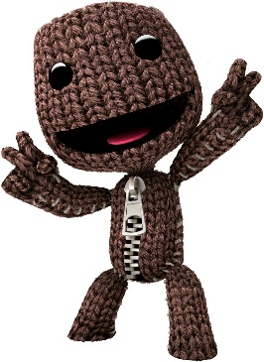
https://littlebigplanet.fandom.com/wiki/Sackboy

- Image of a Sackboy dressed to look like a Zombie:
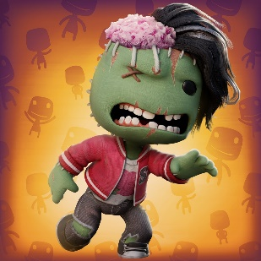
https://store.playstation.com/en-gb/product/EP9000-PPSA01288_00-SABAZOMBIE000001
- Image of Kirby, this image is used to show how the main character would look
https://supersmashbros.fandom.com/wiki/Kirby

- Picture of the male gnomes
https://sunnydazedecor.com/blogs/news/the-complete-history-of-garden-gnomes-why-they-are-wonderful
- Picture of a female gnome

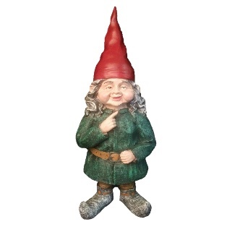

https://www.wayfair.com/outdoor/pdp/homestyles-gnomes-of-toad-hollow-zelda-the-female-garden-statue-w001018729.html

- Picture of a broken gnome
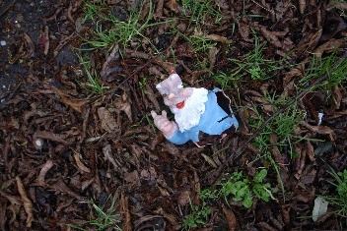
https://www.flickr.com/photos/milov/371643781

- Another picture of a broken gnome
https://www.flickr.com/photos/scottjohnson/494195501

- Picture of a garden
https://distribution.arte.tv/fiche/JARDINS_D_ICI_ET_D_AILLEURS

- Picture of a desert
https://gettingontravel.com/scottsdale-in-spring/

- Picture of a city

https://www.buzzfeed.com/anjalipatel/can-you-make-it-in-the-big-city

- Picture of a snowy tundra
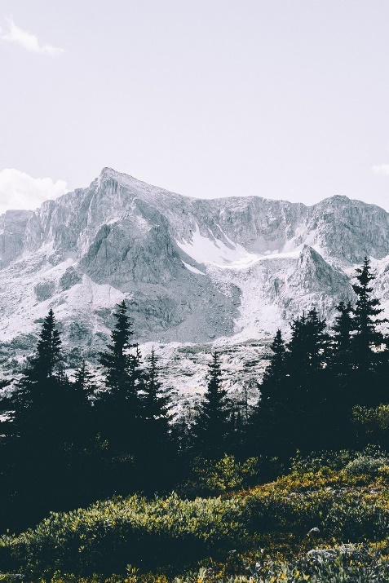
https://unsplash.com/photos/__yDNYiGX-E

- Picture of a power plant
https://www.power-technology.com/features/featurestar-spangled-super-power-the-ten-biggest-power-stations-in-the-us-4303710/

