Practitioners guide

Introduction and overview

It is known that attention-deficit/hyperactivity disorder also known as ADHD is a neurodevelopmental disorder that can have a major influence on an individual in various areas of their life, including their academic and professional abilities. It also affects millions of children and often persists into adulthood and has an impact on the behaviour of individuals. Children with ADHD may appear restless, struggle to concentrate at home or school, and react to distractions. Children with ADHD may suffer with additional concerns, such as sleep and anxiety problems (NHS, 2021). Research has indicated that children who have attention-deficit/hyperactivity disorder (ADHD) may also experience a negative influence on their academic performance if they experience feelings of sleepiness during the day. (Sciberras, 2020). Considering that children with attention-deficit/hyperactivity disorder (ADHD) have difficulties sleeping, enhancing sleep may be able to help improve certain areas of the child's performance. (NHS, 2021). Children who have attention-deficit/hyperactivity disorder (ADHD) sometimes struggle with their poor self-esteem and the challenges they have in their interactions. (Mayo Clinic, 2019). The treatment of attention-deficit/hyperactivity disorder (ADHD) can be carried out through either psychotherapy or medication; however, it is often the combination of the two that proves to be the most successful. A specialist, such as a psychiatrist or paediatrician, usually arranges treatment.

Over the next two years, the number of children in Wales who are waiting for a diagnosis for autism or attention-deficit/hyperactivity disorder might nearly triple to 61,000. (News, 2025) says that the mental health minister for Wales, Sarah Murphy, informed the Senedd children's committee that in September of last year, 20,770 youngsters were awaiting a neurodevelopmental evaluation. "According to the NHS Executive's assessment, between 41,000 and 61,000 patients will be waiting for these evaluations by March 2027."

Symptoms and Diagnosis

The signs and symptoms of attention-deficit/hyperactivity disorder (ADHD) usually show themselves at an early age and may become more noticeable when a child's environment experiences a change, such as when they start attending school or daycare. (NHS, 2021). In addition to the fact that the majority of cases of attention-deficit/hyperactivity disorder (ADHD) are diagnosed in children younger than 12 years old, there are instances in which it is diagnosed later in childhood. In Wales, it is estimated that 8.4% of children and 2.5% of adults suffer from attention-deficit/hyperactivity disorder (ADHD). (Elmaghraby and Garayalde, 2022)

There are five different kinds of medications have been granted to treat ADHD:

- Lisdexamfetamine with methylphenidate
- Dexamfetamine
- Guanfacine with atomoxetine

These medications may help someone with ADHD focus better, be more controlled, feel calmer, and gain and practise new abilities, but they are not a permanent cure. The most often prescribed medication for ADHD is methylphenidate. It belongs to a class of medicines known as stimulants, which work by increasing brain activity, particularly in areas involved in attention and conduct. (NHS, 2021)
- appetite reduction, which may result in inadequate weight gain or weight loss
- trouble sleeping
One medication that activates certain parts of the brain is lisdexamfetamine. It reduces impulsive behaviour, helps focus attention, and improve concentration. (NHS, 2021) taking these tablets can have a side effect which include
- dizziness
- headaches
- nausea.
Dexamfetamine performs a function that is comparable to that of lisdexamfetamine.

Atomoxetine functions distinctly from other ADHD medications.

Guanfacine has been shown to reduce blood pressure and to improve attention by acting on a specific region of the brain. tiredness or fatigue
- headache
- abdominal pain
- dry mouth

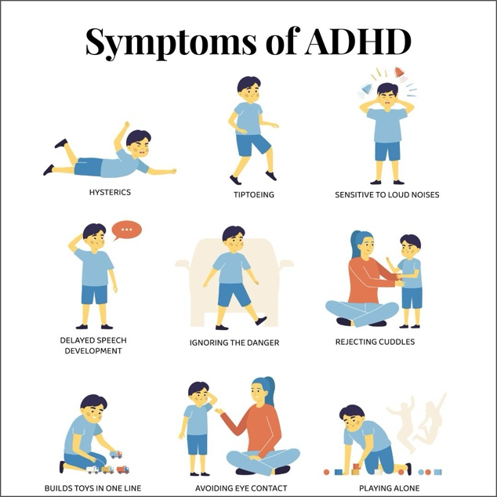

(Konduri, 2023)

There are three unusual types of ADHD:

- Predominantly inattentive presentation. (difficulty concentrating and focusing)
- Predominantly hyperactive/impulsive presentation.
- Combined presentation.

The phrase "hyperactivity" refers to activities that entail a lot of movement, such as fidgeting, having too much energy, not sitting still, or talking too much.
- Constantly moving as though driven by a motor
- Not able to stay seated (in classroom, workplace)
- interferes with or disrupts other people (e.g., interrupts game, talks, or activities, or begins utilising someone else's property without their consent). Older teenagers and adults may mimic what others are doing.

These are the primary indicators of inattentiveness:
- possessing a short attention span and being quickly distracted, making casual mistakes, such as in homework, seeming forgetful, or losing items, in addition to having a short attention span (NHS, 2021)

One form of attention-deficit hyperactivity disorder (ADHD) is known as the mixed type of the illness. This particular form of ADHD is distinguished by the presence of symptoms that include both hyperactivity-impulsivity and inattention. (NHS, 2021)

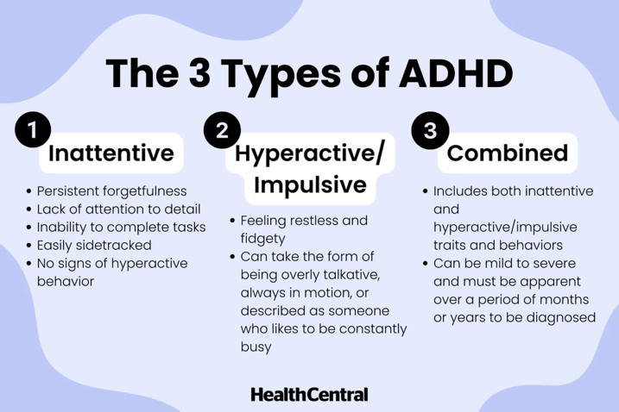

(McQuillan, 2022)

Policy and legislation

The Equality Act 2010:
People with disabilities, including attention-deficit/hyperactivity disorder (ADHD), are needed to get reasonable accommodations from schools and employment in the United Kingdom under the Equality Act of 2010. As a result of this, individuals who have attention-deficit/hyperactivity disorder (ADHD) are given equal chances in terms of education and work, as well as protection from discrimination under the law. According to the Equality Act of 2010, it is against the law for a school or company to treat a person with a limitation in a manner that is less favourable than how they would treat other people who do not have that disability. People with attention-deficit/hyperactivity disorder (ADHD) have the same rights as those without ADHD in terms of education, employment, and other services. (rradar, 2024)

Children and Families Act 2014:
It was during the process of putting this legislation into effect that the Special Educational Needs and Disability (SEND) system was established in the United Kingdom. Its purpose is to guarantee that children and young adults who have specific educational requirements and disabilities, such as attention-deficit/hyperactivity disorder (ADHD), are provided with the necessary assistance to achieve their full potential. In accordance with the act, inclusive education is of the highest priority, as is the right to receive an education that is suitable and adapted to the need of a child. (Child Law Advice, 2014)
Additionally, the legislation specifies that local authorities and educational institutions collaborate to accurately assess the requirements of young people who have special educational needs or disabilities. In addition to this, it is necessary for them to offer appropriate assistance and services. Some of these measures is the provision of additional cash and resources to cater to the need of these children, as well as the guarantee that they would have access to regular educational opportunities. (Department for Education, 2015)
Educational Health and Care Plan (EHCP):
A Child's Educational Health and Care Plan (EHCP), which is described under the Special Educational Needs and Disabilities Act, may outline the supports and services that the child needs to be successful in school. An educational home care plan (EHCP) is developed collaboratively by parents, teachers, and other professionals to give a holistic approach to the education of the child. (GOV.UK, 2024)
For the child understand their full potential, the EHCP sets out the goals, aims, and strategies that they might need to implement. In addition to this, it provides an outline of the resources, support, and services that must be proven for the child to be successful. (Adams et al., 2018)
NHS Long Term Plan:
In an effort to enhance ADHD services, the National Health Service (NHS) is implementing a number of programs, including those that aim to improve access to diagnosis and treatment. The plan's goal is to guarantee that patients receive comprehensive care to control their attention-deficit/hyperactivity disorder (ADHD), in addition to resolving obstacles in service provision.
This entails providing support for patients as well as the families of those individuals. Additionally, it includes the provision of help for mental health issues like as anxiety and depression, which are often connected with attention-deficit/hyperactivity disorder (ADHD), as well as the provision of education about ADHD and its management. These policies and legislative frameworks that encourage equal opportunities in school and employment can be beneficial to individuals who have attention-deficit/hyperactivity disorder (ADHD). (National Guideline Centre (UK), 2019)
Strategies
In order to assist students in achieving academic success, schools are able to create Individualised Education Programs (IEPs) that are tailored to the unique needs of the child. An Individualised Education Program (IEP) is a document that assists the teaching staff in planning for your child. It should include methods that will assist students in learning, and it should also be utilised to evaluate their development. If your kid has a statement of special educational needs (SEN), the Individualised Education Program (IEP) should be based on their profile, records, evaluations, and strengths. The curriculum should be easier to access and engage with for your child as a result of this. (National Autistic Society, 2020)
Every child or young person has their own individual education program (IEP), which should outline what should be taught, how it should be taught, and how often it should be taught. There is no universally accepted format for individualised education programs (IEPs), but in general, they contain information about short-term goals and the additional support that has been implemented to assist your kid in achieving those goals. It is important that the document be easily accessible and digestible to everyone. Due to the fact that it is essential for you to be involved at this initial stage, it is the responsibility of both you and your child to reach a consensus on matters. (National Autistic Society, 2020). There should be the following items included in the part that describes the methods and resources that the school plans to use in order to assist your child in achieving their goals:

When the support will take place (for example, four small group sessions lasting thirty minutes each, four times a week), who will provide it (for example, a teacher or a classroom assistant). (National Autistic Society, 2020)
Visual timetable
When working with a child on an individual basis or as part of a method that involves the entire class or a small group, a visual timeline can be utilised. Children who have special educational needs are not the only ones who benefit from having a clear and concise overview of what is going to happen during their day. Visual timetables are utilised specifically for children who have special educational needs. They are also able to gain a better understanding of where they are in the day from the perspective of knowing what has occurred in the past and what will occur after the current moment. (Council for Disabled Children, 2024)
Differentiated learning
Through the use of differentiated learning, it can be achieved to guarantee that all students, regardless of their skills or preferred modes of learning, are provided with equal access to educational opportunities. Students who have disabilities, learning issues, or who succeed academically and require more challenging materials can be accommodated with the help of this strategy. Through the use of differentiated instruction, avenues to learning are made available, so making the classroom a "good fit" for a wide range of students. (Tomlinson, 2003)
Task blocking
Task blocking is an efficient method of time management that can be a particular benefit to people who have attention-deficit/hyperactivity disorder (ADHD). It entails setting out particular chunks of time throughout the day for all of the various activities or jobs that need to be completed. Make sure that the beginning and finishing times of each task are clearly defined. This makes it easier to avoid spending an excessive amount of time to any one activity.
Self-regulation zones
In order to assist children (and adults) in the development of skills that allow them to self-regulate, the Zones of Regulation framework was developed. Children will have an easier time recognising and managing their moods as a result of this application since it divides levels of attentiveness and emotions into four distinct coloured zones. The Zones of Regulation categorises our emotions, states of awareness, and levels of energy into four distinct zones: blue, green, yellow, and red. This is done with the intention of making it simpler to discuss, think about, and influence these aspects of our lives. The Zones of Regulation include a visual framework and language that is easy to understand, which serves to make the difficult skill of regulation more tangible for students and adults who are responsible for their education. (ZONEs of Regulation, 2023)
Blue zone
- Feelings such as sadness, exhaustion, illness, boredom, or depression are examples of emotions.
- Low energy or alertness are characteristics of this condition.
- Techniques: Get some rest, drink some water, talk to someone, take some slow breaths, or listen to some music that is soothing. (ZONEs of Regulation, 2023)

Green zone
- A happy, peaceful, focused, content, or ready to learn state of mind is an emotion.
- Characteristics: The ideal configuration for learning and engaging with others.
- Strategies: Continue with the tasks you are currently engaged in, engage in mindfulness practices, or employ positive affirmations. (ZONEs of Regulation, 2023)

The Yellow Zone
- Frustrated, anxious, excited, goofy, or nervous are some of the emotions that occur.
- A heightened sense of vigilance while still maintaining control is one of the characteristics.
- Strategies include taking a pause, employing strategies that are calming, talking it out, or engaging in a brief physical exercise. (ZONEs of Regulation, 2023)
Red area
- Angry, enraged, out of control, or too thrilled are all examples of emotions.
- Extremely heightened state of alertness or powerful emotions are characteristics of this condition.
- Techniques include taking slow, deep breaths, counting to ten, finding a quiet place to be, or asking an adult for assistance. (ZONEs of Regulation, 2023)

Peer/ group learning (scaffolding)
Participating in support groups can give both parents and children a sense of belonging to a community and the opportunity to share their experiences. Peer and group learning, which is frequently accompanied by scaffolding, has the potential to be extremely beneficial for children who have attention-deficit/hyperactivity disorder (ADHD). Scaffolding is the process of giving students with support and then progressively decreasing that support as the students grow more proficient. In order to effectively scaffold, a parent must offer the temporary supports that are required for a child to succeed in an activity, while at the same time being mindful of not providing their child with an excessive amount of help or an insufficient amount of support. (Mazursky-Horowitz et al., 2017)
Individual Development Plan
In educational and professional contexts, an Individual Development Plan (IDP) is a personalised and structured strategy to accomplishing particular goals and objectives. It is frequently utilised in these kinds of environments. An Individualised Development Plan (IDP) can be especially helpful for children who have attention-deficit/hyperactivity disorder (ADHD) since it allows for the provision of individualised support and the monitoring of development. To accomplish the goals, it is necessary to determine the tactics, interventions, and adjustments that are required. Alterations to the learning environment, variations in instructional strategies, and the provision of additional support services could fall under this category. The implementation of an Individualised Development Plan (IDP) can provide an organised plan for supporting the development of a child and ensuring that they receive the resources and interventions that are necessary for them to be successful. All of the individuals who are involved in the education of the child are encouraged to maintain close communication and work together. The ALN Code states that a school shall swiftly establish an Individualised Development Plan (IDP), and in any case, within thirty-five school days. (Newport city council, 2024) A description of the child or young person's individualised learning plan (ALN) and the additional learning provision (ALP) that is necessary to address those needs will be included in the Individualised Development Plan (IDP). In most cases, the governing board of the school or FEI in Wales will be the one to design, monitor, and evaluate Individualised Development Plans (IDPs). (gov. Wales, 2018)

Case study

Jamie is an 8-year-old student in year 4 at a primary school in Swansea, Wales. He was diagnosed with ADHD (combined type) at the age of 6. Jamie exhibits both inattentive and hyperactive- impulsive behaviours. He struggles with supporting focus during lessons, completing tasks and controlling impulsive behaviours such as calling out in class as fidgeting.

Throughout his time in school, Jamie will be confronted with a variety of problems. He may have trouble concentrating during lectures and finishing his work. Additionally, he will struggle to support his focus throughout class, particularly when the tasks that are very lengthy or identical. It is possible that they will become distracted by other people on a regular basis. It would be beneficial to have a seating arrangement in the classroom that would place Jamie in a position that is close to the teacher or next to a positive role model. Additionally, Jamie should be placed away from the entrances and exits, such as doors and windows, in the classroom. This will help Jamie in concentrating and staying focused to the best of his ability. Using a reward system, rewarding attention, and providing free choice activities are some of the methods that could be helpful for Jamie with attention-deficit/hyperactivity disorder (ADHD) in school. Due to the fact that Jamie has difficulty concentrating during lessons and finishing assignments, these strategies would be beneficial to Jamie. Due to the fact that Jamie’s symptoms affect his ability to carry out tasks, it is likely that Jamie will have trouble reaching his full potential at school or at work.
It will be easier for Jamie to keep control of his behaviour and to raise his hand when he has a question or a group discussion if he is praised and rewarded for listening to and following the instructions given by the teacher. Jamie will also be able to give his classmates the opportunity to express their thoughts without being interrupted. (NHS, 2024) By utilising tools such as planners, checklists, and colour-coded folders, you may assist the child in maintaining their organisation. It is important to provide particular appreciation for positive behaviour and achievements. As an illustration, rather than saying "Good job," you may say something like, "I really like how you stayed focused on your work here today."

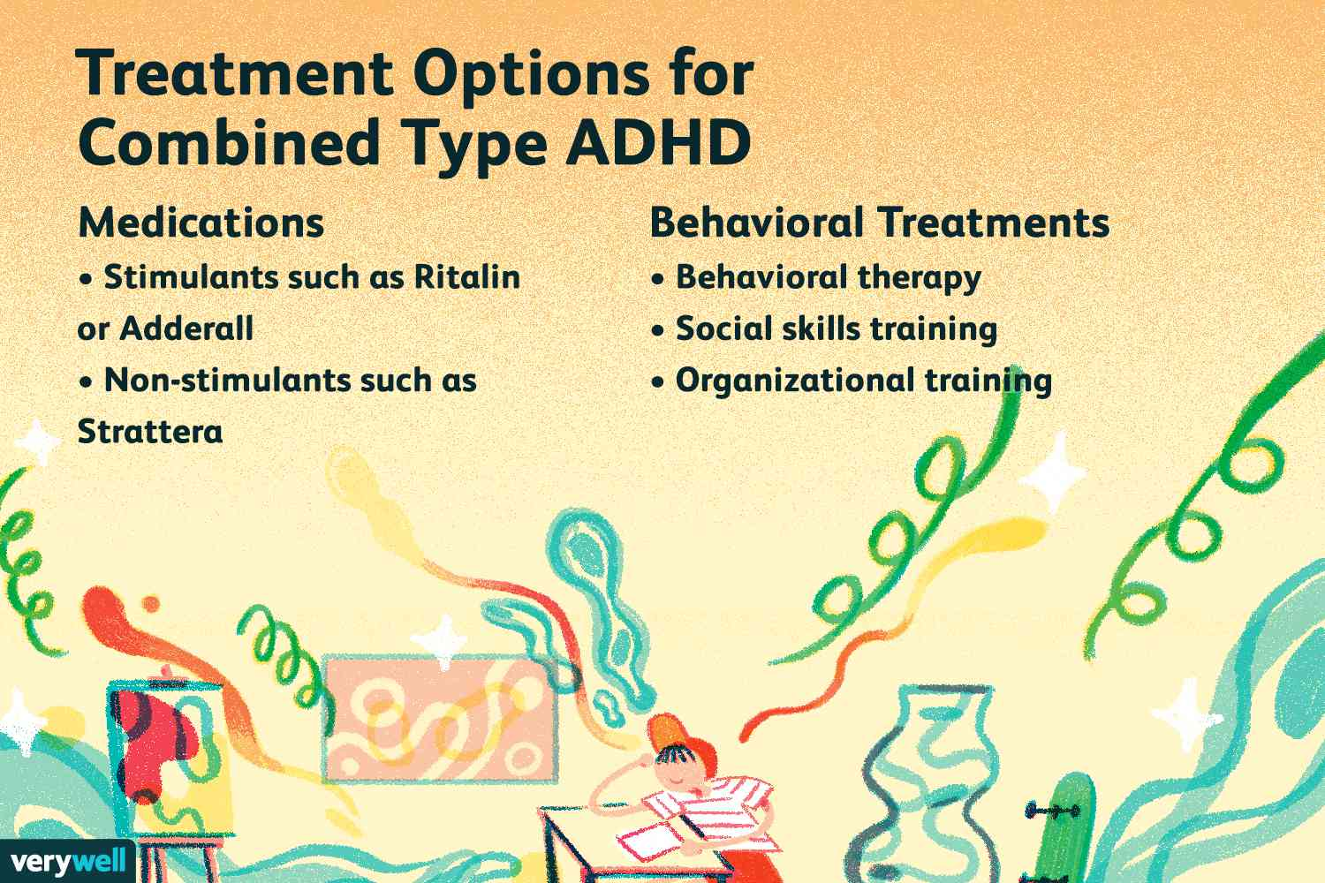

(Burch, 2022)

Good practice guidelines

Primary school pupils who have attention-deficit/hyperactivity disorder (ADHD) require a variety of measures to be used in order to establish a learning environment that is structured, supportive, and engaging. Establishing clear routines and standards for the classroom might assist children with attention-deficit/hyperactivity disorder (ADHD) in comprehending what is expected of them and what they can anticipate throughout the day. (ADHD Foundation, 2018). Attention can be improved by placing pupils in close proximity to the instructor and away from any potential distractions. Maintain the simplicity of language; directions should be clear and simple. The ability to take in at something and listen to instructions at the same time might be challenging for certain children. Preceding a demonstration with straightforward words, such as "do this," may improve the audience's capacity to imitate the behaviours being demonstrated. Additionally, the use of positive reinforcement is essential due to the fact that it is a universal principle that is actually fairly organically present in each and every classroom where it is implemented. (Craig, 2019)
To assist pupils in maintaining their concentration, work should be broken down into smaller, more manageable pieces, and frequent breaks should be provided. (Unlu, 2017). Make sure that each student has their own workstation so that they can concentrate on their assignments and minimise distractions. (Mary Beth Hertz, 2014). Supporting pupils in the development of proper social relations can be accomplished through the implementation of social skills training programs such as Lego Therapy or Social Skills clubs. The development of significant listening skills, the ability to take turns, joint attention, resilience, patience, perseverance, and problem-solving abilities can be observed. (Brodie and Mather, 2017) Students will be able to control their feelings and impulses if they are taught skills for self-regulation, such as exercises that involve deep breathing or the use of fidget toys. (Aspiranti and Hulac, 2021).
Employing individualised rewards and positive reinforcement is an effective way to motivate students to behave well and achieve academic success. Positive reinforcement is widely recognised as one of the most successful instructional strategies. This quantitative study was conducted with the intention of determining whether or not positive reinforcement is successful in enhancing student participation in the classroom in terms of academics, behaviour, and interaction with other students. (Ismail, 2023). Keep an open line of communication with the parents in order to guarantee consistency between home and the school. Encourage teachers and support personnel to work together in order to share techniques and provide consistent support for students who have attention-deficit/hyperactivity disorder (ADHD). As much as you can, try to reduce the number of additional distractions that are present in the space, such as excessive noise or visual stimuli like clutter. (Low, 2023) Ongoing professional development on attention-deficit/hyperactivity disorder (ADHD) and appropriate practices for assisting students with ADHD should be provided to teachers and staff. Some of the strategies may be able to be implemented by teachers or teaching assistants without the need for any further training. For instance, modifying the seating arrangement in the classroom, employing a system of rewards and/or consequences to improve behaviour, and helping with study skills are all examples of strategies that might be used. (gov.wales, n.d.). For students who have attention-deficit/hyperactivity disorder (ADHD), these behaviours can assist establish an environment that is more welcoming and helpful, which will allow them to flourish academically and socially. It has been demonstrated that this strategy, which is guided by the instructor, has the ability to affect student behaviour in a positive way, hence enhancing academic engagement. It has been demonstrated that behavioural classroom management is effective for pupils of all ages, despite the fact that it has been evaluated mostly in elementary schools. (CDC, 2024)

Reference list
Adams, L., Tindle, A., Basran, S., Dobie, S., Thomson, D., Robinson, D. and Codina, G. (2018). Education, Health and Care plans: a Qualitative Investigation into Service User Experiences of the Planning Process Research Report. [online] Available at: https://assets.publishing.service.gov.uk/media/5aba6920e5274a1aa2d418c3/Education_Health_and_Care_plans_-_a_qualitative_investigation.pdf [Accessed 1 Jan. 2025].
ADHD Foundation (2018). Teaching and Managing Students with ADHD: Systems, Strategies Solutions. [online] Available at: https://www.adhdfoundation.org.uk/wp-content/uploads/2022/03/Teaching-and-Managing-Students-with-ADHD.pdf [Accessed 17 Jan. 2025].
Aspiranti, K.B. and Hulac, D.M. (2021). Using Fidget Spinners to Improve on-task Classroom Behavior for Students with ADHD. Behavior Analysis in Practice, [online] 15(2), pp.454–465. doi:https://doi.org/10.1007/s40617-021-00588-2.
Brodie, C. and Mather, V. (2017). Using Lego Therapy with Autistic Pupils. [online] www.autism.org.uk. Available at: https://www.autism.org.uk/advice-and-guidance/professional-practice/lego-pilot.
Burch, K. (2022). What Is Combined Type ADHD? Verywell Health. Available at: https://www.verywellhealth.com/combined-type-adhd-signs-symptoms-and-treatment-5209137 [Accessed 7 Jan. 2025].
CDC (2024). ADHD in the Classroom: Helping Children Succeed in School. [online] Attention-Deficit / Hyperactivity Disorder (ADHD). Available at: https://www.cdc.gov/adhd/treatment/classroom.html [Accessed 4 Jan. 2025].
Child Law Advice (2014). Special Educational Needs. [online] Childlawadvice.org.uk. Available at: https://childlawadvice.org.uk/information-pages/special-educational-needs/ [Accessed 8 Jan. 2025].
Council for Disabled Children (2024). What Is a Visual timetable? [online] Available at: https://councilfordisabledchildren.org.uk/sites/default/files/uploads/attachments/Visual%20Timetables%20Resource.I%20CAN.FINAL_.pdf [Accessed 6 Jan. 2025].
Craig, H. (2019). 5 activities for using positive reinforcement in the classroom. [online] PositivePsychology.com. Available at: https://positivepsychology.com/positive-reinforcement-classroom/ [Accessed 1 Apr. 2025].
Department for Education (2015). Special Educational Needs and Disability Code of practice: 0 to 25 Years . [online] Gov.uk. gov.uk. Available at: https://assets.publishing.service.gov.uk/media/5a7dcb85ed915d2ac884d995/SEND_Code_of_Practice_January_2015.pdf [Accessed 4 Jan. 2025].
Elmaghraby, R. and Garayalde, S. (2022). What Is ADHD? [online] American Psychiatric Association. Available at: https://www.psychiatry.org/patients-families/adhd/what-is-adhd [Accessed 3 Jan. 2025].
gov. Wales (2018). Children’s Rights Impact Assessment (CRIA) Title / Piece of work: Implementing the Additional Learning Needs and Education Tribunal (Wales) Act 2018 a Guide to the Timeframes for Implementing Individual Development Plans for Children of Compulsory School Age and under. [online] Available at: https://www.gov.wales/sites/default/files/publications/2018-06/alnet-wales-act-implementation-guide-for-individual-development-plans-childrens-rights-impact-assessment-cria.pdf.
GOV.UK (2024). Children with Special Educational Needs and Disabilities (SEND). [online] GOV.UK. Available at: https://www.gov.uk/children-with-special-educational-needs/extra-SEN-help [Accessed 13 Jan. 2025].
gov.wales (n.d.). Support for Children and Young People with Attention Deficit Hyperactivity Disorder (ADHD) in Educational Settings. [online] Available at: https://www.gov.wales/sites/default/files/publications/2023-12/ways-of-supporting-learners-with-attention-deficit-hyperactivity-disorder-adhd.pdf.
Ismail, I. (2023). Using Positive Reinforcement to Increase Student Engagement in Using Positive Reinforcement to Increase Student Engagement in the Classroom the Classroom. [online] Available at: https://red.mnstate.edu/cgi/viewcontent.cgi?article=1885&context=thesis.
Konduri, D.R. (2023). ADHD in Adults and Children: Recognizing and Managing Symptoms. continentalhospitals.com. Available at: https://continentalhospitals.com/blog/adhd-in-adults-and-children-recognizing-and-managing-symptoms/ [Accessed 2 Jan. 2025].
Low, K. (2023). 8 Simple School Strategies for Students with ADHD. [online] Verywell Mind. Available at: https://www.verywellmind.com/help-for-students-with-adhd-20538.
Mary Beth Hertz (2014). Digital Tools and Distraction in School. [online] Edutopia. Available at: https://www.edutopia.org/blog/digital-tools-distraction-in-school-mary-beth-hertz [Accessed 2 Jan. 2025].
Mayo Clinic (2019). Attention-deficit/hyperactivity Disorder (ADHD) in Children - Symptoms and Causes. [online] Mayo Clinic. Available at: https://www.mayoclinic.org/diseases-conditions/adhd/symptoms-causes/syc-20350889 [Accessed 10 Jan. 2025].
Mazursky-Horowitz, H., Thomas, S.R., Woods, K.E., Chrabaszcz, J.S., Deater-Deckard, K. and Chronis-Tuscano, A. (2017). Maternal Executive Functioning and Scaffolding in Families of Children with and without Parent-Reported ADHD. Journal of Abnormal Child Psychology, 46(3), pp.463–475. doi:https://doi.org/10.1007/s10802-017-0289-2.
McQuillan, S. (2022). Types of ADHD: What to Know about the 3 Types of ADHD. www.healthcentral.com. Available at: https://www.healthcentral.com/condition/adhd/types-of-adhd [Accessed 16 Jan. 2025].
National Autistic Society (2020). Individual education plans. [online] www.autism.org.uk. Available at: https://www.autism.org.uk/advice-and-guidance/topics/education/extra-help-at-school/northern-ireland/individual-education-plans [Accessed 5 Jan. 2025].
National Guideline Centre (UK) (2019). Attention Deficit Hyperactivity disorder: Diagnosis and Management. [online] PubMed. London: National Institute for Health and Care Excellence (UK). Available at: https://www.ncbi.nlm.nih.gov/books/NBK493361/ [Accessed 5 Jan. 2025].
Newport city council (2024). Individual Development Plan | Newport City Council. [online] Newport.gov.uk. Available at: https://www.newport.gov.uk/schools-and-learning/support-schools/additional-learning-needs-aln/individual-development-plan.
News, I. (2025). Autism and ADHD Waiting Lists in Wales ‘could Triple in Two Years’. [online] ITV News. Available at: https://www.itv.com/news/wales/2025-01-13/autism-and-adhd-waiting-lists-in-wales-could-triple-in-two-years [Accessed 14 Jan. 2025].
NHS (2021a). Attention Deficit Hyperactivity Disorder (ADHD). [online] NHS. Available at: https://www.nhs.uk/conditions/attention-deficit-hyperactivity-disorder-adhd/ [Accessed 12 Jan. 2025].
NHS (2021b). Symptoms - Attention Deficit Hyperactivity Disorder (ADHD). [online] NHS. Available at: https://www.nhs.uk/conditions/attention-deficit-hyperactivity-disorder-adhd/symptoms/ [Accessed 15 Jan. 2025].
NHS (2021c). Treatment - Attention Deficit Hyperactivity Disorder (ADHD). [online] NHS. Available at: https://www.nhs.uk/conditions/attention-deficit-hyperactivity-disorder-adhd/treatment/ [Accessed 13 Jan. 2025].
NHS (2024). A Guide for Teachers. [online] Tees Esk and Wear Valley NHS Foundation Trust. Available at: https://www.tewv.nhs.uk/about-your-care/conditions/adhd/information-for-teachers/ [Accessed 11 Jan. 2025].
rradar (2024). ADHD Classification under the Equality Act 2010. [online] Rradar. Available at: https://rradar.com/adhd-under-the-equality-act-2010/ [Accessed 9 Jan. 2025].
Sciberras, E. (2020). How Can We Help Children with ADHD Get a Better Night’s Sleep? [online] CHADD. Available at: https://chadd.org/attention-article/how-can-we-help-children-with-adhd-get-a-better-nights-sleep/ [Accessed 6 Jan. 2025].
Tomlinson, C.A. (2003). Differentiating Instruction in Response to Student Readiness, Interest, and Learning Profile in Academically Diverse Classrooms: a Review of Literature. Journal for the Education of the Gifted, [online] 27(2-3), pp.119–145. doi:https://doi.org/10.1177/016235320302700203.
Unlu, V. (2017). Tips for Helping Students’ Concentration and Focus. [online] World of Better Learning | Cambridge University Press. Available at: https://www.cambridge.org/elt/blog/2017/12/15/tips-for-helping-students-concentration-and-focus/ [Accessed 20 Jan. 2025].
ZONEs of Regulation (2023). Learn More about the ZONEs of Regulation. [online] The Zones of Regulation. Available at: https://zonesofregulation.com/how-it-works/.

